Supplementary Figures.

Supplementary Figure 1. Expression and purification of active recombinant PvPMX and PfPMIX aspartic proteases. A. PvPMX was expressed in insect cells and protein purified from supernatants using anti-FLAG M2-agarose. Shown is a Coomassie stained gel of eluted fractions. B. Pooled fractions were further purified by Size Exclusion Chromatography (SEC). C. Purified recombinant PvPMX run under reduced (Rd) and non-reduced (NR) conditions and visualized using Coomassie staining. D. Expression and purification of PfPMIX in CHO cells. Shown are proteins from insect cell supernatant (Sup^{n}), protein purified by His-affinity chromatography (His Trap) and further purification using Ion Exchange Chromatography (IEX). Samples were run under reduced (Rd) and non-reduced (Non-rd) conditions and visualized by Coomassie staining.

Supplementary Figure 2. Mass spectrometry analysis of PfRON3 and PfRh2N peptides before and after cleavage with PvPMX or PfPMIX. A. PfRON3 peptide (100 μM) was incubated without and with recombinant PfPMIX (50 nM) and analysed by LC-ES/MS to identify the products. B. PvRON3 peptide (100 μM) was incubated without and with recombinant PfPMIX (50 nM) and analysed by LC-ES/MS to identify the molecular species present. The N-terminal fragment could not be detected by HPLC but was identified by mass spectrometry. C. PfRh2N peptide (100 μM) was incubated without and with recombinant PfPMIX (50 nM) and analysed by LC-ES/MS to identify the molecular species present. For all fluorogenic peptides (PfRON3, PvRON3 and Rh2N) cleavage by PfPMIX occurs on the C-terminal side of the phenylalanine (F). Blue arrows indicate the cleavage product. D. PfRON3 peptide (100 μM) was incubated without and with recombinant PvPMX (50 nM) and analysed by LC-ES/MS to identify the products. E. PvRON3 peptide (100 μM) was incubated without and with recombinant PvPMX (50 nM) and analysed by LC-ES/MS to identify the molecular species present. F. PfRh2N peptide (100 μM) was incubated without and with recombinant PvPMX (50 nM) and analysed by LC-ES/MS to identify the molecular species present. For all fluorogenic peptides (PfRON3, PvRON3 and Rh2N) cleavage by PvPMX occurs on the C-terminal side of the phenylalanine (F). Blue arrows indicate the cleavage product.

Supplementary Figure 3. Comparison of the protein sequence for PfPMX, PvPMX, PfPMIX and PvPMIX and determination of the percent identity. A. Comparison of the protein sequence for PfPMX, PvPMX, PfPMIX and PvPMIX with identical residues shaded in black. Amino acid positions are numbered at the left. B. Percent identity matrix of for PfPMX, PvPMX, PfPMIX and PvPMIX. PlasmoDB and Genbank Database Sequence Accessions: PfPMX PF3D7_0808200, CAD51290.1; PvPMX PVP01_0112200, VUZ93138.1; PfPMIX PF3D7_1430200, CZT99999.1; PvPMIX PVP01_1319200, VUZ98253.1.

Supplementary Figure 4. Recombinant PvPMX and PfPMIX aspartic proteases are enzymatically active. A. Cleavage activity of PvPMX with the PfRh2N fluorogenic peptide at different pH and inhibition with WM382. B. Determination of the IC₅₀ for inhibition of PvPMX with WM382 and cleavage of the PfRh2N peptide. C. Cleavage activity of PfPMIX with the PfRON3 fluorogenic peptide at different pH and inhibition with WM382. D. Determination of the IC₅₀ for inhibition of PfPMIX with WM382 and cleavage of the PfRON3 peptide. E. K_{m} for PfPMX, PvPMX and PfPMIX using peptide substrates PfRh2N and PfRON3 as indicated.

Supplementary Figure 5. Surface charge distribution for PfPMX, PvPMX and PfPMIX and binding of WM382 to the active site (red positive and blue negative charge). A. Surface charge distribution of a front view of PfPMX. B. Surface charge distribution for the back view of PfPMX. C. Surface charge distribution of the active site of PfPMX with WM382 bound. D. Surface charge distribution of a front view of PvPMX. E. Surface charge distribution for the back view of PvPMX. F. Surface charge distribution of the active site of PvPMX with WM382 bound. G. Surface charge distribution of a front view of PfPMIX. H. Surface charge distribution for the back view of PfPMIX. I. Surface charge distribution of the active site of PfPMIX with WM382 bound. For all panels electrostatic calculations were performed using Adaptive Poisson-Boltzmann Solver ³⁰ and rendered in PyMOL (The PyMOL Molecular Graphics System, Version 2.0; Schrödinger, LLC); scale: −5 kT/e (red) to +5 kT/e (blue).

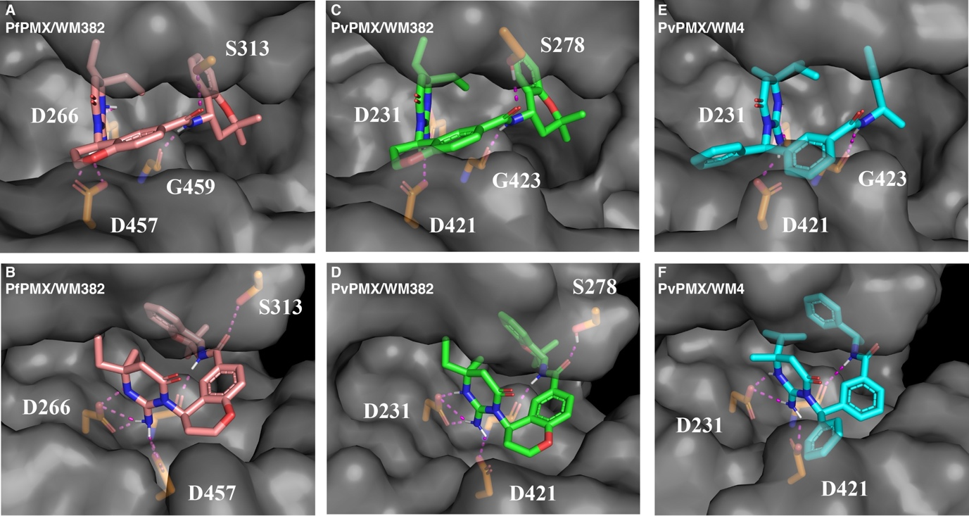

Supplementary Figure 6. Surface view of the active site of PfPMX, PvPMX showing the hydrogen bonds to WM382 or WM4 that have bound to the active site. A and B. Different views for the interaction of WM382 with the active site of PfPMX. C and D. Different views for the interaction of WM382 with the active site of PvPMX. E and F. Different views for the interaction of WM4 with the active site of PvPMX.

Supplementary Table 1. SPR kinetic parameters for WM4 against PvPMX, PfPMX and PfPMIX.

Supplementary Table 2. Data collection and refinement statistics for 3-D crystal structures for PfPMX-apo, PfPMX-WM382, PvPMX-WM382 and PvPMX-WM4.

Supplementary Table 3. Hydrogen bonding interactions between residues of the flap located within the S3 subpocket of PMX.

