Additional files

Box 1. Clinical question in PICO format
Population | Intervention | Comparison | Outcomes
Patients on surgical waiting lists for cataract surgery, knee replacement, or inguinal hernia repair | Prioritization tools used to rank patients on surgical waiting lists | O1: No comparator  O2: Alternative waiting list management strategies | O1: Psychometric properties such as validity and reliability measures  O2: Differences in waiting times or reductions in elective surgery waiting times
O1: objective number one
O2: objective number two

Additional file 1. Search strategy
Database | Search terms
Cataract surgery
Google Scholar: 100*  *First 10 pages | #1 cataract OR “cataract extraction” OR “cataract surgery” OR “cataract treatment” OR phacoemulsification OR “intraocular lens”  #2 “waiting lists” OR “waiting listings” OR “patient lists” OR “patient listings” OR “waiting time” OR “waiting times” OR “warranty time” OR “maximum waiting time” OR “guaranteed waiting time” OR “patient prioritisation”  #3 1 AND 2
PubMed: 281 | #1 "Cataract"[Mesh] OR "Cataract Extraction"[Mesh] OR "Phacoemulsification"[Mesh] OR "Lenses, Intraocular"[Mesh]  #2 cataract[Title/Abstract] OR "cataract extraction"[Title/Abstract] OR "cataract surgery"[Title/Abstract] OR "cataract treatment"[Title/Abstract] OR phacoemulsification[Title/Abstract] OR "intraocular lens"[Title/Abstract]  #3 "Waiting Lists"[Mesh] OR "Appointments and Schedules"[Mesh]  #4 "waiting lists"[Title/Abstract:~1] OR "waiting listings"[Title/Abstract:~1] OR "patient lists"[Title/Abstract:~1] OR "patient listings"[Title/Abstract:~1] OR "waiting time"[Title/Abstract:~1] OR "waiting times"[Title/Abstract:~1] OR "warranty time"[Title/Abstract:~1] OR "maximum waiting time"[Title/Abstract:~1] OR "guaranteed waiting time"[Title/Abstract:~1] OR "patient prioritisation"[Title/Abstract:~1]  #5 (1 OR 2) AND (3 OR 4)  Límites: English, Spanish, Exclude preprints
Embase: 62 | #1 'cataract'/exp OR 'cataract extraction'/exp OR 'phacoemulsification'/exp OR 'lens implant'/exp  #2 cataract:ab,ti OR 'cataract extraction':ab,ti OR 'cataract surgery':ab,ti OR 'cataract treatment':ab,ti OR phacoemulsification:ab,ti OR 'intraocular lens':ab,ti  #3 (waiting NEAR/1 lists):ab,ti OR (waiting NEAR/1 listings):ab,ti OR (patient NEAR/1 lists):ab,ti OR (patient NEAR/1 listings):ab,ti OR (waiting NEAR/1 time):ab,ti OR (waiting NEAR/1 times):ab,ti OR (warranty NEAR/1 time):ab,ti OR (maximum NEAR/1 waiting NEAR/1 time):ab,ti OR (guaranteed NEAR/1 waiting NEAR/1 time):ab,ti OR (patient NEAR/1 prioritisation):ab,ti  #5 (1 OR 2) AND 3  Límites: [embase]/lim NOT ([embase]/lim AND [medline]/lim) AND ([english]/lim OR [spanish]/lim)
Knee replacement
Google Scholar: 100*  *First 10 pages | (arthroplasty OR “knee replacement” OR “knee prosthesis” OR “knee arthroplasty”) AND (“waiting lists” OR “waiting listings” OR “patient lists” OR “patient listings” OR “waiting time” OR “waiting times” OR “warranty time” OR “maximum waiting time” OR “guaranteed waiting time” OR “patient prioritisation”)
PubMed: 409 | #1 "Arthroplasty"[Mesh] OR "Arthroplasty, Replacement, Knee"[Mesh] OR "Knee Prosthesis"[Mesh]  #2 arthroplasty[Title/Abstract] OR "knee replacement"[Title/Abstract] OR "knee prosthesis"[Title/Abstract] OR "knee arthroplasty"[Title/Abstract]  #3 "Waiting Lists"[Mesh] OR "Appointments and Schedules"[Mesh]  #4 "waiting lists"[Title/Abstract:~1] OR "waiting listings"[Title/Abstract:~1] OR "patient lists"[Title/Abstract:~1] OR "patient listings"[Title/Abstract:~1] OR "waiting time"[Title/Abstract:~1] OR "waiting times"[Title/Abstract:~1] OR "warranty time"[Title/Abstract:~1] OR "maximum waiting time"[Title/Abstract:~1] OR "guaranteed waiting time"[Title/Abstract:~1] OR "patient prioritisation"[Title/Abstract:~1]  (#1 OR #2) AND (#3 OR #4)  Límites: English, Spanish, Exclude preprints
Embase: 102 | #1 'arthroplasty'/exp OR 'knee replacement'/exp OR 'knee prosthesis'/exp OR 'knee arthroplasty'/exp  #2 arthroplasty:ab,ti OR 'knee replacement':ab,ti OR 'knee prosthesis':ab,ti OR 'knee arthroplasty':ab,ti  #3 (waiting NEAR/1 lists):ab,ti OR (waiting NEAR/1 listings):ab,ti OR (patient NEAR/1 lists):ab,ti OR (patient NEAR/1 listings):ab,ti OR (waiting NEAR/1 time):ab,ti OR (waiting NEAR/1 times):ab,ti OR (warranty NEAR/1 time):ab,ti OR (maximum NEAR/1 waiting NEAR/1 time):ab,ti OR (guaranteed NEAR/1 waiting NEAR/1 time):ab,ti OR (patient NEAR/1 prioritisation):ab,ti  (#1 OR #2) AND #3  Límites: [embase]/lim NOT ([embase]/lim AND [medline]/lim) AND ([english]/lim OR [spanish]/lim)
Inguinal hernia repair
Google Scholar: 100*  *First 10 pages | (“inguinal hernia” OR “inguinal hernias” OR “hernia repair” OR “hernias repair” OR herniorrhaphy OR hernioplasty) AND (“waiting lists” OR “waiting listings” OR “patient lists” OR “patient listings” OR “waiting time” OR “waiting times” OR “warranty time” OR “maximum waiting time” OR “guaranteed waiting time” OR “patient prioritisation”)
PubMed: 74 | #1 "Hernia, Inguinal"[Mesh]  #2 “inguinal hernia”[Title/Abstract:~1] OR “inguinal hernias”[Title/Abstract:~1] OR “hernia repair”[Title/Abstract:~1] OR “hernias repair”[Title/Abstract:~1] OR herniorrhaphy[tiab] OR hernioplasty[tiab]  #3 "Waiting Lists"[Mesh] OR "Appointments and Schedules"[Mesh]  #4 "waiting lists"[Title/Abstract:~1] OR "waiting listings"[Title/Abstract:~1] OR "patient lists"[Title/Abstract:~1] OR "patient listings"[Title/Abstract:~1] OR "waiting time"[Title/Abstract:~1] OR "waiting times"[Title/Abstract:~1] OR "warranty time"[Title/Abstract:~1] OR "maximum waiting time"[Title/Abstract:~1] OR "guaranteed waiting time"[Title/Abstract:~1] OR "patient prioritisation"[Title/Abstract:~1]  (#1 OR #2) AND (#3 OR #4)  Límites: English, Spanish, Exclude preprints
Embase: 33 | #1 'inguinal hernia'/exp  #2 arthroplasty:ab,ti OR 'knee replacement':ab,ti OR 'knee prosthesis':ab,ti OR 'knee arthroplasty':ab,ti  #3 (waiting NEAR/1 lists):ab,ti OR (waiting NEAR/1 listings):ab,ti OR (patient NEAR/1 lists):ab,ti OR (patient NEAR/1 listings):ab,ti OR (waiting NEAR/1 time):ab,ti OR (waiting NEAR/1 times):ab,ti OR (warranty NEAR/1 time):ab,ti OR (maximum NEAR/1 waiting NEAR/1 time):ab,ti OR (guaranteed NEAR/1 waiting NEAR/1 time):ab,ti OR (patient NEAR/1 prioritisation):ab,ti  (#1 OR #2) AND #3  Límites: [embase]/lim NOT ([embase]/lim AND [medline]/lim) AND ([english]/lim OR [spanish]/lim)

Additional file 2. PRISMA flow diagram of the study selection process
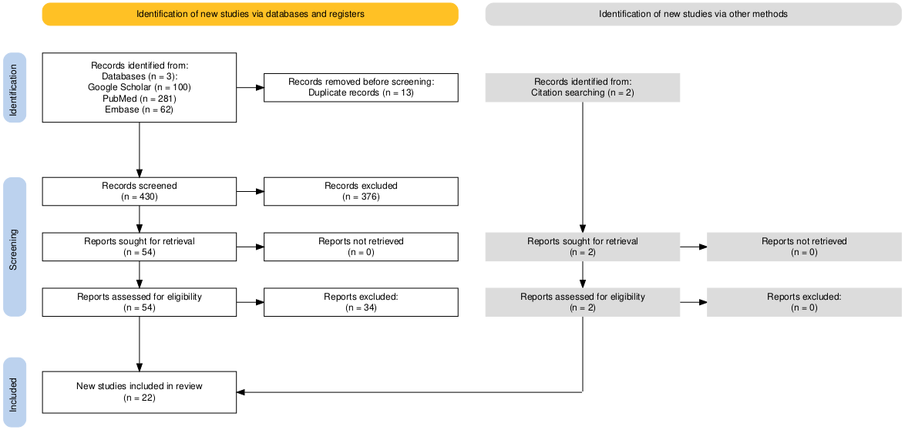
(A) 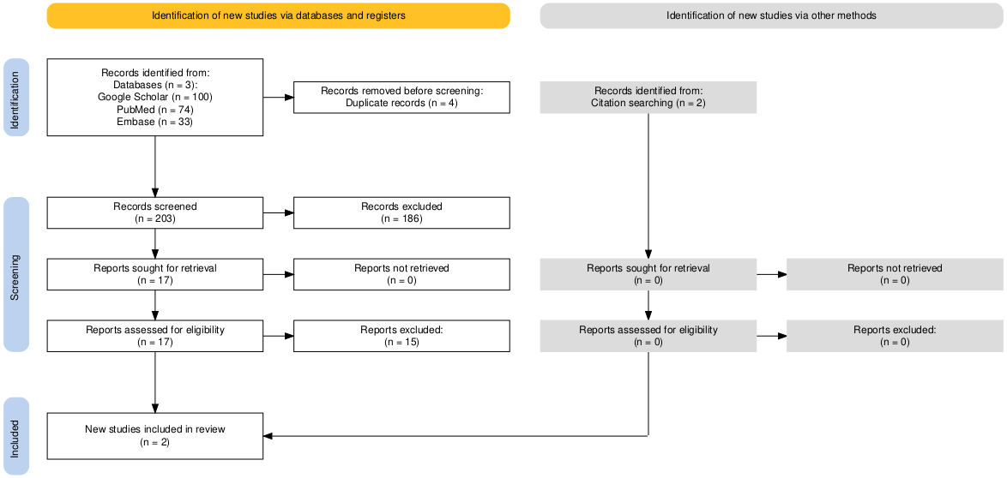

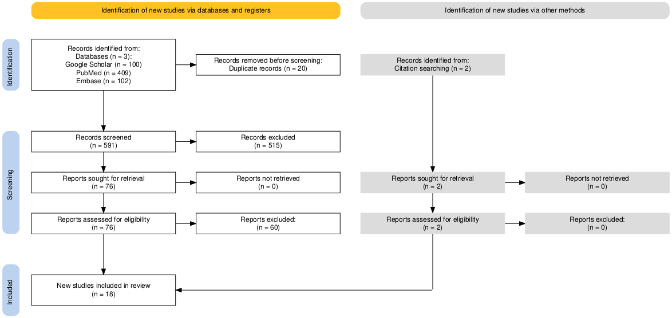
(B)

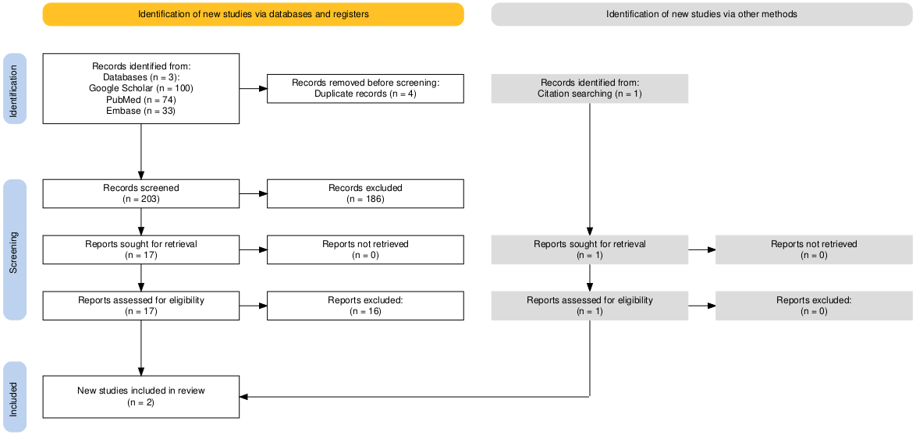
(C)

PRISMA flow diagrams illustrating the study selection process for (A) cataract surgery, (B) knee replacement, and (C) inguinal hernia repair

Additional file 3. Full-text studies excluded and reasons for exclusion
Author, Year | Title | Reason for exclusion
Cataract surgery
Allepuz 2008 | Prioritisation of patients on waiting lists for hip and knee arthroplasties and cataract surgery: Instruments validation | Duplicated*
Cheng 2021 | Cataract risk stratification and prioritisation protocol in the COVID-19 era | It assesses a specific health emergency context.
Chiesa 2024 | Increasing access to cataract surgery in Counties Manukau by optimising the clinical pathway: a quality improvement report | It does not assess tools for prioritising patients on waiting lists
Comas 2008 | Discrete-Event Simulation Applied to Analysis of Waiting Lists. Evaluation of a Prioritization System for Cataract Surgery | Duplicated*
Comas 2008 | Discrete-event simulation applied to analysis of waiting lists. Evaluation of a prioritization system for cataract surgery | Duplicated*
Conner-Spady 2005 | The Prioritization of Patients on Waiting Lists for Cataract Surgery: Validation of the Western Canada Waiting List Project Cataract Priority Criteria Tool | Duplicated*
Fun 2021 | Implications of Dual Practice on Cataract Surgery Waiting Time and Rescheduling: The Case of Malaysia | Duplicated*
Gibbs 2024 | Elective surgery waiting time prioritisation to improve population health  gains and reduce health inequalities | It does not evaluate tools for prioritising patients on waiting lists
Gothwal 2009 | Catquest questionnaire: re-validation in an Australian cataract population | It does not evaluate tools for prioritising patients on waiting lists
Gutiérrez 2009 | Validation of priority criteria for cataract extraction | Duplicated*
Gutiérrez 2010 | Variability in the prioritization of patients for cataract extraction | It does not evaluate the impact of the tool on waiting list time compared to another strategy.
Gutiérrez 2010 | Variability in the prioritization of patients for cataract extraction | Duplicated*
Hayas 2010 | Can an appropriateness evaluation tool be used to prioritize patients on a waiting list for cataract extraction? | Evaluates tool not specifically created for prioritising patients on waiting lists
Hanning 1998 | Assessment of the maximum waiting time guarantee for cataract surgery. The case of a Swedish policy | It does not evaluate tools for prioritising patients on waiting lists
Hanning 2007 | Waiting for cataract surgery – effects of a maximum waiting-time guarantee | Duplicated*
Hanning 2007 | Waiting for cataract surgery – effects of a maximum waiting-time guarantee | It does not evaluate tools for prioritising patients on waiting lists. Patients with only one clinical characteristic are prioritised.
Hanning 1998 | Assessment of the Maximum Waiting Time Guarantee for Cataract Surgery: The Case of a Swedish Policy | Duplicated*
Harrad 2002 | Local funding would reduce waiting lists for cataracts | Letter to the editor
Khadka 2012 | The importance of rating scales in measuring patient-reported outcomes | It does not evaluate tools for prioritising patients on waiting lists
Khadka 2012 | The importance of rating scale design in the measurement of patient-reported outcomes using questionnaires or item banks | It does not evaluate tools for prioritising patients on waiting lists
Kildyushov 2024 | Measurement of and Reporting on Wait Times for Priority Procedures in Canada | It does not evaluate tools for prioritising patients on waiting lists
Las Hayas 2010 | Can an appropriateness evaluation tool be used to prioritize patients on a waiting list for cataract extraction? | Tool built or adapted for a purpose other than patient prioritisation.
Lundström 1996 | Assessment of waiting time and priority setting by means of a national register | It does not evaluate tools for prioritising patients on waiting lists.
McGurran 2002 | Improving the management of waiting lists for elective healthcare services: public perspectives on proposed solutions | It does not evaluate tools for prioritising patients on waiting lists
Mojon-Azzi 2007 | Waiting times for cataract surgery in ten European countries: an analysis using data from the SHARE survey | It does not evaluate tools for prioritising patients on waiting lists
Mojon-Azzi 2007 | Waiting times for cataract surgery in ten European countries: An analysis using data from the SHARE survey | Duplicated*
Ng 2014 | Impact of a National system for waitlist prioritization: the experience with NIKE and cataract surgery in Sweden | Duplicated*
Quintana 2009 | Validity of Newly Developed Appropriateness Criteria for Cataract Surgery | Evaluates a tool not specifically designed for prioritising patients on waiting lists.
Tuft 2021 | Computer modelling of a cataract waiting list | Duplicated*
Rathnayake 2021 | Patient prioritisation methods to shorten waiting times for elective surgery: A systematic review of how to improve access to surgery | Systematic review.
Reason 2022 | How Were Wait Times for Priority Procedures in Canada Impacted during the First Six Months of the COVID-19 Pandemic? | Assess a specific health emergency context.
Ruan 2014 | Optimizing the cataract order of the list in modern surgery | It does not evaluate tools for prioritising patients on waiting lists
Siciliani 2014 | Measuring and comparing health care waiting times in OECD countries | It does not evaluate tools for prioritising patients on waiting lists.
Vissers 2001 | Towards Decision Support for Waiting Lists: An Operations Management View | Duplicated*
Knee replacement
Ackerma 2006 | Evaluating quality of life in hip and knee replacement: Psychometric properties of the World Health Organization Quality of Life short version instrument | It does not evaluate tools for prioritising patients on waiting lists
Ahmad 2007 | Change in functional status of patients whilst awaiting primary total knee arthroplasty | It does not evaluate tools for prioritising patients on waiting lists
Amar 2015 | Sustainability: orthopaedic surgery wait time management strategies | Case report
Allepuz 2008 | Prioritisation of patients on waiting lists for hip and knee arthroplasties and cataract surgery: Instruments validation | Duplicated*
Arnett 2003 | Developing priority criteria for hip and knee replacement: results from the Western Canada Waiting List Project | Duplicated*
Bassam 2021 | Priority Criteria for Hip and Knee Replacement: Addressing Health Service Wait Times | It does not report on a tool but only explores or discusses experiences in certain countries using external references.
Bird 2013 | Wait times increasing for hip and knee replacement | Commentary
Carr 2014 | Time while waiting: patients' experiences of scheduled surgery | It does not evaluate tools for prioritising patients on waiting lists
Chakravarty 2005 | Waiting time for primary hip replacement--a matter of priority | The study population consists of patients requiring hip replacement.
Clement 2022 | Prioritization versus rationing of healthcare - elective surgery is not optional surgery: how should priority be assessed to ensure equity? | Editorial
Coleman 2005 | Does the priority scoring system for joint replacement really identify those in most need? | Tool built or adapted for a purpose other than patient prioritisation.
Comas 2009 | Unmet Needs and Waiting List Prioritization for Knee Arthroplasty | Duplicated*
Conner-Spady 2005 | Determinants of patient and surgeon perspectives on maximum acceptable waiting times for hip and knee arthroplasty | It does not evaluate tools for prioritising patients on waiting lists
Conner-Spady 2004 | Prioritization of patients on waiting lists for hip and knee replacement: validation of a priority criteria tool | Duplicated*
Conner-Spady 2004 | Prioritization of patients on scheduled waiting lists: validation of a scoring system for hip and knee arthroplasty | Duplicated*
Cooper 2009 | Equity, waiting times, and NHS reforms: retrospective study | It does not evaluate tools for prioritising patients on waiting lists
Curtis 2011 | Determining priority for joint replacement: comparing the views of orthopaedic surgeons and other professionals | It does not evaluate tools for prioritising patients on waiting lists
De Coster 2007 | The Western Canada Waiting List Project: development of a priority referral score for hip and knee arthroplasty | Tool for prioritising patient referrals.
De Coster 2007 | The Western Canada Waiting List Project: development of a priority referral score for hip and knee arthroplasty | Duplicated*
Derrett 2003 | Prioritizing patients for elective surgery: a prospective study of clinical priority assessment criteria in New Zealand | The study population consists of patients requiring elective surgery.
Desmeules 2010 | The burden of wait for knee replacement surgery: effects on pain, function and health-related quality of life at the time of surgery | It does not evaluate tools for prioritising patients on waiting lists
Escobar 2005 | [Prioritization of patients on the waiting list for hip and knee replacement: the patients' views] | It does not evaluate tools for prioritising patients on waiting lists
Escobar 2011 | [Validation of a short form of the function dimension of the WOMAC questionnaire] | It does not evaluate tools for prioritising patients on waiting lists
Farrow 2022 | Prioritisation of patients awaiting hip and knee arthroplasty: Lower pre-operative EQ-5D is associated with greater improvement in quality of life and joint function | It does not evaluate tools for prioritising patients on waiting lists
Fielden 2005 | Waiting for hip arthroplasty: economic costs and health outcomes | It does not evaluate tools for prioritising patients on waiting lists
Gooberman-Hill 2014 | Waiting for hip replacement: Patients' experiences of time | Abstract
Gutacker 2016 | Waiting time prioritisation: Evidence from England | It does not evaluate tools for prioritising patients on waiting lists
Hadorn 2003 | Setting priorities on waiting lists: point-count systems as linear models | Commentary
Harry 2000 | Who gets priority? Waiting list assessment using a scoring system | Abstract
Hirvonen 2009 | The effect of waiting time on health-related quality of life, pain, and physical function in patients awaiting primary total hip replacement: a randomized controlled trial | The study population consists of patients requiring hip replacement.
Kavalieratos 2017 | Hip and knee arthroplasty waiting list - how accurate and fair? | It does not evaluate tools for prioritising patients on waiting lists
Kelly 2002 | Equity in waiting times for major joint arthroplasty | It does not evaluate tools for prioritising patients on waiting lists
Kingston 2000 | Need-based waiting lists for hip and knee arthroplasty | It does not evaluate tools for prioritising patients on waiting lists
Kraus 2024 | Equal waiting times for all? Empirical evidence for elective surgeries in the Austrian public healthcare system | It does not evaluate tools for prioritising patients on waiting lists
Lambrou 2015 | Measuring waiting times for elective surgery in public hospitals | Letter to the editor
Lungu 2019 | Decision making tools for managing waiting times and treatment rates in elective surgery | It does not evaluate tools for prioritising patients on waiting lists
Marques 2014 | Disclosing total waiting times for joint replacement: evidence from the English NHS using linked HES data | It does not evaluate tools for prioritising patients on waiting lists
Marshall 2012 | Voluntary versus involuntary waiting for joint replacements: new Alberta wait times rules for hip and knee arthroplasties, with provincial consensus | Consensus
Mascarenhas 2009 | The Manitoba arthroplasty waiting list: impact on health-related quality of life and initiatives to remedy the problem | Commentary
Morris 2020 | Waiting lists for symptomatic joint arthritis are not benign: prioritizing patients for surgery in the setting of COVID-19 | It does not evaluate tools for prioritising patients on waiting lists
Nganga 2018 | Evaluation of the Multi-Attribute Prioritisation Tool for Total Joint Replacement | Tool built or adapted for a purpose other than patient prioritisation.
Pace 2006 | Outcome scoring system evaluation of knee osteoarthritis in patients awaiting TKA | It does not evaluate tools for prioritising patients on waiting lists
Palmer 2023 | PROMs-based Key Performance Indicators (KPIs) to evaluate waiting list prioritisation schemes against prudent healthcare principles | Abstract
Pónusz 2020 | PNS217 DRG PORTFOLIO ANALYSIS OF THE STATE FUNDED HUNGARIAN WAITING-LIST REDUCTION PROGRAM | Abstract
Reeve 2016 | When to operate: online patient-reported outcome measures (PROMs) can help decide | Case report
Sampietro-Colom 2008 | Wide social participation in prioritizing patients on waiting lists for joint replacement: a conjoint analysis | Duplicated*
Sjöling 2005 | Waiting for surgery; living a life on hold--a continuous struggle against a faceless system | It does not evaluate tools for prioritising patients on waiting lists or guarantee times in prioritised contexts.
Spigelman 2003 | Titanic surgical waiting lists: what lies beneath? | Letter to the editor
Stephens 2025 | The treat while you wait initiative: a pilot project on turning surgical waiting lists into preparation lists | Editorial
Thi Vo 2021 | Wait Times in Hip and Knee Replacement: Single-Entry Model and Prioritization | Thesis of a previously evaluated article*
Tuominen 2013 | Cost-utility of waiting time in total joint replacements: a randomized clinical trial | It does not evaluate tools for prioritising patients on waiting lists
Tuominen 2009 | The effect of waiting time on health and quality of life outcomes and costs of medication in hip replacement patients: a randomized clinical trial | The study population consists of patients requiring hip replacement.
Upshur 2006 | Seasonality of service provision in hip and knee surgery: a possible contributor to waiting times? A time series analysis | It does not evaluate tools for prioritising patients on waiting lists
Waddell 2008 | Improving waiting times for surgery | Letter to the editor
Warnock 2005 | Meeting the challenge of reducing waiting times for surgery | Letter to the editor
Williams 1997 | The burden of waiting for hip and knee replacements in Ontario. Ontario Hip and Knee Replacement Project Team | It does not evaluate tools for prioritising patients on waiting lists
Williams 2000 | Shorter waiting times for hip and knee replacement on the horizon | Commentary
Woelfle 2024 | Scheduling and Vendor Consistency Improves Turnover Time Efficiency in Total Joint Arthroplasty | It does not evaluate tools for prioritising patients on waiting lists
Woolhead 2002 | Who should have priority for a knee joint replacement? | It does not evaluate tools for prioritising patients on waiting lists
Vo 2022 | A single-entry model and wait time for hip  and knee replacement in eastern health region of Newfoundland and Labrador 2011–2019 | It does not evaluate the impact of the tool on waiting list time compared to another strategy.
Inguinal hernia repair
Abásolo 2014 | Real waiting times for surgery. Proposal for an improved system for their management | It does not evaluate tools for prioritising patients on waiting lists
Arulanandam 2021 | The burden of waiting: wait times for pediatric surgical procedures in Quebec and compliance with national benchmarks | It does not evaluate tools for prioritising patients on waiting lists
Conroy 2024 | Improving theatre utilisation and reducing waiting list times - Could 'standby' patients be the answer? | Conference abstract
Gaward 2014 | Determinants of wait time for infant inguinal hernia repair in a Canadian children's hospital | It does not evaluate tools for prioritising patients on waiting lists
Harvey 1993 | Can a surgical treatment centre reduce waiting lists? Results of a natural experiment. | General population, including conditions other than hernia.
Koshy 2020 | The Hernia 'CAMP' model: a collaborative action to maximise productivity within the NHS | It does not evaluate tools for prioritising patients on waiting lists
Lizán-García 2001 | Evaluation of a program to reduce surgical waiting-lists according to change in the surgical center | It does not evaluate tools for prioritising patients on waiting lists
López-Cano 2021 | Prioritization criteria of patients on scheduled waiting lists for abdominal wall hernia surgery: a cross‑sectional study | Evaluates a tool not specifically designed for prioritising patients on waiting lists.
López-Cano 2021 | Prioritization criteria of patients on scheduled waiting lists for abdominal wall hernia surgery: a cross-sectional study | Duplicated*
Madhok 1994 | Equitable service provision: a feasibility study of the common waiting lists model | It does not evaluate tools for prioritising patients on waiting lists
Marinello 2021 | Improvement of the clinical-care pathway of inguinal hernia surgery: a mathematical model for implementing a feasibility study | It does not evaluate tools for prioritising patients on waiting lists
Nikolova 2016 | The Impact of Waiting Time on Health Gains from Surgery: Evidence from a National Patient-reported Outcome Dataset | It does not evaluate tools for prioritising patients on waiting lists
Old 2012 | Restructuring services to reduce waiting times and prevent complications: Neonatal inguinal hernias at Bristol Children's Hospital | Duplicated*
Oudhoff 2007 | Waiting for elective surgery: effect on physical problems and postoperative recovery | Duplicated*
Sutherland 2017 | Waiting for surgery: is waiting bad for anyone or everyone? | Duplicated*
Trigg 2025 | The Cost Effectiveness of Elective Surgical Procedures with Longer NHS Waiting Lists: A Targeted Review | Systematic review of cost-effectiveness studies.
*Estudio identificado en Google Scholar.

Additional file 4. Characteristics of studies included evaluating the effect of prioritization tools
Type | Author, year | Country | Study design | Population | Time frame | Intervention time (months) | Comparison time (months) | Reported differential effects
Cataract surgery | Tuft 2001 (45) | United Kingdom | Modelling study | Simulate a population using data from 357 patients treated at the centre between February 1998 and August 1999. | 300 weeks | The national priority criteria project  - Not reported | Baseline system  - Not reported | The prioritised waiting list system proved to be the most effective, reducing delays in access to surgery by 60%.  The baseline system showed greater cumulative delays for patients with greater clinical need.
 |  |  |  |  |  | The national priority criteria project  - Not reported | Triage  - Not reported | The delay in the triage system was greater than that in the prioritised waiting list system.
Cataract surgery | AQUAS 2011 (46) | Spain | Retrospective study | The population consisted of all patients on waiting lists for cataract surgery in Catalonia between 2006 and 2009. | Not reported | CPPS  - The correlation between waiting time and priority score was weak (r = 0.08). | FIFO strategy  - Not reported | The standardised difference between the order of entry and exit by surgery and the priority score had a weak association (r= 0.25); however, there was a strong association with the FIFO system (r= 0.99).  Despite the incorporation of prioritisation in waiting lists, the order of exit from the list practically corresponds to the order of entry (FIFO system). Referring to implementation problems
Cataract surgery | Roman 2008 (47) | Spain | Modelling study (Discrete event simulation) | Simulates individuals aged 50 and over treated in Spain's public health system (universal coverage) | 5 years | CPPS  - Waiting times for surgery*  - Andalucía: 1,69 (IC95% 1,64 – 1,74)  - Aragón: 2.16 (CI95% 2,10 - 2,22)  - Basque Country: 0,73 (CI95% 0,68 – 0,78)  - Canary Islands: 5,63 (CI95% 5,57 – 5,69)  - Catalonia: 1,99 (CI95% 1,82 – 2,16)  - Patients with <20 points (low priority) waited Andalucía: ≥18 months  - Aragón: >4  - Basque Country: >6  - Canary islands: >24  - Catalonia: >10 | FIFO strategy  - Waiting times for surgery**  - Andalucía: 2.81 (CI95% 2,77 – 2,85)  - Aragón: 4.89 (CI95% 4,81 – 4,97)  - Basque Country: 1,93 (CI95% 1,81 – 2,05)  - Canary Islands: 7,23 (CI95% 7,13 – 7,33)  - Catalonia: 4,26 (CI95% 4,02 – 4,50) | The difference in waiting times varied between communities, but a consistently shorter wait was observed in the groups prioritised using the tool:  - Andalucía: -1,12 (CI95% -1,16 a -1,08)  - Aragón: -2.73 (IC95% -2,79 a -2,67)  - Basque Country: -1,20 (CI95% -1,27 a -1,13)  - Canary Islands: -1,60 (CI95% -1,67 a -1,53)  - Catalonia: -2,27 (CI95% -2,36 a -2,18)
Cataract surgery | Comas 2008 (48) | Spain | Modelling study (Discrete event simulation) | Simulates 50-year-old individuals with criteria for cataract surgery on the waiting list and with unexpressed need. | 5 years | CPPS  - Waiting time until surgery: 3,84 (3,64 – 4,03) | FIFO strategy  - Waiting time until surgery: 4,48 (4,23 – 4,73) | The difference in waiting times was lower in the groups prioritised using the tool: -0.65 months (0.55–0.74).
Cataract surgery | Ng 2014 (49) | Sweden | Retrospective observational study | People aged >40 years with waiting times before surgery ranging from 2 weeks to 2 years, using data from the Swedish National Cataract Register for first-eye cataract surgeries performed between 1 January 2009 and 31 December 2011. | 2 years | NIKE  - Waiting time until surgery*  - NIKE 1: 2,48  - NIKE 2: 3,22  - NIKE 3: 3,50  - NIKE 4: 3,62.  - Waiting time until surgery less than 3 months**  - NIKE 1: 69,9–79,4%  - NIKE 2 and NIKE 3: more frequent at intervals of 3-6 months (29–39%)  - NIKE 4: scattered distribution | Baseline system  - Waiting time until surgery*: 2,93  - Waiting time until surgery less than 3 months** 49,9–69,2%  - Waiting time until surgery less than 3–6 months**: 27,6–40,1%  - Waiting time until surgery more than 6 months**: 3,3–10,0% | The probability of cataract surgery on the first eye within 3 months was higher in the high-priority group (NIKE 1) and lower in lower-priority subgroups (NIKE 2, 3, and 4). The difference between the prioritised and non-prioritised groups was statistically significant in all cases:  - General*: 0,28  - NIKE 1: -0,45  - NIKE 2: 0,29  - NIKE 3: 0,57  - NIKE 4: 0,69
Cataract surgery | Smirthwaite 2013 (50) | Sweden | Retrospective observational study | People over 40 years of age with waiting times of less than 2 years before surgery, using data from the Swedish National Cataract Register for first-eye cataract surgeries performed between 2009 and 2011. | 2 years | NIKE  - Waiting time until surgery*  Female  - NIKE 1: 1,68  - NIKE 2: 2,59  - NIKE 3: 2,80  - NIKE 4: 2,86  Male  - NIKE 1: 1,57  - NIKE 2: 2,36  - NIKE 3: 2,70  - NIKE 4: 2,88 | Baseline system  - Waiting time until surgery*  - Female: 2,16  - Male: 1,96 | Waiting times are shorter in the high priority group (NIKE 1) and longer in lower priority subgroups (NIKE 2, 3, and 4) for both women and men:  - Female  - General: 0,42  - NIKE 1: -0,48  - NIKE 2: 0,43  - NIKE 3: 0,64  - NIKE 4: 0,70  - Male  - General 0,44  - NIKE 1: -0,39  - NIKE 2: 0,40  - NIKE 3: 0,74  - NIKE 4: 0,92
Cataract surgery | Fantini 2003 (32) | Italy | Modelling study | Simulate a population using data from patients referred for cataract surgery during June 2000 at five centres in Italy. | 1000 days | WCWL  - Waiting time until surgery (days): 144,5 - 303,6  - Scores >91: 144,5 y 179,2 (according to linear function)  - Score 1-10: 303,6 days y 220,0 (according to cubic and linear function) | FIFO strategy  - Waiting time until surgery (days): 193,3 - 107,9  - Scores >91: 197,4  - Score 1-10: 193,3 | The use of prioritisation through the scale reduces waiting time in prioritised groups, but increases waiting time in non-priority groups.  - Relative reduction in priority >91: 27% (linear function) y 9% (cubic function)  - Relative increase in priority 1-10: 57% (linear function) y 14% (cubic function)
Knee replacement | Cipriano 2008 (51) | Canada | Modelling study (Discrete event simulation) | Simulate a population using data from 26,583 patients on waiting lists in Ontario who advanced at 1-month intervals over 10 years. | 5 years | Strict clinical prioritisation (patients with equal priority received surgery on a first-come, first-served basis)  - Patients who received surgery within recommended times: 68,3%  - Within 1 month (high priority): 91,7%  - Within 3 months (intermediate priority): 89,0%  - Within 6 months (low priority): 46,6% | Status quo: combination of clinical prioritisation and waiting time (patients with longer waiting times go first for surgery)  - Patients who underwent surgery within the recommended time frame: 59%  - Within 1 month (high priority): 41,2%  - Within 3 months (intermediate priority): 52,7%  - Within 6 months (low priority): 68,8% | On average, 9.3% more patients received surgery within their recommended maximum waiting time each year using the strict prioritisation tool.
 |  |  |  |  |  | Clinical prioritisation + guarantee time policy: 1) High-priority patients must undergo surgery within 3 months, 2) High- and medium-priority patients must undergo surgery within 3 months, 3) All patients must undergo surgery within 6 months:  - Patients who underwent surgery within the recommended time frame:  - Policy 1: 58,4%  - Policy 2: 65,1%  - Policy 3: 57,9%  - Within 1 month (high priority):  - Policy 1: 63,6%  - Policy 2: 56,7%  - Policy 3: 37.5%  - Within 3 months (intermediate priority)  - Policy 1: 48,9%  - Policy 2: 89,4%  - Policy 3: 49,3%  - Within 6 months (low priority)  - Policy1: 63,5%  - Policy 2: 50,6%  - Policy 3: 70,1%. |  | Policies 1 and 3 had 0.6% and 1.1% fewer patients who received surgery within their recommended maximum waiting time each year.  When policy 2 was applied, 6.1% more patients received surgery within their maximum waiting time. All of this was compared to the status quo.
Knee replacement | AQUAS 2011 (46) | Spain | Retrospective study | The population consisted of all patients on waiting lists for total knee arthroplasty (ICD-9 code 81.54) in Catalonia between 2007 and 2009. | No reported | CHKPS  - The correlation between waiting time and priority score was weak (r= 0,02) | FIFO strategy  - Not reported | The standardised difference between the order of entry and exit by surgery and the priority score had a weak association (r= 0.09); however, there was a strong association with the FIFO system (r= 0.99).  Despite the incorporation of prioritisation in waiting lists, the order of exit from the list practically corresponds to the order of entry (FIFO system). This points to implementation problems. There was considerable variability in waiting times for higher priority scores (>70).
Knee replacement | Tebé 2015 (52)
Knee replacement | Comas 2010 (53) | Spain | Modelling study (Discrete event simulation) | Simulates individuals aged 50 and over treated in Spain's public health system (universal coverage) | 5 years | CHKPS  - Waiting times until surgery*  - Unadjusted: 6,74 (CI95% 6,58 – 6,89)  - Adjusted: 5,90 (CI95% 5,79 – 6,01) | FIFO strategy  - Waiting times until surgery*  - Unadjusted: 12,55 (IC95% 12,33 - 12,76)  - Adjusted: 10,39 (IC95% 10,24 - 10,54) | On average, shorter waiting times for patients who were prioritised using the tool.  However, patients with priority scores above 40 points had shorter waiting times, while patients with priority scores below 40 points had longer waiting times. All this compared to the FIFO system.  - Unadjusted difference: 5.81 months  - Adjusted difference: 4.49 (95% IC: 4.23 - 4.75)
*Average number of months
**Range of months

Additional file 5. Summary pf the inputs of the modelling studies included
Type | Author | Type of model | Population | Context | Horizon | Surgery indication | Surgery booking | Private sector assumption | Second surgery | Surgery | Dynamic parameters | Prevalence | Waiting list | Distribution of priority score | Validation | Sensitive analysis
Cataract surgery | Tuft 2001 | Discrete-event simulation | Patients presenting to a cataract assessment clinic between February 1998 and August 1999 | NR | 6,25 years (300 weeks) | NR | All patients with indication | NR | NR | NR | NR | NR | NR | Proportion of referrals 25% low; 50% medium; 25% high | NR | NR
Cataract surgery | Roman 2008 | Discrete-event simulation | General population aged 50 years or older at risk of need for cataract surgery | Aragon, Andalusia, Basque Country, the Canary Islands, and Catalonia - 45.7% (Spain) | 5 years | Any lens opacity with visual acuity of 0.5 or less | Only for patients with indication by specialist and requesting surgery | NR | Yes, interventions are performed in one eye at a time (waiting list does not distinguish) | Rate  - 1,39  - 1,39  - 1,72  - 1,65  - 2,16 | number of surgeries per month, probability of second eye surgery, and number of bilateral cases entering the waiting list per month | Based on database of the North London Eye Study.  - 22.4%  - 25.8%  - 22.8%  - 20.4%  - 23.5% | Entries from the waiting lists register of each region's health system in 2003  - 1.9%  - 2.4%  - 1.4%  - 6.3%  - 3.8% | Data from Catalonia, Andalusia and Aragon. For the Canary Islands and the Basque Country, in these two regions we used a pooled distribution | Yes | NR
Cataract surgery | Comas 2008 | Discrete-event simulation | General population aged 50 years or older at risk of need for cataract surgery | Catalonia (Spain) | 5 years | Any lens opacity with visual acuity of 0.5 or less | Only for patients with indication by specialist and requesting surgery | Yes, no return from the private sector to the public sector waiting list | Yes, intervention are performed in one eye at a time | NR | number of surgeries per month, probability of second eye surgery, and number of bilateral cases entering the waiting list per month | Based on database of the North London Eye Study. Prevalence was calculated by age and sex (Catalonia census 2001) | Entries from the health systems waiting list register in 2003 and 2004 | Pilot study in Catalonia | Yes | Deterministic
Cataract surgery | Fantini 2003 | NR | NR | NR | 2,75 years (1000 days) | Based on the appropriateness criteria developed | All patients with indication | NR | NR | NR | NR | NR | NR, 120 patients per day in the waiting list and a 106 daily interventions | Pilot study in Italy | NR | NR
Knee replacement | Cipriano 2008 | Discrete-event simulation | Patients who received total joint replacement in Ontario in 14 regions | Canada | 10 years | Based on WOMAC (cut off 70) | Al patients with indication | Yes, patients with implausibly long waits were excluded because they were assumed to have died, received surgery elsewhere, or no longer been eligible for surgery | Yes. A primary surgery (the first time a joint is replaced) takes less time to complete and consumes fewer resources than a revision surgery. | 28,998 eligible patient records for individuals who received surgery | Monthly demand, monthly surgical capacity by region, waiting list size/composition, patient waiting time, and stochastic patient characteristics affecting priority and queue position. | Ontario Joint Replacement Registry | Ontario Joint Replacement Registry. 13,123 eligible records of patients who were waiting for surgery | Ontario Joint Replacement Registry | Yes | Probabilistic
Knee replacement | Comas 2010 | Discrete-event simulation | General population aged 50 years or older at risk of need for cataract surgery | Aragon, Andalusia, the Canary Islands, and Catalonia - 40.6% (Spain) | 5 years | Confirmed osteoarthritis with severe pain/stiffness and functional impairment, assessed by an orthopaedic surgeon, after failure of non-surgical or prior surgical treatment. | Only for patients with indication by specialist and requesting surgery | Yes, no return from the private sector to the public sector waiting list | Yes | 305.3 surgeries  per 100,000 inhabitants 50 years or older | NR | Basque Country (Vizcaya study) was used. Prevalence estimations were projected to the census population of the regions included in the study. (11.3%) | Entries from the health systems waiting list register in 2003 and 2004 | Sample from the pilot test | Yes | Deterministic

Additional file 6. Risk of bias assessment of included studies evaluating the effect of prioritization tools
Study ID | Study design | Risk of bias tool | Overall judgment | Key domains with concerns | Notes
Cataract surgery
Tuft 2001 | Modelling study | ISPOR-AMCP-NPC | Poor credibility ¹  High risk of bias ² | The model validation domain was not accomplished.  The quality of the data domain was partially accomplished. Key parameters were largely based on population-level data. However, no formal assessment of potential sources of bias was reported, and no GRADE-type assessment was conducted.  Sensitivity analysis was not accomplished. No sensitivity analysis was conducted to assess uncertainty across key input parameters, either through scenario analyses or simultaneously. | The main model inputs included disease prevalence, surgical parameters, waiting list parameters, and the distributions of priority scores. However, no information was provided on the values used for surgery or waiting list parameters, which were considered crucial; therefore, the risk of bias in the model inputs was judged to be high.
Roman 2008 | Modelling study | ISPOR-AMCP-NPC | Good credibility ¹  Some concerns ² | The quality of the data domain was partially accomplished. Key parameters were largely based on population-level data. However, no formal assessment of potential sources of bias was reported, and no GRADE-type assessment was conducted. | The main model inputs included disease prevalence, surgical parameters, waiting list parameters, and the distributions of priority scores. The prevalence inputs were based on external data from other settings and were projected for each community. However, this study only provided an estimate for part of one country, which may introduce selection bias. In addition, priority score distributions were informed by a pilot study conducted in a single community. This raises concerns about representativeness and comparability, as a pilot sample from one community may not adequately reflect the wider target population. For this reason, the overall risk of bias was judged as having some concerns.
Comas 2008 | Modelling study | ISPOR-AMCP-NPC | Good credibility ¹  Some concerns ² | The quality of the data domain was partially accomplished. Key parameters were largely based on population-level data. However, no formal assessment of potential sources of bias was reported, and no GRADE-type assessment was conducted. | The main model inputs included disease prevalence, surgical parameters, waiting list parameters, and the distributions of priority scores. The prevalence inputs were based on external data from other settings and were projected for each community. However, this study only provided an estimate for part of one country, which may introduce selection bias. For this reason, the overall risk of bias was judged as having some concerns.
Fantini 2003 | Modelling study | ISPOR-AMCP-NPC | Poor credibility ¹  High risk of bias ² | The model validation domain was not accomplished.  The quality of the data domain was partially accomplished. Key parameters were largely based on population-level data. However, no formal assessment of potential sources of bias was reported, and no GRADE-type assessment was conducted.  Sensitivity analysis was not accomplished. No sensitivity analysis was conducted to assess uncertainty across key input parameters, either through scenario analyses or simultaneously. | The main model inputs included disease prevalence, surgical parameters, waiting list parameters, and the distributions of priority scores. However, no information was provided on the values used for surgery or waiting list dataset, which were considered crucial; therefore, the risk of bias in the model inputs was judged to be high.
AQUAS 2011 | Observational study | NOS | Poor quality  (Score: 7) | Methodological concerns on this study are related to the representatively of the cohort, because of that only 3.4% of it had a NIKE tool evaluation. Additionally, for Comparability domain, there is no adjustment for main patient-related confounding variables, also there is a lack of isolation from the confounding factor “Shock plan” including maximum time guarantees at the same study period which may have act as a major cofounder for effective waiting times. | Internal validity of the study may be compromised by the simultaneous implementation of regional health policies, reducing waiting lists independently of the prioritization scoring, additionally the lack of adjustment of confounding variables may compromise the conclusions.  Massive proportion of missing data (only 3.4% compliance in cataracts with the NIKE classification data)
Ng 2014 | Observational study | NOS | Good quality  (Score: 8) | The comparability domain was deemed with “some concerns” because of the difficulties of the study to isolate the intervention's effect due to a 6% increase in national surgical capacity during the same study period. Thus this increase may act as a confounder contributing to the observed reduction in waiting times independently of the use of NIKE tool. | Although the results of the study are positive, it cannot be truly assured that they are related to the use of the prioritization tool, due to the national expansion of surgical volume (+- 6% annually), at the same study period.
Smirthwaite 2013 | Observational study | NOS | Good quality  (Score: 9) | Comparability and Outcome Assessment. The statistical adjustment was inadequate to control for the substantial within-group heterogeneity of the "Non-NIKE" cohort. This structural imbalance, combined with a marginal effect size (0.02 months), make impossible a definitive attribution of the observed reduction in waiting times to the prioritization tool. | There is a risk of residual confounding. The marginal clinical significance of the findings (a reduction of 0.02 months) suggests that the results may be driven by baseline differences or systemic fluctuations rather than the intervention itself. Without a more robust adjustment for the diversity of the control group, the internal validity regarding the tool's efficacy remains compromised.
Knee replacement
Cipriano 2008 | Modelling study | ISPOR-AMCP-NPC | Good credibility ¹  Low risk ² | The quality of the data domain was partially accomplished. Key parameters were largely based on population-level data. However, no formal assessment of potential sources of bias was reported, and no GRADE-type assessment was conducted. | All parameters were derived from a national registry. Although this may raise some concerns, as secondary data collected for other purposes can be subject to missing data or misclassification, it was considered the best available source to reflect the real-world setting. Therefore, this potential bias was judged to be of low. Therefore, the risk of bias in the model inputs was judged to be low.
Comas 2010 | Modelling study | ISPOR-AMCP-NPC | Good credibility ¹  Some concerns ² | The quality of the data domain was partially accomplished. Key parameters were largely based on population-level data. However, no formal assessment of potential sources of bias was reported, and no GRADE-type assessment was conducted. | The main model inputs included disease prevalence, surgical parameters, waiting list parameters, and the distributions of priority scores. Priority score distributions were informed by a pilot study sample from a single community. This raises concerns about representativeness and comparability, as a sample drawn from one community may not adequately reflect the broader target population. For this reason, the overall risk of bias was judged to raise some concerns.
AQUAS 2011 | Observational study | NOS | Poor quality  (Score: 8) | The comparability domain has some concerns: 1) the analysis failed to adjust for main confounding variables (age, sex, comorbidities), and 2) The impossibility to isolate the true effect of the prioritization tool from the effect of the maximum guarantee plan (Shock plan). | Internal validity of the study may be compromised by the effect of simultaneous regional health policies, which may have reduced waiting times independently of the prioritization tool, additionally the lack of adjustment of confounding variables may compromise the conclusions. There is a risk of attrition bias, as 12.2% of patients voluntarily dropped out from the waiting list, mostly driven by prolonged waiting times rather than random factors.
Tebé 2015 | Observational study | NOS | Poor quality  (Score: 7) | The main methodological limitation was with the comparability domain, because of the lack of adjustment for patient-related confounding variables when assessing the effect of the prioritisation system. Also the authors could not isolate the effect of prioritization tool from the maximum guarantee plan (Shock plan) effect on waiting lists. | Internal validity of the study may be compromised by the effect of simultaneous regional health policies, which may have reduced waiting times independently of the prioritization tool, additionally the lack of adjustment of confounding variables may compromise the conclusions.  There is a risk of attrition bias, as 12.2% of patients voluntarily dropped out from the waiting list, mostly driven by prolonged waiting times rather than random factors.
1 Refers to the credibility of the model, as assessed using the ISPOR–AMCP–NPC Good Practice Recommendations.
2 Refers to the risk of bias in the main input sources included in the models.

Additional file 7. Reported differences in waiting times associated with prioritization tools for cataract surgery
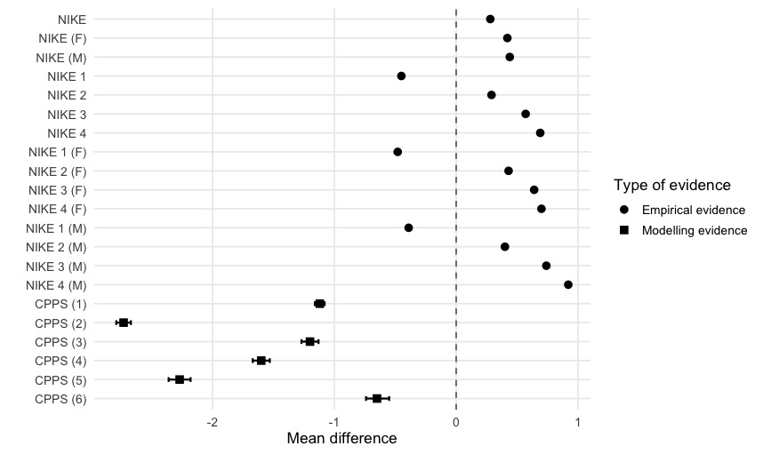
Mean difference refers to the difference in months between the prioritization tools and the status quo.
NIKE: Nationell Indikationsmodell för Kataraktextraktion. NIKE 1–4 correspond to priority categories within the same prioritization system; CPPS: Catalan Agency for Health Technology Assessment and Research cataract priority system. CPPS (1)–(6) represent different estimates derived from the same priority scale; F: female-only cohort; M: male-only cohort.

