Molecular Pathways Governing Earliest Stages of
C-S-H Formation
K M Salah Uddin¹, Mohammadreza Izadifar^{2,*}, Neven Ukrainczyk². Eduardus Koenders², Bernhard Middendorf ¹

¹Department of Structural Materials and Construction Chemistry, University of Kassel, Kassel, 34125, Germany
²Institute of Construction and Building Materials, Technical University of Darmstadt, Darmstadt, 64287, Germany
Corresponding author: Mohammadreza Izadifar (izadifar@wib.tu-darmstadt.de, mr.izadifar@icloud.com)

Table SI 1. The orthogonal simulation cells of atomic representation of the dissolved species during the pre-nucleation of C-S-H in pore solution at 298K (RT).
Case | Scenarios | Structural representation | Orthogonal Cell dimension  (Å³ / 10⁻³⁰ m³) | No. of atoms in the simulation cell
1 | S₁ | 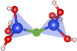 | 20 × 20 × 20 (Ca/Si ratio 1) | 700
1 | S₁ |  | 20 × 20 × 20 (Ca/Si ratio 2) | 698
1 | S₁ |  | 20 × 20 × 20 (Ca/Si ratio 3) | 688
1 | S₂ | 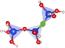 | 30 × 30 × 30 | 2621
 | S₃ | 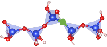 | 30 × 30 × 30 | 2667
2 | S₁ | 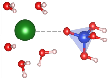 | 30 × 30 × 30 | 2697
 | S₂ | 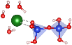 | 30 × 30 × 30 | 2681
 | S₃ | 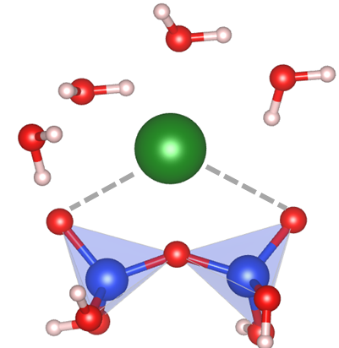 | 30 × 30 × 30 | 2681
 | S₄ | 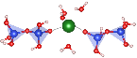 | 30 × 30 × 30 | 2650
 | S₅ | 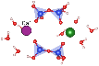 | 30 × 30 × 30 | 2646
3 | S₁ | 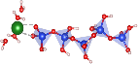 | 30 × 30 × 30 | 2654
 | S₂ | 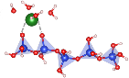 | 30 × 30 × 30 | 2654
 | S₃ | 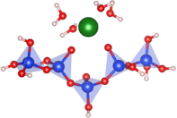 | 30 × 30 × 30 | 2654
4 | S₁ | 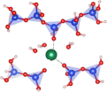 | 30 × 30 × 30 | 2624

Table SI 2. Pairwise interaction energies (activation barrier and binding energies) and atomic representation of the silica polymerization during the pre-nucleation of C-S-H in pore solution at 298K.
Case | Scenarios | Structural representation | Free energy of Activation$(∆G^{*})$  KJ/mol | Binding energy (∆G)  KJ/mol
1 | S₄ | 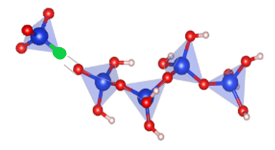 | 65.92 | -13.91
1 | S₅ | 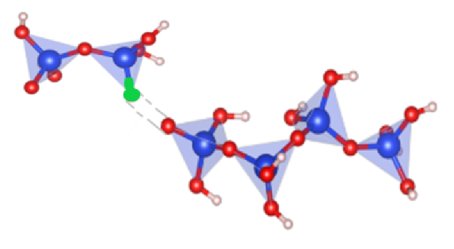 | 62.30 | -21.86
1 | S₆ | 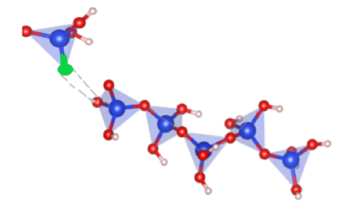 | 65.45 | -22.16
1 | S₇ | 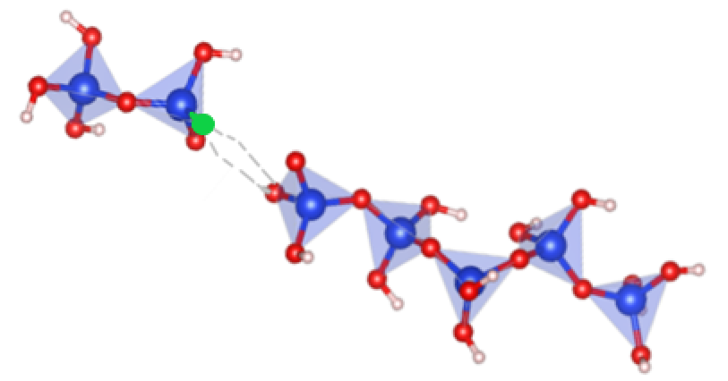 | 69.65 | -13.70
1 | S₈ | 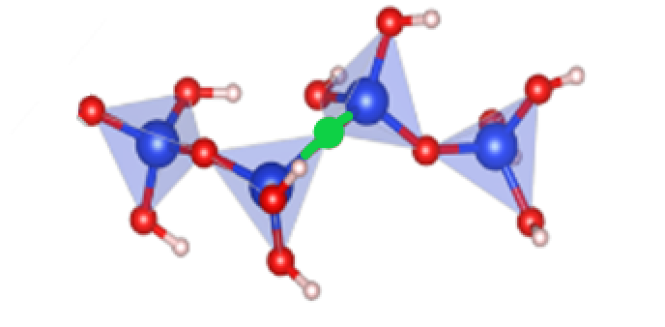 | 66.32 | -16.3
1 | S₉ | 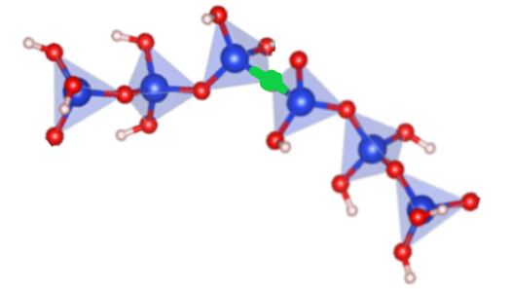 | 65.25 | -15.87
1 | S₁₀ | 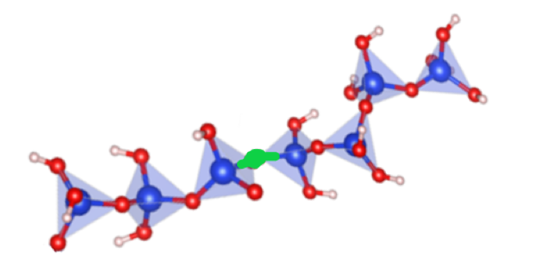 | 67.86 | -17.45
1 | S₁₁ | 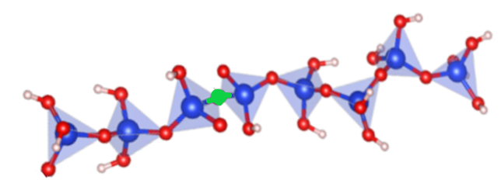 | 66.55 | -16.1
1 | S₁₂ | 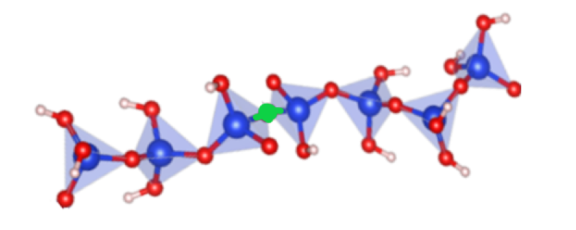 | 65.32 | -18.72
1 | S₁₃ | 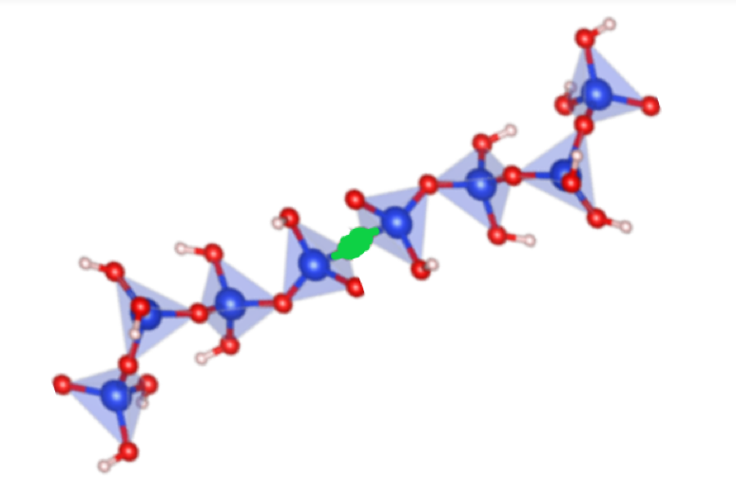 | 67.63 | -14.23
1 | S₁₄ | 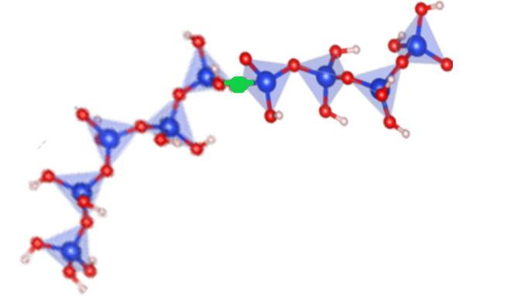 | 66.8 | -16
1 | S₁₅ | 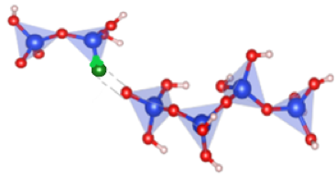 | 62.30 | -13.91
1 | S₁₆ | 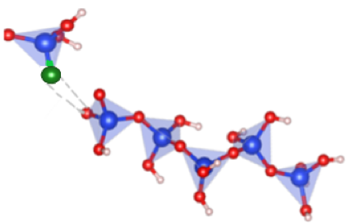 | 65.45 | -21.86
1 | S₁₇ | 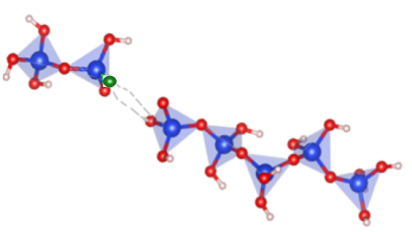 | 63.25 | -22.16

(a) |  | (b)
Figure SI 1. The convergence test for metaD simulations for the polymerization of silicate in pore solution: dimerization of silicate at 298K (a) and 323K (b).

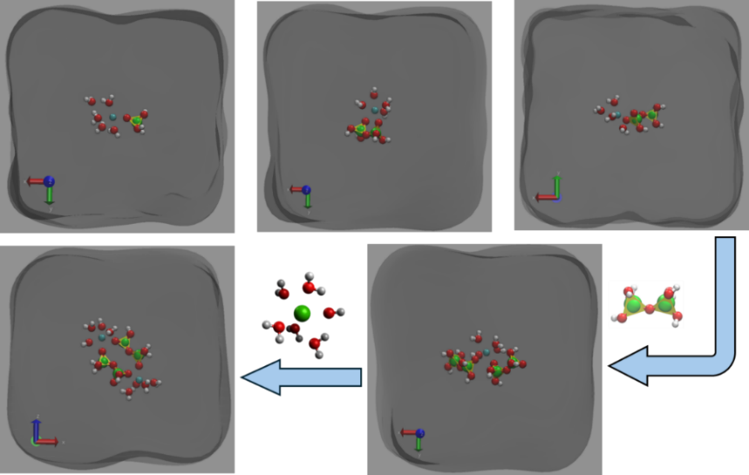
Figure SI 2. Schematic representation of the bonding environments in pore solution and the proposed early-stage formation mechanism of C-S-H pre-nuclei, highlighting key interactions between calcium- and silicon-bearing species identified through ReaxFF and metaD.

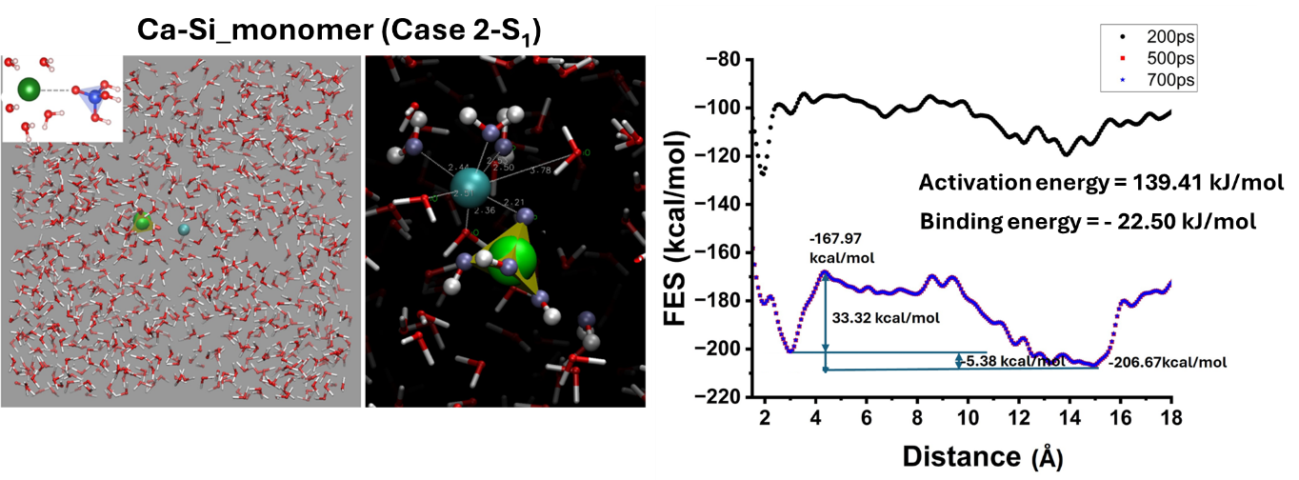
Figure SI 3. The convergence test for metaD simulations for the multibody interaction between the Ca(OH)(H₂O)⁺ and possible silicate-based species in pore solution, The X-axis represents the reaction coordinate in terms of separation distance between the interactive species in Å (10⁻¹⁰ m), starting from the initial state (bonded) at zero to the final state (in the separated state in solution) at the next lowest minima.

(a) | 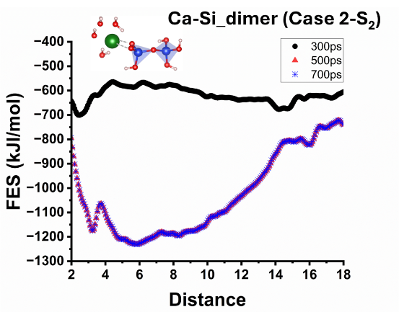 | (b) | 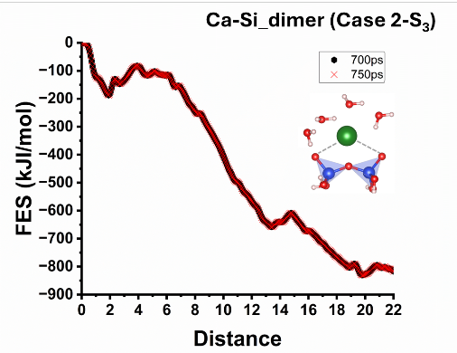
(c) | 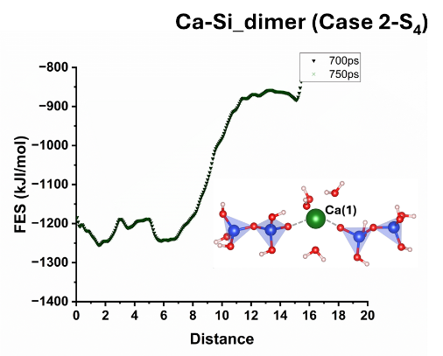 | (d) | 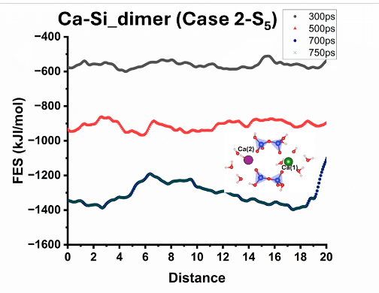
(e) | 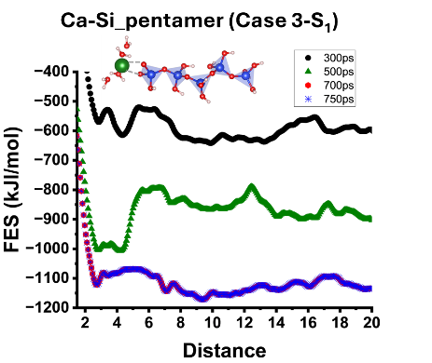 | (f) | 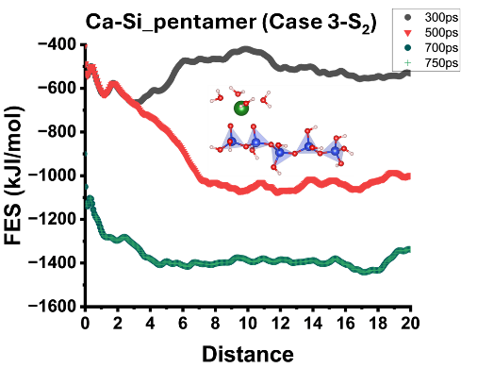
(g) | 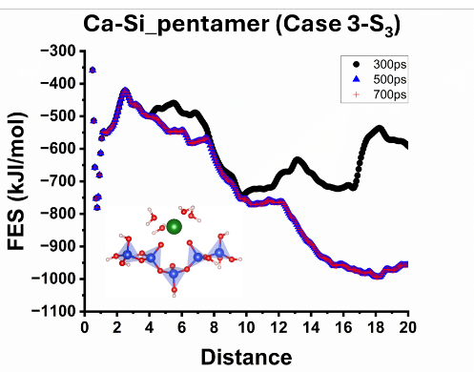 | (h) | 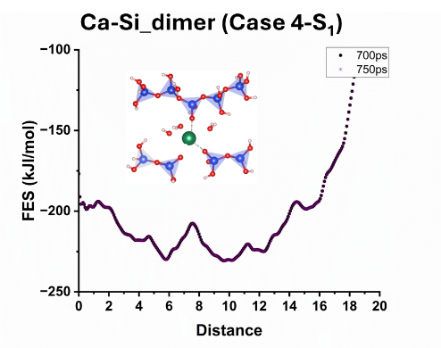
Figure SI 4. The convergence test for metaD simulations for the multibody interaction between the Ca(OH)(H₂O)⁺ and possible silicate dimer and pentamer species in pore solution at 298K. the separation distance between interacting species (Å, 10⁻¹⁰ m), ranging from the initial bonded state to the final separated state corresponding to the next energy minimum.

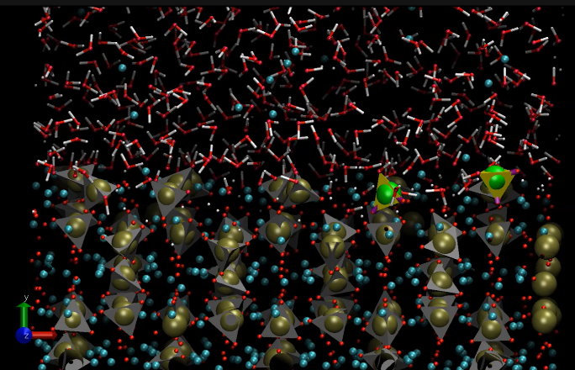 | 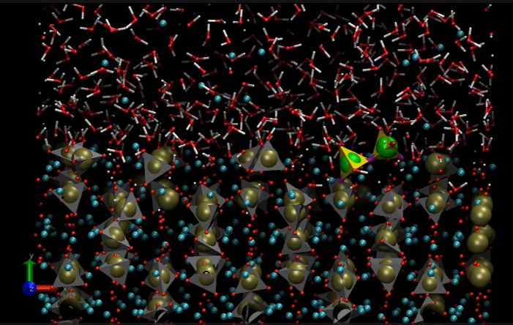
(a) | (b)
Figure SI 5. (a, b) Representative snapshot of heterogeneous nucleation of dissolved species on the m3-C₃S surface under periodic boundary conditions. The apparent bubble in Figure 6A is a transient low-density fluctuation occurring during early interfacial relaxation. The system is fully periodic and contains no vacuum. Equilibrating after removing surrounding Ca, water density stabilizes and no persistent void is observed. Therefore, the nucleation mechanism is not biased by this effect.
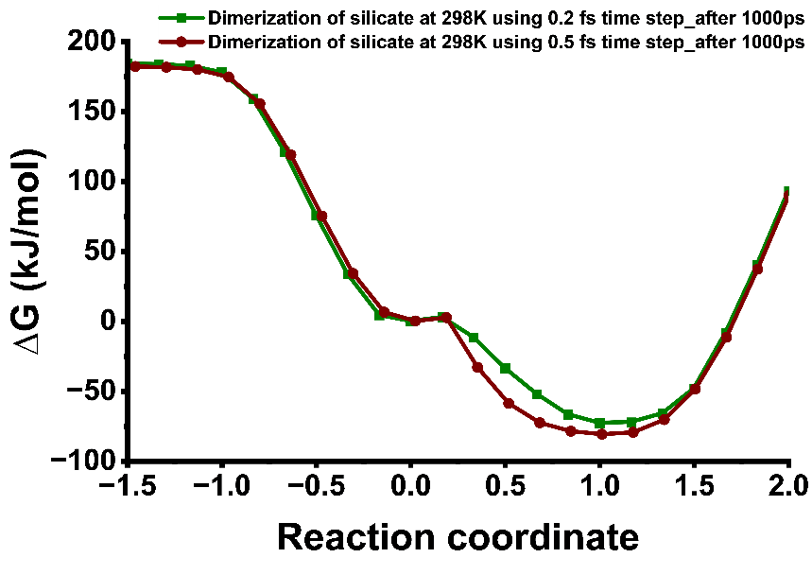
Figure SI 6. Effect of integration timestep on the thermodynamics and kinetics of the dimerization reaction computed using ReaxFF and metadynamics. Comparison of simulations performed with integration timesteps of 0.2 fs and 0.5 fs over a total simulation time of 1000 ps.
Video SI 1. The dimerization mechanism of silicate in pore solution at 298K.
Video SI 2. The dimerization mechanism of silicate on the (100) surface of m3-C₃S at 298K.
Video SI 3. Multibody interaction between the Ca(OH)(H₂O)⁺ and possible silicate monomer and dimer species in pore solution.

