Supporting Information

ASSESSMENT OF STORMWATER QUALITY DISCHARGING FROM A COLD-CLIMATE URBAN LANDSCAPE DURING THE ICE-FREE SEASON

Popick, H. ¹, Brinkmann, M.^{2,3,4,5}, McPhedran, K. ^{1,2,*}

¹ Department of Civil, Geological, and Environmental Engineering, College of Engineering, University of Saskatchewan, Saskatoon, SK, Canada
² Global Institute for Water Security, University of Saskatchewan, Saskatoon, SK, Canada
³ Toxicology Centre, University of Saskatchewan, Saskatoon, SK, Canada
⁴ School of Environment and Sustainability, University of Saskatchewan, Saskatoon, SK, Canada
⁵ Centre for Hydrology, University of Saskatchewan, Saskatoon, SK, Canada

Pages: 12
Tables: 9
Figures: 2

Table S1. Limits of detection (LOD) and quantification (LOQ) for polyaromatic hydrocarbons.
Sample | Acenaphthylene | Fluorene | BbF | BkF | BaP | Benzo[a]  anthracene | Chrysene | Dibenzo[a,h]  anthracene | Pyrene | Phenanthrene | Antrhacene | Indeno[123]cd-pyrene | Benzo[ghi]  perylene
LOD(ppb) | 0.004 | 0.002 | 0.004 | 0.006 | 0.006 | 0.002 | 0.004 | 0.012 | 0.004 | 0.004 | 0.004 | 0.004 | 0.006
LOQ(ppb) | 0.02 | 0.02 | 0.026 | 0.034 | 0.032 | 0.014 | 0.022 | 0.074 | 0.022 | 0.02 | 0.022 | 0.03 | 0.042

Table S2. Land use classifications used to calculate runoff volumes in this study based on Järveläinen et al. (2017). The runoff coefficients (CR) considered in the current study follow City of Saskatoon (CoS) stormwater management guidelines.

Land use class |  | Acronym | CR | Description
Single-family Residential |  | SR | 0.3 | Single dwelling house
Multi-family Residential |  | MR | 0.6 | Multiple separate housing units within a building
Roads |  | R | 0.95 | With average traffic of fewer than 15,000 vehicles/day
Highways |  | HW | 0.95 | With average traffic of more than 15,000 vehicles/day
Commercial |  | CM | 0.6 | Downtown, central business district, shopping centre, university, hospital, etc.
Industrial |  | IN | 0.6 | Industrial area
Green |  | GR | 0.1 | Parks, forests, meadows, and undeveloped area
Agricultural |  | AG | 0.05 | Cultivated area

Table S3. Average flow-weighted site mean concentration (SMC) values for different land use classes, from Melanen (1981), Mitchell (2005), Nordeidet et al. (2004) and Jarvelainen et al. (2017) as adapted by Al Masum et al. (2021). The SMC is the geometric mean of the event mean concentration for each storm event, which is the concentration of pollutants as a function of the runoff volume discharging in the river (flow-weighted). The value is used to estimate overall SW contaminant loading over a given urban area. Values in parentheses are standard deviations (SD).

Land use class | TSS (mg/L) | COD (mg/L) | Pb (μg/L) | Zn (μg/L) | Cu (μg/L) | Cr (μg/L) | Ni (μg/L) | PAHs (μg/L)
Single-family Residential (SR) | 100 (81) | 57 (36) | 60 (50) | 144 (109) | 32 (17.5) | 4.9 (3.5) | 16.5 (19) | 0.4 (0)
Multi-family Residential (MR) | 118 (47) | 68 (45) | 73 (71) | 252 (87) | 39.5 (8) | 13 (8) | 21 (13) | 0.6 (0)
Roads (R) | 271 (175) | 120 (62) | 114 (117) | 237 (42) | 55 (16) | 20 (17) | 29 (2) | 0.8 (0)
Highways (HW) | 288 (148) | 117 (70) | 166 (139) | 327 (173) | 64 (31) | 10 (4) | 15 (21) | 1.4 (0)
Commercial (CM) | 194 (160) | 91 (61) | 145 (140) | 260 (136) | 84 (71) | 14 (9) | 24 (8) | 0.6 (0)
Industrial (IN) | 194 (160) | 91 (61) | 145 (140) | 260 (136) | 84 (71) | 14 (9) | 24 (8) | 0.6 (0)
Green (GR) | 84 (61) | 38 (2.8) | 35 (30) | 116 (110) | 19 (12.5) | 7 (0) | 15 (0) | 0 (0)
Agricultural (AG) | 84 (61) | 38 (2.8) | 35 (30) | 116 (110) | 19 (12.5) | 7 (0) | 15 (0) | 0 (0)

Table S4. Overview of analyzed stormwater quality parameters for the 2019 sampling season grouped by site. Catchments outlined in Figure S1. Values are average (standard deviation).

Sampling Site | pH | TDS (mg/L) | EC (μS/cm) | DOC (mg/L) | COD (mg/L) | TSS (mg/L) | Coliform (CFU/100mL)
SCB E | 7.98 (0.30) | 738 (205) | 1476 (392) | 14.7 (2.8) | 164 (151) | 50.4 (46.4) | 158 (117)
SCB W | 8.44 (0.69) | 363 (108) | 745 (217) | 14.6 (9.9) | 283 (367) | 224 (145) | 2283 (2410)
MacPherson Ave. | 8.10 (1.54) | 349 (243) | 711 (485) | 69.5 (81.1) | 588 (532) | 229 (154) | 5963 (4919)
14th St. E | 7.75 (1.55) | 389 (123) | 793 (243) | 96.1 (136) | 493 (531) | 238 (238) | 4070 (3719)
17th St. W | 7.39 (1.76) | 283 (66.7) | 583 (137) | 116 (175) | 940 (1,196) | 474 (444) | 284 (490)
23rd St. E | 8.30 (1.39) | 560 (499) | 1122 (969) | 55.7 (68.6) | 620 (822) | 526 (566) | 5000 (5772)
Silverwood Dog Park | 7.99 (1.26) | 285 (143) | 586 (290) | 10.3 (2.6) | 465 (684) | 217 (204) | 400 (464)
AVERAGE (SD) | 7.99 (0.35) | 424(167) | 859(327) | 53.9 (42.7) | 507 (250) | 280 (164) | 2594 (2432)

Table S5. Overview of stormwater quality parameters for the 2019 sampling season for each individual event and outfall. Catchments outlined in Figure S1.

Sampling Site Name And Date | pH | TDS (mg/L) | EC (μS/cm) | DOC (mg/L) | COD (mg/L) | TSS (mg/L) | Coliform (CFU/100mL)
June 12, 2019
SCB E | 8.11 | 974 | 1914 | 17.2 | 117 | 13.5 | <1
SCB W | 8.10 | 446 | 911 | 11.6 | 134 | 300.5 | <1
MacPherson Ave. | 9.09 | 713 | 1438 | 60.1 | 748 | 171 | 3850
14th St. E | 7.50 | 551 | 1110 | 60.3 | 362 | 24.5 | 1700
17th St. W | 7.02 | 337 | 694 | 54.8 | 334 | 201.5 | <1
23rd St. E | 9.52 | 1295 | 2550 | 37.8 | 242 | 138 | <1
Silverwood Dog Park | 7.48 | 222 | 457 | 11.5 | 87.5 | 56 | <1
AVERAGE (SD) | 8.12 (0.90) | 648 (378) | 1296 (733) | 36 (23) | 289 (229) | 129 (105) | 794(1,489)
June 20, 2019
SCB E | 8.13 | 570 | 1156 | 14.1 | 88 | 83.5 | 250
SCB W | 9.46 | 445 | 909 | 8.3 | 116 | 183.5 | 400
MacPherson Ave. | 9.26 | 222 | 459 | 16.4 | 217.5 | 376 | <1
14th St. E | 9.56 | 417 | 853 | 12.4 | 243.5 | 526.5 | 100
17th St. W | 9.14 | 301 | 620 | 12.5 | 590.5 | 1045 | 850
23rd St. E | 9.02 | 359 | 736 | 19.1 | 292.5 | 583.5 | <1
Silverwood Dog Park | 9.69 | 313 | 645 | 6.5 | 176 | 360 | <1
AVERAGE (SD) | 9.18 (0.52) | 375 (114) | 768 (228) | 12.8 (4.4) | 246 (168) | 451 (315) | 272(313)
July 25, 2019
SCB E | 8.14 | 562 | 1135 | 10.9 | 62.5 | 7.5 | 245
SCB W | 8.27 | 344 | 707 | 9.1 | 50.5 | 39.5 | 4420
MacPherson Ave. | 8.14 | 226 | 467 | 14.5 | 118 | 39.5 | <9999
14th St. E | 8.11 | 304 | 623 | 14.6 | 93.5 | 61.5 | 7295
17th St. W | 8.29 | 186 | 384 | 20.3 | 124 | 55 | <1
23rd St. E | 8.29 | 188 | 390 | 8.8 | 97.5 | 77 | <9999
Silverwood Dog Park | 8.06 | 470 | 960 | 11.2 | 106 | 28.5 | 855
AVERAGE (SD) | 8.19 (0.10) | 326 (145) | 667 (290) | 13 (4) | 93 (27) | 44 (23) | 4,688(4,467)
August 22, 2019
SCB E | 7.52 | 845 | 1700 | 16.4 | 388 | 97 | 135
SCB W | 7.94 | 218 | 452 | 29.2 | 831 | 371.5 | 4310
MacPherson Ave. | 5.92 | 233 | 481 | 187 | 1269 | 330.5 | <9999
14th St. E | 5.82 | 283 | 584 | 297 | 1271 | 339.5 | 7,185
17th St. W | 5.09 | 309 | 635 | 378 | 2711 | 593.5 | <1
23rd St. E | 6.35 | 396 | 813 | 157 | 1847 | 1304 | <9999
Silverwood Dog Park | 6.73 | 136 | 282 | 12.1 | 1490 | 425 | 745
AVERAGE (SD) | 6.48 (1.00) | 346 (235) | 707 (468) | 154 (145) | 1401 (743) | 494 (386) | 4,625(4,491)

Table S6. Chloride and sulphate analysis for select 2019 stormwater samples.
Date | Sampling Site | Chloride (mg/L) | Sulphate (mg/L)
June 12/19 | SCB E | 140 | 700
June 12/19 | MacPherson Ave. | 170 | 23
June 12/19 | 23rd St. W | 94 | 130
July 25/19 | SCB E | 82 | 370
August 22/19 | SCB E | 220 | 310

 | Sample Id | Al 27 | As 75 | B 11 | Ba 137 | Br 79 | Ca 44 | Cd 111 | Co 59 | Cu 63 | Fe 56 | K 39 | Mg 24 | Mn 55 | Mo 98 | Na 23 | Ni 60 | Pb 208 | Sb 121 | Sn 118 | Sr 88 | Th 232 | Ti 47 | U 238 | V 51 | Zn 66
June 12/19 | SCB E | 143 | 6 | 149 | 36 | 226 | 126410 | 0 | 0 | 196 | 108 | 8957 | 103040 | 86 | 7 | 160498 | 0 | 13 | 0 | 9 | 782 | 0 | 0 | 18 | 0 | 223
 | SCB W | 100 | 5 | 44 | 64 | 0 | 61329 | 0 | 0 | 127 | 66 | 4835 | 32955 | 15 | 6 | 74811 | 0 | 2 | 0 | 10 | 307 | 0 | 0 | 4 | 0 | 162
 | MacPherson Ave. | 49 | 12 | 139 | 22 | 0 | 22063 | 0 | 2 | 115 | 69 | 11441 | 5848 | 28 | 8 | 292134 | 8 | 1 | 2 | 16 | 58 | 0 | 3 | 1 | 4 | 102
 | 14th St. E | 38 | 60 | 127 | 40 | 182 | 80502 | 0 | 2 | 67 | 92 | 8884 | 45494 | 260 | 5 | 74157 | 7 | 1 | 4 | 4 | 414 | 0 | 0 | 14 | 3 | 184
 | 17th St. W | 61 | 63 | 93 | 36 | 302 | 55405 | 3 | 2 | 150 | 186 | 12155 | 23879 | 261 | 5 | 48861 | 6 | 3 | 5 | 21 | 371 | 0 | 3 | 6 | 3 | 200
 | 23rd St. E | 43 | 420 | 117 | 35 | 183 | 50457 | 1 | 1 | 114 | 125 | 8671 | 22313 | 27 | 108 | 462183 | 0 | 3 | 12 | 13 | 231 | 0 | 0 | 4 | 3 | 125
 | Silverwood Dog Park | 31 | 6 | 23 | 32 | 0 | 37954 | 0 | 0 | 116 | 67 | 3786 | 16075 | 83 | 8 | 33910 | 0 | 2 | 0 | 15 | 150 | 0 | 0 | 3 | 0 | 197
June 20/19 | SCB E | 141 | 38 | 149 | 37 | 234 | 68848 | 0 | 1 | 53 | 116 | 12090 | 58300 | 80 | 9 | 82884 | 0 | 2 | 0 | 0 | 427 | 0 | 0 | 8 | 0 | 120
 | SCB W | 126 | 8 | 20 | 15 | 0 | 14798 | 16 | 0 | 11 | 178 | 2449 | 6287 | 36 | 6 | 38051 | 0 | 0 | 0 | 0 | 55 | 0 | 4 | 1 | 2 | 112
 | MacPherson Ave. | 115 | 4 | 41 | 12 | 0 | 9516 | 0 | 0 | 14 | 151 | 7233 | 2039 | 32 | 4 | 68239 | 0 | 1 | 0 | 0 | 29 | 0 | 4 | 1 | 2 | 127
 | 14th St. E | 143 | 7 | 29 | 16 | 0 | 10431 | 1 | 1 | 10 | 156 | 4321 | 3137 | 37 | 10 | 90763 | 0 | 1 | 0 | 0 | 40 | 2 | 7 | 1 | 2 | 136
 | 17th St. W | 84 | 4 | 30 | 21 | 355 | 15911 | 0 | 1 | 18 | 114 | 3972 | 3539 | 40 | 5 | 81236 | 7 | 1 | 0 | 0 | 106 | 0 | 3 | 1 | 2 | 180
 | 23rd St. E | 88 | 15 | 55 | 23 | 342 | 19261 | 1 | 1 | 8 | 119 | 6191 | 5331 | 60 | 4 | 90469 | 5 | 1 | 0 | 0 | 161 | 0 | 3 | 1 | 2 | 140
 | Silverwood Dog Park | 134 | 5 | 0 | 19 | 0 | 15274 | 0 | 0 | 8 | 169 | 1365 | 2811 | 30 | 5 | 65440 | 0 | 1 | 0 | 0 | 42 | 0 | 3 | 0 | 2 | 132
July 25/19 | SCB E | 55 | 12 | 89 | 43 | 141 | 81015 | 0 | 0 | 12 | 51 | 5455 | 48453 | 59 | 19 | 55094 | 0 | 1 | 0 | 0 | 437 | 0 | 0 | 8 | 0 | 222
 | SCB W | 44 | 13 | 47 | 28 | 0 | 45416 | 0 | 0 | 11 | 63 | 3932 | 29110 | 22 | 34 | 36221 | 0 | 1 | 0 | 0 | 218 | 0 | 0 | 5 | 0 | 238
 | MacPherson Ave. | 69 | 4 | 58 | 23 | 0 | 27068 | 0 | 0 | 14 | 64 | 3881 | 13207 | 73 | 7 | 79114 | 0 | 1 | 0 | 0 | 139 | 0 | 0 | 3 | 0 | 408
 | 14th St. E | 229 | 7 | 158 | 42 | 0 | 46420 | 0 | 0 | 40 | 104 | 7836 | 10968 | 45 | 12 | 23325 | 0 | 3 | 0 | 0 | 162 | 0 | 2 | 2 | 0 | 190
 | 17th St. W | 125 | 5 | 57 | 24 | 0 | 26853 | 0 | 0 | 26 | 106 | 4878 | 12821 | 56 | 7 | 21504 | 0 | 2 | 0 | 0 | 131 | 0 | 2 | 3 | 0 | 156
 | 23rd St. E | 83 | 26 | 73 | 27 | 0 | 30355 | 0 | 0 | 14 | 128 | 3639 | 10706 | 42 | 58 | 24038 | 0 | 2 | 0 | 0 | 119 | 0 | 0 | 2 | 0 | 119
 | Silverwood Dog Park | 55 | 10 | 74 | 38 | 224 | 48156 | 0 | 1 | 12 | 49 | 5786 | 40556 | 8 | 14 | 161931 | 0 | 1 | 0 | 0 | 240 | 0 | 0 | 4 | 0 | 541
August 22/19 | SCB E | 355 | 3 | 29 | 32 | 0 | 19849 | 0 | 1 | 24 | 267 | 4813 | 5618 | 103 | 3 | 7973 | 7 | 3 | 0 | 0 | 65 | 0 | 8 | 1 | 2 | 192
 | SCB W | 244 | 5 | 334 | 83 | 3473 | 185343 | 0 | 1 | 25 | 234 | 18159 | 58423 | 172 | 6 | 70264 | 35 | 3 | 0 | 0 | 3463 | 3 | 8 | 14 | 0 | 446
 | MacPherson Ave. | 248 | 3 | 154 | 34 | 169 | 24218 | 0 | 1 | 23 | 353 | 17290 | 5727 | 165 | 3 | 8912 | 12 | 3 | 0 | 0 | 183 | 0 | 11 | 1 | 2 | 218
 | 14th St. E | 181 | 4 | 88 | 32 | 0 | 25424 | 10 | 1 | 19 | 278 | 11945 | 9061 | 195 | 5 | 14331 | 12 | 2 | 0 | 0 | 109 | 0 | 13 | 1 | 4 | 251
 | 17th St. W | 161 | 3 | 140 | 32 | 0 | 22541 | 1 | 2 | 21 | 403 | 15983 | 4863 | 292 | 4 | 7798 | 41 | 2 | 0 | 0 | 77 | 0 | 8 | 1 | 3 | 314
 | 23rd St. E | 290 | 3 | 69 | 37 | 0 | 23428 | 1 | 1 | 18 | 480 | 8271 | 6596 | 201 | 4 | 16893 | 25 | 3 | 0 | 0 | 82 | 0 | 10 | 1 | 2 | 291
 | Silverwood Dog Park | 224 | 9 | 10 | 23 | 0 | 14392 | 10 | 1 | 23 | 304 | 2030 | 3696 | 51 | 3 | 6813 | 27 | 2 | 0 | 0 | 45 | 0 | 9 | 0 | 2 | 924
 | CCME Guideline | 100 | 5 |  |  |  |  | 0.37 |  | 2 | 300 |  |  |  | 73 |  | 25 | 1 |  |  |  |  |  | 15 |  | 30
Table S7. Metals (µg/L) detected in 2019 stormwater samples.

Table S8. PAHs (ng/L) detected in 2019 stormwater samples.
 | Sample Id | Acenaphthylene (ACY) | Fluorene (FL) | Benzo[b] fluoranthene (BbF) | Benzo[k] fluoranthene (BkF) | Benzo[a] pyrene (BaP) | Benz[a] anthracene (BaA) | Chrysene (CHR) | Dibenz[a,h] anthracene (DahA) | Pyrene (PYR) | Phenanthrene (PHE) | Anthracene (ANT) | Indeno[1,2,3] cd-pyrene (I123P) | Benzo[g,h,I] perylene (BghiP) | SUM
June 12/19 | SCB E
 | SCB W | 0.000 | 0.000 | 0.000 | 0.000 | 0.949 | 0.265 | 0.269 | 0.198 | 0.934 | 1.386 | 1.399 | 0.293 | 0.388 | 6.079
 | MacPherson Ave. | 0.066 | 0.000 | 0.113 | 0.088 | 0.135 | 0.097 | 0.112 | 0.056 | 0.046 | 0.000 | 0.000 | 0.095 | 0.082 | 0.890
 | 14th St. E | 0.000 | 0.000 | 0.000 | 0.000 | 0.000 | 0.000 | 0.000 | 0.074 | 0.000 | 0.000 | 0.000 | 0.075 | 0.034 | 0.183
 | 17th St. W | 0.056 | 0.034 | 0.000 | 0.000 | 0.000 | 0.027 | 0.011 | 0.015 | 0.034 | 0.029 | 0.025 | 0.022 | 0.012 | 0.264
 | 23rd St. E | 0.000 | 0.000 | 0.000 | 0.000 | 0.000 | 0.020 | 0.024 | 0.017 | 0.000 | 0.000 | 0.000 | 0.025 | 0.012 | 0.099
 | Silverwood Dog Park | 0.472 | 0.319 | 0.026 | 0.026 | 0.026 | 0.014 | 0.005 | 0.011 | 0.032 | 0.016 | 0.028 | 0.017 | 0.010 | 0.999
June 20/19 | SCB E | 0.000 | 1.147 | 0.000 | 0.000 | 0.000 | 0.034 | 0.039 | 0.024 | 0.056 | 0.061 | 0.075 | 0.027 | 0.017 | 1.479
 | SCB W | 0.523 | 0.000 | 0.051 | 0.051 | 0.069 | 0.051 | 0.033 | 0.044 | 0.051 | 0.032 | 0.027 | 0.041 | 0.030 | 1.002
 | MacPherson Ave. | 0.000 | 0.000 | 0.000 | 0.000 | 0.000 | 0.020 | 0.024 | 0.023 | 0.039 | 0.035 | 0.047 | 0.018 | 0.027 | 0.233
 | 14th St. E | 0.000 | 0.000 | 0.030 | 0.022 | 0.050 | 0.012 | 0.007 | 0.014 | 0.068 | 0.057 | 0.069 | 0.289 | 0.016 | 0.633
 | 17th St. W | 0.000 | 0.000 | 0.000 | 0.000 | 0.050 | 0.018 | 0.015 | 0.000 | 0.031 | 0.028 | 0.017 | 0.023 | 0.011 | 0.192
 | 23rd St. E | 0.000 | 0.227 | 0.000 | 0.000 | 0.041 | 0.012 | 0.009 | 0.000 | 0.038 | 0.023 | 0.035 | 0.026 | 0.022 | 0.433
 | Silverwood Dog Park | 0.000 | 0.000 | 0.058 | 0.053 | 0.081 | 0.055 | 0.051 | 0.044 | 0.042 | 0.027 | 0.039 | 0.037 | 0.058 | 0.544
July 25/19 | SCB E | 0.349 | 0.087 | 0.000 | 0.000 | 0.000 | 0.028 | 0.033 | 0.033 | 0.000 | 0.042 | 0.057 | 0.033 | 0.019 | 0.680
 | SCB W | 0.102 | 0.102 | 0.000 | 0.000 | 0.000 | 0.000 | 0.000 | 0.000 | 0.030 | 0.023 | 0.033 | 0.021 | 0.013 | 0.325
 | MacPherson Ave.
 | 14th St. E | 0.000 | 0.793 | 0.000 | 0.012 | 0.125 | 0.000 | 0.000 | 0.008 | 0.008 | 0.000 | 0.129 | 0.008 | 1.075 | 2.158
 | 17th St. W
 | 23rd St. E | 0.000 | 4.945 | 0.069 | 0.000 | 0.137 | 0.072 | 0.000 | 0.043 | 0.034 | 0.922 | 0.000 | 0.069 | 0.060 | 6.351
 | Silverwood Dog Park | 0.014 | 0.131 | 0.000 | 0.203 | 0.117 | 0.000 | 0.003 | 0.003 | 0.003 | 0.000 | 0.106 | 0.006 | 0.003 | 0.588
August 22/19 | SCB E | 0.000 | 0.086 | 0.002 | 0.002 | 0.040 | 0.008 | 0.000 | 0.000 | 0.002 | 0.000 | 0.044 | 0.002 | 0.002 | 0.188
 | SCB W | 0.116 | 0.205 | 0.000 | 0.000 | 0.000 | 0.011 | 0.015 | 0.011 | 0.033 | 0.037 | 0.049 | 0.018 | 0.009 | 0.505
 | MacPherson Ave. | 0.000 | 0.148 | 0.000 | 0.008 | 0.047 | 0.000 | 0.006 | 0.002 | 0.002 | 0.000 | 0.062 | 0.004 | 0.004 | 0.284
 | 14th St. E | 0.000 | 0.038 | 0.002 | 0.002 | 0.024 | 0.012 | 0.000 | 0.002 | 0.006 | 0.000 | 0.026 | 0.002 | 0.004 | 0.119
 | 17th St. W | 0.130 | 0.070 | 0.168 | 0.174 | 0.083 | 0.108 | 0.137 | 0.119 | 0.094 | 0.009 | 0.021 | 0.137 | 0.136 | 1.385
 | 23rd St. E | 0.078 | 0.055 | 0.027 | 0.026 | 0.027 | 0.041 | 0.009 | 0.010 | 0.039 | 0.033 | 0.026 | 0.020 | 0.012 | 0.402
 | Silverwood Dog Park | 0.000 | 0.000 | 0.051 | 0.051 | 0.046 | 0.032 | 0.031 | 0.022 | 0.046 | 0.023 | 0.036 | 0.037 | 0.017 | 0.391
 | CCME Guideline |  | 3 |  |  | 0.015 | 0.018 |  |  | 0.025 | 0.400 | 0.0012

Catchment | Land Use | CR | % of area | Fraction of area | Land Use Area, A (km²) | A * CR (km²) | Seasonal Loading Estimate (kg)
 |  |  |  |  |  |  | TSS | COD | Cu | Cr | Ni | Pb | Zn | PAHs
Wanuskewin Rd. | R | 0.95 | 4 | 0.04 | 1.02 | 0.97 | 35474 | 15708 | 7.20 | 2.62 | 3.80 | 14.92 | 31.02 | 0.10
 | HW | 0.95 | 4 | 0.04 | 1.02 | 0.97 | 37700 | 15316 | 8.38 | 1.31 | 1.96 | 21.73 | 42.80 | 0.18
 | IN | 0.6 | 37 | 0.37 | 9.43 | 5.66 | 148360 | 69592 | 64.24 | 10.71 | 18.35 | 110.89 | 198.83 | 0.46
 | GR | 0.1 | 55 | 0.55 | 14.02 | 1.40 | 15915 | 7200 | 3.60 | 1.33 | 2.84 | 6.63 | 21.98 | 0.00
SUM |  |  |  |  | 25 | 9.00 | 237449 | 107815 | 83.42 | 15.96 | 26.96 | 154.17 | 294.64 | 0.75
Circle Dr. S. Bridge | SR | 0.3 | 35 | 0.35 | 8.61 | 2.58 | 35314 | 20129 | 11.30 | 1.73 | 5.83 | 21.19 | 50.85 | 0.14
 | MR | 0.6 | 10 | 0.1 | 2.46 | 1.48 | 23812 | 13722 | 7.97 | 2.62 | 4.24 | 14.73 | 50.85 | 0.12
 | R | 0.95 | 9 | 0.09 | 2.21 | 2.10 | 77929 | 34507 | 15.82 | 5.75 | 8.34 | 32.78 | 68.15 | 0.23
 | HW | 0.95 | 7 | 0.07 | 1.72 | 1.64 | 64413 | 26168 | 14.31 | 2.24 | 3.35 | 37.13 | 73.14 | 0.31
 | CM | 0.6 | 7 | 0.07 | 1.72 | 1.03 | 27404 | 12854 | 11.87 | 1.98 | 3.39 | 20.48 | 36.73 | 0.08
 | IN | 0.6 | 15 | 0.15 | 3.69 | 2.21 | 58723 | 27545 | 25.43 | 4.24 | 7.26 | 43.89 | 78.70 | 0.18
 | GR | 0.1 | 17 | 0.17 | 4.18 | 0.42 | 4803 | 2173 | 1.09 | 0.40 | 0.86 | 2.00 | 6.63 | 0.00
SUM |  |  |  |  | 25 | 11.47 | 292397 | 137098 | 87.78 | 18.96 | 33.27 | 172.20 | 365.05 | 1.07
S. Circle Dr. Bridge E | SR | 0.3 | 25 | 0.25 | 2.40 | 0.72 | 11811 | 6732 | 3.78 | 0.58 | 1.95 | 7.09 | 17.01 | 0.05
 | MR | 0.6 | 5 | 0.05 | 0.48 | 0.29 | 5575 | 3213 | 1.87 | 0.61 | 0.99 | 3.45 | 11.91 | 0.03
 | R | 0.95 | 8 | 0.08 | 0.77 | 0.73 | 32434 | 14362 | 6.58 | 2.39 | 3.47 | 13.64 | 28.37 | 0.10
 | HW | 0.95 | 8 | 0.08 | 0.77 | 0.73 | 34469 | 14003 | 7.66 | 1.20 | 1.80 | 19.87 | 39.14 | 0.17
 | CM | 0.6 | 9 | 0.09 | 0.86 | 0.52 | 16497 | 7738 | 7.14 | 1.19 | 2.04 | 12.33 | 22.11 | 0.05
 | IN | 0.6 | 25 | 0.25 | 2.40 | 1.44 | 45826 | 21496 | 19.84 | 3.31 | 5.67 | 34.25 | 61.42 | 0.14
 | GR | 0.1 | 20 | 0.2 | 1.92 | 0.19 | 2646 | 1197 | 0.60 | 0.22 | 0.47 | 1.10 | 3.65 | 0.00
SUM |  |  |  |  | 10 | 4.61 | 149258 | 68741 | 47.47 | 9.50 | 16.39 | 91.73 | 183.59 | 0.53
17th St. W. | SR | 0.3 | 39 | 0.39 | 3.61 | 1.08 | 17814 | 10154 | 5.70 | 0.87 | 2.94 | 10.69 | 25.65 | 0.07
 | MR | 0.6 | 16 | 0.16 | 1.48 | 0.89 | 17248 | 9939 | 5.77 | 1.90 | 3.07 | 10.67 | 36.83 | 0.09
 | R | 0.95 | 8 | 0.08 | 0.74 | 0.70 | 31359 | 13886 | 6.36 | 2.31 | 3.36 | 13.19 | 27.42 | 0.09
 | HW | 0.95 | 5 | 0.05 | 0.46 | 0.44 | 20829 | 8462 | 4.63 | 0.72 | 1.08 | 12.01 | 23.65 | 0.10
 | CM | 0.6 | 14 | 0.14 | 1.30 | 0.78 | 24812 | 11639 | 10.74 | 1.79 | 3.07 | 18.55 | 33.25 | 0.08
 | IN | 0.6 | 5 | 0.05 | 0.46 | 0.28 | 8861 | 4157 | 3.84 | 0.64 | 1.10 | 6.62 | 11.88 | 0.03
 | GR | 0.1 | 5 | 0.05 | 0.46 | 0.05 | 639 | 289 | 0.14 | 0.05 | 0.11 | 0.27 | 0.88 | 0.00
 | AG | 0.05 | 5 | 0.05 | 0.46 | 0.02 | 320 | 145 | 0.07 | 0.03 | 0.06 | 0.13 | 0.44 | 0.00
SUM |  |  |  |  | 9 | 4.24 | 121884 | 58671 | 37.26 | 8.32 | 14.79 | 72.12 | 160.02 | 0.46
14th St. E. | SR | 0.3 | 54 | 0.54 | 1.72 | 0.52 | 8464 | 4825 | 2.71 | 0.41 | 1.40 | 5.08 | 12.19 | 0.03
 | MR | 0.6 | 12 | 0.12 | 0.38 | 0.23 | 4439 | 2558 | 1.49 | 0.49 | 0.79 | 2.75 | 9.48 | 0.02
 | R | 0.95 | 9 | 0.09 | 0.29 | 0.27 | 12106 | 5361 | 2.46 | 0.89 | 1.30 | 5.09 | 10.59 | 0.04
 | HW | 0.95 | 4 | 0.04 | 0.13 | 0.12 | 5718 | 2323 | 1.27 | 0.20 | 0.30 | 3.30 | 6.49 | 0.03
 | CM | 0.6 | 10 | 0.1 | 0.32 | 0.19 | 6082 | 2853 | 2.63 | 0.44 | 0.75 | 4.55 | 8.15 | 0.02
 | GR | 0.1 | 8 | 0.08 | 0.25 | 0.03 | 351 | 159 | 0.08 | 0.03 | 0.06 | 0.15 | 0.48 | 0.00
 | AG | 0.05 | 3 | 0.03 | 0.10 | 0.00 | 66 | 30 | 0.01 | 0.01 | 0.01 | 0.03 | 0.09 | 0.00
SUM |  |  |  |  | 3 | 1.36 | 37225 | 18107 | 10.65 | 2.47 | 4.61 | 20.93 | 47.47 | 0.14
MacPherson Ave. | SR | 0.3 | 54 | 0.54 | 0.79 | 0.24 | 3913 | 2230 | 1.25 | 0.19 | 0.65 | 2.35 | 5.63 | 0.02
 | MR | 0.6 | 12 | 0.12 | 0.18 | 0.11 | 2052 | 1182 | 0.69 | 0.23 | 0.37 | 1.27 | 4.38 | 0.01
 | R | 0.95 | 9 | 0.09 | 0.13 | 0.13 | 5596 | 2478 | 1.14 | 0.41 | 0.60 | 2.35 | 4.89 | 0.02
 | HW | 0.95 | 4 | 0.04 | 0.06 | 0.06 | 2643 | 1074 | 0.59 | 0.09 | 0.14 | 1.52 | 3.00 | 0.01
 | CM | 0.6 | 10 | 0.1 | 0.15 | 0.09 | 2811 | 1319 | 1.22 | 0.20 | 0.35 | 2.10 | 3.77 | 0.01
 | GR | 0.1 | 8 | 0.08 | 0.12 | 0.01 | 162 | 73 | 0.04 | 0.01 | 0.03 | 0.07 | 0.22 | 0.00
 | AG | 0.05 | 3 | 0.03 | 0.04 | 0.00 | 30 | 14 | 0.01 | 0.00 | 0.01 | 0.01 | 0.04 | 0.00
SUM |  |  |  |  | 1 | 0.63 | 17208 | 8370 | 4.92 | 1.14 | 2.13 | 9.68 | 21.95 | 0.06
23rd St. W. | SR | 0.3 | 20 | 0.2 | 0.55 | 0.16 | 2695 | 1536 | 0.86 | 0.13 | 0.44 | 1.62 | 3.88 | 0.01
 | MR | 0.6 | 6 | 0.06 | 0.16 | 0.10 | 1908 | 1100 | 0.64 | 0.21 | 0.34 | 1.18 | 4.07 | 0.01
 | R | 0.95 | 10 | 0.1 | 0.27 | 0.26 | 11564 | 5120 | 2.35 | 0.85 | 1.24 | 4.86 | 10.11 | 0.03
 | HW | 0.95 | 6 | 0.06 | 0.16 | 0.16 | 7373 | 2995 | 1.64 | 0.26 | 0.38 | 4.25 | 8.37 | 0.04
 | CM | 0.6 | 29 | 0.29 | 0.79 | 0.48 | 15162 | 7112 | 6.56 | 1.09 | 1.88 | 11.33 | 20.32 | 0.05
 | IN | 0.6 | 25 | 0.25 | 0.68 | 0.41 | 13070 | 6131 | 5.66 | 0.94 | 1.62 | 9.77 | 17.52 | 0.04
 | GR | 0.1 | 4 | 0.04 | 0.11 | 0.01 | 151 | 68 | 0.03 | 0.01 | 0.03 | 0.06 | 0.21 | 0.00
SUM |  |  |  |  | 3 | 1.57 | 51923 | 24063 | 17.74 | 3.50 | 5.93 | 33.08 | 64.49 | 0.18
TOTAL SUM |  |  |  |  |  |  | 907345 | 422866 | 289.2 | 59.9 | 104.1 | 553.9 | 1137.2 | 3.19
Table S9. Seasonal loading estimates for various physicochemical parameters of interest.

Figure S1. Stormwater catchments delineated within the CoS following Al Masum et al. (2021). Catchments included in this study are Light & Power (SCB E), Circle Drive S Bridge (SCB W), 14th St. E (including both the MacPherson Ave. and 14th St. E catchments), 17th St. W, 23rd St. W, and Wanuskewin Road (Silverwood Dog Park). Stormwater sampling occurred over summer 2019; the data is intended to complement a parallel 2018 study examining summer SW quality in the Taylor Street, Avenue B S, Preston Crossing, Dog Park (Preston), Spadina/Sturgeon, and Whiteswan/WWTP catchments.

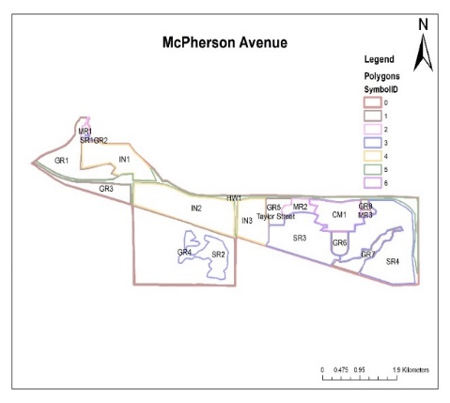
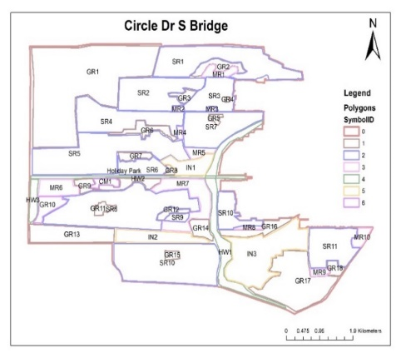
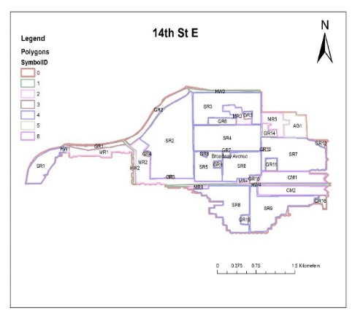
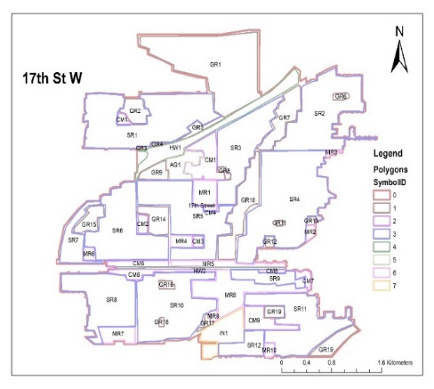
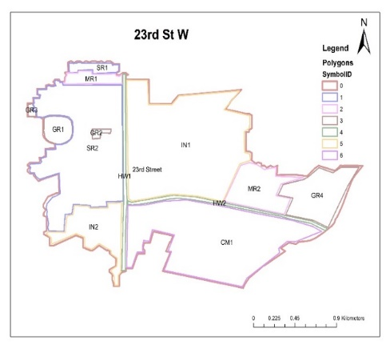
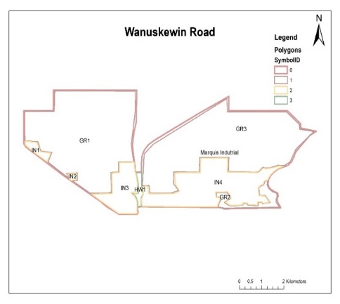
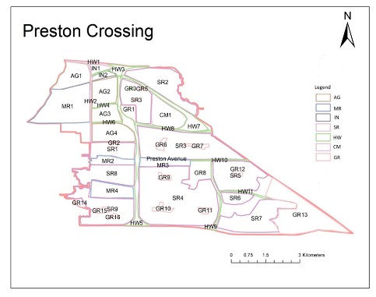
Figure S2. Land use breakdown of study catchments. The 14th St. E catchment above drains to both the MacPherson Ave. and 14th St E outfalls (though not delineated on the land-use map, areas for each subcatchment are provided by the CoS). Adapated from Al Masum et al. (2021). Refer to Table S1 for land use classification acronyms. Refer to Table S2 for total and land-use surface area in km².

