Activity Procedures
- Students are required to study the colonic adenocarcinoma case in advance using the materials provided in the appendix for a period of four months.
- Students will be divided into two groups, each consisting of 12 students, according to their student identification numbers:
  - Group 1: Students with odd-numbered IDs
  - Group 2: Students with even-numbered IDs
Students are required to study the assigned topics in advance based on the provided references and present their findings along with group discussion during the class session.
Group Assignments
Group 1: Pathology and Modern Medicine
- Definition of colonic adenocarcinoma (based on histologic findings)
- Etiology and pathogenesis of colonic adenocarcinoma
- Clinical manifestations
- Pathology
- Differential diagnoses based on clinical features
- Investigations and diagnosis
Group 2: Thai Traditional Medicine and Integrative Medicine
- Staging according to AJCC 8th edition (modern medical approach)
- Treatment according to modern medical guidelines
- Common chemotherapy side effects and their mechanisms
- Follow-up care according to modern medical guidelines
- Detailed analysis of the Samutthana (Etiopathogenesis) of colorectal cancer based on Thai Traditional Medicine concepts
- Appropriate Thai Traditional Medicine management with detailed explanations
Integration Session:
Both groups will collaboratively discuss how knowledge from both medical paradigms can be integrated for patient care.
- Prior to the discussion session, students will complete a pretest consisting of 20 multiple-choice questions (5 options per question). Answers will be marked on answer sheets, and the examination setting will follow standard MCQ examination procedures.
  - Pathology and modern medicine: 7 questions
  - Thai Traditional Medicine: 7 questions
  - Integrative medicine: 6 questions
(Duration: 20 minutes)
- Group representatives will present and discuss their topics, with a maximum of 30 minutes per group (total 60 minutes).
- During the presentations, triggering questions will be posed to promote integrative learning between the two medical systems. Examples include:
  - Alternating constipation and diarrhea, abdominal discomfort/bloating, anorexia, and weight loss: explain the underlying mechanisms according to modern medical pathophysiology and Thai Traditional Medicine concepts in detail.
  - Determine the cancer stage according to the AJCC 8th edition.
  - What are the appropriate treatment approaches according to modern medicine and Thai Traditional Medicine for this patient?
  - How can knowledge from both medical systems be integrated for patient management and follow-up care?
- A 20-minute break will be provided to allow group members to collaboratively discuss and prepare answers if additional questions are posed by the instructors, in order to promote active learning and teamwork.
- Group representatives will respond to additional questions (if any), with a maximum of 10 minutes per group.
- Students will complete a posttest consisting of 20 MCQs (20 minutes), followed by an answer review and explanation (10 minutes), for a total of 30 minutes.
- Student representatives will present the perceived benefits gained from the activity and provide feedback and suggestions (10 minutes).

Assessment and Evaluation
- Group presentation evaluation conducted by two instructors: one pathologist and one Thai Traditional Medicine instructor: 30 points per group
- Individual peer evaluation assessing group collaboration (via Google Form): 20 points per student
- Attitude toward integrative learning evaluation (via Google Form): 5 points
- Satisfaction with the activity evaluation (via Google Form): 5 points
- Posttest MCQ examination (20 questions) after the activity: 20 points per student
Outcome Indicators
- The mean posttest score is significantly higher than the mean pretest score, analyzed using a the Wilcoxon signed-rank test (p < 0.05).
- The group presentation evaluation score is ≥ 24 points (80%).
- The overall mean attitude and satisfaction score is ≥ 3.51.
- The overall mean peer evaluation score for individual collaboration is ≥ 3.51.

References
1. Gonzalez RS. Colon carcinoma overview. PathologyOutlines.com website. https://www.pathologyoutlines.com/topic/colontumorcarcinomageneral.html. Accessed June 30th, 2025.
2. Gonzalez RS. Adenocarcinoma. PathologyOutlines.com website. https://www.pathologyoutlines.com/topic/colontumoradenocarcinoma.html. Accessed June 23rd, 2025.
3. Arole V, Chen W. Staging-carcinoma. PathologyOutlines.com website. https://www.pathologyoutlines.com/topic/colontumorstaging8ed.html. Accessed June 23rd, 2025.
4. American Cancer Society. Colorectal cancer treatment [Internet]. Atlanta: American Cancer Society; c2024 [cited 2025 Jun 23]. Available from: https://www.cancer.org/cancer/types/colon-rectal-cancer/treating.html
5. Daley SF, Ali MA, Ohnuma T, et al. Anorexia and Cachexia. [Updated 2025 Jan 19]. In: StatPearls [Internet]. Treasure Island (FL): StatPearls Publishing; 2025 Jan-. Available from: https://www.ncbi.nlm.nih.gov/books/NBK430977/.
6. มูลนิธิฟื้นฟูส่งเสริมการแพทย์ไทยเดิม. (2550). ตำราการแพทย์ไทยเดิม (แพทยศาสตร์สงเคราะห์ ฉบับอนุรักษ์) เล่มที่ 1 ฉบับชำระ. (พิมพ์ครั้งที่ 1). ศุภวนิชการพิมพ์ กรุงเทพฯ.
7. กรมการแพทย์แผนไทยและการแพทย์ทางเลือก. แนวทางการดูแลผู้ป่วยมะเร็งระยะสุดท้าย แบบประคับประคองแบบบูรณาการ (สำหรับแพทย์แผนไทยและสหวิชาชีพ). [cited 2025 Jun 25]. Available from: https://www.dtam.moph.go.th/wp-content/uploads/e-book/palliative_care/mobile/index.html

Appendix
Case Study for Case Discussion Activity: Colonic Adenocarcinoma
A 60-year-old Thai woman with no underlying medical conditions presented to the hospital with alternating constipation and diarrhea for 2 months, accompanied by abdominal discomfort and bloating. She also reported anorexia and unintentional weight loss from 50 kg to 40 kg over a 2-month period.
A colonoscopy was performed, revealing an ulceroproliferative mass in the sigmoid colon with partial luminal obstruction, suspicious for colonic cancer, as shown in the left image. This finding is compared with a normal sigmoid colon in another patient (right image).
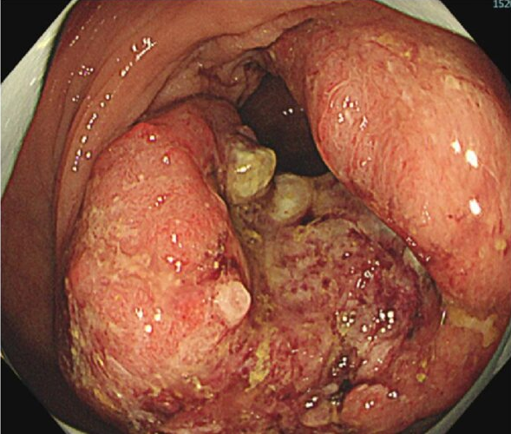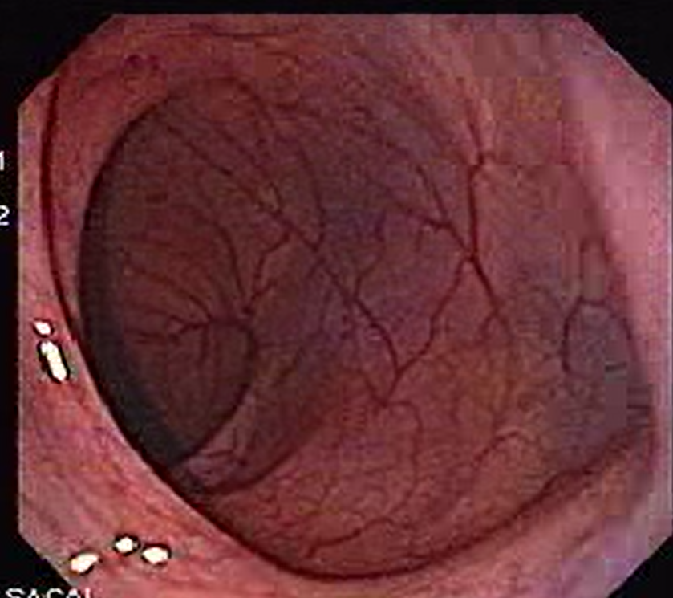

A tissue biopsy was performed and submitted for histopathologic examination. The microscopic features are shown in the image. Students are requested to review the description and study it in comparison with normal histology.

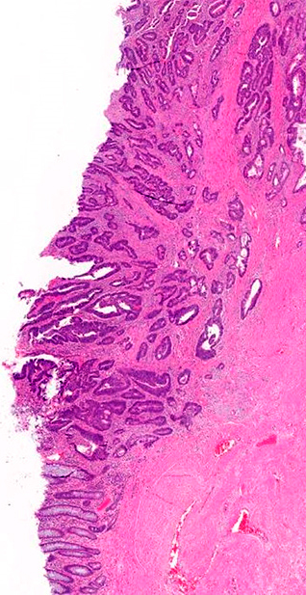
Mucosa
Submucosa
Muscularis propria Submucosa
Low magnification from a colonic mass biopsy showing complex glands at least invading into the submucosa, compatible with adenocarcinoma. The dotted line represents the border between mucosa and submucosa (muscularis mucosae) (H&E, 20x)
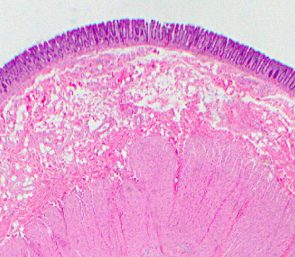
Muscularis prorpria Submucosa
Submucosa
Mucosa
Low magnification from a normal colonic wall (mucosal to muscularis propria) (H&E, 20x)

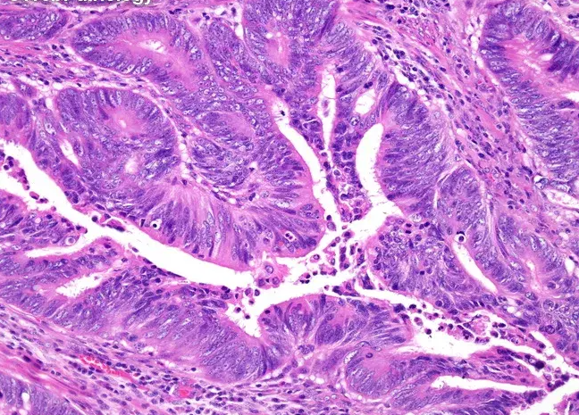 | High power magnification from the tumor in submucosa showing complex glands lined by intestinal-type epithelium with pencillate nuclei reaching apical surface and invading into the submucosa (at least), compatible with adenocarcinoma, moderately differentiated (400x).
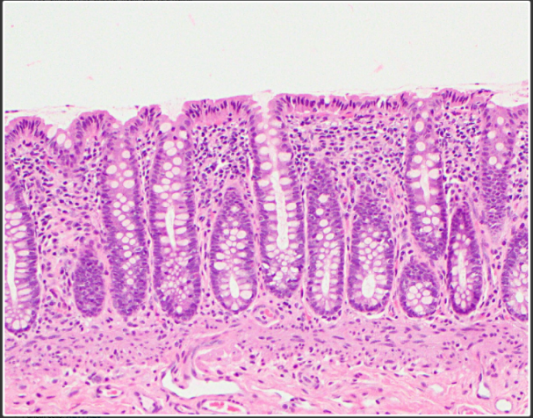  Submucosa  Muscularis mucosae  Mucosa  Mucosa | Normal histology showing normal colonic crypts and glands in the mucosa. Please note the muscularis mucosae between mucosa and submucosa  (100x)

Pathologic Diagnosis
Labeled “Sigmoid mass”, biopsy:
- Adenocarcinoma, moderately differentiated

Additional investigations were performed as follows:
- CT scan of the whole abdomen:
- CT imaging demonstrated an irregular mass in the sigmoid colon with associated pericolic fat stranding, findings suspicious for transmural tumor extension beyond the muscularis propria.
- Multiple pericolic lymph nodes were identified, some of which were enlarged; the largest measured up to 2 cm in short-axis diameter, raising suspicion for nodal metastasis.
- Serum CEA: 100 ng/mL (reference range: < 2.5 ng/mL)

The patient subsequently underwent sigmoidectomy with lymph node dissection. The resected specimens were submitted for histopathologic examination, with the following results:

Gross descriptions (see figures):

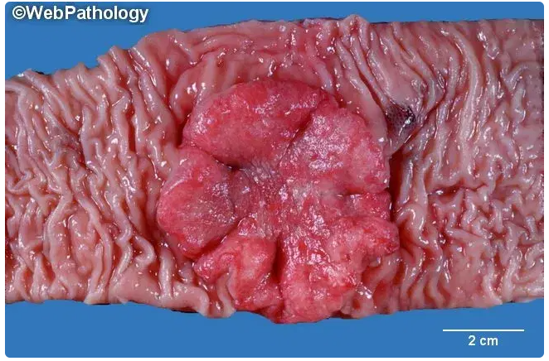 | An ulceroproliferative, rubbery to firm, reddish mass (fresh specimen), measuring 5 cm in maximum longitudinal length and 2 cm in maximum thickness
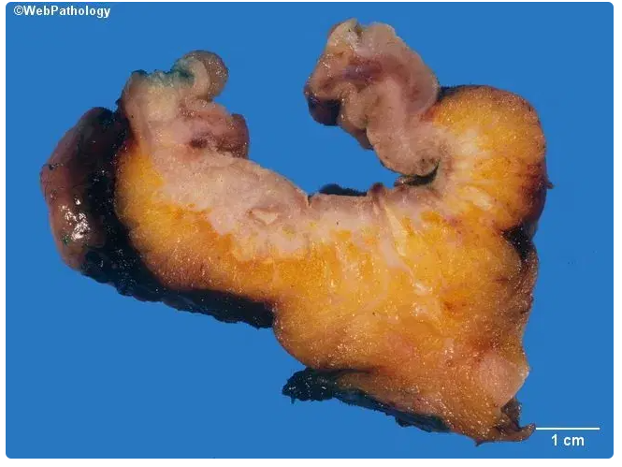 | Serial sectioning reveals gross invasion into the pericolic fat (arrow)

- Multiple firm whish lymph nodes are identified in the pericolic fat, upto 2 cm in maximum dimension (not shown)

Microscopic findings:
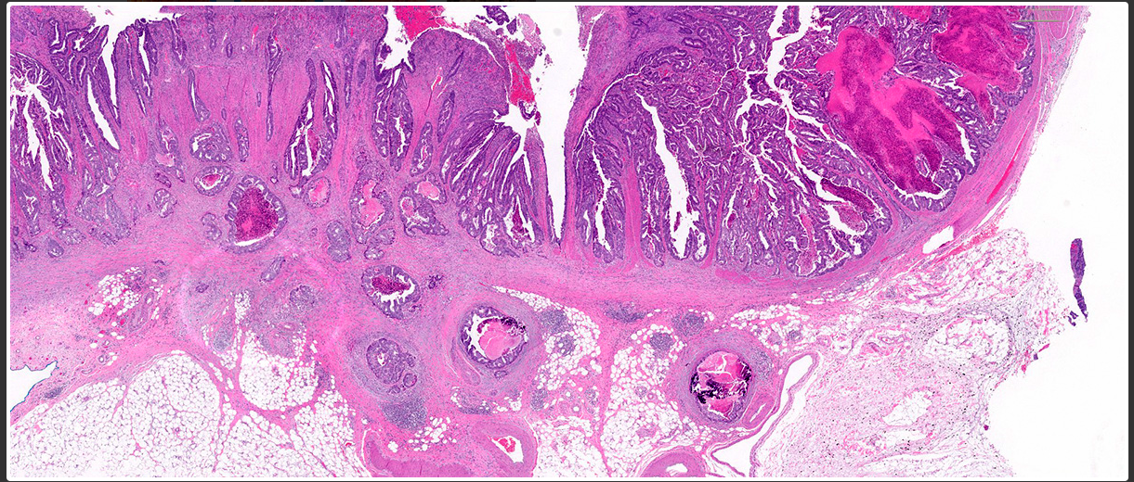
Pericolic fat
Low power showing colonic adenocarcinoma invading into the pericolic fat (arrows) (H&E, 20x)

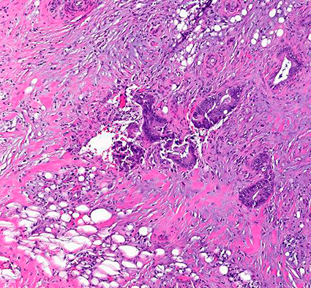

High power showing colonic adenocarcinoma invading into the pericolic fat.
Please note the adipocytes (arrows) (H&E, 200x)

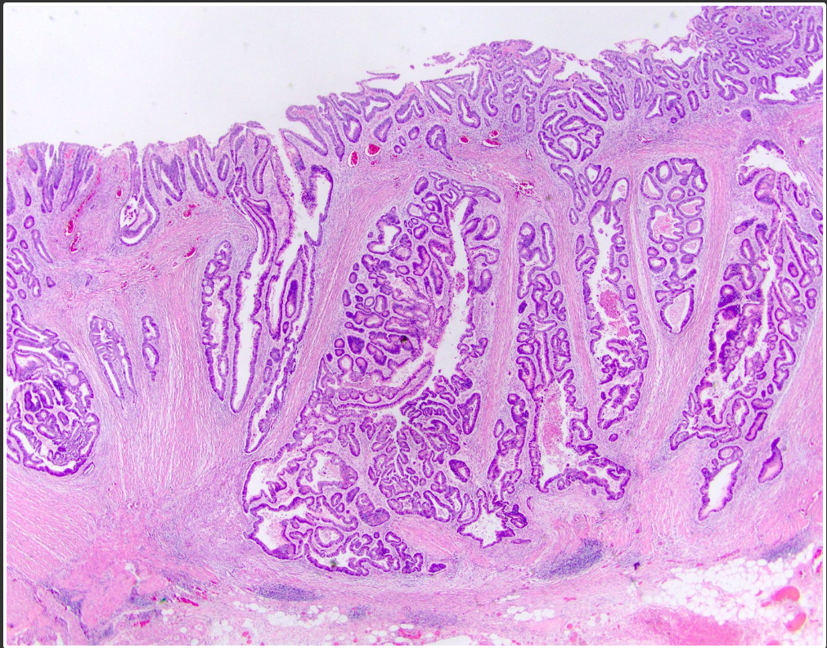  MP  Pericolic fat | Low power of colonic adenocarcinoma showing complex glands invading into the muscularis propria (MP) approaching pericolic fat (H&E, 40x)
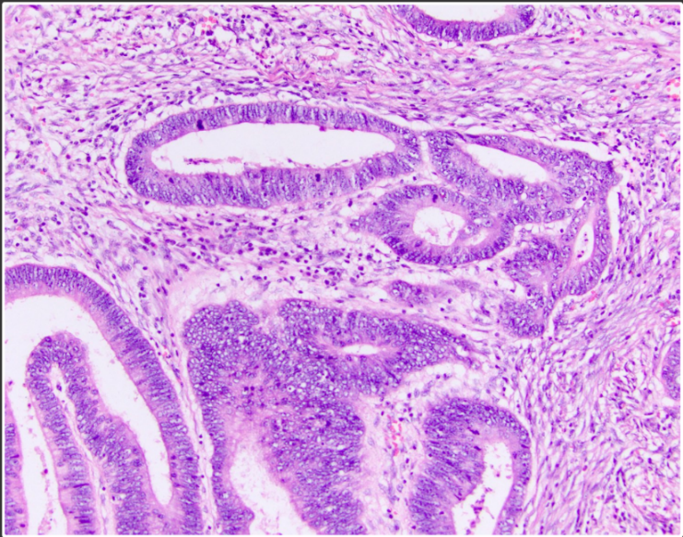 | High power of colonic adenocarcinoma showing irregular and complex glands lined by intestinal type epithelium (pencillate nuclei) (200x)
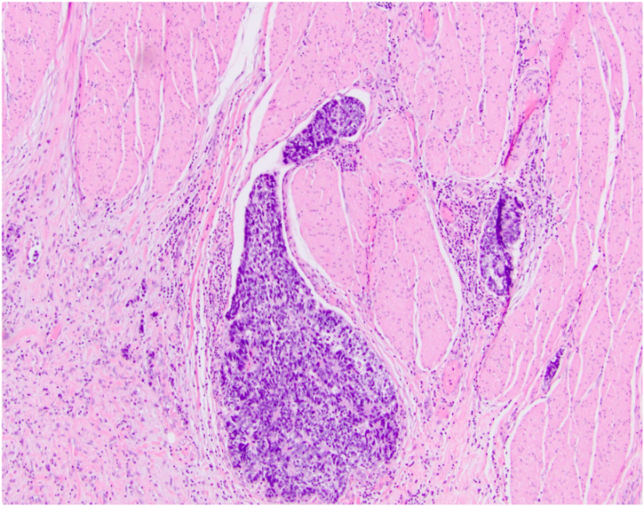 | Lymphovascular space invasion (H&E, 100x)
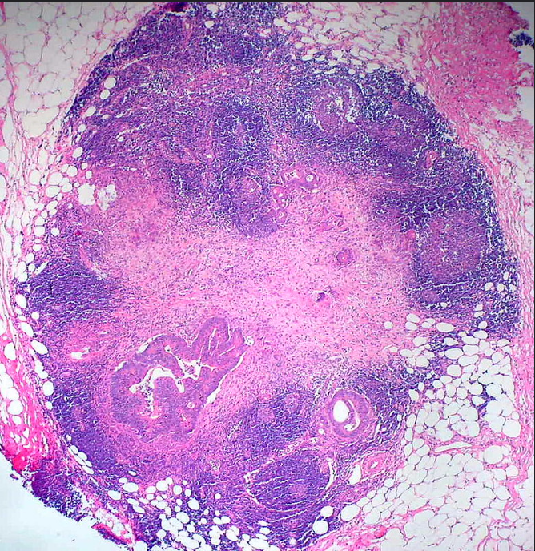 | Nodal metastasis:  Please note metastatic foci (arrows) in the lymph node  (H&E, 40x)

Pathologic Diagnosis:
Sigmoid, sigmoidectomy:
- Adenocarcinoma, moderately differentiated
- Tumor invades into the pericolic fat
- Tumor size: 5 cm in maximum longitudinal length and 2 cm in maximum thickness
- Presence of lymphovascular space invasion
- Negative for perineural invasion
- Metastatic adenocarcinoma in 7 out of 15 nodes (7/15)
- Free all resection margins

