Supplementary data

Study on the effect of different extraction methods in four pharmacopoeia on the content and structural transformation of ginsenoside and the optimization of extraction process

Kai Sun¹, Huang Jiang², Pingya Li¹, Lei Xu², Yaling Deng², Jing Xu^{2,*}, Yuqing Zhao^{2,3,*}
¹ School of Pharmaceutical Sciences, Jilin University, Changchun, Jilin, China
² School of Functional Food and Wine, Shenyang Pharmaceutical University, Shenyang, Liaoning, China
³ Key Laboratory of Structure-based Drug Design and Discovery of Ministry of Education, Shenyang Pharmaceutical University, Shenyang, Liaoning, China
* Corresponding authors:
Yuqing Zhao: Tel: +86 24 43520309, Fax: +86 24 435230300, email: zyq4885@126.com

Figure S1. Quantitative chromatogram of ginseng using the four-country pharmacopoeia extraction method
Figure S2. Chemical structures and possible transformation of ginsenosides in heated ginseng.
Figure S3. The structure of ginsenosides identified by UPLC-Q-Exactive-MS
Table S1. UPLC-Q-Exactive-MS analysis

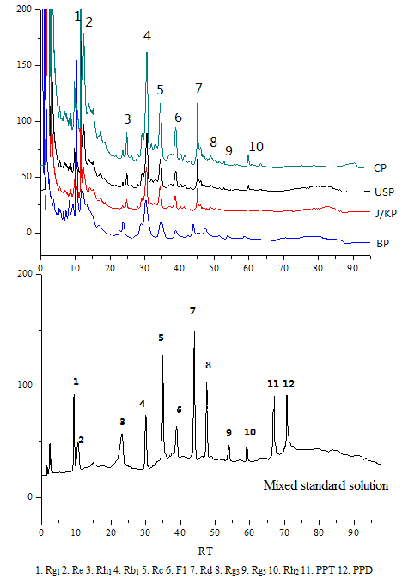
Figure S1. Quantitative chromatogram of ginseng using the four-country pharmacopoeia extraction method
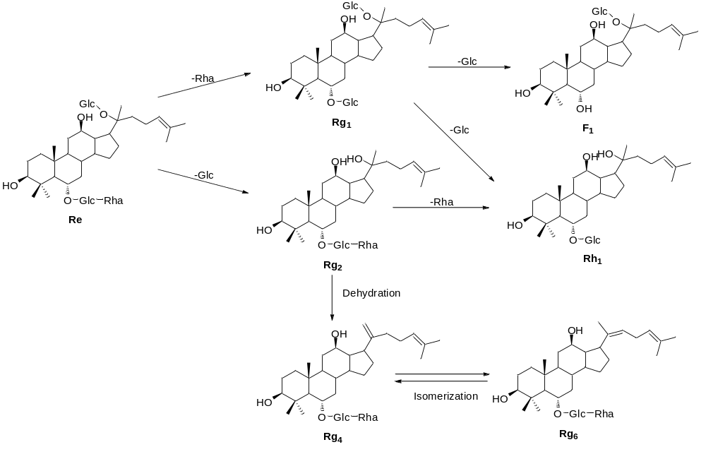
Figure S2. Chemical structures and possible transformation of ginsenosides in heated ginseng.

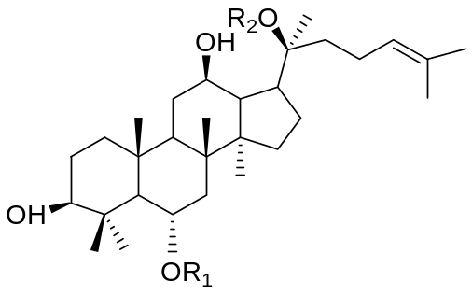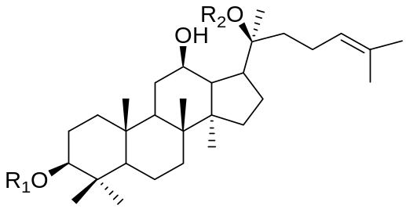
PPD-type PPT-type
Name | R₁ | R₂
Ra₁ | Glc2-Glc | Glc6-Ara（p）4-Xyl
Ra₃ | Glc2-Glc | Glc6-Glc3-Xyl
Rb₁ | Glc2-Glc | Glc6-Glc
Rb₂ | Glc2-Glc | Glc6-Ara（p）
Rb₃ | Glc2-Glc | Glc6-Xyl
Rc | Glc2-Glc | Glc6-Ara（f）
Rd | Glc2-Glc | Glc
Noto-Fe | Glc | Glc6-Ara（f）
F₂ | Glc | Glc
20（S）-Rg₃ | Glc2-Glc | H
20（R）-Rg₃ | Glc2-Glc | H
Noto-R₃ | Glc2-Xyl | Glc
PPD | H | H
Name | R₁ | R₂
Re | Glc2-Xyl | Glc
Rg₁ | Glc | Glc
Rg₂ | Glc2-Rha | H
F₁ | H | Glc
F₅ | H | Glc2-Glc
F₃ | H | Glc6-Ara（p）
Mc | H | Glc6-Ara（f）
Rf | Glc2-Glc | H
Rh₁ | Glc | H
PPT | H | H

Ginsenoside Ro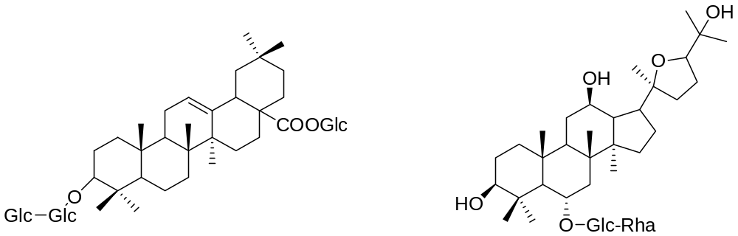 pseudo-ginsenoside F₁₁

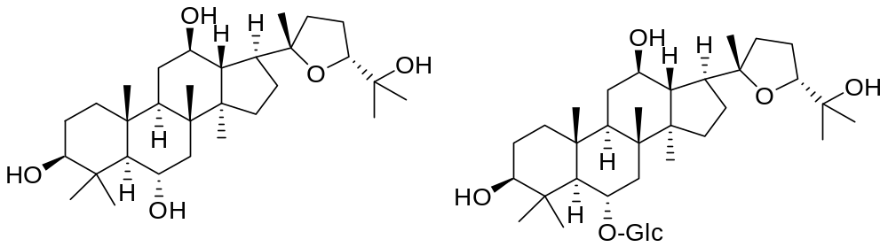
Pseudo sapogenin RT₅
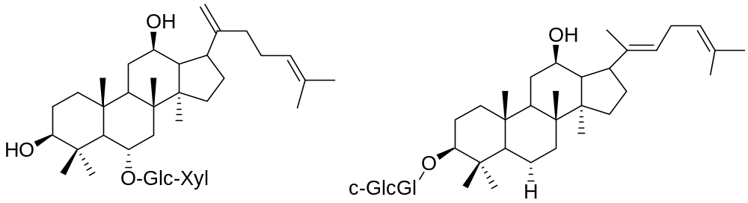
Noto-T5 Rg₅
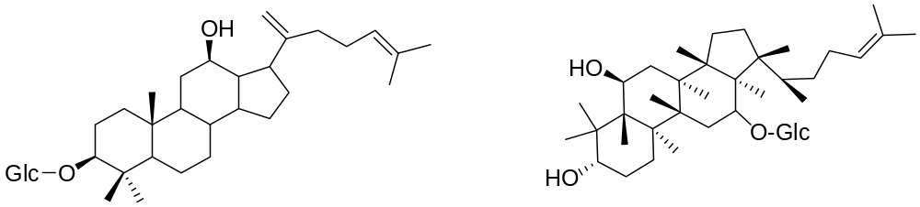 Rk₂ Rh₈
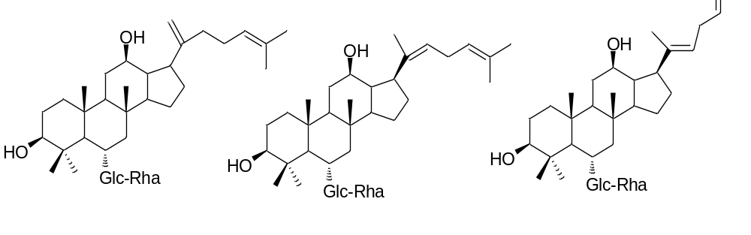 Rg₄ Rg₆ F₄
Figure S3. The structure of ginsenosides identified by UPLC-Q-Exactive-MS

Table S1. UPLC-Q-Exactive-MS analysis
Peak | Identity | t_{R}/min | Molecular formula | Extracting Ion(m/z)[M+H]⁺
1 | Ginsenoside Ra₃ | 11.635 | C₅₉H₁₀₀O₂₇ | 1241.6511
2 | Ginsenoside Ra₁ | 12.786 | C₅₈H₉₈O₂₆ | 1211.6404
3 | Ginsenoside Rb₁ | 11.581 | C₅₄H₉₂O₂₃ | 1109.6086
4 | Ginsenoside Rc | 12.582 | C₅₃H₉₀O₂₂ | 1079.5985
5 | Ginsenoside Rb₂ | 13.877 | C₅₃H₉₀O₂₂ | 1079.5985
6 | Ginsenoside Rb₃ | 18.413 | C₅₃H₉₀O₂₂ | 1079.5985
7 | Notoginsenoside R₃ | 10.118 | C₄₈H₈₂O₁₉ | 963.55109
8 | Ginsenoside Ro | 13.026 | C₄₈H₇₆O₁₉ | 957.50439
9 | Ginsenoside Re | 11.661 | C₄₈H₈₂O₁₈ | 947.5571
10 | Ginsenoside Rd | 18.538 | C₄₈H₈₂O₁₈ | 947.5571
11 | Notoginsenoside Fe | 13.961 | C₄₇H₈₀O₁₇ | 917.5463
12 | Quinquefolium Saponin L₁₀ | 19.062 | C₄₇H₈₀O₁₇ | 917.5463
13 | Ginsenoside Rg₁ | 5.228 | C₄₂H₇₂O₁₄ | 801.4981
14 | Ginsenoside Rf | 6.593 | C₄₂H₇₂O₁₄ | 801.4981
15 | pseudo-ginsenoside F₁₁ | 10.12 | C₄₂H₇₂O₁₄ | 801.4981
16 | Ginsenoside Rg₂ | 13.819 | C₄₂H₇₂O₁₃ | 785.5009
17 | Ginsenoside F₂ | 16.824 | C₄₂H₇₂O₁₃ | 785.5009
18 | (S)-Ginsenoside Rg₃ | 11.613 | C₄₂H₇₂O₁₃ | 785.5009
19 | (R)-Ginsenoside Rg₃ | 12.198 | C₄₂H₇₂O₁₃ | 785.5009
20 | Ginsenoside F₃ | 11.302 | C₄₁H₇₀O₁₃ | 793.4688 [M+Na]⁺
21 | Ginsenoside F₅ | 11.302 | C₄₁H₇₀O₁₃ | 793.4688 [M+Na]⁺
22 | Ginsenoside Rg₅ | 7.207 | C₄₂H₇₀O₁₂ | 767.4339
23 | Ginsenoside Rg₄ | 9.679 | C₄₂H₇₀O₁₂ | 767.4339
24 | Ginsenoside Rg₆ | 14.779 | C₄₂H₇₀O₁₂ | 767.4339
25 | Ginsenoside F4 | 18.056 | C₄₂H₇₀O₁₂ | 767.4339
26 | Ginsenoside MC | 13.921 | C₄₁H₇₀O₁₂ | 755.4929
27 | Notoginsenoside T₅ | 10.849 | C₄₁H₆₈O₁₂ | 753.4447
28 | RT₄ | 1.004 | C₃₆H₆₂O₁₀ | 655.44043
29 | RT₅ | 10.169 | C₃₆H₆₂O₁₀ | 655.44043
30 | Ginsenoside F₁ | 1.554 | C₃₆H₆₂O₉ | 639.4464
31 | Ginsenoside Rh₁ | 17.095 | C₃₆H₆₂O₉ | 639.4464
32 | Rh₈ | 1.071 | C₃₆H₆₀O₉ | 637.1878
33 | Ginsenoside RK₂ | 12.783 | C₃₆H₆₀O₇ | 605.4405
34 | pseudo-sapogenin | 19.341 | C₃₀H₅₂O₅ | 515.3712 [M+Na]⁺
35 | PPT | 28.991 | C₃₀H₅₂O₄ | 477.3933
36 | PPD | 23.813 | C₃₀H₅₂O₃ | 461.3989

