Supplementary Material

Supplementary Figures
Supplementary Figure S1 Chloroplast genome maps of S. deserta (A), S. digitaloides (B), S. leucantha (C), and S. pansamalensis (D). The genes inside and outside of the circle were transcribed in the clockwise and counterclockwise directions, respectively.
Supplementary Figure S2 Phylogenetic relationships of the 14 Salvia species inferred from maximum parsimony (MP) analysis of CDS regions. Numbers above clades are MP bootstrap values.
Supplementary Figure S3 Phylogenetic relationships of the 14 Salvia species inferred from maximum likelihood (ML) analysis of CDS regions. Numbers above clades are ML bootstrap values.

Supplementary Figure S1. Chloroplast genome maps of S. deserta (A), S. digitaloides (B), S. leucantha (C), and S. pansamalensis (D). The genes inside and outside of the circle were transcribed in the clockwise and counterclockwise directions, respectively.

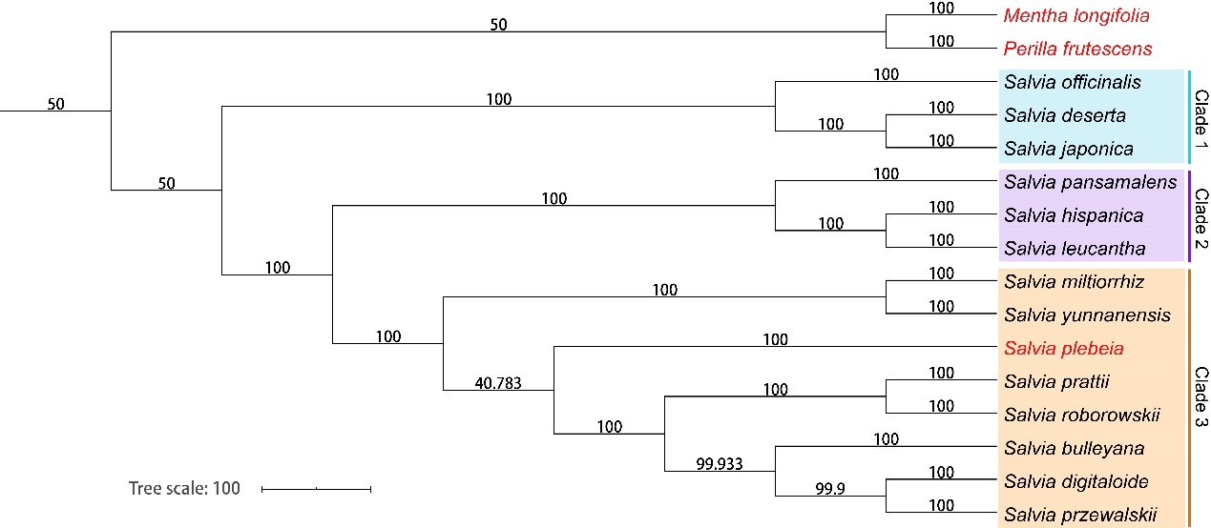
Supplementary Figure S2. Phylogenetic relationships of the 14 Salvia species inferred from maximum parsimony (MP) analysis of CDS regions. Numbers above clades are MP bootstrap values.

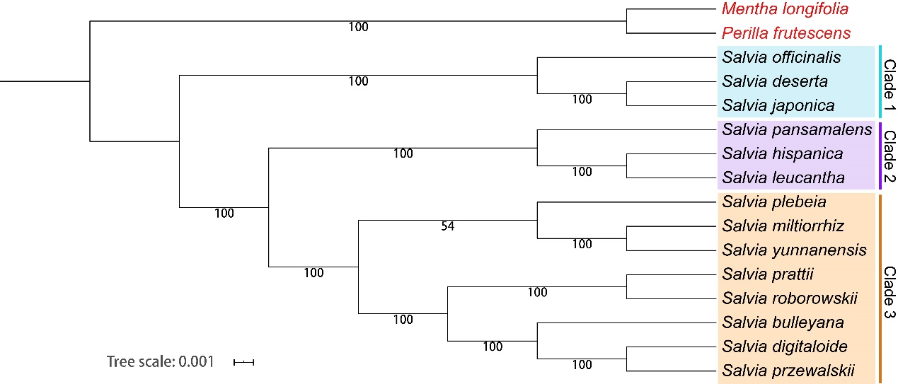
Supplementary Figure S3. Phylogenetic relationships of the 14 Salvia species inferred from maximum likelihood (ML) analysis of CDS regions. Numbers above clades are ML bootstrap values.

Supplementary Tables

Supplementary Table S1 Definition of nineteen bioclimatic factors
Supplementary Table S2 Summary statistics of the 14 Salvia chloroplast genomes
Supplementary Table S3 Features of CDS sequences in fourteen Salvia species

Supplementary Table S1. Definition of nineteen bioclimatic factors*
Code | Bioclimatic factors | Code | Bioclimatic factors
bio1 | annual mean temperature | bio10 | mean temperature of warmest quarter of the year
bio2 | mean diurnal range in temperature | bio11 | mean temperature of coldest quarter of the year
bio3 | isothermality (monthly/annual temperature range) | bio12 | annual precipitation
bio4 | temperature seasonality | bio13 | precipitation of wettest month
bio5 | max temperature of warmest month | bio14 | precipitation of driest month
bio6 | min temperature of coldest month | bio15 | precipitation of seasonality (coefficient of variation)
bio7 | annual range in temperature | bio16 | precipitation of wettest quarter of the year
bio8 | mean temperature of wettest quarter of the year | bio17 | precipitation of driest quarter of the year
bio9 | mean temperature of driest quarter of the year | bio18 | precipitation of warmest quarter of the year
* The spatial resolution of the climate layers was 1 km², and the climate data used to create the layers were restricted to records from 1970 to 2000.

Supplementary Table S2. Summary statistics of the 14 Salvia chloroplast genomes
 | Species | Total cp genome size (bp) | Number of uniq protein-coding genes | Number of uniq tRNAs | Number of uniq rRNAs
1 | S. miltiorrhiza | 151,328 | 80 | 30 | 4
2 | S. japonica | 153,995 | 80 | 30 | 4
3 | S. bulleyana | 151,547 | 80 | 30 | 4
4 | S. officinalis | 151,089 | 80 | 30 | 4
5 | S. przewalskii | 151,319 | 80 | 30 | 4
6 | S. plebeia | 151,062 | 80 | 30 | 4
7 | S. prattii | 151,690 | 80 | 30 | 4
8 | S. roborowskii | 151,654 | 80 | 30 | 4
9 | S. yunnanensis | 151,396 | 80 | 30 | 4
10 | S. hispanica | 150,980 | 80 | 30 | 4
11 | S. deserta | 151,326 | 80 | 30 | 4
12 | S. digitaloides | 151,592 | 80 | 30 | 4
13 | S. leucantha | 151,038 | 79 | 30 | 4
14 | S. pansamalensis | 150,988 | 80 | 30 | 4

Supplementary Table S3. Features of CDS sequences in fourteen Salvia species
 | Species | Length of CDS sequences | Number of condons | GC content of CDS sequences (%)
1 | S. miltiorrhiza | 79,449 | 26483 | 38.12
2 | S. japonica | 79,455 | 26485 | 38.01
3 | S. bulleyana | 79,335 | 26445 | 38.10
4 | S. officinalis | 79,389 | 26463 | 38.13
5 | S. przewalskii | 79,341 | 26447 | 38.09
6 | S. plebeia | 79,293 | 26431 | 38.07
7 | S. prattii | 79,341 | 26447 | 38.13
8 | S. roborowskii | 79,359 | 26453 | 38.10
9 | S. yunnanensis | 79,308 | 26436 | 38.11
10 | S. hispanica | 79,095 | 26365 | 37.99
11 | S. deserta | 79,404 | 26468 | 38.05
12 | S. digitaloides | 79,341 | 26447 | 38.11
13 | S. leucantha | 77,064 | 25688 | 38.18
14 | S. pansamalensis | 79,296 | 26432 | 38.06

