Table 2: Summary of total and out-of-pocked expenditure for c-section hospitalization and follow up by Ubudehe categories (in US$) * N= 477

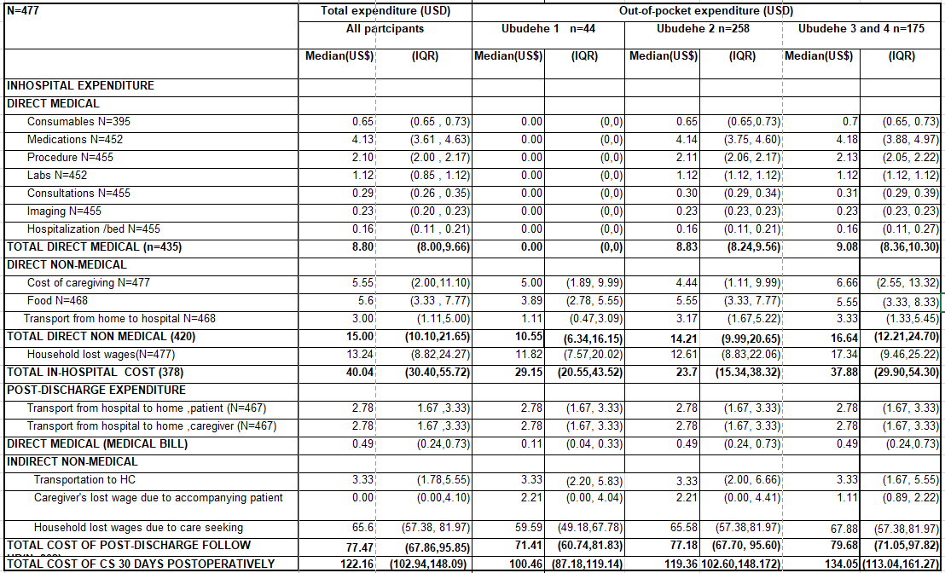
Expenses are converted to USD using nominal exchange rate at study start date (October, 2019) 1 USD = 916.17 RWF

