Supporting Information
for

Engineered double-network hydrogels for robust protection of fragile systems

Dineshkumar Bharathidasan, and Chandan Maity*

(Organic)Material Science and Engineering Laboratory
Centre for Nanobiotechnology (CNBT), Vellore Institute of Technology (VIT), Vellore campus, Tamil Nadu – 632014, India
E-mail: chandanmaitylab@gmail.com, chandan.maity@vit.ac.in

Materials
All chemical reagents and solvents were obtained from commercial suppliers and used as received without further purification. Thioflavin T, boric acid, potassium hydroxide, and potassium chloride were procured from SRL, guanosine was purchased from Tokyo Chemical Industry (TCI), India. Agarose was obtained from HiMedia Laboratories Pvt. Ltd.
Instrumentation
The ¹H NMR and ¹³C NMR spectra were acquired using a Bruker Avance III 400MHz spectrometer. The pXRD analysis was conducted using a Bruker D8 Advance system from the range of 2θ = 2°ꟷ90°. The FTIR analysis was performed using the Thermo Fisher Scientific, Thermo Nicolet iS50 with an inbuilt ATR was taken in ATR mode for the absorbance mode ranging from 4000 cm⁻¹ to 400 cm⁻¹ with resolution of 2 cm⁻¹ and obtained by averaging over 32 scans. Fluorescence images were taken using a Leica DM2500 microscope at a 10x magnification. The rheology measurements were conducted on an Anton Paar rheometer (Model: MCR 92) with 25mm parallel plate geometry at 25 °C. The field emission scanning electron microscopic images were obtained on a Thermo Fisher Model: FEI QUANTA 250 FEG (operating voltage 20 kV). All the hydrogel samples which are lyophilized and used are lyophilized through the Lyophilizer (Alpha 1,2 LD-plus martin christ).
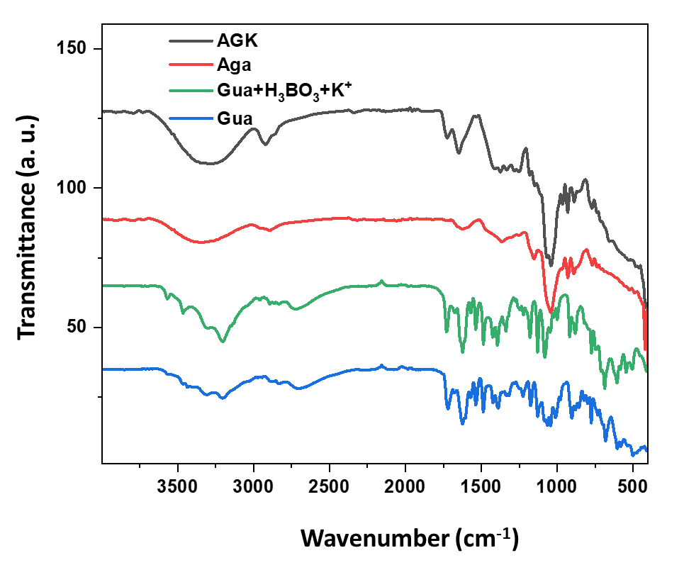
Figure S1: Comparative FTIR patterns of the lyophilized hydrogel materials: AGK (black line), Aga (red line), Gua + H₃BO₃ + K⁺ (green line), and Gua (blue line).
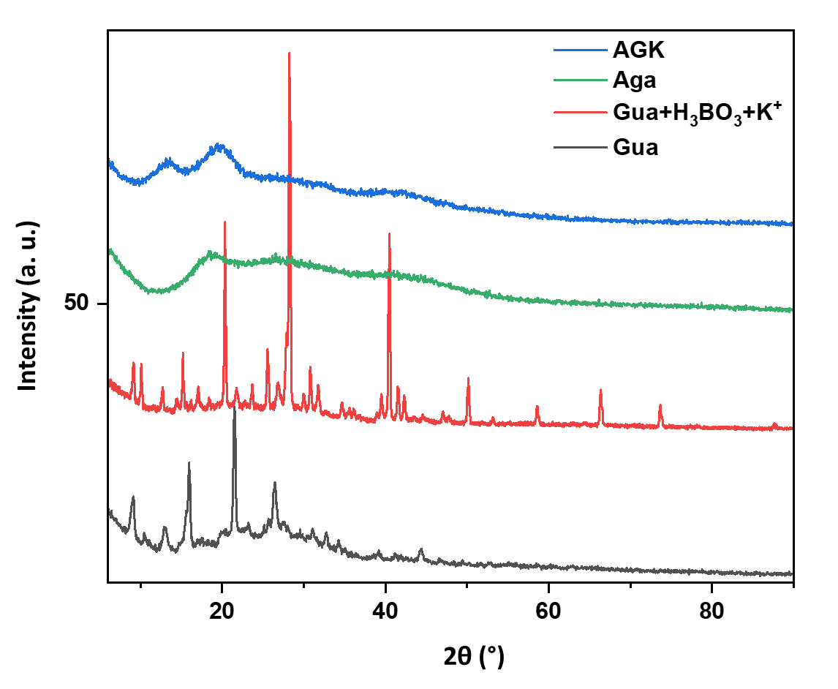
Figure S2: Comparative powder X-ray diffraction (pXRD) patterns of the lyophilized hydrogel materials. The diffractograms correspond to AGK (blue line), Aga (green line), Gua:H₃BO₃:K⁺ (red line), and Gua (black line).

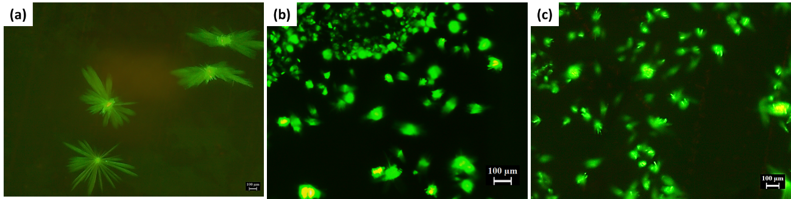
Figure S3: (a-c) Fluorescence microscopy image of Aga–Gua in the absence of K⁺. Scale bar = 100 µm.
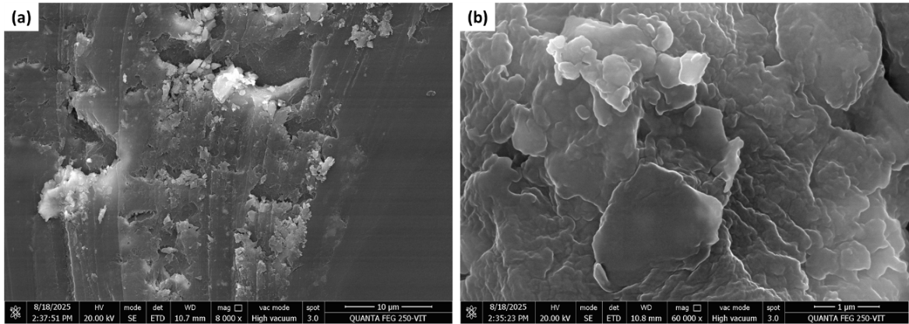
Figure S4: (a-b) Field Emission Scanning Electron Microscopy (FESEM) micrographs of Aga hydrogel (3 wt%). Scale bars: 10 µm and 1 µm, respectively.
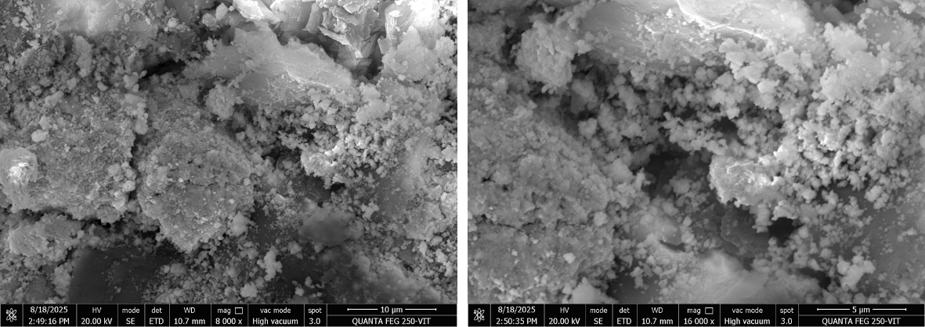
Figure S5: FESEM micrographs of the Aga:Gua hydrogel without K⁺ion (scale bars: 10µm and 5µm).

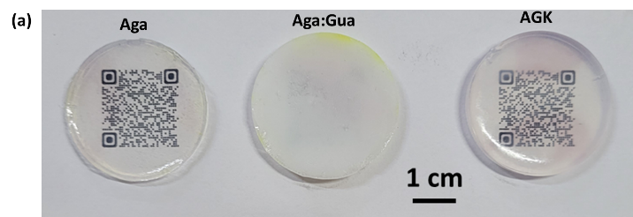
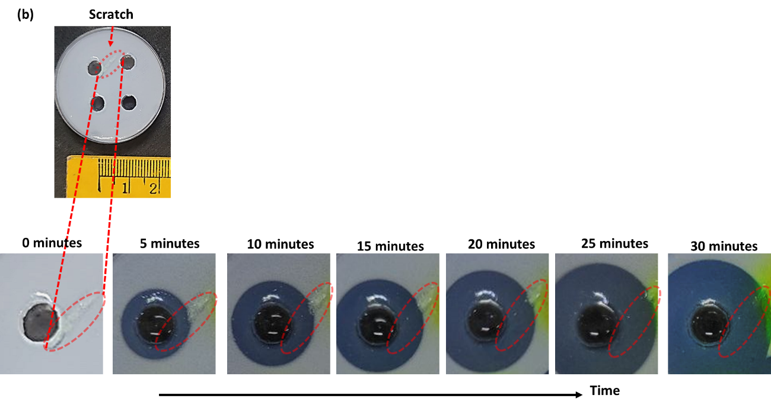
Figure S6: (a) Optical photographs of Aga, Aga–Gua, and AGK hydrogel blocks. (b) Time-dependent optical images illustrating the self-healing of microfracture cracks within the hydrogel upon addition of K⁺ solution, recorded at 5 min intervals.
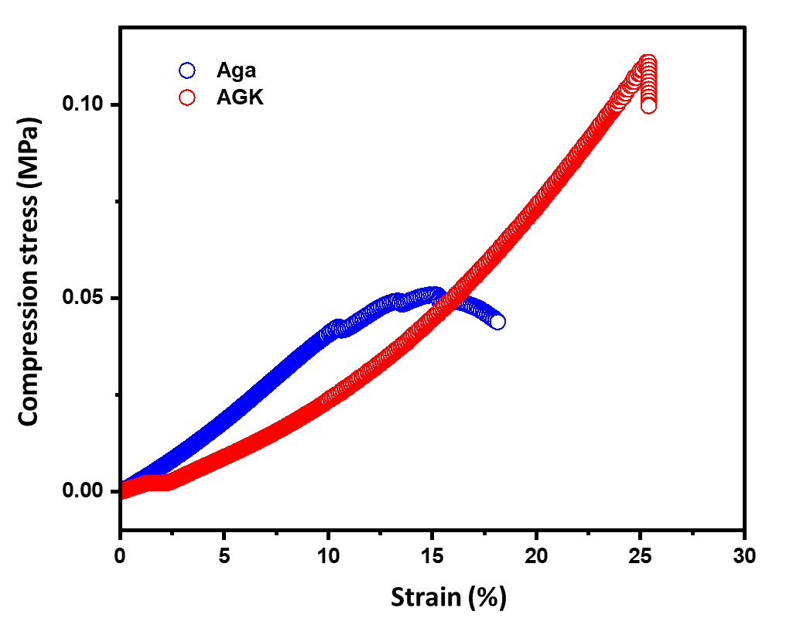
Figure S7: Stress-strain plot of compression test samples of Aga hydrogel and AGK hydrogel.
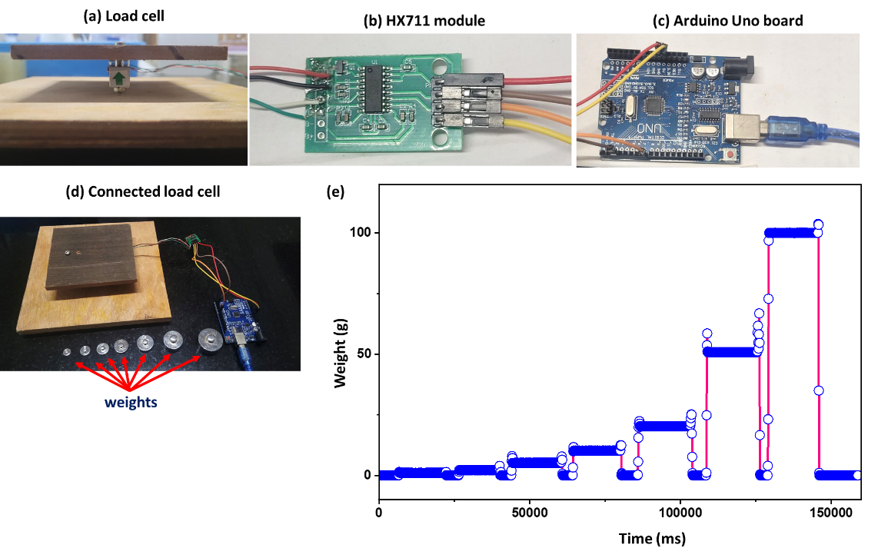
Figure S8: (a) Photograph of the 1 kg load cell; (b) photograph of the HX711 amplifier module; (c) photograph of the Arduino Uno board; (d) image of the assembled load cell setup employed to evaluate impact absorption by gel samples, along with the standard calibration weights (1, 2, 5, 10, 20, 50, and 100 g); and (e) calibration plot showing the applied weights versus sensor response, including response time characteristics.
- Code S1: Arduino programme code for the load cell setup

#include <HX711.h>

#define DOUT 2
#define CLK 7

HX711 scale;

float calibration_factor = -1673.8;

void setup() {
Serial.begin(9600);
scale.begin(DOUT, CLK);

scale.set_scale(calibration_factor);
scale.tare();

Serial.println("Scale ready");
}

void loop() {
if (scale.is_ready()) {
float weight = scale.get_units(10);

Serial.print(millis());
Serial.print(" ms | ");
Serial.print(weight, 3);
Serial.println(" g");
}

delay(300);
}

(b) Code S2: Visual Studio source-code to control load cell

import serial
from datetime import datetime

PORT = "COM6"
BAUD = 9600
OUTPUT_TXT = "serial_raw_log.txt"

with serial.Serial(PORT, BAUD, timeout=1) as ser, open(OUTPUT_TXT, "a") as f:
print("Logging RAW serial data to TXT (Ctrl+C to stop)")
f.write("PC_Time\tRaw_Arduino_Line\n")

try:
while True:
line = ser.readline().decode("utf-8", errors="ignore").strip()
if line:
pc_time = datetime.now().strftime("%Y-%m-%d %H:%M:%S.%f")[:-3]
log_line = f"{pc_time}\t{line}\n"

f.write(log_line)
f.flush()
print(log_line.strip())

except KeyboardInterrupt:
print("\nStopped logging.")

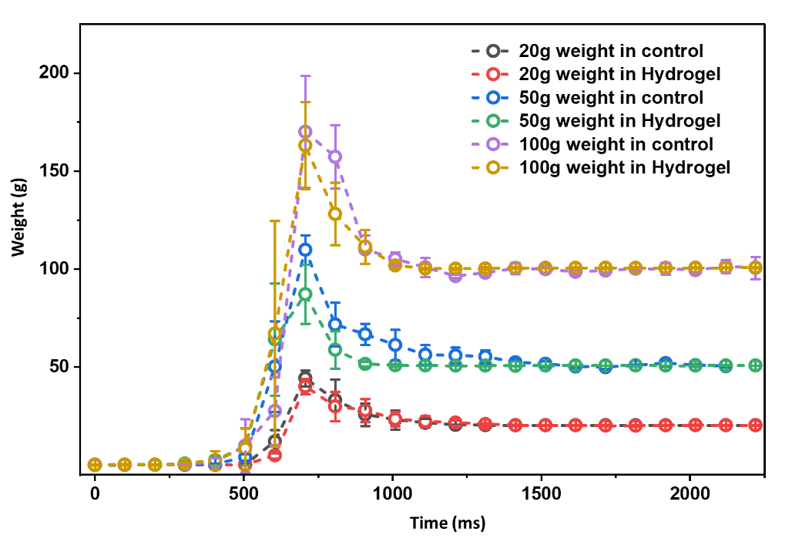
Figure S9: Weight–time profiles showing the impact response of control (Aga) and AGK-based hydrogels subjected to weights of 20, 50, and 100 g loads dropped from a height of 30 cm.

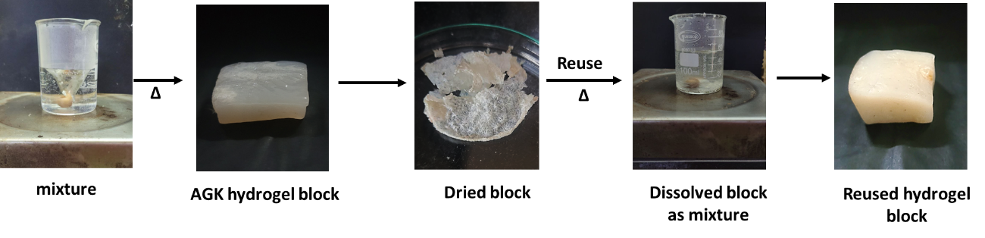
Figure S10: Photographic representation of reusability of AGK gel using heating and cooling method.
Video SV1: Time-lapse visualization of K⁺ diffusion within the hydrogel matrix. The diffusion process is accompanied by a distinct transition from an opaque to a transparent state.
Video SV2: Coefficient of restitution (COR) measurement using a standardized ball-drop test. A 53.6 g marble was released from a height of 25 cm to evaluate impact dissipation. The bare surface exhibited a high rebound, while a 3 wt% agarose gel showed moderate energy loss.
Video SV3: Impact protection of glass specimens with and without the AGK hydrogel. Unprotected glass slides shatter upon impact, whereas hydrogel-coated specimens remain intact.
Video SV4: Impact protection of egg using the AGK hydrogel. Egg enclosed within the hydrogel layer retains their structural integrity upon impact, whereas unprotected sample undergoes immediate damage.
Video SV5: Impact response of glass bottles under free-fall conditions. Unprotected samples fracture upon impact with a rigid surface, whereas AGK hydrogel–encapsulated specimens remain intact.

