Supplemental File. Training materials and simulation environment

1.Fully immersive simulation manikin employed in the study (Gaumard®/Hal 3201®)

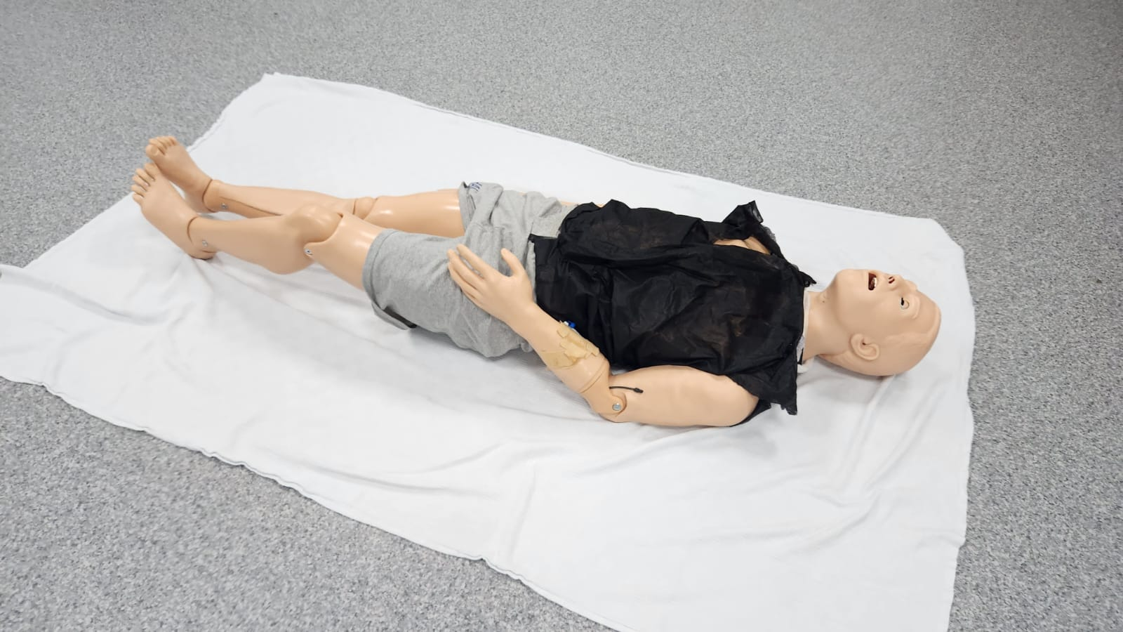

2.Low-fidelity simulation manikin (Simulaids Brad) and AED ( Nasco Life/Form®) utilized in the conventional group training

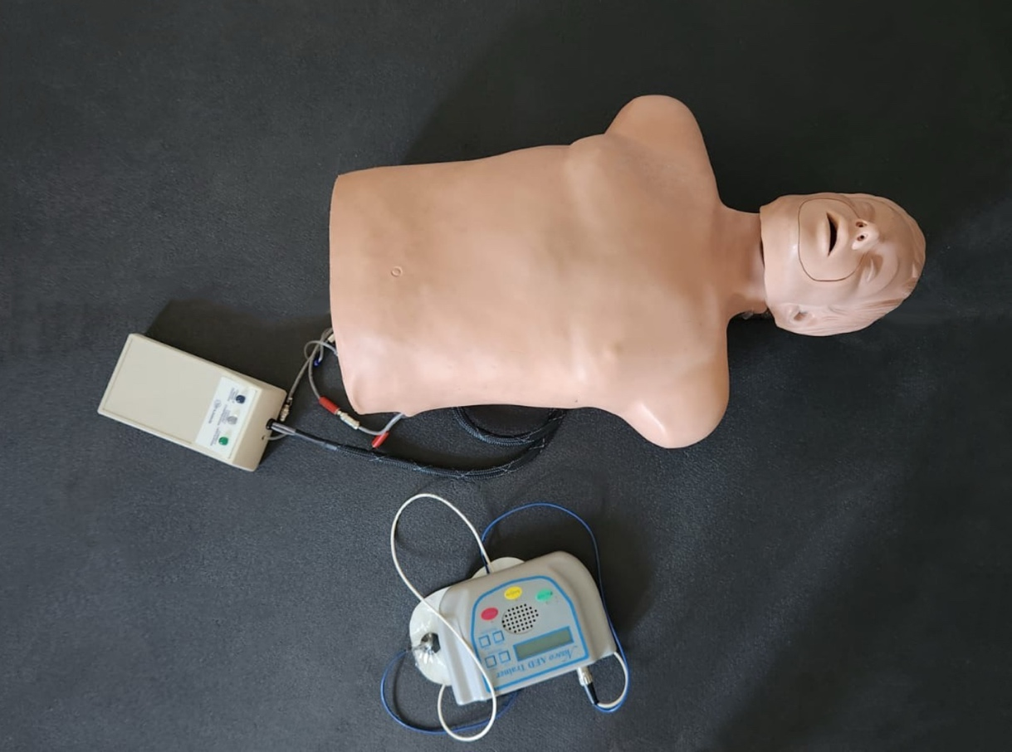

3.VR headset (Meta-Oculus Quest 2) and 360° video recording device (Insta360 X3) utilized in the VR group training

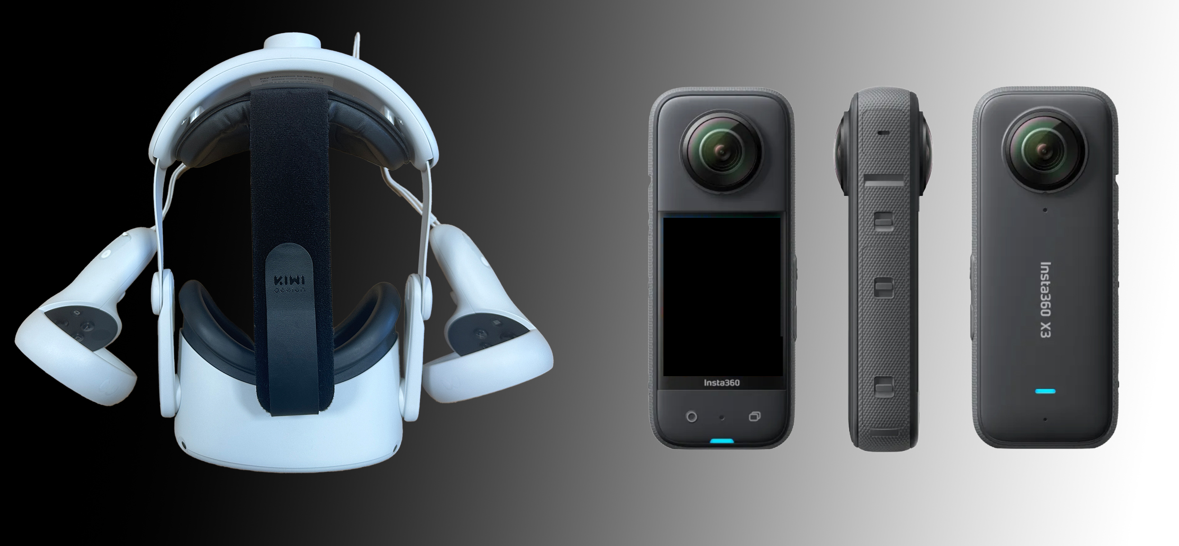

4. Interface of the VR-CPR (AATE VR®) application used for training in the VR group

