Supporting Information

Design, synthesis, and biological evaluation of novel 2-aminopyridine derivatives as potent VEGFR-2 inhibitors

Hui-min Liao^{1,2}, Ximneng Wan, Yang Jin², Ping Gong^{*1}

¹School of Pharmaceutical Engineering, Shenyang Pharmaceutical University, 103 Wenhua Road, Shenhe District, Shenyang 110016, PR China.
²Shenyang Xingqi Pharmaceutical Co., Ltd., Shenyang 110163, PR China.

*Corresponding author, e-mail: gongpinggp@126.com

¹H NMR, ¹³C NMR and MS spectra of products
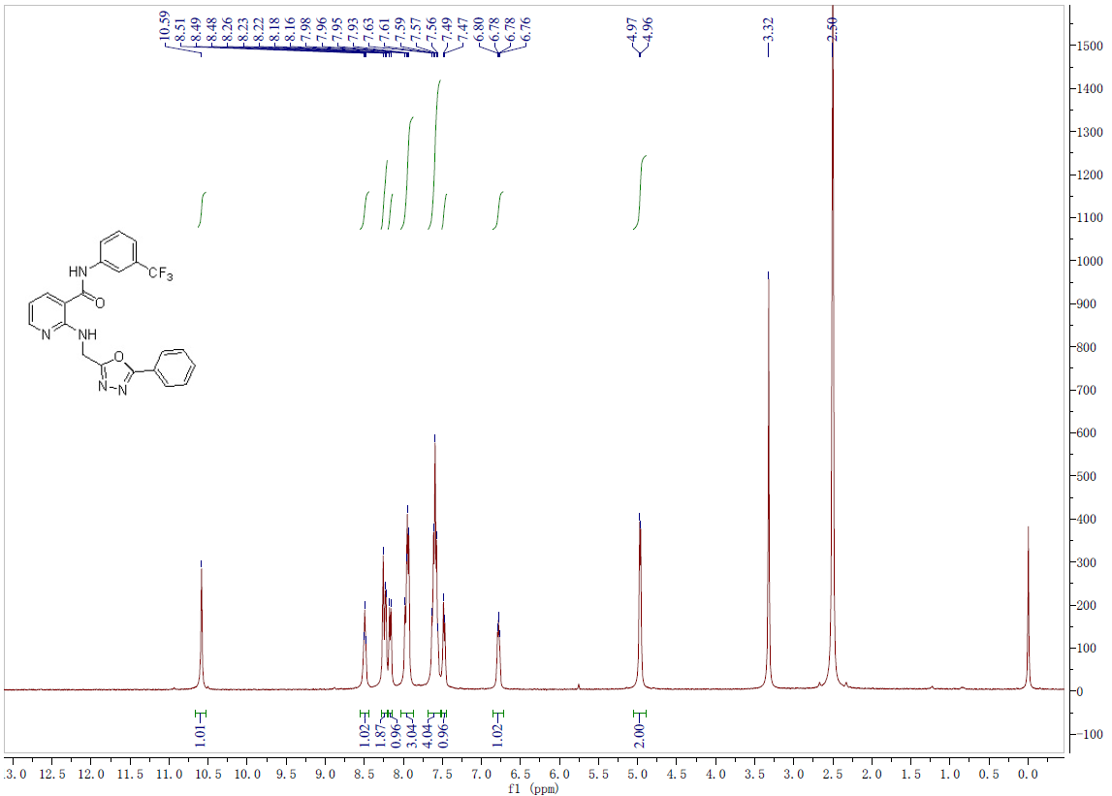
Fig.1-1 ¹H-NMR spectrum of compound 14

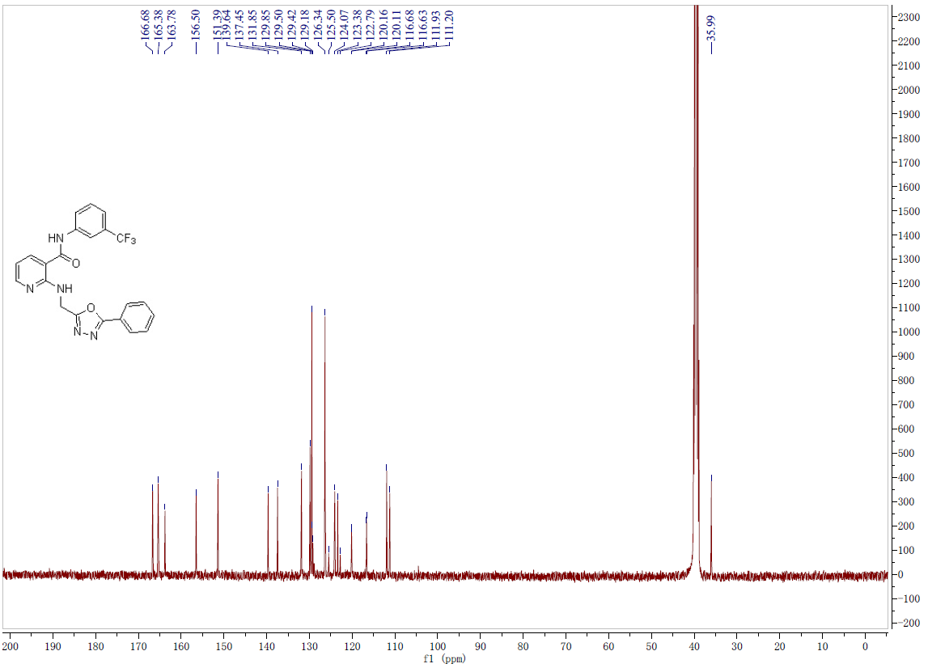
Fig.1-2 ¹³C-NMR spectrum of compound 14
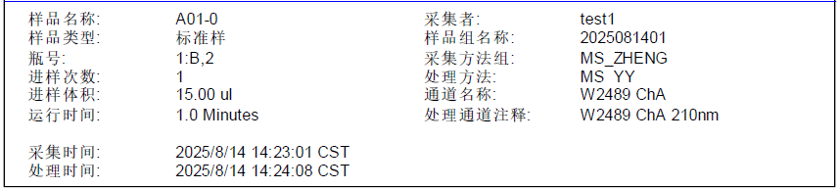
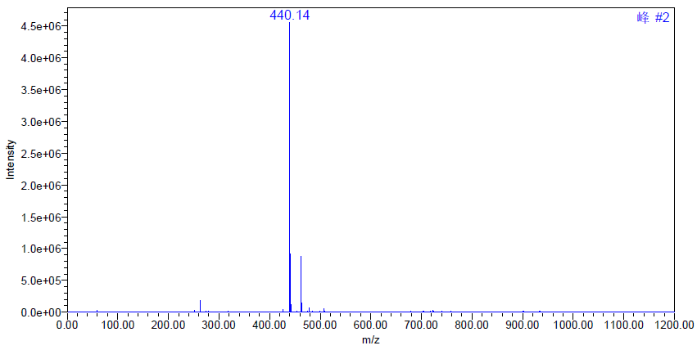
Fig.1-3 MS spectrum of compound 14
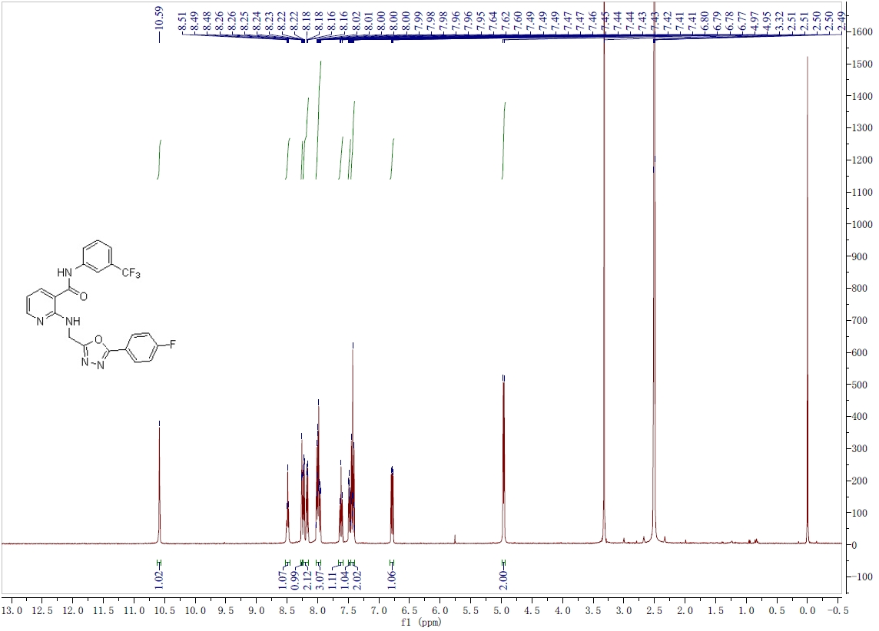
Fig.2-1 ¹H-NMR spectrum of compound 15
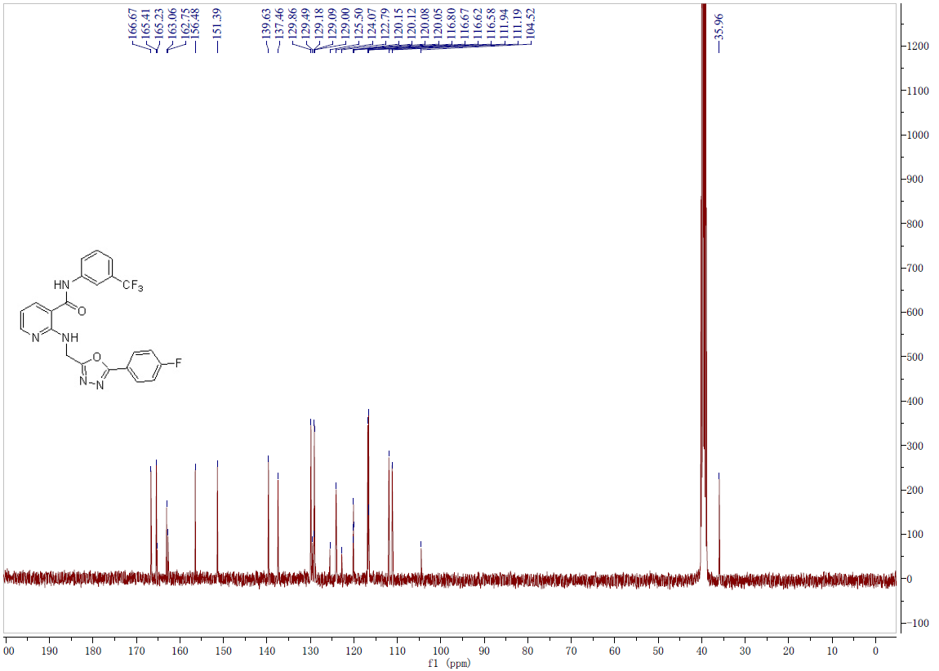
Fig.2-2 ¹³C-NMR spectrum of compound 15
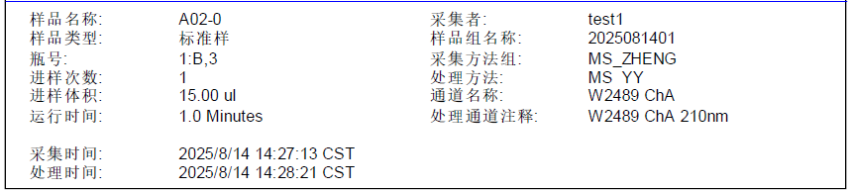
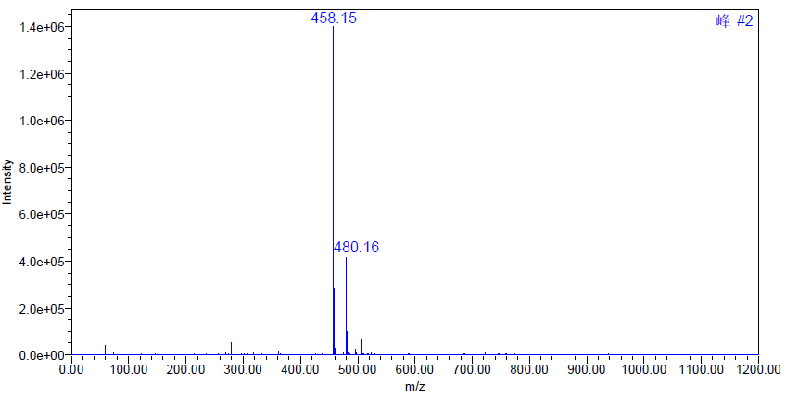
Fig.2-3 MS spectrum of compound 15
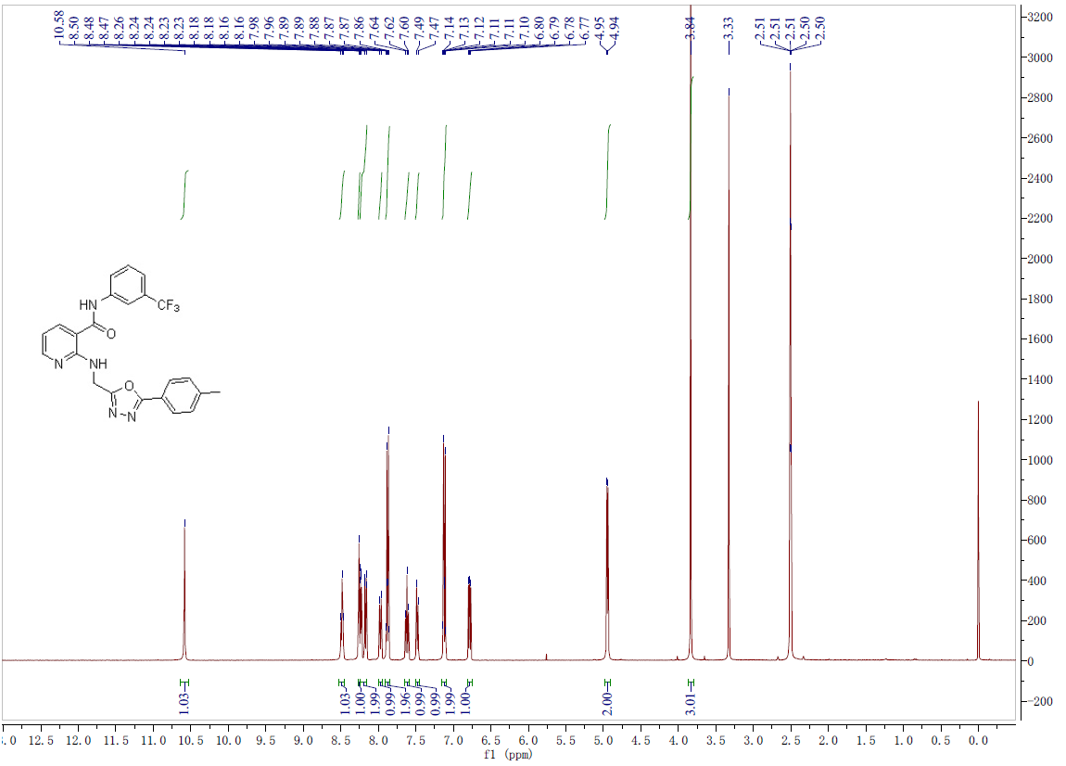
Fig.3-1 ¹H-NMR spectrum of compound 16

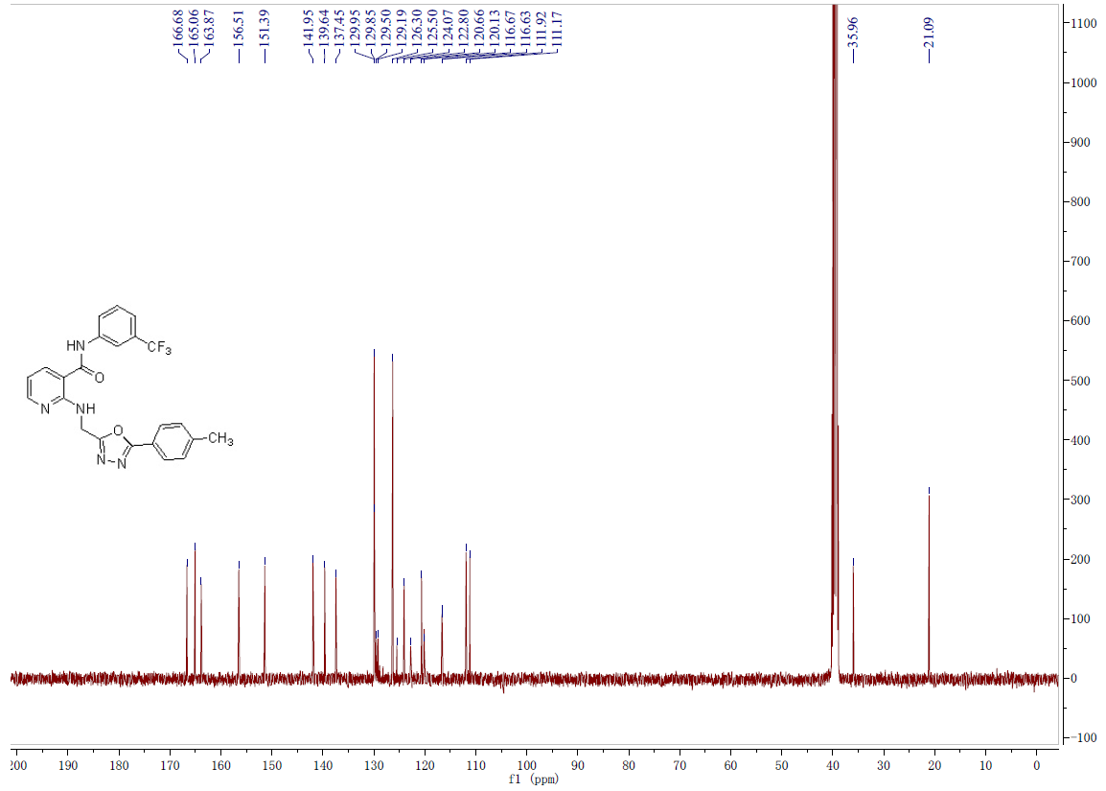
Fig.3-2 ¹³C-NMR spectrum of compound 16
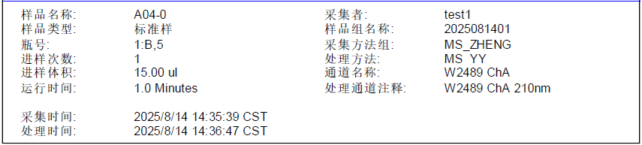
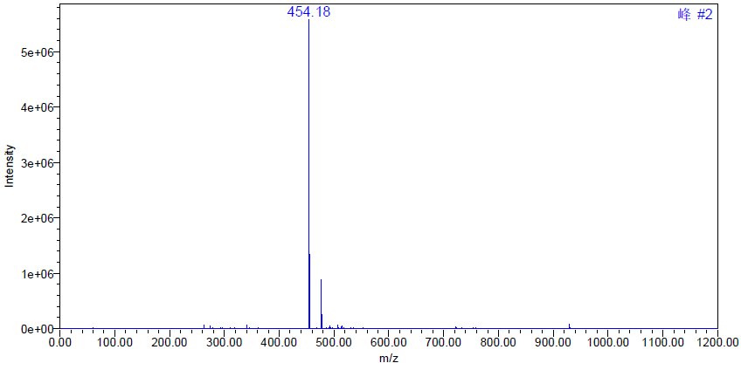
Fig.3-3 MS spectrum of compound 16
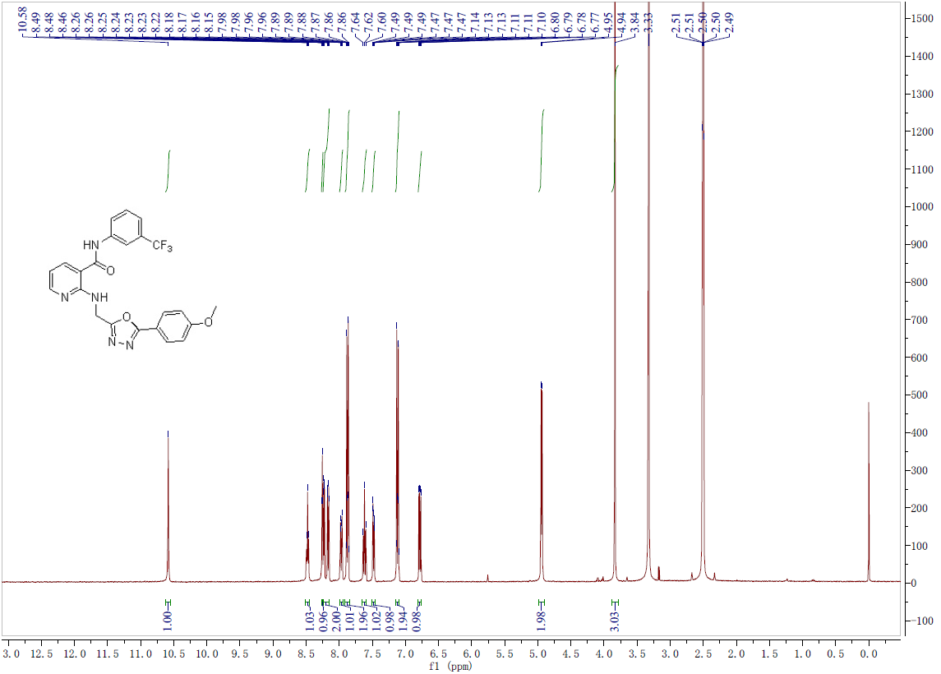
Fig.4-1 ¹H-NMR spectrum of compound 17
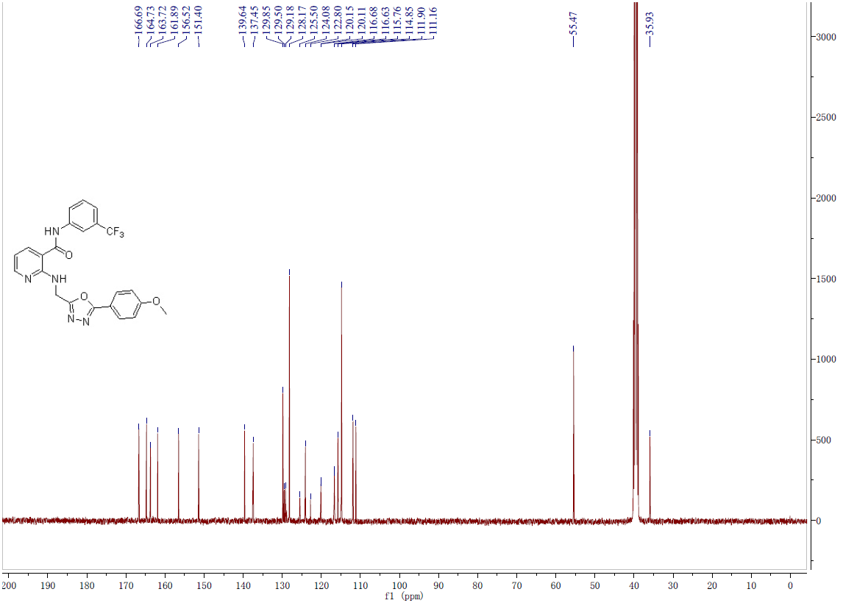
Fig.4-2 ¹³C-NMR spectrum of compound 17
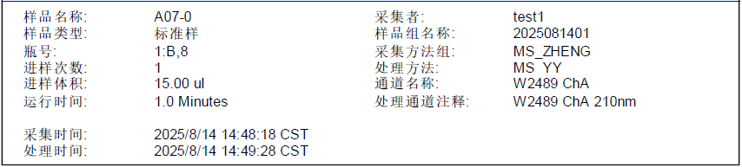
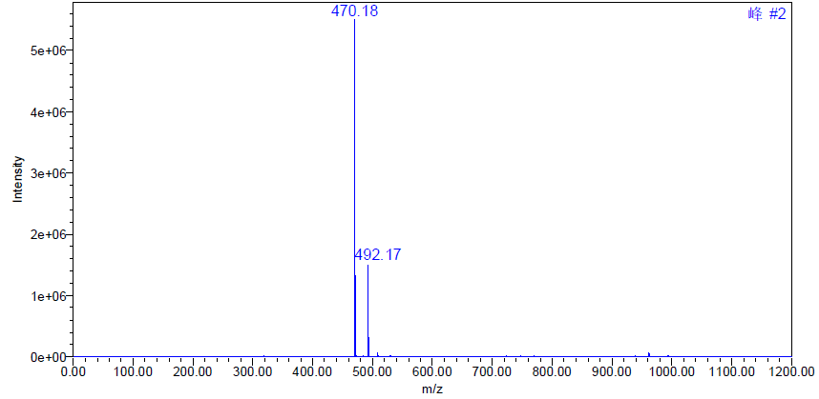
Fig.4-3 MS spectrum of compound 17
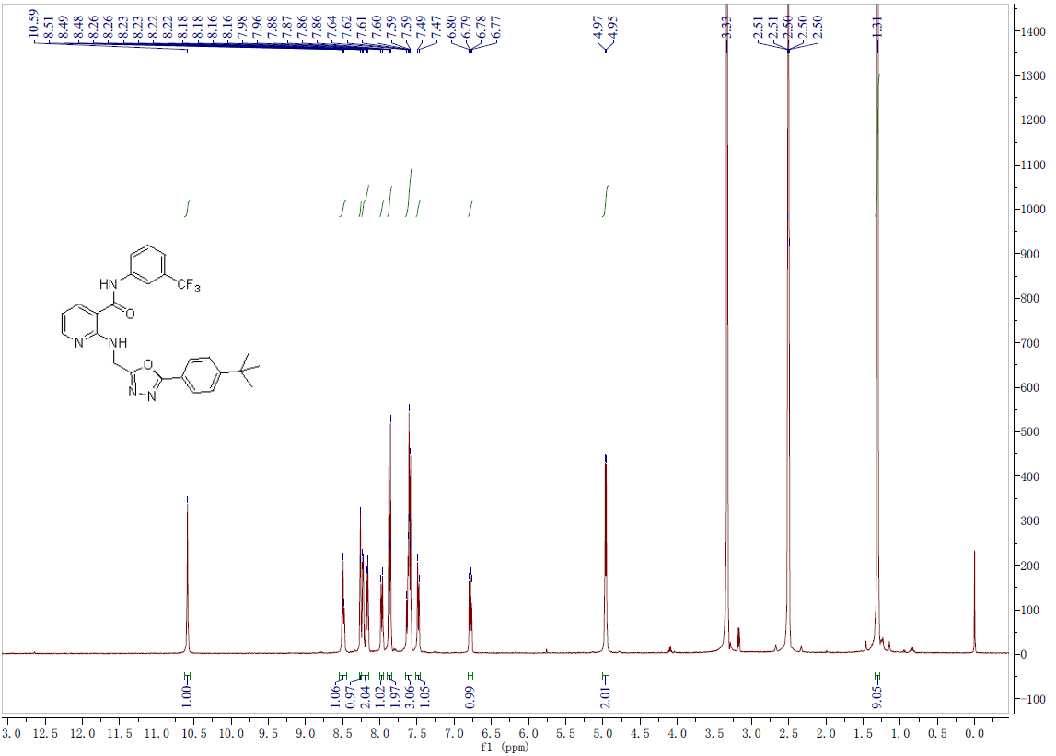
Fig.5-1 ¹H-NMR spectrum of compound 18

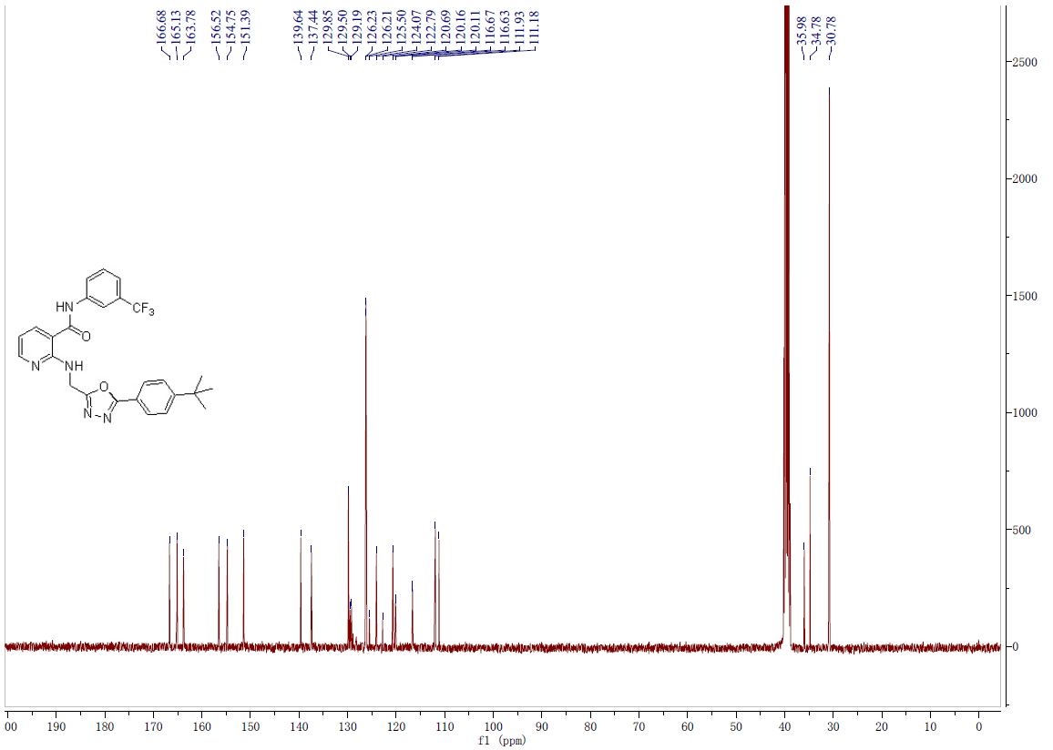
Fig.5-2 ¹³C-NMR spectrum of compound 18
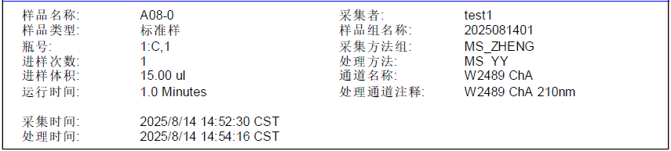
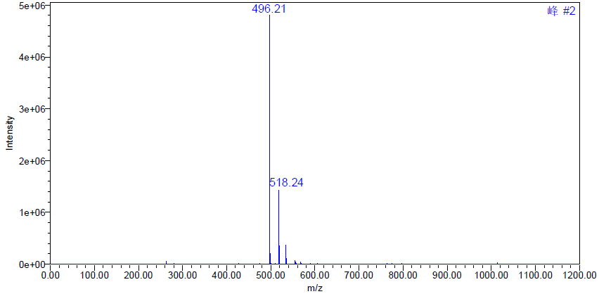
Fig.5-3 MS spectrum of compound 18
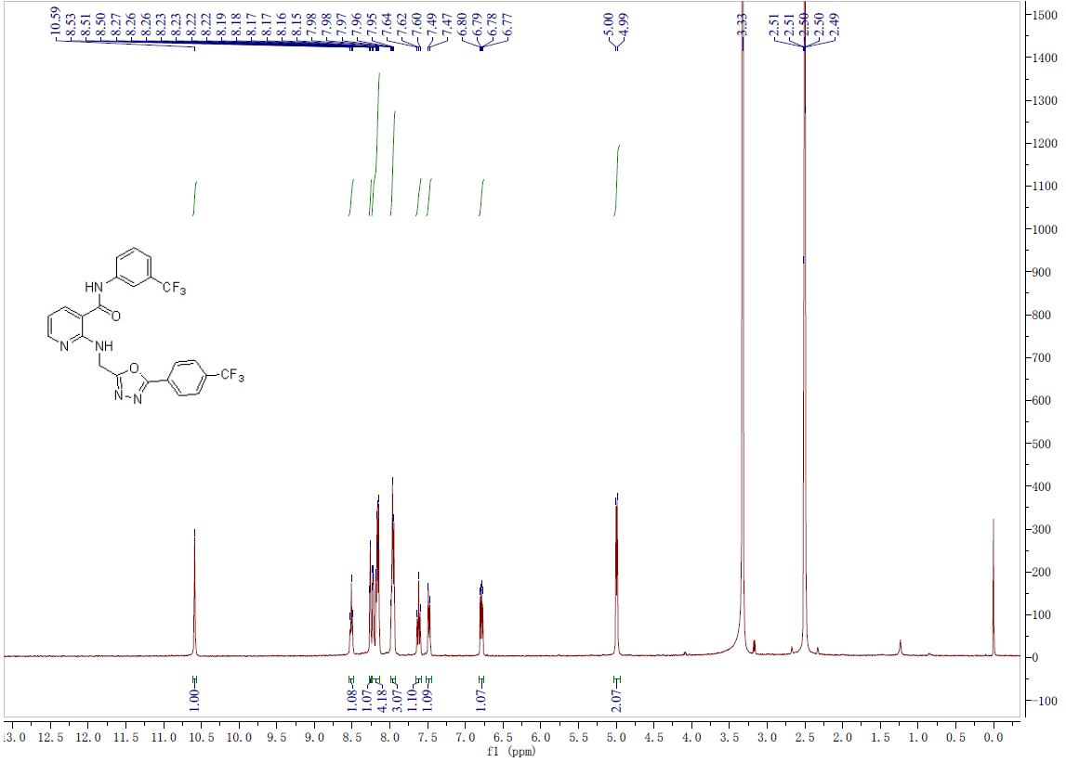
Fig.6-1 ¹H-NMR spectrum of compound 19
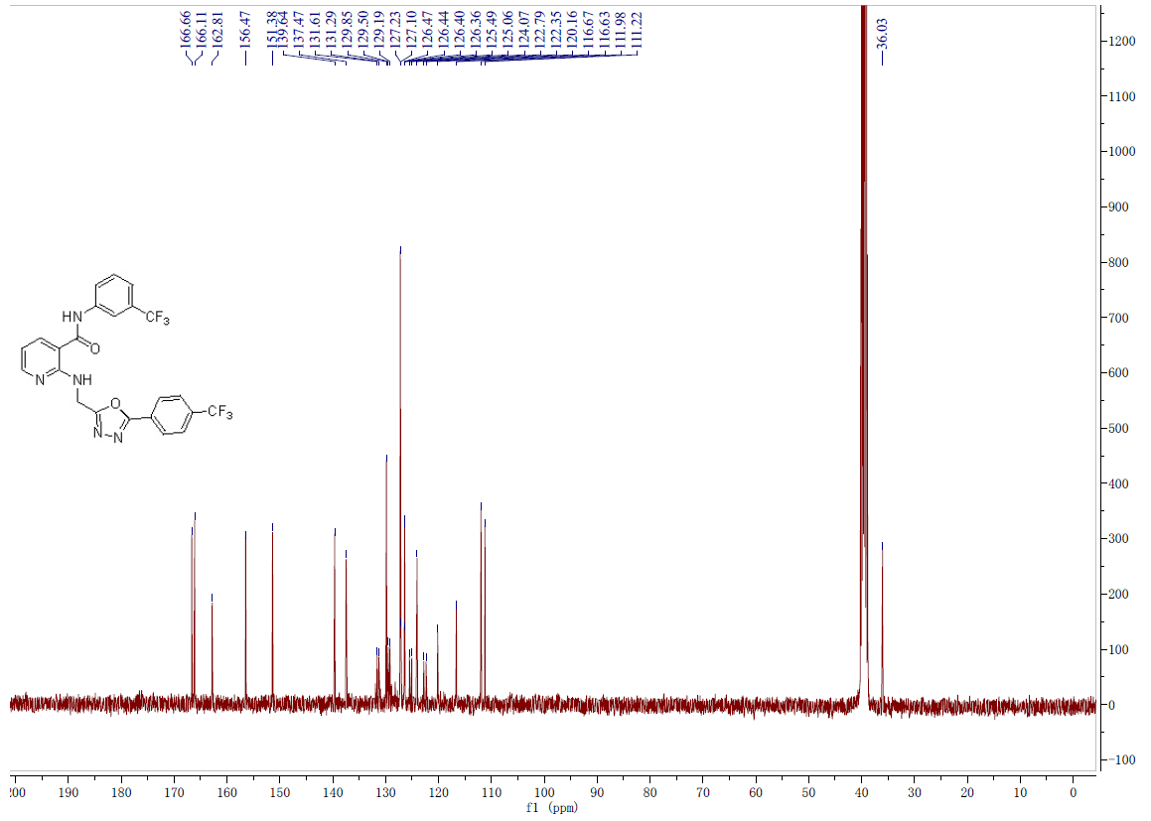
Fig.6-2 ¹³C-NMR spectrum of compound 19
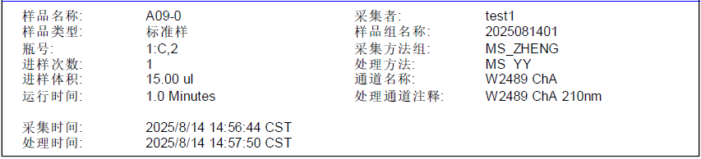
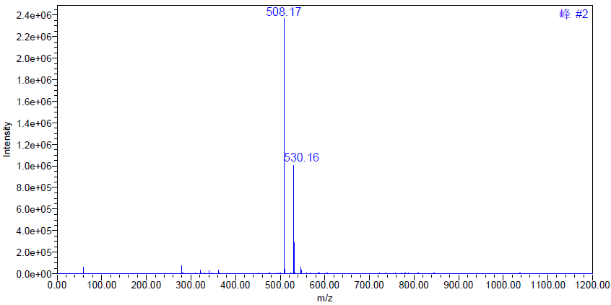
Fig.6-3 MS spectrum of compound 19
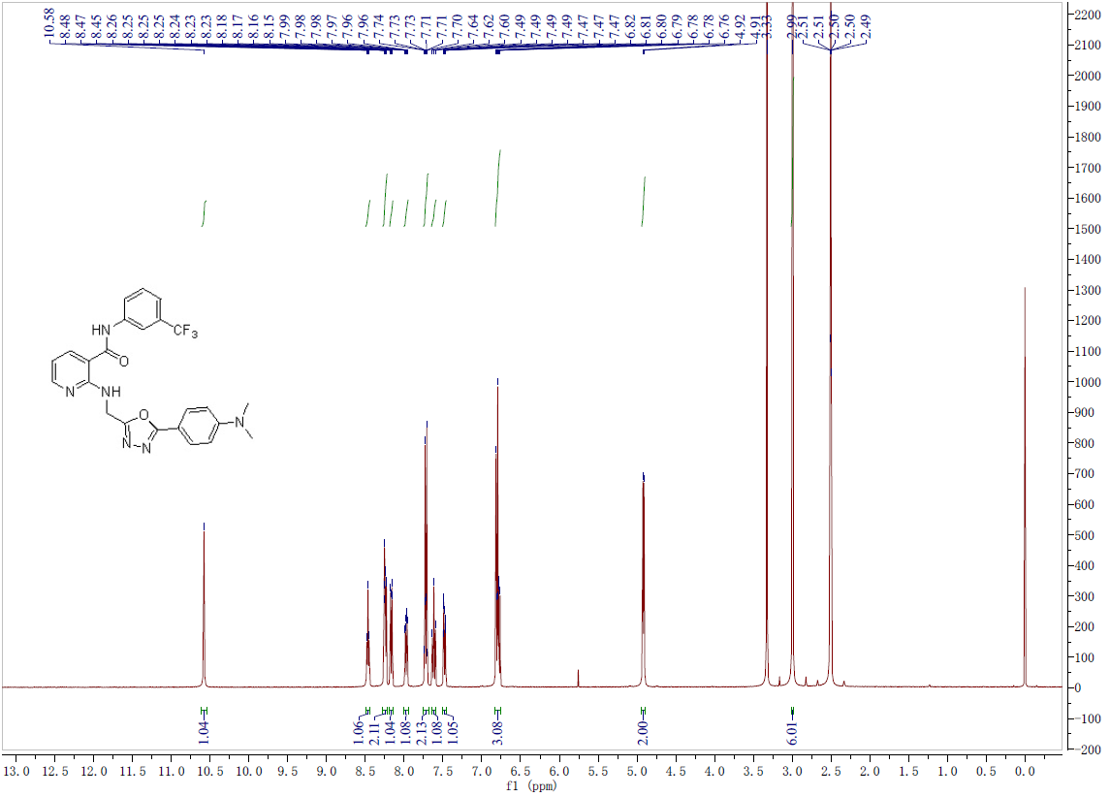
Fig.7-1 ¹H-NMR spectrum of compound 20

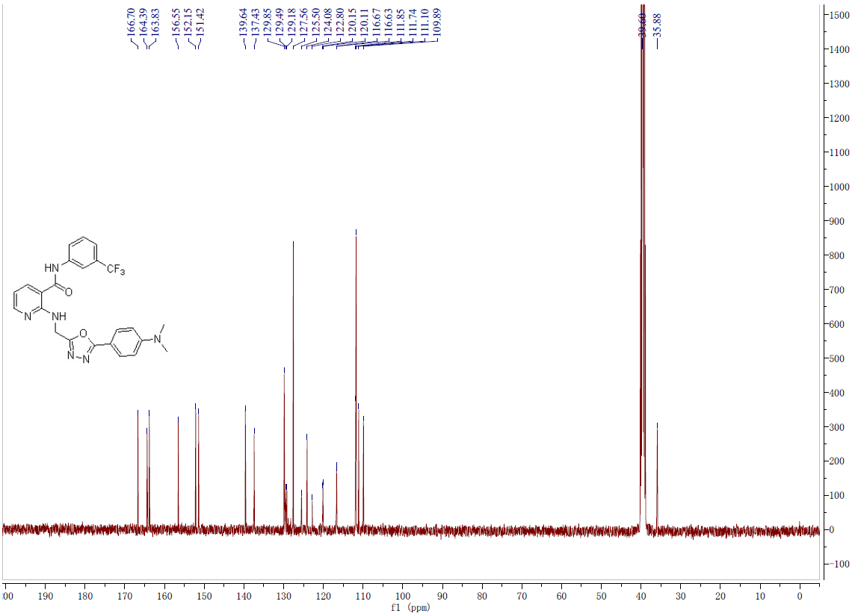
Fig.7-2 ¹³C-NMR spectrum of compound 20
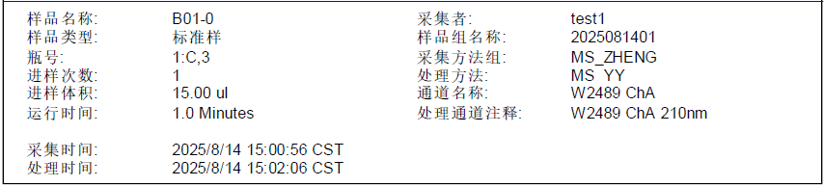
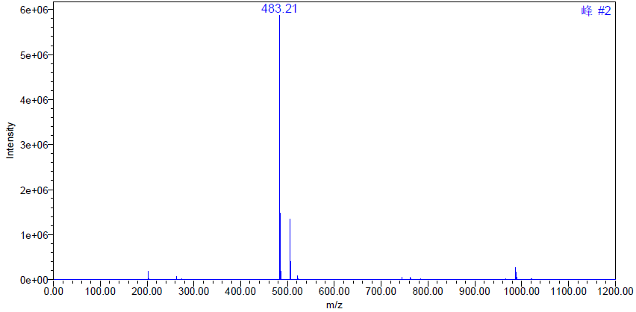
Fig.7-3 MS spectrum of compound 20
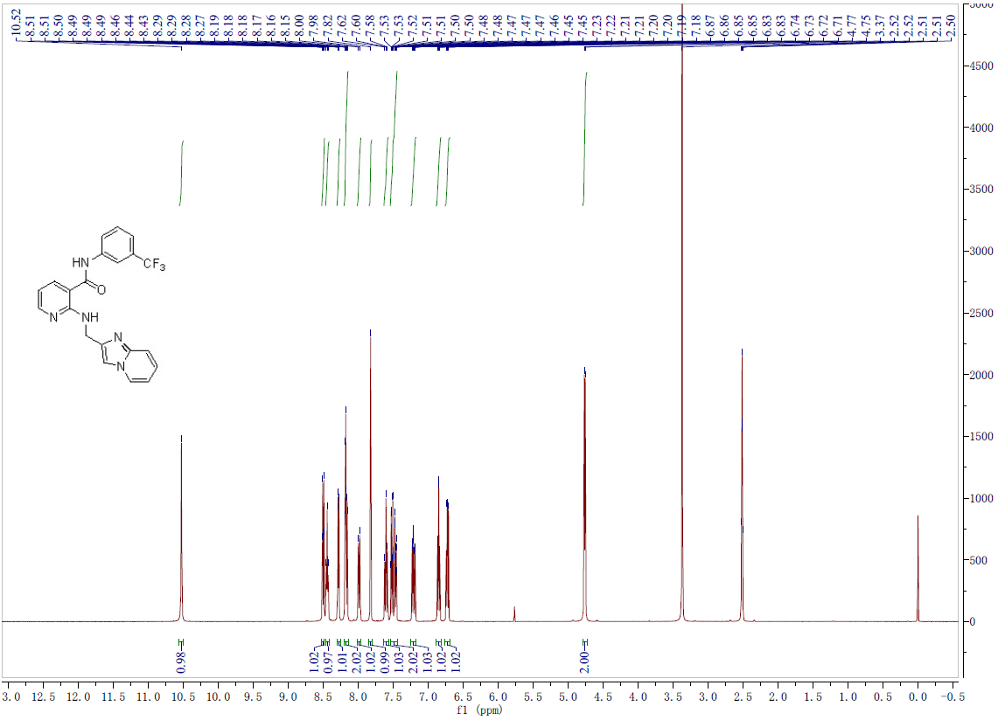
Fig.8-1 ¹H-NMR spectrum of compound 21
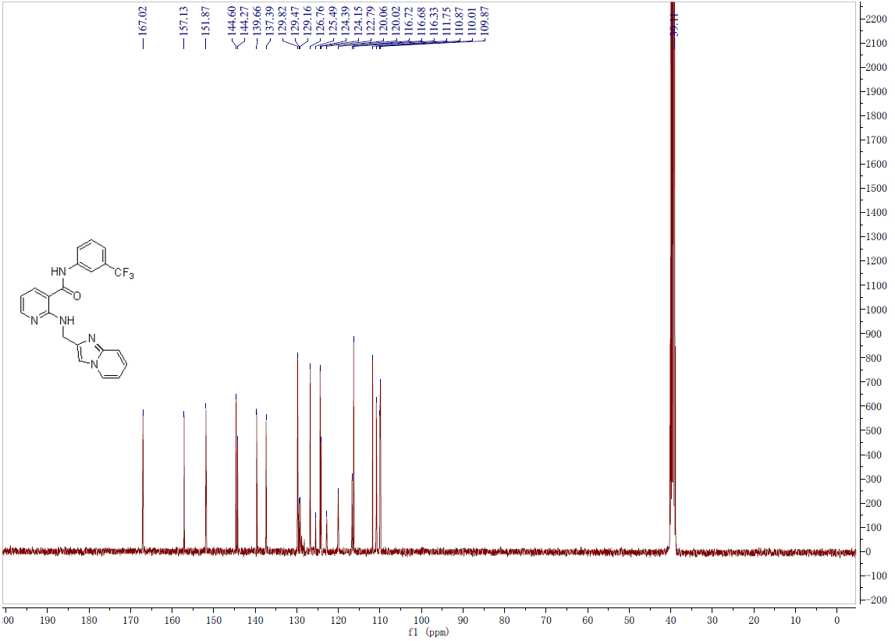
Fig.8-2 ¹³C-NMR spectrum of compound 21
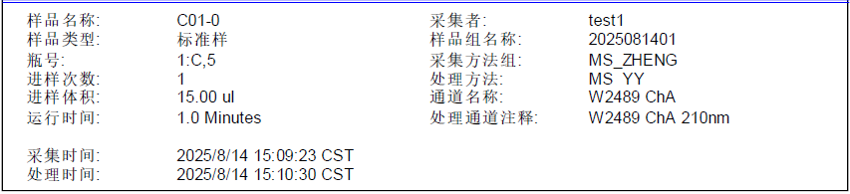
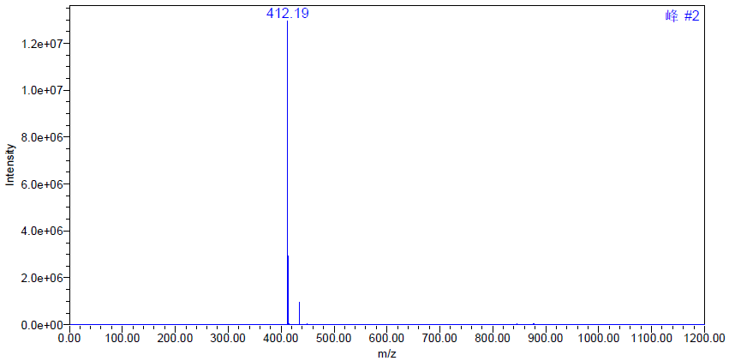
Fig.8-3 MS spectrum of compound 21
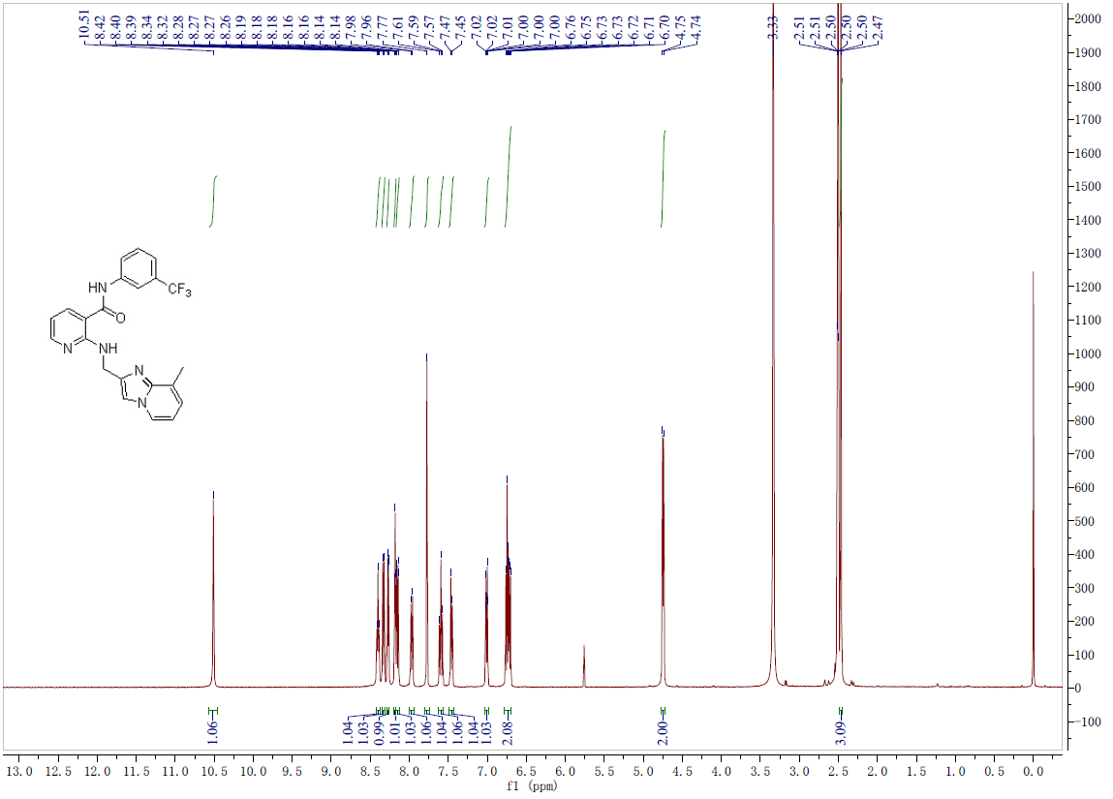
Fig.9-1 ¹H-NMR spectrum of compound 22

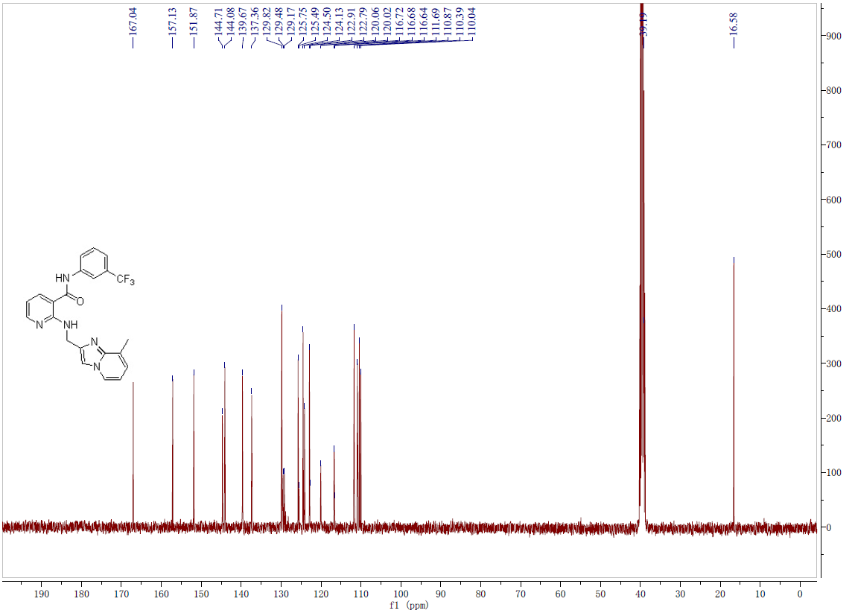
Fig.9-2 ¹³C-NMR spectrum of compound 22
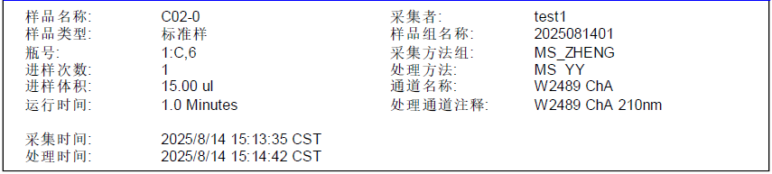
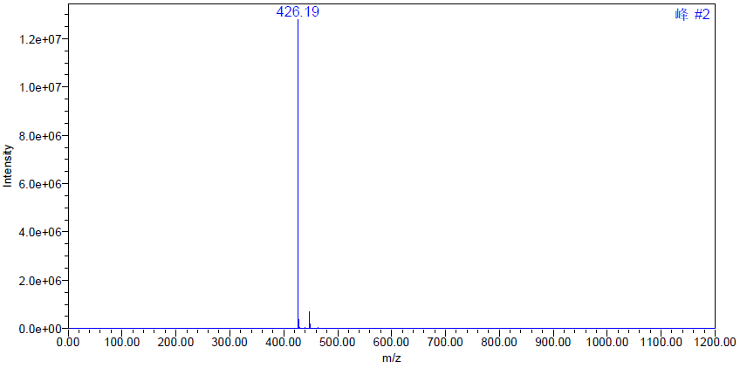
Fig.9-3 MS spectrum of compound 22
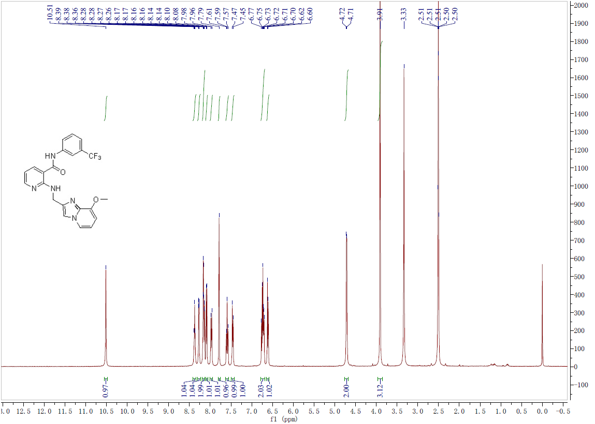
Fig.10-1 ¹H-NMR spectrum of compound 23
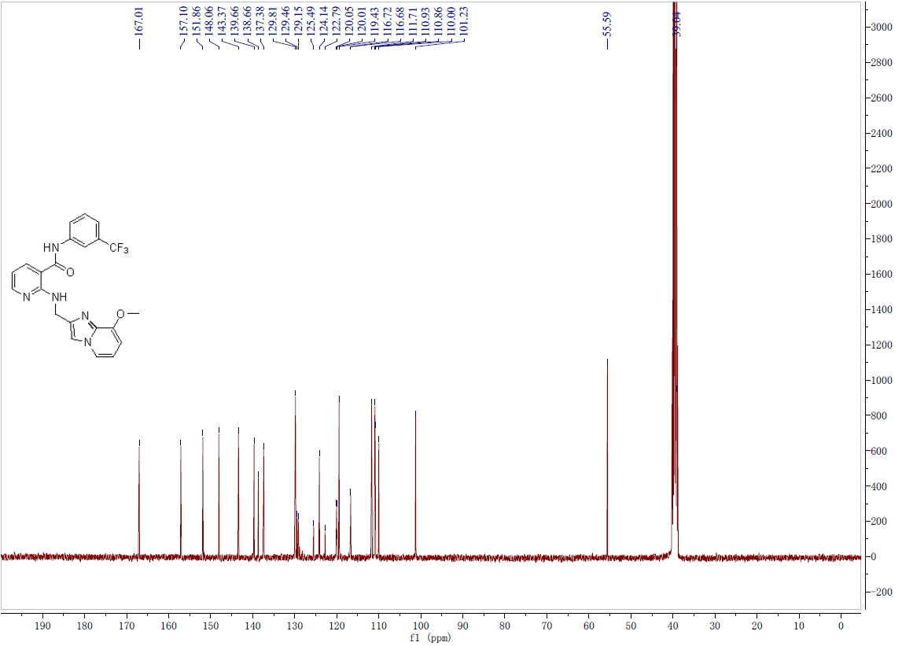
Fig.10-2 ¹³C-NMR spectrum of compound 23
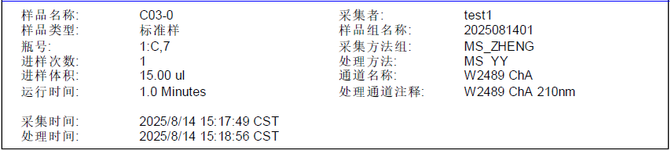
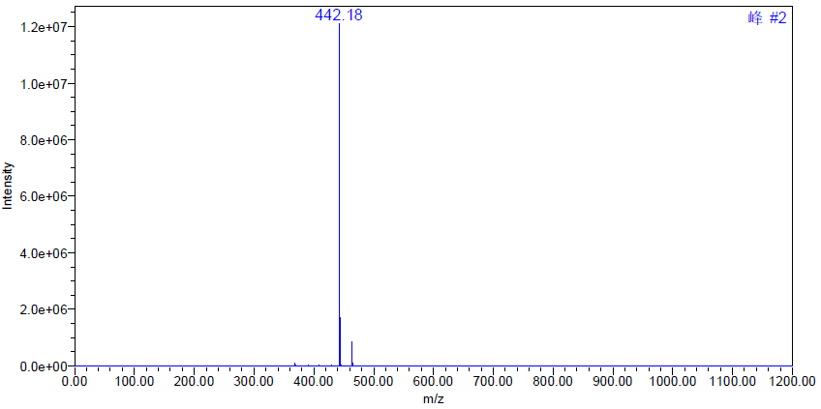
Fig.10-3 MS spectrum of compound 23
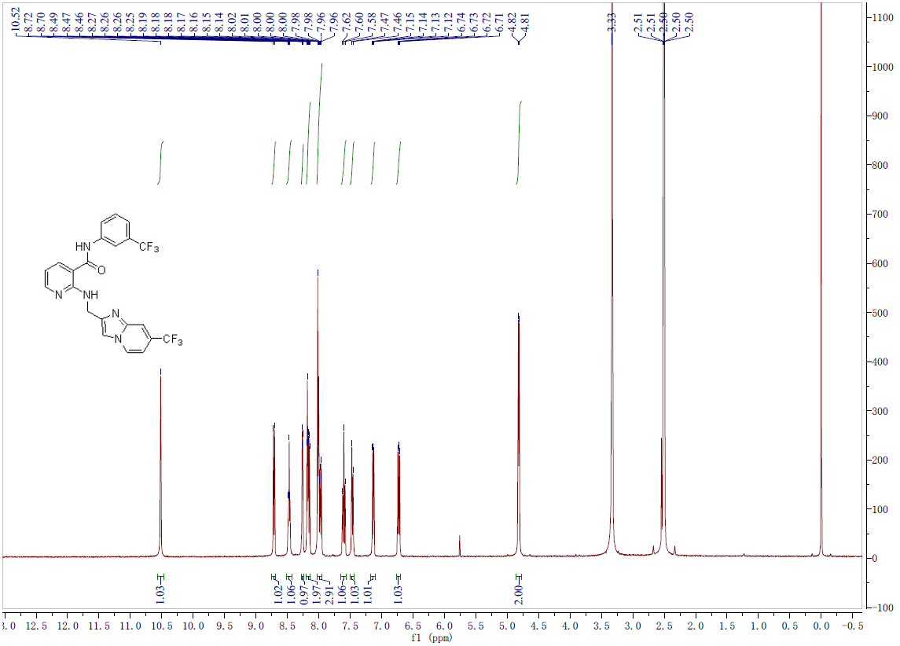
Fig.11-1 ¹H-NMR spectrum of compound 24

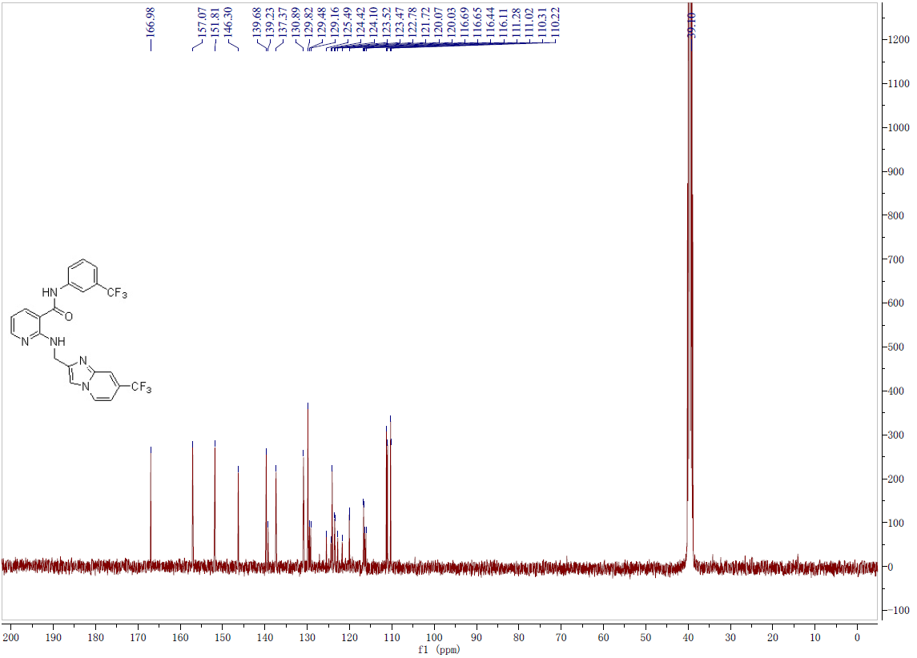
Fig.11-2 ¹³C-NMR spectrum of compound 24
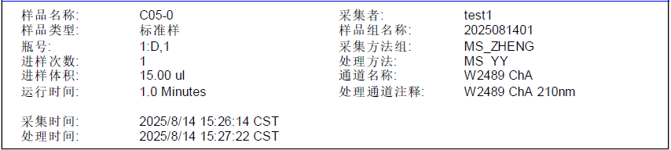
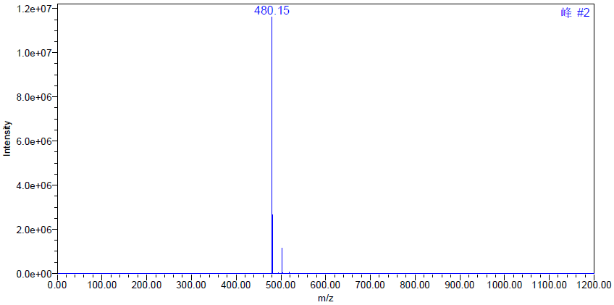
Fig.11-3 MS spectrum of compound 24
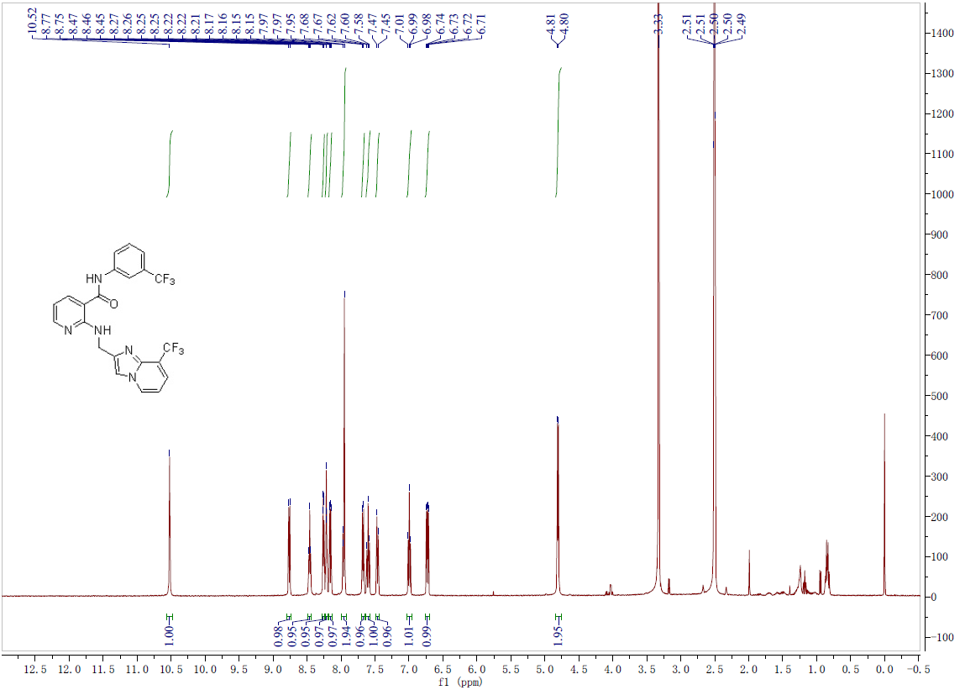
Fig.12-1 ¹H-NMR spectrum of compound 25
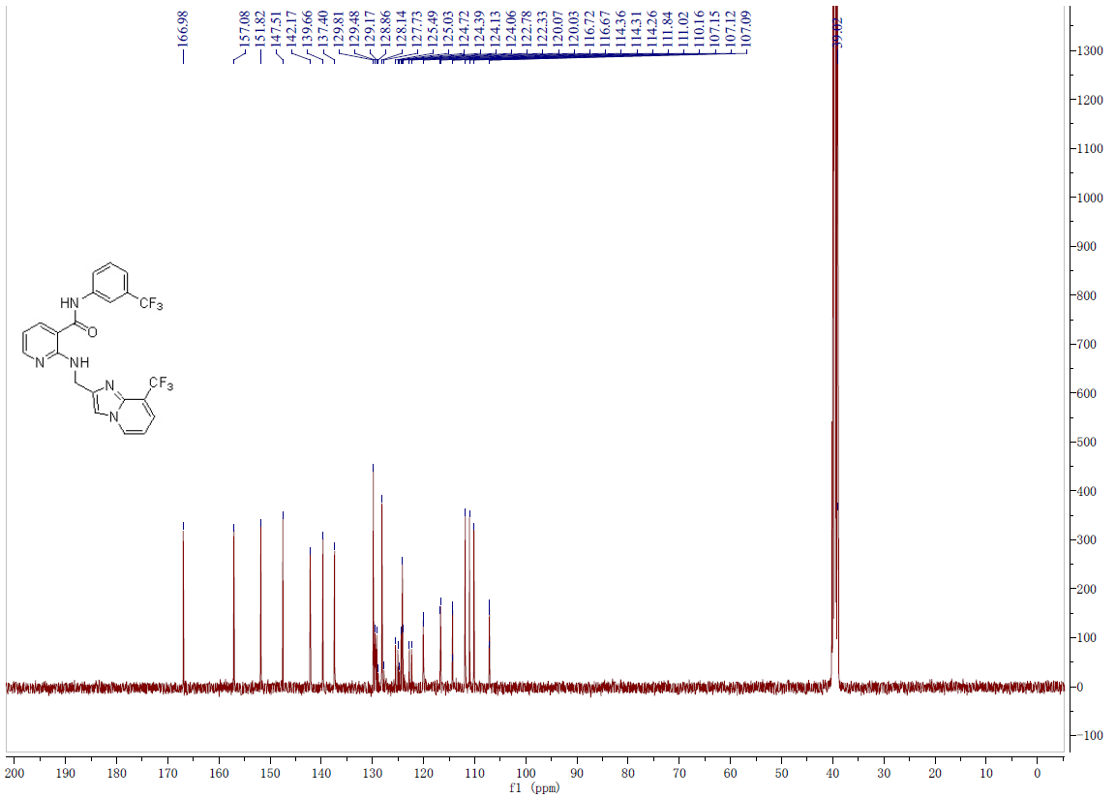
Fig.12-2 ¹³C-NMR spectrum of compound 25
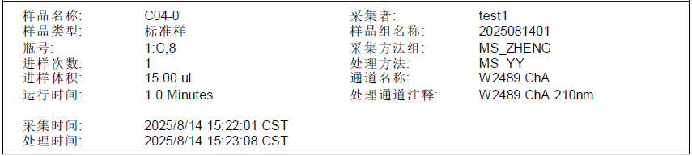
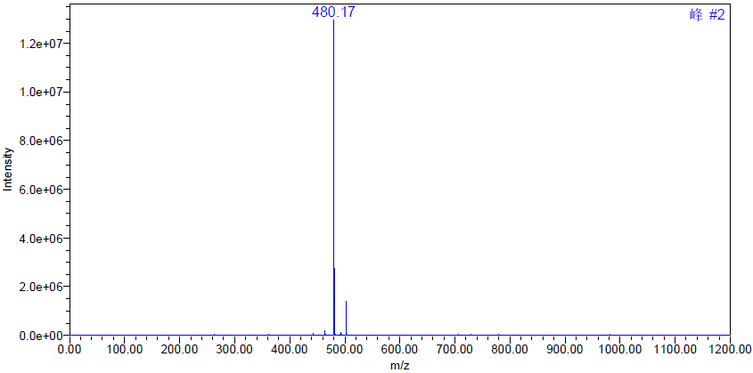
Fig.12-3 MS spectrum of compound 25
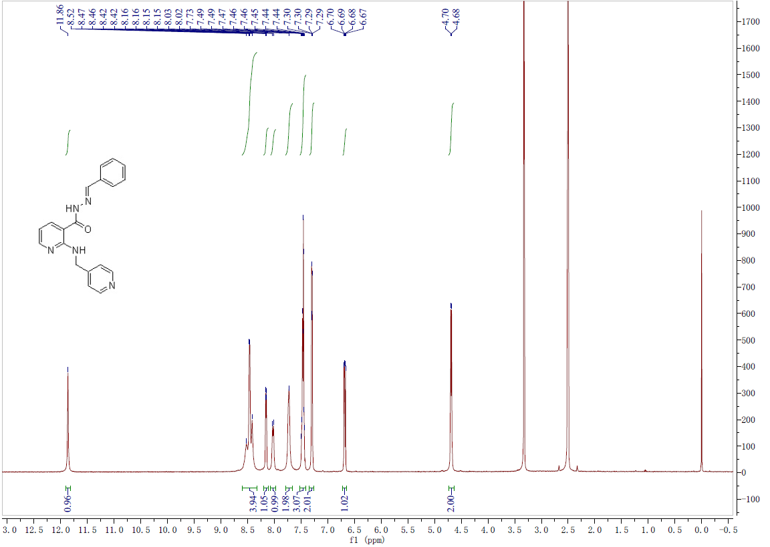
Fig.13-1 ¹H-NMR spectrum of compound 26

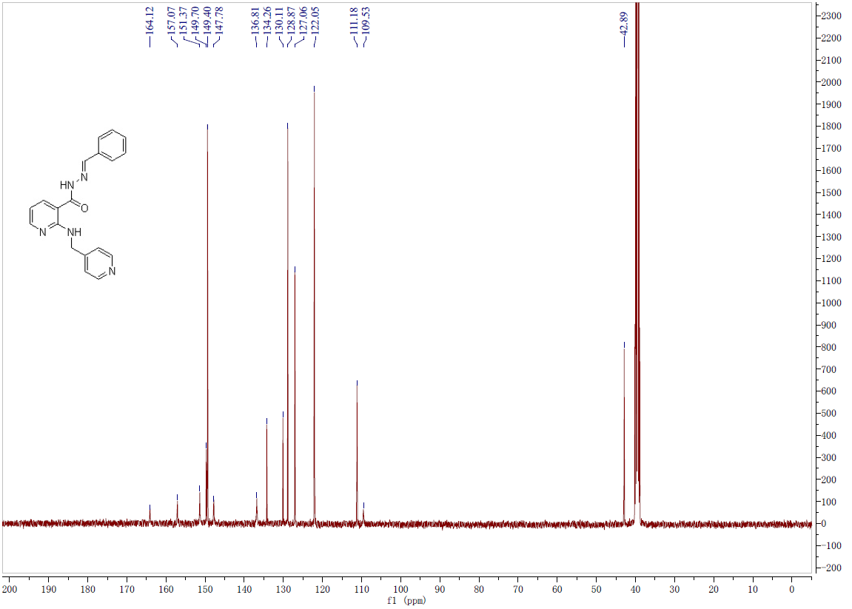
Fig.13-2 ¹³C-NMR spectrum of compound 26

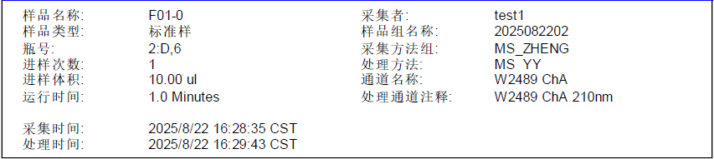
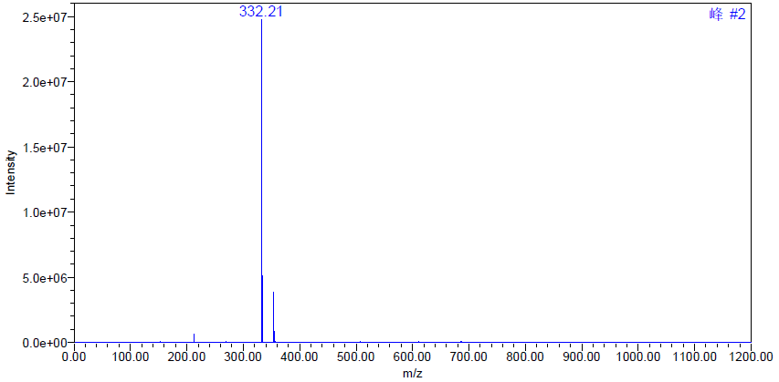
Fig.13-3 MS spectrum of compound 26

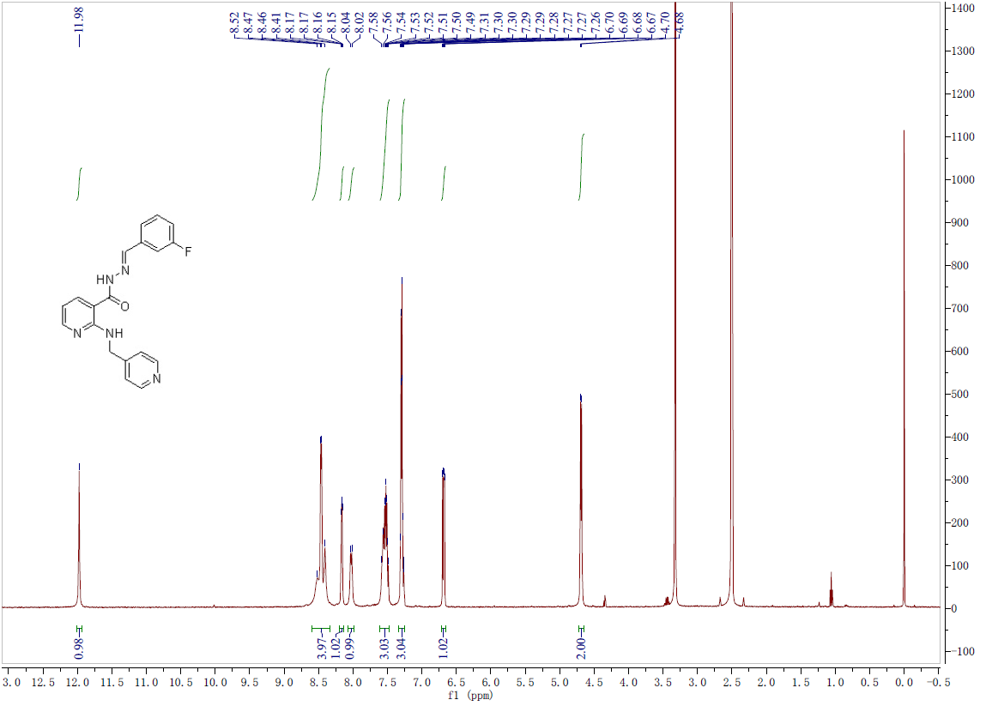
Fig.14-1 ¹H-NMR spectrum of compound 27
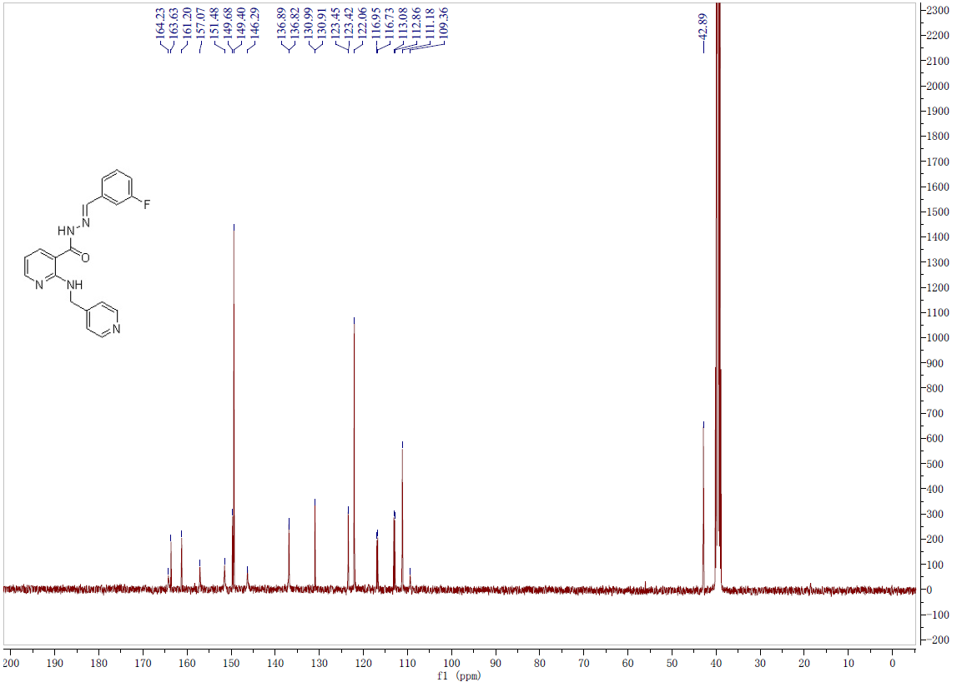
Fig.14-2 ¹³C-NMR spectrum of compound 27

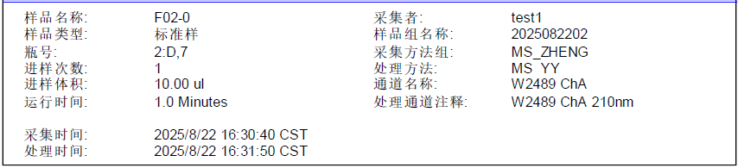
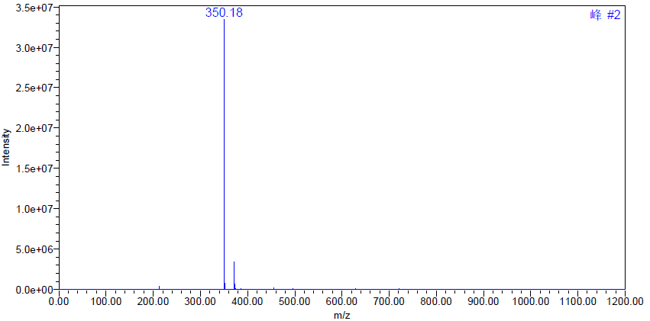
Fig.14-3 MS spectrum of compound 27
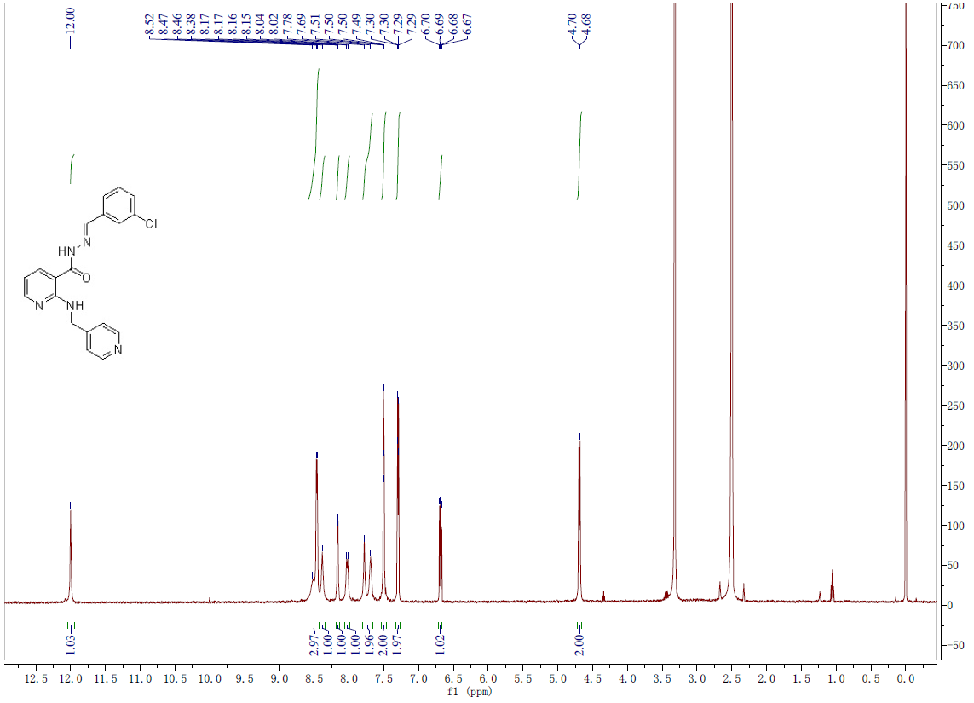
Fig.15-1 ¹H-NMR spectrum of compound 28

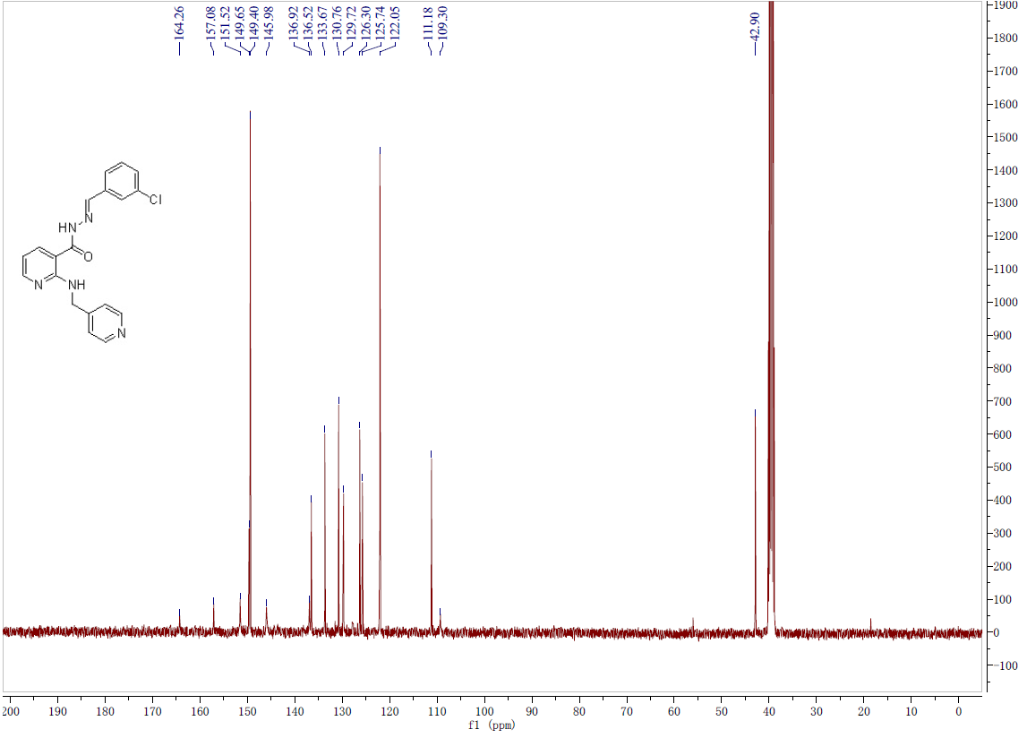
Fig.15-2 ¹³C-NMR spectrum of compound 28
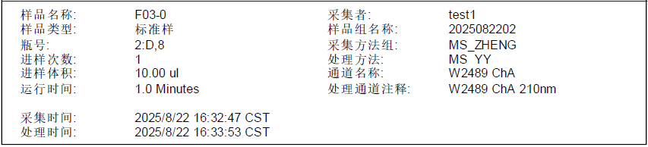
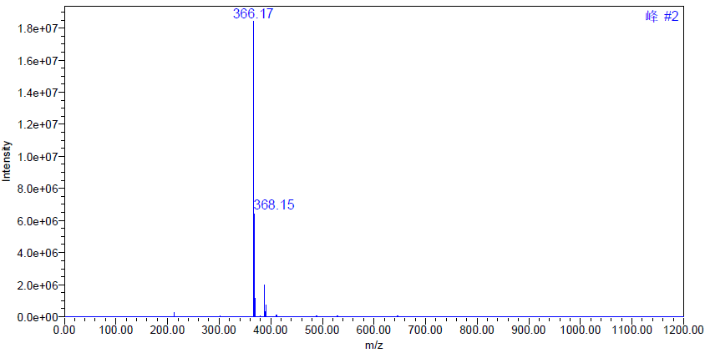
Fig.15-3 MS spectrum of compound 28
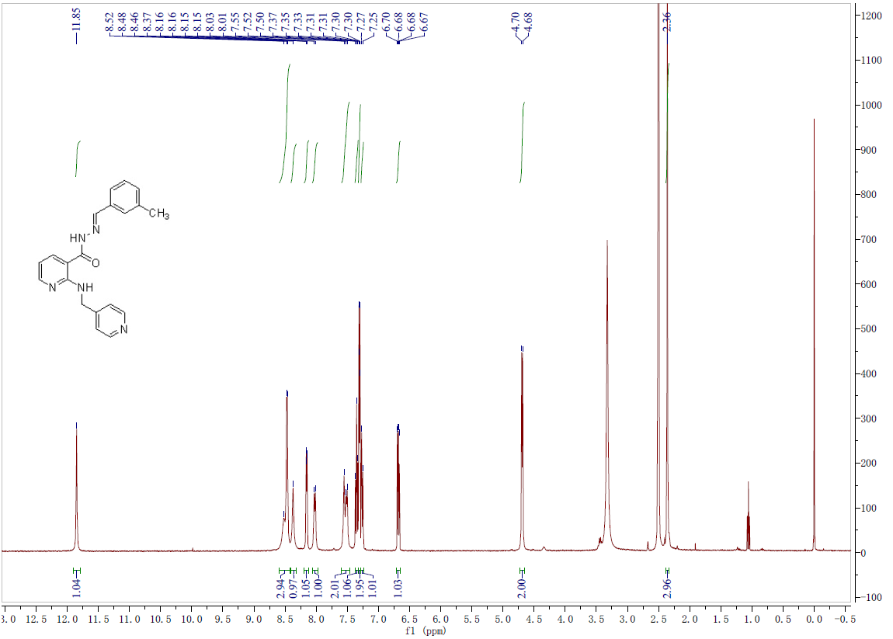
Fig.16-1 ¹H-NMR spectrum of compound 29
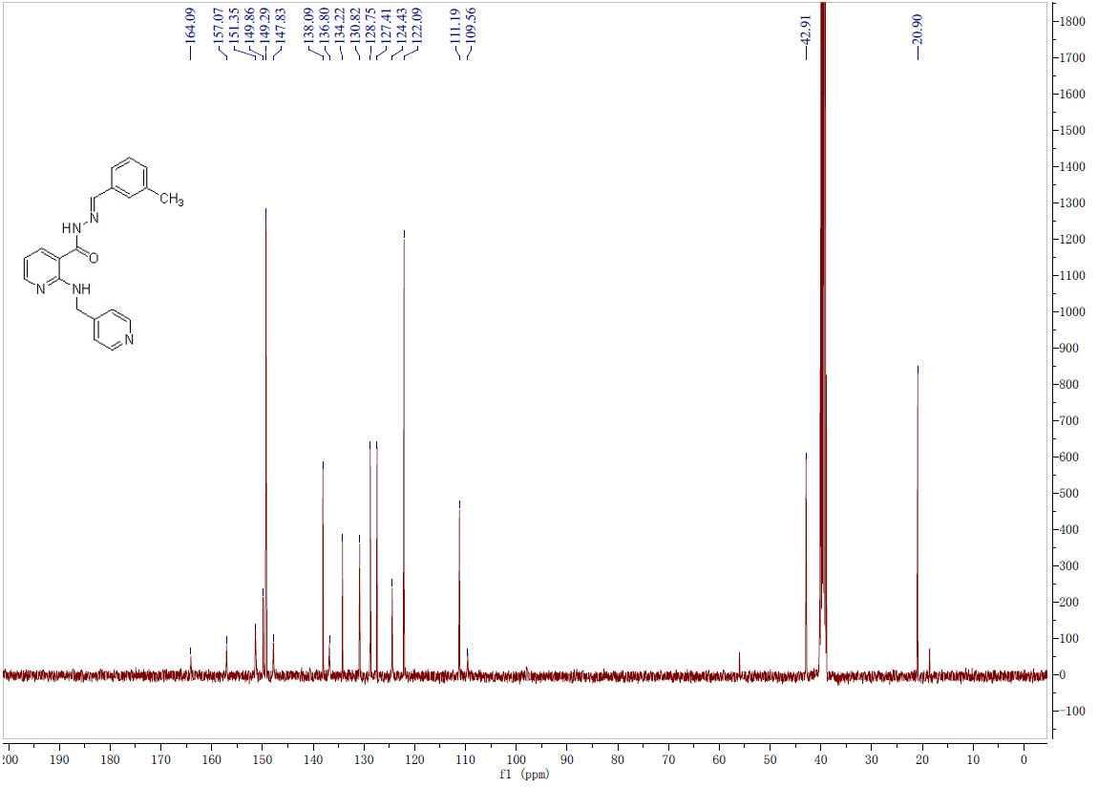
Fig.16-2 ¹³C-NMR spectrum of compound 29
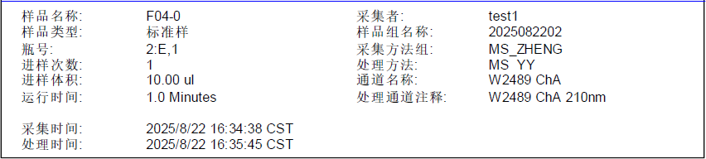
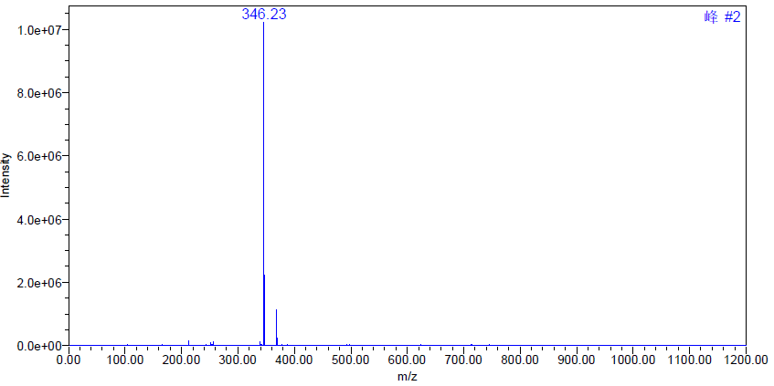
Fig.16-3 MS spectrum of compound 29
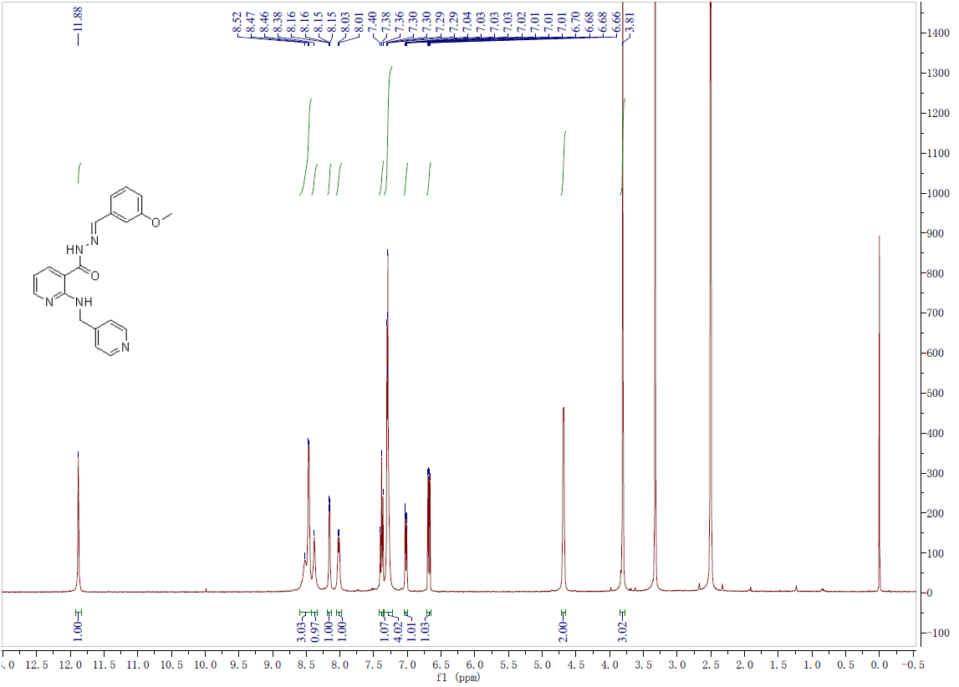
Fig.17-1 ¹H-NMR spectrum of compound 30
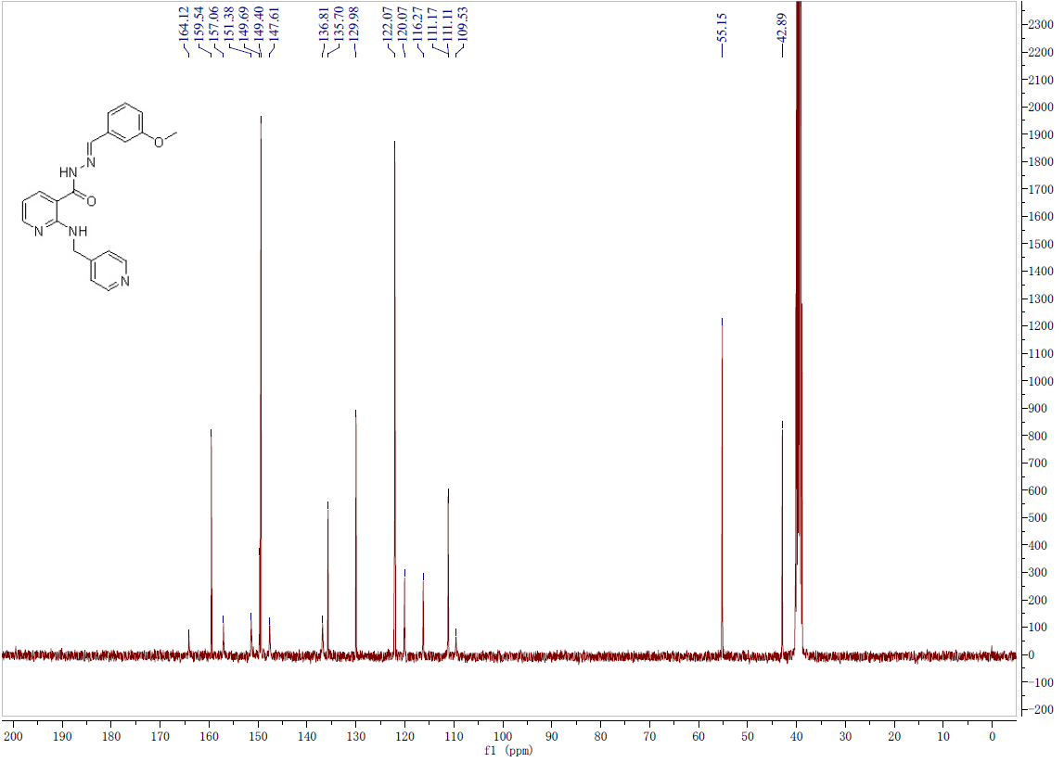
Fig.17-2 ¹³C-NMR spectrum of compound 30
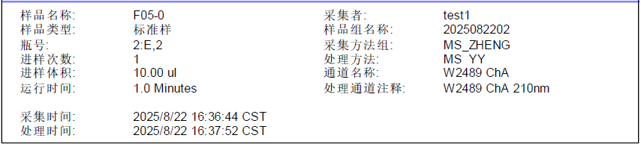
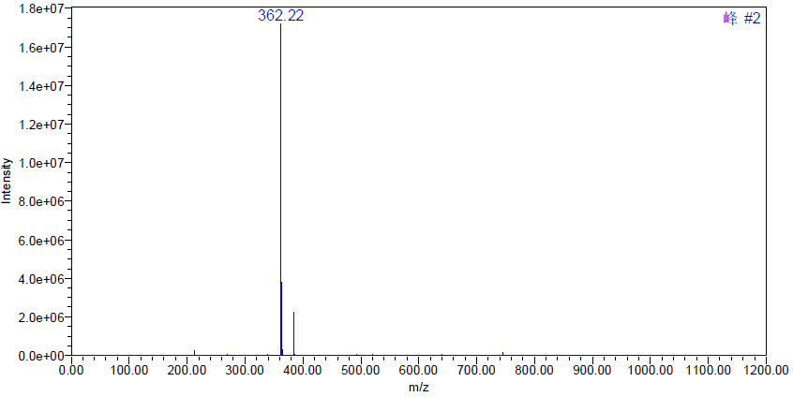
Fig.17-3 MS spectrum of compound 30
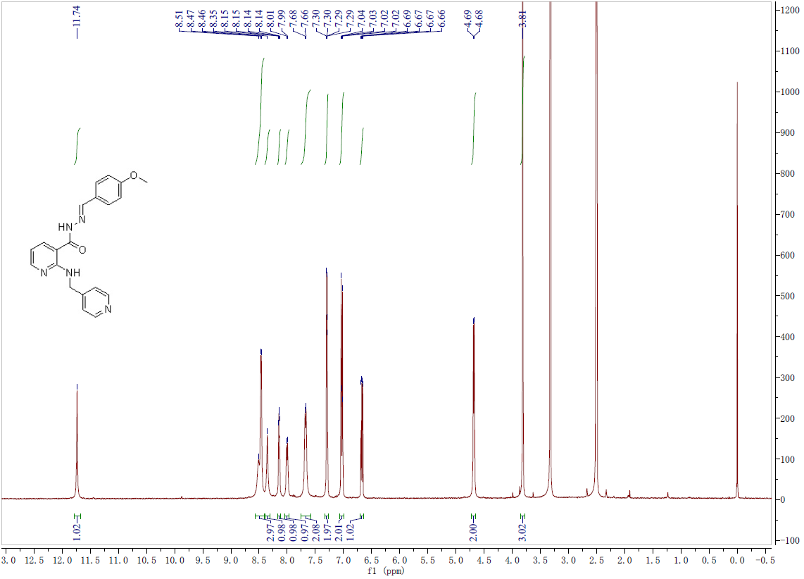
Fig.18-1 ¹H-NMR spectrum of compound 31
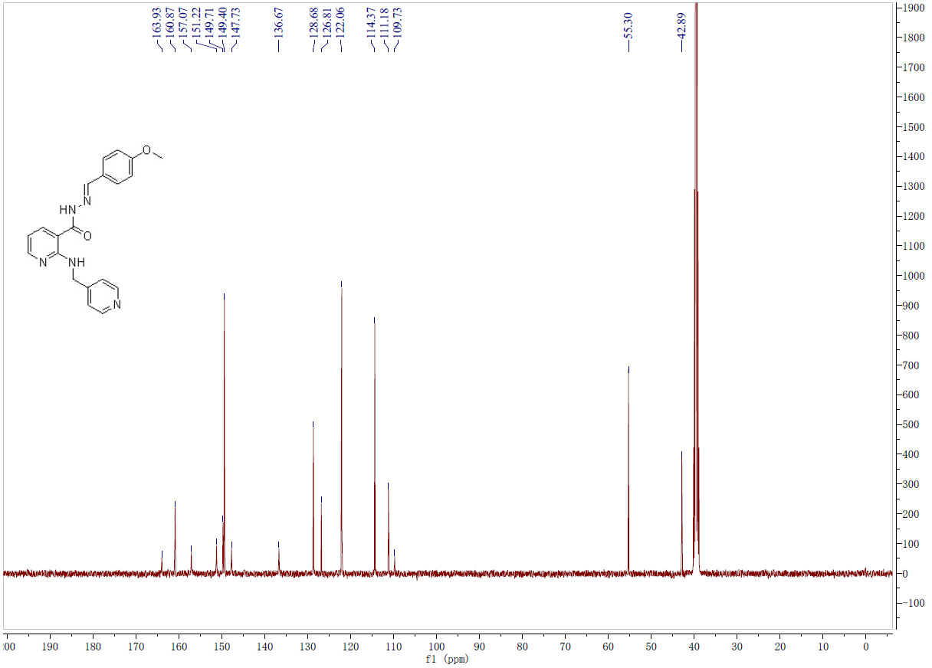
Fig.18-2 ¹³C-NMR spectrum of compound 31

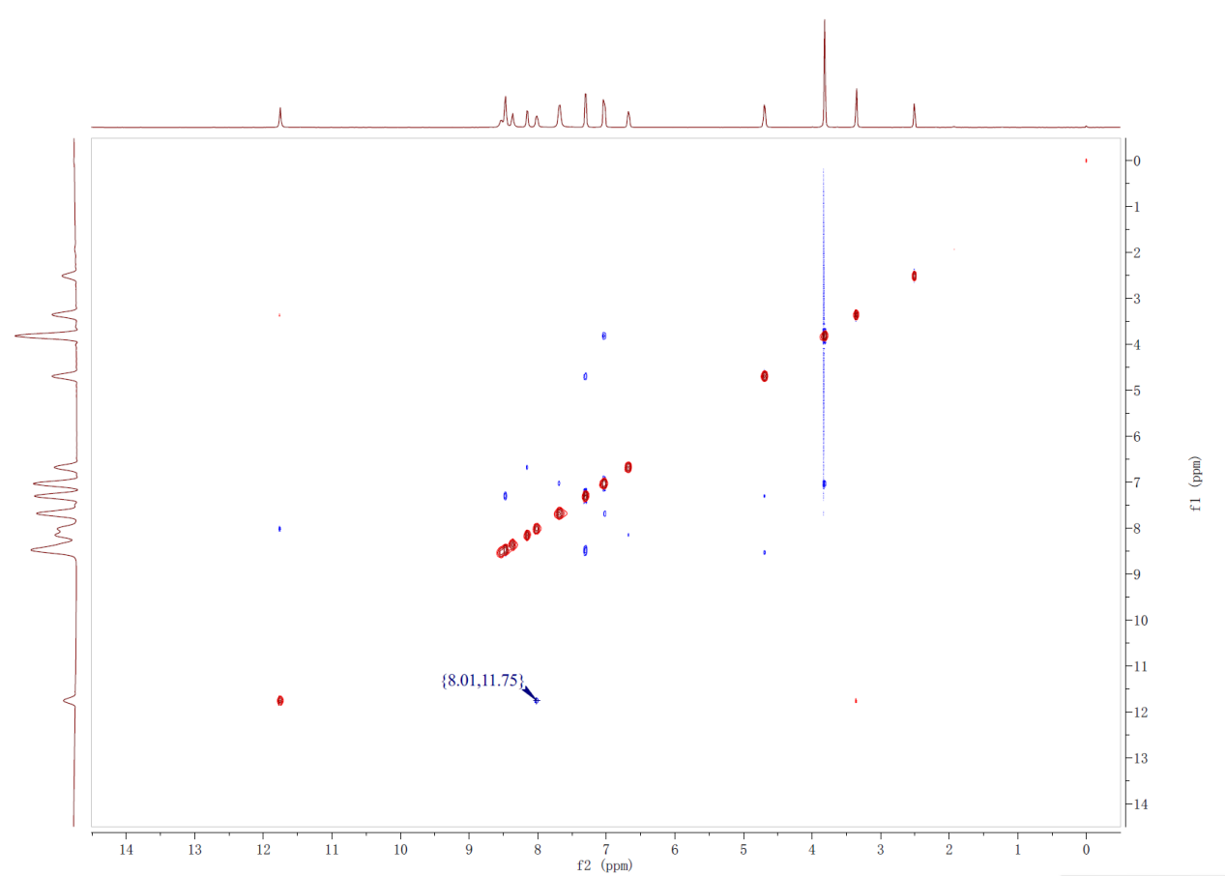
Fig.18-3 2D-NOESY spectrum of compound 31
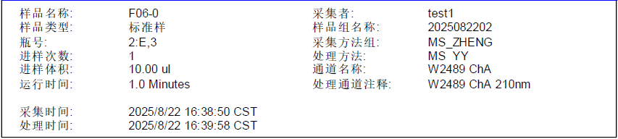
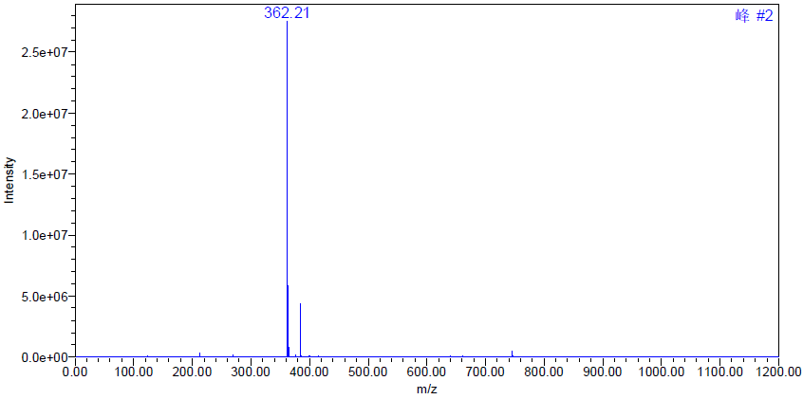
Fig.18-4 MS spectrum of compound 31
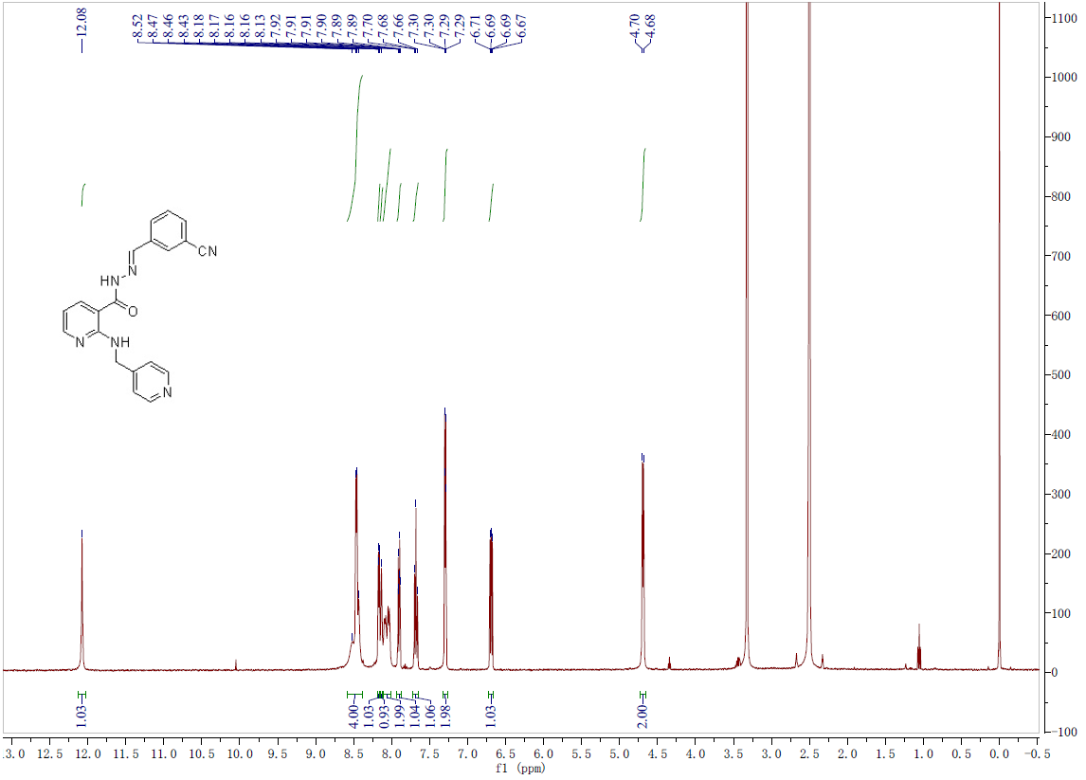
Fig.19-1 ¹H-NMR spectrum of compound 32
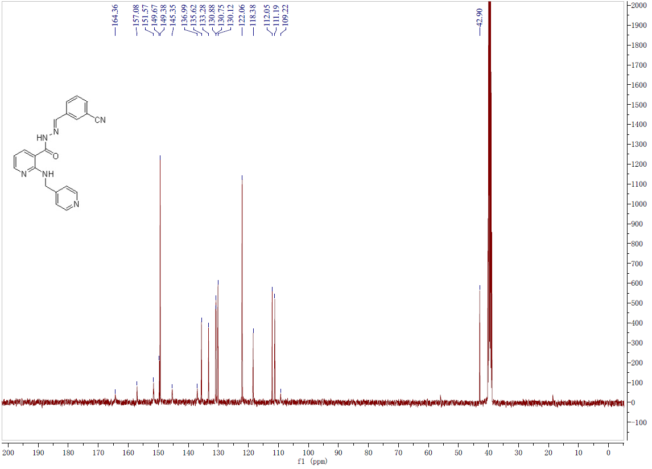
Fig.19-2 ¹³C-NMR spectrum of compound 32
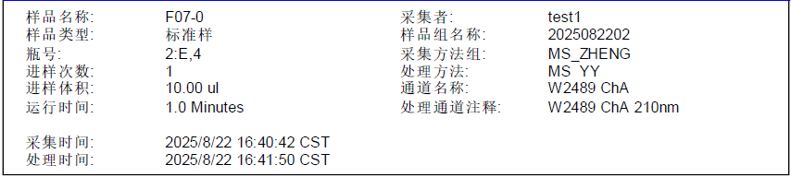
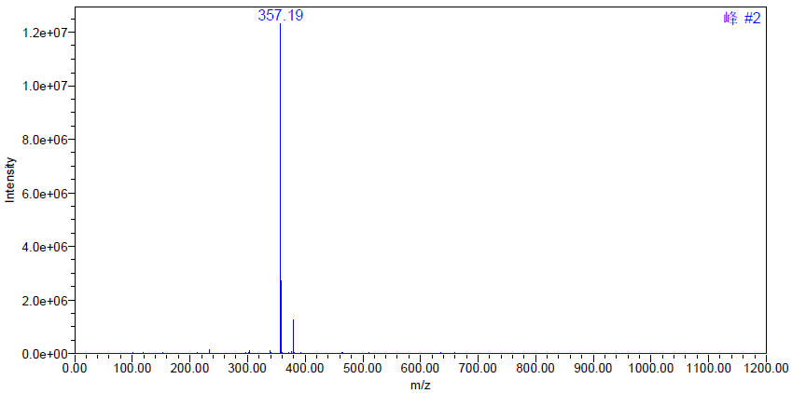
Fig.19-3 MS spectrum of compound 32
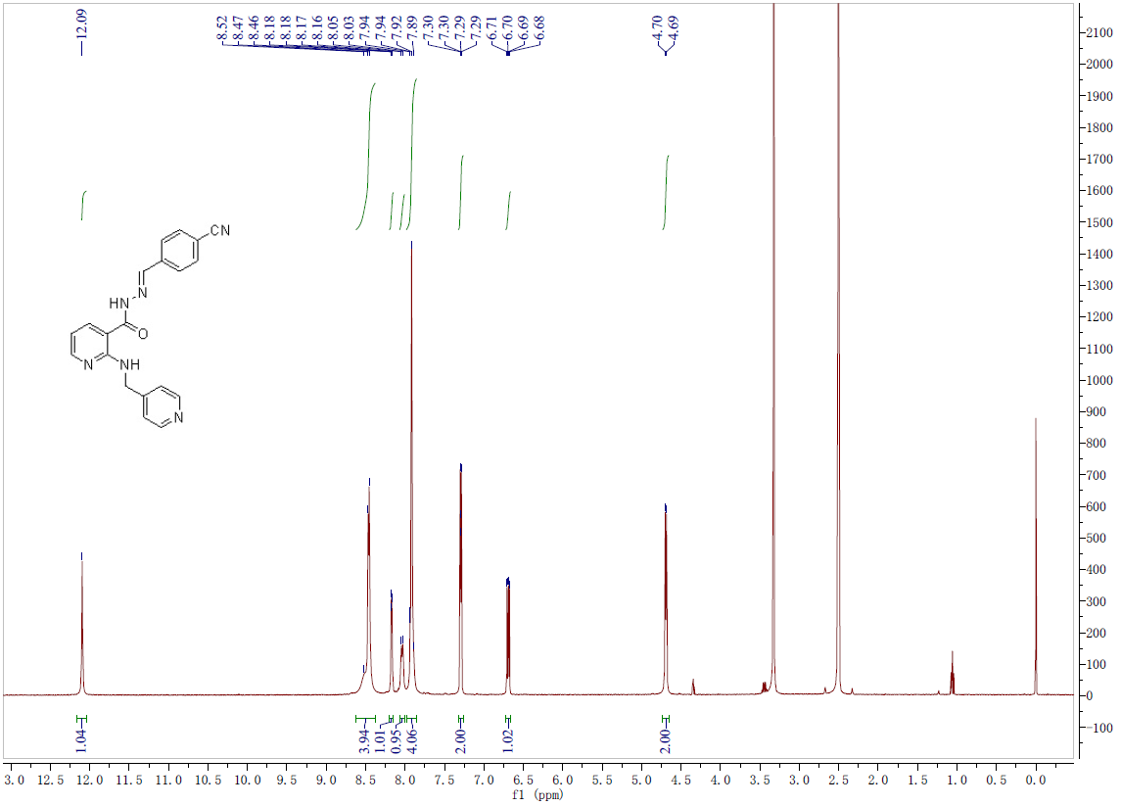
Fig.20-1 ¹H-NMR spectrum of compound 33
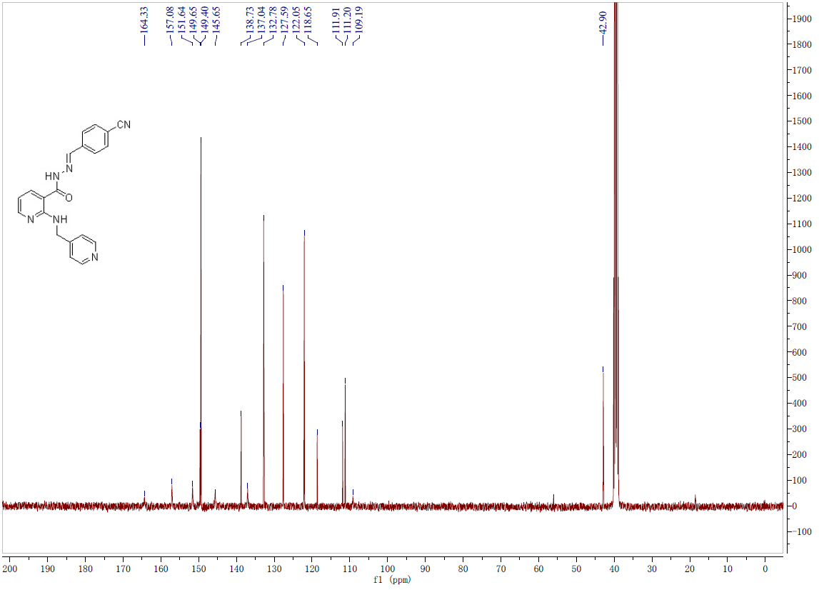
Fig.20-2 ¹³C-NMR spectrum of compound 33
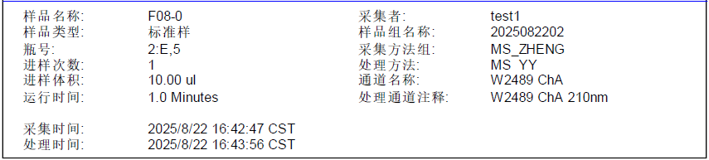
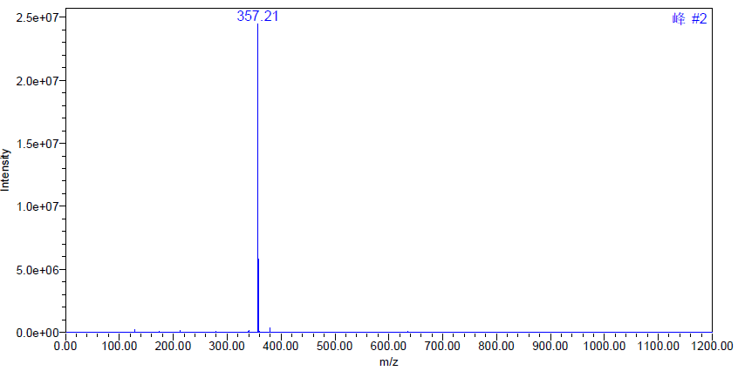
Fig.20-3 MS spectrum of compound 33
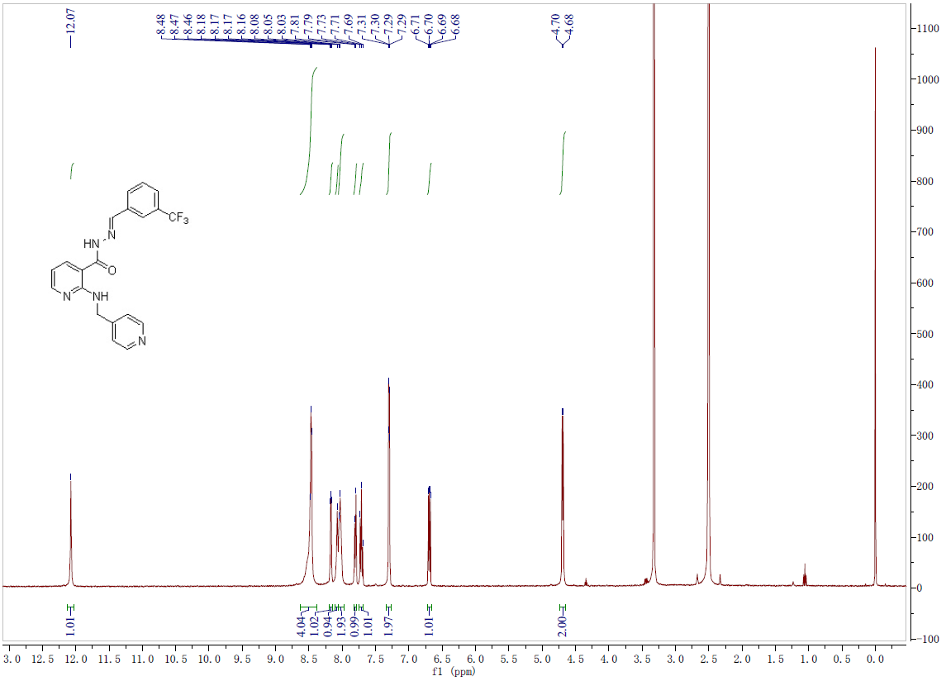
Fig.21-1 ¹H-NMR spectrum of compound 34
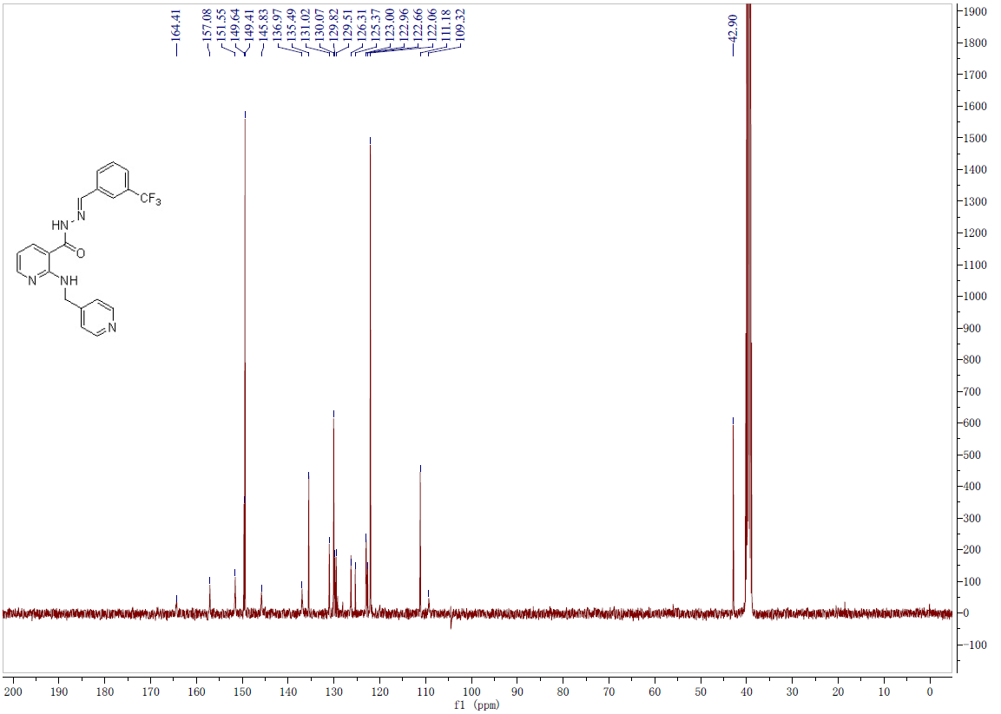
Fig.21-2 ¹³C-NMR spectrum of compound 34
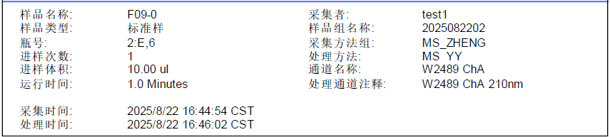
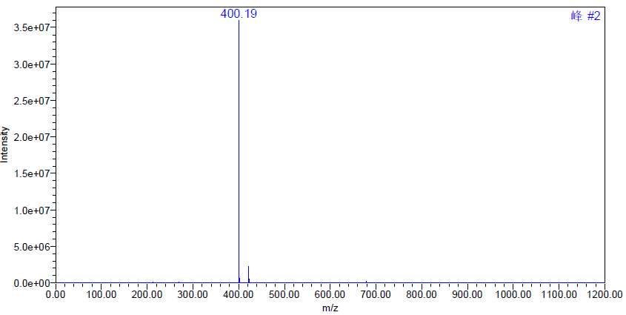
Fig.21-3 MS spectrum of compound 34
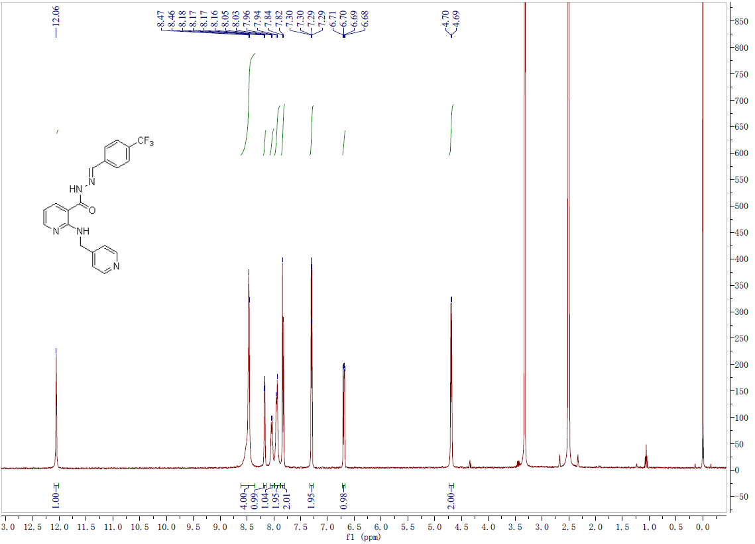
Fig.22-1 ¹H-NMR spectrum of compound 35

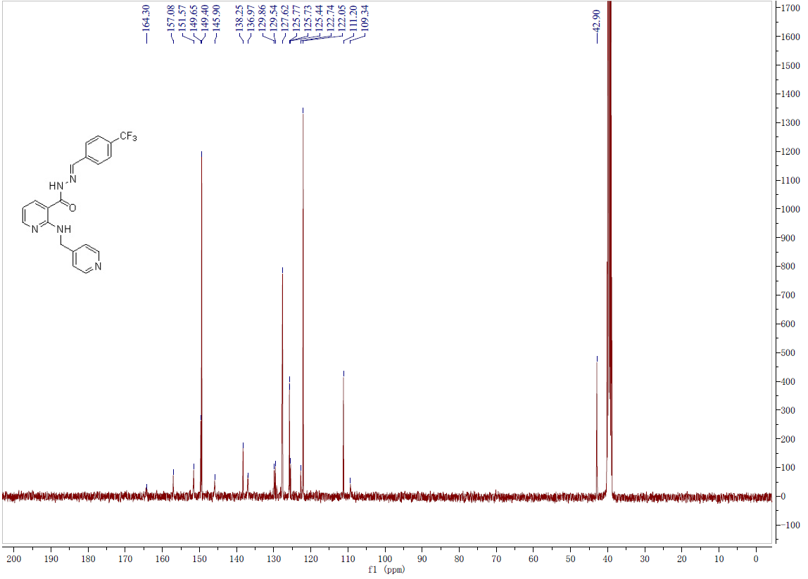
Fig.22-2 ¹³C-NMR spectrum of compound 35
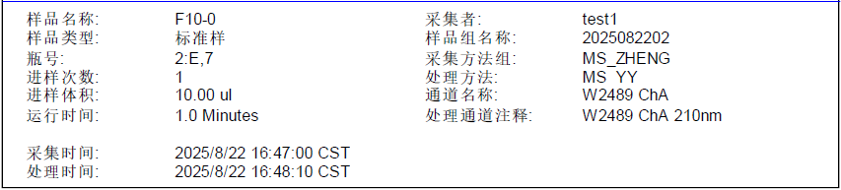
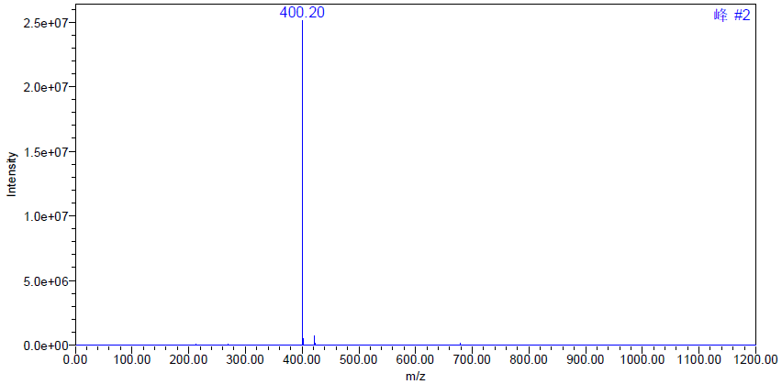
Fig.22-3 MS spectrum of compound 35
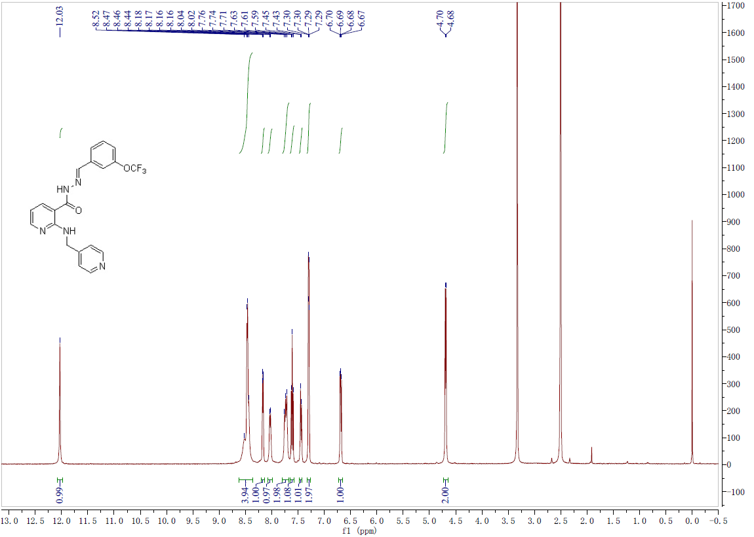
Fig.23-1 ¹H-NMR spectrum of compound 36
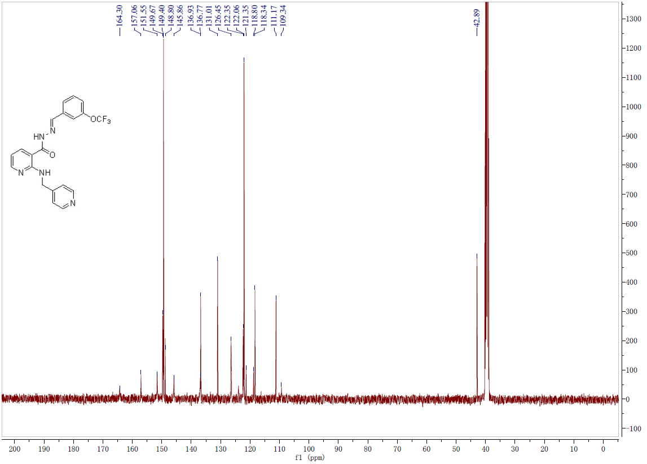
Fig.23-2 ¹³C-NMR spectrum of compound 36
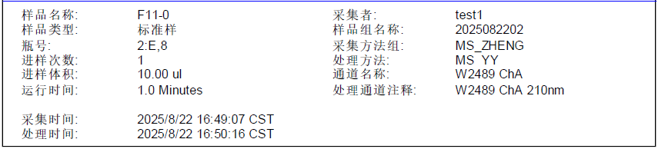
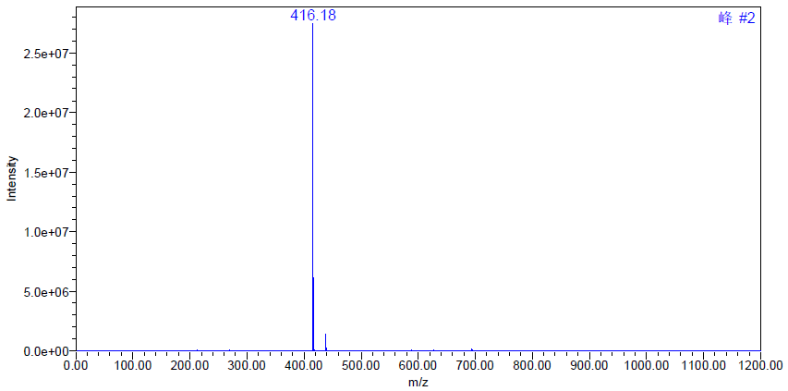
Fig.23-3 MS spectrum of compound 36
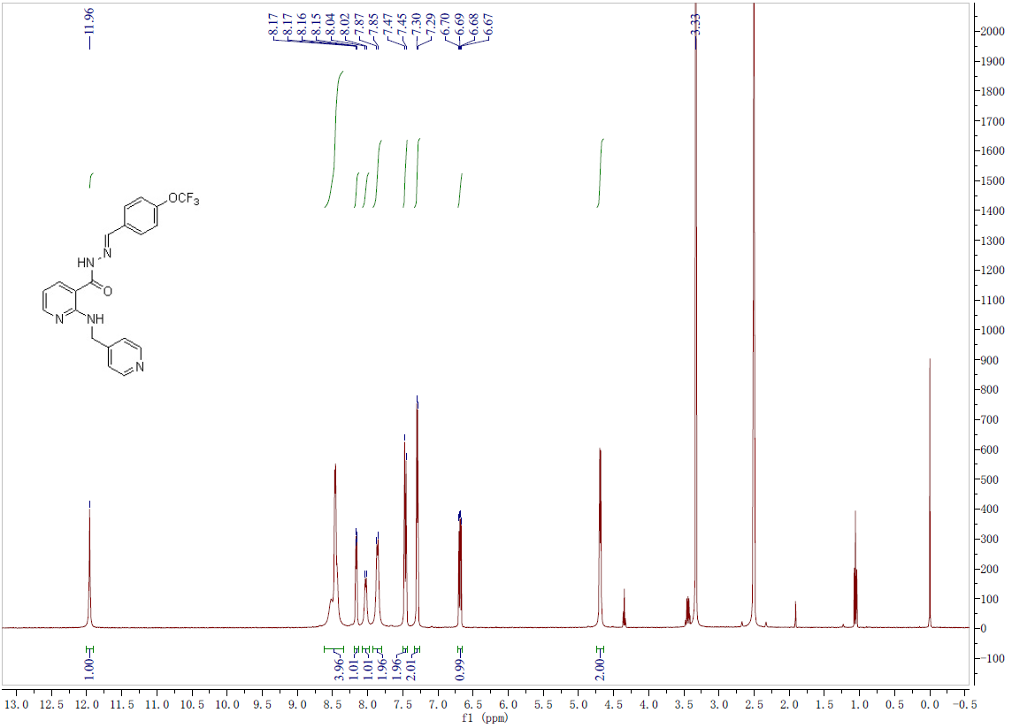
Fig.24-1 ¹H-NMR spectrum of compound 37

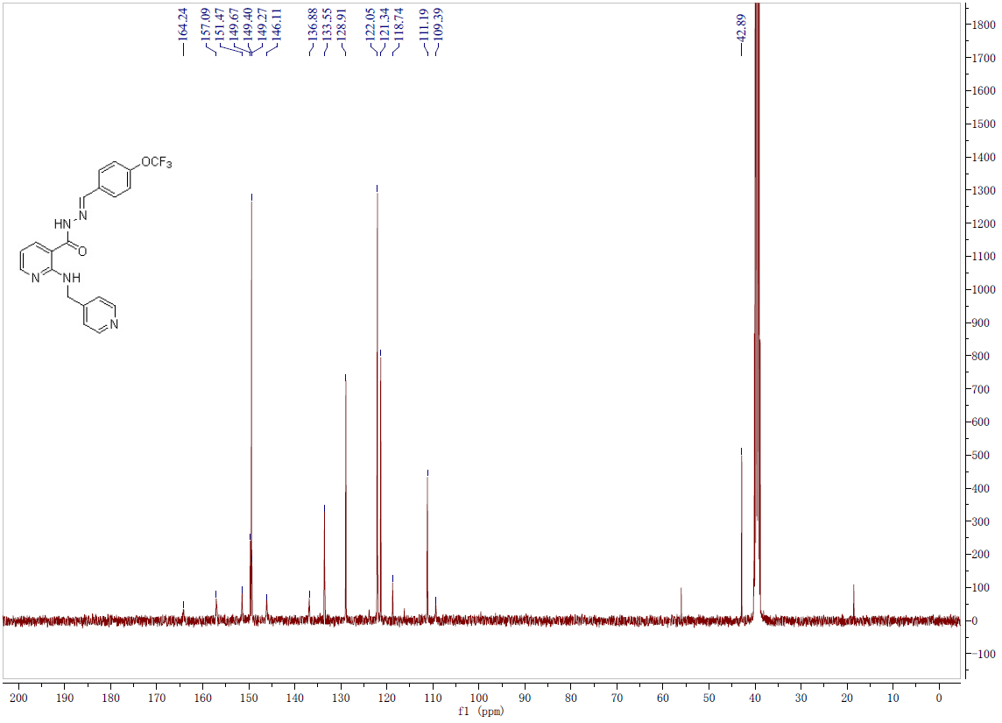
Fig.24-2 ¹³C-NMR spectrum of compound 37
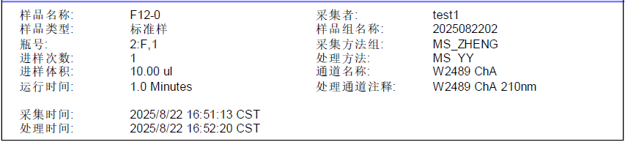
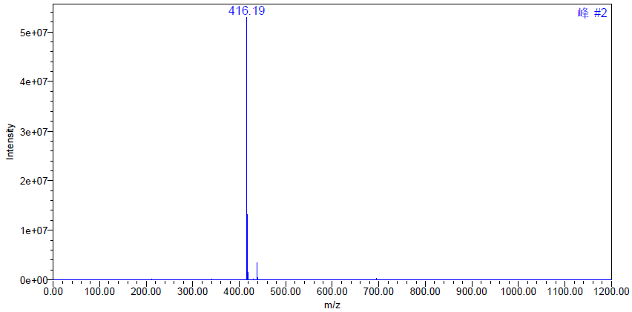
Fig.24-3 MS spectrum of compound 37
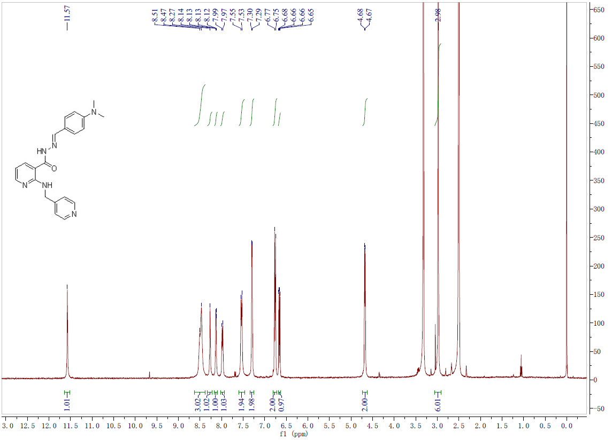
Fig.25-1 ¹H-NMR spectrum of compound 38
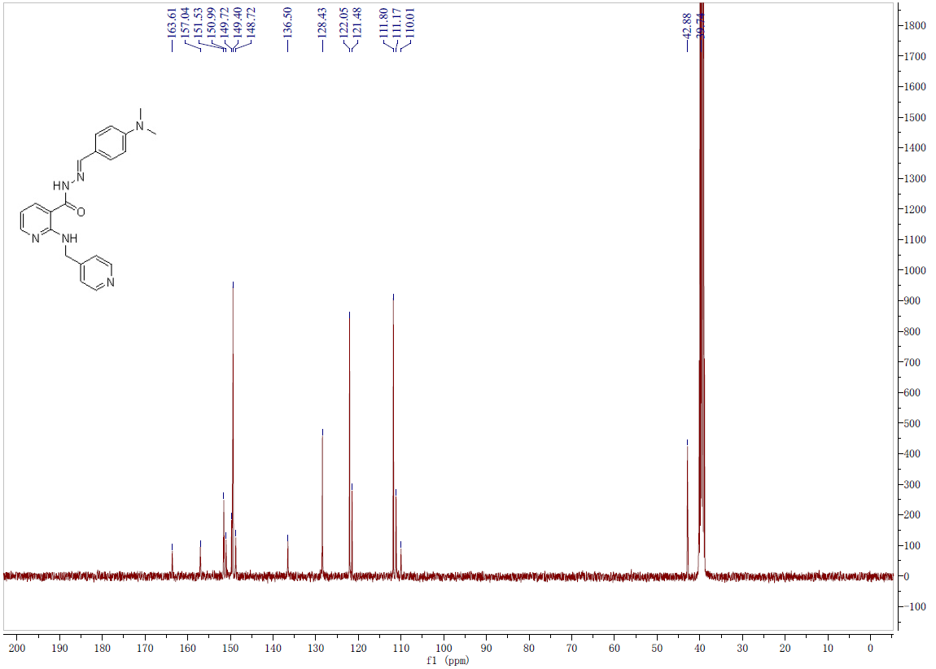
Fig.25-2 ¹³C-NMR spectrum of compound 38
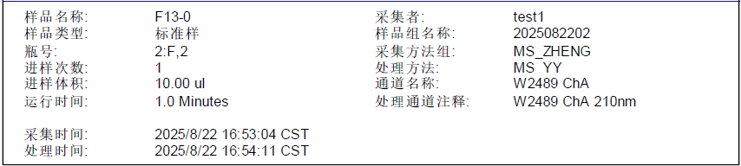
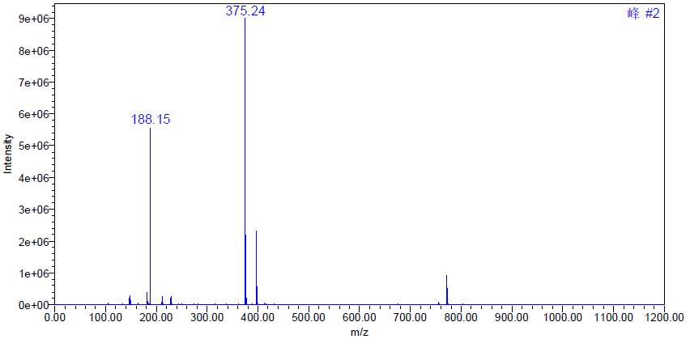
Fig.25-3 MS spectrum of compound 38
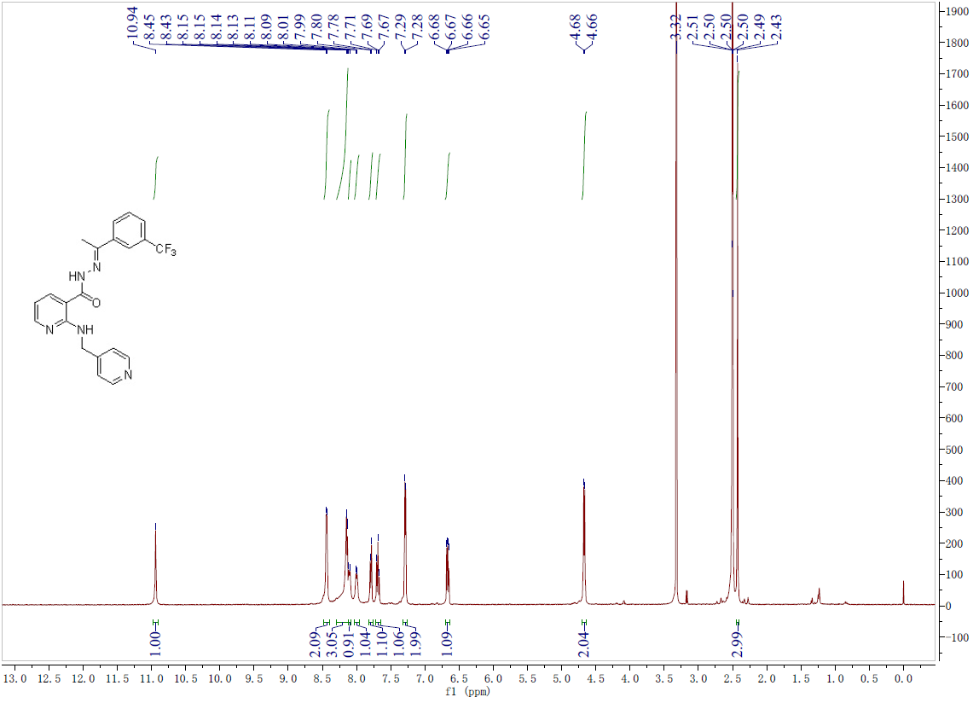
Fig.26-1 ¹H-NMR spectrum of compound 39

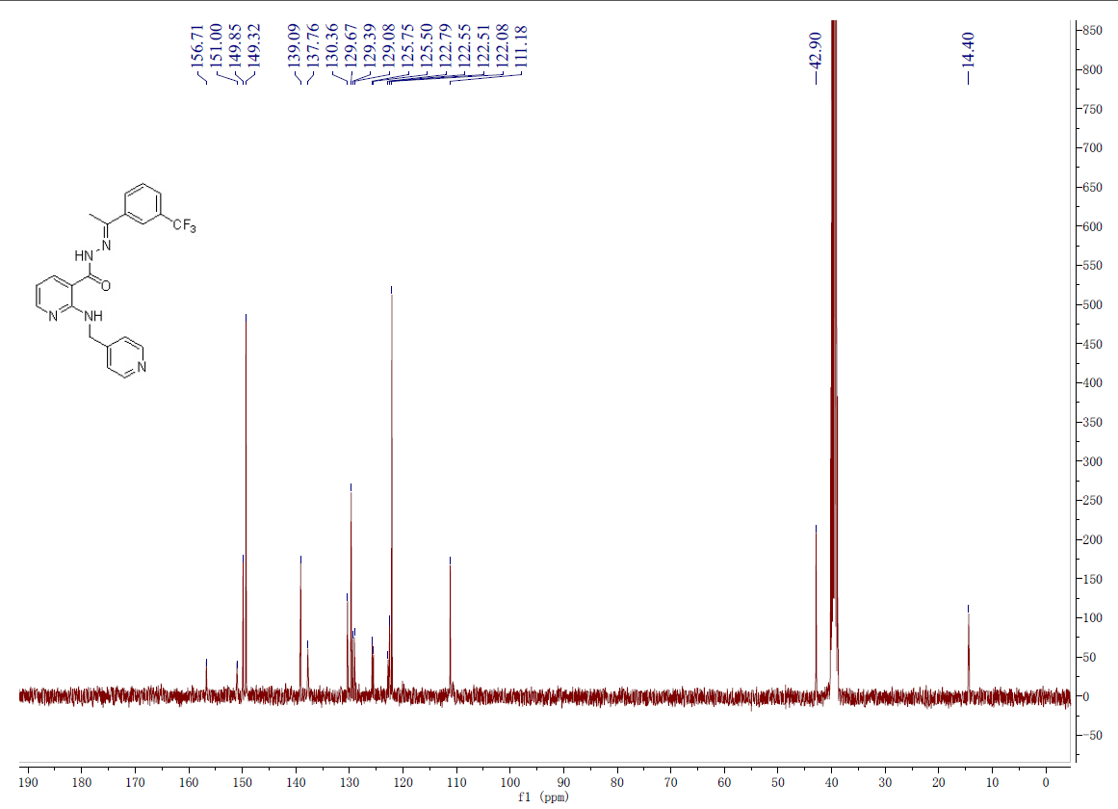
Fig.26-2 ¹³C-NMR spectrum of compound 39

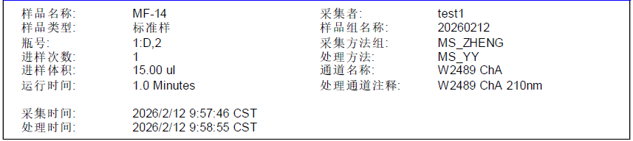
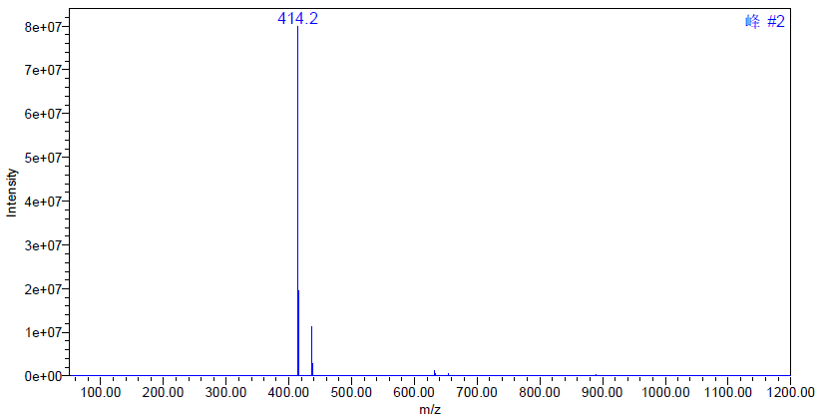
Fig.26-3 MS spectrum of compound 39
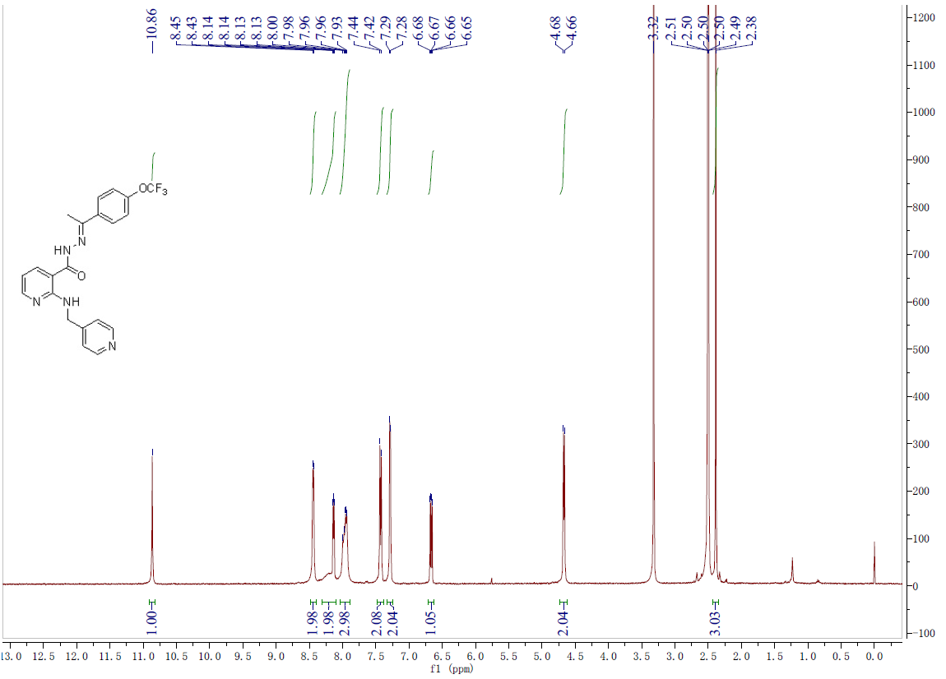
Fig.27-1 ¹H-NMR spectrum of compound 40
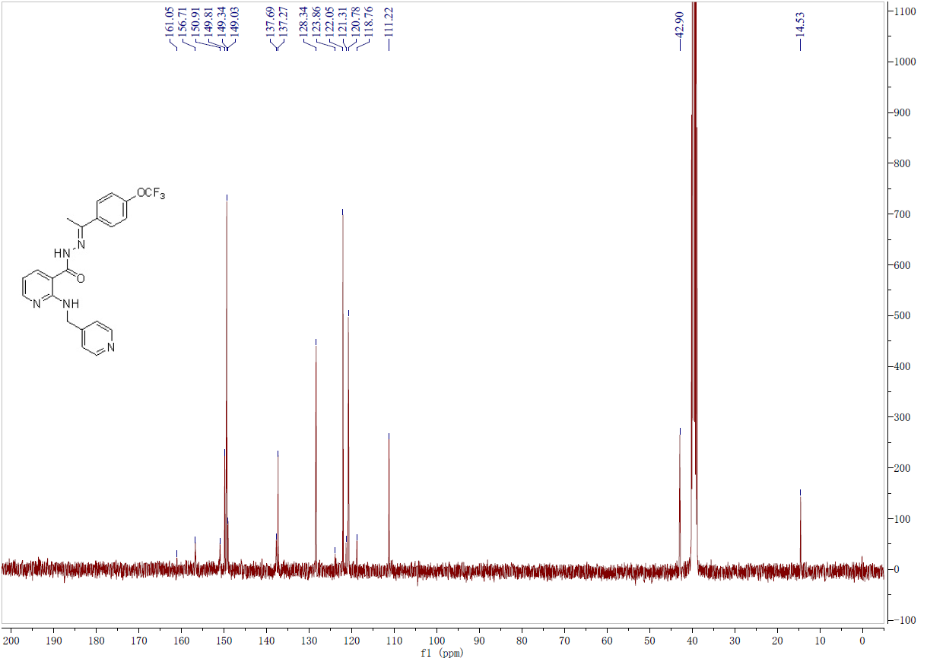
Fig.27-2 ¹³C-NMR spectrum of compound 40
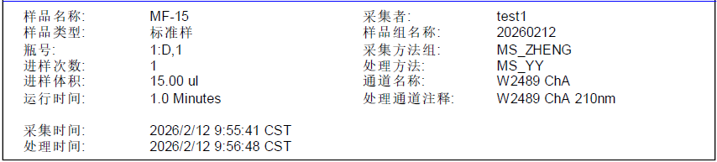
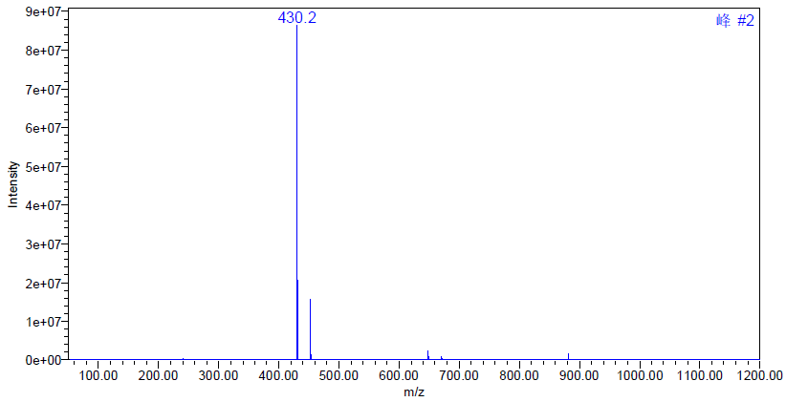
Fig.27-2 MS spectrum of compound 40

