Table 2. Taxonomic composition and diversity indices of different insect community groups
Signs | Order | Family | Genus | Richness | Abundance | Shannon  Diversity Index | Simpson  Dominance  Index
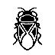 | Hemiptera | 4 | 61 | 92 | 3462 | 3.9661 | 0.0250
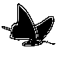 | Lepidoptera | 6 | 83 | 151 | 4515 | 4.2947 | 0.0182
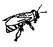 | Hymenoptera | 9 | 40 | 76 | 1911 | 4.0133 | 0.0228
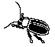 | Coleoptera | 16 | 142 | 192 | 1522 | 3.988 | 0.0241
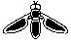 | Diptera | 12 | 63 | 90 | 1038 | 3.7331 | 0.0371
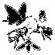 | Total | 47 | 389 | 601 | 12448 | 4.5458 | 0.0321

