Supplementary Information
for
Enhancing Radiation Resilience of Lead Halide Perovskites via Multifunctional Pyridinylpiperazine Modification

Victoria V. Ozerova¹, Nikita A. Emelianov¹, Tatiana N. Khokhlova¹, Nikita A. Slesarenko¹, Alexander F. Shestakov¹, Gennady V. Shilov¹, Nadezhda N. Dremova¹, Mikhail V. Zhidkov¹, Mohamed Elnaggar^{2,3}, Maxim N. Sarychev⁴, Stepan S. Zyryanov⁴, Dmitry P. Kiryukhin¹, Weixing Zhou^{2,3}, Ivan S. Zhidkov^{4,5}, Sergey M. Aldoshin¹, and Pavel A. Troshin^{2,3,1}*

¹ Federal Research Center of Problems of Chemical Physics and Medicinal Chemistry, Russian Academy of Sciences (FRC PCP MC RAS), Semenov Prospect 1, 141432 Chernogolovka, Moscow Region, Russian Federation
² Zhengzhou Advanced Research Institute of Harbin Institute of Technology, No. 112 Longhu Zhonghuan North Road, Jinshui District, Zhengzhou, Henan Province, P.R. China
³ Harbin Institute of Technology, 92 West Dazhi Street, Nan Gang District, Harbin, Heilongjiang Province, P.R. China
⁴ Institute of Physics and Technology, Ural Federal University, Mira 19 Street, 620002 Yekaterinburg, Russia
⁵ M.N. Mikheev Institute of Metal Physics, Ural Branch of Russian Academy of Sciences, S. Kovalevskoi 18 Street, 620108 Yekaterinburg, Russia
*Corresponding author
E-mail: troshin2003@inbox.ru (P.A.T.)

- Experimental Section
Materials
Lead iodide (PbI₂, 99.9%) and cesium iodide (CsI, 99.9%) were purchased from Lanhit Ltd. (Russia) and Sigma-Aldrich, respectively. Formamidinium iodide (FAI, 99%), methylammonium iodide (MAI, 99%), 1-(pyridin-4-yl)piperazine dihydroiodide (PyPiI₂, 97%) were obtained from FOMaterials, LTD (Russia). The solvents used included acetone (high purity, Ekos-1), isopropyl alcohol (high purity, Ekos-1), N,N-dimethylformamide (DMF, non-aqueous, 99.8%, Sigma-Aldrich), dimethyl sulfoxide (DMSO, non-aqueous, 99.9+%, Sigma-Aldrich), and chlorobenzene (99.9%, Sigma-Aldrich). FTO-coated glass substrates (2.2 mm thick, 14-15 Ω sq⁻¹) were obtained from Kintec, Glass slides (25 × 25 mm) were cut from standard objective borosilicate glass purchased from Isolab GmbH.
Substrate preparation
For photostability tests, the perovskite films were deposited on glass slides. For stability tests against electrons and gamma rays, the films were deposited on polyimide substrates due to their high radiation hardness. Additional samples for SEM and XPS measurements were prepared on FTO-coated glass substrates. In the case of neutron and proton irradiation, all samples were deposited on polyimide.
The glass slides and FTO-coated glass substrates were ultrasonically cleaned in a series of solvents: distilled water, acetone, isopropyl alcohol for 15 minutes each, followed by drying with an air stream. Subsequently, the pre-cleaned substrates underwent air plasma treatment (base pressure 10⁻² mbar, 150 W) for 5 minutes to remove any residual organic contaminants. Polyimide 40 µm thick substrates were ultrasonically cleaned in acetone for 15 minutes, followed by drying with an air stream and air plasma treatment for 3 minutes to remove any residual organic contaminants and improve the substrate wettability. The polyimide substrates were attached to glass slides throughout perovskite film deposition to ensure flatness and were delaminated only prior to heating on a hotplate.
Characterization of the perovskite films
The UV-Vis absorption spectra were measured using an AvaSpec-2048-2 UV-vis fiber spectrometer integrated into the MBraun glove box. FTIR spectra were measured inside the glove box using Perkin Elmer Spectrum Two spectrometer in Attenuated Total Reflection (ATR) mode using KRS-5/diamond prism. Steady-state PL spectra were measured under a nitrogen atmosphere inside a glove box using Ocean Insight QE Pro spectrometer and a 450 nm laser as the excitation source. XRD patterns were collected using Aeris instrument (Malvern PANalytical B.V.) with a CuKα source. SEM images were obtained using Zeiss SUPRA 25 instrument. IR scattering-type scanning nearfield optical microscopy (IR s-SNOM) (neaSNOM, Neaspec) (PsHet mode, Neaspec) measurements were performed inside a glove box, the details were presented previously.¹
The optical images were obtained using a confocal scanning laser microscope Optelics Hybrid (Lasertec, Yokohama, Japan) with a xenon lamp and a 405 nm laser as illumination sources.
- Theoretical calculations and the associated results
Optimization of structure of the system studied was performed using the PBE exchange-correlation functional² and with the extended basis set C,N,O,S,I,Pb: [5s5p2d/3s3p2d], H :[5s1p/3s1p] for the valence electrons and the SBK pseudopotential³ implemented in the PRIRODA package⁴. The Hirschfeld method⁵ was used to calculate atomic charges. Magnetic shielding constant were calculated in all-electron basis set. All calculations were performed at Joint Supercomputer Center of the Federal research center “Kurchatov Institute”
Theoretical calculation of the ¹H NMR spectrum for the PyPi²⁺ dication gives almost identical chemical shifts for protons in positions a and b and very large differences for c and d (Notations of the atoms follow Fig. S1, the chemical shifts are listed on Table T1). In the presence of two iodide ions, the closeness of the chemical shifts for protons a and b remains, while strong shifts occur for protons c and d. Such small differences in signals for different types of aromatic and aliphatic C–H bonds are qualitatively inconsistent with the experimental NMR spectrum. Moreover, the total width of the theoretical spectrum (4.28 ppm) is noticeably smaller than the experimental one (5.07 ppm). These findings strongly suggest that PyPiI₂ does not exist in the form of solvated individual molecules in solution and, most likely, is aggregated into more complex supramolecular assembles. Indeed, the dimerization of PyPiI₂ occurs with a large energy gain of 23.0 kcal/mol. The calculated chemical shifts for the formed dimer (Fig. T1) shows significantly improved agreement with the experimental NMR spectrum. The total width of the theoretical spectrum (4.95 ppm) is very close to the experimental one, and the splitting for protons at positions a and b increases significantly to 0.27 ppm. Thus, the structure of the dimer [PyPiI₂]₂ was chosen for further analysis of its interactions with the perovskite precursor components. It is worthy to mention that [PyPiI₂]₂ dimer has two isomers with very similar energies, differing in the coordination mode of the bridging iodide ion.
In the octahedral complex cis‑[PbI₂(DMSO)₄], the fourth solvent molecule is very weakly bound (dissociation energy 6.5 kcal/mol). Therefore, the coordinatively unsaturated complex [Pb(I)₂(DMSO)₃] was chosen as the structural unit for studying its interactions with PyPiI₂. In (PyPiI₂)₂, there are two types of nucleophilic centers – pyridine group atoms with a charge of –0.14 and iodide ions (terminal and bridging) with charges of –0.44 and –0.39, respectively. This ratio indicates that attaching two [Pb(I)₂(DMSO)₃] groups (with a charge of +0.41 on the lead atom) to the terminal iodide ions is much more favorable (19.2 kcal/mol) compared to the formation of pyridine-type complexes (8.2 kcal/mol). However, after attaching [Pb(I)₂(DMSO)₃] at the most favorable positions, their further attachment to the pyridine fragments becomes twice as favorable (18.5 kcal/mol) (Fig. T2).
Methylammonium iodide (MAI) is strongly associated. The dimerization energy of MAI molecules is significant – 31.1 kcal/mol. Therefore, the dimer (MAI)₂ was chosen as the structural unit for modelling its interaction with (PyPiI₂)₂. The formation of the adduct (Fig. T3) occurs with a gain of 35.2 kcal/mol due to the formation of new hydrogen bonds with terminal and bridging iodide ions (2.54 and 2.68 Å, respectively), which are comparable to the internal hydrogen bonds (ranging from 2.33 to 2.49 Å). The structure of the (MAI)₂ dimer is largely preserved.
The main associate of formamidinium iodide (FAI) is the tetramer (FAI)₄, in which all mobile H atoms on the N atoms are already involved in intramolecular hydrogen bonds. Therefore, it is not well suited for forming energetically favorable adducts. Its dissociation into dimers (FAI)₂ requires 27.4 kcal/mol. This makes available NH bonds, through which their binding to (PyPiI₂)₂ occurs with a gain of 36.7 kcal/mol, compensating for the dissociation cost. The interaction mode of (FAI)₂ is similar to that of (MAI)₂ (Fig. T4).

Table T1. Calculated chemical shifts for the ¹H NMR spectrum
Structure | Chemical shifts, ppm
Structure | a | b | c | d
PyPi²⁺ | 4.46 | 4.40 | 7.37 | 10.29
PyPiI₂ | 5.07 | 5.02 | 9.07 | 9.35
(PyPiI₂)₂ | 4.43 | 4.70 | 8.99 | 9.38
Experimental spectrum | 3.29 | 3.90 | 7.27 | 8.37

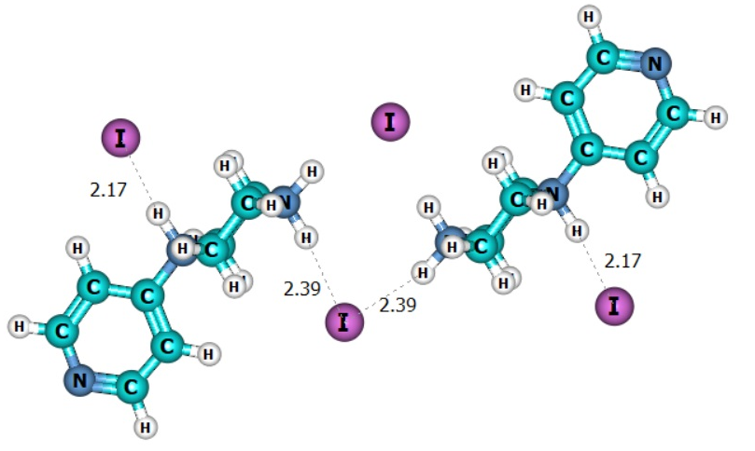
Figure T1. Molecular structure of the dimer [PyPiI₂]₂
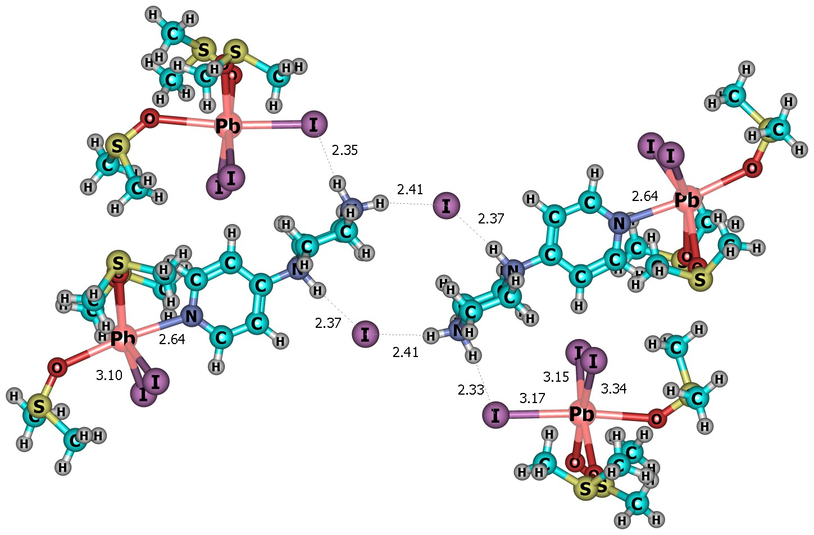
Figure T2. Low-energy structure of the coordination complexes formed between solvated PbI₂ and [PyPiI₂]₂ dimer

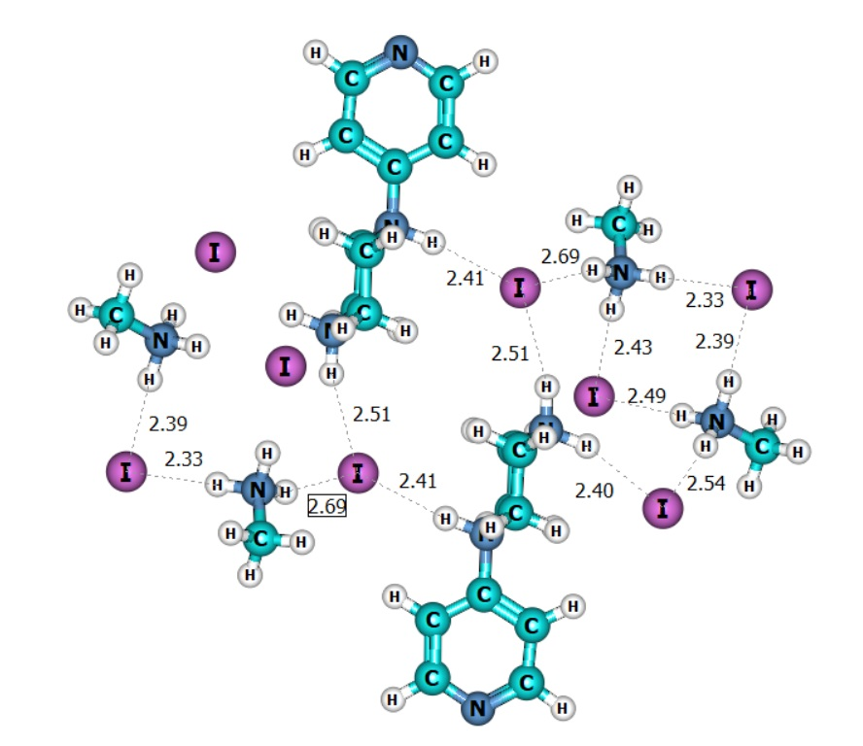
Figure T3. Low-energy structure of the H-bonded complexes formed between [MAI]₂ and [PyPiI₂]₂ dimers

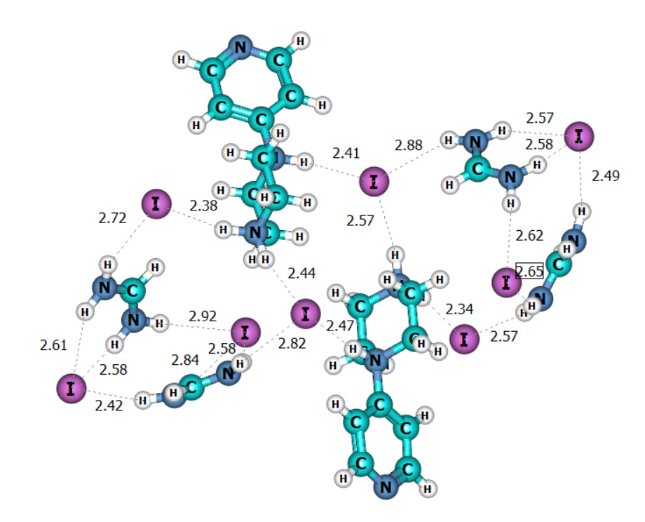
Figure T4. Low-energy structure of the H-bonded complexes formed between [FAI]₂ and [PyPiI₂]₂ dimers

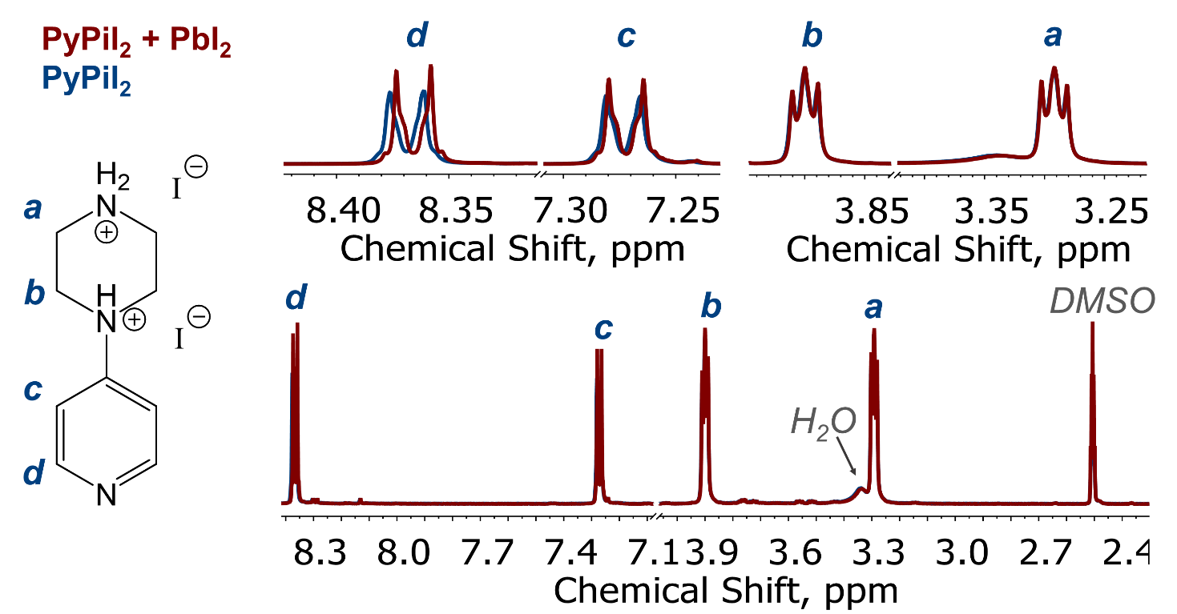
Figure S1. ¹H NMR spectra of PyPiI₂ and PyPiI₂-PbI₂ equimolar solution in DMSO-d⁶ (a). Peak assignment is shown on the structure on the left side.

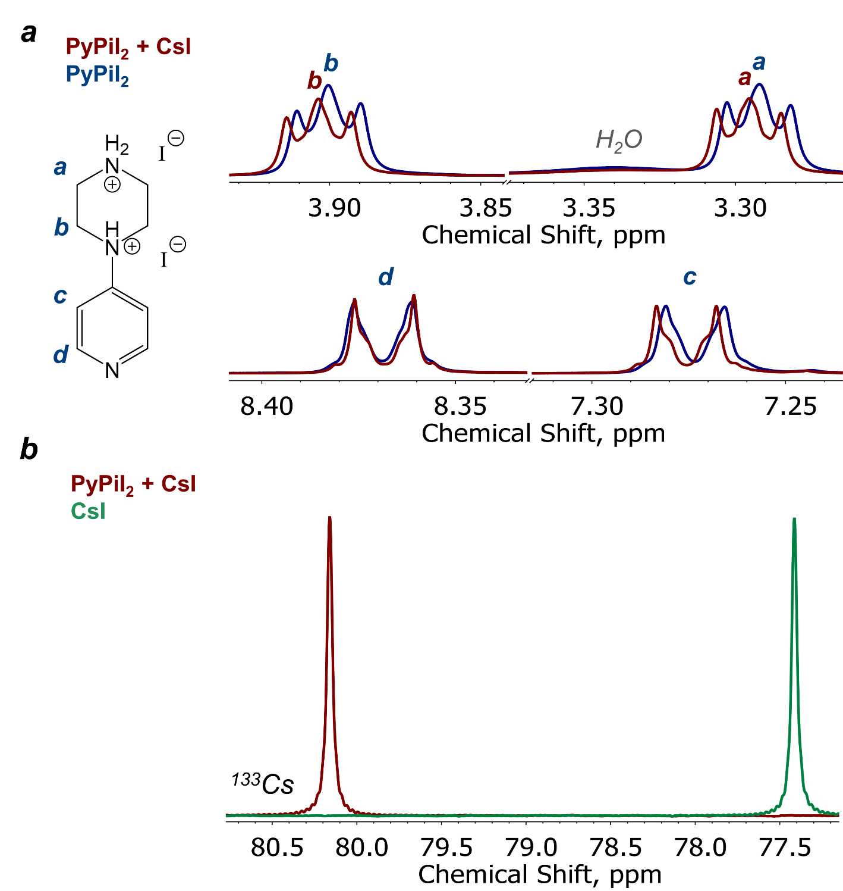
Figure S2. ¹H NMR spectra of PyPiI₂ and PyPiI₂-CsI equimolar solution in DMSO-d⁶; peak assignment is shown on the structure on the left side (a). ¹³³Cs NMR spectra of CsI and PyPiI₂-CsI equimolar solution in DMSO-d⁶ (b).

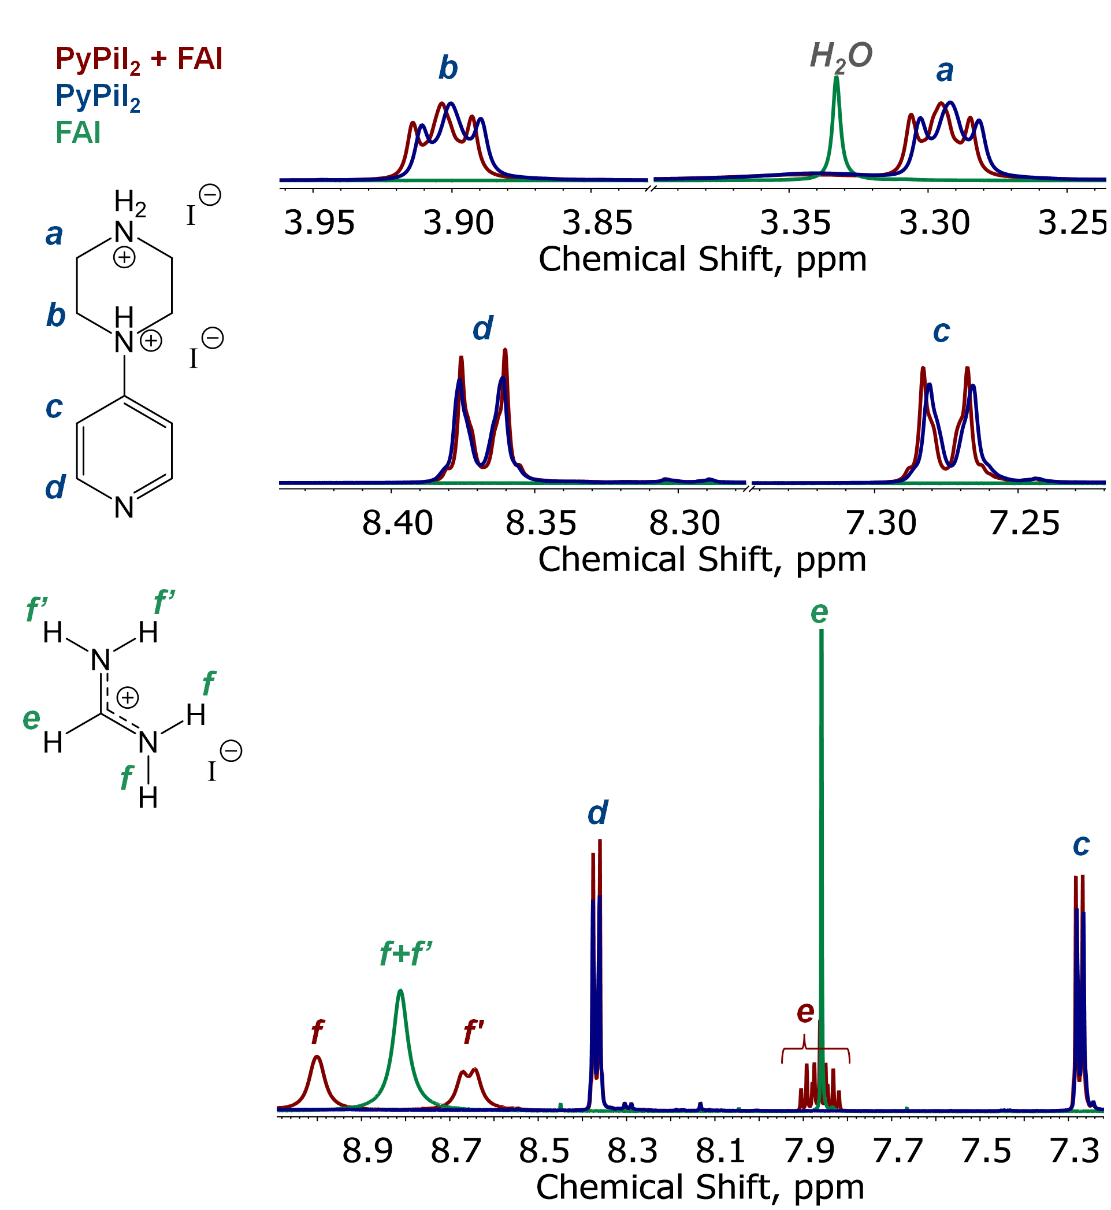
Figure S3. ¹H NMR spectra of PyPiI₂, FAI and PyPiI₂-FAI equimolar solution in DMSO-d⁶. Peak assignment is shown on the structures on the left side.

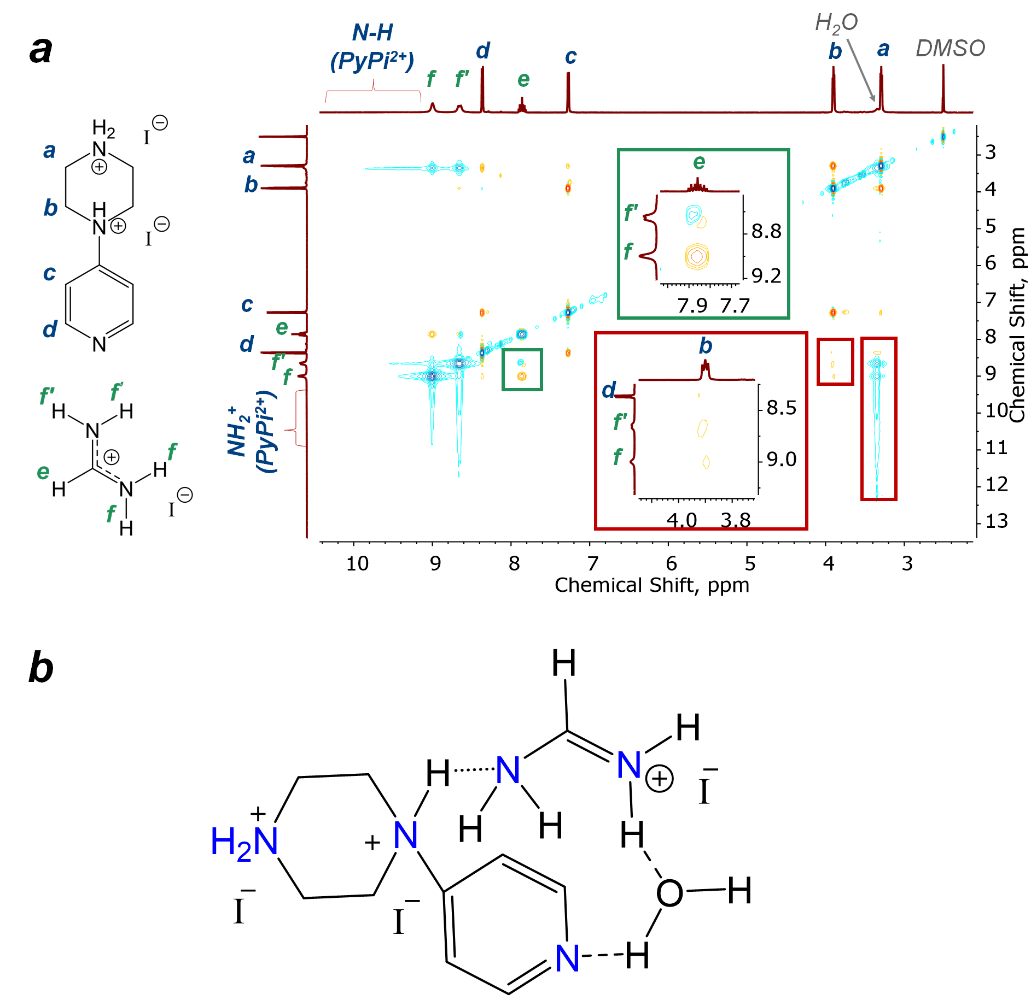
Figure S4. NOESY 2D NMR spectrum of the PyPiI₂-FAI equimolar solution in DMSO-d⁶. Some characteristic regions featuring key cross-couplings are highlighted with rectangles; peak assignment is shown on the structures on the left side (a). Proposed molecular structure of the PyPiI₂-FAI complex matching the obtained 1D and 2D NMR spectroscopy data (b)

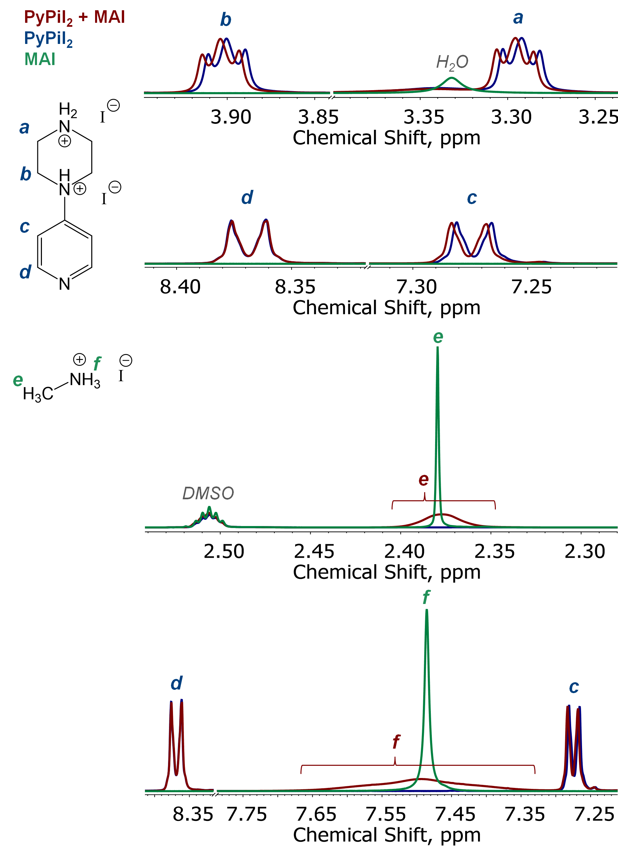
Figure S5. ¹H NMR spectra of PyPiI₂, MAI and PyPiI₂-MAI equimolar solution in DMSO-d⁶; peak assignment is shown on the structures on the left side.

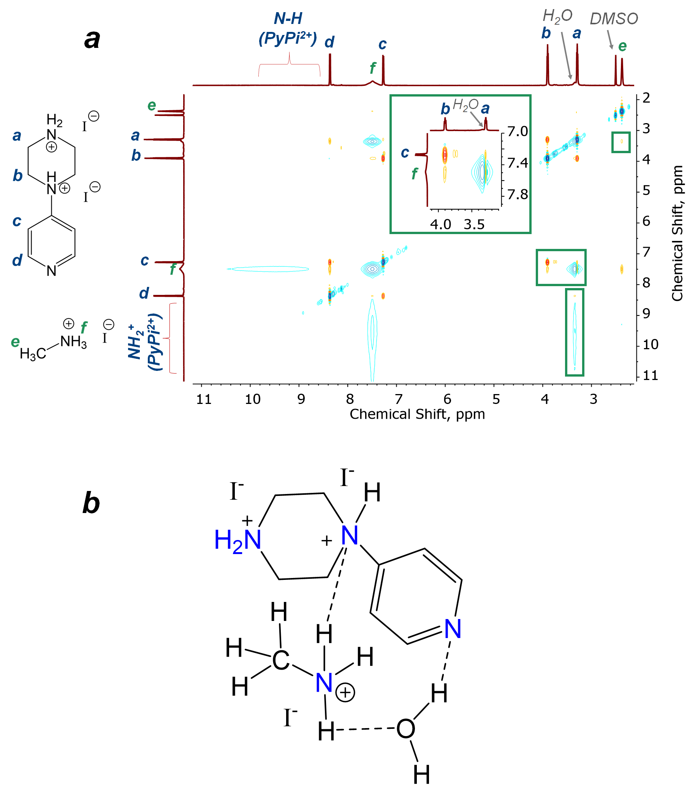
Figure S6. NOESY 2D NMR spectrum of the PyPiI₂-MAI equimolar solution in DMSO-d⁶. Some characteristic regions featuring key cross-couplings are highlighted with rectangles; peak assignment is shown on the structures on the left side (a). Proposed molecular structure of the PyPiI₂-MAI complex matching the obtained 1D and 2D NMR spectroscopy data (b)

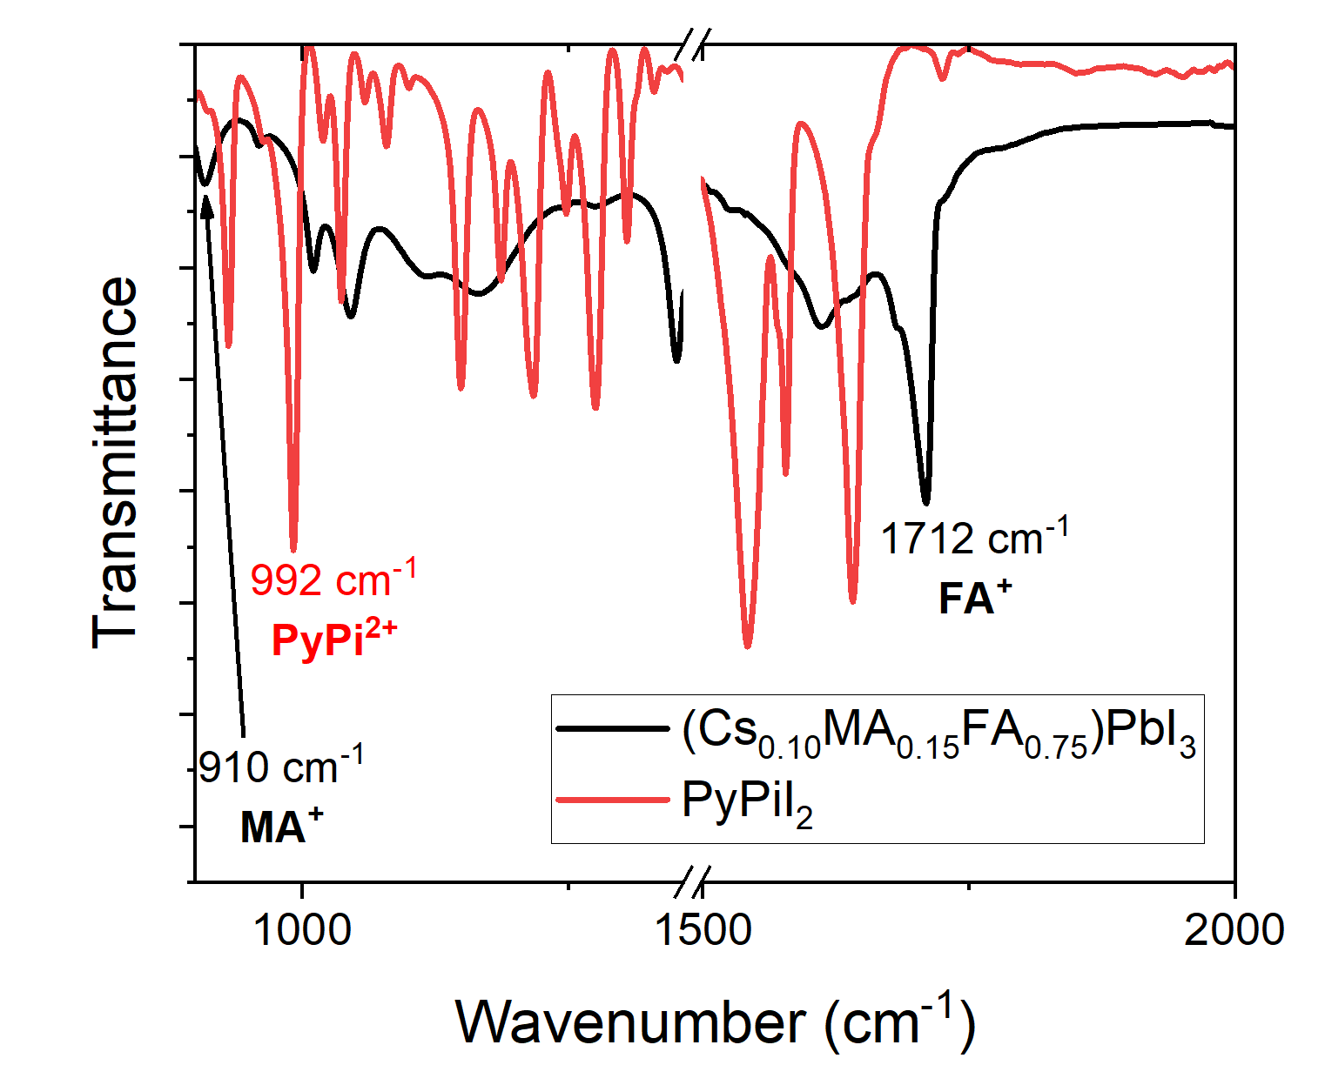
Figure S7. FTIR spectra of PyPiI₂ and Cs_{0.1}MA_{0.15}FA_{0.75}PbI₃ showing the characteristic frequencies selected for IR s-SNOM mapping MA, FA and PyPi cations.

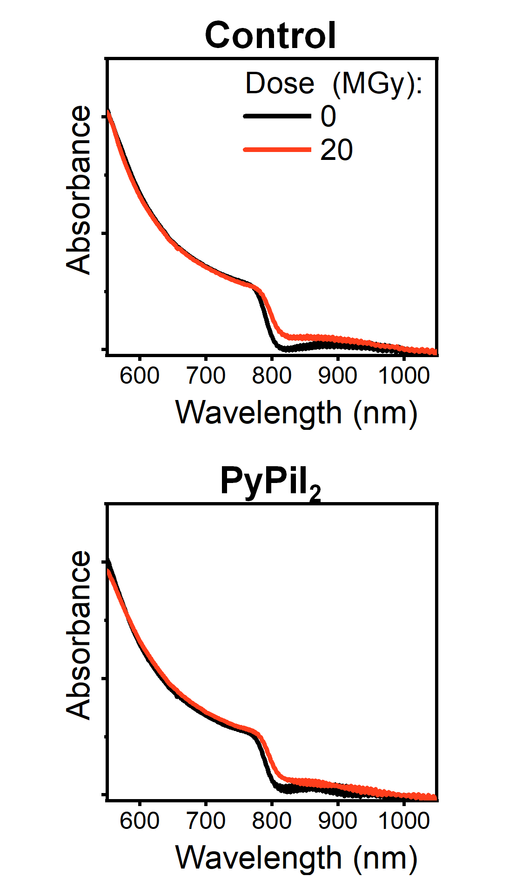
Figure S8. Comparison of the UV-vis spectra of the Control and PyPiI₂-modified perovskite films measured before and after exposure to 20 MGy dose of gamma rays

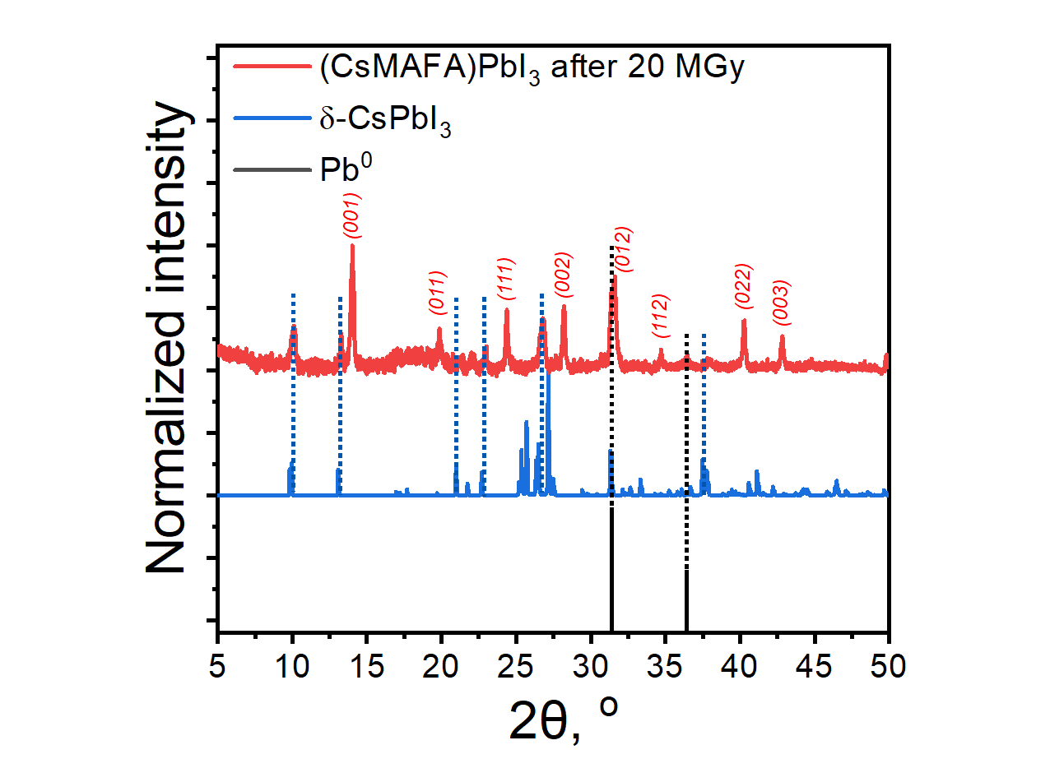
Figure S9. Detailed assignment of the peaks observed on the XRD pattern of the Control perovskite films exposed to 20 MGy of gamma rays. The hkl indexes are assigned following the previous report⁶

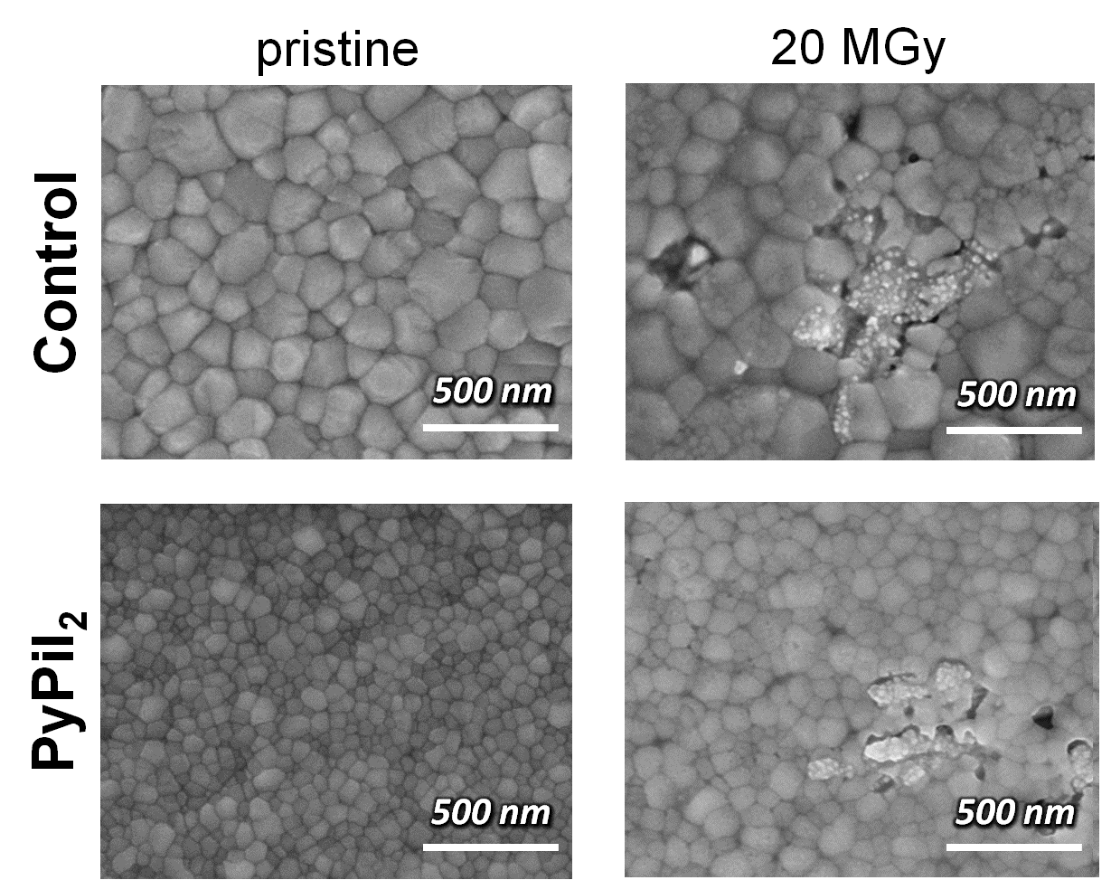
Figure S10. SEM images of the Control and PyPiI₂-modified perovskite films before (pristine) and after exposure to 20 MGy dose of gamma rays.

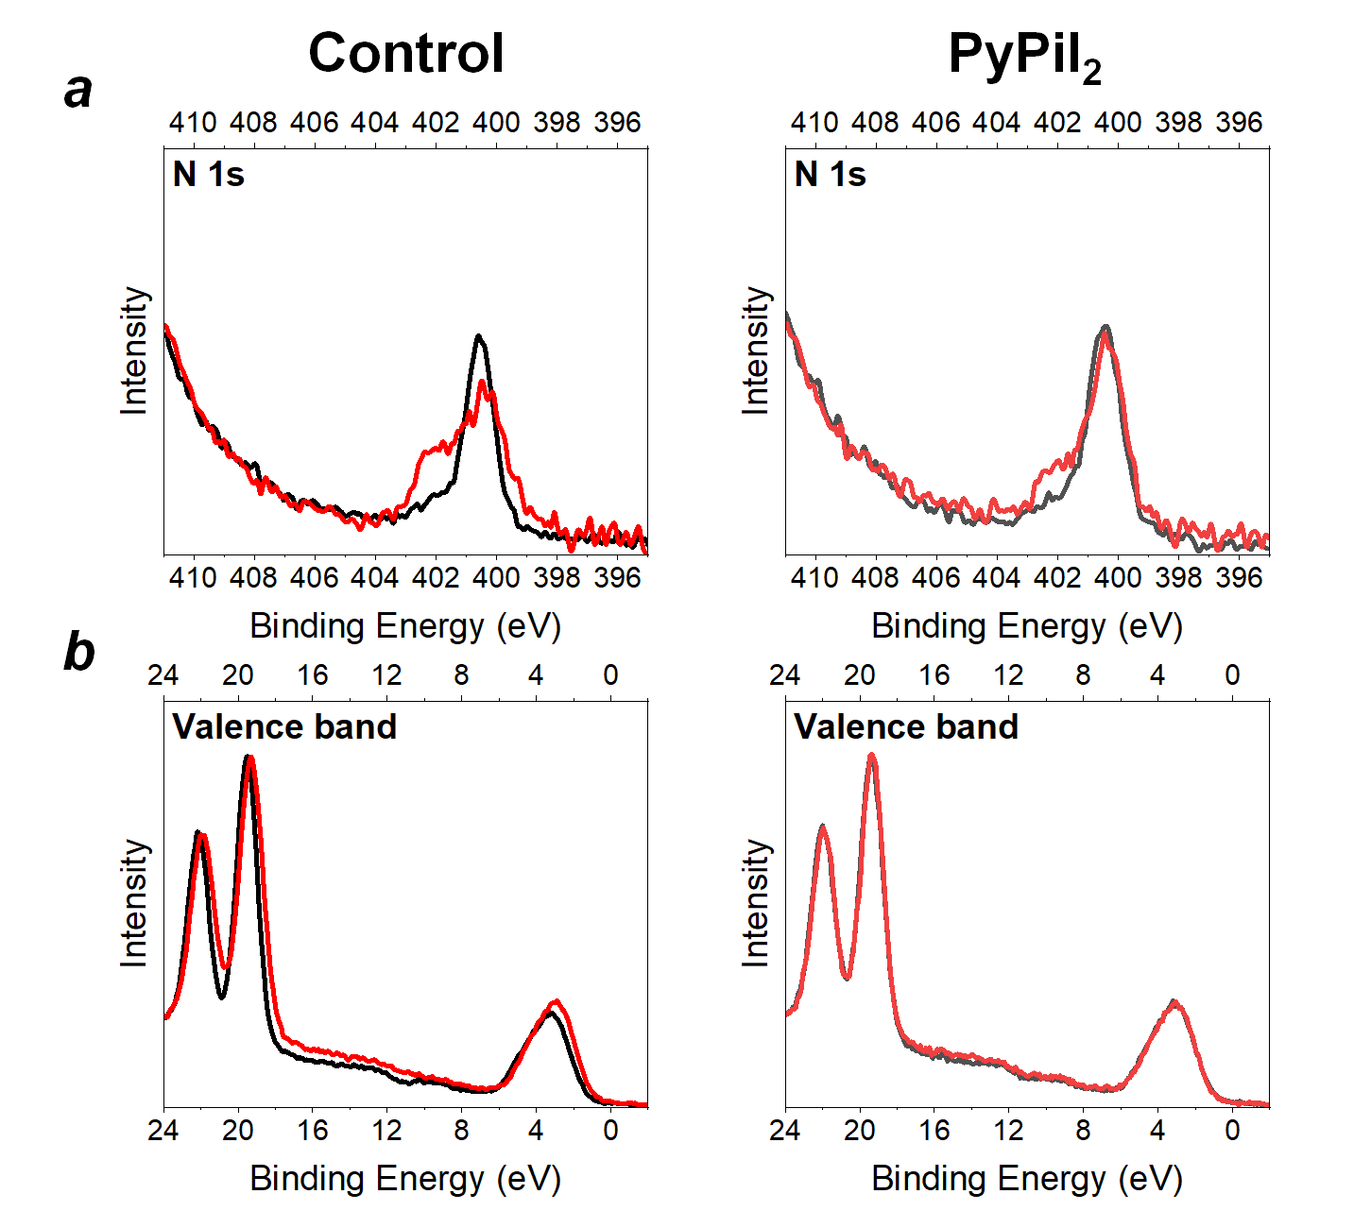
Figure S11. N 1s (a) and VB (b) XPS spectra of the Control (left) and PyPiI₂-modifed (right) perovskite films before (black color) and after (red color) exposure to 20 MGy dose of gamma rays

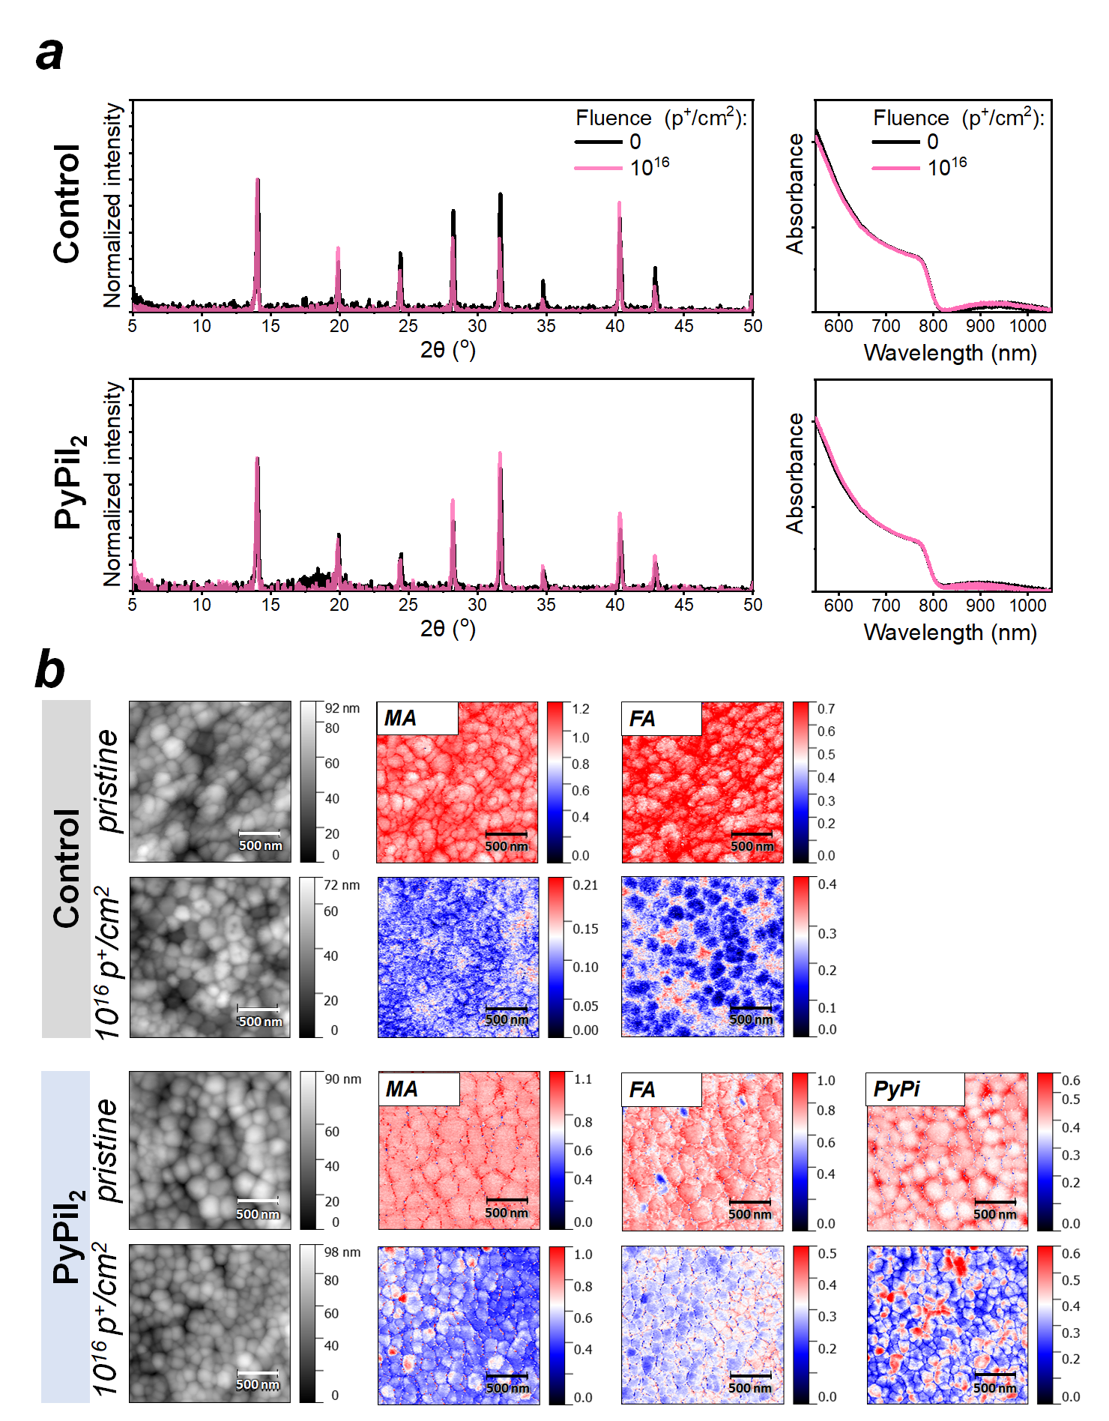
Figure S12. Comparison of the XRD patterns (left) and UV-vis spectra (right) for the Control and PyPiI₂-modified perovskite films before and after exposure to high-energy protons with the fluence of 10¹⁶ p/cm² (a). Radiation-induced evolution of the film morphology revealed by IR s-SNOM (b).

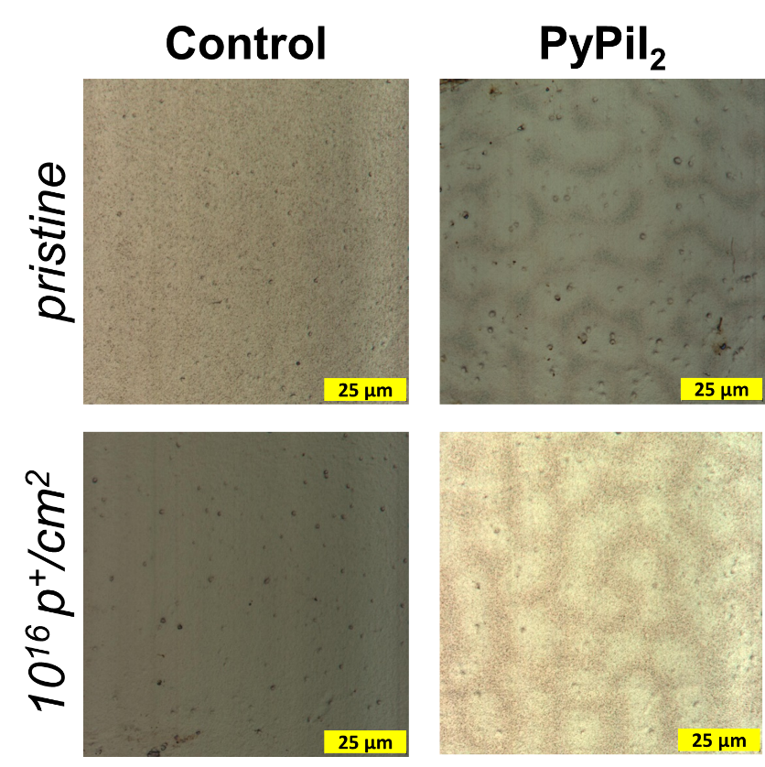
Figure S13. Confocal microscopy images of the Control and PyPiI₂-modified perovskite films before (pristine) and after exposure to high-energy protons with the fluence of 10¹⁶ p/cm²

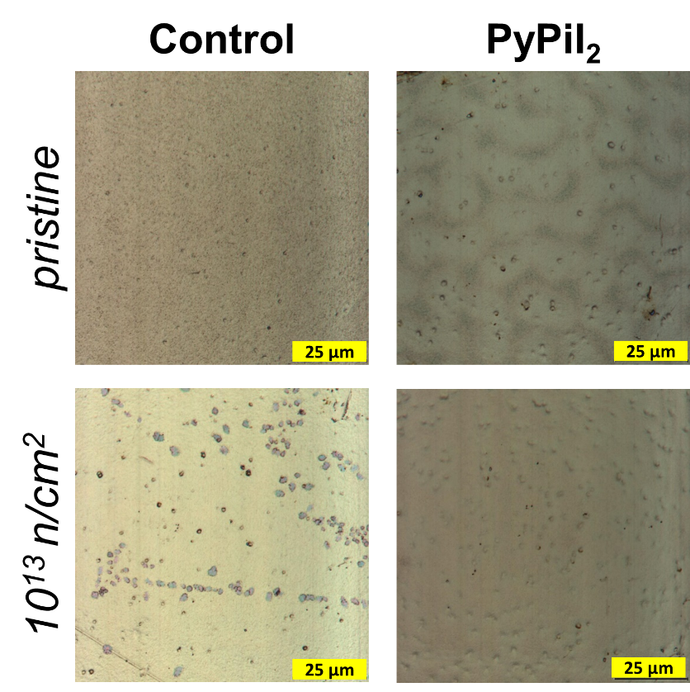
Figure S14. Confocal microscopy images of the Control and PyPiI₂-modified perovskite films before (pristine) and after exposure to 10¹³ n/cm² fluence of neutrons

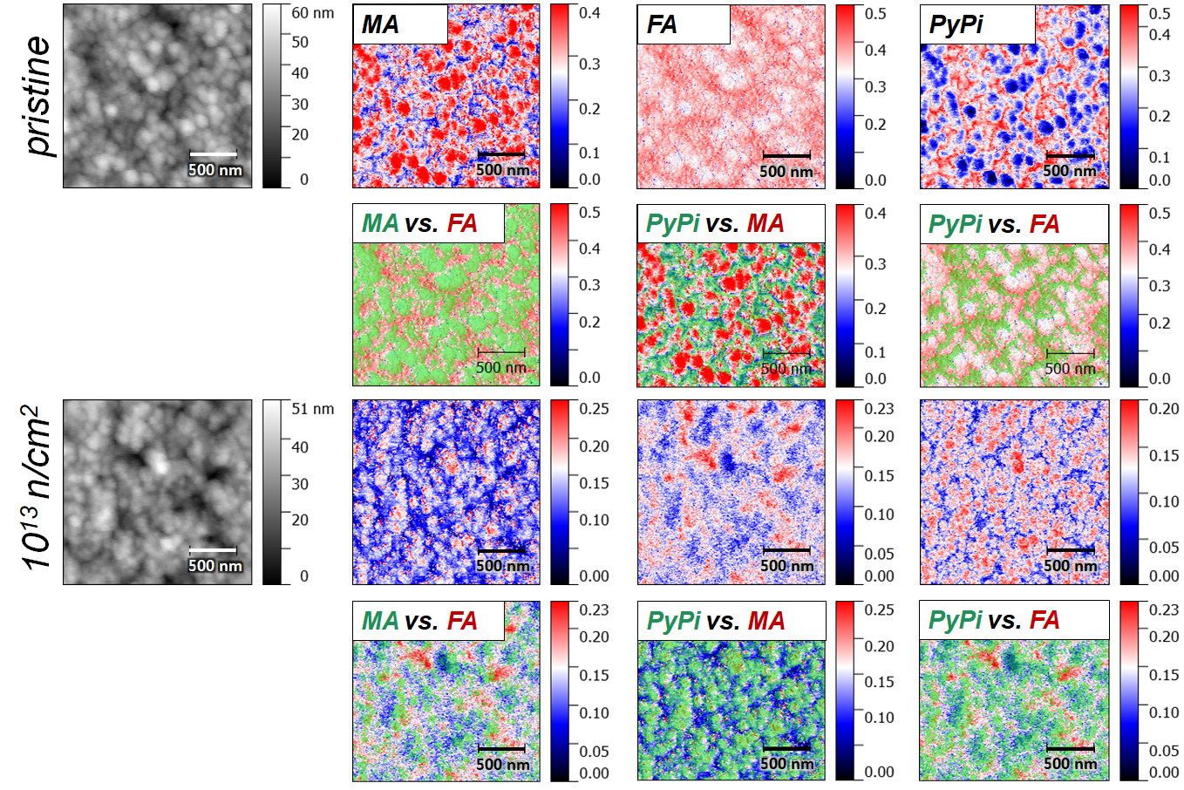
Figure S15. Detailed IR s-SNOM analysis of the PyPi-modified perovskite films before (pristine) and after exposure to 10¹³ n/cm² fluence of neutrons. Colocalization images are presented in green and red colors featuring distributions of the corresponding species following the color code in the legend.

References
- Emelianov, N. A. et al. Nanoscale Visualization of Photodegradation Dynamics of MAPbI₃ Perovskite Films. J. Phys. Chem. Lett. 13, 2744-2749 (2022).
- Perdew, J. P., Burke, K. & Ernzerhof, M. Phys. Rev. Lett. 77, 3865-3868 (1996).
- Stevens, W. J., Basch, H. & Krauss, M. J. Chem. Phys. 81, 6026 (1984).
- Laikov, D. N. Chem. Phys. Lett. 281, 151-156 (1997).
- Hirshfeld, F. L. Theor. Chim. Acta 44, 129-138 (1977).
- Saidaminov, M.I., Kim, J., Jain, A. et al. Suppression of atomic vacancies via incorporation of isovalent small ions to increase the stability of halide perovskite solar cells in ambient air. Nat Energy 3, 648-654 (2018).

