SUPPLEMENTARY APPENDIX

Potent Anti-Delta Effect By a Booster Third-Dose of UB-612, a Precision-Designed SARS-CoV-2 Multitope Protein-Peptide Vaccine
The UB-612 Study Group members are listed in the Supplementary Appendix, available with the full text of this article at https://www.nature.com/ncomms/
^{1,2,3,*}Chang-Yi Wang, PhD.,^{4,5.}Kao-Pin Hwang, M.D., PhD., ^{2.}Hui-Kai Kuo, M.S., ^{1,2.}Wen-June Peng, PhD., ^{5.}Daphne Ya-Hui Shen, M.D., M.P.H., ^{1,2,3.}Be-Sheng Kuo, PhD., ^{2.}Kuo-Liang Hou, PhD., ^{2.}Jennifer Chia-Ying Cheng, M.S., ^{2.}Min-Sheng Wang, D.V.M., ^{2.}Ya-Ting Yang, M.S., ^{2.}Juin-Hua Huang, PhD., ^{2.}Han-Chen Chiu, PhD., ^{2.}Hao-Yu Shih, M.S., ^{2.}Yu-Rou Lan, M.S.,^{2.}Hsuan-Yu Shen, M.S.,^{2.}Po-Yen Chang, M.S., ^{6.}Sky Chi-Tian Chen, PhD., ^{2.}Hope Liu, PhD., ^{2..}Yu-Hsin Ho, M.S., ^{1.}Feng Lin, PhD., ^{1.}Shuang Ding, PhD., ^{1.}Zhi Liu, PhD., ^{2.}Huan-Ting Wu, PhD., ^{7,8.}Yi-Ling, Lin, PhD., ^{7.}Jian-Jong, Liang, PhD., ^{7.}Chun-Che, Liao, PhD., ^{8.}Yu-Chi, Chou, PhD., ^{9.}Mary Kate Morris, PhD., ^{9.}Carl V. Hanson, PhD., ^{10.}Farshad Guirakhoo, PhD., ^{10.}Michael Hellerstein, PhD., ^{10.}Meimei Hu, J.D., ^{10.}Hui-Jing Yu, PhD, ^{11.}Chwan-chuen King, PhD, ^{10.}Tracy Kemp, M.P.H., D. ¹⁰ Gray Heppner, ¹⁰.Tom Monath, M.D.

- United Biomedical, Inc., Hauppauge, NY
- UBI Asia, Hsinchu, Taiwan
- United BioPharma, Inc., Hsinchu, Taiwan
- Division of Infectious Diseases, China Medical University Children’s Hospital, China Medical University, Taichung, Taiwan
- School of Medicine, College of Medicine, China Medical University, Taichung, Taiwan
- StatPlus, Inc., Taipei, Taiwan
- Institute of Biomedical Sciences, Academia Sinica, Taipei, Taiwan
- Biomedical Translation Research Center (BioTReC), Academia Sinica, Taipei, Taiwan
- Viral and Rickettsial Disease Laboratory, California Department of Public Health, Richmond, CA, USA
- Vaxxinity Inc., Dallas, TX, USA
- Institute of Epidemiology and Preventive Medicine, College of Public Health, National Taiwan University, Taipei, Taiwan

*Corresponding Author

Table of Contents
Supplementary Figures……………………………………………………………. 3 - 8
Supplementary Tables………………………………………………………………9
Attachments

SUPPLEMENTARY FIGURES

Fig. S1. Components of the UB-612 Multitope vaccine

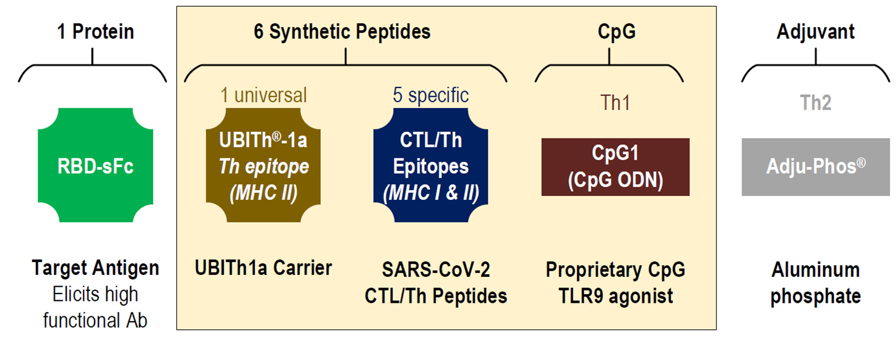

UB-612 vaccine construct contains an S1-RBD-sFc fusion protein for the B cell epitopes, plus five synthetic Th/CTL peptides for class I and II MHC molecules derived from SARS-CoV-2 spike S2, membrane (M), and nucleocapsid (N) proteins, and the UBITh1a peptide. These components are mixed with CpG1 which binds the positively (designed) charged peptides by dipolar interactions and also serves as an adjuvant, which is then bound to Adju-Phos adjuvant to constitute the UB-612 vaccine drug product.

Fig. S2. Viral-neutralizing antibody titers expressed in International Unit (IU/mL) are shown against live SARS-CoV-2 wild type after the primary 2-dose vaccination and the booster third-dose
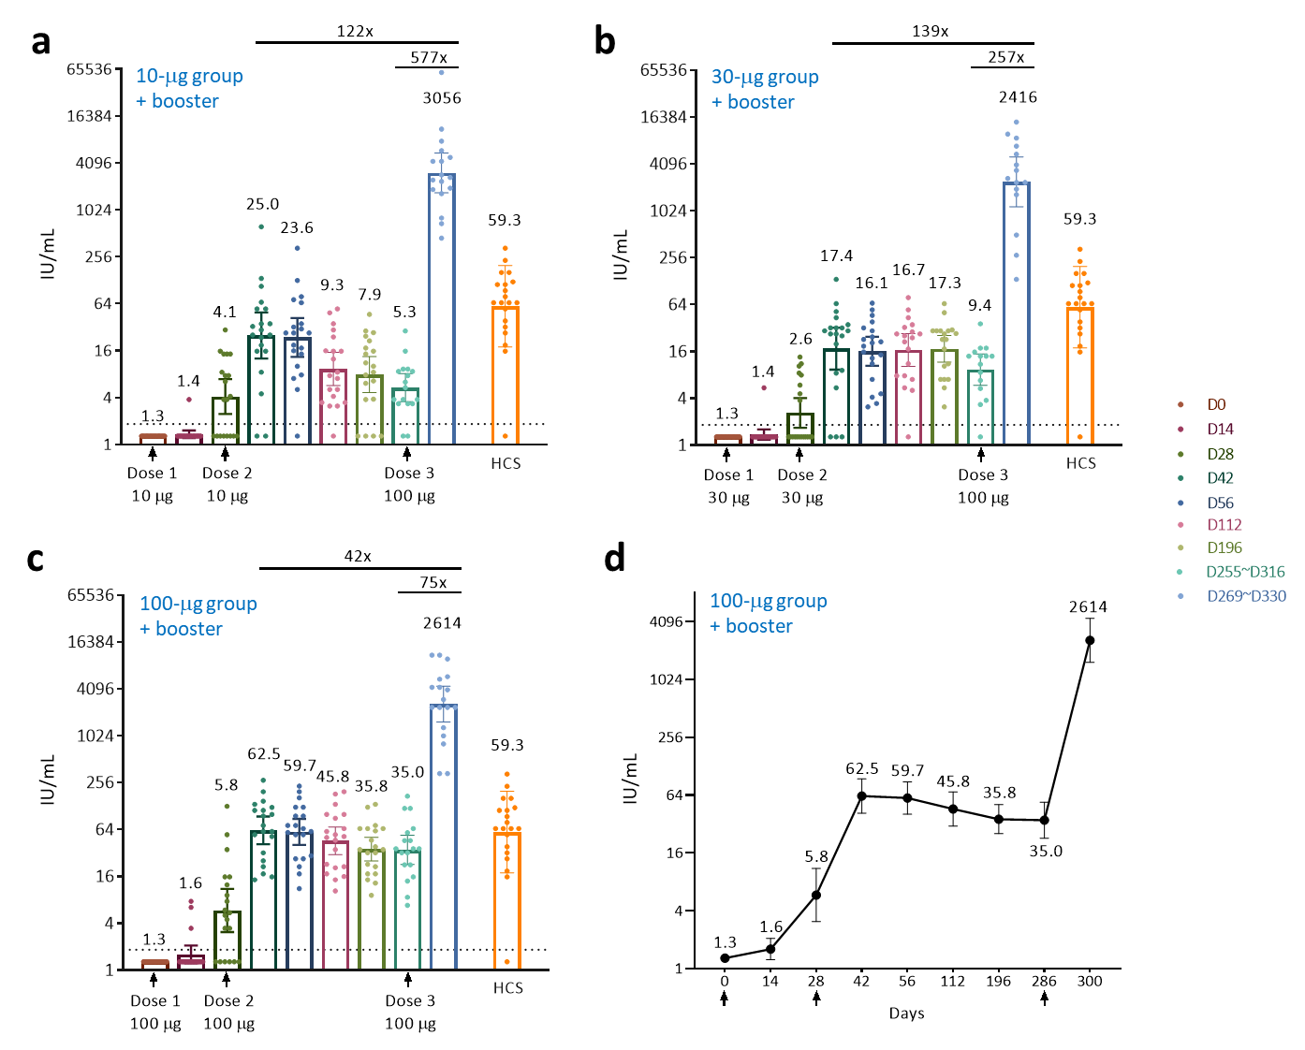

In the primary 2-dose vaccination series of the 196-day phase-1 UB-612 trial, 60 participants were enrolled for the10-μg, 30-μg, and 100-μg dose groups (n = 20 each group), of which 50 participants were enrolled for the extension study where participants received a booster 3rd-dose at 100 μg (n = 17 for the 10-μg; n = 15 for the 30-μg, and n = 18 for the 100-μg dose group). The viral-neutralizing antibody geometric mean titers (GMT) that inhibit 50% of live SARS-CoV-2 wild-type (WT, Wuhan strain) were measured and expressed as International Unit (IU/mL) for (a) the 10-μg, (b) 30-μg, and (c) 100-μg dose groups. The interchange of VNT50 and IU/mL is based on the lab-established relationship: International Unit (IU) = 0.4964*(VNT50^{1.0334}). (d) Illustrated with the 100-μg dose group, the VNT50 data were recorded on Day 0 (pre-dose 1), Day 14 (14 days post-dose 1), Day 28 (1 mon. post-dose 1; pre-dose 2), Day 42 (14 days post-dose 2), Day 56 (1 mon. post-dose 2), Day 112 (3 mon. post-dose 2), Day 196 (6 mon. post-dose 2), Days 255 to 316 (pre-dose 3, the pre-booster), and Days 269 to 330 (14 days post-booster) for study participants of the three dose groups. The 50% neutralizing GMT (VNT50) corresponding to International Unit (IU/mL) corresponding to is shown in the Fig. 3. The results are denoted on the top of the box and the 95% confidence intervals are shown by the brackets. The titers for individual participants are shown by the circles. The horizontal dotted lines indicate the lower limit of quantification (LLOQ). HCS: human convalescent serum samples in the control group (n = 20).

Fig. S3. Anti-S1-RBD antibody titers on ELISA expressed in Binding Antibodies Unit per milliliter (BAU/mL) in the primary 2-dose vaccination and after the booster third-dose
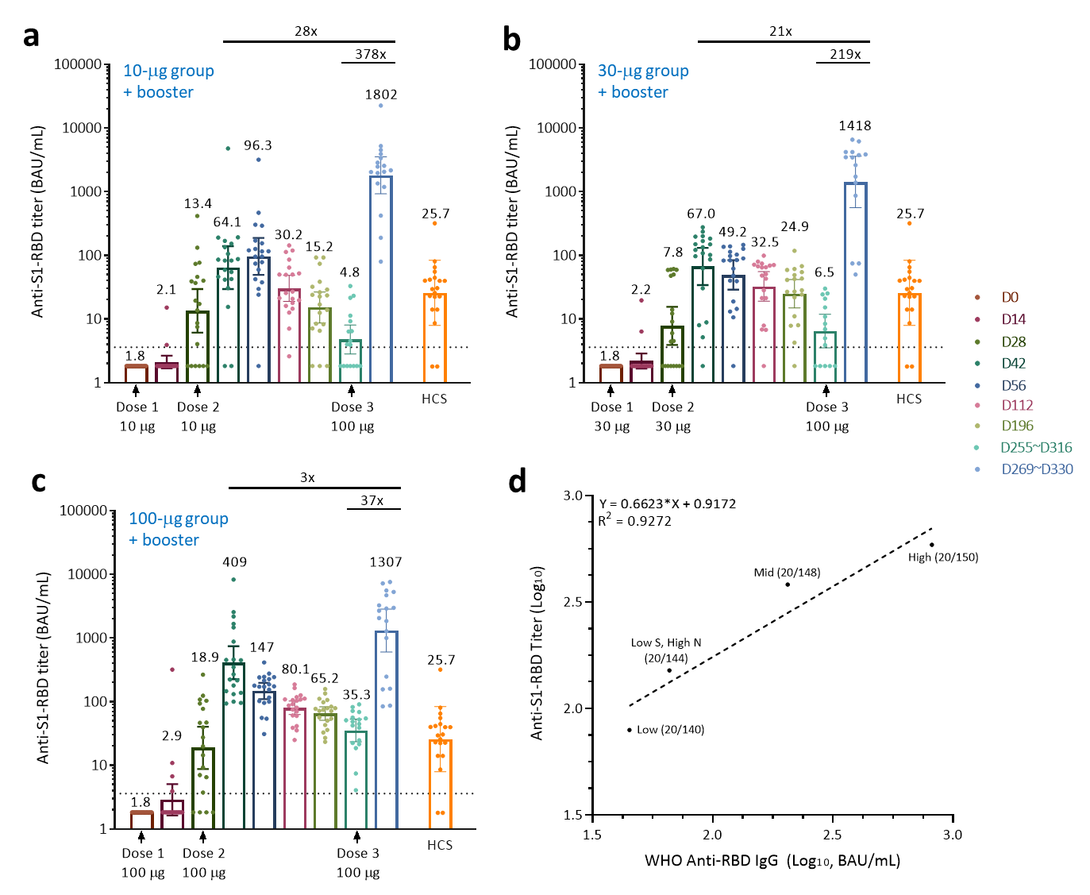

ELISA-based anti-S1-RBD antibody binding titers in the primary 2-dose vaccination series of a 196-day phase 1 trial (60 participants) and in the extension study with a booster third-dose. Participants of (a) 10-μg, (b) 30-μg, and (c) 100-μg dose groups (n = 20 each dose group) received two assigned vaccine doses, 28 days apart, and a booster third dose of 100 μg at a time over 6 months administered to 50 participants (n = 17 for the 10-μg, n = 15 for the 30-μg, and n = 18 for the 100-μg dose groups). Serum samples were collected at the indicted time points for measuring anti-S1-RBD antibody binding by ELISA. The horizontal dotted lines indicate the lower limit of quantification (LLOQ). (d) The binding titers are translated into Binding Antibodies Unit (BAU/mL) by fitting anti-S1-RBD titers and WHO International Reference panel 20/2689 with simple liner regression (Pearson r = 0.9559). Good correlation exists between anti-S1-RBD antibody binding and BAU. Data are plotted for all prime/boost vaccinated participants (10-, 30- and 100-μg dose groups). Data points for participants at day 0 are excluded from correlation analysis. Correlation is analysed by Nonparametric Spearman correlation method.

Fig. S4. Viral-neutralizing VNT₅₀ titers against different SARS-CoV-2 variants
observed in the primary series of phase-1 trial of UB-612 at 100-μg dose

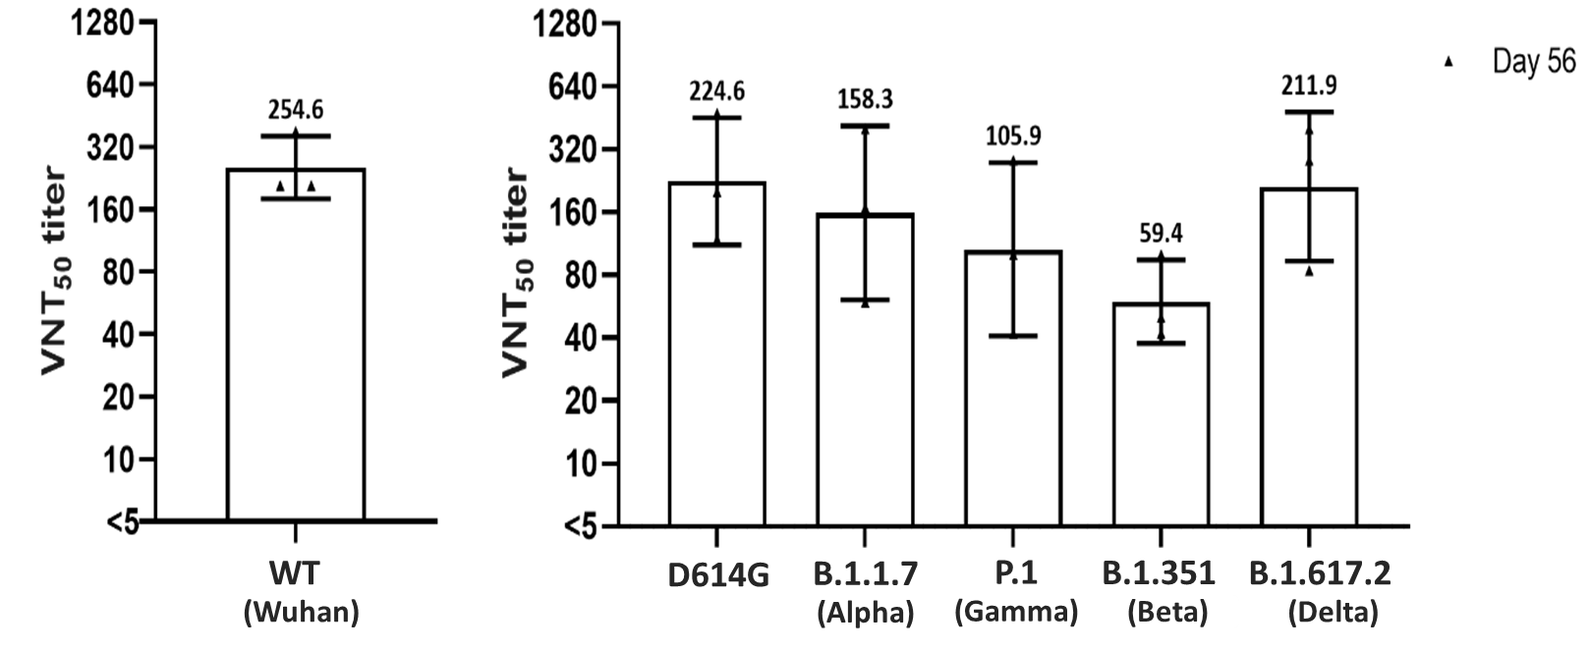

In the primary 2-dose vaccination series of phase-1 trial with vaccinees receiving two UB-612 doses at 100 μg, three samples (n = 3) of Day-56 immune sera (28 days after the second dose) were selected for measuring comparative neutralizing antibody activity against Variants of Concerns (VoCs). VNT₅₀ titers were assessed by cytopathic effect (CPE) assay (in vitro live virus microneutralization). The study was conducted in BSL3 lab at Viral and Rickettsial Disease Laboratory (VRDL), California State Department of Public Health (CDPH), USA. The UB-612-induced immune sera and preserved substantial viral neutralizing activities, in particular against the Delta B.1.617.2 variant, to which an 83% neutralizing activity (1.2-fold reduction) is retained as relative to the wild type Wuhan strain. Notable neutralizing antibodies were preserved as well against the Alpha B.1.1.7, with 62% retained (1.6-fold reduction), Gamma P.1 with 42% retained (2.4-fold reduction), while that against Beta B.1.351 was weaker, 23% retained (4.3-fold reduction).

Fig. S5. Pre- and post-booster T cell responses measured by IFN-γ ELISpot and IL-4 ELISpot after restimulation with RBD+Th/CTL, Th/CTL, or CoV2 peptides for 10-, 30-, and 100-μg dose groups in the 196-day Phase-1 trial
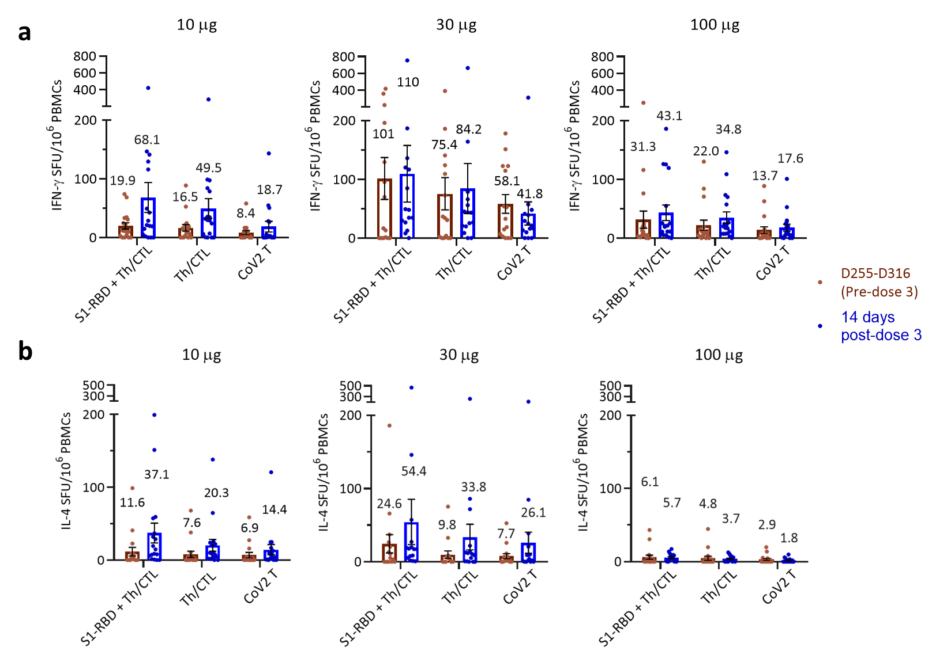

Peripheral blood mononuclear cells (PBMCs) collected from vaccinees before the booster (Pre-dose 3) and 14 days post-booster were subjected to ELISpot assays. These results are shown as spot forming unit (SFU) per million PBMCs producing (a) IFN-γ and (b) IL-4 in response to stimulation with S1-RBD+ Th/CTL peptide pool, Th/CTL peptide pool, or CoV2 T peptides as indicated. Th/CTL peptide pool includes 5 Th/CTL peptides derived from SARS-CoV-2 S2, M, and N proteins (CoV2 T peptides) and UBITh®1a peptide.

Fig. S6. Pre- and post-booster antigen-specific CD4⁺ and CD8⁺ T cell responses assessed by ICS for 10-, 30-, and 100-μg dose groups in the 196-day Phase-1 trial
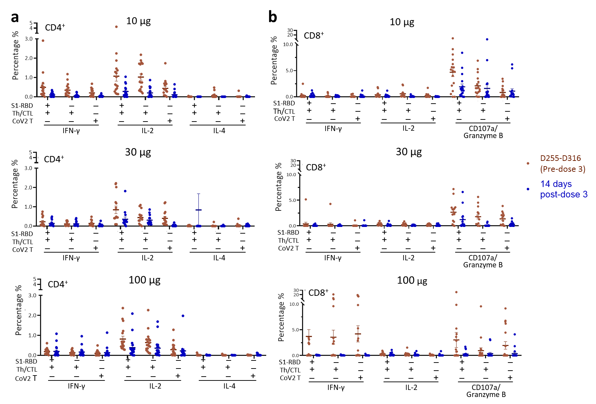

PBMCs collected from vaccines at Pre-dose 3 (pre-booster) and 14 days post-dose 3 (post-booster) were subjected to intracellular cytokine staining and flow cytometric analysis. The Y-axis shows the percentage of cytokine positive cells. The X-axis depicts IFN-γ, IL-2, IL-4 response in (a) CD4⁺ T cells and IFN-γ, IL-2, CD107a/granzyme B response in (b) CD8⁺ T cells induced by restimulation with S1-RBD+ Th/CTL peptide pool, Th/CTL peptide pool, or CoV2 T peptides as indicated. Th/CTL peptide pool includes 5 Th/CTL peptides derived from SARS-CoV-2 S2, M, and N proteins (CoV2 T peptides) and UBITh®1a peptide.

SUPPLEMENTARY TABLES

Table S1. In the phase-1 trial of UB-612 for the 10-, 30-, and 100-μg dose group,
viral-neutralizing GMT titers (VNT₅₀) against SARS-CoV-2 wild type (Wuhan strain) observed on Day 14 post-dose 2 in the primary 2-dose vaccination and on Day 14 after the booster third-dose of 100 μg.
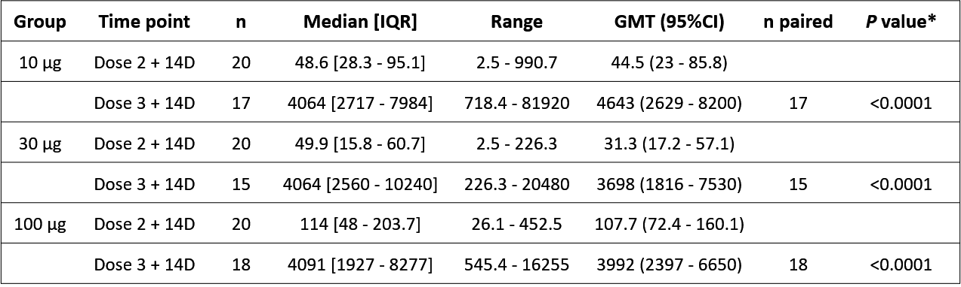

*P values shown pairwise comparison using Wilcoxon sign rank test using Dose 2+14D as reference time-point

