Table 1. Characteristics of study participants in the primary and booster series of the phase 1 trial of UB-612
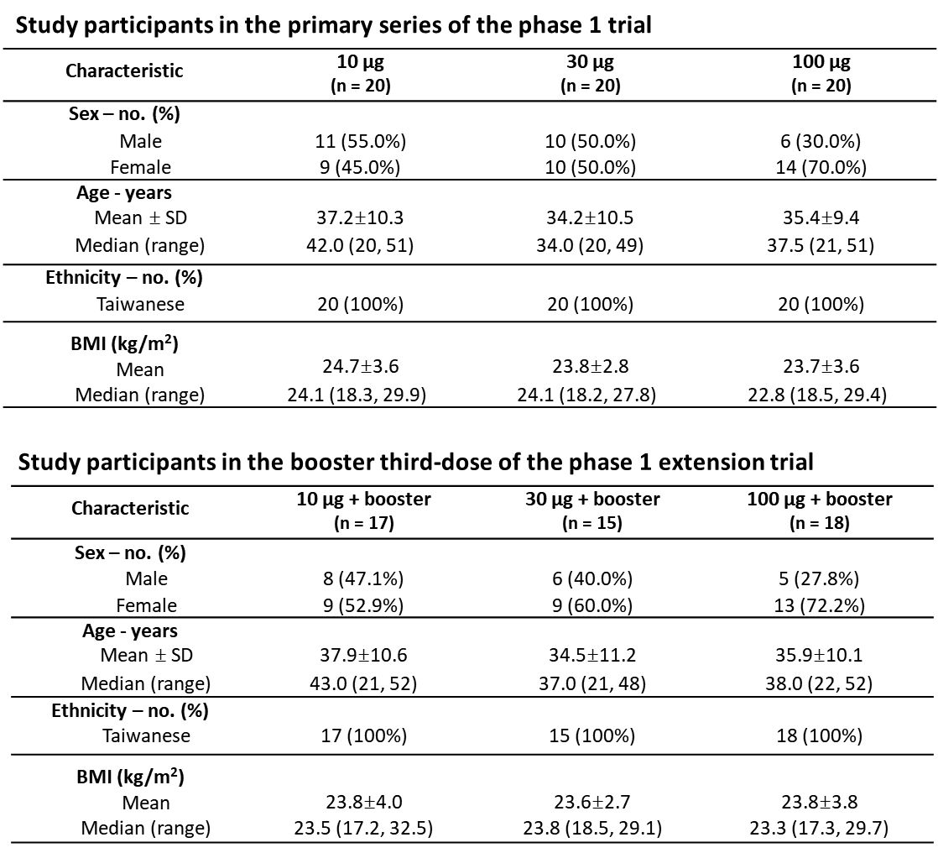

Table 2. Post-booster viral-neutralizing antibody titers against SARS-CoV-2 wild-type (WT) and Delta variant

