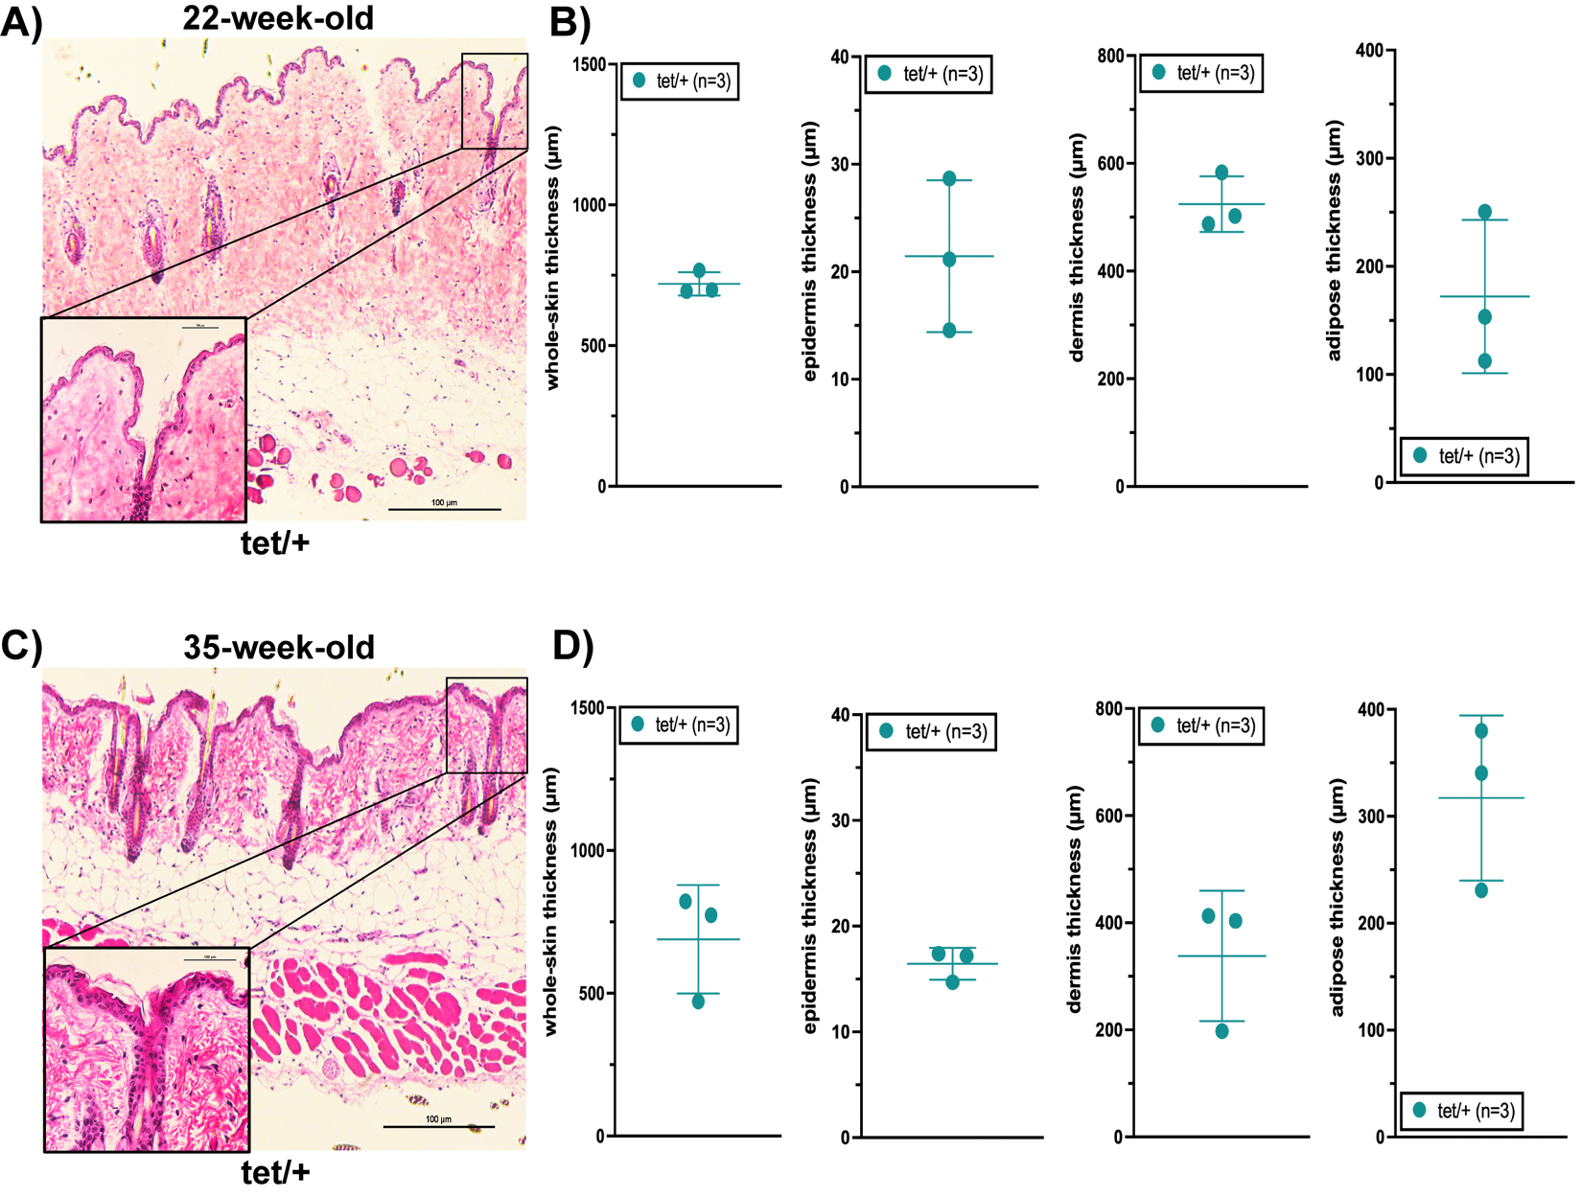

Supplementary Figure 1. Npy^{tet/+} skin exhibits fibrosis, but no changes in the
thickness of skin layers is observed. Representative images of H&E staining of skin from Npy^{tet/+} (n=3) at 22 (A) and 35 (C) weeks old shows fibrosis in Npy^{tet/+} skin. Scale bars: 100µm. (B) The average thickness of all skin layers is similar in 22-week-old Npy^{tet/tet} mice ( p > 0.1700 vs Npy^{+/+}). (D) The average thickness of all skin layers is similar in 35-week-old Npy^{tet/tet} mice ( p > 0.1100 vs Npy^{+/+}).

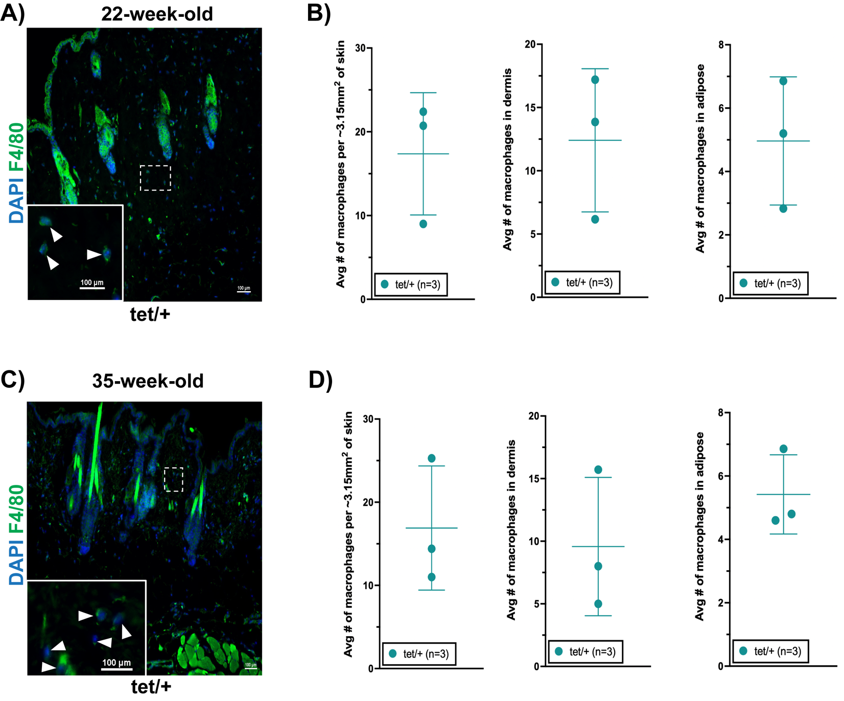

Supplementary Figure 2. Macrophages are more abundant in the subcutaneous
adipose tissue of 35-week-old Npy^{tet/+} skin. (A,C) Representative images of immunolabeled F4/80⁺ macrophages in the skin of 22- and 35-week-old Npy^{tet/+} (n=3) mice. Scale bar: 100µm. (B) The average number of macrophages is similar in 3.15mm² of skin in 22-week-old Npy^{tet/+} mice (p = 0.3270 vs Npy^{+/+}), with no difference in any layer of the skin (p > 0.2000 vs Npy^{+/+}). (D) The average number of macrophages shows a trend to be greater in 3.15mm² of skin in 35-week-old Npy^{tet/+} mice (p = 0.0577 vs Npy^{+/+}), with significantly more abundant macrophages in the subcutaneous adipose tissue (p = 0.0235 vs Npy^{+/+}) and no difference in the other skin layers (p > 0.0900 vs Npy^{+/+}).

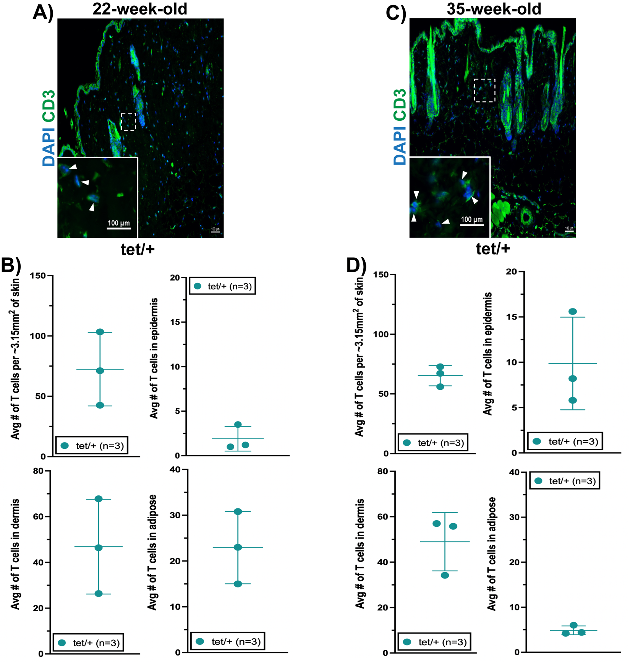

Supplementary Figure 3. T cells are not more abundant in Npy^{tet/+} skin overall. (A,C) Representative images of immunolabeled CD3⁺ T cells in the skin of 22- and 35-week-old Npy^{tet/+} (n=3) mice. Scale bar: 100µm. (B) The average number of T cells is similar in 3.15mm² of skin in 22-week-old Npy^{tet/+} mice (p = 0.7184 vs Npy^{+/+}), with no differences in any layer of the skin (p > 0.4000 vs Npy^{+/+}). (D) The average number of T cells is similar in 3.15mm² of skin in 35-week-old Npy^{tet/+} mice (p = 0.0909 vs Npy^{+/+}), with no differences in any layer of the skin (p > 0.0500 vs Npy^{+/+}).

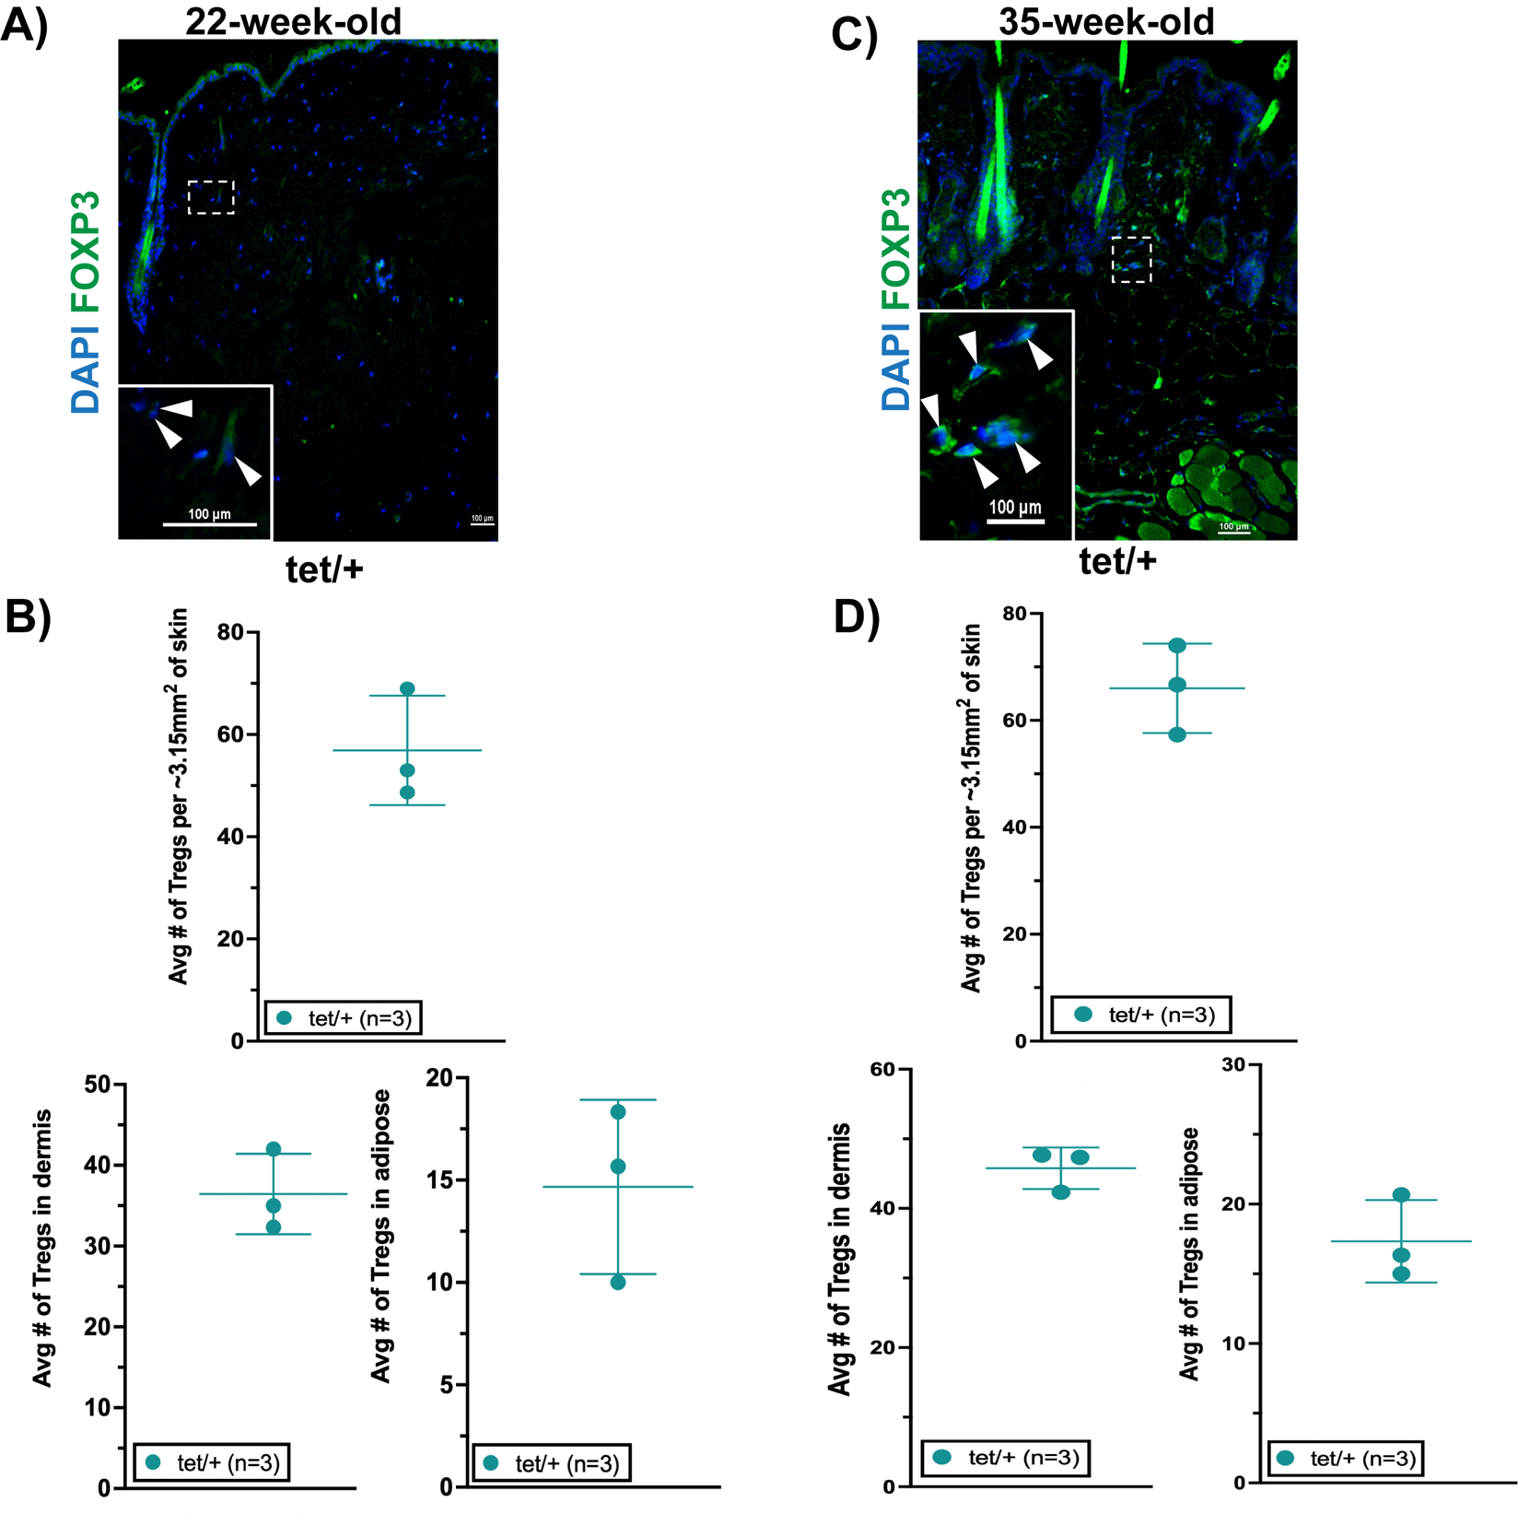

Supplementary Figure 4. Tregs are more abundant in the 35-week-old Npy^{tet/+} skin. (A,C) Representative images of immunolabeled FOXP3⁺ Tregs in the skin of 22- and 35-week-old Npy^{tet/+} (n=3) mice. Scale bar: 100µm. (B) The average number of Tregs is similar in 3.15mm² of skin in 22-week-old Npy^{tet/+} mice (p = 0.2890 vs Npy^{+/+}), although they are significantly more abundant in the dermis (p = 0.0256 vs Npy^{+/+}) but not the subcutaneous adipose tissue (p = 0.4352 vs Npy^{+/+}). (D) The average number of Tregs is significantly greater in 3.15mm² of skin in 35-week-old Npy^{tet/+} mice (p = 0.0028 vs Npy^{+/+}), which is attributed to their increased abundance in the dermis (p = 0.0013 vs Npy^{+/+}) and subcutaneous adipose tissue (p = 0.0071 vs Npy^{+/+}).

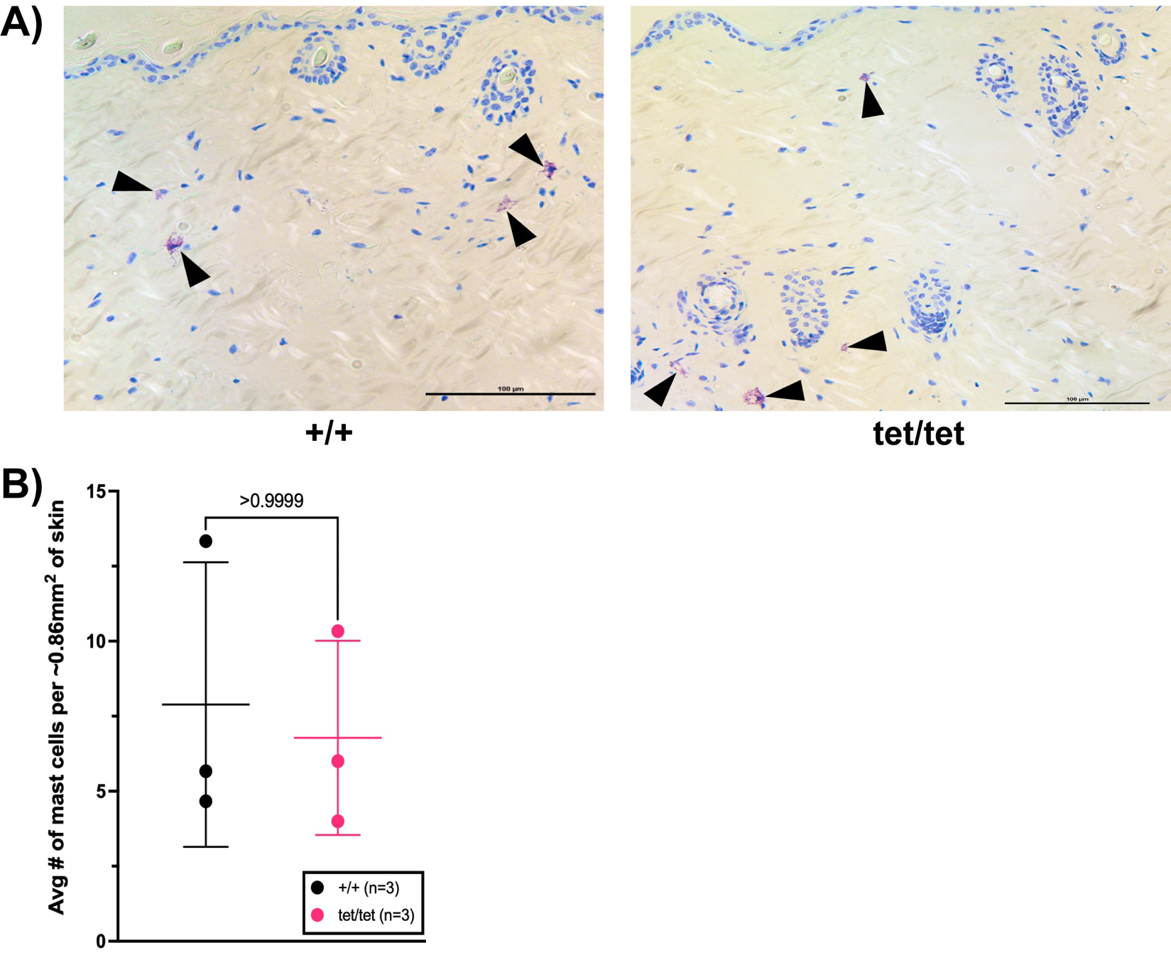

Supplementary Figure 5. Mast cells are not dysregulated in 22-week-old Npy^{tet/tet} skin. (A) Representative images of Toluidine Blue-labeled mast cells in the skin of 22-week-old Npy^{+/+} (n=3) and Npy^{tet/tet} (n=3) mice. Scale bar: 100µm. (B) The average number of mast cells is similar in 0.86mm² of skin in 22-week-old mice (p > 0.9999 vs Npy^{+/+}).

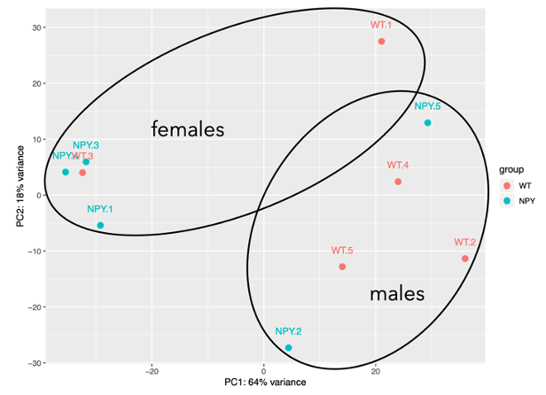

Supplementary Figure 6. PCA plot of RNAseq data obtained from 22-week-old Npy^{+/+} (n=5) and Npy^{tet/tet} (n=5) skin. Ovals indicate the general clustering of samples based on sex.

