Supplementary Information
Modular Multifunctional 5HP2O Linkers for the Versatile Assembly of Protein-Oligonucleotide Conjugates

Jan H. Meffert^{1,*}, Alexandros Kostakis^{2, 3}, Joshua McHale^{4, 5}, Sara Mangsbo³, Carlo Vascotto^{4,5}, Martin Bollmark⁶, Annemieke Madder^{1,*}
¹Organic and Biomimetic Chemistry Research Group, Department of Organic and Macromolecular Chemistry, Ghent University, Krijgslaan 281, 9000 Ghent, Belgium.
²Strike Pharma AB, Lund, Sweden
³ Department of Pharmacy and Science for Life Laboratory, Uppsala University, Uppsala, Sweden.
⁴ IMol Polish Academy of Sciences, Warsaw, Poland
⁵ Department of Medicine, University of Udine, Udine, Italy
⁶ RISE, Department Chemical Process and Pharmaceutical Development, Forskargatan 18, SE-15136 Södertälje, Sweden.

Table of Contents:
SI 1 General Information 3
SI 1.1 Instrumentation 3
SI 1.2 5HP2O Linker and Conjugate Nomenclature 6
SI 1.3 DNA Oligomers and their Synthesis 7
SI 1.4 Peptides 11
SI 1.5 Proteins 11
SI 2 Organic Synthesis 12
SI 2.1 Synthesis of 2-substituted furans 12
SI 2.2 Synthesis of Heterobifunctional Linkers 14
SI 2.3 Synthesis of Trifunctional 5HP2O Linkers 16
SI 2.4 Synthesis of Tetrafunctional 5HP2O Linker 20
SI 2.5 Synthesis of Fluorescent Tags 24
SI 3 Functionalization of Amino-oligonucleotides 25
SI 3.1 Characterization 27
SI 3.2 Stability against hydrolysis 28
SI 4 Protein-bioconjugation of functionalized oligonucleotides 30
SI 4.1 Alphabody – 5HP2O 30
SI 4.2 Alphabody – Maleimide 33
SI 4.3 Conjugate Stability against thiol-exchange 35
SI 4.4 Rituximab – 5HP2O 37
SI 5 Fluorescent Alphabody Conjugate 41
SI 6 Alkyne-5HP2O mediated late-stage functionalisation 45
SI 7 NMR Spectra 51
SI 7.1 2-substituted furans 51
SI 7.2 Heterobifunctional Linkers 55
SI 7.3 Trifunctional 5HP2O Linkers 59
SI 7.4 Tetrafunctional 5HP2O Linker 66
SI 7.5 Fluorescent Tags 70
SI 8 Mass Spectra 72
SI 8.1 2-substituted furans 72
SI 8.2 Heterobifunctional Linkers 76
SI 8.3 Trifunctional 5HP2O Linkers 78
SI 8.4 Tetrafunctional 5HP2O Linker 86
SI 8.5 Fluorescent tags 90
SI 9 References 92

        - General Information
All the reagents and solvents (HPLC grade) were used as received from chemical vendors without any further purification. Commercial chemicals were ordered from BLD-Pharma, Merck, TCI Europe, ABCR while the solvents were ordered from Chemlab. Synthesized products were stored at −20 ◦C. All reactions involving buffered aqueous solutions are using Carmody buffers of a specific pH, which was prepared according to the literature¹.
          - Instrumentation
HPLC-MS of small molecules was performed on an Agilent 1100 series HPLC, equipped with quaternary pump and DAD detector, coupled to an Agilent G1946C single quadrupole MS, equipped with an ESI-ionisation source. A Phenomenex Kinetex C18 column (150 x 4.6 mm, 5 μm at 35 °C) was used with the following solvent system (A) 5 mM NH₄OAc in H₂O and (B) MeCN and the following gradient (flow rate of 1.5 mL/min): 0.5 min 100%A, then a linear gradient from 100% A to 100% B in 6 min, then flushing with 100%B for 2 min.
HPLC-MS of Peptides/Proteins was performed on an Agilent 1100 series HPLC, equipped with quaternary pump and DAD detector, coupled to an Agilent G1956B single quadrupole MS, equipped with an ESI-ionisation source. A Phenomenex Kinetex C18 column (150 x 4.6 mm, 5 μm at 35 °C) was used with the following solvent system (A) 0.1% HCOOH in H2O and (B) MeCN and the following gradient (flow rate of 1.5 mL/min): 0.5 min 100%A, then a linear gradient from 100% A to 100% B in 6 min, then flushing with 100%B for 2 min.
PREP-HPLC purification of small molecules was performed on a Gilson PLC 2250 Instrument equipped with a Waters Delta Pack C18 column (15 µM, 300 x 50 mm, 100 Å) at a flow rate of 65 mL/min. A gradient from 100% A and 0% B to 75%A and 25% B over 40 min followed by a gradient to 100% B over 5 min and a 10 min washing with 100%B, was mainly employed. Solvent A: mQ. Solvent B: Acetonitrile.
HPLC-UV (DNA Functionalisation and Conjugation) analyses and purifications were performed on either an Agilent 1100 or 1200 series instrument, connected to a DAD on a Waters X-Bridge BEH C18 XP Column (130 Å, 2.5 μm, 4.6 mm X 50 mm) with a flow rate of 0.8 mL/min from 100 % A and 0 % B to 70 % A and 30 % B over 13 min respectively to 70% B over 13 min. Solvent A: 5 % acetonitrile, 95% Triethylammonium acetate buffer 0.1M. Solvent B: Acetonitrile.

NMR spectra were recorded with a resolution of 300 or 400 MHz. The 300 MHz measurements were performed on a 300 MHz Avance I (Bruker) with a 5 mm dual channel probe head, ¹H and Broadband (BBO-type), equiped with an ultrashield type magnet. Measurements with 400 MHz resolution was carried out on a 400 MHz Avance II (Bruker) with a 5 mm dual channel probe head, 1H and Broadband (BBO-type), and an ultrashield type magnet. The chemical shifts are expressed in ppm and the residual solvent peak was used as internal reference. Scalar couplings (J) are reported in Hertz (Hz). The multiplicity of the signals were indicated by the following abbreviations: s, singlet; d, doublet; t, triplet; q, quadruplet; p, quintuplet; sx, sextet; sept, septuplet; m, multiplet; br, broadened; band, several overlapping signals).

HRMS were recorded on an Agilent Accurate Mass Quadrupole Time-of-Flight mass spectrometer (small molecules) or an Orbitrap mass spectrometer (DNA oligomers). Orbitrap settings are as follows: ESI Infusion, Scan range: 150-2000, Resolution: 70000, Sheath gas flow rate: 35, Aux gas flow rate: 10, Sweep gas flow rate: 1, Spray voltage: 3 kV, Capillary temperature: 250°C, S-Lens RF level: 50, Aux gas heater temperature: 200°C.
MALDI-TOF mass spectrometry data of proteins/conjugates were collected on a Sciex/Applied Biosystems 4800plus MALDI-TOF/TOF analyser equipped with a Nd-YAG solid-state laser (355 nm) and a pulse frequency of 200 Hz using 1) 2,5-Dihydroxybenzoic acid matrix (10 g/L in ACN : 0.1 % TFA in mQ, 1:2 v/v) or 2) sinapinic acid (saturated in ACN : 0.1% TFA in mQ, 1:2) or cocktail 3) 3-hydroxypicolinic acid solution (1 mg per 10.5 µL of 1:1 ACN/H₂O) mixed with a picolinic acid solution (1 mg per 20 µL of Milli-Q) in a 4:1 ratio. A 9 µL aliquot of this mixture was then combined with 0.5 µL of 230 mg/mL ammonium citrate and 0.5 µL of 1% HFIP to create the final spotting cocktail 3. Samples were analysed in positive linear mode linear and spotted by allowing 0.7 µL matrix to dry and subsequent addition of 0.7 µL of protein/conjugate sample on the dried matrix spot. Analysis was performed with full laser intensity.
Light Irradiation for 2-substituted furan activation was performed using Euromex Illuminator EK-1 Lamps, equipped with a 100 W halogen lamp LE.5210 and connected to a Euromex LE.5214 dual arm light conductor. Lamp was used at maximum brightness.
Freeze-drying of DNA samples was achieved using a Heto Drywinner freeze dryer in combination with a Thermoelectron corporation Savat SPD111V Speedvac concentrator. Peptide/Protein samples were freeze-dried in a RVC 2-18 Cdplus (Christ) speedvac concentrator in combination with an Alpha 2-4 Ldplus (Christ) freeze dryer.
UV-vis measurements for oligomer quantification were performed on a Thermo Scientific Nanodrop instrument measuring the absorption at 260nm.
Yield Calculation was performed by integration (Int) of starting material and product signal in HPLC and subsequent calculation using the following formula: Yield (%) = Int_{Prd} / (Int_{SM} + Int_{Prd}). In case of overlapping signals, the peak was split at the local minima.
Isolated Yield Calculation was performed by quantification of isolated product via UV-vis and subsequent calculation using the following formula: Isolated Yield (%) = n _{Prd} / n_{SM}
PAGE gels were prepared by mixing BioRad 30% Acrylamide/Bis Solution (37.5:1), 1.50 M Tris-HCl, pH 8.8, 10% SDS and water in a Falcon tube until completely dissolved. Tetramethylethylenediamine (TEMED) and ammonium persulfate (APS) were added to induce polymerization. The mixture was poured into SDS PAGE casettes, leaving space at the top of the plate, and isopropanol (1 mL) was added during the polymerisation of the separation gel. Upon polymerisation, the isopropanol is separated, and the stacking gel is added: TEMED and APS were added beforehand to the premixed stacking PAGE gel (BioRad 40% Acrylamide/Bis Solution (37.5:1), 0.50 M Tris-HCl, pH 6.8, 10% SDS, water). A suitable comb was added. After full polymerisation, the comb was removed and the gel rinsed with water. The wells were flushed with 1X SDS-PAGE running buffer (25 mM Tris base, 192 mM Glycine, 3.5 mM SDS) before loading the samples. Nanobodies and Alphabodies were run on a 15% separating gel whereas RTX was analysed on a 8% separating Gel. 2.5 µg of protein (RTX) was loaded by diluting to 10 µL in SDS-PAGE Loading buffer (NuPAGE). Samples were heated to 95°C for 5 minutes to achieve denaturing. The sample was subsequently centrifuged to load the sample in the well. Gels were run at a constant 25 mA (50 mA in case of two gels) until the dye front eluted from the cassette. Gels were stained using Coomassie Brilliant Blue G250 stain for 15 minutes before destaining in water overnight. PageRuler 26616 of ThermoFisher was employed as protein ladder.
8% Separating PAGE gel composition – RTX
Component | Amount
30% Acrylamide/Bis Solution (37.5:1) | 2.60 mL
1.50 M Tris-HCl pH 8.8 | 2.50 mL
10% SDS | 0.10 mL
mQ | 4.69 mL
TEMED | 0.01 mL
10% APS (fresh) | 0.10 mL

5% Stacking PAGE gel composition
Component | Amount
30% Acrylamide/Bis Solution (37.5:1) | 0.80 mL
1.00 M Tris-HCl pH 6.8 | 1.30 mL
10% SDS | 0.05 mL
mQ | 2.80 mL
TEMED | 0.005 mL
10% APS (fresh) | 0.05 mL

10X SDS-PAGE Running buffer (pH 8.3)
Component | Concentration | Amount
Tris-Base | 0.250 M | 30.3 g
Glycine | 1.9 M | 144.4 g
SDS | 0.03 M | 10 g
mQ |  | to 1 L

          - 5HP2O Linker and Conjugate Nomenclature
General Nomenclature of 5HP2O Linkers:
5HP2O(SideChain)-Spacer-NHS
- If R1=Me then no specification of side chain: 5HP2O-Spacer-NHS
- If no NHS ester formed yet: 5HP2O-Spacer-COOH
- In case other handles used: Mal=Maleimide, DBCO= Dibenzocyclooctyne …
Spacer:
- C# for a carbonyl chain bearing #CH₂-units
- EG# for # oxygens in ethylene glycol spacer unit
- Amide/ester bonds are typically not indicated in the name

General Nomenclature of functionalised Oligonucleotides:
5HP2O(SideChain)-Spacer-Oligomer
Oligomer will be abbreviated referring to its sequence by: D1, M4, M5...
A list of all oligomers, including their sequences, can be found in Table S 1.
D: Oligodeoxynucleotide, M: MALAT1 LNA-Gapmer

General Nomenclature of Oligonucleotide Conjugates:
In accordance with the proposed nomenclature in the literature ².

R-5HP2O(SideChain)-Spacer-Oligomer
R (Protein or Peptide) will be abbreviated, referring to its sequence by: Ab, RTX
A list of all proteins and peptides can be found in Table S2 and S3.

Special Cases:
In case the oligomer is linked via the side chain (e.g. NBD containing linker 8), the nomenclature changes to:
5HP2O(SideChain-Oligomer)-Spacer

          - DNA Oligomers and their Synthesis
Table S 1: DNA constructs employed in this work. * = Phosphorothioate, ^{m}C = methylCytosine, LNA = Locked nucleic acid, PAMBA = para-aminomethylbenzoic acid, NH₂-C₆H₁₂ = commercial 5AmMC6 IDT Amino Modifier, PO = phosphodiester backbone, PS = Phosphothioate backbone, ex. = exact mass as measured with Orbitrap HRMS.
DNA | Source | Type of AON | Sequence (5’ to 3’) | Epsilon /  L/(mole·cm) | Exact Mass / Da | M_{obs.}/ Da
D1 | IDT | PO | H₂N-C₆H₁₂-(CGA)₇ | 212300 | 6638.41 | 6638.19
M4 | RISE | PS, LNA Gapmer, cleavable | NH₂-Ribose-TCATCA-G*^{m}C*A*T*T*C*T*A*A*T*A*G*C*A*G*^{m}C | 285700 | 7468.89 | 7469.94
M5 | RISE | PS, LNA Gapmer, non cleav. | NH₂-Ribose-G*^{m}C*A*T*T*C*T*A*A*T*A*G*C*A*G*^{m}C | 212800 | 5656.59 | 5657.63

IDT Oligonucleotide was ordered and used as received.

RISE Oligonucleotides were synthesized on an ÄKTA oligopilot 10 DNA/RNA synthesizer, through standard solid-phase phosphoramidite chemistry. All syntheses were carried out at 50 μmol scale. NittoPhase®HL UnyLinkerTM 400 was purchased from Kinovate Life Sciences, Inc.; T, Ac-protected dC, iBu protected dG and Bz-protected dA DMTr 5ʹ hydroxyl protected phosphoramidites were purchased from Thermo Fisher Scientific Inc. and LNA T, LNA Bz-protected me-C, LNA Bz-protected A and LNA dmf-protected G DMTr 5ʹ hydroxyl protected phosphoramidites were purchased from Hongene Biotech Corporation. All solvents and reagents were used without further purification. Anhydrous acetonitrile (< 10ppm H₂O), Deblocking (3% DCA in toluene) reagent, Capping A and B and Oxidizer Reagent were obtained from emp BIOTECH GmbH, BTT Activator and 20% DEA in ACN were obtained from Sigma-Aldrich, sulfurisation solution was prepared in house (0.2 M Xanthane Hydride in Pyridine). Stepwise coupling efficiencies were determined by the automated trityl cation UV monitoring of the DNA/RNA synthesizer. All phosphoramidite monomers were dissolved in anhydrous acetonitrile to a concentration of 0.1 M, with exception of LNA Bz-protected me-C phosphoramidite which was dissolved in 3:1 solution of anhydrous acetonitrile and anhydrous THF, to a concentration of 0.1 M; for all phosphoramidite solutions, the head space was purged and left under nitrogen atmosphere with 3Å molecular sieves for 30 minutes to 18h prior to use. Deprotection and cleavage from the solid support was achieved through suspension of the resin in 8 mL of concentrated aqueous ammonia solution, over 30 minutes at room temperature with shaking, followed by overnight heating at 55 °C. The resin was then filtered through ISOLUTE® Single fritted reservoir (AG), 25 mL 10 μm PE with a nitrogen flow, and washed with water, to a known volume. The purity of oligonucleotides (crude and isolated product) was confirmed by Reverse-Phase Liquid Chromatography-Mass Spectrometry (RP-LC-MS) using electrospray ionization (ESI) in negative ion mode, carried out on a RP-LC-MS system equipped with UV detection at 254 nm using an ACQUITYTM PREMIER oligonucleotide BEH C18, 130 Å (1.7 μm, 2.1 × 50 mm) column with 0.2 mL flow rate and a linear gradient from 0-95% of buffer B in buffer A over 15 min at 40 °C. Buffers for RP-HPLC were as follows: (A) 8.6 mM TEA, 100 mM HFIP in H₂O, (B) 8.6 mM TEA, 100 mM HFIP in MeOH.

Purification: Oligonucleotides were purified through reverse phase chromatography, carried out on Biotage Selekt using Biotage Sfär C18 D - duo 100 Å 30 μm or Biotage Sfär C18 D - duo 300 Å 20 μm prepacked columns (acquired from Biotage), with 25 mL/min and 40 mL/min flow rates, respectively, and a linear gradient from 0-30% MeCN (with 1-5% of TEEA) in 0.1 mM of TEEA (both were degassed prior to purifications).

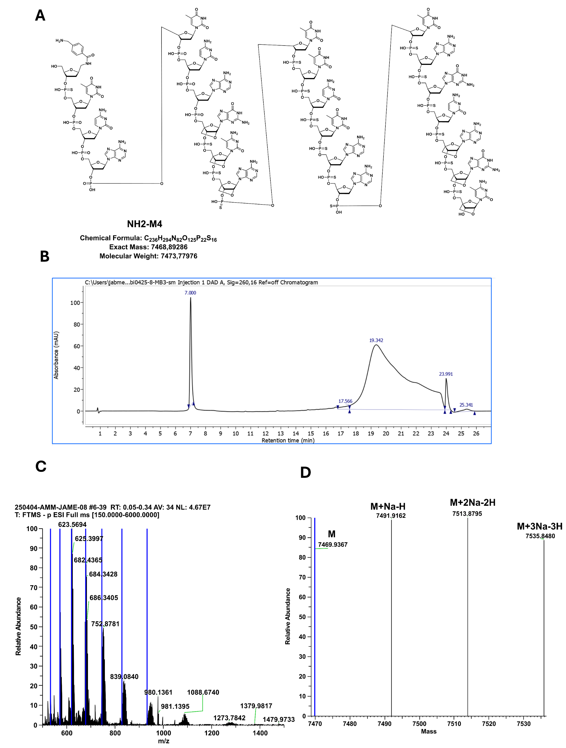Supplementary Figure 1: Synthesised and purified according to general procedures. (A) Structure of M4. (B) HPLC chromatogram (260 nm, to 75%) of M4. (C) Orbitrap mass spectrum of M4. (D) Deconvoluted mass spectrum of M4.

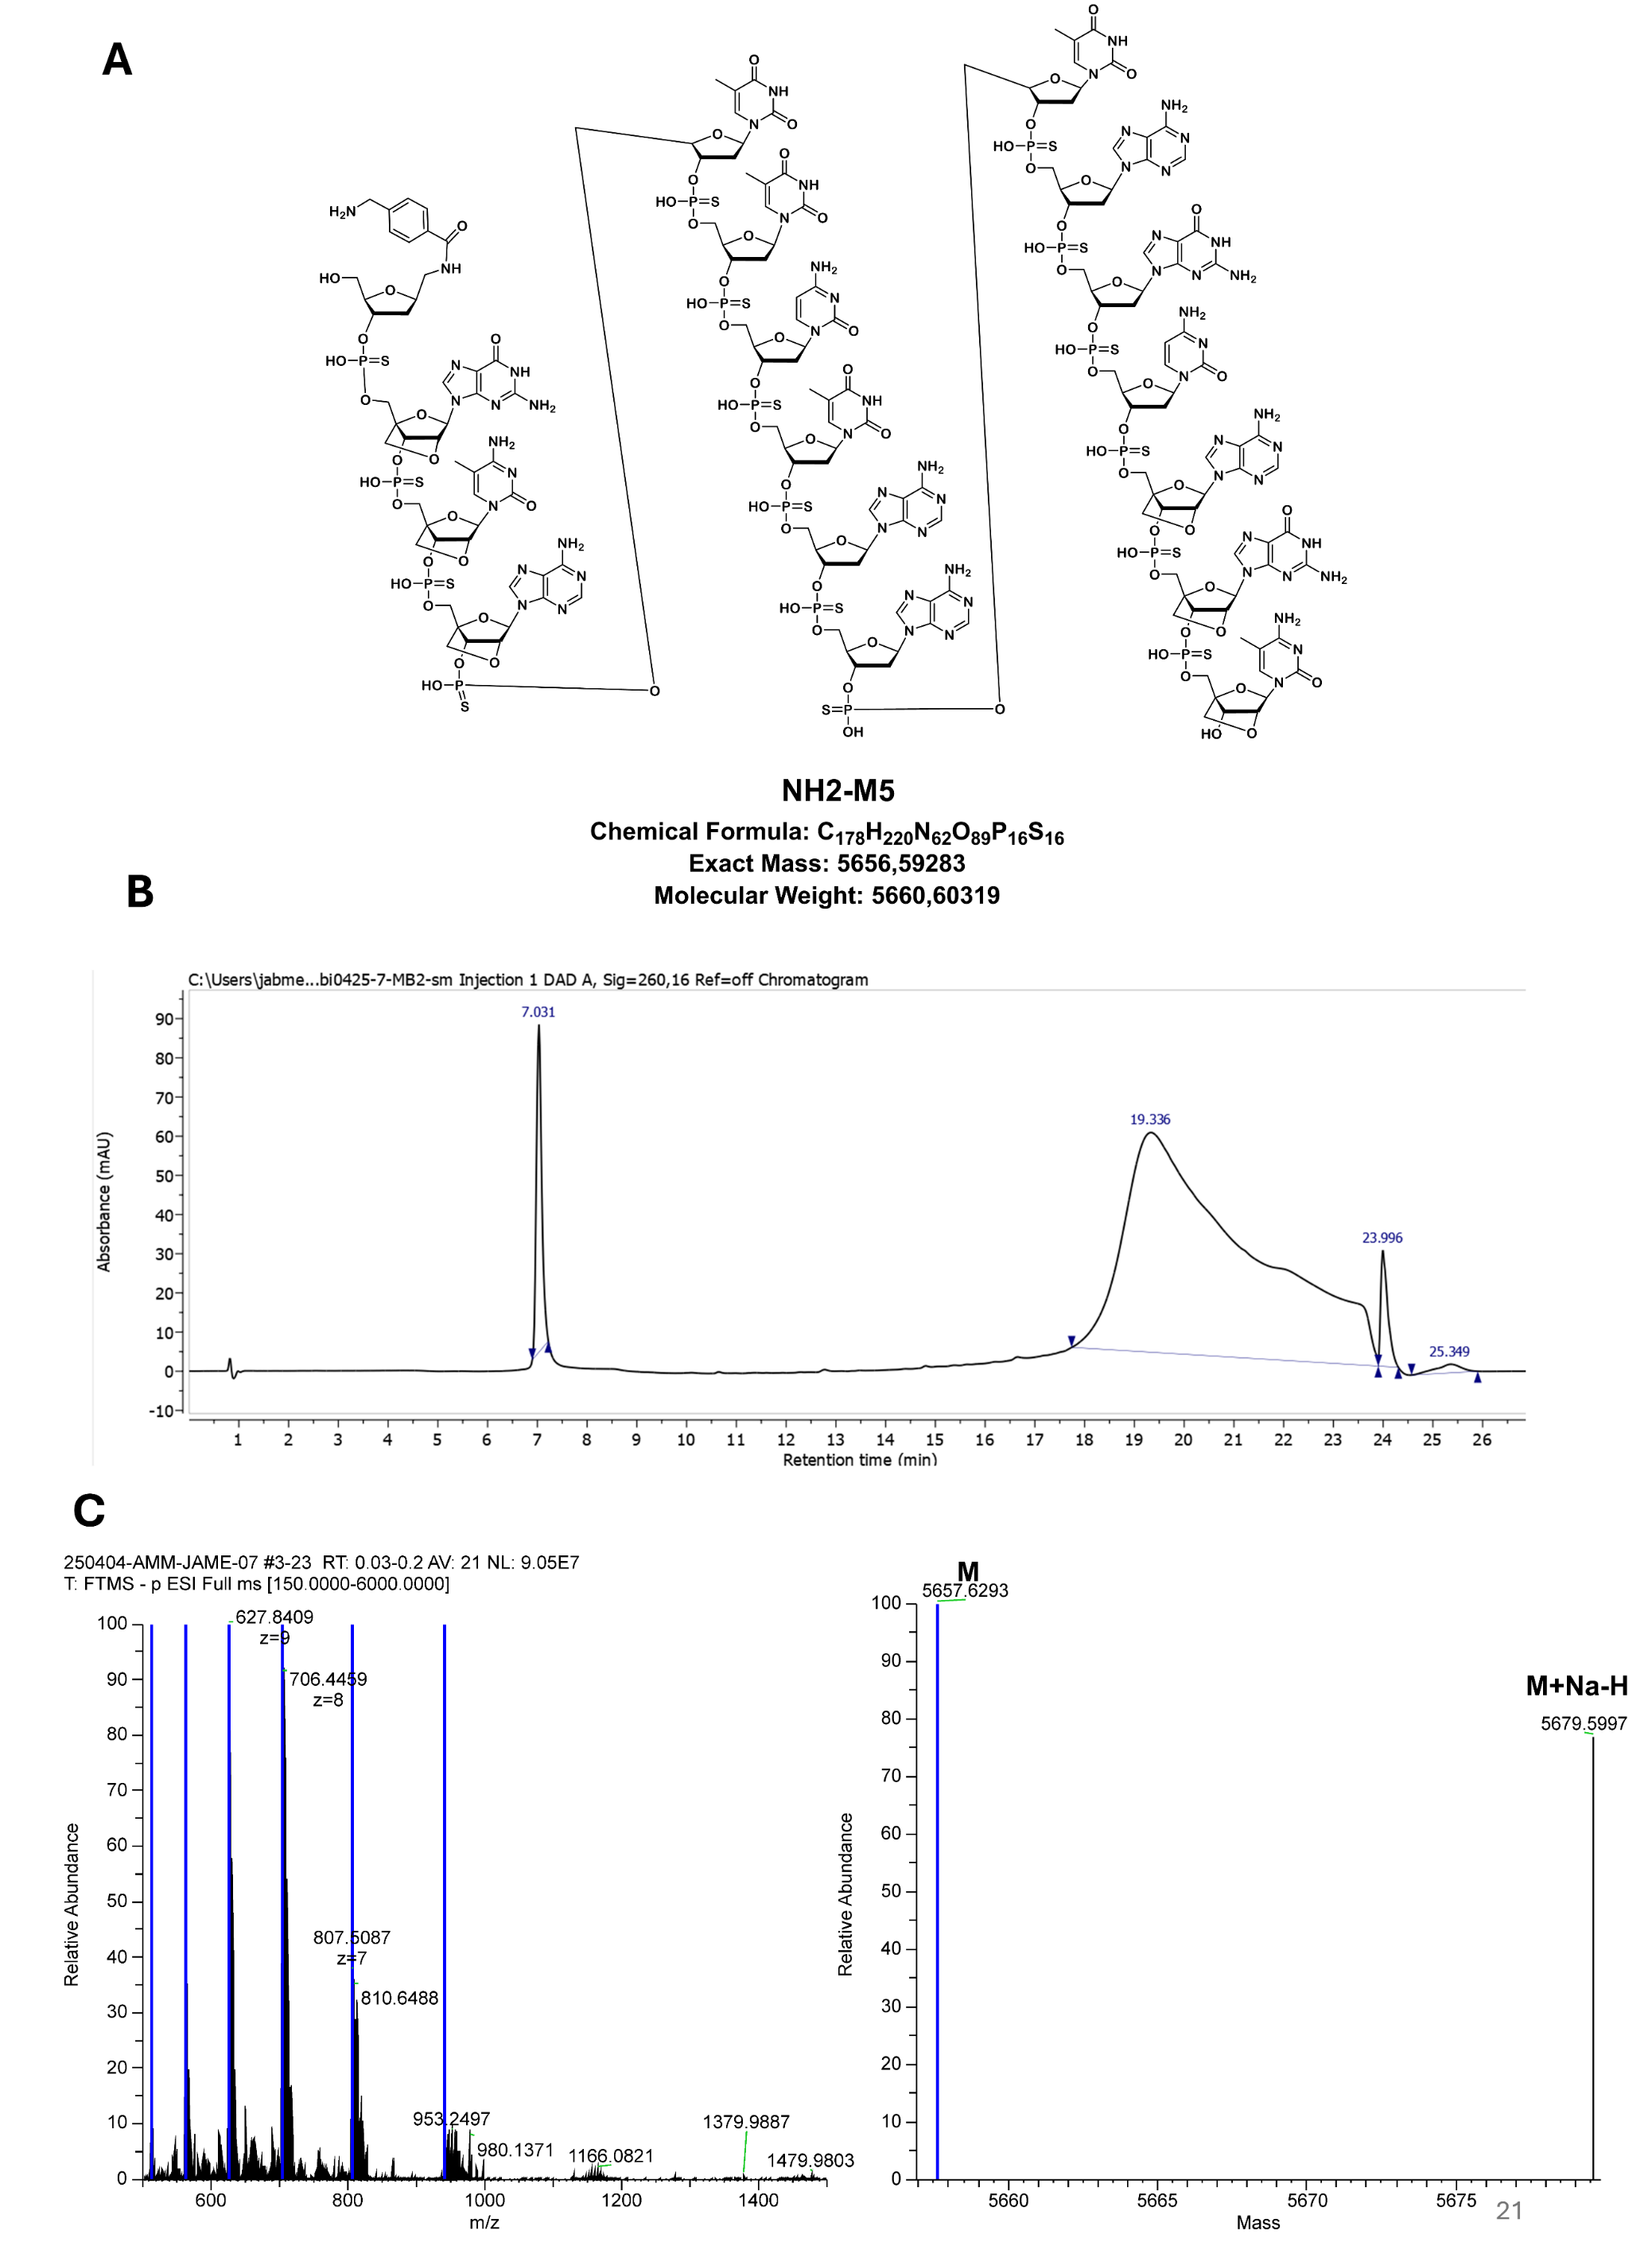
Supplementary Figure 2: Synthesised and purified according to general procedures. (A) Structure of M5. (B) HPLC chromatogram (260 nm, to 75%) of M5. (C) Orbitrap mass spectrum of M5. (D) Deconvoluted mass spectrum of M5.

          - Peptides
Table S 2: Peptides employed in this work.
Peptide | Source | Sequence (N to C term.) | MW _{calc.} / Da
pTagC(K) | commercial | H-FIGITELLKC-OH | 1150
pTagC(L) | commercial | H-FIGITELKKC-OH | 1135

          - Proteins
Table S 3: Proteins employed in this work.
Name | Abbreviation | Source | Type of Protein
Alphabody³ | Ab | Complix | De-novo designed triple-helical coiled coil
Rituximab⁴ | RTX | University of Southampton | Full monoclonal antibody
Anti-CD40 mAb Fusion to antipTag⁵ | antiCD40-mAb  (STRIKE2001) | Strike Pharma | Fusion protein containing mAb and scFv

        - Organic Synthesis
          - Synthesis of 2-substituted furans
            - N-2-Propyn-1-yl-2-furanpropanamide (16)
General procedure GP1: 4 mmol furan 6, 83% yield, white solid, purified by silica flash chromatography (gradient from 100% Cyclohexane to 100% Ethyl acetate). ¹H NMR (300 MHz, CDCl₃) δ 7.31 – 7.25 (m, 1H, H2/5), 6.28 – 6.24 (dd, J = 3.2, 1.8 Hz, 1H, H1), 6.06 – 5.98 (m, 1H, H2/5), 4.03 (dd, J = 5.0, 2.6 Hz, 2H, H11), 2.98 (dd, J = 8.6, 6.7 Hz, 2H, H6/7), 2.53 (dd, J = 8.3, 6.9 Hz, 2H, H6/7) 2.24 – 2.18 (m, 1H, H13).¹³C NMR (101 MHz, CDCl₃) δ 171.67 (C4/8), 154.20 (C4/8), 141.34 (C2/5), 110.37 (C1), 105.66 (C2/5), 79.49 (C12), 71.73 (C13), 34.71 (C6/7), 29.34 (C11), 23.95 (C6/7). LCMS t_{ret} = 4.57 min, ESI-MS+ m/z calculated for C15H24N4O5 177.08 [M], found 178.07 [M+H]+. HRMS (ESI+): calculated for C₁₀H₁₁NO₂: 177.0790 [M]; found 178.0870 [M+H]⁺.

            - N-(2-(2-(2-(2-azidoethoxy)ethoxy)ethoxy)ethyl)-3-(furan-2-yl)propenamide
(13)
General procedure GP1: 3.0 mmol furan 6, 89%, preparative reverse phase chromatography. ¹H NMR (400 MHz, MeOD) δ 7.32 (dd, J = 1.9, 0.8 Hz, 1H, H2/5), 6.25 (dd, J = 3.2, 1.9 Hz, 1H, H1), 6.02 (dd, J = 3.2, 1.0 Hz, 1H, H2/5), 3.68 – 3.59 (m, 8H, H14-18), 3.59 – 3.53 (m, 2H, H11/12/20/21), 3.48 (t, J = 5.5 Hz, 2H, H11/12/20/21), 3.33 (dt, J = 8.2, 5.3 Hz, 4H, H11/12/20/21), 2.94 – 2.85 (t, J = 7.6 Hz, 2H, H6/7), 2.49 (t, J = 7.6 Hz, 2H, H6/7). ¹³C NMR (101 MHz, MeOD) δ 174.81 (C4/8), 155.75 (C4/8), 142.39 (C2/5), 111.17 (C1), 106.25 (C2/5), 71.64 (C14/15/17/18), 71.61 (C14/15/17/18), 71.49 (C14/15/17/18), 71.27 (C14/15/17/18), 71.12 (C11/12/20/21), 70.53 (C11/12/20/21), 51.73 (C11/12/20/21), 40.40 (C11/12/20/21), 35.36 (C6/7), 25.06 (C6/7). LCMS t_{ret} = 4.97 min, ESI-MS+ m/z calculated for C15H24N4O5 340.17 [M], found 341.15 [M+H]+, 465.03 [2M-H]- HRMS (ESI+): calculated for C15H24N4O5 340.1747 [M]; found 341.1823 [M+H]+.

            - 3-(2-(2-(3-(furan-2-yl)propanamido)ethoxy)ethoxy)propanoic acid (6)
General procedure GP1 (7 mmol furan 6) was initially followed to couple NH₂-EG2-COO^{t}Bu to furan 6. The reaction mixture was then concentrated under reduced pressure. The residue was redissolved in THF:MeOH:Water (8:8:1 v/v, 17 mL) and treated with potassium hydroxide (40 equiv.). The solution was stirred overnight and concentrated under reduced pressure. The residue was redissolved in water and pH was adjusted to 4 by HCl (3 M). The solution was subsequently purified by preparative HPLC (addition of 0.1 % TFA to solvent A) leading to an orange oil (1.29 g, 62%).
¹H NMR (400 MHz, MeOD) δ 7.35 (dd, J = 1.9, 0.8 Hz, 1H, H2/5), 6.28 (dd, J = 3.2, 1.9 Hz, 1H, H1), 6.08 – 6.03 (m, 1H, H2/5), 3.74 (t, J = 6.2 Hz, 2H, H16), 3.59 (tt, J = 5.4, 2.9 Hz, 4H, H13, 14), 3.50 (t, J = 5.4 Hz, 2H, H10/11), 3.37 – 3.32 (m, 2H, H10/11), 2.96 – 2.84 (m, 2H, H6), 2.59 – 2.48 (m, 4H, H17, 7). ¹³C NMR (101 MHz, MeOD) δ 175.41 (C4/8/18), 174.85 (C4/8/18), 155.72 (C4/8/18), 142.36 (C2/5), 111.16 (C1), 106.25 (C2/5), 71.33 (C13/14), 71.15 (C13/14), 70.52 (C10/11), 67.80 (C16), 61.54 (EtOAc), 40.37 (C10/11), 35.76 (C7/17), 35.31 (C7/17), 25.03 (C6), 14.46 (EtOAc). LCMS t_{ret}= 3.34 min; ESI-MS- m/z calculated for C₁₄H₂₁NO₆: 299.1360 [M]; found 298.111 [M-H]⁻. HRMS (ESI+): calculated for C₁₄H₂₁NO₆ 299.1369 [M]; found 300.1446 [M+H]⁺.

            - Synthesis of 4-(2-Furyl)-2-butanone
4-(2-Furyl)-2-butanone (volatile) was synthesized according to the reported procedure⁶.
¹H NMR (300 MHz, CDCl₃) δ 7.33 – 7.25 (m, 1H), 6.27 (dd, J = 3.1, 2.0 Hz, 1H), 6.04 – 5.96 (m, 1H), 2.98 – 2.86 (m, 2H), 2.79 (ddd, J = 8.2, 6.9, 1.6 Hz, 2H), 2.17 (d, J = 0.6 Hz, 3H). In accordance with literature ⁶.

            - Synthesis of 2-(2-(furan-2-yl)ethyl)-2-methyl-1,3-dioxolane (11)
To a solution of 4-(2-Furyl)-2-butanone (250 mg, 1.81 mmol) in dry DCM (10 mL, with molecular sieves) was added triethylorthoformate (3.0 equiv., 0.94 mL), ethylene glycol (1.1 equiv., 123 mg) and p-toluenesulfonic acid (0.1 equiv., 34 mg). The reaction mixture was stirred overnight at room temperature before the solution was concentrated under reduced pressure. 2-(2-(furan-2-yl)ethyl)-2-methyl-1,3-dioxolane (38%, 74 mg) was obtained upon silica flash chromatography (0:100 to 100:0 Ether:Pentane v/v).
¹H NMR (300 MHz, CDCl₃) δ 7.33 – 7.26 (m, 1H, H2/5), 6.31 – 6.23 (m, 1H, H1), 5.98 (m, 1H, H2/5), 4.05 – 3.88 (m, 4H, H11+12), 2.83 – 2.66 (m, 2H, H6/7), 2.07 – 1.95 (m, 2H, H6/7), 1.35 (s, 3H, H10). ¹³C NMR (101 MHz, CDCl₃) δ 140.91 (C2/5), 110.28 (C1), 104.47 (C2/5), 64.81 (2C, C11+12), 37.40 (C6/7), 24.04 (C10), 22.87 (C6/7). LCMS t_{ret}=5.83 min; ESI-MS+ m/z calculated for C₁₀H₁₄O₃: 182.2190 [M]; found 183.087 [M+H]⁺.
          - Synthesis of Heterobifunctional Linkers
            - 6-(2-hydroxy-2-methyl-5-oxo-2,5-dihydro-1H-pyrrol-1-yl)hexanoic acid
(5HP2O-C5-COOH, 1)
General procedure GP2: 1 mmol 2-methylfuran, preparative reverse phase chromatography partly isolated as triethylamine salt (62% salt, 38% acid), 19% yield. ¹H NMR (300 MHz, D₂O) δ 7.10 (d, J = 6.0 Hz, 1H), 6.09 (d, J = 6.0 Hz, 1H), 3.50 – 3.22 (m, 2H), 3.24-3.15 (m, 2H, Et₃N), 2.33 (t, J = 7.4 Hz, 2H), 1.71 – 1.58 (m, 4H), 1.55 (s, 3H), 1.43-1.31 (m, 2H), 1.28 (t, J = 7.3 Hz, 2H). In accordance with literature⁷.

            - 2,5-dioxopyrrolidin-1-yl-6-(2-hydroxy-2-methyl-5-oxo-2,5-dihydro-1Hpyrrol-1-yl)hexanoate (5HP2O-C5-NHS, 2)
General procedure GP3: 1 mmol 5HP2O 1, 77% yield, white solid, preparative reverse phase chromatography. ¹H NMR (300 MHz, CD₃CN) δ 6.93 (d, J = 5.9 Hz, 1H), 5.94 (d, J = 5.9 Hz, 1H), 3.43 – 3.30 (m, 1H), 3.24 – 3.11 (m, 1H), 2.76 (s, 4H), 2.62 (t, J = 7.4 Hz, 2H), 1.81 – 1.56 (m, 4H), 1.45 (s, 3H), 1.44 – 1.37 (m, 2H). In accordance with the literature⁷.

            - 2,5-Dioxopyrrolidin-1-yl-6-(2,5-dioxo-2,5-dihydro-1H-pyrrol-1-yl)hexanoate
(Mal-C5-NHS)
General procedure GP3: 1 mmol 6-aminohexanoic acid, 94% yield, pale yellow oil, silica flash chromatography (0:100 to 100:0 EtOAc:Cyclohexane v/v). ¹H NMR (300 MHz, CDCl₃) δ 6.68 (s, 2H), 3.53 (t, J = 7.1 Hz, 2H), 2.82 (s, 4H), 2.60 (t, J = 7.4 Hz, 2H), 1.77 (p, J = 7.4 Hz, 2H), 1.70 – 1.55 (m, 2H), 1.48 – 1.35 (m, 2H). In accordance with the literature⁸.

            - 3-(2-(2-(2-hydroxy-2-methyl-5-oxo-2,5-dihydro-1H-pyrrol-1-yl)ethoxy)ethoxy)propanoic acid (5HP2O-EG2-COOH, 3)
General procedure GP2: 1 mmol 2-methylfuran, preparative reverse phase chromatography, 21% yield. ¹H NMR (300 MHz, MeOD) δ 7.00 (d, J = 6.0 Hz, 1H, H1/5), 5.96 (d, J = 6.0 Hz, 1H, H1/5), 3.67 (t, J = 6.5 Hz, 2H, Hdeg), 3.58 – 3.56 (m, 8H, Hdeg), 3.19 (q, J = 7.3 Hz, XH, Et₃N), 2.45 (t, J = 6.5 Hz, 2H, Hdeg), 1.46 (s, 3H, H8), 1.25 (t, J = 7.3 Hz, XH, Et₃N). ¹³C NMR (75 MHz, MeOD) δ 176.79 (quartC), 171.68 (quartC), 153.43 (C1/5), 125.70 (C1/5), 91.22 (Cquart), 71.24 (Cdeg), 71.16 (Cdeg), 69.66 (Cdeg), 68.41 (Cdeg), 47.51 (Et₃N, CH₂), 39.01 (Cdeg), 36.99 (Cdeg), 23.48 (C8), 9.11 (Et₃N, CH₃), LCMS (ESI-): t_{ret} = 2.90 min., m/z calculated for C₁₂H₁₉NO₆: 273.29 [M]; found 272.08 [M-H]⁻.

            - 2,5-dioxopyrrolidin-1-yl-3-(2-(2-(2-hydroxy-2-methyl-5-oxo-2,5-dihydro-1H-pyrrol-1-yl)ethoxy)ethoxy)propanoate (5HP2O-EG2-NHS, 4)
General procedure GP3: 0.29 mmol 5HP2O 3, 70% yield. ¹H NMR (400 MHz, MeOD) δ 7.06 (d, J = 6.0 Hz, 1H, H1), 6.02 (d, J = 5.9 Hz, 1H, H2), 3.83 (t, J = 6.1 Hz, 2H, H10), 3.69 – 3.57 (m, 8H, H9,12,13,15), 2.90 (t, J = 6.1 Hz, 2H, H16), 2.84 (s, 4H, H22+23), 1.52 (s, 3H, H8). ¹³C NMR (101 MHz, MeOD) δ 170.34 (2C, C24,21), 167.19 (C4), 152.05 (C1), 124.39 (C5), 89.87 (C2), 70.10 (C12), 69.89 (C13), 68.33 (C10), 65.45 (C15), 37.66 (C9), 31.52 (C16), 25.15 (2C, C22,23), 22.11 (C8). LCMS (ESI-): t_{ret} = 4.51 min., m/z calculated for C₁₆H₂₂N₂O₈: 370.36 [M]; found 369.00 [M-H]⁻

          - Synthesis of Trifunctional 5HP2O Linkers
Fluorescent 5HP2O procedure: The reaction was performed as described in general procedure GP1 however the amine-fluorophore was employed as limiting reagent (1.0 equiv, 1.0 mmol) whereas the 2-substituted furan was employed in excess (1.5 equiv).
            - 3-(2-(2-(3-(2-hydroxy-1-(5-((7-nitrobenzo[c][1,2,5]oxadiazol-4-yl)amino)pentyl)-5-oxo-2,5-dihydro-1H-pyrrol-2-yl)propanamido)ethoxy)ethoxy)propanoic acid
(5HP2O(C2-EG2-COOH)-C5-NBD, 7)
Fluorescent 5HP2O procedure SI 2.3: 1.0 mmol furan 6, preparative reverse phase chromatography, 14% yield, isolated as triethylamine salt. ¹H NMR (400 MHz, MeOD) δ 8.43 (d, J = 8.8 Hz, 1H, H28/29), 6.95 (d, J = 6.0 Hz, 1H, H1/2), 6.29 (d, J = 8.9 Hz, 1H, H28/29), 6.03 (d, J = 6.0 Hz, 1H, H1/2), 3.68 (t, J = 6.2 Hz, 2H, H21), 3.55 (tt, J = 4.9, 2.8 Hz, 4H, H18/19), 3.46 (m, 4H, H39,16), 3.27 (dt, J = 3.3, 1.6 Hz, 2H, H15), 3.41 – 3.09 (m, 2H, H8), 2.50 (t, J = 6.2 Hz, 2H, H22), 2.27 – 1.95 (m, 4H, H6,11), 1.78 (m, 2H, H38), 1.69 (m, 2H, H9), 1.46 (m, 2H, H37).
¹³C NMR (101 MHz, MeOD) δ 175.37 (Cq), 174.66 (Cq), 171.94 (Cq), 151.21 (C1/2), 146.42 (Cq), 145.82 (Cq), 145.48 (Cq), 137.83(C28/29), 127.34 (C1/2), 122.85 (Cq) 99.64 (C28/29), 93.63 (Cq), 71.34 (C18/19), 71.12 (C18/19), 70.43 (C39/16), 67.81 (C21/22), 44.60 (C39/16), 40.42 (C15), 39.31 (C8), 35.77 (C22), 32.21 (C11/6), 31.20 (C11/6), 29.47 (C9), 28.74 (C38), 25.56 (C37). LCMS (ESI-): t_{ret} = 3.87 min., m/z calculated for C₂₅H₃₄N₆O₁₀: 578.58 [M]; found 577.13 [M-H]⁻.
            - 2,5-dioxopyrrolidin-1-yl-3-(2-(2-(3-(2-hydroxy-1-(5-((7-nitrobenzo[c][1,2,5]oxadiazol-4-yl)amino)pentyl)-5-oxo-2,5-dihydro-1H-pyrrol-2-yl)propanamido)ethoxy)ethoxy)propanoate
(5HP2O(C2-EG2-NHS)-C5-NBD, 8)
General procedure GP3: 0.33 mmol 5HP2O 7, preparative reverse phase chromatography, 20% yield.
¹H NMR (400 MHz, MeOD) δ 8.48 (d, J = 8.8 Hz, 1H, H28/29), 6.96 (d, J = 6.0 Hz, 1H, H1/2), 6.33 (d, J = 8.9 Hz, 1H, H28/29), 6.05 (d, J = 6.0 Hz, 1H, H1/2), 3.80 (t, J = 6.0 Hz, 2H, H21/22), 3.61 - 3.54 (m, 4H, H18/19), 3.49 (m, 4H, H39/16), 3.32 – 3.27 (m, 2H), 3.43 - 3.12 (m, 2H, H8), 2.87 (t, J = 6.0 Hz, 2H, H22), 2.81 (s, 4H, H42,43), 2.24 – 1.94 (m, 4H, H6,11), 1.85-1.76 (m, 2H, H38), 1.76 - 1.64 (m, 2H, H9), 1.48 - 1.42 (m, 2H, H37). ¹³C NMR (101 MHz, MeOD) δ 174.64 (Cq), 171.92 (Cq), 171.72 (Cq), 168.60 (Cq) , 151.22 (C1/2), 138.68 (C28/29), 127.36 (C1/2), 99.67 (C28/29), 93.61 (Cq), 71.61 (C18/19), 71.35 (Cq) , 71.17 (C18/19), 70.48 (C39/16), 67.62(Cq), 66.86 (C21/22), 56.03 (Cq), 44.58 (C39/16), 40.45 (C15), 40.41 (Cq), 39.30 (C8), 35.64 (Cq) , 32.90 (C21/22), 32.23 (C11/6), 31.22 (C11/6), 29.49 (C9), 28.76 (C38), 26.51 (C42/43), 26.27 (C42/43), 25.57 (C37). LCMS (ESI-): t_{ret} = 4.91 min., m/z calculated for C₂₉H₃₇N₇O₁₂: 675.65 [M]; found 674.09 [M-H]⁻. HRMS (ESI+): calculated for C₂₉H₃₇N₇O₁₂: 675.2500 [M]; found 698.2370 [M+Na]⁺.

            - 3-(2-(2-(2-(1-azido-13-oxo-3,6,9-trioxa-12-azapentadecan-15-yl)-2-hydroxy-5-oxo-2,5-dihydro-1H-pyrrol-1-yl)ethoxy)ethoxy)propanoic acid
(5HP2O(C2-EG3-N3)-EG2-COOH, 14)
General procedure GP2: 0.6 mmol furan 13, preparative reverse phase chromatography, 9% yield. ¹H NMR (400 MHz, MeOD) δ 7.00 (d, J = 6.0 Hz, 1H, CHCH), 6.07 (d, J = 6.0 Hz, 1H, CHCH), 3.72 (td, J = 5.8, 2.0 Hz, 4H, CONHCH2), 3.70 – 3.63 (m, 12H, OCH₂CH₂O), 3.63 – 3.58 (m, 8H, CH₂O), 3.52 (t, J = 5.5 Hz, 2H, CH2N3 or CH2COOH), 3.41 – 3.32 (m, 2H, CH2N3 or CH2COOH), 2.60 – 2.47 (m, 2H, C2 spacer), 2.20 – 2.05 (m, 2H, C2 spacer). ¹³C NMR (101 MHz, MeOD) δ 176.08, 174.83, 172.22, 151.68, 127.11, 93.34, 71.64, 71.60, 71.49, 71.24, 71.18, 71.17, 71.13, 70.47, 69.59, 68.13, 51.75, 40.43, 39.27, 36.40, 32.17, 31.14.
            - 2,5-dioxopyrrolidin-1-yl 3-(2-(2-(2-(1-azido-13-oxo-3,6,9-trioxa-12-azapentadecan-15-yl)-2-hydroxy-5-oxo-2,5-dihydro-1H-pyrrol-1-yl)ethoxy)ethoxy)propanoate
(5HP2O(C2-EG3-N3)-EG2-NHS, 15)
General procedure GP3: 0.036 mmol 5HP2O 14, preparative reverse phase chromatography, 13% yield. ¹H NMR (400 MHz, CD₃CN) δ 6.93 (d, J = 6.0 Hz, 1H), 6.00 (d, J = 6.1 Hz, 1H), 3.69 – 3.50 (m, 24H), 3.46 (t, J = 5.6 Hz, 2H), 3.37 (t, J = 5.0 Hz, 2H), 3.28 (q, J = 5.4 Hz, 2H), 2.58 – 1.99 (br m). ¹³C NMR (101 MHz, CD₃CN) δ 206.75, 173.63, 150.81, 126.92, 92.21, 82.88, 71.10 (4C), 70.89, 70.77, 70.62, 70.48, 70.07, 69.83, 69.60, 67.84, 67.42, 51.45, 40.03, 39.01, 35.59, 32.28, 31.07. LCMS (ESI-): t_{ret} = 4.37 min., m/z calculated for C₂₆H₄₀N₆O₁₂: 628.704 [M]; ESI-found 627.08 [M-H]⁻. ESI+: 611.159 [M-H₂O+H]⁺.
            - 3-(2-(2-(2-hydroxy-5-oxo-2-(3-oxo-3-(prop-2-yn-1-ylamino)propyl)-2,5-dihydro-1H-pyrrol-1-yl)ethoxy)ethoxy)propanoic acid (5HP2O(C2-C1-Alkyne)-EG2-COOH, 17)
General procedure GP2: 1.0 mmol furan 16, preparative reverse phase chromatography, isolated as triethylamine salt, 22 % yield.
¹H NMR (300 MHz, MeOD) δ 7.00 (d, J = 6.0 Hz, 1H, CHCH), 6.06 (d, J = 6.0 Hz, 1H, CHCH), 3.92 (dd, J = 2.6, 0.9 Hz, 2H, H15), 3.71 (t, J = 6.7 Hz, 2H, H22), 3.66 – 3.55 (m, 6H, H9,19,20), 3.50 – 3.34 (m, 2H, H8), 3.18 (q, J = 7.3 Hz, Et₃N), 2.60 (t, J = 2.5 Hz, 1H, H17), 2.45 (t, J = 6.8 Hz, 2H, H23), 2.50 – 2.18 (m, 2H, H6), 2.20 – 2.03 (m, 2H, H11), 1.30 (t, J = 7.3 Hz, Et₃N). LCMS (ESI-): t_{ret} = 2.93 min., m/z calculated for C₁₇H₂₄N₂O₇: 368.16 [M]; ESI-found 547.19 [M+ET₃N-H]

            - 2,5-dioxopyrrolidin-1-yl-3-(2-(2-(2-hydroxy-5-oxo-2-(3-oxo-3-(prop-2-yn-1-ylamino)propyl)-2,5-dihydro-1H-pyrrol-1-yl)ethoxy)ethoxy)propanoate
(5HP2O(C2-C1-Alkyne)-EG2-NHS, 18)
General procedure GP3: 0.18 mmol 5HP2O 17, preparative reverse phase chromatography, 34% yield.
¹H NMR (400 MHz, MeOD) δ 6.99 (d, J = 6.0 Hz, 1H, H2), 6.07 (d, J = 6.0 Hz, 1H,H1), 3.92 (t, J = 2.3 Hz, 2H, H15), 3.83 (t, J = 6.1 Hz, 2H, H22), 3.72 - 3.60 (m, 6H, H9+19+20), 3.60 - 3.35 (m, 2H, H8), 2.90 (t, J = 6.1 Hz, 2H, H23), 2.84 (s, 4H, H29+30), 2.68 (s, 1H, H17), 2.33 – 2.13 (m, 2H, H6), 2.13 – 2.01 (m, 2H, H11). ¹³C NMR (101 MHz, MeOD) δ 174.35 (C12), 172.28 (C5), 171.72 (C28, C31), 168.54 (C24), 151.64 (C2), 127.13 (C1), 93.28 (C3), 72.20 (C16), 71.42 (C9/19/20), 71.20 (C9/19/20), 69.70 (C9/19/20), 66.82 (C22), 39.32 (C8), 32.87 (C23), 31.99 (C6), 30.92 (C11), 29.42 (C15), 26.49 (C29+30), 26.27 (C17). LCMS (ESI+): t_{ret} = 4.00 min., calculated for C₂₁H₂₇N ₃O₉: 465.17 [M]; found 448.08 [M-H₂O+H]⁺. HRMS (ESI+): calculated for C₂₁H₂₇N₃O₉: 465.1747 [M]; found 488.1634 [M+Na]⁺.

            - 3-(2-(2-(2-hydroxy-2-(2-(2-methyl-1,3-dioxolan-2-yl)ethyl)-5-oxo-2,5-dihydro-1H-pyrrol-1-yl)ethoxy)ethoxy)propanoic acid (5HP2O(C2-Acetal)-EG2-COOH, 11b)
General procedure GP2: 1.0 mmol furan 11, 16% yield, preparative reverse phase chromatography.
¹H NMR (400 MHz, MeOD) δ 6.96 (d, J = 6.0 Hz, 1H, H1/2), 6.01 (d, J = 6.0 Hz, 1H, H1/2), 3.90 – 3.83 (m, 4H, H16/17), 3.66 (t, J = 6.8 Hz, 2H, H22), 3.63 – 3.52 (m, 6H, H9,19,20), 3.31 – 3.22 (m, 2H, H8), 2.41 (t, J = 6.8 Hz, 2H, H23), 2.01 – 1.81 (m, 2H, H6/11), 1.52 – 1.29 (m, 2H, H6/11), 1.21 (s, 3H, H14). ¹³C NMR (101 MHz, MeOD) δ 178.72 (Cq), 172.12 (Cq), 151.99 (C1/2), 126.85 (C1/2), 110.45 (Cq), 93.54 (Cq), 71.26 (C8/9/19/20), 71.05 (C8/9/19/20), 69.48 (C8/9/19/20), 69.23 (C8/9/19/20), 65.78 (C16/17), 65.75 (C16/17), 39.00 (C22), 38.56 (C23), 34.08 (C6/11), 30.94 (C6/11), 24.24 (C14). LCMS (ESI+): t_{ret} = 3.20 min., calculated for C₁₇H₂₇NO₈: 373.17 [M]; found 372.11[M-H]⁻. HRMS (ESI-): calculated for C₁₇H₂₇NO₈: 373.17367 [M]; found 372.1662 [M-H].

            - 3-(2-(2-(2-hydroxy-5-oxo-2-(3-oxobutyl)-2,5-dihydro-1H-pyrrol-1-yl)ethoxy)ethoxy)propanoic acid (5HP2O(C2-Ketone)-EG2-COOH, 11c)
3-(2-(2-(2-hydroxy-2-(2-(2-methyl-1,3-dioxolan-2-yl)ethyl)-5-oxo-2,5-dihydro-1H-pyrrol-1-yl)ethoxy)ethoxy)propanoic acid (5HP2O(C2-Acetal)-EG2-COOH, 11b, 0.16 mmol) was stirred in THF:Water:HCl_{aq, 3M} (2:1:1 v/v, 10 mL) for 2 hours. The crude mixture was purified by reverse phase chromatography yielding 5HP2O 11c (0.08 mmol, 50%).
¹H NMR (300 MHz, MeOD) δ 6.98 (d, J = 6.0 Hz, 1H), 6.06 (d, J = 6.0 Hz, 1H), 3.72 (t, J = 6.3 Hz, 2H), 3.67 – 3.51 (m, 6H), 3.56 – 3.33 (m, 2H), 2.54 (t, J = 6.3 Hz, 2H), 2.45 – 2.33 (m, 2H), 2.11 (s, 3H), 2.30 – 1.97 (m, 2H). LCMS (ESI-): t_{ret} = 2.97 min., calculated for C₁₅H₂₃NO₇: 329.15 [M]; found 328.09 [M-H]⁻

            - 2,5-dioxopyrrolidin-1-yl-3-(2-(2-(2-hydroxy-5-oxo-2-(3-oxobutyl)-2,5-dihydro-1H-pyrrol-1-yl)ethoxy)ethoxy)propanoate (5HP2O(C2-Ketone)-EG2-NHS, 12)
General procedure GP3: 0.08 mmol 5HP2O 11c, preparative reverse phase chromatography, 50% yield.
¹H NMR (300 MHz, MeOD) δ 6.99 (d, J = 6.0 Hz, 1H, H1), 6.08 (d, J = 6.0 Hz, 1H, H2), 3.84 (t, J = 6.1 Hz, 2H, H9), 3.76 – 3.48 (m, 6H, H13, 14, 16), 3.59 – 3.36 (m, 2H, H8), 2.91 (t, J = 6.1 Hz, 2H, H17), 2.85 (s, 4H, H27, 26), 2.41 (dd, J = 8.8, 7.0 Hz, 2H, H11), 2.29 – 2.00 (m, 2H, H6), 2.12 (s, 3H, H19). ¹³C NMR (101 MHz, MeOD) δ 210.12 (C18), 172.28 (C21), 171.70 (C5), 168.56 (2C, C25,28), 151.84 (C1), 126.89 (C2), 93.31 (C3), 71.46 (C13), 71.26 (C14), 69.77 (C9), 66.84 (C16), 39.29 (C8), 38.52 (C11), 32.90 (C8), 30.25 (C17), 29.99 (C19), 26.50 (C26, 27). LCMS (ESI+): t_{ret} = 3.20 min., calculated for C₁₉H₂₆N₂O₉: 426.17 [M]; found 409.10 [M-H₂O+H]⁺. HRMS (ESI-): calculated for C₁₇H₂₇NO₈: 426.16383 [M]; found 449.1534 [M+Na]⁺.

          - Synthesis of Tetrafunctional 5HP2O Linker
Cleavable Procedure 1 – Carbonate formation: Benzylic alcohol containing ValCit-5HP2O (0.023 mmol) was dissolved in minimal amount of DMF (5 mL). Bis(4-nitrophenyl) carbonate (1.5 equiv.) and DIPEA (2.0 equiv.) were added, and the solution was stirred overnight at room temperature.
Cleavable Procedure 2 – 5HP2O synthesis: The reaction was performed as described in general procedure GP2 however the amine-ValCitPAB-OH was employed as limiting reagent (1.0 equiv, 0.5 mmol) whereas furan 13 was employed in excess (1.5 equiv). Furthermore, amount of methylene blue in the photooxidation (first step of 5HP2O synthesis) was increased four-fold to 0.02 equiv.
            - (S)-2-((S)-2-(3-(2-(2-aminoethoxy)ethoxy)propanamido)-3-methylbutanamido)-N-(4-(hydroxymethyl)phenyl)-5-ureidopentanamide (NH₂-EG2-ValCitPAB-OH)
Amide coupling following general procedure GP1 (1.0 mmol scale NH₂-ValCitPAB-OH) with Fmoc-NH-PEG2-COOH. The Fmoc-intermediate was then treated with piperidine (40% v/v in DMF) at room temperature for one hour before purification via preparative reverse phase chromatography, 75% yield.
¹H NMR (400 MHz, MeOD) δ 7.56 (d, J = 8.5 Hz, 1H), 7.30 (d, J = 8.6 Hz, 2H), 4.56 (s, 2H), 4.51 (dd, J = 9.0, 5.1 Hz, 1H), 4.26 (d, J = 7.0 Hz, 1H), 3.75 (d, J = 5.4 Hz, 1H), 3.67 (t, J = 5.0 Hz, 2H), 3.62 (s, 4H), 3.25 – 3.03 (m, 4H), 2.80 (s, 1H), 2.57 (t, J = 6.0 Hz, 2H), 2.11 (h, J = 6.8 Hz, 1H), 1.98 – 1.84 (m, 1H), 1.83 – 1.69 (m, 1H), 1.68 – 1.51 (m, 3H), 0.97 (t, J = 6.7 Hz, 6H). ¹³C NMR (101 MHz, MeOD) δ 174.20, 173.90, 172.27, 162.32, 138.73, 138.57, 128.61 (2C), 121.22 (2C), 71.23, 71.18, 68.15, 67.79, 64.76, 60.39, 55.03, 40.58, 38.87, 37.13, 31.86, 30.33, 27.76, 19.76, 18.73. LCMS (ESI+): t_{ret} = 3.51 min., calculated for C₂₅H₄₂N₆O₇: 538.31 [M]; found 539.23 [M+H]⁺. HRMS (ESI-): calculated for C₂₅H₄₂N₆O₇: 538.3115 [M]; found 539.3186 [M+H]⁺.

            - (2S)-2-((2S)-2-(3-(2-(2-(2-(1-azido-13-oxo-3,6,9-trioxa-12-azapentadecan-15-yl)-2-hydroxy-5-oxo-2,5-dihydro-1H-pyrrol-1-yl)ethoxy)ethoxy)propanamido)-3-methylbutanamido)-N-(4-(hydroxymethyl)phenyl)-5-ureidopentanamide
(5HP2O(C2-EG3-N3)-EG2-ValCitPAB-OH, 19)
Cleavable Procedure 2: 25% yield, preparative reverse phase chromatography. ¹H NMR (400 MHz, MeOD) δ 7.58 (dd, J = 8.5, 1.7 Hz, 2H), 7.30 (d, J = 8.8 Hz, 2H), 7.00 (d, J = 6.0 Hz, 1H), 6.08 (dd, J = 6.0, 2.3 Hz, 1H), 4.56 (s, 2H), 4.54 – 4.50 (m, 1H), 4.24 (dd, J = 7.0, 1.1 Hz, 1H), 3.73 (ddd, J = 6.3, 4.6, 1.7 Hz, 2H), 3.69 – 3.56 (m, 20H), 3.51 (t, J = 5.5 Hz, 2H), 3.38 (dd, J = 4.9, 1.1 Hz, 2H), 3.15 (dtd, J = 25.2, 13.5, 6.7 Hz, 2H), 2.59 – 2.51 (m, 2H), 2.31 – 2.21 (m, 1H), 2.18 – 2.05 (m, 4H), 2.00 – 1.86 (m, 1H), 1.82 – 1.70 (m, 1H), 1.57 (ddt, J = 16.0, 9.4, 6.8 Hz, 2H), 0.98 (ddd, J = 6.8, 5.0, 1.7 Hz, 6H). ¹³C NMR (101 MHz, MeOD) δ 195.43, 174.75, 174.25, 173.79, 172.17, 172.09, 162.18, 158.25, 151.59, 138.69, 133.46, 128.18 (2C), 127.10, 121.15 (2C), 93.28, 71.59, 71.55, 71.45, 71.20, 71.06, 70.46, 69.66, 68.23, 64.79, 60.50, 54.93, 51.72, 49.85, 40.41, 39.18, 37.38, 32.19, 31.83, 31.14, 30.40, 27.86, 19.80, 18.84. LCMS (ESI-): t_{ret} = 4.19 min., calculated for C₄₀H₆₄N₁₀O₁₃: 892.47 [M]; found 891.39 [M-H]⁻. HRMS (ESI+): calculated for C₄₀H₆₄N₁₀O₁₃: 892.4654 [M]; found 915.4538 [M+Na]⁺.

            - 1-(4-((2S,5S)-15-(2-(1-azido-13-oxo-3,6,9-trioxa-12-azapentadecan-15-yl)-2-hydroxy-5-oxo-2,5-dihydro-1H-pyrrol-1-yl)-5-isopropyl-4,7-dioxo-2-(3-ureidopropyl)-10,13-dioxa-3,6-diazapentadecanamido)phenyl)-3-oxo-2,7,10-trioxa-4-azatridecan-13-oic acid (5HP2O(C2-EG3-N3)-EG2-ValCitPAB-EG2-COOH, 19b)
Cleavable Procedure 1 (0.13 mmol) was followed by the addition of NH₂-EG2-COOH (3.0 equiv.) and Et₃N (6.0 equiv.). The solution was allowed to stir overnight at room temperature. Crude mixture was purified by preparative reverse phase chromatography. p-nitrophenol as impurity. 36% yield.
¹H NMR (400 MHz, MeOD) δ 7.64 (d, J = 8.1 Hz, 2H), 7.42 (d, J = 8.1 Hz, 2H), 7.13 (d, J = 6.0 Hz, 1H), 6.21 (d, J = 6.0 Hz, 1H), 5.12 (s, 2H), 4.58 (dd, J = 9.0, 5.3 Hz, 1H), 4.28 (t, J = 6.8 Hz, 1H), 3.73 (tdd, J = 30.8, 19.5, 8.3 Hz, 32H), 3.50 (t, J = 4.9 Hz, 4H), 3.22 (q, J = 6.4 Hz, 2H), 2.66 (t, J = 6.2 Hz, 2H), 2.52 (t, J = 6.8 Hz, 2H), 2.47 – 2.30 (m, 2H), 2.29 – 2.10 (m, 3H), 2.06 – 1.93 (m, 1H), 1.92 – 1.80 (m, 1H), 1.77 – 1.56 (m, 2H), 1.05 (d, J = 6.7 Hz, 6H). ¹³C NMR (101 MHz, MeOD) δ 180.13, 174.97, 174.63, 174.02, 172.43, 168.42, 162.25, 159.01, 151.41, 144.46, 139.75, 138.70, 134.22, 129.61, 127.47 (2C), 127.19, 126.14, 121.38, 117.49 (2C), 93.36, 71.18, 71.14, 71.10, 70.90, 70.88, 70.72, 70.21, 69.42, 68.01, 67.16, 60.55, 55.06, 51.53, 41.45, 40.22, 39.08, 39.00, 37.09, 34.47, 31.80, 31.59, 31.02, 30.03, 27.41, 19.64, 18.80. LCMS (ESI-): t_{ret} = 4.00 min., calculated for C₄₈H₇₇N₁₁O₁₈: 1095.54 [M]; found 1094.35 [M-H]⁻ HRMS (ESI+): calculated for C₄₈H₇₇N₁₁O₁₈: 1095.5448 [M]; found 1118.5368 [M+Na]⁺.

            - 2,5-dioxopyrrolidin-1-yl 1-(4-((2S,5S)-15-(2-(1-azido-13-oxo-3,6,9-trioxa-12-azapentadecan-15-yl)-2-hydroxy-5-oxo-2,5-dihydro-1H-pyrrol-1-yl)-5-isopropyl-4,7-dioxo-2-(3-ureidopropyl)-10,13-dioxa-3,6-diazapentadecanamido)phenyl)-3-oxo-2,7,10-trioxa-4-azatridecan-13-oate
(5HP2O(C2-EG3-N3)-EG2-ValCitPAB-EG2-NHS, 20)
General procedure GP3: 0.04 mmol 5HP2O 19b. 5 equiv. of DCC and NHS. Preparative reverse phase chromatography. 49% yield.
¹H NMR (400 MHz, MeOD) δ 7.63 – 7.55 (m, 2H), 7.32 (d, J = 8.2 Hz, 2H), 7.00 (d, J = 6.0 Hz, 1H), 6.68 (d, J = 15.3 Hz, 0H), 6.39 (d, J = 15.3 Hz, 0H), 6.07 (dd, J = 6.0, 2.1 Hz, 1H), 5.03 (s, 2H), 4.51 (dd, J = 9.1, 5.0 Hz, 1H), 4.22 (dd, J = 8.8, 6.7 Hz, 1H), 3.81 (t, J = 6.0 Hz, 2H), 3.74 (dd, J = 6.4, 3.6 Hz, 2H), 3.69 – 3.49 (m, 28H), 3.41 – 3.35 (m, 4H), 3.24 – 3.05 (m, 2H), 2.88 (t, J = 6.0 Hz, 2H), 2.80 (s, 4H), 2.55 (t, J = 6.0 Hz, 2H), 2.50 – 2.19 (m, 2H), 2.11 (tq, J = 10.1, 3.0 Hz, 3H), 1.92 (d, J = 10.7 Hz, 1H), 1.75 (dtd, J = 13.9, 9.3, 5.0 Hz, 1H), 1.57 (dq, J = 15.8, 6.9 Hz, 2H), 1.02 – 0.94 (m, 6H). ¹³C NMR (101 MHz, MeOD) δ 174.73, 174.35, 173.85, 172.26, 172.16, 171.73, 168.61, 167.63, 162.26, 158.86, 151.61 (neg), 144.71 (neg), 139.40, 134.21, 129.74 (2C, neg), 126.33 (neg), 121.08 (2C, neg), 93.33, 71.64, 71.62, 71.60, 71.50, 71.35, 71.24, 71.11, 70.95, 70.50, 69.71, 69.54, 68.26, 67.11, 66.88, 60.59 (neg), 54.97 (neg), 51.76, 41.79, 40.45, 39.23, 37.37, 32.94, 32.22, 31.79 (neg), 31.17, 30.40, 27.90, 26.50, 26.28, 19.77 (neg), 18.80 (neg). LCMS (ESI-): t_{ret} = 4.62 min., calculated for C₅₂H₈₀N₁₂O₂₀: 1192.56 [M]; found 1191.35 [M-H]⁻. HRMS (ESI+): calculated for C₅₂H₈₀N₁₂O₂₀: 1192.5612 [M]; found 1215.5515 [M+Na]⁺.

          - Synthesis of Fluorescent Tags
Fluorophore Procedure 1 – Substitution: 4-Chlor-7-nitrobenzo-2-oxa-1,3-diazol (NBD-Cl) was dissolved in DMF (5 mL) in a round bottomed flask. Primary amine (1.4 equiv.) and DIPEA (1.0 equiv.) were added, and the solution was stirred overnight at room temperature before concentration under reduced pressure.
Fluorophore Procedure 1 – Boc Deprotection: To the Boc-containing fluorophore was added TFA (80 equiv.) in DCM and the solution was stirred at 40°C for 2 hours before concentration under reduced pressure.
            - N-[2-(2-{2-(2-Azidoethoxy)ethoxy}ethoxy)ethyl]-7-nitro-2,1,3-benzoxadiazol-4-amine
(NBD-EG3-Azide)
Fluorophore procedure 1: 0.5 mmol NBD-Cl, 1.4 equiv. NH₂-(CH₂CH₂O)₃-CH₂CH₂-N₃ (amine-TEG-azide), qt, no purification (mixture containing remainder of ca. 37% free amine-TEG-azide as determined by NMR). ¹H NMR (400 MHz, CDCl₃): δ = 8.47 (d, J = 8.7 Hz, 1H), 7.68 (br s, 1H), 6.20 (d, J = 8.7 Hz, 1H), 3.86 (dd, J = 5.5, 4.5 Hz, 3H), 3.73–3.67 (m, 12 H), 3.37 (t, J = 5.0 Hz, 3H). ¹³C NMR (101 MHz, CDCl₃) δ 144.44, 144.13, 142.09, 140.25, 136.65, 135.06, 70.84, 70.81, 70.74, 70.65, 70.11, 68.33, 50.80, 42.15). LCMS t_{ret}=5.60 min; ESI-MS+ m/z calculated for C₁₄H₁₉N₇O₆: 381.14 [M]; found 382.12 [M+H]⁺. In accordance with the literature⁹.
            - N1-(7-nitrobenzo [1,2,5]oxadiazol-4-yl)pentane-1,5-diamine (NBD-C5-NH₂)
Fluorophore procedure 1 followed by Fluorophore procedure 2: 1 mmol NBD-CL, Preparative reverse phase chromatography, qt. ¹H NMR (400 MHz, MeOD) δ 8.47 (d, J = 8.9 Hz, 1H, H4/5), 6.32 (d, J = 8.9 Hz, 1H, H4/5), 3.02 – 2.91 (m, 2H, H12), 1.88 – 1.79 (m, 2H, H14), 1.79 – 1.67 (m, 2H, H13) 1.62 – 1.49 (m, 2H, H15), 1.40 – 1.35 (m, 2H, H16). ¹³C NMR (101 MHz, MeOD) δ 137.14 (C4/5), 98.20 (C4/5), 39.16 (C12), 26.92 (2C, C13,14), 23.51 (C15), 17.30 (C16). LCMS t_{ret}=4.29 min; ESI-MS- m/z calculated for C₁₁H₁₅N₅O₃: 265.27 [M]; found 266.12 [M+H]⁺. In accordance with literature¹⁰.

        - Functionalisation of Amino-oligonucleotides
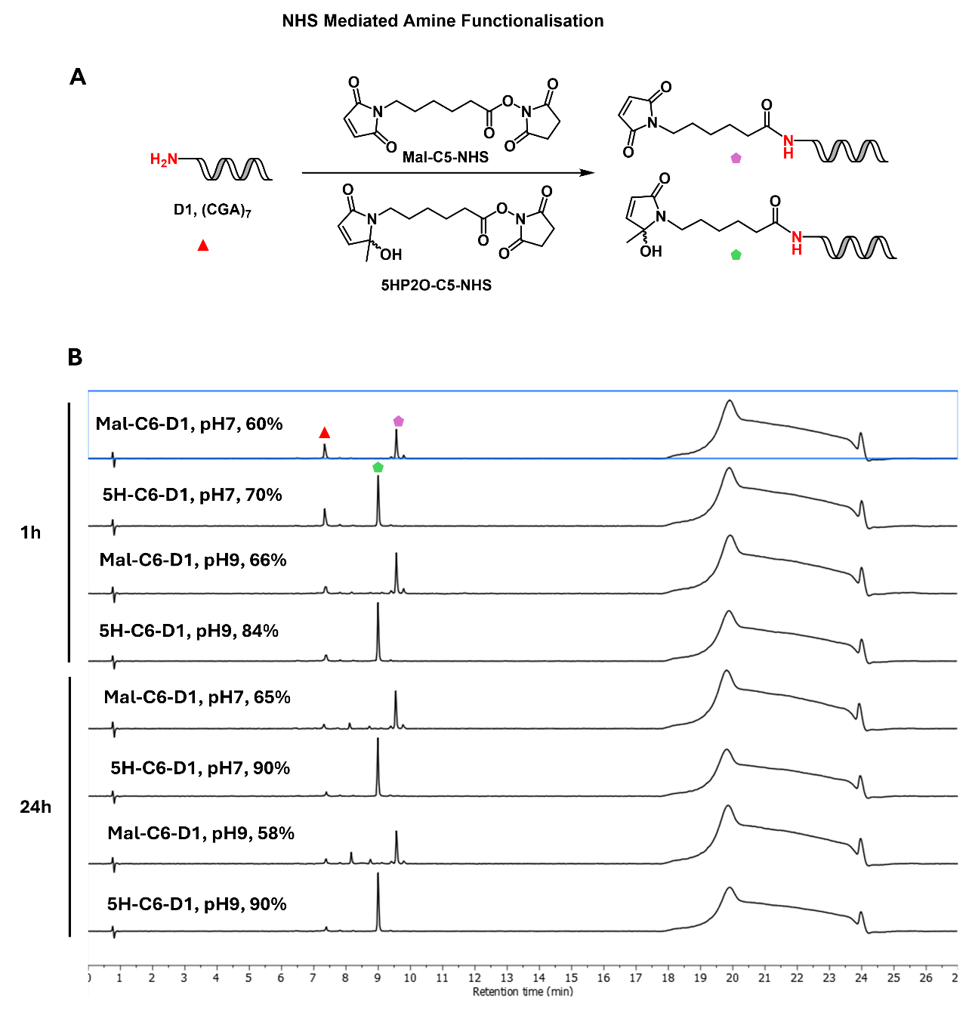
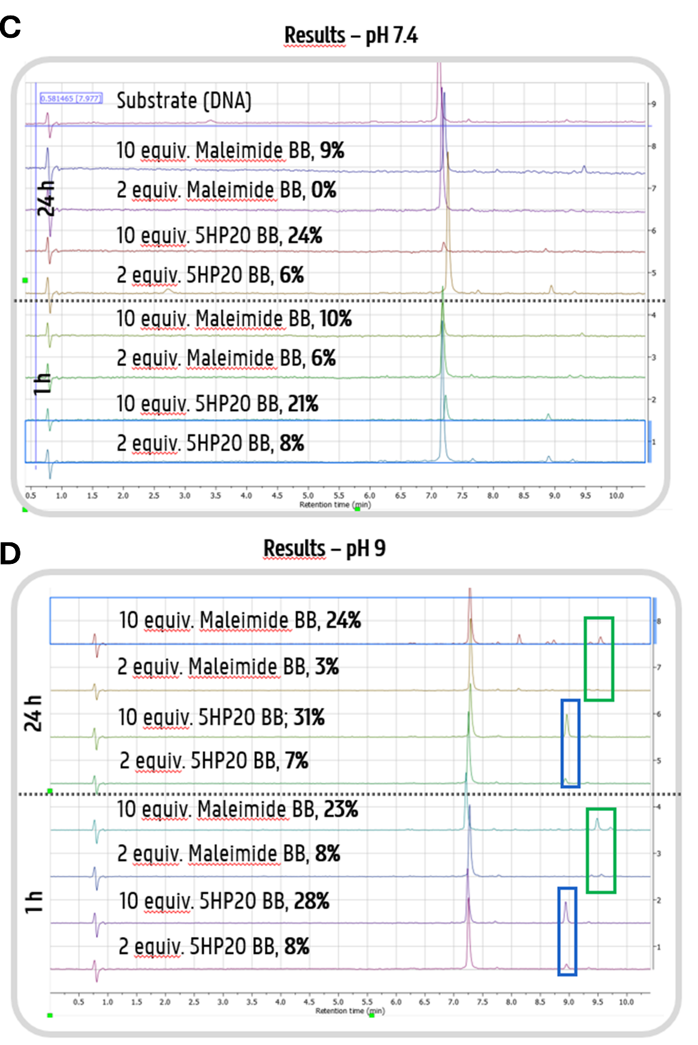
Supplementary Figure 3: NHS-mediated 5HP2O-, respectively maleimide-, functionalization. See summarized data in Fig. 2a-d (A-D) Reactions were performed at 50 µM AON concentration at room temperature at indicated pH and for indicated time. (A) Scheme of NHS mediated 5HP2O- and Maleimide- functionalization of D1 AON (B) Crude HPLC chromatograms (260nm, to 30% ACN) of NHS-mediated amide coupling at two timepoints (1h and 24h) and at two pH (7 and 9) with 40 equiv. of building block (BB). (C) Crude HPLC chromatograms (260nm, to 30% ACN) of NHS-mediated amide coupling at two timepoints (1h and 24h) at pH 7.4 with 2 and 10 equiv. of building block (D) (C) Crude HPLC chromatograms (260nm, to 30% ACN) of NHS-mediated amide coupling at two timepoints (1h and 24h) at pH 9 with 2 and 10 equiv. of building block.
          - Characterization
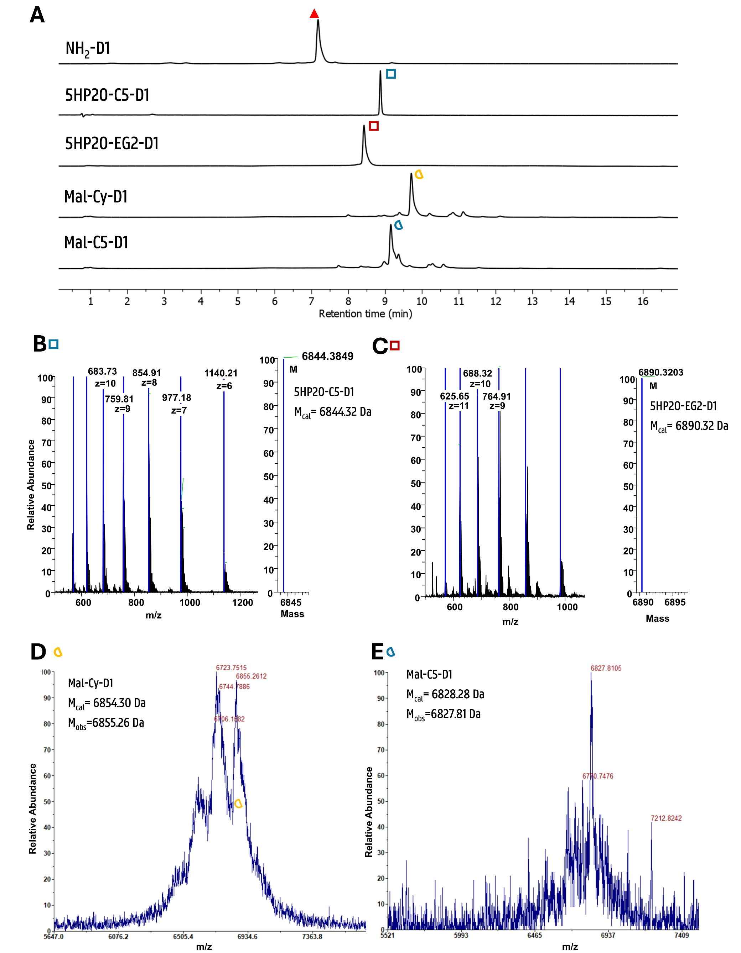
Supplementary Figure 4: Characterization of functionalised oligonucleotides obtained through NHS-mediated amide coupling with four different linkers (5HP2O-C5-NHS (34% isolated yield), 5HP2O-EG2-NHS, Mal-C5-NHS (12% isolated yield), SMCC). (A) HPLC Chromatograms (260 nm, to 30% ACN) of purified 5HP2O- and maleimide-functionalised D1. Product fractions are slightly impure for both maleimide constructs due to the continuous degradation. (B) Orbitrap ESI- MS Spectrum of 5HP2O-C5-D1 (left) and deconvoluted mass (right), which is in accordance with the calculated mass. (C) Orbitrap ESI- MS Spectrum of 5HP2O-EG2-D1 (left) and deconvoluted mass (right), which is in accordance with the calculated mass. (D) MALDI-TOF MS Spectrum of Mal-Cy-D1 (with cyclohexyl spacer) where the product mass is observed (proper signal). The other two signals (6723.75 Da and a plateau around 6586 Da) cannot be attributed. (E) MALDI-TOF MS Spectrum of Mal-C5-D1, where the desired product mass is observed.
          - Stability against hydrolysis

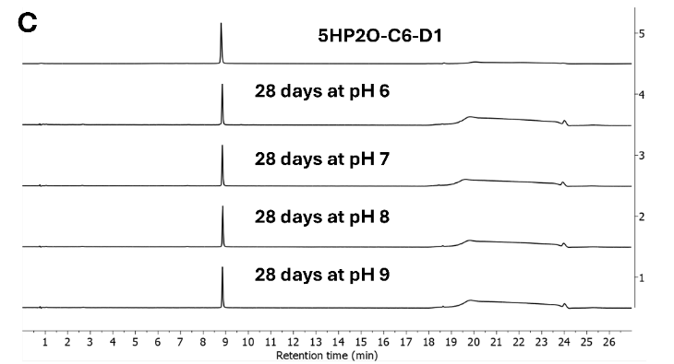

Supplementary Figure 5: Evaluation of hydrolytic stability of purified 5HP2O-C6-D1 and Mal-C6-D1 (see summarised data in Figure 2). (A,B) Deleted (C-G) C6 means C5 to be in accordance with the rest of the SI and the paper (C) HPLC Chromatograms (260 nm, to 30% ACN) of 5HP2O-C6-D1 incubated for four weeks at different pH. (D) HPLC Chromatograms (260 nm, to 30% ACN) of Mal-C6-D1 incubated at pH 6. (E) HPLC Chromatograms (260 nm, to 30% ACN) of Mal-C6-D1 incubated at pH 6. (F) HPLC Chromatograms (260 nm, to 30% ACN) of Mal-C6-D1 incubated at pH 8. (G) HPLC Chromatograms (260 nm, to 30% ACN) of Mal-C6-D1 incubated at pH 9.

        - Protein-bioconjugation of functionalized oligonucleotides
          - Alphabody – 5HP2O
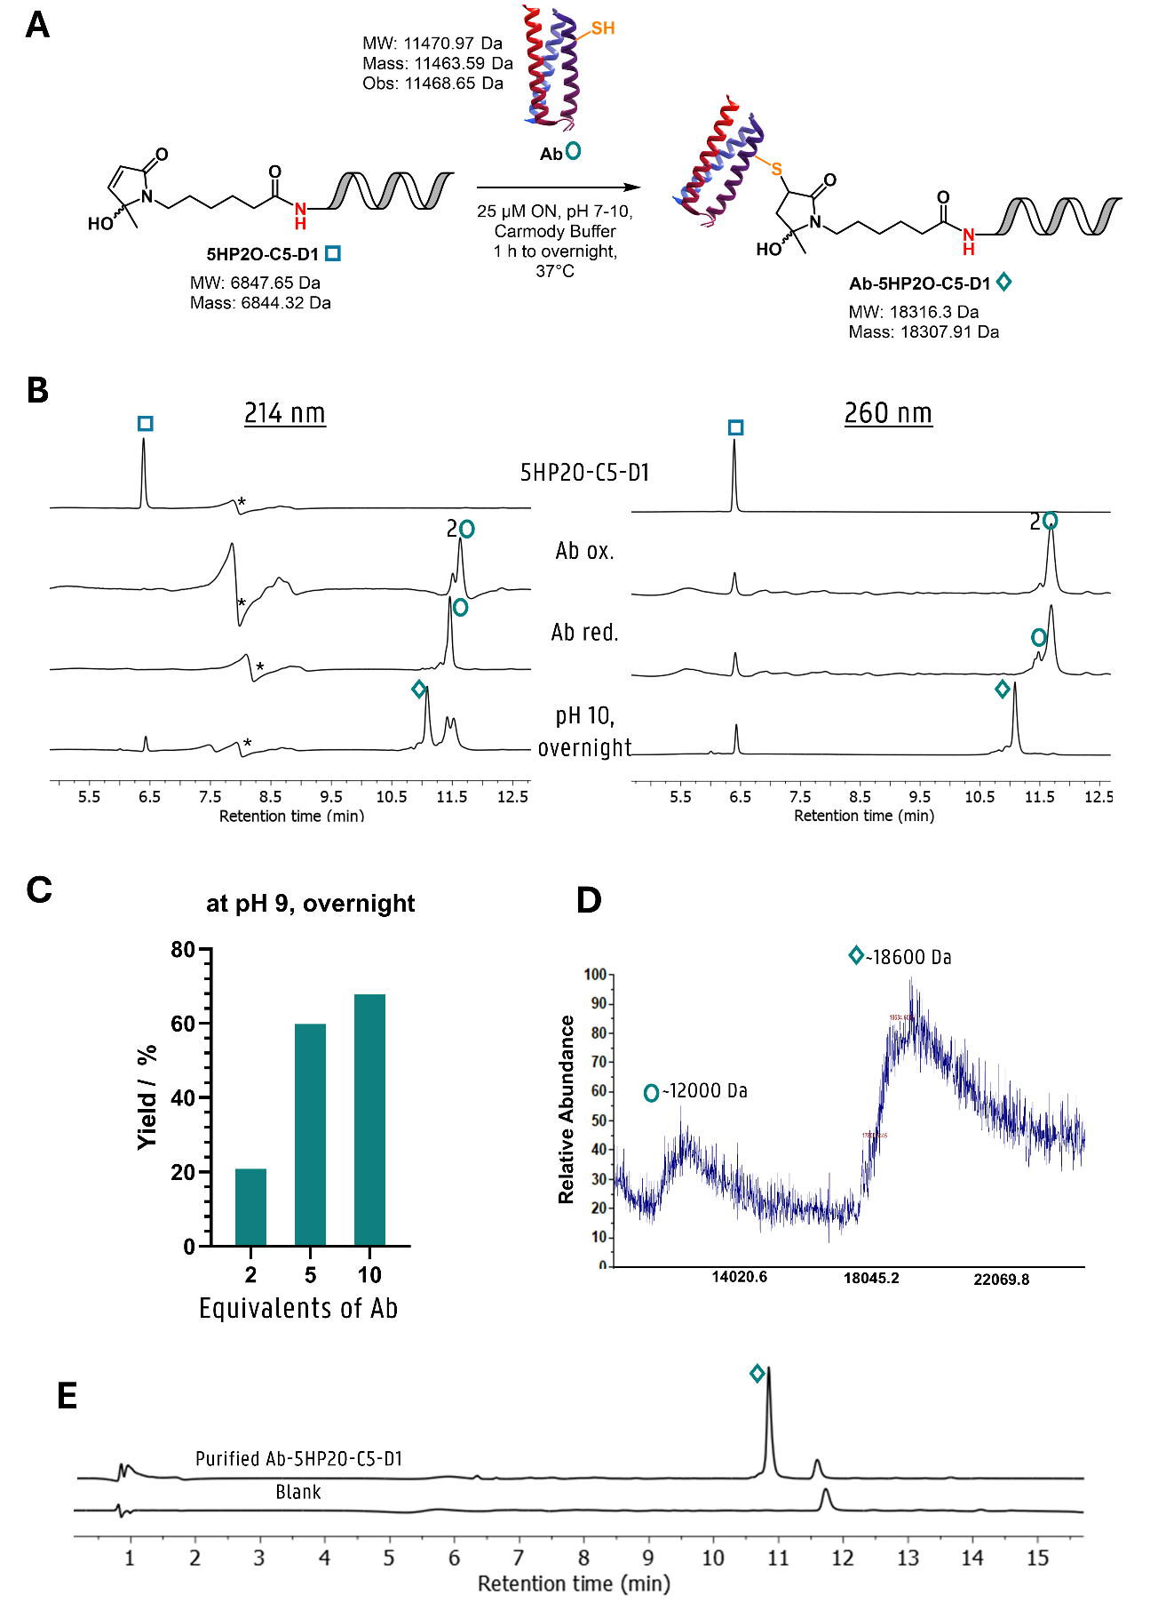
Supplementary Figure 6: (A) Reaction scheme of Ab conjugation to 5HP2O-C5-D1 forming Ab-5HP2O-C5-D1. (B) Example HPLC chromatograms (214 and 260 nm, to 100% ACN, 100 Å) of alphabody (10 equiv.) bioconjugation at pH 10. Traces 1 to 3 show the starting material signals, whereas the crude reaction is shown in trace 4. Artefacts highlighted with an asterisk arise from baseline correction with MestreNova. Reoxidation of Ab is observed in the 214 nm chromatogram as seen by formation of double signals at 11.5 min (C) Reaction yields for overnight bioconjugations at pH 9 with varying excess of Alphabody. (D) MALDI-TOF of purified product shows broad signals in the mass region of the free protein and in the mass region of the desired conjugate mass. Conjugate cleavage during ionisation could explain the formation of the two peaks. Matrix 1 was used for MALDI spotting. (E) HPLC Chromatograms (260 nm, to 100%) of purified Alphabody-D1 conjugate Ab-5HP2O-C5-D1 and blank injection.

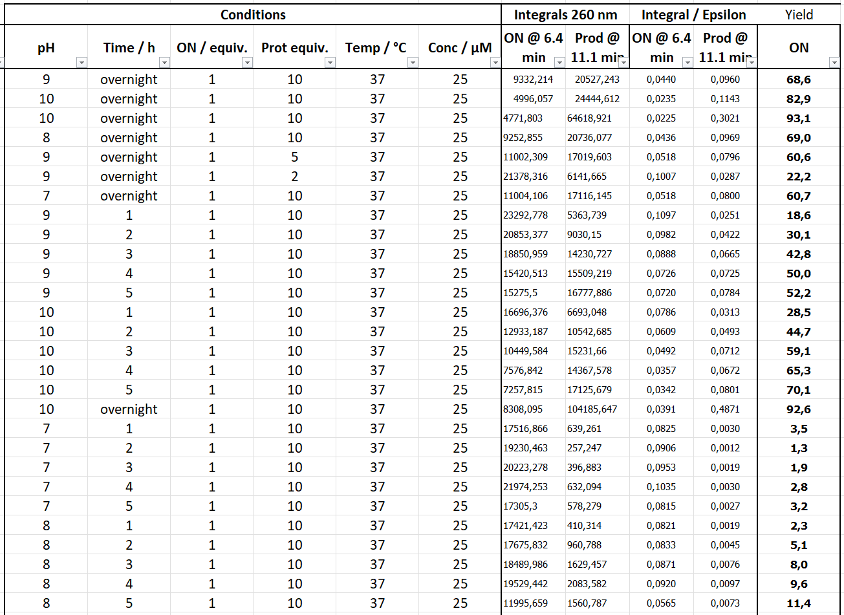
Supplementary Figure 7: Complete condition screening as highlighted in diagrams in Figure 3c and Suppl. Fig. 6c including the underlying integral data for yield calculation as described in general methods SI 1.1.
Epsilon(ON, 260nm) = 212300 L/(mole·cm)
Epsilon(Ab, red, 260nm) = 1602 L/(mole·cm)
Epsilon(Ab, ox, 260nm) = 3324 L/(mole·cm)

          - Alphabody – Maleimide
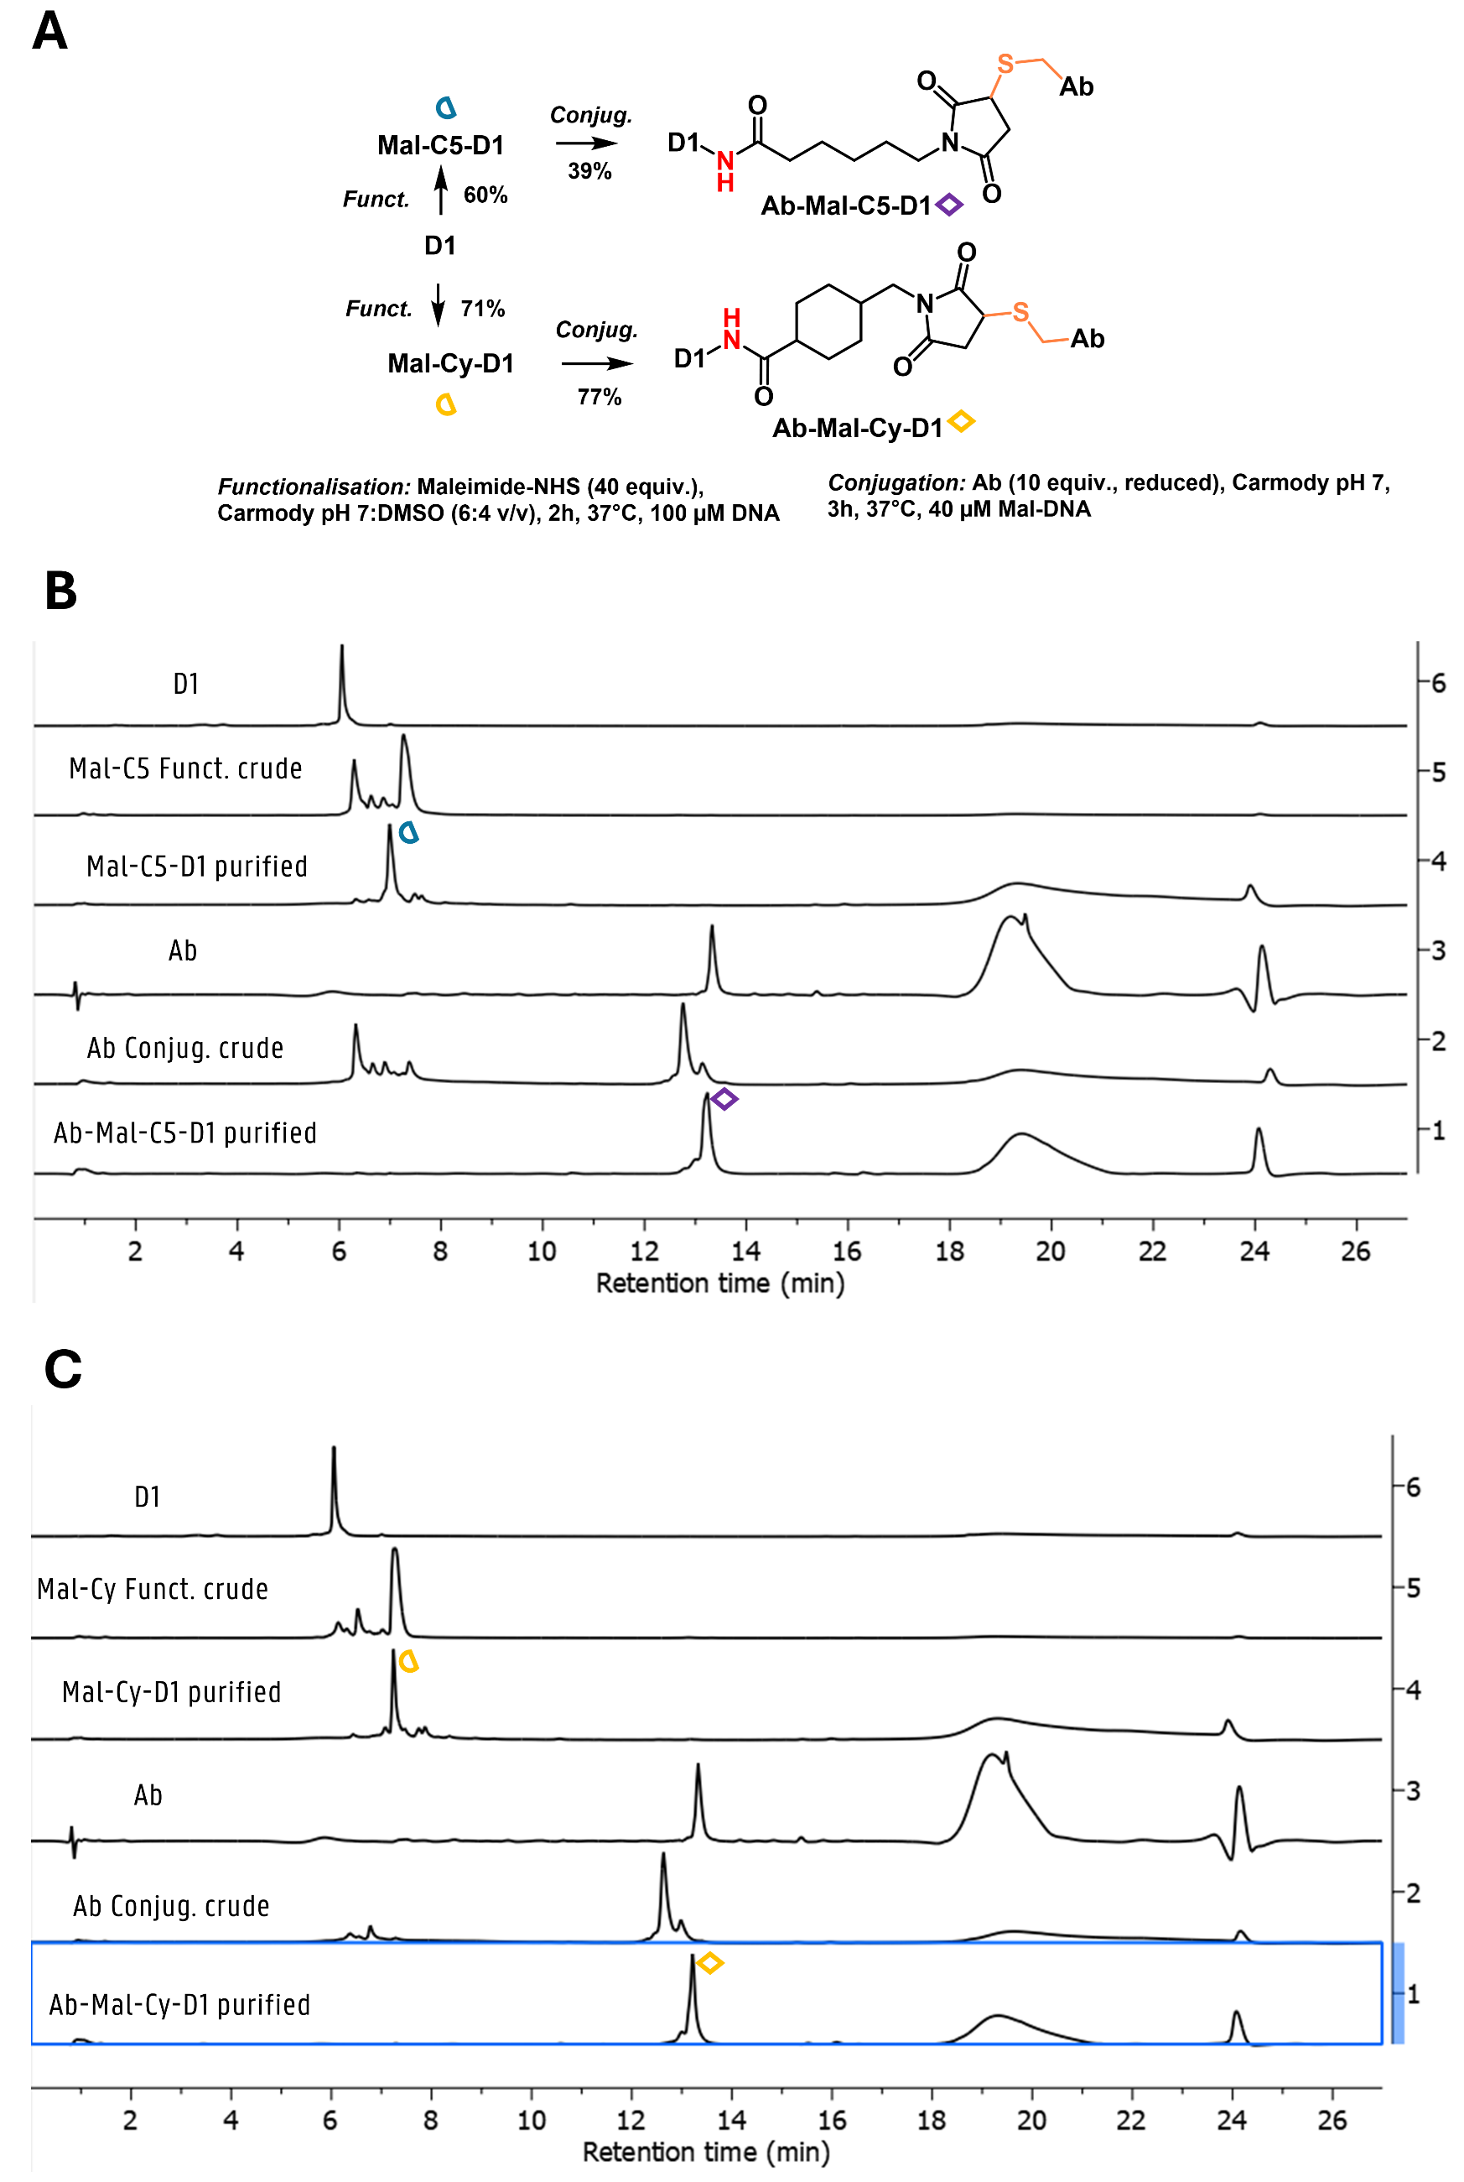
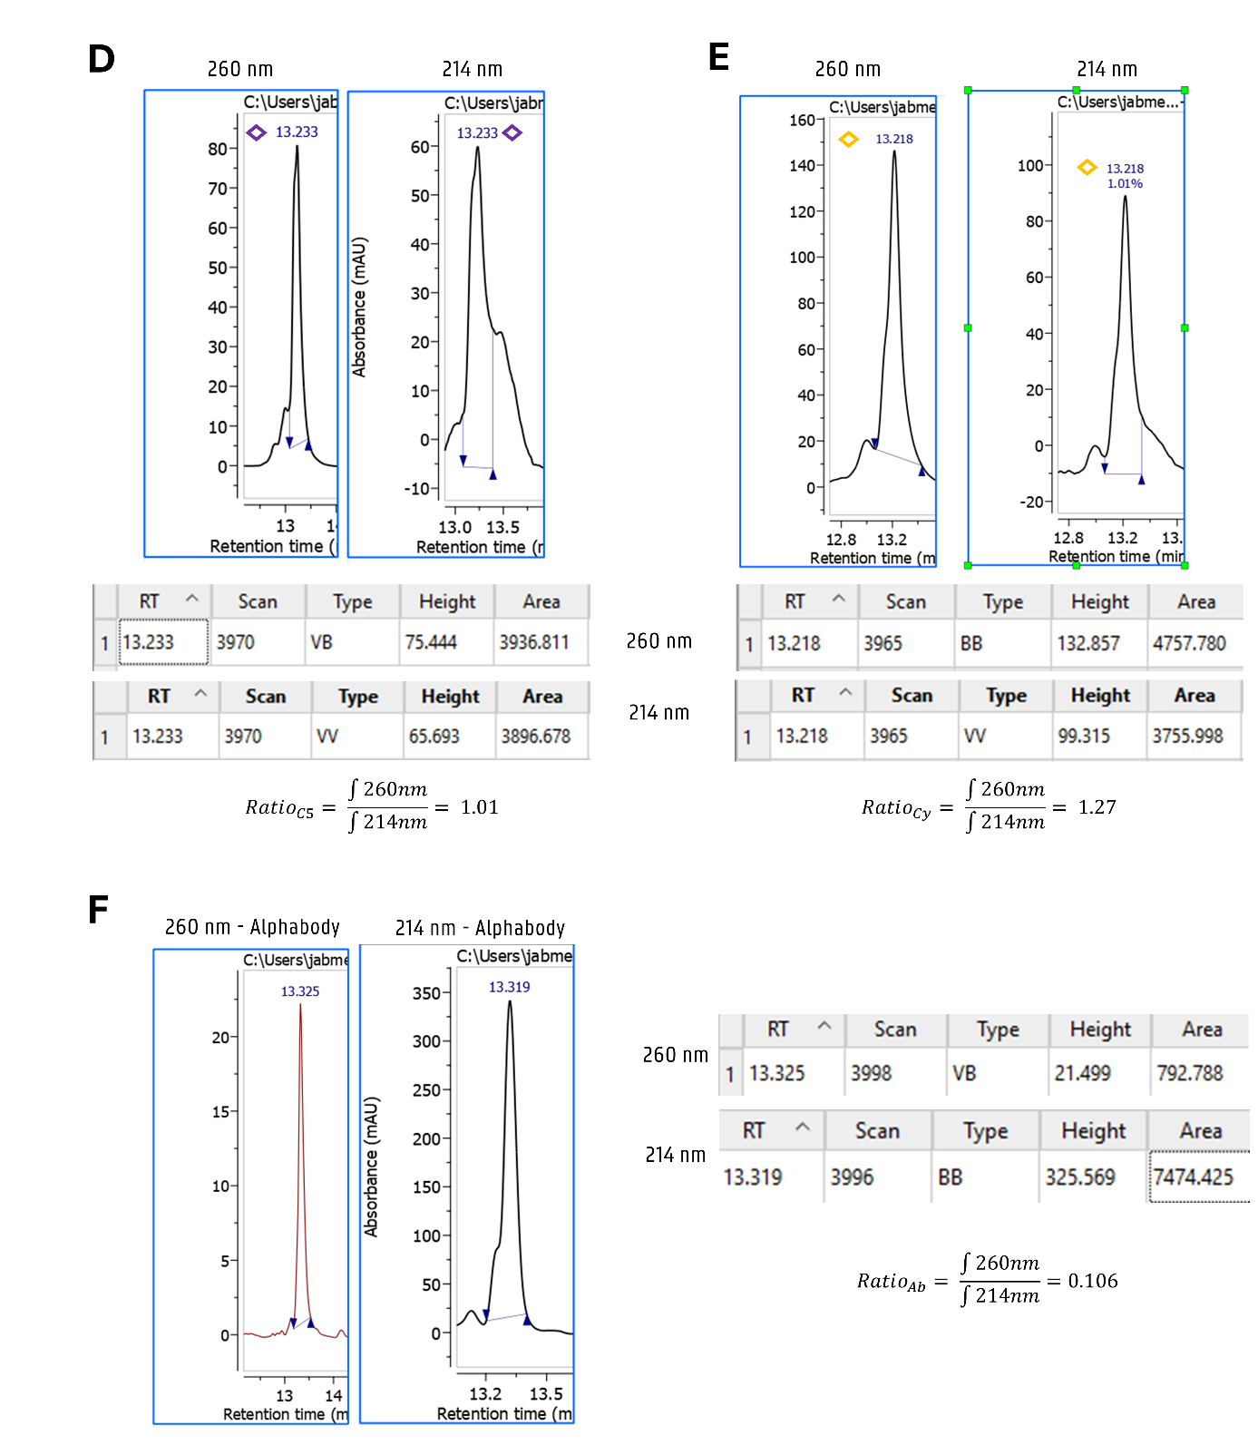
Supplementary Figure 8: Maleimide-mediated Alphabody oligonucleotide conjugation. (A) Synthetic Scheme. (B) HPLC Chromatograms (260 nm, to 75% ACN) of conjugation employing aliphatic Mal-C5-NHS linker. (C) HPLC Chromatograms (260 nm, to 75% ACN) of conjugation employing cyclic Mal-Cy-NHS (SMCC) linker. (D-F) Product characterisation via absorbance ratio 260nm/214nm (D) Absorbance ratio of purified Ab-Mal-C5-D1. (E) Absorbance ratio of purified Ab-Mal-Cy-D1. (F) Absorbance ratio of Alphabody protein.

          - Conjugate Stability against thiol-exchange
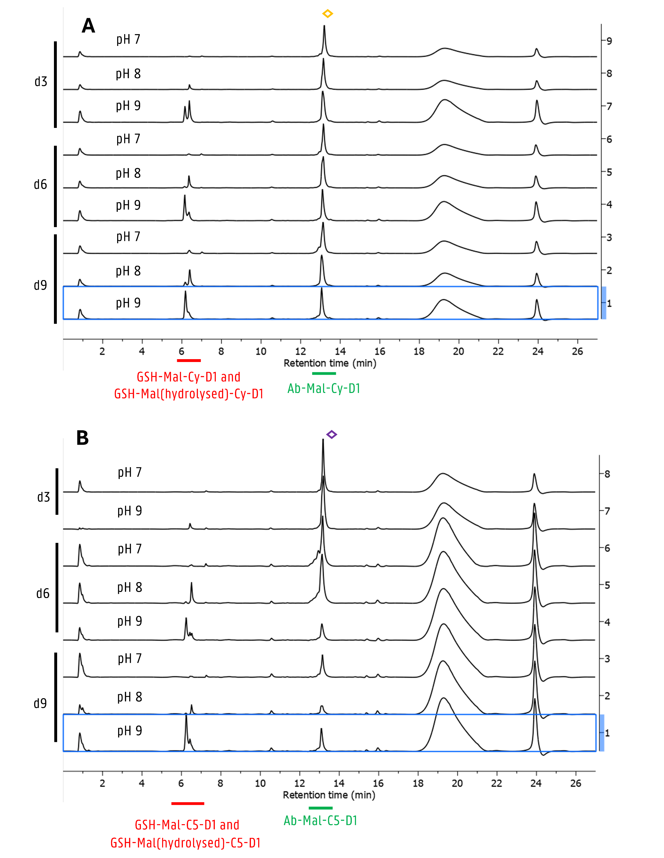

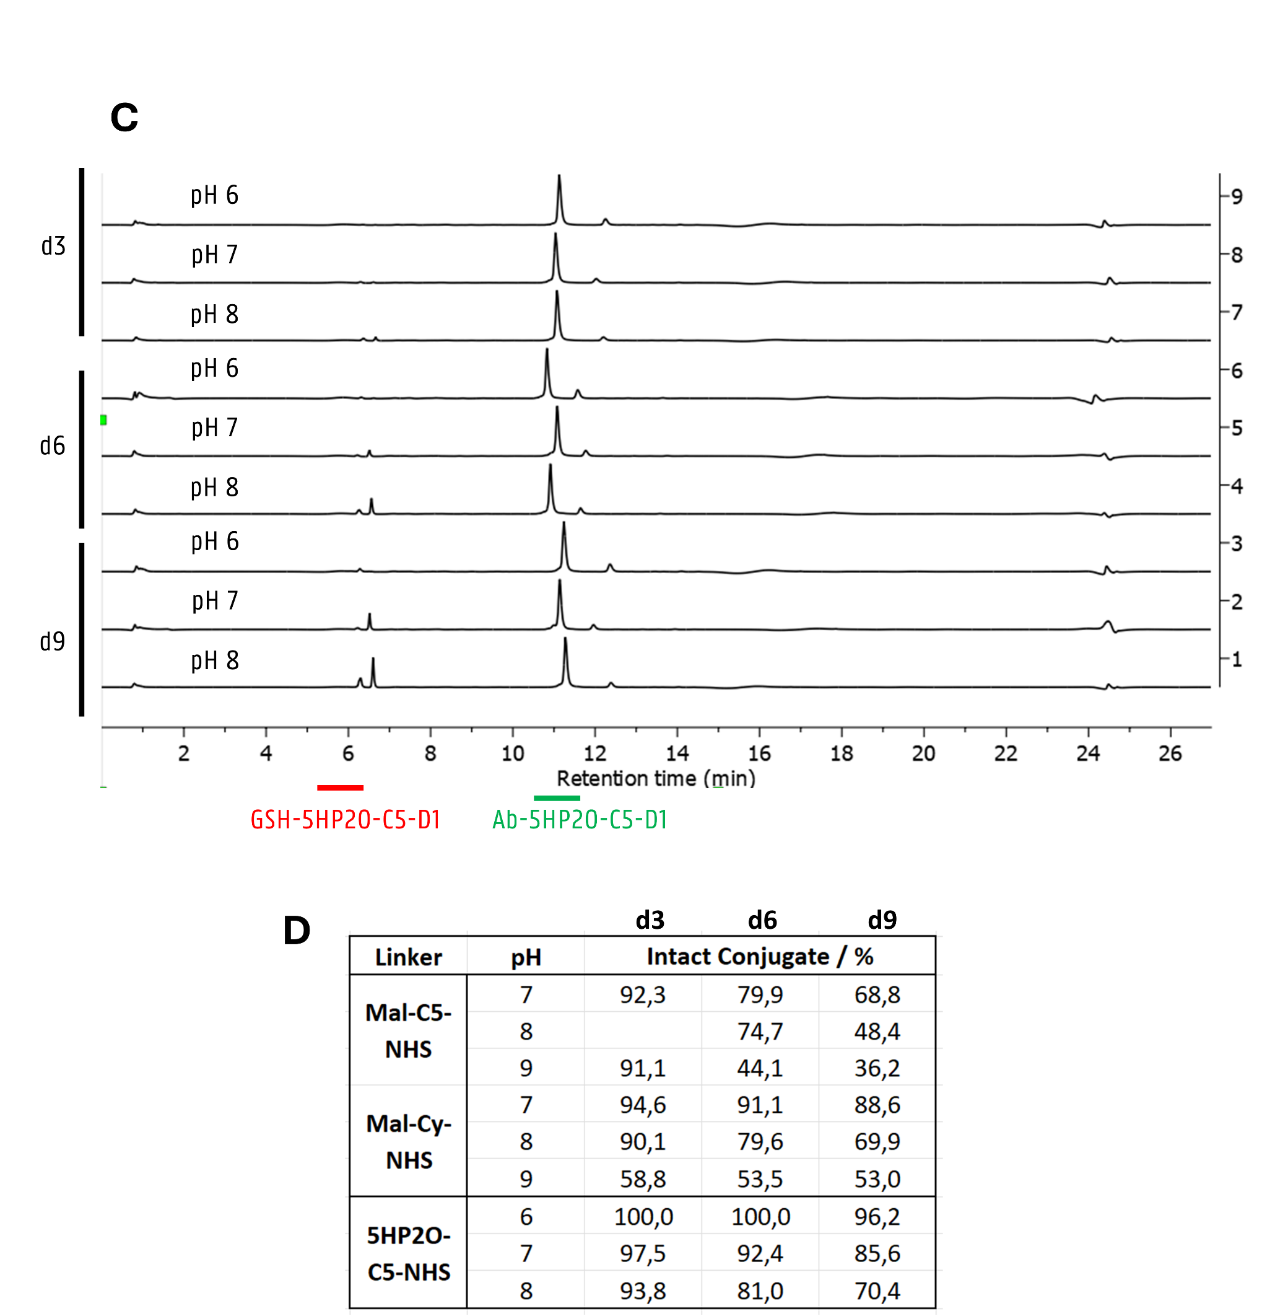
Supplementary Figure 9: Chromatograms of Glutathione (GSH) exchange experiments (see Figure 3f). (A) HPLC Chromatograms (260 nm, to 75% ACN) of GSH exchange experiment of purified POC bearing the Mal-Cy linker. (B) HPLC Chromatograms (260 nm, to 75% ACN) of GSH exchange experiment of purified POC bearing the Mal-C5 linker. (C) HPLC Chromatograms (260 nm, to 75% ACN) o f GSH exchange experiment of purified POC bearing the 5HP2O-C5 linker. (D) Summarised data of intact POC in table format with additional data (compare Fig. 3f).

          - Rituximab – 5HP2O
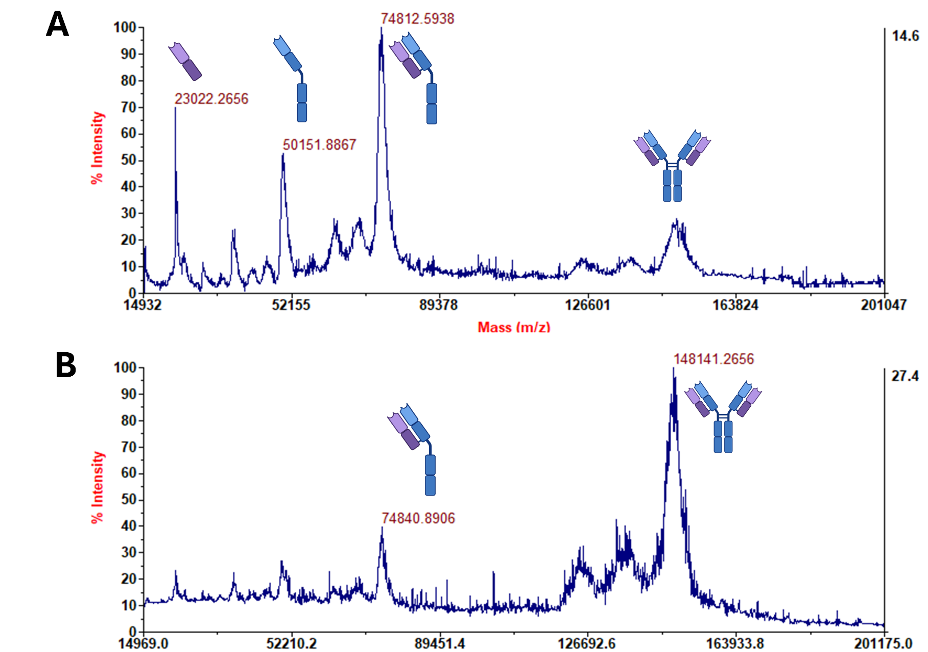
Supplementary Figure 10: (A-B) Observed protein fragments: 23 kDa L, 50 kDa H, 75 kDa LH, 125 kDa LHH, 148 kDa RTX (L: Light Chain, H: Heavy Chain). Matrix 2 employed for spotting. (A) MALDI-TOF mass spectra (pos. mode) of intact protein as measured with focus mass 50kDa. (B) MALDI-TOF mass spectra (pos. mode) of intact protein as measured with focus mass 150 kDa.

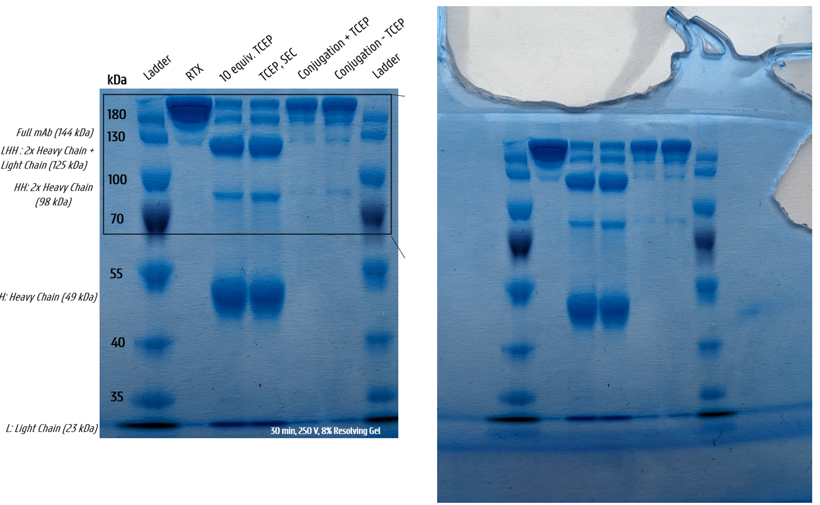
Supplementary Figure 11: SDS-PAGE analysis of Bioconjugation reaction between purified 5HP2O-C5-D1 (10 equiv.) and reduced Rituximab (7 uM, 1mg/mL, reduced with 10 equiv. TCEP) in absence/presence of TCEP (RT, overnight at pH 8 Carmody Buffer). SDS-PAGE (8%) was run for 30 minutes at 250 V.

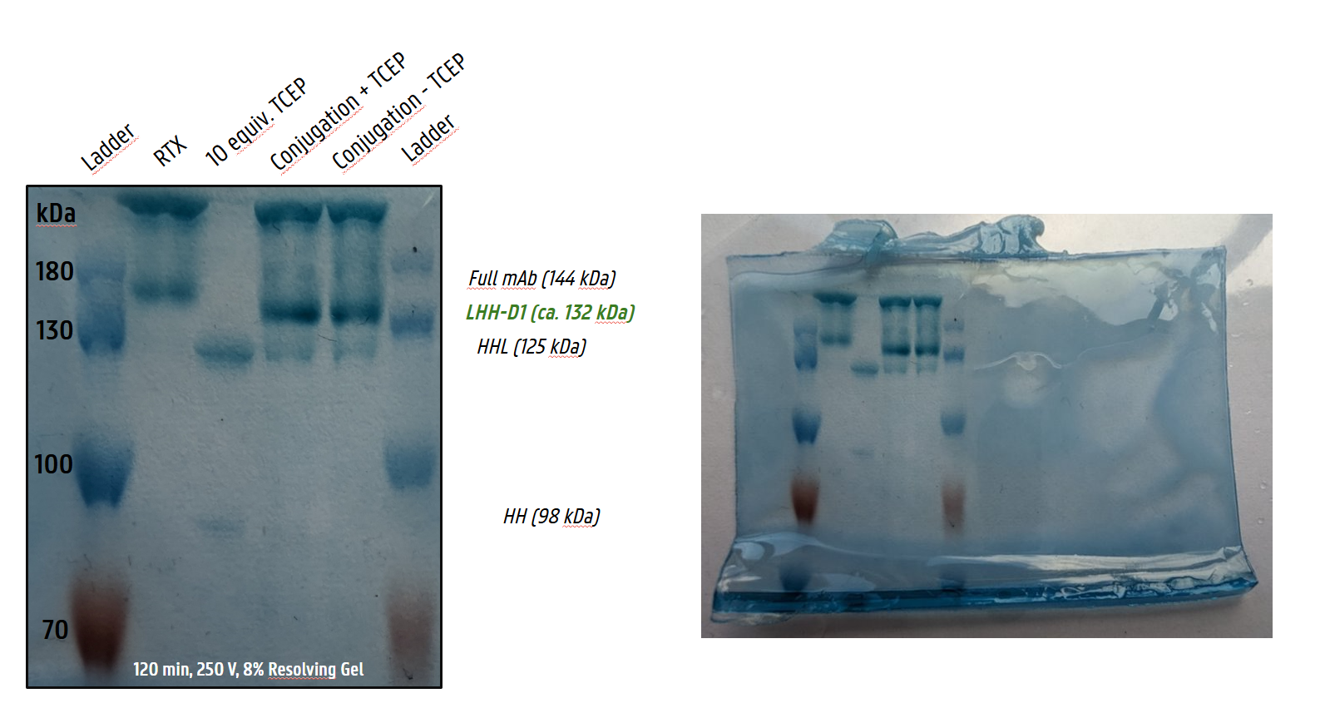
Supplementary Figure 12: SDS-PAGE analysis of Bioconjugation reaction between purified 5HP2O-C5-D1 (10 equiv.) and reduced Rituximab (7 uM, 1mg/mL, reduced with 10 equiv. TCEP) in absence/presence of TCEP (RT, overnight at pH 8 Carmody Buffer). SDS-PAGE (8%) was run for 120 minutes at 250 V.

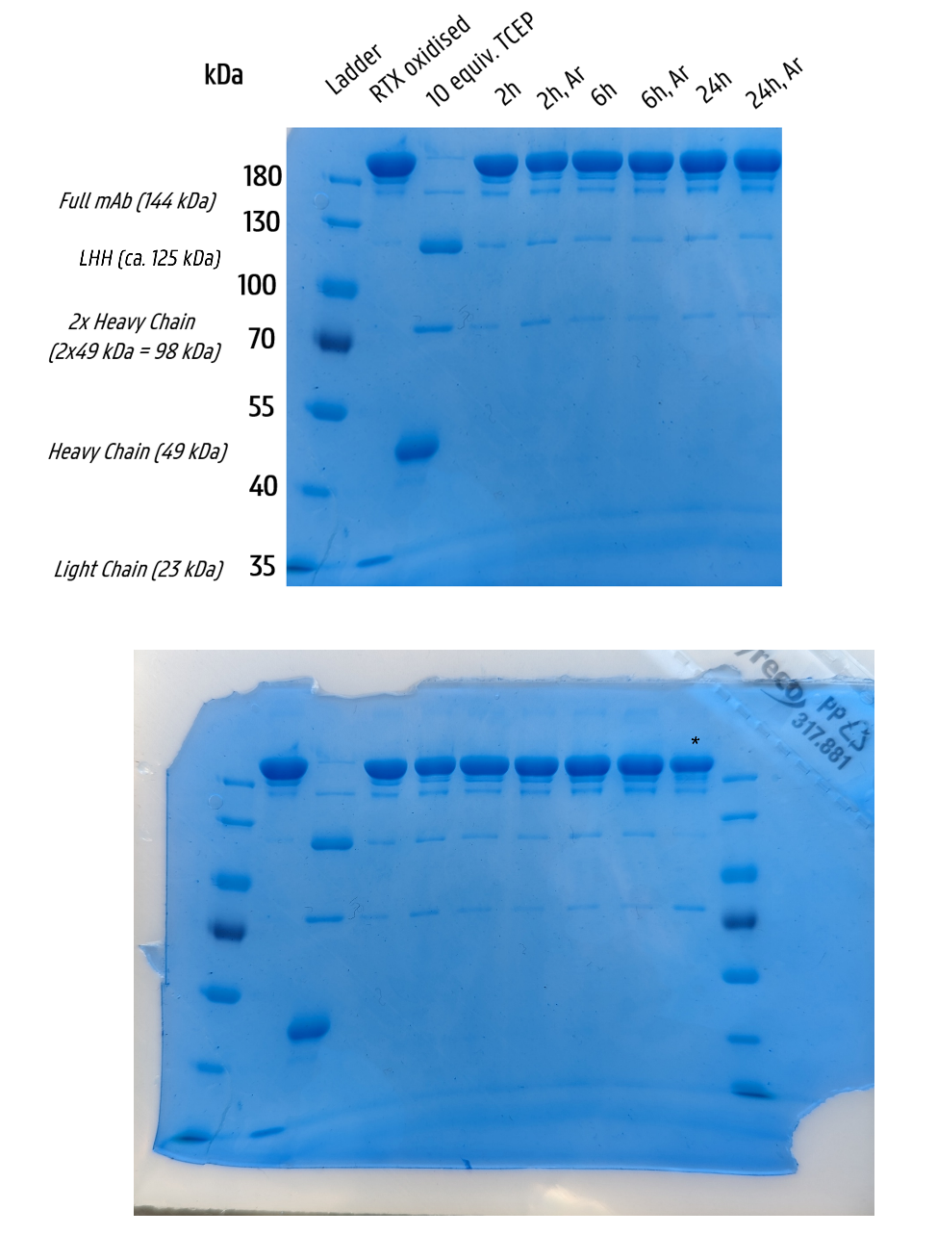
Supplementary Figure 13: SDS-PAGE analysis of RTX reoxidation behaviour. Major reoxidation is already observed after 2 hours without any impact of storage under argon: Heavy and light chain bands disappear completely at the 2 hours timepoint and the intensity of the HHL band decreases (L: Light Chain, H: Heavy Chain). Intensity of the HH band further diminishes with longer standing time. The lane highlighted with an asterisk contains the conjugation reaction. SDS-PAGE (8%) was run for 45 minutes at 250 V.
Procedure: RTX was reduced with TCEP (10 equiv.) at 5 mg/mL mAb concentration for 30 min at room temperature. TCEP was then removed by means of a SEC spin column and buffer exchanged into SSC buffer (MicroBio Spin 6 BioRad Columns). The reduced protein was either stored under argon or under normal atmosphere and sampled with SDS-PAGE as described in the general procedures at various timepoints (2h, 6h, 24h).

        - Fluorescent Alphabody Conjugate

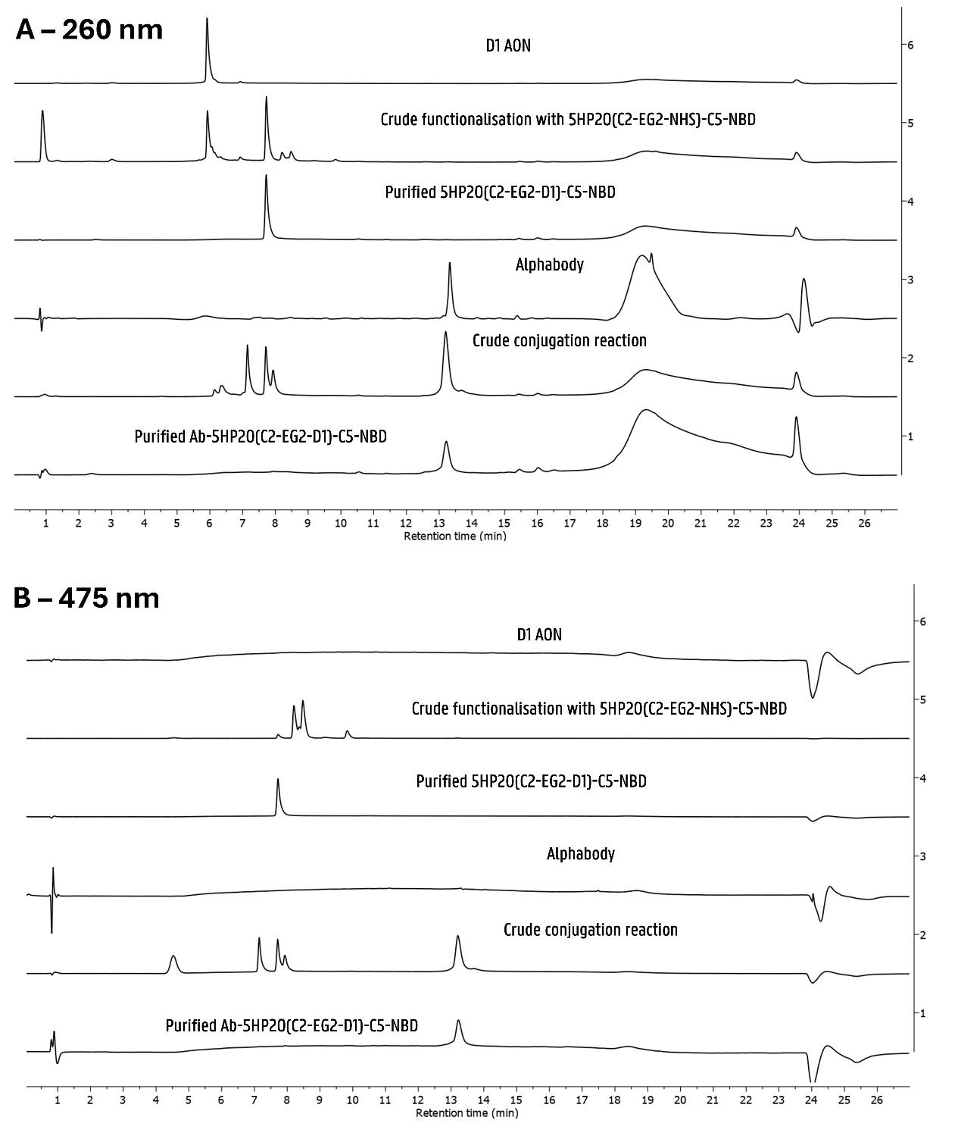

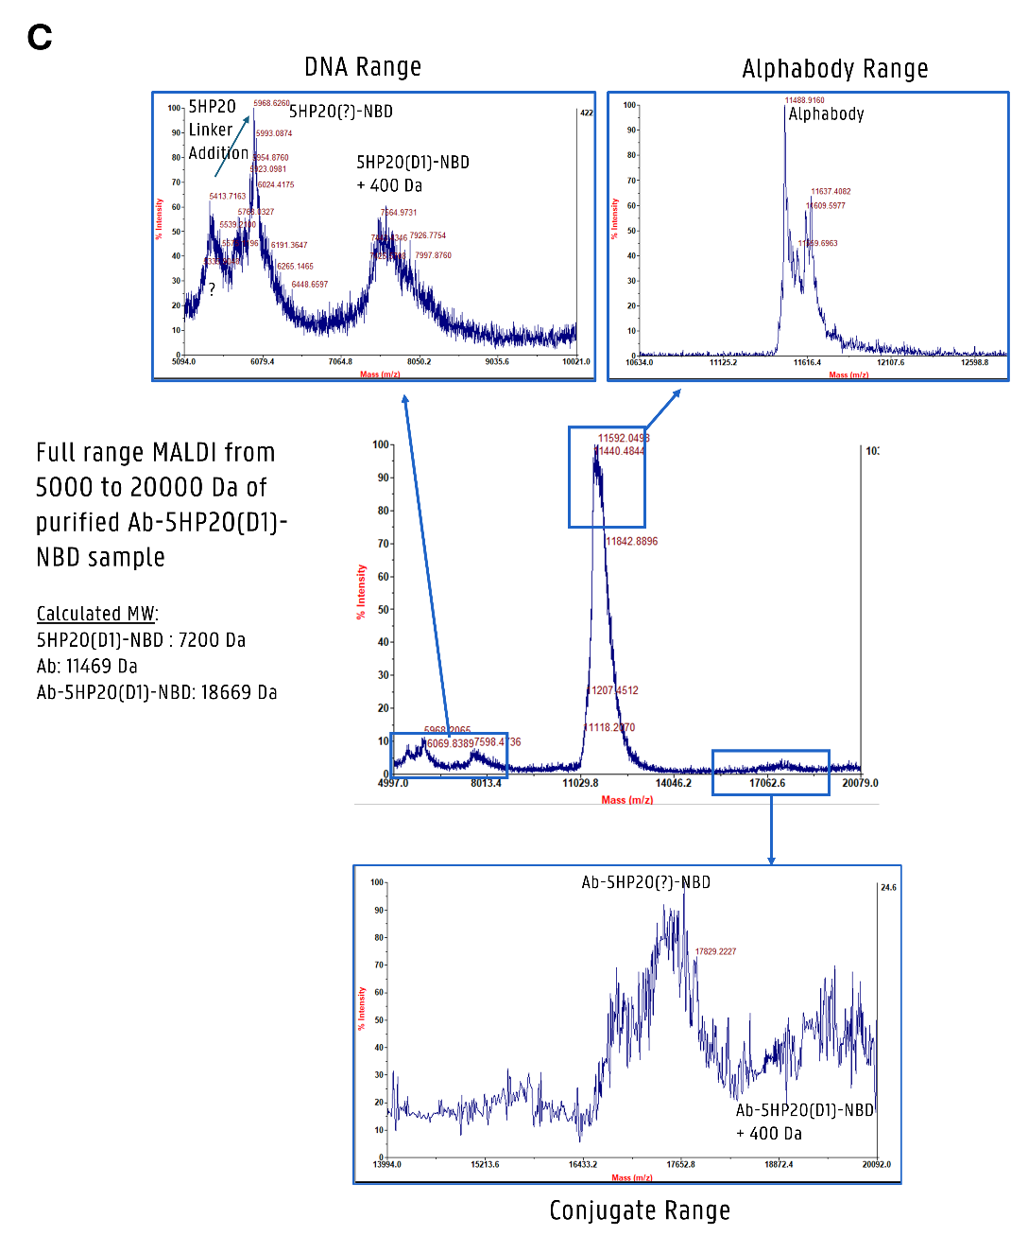
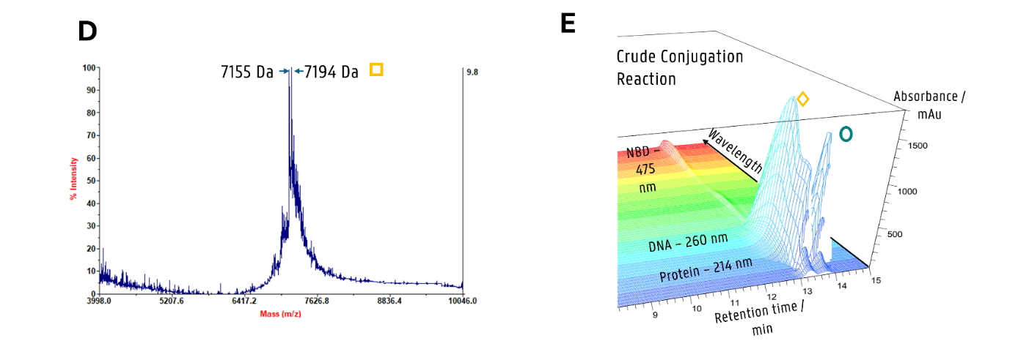
Supplementary Figure 14: Full HPLC traces (to 75% ACN) of fluorescent Alphabody-D1 conjugate synthesis (shown cropped in Figure 5). (A) Chromatograms at 260 nm (DNA absorbance). Signals between 7.0 and 8.0 min in trace 2 might arise from the TCEP side product arising through insufficient TCEP removal. (B) Chromatograms at 475 nm (NBD absorbance). Signals at 8.23 and 8.51 in trace 5 are arising from the multifunctional 5HP2O linker respectively its NHS-hydrolysed version thereof. (C) MALDI-TOF MS spectra of purified Ab-5HP2O(D1)-NBD fluorescent conjugate. Full range spectra (from 5000 to 20000 Da, central) show broad peaks in the range of DNA, protein, and conjugate arising through conjugate cleavage upon laser ionisation. Subsequently, each mass range was remeasured with adapted MALDI focus settings. The observed mass of the MALDI-uncleaved conjugate is around +400 Da to the calculated desired mass. This [M+400 Da] MALDI adduct was also observed for non-fluorescent conjugate Ab-5HP2O-C5-D1 (see Suppl. Fig. 6 D), despite the correct mass being observed in Orbitrap HRMS (Figure 3 d,e). This [M+400 Da] is therefore a MALDI artefact/adduct, eventually arising from mass complexation with matrix 1). (D) MALDI-TOF spectrum of purified 5HP2O(C2-EG2-D1)-C5-NBD indicating the desired product mass (delta 6 Da). Matrix cocktail 3) was employed. (E) 3D-chromatographic plot of crude conjugation showing the Alphabody protein (214 nm) and the conjugated protein (214 nm) with absorbance contributions at 260 nm (D1 DNA) and 475 nm (NBD fluorophore).

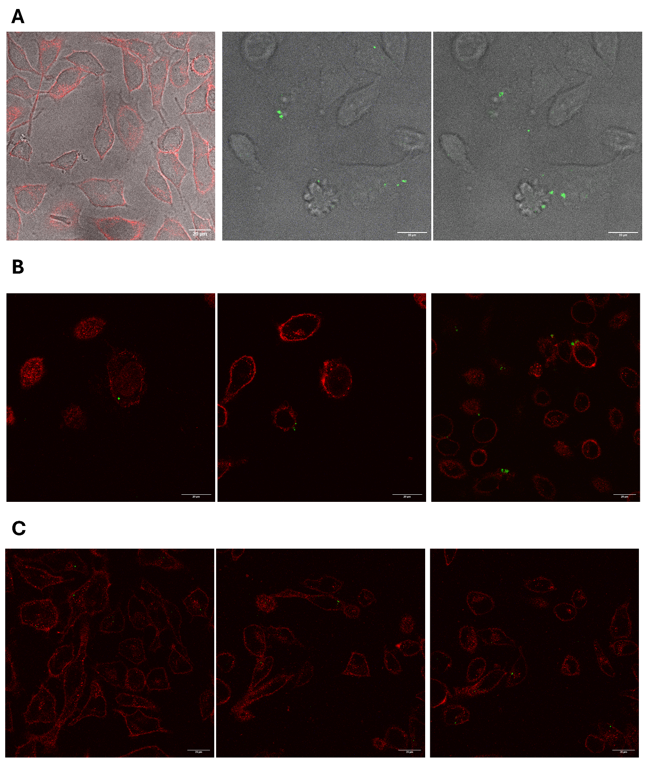
Supplementary Figure 15: Confocal microscopy of fluorescent conjugates on HeLa cells. (A) From left to right: overlay of brightfield and WGA-555 stained cells and two different acquisition planes of brightfield overlay with fluorescent channel visualising NBD-constructs. (B) Cells incubated with 5HP2O(C2-EG2-D1)-NBD. (C) Cells transfected with Ab-5HP2O(C2-EG2-D1)-NBD.

        - Alkyne-5HP2O mediated late-stage functionalisation
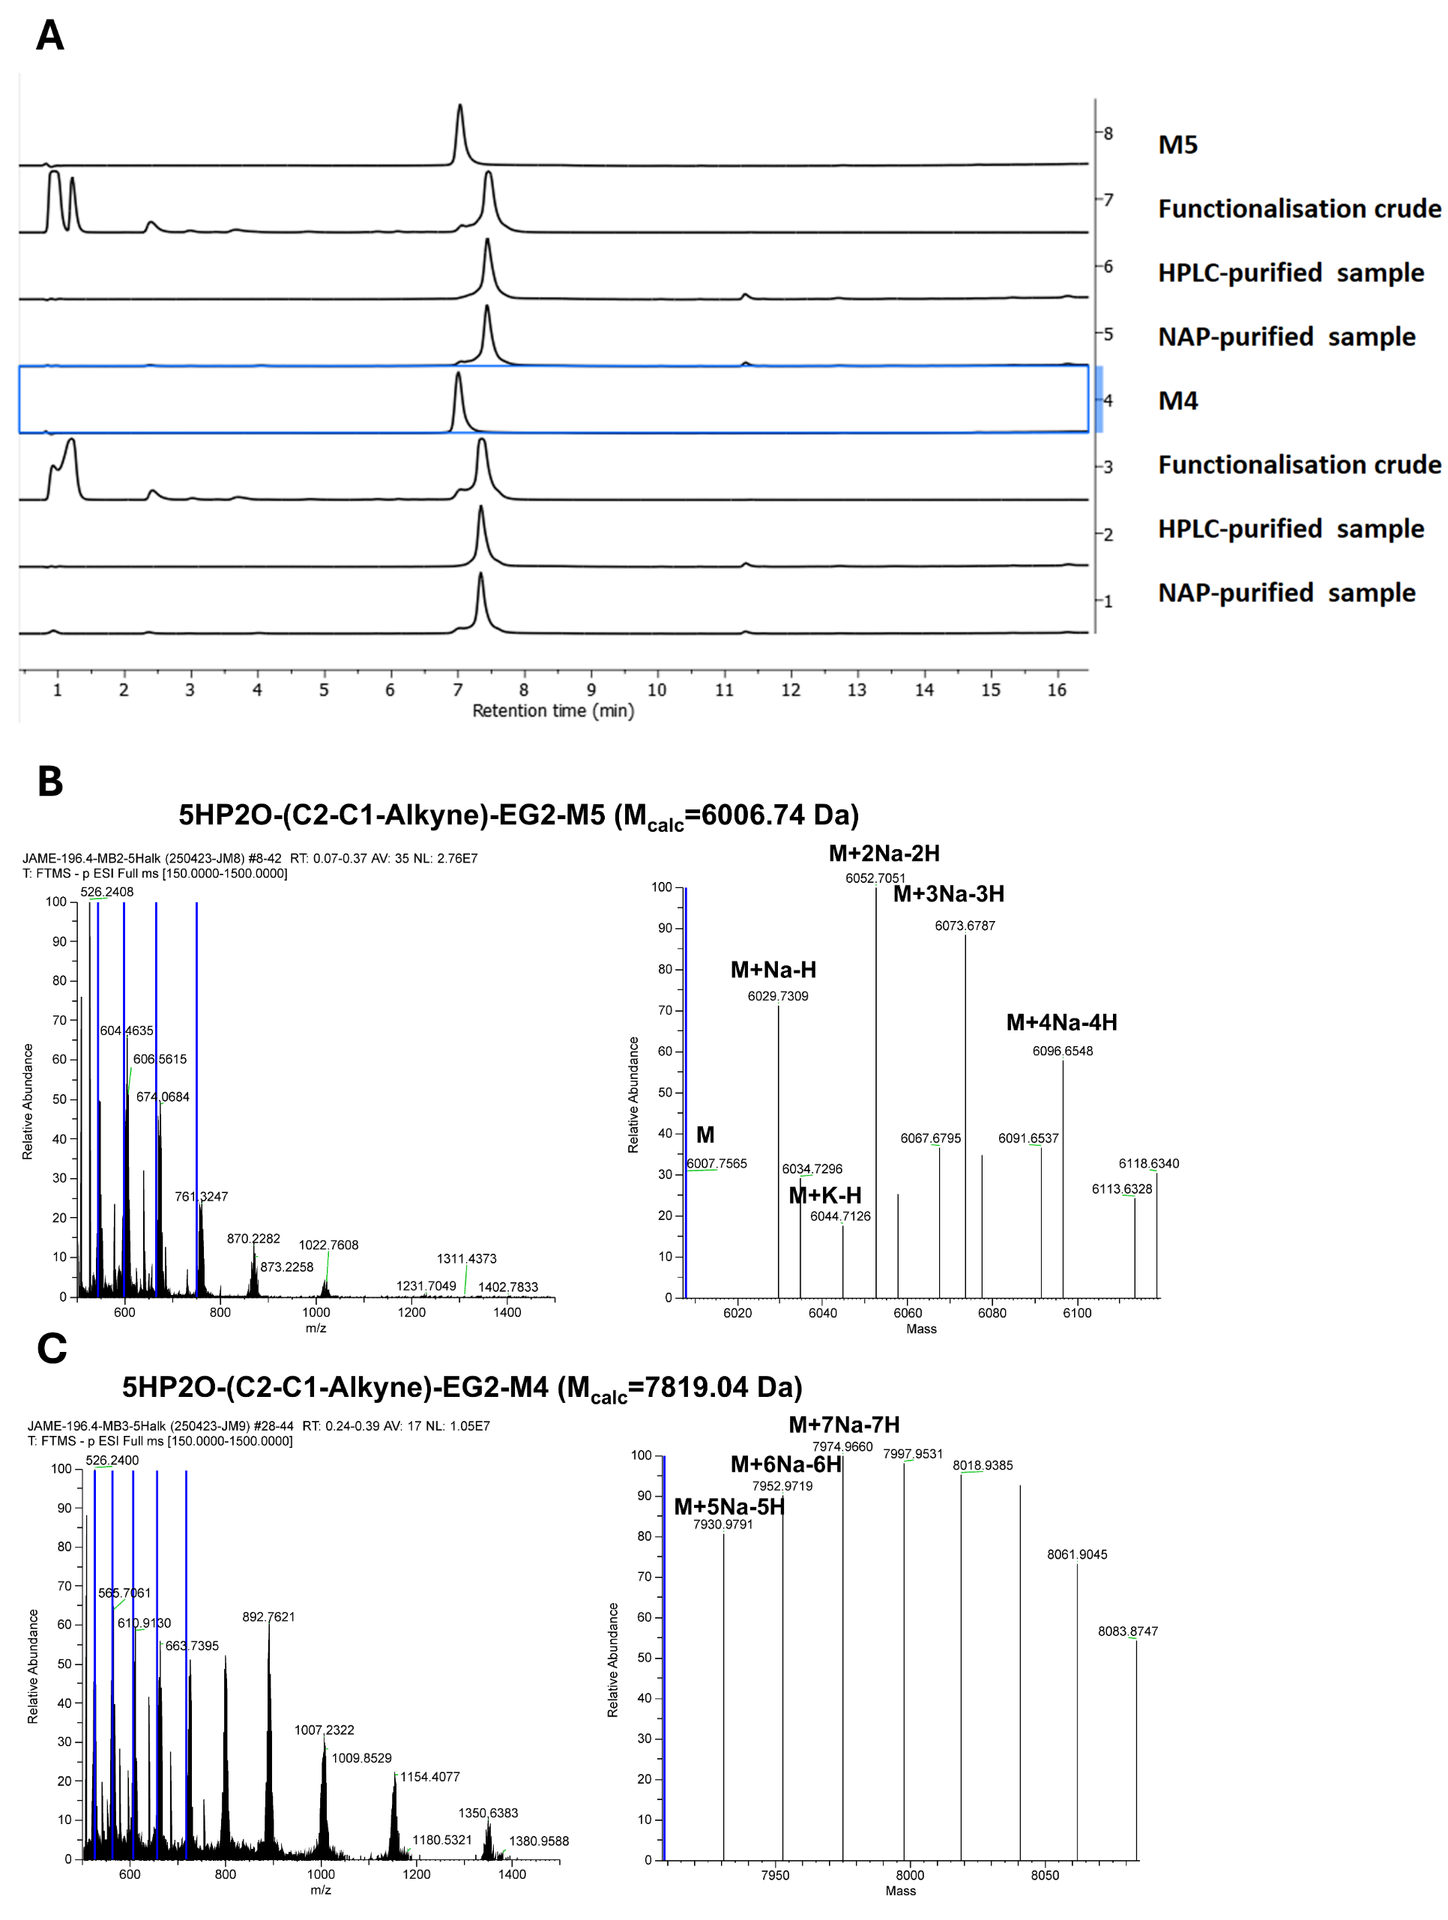

Supplementary Figure 16: Functionalisation of Malat1 ASO using 5HP2O(C2-C1-Alkyne)-EG2-NHS (18). (A) HPLC chromatograms (260 nm, to 75% ACN) of crude NHS-mediated functionalisation and purified products. (B) Orbitrap mass spectrum of purified 5HP2O(C2-C1-Alkyne)-EG2-M5 and the corresponding deconvoluted mass spectrum. (C) Orbitrap mass spectrum of purified 5HP2O(C2-C1-Alkyne)-EG2-M4 and the corresponding deconvoluted mass spectrum.
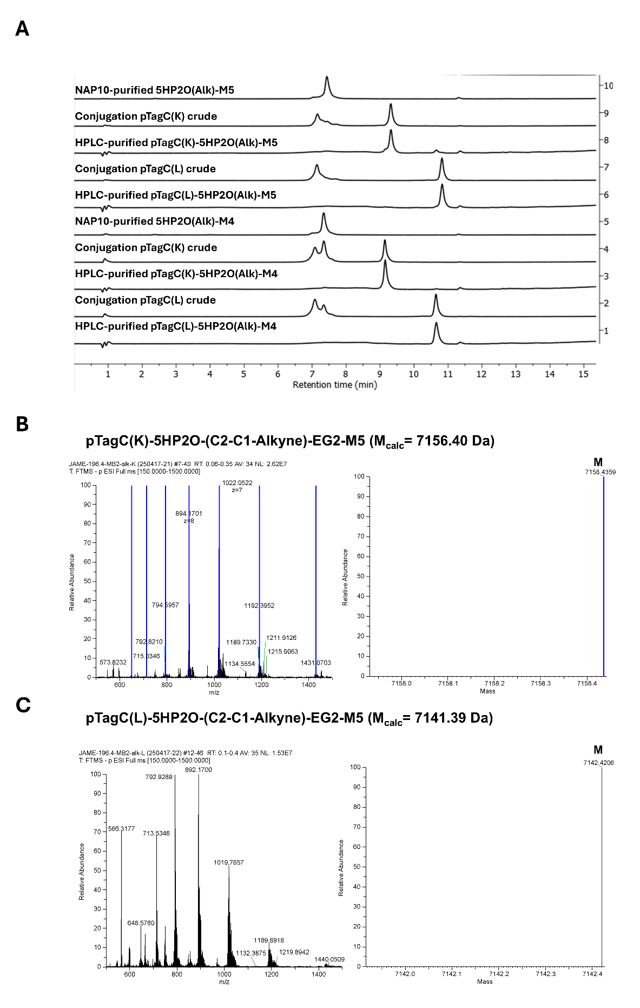

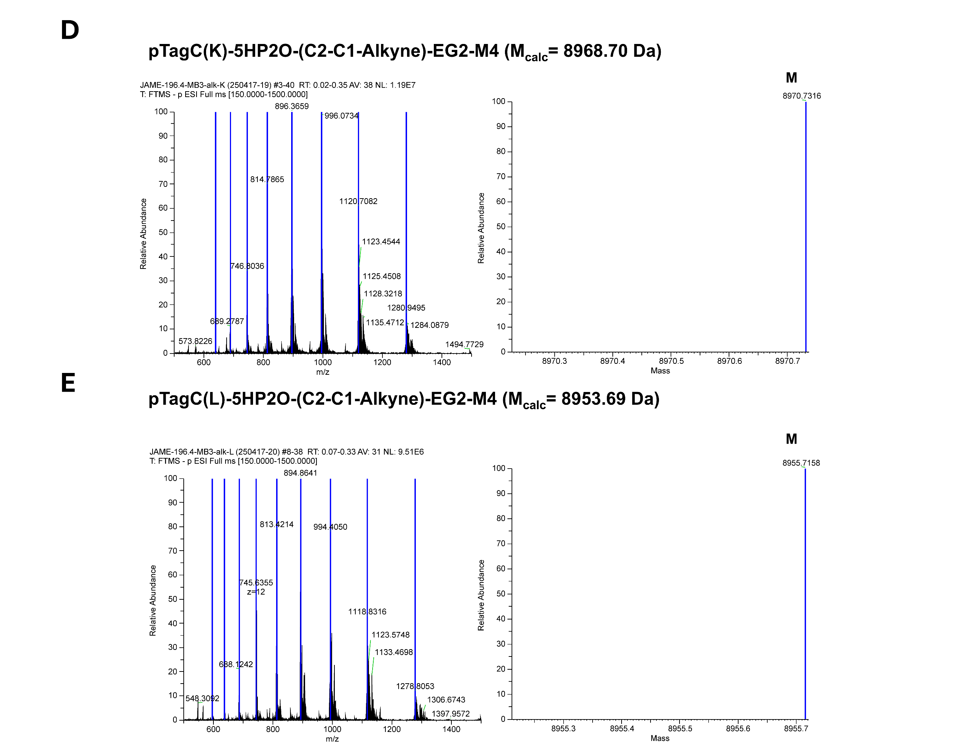
Supplementary Figure 17: Conjugation of functionalised Malat1 ASO (with alkyne) to pTagC. (A) HPLC chromatograms (260 nm, to 75% ACN) of crude conjugation after 3h reaction time and the purified products. (B) Orbitrap mass spectrum of purified pTagC(K)-5HP2O(C2-C1-Alkyne)-EG2-M5 and the corresponding deconvoluted mass spectrum. 47% HPLC yield. 17% isolated yield. (C) Orbitrap mass spectrum of purified pTagC(L)-5HP2O(C2-C1-Alkyne)-EG2-M5 and the corresponding deconvoluted mass spectrum. 44% HPLC yield. 21% isolated yield. (D) Orbitrap mass spectrum of purified pTagC(K)-5HP2O(C2-C1-Alkyne)-EG2-M4 and the corresponding deconvoluted mass spectrum. 30% HPLC yield. 20% isolated yield. (E) Orbitrap mass spectrum of purified pTagC(L)-5HP2O(C2-C1-Alkyne)-EG2-M4 and the corresponding deconvoluted mass spectrum. 30% HPLC yield. 20% isolated yield.

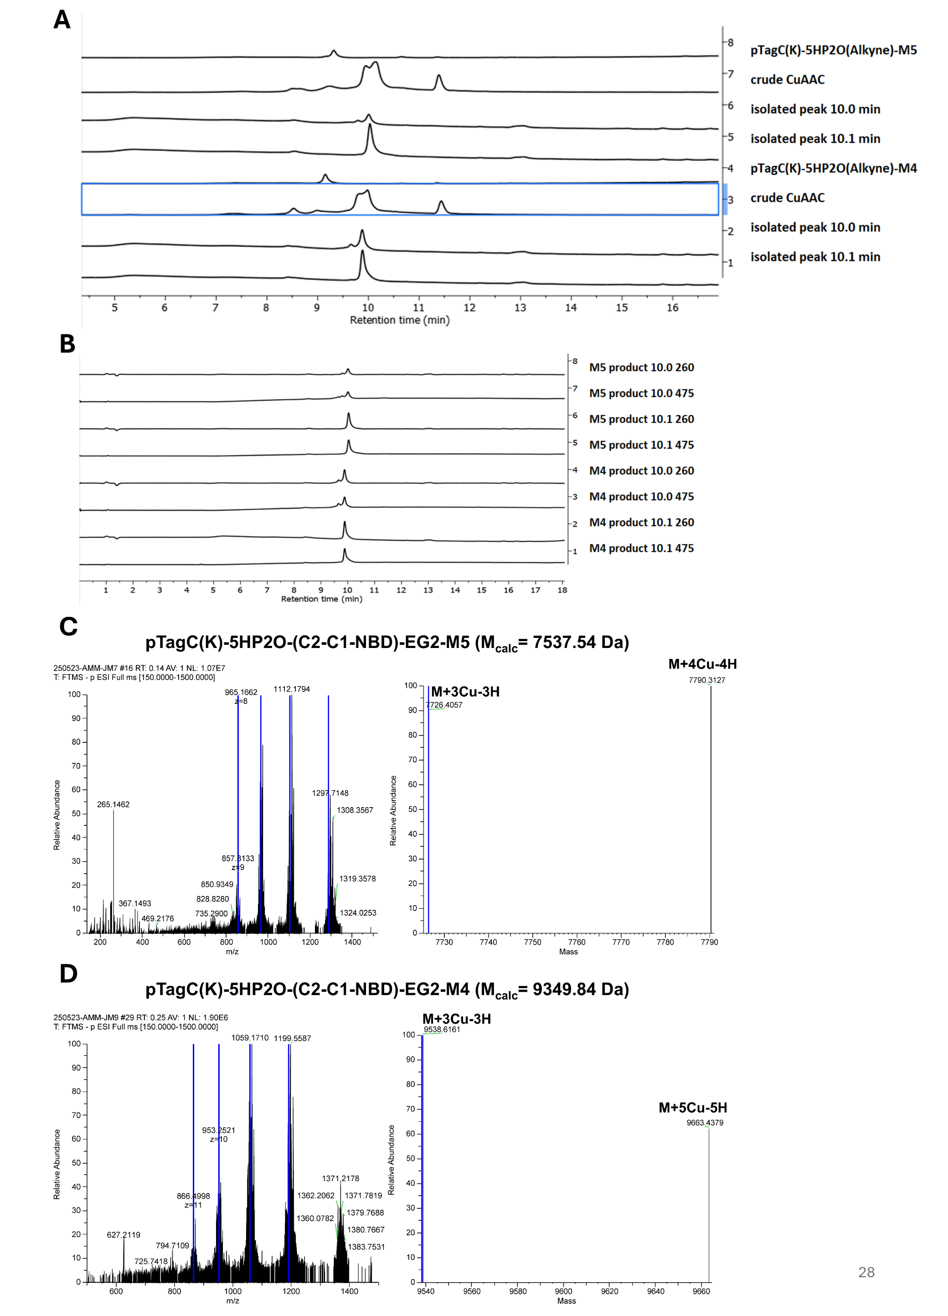
Supplementary Figure 18: CuAAC post-modification of conjugates with azide-NBD (A) HPLC chromatograms (260 nm, to 75% ACN) of starting materials, crude modification and the purified products. (B) HPLC chromatograms (475 nm, to 75% ACN) of purified products indicate absorbance at 475 nm. (C) Orbitrap mass spectrum of purified pTagC(K)-5HP2O(NBD)-EG2-M5 and the corresponding deconvoluted mass spectrum. (C) Orbitrap mass spectrum of purified pTagC(K)-5HP2O(NBD)-EG2-M4 and the corresponding deconvoluted mass spectrum.
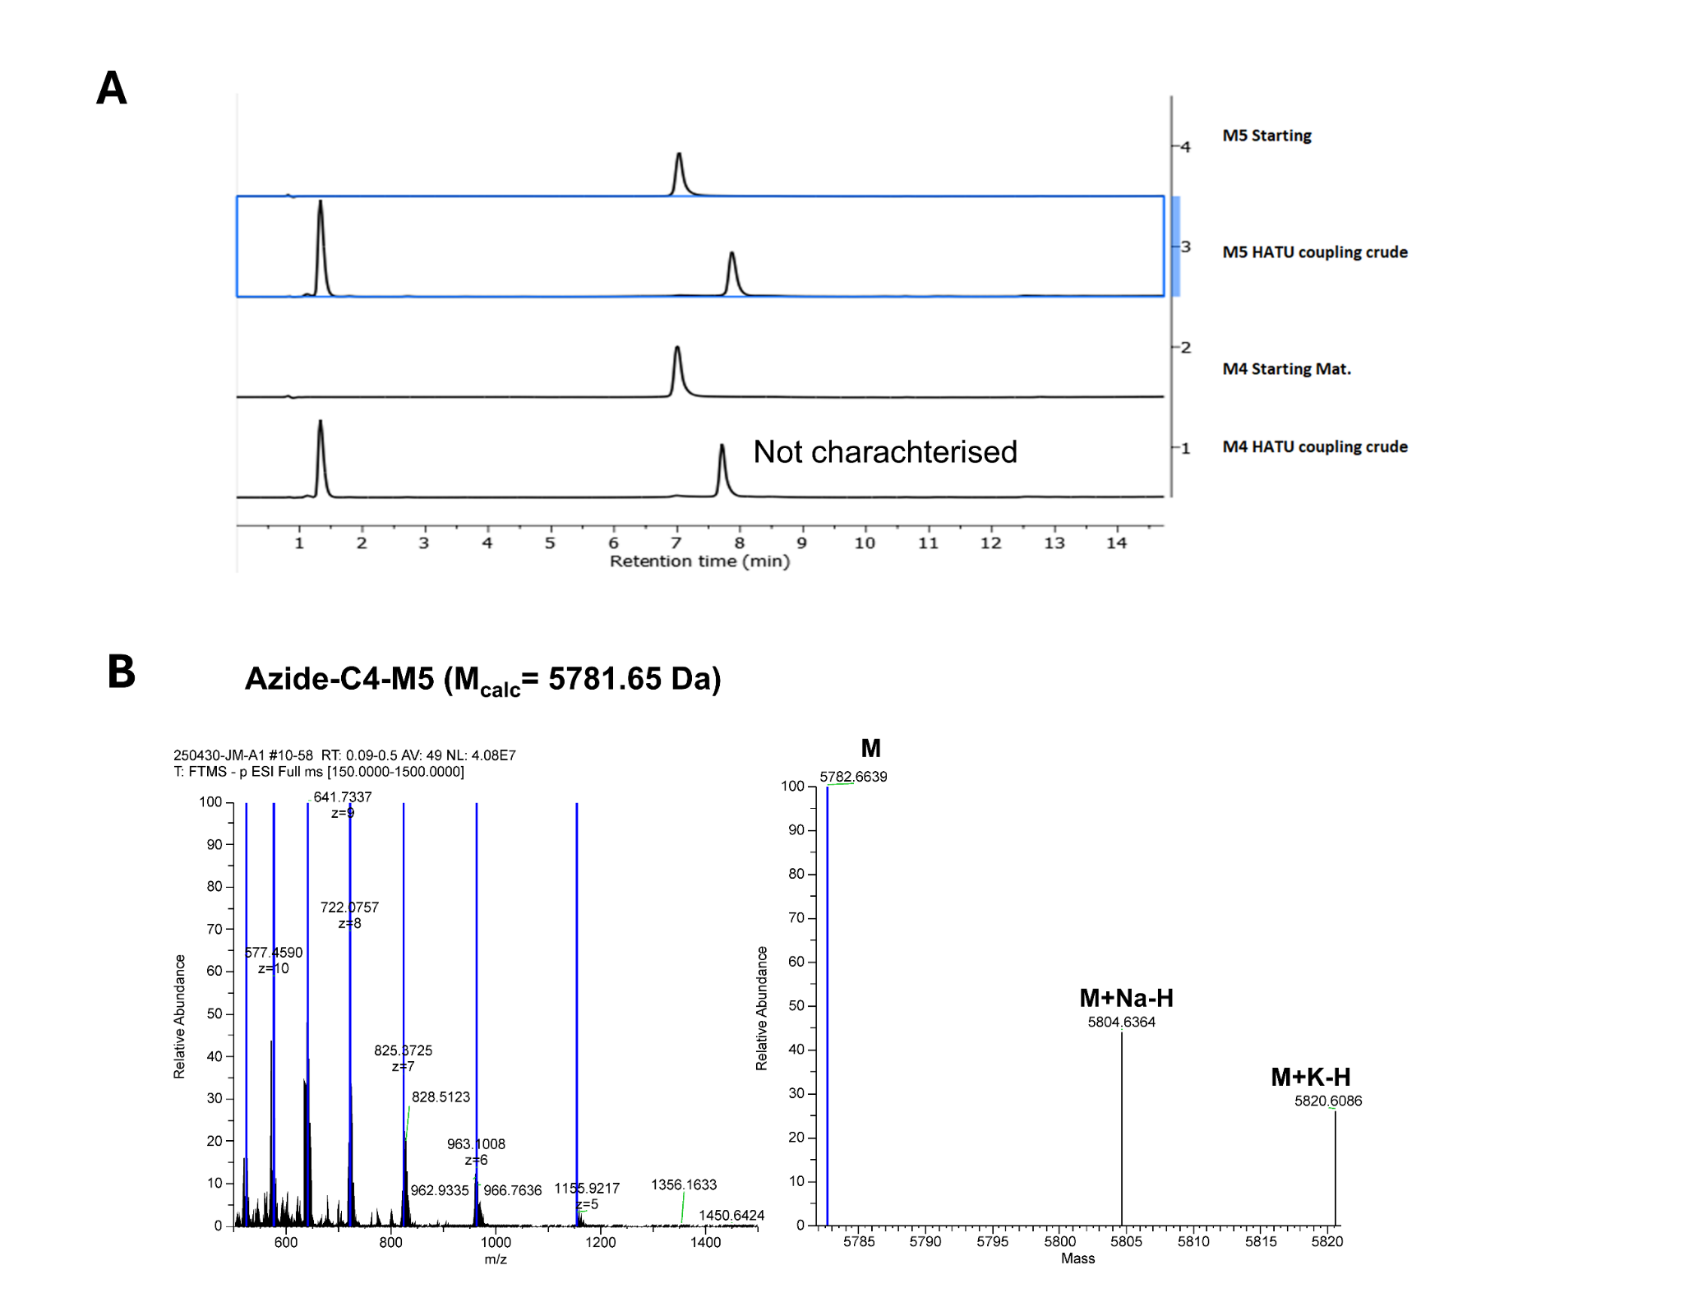
Supplementary Figure 19: HATU-mediated azide-functionalisation of ASO following literature procedure¹¹. (A) HPLC chromatograms (260 nm, to 75% ACN) of starting material and crude amide coupling. (B) Orbitrap mass spectrum of purified Azide-C4-M5 and the corresponding deconvoluted mass spectrum.

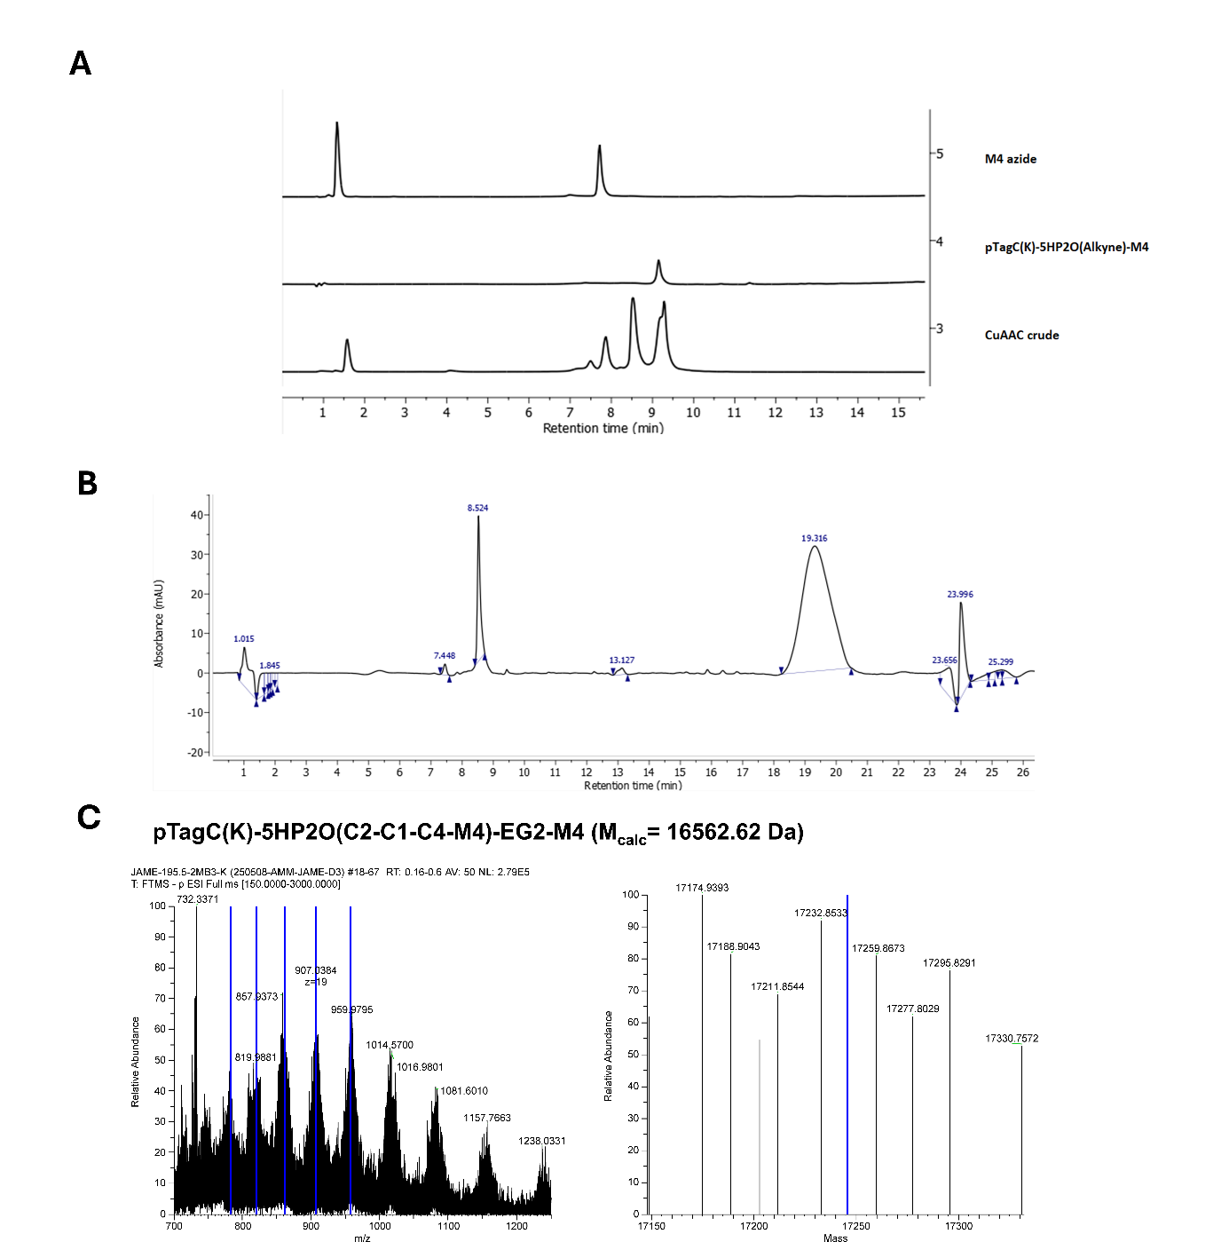
Supplementary Figure 20: CuAAC post-modification of pTagC(K)-5HP2O(C2-C1-Alkyne)-M4 with azide-M4. (A) HPLC chromatograms (260 nm, to 75% ACN) of starting materials and crude CuAAC. (B) HPLC chromatograms (260 nm, to 75% ACN) of purified product. (C) Orbitrap mass spectrum of purified pTagC(K)-5HP2O(M4)-EG2-M4 and the corresponding deconvoluted mass spectrum. M_{found} = 17150.95 [M-12H+8Cu+4Na], 17174.94 [M-12H+8Cu+4Na], 17188.91 [M-10H+10Cu], 17211.85 [M-23H+14Na+9K].

        - NMR Spectra
          - 2-substituted furans
            - Compound 16, N-2-Propyn-1-yl-2-furanpropanamide
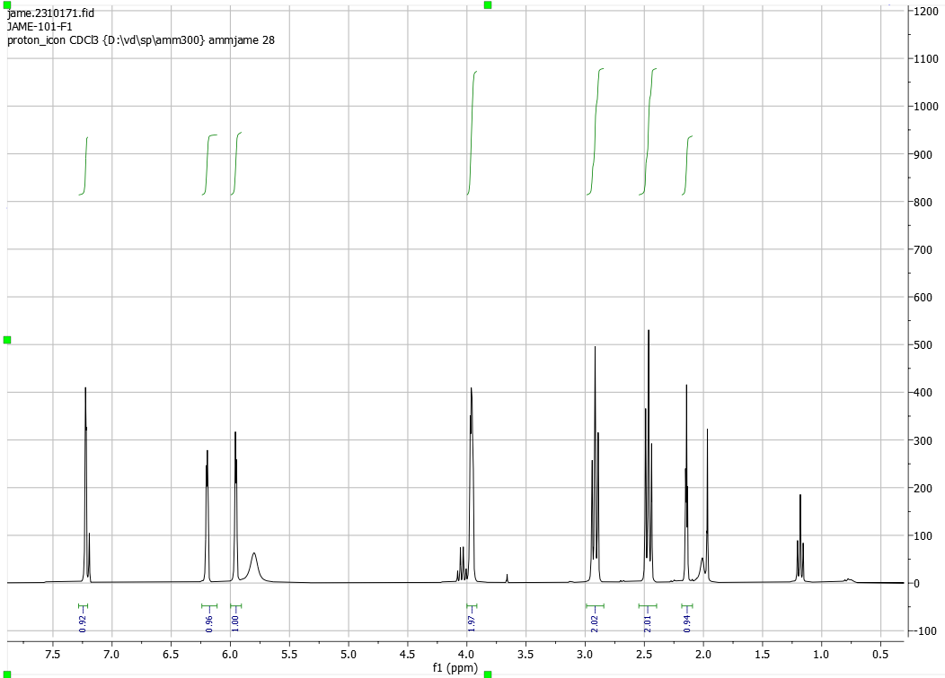
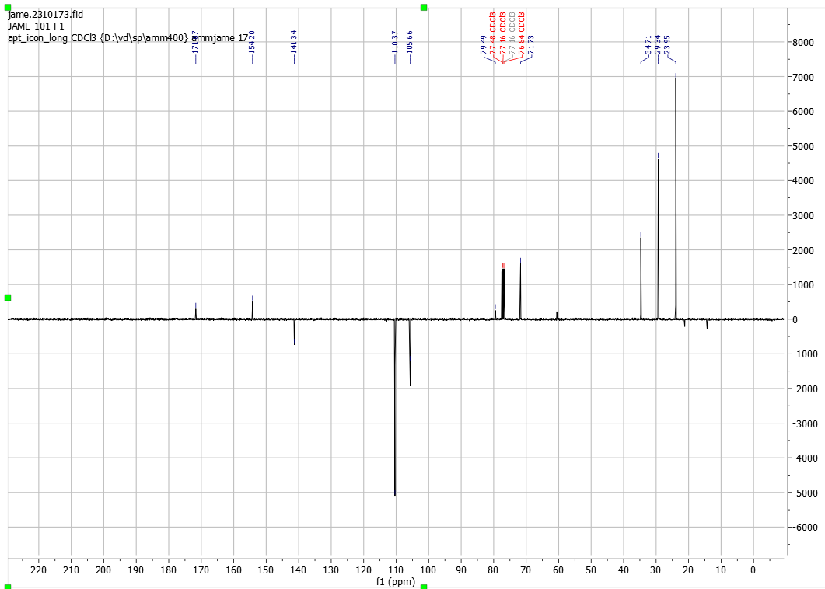
            - Compound 13, N-(2-(2-(2-(2-azidoethoxy)ethoxy)ethoxy)ethyl)-3-(furan-2-yl)propenamide
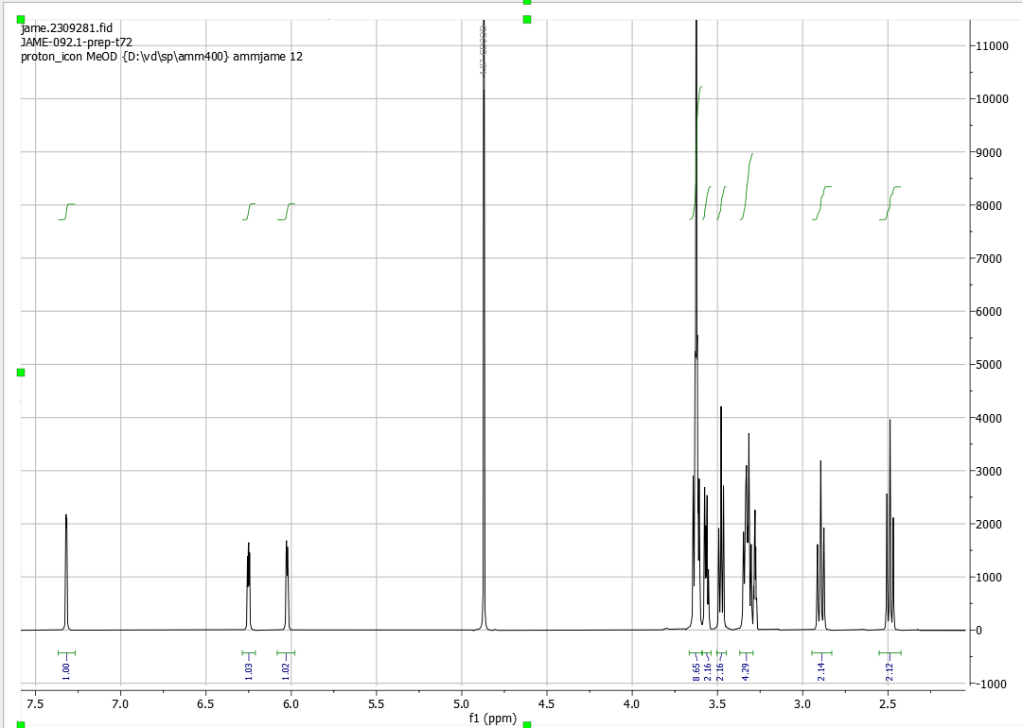
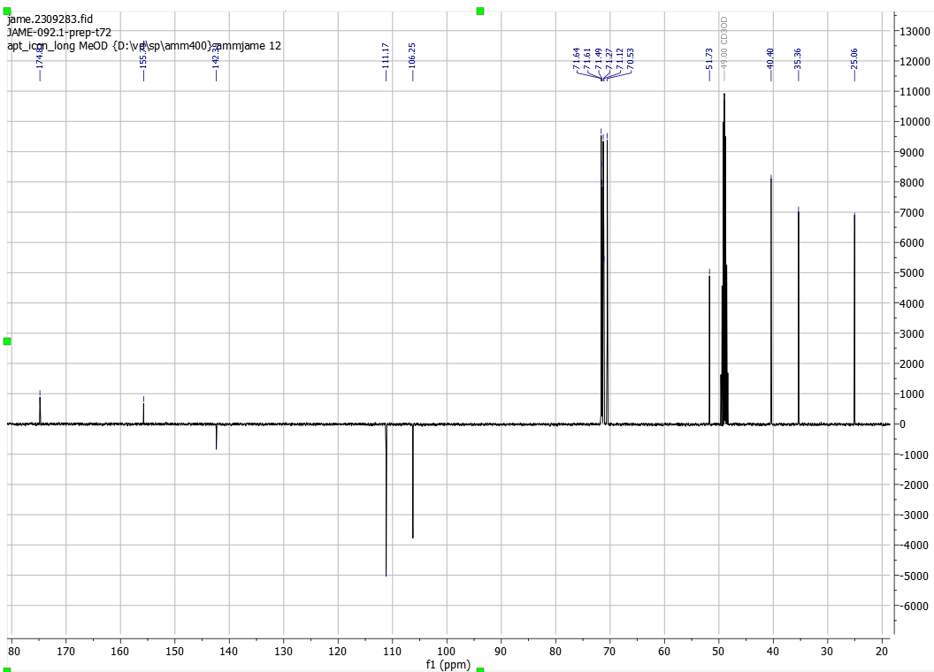

            - Compound 11, 2-(2-(furan-2-yl)ethyl)-2-methyl-1,3-dioxolane
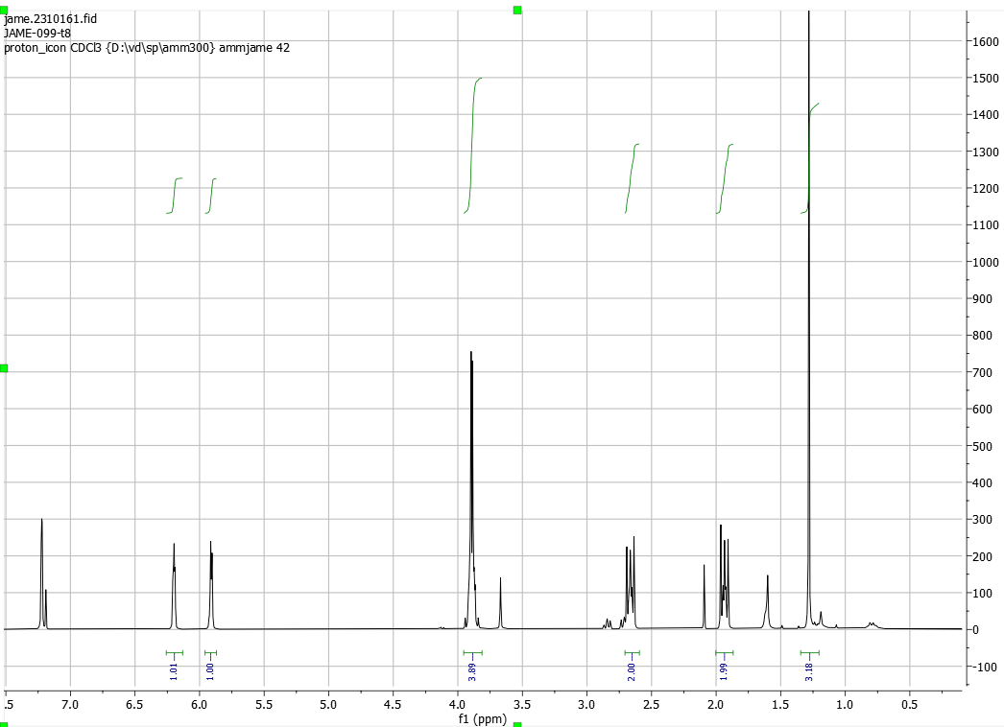
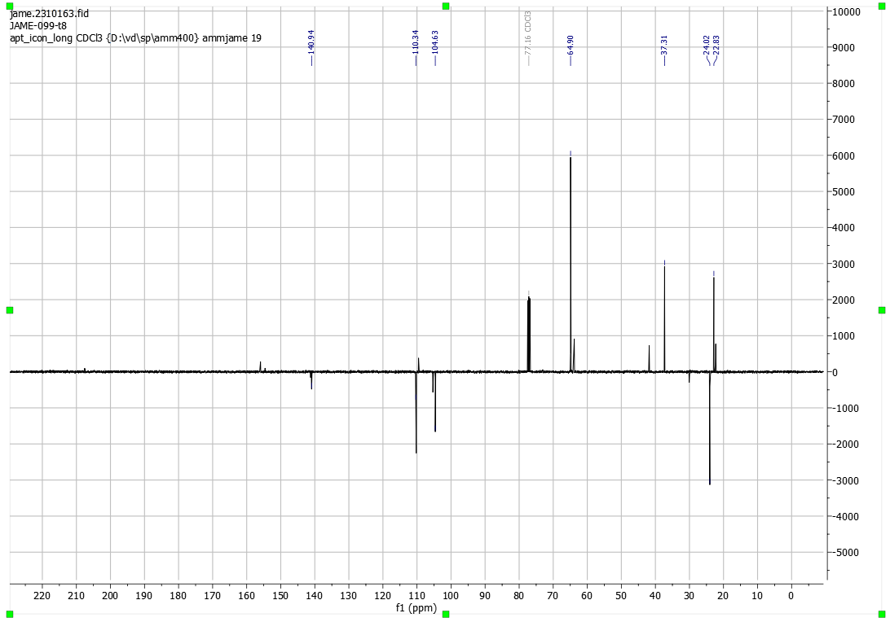
            - Compound 6, 3-(2-(2-(3-(furan-2-yl)propanamido)ethoxy)ethoxy)propanoic acid
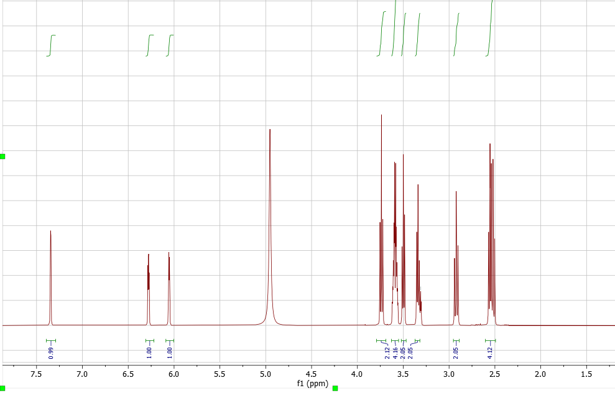
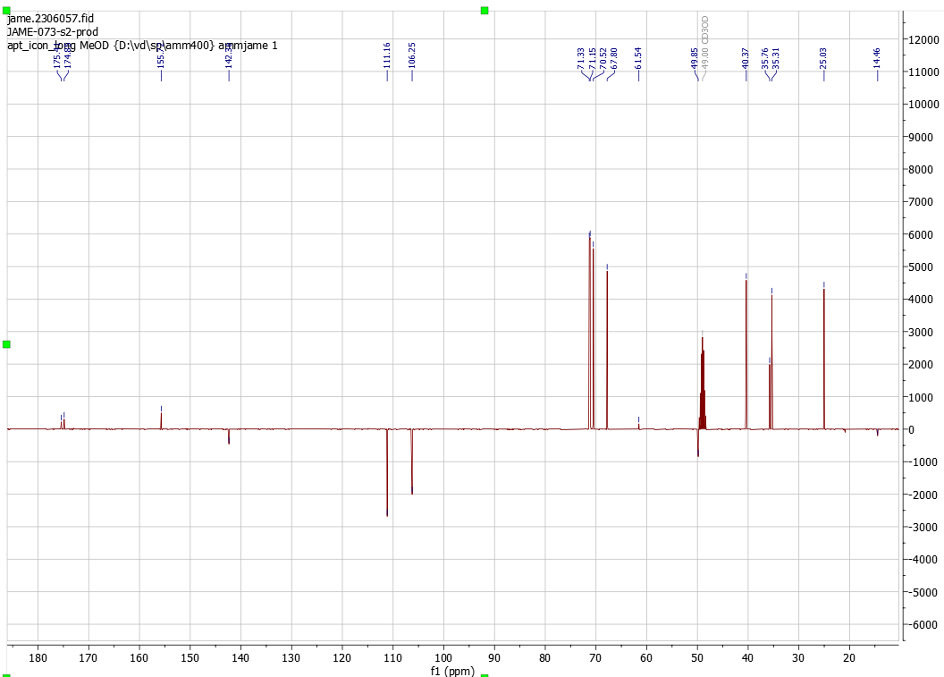

          - Heterobifunctional Linkers
            - Mal-C5-NHS

            - Compound 2, 5HP2O-C5-NHS
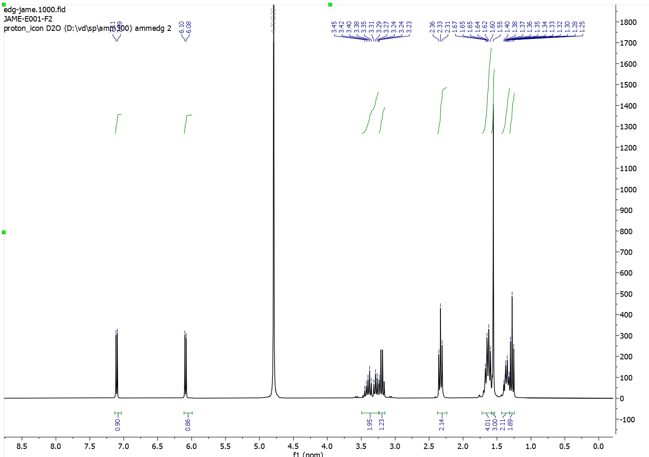

            - Compound 3, 5HP2O-EG2-COOH
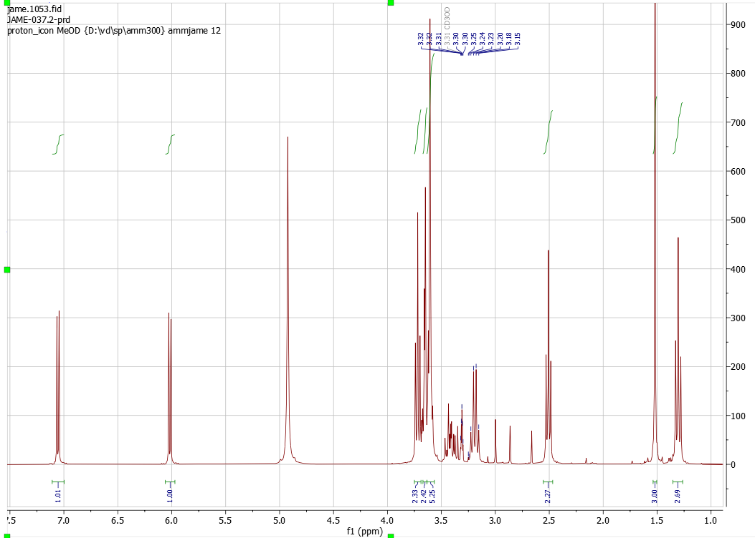
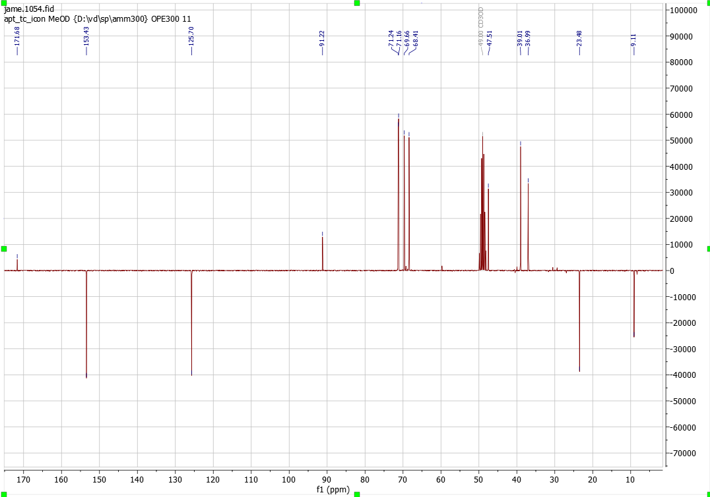

            - Compound 4, 5HP2O-EG2-NHS
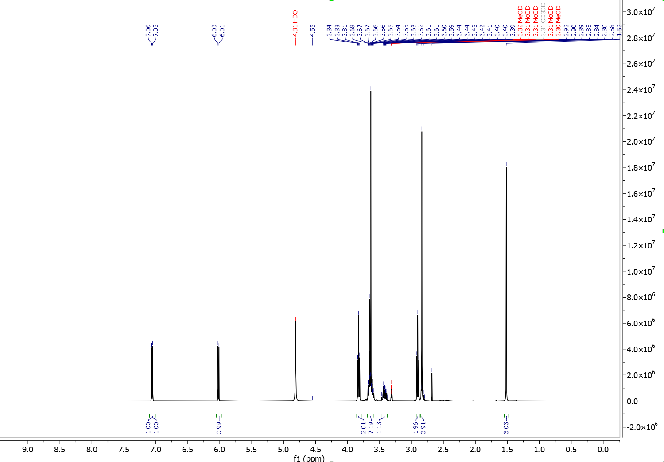
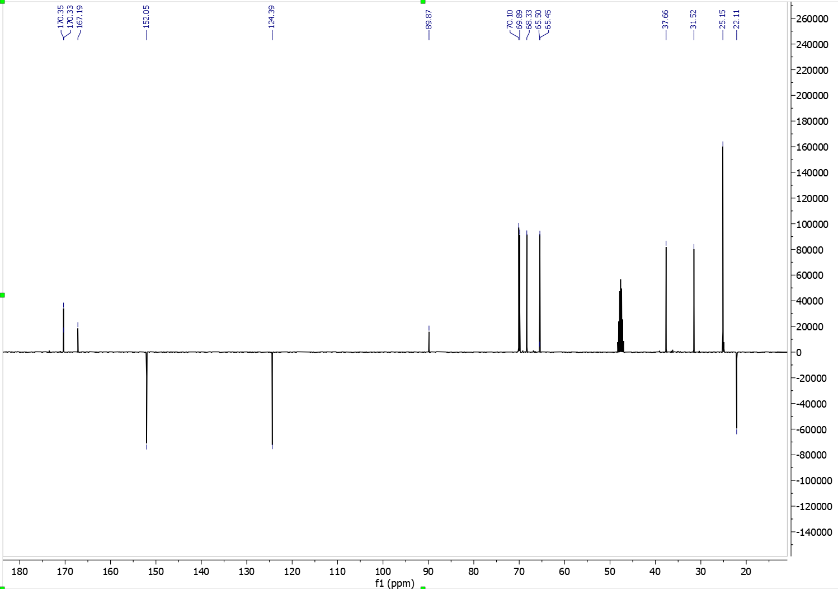

          - Trifunctional 5HP2O Linkers
            - Compound 7, 5HP2O(C2-EG2-COOH)-C5-NBD
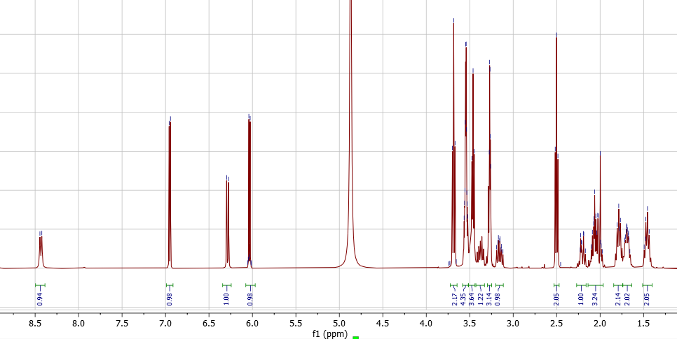
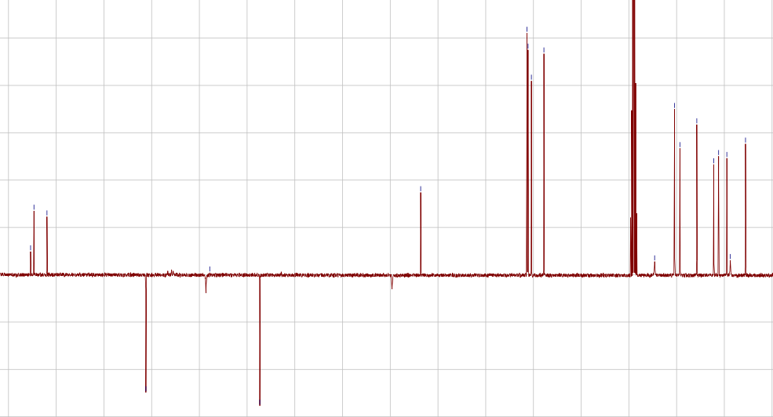

            - Compound 8, 5HP2O(C2-EG2-NHS)-C5-NBD
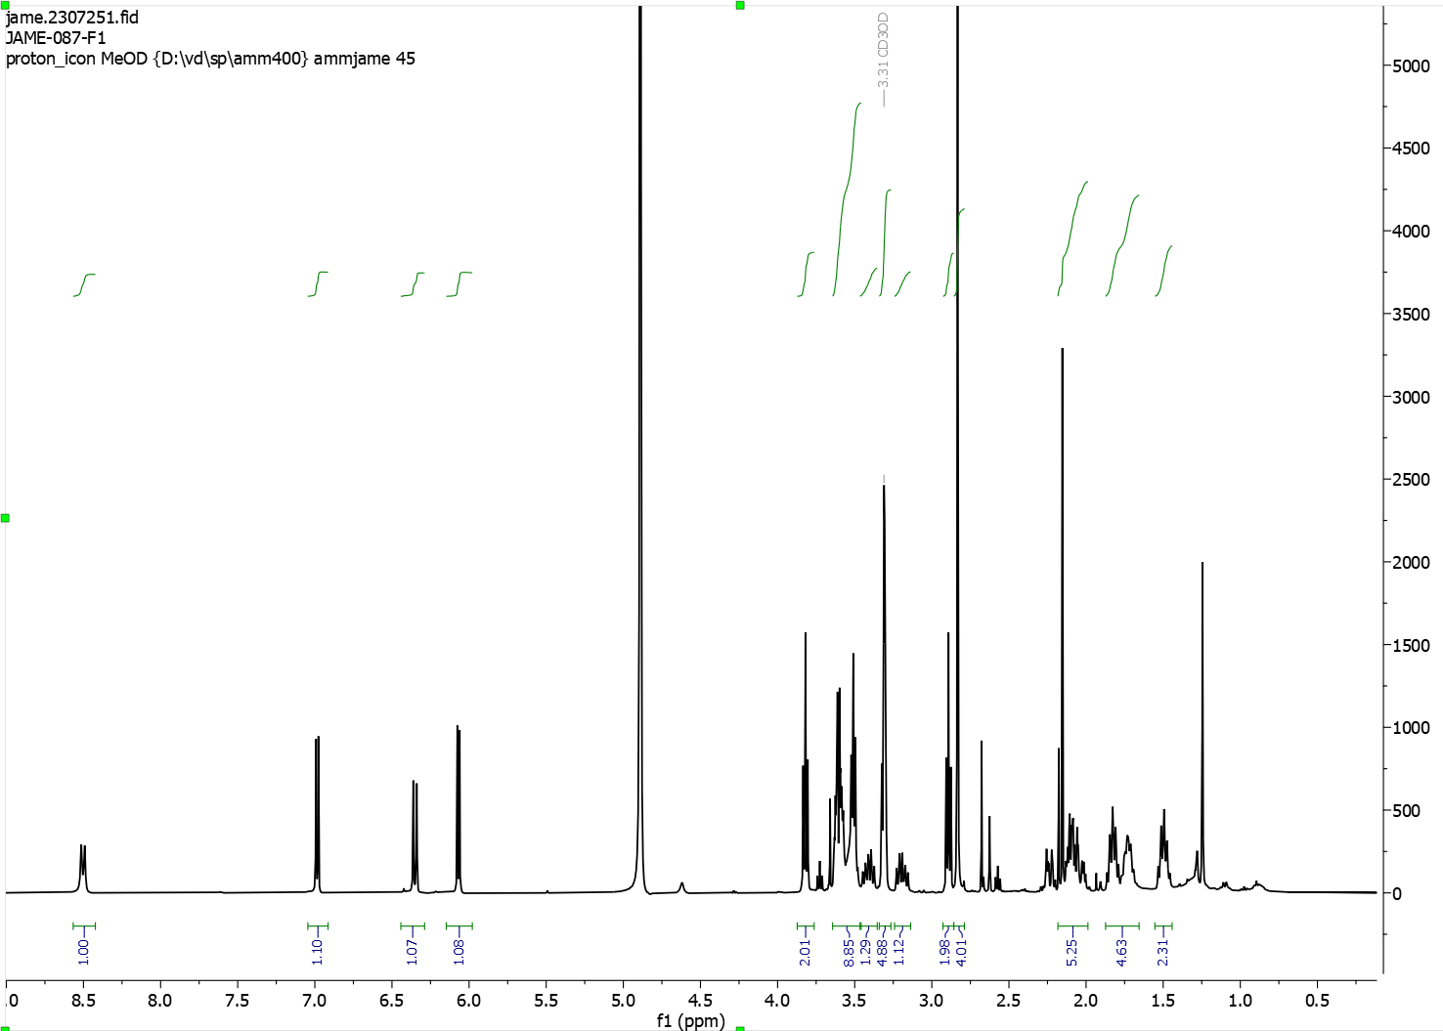
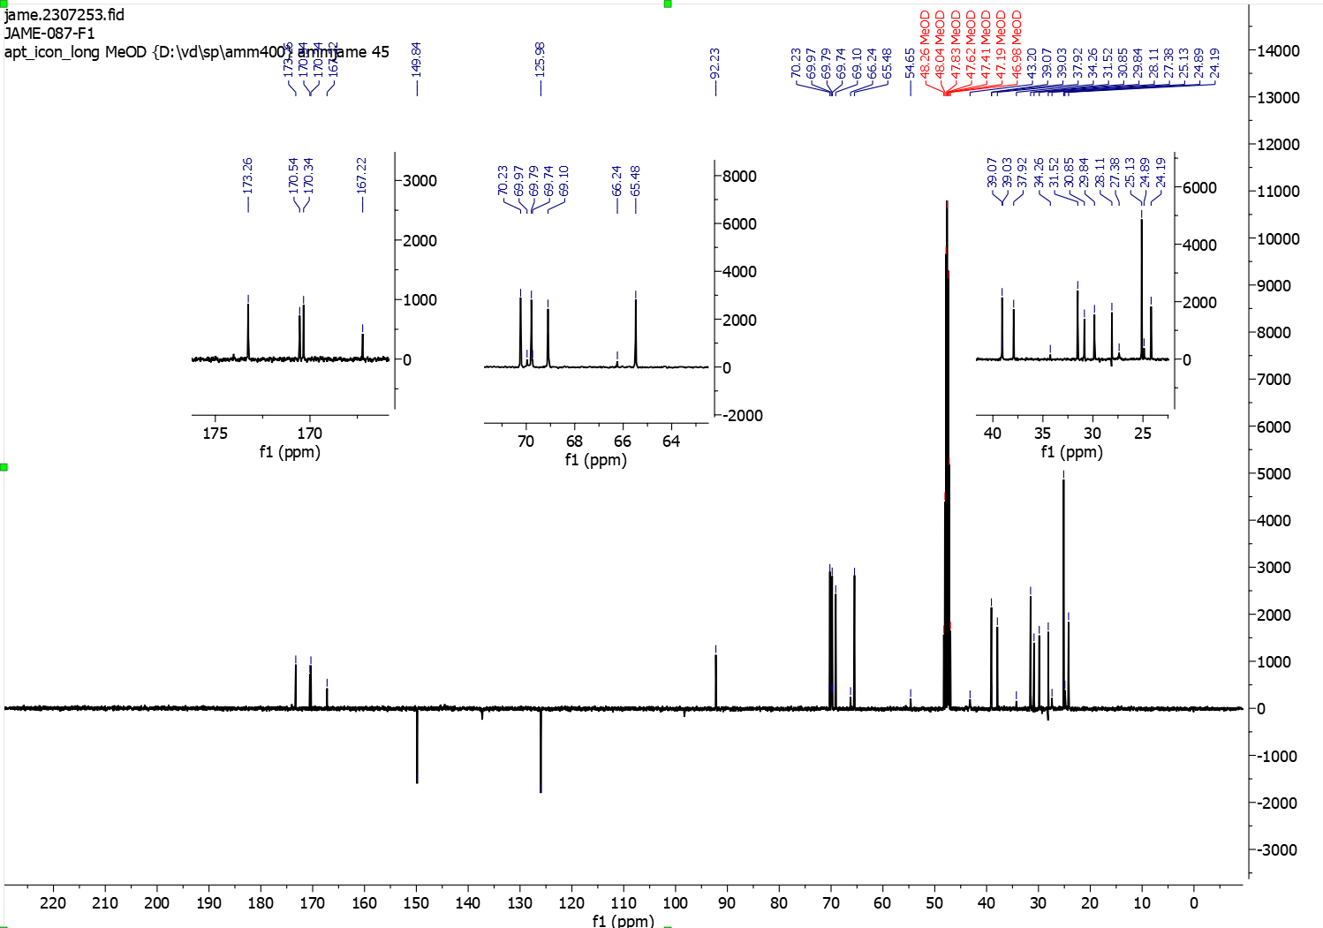

            - Compound 12, 5HP2O(C2-Ketone)-EG2-NHS
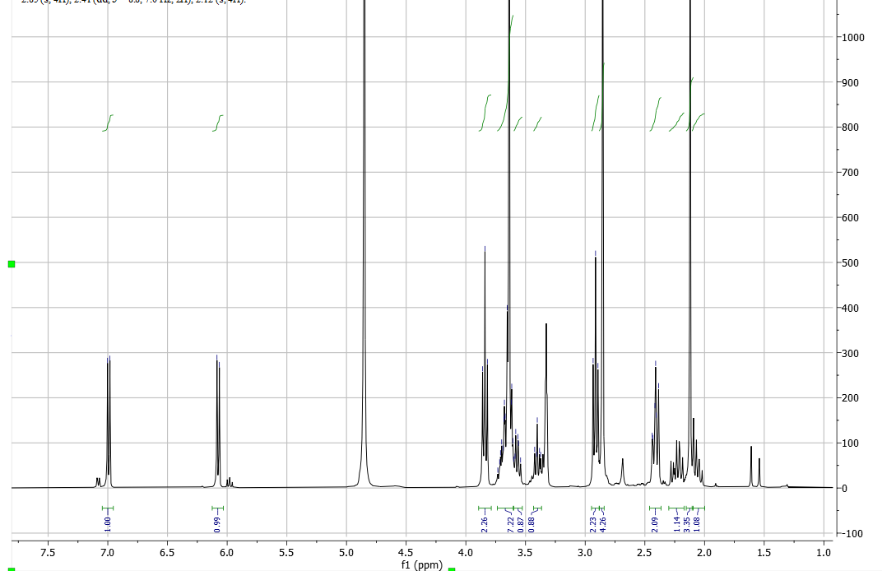
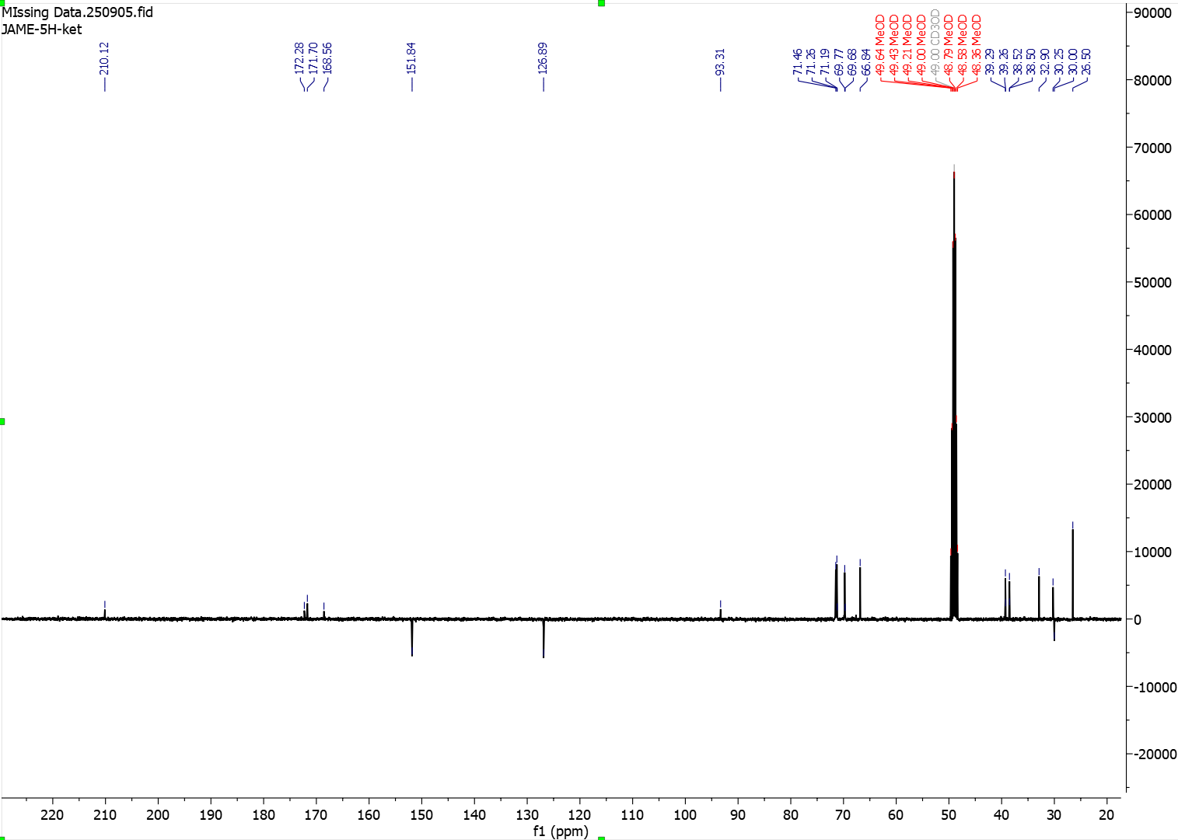

            - Compound 14, 5HP2O(C2-EG3-N3)-EG2-COOH
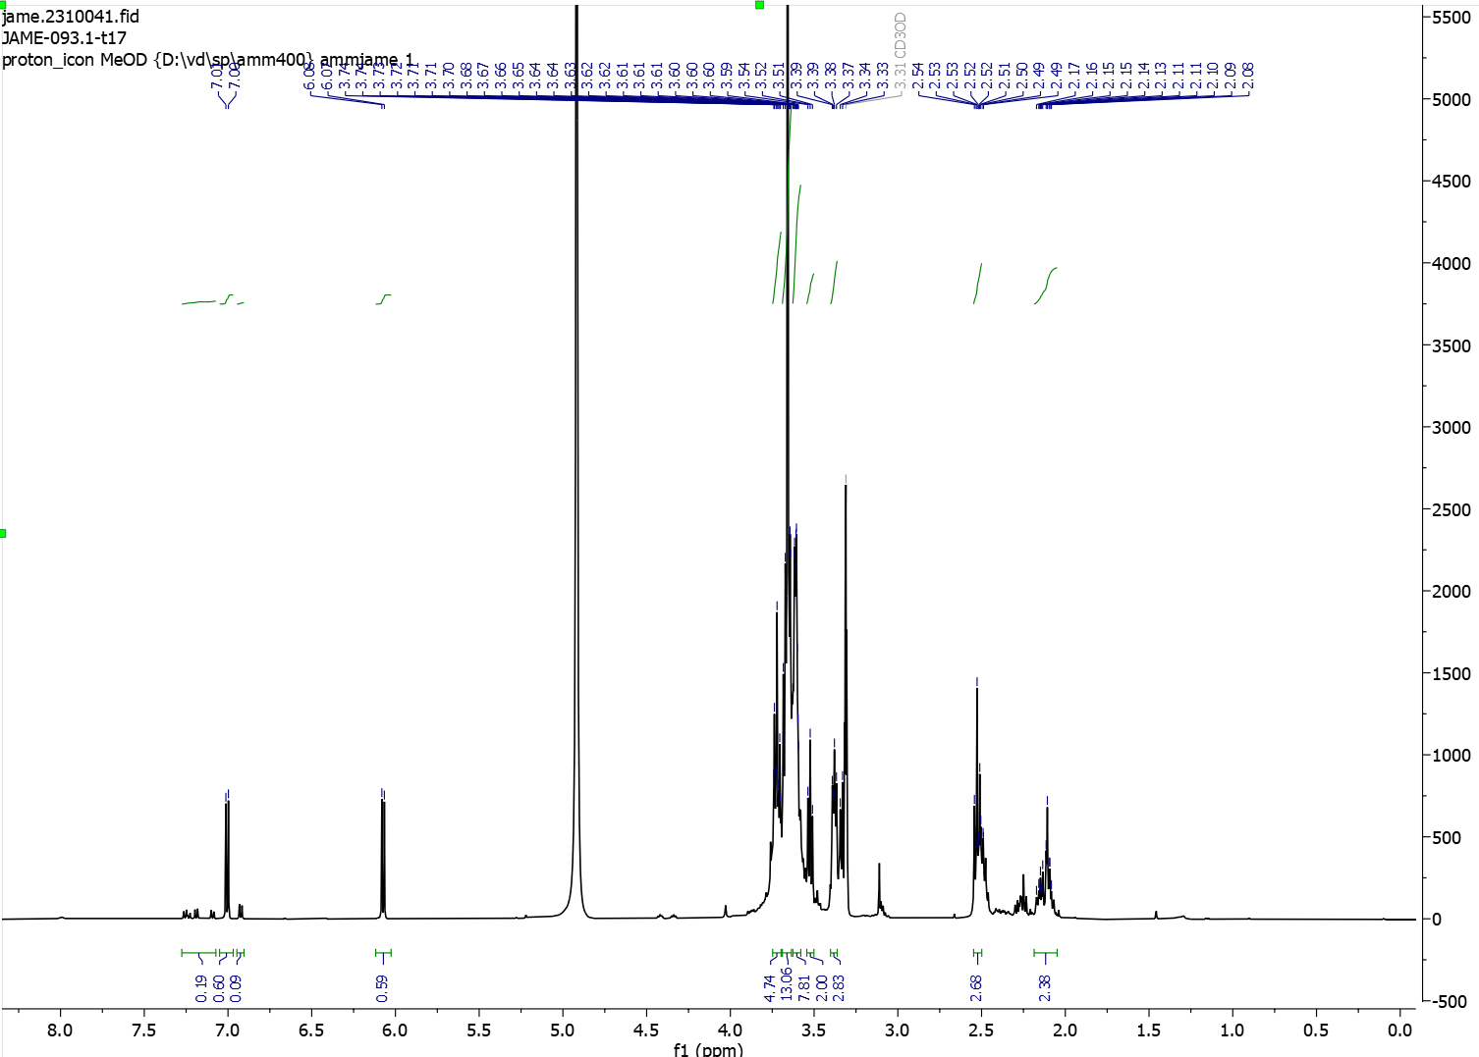
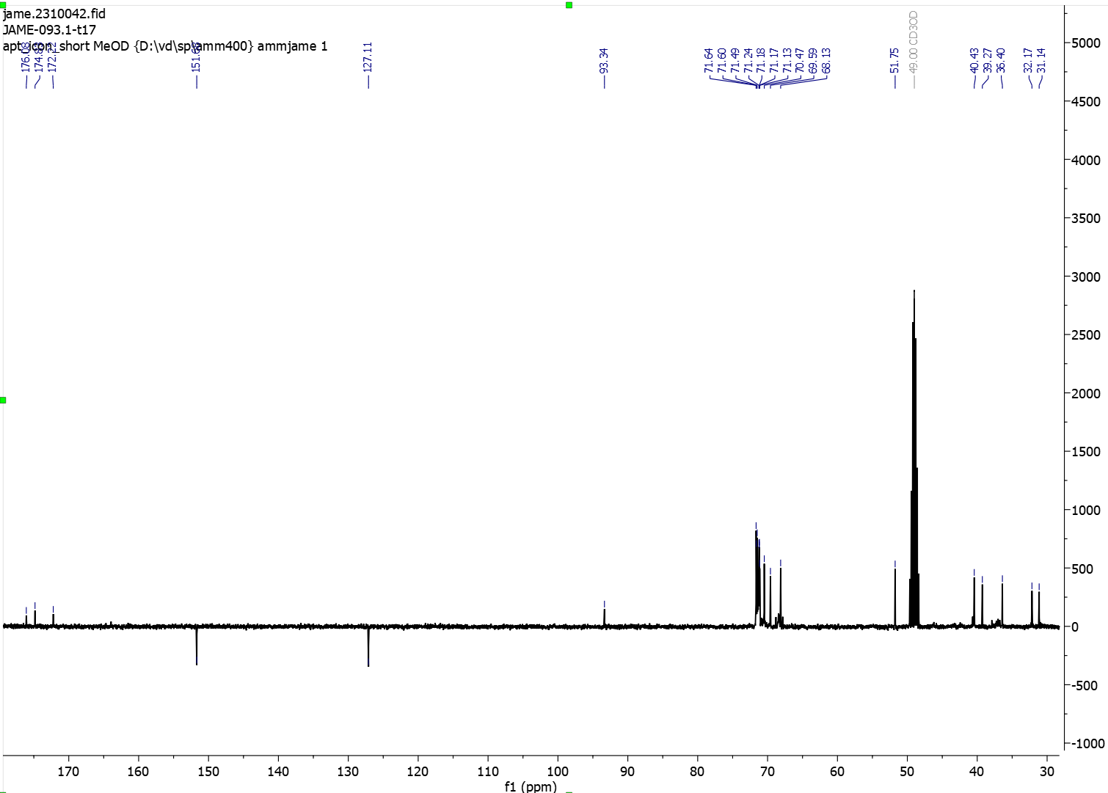

            - Compound 15, 5HP2O(C2-EG3-N3)-EG2-NHS
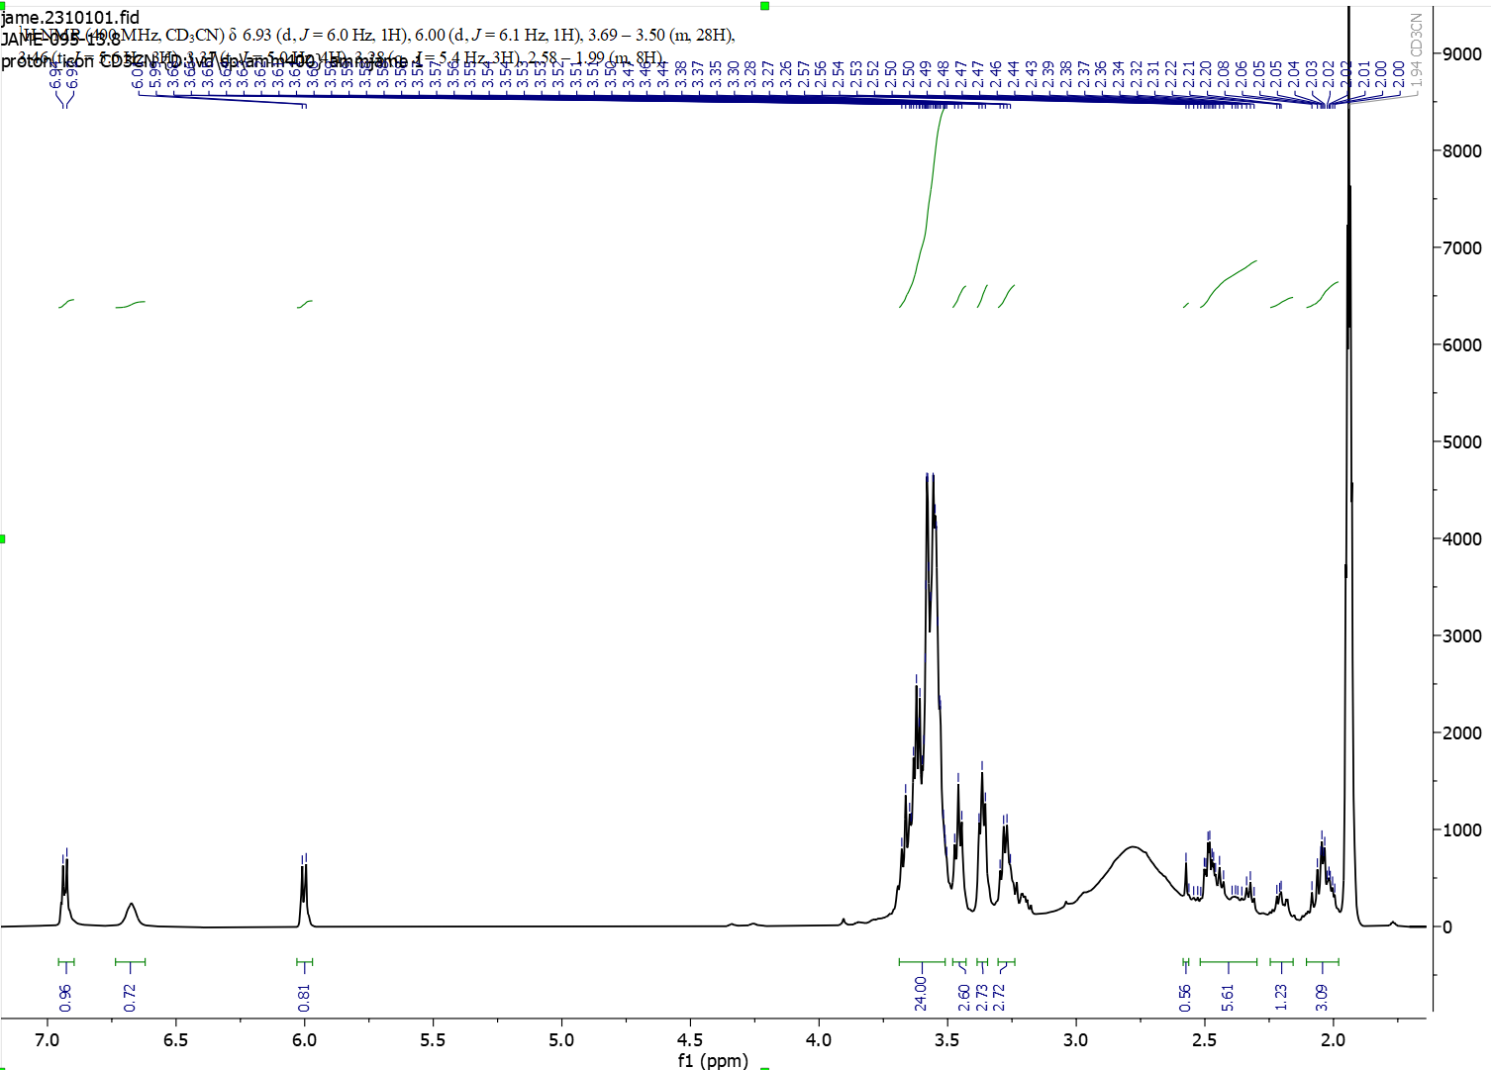
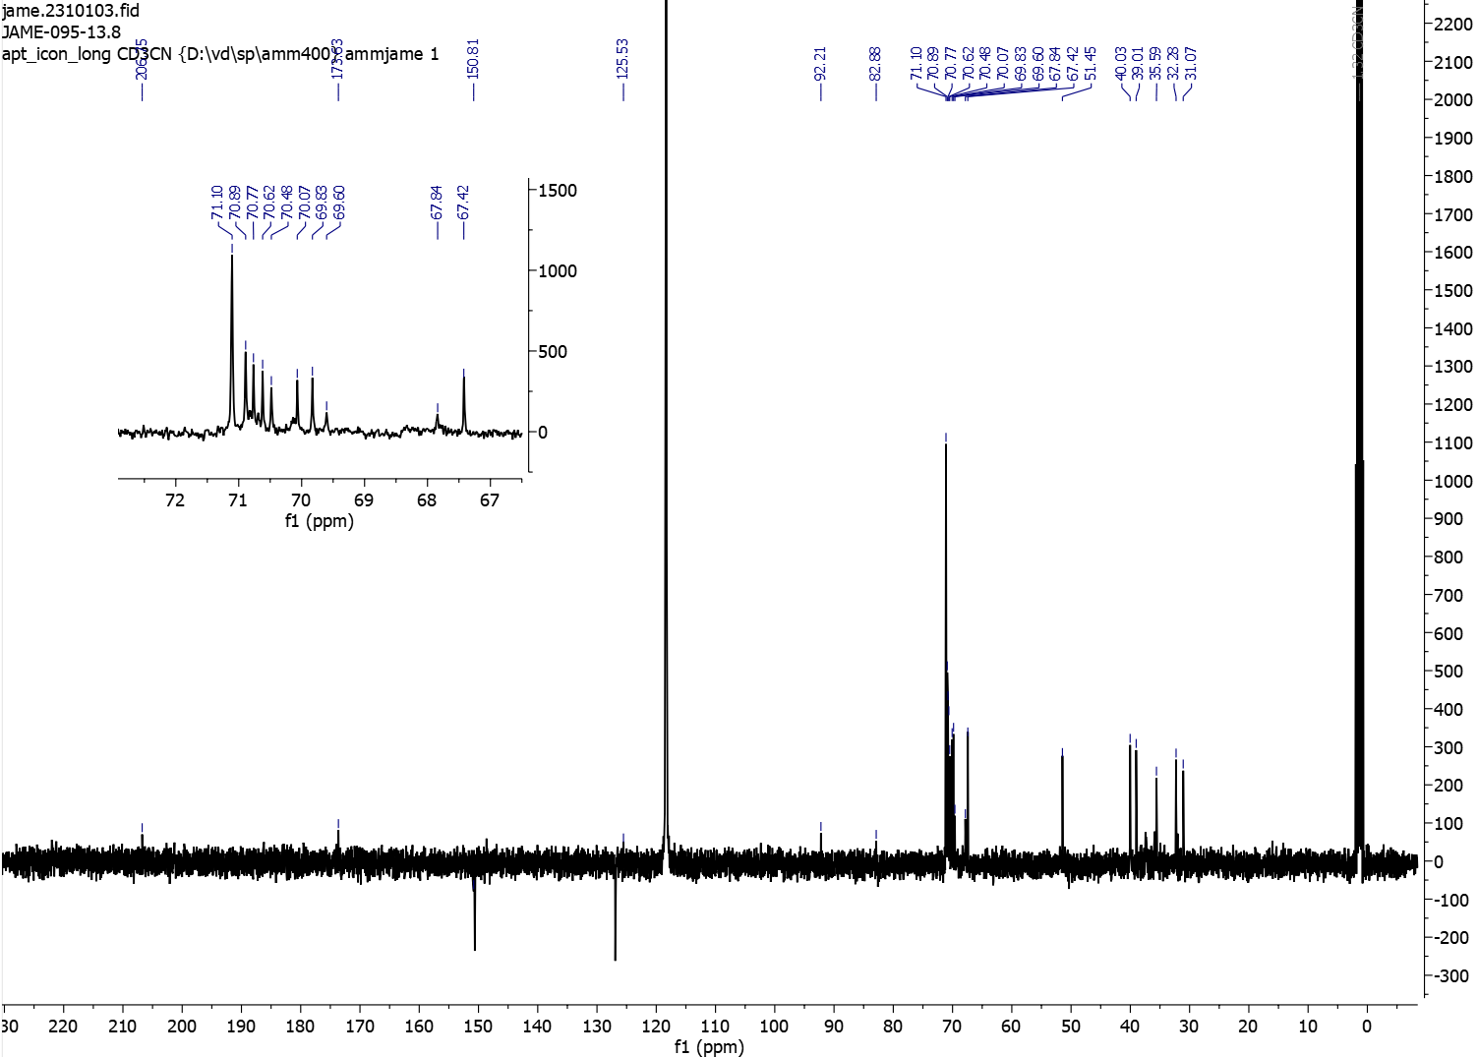

            - Compound 17, 5HP2O(C2-C1-Alkyne)-EG2-COOH
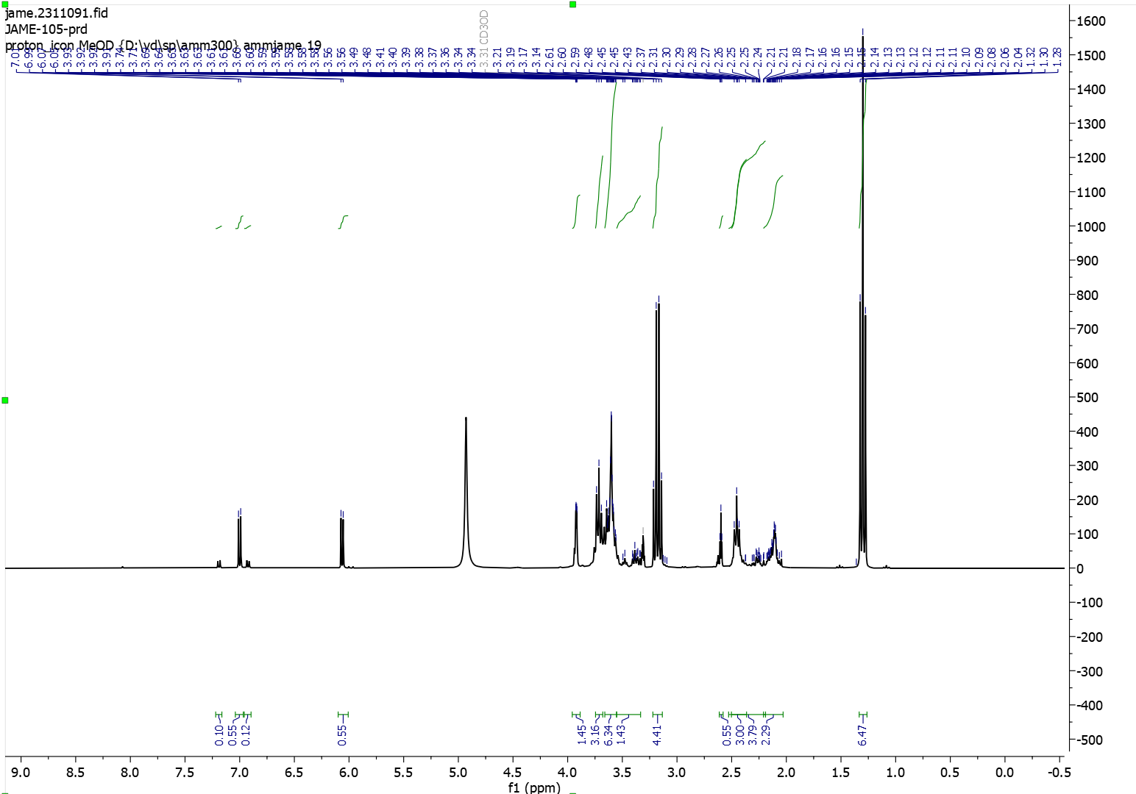

            - Compound 18, 5HP2O(C2-C1-Alkyne)-EG2-NHS
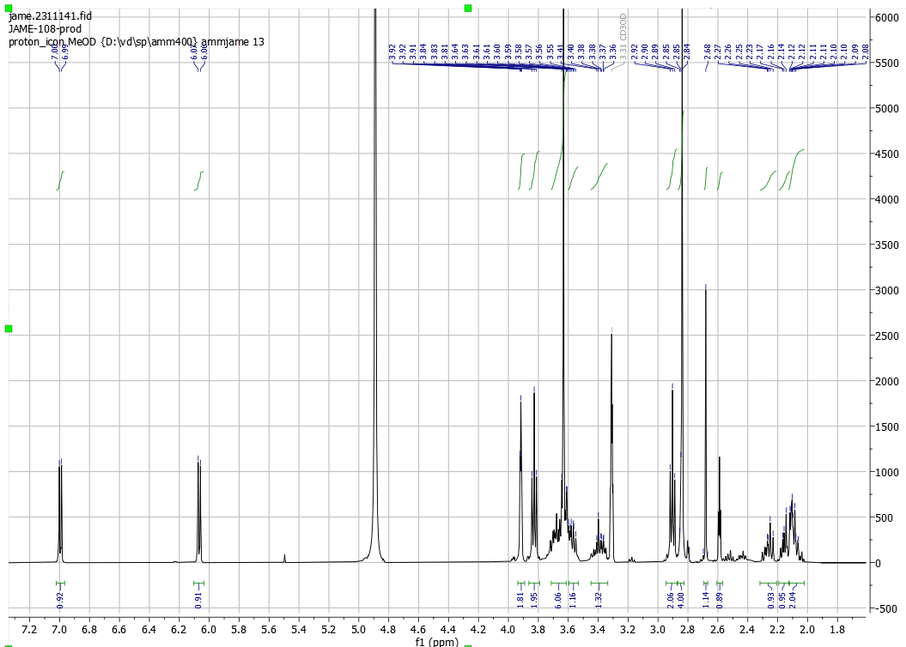
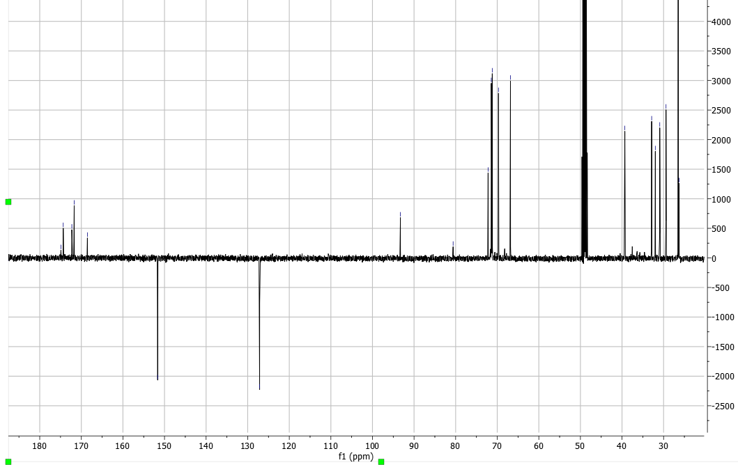

          - Tetrafunctional 5HP2O Linker
            - NH₂-EG2-ValCitPAB-OH
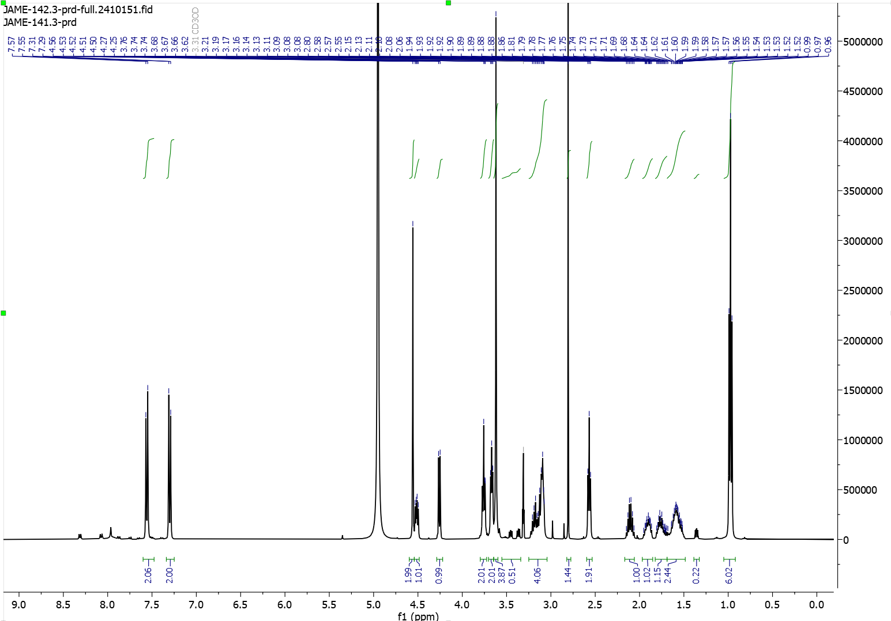
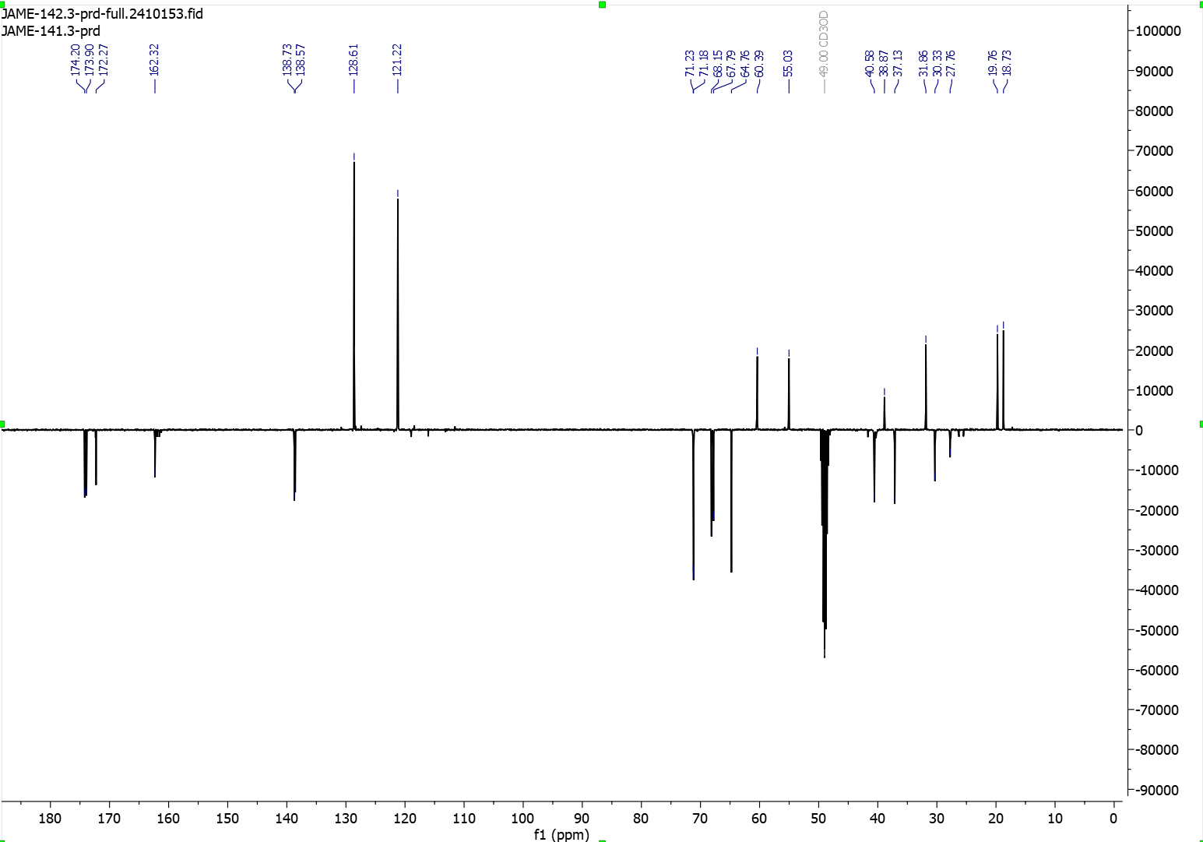
Phase is inverted in Carbon-NMR.
            - Compound 19, 5HP2O(C2-EG3-N3)-EG2-ValCitPAB-OH
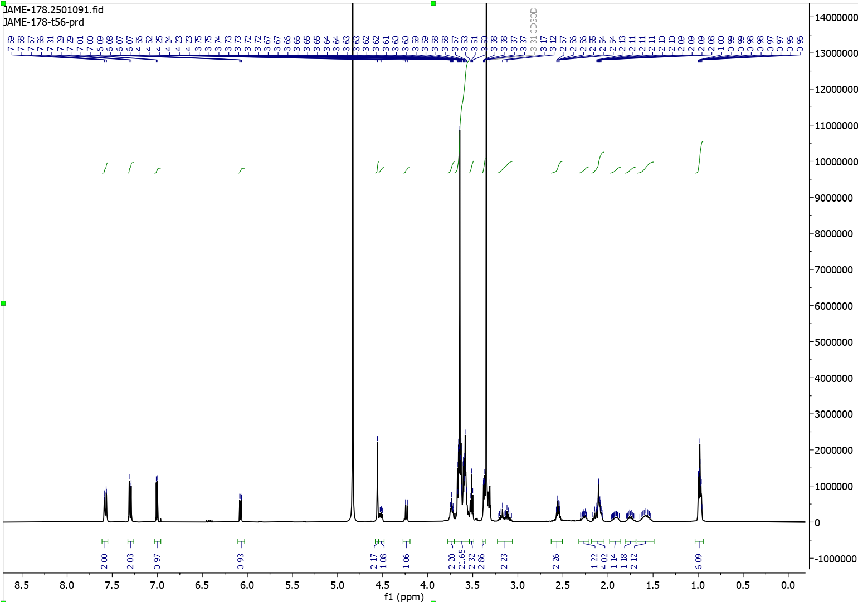
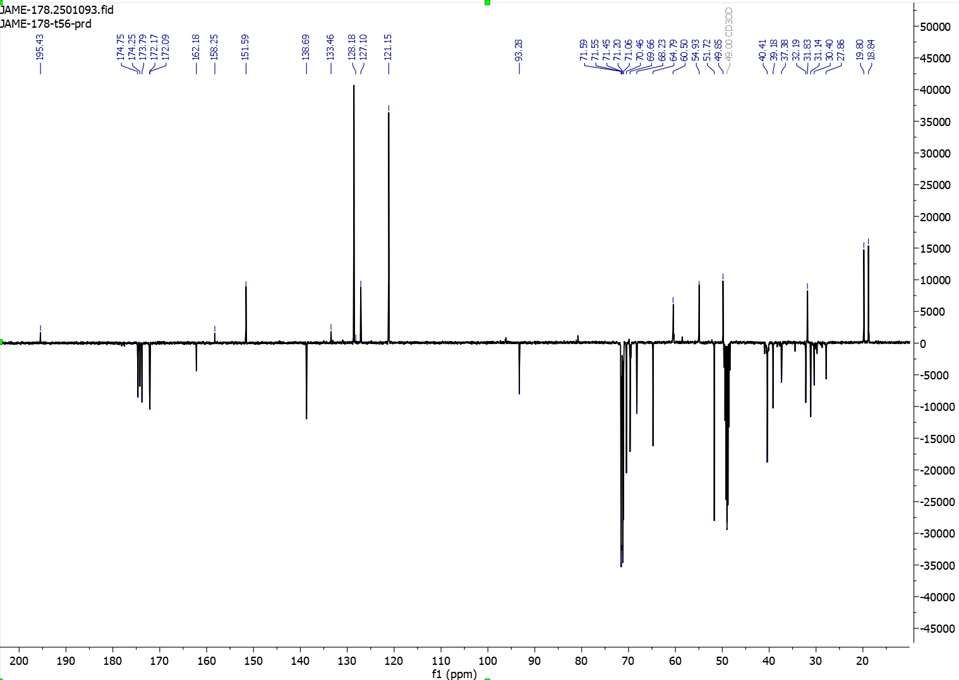

            - Compound 19b, 5HP2O(C2-EG3-N3)-EG2-ValCitPAB-EG2-COOH
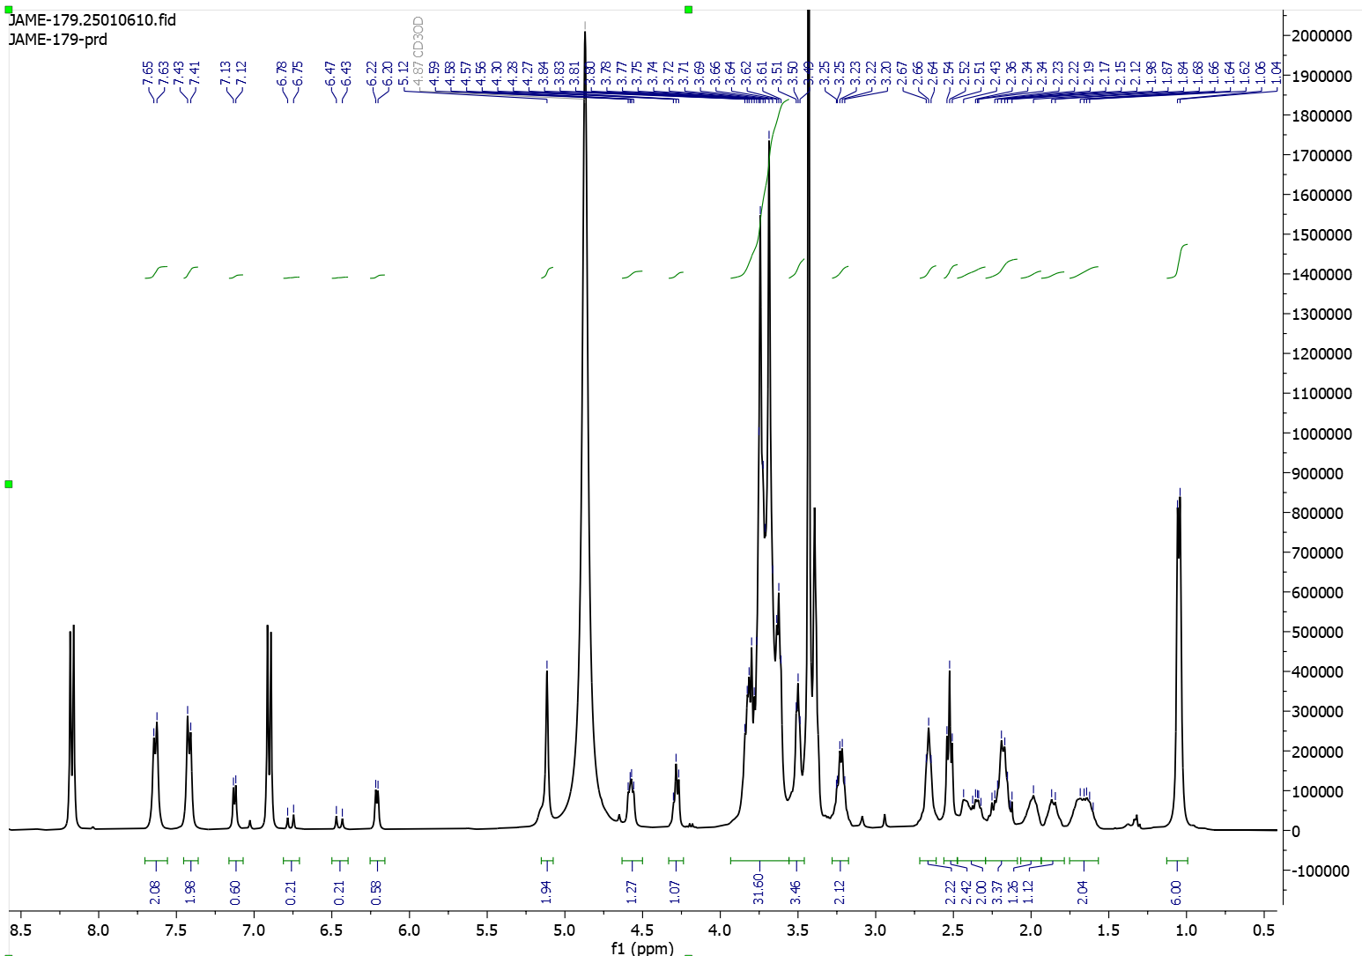
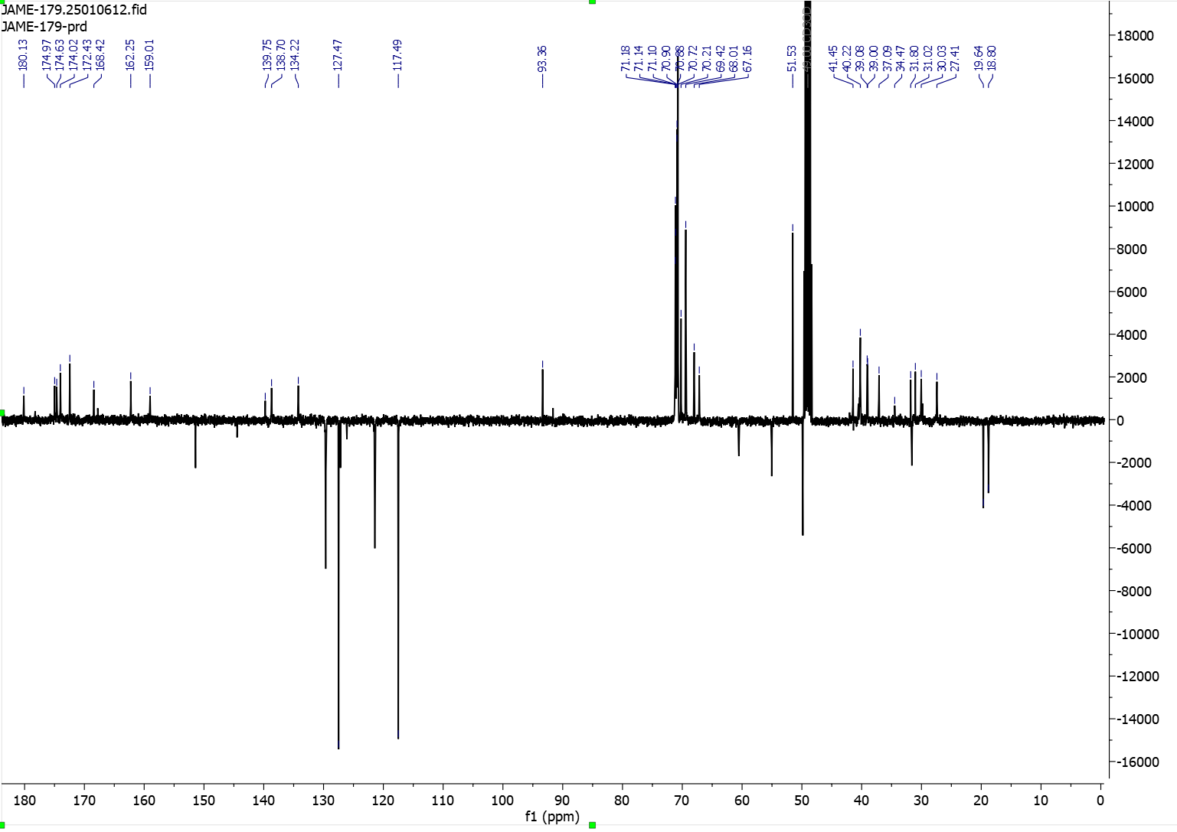

            - Compound 20, 5HP2O(C2-EG3-N3)-EG2-ValCitPAB-EG2-NHS
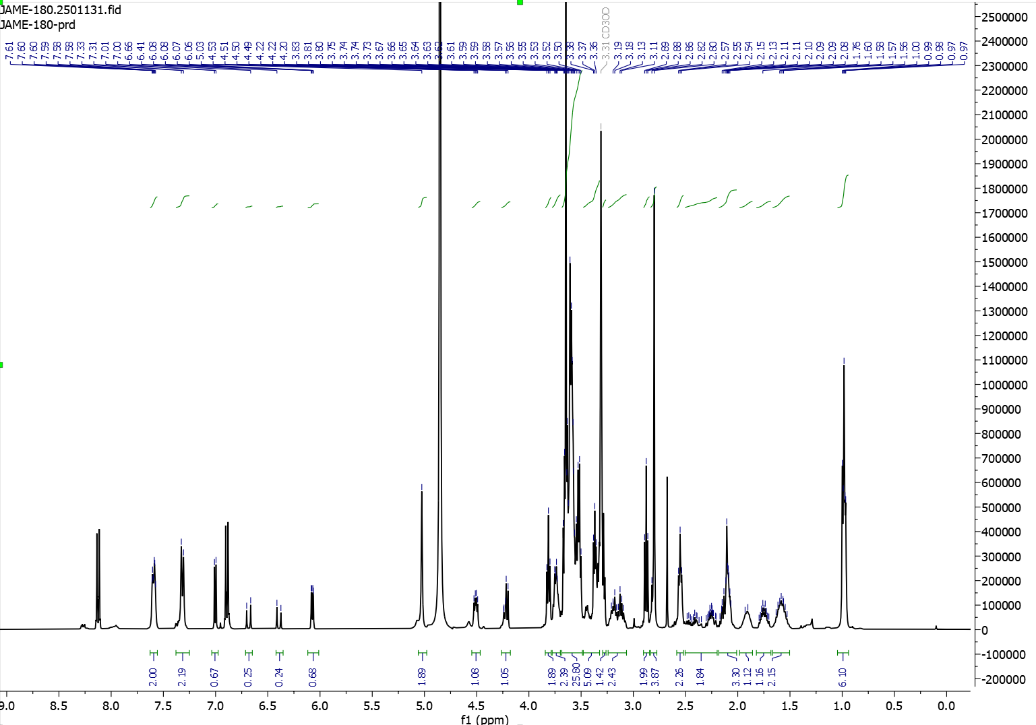
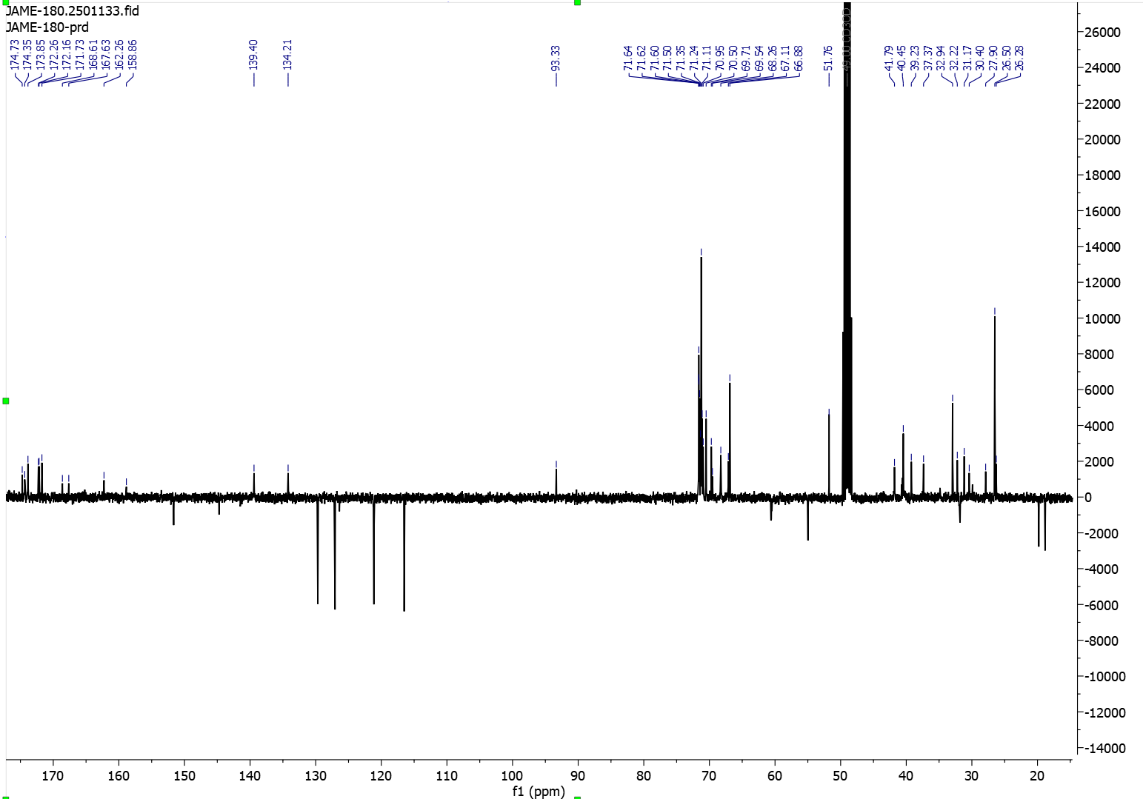

          - Fluorescent Tags
            - NBD-C5-NH2
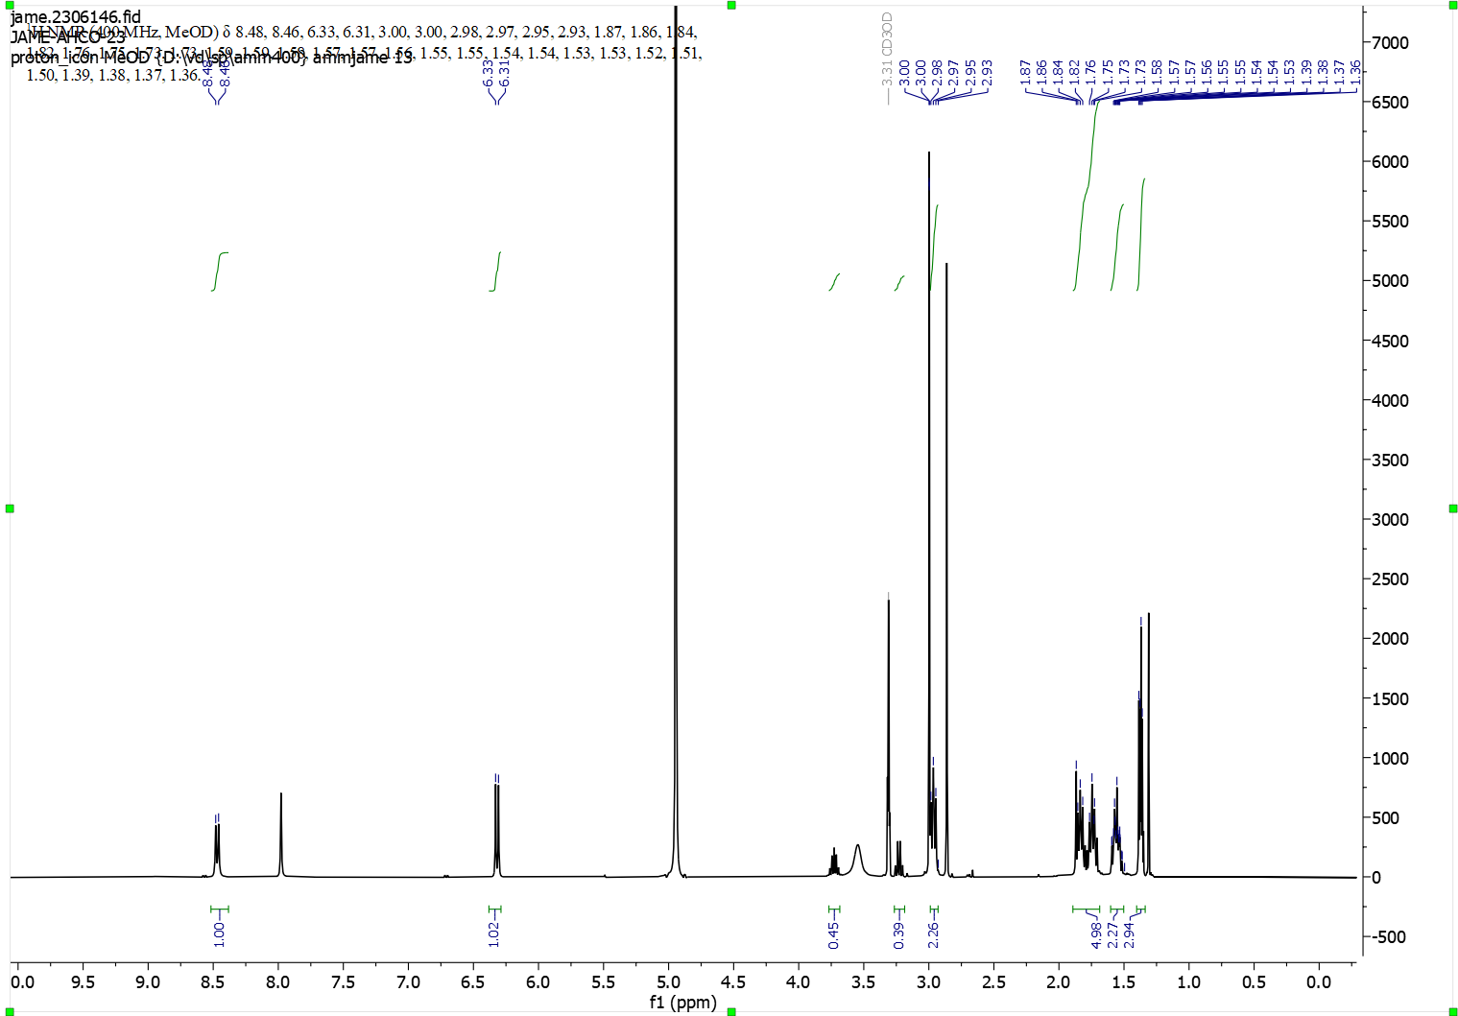
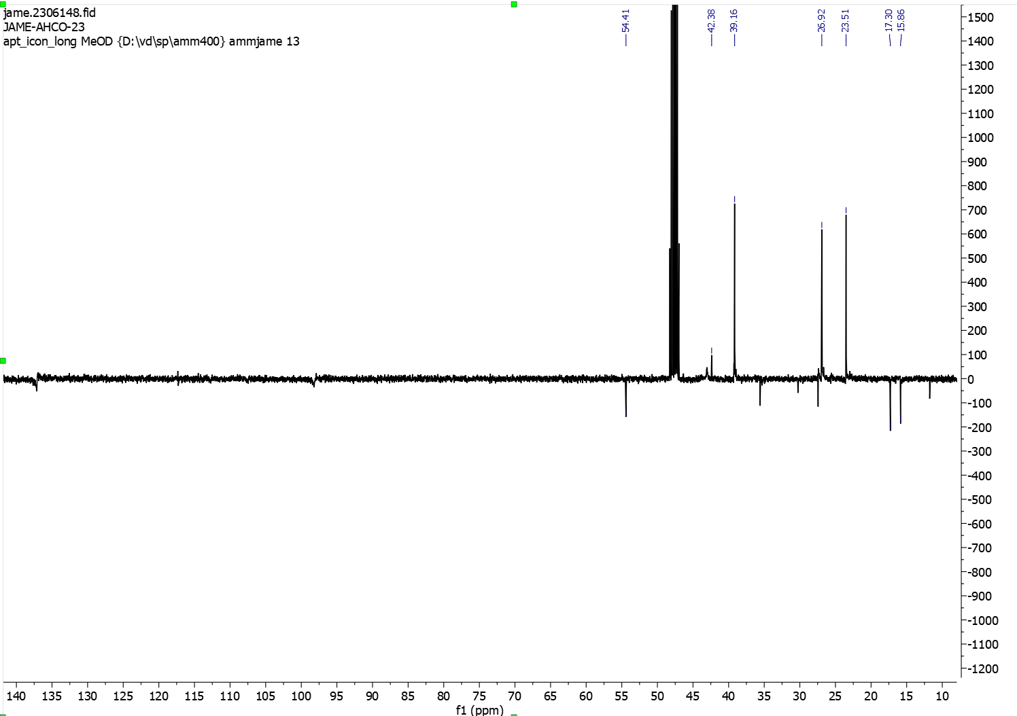
            - NBD-EG3-azide

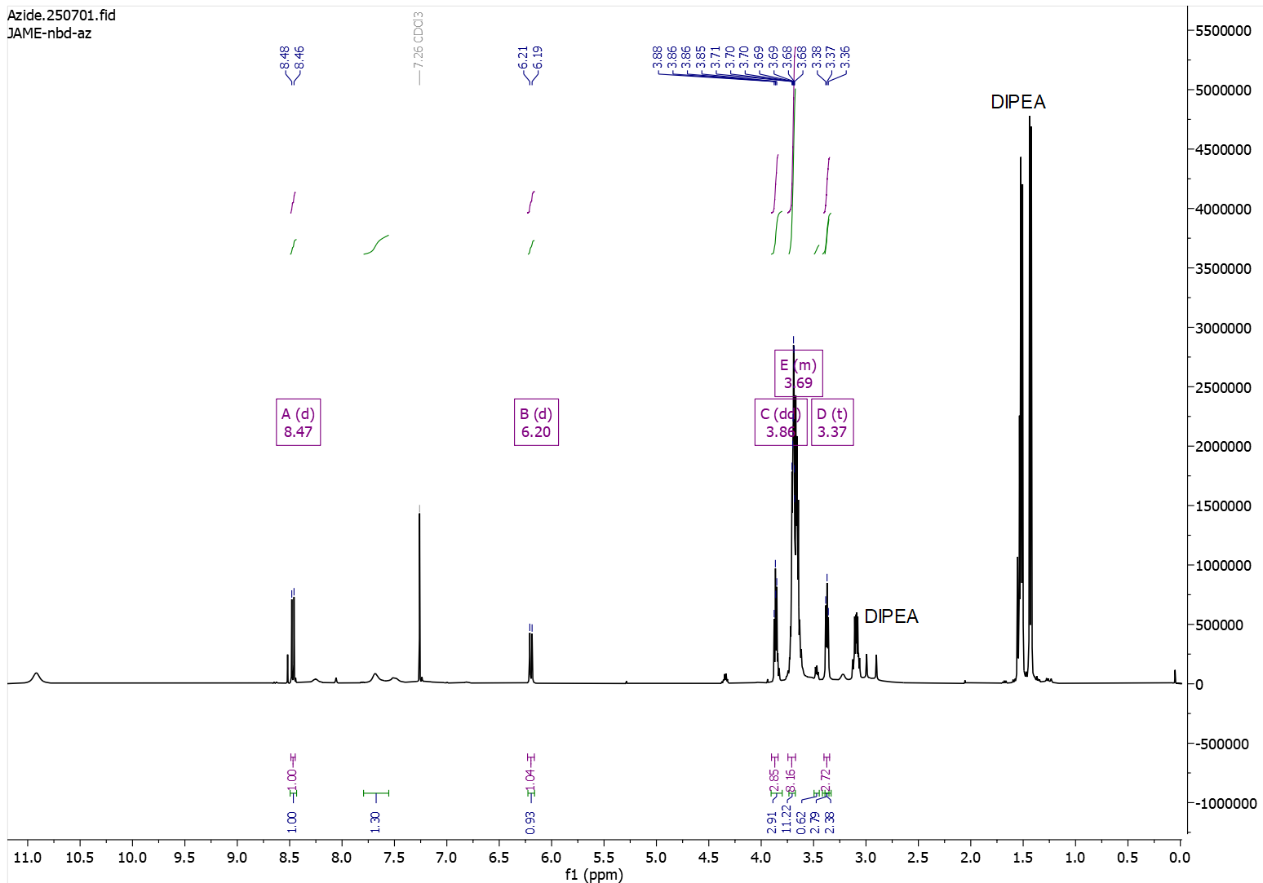
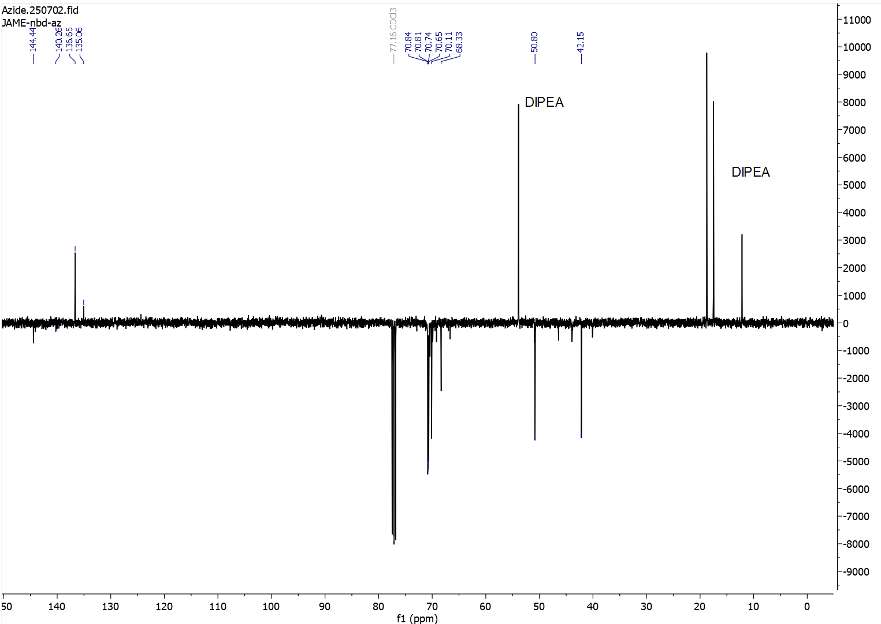
        - Mass Spectra
          - 2-substituted furans
            - Compound 16, N-2-Propyn-1-yl-2-furanpropanamide
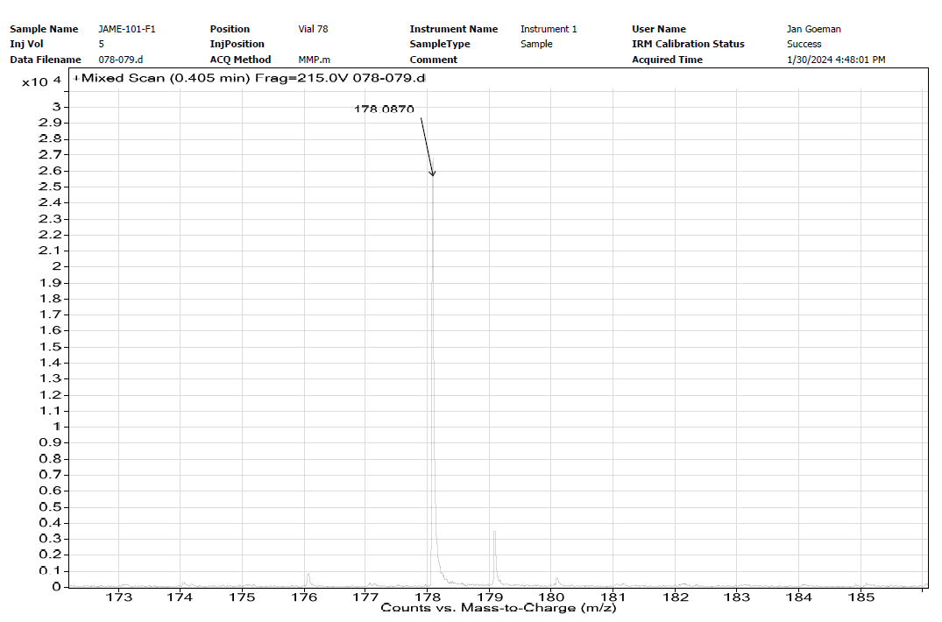
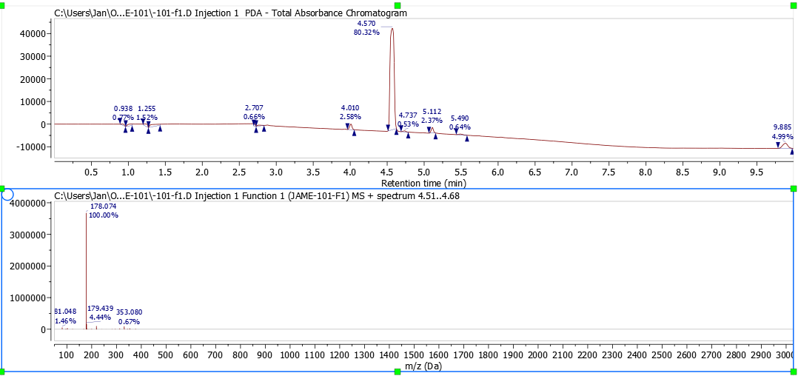

            - Compound 13, N-(2-(2-(2-(2-azidoethoxy)ethoxy)ethoxy)ethyl)-3-(furan-2-yl)propenamide
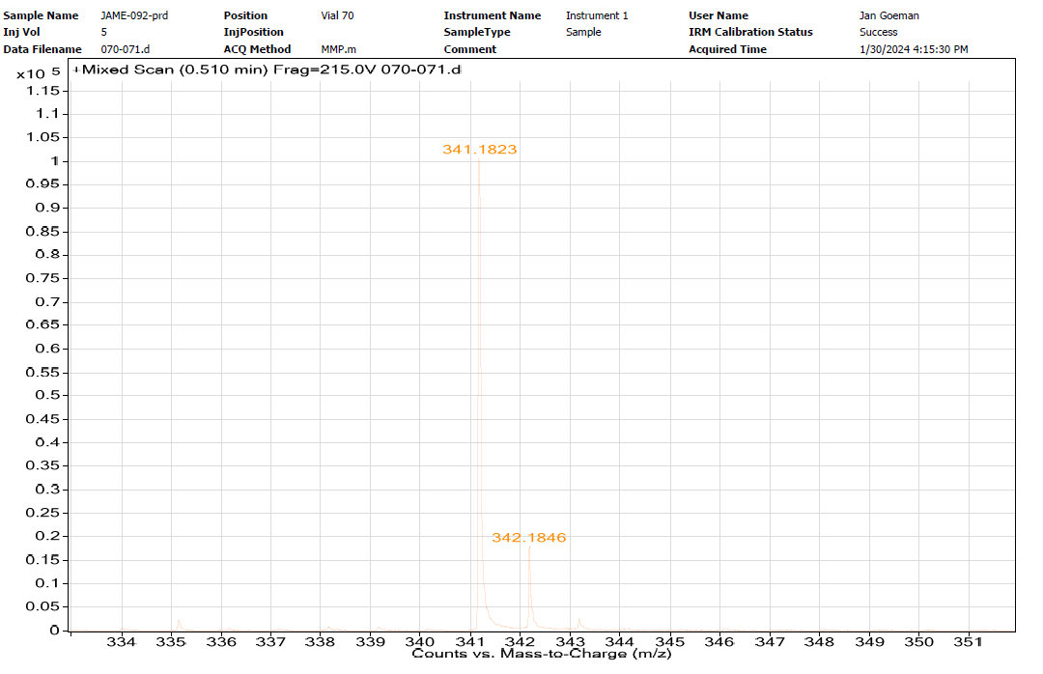
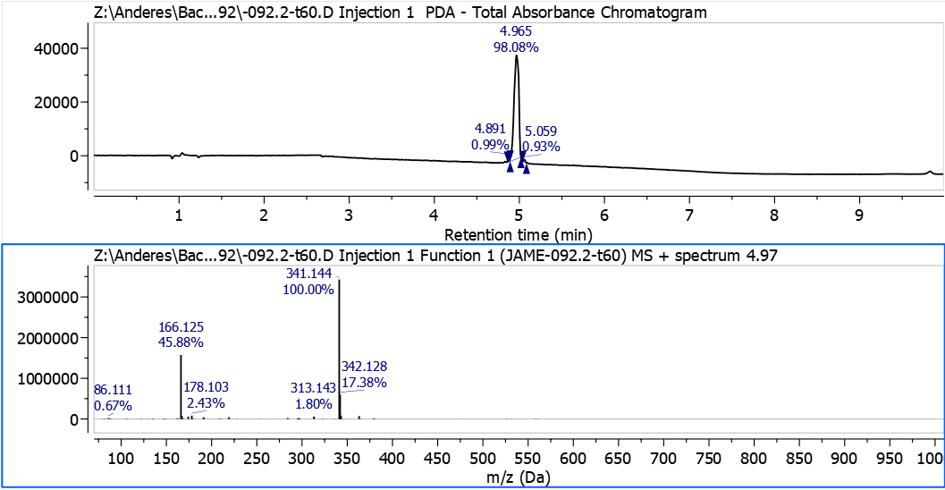

            - Compound 6, 3-(2-(2-(3-(furan-2-yl)propanamido)ethoxy)ethoxy)propanoic acid
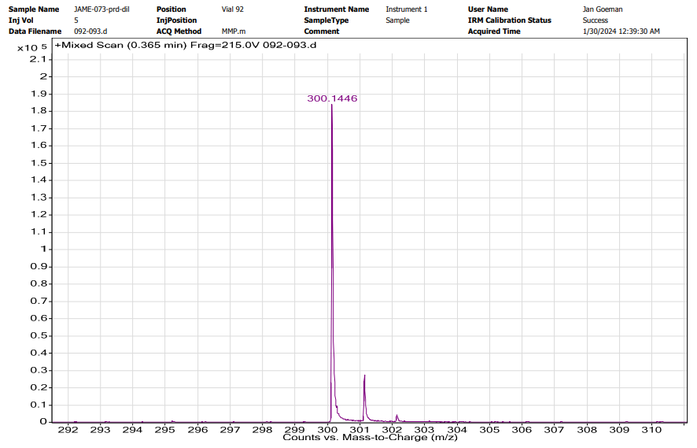
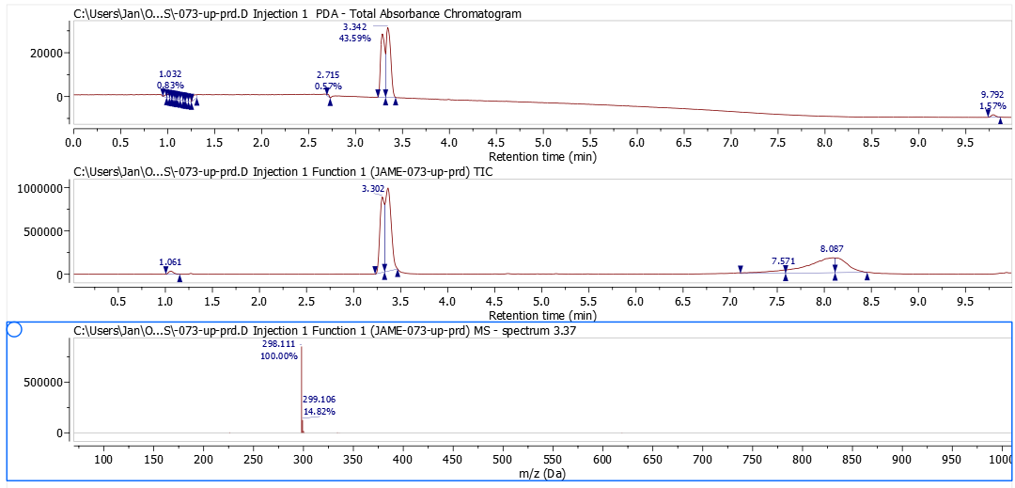

            - Compound 11, 2-(2-(furan-2-yl)ethyl)-2-methyl-1,3-dioxolane
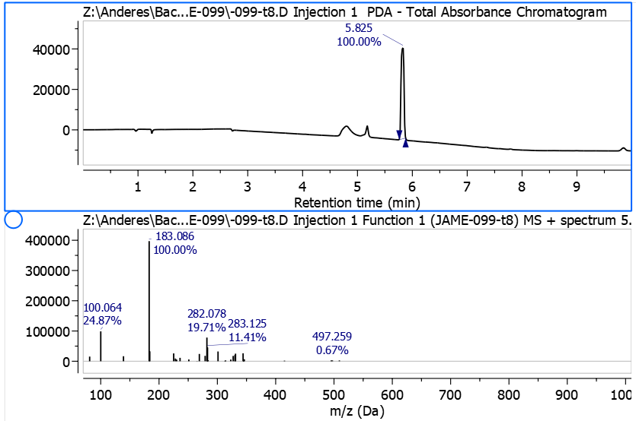

          - Heterobifunctional Linkers
            - Compound 3, 5HP2O-EG2-COOH
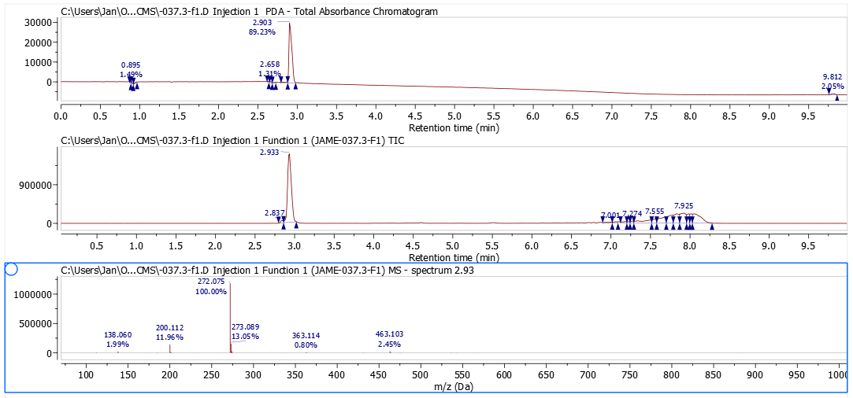

            - Compound 4, 5HP2O-EG2-NHS

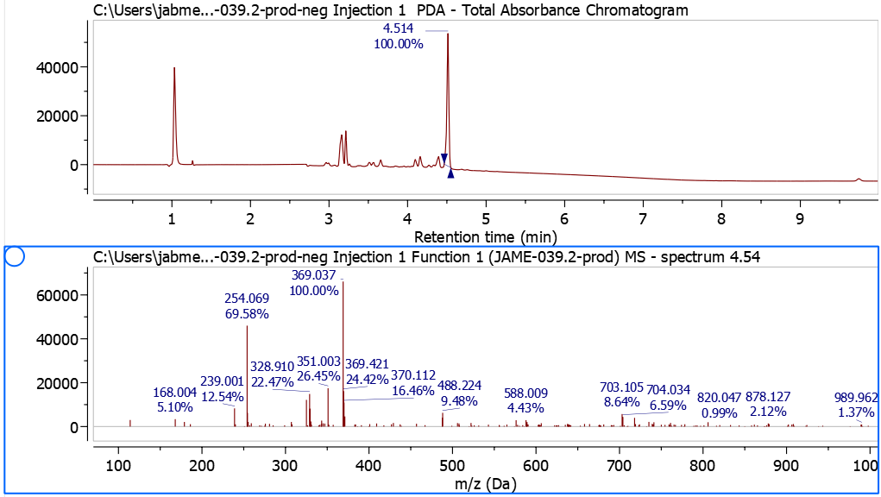
          - Trifunctional 5HP2O Linkers
            - Compound 7, 5HP2O(C2-EG2-COOH)-C5-NBD
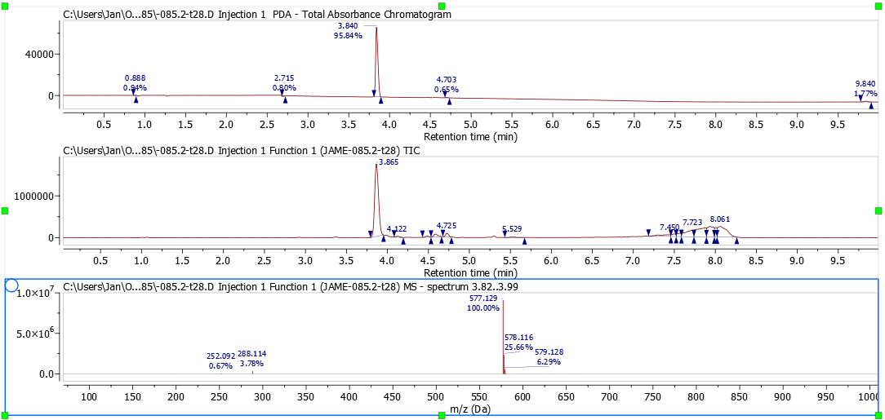

            - Compound 8, 5HP2O(C2-EG2-NHS)-C5-NBD

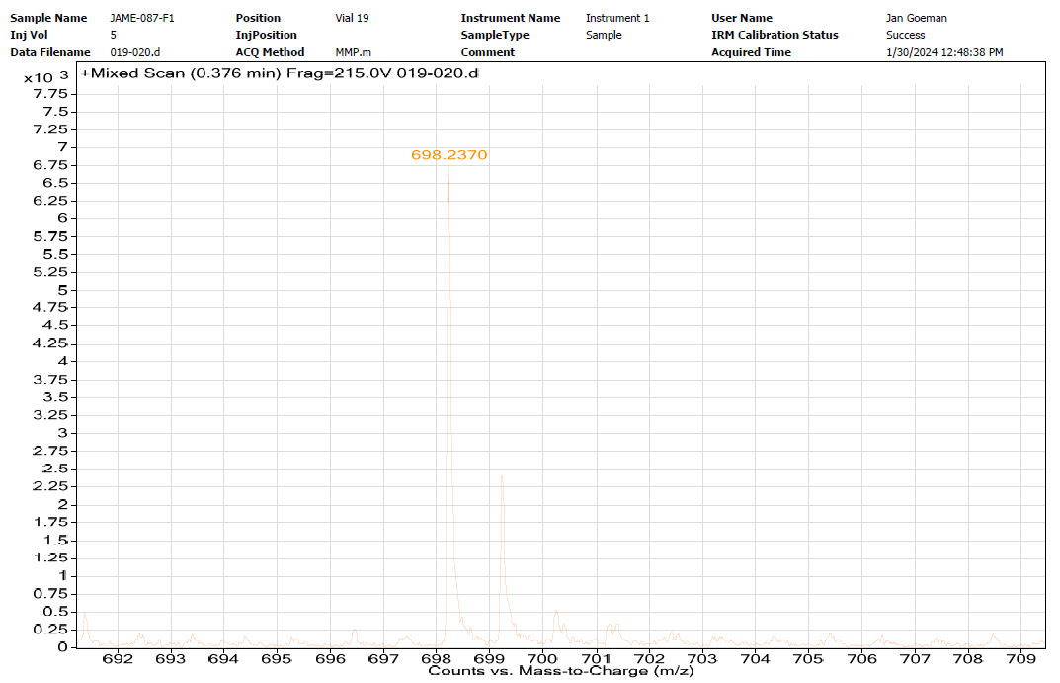

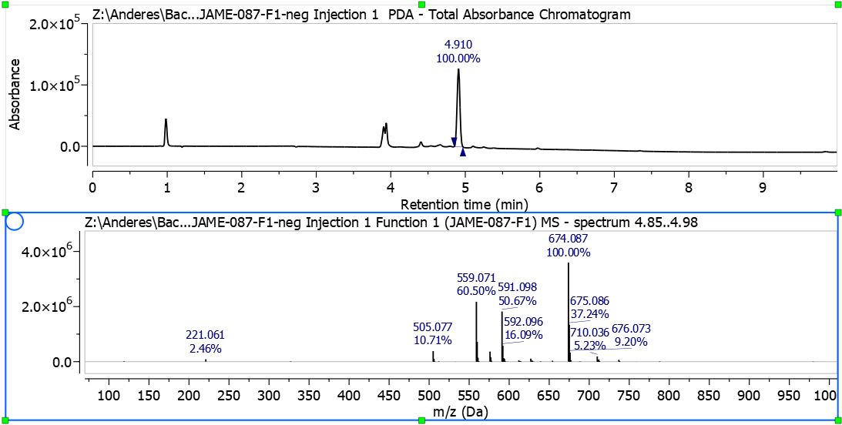

            - Compound 15, 5HP2O(C2-EG3-N3)-EG2-NHS
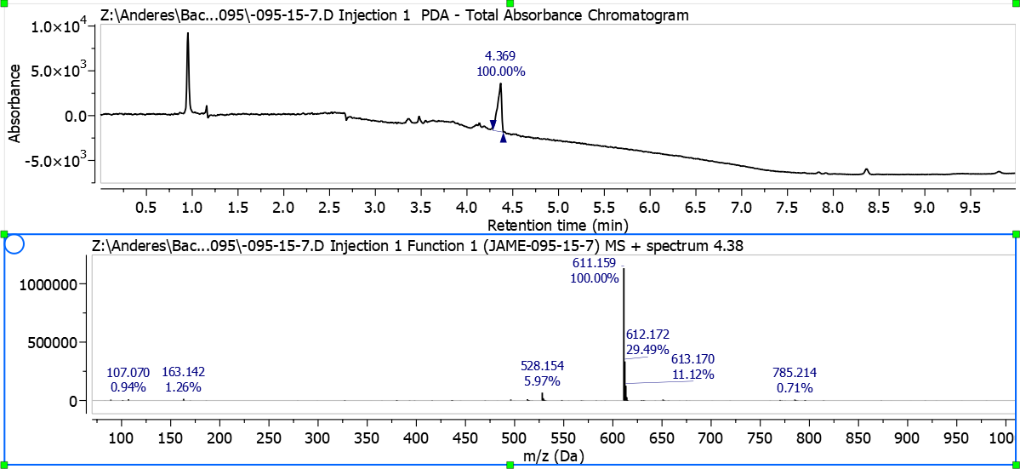
5HP2O dehydration is observed in pos. mode ESI as reported previously¹².

            - Compound 17, 5HP2O(C2-C1-Alkyne)-EG2-COOH
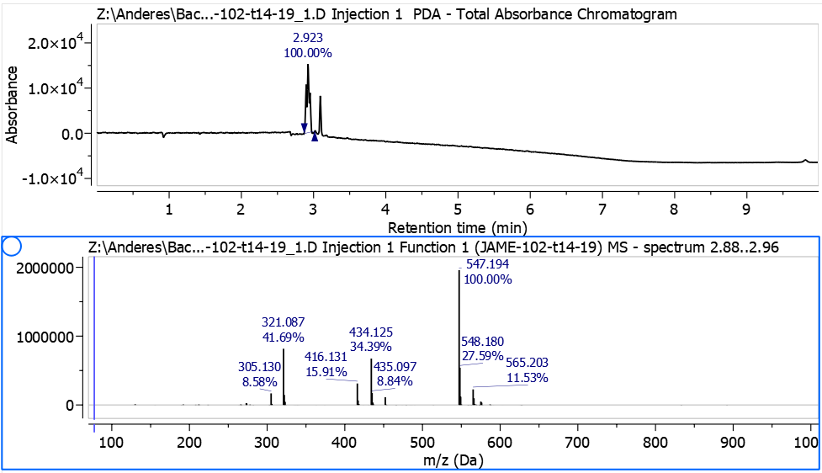

Compound 18, 5HP2O(C2-C1-Alkyne)-EG2-NHS

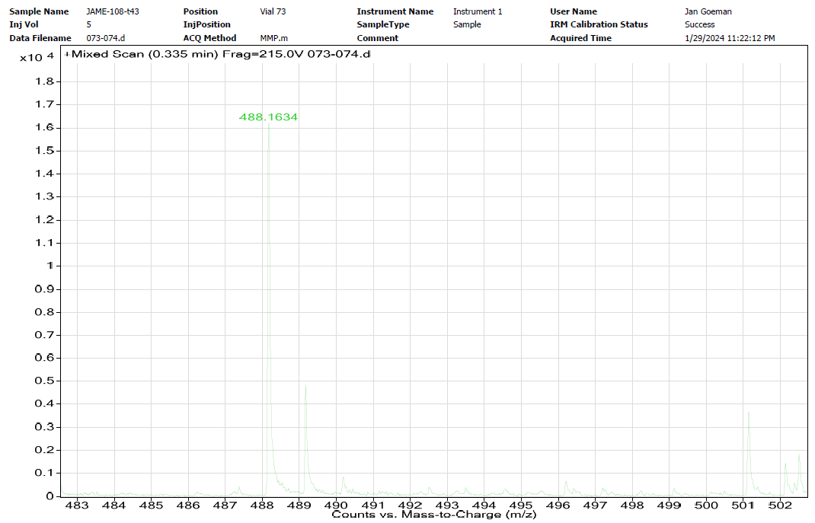
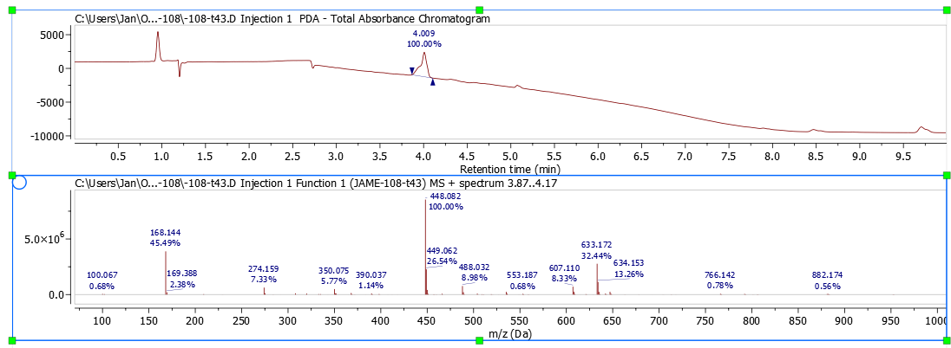
5HP2O dehydration is observed in pos. mode LCMS as reported previously¹².

            - Compound 11b, 5HP2O(C2-Acetal)-EG2-COOH
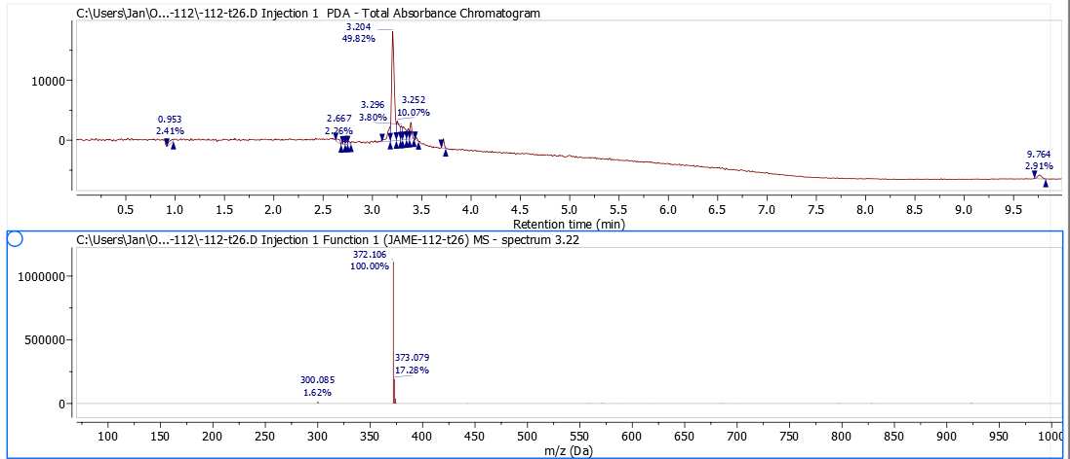
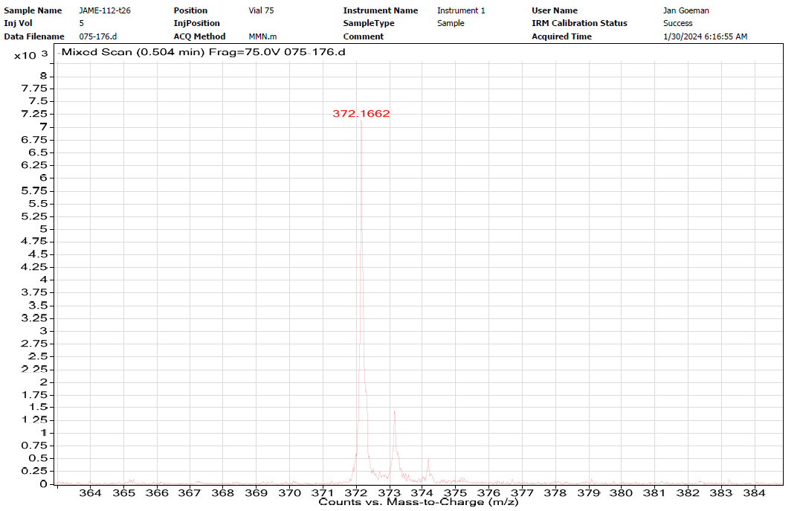

            - Compound 11c, 5HP2O(C2-Ketone)-EG2-COOH
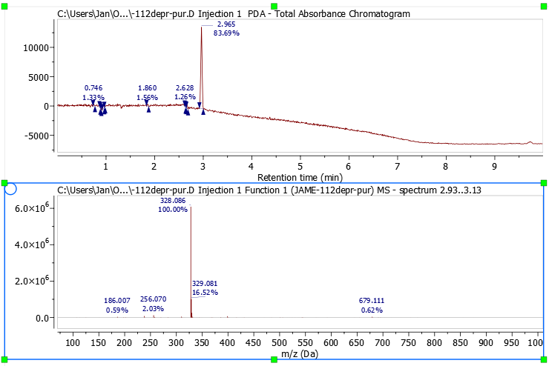

            - Compound 12, 5HP2O(C2-Ketone)-EG2-NHS

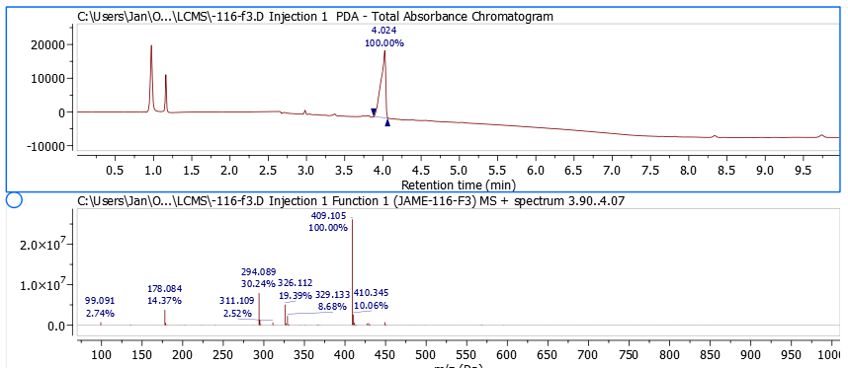

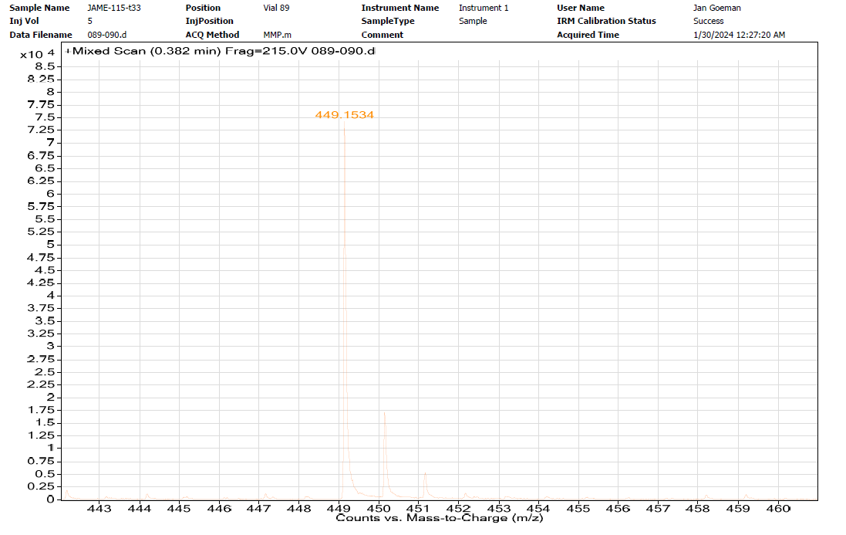

          - Tetrafunctional 5HP2O Linker
            - NH₂-EG2-ValCitPAB-OH
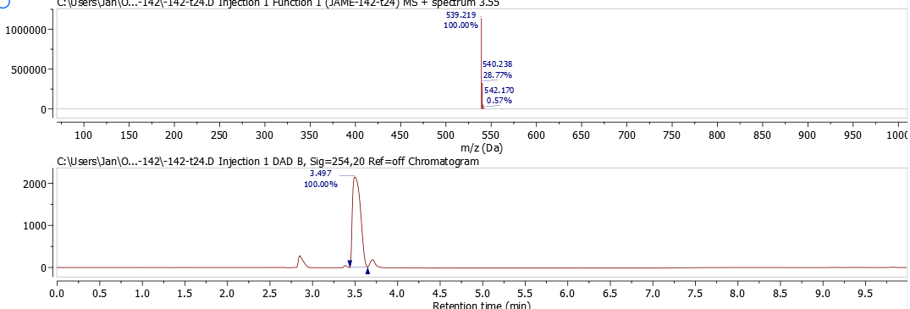
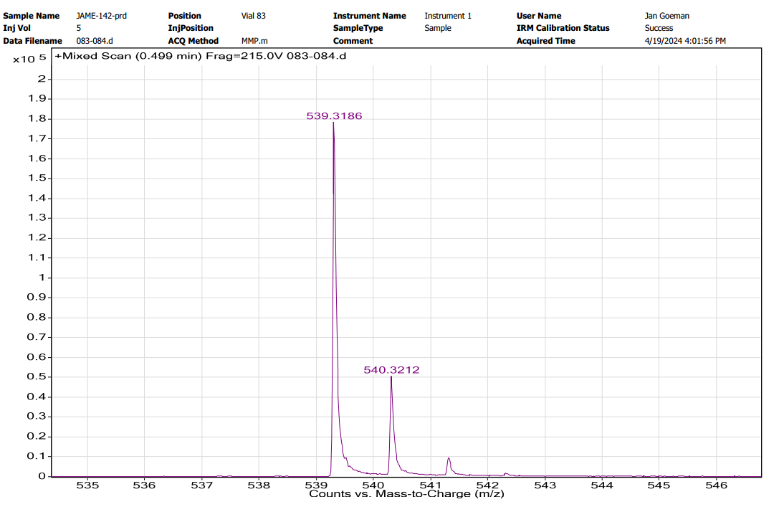

            - Compound 19, 5HP2O(C2-EG3-N3)-EG2-ValCitPAB-OH

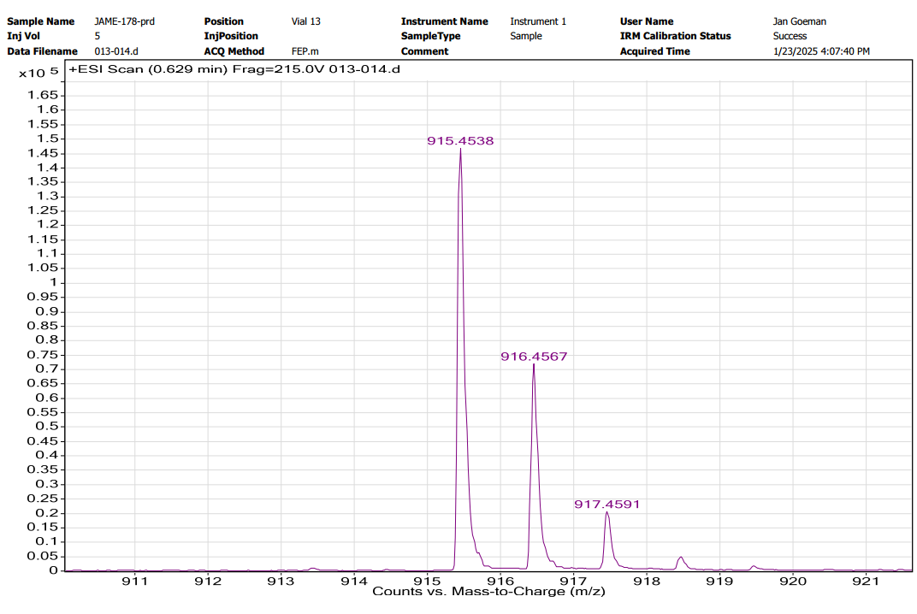
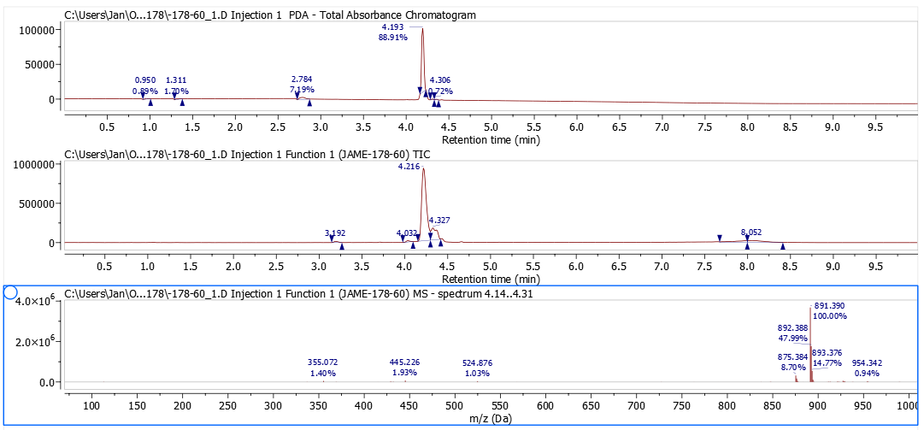

            - Compound 19b, 5HP2O(C2-EG3-N3)-EG2-ValCitPAB-EG2-COOH
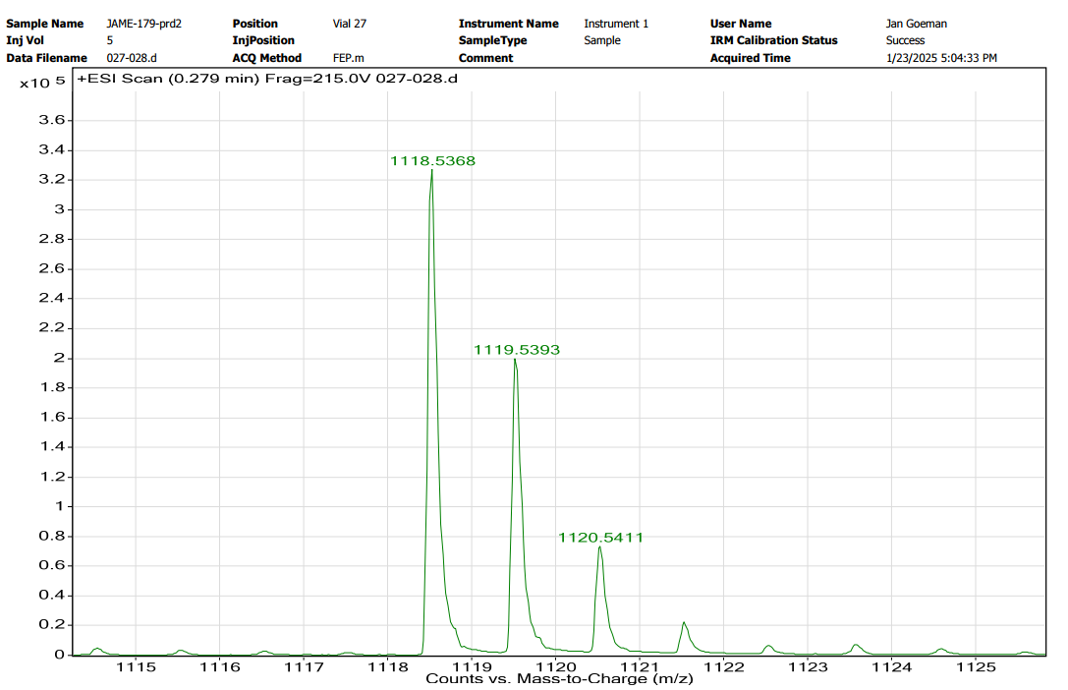
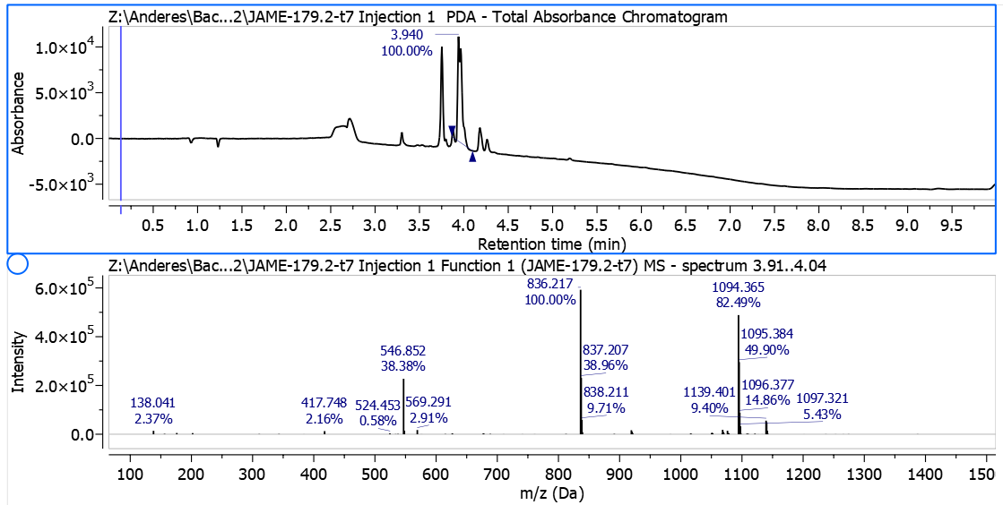

            - Compound 20, 5HP2O(C2-EG3-N3)-EG2-ValCitPAB-EG2-NHS
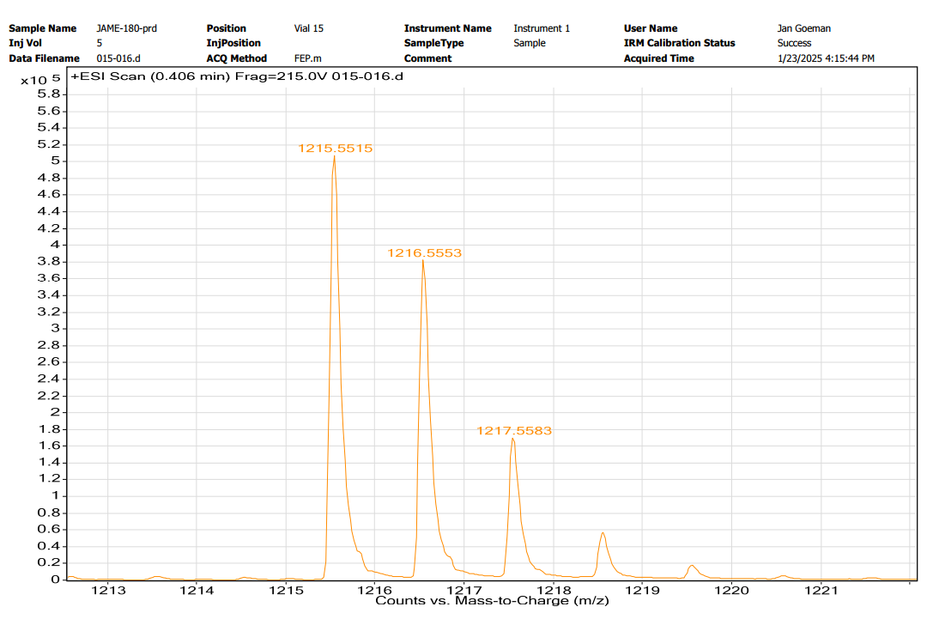
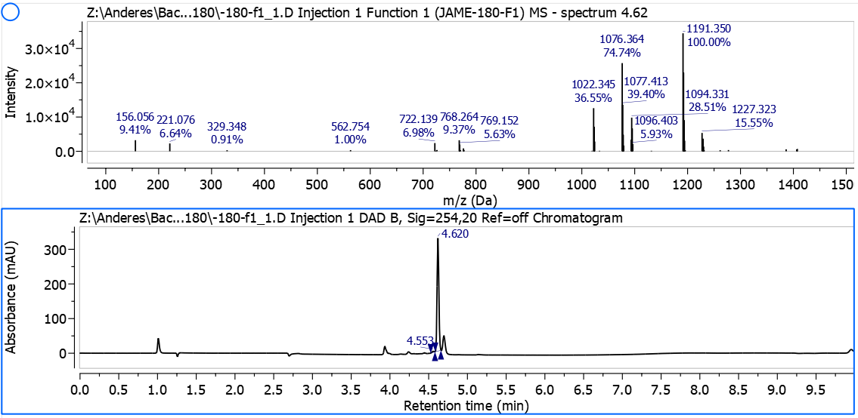

          - Fluorescent tags
            - NBD-EG3-azide
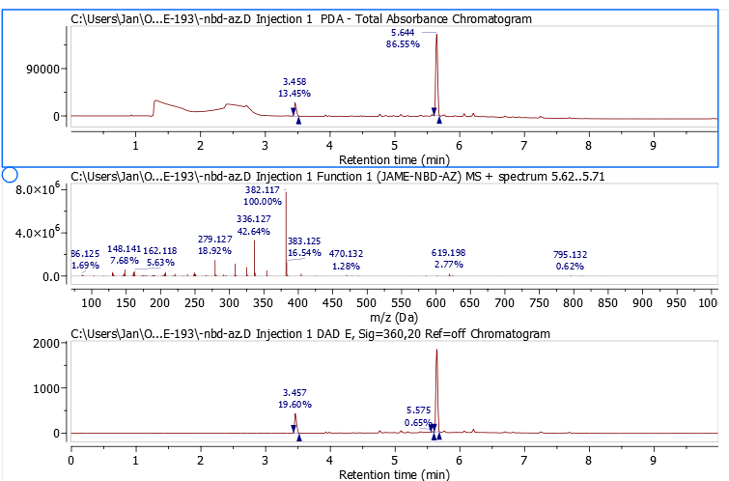

            - NBD-C5-NH₂
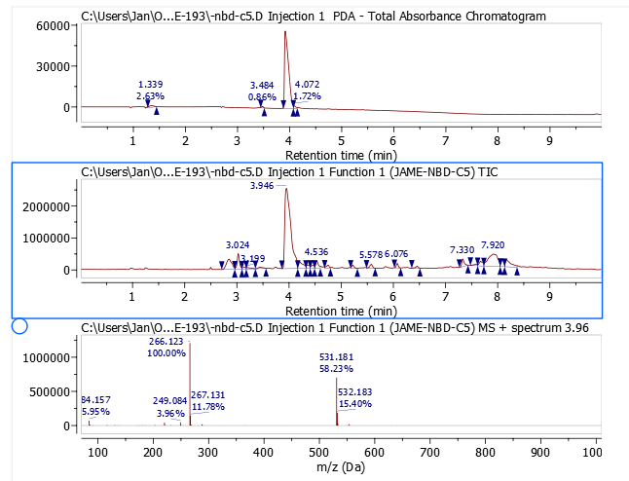

        - References
1. Carmody, W. R. Easily prepared wide range buffer series. J. Chem. Educ. 38, 559; 10.1021/ed038p559 (1961).
2. Cochran, M. et al. Structure-Activity Relationship of Antibody-Oligonucleotide Conjugates: Evaluating Bioconjugation Strategies for Antibody-siRNA Conjugates for Drug Development. J. Med. Chem. 67, 14852–14867; 10.1021/acs.jmedchem.4c00802 (2024).
3. Desmet, J. et al. Structural basis of IL-23 antagonism by an Alphabody protein scaffold. Nat. Commun. 5, 5237; 10.1038/ncomms6237 (2014).
4. Johnson, P. W. & Glennie, M. J. Rituximab: mechanisms and applications. British journal of cancer 85, 1619–1623; 10.1054/bjoc.2001.2127 (2001).
5. Eltahir, M. et al. An Adaptable Antibody‐Based Platform for Flexible Synthetic Peptide Delivery Built on Agonistic CD40 Antibodies. Advanced Therapeutics 5; 10.1002/adtp.202200008 (2022).
6. Law, J. A., Callen, D. P., Paola, E. L., Gomes, G. & Frederich, J. H. A Stereoselective Photoinduced Cycloisomerization Inspired by Ophiobolin A. Org. Lett. 24, 6499–6504; 10.1021/acs.orglett.2c02272 (2022).
7. Geyter, E. de et al. 5-Hydroxy-pyrrolone based building blocks as maleimide alternatives for protein bioconjugation and single-site multi-functionalization. Chem. Sci. 12, 5246–5252; 10.1039/d0sc05881e (2021).
8. Surnar, B. et al. Orally Administrable Therapeutic Synthetic Nanoparticle for Zika Virus. ACS nano 13, 11034–11048; 10.1021/acsnano.9b02807 (2019).
9. Berchel, M. et al. Modular Construction of Fluorescent Lipophosphoramidates by Click Chemistry. European J Organic Chem 2011, 6294–6303; 10.1002/ejoc.201100900 (2011).
10. Li, K. et al. Environmentally sensitive fluorescent probes with improved properties for detecting and imaging PDEδ in live cells and tumor slices. Chinese Chemical Letters 34, 108231; 10.1016/j.cclet.2023.108231 (2023).
11. Homer, A. & Seitz, O. New Thiazole Orange Derivatives for Improved Fluorescence Signaling of DNA FIT Probes. Synthesis 55, 3251–3262; 10.1055/a-2111-2333 (2023).
12. Ewout De Geyter. Enlarging the Toolbox for Cysteine Selective Protein Modification. PhD Thesis 2022.

