Supplementary material

Image stimuli used in the sessions (AI generated), with corresponding AOI mapping


Figure 1. In this future, strong social systems and technological innovation improve quality of life, but a consumption-driven economy continues to degrade the planet, forcing costly adaptation to extreme weather.

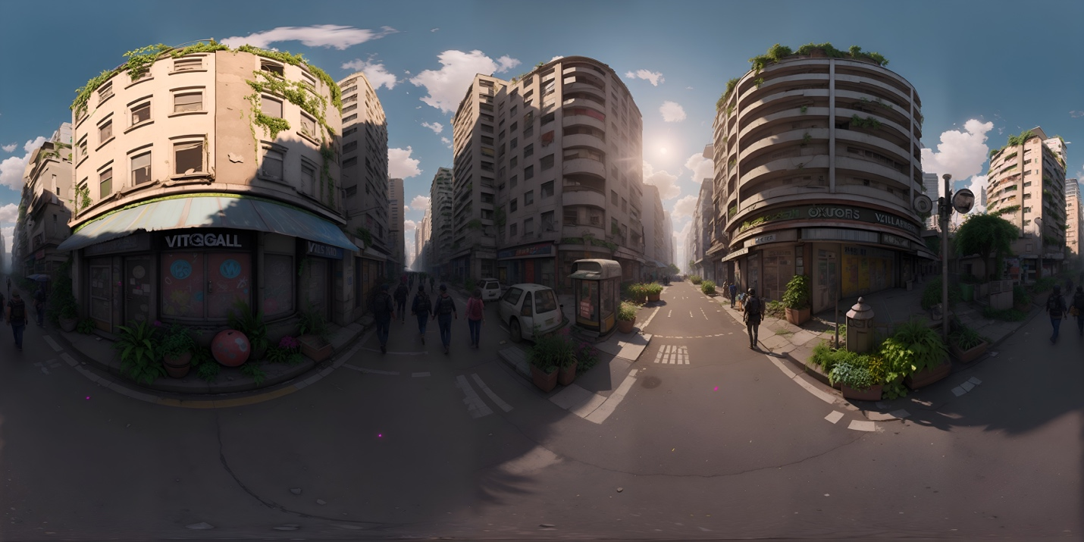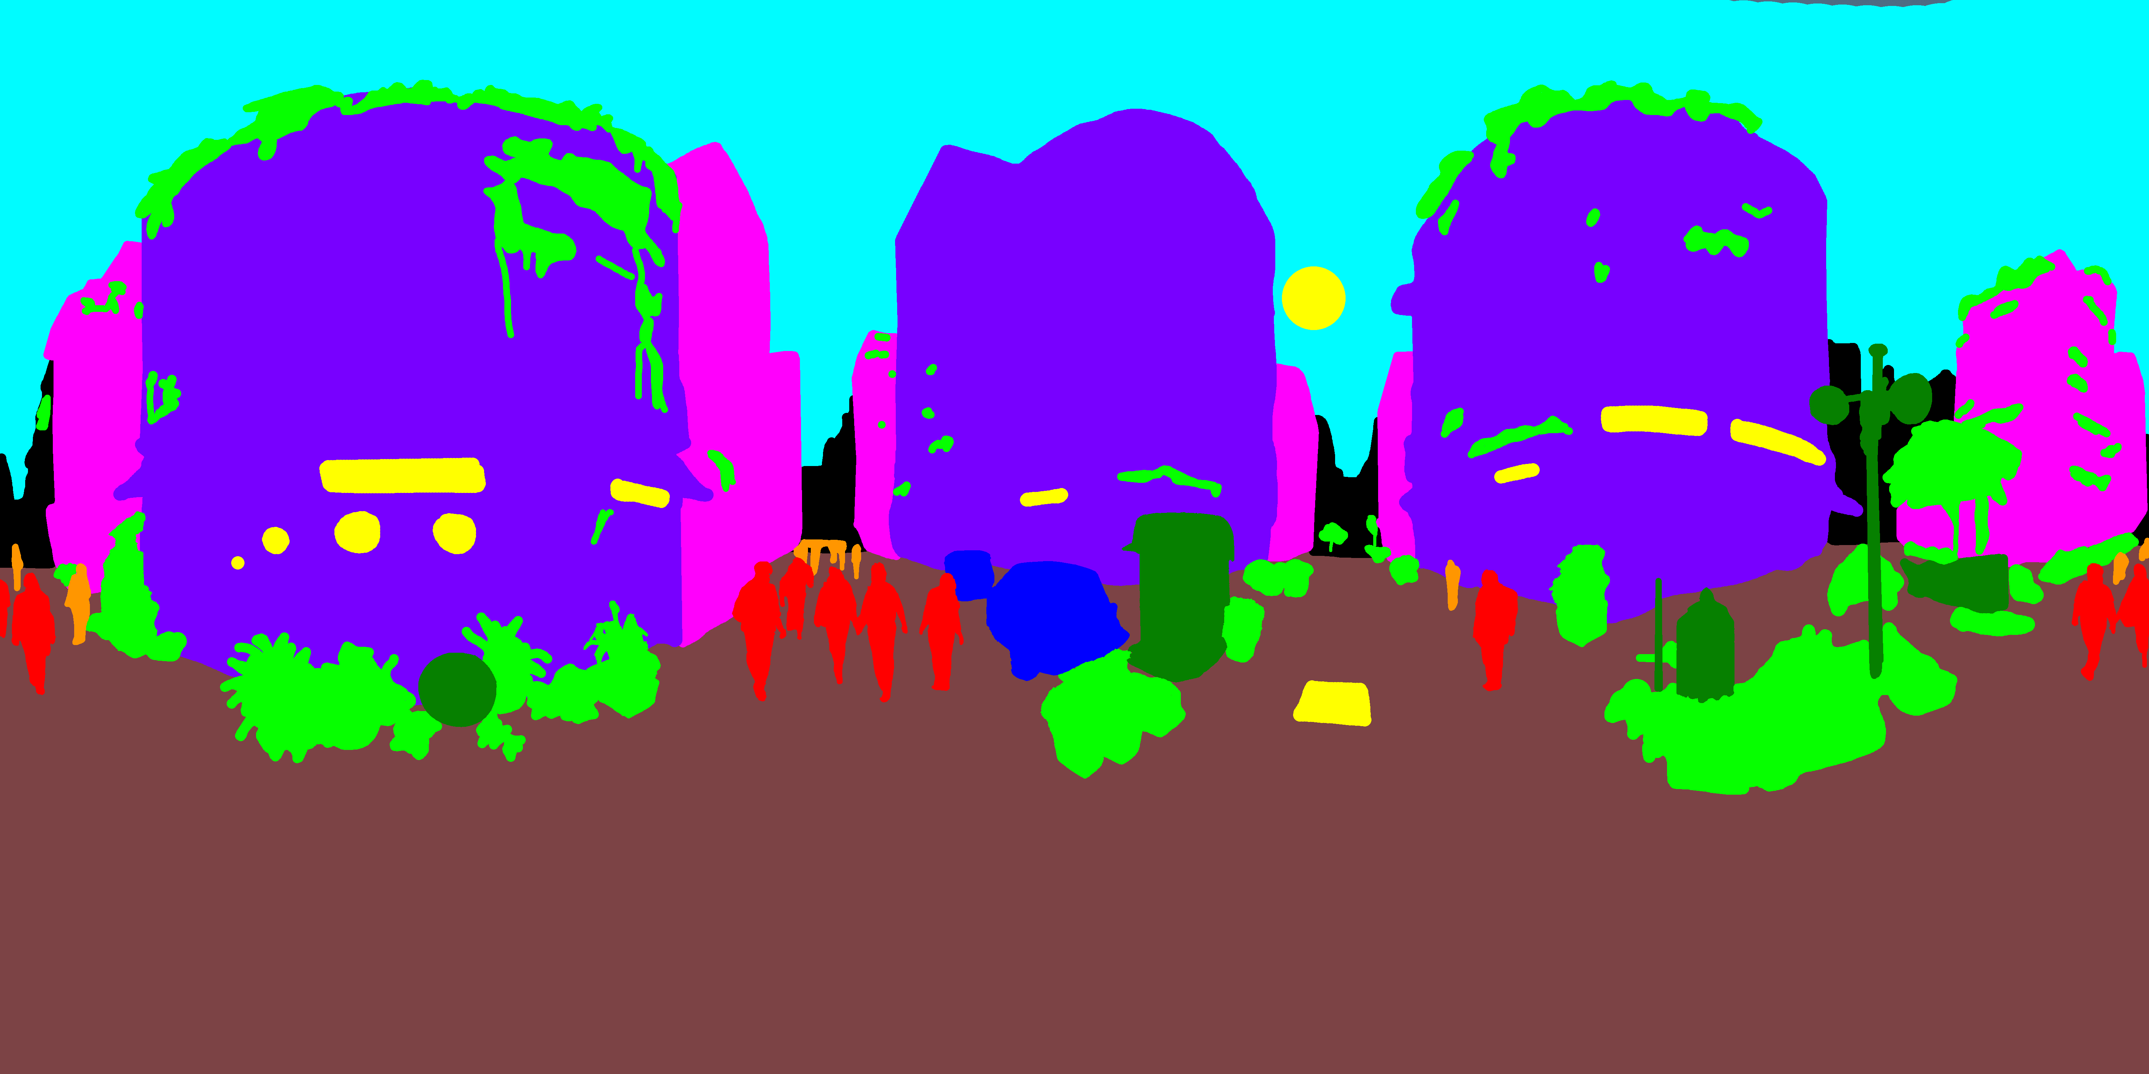
Figure 2. In this future, strict quotas and authoritarian control enforce a circular economy, extreme urban density, and ecosystem preservation, but at the cost of civil liberties.

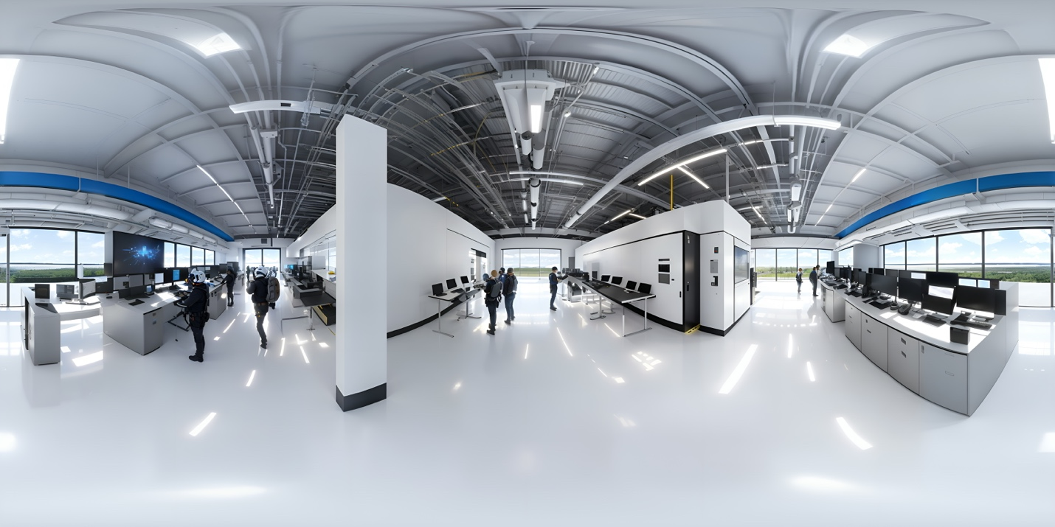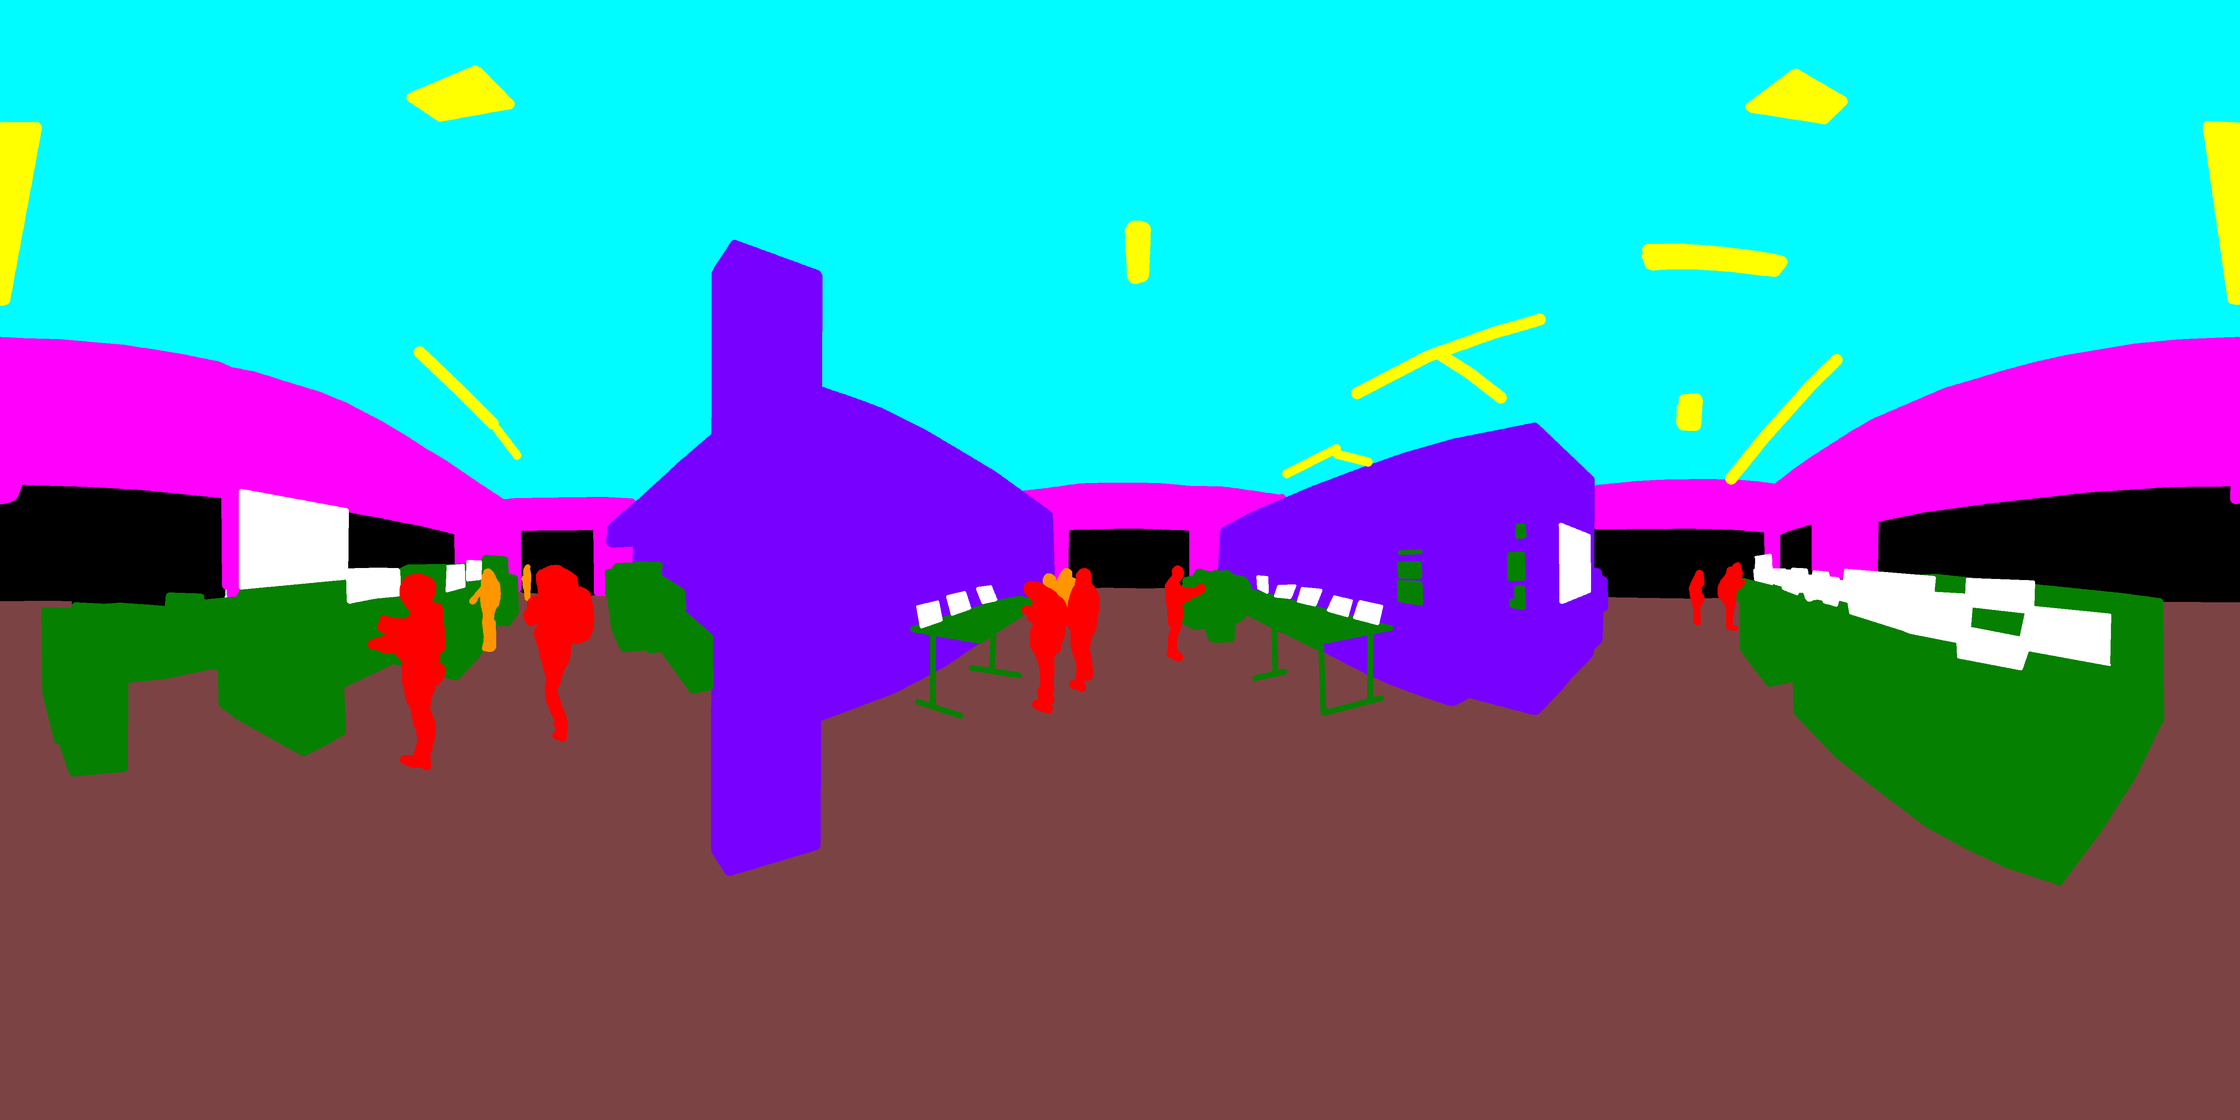
Figure 3. In this future, innovation happens in huge server rooms where AI runs advanced simulations, forecasts, and
decision-making. Most staﬀ work remotely via cutting-edge telepresence, gathering annually to celebrate the innovations and
collaborations driven by AI capabilities.

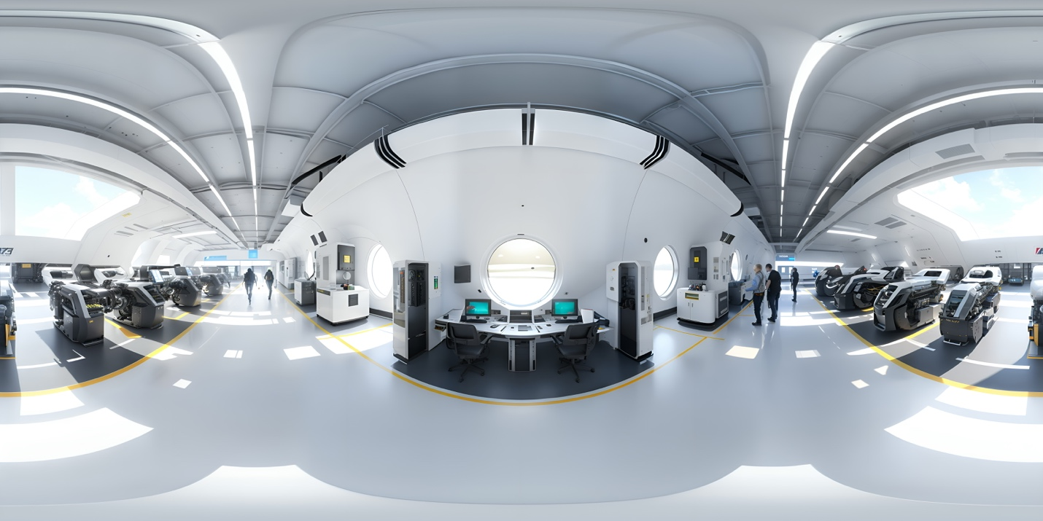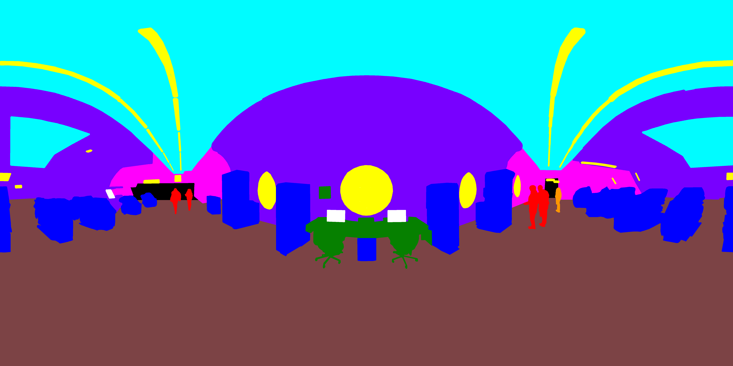
Figure 4. In this future, secure, exclusive tech campuses where leading companies collaborate in state-of-the-art labs, oﬀer
residents education, quality spaces, and leisure to foster a thriving community.

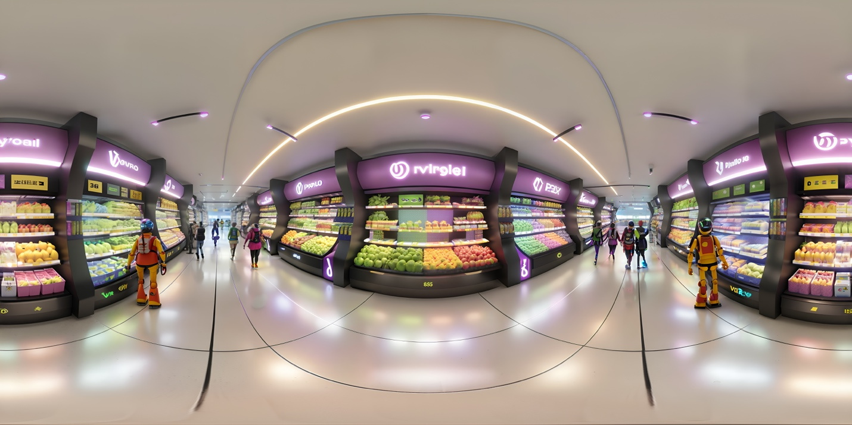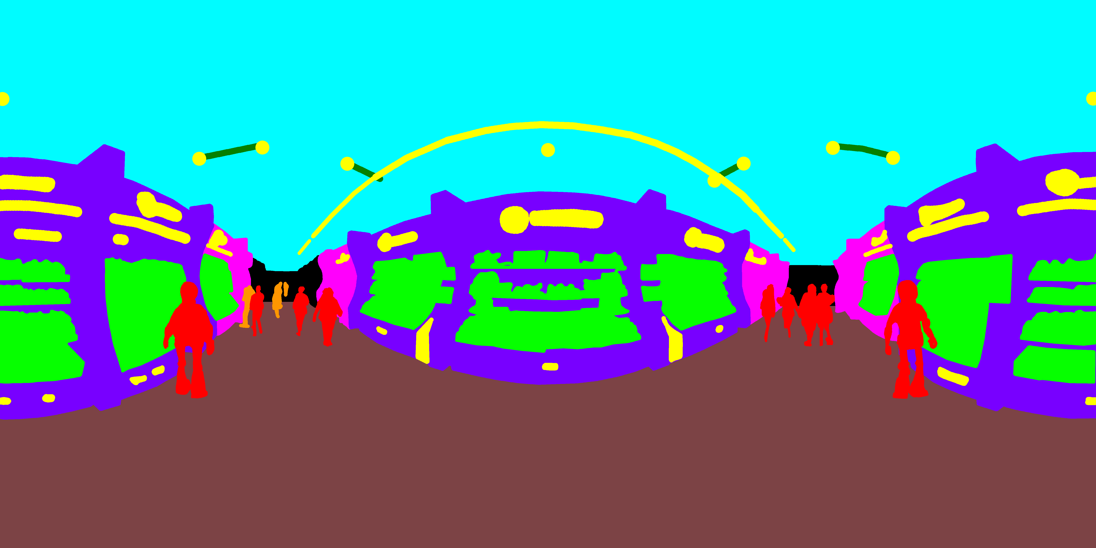
Figure 5. In this future, global mega-malls like Walmart oﬀer fresh, international goods delivered daily with renewable-
powered logistics, recycled packaging, robot-stocked shelves, and drone delivery for anything customers’ desire.

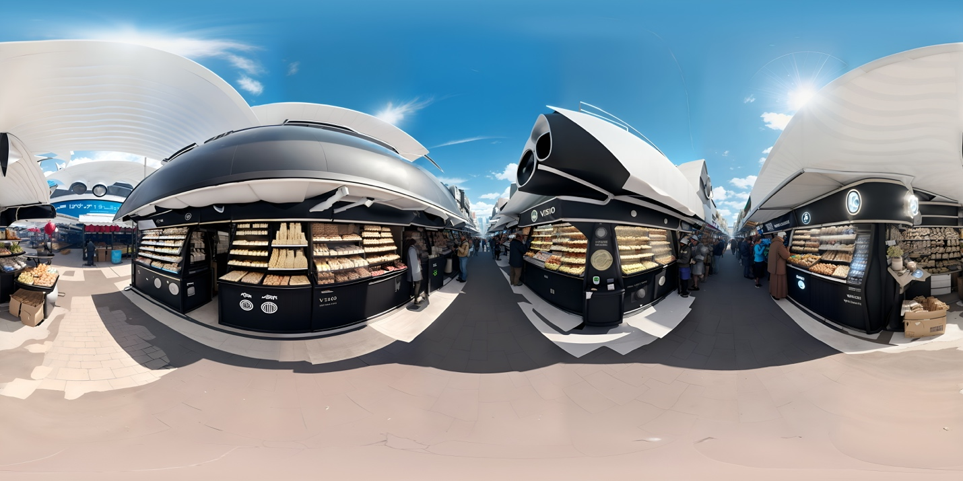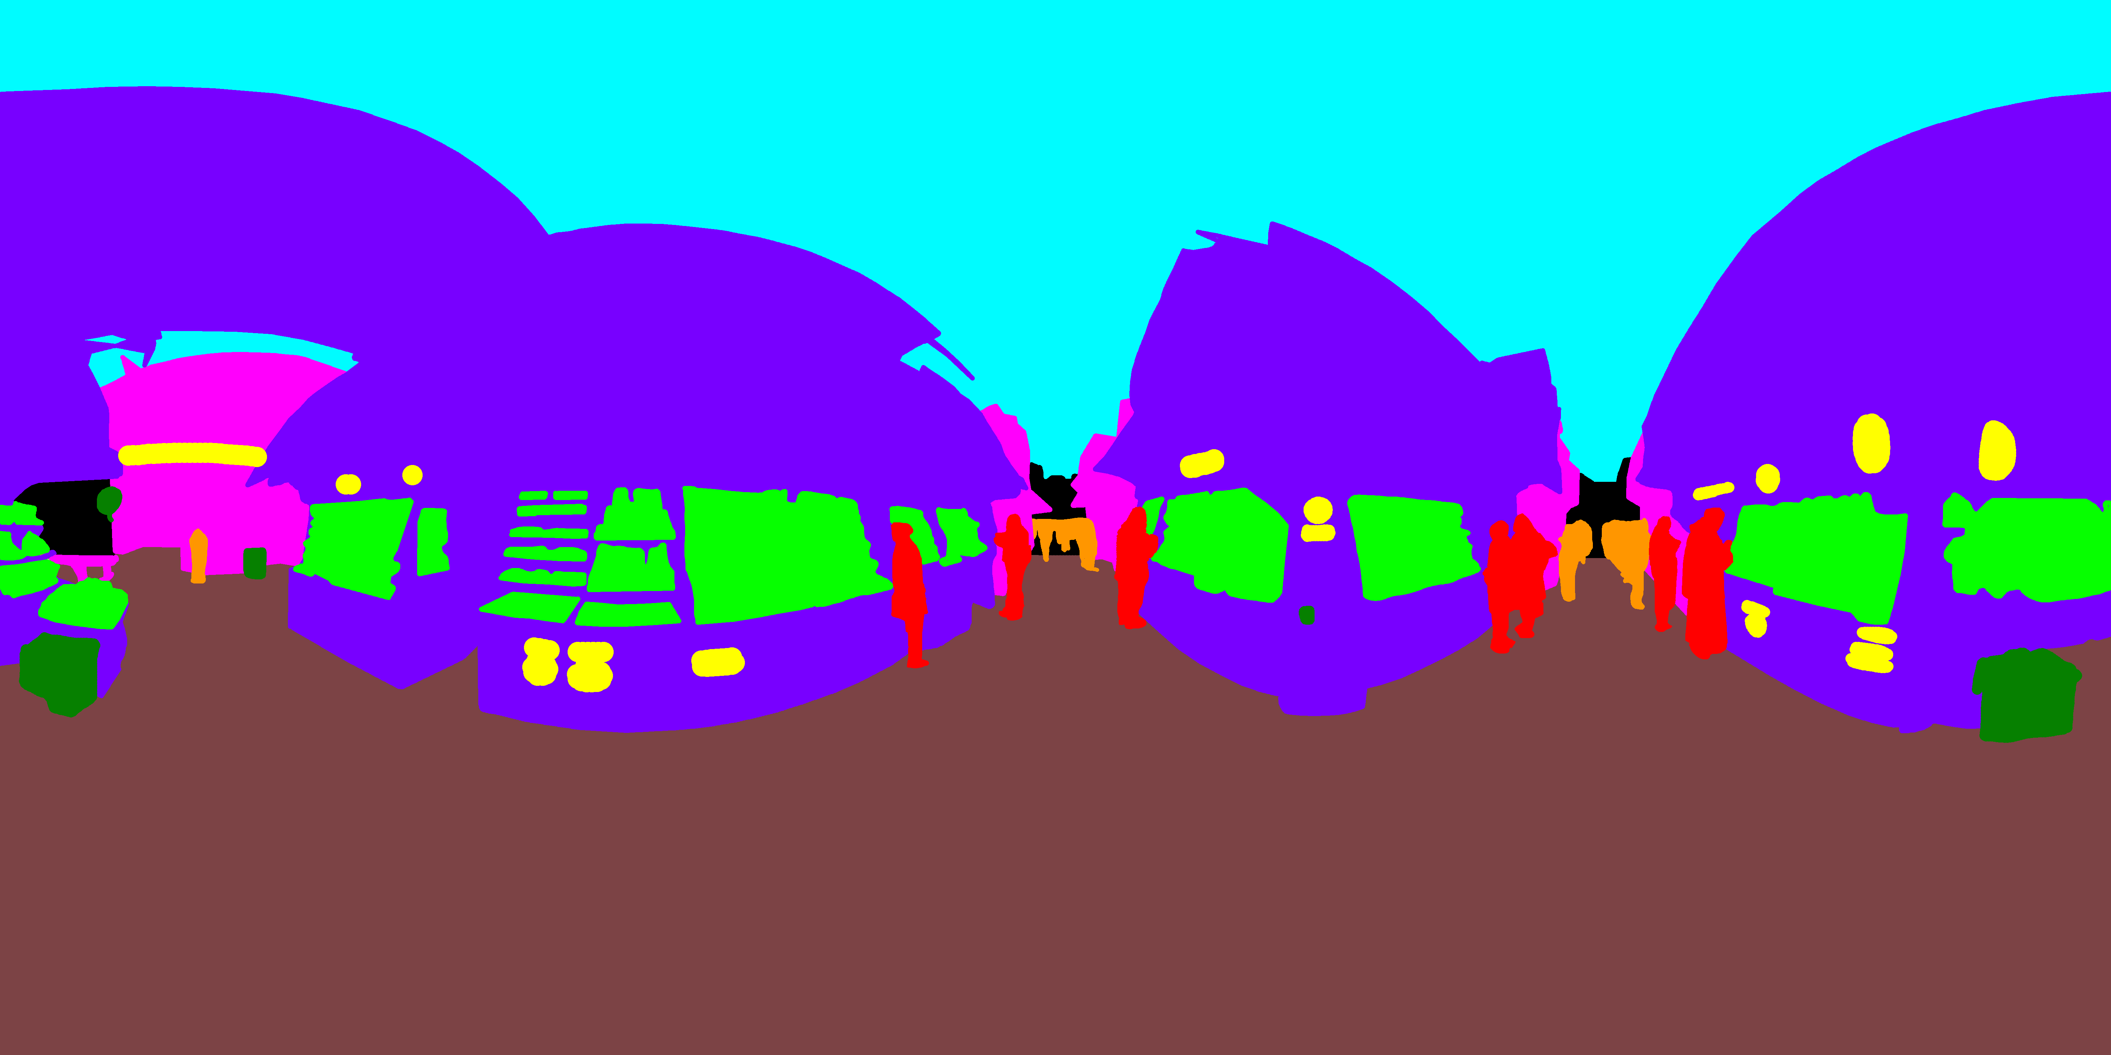
Figure 6. In this future, daily neighbourhood markets replace supermarkets, with seasonal, locally harvested foods and
minimal packaging, while diets adapt to climate and seasonal shifts.

Fixations identification algorithm
Several techniques are available for detecting fixations (Blignaut, 2009; Salvucci & Goldberg, 2000). In this research, the velocity-threshold identification (I-VT) method was applied.
This approach calculates gaze velocity by dividing the angular distance between successive gaze points by the time interval separating them (v₁ = Δθ₁ / (t₂ − t₁)). The angular distance is expressed in degrees of visual angle and is computed using the haversine formula based on each point’s latitude and longitude (Daidzic, 2017; David et al., 2018). When the computed velocity falls below a predefined threshold (v’), the point is categorized as part of a fixation and added to a fixation group; otherwise, it is labeled as a saccade, and the algorithm continues searching for the next fixation. A fixation was deemed valid only if its total duration – measured as the time between the first and last gaze points in the fixation group – is at least 100 ms, since shorter fixations occur infrequently (Salvucci & Goldberg, 2000).
In this method, the velocity threshold plays a crucial role in accurately identifying fixations. When the threshold is set too high, brief saccades may go undetected; conversely, if it is too low, fixation points may be incorrectly classified as saccades. In many cases, this threshold is selected arbitrarily, relying on researcher preference or the default settings of the eye-tracking system (Nystrom & Holmqvist, 2010). However, this practice is problematic, as studies have shown consistent individual differences in fixation durations and saccade amplitudes (van der Lans et al., 2011).
To overcome this limitation, an iterative, data-driven method was employed based on the approach proposed by (Nystrom & Holmqvist, 2010). In this method, the velocity threshold is determined individually for each participant using their gaze data collected during the experimental session.
The procedure starts with an initial peak velocity threshold (VT₁), which was set to 100º/s in this study. The exact value of VT₁ is not crucial, provided that some saccade velocities exceed this initial threshold.
For all gaze samples with velocities below the initial threshold (VT₁), the mean (µ) and standard deviation (σ) of these velocities are computed (Figure 7). The threshold is then updated iteratively according to the following rule:
$${VT}_{n}=μ_{n-1}+4σ_{n-1}$$
This process continues until the difference between successive threshold values, |VTₙ − VTₙ₋₁|, becomes smaller than 1º/s. At that point, the procedure stops, and the final velocity threshold (v’) is defined as the last calculated value. Through this iterative refinement, the threshold converges to a level that it is low enough to capture as many saccades as allowed by the data quality, yet sufficiently high to avoid falsely identifying noise as saccades. The inclusion of the 4σ term provides a safety margin, consistent with the approach used by (Andersson et al., 2010).
Velocity-based approaches are particularly sensitive to noise (Saez de Urabain et al., 2015), which can lead to the identification of false fixations. To address this, (Duchowski, 2017) proposed using a 5-tap filter for noise reduction. Considering that typical saccades last at least 100 ms and that the data were sampled at 72 Hz, this duration corresponds to about seven gaze samples. Therefore, in line with (Nystrom & Holmqvist, 2010), a normalized 7-tap Finite Impulse Response (FIR) filter was implemented (Figure 8):
$$v^{'}=\sum_{j=0}^{k}{h_{j}v_{i+j}, i ∈[0,n-k]}$$
Figure 9 illustrates an example of a denoised velocity signal, while Figure 10 provides an overview of the entire fixation identification process.

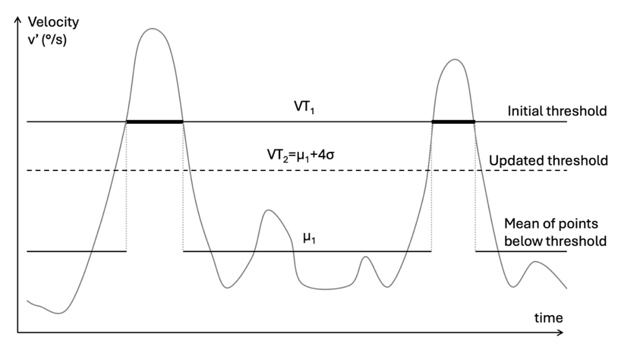
Figure 7. Principle for iterative estimation of velocity threshold (v’). Adapted from (Nystrom & Holmqvist, 2010).

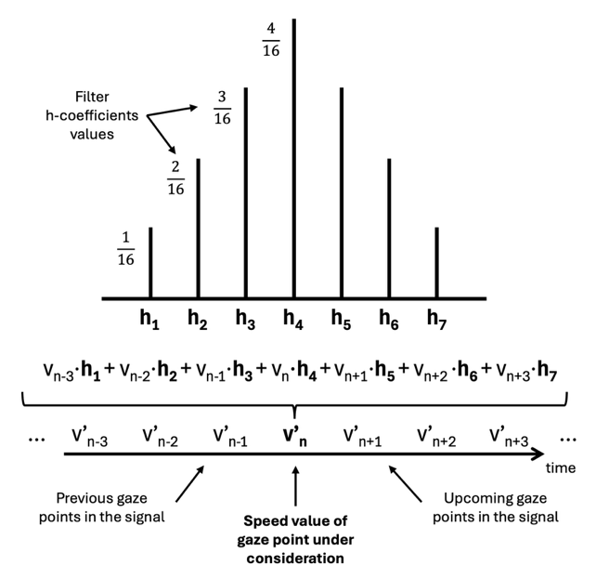
Figure 8. Using the 7-tap filter the velocity of each gaze point is a ‘smoothed’ weighted average incorporating the three preceding and three following points’ velocities.

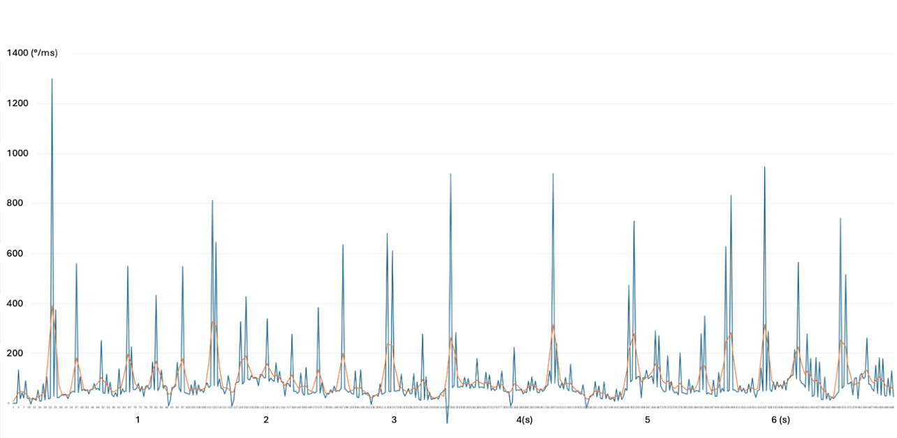
Figure 9. Plot of a gaze velocity signal demonstrating the noise-reduction effect of the FIR filter. The blue curve shows the original signal, while the orange curve represents the smoothed velocity signal.

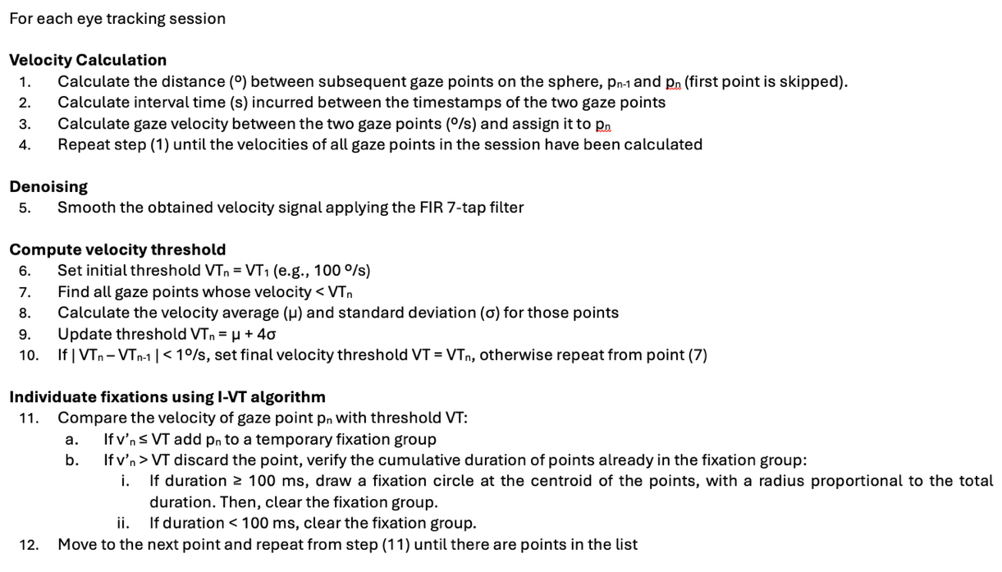
Figure 10. Pseudocode of the procedure used to individuate fixations for each participant.

List of AOIs mapping and inclusion criteria
AOI Name | Mask colour | Definition criteria
Background | Black | Farthest visible part of the scene due to distance where details fade and don’t allow to recognize elements
Ground/Floor | Brown | -
Highlights | Yellow | Objects or part of the scene that could attract attention due to their bold appearance (e.g. lights, texts, logos)
Humans Foreg. | Red | Profiles that resemble people (in foreground)
Humans Backg. | Orange | Same as above (in background)
Objects: |  | Overarching category for all objects that possess a distinct visual and/or functional identity within a scene (e.g. food items in the supermarket or desks in the server room). These are the objects that users might interact with if the scenes were interactive.
Food | Light green
Furniture | Dark green
Machinery/Cars | Dark blue
Screens | White
Vegetation | Light green
Sky/Cieling | Light blue | -
Structure Foreg. | Dark purple | Surfaces that spatially compose the scene (e.g. buildings in the suburb scene, walls in the interior scenes, food shelves in the supermarket (in foreground).
Structure Backg. | Magenta | Same as above (in background).

Additional results

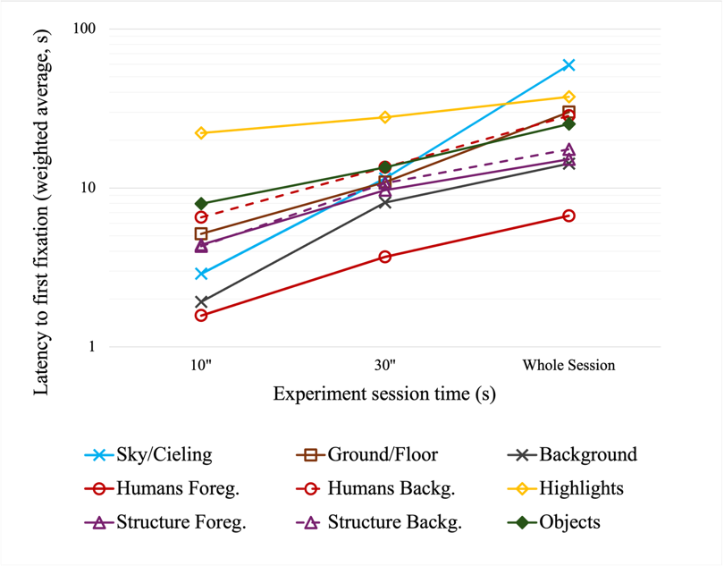
Figure 11. Graph showing LATENCY TO FIRST FIXATION for each AOI, indicating reflecting how quickly attention-grabbing elements attracted attention (Gliga et al., 2009). A hierarchy emerges that resembles, though is less clearly defined, the one presented in the paper for attentional importance. Humans in the foreground were the first to attract attention, followed by background areas, layout structures and eventually objects and highlights. An interesting difference is sky and ceiling areas: when participants noticed them, they tended to fixate on them early in the session, which explains their low latency in the first timeframe. Otherwise, they were observed much later, or not at all.
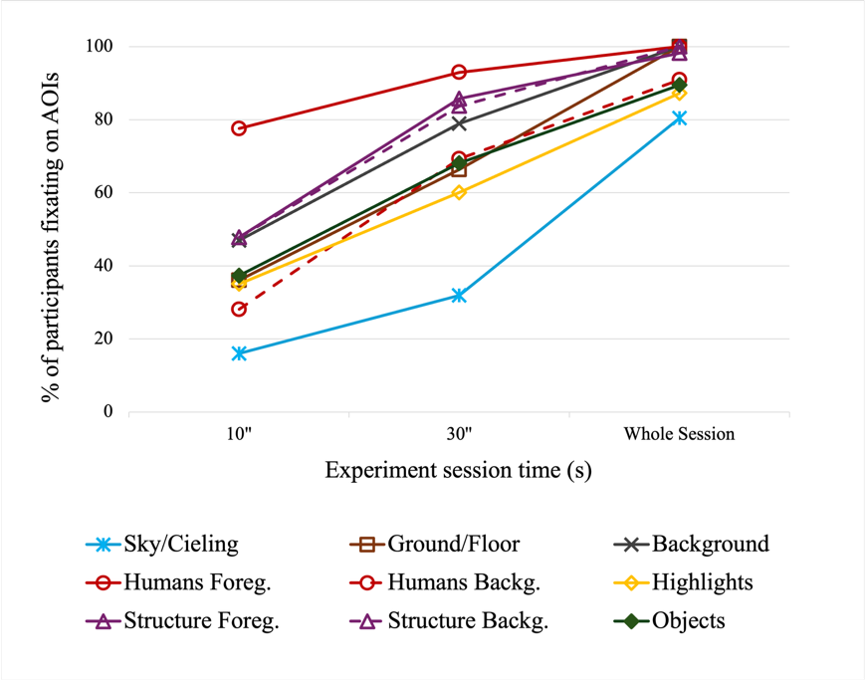
Figure 12. Graph showing the PERCENTAGE OF PARTICIPANTS WHO FIXATED on a specific AOI, measuring its likelihood of capturing attention (Wilkinson & Light, 2011). Here too, a similar hierarchy emerges: humans in the immediate surroundings are the most likely to attract attention, followed by layout structures and background areas. Finally come miscellaneous elements such as objects, highlights, and human figures in the background. The relatively high likelihood of scene structures may be partly due to the large space they occupy, but also to a perceptual need to first understand the overall scene composition before focusing on specific objects and details. By the end of the sessions, all participants had fixated on humans, layout structures, and the floor; this was not the case for the remaining elements.

Vertical distribution of fixations

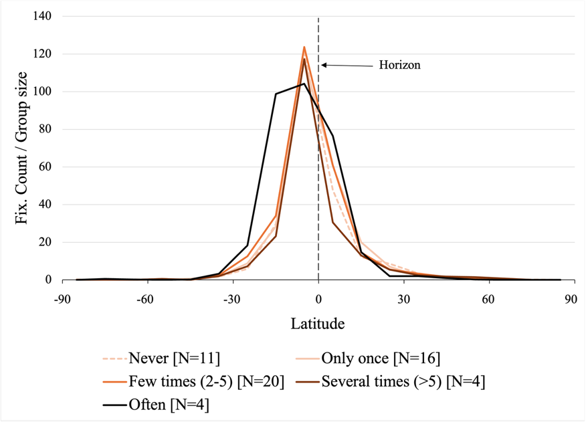
Figure 13. Vertical distribution of fixations for DIFFERENT LEVELS OF VR EXPERIENCE. Two observations stand out: (i) the equator bias appears independent of VR experience, and (ii) it is not vertically symmetrical as attention tends to focus on a band slightly below eye level.
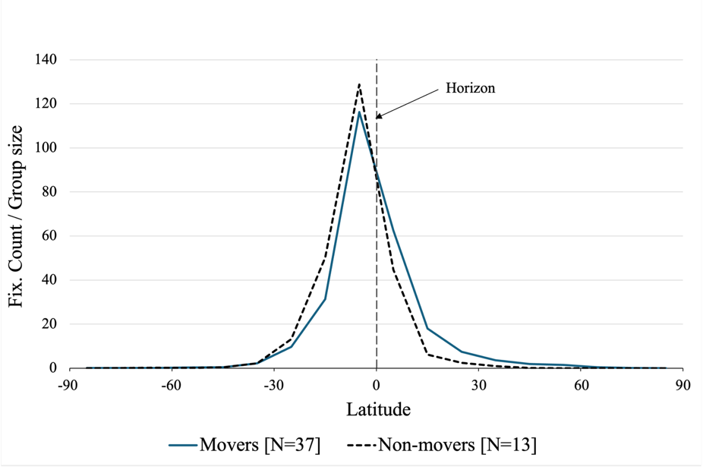
Figure 14. Vertical distribution of fixations for MOVERS and NON-MOVERS. The equator bias doesn’t seem to depend on exploratory dexterity of the users.

Attention metrics analysis for each image stimuli
The “participants” columns indicate how many individuals fixated on each AOI. The “attention time” columns show the average duration spent viewing each element, along with the proportion of viewing time relative to its size. The “latency” column presents the mean time to first fixation for each element. Numbers in parentheses next to each element name refer to the area it occupies in the image, while parentheses in the latency column indicate the ranking of shortest latency. Bold values highlight the highest or lowest figures within a specific metric and timeframe.
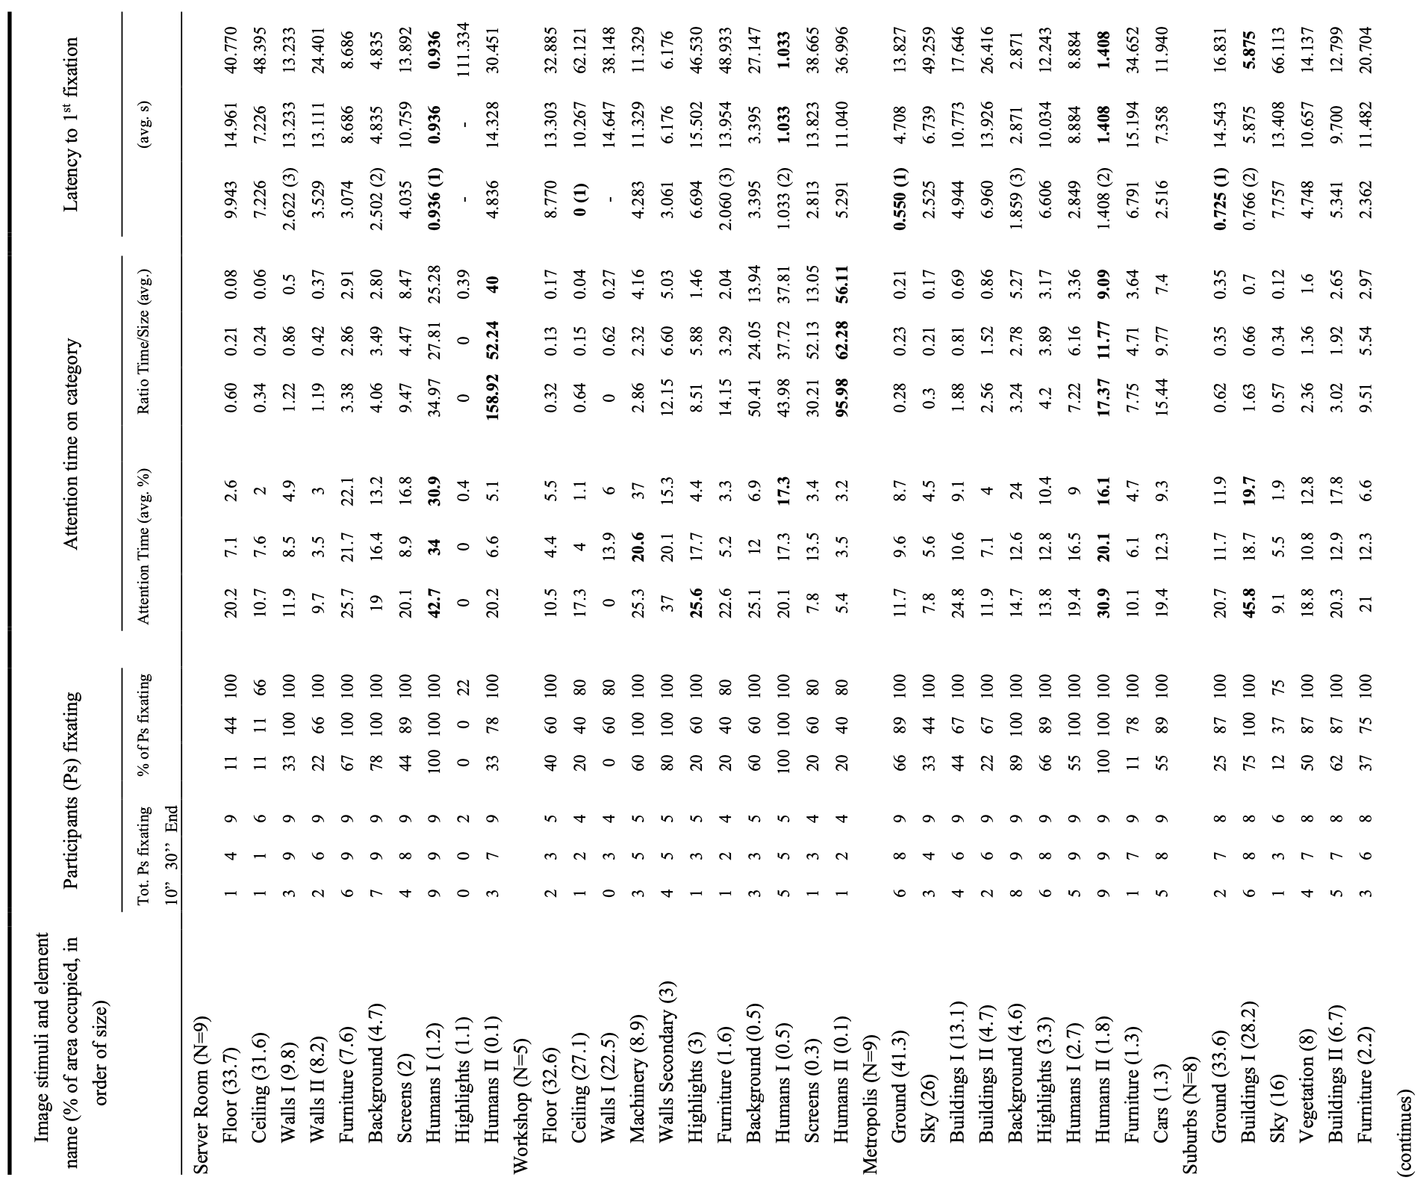
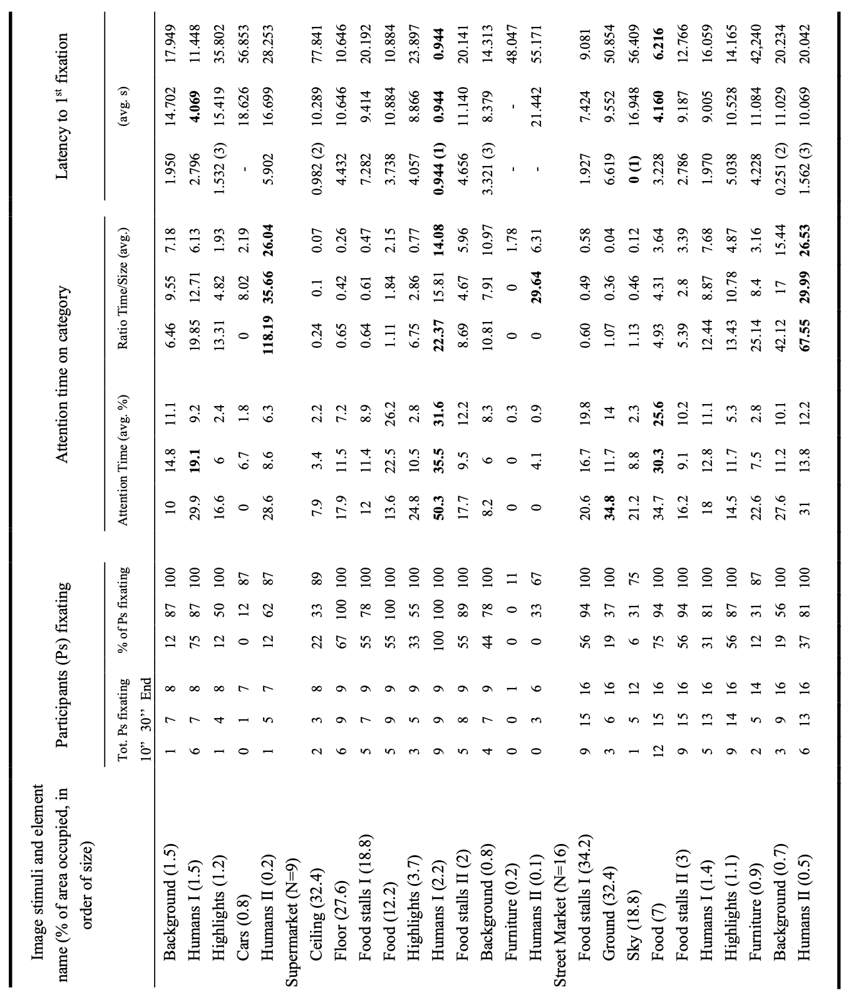

Andersson, R., Nyström, M., & Holmqvist, K. (2010). Sampling frequency and eye-tracking measures: how speed affects durations, latencies, and more. Journal of Eye Movement Research, 3(3). https://doi.org/10.16910/jemr.3.3.6
Blignaut, P. (2009). Fixation identification: the optimum threshold for a dispersion algorithm. Atten Percept Psychophys, 71(4), 881-895. https://doi.org/10.3758/APP.71.4.881
Daidzic, N. E. (2017). Long and short-range air navigation on spherical Earth. International Journal of Aviation Aeronautics and Aerospace, 4(1). https://doi.org/10.15394/ijaaa.2017.1160
David, E. J., Gutiérrez, J., Coutrot, A., Da Silva, M. P., & Callet, P. L. (2018). A dataset of head and eye movements for 360° videos Proceedings of the 9th ACM Multimedia Systems Conference,
Duchowski, A. T. (2017). Eye Movement Analysis. In Eye Tracking Methodology (pp. 141-158). https://doi.org/10.1007/978-3-319-57883-5_13
Gliga, T., Elsabbagh, M., Andravizou, A., & Johnson, M. (2009). Faces attract infants' attention in complex displays. Infancy, 14(5), 550-562. https://doi.org/10.1080/15250000903144199
Nystrom, M., & Holmqvist, K. (2010). An adaptive algorithm for fixation, saccade, and glissade detection in eyetracking data. Behav Res Methods, 42(1), 188-204. https://doi.org/10.3758/BRM.42.1.188
Saez de Urabain, I. R., Johnson, M. H., & Smith, T. J. (2015). GraFIX: a semiautomatic approach for parsing low- and high-quality eye-tracking data. Behav Res Methods, 47(1), 53-72. https://doi.org/10.3758/s13428-014-0456-0
Salvucci, D. D., & Goldberg, J. H. (2000). Identifying fixations and saccades in eye-tracking protocols. Proceedings of the 2000 symposium on Eye tracking research & applications,
van der Lans, R., Wedel, M., & Pieters, R. (2011). Defining eye-fixation sequences across individuals and tasks: the Binocular-Individual Threshold (BIT) algorithm. Behav Res Methods, 43(1), 239-257. https://doi.org/10.3758/s13428-010-0031-2
Wilkinson, K. M., & Light, J. (2011). Preliminary investigation of visual attention to human figures in photographs: potential considerations for the design of aided AAC visual scene displays. J Speech Lang Hear Res, 54(6), 1644-1657. https://doi.org/10.1044/1092-4388(2011/10-0098)

