Directional Proton Conductance in Bacteriorhodopsin Is Driven by Concentration Gradient, Not Affinity Gradient

Zhong Ren

Department of Chemistry, University of Illinois at Chicago, Chicago, IL 60607, USA
Renz Research, Inc., Westmont, IL 60559, USA

zren@uic.edu
ORCID 0000-0001-7098-3127

Supplementary Information
Intermediates K and L
Emerged from J around 10 ps, K lasts more than five decades into μs, which suggests that it is a struggle to achieve the next state L over a significant energy barrier. The creased retinal ever since I’ at the very first time point (Ren, 2021) is relaxing in K (blue; Figs. 3ef and S8). This slow and difficult relaxation could be driven in part by the energy stored in the creased 13-cis retinal and leads to global changes over the entire molecule. First, C₂₀ methyl group is tilting less at 20° from its resting orientation (Fig. 2b bottom panel). Although protruded toward the CP direction due to the 13-cis configuration, the tilted C₂₀ in J is not pointing to Trp182 directly (Fig. 3ef). Therefore, Trp182 is little affected in J. As C₂₀ swings back in K, it starts to push Trp182 toward the CP and causes displacements in the main chain (Fig. 3cdef). The positive density that indicates the position of C₂₀ in the reconstituted difference map K – bR forms an arc shape centered on the polyene chain (Fig. 3c). This observation strongly suggests that K is a process, rather than a discrete state, with C₂₀ distributed along the arc leading toward the next state L, in which the methyl group is fully erected (Fig. 3ef). Second, the entire chromophore in K, except the most distal segment beyond C₈, is in a flat conformation with the double bond C₁₃=C₁₄ in cis and the single bond C_{ε}–C_{δ} in syn. 12 consecutive torsion angles from C₈ to C_{α} deviate no more than 20° from trans/cis or anti/syn. The root-mean-squared deviation (rmsd) is 8.6° (Fig. 2b 4th panel). To achieve such energetically favorable conformation in the chromophore, the retinal anchor Lys216 is driven toward the EC direction, which causes a significant shift of the main chain in the vicinity. Third, again due to the 13-cis configuration, Trp86 on the EC side moves with the proximal segment of the retinal toward the CP direction, which also causes movement in the main chain. All three developments above are the progresses in a long and hard work toward the goal to establish the state L with global consequences.

After five decades of time since tens of ps, the large energy barrier is finally overcome around several μs as described by the component map U₃ (Fig. S5c) in the global transition of K L. This transition is modeled here at a time constant of 2 μs (Fig. S7). The potential energy in the creased retinal established within tens of fs after photon absorption is spent to trigger this transition, at least in part. Other sources of potential energy, such as that stored in the bent helix C (Fig. S10a), could also drive the global transition. Strong signals in the reconstituted difference map L – bR (Fig. 3d) support the refined structure of L (pink; Fig. S9). The refined structure of L shows that the 13-cis retinal is finally flattened as its potential energy is consumed. 12 consecutive torsion angles from C₅ to C_{δ}, including the SB, deviate from trans/cis or syn/anti no more than 23° with an rmsd of 10° (Fig. 2b 4th panel). As a small cost, a couple of single bonds of Lys216 have to deviate from the perfect syn or anti conformation like those in the flat all-trans retinal in the resting state. The plane of the flattened 13-cis retinal has largely returned to the original plane of the all-trans retinal (Fig. 2b 2nd panel). C₂₀ methyl group is pointing directly to Trp182, which causes helix F to displace (Figs. 3d and S10b). Leu93 in helix C is also affected by the protruding C₂₀ methyl group back into the original retinal plane. On the other hand, the fully erected C₂₀ displaces the anchor helix G with equally strong signals (Figs. 3d and S10c).

Intermediates M₁ and M₂
An increase of the component map U₁ separating the long delays > 10 μs from the earlier ones is modeled as the L M transition at a time constant of 27 μs. The M state could be split into two by an increase of the component map U₆ at a time constant of 290 μs (Fig. S7). Signals in both U₁ and U₆ are distributed over the EC half of the molecule instead of globally (Fig. S5ad). Two similar structures M₁ and M₂ (yellow and orange) are refined according to the reconstituted difference maps M₁ – bR and M₂ – bR (Figs. S12 and S13). Since the L state, the SB is moving inboard mainly by twisting the torsion angle around N_{ζ}-C_{ε} (Fig. 2b 4th panel). C_{ε} in M₁ and M₂ has moved 0.6 and 0.8 Å, respectively, from its position in L. It seems that the conformation is approaching a point poised to isomerize back to all-trans. In the meanwhile, Thr89 and helix C are being pushed back toward inboard, which restores the kink of helix C in the resting state (Fig. 4abc). The new development in the retinal displaces helix G further toward the EC direction as previously observed (Takeda et al., 2004). On the other hand, the stretched helix F in L springs back in M and becomes shorter than that in the resting state. The EC segment of helix F turns around to move outboard since L (Fig. 4d). However, the EC segments of helices C and G squeeze even tighter, while Arg82 swings out of the way as observed previously (Luecke et al., 2000; Sass et al., 2000).

Mutant functions
Under the mechanism of proton conductance driven by concentration gradient presented here, a number of mutant functions are explained. How mutants behave, in return, further support these hypotheses. Proton pumping activity is abolished in D85N at neutral pH (Mogi et al., 1988). The remaining proton acceptor Asp212 is H-boned to the phenol hydroxy group of Tyr57 (Fig. S14). After two successful photocycles, Asp212 and Wat402 are both protonated. However, proton conductance is stopped at the carbonyl groups =O of both side chains of Asn85 and Asp212, the amide group -NH₂ of Asn85, and the hydroxy groups -OH of Tyr57 and 185, since none of them can be protonated further. The lack of a proton outlet causes the SB to be reprotonated quickly during I’ or I before isomerization. The proton pump stalls with repeated futile photocycles. It has been shown that the proton pumping activity of D85N can be somewhat restored at an alkaline pH (Dickopf et al., 1995), which is consistent with the concentration-driven proton conductance proposed here. The phenol hydroxy group of Tyr57, a weak acid, could start to conduct proton to Wat403 and Arg82 only at an alkaline pH by deprotonation. On the other hand, some activity remains in D212N, which suggests a proton outlet going through Asp85, Wat401, 400, Arg82, and beyond (Fig. S14). In addition, Asp to Glu mutants are harder to assess because of their severe structural impacts. Proton pumping activity is also abolished in D212A (Mogi et al., 1988) perhaps due to a more mobile Wat402 or a hydronium that reprotonates the SB before isomerization or fails to withhold the proton during the SB U-turn. This mutant function further underscores the importance that Wat402 or a hydronium ion maintains its H-bonds to both Asp 85 and 212 throughout the photocycle as observed in this study despite its large traveling trajectory (Fig. 2a).

Mutants at the site of Arg82 are crucial tests to the mechanisms proposed here. M formation in the wildtype is pH-dependent at a few μs under alkaline pH and 85 μs at neutral pH (Balashov et al., 1993; Zimanyi et al., 1992), which nicely illustrates the concentration-gradient-driven proton conductance proposed here as faster proton release takes place driven by greater proton gradient. The proton barrier is breached in R82A mutant (Fig. 5). Therefore, the EC half channel must be filled with a continuous water network. Very little proton gradient can be established along the water filled channel during continuous pumping activity. R82A exhibits the same rate of proton uptake as the wildtype, but a rapid M formation without a pH dependency between neutral pH and pH10. Such rapid M formation is even faster than the wildtype under alkaline condition (Balashov et al., 1993). This is obviously due to the inability to establish the super-acidic inner EC channel without an intact proton barrier so that the protonation of Asp85 is accelerated compared to the wildtype. More interestingly, the fast phase of proton release is absent in R82A. Instead, a slow relaxation of 30 ms after proton uptake was observed (Balashov et al., 1993). Under the mechanism of a concentration-gradient-driven proton conductance, this slow relaxation is the spontaneous movement of the newly pumped proton in the same photocycle driven by a small gradient. Therefore, the “early release” in the fast phase of proton release cannot be observed without a well-established super-acidic inner EC channel in R82A. The “early release” observed from the wildtype is actually a much slower proton movement, in which a proton pumped into the super-acidic inner channel several photocycles ago is “squeezed out” by a newly pumped proton. This proton released from the wildtype appears to be coupled with or even faster than the protonation of Asp85.

Similar to R82A, another mutant R82Q also features rapid, biphasic formation of M at 1 and 160 μs but delayed proton release after uptake at neutral pH (Govindjee et al., 1996). However, unlike R82A, proton release from R82Q shows its strong pH-dependency. At neutral pH, the majority of proton release occurs late at 23 ms. If the pH increases to 8, most proton release precedes proton uptake at a few ms. The amide group on the side chain of the neutral residue Gln82 could be protonated by hydroniums in the inner EC channel. However, the amide group is not a sufficient proton barrier with its pK_{a} of -1.4 that could only establish a proton puddle less acidic compared to that of the wildtype. Another important factor to a smaller proton puddle is that Gln is two bonds shorter than Arg. As a result, rapid proton release at a few ms is possible with a sufficient proton gradient under high pH. However, proton release is delayed to 23 ms as the proton gradient decreases under neutral pH. Again, the proton apparently released early is one of the protons accumulated in the inner EC channel, not the one freshly pumped in the same photocycle.

Supplementary Q&A
This study addresses four key questions regarding the operating mechanisms of the light-driven proton pump bR in addition to the question of isomerization sampling (Ren, 2021). Answers to these questions are somewhat scattered in the main text while evidence are presented to support these answers. Here the answers are recapped without the interruption of the technical details of the supporting data.

Q1) How does the protonated SB with a pK_{a} of 13.3 transfer its proton to the acidic acceptors and when?

A1) Which of the two weak interactions N_{ζ}:H⁺:O402 survives an abrupt tare while the retinal prepares to undergo photoisomerization is determined by the inertia of the proton (Fig. 2c). It is decisive that the proton dissociates from the SB due to its inertia at the beginning of the retinal photoisomerization. The SB nitrogen makes a rapid U-turn at ~30 fs (Figs. 2a and S2). A force > 500 pN is required to accelerate the proton as fast as the SB. Breaking the H-bond H₂O402:H⁺ is nearly as costly as breaking the association N_{ζ}:H⁺ (Figs. 1 inset and 2c). Therefore, the proton joins Wat402 to form a hydronium ion due to its inertia instead of keeping up to maintain the SB protonated. Such a proton transfer uphill over 15 pH units within tens of fs is not achieved by a chemical equilibrium, thus not governed by pK_{a} values. This proton transfer requires a high peak power dH/dt localized at the SB. On the other hand, holding Wat402 in place by both Asp85 and 212 symmetrically from inboard and outboard is as important as the ultrafast shaking of the SB. This proton transfer uses the same mechanism of the tablecloth trick. The early deprotonation from the SB is a separate event from the protonation of Asp85 ten decades later at the formation of M state. Vibrational signatures from the neutralization of the carboxylates previously observed do not imply SB deprotonation. This light-driven reaction of a proton pump differs markedly from a thermal driven chemical equilibrium (Fig. 2c).

Q2) Which molecular event, the isomerization, or another event, switches the accessibility of the SB from EC side to CP side and how does the SB avoid reprotonation on the wrong side?

A2) Immediately before isomerization in the I state, the SB is reoriented toward the inboard while Wat402, a hydronium at this moment, is displaced to the outboard. This geometry is very bad for proton exchange (Fig. S3). Therefore, the accessibility of the SB is already limited even before isomerization. However, accessibility switch of the SB is finally accomplished by the photoisomerization during I J’. The photoisomerization must be quick enough to prevent a chemical equilibrium in the EC half channel. If the equilibrium is reached before isomerization, the SB is reprotonated from the EC side, and the quantum yield of the proton pump is sacrificed (Govindjee et al., 1990).

Q3) How are protons conducted > 15 Å through the rollercoasting pK_{a} values and released into the EC medium from the SB of a high pK_{a} through aspartic acids of low pK_{a}, arginine (strictly speaking, its guanidinium ion) and tyrosine of high pK_{a}, and glutamic acids of low pK_{a} again?

A3) The EC half channel is obviously not lined with residues of pK_{a} values in a monotonic order (Figs. 5 and S1). Despite numerous observations of pK_{a} changes, no sufficient evidence supports photoinduced changes to form an ascending order of pK_{a} values either. Proton is therefore not conducted along an ascending order of pK_{a} values driven by the proton affinity (Stoeckenius, 1999; Stoeckenius et al., 1979). Instead, proton conductance is driven by concentration gradient, not by affinity gradient. The guanidinium ion of the arginine and tyrosines of high pK_{a}, together with several main chain carbonyls, are arranged to function as a proton levee so that protons could only overflow outward from a super-acidic inner EC channel established after several successful cycles of proton pumping. No proton is released during the first a few cycles of productive pumping until a sufficient proton gradient is established. Under a super-acidic condition in the inner EC channel, the guanidinium group of Arg82 is protonated for a second time to form a divalent cation. While it swings outward, the extra proton is discharged to Glu194, 204, and a water cluster in the outer EC channel, the proton release complex. Protons could never flow backward into the cell as long as sufficient water is available in the EC medium. The rollercoasting pK_{a} values ensure the concentration-driven outward conductance of protons and prevent the concentration-driven inward conductance during dark, that is, a unidirectional valve.

Q4) How is a gradient-driven proton leak prevented in the resting state and during the pumping motions?

A4) A potential proton leak back into the cell during dark is prevented by the exact mechanism that conducts proton outward (A3). However, the chance of proton leak increases dramatically during the molecular motions of proton pumping because the inner EC channel becomes super acidic and the retinal and its surrounding are in constant motions. Lys216 forms a corner at C_{ε} that protrudes inboard and makes a van der Waals contact with Thr89 in helix C (Figs. 2b and S10a). Pressed by the corner at C_{ε}, helix C is kinked and bends away. This contact is a seal between two half channels. This seal could be broken briefly in I’ state but inconsequential. C_{δ}-C_{ε} moves outboard in L state once again due to a flattened 13-cis retinal (Figs. 2b and S10a). But this motion is slow enough to allow the spring-loaded helix C to react. Helix C straightens and maintains the contact between the chromophore and Thr89 to prevent a concentration-gradient-driven proton leak back into the CP (Figs. 3f and 4c). During the M states, the corner at C_{ε} is reestablished. It pushes Thr89 and helix C to restore its kink.

Methods

From the outset, the key presumption is that every crystallographic dataset, at a given temperature and a given time delay after the triggering of the photochemical reaction, captures a mixture of unknown number of intermediate species at unknown fractions. Needless to say, all structures of the intermediates are also unknown except the structure at the ground state that has been determined and well refined by static crystallography. A simultaneous solution of all these unknowns requires multiple datasets that are collected at various temperatures or time delays so that a common set of intermediate structures are present in these datasets with variable ratios. If the number of available datasets is far greater than the number of unknowns, a linear system can be established to overdetermine the unknowns with the necessary stereochemical restraints (Ren et al., 2013). This analytical strategy is recapped below.

The methodological advance in this work and the companion work (Ren, 2021) is the refinement of each pure intermediate structure that has been deconvoluted from multiple mixtures. Structure factor amplitudes of a single conformation free of heterogeneity are overdetermined. Unlike the conventional crystallography, such a deconvoluted dataset of structure factor amplitudes are not observed directly from any crystal but computed from many experimental datasets. It could be considered as an extrapolated dataset “on steroids” if compared to the traditional extrapolation of small differences, such as, 3Fo-2Fc map, a technique often used to overcome a partial occupancy of an intermediate structure, except that this deconvolution method is an interpolation among many experimental datasets rather than an extrapolation. The standard structural refinement software is taken full advantage of with the built-in stereochemical constraints, e.g. PHENIX (Adams et al., 2010; Liebschner et al., 2019). In case that the computed deconvolution has not achieved a single pure structural species, the structural refinement is expected to make such indication.

Difference Fourier maps

A difference Fourier map is synthesized from a Fourier coefficient set of F_{light}-F_{reference} with the best available phase set, often from the ground state structure. Before Fourier synthesis, F_{light} and F_{reference} must be properly scaled to the same level so that the distribution of difference values is centered at zero and not skewed either way. A weighting scheme proven effective assumes that a greater amplitude of a difference Fourier coefficient F_{light}-F_{reference} is more likely caused by noise than by signal (Ren et al., 2001, 2013; Šrajer et al., 2001; Ursby and Bourgeois, 1997). Both the dark and light datasets can serve as a reference in difference maps. If a light dataset at a certain delay is chosen as a reference, the difference map shows the changes since that delay time but not the changes prior to that delay. However, both the dark and light datasets must be collected in the same experiment. A cross reference from a different experimental setting usually causes large systematic errors in the difference map that would swamp the desired signals. Each difference map is masked 3.5 Å around the entire molecule of bacteriorhodopsin (bR). No lipid density is analyzed.

Meta-analysis of protein structures
Structural meta-analysis based on singular value decomposition (SVD) has been conducted in two forms. In one of them, an interatomic distance matrix is calculated from each protein structure in a related collection. SVD of a data matrix consists of these distance matrices enables a large-scale joint structural comparison but requires no structural alignment (Ren, 2013a, 2013b, 2016). In the second form, SVD is performed on a data matrix of electron density maps of related protein structures (Ren, 2019; Ren et al., 2013; Schmidt et al., 2003, 2010). Both difference electron density maps that require a reference dataset from an isomorphous crystal and simulated annealing omit maps that do not require the same unit cell and space group of the crystals are possible choices in a structural meta-analysis (Ren, 2019; Ren et al., 2013). The distance matrices or the electron density maps that SVD is performed on are called core data. Each distance matrix or electron density map is associated with some metadata that describe the experimental conditions under which the core data are obtained, such as temperature, pH, light illumination, time delay, mutation, etc. These metadata do not enter the SVD procedure. However, they play important role in the subsequent interpretation of the SVD result. This computational method of structural analysis takes advantage of a mathematical, yet practical, definition of conformational space with limited dimensionality (Ren, 2013a). Each experimentally determined structure is a snapshot of the protein structure. A large number of such snapshots taken under a variety of experimental conditions, the metadata, would collectively provide a survey of the accessible conformational space of the protein structure and reveal its rection trajectory. Such joint analytical strategy would not be effective in early years when far fewer protein structures were determined to atomic resolution. Recent rapid growth in protein crystallography, such as in structural genomics (Berman et al., 2012; Chandonia and Brenner, 2006) and in serial crystallography (Glynn and Rodriguez, 2019; Schaffer et al., 2021), has supplied the necessarily wide sampling of protein structures for a joint analytical strategy to come of age. The vacancies or gaps in a conformational space between well-populated conformational clusters often correspond to less stable transient states whose conformations are difficult to capture, if not impossible. These conformations are often key to mechanistic understanding and could be explored by a back calculation based on molecular distance geometry (Ren, 2013a, 2016), the chief computational algorithm in nucleic magnetic resonance spectroscopy (NMR), and by a structure refinement based on reconstituted dataset, a major methodological advance in this work (see below). These structures refined to atomic resolution against reconstituted datasets may reveal short-lived intermediate conformation hard to be captured experimentally. Unfortunately, a protein structure refined against a reconstituted dataset currently cannot be recognized by the Protein Data Bank (PDB). Because crystallographic refinement of a macromolecular structure is narrowly defined as a correspondence from one dataset to one structure. A never-observed dataset reconstituted from a collection of experimental datasets does not match the well-established crystallographic template of PDB; let alone a refinement of crystal structure with the NMR algorithm.

A distance matrix contains M pairwise interatomic distances of a structure in the form of Cartesian coordinates of all observed atoms. An everyday example of distance matrix is an intercity mileage chart appended to the road atlas. Differences in the molecular orientation, choice of origin, and crystal lattice among all experimentally determined structures have no contribution to the distance matrices. Due to its symmetry, only the lower triangle is necessary. A far more intimate examination of protein structures in PDB is a direct analysis of their electron density maps instead of the atomic coordinates. M such (difference) electron densities, often called voxels in computer graphics, are selected by a mask of interest. In the case of difference maps, only the best refined protein structure in the entire collection supplies a phase set for Fourier synthesis of electron density maps. This best structure is often the ground state structure determined by static crystallography. Other refined atomic coordinates from the PDB entries are not considered in the meta-analysis. That is to say, a meta-analysis of difference electron density maps starts from the X-ray diffraction data archived in PDB rather than the atomic coordinates interpreted from the diffraction data, which removes any potential model bias.

Singular value decomposition of (difference) electron density maps
An electron density map, particularly a difference map as emphasized here, consists of density values on an array of grid points within a mask of interest. All M grid points in a three-dimensional map can be serialized into a one-dimensional sequence of density values according to a specific protocol. It is not important what the protocol is as long as a consistent protocol is used to serialize all maps of the same grid setting and size, and a reverse protocol is available to erect a three-dimensional map from a sequence of M densities. Therefore, a set of N serialized maps, also known as vectors in linear algebra, can fill the columns of a data matrix A with no specific order, so that the width of A is N columns, and the length is M rows. Often, M >> N, thus A is an elongated matrix. If a consistent protocol of serialization is used, the corresponding voxel in all N maps occupies a single row of matrix A. This strict correspondence in a row of matrix A is important. Changes of the density values in a row from one structure to another are due to either signals, systematic errors, or noises. Although the order of columns in matrix A is unimportant, needless to say, the metadata associated with each column must remain in good bookkeeping.

SVD of the data matrix A results in $A=UWV^{T}$, also known as matrix factorization. Matrix U has the same shape as A, that is, N columns and M rows. The N columns contain decomposed basis components U_{k}, known as left singular vectors of M items, where k = 1, 2, …, N. Therefore, each component U_{k} can be erected using the reverse protocol to form a three-dimensional map. This decomposed elemental map can be presented in the same way as the original maps, for example, rendered in molecular graphics software such as Coot and PyMol. It is worth noting that these decomposed elemental maps or map components U_{k} are independent of any metadata. That is to say, these components remain constant when the metadata vary. Since each left singular vector U_{k} has a unit length due to the orthonormal property of SVD (see below), that is, |U_{k}| = 1, the root mean squares (rms) of the items in a left singular vector is 1/√M that measures the quadratic mean of the items.

The second matrix W is a square matrix that contains all zeros except for N positive values on its major diagonal, known as singular values w_{k}. The magnitude of w_{k} is considered as a weight or significance of its corresponding component U_{k}. The third matrix V is also a square matrix of N × N. Each column of V or row of its transpose $V^{T}$, known as a right singular vector V_{k}, contains the relative compositions of U_{k} in each of the N original maps. Therefore, each right singular vector V_{k} can be considered as a function of the metadata. Right singular vectors also have the same unit length, that is, |V_{k}| = 1. Effectively, SVD separates the constant components independent of the metadata from the compositions that depend on the metadata.

A singular triplet denotes 1) a decomposed component U_{k}, 2) its singular value w_{k}, and 3) the composition function V_{k}. Singular triplets are often sorted in a descending order of their singular values w_{k}. Only a small number of n significant singular triplets identified by the greatest singular values w₁ through w_{n} can be used in a linear combination to reconstitute a set of composite maps that closely resemble the original ones in matrix A, where n < N. For example, the original map in the ith column of matrix A under a certain experimental condition can be closely represented by the ith composite map w₁v_{1i}U₁ + w₂v_{2i}U₂ + … + w_{n}v_{ni}U_{n}, where (v_{1i}, v_{2i}, …) is from the ith row of matrix V. The coefficient set for the linear combination is redefined here as c_{ki} = w_{k}v_{ki}/√M. The rms of the values in a map component, or the average magnitude measured by the quadratic mean, acts as a constant scale factor that resets the modified coefficients c_{ki} back to the original scale of the core data, such as Å for distance matrices and e⁻/Å³ for electron density maps if these units are used in the original matrix A. Practically, an electron density value usually carries an arbitrary unit without a calibration, which makes this scale factor unnecessary. In the linear combination c_{1i}U₁ + c_{2i}U₂ + … + c_{ni}U_{n}, each component U_{k} is independent of the metadata while how much of each component is required for the approximation, that is, c_{ki}, depends on the metadata.

Excluding the components after U_{n} in this approximation is based on an assumption that the singular values after w_{n} are very small relative to those from w₁ through w_{n}. As a result, the structural information evenly distributed in all N original maps is effectively concentrated into a far fewer number of n significant components, known as information concentration or dimension reduction. On the other hand, the trailing components in matrix U contain inconsistent fluctuations and random noises. Excluding these components effectively rejects noises (Schmidt et al., 2003). The least-squares property of SVD guarantees that the rejected trailing components sums up to the least squares of the discrepancies between the original core data and the approximation using the accepted components.

However, no clear boundary is guaranteed between signals, systematic errors, and noises. Systematic errors could be more significant than the desired signals. Therefore, excluding some components from 1 through n is also possible. If systematic errors are correctly identified, the reconstituted map without these significant components would no longer carry the systematic errors.

The orthonormal property of SVD
The solution set of SVD must guarantee that the columns in U and V, the left and right singular vectors U_{k} and V_{k}, are orthonormal, that is, U_{h}•U_{k} = V_{h}•V_{k} = 0 (ortho) and U_{k}•U_{k} = V_{k}•V_{k} = 1 (normal), where h ≠ k but both are from 1 to N. The orthonormal property also holds for the row vectors. As a result, each component U_{k} is independent of the other components. In other words, a component cannot be represented by a linear combination of any other components. However, two physical or chemical parameters in the metadata, such as temperature and pH, may cause different changes to a structure. These changes are not necessarily orthogonal. They could exhibit some correlation. Therefore, the decomposed components U_{k} not necessarily represent any physically or chemically meaningful changes (see below).

Due to the orthonormal property of SVD, an N-dimensional Euclidean space is established, and the first n dimensions define its most significant subspace. Each coefficient set c_{i} = (c_{1i}, c_{2i}, …, c_{ni}) of the ith composite map is located in this n-dimensional subspace. All coefficient sets for i = 1, 2, …, N in different linear combinations to approximate the N original maps in a least-squares sense can be represented by N points or vectors c₁, c₂, …, c_{N} in the Euclidean subspace. This n-dimensional subspace is essentially the conformational space as surveyed by the jointly analyzed core data. The conformational space is presented as scatter plots with each captured structure represented as a dot located at a position determined by the coefficient set c_{i} of the ith observed map. When the subspace has greater dimensionality than two, multiple two-dimensional orthographical projections of the subspace are presented. These scatter plots are highly informative to reveal the relationship between the (difference) electron density maps and their metadata.

If two coefficient sets c_{i} ≈ c_{j}, they are located close to each other in the conformational space. Therefore, these two structures i and j share two similar conformations. Two structures located far apart from each other in the conformational space are distinct in their conformations, and distinct in the compositions of the map components. A reaction trajectory emerges in this conformational space if the temporal order of the core data is experimentally determined (Figs. S4 and S7). Otherwise, an order could be assigned to these structures based on an assumed smoothness of conformational changes along a reaction trajectory (Ren, 2013a, 2013b, 2016). Causation and consequence of structural motions could be revealed from the order of the structures in a series, which may further lead to structural mechanism. In addition, an off-trajectory location in the conformational space or a location between two clusters of observed structures represents a structure in a unique conformation that has never been experimentally captured. Such a hypothetical structure can be refined against a reconstituted distance matrix using molecular distance geometry (Ren, 2013a, 2013b, 2016) or a reconstituted electron density map with the method proposed below.

Rotation in SVD space
Dimension reduction is indeed effective in meta-analysis of protein structures when many datasets are evaluated at the same time. However, the default solution set of SVD carries complicated physical and chemical meanings that are not immediately obvious. The interpretation of a basis component U_{k}, that is, “what-does-it-mean”, requires a clear demonstration of the relationship between the core data and their metadata. The outcome of SVD does not guarantee any physical meaning in a basis component. Therefore, SVD alone provides no direct answer to “what-does-it-mean”, thus its usefulness is very limited to merely a mathematical construction. However, the factorized set of matrices U, W, and V from SVD is not a unique solution. That is to say, they are not the only solution to factorize matrix A. Therefore, it is very important to find one or more alternative solution sets that are physically meaningful to elucidate a structural interpretation. The concept of a rotation after SVD was introduced by Henry & Hofrichter (Henry and Hofrichter, 1992). But they suggested a protocol that fails to preserve the orthonormal and least-squares properties of SVD. The rotation protocol suggested by Ren incorporates the metadata into the analysis and combines with SVD of the core data. This rotation achieves a numerical deconvolution of multiple physical and chemical factors after a pure mathematical decomposition, and therefore, provides a route to answer the question of “what-does-it-mean” (Ren, 2019). This rotation shall not be confused with a rotation in the three-dimensional real space, in which a molecular structure resides.

A rotation in the n-dimensional Euclidean subspace is necessary to change the perspective before a clear relationship emerges to elucidate scientific findings. It is shown below that two linear combinations are identical before and after a rotation applied to both the basis components and their coefficients in a two-dimensional subspace of h and k. That is,

c_{h}U_{h} + c_{k}U_{k} = f_{h}R_{h} + f_{k}R_{k}, | (1)

where c_{h} and c_{k} are the coefficients of the basis components U_{h} and U_{k} before the rotation; and f_{h} and f_{k} are the coefficients of the rotated basis components R_{h} and R_{k}, respectively. The same Givens rotation of an angle θ is applied to both the components and their coefficients:

$$\left\{\begin{aligned}R_{h}=U_{h}cosθ-U_{k}sinθ; \\ R_{k}=U_{h}sinθ+U_{k}cosθ.\end{aligned}\right.$$ | (2)

Obviously, the rotated components R_{h} and R_{k} remain mutually orthonormal and orthonormal to other components. And

$$\left\{\begin{aligned}f_{h}=s_{h}t_{h}=c_{h}cosθ-c_{k}sinθ; \\ f_{k}=s_{k}t_{k}{=c}_{h}sinθ+c_{k}cosθ.\end{aligned}\right.$$ | (3)

Here $s_{h|k}=\sqrt{\sum{f_{h|k}^{2}}}$ are the singular values that replace w_{h} and w_{k}, respectively, after the rotation. They may increase or decrease compared to the original singular values so that the descending order of the singular values no longer holds. T_{h|k} = (t_{h|k1}, t_{h|k2}, …, t_{h|kN}) = (f_{h|k1}, f_{h|k2}, …, f_{h|kN})/s_{h|k} are the right singular vectors that replace V_{h} and V_{k}, respectively. T_{h} and T_{k} remain mutually orthonormal after the rotation and orthonormal to other right singular vectors that are not involved in the rotation.

Eq. 1 holds because the dot product of two vectors does not change after both vectors rotate the same angle. To prove Eq. 1 in more detail, Eqs. 2 and 3 are combined and expanded. All cross terms of sine and cosine are self-canceled:

f_{h}R_{h} + f_{k}R_{k} = (c_{h}cosθ – c_{k}sinθ)(U_{h}cosθ – U_{k}sinθ) + (c_{h}sinθ + c_{k}cosθ)(U_{h}sinθ + U_{k}cosθ)
= c_{h}U_{h}cos²θ + c_{k}U_{k}sin²θ + c_{h}U_{h}sin²θ + c_{k}U_{k}cos²θ ± c_{h}U_{k}sinθcosθ ± c_{k}U_{h}sinθcosθ
= c_{h}U_{h}(cos²θ + sin²θ) + c_{k}U_{k}(sin²θ + cos²θ)
= c_{h}U_{h} + c_{k}U_{k}

A rotation in two-dimensional subspace of h and k has no effect in other dimensions, as the orthonormal property of SVD guarantees. Multiple steps of rotations can be carried out in many two-dimensional subspaces consecutively to achieve a multi-dimensional rotation. A new solution set derived from a rotation retains the orthonormal property of SVD. The rotation in the Euclidean subspace established by SVD does not change the comparison among the core data of protein structures. Rather it converts one solution set $A=UWV^{T}$ to other alternative solutions $A=RST^{T}$ so that an appropriate perspective can be found to elucidate the relationship between the core data and metadata clearly and concisely.

For example, if one physical parameter could be reoriented along a single dimension k but not involving other dimensions by a rotation, it would be convincing to show that the left singular vector U_{k} of this dimension illustrates the structural impact by this physical parameter. Before this rotation, the same physical parameter may appear to cause structural variations along several dimensions, which leads to a difficult interpretation. Would a proper rotation establish a one-on-one correspondence from all physical or chemical parameters to all the dimensions? It depends on whether each parameter induces an orthogonal structural change, that is, whether structural responses to different parameters are independent or correlated among one another. If structural changes are indeed orthogonal, it should be possible to find a proper rotation to cleanly separate them in different dimensions. Otherwise, two different rotations are necessary to isolate two correlated responses, but one at a time.

For another example, if the observed core datasets form two clusters in the conformational space, a rotation would be desirable to separate these clusters along a single dimension k but to align these clusters along other dimensions. Therefore, the component U_{k} is clearly due to the structural transition from one cluster to the other. Without a proper rotation, the difference between these clusters could be complicated with multiple dimensions involved. A deterministic solution depends on whether a clear correlation exists between the core data and metadata. A proper rotation may require a user decision. A wrong choice of rotation may select a viewpoint that hinders a concise conclusion. However, it would not alter the shape of the reaction trajectory, nor create or eliminate an intrinsic structural feature. A wrong choice of rotation cannot eliminate the fact that a large gap exists between two clusters of observed core datasets except that these clusters are not obvious from that viewpoint. A different rotation may reorient the perspective along another direction. But the structural conclusion would be equivalent. See example of before and after a rotation in (Ren, 2016).

This rotation procedure finally connects the core crystallographic datasets to the metadata of experimental conditions and accomplishes the deconvolution of physical or chemical factors that are not always orthogonal to one another after a mathematical decomposition. SVD analysis presented in this paper employs rotations extensively except that no distinction is made in the symbols of components and coefficients before and after a rotation except in this section. This method is widely applicable in large-scale structural comparisons. Furthermore, Ren rotation after SVD is not limited to crystallography and may impact other fields wherever SVD is used. For example, SVD is frequently applied to spectroscopic data, images, and genetic sequence data.

A preliminary analysis of SVD involving all difference maps (Table S1) shows that the short and long delays are in two different subspaces (Fig. S15). That is to say, difference maps in the time regimes before 10 ps and after 10 ns share no common features. This conclusion cannot be reached without a proper rotation of the components. The separation between the short and long delays into different subspaces can only be viewed clearly from this specific perspective shown in Fig. S15. Therefore, these time regimes are analyzed separately.

Exponential fitting of SVD coefficients
The time dependencies of the SVD coefficients c₁(t), c₃(t), and c₆(t) for the long delays > 10 ns are modeled with exponential functions (Fig. S7). Each time-dependent coefficient

$$c_{k}\left(t\right)=b_{k}+p_{k}\exp\left(-\frac{t}{τ_{1}}\right)+q_{k}\exp\left(-\frac{t}{τ_{3}}\right)+r_{k}\exp\left(-\frac{t}{τ_{6}}\right)$$ | (4)

where k = 1, 3, or 6. The time constant τ_{k} associated with the major change in each coefficient models each step in the reaction scheme K L M₁ M₂. Whether the time-dependent coefficients can be successfully fitted with exponentials is also a good test for a proper rotation. Because the fact that the fractional concentrations of intermediate species can be expressed as exponentials indicate that the reaction follows a regular kinetic scheme.

Structural refinement against reconstituted dataset
The linear combination Δρ(t) = f₁(t)R₁ + f₂(t)R₂ + … + f_{n}(t)R_{n} after a rotation reconstitutes one of the observed difference maps at a specific time point t. This time-dependent difference map depicts an ever-evolving mixture of many excited species. A reconstituted difference map Δρ(E) for a time-independent, pure, excited species E = intermediate I’, I, J’, and J deconvoluted from many mixtures would take the same form except that only one or very few coefficients remain nonzero if a proper rotation has been found (Table S2). In order to take advantage of the mature refinement software for macromolecular structures with extensive stereochemical restraints, a set of structure factor amplitudes is needed. Therefore, it is necessary to reconstitute a set of structure factor amplitudes that would produce the target difference map Δρ(E) based on a known structure at the ground state. First, an electron density map of the structure at the ground state is calculated. This calculated map is used as a base map. Second, this base map of the ground state is combined with the positive and negative densities in the target difference map Δρ(E) so that the electron densities at the ground state are skewed toward the intermediate state. Third, structure factors are calculated from the combined map. Finally, the phase set of the calculated structure factors is discarded, and the amplitudes are used to refine a single conformation of the intermediate species E that Δρ(E) represents.

This protocol following the SVD and Ren rotation of components achieves a refinement of a pure structural species without the need of alternative conformations. Several points are noteworthy. First, the minimization protocol in this refinement is performed against a numerically reconstituted amplitude set that has never been directly measured from a crystal. This reconstituted dataset could be considered as an extrapolated dataset “on steroids” if compared to the traditional extrapolation of small differences, such as, the Fourier coefficient set to calculate a 3Fo-2Fc map, a technique often used to overcome a partial occupancy of an intermediate structure. An extrapolation of small differences is not directly observed either but computed by an exaggeration of the observed difference based on an assumption that the intermediate state is partially occupied, such as the doubling of the observed difference in 3Fo-2Fc = Fo + 2(Fo-Fc). In contrast to the conventional technique of extrapolation, the deconvolution method applied here is an interpolation among many experimental datasets rather than an extrapolation. Secondly, the deconvolution is a simultaneous solution of multiple intermediate states mixed together instead of solving a single excited state.

Second, a map calculated from the ground state structure is chosen as the base map instead of an experimental map such as Fo or 2Fo-Fc map. If the second step of the protocol is skipped, that is, no difference map is combined with the ground state map, the refinement would result in an R factor of nearly zero, since the refinement is essentially against the calculated structure factors (bR in Table S2). This is to say, the residuals of the refinement are solely due to the difference component instead of the base map. This is desirable since errors in the static structure of the ground state are gauged during its own refinement. On the other hand, if an experimental map is chosen as a base map, the refinement R factors would reflect errors in both the base map and the difference map, which leads to a difficulty in an objective evaluation of this refinement protocol.

Third, the combination of the base map and a difference map is intended to represent a pure intermediate species. Therefore, alternative conformations in structural refinement that model a mixture of species would defeat this purpose. However, this combined map could be very noisy and may not represent a single species without a proper rotation. This is particular the case, if the target difference map Δρ is not derived from an SVD analysis and Ren rotation. The SVD analysis identifies many density components that are inconsistent among all observed difference maps and excludes them, which greatly reduces the noise content. Therefore, this refinement protocol may not be very successful without an SVD analysis. Another source of noise originates from the phase set of the structure factors. Prior to the refinement of the intermediate structure, the phase set remains identical to that of the ground state. This is far from the reality when an intermediate structure involves widespread changes, such as those refined in this study. If the rotation after SVD is not properly selected, the target difference map would remain as a mixture minus the ground state. Therefore, the refinement of a single conformation would encounter difficulty or significant residuals, as judged by the R factors, the residual map, and the refined structure. A proper solution to this problem is a better SVD solution by Ren rotation rather than alternative conformations. A successful refinement of near perfect trans or cis double bonds is a good sign to indicate that the reconstituted amplitude set after a rotation reflects a relatively homogeneous structure. If a double bond could not be refined well to near perfect trans or cis configuration, the dataset of structure factor amplitudes is likely from a mixture of heterogeneous configurations, which occurred frequently in previous studies of bR and photoactive yellow protein (Jung et al., 2013; Lanyi and Schobert, 2007; Nogly et al., 2018). It has been a great difficulty in crystallographic refinement in general that a heterogeneous mixture of conformations cannot be unambiguously refined even with alternative conformations. This difficulty becomes more severe when a mixture involves more than two conformations or when some conformations are very minor.

Lastly, the refinement protocol proposed here could be carried out in the original unit cell and space group of the crystal at the ground state. However, this is not always applicable as the original goal of the meta-analysis is a joint examination of all available structures from a variety of crystal forms. It would be highly desirable to evaluate difference maps of the same or similar proteins from non-isomorphous crystals together by SVD. Alternatively, the refinement protocol could also be performed in the space group of P1 with a virtual unit cell large enough to hold the structure, which is the option in this study (Table S2). This is to say, the entire analysis of SVD-rotation-refinement presented here could be extracted and isolated from the original crystal lattices, which paves the way to future applications to structural data acquired by experimental techniques beyond crystallography, most attractively, to single particle reconstruction in cryo electron microscopy.

Supplementary Tables

Table S1. Datasets analyzed in this work
Publication | PDB | Label | Resolution | Main conclusions | New findings in this work
Nango et al. Science 354, 1552, 2016 | 5b6v | dark5 | 1.77 Å | A newly ordered water on the CP side bridges the SB to Thr89 after isomerization, thus further conducts a proton to Asp85. | These datasets contribute to the overdetermination of the structures K L M₁ M₂. The early creased retinal is flattened; C₂₀ methyl group returns into the original plane of the resting retinal as K transitions to L. The most flattened chromophore is achieved in L. The EC half channel contracts in L while the CP half channel starts to open. Reprotonation of the SB starts in L. Several ordered waters are observed in the enlarged CP half channel in M₁. The SB move toward inboard in M₁ and M₂.
Nango et al. Science 354, 1552, 2016 | 5b6w | 16ns | 2.0 Å
Nango et al. Science 354, 1552, 2016 | 5h2h | 40ns | 2.0 Å
Nango et al. Science 354, 1552, 2016 | 5h2i | 110ns | 2.0 Å
Nango et al. Science 354, 1552, 2016 | 5h2j | 290ns | 2.0 Å
Nango et al. Science 354, 1552, 2016 | 5b6x | 760ns | 2.0 Å
Nango et al. Science 354, 1552, 2016 | 5h2k | 2μs | 2.0 Å
Nango et al. Science 354, 1552, 2016 | 5h2l | 5.25μs | 2.0 Å
Nango et al. Science 354, 1552, 2016 | 5h2m | 13.8μs | 2.0 Å
Nango et al. Science 354, 1552, 2016 | 5b6y | 36.2μs | 2.0 Å
Nango et al. Science 354, 1552, 2016 | 5h2n | 95.2μs | 2.0 Å
Nango et al. Science 354, 1552, 2016 | 5h2o | 250μs | 2.0 Å
Nango et al. Science 354, 1552, 2016 | 5h2p | 657μs | 2.0 Å
Nango et al. Science 354, 1552, 2016 | 5b6z | 1.725ms | 2.0 Å
Nogly et al. Science 361, eaat0094, 2018 | 6g7h | dark6 | 1.5 Å | Retinal fully isomerizes at 10 ps. But the SB water dissociates earlier. | The short-delay datasets contribute to the structures of I’ I J’ J. Photoisomerization in J’; retinal binding pocket expansion before 1 ps in I and contraction at 10 ps in J
Nogly et al. Science 361, eaat0094, 2018 | 6g7i | 49-406fs | 1.9 Å
Nogly et al. Science 361, eaat0094, 2018 | 6g7j | 457-646fs | 1.9 Å
Nogly et al. Science 361, eaat0094, 2018 | 6g7k | 10ps | 1.9 Å
Nogly et al. Science 361, eaat0094, 2018 | 6g7l | 8.33ms | 1.9 Å
Kovacs et al. Nat. Commun. 10, 3177, 2019 | 6ga1 | dark1 | 1.7 Å | The exceedingly high power density of the pump laser causes two-photon absorption. Vibrational motions were observed. | The sub-ps datasets exhibit extensive vibrations at various frequencies. The vibrational signals are widespread over the entire bR molecule and not associated with any structural elements. Therefore, it is concluded that these global vibrations are intrinsic properties of bR induced by short laser pulses. The vibrational signals are more prominent under higher power density of the laser pulses. However, these vibrations are irrelevant to the light-driven proton pumping function of bR.
Kovacs et al. Nat. Commun. 10, 3177, 2019 | 6ga2 | dark2 | 1.8 Å
Kovacs et al. Nat. Commun. 10, 3177, 2019 | 6rmk | dark3 | 1.8 Å
Kovacs et al. Nat. Commun. 10, 3177, 2019 | 6ga7 | 240fs | 1.8 Å
Kovacs et al. Nat. Commun. 10, 3177, 2019 | 6ga8 | 330fs | 1.8 Å
Kovacs et al. Nat. Commun. 10, 3177, 2019 | 6ga9 | 390fs | 1.8 Å
Kovacs et al. Nat. Commun. 10, 3177, 2019 | 6gaa | 430fs | 1.8 Å
Kovacs et al. Nat. Commun. 10, 3177, 2019 | 6gab | 460fs | 1.8 Å
Kovacs et al. Nat. Commun. 10, 3177, 2019 | 6gac | 490fs | 1.8 Å
Kovacs et al. Nat. Commun. 10, 3177, 2019 | 6gad | 530fs | 1.8 Å
Kovacs et al. Nat. Commun. 10, 3177, 2019 | 6gae | 560fs | 1.8 Å
Kovacs et al. Nat. Commun. 10, 3177, 2019 | 6gaf | 590fs | 1.8 Å
Kovacs et al. Nat. Commun. 10, 3177, 2019 | 6gag | 630fs | 1.8 Å
Kovacs et al. Nat. Commun. 10, 3177, 2019 | 6gah | 680fs | 1.8 Å
Kovacs et al. Nat. Commun. 10, 3177, 2019 | 6gai | 740fs | 1.8 Å
Kovacs et al. Nat. Commun. 10, 3177, 2019 | 6ga4 | 1ps | 1.8 Å
Kovacs et al. Nat. Commun. 10, 3177, 2019 | 6ga5 | 3ps | 1.9 Å
Kovacs et al. Nat. Commun. 10, 3177, 2019 | 6ga6 | 10ps | 1.8 Å
Kovacs et al. Nat. Commun. 10, 3177, 2019 | 6ga3 | 33ms | 2.1 Å
Weinert et al. Science 365, 61, 2019 | 6rqp | dark | 1.8 Å | Helices E and F swing outward after 10 ms. | These datasets contribute to the overdetermination of M₂, in which an open CP half channel is observed. The SB moves toward inboard.
Weinert et al. Science 365, 61, 2019 | 6rnj | 0-5ms | 2.6 Å | Helices E and F swing outward after 10 ms.
Weinert et al. Science 365, 61, 2019 | 6rph | 10-15ms | 2.6 Å | Helices E and F swing outward after 10 ms.
Weinert et al. Science 365, 61, 2019 | 6rqo | activated | 2.0 Å | Helices E and F swing outward after 10 ms.

Table S2. Refinement statistics
Intermediate |  | bR | I’ | I | J’ | J | K | L | M₁ | M₂
Time period |  | 0- | < 50 fs | 40-700 fs | 0.5-2 ps | 1-30 ps | 3 ps-2 μs | 1-100 μs | 10-1000 μs | 0.5-5 ms
Short delay components | U₁₀ |  |  | 3,300 |  | -4,200
Short delay components | U₁₄ |  | 2,000 | 2,700 | 2,700 | 2,000
Short delay components | U₁₇ |  | 3,000 |  | -1,300 | -300
Long delay components | U₁ |  |  |  |  |  | -700 |  | 2,200 | 1,000
Long delay components | U₂ |  |  |  |  |  | 1,800 | 1,800 | 1,800 | 1,200
Long delay components | U₃ |  |  |  |  |  | -1,000 | 2,100 | 1,500 | 900
Long delay components | U₆ |  |  |  |  |  |  | -600 |  | 1,500
Starting model |  | PDB 6g7h
Resolution range |  | 50-2.1 Å
Space group |  | P1
Unit cell |  | a = 62.32 Å; b = 62.32 Å; c = 111.10 Å; α = 90°; β = 90°; and γ = 120°
Unique reflections |  | 80,354 in working set + 4,236 in test set = 84,590 total
Completeness |  | 95% in working set + 5% in test set = 100% reconstituted
R (%) |  | 1.8 | 29.4 | 31.0 | 29.1 | 30.0 | 26.0 | 27.7 | 28.4 | 28.5
R_{free} (%) |  | 1.9 | 31.1 | 32.4 | 30.4 | 30.7 | 26.3 | 28.8 | 29.6 | 29.7
Refined content |  | 230 protein residues + 1 retinal + water molecules
Number of atoms |  | 1,798 | 1,795 | 1,798 | 1,796 | 1,795 | 1,798 | 1,794 | 1,799 | 1,796
Water molecules |  | 8 | 5 | 8 | 6 | 5 | 8 | 4 | 9 | 6
RMSD bonds (Å) |  | 0.005 | 0.009 | 0.009 | 0.009 | 0.009 | 0.009 | 0.009 | 0.009 | 0.009
RMSD angles (°) |  | 0.793 | 1.206 | 1.105 | 1.085 | 1.068 | 1.006 | 1.074 | 1.120 | 1.081
Rama. favored (%) |  | 98.7 | 96.5 | 95.6 | 96.1 | 96.5 | 97.8 | 96.5 | 97.4 | 96.1
Rama. outliers (%) |  | 0.0 | 0.0 | 0.4 | 0.4 | 0.4 | 0.4 | 0.0 | 0.0 | 0.4
Clash score |  | 4 | 9 | 5 | 4 | 6 | 6 | 7 | 10 | 7

Supplementary Figures and Legends

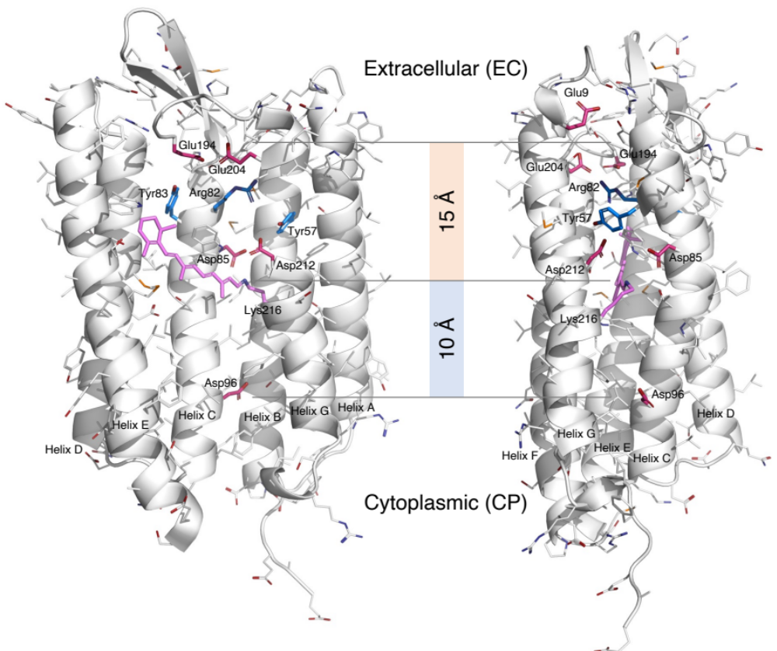

Figure S1. Orthographical views of EC and CP half channels. Parts of the structure are omitted to reveal the interior. The acidic residues in the half channels are highlighted in red. Those in the EC half channel are deprotonated. Asp96 in the hydrophobic CP half channel could be protonated (Gerwert et al., 1989). Arg82 in blue is protonated at neutral pH to form a positive charged guanidinium ion with a pK_{a} of 12.5. Tyr57 and 83 with a pK_{a} of 10 in blue could be deprotonated at alkaline pH.

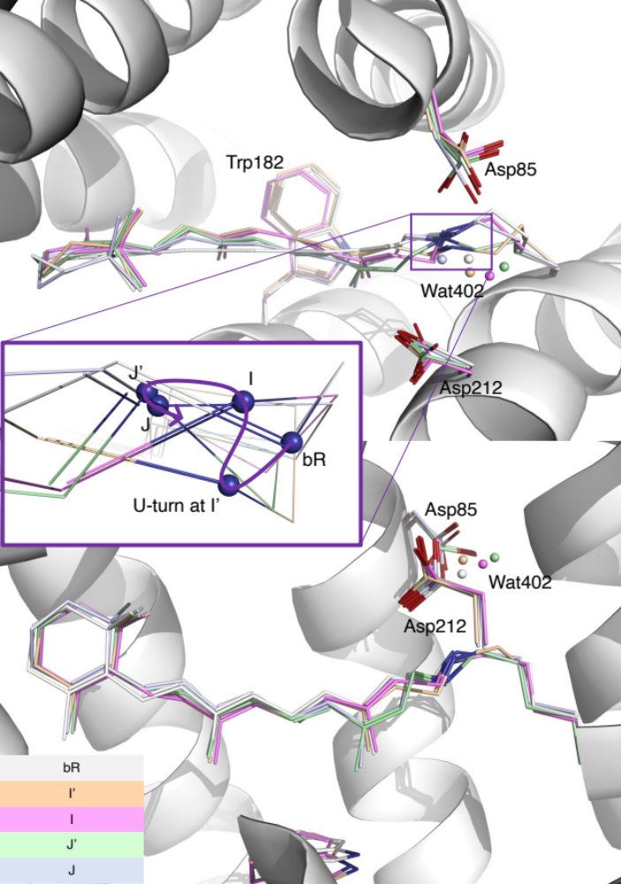

Figure S2. Two orthographical views of early intermediates. The refined conformations of the retinal and several key side chains are rendered in stick models of various colors. These early intermediates are compared with the resting state in white ribbon and stick model. Wat402 is rendered in small spheres. A zoom-in view of the SB is presented in the inset. N_{ζ} is shown in blue spheres. Its trajectory marked by a spline curve shows a sharp U-turn at I’ state. The SB moves toward the distal direction during I and J due to a creased retinal (Fig. 2b).

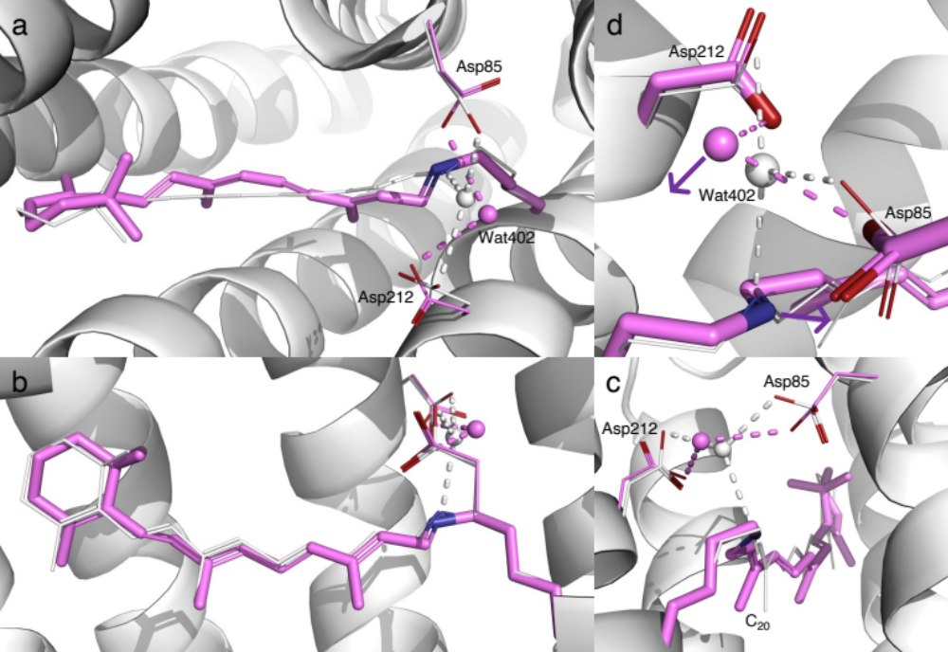

Figure S3. Refined structure of I state. (a, b, and c) Three orthographical views of retinal in I state. The refined retinal conformation in purple is compared with the resting state in white. The SB is pointing toward inboard with a perfect syn conformation at the single bond N_{ζ}-C_{ε}. C₂₀ methyl group remains tilted toward outboard. Wat402 with good electron density is displaced toward outboard and remains H-bonded with both Asp85 and 212. (d) Zoom-in view of SB and Wat402. Wat402 is 3.7 Å away from the SB N_{ζ}. The would-be H-bond directions of the SB and Wat402 are pointing toward the opposite directions as marked by the arrows. This geometry makes not only a H-bond impossible but also any proton transfer difficult.

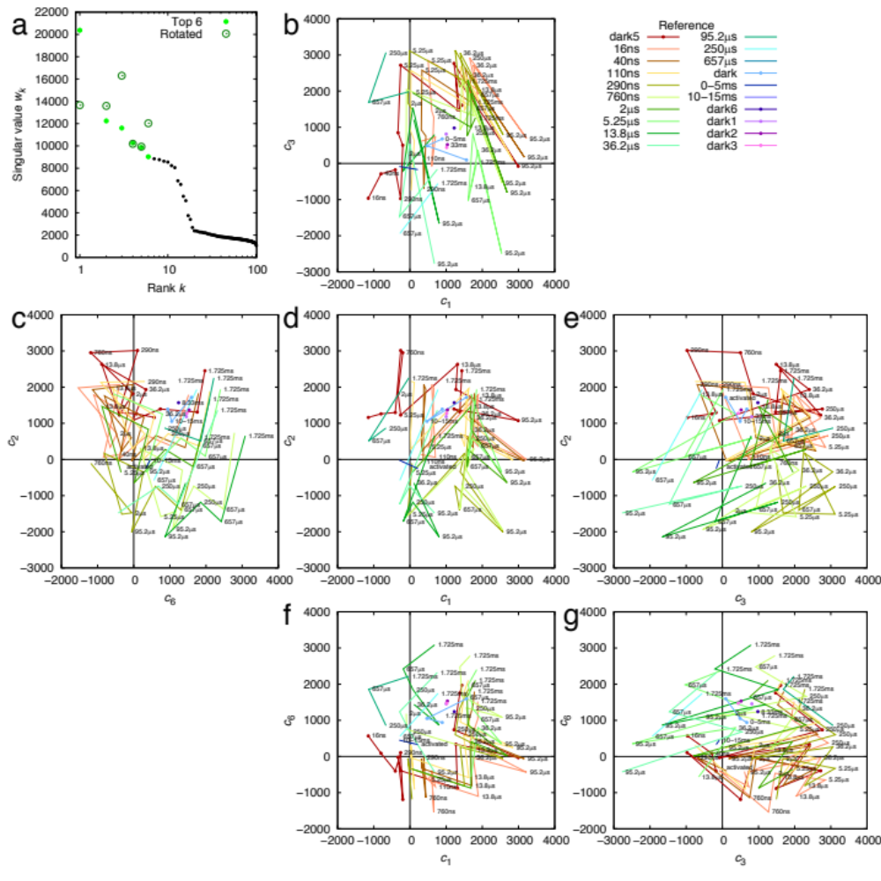

Figure S4. SVD analysis of difference Fourier maps at long delays > 10 ns. SVD analyses of difference Fourier maps result in time-dependent coefficients c_{k}(t), where k = 1, 2, …, each corresponding to a time-independent components U_{k}. Each raw difference map at a time delay t can be closely represented by a linear combination of these components, c₁(t)U₁ + c₂(t)U₂ + …, that is called a reconstituted difference map. Each of these components U_{k} and the reconstituted difference maps can be rendered in the same way as an observed difference map. The coefficient set c_{k}(t) is therefore a trace of the photocycle trajectory, when these time-dependent functions are plotted in a multi-dimensional space or plotted together against the common variable t. See Methods for detail. (a) Singular values before and after rotation (Ren, 2019, 2021). 19 components stand out. (b-g) Time-dependent coefficients of four components U₁, U₂, U₃, and U₆. Each pair of the adjacent orthographical views, horizontal or vertical, can be folded along a straight line between them to erect a three-dimensional space. Each colored trace represents difference maps in a time series calculated with a common reference. Those time series with a dark reference are plotted with thick lines with dots. Other series are in thin lines without dots.

Figure S5. Component maps U₁, U₂, U₃, and U₆ from long delays. The main chain and side chains of the protein are rendered with ribbons and sticks, respectively. The retinal and Lys216 are in purple sticks. Several key waters are in blue spheres. Parts of the structure are omitted to reveal more of the interior. The maps are contoured at ±3σ in green and red, respectively. (a) Two orthographical views of U₁. The signals are distributed over the EC half of the molecule. (b) Two orthographical views of U₂. The signals are concentrated around the proximal segment of the retinal. (c) Three orthographical views of U₃. Widespread signals are associated with all seven helices. (d) Two orthographical views of U₆. The signals are over the EC half of the molecule.

Figure S6. Component maps U₄ and U₅ from long delays. The main chain and side chains of the protein are rendered with ribbons and sticks, respectively. The retinal and Lys216 are in purple sticks. Several key waters are in blue spheres. Parts of the structure are omitted to reveal more of the interior. The maps are contoured at ±3σ in green and red, respectively. These components are not associated with a clear time dependency. Therefore, they are isolated but not used in structure refinement. (a) Two orthographical views of U₄. Some signals are distributed over the EC half of the molecule. (b) Two orthographical views of U₅. Some signals are located around the CP segments of helices E and F.

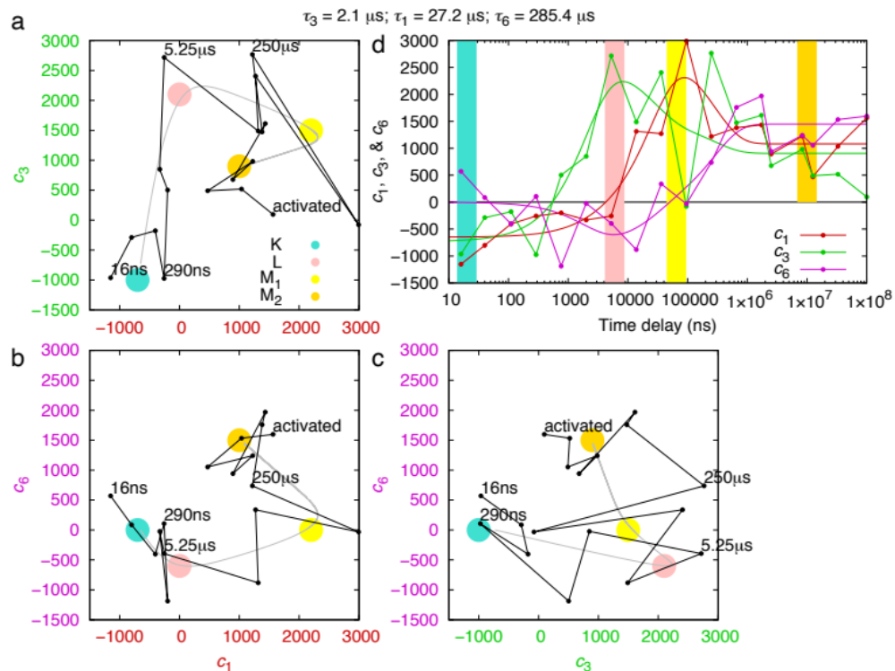

Figure S7. Exponential fitting of SVD coefficients of long delays. (a, b, and c) The time dependencies of the SVD coefficients c₁(t), c₃(t), and c₆(t) of the long delays are modeled with exponential functions (Methods). The time constant τ_{k} associated with the major change in each coefficient models a step in the reaction scheme K L M₁ M₂. τ₃ = 2.1±1 μs or a rate of 470 ms⁻¹ is the rate of increase in c₃(t). τ₁ = 27±10 μs or a rate of 37 ms⁻¹ describes the jump in c₁(t). τ₆ = 290±100 μs or a rate of 4 ms⁻¹ seems to separate M₁ and M₂. The fitted exponential functions are plotted as the gray curves through the black dots derived from SVD in three orthographical views of the three-dimensional subspace of c₁, c₃, and c₆. The large colored dots mark the relatively pure states of K, L, M₁, and M₂. (d) SVD coefficients and their exponential fittings as functions of time. The relatively pure states are marked as color bars at the approximate time. The result of exponential fitting shows the time-dependency clearer. The second component map U₂ seems to be a constant component without a time-dependent trend (Fig. S4cde). It describes significant changes near the SB and the retinal anchor (Figs. 3ab and S5b). The third component map U₃ increases sharply and consistently around 1 μs (Figs. S4beg). This component contains widespread signals associated with all seven helices (Fig. S5c), therefore describes the global changes during K L transition. The first component U₁ increases at 10 μs (Figs. S4bdf), which could reflect the changes during L M transition. U₁ clearly contains signals over the EC half of the molecule (Fig. S5a), which indicates events related to the proton release. Similarly, the sixth component U₆ also shows additional signals on the EC half to a lesser extent (Fig. S5d). This component seems to increase at a rather late time around hundreds of μs (Figs. S4cfg), which splits the M state into M₁ and M₂.

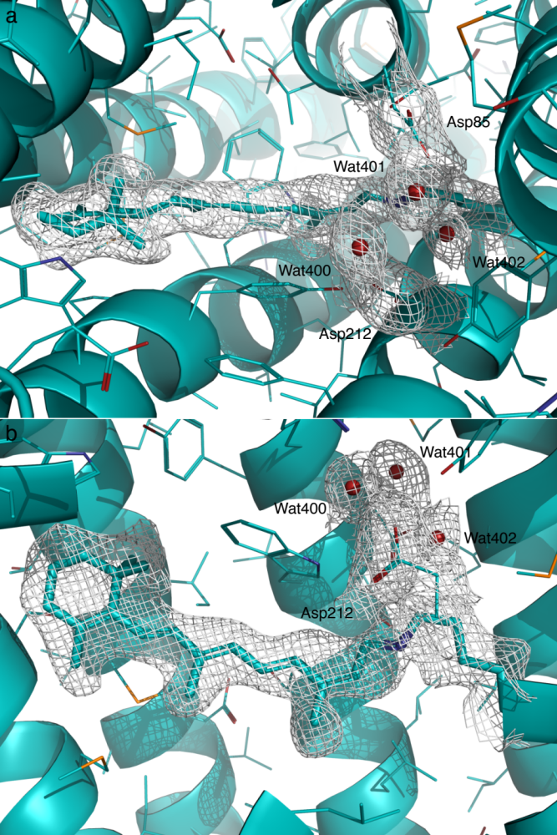

Figure S8. Two orthographical views of the 2Fo-Fc map of K contoured at 6σ. Here Fo is the reconstituted structure factor amplitudes rather than observed amplitudes (Table S2). Fc is the structure factor amplitudes calculated from the refined structure (Methods). The same applies to the other 2Fo-Fc maps.
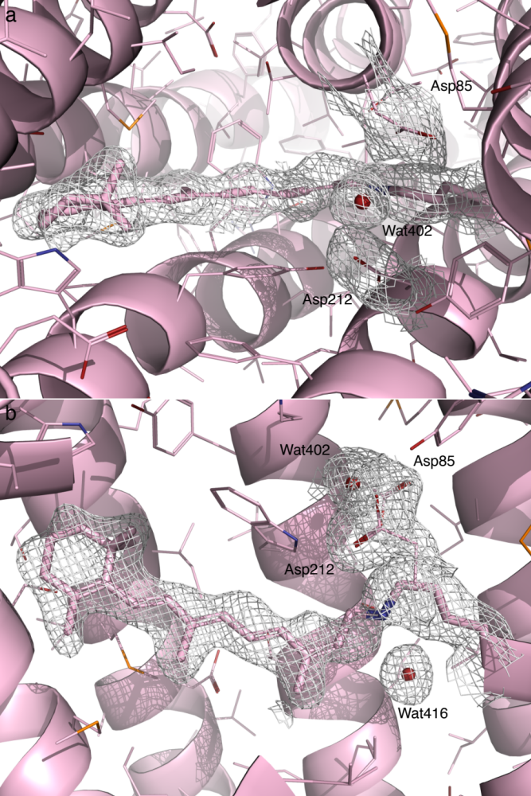

Figure S9. Two orthographical views of the 2Fo-Fc map of L contoured at 3.5σ. Here Fo is the reconstituted structure factor amplitudes rather than observed amplitudes (Table S2). Fc is the structure factor amplitudes calculated from the refined structure (Methods).

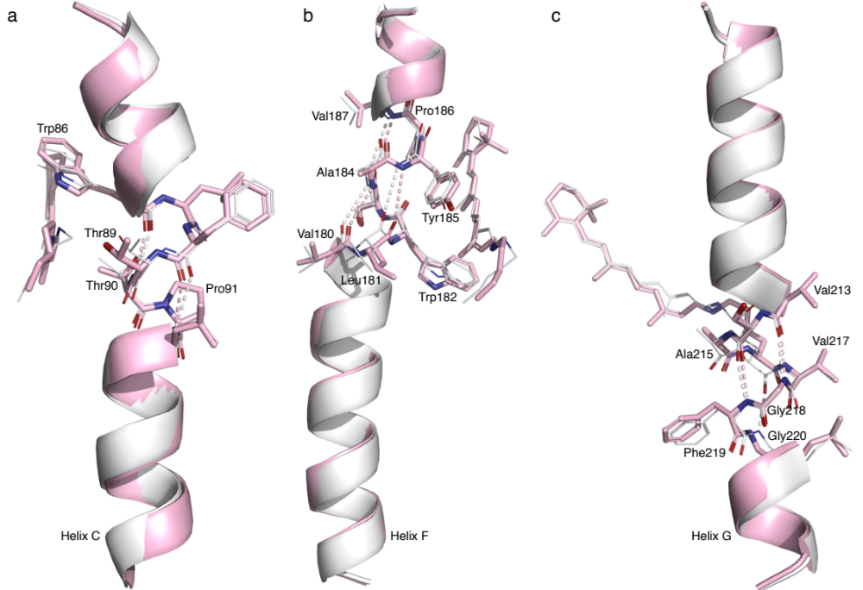

Figure S10. Irregularities in helices C, F, and G. bR in the resting state and L are rendered in white and pink, respectively. (a) Kinked helix C. All main chain H-bonds are regular except that Pro91 in helix C causes a kink. This kink was noticed as soon as the bR structure was determined to a reasonable resolution (Grigorieff et al., 1996). In the resting retinal, the corner of C_{ε} makes a contact with Thr89 and pushes the helix inboard. In bR, J, K, and L, C_{ε} moves more and more outboard (Fig. 3f). So does Thr89. The opposite motions occur in L, M₁, M₂, and back to bR (Fig. 4c). Thr90 also contributes to the seal. Pro91 is located exactly at right place to facilitate this spring-loaded bend. (b) Stretched helix F. Pro186 removes one H-bond in helix F. Several would-be H-bonds in the main chain around Pro186 are stretched to 3.6-4.2 Å in the resting state, such as Val180O-Ala184N, Leu181O-Tyr185N, and Ser183O-Val187N. Pro186 and these stretched H-bonds marked by dashed lines effectively breaks helix F into two segments. In J, K, and L, Trp182 is pushed by C₂₀ methyl group more and more toward the CP. The breakage in helix F stretches even more. P186L mutant is likely to feature an intact α helix F with uninterrupted main chain H-bonds. Its proton pumping activity is severely affected (Hackett et al., 1987). A more rigid helix F would increase the difficult to displace Trp182 toward the CP direction and hinder the opening of the CP half channel for proton uptake. (c) π helical segment in helix G. The retinal anchor is in a π helical segment with two main chain H-bonds Val213O-Gly218N and Ser214O-Phe219N. Unlike the regular α helix, a π helix features H-bonds from the carbonyl of residue n to the amide N of residue n+5. During the transition from the α helix to the π helical segment, Val217N does not have a H-bond partner. As the π helical segment transitions back to the regular α helical conformation, Ala215O does not join the H-bond pattern for helical formation. Loss of main chain H-bonds on both sides of the retinal anchor allows the anchor to move 1.2 Å in L. In addition, two nearby Gly218 and 220 increase the flexibility of the anchor.

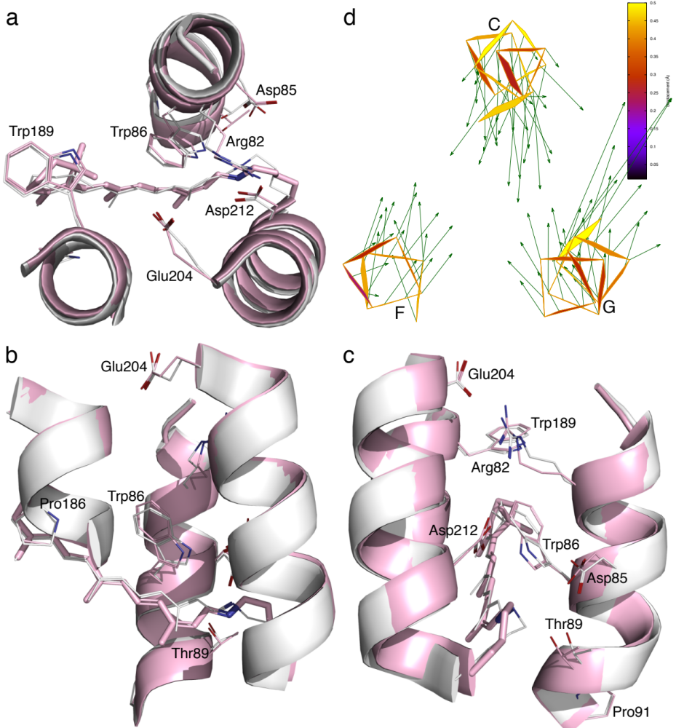

Figure S11. Tighter EC half channel in L. (a-c) Three orthographical views of the EC half channel. The resting state and L state are rendered in white and pink, respectively. (d) Atomic displacements in the main chain around the EC half channel from the resting state to L are marked with arrows 10× as long as the actual values.

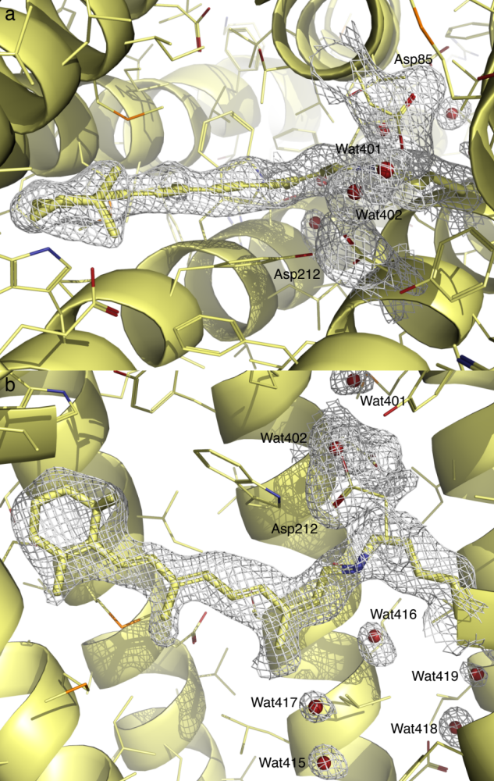

Figure S12. Two orthographical views of the 2Fo-Fc map of M₁ contoured at 3σ. Here Fo is the reconstituted structure factor amplitudes rather than observed amplitudes (Table S2). Fc is the structure factor amplitudes calculated from the refined structure (Methods).

Figure S13. Two orthographical views of the 2Fo-Fc map of M₂ contoured at 5σ. Here Fo is the reconstituted structure factor amplitudes rather than observed amplitudes (Table S2). Fc is the structure factor amplitudes calculated from the refined structure (Methods).

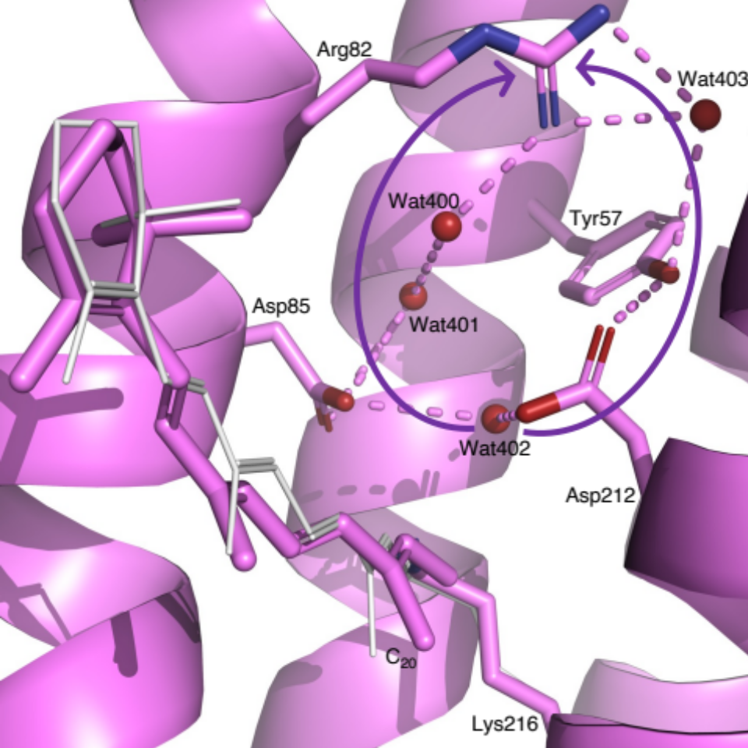

Figure S14. H-bond network at end of EC half channel in I state. Two curved arrows mark two possible proton conductance pathways. At more acidic EC pH, the pathway through Asp85 is in use and that through Asp212 is blocked by Tyr57. At more alkaline EC pH, Tyr57 could deprotonate thus the pathway through Asp212 may help to increase the proton flow. Both pathways conduct protons only under a concentration gradient of protons.

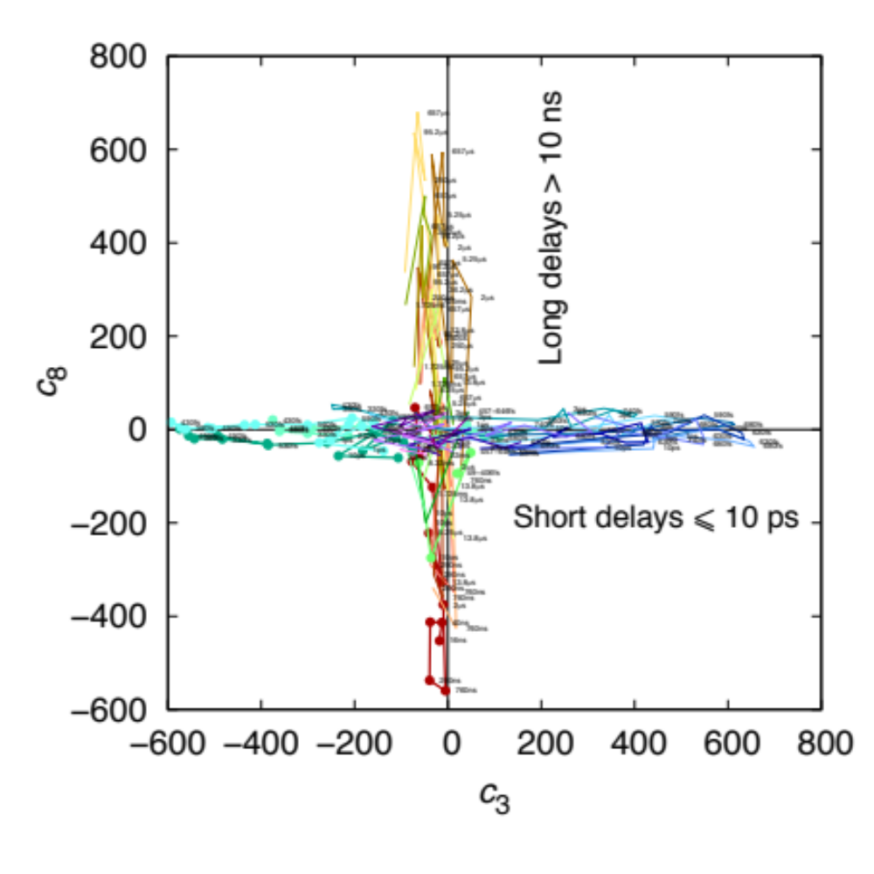

Figure S15. Short and long delays in two orthogonal subspaces. A preliminary SVD analysis shows that the difference Fourier maps at short and long delays do not share common features among the major components. This is an example to show that the third and eighth components are in two orthogonal subspaces. Each colored trace represents difference maps in a time series calculated with a common reference. Those time series with a dark reference are plotted in thick lines with dots. Other series are in thin lines without dots. Short delays are in cool colors and long delays are in warm colors.

