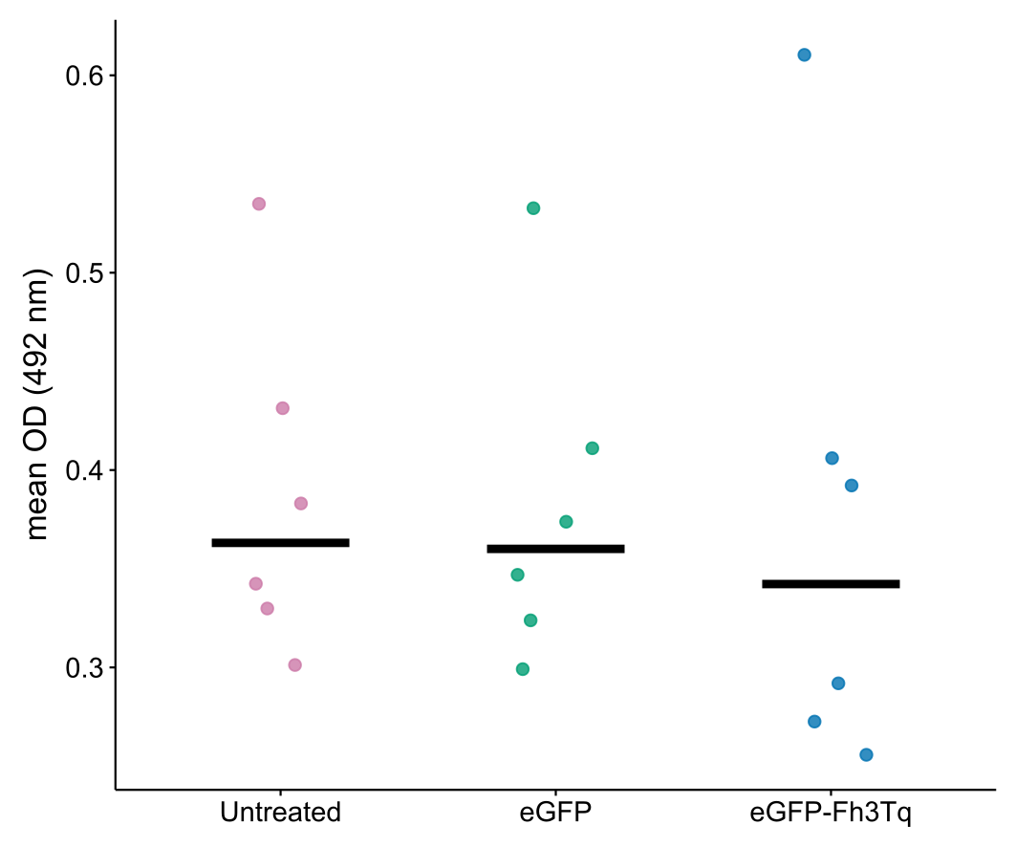
Supplementary Figure 1. Anti-peptide antibody response
T14-T15-T16 coated plates were probed by ELISA with D42 post-vaccination serum for IgG. Individual OD values are shown with group means (black bars). Groups: Untreated (PBS), eGFP (SLN-eGFP mRNA), and eGFP-Fh3Tq (SLN-eGFP-Fh3Tq mRNA).

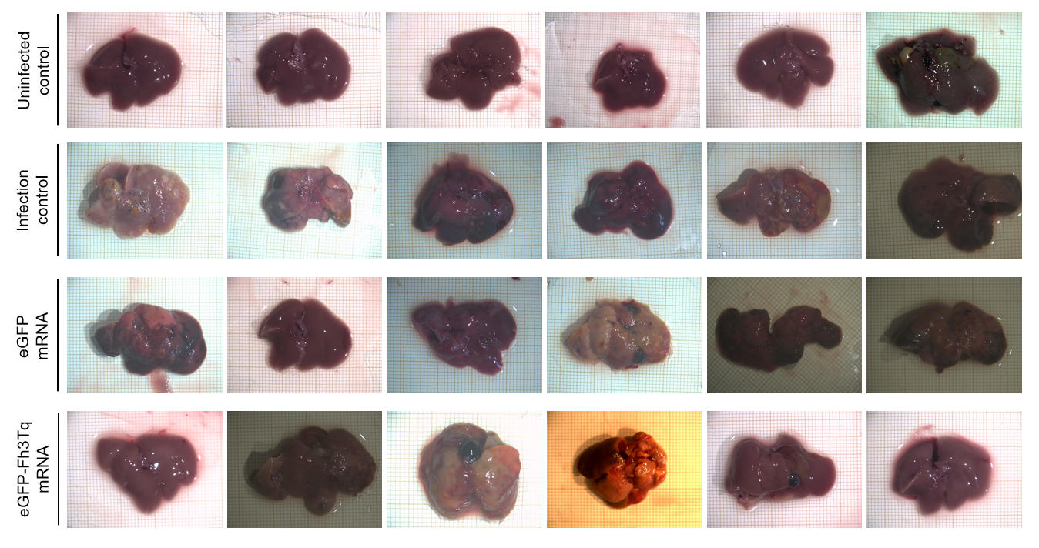
Supplementary Figure 2. Photographs of livers from each mouse at necropsy after F. hepatica challenge. Groups: Uninfected control (PBS, unchallenged), Infection control (PBS, challenged), eGFP (SLN-eGFP mRNA), and eGFP-Fh3Tq (SLN-eGFP-Fh3Tq mRNA).

Supplementary Table 1. Antibodies and reagents employed in spectral flow cytometry.
Antibody/Reagent | Clone | Source | Identifier | Panel
CD3 PE Fire700 | 17A2 | BioLegend | Cat# 100271,  RRID: AB_2876394 | 1, 2
CD4 BV605 | GK1.5 | BD Biosciences | Cat# 743156,  RRID: AB_2741309 | 1, 2, 3
CD5 BV750 | 53-7.3 | BD Biosciences | Cat# 747114,  RRID: AB_2871865 | 2
CD8a BUV395 | 53-6.7 | BD Biosciences | Cat# 563786,  RRID: AB_2732919 | 1, 2, 3
CD11b BV421 | M1/70 | BioLegend | Cat# 101236,  RRID: AB_11203704 | 1, 2
CD11c BUV615 | N418 | BD Biosciences | Cat# 751222,  RRID: AB_2875243 | 1, 2
CD19 RB545 | 1D3 | BD Biosciences | Cat# 569727,  RRID: AB_3668953 | 1, 2
CD21/CD35 APC | 7E9 | BioLegend | Cat# 123412,  RRID: AB_2085160 | 2
CD23 BUV737 | B3B4 | BD Biosciences | Cat# 749668,  RRID: AB_2873931 | 2
CD25 BV480 | PC61 | BD Biosciences | Cat# 566120,  RRID: AB_2739522 | 2
CD27 BB700 | LG.3A10 | BD Biosciences | Cat# 742135,  RRID: AB_2871394 | 2
CD43 BV510 | S7 | BD Biosciences | Cat# 563206,  RRID: AB_2738069 | 1, 2
CD44 APC Vio770 | REA664 | Miltenyi Biotec | Cat# 130-118-695,  RRID: AB_2733120 | 2, 3
CD45 BUV496 | 30F11 | BD Biosciences | Cat# 569673,  RRID: AB_3675211 | 1, 2, 3
CD45 APC | I3/2.3 | BioLegend | Cat# 147708,  RRID: AB_2563540 | 1, 2, 3
CD45.2 PerCP | 104 | BioLegend | Cat# 109826,  RRID: AB_893349 | 1, 2, 3
CD45R (B220) VioBlue | RA3-6B2 | Miltenyi Biotec | Cat# 130-118-321,  RRID: AB_2733945 | 1, 2, 3
CD62L BUV805 | MEL-14 | BD Biosciences | Cat# 569201,  RRID: AB_3668954 | 2, 3
CD69 BUV661 | H1.2F3 | BD Biosciences | Cat# 741478,  RRID: AB_2870943 | 2
CD93 RY586 | AA4.1 | BD Biosciences | Cat# 753131,  RRID: AB_3668955 | 2
CD103 PE Fire640 | QA17A24 | BioLegend | Cat# 156917,  RRID: AB_2924487 | 1, 2
CD127 RB780 | A7R34 | BD Biosciences | Cat# 569066,  RRID: AB_3668957 | 2
CD138 PE Cy5 | 281-2 | BD Biosciences | Cat# 142539,  RRID: AB_2894661 | 2
CD304 BUV563 | V46-1954 | BD Biosciences | Cat# 752460,  RRID: AB_2917455 | 2
CD335 (NKp46) BV711 | 29A1.4 | BioLegend | Cat# 137621,  RRID: AB_2563289 | 1, 2, 3
I-A/I-E (MHC-II) BV650 | M5/114.15.2 | BD Biosciences | Cat# 563415,  RRID: AB_2738192 | 1, 2
IgD BV605 | 11-26c.2a | BD Biosciences | Cat# 563003,  RRID: AB_2737944 | 2
IgM BUV395 | R6-60.2 | BD Biosciences | Cat# 564025,  RRID: AB_2738550 | 2
Ly6C PE Fire810 | HK1.4 | BioLegend | Cat# 128061,  RRID: AB_3083119 | 1, 2
Ly6G R718 | 1A8 | BD Biosciences | Cat# 567039,  RRID: AB_2916402 | 1, 2
Siglec-F AF647 | E50-2440 | BD Biosciences | Cat# 562680,  RRID: AB_2687570 | 1, 2
TCRβ RB545 | H57-597 | BD Biosciences | Cat# 756204,  RRID: AB_3668961 | 2, 3
ILA4 Vio515 | BVD4-1D11 | Miltenyi Biotec | Cat# 130-131-900,  RRID: AB_2660588 | 3
IL17A BV786 | TC11-18H10 | BD Biosciences | Cat# 564171,  RRID: AB_2738642 | 3
IL22 AF647 | MH22B2 | BD Biosciences | Cat# 56716,  RRID: AB_2916478 | 3
IFN-γ PE Cy7 | XMG1.2 | BioLegend | Cat# 505826,  RRID: AB_2295770 | 3
TruStain FcX™ PLUS | S17011E | BioLegend | Cat# 156604,  RRID: AB_2783138 | 1, 2, 3
Brilliant Stain Buffer Plus | N/A | BD Biosciences | Cat# 566385 | 1, 2, 3
True-Stain™ Monocyte Blocker | N/A | BioLegend | Cat# 426102 | 1, 2, 3
BD FACS™ Lysing Solution 10X | N/A | BD Biosciences | Cat# 349202 | 1, 2
FIX&PERM® Cell Fixation and Permeabilization Kit | N/A | Nordic-MUbio | Cat# GAS-002-1 | 3
Zombie NIR™ Fixable Viability Kit | N/A | BioLegend | Cat# 423105 | 1, 2, 3
Panel: 1, Blood innate; 2, Blood adaptive; 3, ICS in spleen.
Abbreviations: AF, Alexa Fluor; APC, allophycocyanin; BB, Brilliant Blue; BUV, Brilliant Ultraviolet; BV, Brilliant Violet; Cat#, catalog number; CF, Cyanin-based Fluorescent dye; Cy5, Cyanin 5; Cy7, Cyanin 7; N/A, not applicable; NIR, near-infrared; PE, phycoerythrin; PerCP, peridinin-chlorophyll-protein; RB, RealBlue; RY, RealYellow; R, Red; RRID, Research Resource Identifier.

Supplementary Table 2. Single-stained reference controls employed for spectral unmixing.
Antibody | Type of particle | Positive reference population
CD3 PE Fire700 | Beads | Beads
CD4+ IgD BV605 | Cells (pre-wash) | Lymphocytes
CD5 BV750 | Beads | Beads
CD8a + IgM BUV395 | Cells (pre-wash) | Lymphocytes
CD11b BV421 | Beads | Beads
CD11c BUV615 | Cells | Monocytes
CD19 + TCRβ RB545 | Cells | Lymphocytes
CD21/CD35 APC | Cells | Lymphocytes
CD23 BUV737 | Cells | Lymphocytes
CD25 BV480 | Beads | Beads
CD27 BB700 | Cells | Lymphocytes
CD43 BV510 | Cells | Monocytes
CD44 APC Vio770 | Cells | Lymphocytes
CD45 BUV496 | Cells | Lymphocytes
CD45 APC | Cells | Lymphocytes
CD45.2 PerCP | Cells | Lymphocytes
CD45R (B220) VioBlue | Cells | Lymphocytes
CD62L BUV805 | Cells | Lymphocytes
CD64 PE | Beads | Beads
CD69 BUV661 | Beads | Beads
CD93 RY586 | Cells | Lymphocytes
CD95 RB744 | Beads | Beads
CD103 PE Fire640 | Cells | Lymphocytes
CD127 RB780 | Cells | Lymphocytes
CD138 PE Cy5 | Beads | Beads
CD185 PE CF594 | Beads | Beads
CD279 (PD1) APC Fire810 | Beads | Beads
CD304 BUV563 | Cells | Lymphocytes
CD335 (NKp46) BV711 | Beads | Beads
F4/80 SparkNIR685 | Beads | Beads
GL7 RB705 | Beads | Beads
I-A/I-E (MHC-II) BV650 | Cells | Lymphocytes
Ly6C PE Fire810 | Cells | Monocytes
Ly6G Ly6G | Cells | Neutrophils
NK1.1 BV570 | Beads | Beads
Siglec F AF647 | Beads | Beads
Zombie NIR | Cells* | Dead cells
IFNγ PE Cy7 | Beads | Beads
IL4 Vio B515 | Beads | Beads
IL17A BV786 | Beads | Beads
IL22 AF647 | Beads | Beads
* Induce cell death prior to staining by incubating the cells at 60ºC for 10min prior to staining
Beads employed for spectral unmixing: UltraComp eBeadsTM (Thermo Fisher Scientific, cat. nr. 01-2222-42)
Abbreviations: AF, Alexa fluor; APC, allophycocyanin; BB; Brilliant Blue; BUV, Brilliant Ultraviolet; BV, Brilliant Violet; CF, Cyanin-based Fluorescent dye; Cy7, Cyanin7; N/A, not applicable; NIR, near-infrared; PE, Phycoerythrin; PerCP Cy5.5, Peridinin-chlorophyll-protein-cyanin 5.5; RB, RealBlue; RY, RealYellow; R, Red;

Supplementary Table 3. Immunophenotypic profiles employed for population identification in blood
Leukocyte population | Immunophenotype
Eosinophils | SSC^{hi}, Siglec F⁺, CD11c^{-/lo}, CD3⁻, CD19⁻, CD335⁻, F4/80⁻, Ly6G⁻
Total neutrophils | SSC^{hi}, Ly6G^{lo/+}, CD11b^{lo/+}, CD3⁻, CD11c⁻, CD19⁻, CD335⁻, F4/80⁻, Siglec F⁻
Immature neutrophils | SSC^{hi}, Ly6G^{lo}, CD11b^{lo/+}, CD3⁻, CD11c⁻, CD19⁻, CD335⁻, F4/80⁻, Siglec F⁻
Mature neutrophils | SSC^{hi}, Ly6G⁺, CD11b^{/+}, CD3⁻, CD11c⁻, CD19⁻, CD335⁻, F4/80⁻, Siglec F⁻
Monocytes | CD43^{-/+}, Ly6C^{-/+}, I-A/I-E^{-/lo}, CD3⁻, CD19⁻, CD335⁻, F4/80⁻, Ly6G⁻, Siglec F⁻
Classical monocytes | CD43⁻, Ly6C⁺, I-A/I-E^{-/lo}, CD3⁻, CD19⁻, CD335⁻, F4/80⁻, Ly6G⁻, Siglec F⁻
Intermediate monocytes | CD43⁺, Ly6C⁺, I-A/I-E^{-/lo}, CD3⁻, CD19⁻, CD335⁻, F4/80⁻, Ly6G⁻, Siglec F⁻
Non-classical monocytes | CD43⁺, Ly6C⁻, I-A/I-E^{-/lo}, CD3⁻, CD19⁻, CD335⁻, F4/80⁻, Ly6G⁻, Siglec F⁻
Dendritic cells (DC) | B220^{-/+}, CD11b^{-/+} CD11c^{-/+}, CD8a^{-/+}, CD103^{-/+}, I-A/I-E^{+/++}, CD3⁻, CD19⁻, CD335⁻, F4/80⁻, Ly6G⁻, Siglec F⁻
Plasmacytoid DC | B220⁺, CD11b⁻ CD11c^{-/+}, CD8a⁻, CD103⁻, I-A/I-E⁺, CD3⁻, CD19⁻, CD335⁻, F4/80⁻, Ly6G⁻, Siglec F⁻
Myeloid DC | B220⁻, CD11b^{-/+} CD11c⁺, CD8a^{-/+}, CD103^{-/+}, I-A/I-E⁺⁺, CD3⁻, CD19⁻, CD335⁻, F4/80⁻, Ly6G⁻, Siglec F⁻
cDC2 | B220⁻, CD11b⁺ CD11c⁺, CD8a⁻, CD103⁻, I-A/I-E⁺⁺, CD3⁻, CD19⁻, CD335⁻, F4/80⁻, Ly6G⁻, Siglec F⁻
cDC1 | B220⁻, CD11b^{-/lo} CD11c⁺, (CD8a and/or CD103)⁺, I-A/I-E⁺⁺, CD3⁻, CD19⁻, CD335⁻, F4/80⁻, Ly6G⁻, Siglec F⁻
Total lymphocytes | SSC^{lo/int}, CD45^{hi} (B220^{-/+} and/or CD3^{-/+} and/or CD19^{-/+} and/or CD335^{-/+})
NK cells | SSC^{lo}, CD45^{hi}, CD335+, B220⁻, CD3⁻, CD19⁻
Immature NK cells | SSC^{lo}, CD45^{hi}, CD335+, CD11b^{lo}, CD27⁺, B220⁻, CD3⁻, CD19⁻
Mature NK cells | SSC^{lo}, CD45^{hi}, CD335+, CD11b⁺, CD27^{lo}, B220⁻, CD3⁻, CD19⁻
Mature resting NK cells | SSC^{lo}, CD45^{hi}, CD335+, CD11b⁺, CD27^{lo}, Ly6C⁺, B220⁻, CD3⁻, CD19⁻
Mature non-resting NK cells | SSC^{lo}, CD45^{hi}, CD335+, CD11b⁺, CD27^{lo}, Ly6C^{-/lo}, B220⁻, CD3⁻, CD19⁻
T cells | SSC^{lo}, CD45^{hi}, CD3⁺, TCRβ^{-/+}, CD19⁻, CD335⁻
CD4⁺ CD8⁻ T cells | SSC^{lo}, CD45^{hi}, CD3⁺, CD4⁺, CD8⁻, TCRβ⁺, CD19⁻, CD335⁻
TFH | SSC^{lo}, CD45^{hi}, CD3⁺, CD4⁺, CD8⁻, CD185⁺, CD279⁺, TCRβ⁺, CD19⁻, CD335⁻
Treg | SSC^{lo}, CD45^{hi}, CD3⁺, CD4⁺, CD8⁻, CD127^{lo}, (CD25⁺ and/or CD304⁺), TCRβ⁺, CD19⁻, CD335⁻
CD25⁺ Treg | SSC^{lo}, CD45^{hi}, CD3⁺, CD4⁺, CD8⁻, CD25⁺, CD127^{lo}, CD304^{-/+}, TCRβ⁺, CD19⁻, CD335⁻
CD25⁻ Treg | SSC^{lo}, CD45^{hi}, CD3⁺, CD4⁺, CD8⁻, CD25⁻, CD127^{lo}, CD304⁺, TCRβ⁺, CD19⁻, CD335⁻
CD4+ Th cells | SSC^{lo}, CD45^{hi}, CD3⁺, CD4⁺, CD8⁻, CD127⁺, TCRβ⁺, CD19⁻, CD335⁻
CD4⁻ CD8⁺ T cells | SSC^{lo}, CD45^{hi}, CD3⁺, CD4⁻, CD8⁺, TCRβ⁺, CD19⁻, CD335⁻
CD4⁺ CD8⁺ T cells | SSC^{lo}, CD45^{hi}, CD3⁺, CD4⁺, CD8⁺, TCRβ⁺, CD19⁻, CD335⁻
CD4⁻ CD8^{-/lo} TCRαβ+ T cells | SSC^{lo}, CD45^{hi}, CD3⁺, CD4⁻, CD8^{-/lo}, TCRβ⁺, CD19⁻, CD335⁻
CD4⁻ CD8^{-/lo} TCRγδ+ T cells | SSC^{lo}, CD45^{hi}, CD3⁺, CD4⁻, CD8^{-/lo}, TCRβ⁻, CD19⁻, CD335⁻
B cells | SSC^{lo/int}, CD45^{hi}, B220^{-/+}, CD19⁺, CD3⁻, CD335⁻
B1 B cells | SSC^{lo}, CD45^{hi}, B220^{-/lo}, CD19⁺, CD3⁻, CD335⁻
B1a B cells | SSC^{lo}, CD45^{hi}, B220^{-/lo}, CD5⁺, CD19⁺, CD3⁻, CD335⁻
B1b B cells | SSC^{lo}, CD45^{hi}, B220⁺, CD5⁻, CD19⁺, CD3⁻, CD335⁻
B2 B cells | SSC^{lo}, CD45^{hi}, B220⁺, CD19⁺, CD3⁻, CD335⁻
Immature B2 cells | SSC^{lo}, CD45^{hi}, B220⁺, CD19⁺, CD93+, CD3⁻, CD335⁻
Mature MZ B2 cells | SSC^{lo}, CD45^{hi}, B220⁺, CD19⁺, CD21/CD35^{hi}, CD23^{lo}, CD43⁻, CD93⁻, IgD^{lo}, IgM^{hi}, CD3⁻, CD335⁻
Mature Follicular B2 cells | SSC^{lo}, CD45^{hi}, B220⁺, CD19⁺, CD21/CD35^{lo}, CD23^{hi}, CD43⁺, CD93⁻, IgD^{hi}, IgM^{lo}, CD3⁻, CD335⁻
Abbreviations: cDC, Conventional dendritic cells; hi, high; int, intermediate; GC, germinal center; lo, low; MZ, marginal zone; SSC, side scatter; TFH, T follicular helper cells; Th, T helper; Treg, regulatory T cells.

