Supplementary Information
Chemical Mapping of Crocus sativus L. Floral Parts for Assessing Compositional Consistency and Auto-Adulteration in Saffron-Based Botanicals

Hilva Gjoni¹, Guillem Campmajó^{1*}, Marco Biagi¹, Renato Bruni¹, Chiara Dall’Asta¹

¹Department of Food and Drug, University of Parma, Parma, Italy

* Corresponding author: Guillem Campmajó
Department of Food and Drug, University of Parma, Parma, Italy
(e-mail: guillem.campmajogalvan@unipr.it)

Supplementary Figure 1 Stability of directional projections under compound resampling. Directional scores were recalculated using (i) macro-class block bootstrap resampling (n = 1500) and (ii) feature subsampling without replacement (80% of compounds, n = 500). Points represent mean projections and error bars indicate 95% empirical confidence intervals.
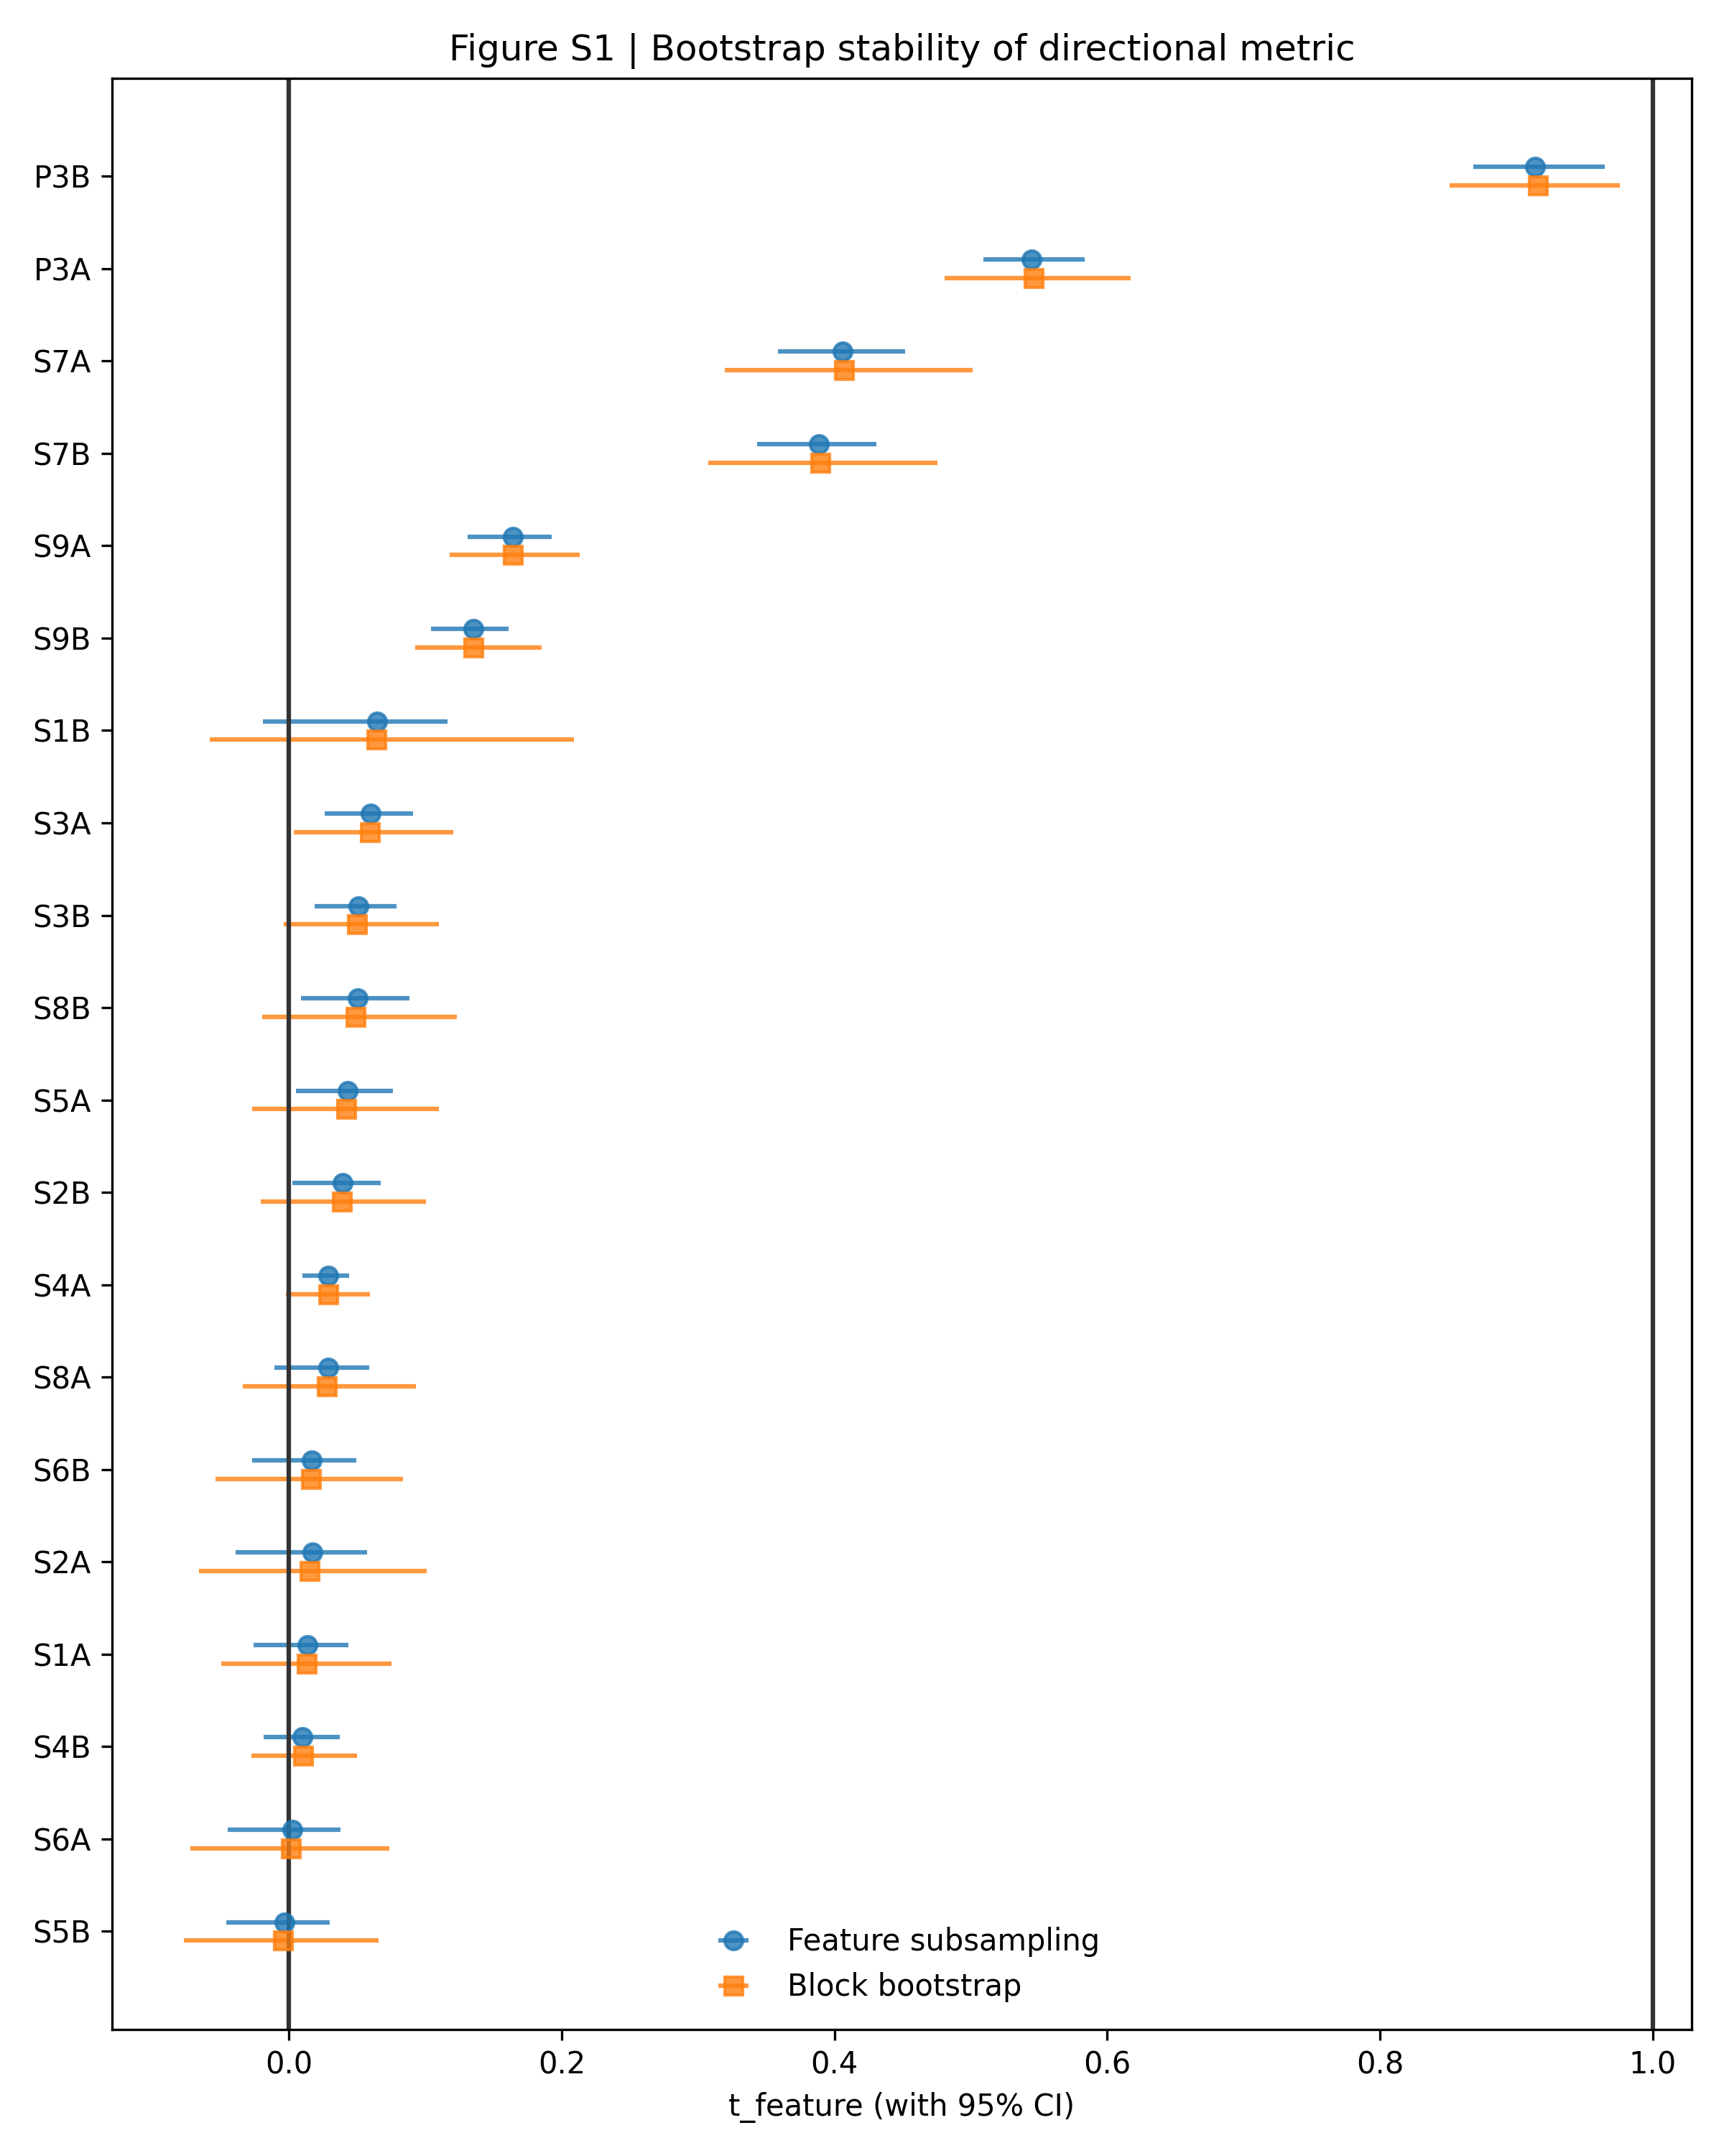
Confidence intervals were narrow for all supplements, and no major rank inversions were observed under resampling. These results confirm that directional positioning is not driven by small subsets of compounds or individual chemical classes.

Table S1 Tentative identification by LC−TWIMS−HRMS of C. sativus secondary metabolites
Measured accurate mass | RT (min) | Ion assignment | Molecular formula | Accurate mass error (ppm) | Isotopic pattern match error (%) | MS/HRMS | CCS (Å²) | Putative identification | Identification confidence level
PHENOLIC COMPOUNDS
Anthocyanins
627.1561 | 1.39 | [M]⁺ | C₂₇H₃₁O₁₇⁺ | 0.8 | 3.4 | 303.0497 | 244.46 | Delphinidin 3,5-O-diglucoside (Delphin) | 2
611.1614 | 2.29 | [M]⁺ | C₂₇H₃₁O₁₆⁺ | 1.2 | 17.95 | 287.0547 | 239.47 | Cyanidin 3,5-O-diglucoside | 2
641.1719 | 2.39 | [M]⁺ | C₂₈H₃₃O₁₇⁺ | 1.1 | 0.45 | 317.0654 | 248.99 | Petunidin 3,5-O-diglucoside (Petunin) | 2
465.1030 | 2.52 | [M]⁺ | C₂₁H₂₁O₁₂⁺ | 0.5 | 1.98 | 257.0445 / 303.0497 | 204.42 | Delphinidin 3-O-glucoside | 2
595.1568 | 2.55 | [M]⁺ | C₂₇H₃₁O₁₅⁺ | 0.0 | 7.77 | 271.0603 | 238.91 | Pelargonidin 3,5-O-diglucoside | 2
655.1874 | 2.65 | [M]⁺ | C₂₉H₃₅O₁₇⁺ | 0.8 | 6.49 | 331.0813 / 353.0649 | 254.24 | Malvidin 3,5-diglucoside (Malvin) | 2
479.1186 | 2.80 | [M]⁺ | C₂₂H₂₃O₁₂⁺ | 0.5 | 1.58 | 302.0419 / 317.0653 | 209.73 | Petunidin 3-O-glucoside | 2
493.1341 | 3.02 | [M]⁺ | C₂₃H₂₅O₁₂⁺ | 0.1 | 14.12 | 331.0807 | 214.49 | Malvidin 3-O-glucoside (Oenin) | 2
271.0604 | 3.76 | [M]⁺ | C₁₅H₁₁O₅⁺ | 1.3 | 7.91 | - | 155.38 | Pelargonidin | 3
Flavonols
787.1949 | 2.50 | [M-H]⁻ | C₃₃H₄₀O₂₂ | 1.3 | 3.30 | 462.0808 / 625.1416 | 263.56 | Quercetin 3,7,4'-triglucoside | 2
771.1997 | 2.60 | [M-H]⁻ | C₃₃H₄₀O₂₁ | 1.0 | 2.65 | 284.0322 / 609.1457 | 273.92 | Kaempferol 3-O-sophoroside 7-O-glucoside | 2
755.2043 | 2.71 | [M-H]⁻ | C₃₃H₄₀O₂₀ | 0.4 | 1.61 | 446.0869 / 593.1520 | 274.21 | Kaempferol 3-O-sophoroside-7-O-rhamnoside | 2
625.1415 | 2.88 | [M-H]⁻ | C₂₇H₃₀O₁₇ | 0.7 | 7.53 | 271.0251 / 300.0264 / 301.0351 | 238.91 | Quercetin diglucoside isomer A | 3
609.1461 | 2.94 | [M-H]⁻ | C₂₇H₃₀O₁₆ | -0.1 | 1.21 | 283.0248 / 285.0403 / 447.0928 | 253.02 | Kaempferol-3,7-di-O-β-D-glucoside | 2
771.1994 | 2.98 | [M-H]⁻ | C₃₃H₄₀O₂₁ | 0.7 | 0.33 | 284.0324 / 285.0400 / 609.1462 | 271.10 | Kaempferol 3,7,4'-O-triglucoside | 2
593.1513 | 3.06 | [M-H]⁻ | C₂₇H₃₀O₁₅ | 0.1 | 2.49 | 325.0714 / 353.0665 / 383.0781 / 473.1091 / 503.1204 | 240.38 | Kaempferol diglycoside isomer | 3
625.1417 | 3.08 | [M-H]⁻ | C₂₇H₃₀O₁₇ | 1.1 | 4.49 | 301.0355 | 241.84 | Quercetin diglucoside isomer B | 3
651.1598 | 3.09 | [M-H]⁻ | C₂₉H₃₂O₁₇ | 4.8 | 12.69 | 284.0322 / 285.0400 / 446.0857 / 447.0919 | 260.48 | Kaempferol 3-(6''-acetylglycoside)-7-glycoside isomer A | 3
771.1997 | 3.20 | [M-H]⁻ | C₃₃H₄₀O₂₁ | 0.9 | 2.04 | 284.0325 / 285.0395 / 489.1070 / 651.1600 | 257.40 | Kaempferol triglucoside isomer | 3
625.1411 | 3.23 | [M-H]⁻ | C₂₇H₃₀O₁₇ | 0.2 | 1.55 | 255.0297 / 271.0245 / 301.0347 | 234.00 | Quercetin 3-O-sophoroside | 2
609.1459 | 3.26 | [M-H]⁻ | C₂₇H₃₀O₁₆ | -0.4 | 1.70 | 283.0247 / 285.0397 / 446.0851 / 447.0943 | 245.82 | Kaempferol 7-O-sophoroside | 2
663.1530 | 3.31 | [M+Na]⁺ | C₂₈H₃₂O₁₇ | -0.3 | 7.99 | 317.0649 / 501.1001 | 247.21 | Isorhamnetin 3,7-diglucoside | 2
609.1466 | 3.41 | [M-H]⁻ | C₂₇H₃₀O₁₆ | 0.9 | 0.60 | 227.0351 / 255.0299 / 284.0327 | 232.98 | Kaempferol 3-O-sophoroside | 2
663.1526 | 3.45 | [M+Na]⁺ | C₂₈H₃₂O₁₇ | -0.9 | 6.29 | 317.0655 | 248.99 | Isorhamnetin 3-O-sophoroside | 2
593.1511 | 3.57 | [M-H]⁻ | C₂₇H₃₀O₁₅ | -0.1 | 8.51 | 227.0350 / 255.0303 / 284.0329 / 285.0392 | 229.14 | Kaempferol 3-O-rutinoside | 2
623.1613 | 3.63 | [M-H]⁻ | C₂₈H₃₂O₁₆ | -0.7 | 2.52 | 243.0295 / 271.0248 / 285.0405 / 299.0194 / 314.0428 | 237.82 | Isorhamnetin 4'-neohesperidoside | 2
505.0990 | 3.73 | [M-H]- | C₂₃H₂₂O₁₃ | 0.5 | 5.44 | 300.0274 / 301.0338 | 213.80 | Quercetin acetylhexoside isomer A | 3
623.1606 | 3.76 | [M-H]⁻ | C₂₈H₃₂O₁₆ | -1.8 | 18.81 | 315.0502 / 345.0611 | 236.53 | Isorhamnetin 3-O-rutinoside | 2
651.1563 | 3.82 | [M-H]⁻ | C₂₉H₃₂O₁₇ | -0.5 | 2.66 | 227.0352 / 255.0297 / 284.0324 / 285.0391 | 245.08 | Kaempferol 3-(6''-acetylglycoside)-7-glycoside isomer B | 3
447.0936 | 3.83 | [M-H]⁻ | C₂₁H₂₀O₁₁ | 0.7 | 0.34 | 227.0352 / 255.0298 / 284.0324 | 201.37 | Kaempferol 3-O-glucoside | 2
477.1037 | 3.91 | [M-H]- | C₂₂H₂₂O₁₂ | -0.3 | 3.9 | 243.0297 / 257.0458 / 271.0249 / 285.0404 / 314.0430 | 209.41 | Isorhamnetin 3-O-glucoside | 2
447.0934 | 3.94 | [M-H]⁻ | C₂₁H₂₀O₁₁ | 0.2 | 16.08 | 257.0443 / 284.0332 / 285.0399 | 212.69 | Kaempferol 7-O-glucoside | 2
505.0987 | 3.94 | [M-H]- | C₂₃H₂₂O₁₃ | -0.2 | 2.02 | 151.0033 / 257.0434 / 300.0270 / 301.0331 | 212.83 | Quercetin acetylhexoside isomer B | 3
447.0938 | 4.03 | [M-H]⁻ | C₂₁H₂₀O₁₁ | 1.0 | 10.65 | 284.0319 | 215.67 | Kaempferol hexoside isomer | 3
489.1041 | 4.21 | [M-H]⁻ | C₂₃H₂₂O₁₂ | 0.5 | 2.15 | 227.0349 / 255.0298 / 284.0332 / 285.0392 | 213.32 | Kaempferol 3-(6''-acetylglycoside) isomer | 3
301.0349 | 4.61 | [M-H]⁻ | C₁₅H₁₀O₇ | -1.4 | 5.73 | - | 162.76 () | Quercetin | 2
285.0404 | 5.10 | [M-H]⁻ | C₁₅H₁₀O₆ | 0.0 | 4.28 | 211.0401 / 255.0306 | 160.21 () | Kaempferol | 2
317.0651 | 5.21 | [M+H]⁺ | C₁₆H₁₂O₇ | -1.5 | 3.94 | 153.0180 / 229.0507 | 167.23 | Isorhamnetin | 2
Flavones
431.0981 | 3.57 | [M-H]⁻ | C₂₁H₂₀O₁₀ | -0.7 | 9.96 | 283.0611 / 311.0554 | 202.19 | Isovitexin (Apigenin 6-glucoside) | 2
593.1510 | 3.71 | [M-H]⁻ | C₂₇H₃₀O₁₅ | -0.4 | 2.33 | 284.0324 / 285.0396 | 233.31 | Luteolin 7-O-rutinoside | 2
593.1507 | 3.76 | [M-H]- | C₂₇H₃₀O₁₅ | -0.8 | 1.77 | 269.0454 / 291.0293 | 232.69 | Apigenin diglucoside isomer | 3
431.0983 | 3.96 | [M-H]- | C₂₁H₂₀O₁₀ | -0.1 | 8.98 | 268.0393 / 269.0443 | 208.89 | Apigenin 7-glucoside | 2
285.0398 | 4.60 | [M-H]⁻ | C₁₅H₁₀O₆ | -2.3 | 4.41 | - | 162.59 | Luteolin | 2
Flavanonols
287.0556 | 4.18 | [M-H]- | C₁₅H₁₂O₆ | -1.6 | 5.74 | - | 163.75 | Dihydrokaempferol | 2
Flavanones
271.0610 | 5.06 | [M-H]⁻ | C₁₅H₁₂O₅ | -0.8 | 4.11 | - | 162.22 | Naringenin | 2
CROCINS
1161.4211 | 3.61 | [M+Na]⁺ | C₅₀H₇₄O₂₉ | 0.3 | 1.46 | 675.2627 / 837.3157 | 341.78 | trans-5-tG | 2
1161.4213 | 3.72 | [M+Na]⁺ | C₅₀H₇₄O₂₉ | 0.4 | 0.66 | 675.2624 / 837.3144 | 335.93 | trans-5-nG | 2
1161.4206 | 3.85 | [M+Na]⁺ | C₅₀H₇₄O₂₉ | -0.2 | 4.74 | 837.3150 | 350.28 | cis-5-tG | 2
975.3717 | 3.89 | [M-H]⁻ | C₄₄H₆₄O₂₄ | 0.2 | 1.14 | 239.1804 / 283.1702 / 327.1599 / 651.2653 | 329.10 | trans-crocin (trans-4-GG) | 2
975.3713 | 4.06 | [M-H]⁻ | C₄₄H₆₄O₂₄ | -0.2 | 1.20 | 283.1705 / 327.1599 / 651.2654 | 326.14 | trans-4-tg | 2
859.3242 | 4.17 | [M+FA-H]⁻ | C₃₈H₅₄O₁₉ | 0.1 | 0.72 | 283.1702 | 324.43 | trans-3-Gg | 2
975.3719 | 4.48 | [M-H]⁻ | C₄₄H₆₄O₂₄ | 0.4 | 14.72 | 239.1806 / 283.1706 / 327.1601 / 489.2130 / 651.2656 | 318.89 | trans-4-ng | 2
975.3721 | 4.59 | [M-H]⁻ | C₄₄H₆₄O₂₄ | 0.6 | 1.33 | 283.1702 / 327.1603 / 349.1421 / 651.2655 | 314.44 | Crocin isomer A | 3
1161.4213 | 4.64 | [M+Na]⁺ | C₅₀H₇₄O₂₉ | 0.4 | 3.2 | 837.3152 | 341.04 | cis-5-nG | 2
1161.4207 | 4.81 | [M+Na]⁺ | C₅₀H₇₄O₂₉ | -0.1 | 1.46 | 675.2625 | 334.62 | Crocetin diester pentaglycoside isomer A | 3
813.3190 | 4.91 | [M-H]⁻ | C₃₈H₅₄O₁₉ | 0.4 | 17.52 | 239.1803 / 283.1700 / 327.1598 / 349.1422 / 651.2656 | 295.81 | Crocin II isomer A | 3
1161.4209 | 4.93 | [M+Na]⁺ | C₅₀H₇₄O₂₉ | 0.1 | 11.70 | 619.2361 / 837.3150 / 859.3570 / 1021.4250 | 349.18 | Crocetin diester pentaglycoside isomer B | 3
975.3723 | 5.02 | [M-H]⁻ | C₄₄H₆₄O₂₄ | 0.8 | 0.61 | 239.1804 / 283.1703 / 327.1600 / 651.2658 | 315.77 | cis-crocin (cis-4-GG) | 2
975.3717 | 5.15 | [M-H]⁻ | C₄₄H₆₄O₂₄ | 0.2 | 2.21 | 239.1803 / 283.1701 / 327.1599 / 349.1419 / 651.2654 | 323.54 | Crocin isomer B | 3
975.3720 | 5.26 | [M-H]⁻ | C₄₄H₆₄O₂₄ | 0.5 | 1.22 | 651.2656 | 318.45 | Crocin isomer C | 3
837.3148 | 5.34 | [M+Na]⁺ | C₃₈H₅₄O₁₉ | -0.4 | 0.58 | 347.0942 / 513.2092 / 675.2623 | 297.62 | cis-3-Gg | 2
837.3139 | 5.48 | [M+Na]⁺ | C₃₈H₅₄O₁₉ | -1.5 | 5.16 | 675.2627 | 303.99 | Crocin II isomer B | 3
651.2659 | 5.93 | [M-H]⁻ | C₃₂H₄₄O₁₄ | 0.1 | 0.78 | 239.1806 / 283.1705 / 327.1602 | 259.24 | trans-2-gg | 2
651.2660 | 6.03 | [M-H]⁻ | C₃₂H₄₄O₁₄ | 0.2 | 0.11 | 239.1807 / 283.1705 / 349.1421 | 268.55 | trans-2-G | 2
513.2094 | 6.50 | [M+Na]⁺ | C₂₆H₃₄O₉ | -0.3 | 1.27 | 351.1570 | 229.33 | trans-1-g | 2
513.2095 | 6.57 | [M+Na]⁺ | C₂₆H₃₄O₉ | 0.0 | 1.67 | 351.1572 | 231.92 | cis-1-g | 2
OTHERS
369.1510 | 2.55 | [M+Na]⁺ | C₁₆H₂₆O₈ | -2.7 | 18.22 | 121.1014 / 149.0960 / 167.1066 | 178.68 | Picrocrocinic acid | 2
353.1571 | 3.48 | [M+Na]⁺ | C₁₆H₂₆O₇ | -0.1 | 1.26 | 123.1166 / 151.1108 / 233.1020 | 176.08 | Picrocrocin | 2

Table S2 Stability of directional ranking across alternative imputation strategies. Directional scores (t_feature) were recalculated under zero baseline, half-minimum, and 5th-percentile-based imputation schemes. Rank concordance was quantified using Spearman’s ρ and Kendall’s τ. Top-3 and Top-5 overlap indicate the number of shared samples among the highest-ranked supplements.

method_A | method_B | spearman_rho | kendall_tau | top3_overlap | top5_overlap
zero | halfmin | 0.792208 | 0.662338 | 3 | 5
halfmin | q05 | 0.867871 | 0.731602 | 3 | 5
zero | q05 | 0.751553 | 0.601732 | 3 | 5

Directional rankings were moderately to strongly correlated across imputation strategies (Spearman ρ = 0.75–0.87). Importantly, the top five supplements were preserved across all imputation schemes, indicating that primary conclusions are robust to reasonable preprocessing variation.

