Supplementary material of ‘Controlling the dynamics of electric field driven droplet on a lubricant-infused surface’
Geng Wang^{1,2,3}, Junyu Yang⁴, Timan Lei⁵, Jin Chen², Halim Kusumaatmaja^{4*}, Kai Li^{6,1,3*}, Kai H. Luo^{3*}
- National Microgravity Laboratory, Institute of Mechanics, Chinese Academy of Sciences, Beijing 100190, China
- Department of Mechanical Engineering, University College London, Torrington Place, London WC1E 7JE, UK
- School of Engineering Science, University of Chinese Academy of Sciences, Beijing 100049, China
- Institute for Multiscale Thermofluids, School of Engineering, The University of Edinburgh, Edinburgh, UK
- Chair of Building Physics, Department of Mechanical and Process Engineering, ETH Zürich (Swiss Federal Institute of Technology in Zürich), Zürich 8092, Switzerland
- School of Fundamental Physics and Mathematical Sciences, Hangzhou Institute for Advanced Study, UCAS, Hangzhou, 310024, China
* Corresponding Authors:
halim.kusumaatmaja@ed.ac.uk (H. K.)
likai@imech.ac.cn (K. L.)
k.luo@ucl.ac.uk (K. H. L.)

Mesh sensitivity assessment
A mesh resolution sensitivity analysis is conducted in this section. The validation is performed from two aspects, which are ternary multiphase flow and ternary flow coupled with an electric field. First, similar to the case in Fig. 3(b), different mesh resolutions are used to simulate the droplet deceleration during sliding on a lubricant-infused pillar. For all cases, the droplet radius is $R_{0}=0.5$ mm and the initial velocity is $V_{0}=0.4 m/s$. Three mesh resolutions $dx=R_{0}/35$, $dx=R_{0}/70$ and $dx=R_{0}/105$ are examined. The quantitative comparison of dimensionless droplet displacement $S^{*}$ is shown in Fig. S1 (right axis). It can be seen that when the mesh resolution is increased from $R_{0}/35$ to $R_{0}/70$ or $R_{0}/105$, the maximum error in $S^{*}$ remains within 5%. In addition, Fig. S1(b) presents a qualitative comparison of the droplet morphology at $t/t_{c}=24$ for the three mesh resolutions. The droplet shapes are highly consistent, with only minor differences observed in the thickness of the lubricant cloak layer.
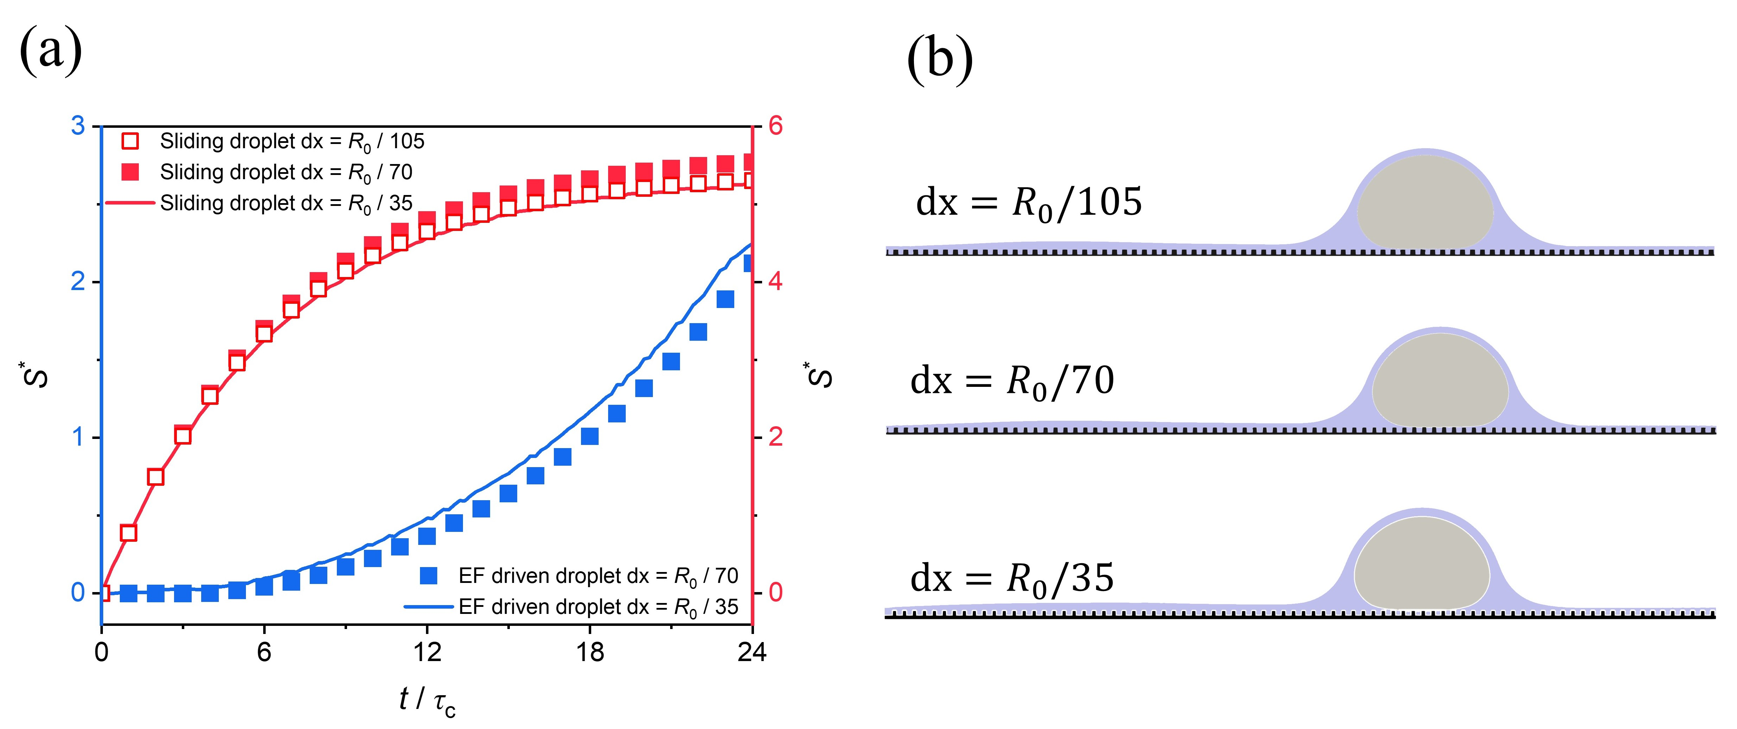
Figure S1. For cases with different mesh resolutions, (a) shows a quantitative comparison of $S^{*}$ for sliding deceleration (right axis) and EF driven (left axis) droplet on LIS. (b) is a qualitative comparison of the sliding droplet morphology at $t/t_{c}=24$.
Then, similar to Fig. 4, the above simulations are extended to EF driven droplet motion on LIS. The results of droplet displacement $S^{*}$ obtained using resolutions of $R_{0}/35$ and $R_{0}/70$ are compared. In this simulation, we set $S_{0}=9.3R_{0}$ and $E_{0}=0.6E_{c}$. It is observed that at the end of the simulation ($t/t_{c}=24$), the maximum error in $S^{*}$ between the two resolutions is also approximately 5%. Considering the computational complexity of the present model and the large number of three-dimensional simulations performed, a mesh resolution of $R_{0}/35$ is adopted. This resolution ensures that the key features are accurately captured while maintaining a reasonable computational cost.

Correlation analysis of $C_{α}$
In this section, we perform a correlation analysis of the constant parameter $C_{α}$ appearing in Eq. (1) of the main text. In particular, we examine the effects of the simulation configuration (3D or Q3D), the initial lubricant thickness, and $I_{os(w)}/I_{s}$. Figure S2 plots the relationship between $I_{os(w)}/I_{s}$ and $C_{α}$ for different $h_{oil}$ with both 3D and Q3D simulations, where:
$$\begin{aligned}C_{α}=\frac{C_{drag,sim}}{\left(1+1.5{\left(\frac{I_{os\left(w\right)}}{I_{s}}\right)}^{2}\right)\left(\frac{\overset{ˉ}{μ}}{μ_{0}}\right)}.\#（S1）\end{aligned}$$
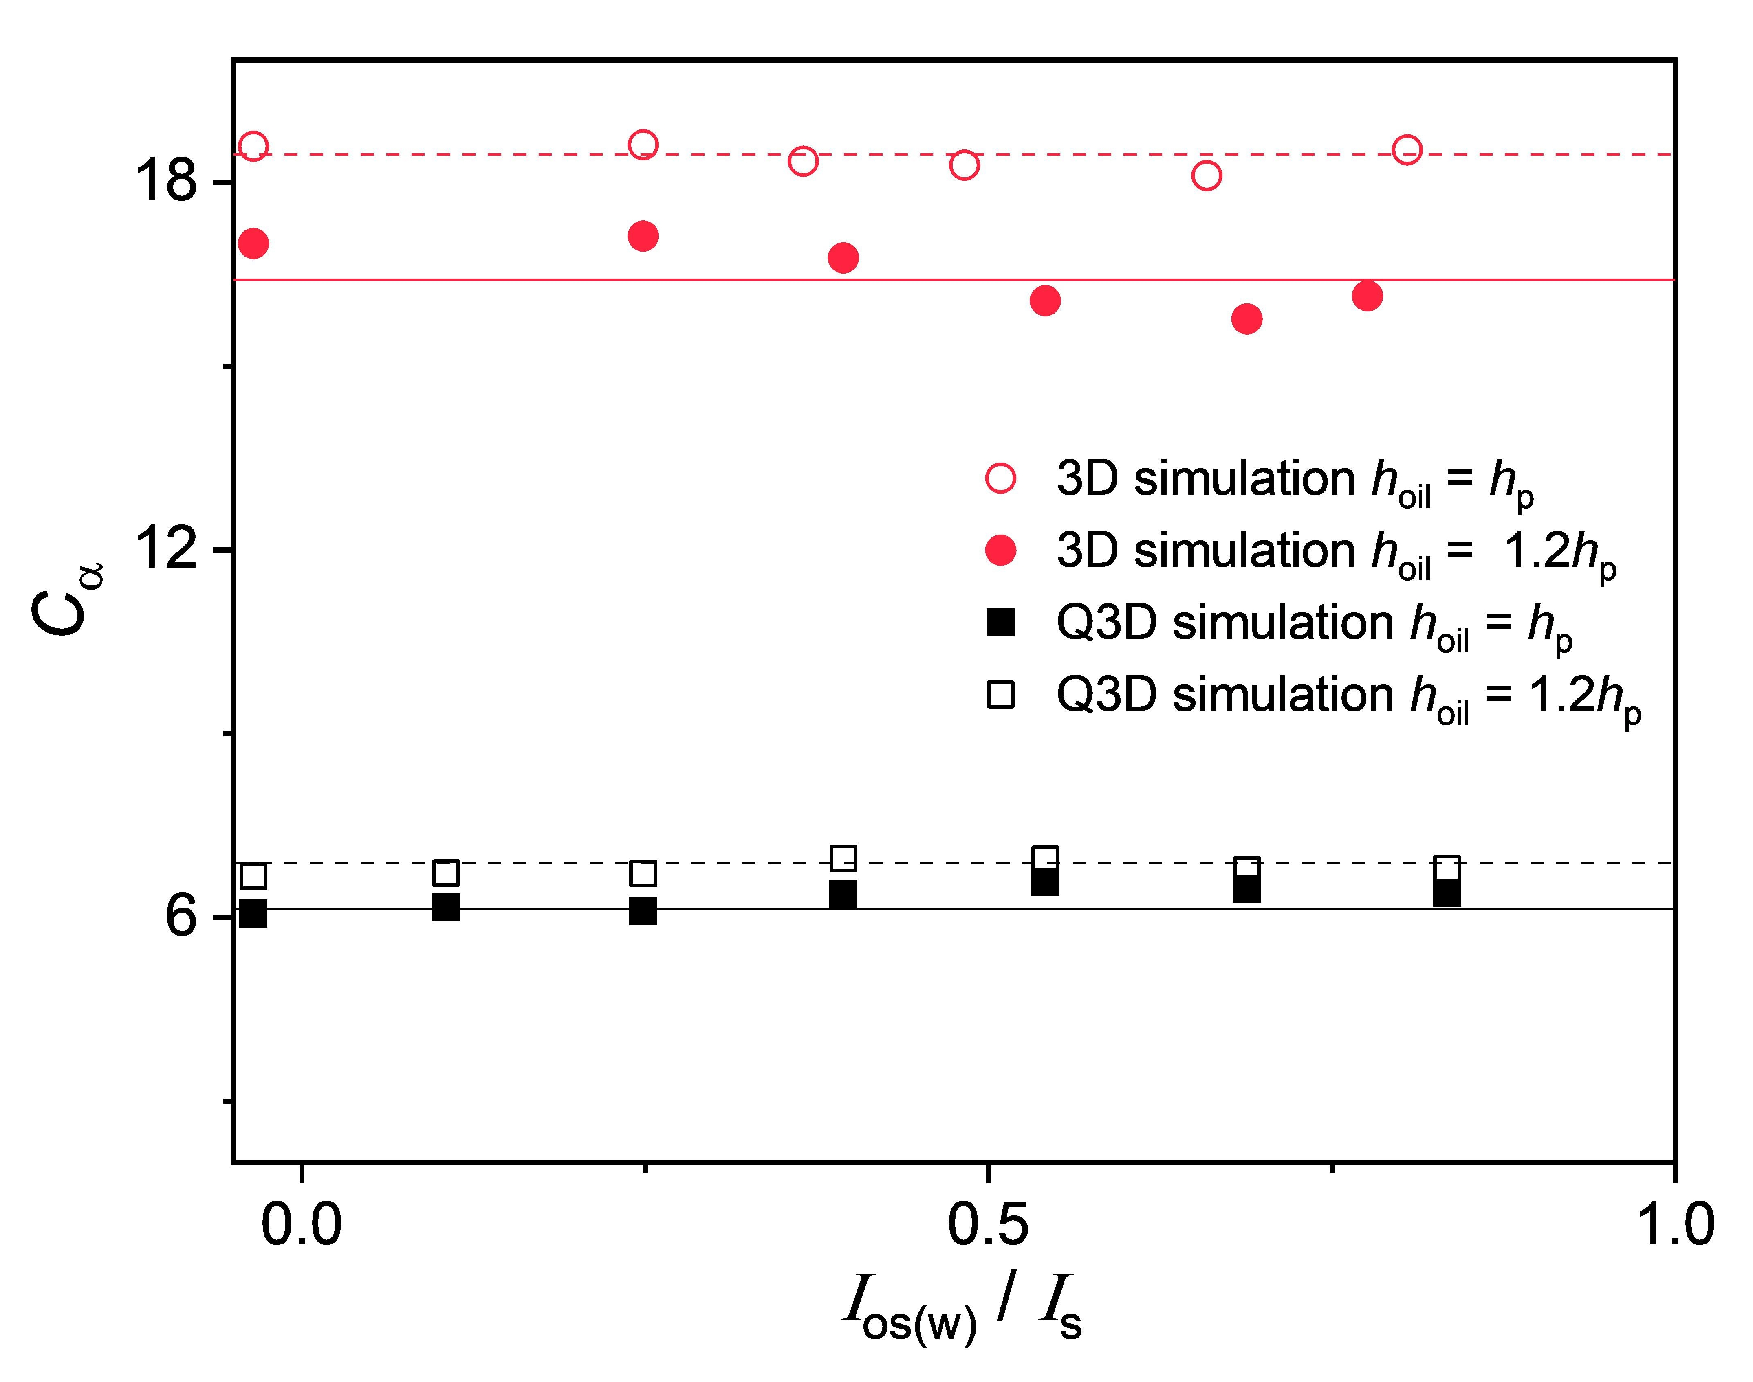
Figure S2. $C_{α}$ as a function of $I_{os(w)}/I_{s}$ for different $h_{oil}$ for 3D and Q3D simulations. The lines represent the best fitted values for $C_{α}$ that we employ for further calculations in the main text.
As shown in Fig. S2, the values of $C_{α}$ mainly related to the simulation configuration (3D or Q3D) and $h_{oil}$ when $I_{os(w)}/I_{s}$ increases from 0 to 0.8, while it is nearly independent of $I_{os(w)}/I_{s}$. The lines represent the best-fitted values of $C_{α}$ for different $h_{oil}$ in the 3D and Q3D cases.

Validation of drag force
Figures S3(a) and S3(b) show the evolution of the velocity $V$ and the normalised displacement $S^{*}$ for droplets with $R_{0}=0.5$mm decelerating on LIS at different initial velocities. The symbols represent the LBM simulation results, while the solid lines denote the analytical solutions obtained by solving the droplet force balance equation, in which $F_{drag}$ is given by equation (1) in the main text.
$$\begin{aligned}F_{drag}=-m\frac{dV}{dt}=-m\frac{d^{2}S}{dt^{2}}.\#（S2）\end{aligned}$$
Figure S3(c) presents the comparison between the LBM results and the analytical solutions for different $R_{0}$. It can be seen that equation (1) in the main text accurately describes $F_{drag}$ for different initial velocities and droplet radius, and the LBM results are in excellent agreement with the analytical solutions.
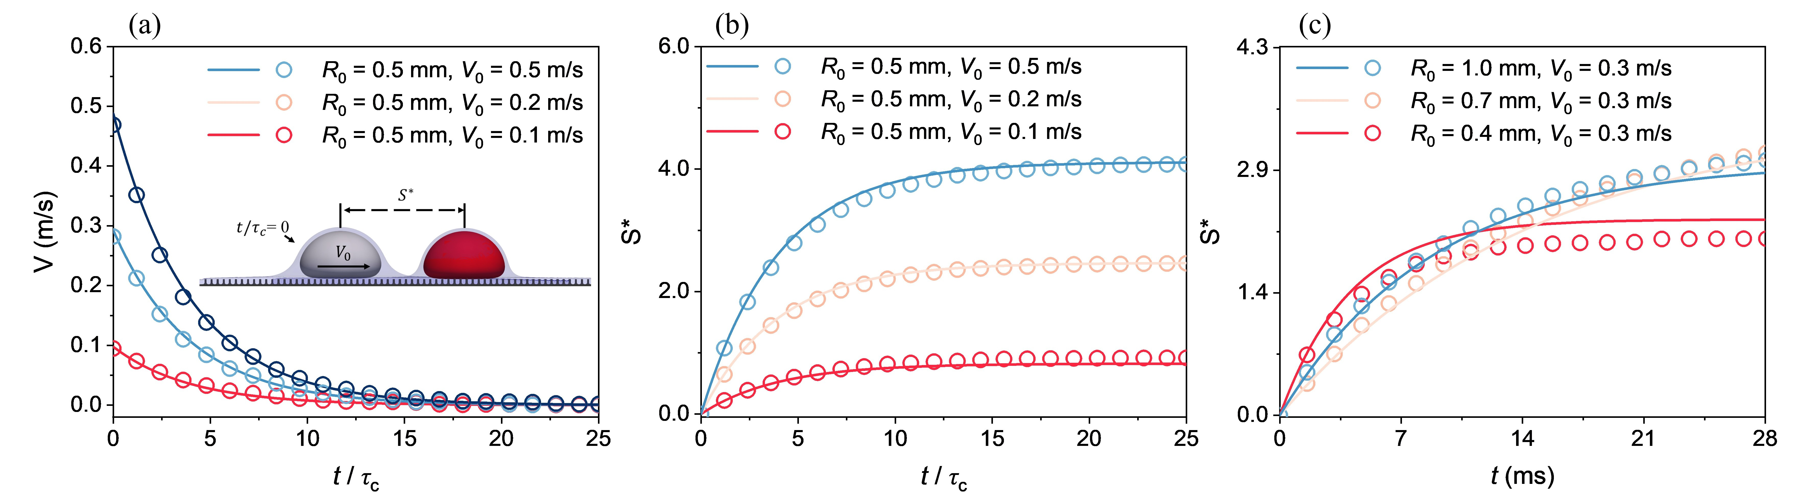
Figure S3. Transient evolution of (a) the velocity $V$ and (b) the normalised displacement $S^{*}$during droplets sliding deceleration on LIS for with different initial velocities. (c) is the transient evolution of $S^{*}$ for droplets with different initial radius. Symbols in the figures represent the LBM simulation results and the lines denote the analytical solutions.
Figure S4(a) shows the evolution of $S^{*}$ for droplets with different $θ_{ws}$ and $θ_{os}$, with $R_{0}=0.5$mm, $μ_{o}=1$cP, and $V_{0}=0.4 m/s$. It can be observed that, depending on the value of $I_{os(w)}/I_{s}$, the droplet motion can be classified into three different regimes. For cases with $I_{os(w)}/I_{s}>0.8$, the droplet is almost stationary due to pinning on the micropillar surface. For cases with $I_{os(w)}/I_{s}<0$, the evolution of $S^{*}$ for cases with different $θ_{ws}$ is nearly identical and follows the analytical solution with $I_{os(w)}/I_{s}=0$ (black solid line in Fig. S4(a)). When $0<I_{os(w)}/I_{s}<0.8$, the droplet evolution can be described by solving the analytical solution in Eq. (S2).
Figure S4(b) shows the evolution of $S^{*}$ for droplets with different $μ_{o}$. It can be seen that the LBM results are in good agreement with the analytical solutions. However, for cases with larger $μ_{o}$, the LBM results show a slight decrease in $S^{*}$ after reaching the maximum value. This is because the high-viscosity lubricant accumulates at the meniscus at the front of the droplet during motion. After the initial kinetic energy of the droplet is dissipated, the accumulated lubricant pushes the droplet backwards, leading to a small recoil of $S^{*}$.
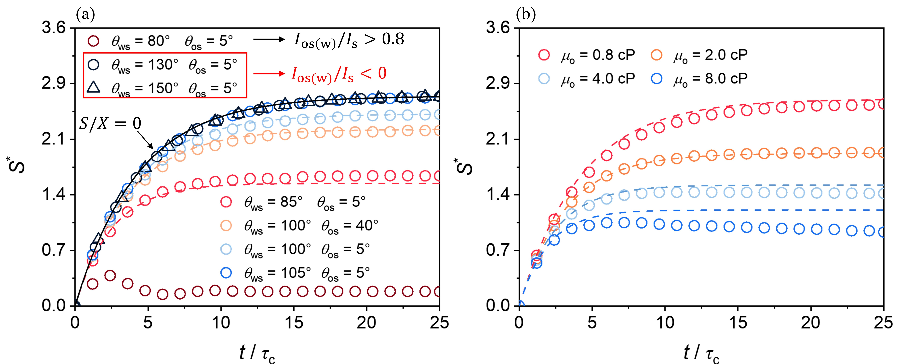
Figure 4. Transient evolution of $S^{*}$during droplet sliding deceleration on LIS with (a) different $θ_{ws}$ and $θ_{os}$ and (b) lubricant viscosity $μ_{o}$. Symbols represent the LBM simulation results, and the lines denote the analytical solutions.

Derivation of the electric-field force
In this section, the derivation of the analytical solution for the electric field force is presented and validated through comparison with LBM results. For the electric field far from the droplet, the electric potential $φ(x,y)$ satisfies the Laplace equation:
$$\begin{aligned}\frac{∂^{2}φ}{∂x^{2}}+\frac{∂^{2}φ}{∂y^{2}}=0.\#\left(S3\right)\end{aligned}$$
In our simulation, the bottom boundary $\left(y = 0\right)$ is set as a grounded boundary. The top boundary $\left(y = L_{y}\right)$ and left boundary $\left(x = 0\right)$ are insulating boundaries. The right boundary $\left(x = L_{x}\right)$ can be recognized as a mixed boundary condition, with a driven electrode segment $\left.y∈(y_{c},L_{y}\right]$ held at $φ_{0}$ and an insulating segment $\left.y∈[0,y_{c}\right)$ with $∂φ/∂x=0$. The above boundary conditions can be summarized as:
$$φ\left(x,0\right)=0, \frac{∂φ}{∂y}\left(x,L_{y}\right)=0, \frac{∂φ}{∂x}(0,y)=0,$$
$$\begin{aligned}φ\left(L_{x},y\right)=φ_{0} \left(y>y_{c}\right), \frac{∂φ}{∂x}\left(L_{x},y\right)=0\left(y<y_{c}\right).\#\left(S4\right)\end{aligned}$$
To satisfy $φ\left(x,0\right)=0$and $∂φ/∂y(x,L_{y})=0$, $φ$ is expanded in the orthogonal basis $sin⁡(α_{n}y)$, with transverse wavenumbers:
$$\begin{aligned}α_{n}=\frac{\left(2n+1\right)π}{2L_{y}},n=0,1,2,⋯\#\left(S5\right)\end{aligned}$$
By adopting separation of variables solution for Eq. (S3), a solution satisfies $∂φ/∂x(0,y)=0$ can be written as:
$$\begin{aligned}φ\left(x,y\right)=\sum_{n=0}^{∞}{A_{n}}\cosh\left(α_{n}x\right)\sin\left(α_{n}y\right).\#\left(S6\right)\end{aligned}$$
Imposing the mixed boundary condition at $x=L_{x}$ using a weighted-residual projection onto $sin⁡(α_{n}y)$ yields a scalar relation for each mode. Defining the segment integrals:
$$\begin{aligned}J_{D,n}=\int_{y_{c}}^{L_{y}}{\sin^{2}}\left(α_{n}y\right)dy, J_{N,n}=\int_{y_{c}}^{L_{y}}{\sin^{2}}\left(α_{n}y\right)dy,\#\left(S7\right)\end{aligned}$$the modal amplitude can be expressed compactly as:
$$\begin{aligned}A_{n}=\frac{φ_{0}\cos\left(α_{n}y_{c}\right)}{ α_{n}\left(\cosh\left(α_{n}L_{x}\right)J_{D,n} + α_{n}\sinh\left(α_{n}L_{x}\right)J_{N,n}\right)}.\#\left(S8\right)\end{aligned}$$
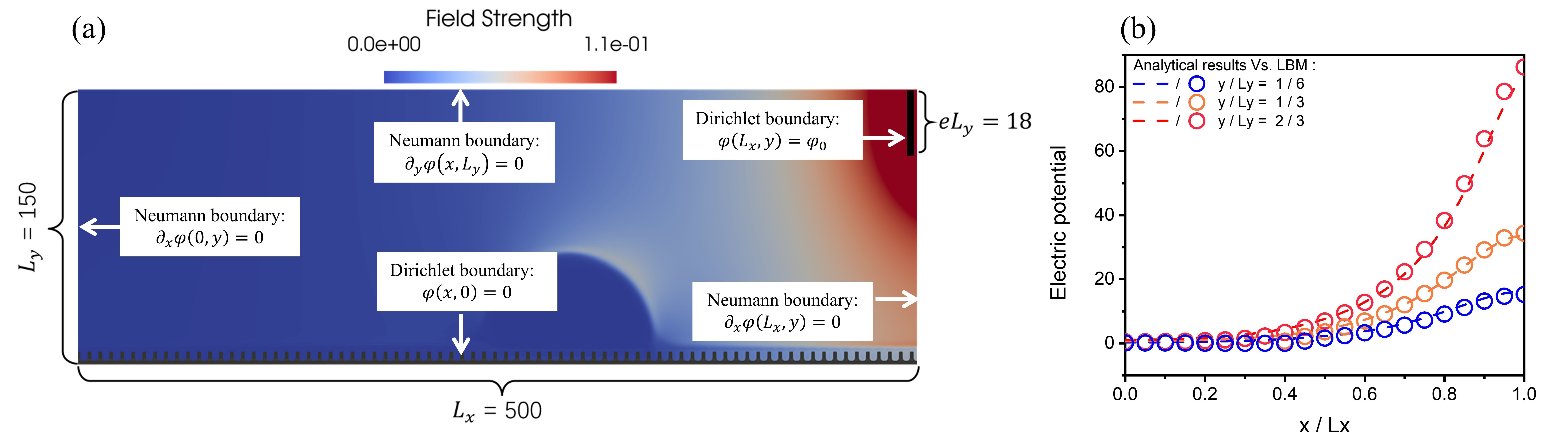
Figure S5. (a) Qualitative illustration of the simulation domain and the spatial electric field strength distribution for the validation case. (b) Quantitative comparison of the electric potential obtained from LBM simulations (symbols) and the analytical solution (lines) at different heights
In the semi-infinite-strip approximation ($i.e.,L_{x}→ ∞$), the hyperbolic factor reduces to an exponential decay ($e^{-α_{n}(L_{x}-x)}$) away from the driven boundary. Thus Eq. (S6) has:
$$\begin{aligned}φ\left(x,y\right)=\sum_{n=0}^{∞}{B_{n}}e^{-α_{n}\left(L_{x}-x\right)}\sin\left(α_{n}y\right),\#\left(S9\right)\end{aligned}$$
This form automatically satisfies Laplace’s equation and $(L_{x}-x)→ ∞$, where $B_{n}$ can be achieved by subscribing $L_{x}→ ∞$ into Eq. (S8):
$$\begin{aligned}B_{n}=\frac{φ_{0}\cos\left(α_{n}y_{c}\right)}{α_{n}\left(J_{D}\left(α_{n}\right)+α_{n}J_{N}\left(α_{n}\right)\right)},\#\left(S10\right)\end{aligned}$$
considering $\sin^{2}(αy)=(1-cos⁡(2αy))/2$ we have:
$$\begin{aligned}\int{{sin⁡}^{2}(αy) dy}=\frac{y}{2}-\frac{sin⁡(2αy)}{4α},\#\left(S11\right)\end{aligned}$$
according to Eq. (S5), we have $2α_{n}L_{y}=(2n+1)π$, hence:
$$\begin{aligned}J_{D,n}=\frac{L_{y}-y_{c}}{2}+\frac{sin⁡(2α_{n}y_{c})}{4α_{n}}, \\ J_{N,n}=\frac{y_{c}}{2}-\frac{sin⁡(2α_{n}y_{c})}{4α_{n}},\#\left(S12\right)\end{aligned}$$
For simplicity, we assume that the mode $n=0$ is dominant. Therefore, Eq. (S9) can be simplified as:
$$\begin{aligned}φ\left(x,y\right)=B_{0}e^{-α_{0}\left(L_{x}-x\right)}\sin\left(α_{0}y\right).\#\left(S13\right)\end{aligned}$$
To validate the above equation, the LBM results are compared with the analytical solution in Eq. (S13). In this simulation, we set $L_{x}=500$, $L_{y}=150$, $y_{c}=l_{c}=18$, and $φ_{0}=19.99$ (all in lattice units). The simulation setup is also shown in Fig. S5(a). Figure S5(b) shows the comparison between the electric potential obtained from the LBM simulations and the analytical solution (Eq. (S13)) at different height $y$. It can be seen that the analytical results are in very good agreement with the LBM results, with only slight deviations observed in the region near the electrode (i.e., $x=L_{x}$ and $y=2L_{y}/3$).
We then derive the expression for the electric force in the point dipole dielectrophoretic (DEP) model. The electric field is defined as $E=-∇φ$, according to Eq. (S13), we have:
$$\begin{aligned}\begin{matrix}E_{x}=-\frac{∂ϕ}{∂x}=α_{0}B_{0}e^{-α_{0}d}\sin\left(α_{0}y\right), \\ E_{y}=-\frac{∂ϕ}{∂y}=-α_{0}B_{0}e^{-α_{0}d}\cos\left(α_{0}y\right).\end{matrix}\#\left(S14\right)\end{aligned}$$
Defining the squared electric field magnitude along the direction of motion as:
$$\begin{aligned}{\left|E\right|}_{x}^{2}≡\frac{1}{L_{y}}\int_{0}^{L_{y}}{\left(E_{x}^{2}+E_{y}^{2}\right)} dy=α_{0}^{2}B_{0}^{2} e^{-2α_{0}\left(L_{x}-x\right)},\#\left(S15\right)\end{aligned}$$
and
$$\begin{aligned}\frac{d\left({\left|E\right|}_{x}^{2}\right)}{dx}=2α_{0}^{3}B_{0}^{2}e^{-2α_{0}(L_{x}-x)},\#\left(S16\right)\end{aligned}$$
substituting $S_{e}=(L_{x}-x)$, $y_{c}=l_{e}$, and $L_{y}=(h_{e}+l_{e})$ into $F_{ele}$ (Eq. (2) in main text), we obtain the same form as the analytical expression for the electric force given by Eqs. (4) and (5) in the main text.

$$\begin{aligned}F_{ele} =K_{e}C_{ele}e^{-2α_{0}S_{e}},\#\left(S17\right)\end{aligned}$$
and
$$\begin{aligned}\left\{\begin{aligned}C_{ele}=\frac{2α_{0}φ_{0}^{2}\cos^{2}\left(α_{0}l_{e}\right)}{{\left( J_{D}\left(α_{0}\right)+α_{0} J_{N}\left(α_{0}\right)\right)}^{2}}, \\ α_{0}=\frac{π}{2\left(h_{e}+l_{e}\right)}, \\ J_{D}\left(α_{0}\right)=\frac{h_{e}}{2}+\frac{\sin\left(2α_{0}l_{e}\right)}{4α_{0}}, \\ J_{N}\left(α_{0}\right)=\frac{l_{e}}{2}-\frac{\sin\left(2α_{0}l_{e}\right)}{4α_{0}}.\end{aligned}\right.\#\left(S17\right)\end{aligned}$$

