Supplementary file
Methods
Preparation of Plant extract
30g of the whole plant powder of Ascophyllum nodosum was weighed and boiled in 100ml of double distilled deionized water. The boiling was continued for around 30-35min. Then the excess water was decanted and filtered through Whatman Filter paper No.1. The filtrate is then evaporated to get rid of the solvent completely and to obtain the crude extract. The collected crude extracted was dried well and stored at 4°C.
Characterization of the green synthesised AgNPs
The FTIR spectra was attained from Perkin Elmer Spectrophotometer-2, Germany by employing KBr pellet technique, in the wave number range of 450 to 4000 cm⁻¹. The XRD pattern was checked by X-ray diffractometer (Rigaku Miniflex 600) which was installed with Cu Kα radiation source along with Ni filter. Spectra were performed in the 2θ region in the range of 20–80° at the scanning rate of 2° min⁻¹.Crystalline nature of the particles was authenticated using the Selected area electron diffraction (SAED) pattern. spectroscopy was done consequently after the photo-synthesis as mentioned above at 200 – 700nm. The surface texture of AgNPs was analyzed using Atomic Force Microscopy (NT-MDT, Russia). The images were processed using NOVA software. AgNPs obtained from AE were analysed for its chemical state and near surface composition using X-ray photoelectron spectroscopy (XPS). Specific groups of macromolecules such as P=S, aromatic rings, C–O, and C=O was recognized and characterized by XPS.
In- vitro antifungal activity
The main aim of this study is to compare the antifungal potential of both the AgNPs as well as AE with that of the standard anti-fungal drug (Fluconazole). A week-old cultured stains of Candida albicans (ATCC 90028) and Candida tropicalis (ATCC 750) were selected for this study. The study was conducted by following the CLSI guidelines M44-A2. The standard inoculum is prepared by treating the stains with 5ml of sterile saline and the turbidity is maintained to be at Mac Farland’s scale 0.5 (10⁶ C.F.U/ml)[1].

Disc diffusion method
In vitro Antifungal activity was assessed by performing agar disc diffusion assay[2].About 0.2ml suspension of the prepared standard inoculum was spread on the surface of Mueller Hinton Agar media (MHA media), with a sterile cotton swab. Stock solutions of 100µg/ml of the test samples were prepared in DMSO. 5µl of the stock solution was impregnated into the well sterilized Whatman No.1 Paper disc of 6mm diameter. These Paper discs containing the samples (AE & AgNPs) were placed on the inoculated MHA media. A standard anti-fungal disc (Fluconazole 10mg/disc, HiMedia) was also placed. The experiment was performed in triplicates aseptically and all the plates were incubated at 25°C for 48 hours. The diameter of zone of inhibition was measured to assess the susceptibility.

Determination of MFC and MIC
The Minimum Inhibitory concentration (MIC) and Minimum Fungicidal Concentration (MFC) were measured using broth micro-dilution method [18,19]. An initial stock of 4mg/ml of the samples was made in DMSO. 1ml of Mueller Hinton Broth solution was added to 10 sterile clean tubes. Two-fold serial dilutions (2000µg/ml, 1000µg/ml, 500µg/ml, 250µg/ml, 125µg/ml, 62.5µg/ml, 31.2µg/ml, 15.6µg/ml) of the test samples were added to the tubes. Now 1ml of the filtrate suspension of the standard inoculum, containing the fungal stains were added to all the tubes. One tube was labelled as Antifungal control (AC) which received the stock concentration of the test antifungal sample, but inoculum was not added. Another tube was labelled as Growth control (GC) in which no test sample was added. All the tubes were incubated at 37°C for 24 hours and the growth of the organisms were examined. The MIC was verified by observing the minimum concentration that inhibits the visible growth (cloudiness) in the tubes.
For the checking the minimum fungicidal concentration (MFC), the contents of the selective tubes (2nd last non-visible tube to 2nd visible tube) are sub-cultured into the Mueller Hinton Broth, which do not contain any anti-fungal test samples. Then they are inoculated into the MHA media for plate culturing, by drop method using sterile micropipettes. Culture plates were kept at 37°C for 24 hours.

Cytotoxicity activity
Cervical dislocation of Balb/c mice was carried out and spleen was dissected out from sacrificed mice. Spleen was washed with cold phosphate buffered saline (PBS) and cell suspension was made by chopping the tissues in incomplete Dulbecco’s modified eagles medium (DMEM). RBCs’lysis was carried out in the presence of RBCs lysis buffer (1 mM NaHCO3, 0.15 M NH4Cl, 0.1 mM EDTA at pH 7.4). Incomplete DMEM medium was used to wash the isolated splenocytes twice and centrifuged at a speed of 2,000 rpm for 10 min at 4 °C. The obtained pellet was re-suspended in incomplete DMEM medium. Viability of cells was checked by trypan blue exclusion assay using haemocytometer. Viable cells of concentration 2x10⁶ cells/ ml were seeded in 6-well culture plate and kept in CO₂ incubator for cells to grow properly up to 2 h at 37 °C and 5 % CO₂. All the animal ethical rules were followed as per to the guidelines of animal ethical committee of Banaras Hindu University, Varanasi, UP, India.
Cytotoxicity assay with plants extract
Splenocyte cells were treated with various concentration of prepared plant extract (0, 20, 80, 100, 200 and 400 µg/ml). Cells were incubated for 1 h in CO₂ incubator at 37 °C and 5 % CO₂ after the treatment. Cells were collected by trypsinization from the culture plate and subjected to centrifugation at 2,000 rpm at 4 °C for 10 min for pellet formation. Pellet was re-suspended in the incomplete DMEM medium and percent cell viability was calculated by trypan blue exclusion assay using haemocytometer.
Cytotoxicity assay with synthesized nanoparticles
Splenocyte cells were treated with different concentration of synthesized nanoparticles (0, 20, 40, 80, 100 and 200 µg/ml). Cells were incubated for 1 h in CO₂ incubator at 37 °C and 5 % CO₂ after the treatment. Cells were collected by trypsinization from the culture plate and subjected to centrifugation (2,000 rpm / 4 °C / 10 min) for pellet formation. Pellet was re-suspended in the incomplete DMEM medium and percent cell viability was total led by trypan blue exclusion assay using haemocytometer.
Result
FTIR-ATR
The combined FTIR spectra of both the AE and the AgNPs are shown in the Figure-S-1. The AE showed the bands at 3310cm⁻¹, 2876cm⁻¹, 1634cm⁻¹, 1537cm⁻¹, 1514cm⁻¹ and 1410cm⁻¹. The band at 3310cm⁻¹ was strong and broad, indicating the O-H stretching by the phenolic groups in the extract. This band was reduced to a much lower intensity in the AgNPs spectra. This observation was probably due to the fact of transmission to quinonoid form, from the enol form of the polyphenols present in the AE during the biosynthesis of AgNPs [5]. The IR band at 2876cm⁻¹ of the AE was due to aldehydic C-H stretching. The diminishing of this peak in the AgNPs spectra showed that the reduction of AgNO₃ took place due to the involvement of an aldehydic group [6].The strong peak at 1634cm⁻¹ was due to C=O stretching of a primary amide group. This characteristic peak indicates the presence of amino acids in the AE, which were used in the stabilization of AgNPs [7].These results indicate to us, that the AE did acted as a capping agent for the formation of AgNPs.

X-Ray diffraction analysis of AgNPs
XRD examination was done to understand the crystalline nature of dried AgNPs. The obtained XRD pattern of AgNPs was given in Figure-S-2. Formation of four distinct diffraction peaks is seen at the 2θ range of 38.17, 44.27, 64.42, and 77.47 respectively corresponding to (111), (200), (220) and (311) the planes of face centred cubic crystal structure of metallic silver (Joint committee on Powder Diffraction Standards-JCPDS file no.00-004-0783). Debye-Scherer equation has been reported in literature for checking the average particle size of the AgNPs,
D=K λ/β cos θ
D = average crystallite domain size, perpendicular to the reflecting planes;
K = Scherer’s constant (value from 0.9 to 1);
λ= wave length of the X-ray source (0.1541 nm) used in XRD,
β = full width at the half maximum of the diffraction peak and θ is the diffraction angle. In accordance to the Debye-Scherer equation, 20 nm is said to be the average particle size.

Atomic Force Microscopy analysis
AFM is regarded as an ideal tool for the characterization of texture of particle surface and particle size distributions of the produced nanoparticles. Based on AFM study, 2D (Figure-S-3A) and 3D (Figure-S-3B) pictures of AgNPs were recorded. Based on the analysis, the average surface roughness of AgNPs was calculated as 9.359nm. The results depicted the maximum profile peak height and valley depth as 48.187nm and 40.818nm respectively (Figure-S-3C).

XPS analysis
X-ray photoelectron spectroscopy is carried out to assure chemical state and near-surface composition of the AgNPs obtained from AE. XPS spectrum of the AgNPs differ from 0 to 600 eV (Figure S-4 (a)). Silver [Ag 3d], Carbon [C (1s)], nitrogen [N (1s)], and oxygen [O (1s)] elements were identified. High resolution XPS (HR-XPS) of binding energy (BE) of Ag 3d region of the reaction mixture is portrayed in figure S-4 (b). Peaks placed at 365.5 eV and 371.5 eV depicts Ag 3d region. Two peaks arise because of the spin orbital splitting that corresponds to Ag 3d_{5/2} and Ag 3d_{3/2} core levels. Figure S-4 (c) displays the XPS spectra for the N (1s) region. Also, the binding energies observed at 399.8 eV are attributed to the strong interaction between the AgNPs and the organic compounds with multiple amine groups presents in the AE. This finding aligns with FTIR results. Figure S-4 (d), illustrates the XPS of the O (1s) region. An intensity at 529.8 eV in the O (1s) region corresponds to the bond AgO. Strong contact between a vacancy in the d-orbital of Ag and organic molecules in AE leads to the formation of bond AgO. Lastly, figure S-4(e) demonstrates the C (1s) spectrum parallel to the bonds of the carbon atoms. According to this, intensity of 284.5 eVcan be credited to the CO bond.
In vitro Anti-fungal activity
The disc diffusion assay, exhibited an inhibited growth of the inoculums, surrounding the samples (Figure-S-5). The fungal growth was inhibited in both the species, by both AE and AgNPs, showing a clear zone of inhibition. This outlines the anti-fungal ability of both the AE and AgNPs. The values of zone of inhibition are given in the table-S1. Moreover, the AgNPs exhibited greater fungal inhibitory effect, than the AE. Interestingly, the MIC value of AgNPs was 8 times lesser than the AE in both the species (C.albicans and C.tropicalis). Furthermore, the MFC values of AgNPs were also much lesser, in comparison with the AE. This result shows a significant anti-fungal ability of the AgNPs, in contrast with the AE of Ascophyllum nodosum. The values of MIC and MFC are listed in the Table-S1.

Cytotoxicity study (Splenocyte)
Plant extract with 20, 80 and 100 µg/ml concentration show 88, 47 and 42 % splenocyte cells viability, respectively, following 1 hour of incubation of pre-treated cells (Figure S-6 A). However, NPs with 20, 40, 80 and 100 µg/ml concentration show 88, 66, 42 and 34 % splenocyte cells viability, respectively, post 1 hour of incubation of pre-treated cells (Figure S-6 B). In comparison to plant extract, NPs shows slightly more toxicity at higher dose such as 80 µg/ml dose & above concentrations. This concludes that up to 40 µg/ml freshly synthesized NPs are very less cytotoxic to splenocyte cells and could be considered as an accepted dose for therapy.

Table S-1: The values of Anti-fungal activity of aqueous extract and synthesized silver nanoparticles.
Parameters | Test sample | Test fungi
Parameters | Test sample | Candida albicans | Candida tropicalis
Zone of inhibition (mm) | AE | 10mm | 12mm
Zone of inhibition (mm) | AgNPs | 15mm | 10mm
Minimum inhibitory concentration | AE | 500µg/ml | 1000µg/ml
Minimum inhibitory concentration | AgNPs | 62.5µg/ml | 125µg/ml
Minimum Fungicidal concentration | AE | 1000µg/ml | 2000µg/ml
Minimum Fungicidal concentration | AgNPs | 25µg/ml | 500µg/ml

Supplementary Figures
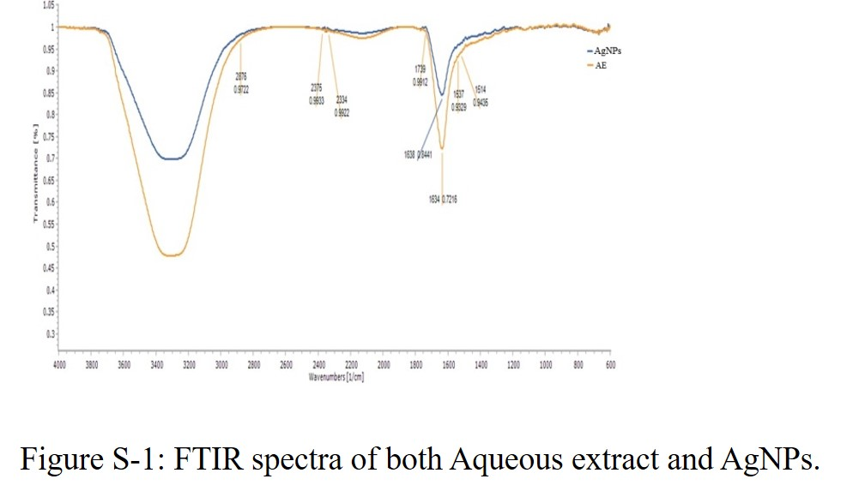

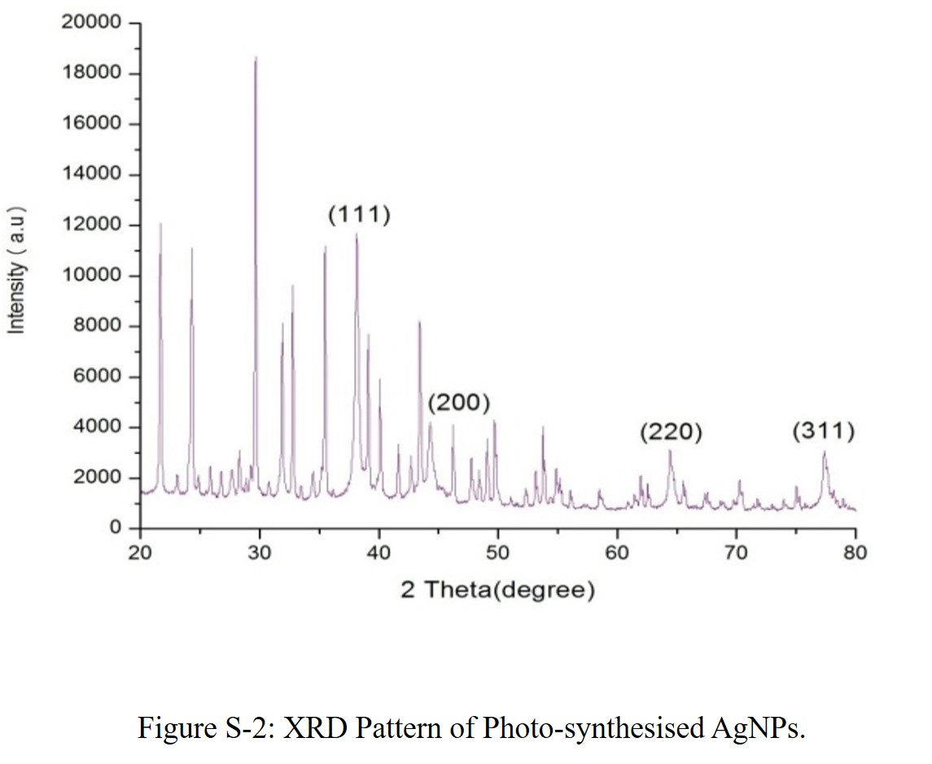

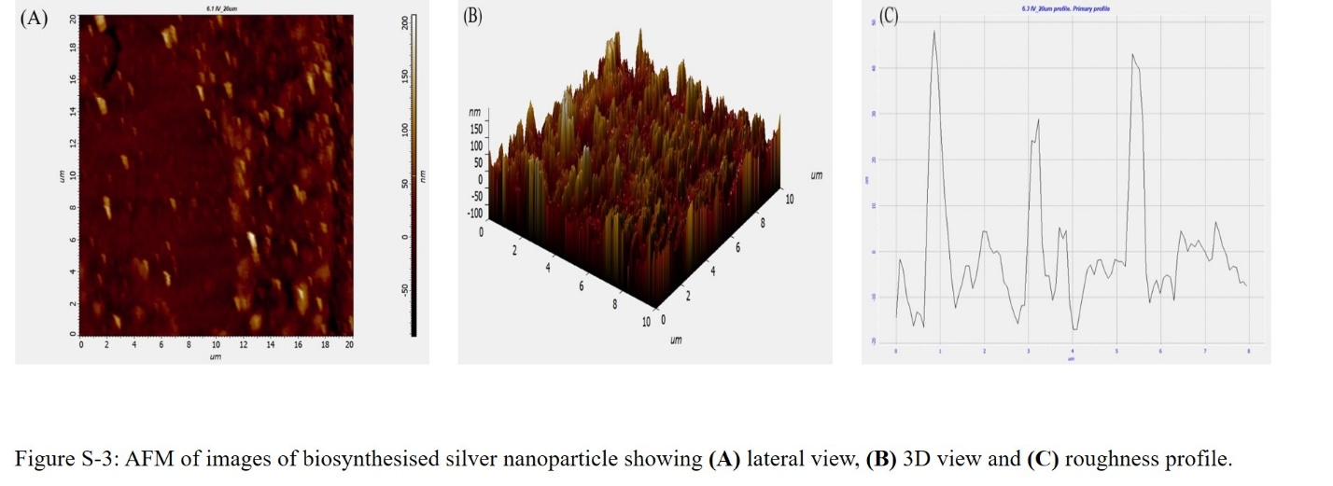

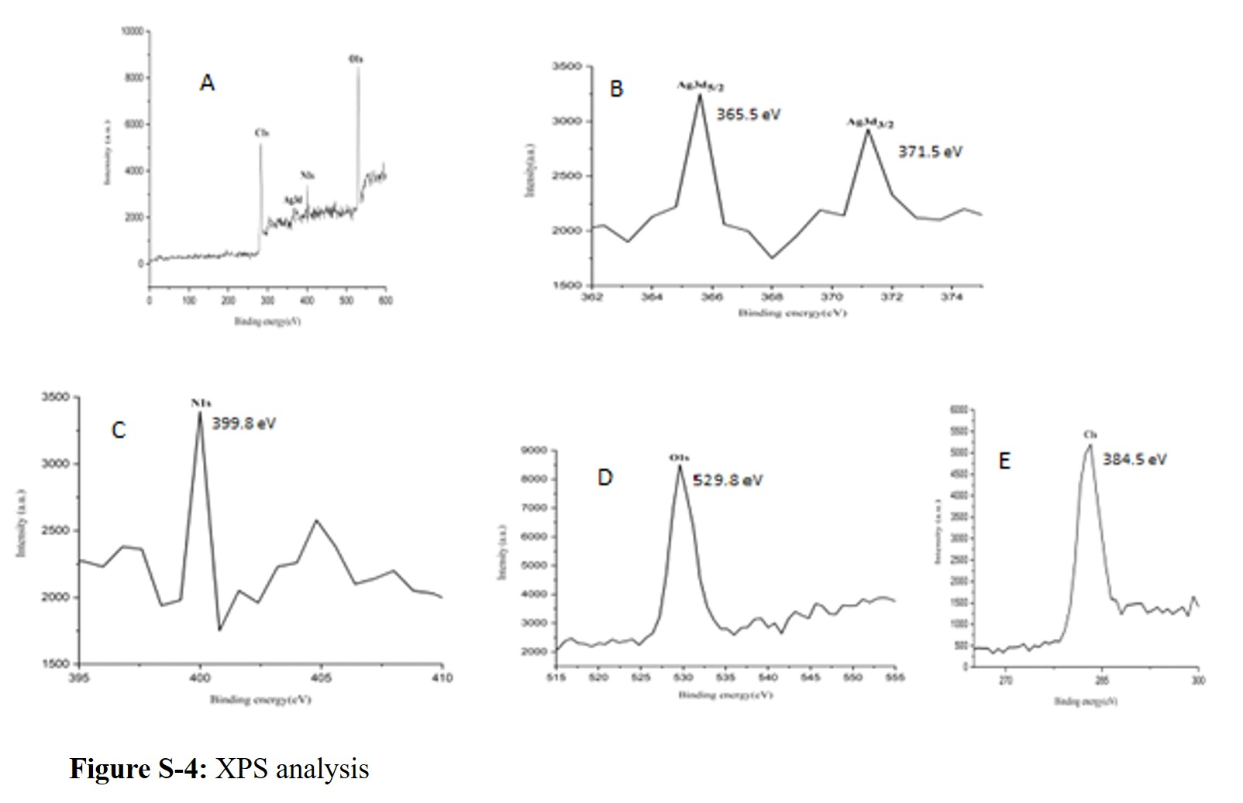

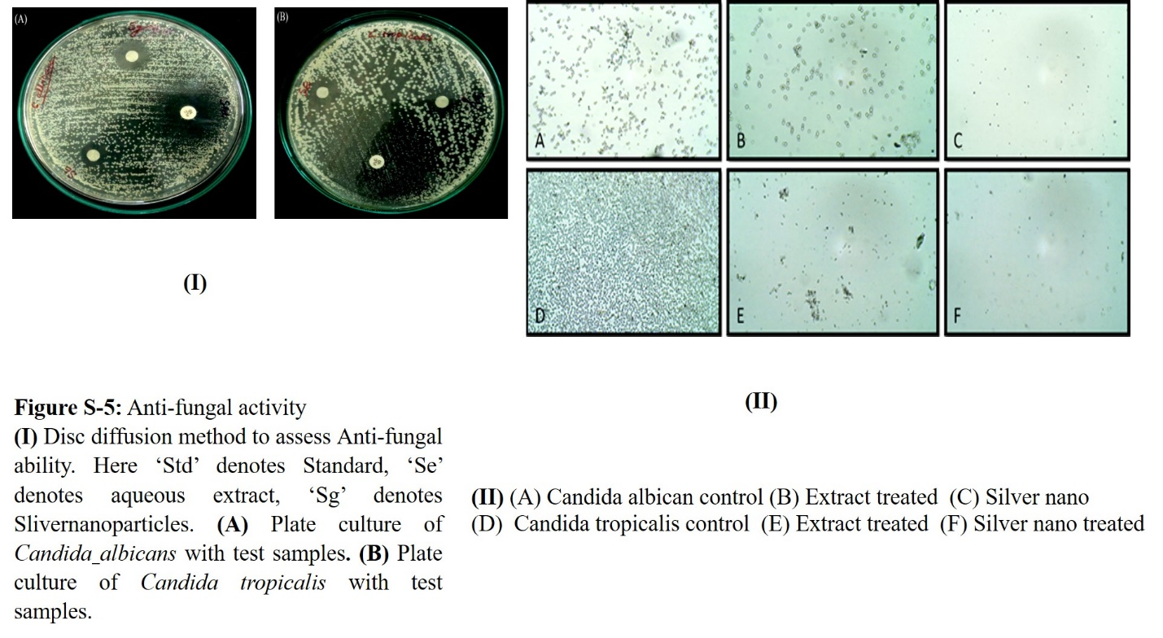
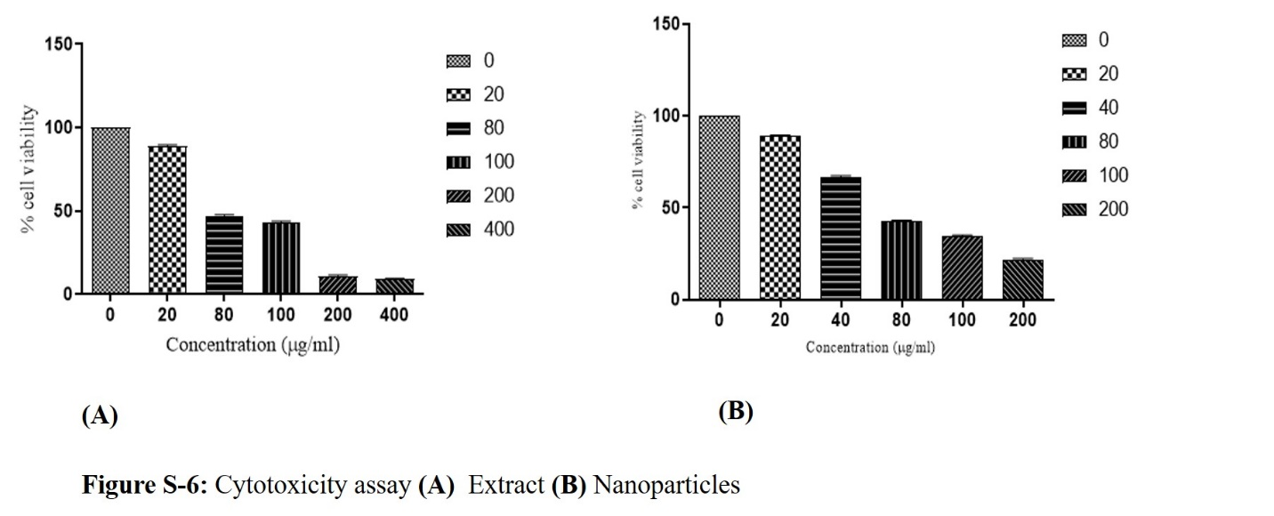

References

1. Mm K, Mm H, Fatema N (2009) Determination of MIC and MBC of selected azithromycin capsule commercially available in Bangladesh. undefined
2. Hudzicki J (2009) Kirby-Bauer Disk Diffusion Susceptibility Test Protocol
3. Mathabe MC, Hussein AA, Nikolova R V., et al (2008) Antibacterial activities and cytotoxicity of terpenoids isolated from Spirostachys africana. J Ethnopharmacol 116:194–197
4. Hastey CJ, Dale SE, Nary J, et al (2017) Comparison of Clostridium difficile minimum inhibitory concentrations obtained using agar dilution vs broth microdilution methods. Anaerobe 44:73–77. https://doi.org/10.1016/j.anaerobe.2017.02.006
5. Kumar V, Singh DK, Mohan S, Hasan SH (2016) Photo-induced biosynthesis of silver nanoparticles using aqueous extract of Erigeron bonariensis and its catalytic activity against Acridine Orange. J Photochem Photobiol B Biol 155:39–50. https://doi.org/10.1016/j.jphotobiol.2015.12.011
6. Iravani S, Korbekandi H, Mirmohammadi S V., Zolfaghari B (2014) Synthesis of silver nanoparticles: Chemical, physical and biological methods. Res. Pharm. Sci. 9:385–406
7. Rafique M, Sadaf I, Rafique MS, Tahir MB (2017) A review on green synthesis of silver nanoparticles and their applications. Artif Cells, Nanomedicine, Biotechnol 45:1272–1291. https://doi.org/10.1080/21691401.2016.1241792

