Supplementary Information for:
Estimating the carbon impacts of leakage from forest restoration and the costs of reducing them

Authors: Francisco d’Albertas^{1,2}, Tom Swinfield^{1,2}, Ben Filewod³, Stefan Wirsenius⁴, Timothy Searchinger^{5,6}, Thomas Ball^{1,2}, Gianluca Cerullo^{1,2,7}, Jody Holland^{1,2}, Anil Madhavapeddy⁸, Demetrius Martins⁹, Sara Mortara¹⁰, Andrew Balmford^{1,2}

Affiliations:
¹ Department of Zoology, University of Cambridge, Cambridge CB2 3EJ, UK.
² Conservation Research Institute, University of Cambridge. Cambridge CB2 3EJ, UK.
³ Canadian Forest Service, Ottawa, Canada.
⁴ Chalmers University of Technology; Gothenburg, Sweden.
⁵ World Resources Institute; Washington DC, USA.
⁶ Princeton University; Princeton NJ, USA.
⁷ Department of Forest Ecosystems and Society, Oregon State University, Corvallis, OR, USA.
⁸ Department of Computer Science and Technology, University of Cambridge, Cambridge, UK
⁹ Earthshot Labs, Sebastopol CA USA
¹⁰ Re.green, Rio de Janeiro, Brazil

Contents
Contents 2
List of Figures 3
List of Tables 4
Supplementary Methods 5
Defining project sizes 5
Estimating current beef yields 5
Projecting future beef yields 7
Maximum beef yield at carrying capacity 8
Costs for increasing beef yields 9
Primary estimation used in main analyses 9
Alternative estimation used for robustness evaluation 10
Restoration costs 11
Modelling the probability of natural regeneration 12
Discounting the carbon additionality and carbon opportunity cost of restoration 15
Sensitivity to international leakage 17
Comparison of carbon costs with published estimates 18
Supplementary Figures 19
Supplementary Tables 28
Supplementary References 35

List of Figures
Supplementary Figure 1. Distributions of pasture stocking rate and resulting beef yield. 19
Supplementary Figure 2. Spatial datasets used in the leakage modelling framework for Brazil. 20
Supplementary Figure 3. Sensitivity of carbon costs to assumptions about future beef yield trajectories. 21
Supplementary Figure 4. Forgone-production-to-carbon-gained ratio distribution of the top ten beef-exporting countries. 22
Supplementary Figure 5. Above-ground biomass recovery in secondary tropical forests over time. 23
Supplementary Figure 6. Predictor importance and classification performance of the natural regeneration model . 24
Supplementary Figure 7. Discounted social cost of carbon (SCC) over time under three discount rate assumptions. 25
Supplementary Figure 8. Sensitivity of forgone-production-to-carbon-gained ratio variability to weighting of stocking rates across scales 26
Supplementary Figure 9. Carbon cost outcomes under alternative beef-intensification cost assumptions. 27

List of Tables
Supplementary Table 1. Property size classes used in the 2017 Brazilian Agricultural Census. 28
Supplementary Table 2. State-level intensification costs and added beef production in Brazilian extensive pasture systems. 29
Supplementary Table 3. Reform, recovery and maintenance costs (in 2021 USD per hectare) for Brazilian biomes. 31
Supplementary Table 4. Variation in carbon costs under different discount rates when ignoring vs. mitigating leakage. 32
Supplementary Table 5. Carbon costs from restoration. 33
Supplementary Table 6. Forest restoration costs under different methods for Brazilian biomes. 34

Supplementary Methods

Defining project sizes
We collected data on property size classes across Brazilian municipalities from IBGE ¹(Supplementary Table 1). For each size class 𝑖 within a municipality j total area was calculated as a proportion of all rural properties $\left({Pr}_{[i,j]}\right)$as:
$$\begin{aligned}{Pr}_{[i,j]}= \frac{A_{[i,j]}}{M_{[j]}} \#(S1)\end{aligned}$$
where $A_{[i,m]}$ is the total area (ha) of rural properties in size class 𝑖 for municipality 𝑗 and $M_{[j]}$ is the total area (ha) of all rural properties within municipality j.
We then calculated the average property size ($S_{[j]}$) for municipality j as:
$$\begin{aligned} S_{[j]}= \sum_{i}{{(Pr}_{[i,j]}∙m_{[i]})} \#\left(S2\right)\end{aligned}$$
where $m_{[i]}$ is the midpoint value of size class 𝑖.
We next calculated the mean property size per biome and found average property sizes to be 1,700 ha in the Amazon biome and 300 ha in the Atlantic Forest biome.

Estimating current beef yields
To map beef yield for the year 2021(current yield, $Y_{C}$), we combined beef production statistics reported at national and state levels with municipal-level data on stocking rates and pasture area and spatially explicit pasture land-use data. Pasture maps were originally available at 30-m resolution and classified into low, medium, and high vigour classes², which we subsequently reclassified them to a 1-km grid to match the analysis resolution. We relied on national-level beef production estimates as the most accurate annual totals available ³, and used state-level slaughter statistics to spatially disaggregate production across states (the finest resolution available ⁴). To integrate datasets, first, we estimated the proportion of slaughter ($S_{p})$ for each state as:
$$\begin{aligned}S_{p[UF]}=\frac{slaughter_{[UF]}}{∑slaughter_{[UF]}} \#(S3)\end{aligned}$$
where $slaughter_{UF}$ is the amount (kg carcass weight) slaughtered in each state (UF) and $∑slaughter_{UF}$ is the total beef production slaughtered in Brazil for 2021. We aggregated quarterly slaughter data at the state level to annual totals to estimate state-level beef production for 2021.
Next, we estimated state-level production ($P_{[UF]}$, in kg carcass weight) by multiplying each state's slaughter proportion ($S_{p[UF\}}$) by the total meat production in Brazil for the year 2021 ($P_{Brazil}$ , 8328.5 in 2021):
$$\begin{aligned}P_{[UF]}=S_{p[UF\}}×P_{Brazil} \#(S4)\end{aligned}$$
Then, we calculated animal performance per state ($AP_{UF}$, in kg carcass weight AU ⁻¹ year⁻¹) by dividing state meat production by the number of animal units in the respective state:
$$\begin{aligned}AP_{[UF]}=\frac{P_{[UF]}}{{AU}_{[UF]}} \#\left(S5\right)\end{aligned}$$
where ${AU}_{[UF]}$ is the number of animal units per state, which we obtained by aggregating municipality data from IBGE².
We next estimated the stocking rate ( $Sr$ in AU/ha) at the municipality level ($j$), following a series of steps. Because different pasture qualities can hold different densities we first attributed a different weight w to each class of pasture $k$ (low vigor= 0.5, medium = 0.7, high = 1.5; following Carlos et al. ⁵) and then for each municipality $j$ and pasture class 𝑘 we calculated a weighted pasture area ($a_{w[j,k]}$, in ha) by multiplying the pasture area of each class ($a_{[j,k]}$) by the corresponding weights:
$$\begin{aligned}a_{w[j,k]}={a_{[j,k]}∙w_{[k]}}_{ }\#(S6)\end{aligned}$$
For each municipality we allocated its animal units to each class of pasture $({AU}_{w[j,k]}$) by multiplying its total number of animal units (${AU}_{[j]}$) by the weighted area of each pasture class divided by the total weighted area for the municipality:
$$\begin{aligned}AU_{w[j,k]}=AU_{[j]} ×\frac{a_{w[j,k]}}{\sum{a_{w[j,k]}}} \#(S7)\end{aligned}$$
We then obtained stocking rates ($Sr_{[j,k]}$, AU ha⁻¹) by dividing the number of animal units assigned to each pasture class by the area of the corresponding pasture class:
$$\begin{aligned}Sr_{[j,k]}=\frac{AU_{w[j,k]}}{a_{w[j,k]}} \#(S8)\end{aligned}$$
These stocking rates were subsequently attributed to every pasture cell 𝑐 within municipality 𝑗 and pasture class 𝑘, assuming homogeneous stocking rates within each municipality–class combination. To remove implausible values arising from errors in the source data, we capped stocking rate distribution between the 5th and the 95th percentiles, thereby excluding the lowest and highest extremes (Supplementary Fig.1). We then calculated current yield by multiplying stocking rate by animal performance as shown in Equation 1 from the main text. The resulting yield estimates exhibit substantial spatial variability, reflecting underlying heterogeneity in pasture condition, management intensity, and animal performance across Brazil.
Additionally, as a sensitivity test of the influence of the weights on the heterogeneity of the forgone-production-to-carbon-gained ratio distribution, we calculated yields both using the weights and assuming equal stocking rates across pasture classes. We then calculated the forgone-production-to-carbon-gained ratio across scales (country, biome, and local) and compared the coefficients of variation with and without weighting (Supplementary Fig. 8). We found only limited changes in variability, indicating that our results are robust even without weighting stocking rates.

Projecting future beef yields
For our analysis, we used past trends in yields to adjust our expectations of yield growth over time. Alternatively, we considered two additional scenarios: one where beef yield was kept constant under 2021 values across the 50 years duration of the projects; one where all projects achieved a yield of 90% of the estimated carrying capacity for the region (see on the next section how we estimate carrying capacity and Supplementary Fig. 3 for comparisons among predictions).
To project future beef yields in the absence of projects using past trends, we first aggregated municipality-level beef stocking rate data to the local domain for the period 2010–2019 , which reduces variability compared to municipality data. We adopted immediate regions, territorial units defined around urban centres defined by IBGE⁶ that provide basic goods and services to surrounding municipalities, capturing short-range socio-economic interactions, as our local domain. Animal performance and yield were calculated following the same approach used for current yields (see ”Estimating stocking rates and animal performance” section). Data from 2020 was excluded due to yield anomalies likely related to the COVID-19 pandemic.
We then fitted both linear and exponential models of yield over time and evaluated them against null models using a ΔAIC > 2 threshold. While both outperformed their nulls, we adopted the linear model for projections, as exponential fits produced implausible results (e.g. >8x increases in yield over 50 years, the typical duration of restoration projects for carbon, vs. a 1.5x with the linear model). Under the exponential model, grazing carrying capacity was reached very quickly, whereas the linear model did not reach it in most cases.
A separate linear model was fitted for each immediate region im:
$$\begin{aligned}y_{[im,t]}= β_{[0,im]}+ β_{[1,im]}∙ t+ ∈_{[r,im]}\#(S9)\#\end{aligned}$$
where $y_{[im,t]}$ is the beef yield (kg carcass weight ha⁻¹ yr⁻¹) in region im and year $t$, $β_{[0,im]}$ ​ is the intercept, $β_{[1,im]}$​ is the slope representing the annual change in yield, and $∈_{[im,t]}$​ is the residual error term.

Maximum beef yield at carrying capacity
To ensure that projected yields did not exceed biophysically feasible limits, (see above) we estimated the potential stocking rate as a function of the potential biomass growth of grasses under future climate conditions, based on projections from RCP 4.5 for the period 2011–2040⁷. Potential grass productivity represents climatically and edaphically constrained biomass growth under standardized assumptions of optimal pasture management. As such, the resulting stocking rates should be interpreted as a theoretical upper bound on cattle density. The stocking rate (SR), expressed in animal units (AU), was calculated using the following equation:
$$\begin{aligned}SR=\frac{DDP⋅GE}{I*cos\left(S\right)} \#(S10)\end{aligned}$$

where $DDP$ is the Daily demand for pasture; $GE$ is grazing efficiency (i.e., the proportion of available forage that is actually consumed by cattle), $I$ is ingested feed per animal unit per day (kg AU⁻¹ day⁻¹); and $S$ is terrain slope in degrees ⁸. We used the maximum daily potential biomass growth (kg of grass ha⁻¹ day⁻¹) as a proxy for DDP to estimate an upper bound on maximum cattle density that could be supported under ideal conditions. We assumed a grazing efficiency (GE) of 0.5 and an average ingestion rate (I) of 8 kg AU⁻¹ day⁻¹, in line with values reported in previous studies ^{9–11} (Supplementary Fig. 2C).
After calculating stocking rate, we assumed animal performance remained constant and calculated beef yield at carrying capacity.

Costs for increasing beef yields

Primary estimation used in main analyses
We estimated beef intensification costs through improved pasture management using spatially explicit yield (kg carcass weight ha⁻¹ yr⁻¹) and production cost (USD ha⁻¹) estimates derived from the BeefSC model described in Wirsenius & d’Albertas¹². The model provides pixel-level estimates of beef yields and costs on a ~10-km grid across Brazil under contrasting production systems ranging from low-productivity extensive ranching to more intensive pasture-based systems. Model outputs incorporate biophysical conditions, herd dynamics, fertilizer and feed inputs, and transportation costs for agricultural inputs and live cattle to slaughterhouses. To estimate the cost of intensification, we calculated the difference in annual production costs between the Extensive 1 – which is the predominant across Brazil – and Extensive 2 systems, representing the transition from low-input grazing to improved pasture management with fertilizer application. Corresponding yield gains were calculated as the difference in carcass production (kg ha⁻¹ yr⁻¹) between these two systems.
To adopt a conservative approach, we aggregated these BeefSC-derived estimates by calculating mean beef yields and production costs at the Brazilian state (UF) level, and assumed that the difference between Extensive 1 and Extensive 2 represents the potential yield gain achievable through pasture intensification, while the corresponding difference in costs represents the effective cost of that level of intensification (Supplementary Table 2). State-level estimates were derived together with their associated 95% confidence intervals. For each pasture cell $c$ classified as degraded based on pasture vigour, we attributed an annual yield gain corresponding to the state in which the cell is located, interpolating between the lower and upper bounds of the confidence intervals according to the relative composition of low- and medium-vigour pasture withing each cell. This assigns larger gains to more degraded pastures while preserving conservative, empirically grounded uncertainty. We then estimated long-run costs as a Net Present Value (NPV):
$$\begin{aligned}NPV= \sum_{t=1}^{50}{\frac{C_{prod[c,UF]}}{{\left(1+r\right)}^{t}}} \#\left(S11\right)\end{aligned}$$
where $C_{prod[c,UF]}$ is the annual production costs (USD ha⁻¹ year⁻¹); r is the discount rate (0.08, aligned with subsidized loan rates available to producers under Brazil’s Low-Carbon Agriculture Plan ¹³, and t spans project years 1-50.

Alternative estimation used for robustness evaluation
Alternatively, we also estimated beef intensification costs through improved pasture management, using recovery and reform costs from Carlos et al.⁵, where recovery applies to moderately degraded pastures and reform to severely degraded areas (Supplementary Table 3). Recovery and reform activities are estimated to increase carrying capacity by 1 and 0.75 AU ha⁻¹ respectively. Both are assumed to occur in year one of implementation.
Maintenance cost required in subsequent years were also taken from Carlos et al. ⁵, and comprise per-activity costs and their frequency over a 5-year period. From this, we calculated average annual costs(USD ha⁻¹; Supplementary Table 3) and applied Equation S11 from years t=2 to t=50 only to maintenance costs – as pasture recovery and reform costs are assumed to occur entirely in year 1.
To estimate total mitigation costs, we assigned biome- and degradation-specific values to each pasture pixel: recovery to medium-vigor areas and reform to low-vigor ones. When both occurred in a pixel, we converted each to cost per AU gained (dividing recovery by 1 and reform by 0.75) before summing them as capital investment per hectare.
Finally, we added the NPV of maintenance to this combined cost to obtain the total mitigation cost per hectare (USD ha⁻¹) to add 1 AU per pixel.
These costs were used in a sensitivity analysis in which we estimated carbon costs under full leakage mitigation using an alternative set of beef intensification cost assumptions and compared the resulting distributions with those obtained using Wirsenius et al. While absolute carbon cost estimates differ between the two sources – being consistently higher when using Wirsenius-based costs – the relative patterns across biomes and leakage classes are unaffected (Supplementary Fig. 9). We therefore use Wirsenius-based costs in the main analysis as a conservative assumption.

Restoration costs
We obtained restoration costs from re.green, a project developer in Brazil working in the Atlantic Forest and in the Amazon. They vary depending on biome, natural regeneration potential, and feasibility of mechanization (Supplementary Table 6). We considered three restoration types reflecting increasing intervention intensity and costs: assisted natural regeneration, intermediate restoration, and active restoration. Assisted natural regeneration involves minimal intervention beyond site protection and management (e.g. fencing and invasive species management), and is suitable where natural regeneration probability is high. Intermediate restoration combines natural regeneration with targeted activities such as enrichment planting or soil preparation, and is typically applied in moderately degraded areas. Active restoration represents the most intervention-intensive approach, relying on full planting of seeds or seedlings and site preparation, and is required where natural regeneration probability is low.
To adjust these costs based on the probability of natural regeneration and the potential for mechanization, we applied equation S12, with biome specific parameter values from Supplementary Table 6:
$$\begin{aligned}r=\left\{\begin{matrix}[M ∙\left(1-p\right)⋅C_{\text{int,}\text{m}}+p⋅C_{\text{anr,nm }}] +\left(1-M\right)∙[\left(1-p\right]∙C_{int,nm}+p∙C_{anr},_{nm}, & \text{if }p≥0.5 \\ [M ∙\left(1-p\right)⋅C_{\text{act,m}}+p⋅C_{\text{int,m]}}] +\left(1-M\right)∙[\left(1-p\right]∙C_{act,nm}+p∙C_{int},_{nm}, & \text{if }p<0.5\end{matrix}\right. (\#S12)\end{aligned}$$
where r is the total restoration cost per unit area (USD ha⁻¹); p is the probability of natural regeneration; M is a binary mechanization factor (M=1 for mechanized, M=0 for non-mechanized restoration); $C_{\text{int,}\text{m}}$ and $C_{int,nm}$ are the costs associated with intermediate restoration (mechanized and non-mechanized, respectively); $C_{\text{anr,nm }}$is the costs associated with assisted natural regeneration; and $C_{\text{act,m}}$ and $C_{act,nm}$ are the costs associated with active restoration (Supplementary Fig. 2E). We assumed mechanized restoration to be feasible in areas with slopes ≤ 20%. We generated a probability for natural regeneration (p) layer following Williams et al. ¹⁴ according to the methodology described in the section “Modelling the probability of natural regeneration”. Although restoration cost parameters (𝐶) are biome-specific, Eq. (S12) is evaluated at the cell level by assigning the corresponding biome-level costs to each cell, while allowing 𝑝 and 𝑀 to vary spatially across cells.

Modelling the probability of natural regeneration
The probability that a human-degraded area recovers to its natural state is determined by key drivers of restoration success, most notably disturbance type (e.g. selective logging versus high-intensity agricultural activities) and landscape context (e.g. forest cover, fragmentation, and distance to existing forests)^{14–16}. To map the probability of natural regeneration across Brazil, we adapted the modelling framework developed by Williams et al. ¹⁴, retraining it using Brazil-specific data. We employed a random forest classifier to predict the likelihood of natural vegetation regrowth at 1-km resolution, using observed secondary forest regrowth as a binary response variable and a suite of biophysical and socioeconomic predictors. Formally, let $y_{s}∈\{0,1\}$denote whether site $s$ undergoes natural regeneration. Regeneration was modelled as a Bernoulli (binomial) outcome, with the associated probability $p_{s}$estimated as a function of the predictor variables using a random forest approach:
$$\begin{aligned}y_{s}\sim Bernoulli \left(p_{s}\right) \#(S13)\end{aligned}$$
$$p_{s}=f(X_{s})$$
where $p_{s}$is the probability of natural regeneration; $X_{s}$is a vector of explanatory variables representing drivers of regeneration; and $f(⋅)$is an unknown, non-parametric function estimated using a random forest classifier.
We derived the binary response variable from MapBiomas ( MapBiomas Project Collection 8 – Deforestation and Secondary Vegetation v1). Although the platform does not differentiate between natural regeneration vs. active restoration, national statistics indicate that active restoration represents only a very small fraction of secondary vegetation in Brazil. According to the Brazilian Restoration and Reforestation Observatory (https://observatoriodarestauracao.org.br/dashboard), of the approximately 18.6 million ha of secondary vegetation currently present in the country, only ~153 thousand ha correspond to restoration projects (0.82% of the total), making secondary forest regrowth a reasonable proxy for natural regeneration at the national scale. Secondary vegetation was identified when pixels transitioned from anthropic land uses to forest cover and remained classified as vegetation for at least three consecutive years; transitions smaller than 1 ha were excluded to reduce classification noise.
Pixels were labelled as:
- Regenerated (1): All areas previously classified as anthropogenic if classified as secondary vegetation by MapBiomas in any year between 2000 and 2022;
- Non-regenerated (0): consistently classified as anthropogenic land cover (excluding urban areas and water bodies) throughout the same period.
To prevent spatial autocorrelation and ensure broad geographic representation, we generated background (non-regeneration) points using random sampling proportional to biome area. Specifically, we calculated the number of background points per biome proportional to its total area, and drew random samples from each biome polygon accordingly. The total number of background points was set to four times the number of natural regeneration points.
As drivers of natural regeneration, we used the same set of predictor variables evaluated by Williams et al. ¹⁴, who tested a wide range of biophysical and socioeconomic covariates. Their results indicated that model performance plateaued after including the top ten biophysical predictors, which formed the basis of their best-performing model. Following this evidence, we adopted the same top ten biophysical variables and additionally included one climatic variable and distance to urban areas—both part of the full model tested by the authors—to better reflect our study’s specific context. These predictors were grouped into the following categories:
- Climate: We used the first five principal component (PC) axes derived from the 19 bioclimatic variables from WorldClim ¹⁷, and not the first four as ref. ¹⁴ mainly due to its importance in exploratory analysis (Supplementary Fig. 6A) ;
- Soil: mean soil organic carbon and pH within the top 30cm, weighted by depth interval (0-5cm;5-15cm; 15-30cm) from ref. ¹⁸;
- Landscape: distance to forest, forest density, density of agricultural land, distance to urban areas, calculated from Mapbiomas ( MapBiomas Project Collection 8 – Land use and land cover). Particularly for the Atlantic Forest, with a long history of disturbance and where ~ 70% of the Brazilian population is¹⁹, we considered that proximity to urban areas would be an important predictor;
- Vegetation type: Unlike ref. ¹⁴, who used biome as a categorical variable, we adopted the official vegetation types defined by the Brazilian government (https://www.ibge.gov.br/geociencias/informacoes-ambientais/vegetacao/15842-mapa-de-vegetacao.html). This approach accounts for the fact that many Brazilian biomes encompass multiple vegetation types with distinct successional dynamics;
All predictor layers were resampled or aggregated to 1-km spatial resolution and projected to Albers Equal Area Conic projection.
We fitted the natural regeneration model using a random forest classifier implemented in the R package ‘randomForestSRC’ ²⁰, using 400 trees and default parameter settings except for a minimum node size of 20. The model was trained on 80% of the dataset, with the remaining 20% withheld for independent validation. Model performance was assessed using the area under the receiver operating characteristic curve (AUC), which quantifies the model’s ability to discriminate between sites that do and do not undergo natural regeneration across all possible probability thresholds. An AUC value of 0.5 indicates no discriminative ability (equivalent to random classification), whereas a value of 1 indicates perfect discrimination²¹. The model achieved an AUC of 0.896 on the validation set, indicating high predictive accuracy and strong discrimination between regenerating and non-regenerating sites. Variable importance rankings are shown in Supplementary Fig. 6A, and the receiver operating characteristic curve and the distribution of predicted regeneration probabilities are shown in Supplementary Fig. 6B.

Generation of the regeneration probability surface
We applied the trained model to all 1-km pixels across Brazil to generate a continuous surface of natural regeneration probability p (values between 0 and 1). This included areas both within and outside the tropical latitudes (i.e., beyond the Tropics of Cancer and Capricorn). The resulting map is shown in Supplementary Fig. 2D. We then used modelled estimates of p as a proxy for counterfactual land-use dynamics in the absence of interventions. While quasi-experimental estimators of counterfactual outcomes would be preferable²², these can only be implemented to assess the effectiveness of projects ex post.
The outcome of this model is not only dependent on ecological capacity for growth but also on socioeconomic conditions. Even if all ecological requirements are present for native vegetation to re-establish, regeneration will only occur if human disturbances are reduced (i.e. land abandonment and/or assisted natural regeneration). This might help explain why we detected a predominance of low probability values, including in the amazon, where there is an abundance of seed sources for recolonization from the surrounding forests – at least at broader landscape scale. Here, the limiting factor is not ecological capacity but the likelihood of limiting ongoing pressures such as grazing, fires, or invasive species (among other factors), which can undermine forest recovery ¹⁶.

Discounting the carbon additionality and carbon opportunity cost of restoration
To calculate the discounted Social Cost of Carbon (SCC_{t}^{disc}​ ) we used equation S14:
$$\begin{aligned}SCC_{[t]}^{disc}= \frac{SCC_{[t]}}{{\left(1+ δ\right)}^{t}} \#\left(S14\right)\end{aligned}$$
where $SCC_{t}$​ is the undiscounted SCC in year t (USD tons CO₂⁻¹) , available from Groom²³, and the discount rate δ=0.03 . We then normalized the discounted SCC by the present-day value according to equation 6:
$$\begin{aligned}R_{[t]}= \frac{SCC_{[t]}^{disc}}{SCC_{0}} \#(S15)\end{aligned}$$
For each year in each scenario, we calculated the net undiscounted carbon balance (after leakage) ($C_{[t]}^{und}$;tonnes CO₂ e) as the difference between the carbon additionality from restoration ($C_{a })$ and the carbon leaked ($C_{leak})$ or the foregone carbon opportunity cost of natural regeneration ($C_{fg}$) (Equation 8 from the main text; all in tCO₂e). Without mitigation, $C_{leak}>0$ and $C_{fg}=0$; conversely, under full mitigation, $C_{leak}= 0$ and the cost is reflected through $C_{fg}$, representing the carbon sequestration that would have occurred on mitigation sites had they been regenerated instead.
$C_{leak}$ is calculated as:
$$\begin{aligned}C_{leak}=\sum_{c=1}^{Ncells}{C_{agc[c]}∙a_{leak[c]}} \#(S16)\end{aligned}$$
where $C_{agc_{[c]}}$ is the current woody above-ground carbon density (in tonnes CO₂ e ha^{-1;}; layer from Walker et al.²⁴ harmonized to 1km) from each cell c where the forgone production is displaced and $a_{leak[c]}$ is the area extensified in each cell.
Carbon lost due to mitigation ($C_{\text{fg}}$) at the cell level ($C_{a[c]}$; Eq. 7 in the main text) and subsequently aggregated by summing cell-level values across all selected mitigation cells for each project.
We then multiplied the relative factor $R_{t}$ by each year’s $C_{[t]}^{und}$ and summed over the project lifetime to obtain the total discounted carbon balance ($C_{pj}^{disc}$ ; in tonnes of CO₂e) according to Equation 8.
As a sensitivity analysis, we tested different discount rates of δ=0.02 and δ=0.04 to check how it would change the cost per tonne of carbon we obtained. Higher discount rates result in stepper R_{t} curves, consequently attributing a higher weight to recent carbon emissions and removals while more strongly discounting future climate damages. Because the Social Cost of Carbon is defined as the present value of future damages caused by an additional tonne of CO₂, increasing the discount rate also reduces the present value of the SCC itself, thereby lowering the discounted value of future carbon removals and increasing the relative importance of near-term emissions (Supplementary Fig. 7).
Using the cost values obtained under different discount rates (2%, 3%, and 4%), we assessed the robustness of our patterns by comparing, in both the Atlantic Forest and the Amazon, the carbon costs of high- and low-leakage projects against the biome-wide mean cost calculated across the full forgone-production-to-carbon-gained ratio distribution ( Extended Data figures 9-10).

Sensitivity to international leakage
To assess the sensitivity of our results to the assumption of domestic leakage only, we compared the distribution of forgone-production-to-carbon-gained ratios across the top 10 beef exporters according to USDA data ²⁵ for 2021. The rationale is: if low-leakage sites – projects around the 20th percentile of the Brazilian distribution – show forgone-production-to-carbon-gained values below the averages found in other major exporters, then such projects are still to be beneficial, removing more carbon than is emitted through production displacement. This implies that our findings remain robust even if leakage occurs internationally.
We obtained global stocking rates (density of animals, originally per km² transformed to ha) from ref.²⁶, with 5 minutes of arc resolution (~ 10 km at the equator) and estimated animal performance by dividing total national beef and buffalo meat production (tonnes)²⁷ by herd size (number of animals) ²⁸ for 2021. Combining stocking rates with animal performance, we generated a global beef yield grid at 5 arc-minute resolution. This grid was masked using pasture coverage data from ref.²⁹, which provides annual probabilities of cultivated grassland at 30 m resolution. Following the authors’ recommendation, we applied a threshold of p = 0.38 to binarize pasture cover for 2021 and resampled the data to calculate pasture fraction coverage within each 5 arc-minute cell. We retained only cells with >1% pasture coverage for yield estimates.
For carbon, given the coarse resolution of beef yield, we assumed pasturelands had zero initial carbon stocks and used the potential carbon density layer (combining above-ground, below-ground and soil organic carbon; tonnes of Carbon per ha) from Walker et al.²⁴ to represent restoration additionality. At ~10km resolution, calculating differences between current and potential carbon – as done in our main Brazil-specific analysis – underestimate gains in pasture-dominated cells surrounded by forest, since averages would mix low pasture values with high forest values. We have also considered the full carbon potential gains without applying a temporal cap (i.e. not limiting to 50 years, as in our main analysis). This approach can be regarded as conservative, since tropical regions are expected to accumulate carbon more rapidly in the first decades compared with temperate zones.
We found that Brazilian low-leakage sites remain favorable in terms of carbon efficiency even under an international leakage scenario, since their forgone-production-to-carbon-gained ratios are lower than the average values of other major beef exporters (Supp.Fig. 4).

Comparison of carbon costs with published estimates
The carbon costs for projects combining low-leakage site selection with full leakage mitigation – assuming 100% displacement of forgone production and complete compensation through intensification at the national scale – are comparable to or lower than published estimates (Supplementary Table 5). Median costs are 22 USD tCO₂e⁻¹ in the Atlantic Forest and 16 USD tCO₂e⁻¹ in the Amazon (Figs. 3B and 3D ). This is despite treating intensification purely as a cost. If instead considered as an investment³⁰ – where future returns offset or exceed initial expenditures – carbon costs could be even lower than those reported here.

Supplementary Figures
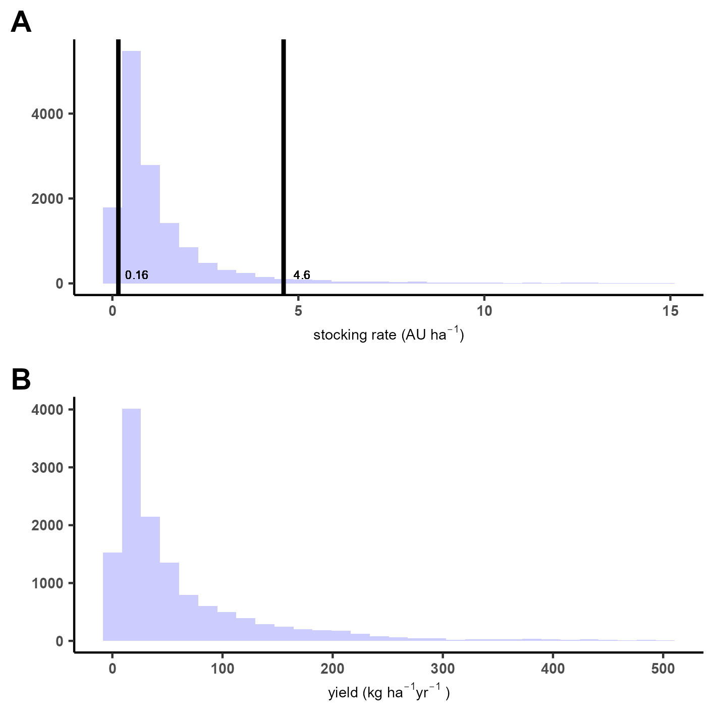
Supplementary Figure 1. Distributions of pasture stocking rate and resulting beef yield.
(A) Distribution of stocking rate across all grid cells after we combined official municipality-level data on production with land use data, expressed as animal units per hectare. Vertical black lines indicate the 5th (0.16 AU ha⁻¹) and 95th (4.6 AU ha⁻¹) percentiles; these thresholds were used to exclude extreme values. (B) Distribution of estimated beef yield (kg ha⁻¹ yr⁻¹) after excluding observations with stocking rates below the 5th or above the 95th percentile. We obtained beef yield by multiplying stocking rate by animal performance obtained at State level (see Methods).

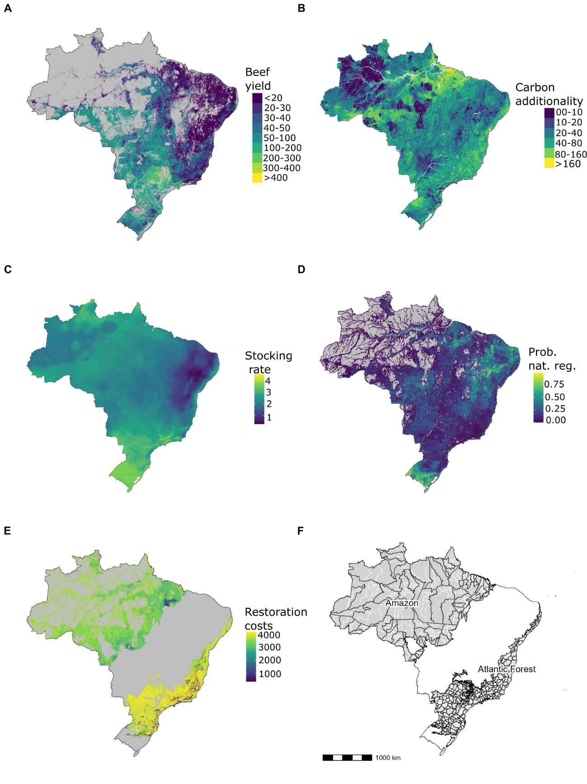
Supplementary Figure 2. Spatial datasets used in the leakage modelling framework for Brazil.
(A) Modelled beef yield (kg ha⁻¹yr⁻¹) at 1-km resolution across pasturelands (grey = non-pasture). We derived yields from estimated stocking rates and animal performance, excluding extreme values (<5th and >95th percentiles). (B) Potential carbon gain (tCarbon ha⁻¹) from 50 yr restoration, calculated as the difference between current and recovered carbon density. (C) Stocking rate at carrying capacity (animal units ha⁻¹) based on potential grass biomass growth. (D) Probability of natural regeneration across anthropogenic lands, excluding water and urban areas (see Supplementary Methods). (E) Restoration costs (USD ha⁻¹) accounting for regeneration potential, required planting effort, and mechanization feasibility (terrain slope). (F) Map of Brazil showing the Amazon and Atlantic Forest (grey). Black lines delineate IBGE’s Immediate Regions, which we used to define our local analysis scale. Thin white lines represent municipal boundaries.
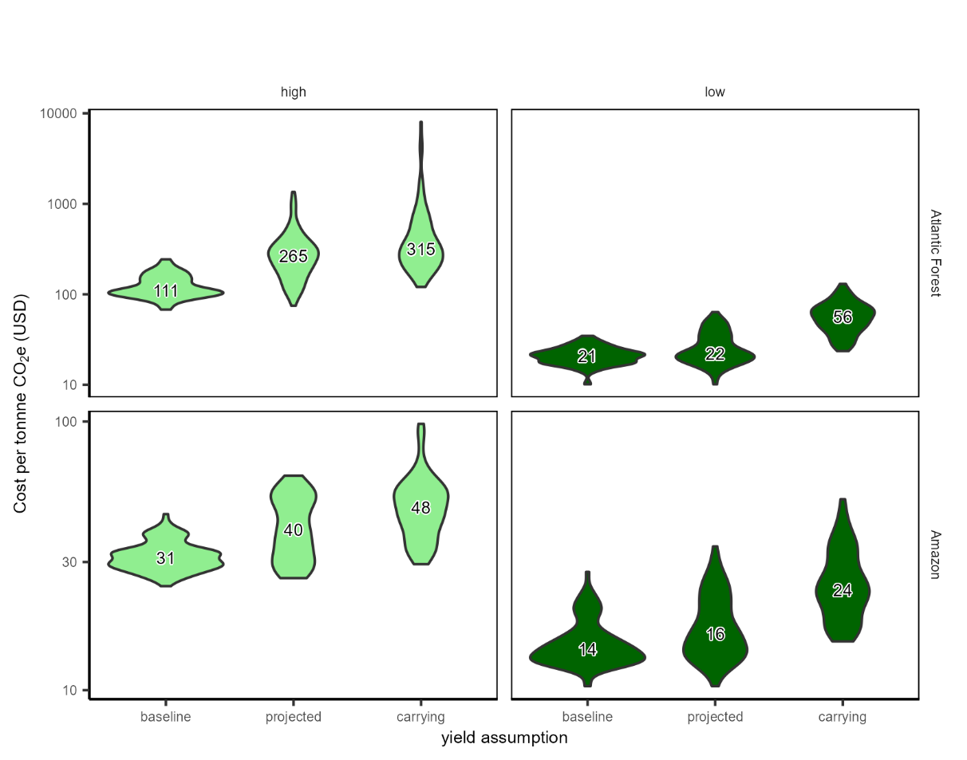
Supplementary Figure 3. Sensitivity of carbon costs to assumptions about future beef yield trajectories.
Violin plots show the distribution of costs (USD tCO₂e⁻¹) under three alternative assumptions about future beef yields over a 50-year period: baseline (yield is kept constant on its current 2021 value), projected (moderate growth based on historical rates; this is the central case presented in the main text), and carrying (yields reaches 90% of carrying capacity). Panels reflect combinations of biome (Amazon vs. Atlantic Forest) and leakage intensity (high vs. low) and include mitigation costs. All results assume that 100% of forgone beef production is displaced across the country, and that mitigation actions are also undertaken at the country domain. Note the logarithmic scale on the y-axis.

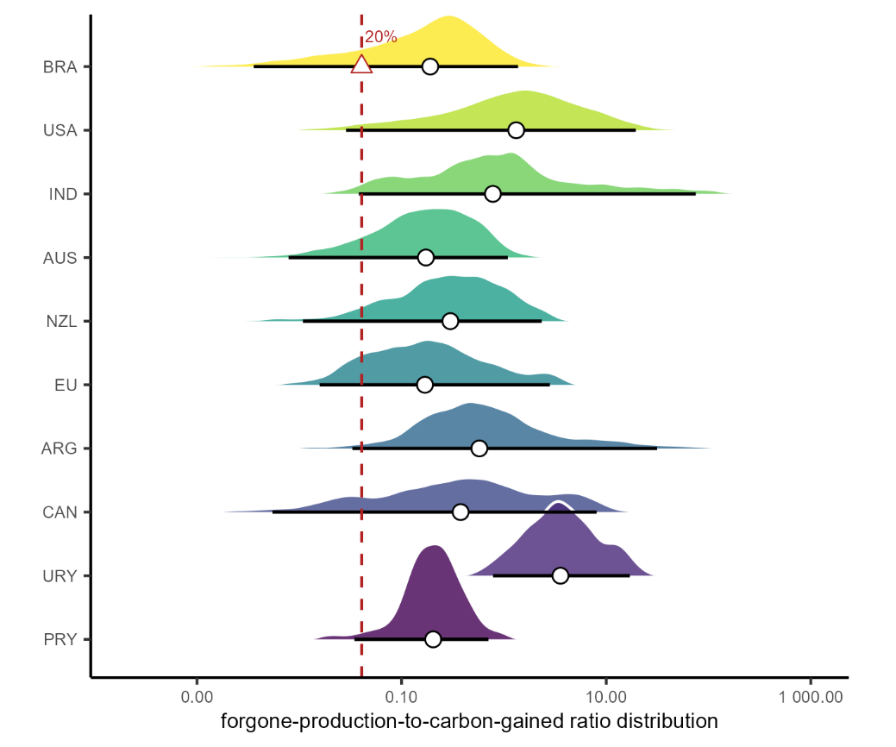
Supplementary Figure 4. Forgone-production-to-carbon-gained ratio distribution of the top ten beef-exporting countries.
Ridge plots show the distribution of forgone-production-to-carbon-gained ratios across pasturelands for Brazil (BRA), United States of America (USA), India (IND), Australia (AUS), New Zealand (NZL), European Union (EU), Argentina (ARG), Canada (CAN), Uruguay (URY) and Paraguay (PRY). White circles denote the median and black horizontal lines the 95% confidence interval of each country’s distribution. The red triangle indicates the 20th percentile of the Brazilian distribution, used as the threshold for selecting low-leakage projects. The dashed red vertical line marks this value across all countries. Note the logarithm scale on the x-axis. Countries are order in decreasing order of volume exported.

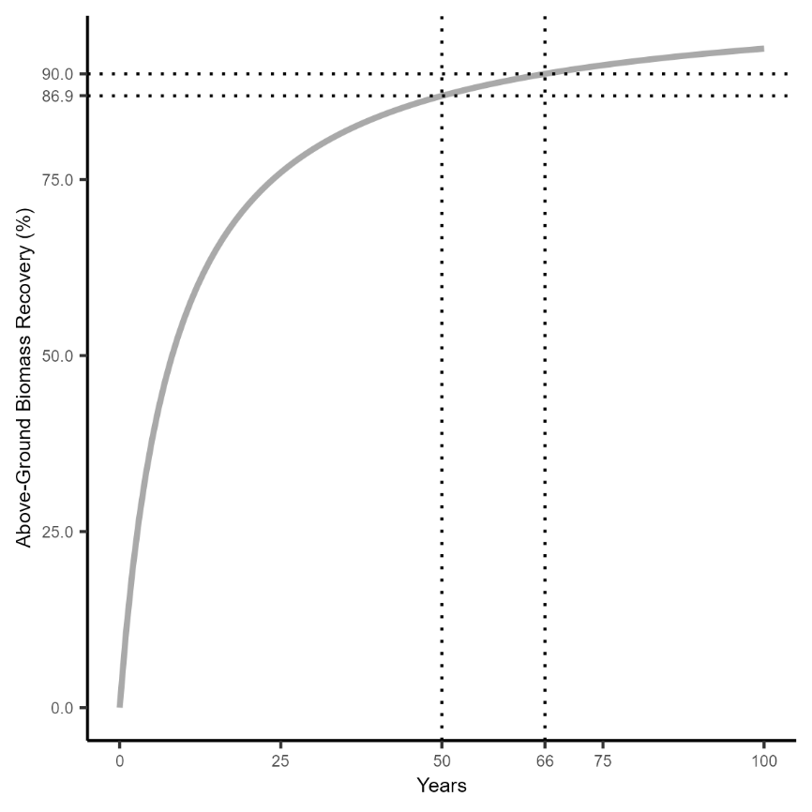
Supplementary Figure 5. Above-ground biomass recovery in secondary tropical forests over time.
The curve represents the percentage of above-ground biomass recovery relative to old-growth forest, based on data compiled by Poorter et al.³¹ . An asymptotic model was fitted to estimate recovery dynamics, showing that 86.9% of biomass is recovered after 50 years of regeneration. Dotted lines indicate the 50-year and 66-year marks, as well as the corresponding recovery thresholds (86.9% and 90%).

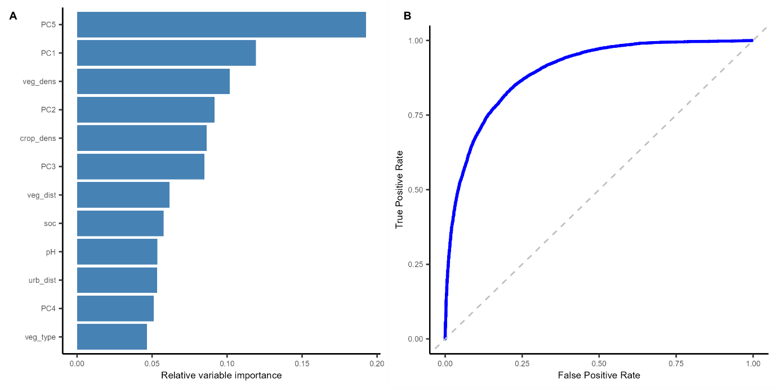
Supplementary Figure 6. Predictor importance and classification performance of the natural regeneration model .
(A) Relative variable importance of predictors used in the natural regeneration model. Bars represent the relative importance of each variable, calculated as the individual variable importance score divided by the sum of all variable importance scores across predictors. This normalization allows for direct comparison of each variable's contribution to model performance. PC1 to PC5 refer to the principal components derived from 19 bioclimatic variables. Other variables include measures of vegetation density (veg_dens), crop density (crop_dens), distances to vegetation and urban areas (veg_dist, urb_dist), a categorical vegetation type (veg_type), soil pH (pH), and a soil organic carbon (soc). (B) Receiver Operating Characteristic (ROC) curve for the natural regeneration model. The ROC curve illustrates the trade-off between the True Positive Rate (sensitivity) and the False Positive Rate (1 – specificity) across all classification thresholds. The solid blue line represents the model's performance, while the dashed diagonal line indicates a random classifier (AUC = 0.5). The area under the curve (AUC) was 0.89, indicating good classification performance.

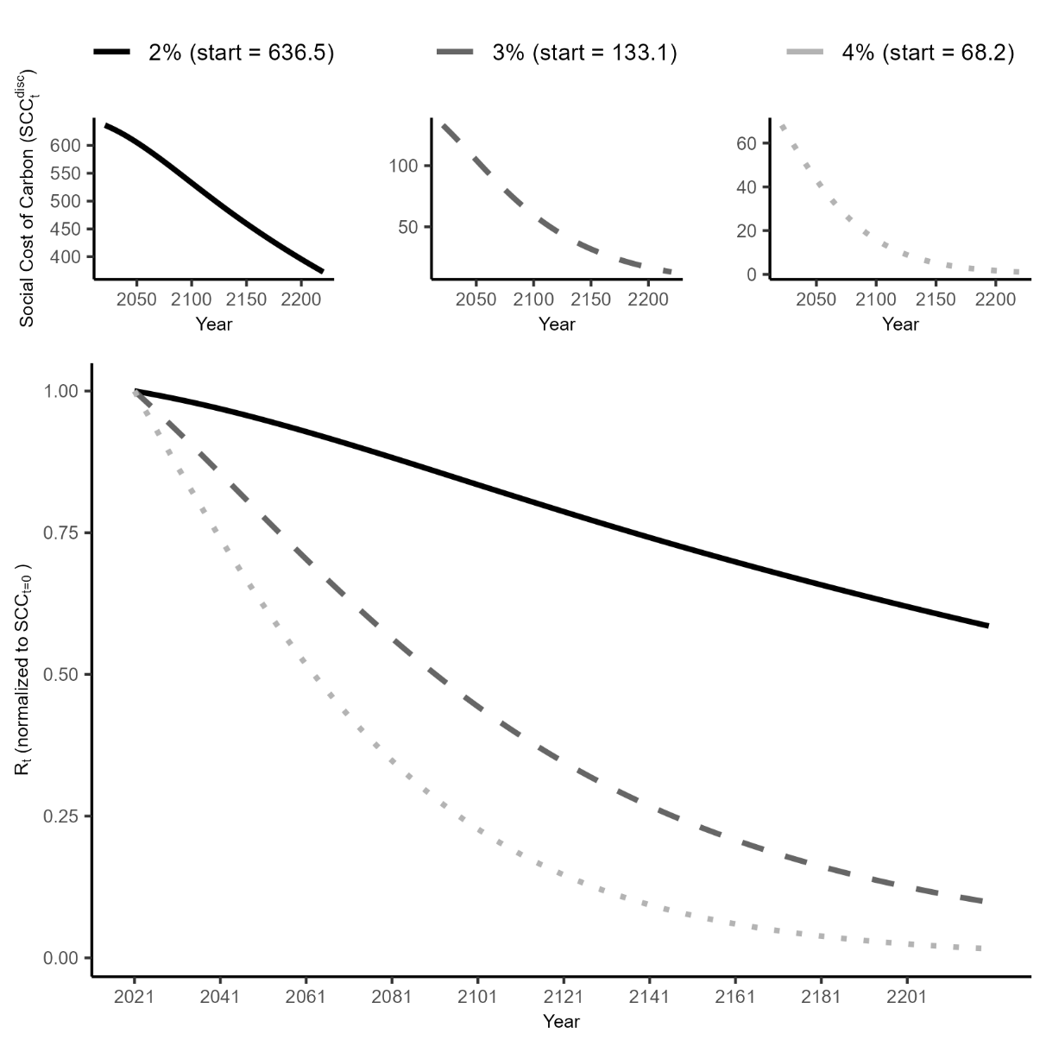
Supplementary Figure 7. Discounted social cost of carbon (SCC) over time under three discount rate assumptions.
Curves show the projected decline in SCC from 2021 onward under annual discount rates of 2%, 3%, and 4%. On the top panel, the left y-axis shows the discounted SCC value in USD t CO₂e⁻¹, while on the bottom figure, the y-axis shows the normalized ratio between the discounted SCC at time t and its value in 2021.

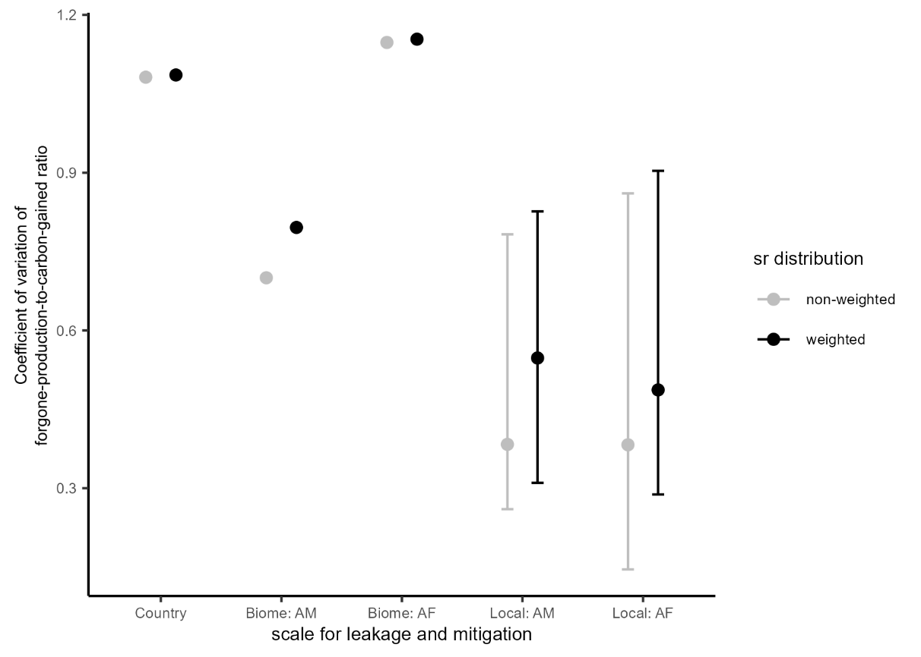
Supplementary Figure 8. Sensitivity of forgone-production-to-carbon-gained ratio variability to weighting of stocking rates across scales
Coefficient of variation of the forgone-production-to-carbon-lost ratio when stocking rates (sr) are weighted (black) versus non-weighted (grey) across the scales adopted for leakage and mitigation: country, biome (Amazon, Atlantic Forest), and local domains. See “Estimating stocking rates and animal performance” section on the Supplementary Methods for an explanation on the weights on stocking rates. Error bars indicate 95% confidence intervals.

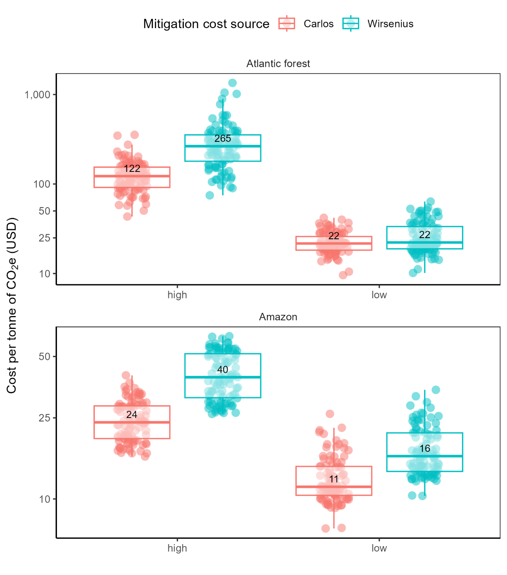
Supplementary Figure 9. Carbon cost outcomes under alternative beef-intensification cost assumptions.
Distribution of total cost per tonne of CO₂e (USD) for restoration projects in the Brazilian Atlantic Forest and Amazon, shown separately for high-leakage and low-leakage projects. Results compare outcomes obtained using two alternative sources of beef intensification costs (Carlos et al.⁵ and Wirsenius & d’Albertas¹²), with total costs including restoration, land, and leakage-mitigation costs, assuming full compensation of forgone production through intensified beef production elsewhere. All results assume that 100% of forgone beef production is displaced across the country, and that mitigation actions are also undertaken at the country domain .Boxplots summarize the distribution across projects, with boxes indicating the interquartile range, horizontal lines the median, and whiskers extending to 1.5× the interquartile range. Semi-transparent points show individual project outcomes, and numbers inside boxes indicate median costs.

Supplementary Tables
Supplementary Table 1. Property size classes used in the 2017 Brazilian Agricultural Census.
Each row represents a property size class as defined by the Brazilian Institute of Geography and Statistics (IBGE). The "Size interval (ha)" column refers to the range of values of each class in hectares. The "Mid-point area (ha)" column indicates the arithmetic midpoint of each interval, used as a representative value for analysis.

Size Interval | Mid-point
More than 0 to less than 0.1 ha | 0.05
From 0.1 to less than 0.2 ha | 0.15
From 0.2 to less than 0.5 ha | 0.35
From 0.5 to less than 1 ha | 0.75
From 1 to less than 2 ha | 1.5
From 2 to less than 3 ha | 2.5
From 3 to less than 4 ha | 3.5
From 4 to less than 5 ha | 4.5
From 5 to less than 10 ha | 7.5
From 10 to less than 20 ha | 15
From 20 to less than 50 ha | 35
From 50 to less than 100 ha | 75
From 100 to less than 200 ha | 150
From 200 to less than 500 ha | 350
From 500 to less than 1,000 ha | 750
From 1,000 to less than 2,500 ha | 1750
From 2,500 to less than 10,000 ha | 6250
From 10,000 ha and more | 15000

Supplementary Table 2. State-level intensification costs and added beef yield in Brazilian extensive pasture systems.
For each Brazilian state (UF), cost represents the mean annual production costs (2021 USD ha⁻¹ yr⁻¹) associated with intensifying degraded extensive pastures to well-maintained extensive systems, while yield represents the mean increase in beef yield (kg ha⁻¹ yr⁻¹). Mean reports the state-level mean, and low and high denote the lower and upper bounds of the 95% confidence interval, respectively.

UF | variable | mean | low | high
Acre | cost | 241.56 | 238.36 | 244.77
Acre | yield | 55.55 | 54.21 | 56.90
Alagoas | cost | 179.02 | 156.71 | 201.34
Alagoas | yield | 16.46 | 3.78 | 29.14
Amapá | cost | 266.81 | 262.37 | 271.25
Amapá | yield | 80.73 | 78.56 | 82.90
Amazônas | cost | 245.47 | 243.72 | 247.21
Amazônas | yield | 40.73 | 39.77 | 41.70
Bahia | cost | 190.63 | 186.69 | 194.57
Bahia | yield | 29.16 | 27.09 | 31.24
Ceará | cost | 182.95 | 173.20 | 192.70
Ceará | yield | 11.47 | 8.82 | 14.12
Distrito Federal | cost | 220.80 | 214.38 | 227.23
Distrito Federal | yield | 51.62 | 48.58 | 54.66
Espírito Santo | cost | 173.07 | 164.62 | 181.52
Espírito Santo | yield | 27.14 | 23.53 | 30.75
Goiás | cost | 204.07 | 202.64 | 205.50
Goiás | yield | 49.50 | 48.75 | 50.24
Maranhão | cost | 228.73 | 216.79 | 240.67
Maranhão | yield | 48.62 | 44.70 | 52.54
Mato Grosso | cost | 192.86 | 191.59 | 194.13
Mato Grosso | yield | 47.14 | 46.49 | 47.79
Mato Grosso Do Sul | cost | 204.69 | 203.04 | 206.34
Mato Grosso Do Sul | yield | 58.96 | 58.11 | 59.81
Minas Gerais | cost | 204.28 | 203.15 | 205.41
Minas Gerais | yield | 43.79 | 43.10 | 44.48
Pará | cost | 253.97 | 250.71 | 257.23
Pará | yield | 53.69 | 52.18 | 55.20
Paraíba | cost | 203.07 | 177.88 | 228.26
Paraíba | yield | 12.71 | 7.62 | 17.80
Paraná | cost | 197.28 | 195.02 | 199.54
Paraná | yield | 52.79 | 51.05 | 54.53
Pernambuco | cost | 192.97 | 182.00 | 203.93
Pernambuco | yield | 16.90 | 14.51 | 19.29
Piauí | cost | 222.53 | 212.90 | 232.16
Piauí | yield | 37.99 | 35.80 | 40.18
Rio De Janeiro | cost | 173.19 | 164.99 | 181.39
Rio De Janeiro | yield | 35.47 | 31.58 | 39.37
Rio Grande Do Norte | cost | 182.72 | 168.19 | 197.24
Rio Grande Do Norte | yield | 3.45 | -2.40 | 9.31
Rio Grande Do Sul | cost | 168.39 | 165.80 | 170.99
Rio Grande Do Sul | yield | 25.15 | 23.43 | 26.86
Rondônia | cost | 174.09 | 165.36 | 182.83
Rondônia | yield | 35.77 | 32.48 | 39.06
Roraima | cost | 249.53 | 243.52 | 255.54
Roraima | yield | 39.86 | 36.42 | 43.30
Santa Catarina | cost | 182.45 | 177.78 | 187.13
Santa Catarina | yield | 24.98 | 21.96 | 28.01
São Paulo | cost | 201.56 | 199.86 | 203.27
São Paulo | yield | 49.00 | 48.16 | 49.84
Sergipe | cost | 189.02 | 174.26 | 203.77
Sergipe | yield | 6.42 | 2.28 | 10.56
Tocantins | cost | 176.79 | 173.80 | 179.78
Tocantins | yield | 31.19 | 29.35 | 33.02

Supplementary Table 3. Reform, recovery and maintenance costs (in 2021 USD per hectare) for Brazilian biomes.
Reform costs apply to low-vigour pastures, while recovery costs apply to medium-vigour pastures. After reform of recovery, annual maintenance costs incur. Values were extracted from Carlos et al. ⁵.

Biome | Reform | Recovery | Maintenance
Amazonia | 333 | 233 | 52
Caatinga | 360 | 258 | 71
Cerrado | 303 | 203 | 71
Atlantic Forest | 274 | 171 | 50
Pampa | 368 | 270 | 131
Pantanal | 285 | 178 | 52

Supplementary Table 4. Variation in carbon costs under different discount rates when ignoring vs. mitigating leakage.
For each scenario (defined by biome and leakage level), the table reports the median carbon cost (USD tCO₂e⁻¹) under discount rates of 2%, 3%, and 4%, assuming leakage is either ignored or fully mitigated. It also shows the relative cost increase from mitigation (%), and the percentage point (pp) change in that cost increase compared to the central estimate using a 3% discount rate for the same scenario.

(a) Atlantic Forest
Leakage level | Disc.  rate (r) | Ignoring leakage | With mitigation | Cost increase (%) | Change vs. Ignoring leakage with r=3 (pp)
Low | 2 | 17.7 | 21.8 | 23 | -3
 | 3 | 18.9 | 22.2 | 17 | 0
 | 4 | 20.3 | 23.8 | 17 | 0
High | 2 | 57.4 | 233.0 | 306 | -25
 | 3 | 61.3 | 264.5 | 331 | 0
 | 4 | 65.7 | 302.9 | 361 | 30
(b) Amazon
Low | 2 | 8.8 | 15.1 | 71 | 1
 | 3 | 9.42 | 16.2 | 72 | 0
 | 4 | 10.1 | 17.4 | 72 | 0
High | 2 | 15.1 | 36.7 | 143 | -2
 | 3 | 16.1 | 39.5 | 145 | 0
 | 4 | 17.3 | 42.8 | 147 | 2

Supplementary Table 5. Carbon costs from restoration.
Carbon costs estimates extracted from the literature, reflecting the costs per tonne of CO₂e generated by restoration projects.
USD tonne of CO₂ e⁻¹ | Targeted area
18–29 | Atlantic Forest³²
23.80 | Median value for tropical forests³³
20-75 | Range of values from the Tropics³⁴

Supplementary Table 6. Forest restoration costs under different methods for Brazilian biomes.
Forest restoration costs under different methods for Brazilian biomes. Forest restoration costs (in 2021 USD per hectare) under different restoration methods, for the Atlantic Forest and Amazon biomes. Restoration methods are classified as Assisted, Intermediate, and Active. Assisted refers to natural regeneration supported by minimal intervention (e.g., fencing, control of invasive species). Intermediate involves partial planting combined with natural regeneration. Active entails full planting of native species with intensive site preparation. The "Mechanization" column indicates whether mechanical soil preparation and planting were used (Y = Yes, N = No). Cost estimates are based on operational data provided by reg.reen, a project developer in Brazil.

Restoration type | Mechanization | Atlantic Forest | Amazon Forest
Assisted | N | 232 | 140
Intermediate | N | 759 | 680
Intermediate | Y | 2421 | 1976
Active | N | 808 | 826
Active | Y | 4206 | 3677

Supplementary References
1. IBGE. Censo Agropecuário: Tabela 6754. (2017).
2. LAPIG. Atlas das Pastagens. Atlas das Pastagens https://atlasdaspastagens.ufg.br/ (2024).
3. CONAB. Oferta e demanda de carnes. https://www.conab.gov.br/info-agro/analises-do-mercado-agropecuario-e-extrativista/analises-do-mercado/oferta-e-demanda-de-carnes (2024).
4. IBGE. Pesquisa Trimestral do Abate de Animais. https://sidra.ibge.gov.br/tabela/1094 (2024).
5. Carlos, S. D. M. et al. Costs of Recovering Degraded Pastures in the Brazilian States and Biomes. https://agro.fgv.br/sites/default/files/2023-02/costs_of_recovering_degraded_pastures_in_the_brazilian_states_and_biomes_0.pdf (2022).
6. IBGE. Divisão regional do Brasil em regiões geográficas imediatas e regiões geográficas intermediárias. (IBGE, Rio de Janeiro, 2017).
7. G. Fischer et al. Global Agro-Ecological Zones v4 – Model Documentation. (FAO ;, 2021).
8. Jarvis, A., H.I. Reuter, A. Nelson, & E. Guevara. Hole-filled SRTM for the globe Version 4. available from the CGIAR-CSI SRTM 90m Database (2008).
9. Alves-Pinto, H. N. et al. Reconciling rural development and ecological restoration: Strategies and policy recommendations for the Brazilian Atlantic Forest. Land Use Policy 60, 419–426 (2017).
10. Arantes, A. E., Couto, V. R. de M., Sano, E. E. & Ferreira, L. G. Livestock intensification potential in Brazil based on agricultural census and satellite data analysis. Pesqui. Agropecuária Bras. 53, 1053–1060 (2018).
11. Strassburg, B. B. N. et al. When enough should be enough: Improving the use of current agricultural lands could meet production demands and spare natural habitats in Brazil. Glob. Environ. Change 28, 84–97 (2014).
12. Wirsenius, S. & d’Albertas Gomes de Carvalho, F. BeefSC: A Model for Calculating Optimal Stocking Rates and Costs of Beef. Description of Model (v. 1.0) and Input Data for Application on Brazilian Beef Production. https://zenodo.org/records/18845417 (2026) doi:10.5281/zenodo.18845417.
13. Brazil. Ministry of Agriculture, Livestock and Food Supply. Plan for Adaptation and Low Carbon Emission in Agriculture Strategic Vision for a New Cycle. https://www.gov.br/agricultura/pt-br/assuntos/sustentabilidade/planoabc-abcmais/publicacoes/abc-english.pdf (2021).
14. Williams, B. A. et al. Global potential for natural regeneration in deforested tropical regions. Nature 1–7 (2024) doi:10.1038/s41586-024-08106-4.
15. Crouzeilles, R. et al. A global meta-analysis on the ecological drivers of forest restoration success. Nat. Commun. 7, 11666 (2016).
16. Chazdon, R. L. & Guariguata, M. R. Natural regeneration as a tool for large-scale forest restoration in the tropics: prospects and challenges. Biotropica 48, 716–730 (2016).
17. Fick, S. E. & Hijmans, R. J. WorldClim 2: new 1-km spatial resolution climate surfaces for global land areas. Int. J. Climatol. 37, 4302–4315 (2017).
18. Hengl, T. et al. SoilGrids250m: Global gridded soil information based on machine learning. PLOS ONE 12, e0169748 (2017).
19. Joly, C. A., Metzger, J. P. & Tabarelli, M. Experiences from the Brazilian Atlantic Forest: ecological findings and conservation initiatives. New Phytol. 204, 459–473 (2014).
20. Ishwaran, H. & Kogalur, U. B. randomForestSRC: Fast Unified Random Forests for Survival, Regression, and Classification (RF-SRC). (2025).
21. Fawcett, T. An introduction to ROC analysis. Pattern Recognit. Lett. 27, 861–874 (2006).
22. Swinfield, T., Shrikanth, S., Bull, J. W., Madhavapeddy, A. & zu Ermgassen, S. O. S. E. Nature-based credit markets at a crossroads. Nat. Sustain. 1–4 (2024) doi:10.1038/s41893-024-01403-w.
23. Groom, P. B. BenGroom/socialvalueofoffsets: The Social Value of Offsets. https://doi.org/10.5281/zenodo.7848893 (2023) doi:10.5281/zenodo.7848893.
24. Walker, W. S. et al. The global potential for increased storage of carbon on land. Proc. Natl. Acad. Sci. 119, e2111312119 (2022).
25. USDA Foreign Agricultural Service. Beef and beef products: exports by country. (2025).
26. Food and Agriculture Organization of the United Nations (FAO). GLW 4: Gridded Livestock Density (Global - 2020 - 10 km). (2025).
27. Food and Agriculture Organization of the United Nations (FAO) – with major processing by Our World in Data. Beef and buffalo meat production. (2025).
28. Food and Agriculture Organization of the United Nations (FAO). FAOSTAT: Production – Livestock Primary (Beef production) & Livestock (Herd size, cattle). (2025).
29. Parente, L. et al. Annual 30-m maps of global grassland class and extent (2000–2022) based on spatiotemporal Machine Learning. Sci. Data 11, 1303 (2024).
30. Romanzini, E. P., Barbero, R. P., Reis, R. A., Hadley, D. & Malheiros, E. B. Economic evaluation from beef cattle production industry with intensification in Brazil’s tropical pastures. Trop. Anim. Health Prod. 52, 2659–2666 (2020).
31. Poorter, L. et al. Biomass resilience of Neotropical secondary forests. Nature 530, 211–214 (2016).
32. Brancalion, P. H. S. et al. The cost of restoring carbon stocks in Brazil’s Atlantic Forest. Land Degrad. Dev. 32, 830–841 (2021).
33. Busch, J. et al. Cost-effectiveness of natural forest regeneration and plantations for climate mitigation. Nat. Clim. Change 1–7 (2024) doi:10.1038/s41558-024-02068-1.
34. Austin, K. G. et al. The economic costs of planting, preserving, and managing the world’s forests to mitigate climate change. Nat. Commun. 11, 5946 (2020).

