SUPPLEMENTARY INFORMATION

Supplementary methods
Inclusion criteria were as follows: age ≥18 years and intraocular pressure ≤21 mmHg. Specifically, inclusion criteria for the control group were (1) no systemic diseases; (2) normal fundus examination results; those for the NDR group (comprising patients with diabetes without diabetic retinopathy [DR]) were (1) diagnosis of type 2 diabetes mellitus¹; (2) no diabetic retinopathy observed on fundus examination; those for the NPDR group (comprising patients with preclinical or early non-proliferative DR) were (1) diagnosis of type 2 diabetes mellitus; (2) met the diagnostic criteria for NPDR; (3) no other fundus abnormalities except diabetic retinopathy. Exclusion criteria were as follows: (1) history of ocular trauma or intraocular surgery (including intravitreal injection, retinal laser photocoagulation, vitrectomy, etc.); (2) presence of other systemic diseases affecting visual function besides type 2 diabetes mellitus; (3) spherical equivalent greater than +3.00 D or less than −3.00 D; (4) poor optical coherence tomography angiography (OCTA)/ optical coherence tomography (OCT) data quality due to eye movement, blinking, or other technical factors, with significant retinal layer segmentation failure or signal strength of <7.
Microaneurysms (MAs) represent the early hallmark lesions of DR, arising from a pathological compensatory response of retinal capillary endothelial cells to local hypoxia following pericyte loss. HEs are yellow, waxy deposits that accumulate in the outer plexiform layer and are composed predominantly of leaked serum lipoproteins; their presence indicates extensive disruption of the inner blood–retinal barrier. Cotton wool spots (CWSs) are ischemic infarcts within the retinal nerve fibre layer resulting from arteriolar occlusion, and their histopathological correlate is the formation of “cytoid bodies” caused by obstructed axoplasmic flow.

Supplementary Figures
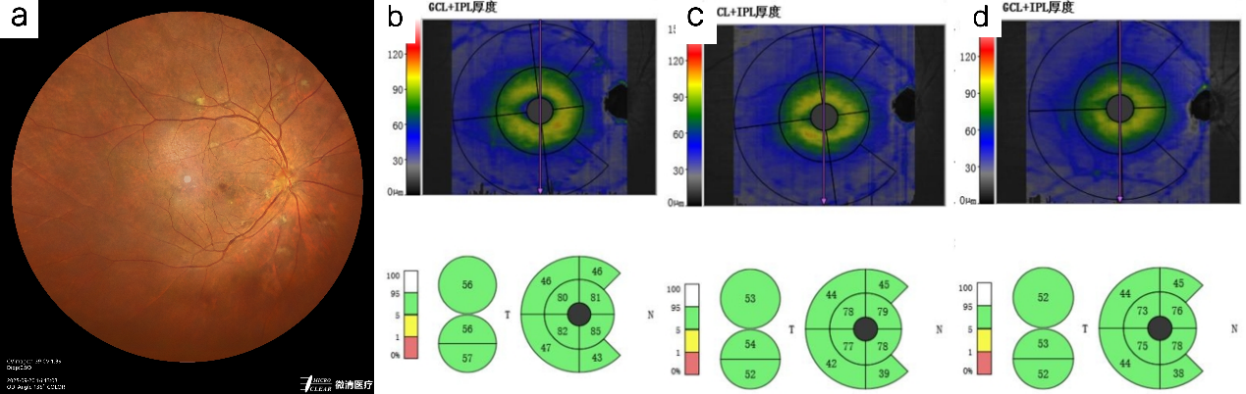
Supplementary Figure 1. GCIPL thickness across the three groups. a Colour wide-field fundus photograph of NPDR with cotton wool spots. b GCIPL thickness in the control group. c GCIPL thickness in the NDR group; d GCIPL thickness in the NPDR group. GCIPL, ganglion cell–inner plexiform layer; NDR, no diabetic retinopathy; NPDR, non-prsoliferative diabetic retinopathy

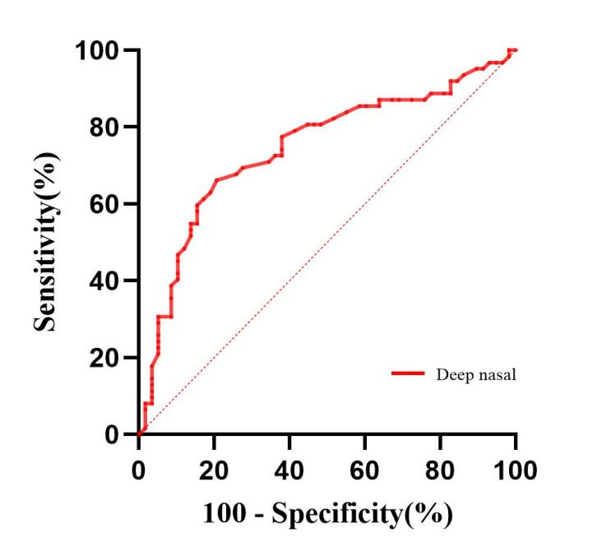
Supplementary Figure 2. ROC curve of deep nasal retinal vessel density for diagnosing preclinical diabetic retinopathy. ROC, receiver operating characteristic

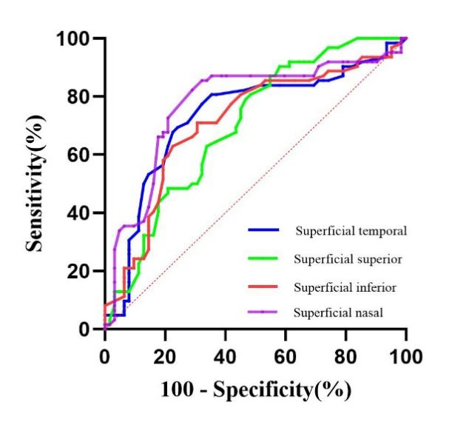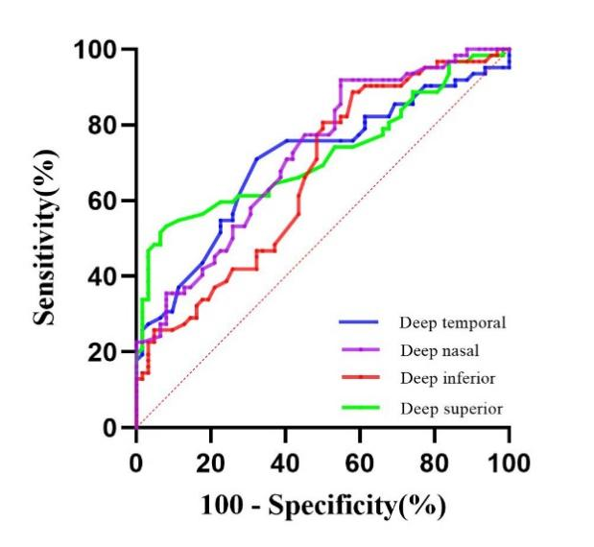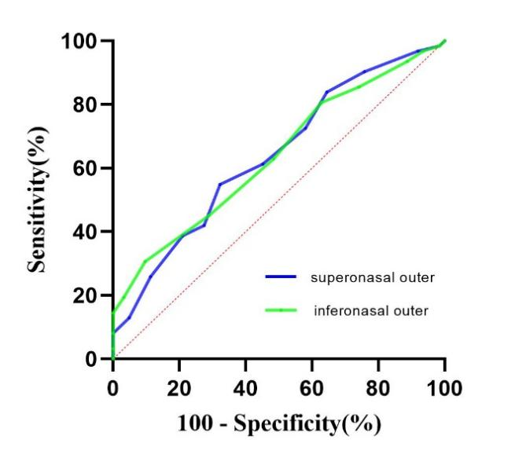
Supplementary Figure 3. ROC curves of retinal vascular density and GCIPL thickness parameters for diagnosing diabetic retinopathy. GCIPL, ganglion cell–inner plexiform layer; ROC, receiver operating characteristic

1 American Diabetes Association Professional Practice Committee for, D. 2. Diagnosis and Classification of Diabetes: Standards of Care in Diabetes-2026. Diabetes Care 49, S27-S49, doi:10.2337/dc26-S002 (2026).

