Toys and pictures used in Study 1 are listed as follows.

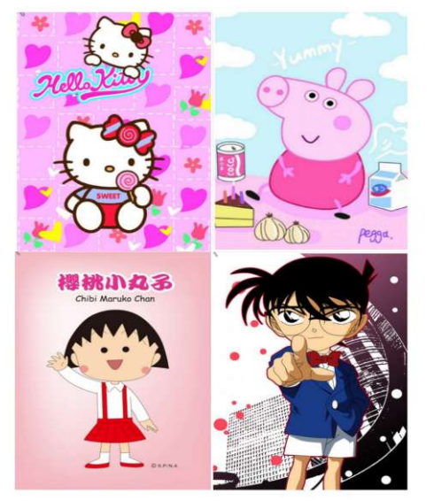
- cartoon pictures

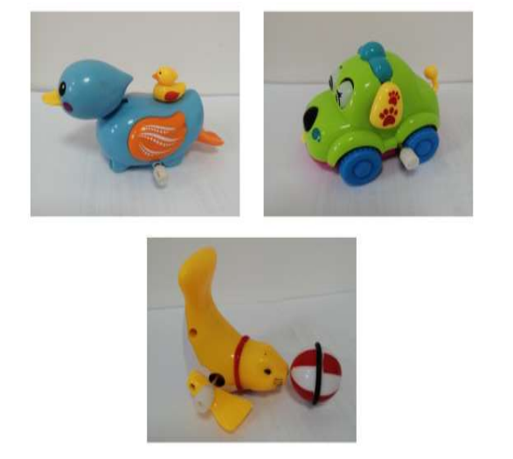
- wind-up

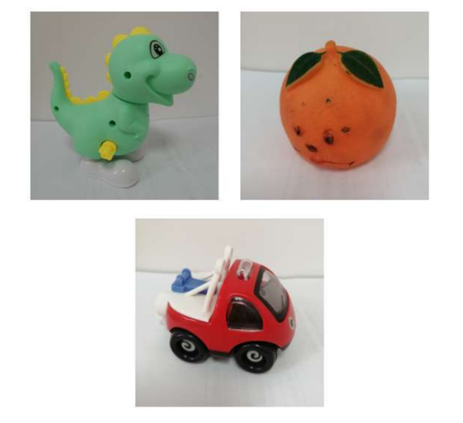
- hand-held

The coding definitions for each behavioral category are specified below:
- Low-level Responsive Joint Attention (RJA-L)
Defined as the child’s ability to follow the researcher’s finger pointing to a near-distance picture book (located 5 cm from the finger). The percentage of successful trials was recorded.

- High-level Responsive Joint Attention (RJA-H)
Defined as the child’s ability to follow the researcher’s finger pointing to images on walls at a far-distance position (left, right, left rear, or right rear). The percentage of successful trials was recorded.

- Eye Contact (EC)
Defined as the child’s initiative to establish eye contact with the researcher while touching a toy. The frequency of occurrence was recorded.

- Gaze Alternation (GA)
Defined as the child’s initiative eye shifting back and forth between a toy and the researcher’s eyes. The frequency of occurrence was recorded.

- Pointing
Defined as the child’s initiative index-finger pointing toward an object, intended for sharing or informing rather than obtaining the object. This behavior may or may not be accompanied by eye contact with the researcher. The frequency of occurrence was recorded.

- Showing
Defined as the child’s initiative to pick up a toy, hold it up to the researcher’s face, and look at the researcher. The frequency of occurrence was recorded.

