Supplementary Materials
For
Cross-Platform Experimental Validation of Multi-Stage Adaptive Gate Driving for MOSFET Switching Loss Reduction in Transformer Boost Circuits
This supplementary material documents the original MS-AGD implementation and its validation on a 5 W, 24–800 V SiC MOSFET flyback prototype, supporting the cross-platform adaptation presented in the main manuscript.
S1. Original Platform Specifications
S1.1 Converter design
The prototype targets portable high-step-up applications. Design parameters: input 24 V (±20%), output 800 V, rated 5 W, switching frequency 100 kHz, DCM operation, step-up ratio 33:1.
S1.2 Power stage
Transformer: EFD15 core, 1:40 turns ratio. Output stage: 2.2 μF/1500 V film capacitor with resistive load. Main switch: Wolfspeed C3M0065090D SiC MOSFET (900 V, 65 mΩ,$Q_{g}≈60nC$), rated to sustain the 800 V output stress plus leakage-inductance spikes.
S1.3 Instrumentation
Power measurement: Yokogawa WT310E (±0.1%, 100 kHz). Waveform capture: Tektronix MDO3104 (1 GHz, 2.5 GS/s) with P6139A voltage probe and TCP0030A current probe. Thermal measurement: PT1000 (±0.05°C) bonded to the MOSFET package. Ambient control: programmable chamber at 16°C with ±1.1 m°C stability over 240 min.
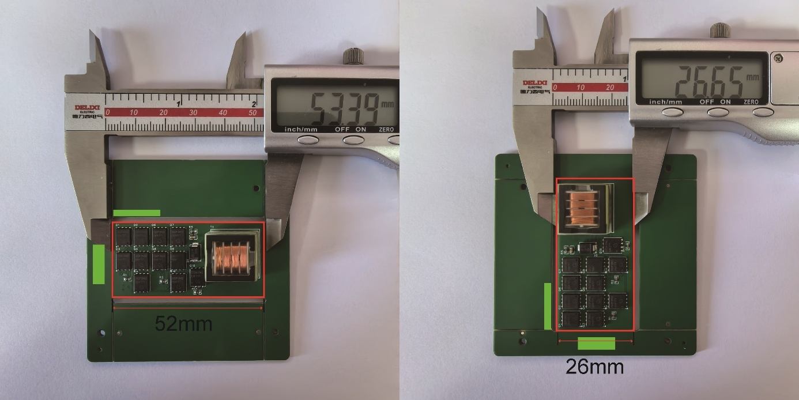
Fig. S1. Flyback prototype PCB with integrated MS-AGD module (52 mm × 26 mm)
S2. Fixed Gate Resistor Trade-off
S2.1 Governing relation
During the Miller plateau, the drain–source slew rate is set by the gate loop impedance:
$$\begin{aligned}\frac{{dV}_{DS}}{dt}=-\frac{V_{drive}-V_{mp}}{R_{g}×C_{gd}\left(V_{DS}\right)}\#\left(S1\right)\end{aligned}$$
The strong nonlinearity of $C_{gd}\left(V_{DS}\right)$ causes ${{dV}_{DS}}/{dt}$ to accelerate 3–5× as $V_{DS}$​ decreases, even under constant $I_{g}$​.
S2.2 Quantitative trade-off
For the original platform ($V_{DD}=24V,C_{gd0}=80pF$):
$R_{g}=2Ω,t_{mp}≈9ns$, peak ${{dV}_{DS}}/{dt}≈2.67V/{ns}$—loss minimized, EMI exceeds regulatory limits.
$R_{g}=10Ω,t_{mp}≈45ns$; Stage-III energy $E_{stage3}≈0.54μJ$, accounting for approximately 87% of total turn-on loss.
$R_{g}=20Ω,t_{mp}≈90ns$; EMI compliant but switching loss rises 3–4× relative to the 2 Ω case.
S2.3 Input voltage sensitivity
Since $t_{mp}∝V_{DD}$​, a 12–48 V input range induces a 4× variation in $t_{mp}$​. Any fixed $R_{g}$​ optimized at one operating point therefore deviates from optimum at voltage extremes, precluding single-parameter optimization.
S3. MS-AGD Architecture
S3.1 Topology
Fig. S2. Complete MS-AGD schematic. Upper dashed region: three cascode current-mirror groups (mirror_1–mirror_3), each comprising four transistors and an enable switch (S1–S3), sharing low-voltage supply vcc_L. Lower-left: differentiating network (C2 with resistor divider). Lower-right: comparison stage. Central region: flyback power stage (T1, Q0, D1, C3), supplied by vcc_P.
The driver integrates three functional blocks: programmable current mirrors for stage-wise gate drive, a passive differentiator for ${{dV}_{DS}}/{dt}$ extraction, and a dual-threshold comparator pair for plateau boundary identification.
S3.2 Four-stage piecewise-linear drive profile
The MS-AGD replaces the conventional rectangular PWM profile with four independently configured current segments:
Stage 1 (turn-on delay): low $I_{g}$​ suppresses gate-trace EMI during sub-threshold charging.
Stage 2 (current rise): elevated $I_{g}$​ minimizes $V_{DS}-I_{D}$​ overlap loss.
Stage 3 (Miller plateau): moderate $I_{g}$​ decouples plateau ${{dV}_{DS}}/{dt}$ (EMI determinant) from total switching energy.
Stage 4 (enhanced conduction): high $I_{g}$​ drives $V_{GS}$​ to steady state, minimizing $R_{DS(on)}$​ settling time.
This stage-wise current allocation decouples loss optimization ($I_{g}$​ amplitude) from EMI control (${{dV}_{DS}}/{dt}$).
S3.3 Cascode current mirror
A simple current mirror exhibits an output impedance of approximately 50 kΩ, insufficient for the 0–15 V $V_{GS}$​ swing. The cascode topology raises output impedance above 5 MΩ, limiting current deviation to below 5% across the full swing.
S4. Detection Circuit Design
S4.1 Differentiator sizing
The time constant $τ_{diff}=R_{diff}×C_{diff}$ satisfies $τ_{diff}≪t_{mp}$​ (preserving differentiation mode) and $τ_{diff}≫t_{noise}$ (suppressing noise amplification). The original platform uses $τ_{diff}=5ns,(R_{diff}=1KΩ,C_{diff}=5pF)$. The peak differentiator output is:
$$\begin{aligned}V_{peak}=R_{diff}×C_{diff}×\frac{V_{DD}}{t_{mp}}\#\left(S2\right)\end{aligned}$$
Since $t_{mp}∝V_{DD}$​, the ratio ${V_{DD}}/{t_{mp}}$​ is approximately invariant. Measured $V_{peak}=2.6±0.3V$ across 12–48 V input, confirming calibration-free operation.
S4.2 Dual-threshold discrimination
Two TLV3601 comparators (2.5 ns propagation delay) implement threshold discrimination:
Miller_Start: $V_{th_{high}}=0.9×V_{peak}$​ (approximately 2.4 V)—delays triggering until ${{dV}_{DS}}/{dt}$ is fully established, suppressing false triggers from Stage 1–2 noise.
Miller_End: $V_{th_{low}}=0.1×V_{peak}$​ (approximately 0.27 V)—extends detection into the ${{dV}_{DS}}/{dt}$ decay tail, ensuring plateau-stage drive persists until $V_{DS}$​ settles.
S4.3 Timing budget
Combined differentiator response, comparator propagation, and switch-gate delay yield a total detection delay below 50 ns, substantially shorter than the minimum observed $t_{mp}$​ across all operating conditions.
S5. Discrete Implementation
S5.1 BOM and footprint
The MS-AGD uses only general-purpose discrete components, with no ICs, MCUs, or programmable logic. Single-unit BOM cost is $0.48, versus approximately $15.70 for a comparable digital closed-loop driver. The cascode current mirror module measures 13 mm × 14 mm (182 mm²), verified by caliper measurement.
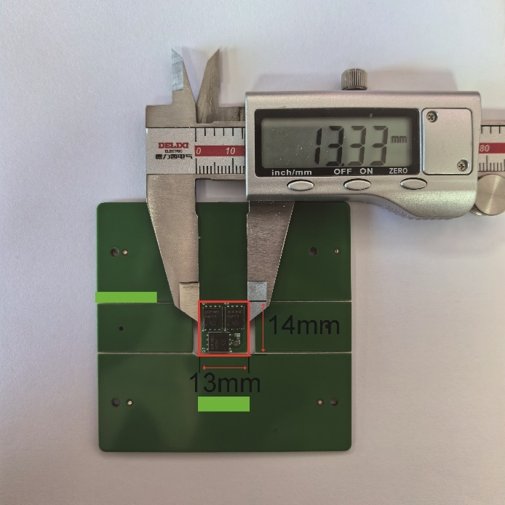
Fig. S3. MS-AGD current-mirror PCB with dimensional reference.
S5.2 PWM interface
The MS-AGD accepts a single enable signal from a standard PWM controller, requiring no firmware modification. Internal comparators autonomously handle stage transitions based on real-time ${{dV}_{DS}}/{dt}$ sensing.
S5.3 Static consumption
Total static power consumption is approximately 8 mW, compared with approximately 185 mW for the digital closed-loop baseline—a primary contributor to the light-load efficiency advantage documented in Section S6.
S6. Original Platform Validation
S6.1 Four-stage $V_{GS}$​ waveform
Fig. S4. Measured $V_{GS}$​ at $V_{in}=24V,P_{out}=5W,f_{sw}=100kHz$
Stage 1 (0–155 ns): 0 → 3.04 V at 20 mV/ns, yielding $I_{g}≈48mA$ (design 50 mA, <5% deviation).
Stage 2 (155–278 ns): 3.04 → 4.39 V at 36 mV/ns.
Stage 3 (278–790 ns): plateau at 4.33–4.39 V for 512 ns.
Stage 4 (790–1300 ns): 4.39 → 11.43 V.
S6.2 Thermal performance
Fig. S5. MOSFET temperature rise $ΔT$ vs. $f_{sw}$​ (20–125 kHz)
At 125 kHz, the MS-AGD reduces $ΔT$ by 0.79°C relative to the $R_{g}=10Ω$ baseline (1.13°C vs. 1.92°C). Averaged across the frequency range, the MS-AGD yields a 30% reduction in switching loss, with $ΔT$ held within 1.05–1.20°C against a 1.47–1.92°C baseline range.
S6.3 Conversion efficiency
Fig. S6. Efficiency vs. $P_{out}$ (0.5–5 W), fixed $R_{g}$​ vs. MS-AGD
Full load (5 W): 91.9% → 94.5% (+2.6 pp).
Light load (0.5 W): 85.6% → 88.5% (+2.9 pp; reported as 3.3–3.4 pp in the main manuscript due to rounding across repeated measurements).
The elevated light-load gain reflects the MS-AGD's suppression of gate-charge-dependent losses that fixed $R_{g}$​ driving cannot mitigate.

S6.4 Input voltage robustness
Fig. S7. Efficiency and detected $V_{mp}$​ vs. input voltage (10–50 V)
Across the 5× input range, conversion efficiency remains within 92–94.5% (peak near $V_{in}=25V$), and the detected Miller plateau voltage fluctuates within 4.21–4.24 V (peak-to-peak 30 mV), confirming the calibration-free detection predicted in Section S4.
S6.5 Device compatibility
Fig. S8. Turn-on waveforms on three MOSFETs ($V_{ds}=100V$)
Device A (C3M0065090D SiC): $Q_{g}=38nC,t_{mp}≈200ns$.
Device B (Si MOSFET): $Q_{g}=65nC,t_{mp}≈488ns$.
Device C (200 W-class MOSFET): $Q_{g}=140nC,t_{mp}≈900ns$.
The plateau voltage held at $V_{mp}≈4.18V$ across all three devices, and the four-stage profile exhibited no oscillation or overshoot. The MS-AGD resolved plateau boundaries across a 4.5× variation in $t_{mp}$​ without recalibration.
S6.6 Applicability boundaries
Detection floor: inherent circuit delay 28–30 ns. For $Q_{gd}<10nC$ devices (e.g., 30 V GaN HEMTs), $t_{mp}$​ may fall below 15 ns, exceeding the circuit's time resolution.
Power range: 1–50 W direct application. Above 50 W, paralleled current mirrors are required; below 1 W, the 8 mW static consumption erodes the efficiency advantage.
Operating-point specificity: current setpoints optimized for the nominal operating point; performance degrades at range extremes.

