Contrast-enhanced PET/MRI improves the diagnostic efficacy for detecting intrahepatic malignancies postlocoregional therapies in hepatocellular carcinoma

Ying-He Li, MD, Li Tian, MD, Yu-Qian Huang, MD, Ji-Ling Zeng, MD, Zhi-Mei Huang, MD, Le-Tao Lin, MD, Yu-Mo Zhao, MD, Wei Fan, MD, Jin-Hua Huang, MD, Ying-Ying Hu, MD

Corresponding author:
Ying-Ying Hu
Affiliation：Sun Yat-Sen University Cancer Center, Department of Nuclear Medicine, Guangzhou, Guangdong, China
E-mail: huyy@sysucc.org.cn

Supplemental materials

Supplementary methods
The process of PET/MR image acquirement and construction: MRI Respiratory gating was used in MRI. The MRI sequences included unenhanced in-phase and out-phase T1-weighted image (T1WI), T2WI with fat saturation, diffusion weighted imaging (DWI) and multiphase contrast-enhanced T1WI (arterial phase, portal venous phase and delayed phase). PET data were acquired simultaneously with a plain MR scan with a mean scan time of 18 min. PET images were reconstructed in a 192 × 192 matrix using a 3D-Ordered Subsets Expectation Maximization algorithm. PET attenuation correction was carried out using a four-compartment-model attenuation map (m-map) that was automatically generated based on a water-fat-imaging MR sequence. The PET images were smoothed by a Gaussian filter with a 3 mm full width at half maximum. PET images, MR images and fused PET/MR images were generated for review on a computer workstation (UIH Medical Systems).
Supplementary Table 1 PET/MRI-based evaluation and clinical nature of intrahepatic lesions discordant in empirical MRI-based and PET-based assessments
 | Image-based assessment (N) | PET/MRI-based assessment | Total number (N) | Clinically benign (N) | Clinically malignant (N) | Undefined (N)
Newly detected & treatment-naïve lesions | MRI benign & PET malignant (11) | Malignant | 11 | 0 | 9 | 2
Newly detected & treatment-naïve lesions | MRI benign & PET malignant (11) | benign | 0 | 0 | 0 | 0
Newly detected & treatment-naïve lesions | MRI malignant & PET benign (8) | Malignant | 5 | 1 | 4 | 0
Newly detected & treatment-naïve lesions | MRI malignant & PET benign (8) | benign | 3 | 1 | 1 | 1
Post-local ablation lesions | MRI benign & PET malignant (6) | Malignant | 5 | 0 | 4 | 1
Post-local ablation lesions | MRI benign & PET malignant (6) | benign | 1 | 1 | 0 | 0
Post-local ablation lesions | MRI malignant & PET benign (3) | Malignant | 2 | 0 | 1 | 1
Post-local ablation lesions | MRI malignant & PET benign (3) | benign | 1 | 1 | 0 | 0
Post-TACE/TAE lesions with or without local ablation | MRI benign & PET malignant (6) | Malignant | 3 | 0 | 2 | 1
Post-TACE/TAE lesions with or without local ablation | MRI benign & PET malignant (6) | benign | 3 | 0 | 1 | 2
Post-TACE/TAE lesions with or without local ablation | MRI malignant & PET benign (2) | Malignant | 2 | 1 | 0 | 1
 | MRI malignant & PET benign (2) | benign | 0 | 0 | 0 | 0

Figure S1 Patients selection and inclusion in this study

Figure S2 Inconspicuous residuals and atypical enhancement appearance brought false MRI results of the lesion post-TACE (A) A 31-year-old female with moderately differentiated HCC underwent two cycles of TACE combined with lenvatinib, but her blood AFP level (64.3 ng/ml) was still above the normal level (0.0-25.0 ng/ml) months later. The PET/MR scans found streak-like abnormally high PET signals (SUV_{lesion} = 2.80, SUV_{mean} of liver ± 2SD = 1.89 ± 0.20) along the edge of the posttreatment hepatic lesion, corresponding to a streak-like lesion with delayed enhancement performance on MR images (orange arrows). (B) The lesion was treated with cryoablation, and the AFP level decreased soon and remained normal in the one-year follow-up, suggesting that the lesion with an abnormal PET signal was actually malignant. (A: arterial phase; P: portal venous phase; D: delayed phase)

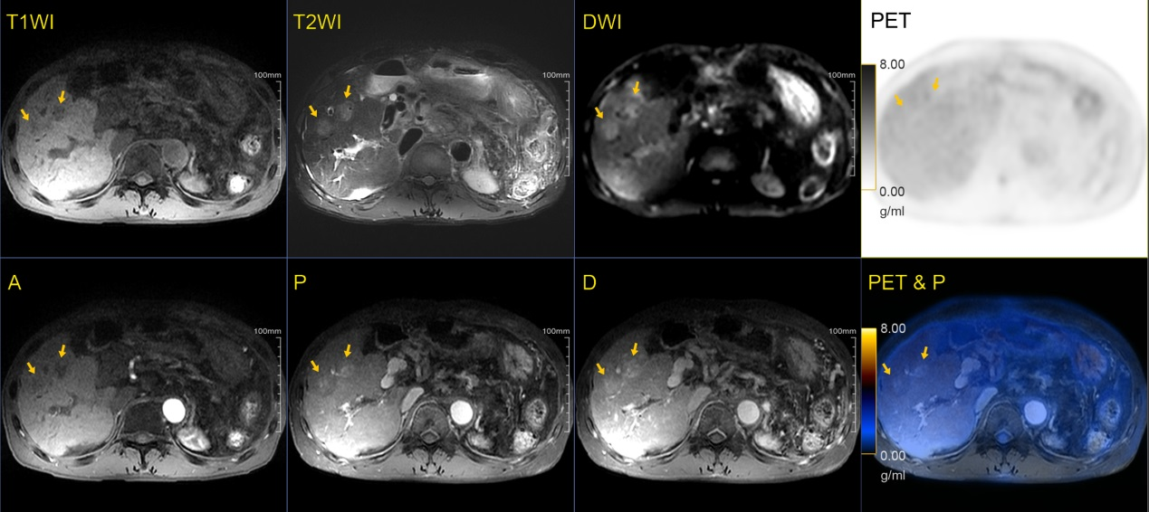
Figure S3 Abnormal MR signal intensity and weird enhancement performance led to false-positive MRI-based assessment A 56-year-old male with HCC underwent TACE two months prior and was found to have two new lesions at hepatic segment VIII on the MR images (orange arrows). The lesions were hypointense in T1WI and hyperintense in T2WI, restricted in DWI, and displayed an inhomogeneous delayed enhancement pattern. The lesions were suspected to be malignant based on MRI but benign based on PET since there was no abnormal signal on PET images. Finally the lesions were proved to be benign cirrhotic nodules through biopsy. (A: arterial phase; P: portal venous phase; D: delayed phase)

Figure S4 Similar FDG uptake between newly detected lesions and normal liver parenchyma led to false-negative PET results (A) A 47-year-old male with moderately differentiated HCC underwent RFA 2 years prior and was found to have a new lesion beside the ablation area (orange arrows) with abnormal signal intensity and typical enhancement pattern, but no abnormal signal was observed on PET images. (B&C) After the PET/MR scan, the patient underwent ablation, but the tumor relapsed around the ablation bed and metastasized one month later (Red arrow: ablation bed; Blue arrow: the recurrences and metastases; A: arterial phase; P: portal venous phase; D: delayed phase)

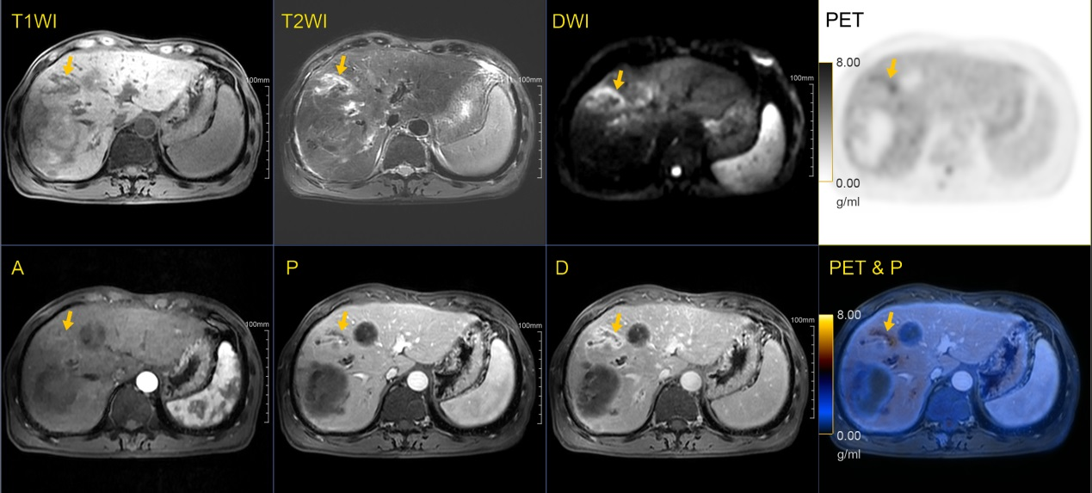
Figure S5 Inflammation caused false-positive PET results in newly detected lesion A 59-year-old male with moderately differentiated HCC underwent TACE was complicated by cholangitis (orange arrow), which displayed an abnormal high PET signal and caused false-positive PET-based assessment. (A: arterial phase; P: portal venous phase; D: delayed phase)
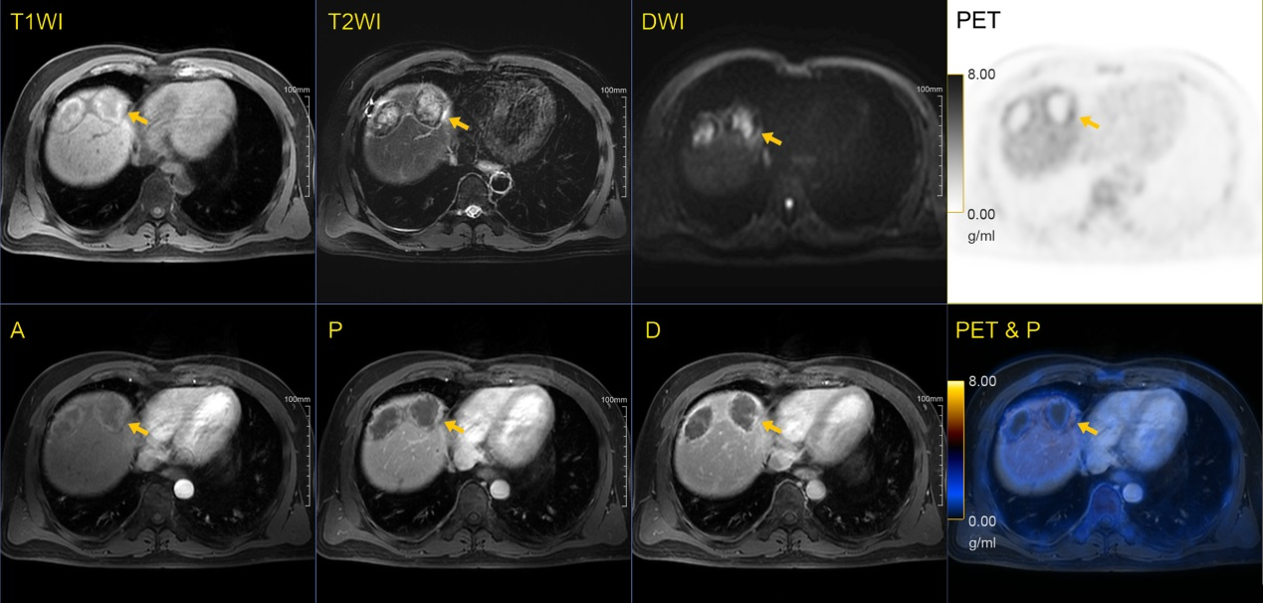
Figure S6 Inflammation at the edge of the residual cavity after ablation caused false-positive PET results A 45-year-old male with MRI-diagnosed HCC underwent RFA at the hepatic segment VIII one month prior and rim-like high PET signals along the edge of ablation areas were observed (orange arrow, SUV_{lesion} = 2.71, SUV_{mean} of liver ± 2SD = 1.69 ± 0.16). During the follow-up, the ablation areas were gradually reduced in sizes and no abnormal signal or enhancement pattern was observed alongside them, suggesting that the previous observed abnormal PET signals were benign and most likely caused by inflammation after ablation. (A: arterial phase; P: portal venous phase; D: delayed phase)

