Supplementary information

Tables

Table S1. Number of enhancers in each cell type after the filtering procedure
Cell type | Number of enhancers
gm12878 | 92,763
H1hesc | 21,560
hepg2 | 69,337
Hmec | 136,641
Hsmm | 145,952
Huvec | 147,113
K562 | 80,912
Nhek | 136,803
Nhlf | 111,889

Table S2. Structures of deep learning models in SeqEnhDL
Deep learning model | Structure
MLP | Dense(400, activation='relu')  Dropout(0.5)  Dense(400, activation='relu')  Dropout(0.5)  Flatten()  Dense(2, activation='softmax')
CNN | Conv2D(32, kernel_size=(4, 1), strides=(1, 1), activation='relu')  MaxPooling2D(pool_size=(4, 1), strides=(4, 1))  Conv2D(64, kernel_size=(5, 1), strides=(1, 1),activation='relu')  MaxPooling2D(pool_size=(5, 1), strides=(5, 1))  Flatten()  Dense(400, activation='relu')  Dropout(0.5)  Dense(2, activation='softmax')
RNN | Bidirectional(layers.LSTM(128))  Flatten()  Dense(128, activation='relu')  Dropout(0.5)  Dense(2, activation='softmax')

Table S3. Accuracies and AUCs of the ensemble of deep RNN approach
Cell type | Accuracy | AUC
gm12878 | 0.522 | 0.529
H1hesc | 0.530 | 0.544
hepg2 | 0.524 | 0.532
Hmec | 0.521 | 0.529
Hsmm | 0.523 | 0.530
Huvec | 0.522 | 0.530
K562 | 0.521 | 0.530
Nhek | 0.521 | 0.529
Nhlf | 0.524 | 0.532

Figures
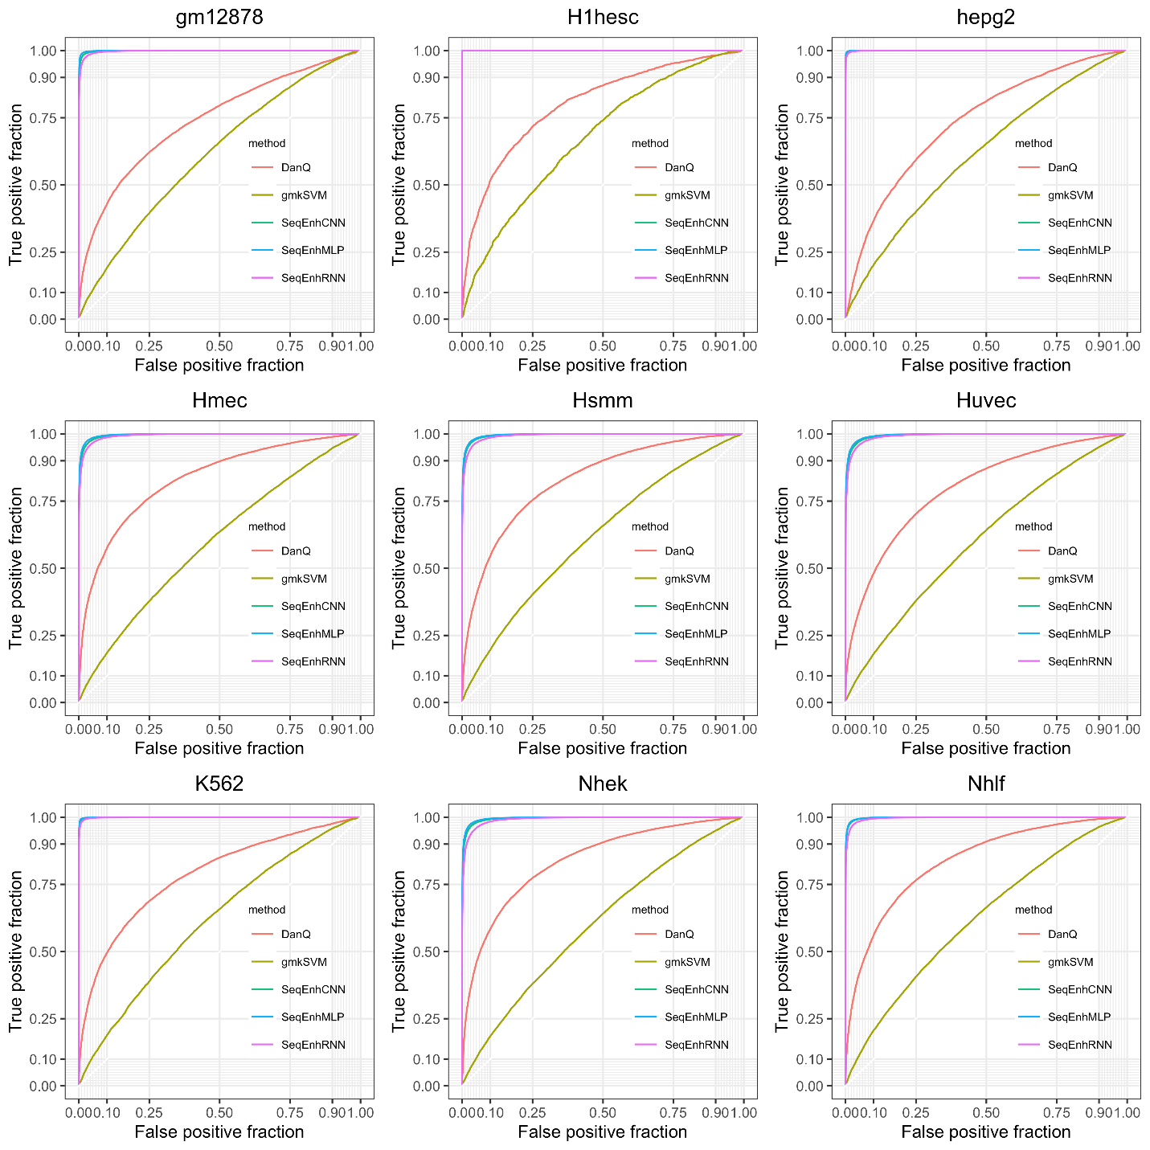
Figure S1. Comparison among different enhancer classifiers in terms of ROC curves. The curves were generated based on the first cross-validation dataset of each cell type.

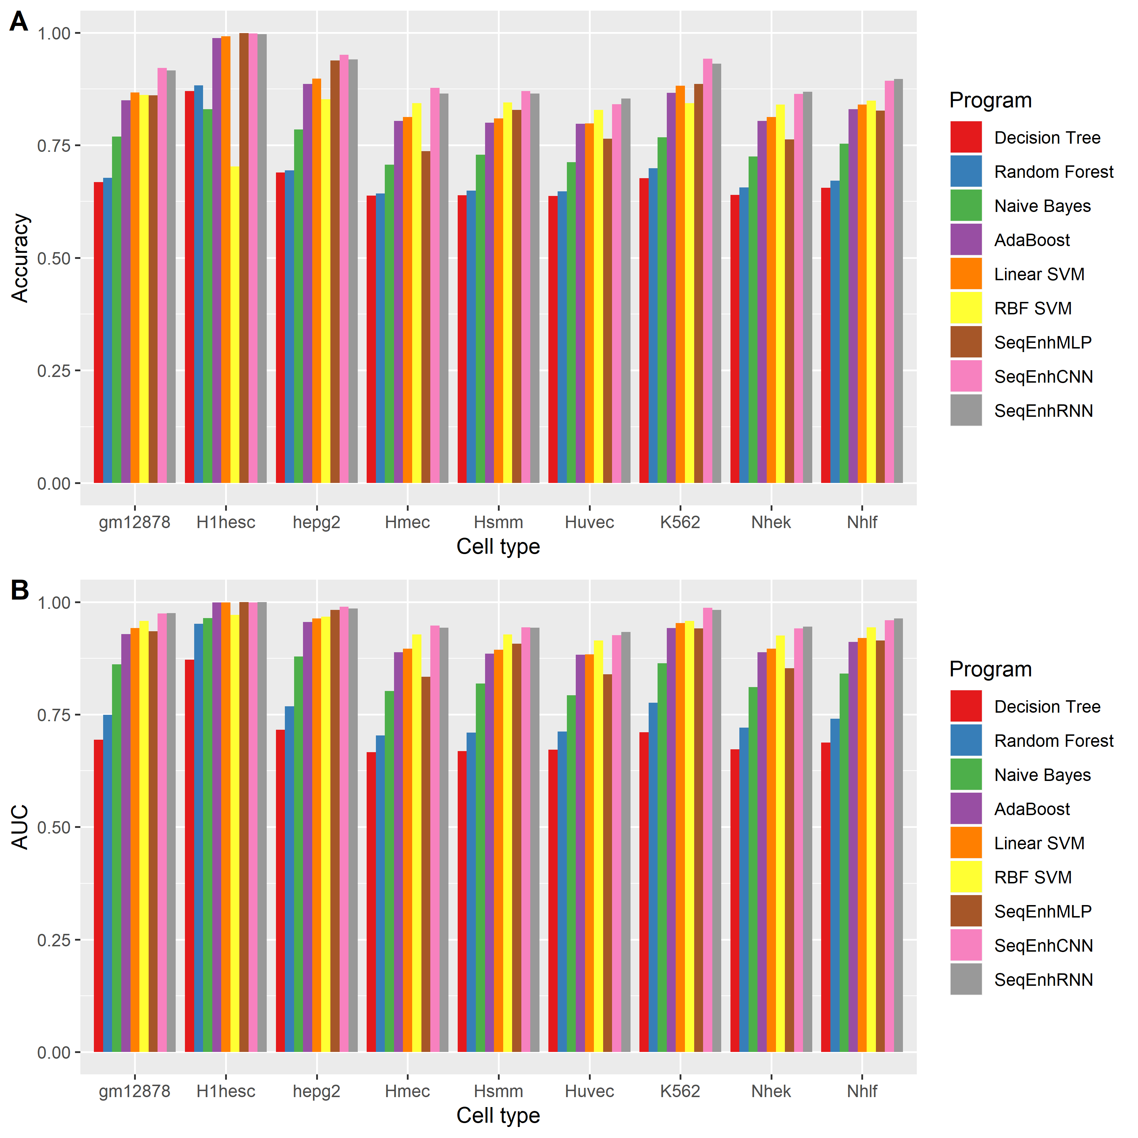
Figure S2. Comparison between SeqEnhDL and conventional machine learning models. (A) Comparison of accuracies. (B) Comparison of AUCs.

