Supplementary materials

1. Selection of seed regions for functional connectivity analyses
The selection of seed regions (STG and TTG in both cerebral hemispheres) is shown in Figure S1. It can be seen from the figure that the STG and TTG brain regions in both cerebral hemispheres can be obtained accurately by segmenting a modified ICBM152_2009C T1-weighted template using the FreeSurfer software (Martinos Center, Charlestown, MA, USA) (Fischl, 2012), as mentioned in section 2.5 of the main manuscript. The labels of the Anatomical Automatic Labeling (AAL) template were not well-matched with the anatomical space of the Montreal Neurological Institute (MNI). It contains both gray matter and white matter in AAL; therefore, each brain region has a large range in AAL. This study focuses on the whole brain RSFC within the auditory network. It is important to select the STG and TTG regions precisely; only then can the functional connectivity of the whole brain in the auditory cortex be analyzed more accurately.
Fischl, B. (2012). FreeSurfer. Neuroimage, 62, 774–781.http:// doi: 10.1016/j.neuroimage.2012.01.021

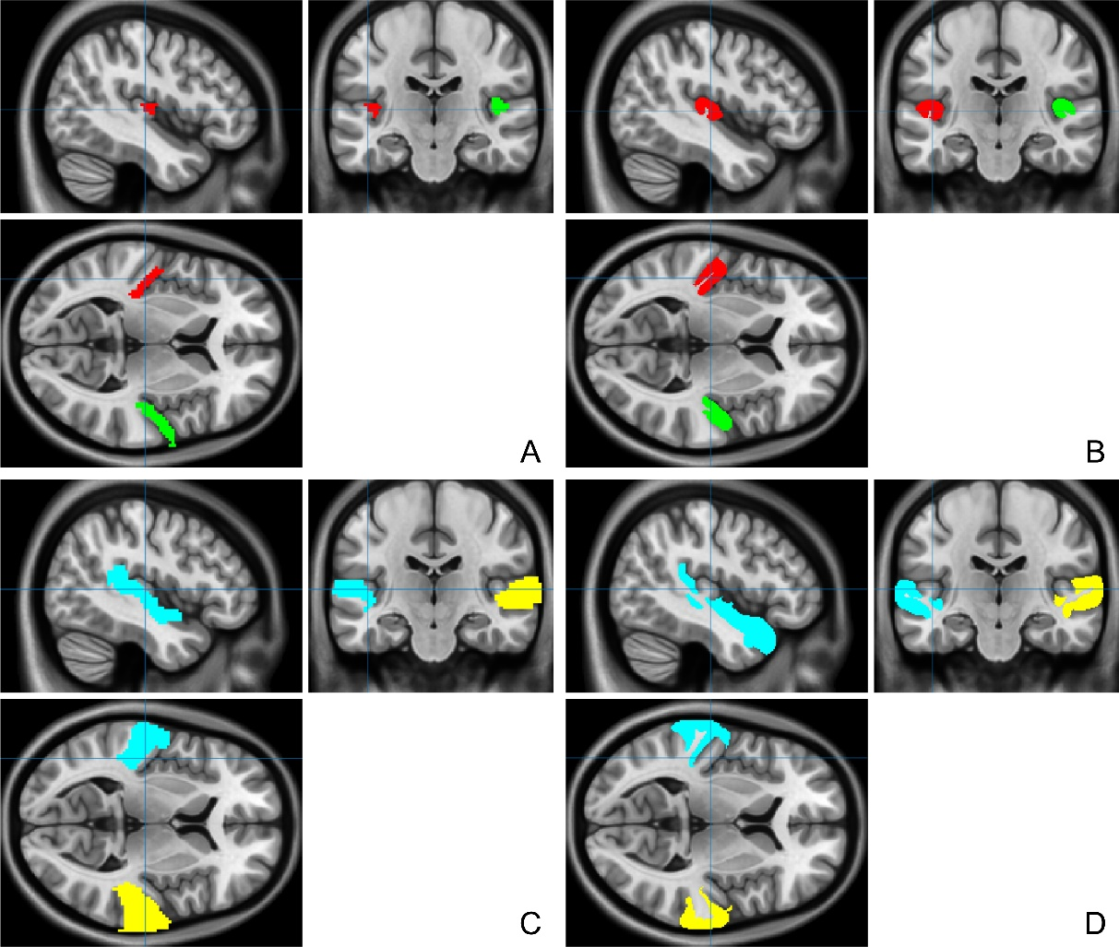
Supplementary Figure S1. Selection of seed regions. Figure A and Figure C show the seed regions of the TTG; the left TTG is indicated in red and the right TTG in green. Figure B and Figure D show the seed regions of the STG; the left STG is indicated in blue and the right STG in yellow. Figure A and Figure B are the results of seed region extraction by the method mentioned in section 2.5 of the manuscript, and it is relatively accurate. Figure C and Figure D are the seed regions extracted using the AAL template, which contain both gray matter and white matter, with a large range.

2. Statistical analyses for whole-brain functional connectivity with four seed regions
A two-sample t test was conducted for the whole brain functional connections of the four seed regions. P < 0.05 false discovery rate (FDR) and clusterw > 100 voxels were considered statistically significant (Supplementary Figures S2-5).
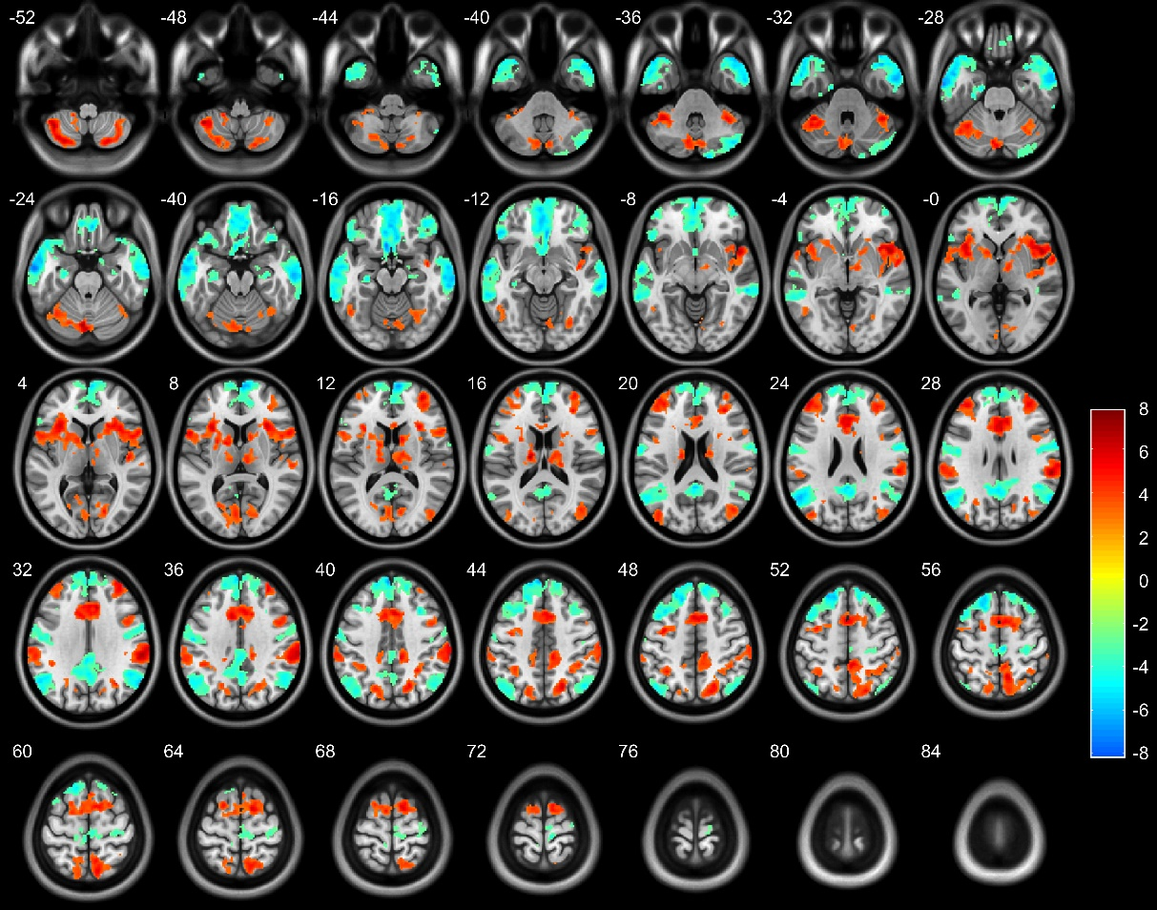
Supplementary Figure S2. Significantly altered resting-state functional connection to the right superior temporal gyrus (STG) in the deaf group (P < 0.05, FDR corrected, Cluster size > 100 voxels) in comparison with the control group with normal hearing. The red-yellow color indicates a cluster showing increased connectivity with the right STG in the deaf group relative to the normal hearing controls; the blue-white color indicates clusters demonstrating decreased connectivity.
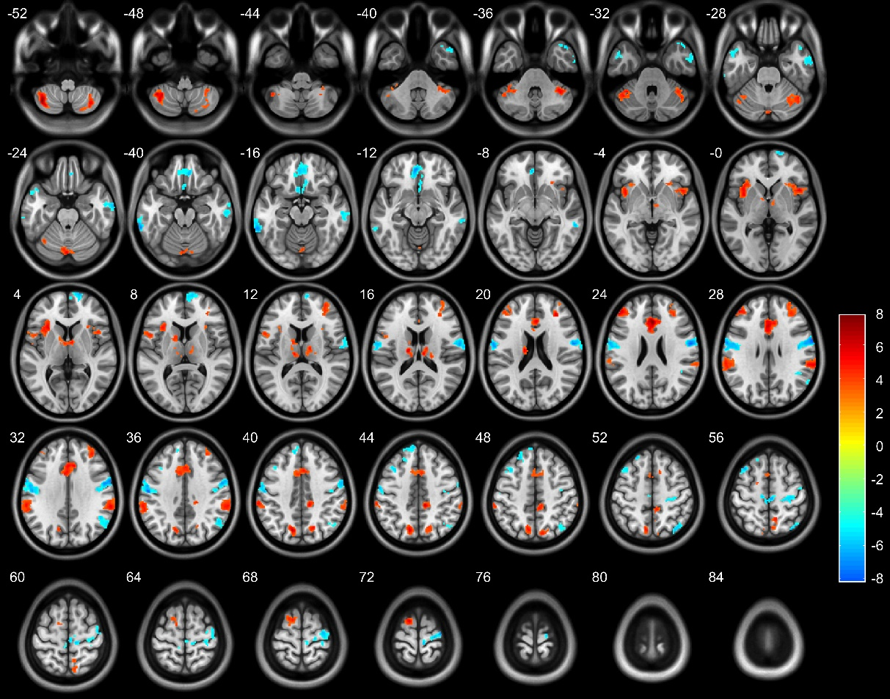
Supplementary Figure S3. Significantly altered resting-state functional connection to the left superior temporal gyrus (STG) in the deaf group (FDR corrected, P < 0.05, Cluster size > 100 voxels) in comparison with the control group with normal hearing. The red-yellow color indicates a cluster showing increased connectivity with the left STG in the deaf group relative to the normal hearing controls; the blue-white color indicates clusters demonstrating decreased connectivity.
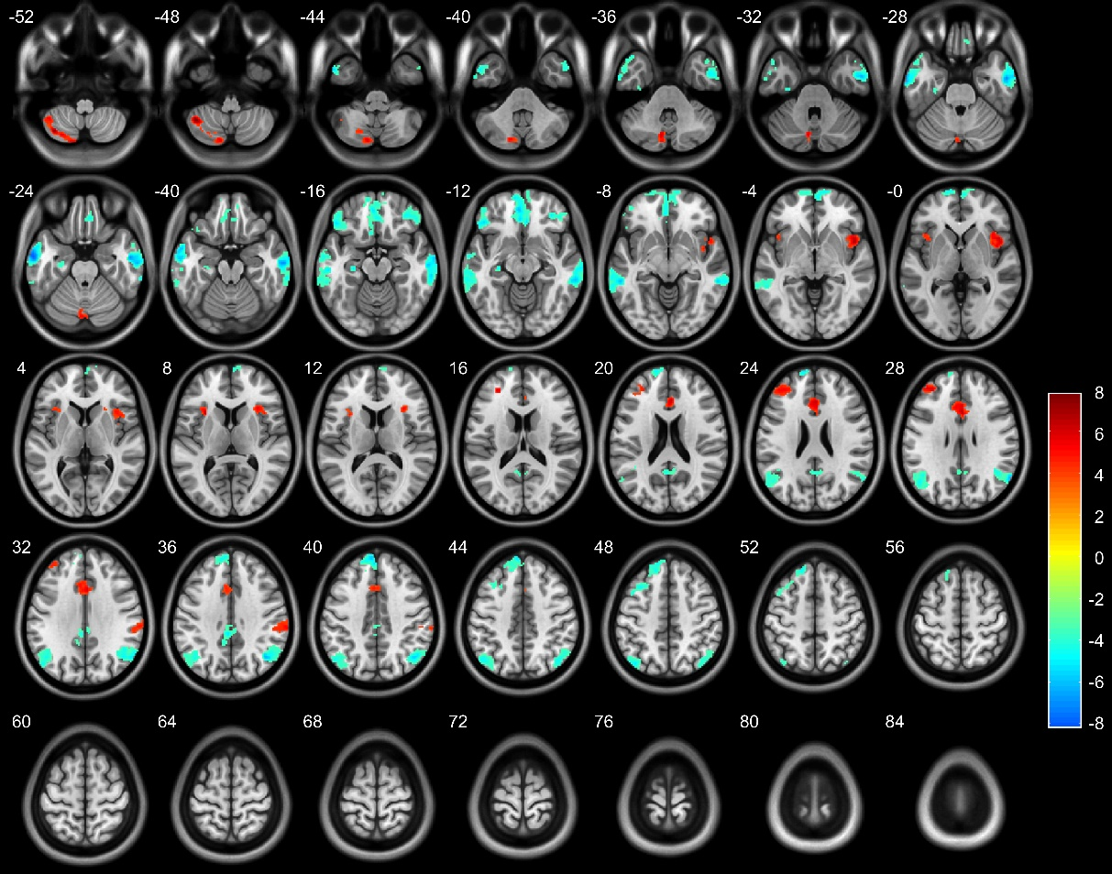
Supplementary Figure S4. Significantly altered resting-state functional connection to the right transverse temporal gyrus (TTG) in the deaf group (FDR corrected, P < 0.05, Cluster size > 100 voxels) in comparison with the control group with normal hearing. The red-yellow color indicates a cluster showing increased connectivity with the right TTG in the deaf group relative to the normal hearing controls; the blue-white color indicates clusters demonstrating decreased connectivity.
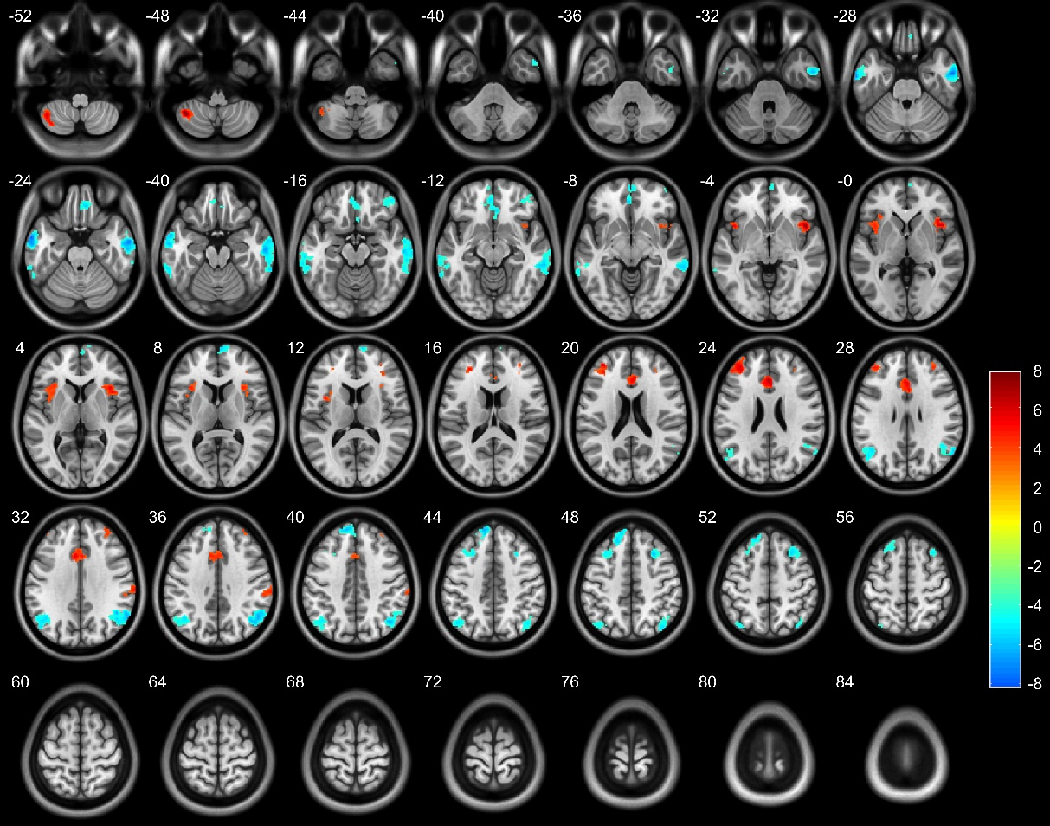
Supplementary Figure S5. Significantly deceased resting-state functional connection to the left transverse temporal gyrus (TTG) in the deaf group (FDR corrected, P < 0.05, Cluster size > 100 voxels) in comparison with the control group with normal hearing. The red-yellow color indicates a cluster showing increased connectivity with the left TTG in the deaf group relative to the normal hearing controls; the blue-white color indicates clusters demonstrating decreased connectivity.

