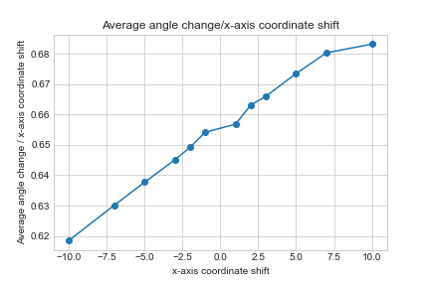
Supplementary Figure 1. Effect of landmark displacement on α angle measurement. Horizontal shifts of the lower limb point show a linear relationship with α angle variation.

