Supplemental Material

Influence of UV Irradiation on the Skin-Immune Cell Inflammatory Response

Rebecca T. Miceli^{1,2}, Noah G. Allen^{2,3}, Meaghan S. Jankowski^{2,3}, Jennifer S. Haghpanah⁵, Rishabh Kala⁵, Jennifer M. Hurley^{2,3,4*}, and Jonathan S. Dordick^{1,2,3,6*}

¹Department of Chemical and Biological Engineering, ²Center for Biotechnology and Interdisciplinary Science, ³Department of Biological Sciences, ⁴Department of Biomedical Engineering, Rensselaer Polytechnic Institute, Troy, NY.
⁵The Estée Lauder Companies, 125 Pinelawn Road, Melville, NY, 11747
⁶RPI-Mount Sinai Joint Center for Engineering and Precision Medicine, 619 W. 54th Street, New York, NY 10019

*To whom correspondence should be addressed (dordick@rpi.edu; hurlej@rpi.edu)

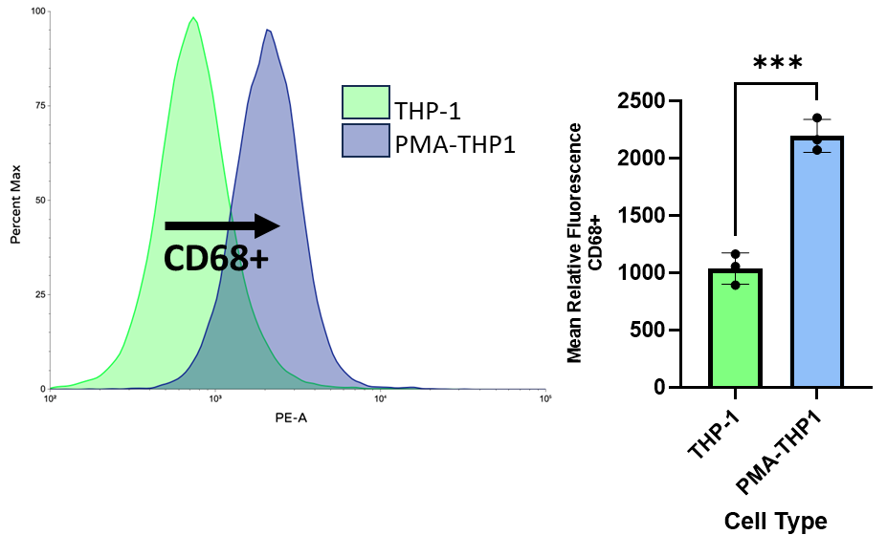
CD68
B.
A.
Supplemental Figure 1. Differentiation of THP-1 cells into THP1-PMA macrophages using 150 nM PMA for 24 h. CD68 Antibody binding was significantly increased in PMA-treated THP-1 cells, indicating that THP-1 monocytes successfully differentiated into CD68 positive macrophages. Example of change in PE (A) and average relative mean fluorescence of CD68 positivity (B). Statistical analysis completed using t-tests, where *p<0.05, **p<0.01, ***p<0.001, and ****p<0.0001. N=3.

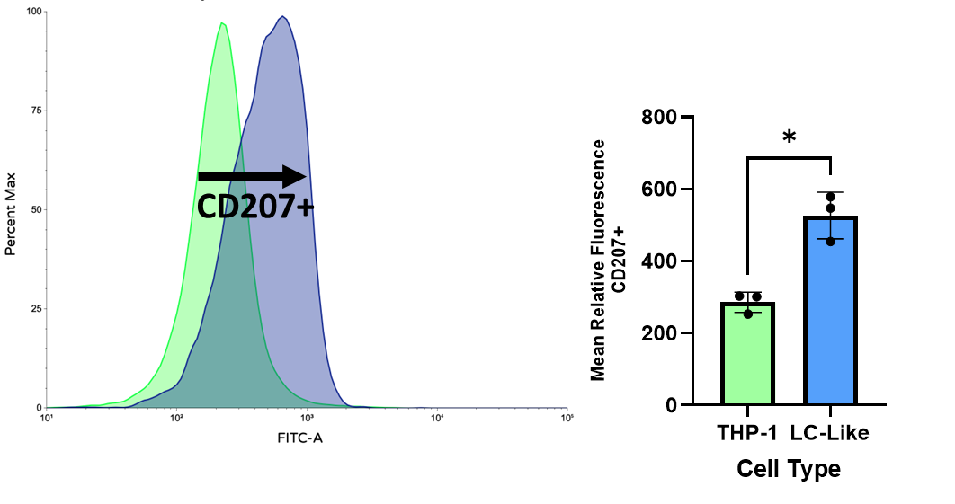
CD207
A.
B.
Supplemental Figure 2. Differentiation of THP-1 cells into Langerhans-like dendritic macrophages using 10 ng/mL IL-4, 10 ng/mL TNFβ, and 100 ng/mL GM-CSF for 6 d. CD207 Antibody binding was significantly increased in Langerhans-like treated THP-1 cells, indicating that THP-1 monocytes successfully differentiated into CD207 positive dendritic macrophages. Example of change in FITC (A) and average relative mean fluorescence of CD207 positivity (B). Statistical analysis completed using t-tests, where *p<0.05, **p<0.01, ***p<0.001, and ****p<0.0001. N=3.
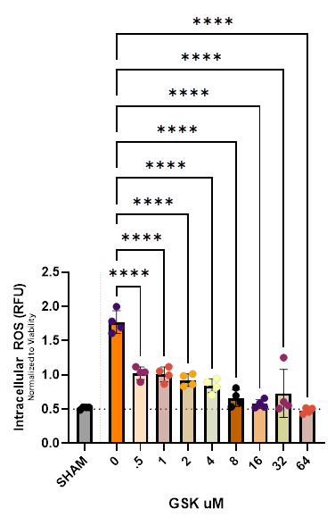
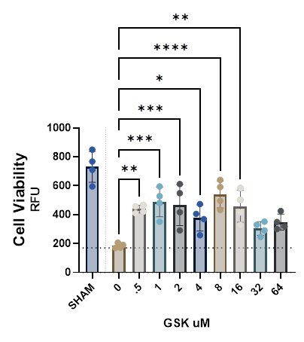
B.
A.
Supplemental Figure 3. Cell viability (A) and iROS (B) in HaCaT cell monolayer 24 h post-UV exposure to 500 mJ/cm² UVB and 10 J/cm² UVA radiation with 24 h pre- and post-treatment with concentrations of GSK ranging from 0 to 64 μM. RFU refers to relative fluorescent units. Horizontal dotted line in A shows cell death sustained without addition of GSK, where any data above the line shows cell recovery from UVR. The horizontal dotted line in B shows SHAM level of iROS, where any data close to this value show the promise of GSK to reduce iROS production after UVR. Statistical analysis completed using one-way ANOVA with Tukey, where *p<0.05, **p<0.01, ***p<0.001, and ****p<0.0001. N=4.

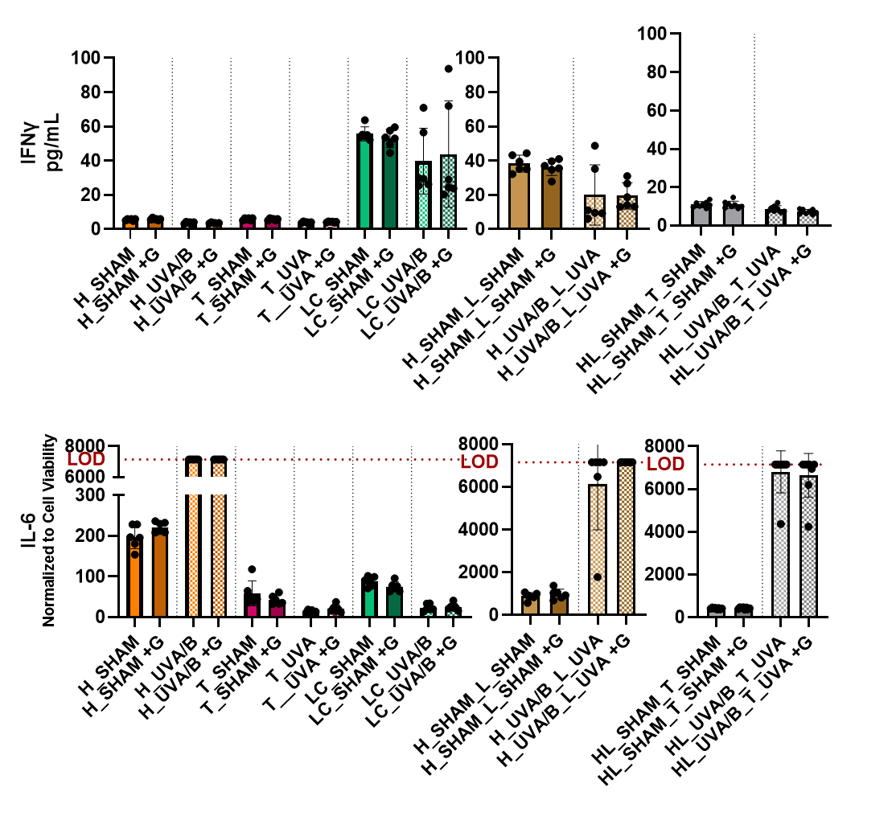
B.
A.
Supplemental Figure 4. Assessment of NOX2 inhibitor, GSK, on cytokine response in the complex skin-immune model, 24 h post SHAM or UVAR+UVBR exposure. HaCaT cells (orange), THP1-PMA macrophages (pink), Langerhans-like cells (green), and co-culture epidermis model (brown) and dermis transwell model (grey) are included. Left bar shows no GSK treatment, right bar shows with GSK treatment, within each pairing. Cytokines included are the IFNy (A) and IL-6 (B). The addition of “+ G” denotes samples were pre- and post-UVR incubation of cells with 8 uM GSK were applied. LOD refers to the limit of detection specified in the kit via a given standard curve, any data beyond this value is not validated by the standard curve. Cytokines were measured 24 h post-UVR using a Luminex 10-plex kit. Statistical analysis completed using t-tests, where *p<0.05, **p<0.01, ***p<0.001, and ****p<0.0001. N = 6.

