Graphical summary：
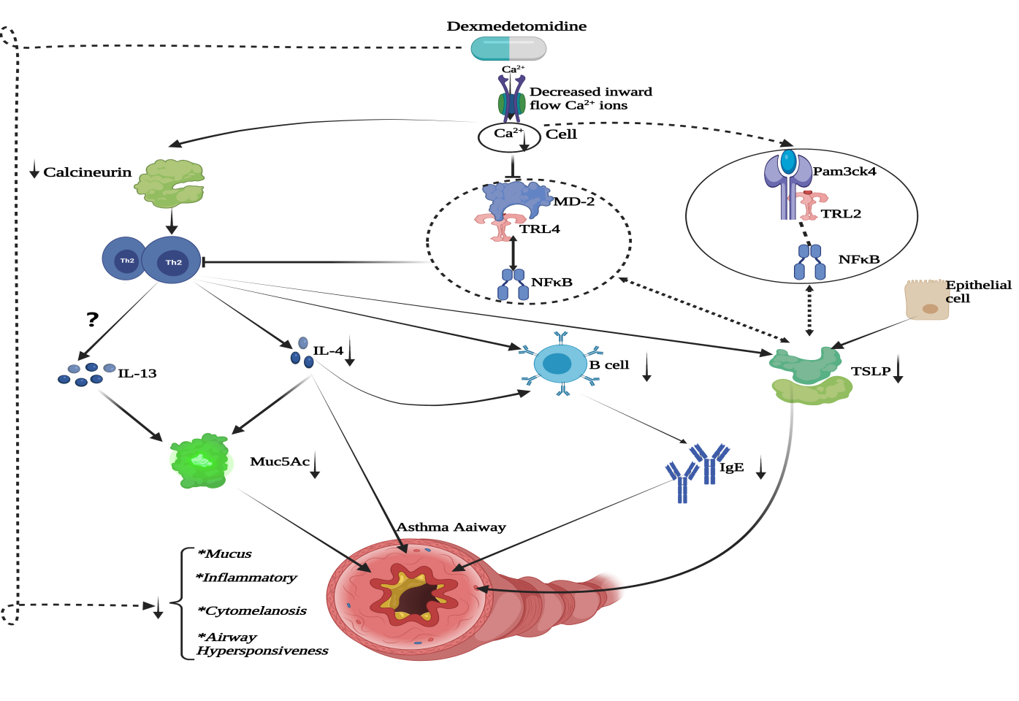
The present study suggests ：Dexmedetomidine attenuates inflammatory cytokines and airway hyperresponsiveness in models of asthma, and there are possible mechanisms by which.
1. Dexmedetomidine downregulates the TRL4/NFκB signalling pathway by inhibiting Ca2+ inward flow;
2. Down-regulation of TRL4/NFκB reduces stimulation of TH2 cells, thereby decreasing IL4 and IGE secretion and consequently Muc5AC protein expression;
3.The decrease in TSLP expression after dexmedetomidine application may be related to the downregulation of the TRL4/NFκB signalling pathway and possibly to attenuated epithelial cell stimulation;
4.The effect of dexmedetomidine on TH2 cells may have the involvement of calcium-regulated neurophosphatase.

