Hydration and Entanglement Contrasts Between Dry and Wet States in Blood-Compatible Poly(2-methoxyethyl acrylate)
(Chojnowski Memorial Issue)

Yi Zhang¹, Yukiko Tanaka¹, Satoshi Honda¹*, Masaru Tanaka¹*
¹Institute for Materials Chemistry and Engineering, Kyushu University, 744 Motooka, Nishi-ku, Fukuoka 819-0385, Japan

Correspondence and requests for materials should be addressed to S.H. (email: honda.satoshi.329@m.kyushu-u.ac.jp) or M.T. (email: tanaka.masaru.763@m.kyushu-u.ac.jp)

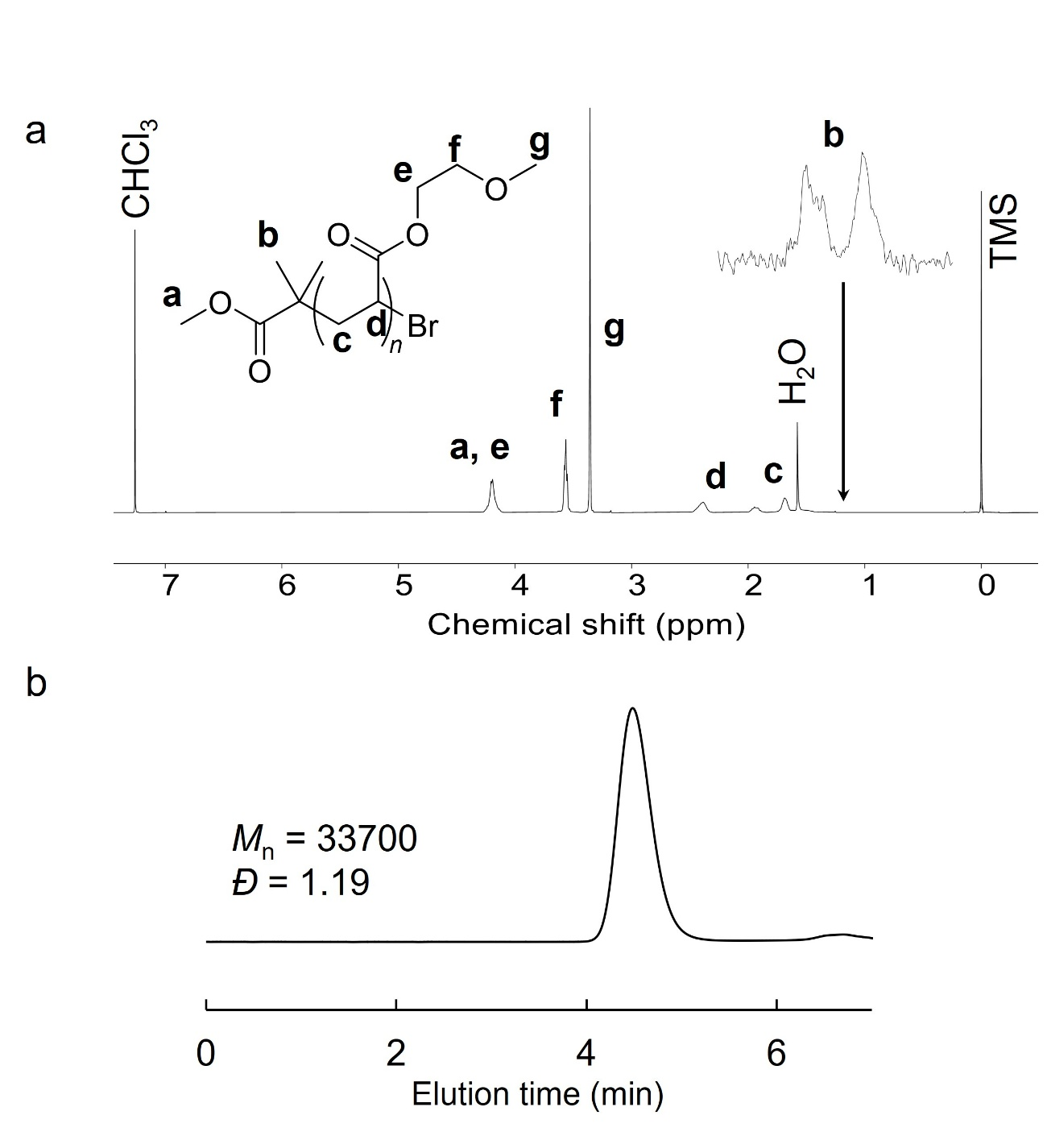
Fig. S1 a ¹H NMR spectrum confirming successful polymerization, with disappearance of vinyl proton signals and absence of low-molecular-weight impurities. b SEC chromatogram showing a narrow and unimodal molecular weight distribution, indicating high purity of the obtained polymer.

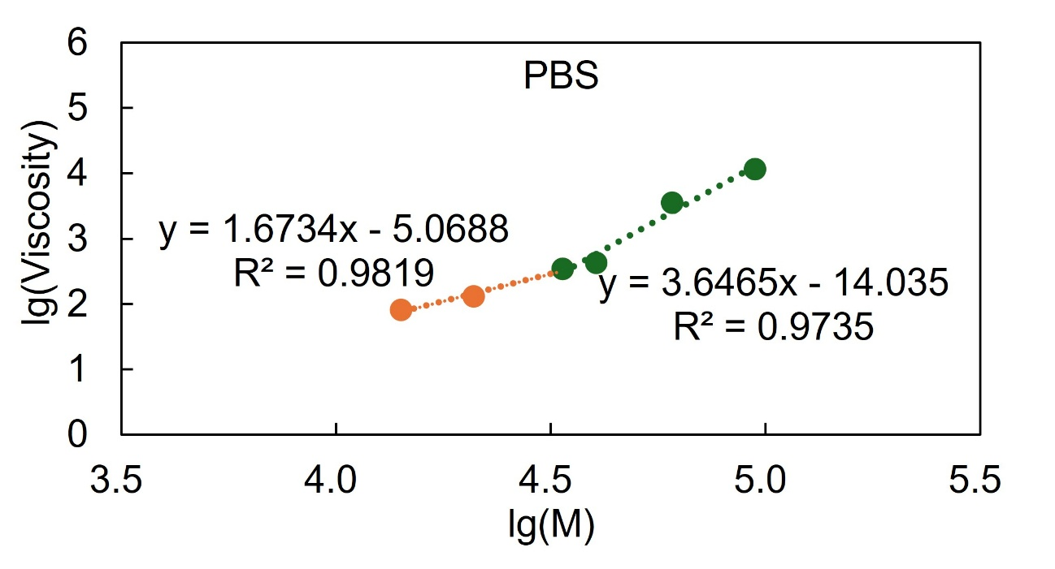Fig. S2 Determination of the entanglement molecular weight (Mc) of PMEA in dry and hydrated states. Hydrated in PBS (1 week). The Mc for chain entanglement is 35 kDa.

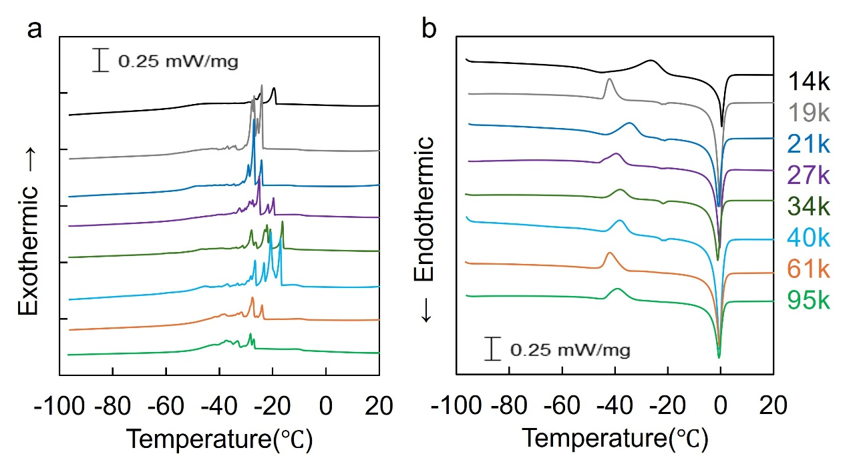
Fig. S3 DSC thermograms (heating and cooling scans) of linear PMEA polymers hydrated in PBS to their equilibrium water content (EWC). a Cooling scans. b Heating scans.

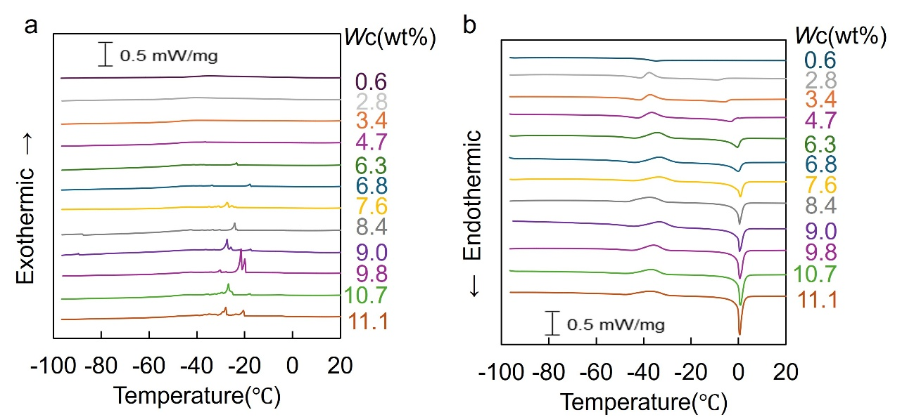
Fig. S4 DSC thermograms of PMEA -14k with different water contents, showing the contributions of different water states. a Cooling scans. b Heating scans.

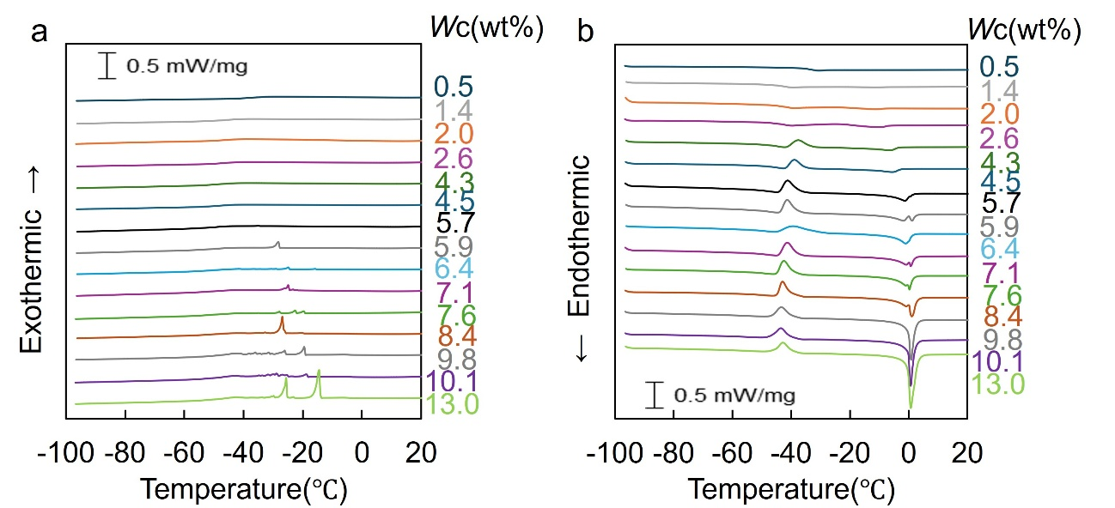
Fig. S5 DSC thermograms of PMEA -19k with different water contents, showing the contributions of different water states. a Cooling scans. b Heating scans.

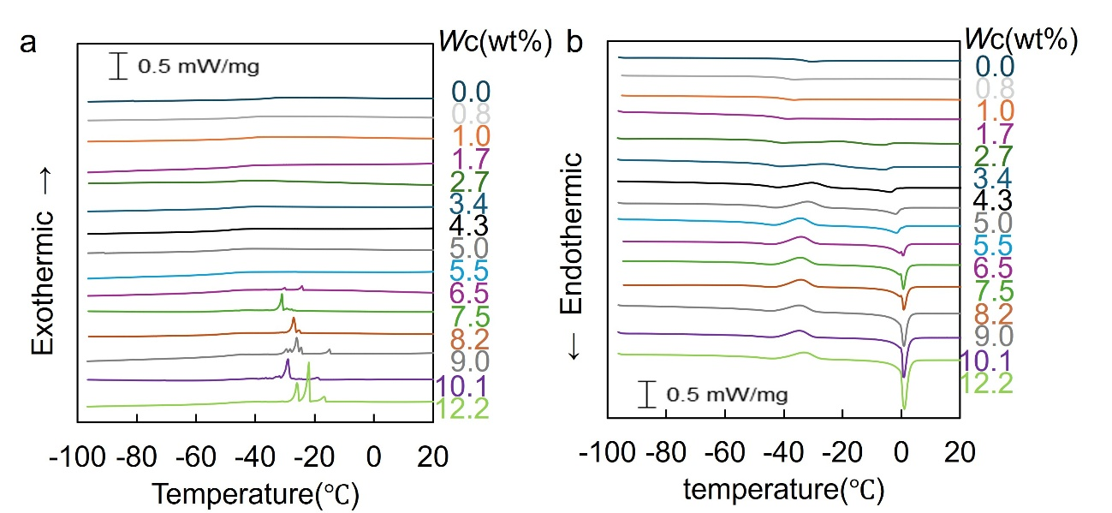
Fig. S6 DSC thermograms of PMEA -21k with different water contents, showing the contributions of different water states. a Cooling scans. b Heating scans.

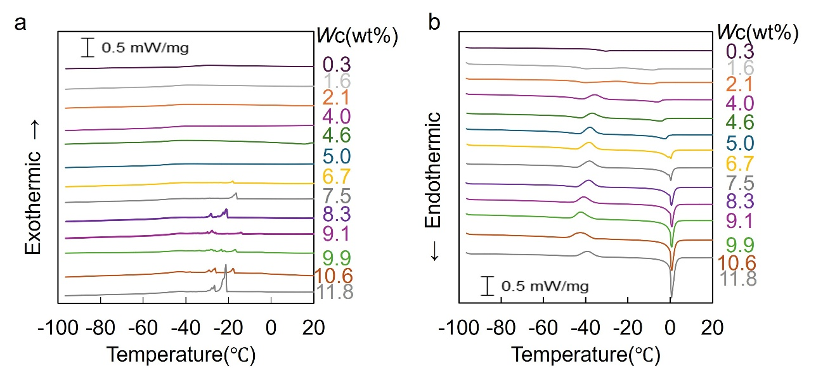
Fig. S7 DSC thermograms of PMEA -27k with different water contents, showing the contributions of different water states. a Cooling scans. b Heating scans.

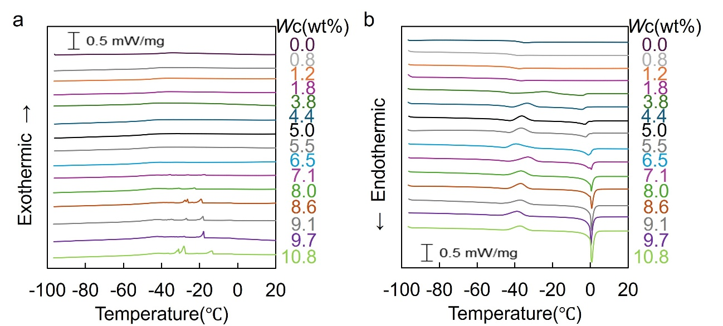
Fig. S8 DSC thermograms of PMEA -34k with different water contents, showing the contributions of different water states. A Cooling scans. B Heating scans.

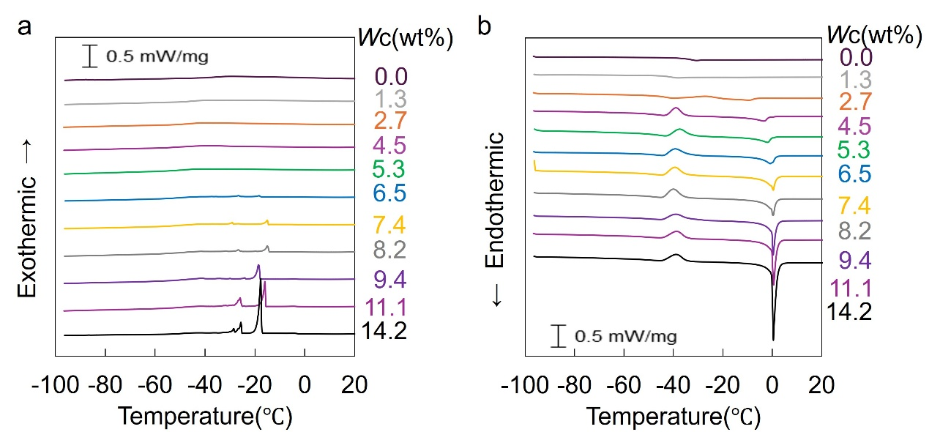
Fig. S9 DSC thermograms of PMEA -40k with different water contents, showing the contributions of different water states. a Cooling scans. b Heating scans.

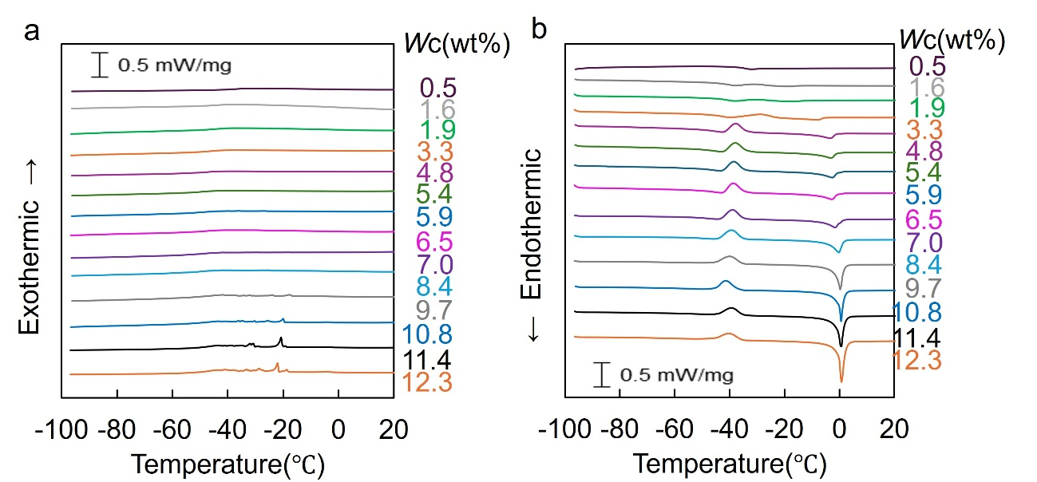
Fig. S10 DSC thermograms of PMEA -61k with different water contents, showing the contributions of different water states. A Cooling scans. B Heating scans.

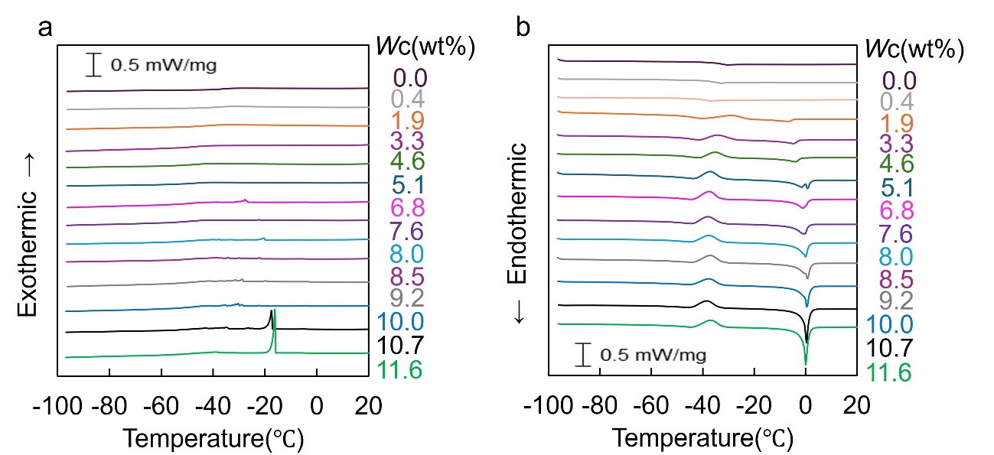
Fig. S11 DSC thermograms of PMEA -95k with different water contents, showing the contributions of different water states. A Cooling scans. B Heating scans.

Section S1
The amount of NFW (R_{NFW}, Eq. S1) can be written as
R_{NFW} = ((M₁ − M₀) − ΔH_{m}/ΔH_{m}°)/M₀ (Eq.S1)
where, M₀ is mass of dry sample, M₁ is mass of hydrated sample, ΔH_{m} is melting enthalpy of water based on the dry sample, and ΔH_{m}° is standard melting enthalpy of water at 0 ºC and 101.3 kPa (334 J/g). The amount of IW (R_{IW}, Eq. S2), and FW (R_{FW}, Eq.S3) were calculated as follows:
IW: R_{IW}: = (ΔH_{cc}/ΔH_{m}°)/M₀ (Eq. S2)
FW: R_{FW} = (ΔH_{m}/ΔH_{m}°)/M₀ − R_{IW} (Eq.S3)
where ΔH_{cc} is cold-crystallization enthalpy of water.
Total water content: Wc = (M₁ − M₀)/M₁ × 100: (wt%) (Eq. S4)
The equilibrium water content ：EWC = (M_{NFW} + M_{IW} + M_{FW})/M₁ × 100

