Supplementary files: Comparative genomics analysis between frog virus 3-like ranavirus from the first Canadian reptile mortality event and similar viruses from amphibians

Supplementary Material
Supplementary Table 1: Nucleotide sequence (%) identity of the complete genome of different frog virus 3-like strains to FV3-like ON turtle/2018.
Location of FV3-like origin | Year Collected | Animal Host | GenBank Reference Accession | Identity of nucleotide sequence (%) to FV3-like ON turtle/2018
Canada-Northwest Territories | 2017 | Pseudacris maculata | MK959611 | 98.79
Canada-Northwest Territories | 2017 | Lithobates sylvaticus | MK959612 | 98.79
Canada-Northwest Territories | 2017 | Lithobates sylvaticus | MK959613 | 98.78
Canada-Northwest Territories | 2017 | Pseudacris maculata | MK959614 | 98.79
Canada-Northwest Territories | 2017 | Pseudacris maculata | MK959615 | 98.78
Canada-Northwest Territories | 2017 | Pseudacris maculata | MK959616 | 98.83
Canada-Northwest Territories | 2017 | Lithobates sylvaticus | MK959617 | 98.79
Canada-Northwest Territories | 2017 | Lithobates sylvaticus | MK959618 | 98.78
Canada-Northwest Territories | 2017 | Lithobates sylvaticus | MK959619 | 98.84
Canada-Northwest Territories | 2017 | Lithobates sylvaticus | MK959620 | 98.78
Canada-Alberta | 2017 | Lithobates sylvaticus | MK959621 | 99.71
Netherlands-N/A | 2015 | Oophaga pumilio | MF360246 | 99.27
United States-N/A | N/A | Rana pipiens | AY548484 | 99.71
Brazil-Sao Paulo | 2012 | Lithobates catesbeianus | MH351268 | 99.18
United States-N/A | N/A | Frog (host not informed) | KJ175144 | 99.34

Supplementary Table 2: Relative synonymous codon usage values for the FV3-like turtle ON/2018, closely related FV3 wild-type, FV3-like Z994, ATV 2013-ATV-04 and EHNV strains.
Excel file 1

Supplementary Table 3: Nucleotide Composition analysis of Individual ORFs encoded by the two FV3-like strains and wt-FV3.
Excel file 2

Supplementary Figure 1: Statistically significant recombination events identified by RDP. Four major recombination breakpoints were identified in the FV3-like ON turtle/2018 genome.

Potential Recombination Event 22:

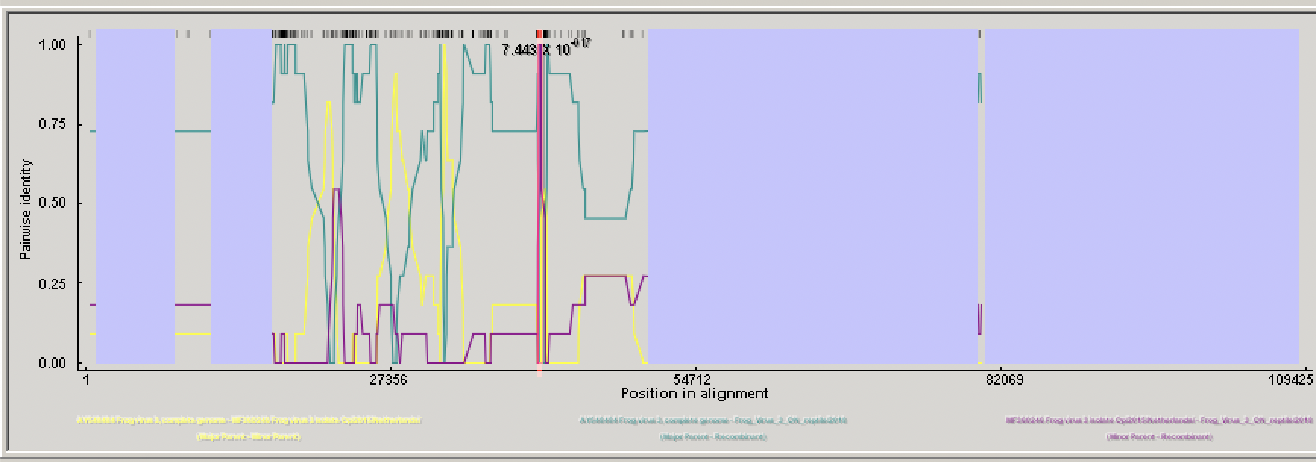

Potential Recombination Event 11:

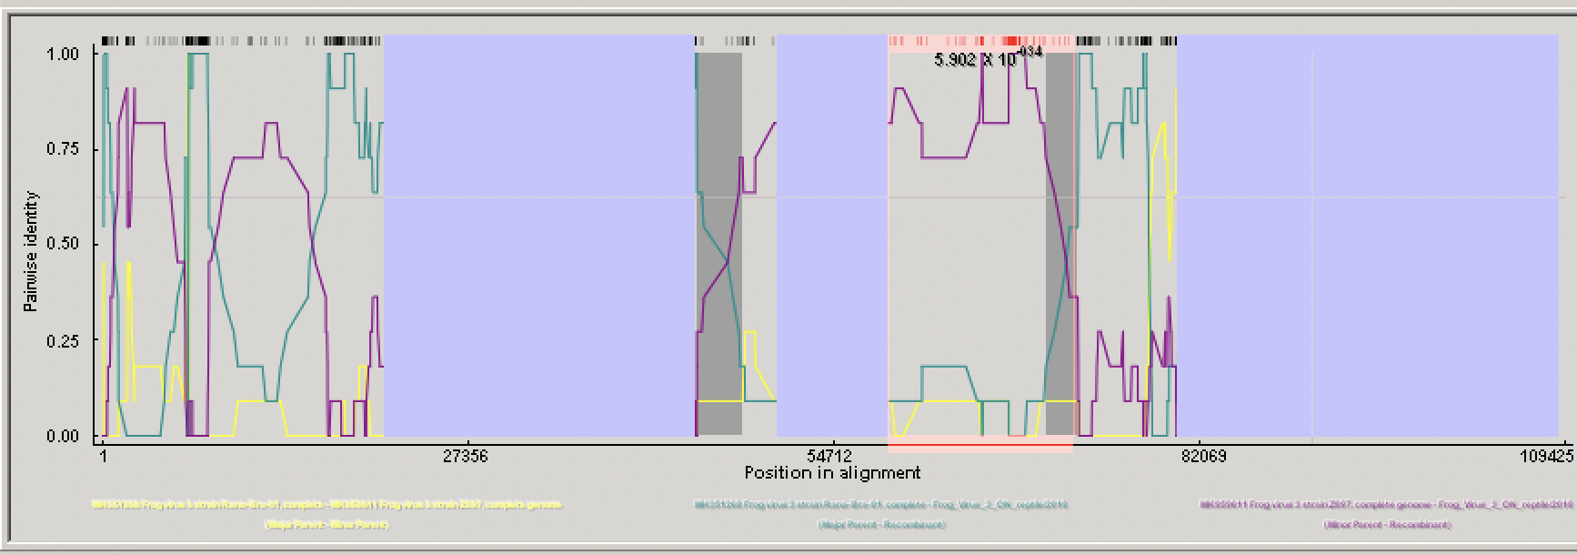

Potential Recombination Event 4:
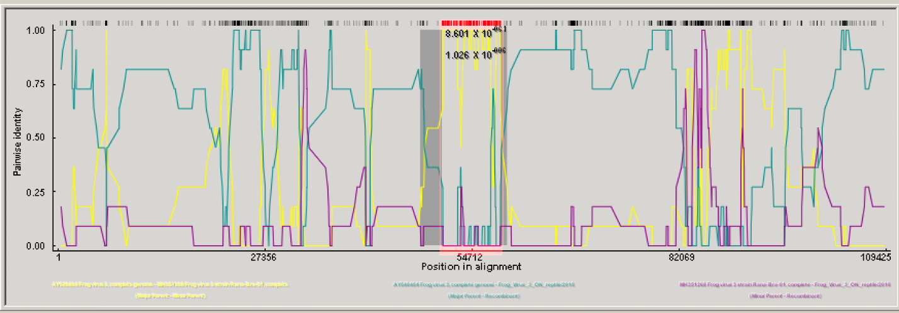
Potential Recombination Event 5:

