Supplement Files:
A) Additional figures
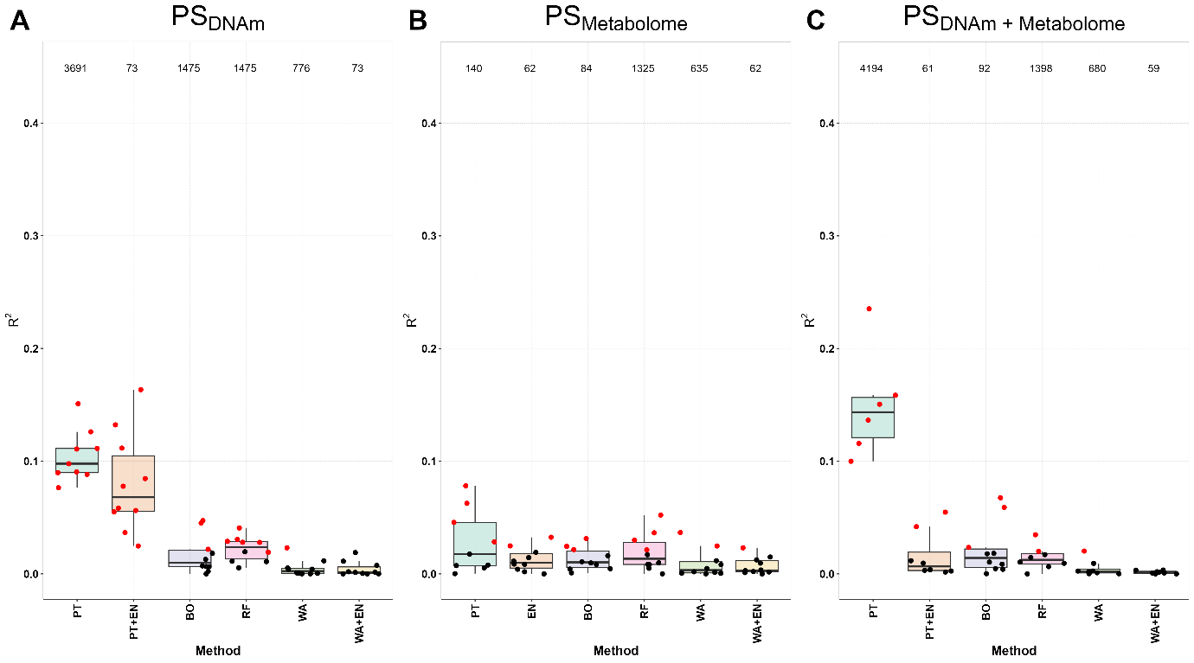
Figure S1. Overview of the results of PS calculation using the various methods and their accuracy of fitting from the individual and combined data sets (McFadden 𝑅² and p-value) on Braak stage outcome. All three sub-graphs are structured in the same way and therefore the explanation can be made on one graph and apply to all three graphs: A) DNAm data set (single-omics PS), B) ) metabolome data set (single-omics PS) and C) combination of both individual data sets (multi-omics PS). The following 6 methods are shown on the x-axis: PT: Pruning & Thresholding, EN: Elastic Net or EN+PT, BO: Boosting, RF: Random Forest, WA: Windows Approach and WA+EN (due to the high dimension, EN can only be applied to the smaller data set and then PT is used before for dimension reduction). Partial McFadden R² is shown on the y-axis, so that for each method a boxplot is shown for the 10 iterations, with the individual results shown as black (not significant) and red (significant) points. At the top are the recorded number of features or cpg-sites included in the PS (mean value across the 10 iterations).
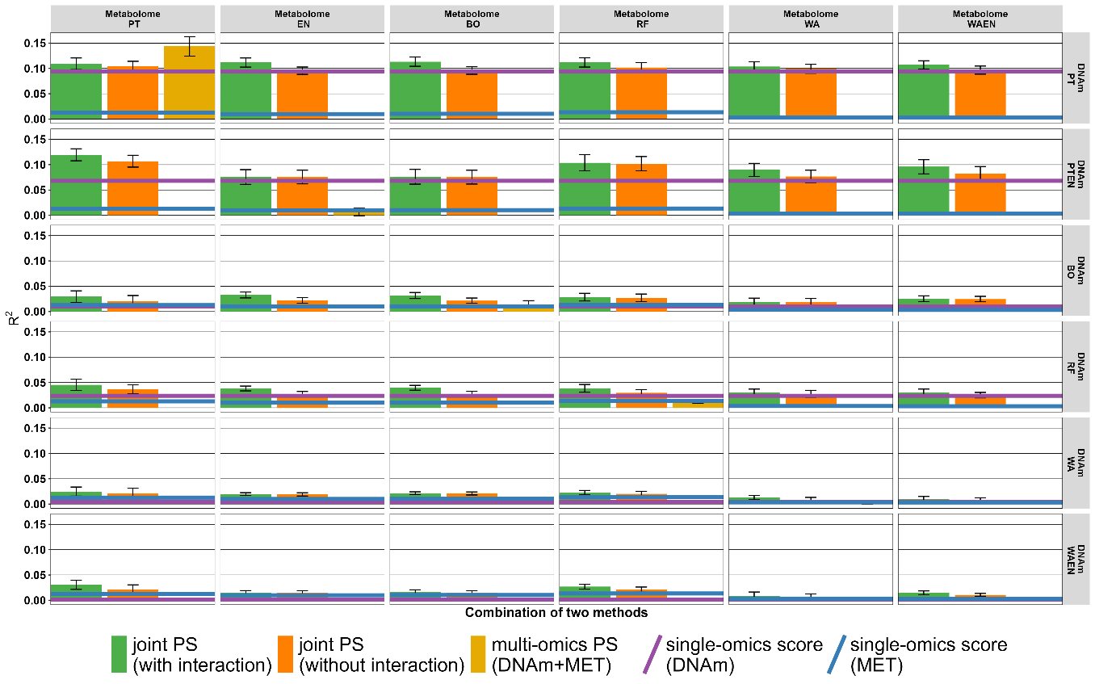
Figure S2. Results from single- and multi-omics PS each individual graph shows the R² for the PS of the individual and combined datasets, with the method from the DNAm dataset shown on the x-axis and the metabolome dataset on the y-axis (Braak stage). The methods are PT: Pruning & Thresholding, EN: Elastic Net, BO: Boosting, RF: Random Forest, WA: Windows Approach and WA+EN. McFadden R2 is shown on the y-axis, so that for each method the median with standard error (SE) is drawn as bar plot with SE bars. The values in a subgraph are from the following data sets or combinations: Joint PS models with interaction term (green), Joint PS models without interaction term (orange) and multi-omics PS from both combined data sets (golden). Since the single PS are at most as good (median) as the joint PS, we have omitted these for better consideration and drawn only the PS with the highest value as a line in the subgraph. If the single PS from DNAm data set is higher than the PS from the metabolome data set, we took the value of the DNAm PS and drew a blue line (vice versa for the single PS from metabolome data set purple). Due to the calculation, the golden boxplots are only present in the subgraphs that use the same methods in both data sets.

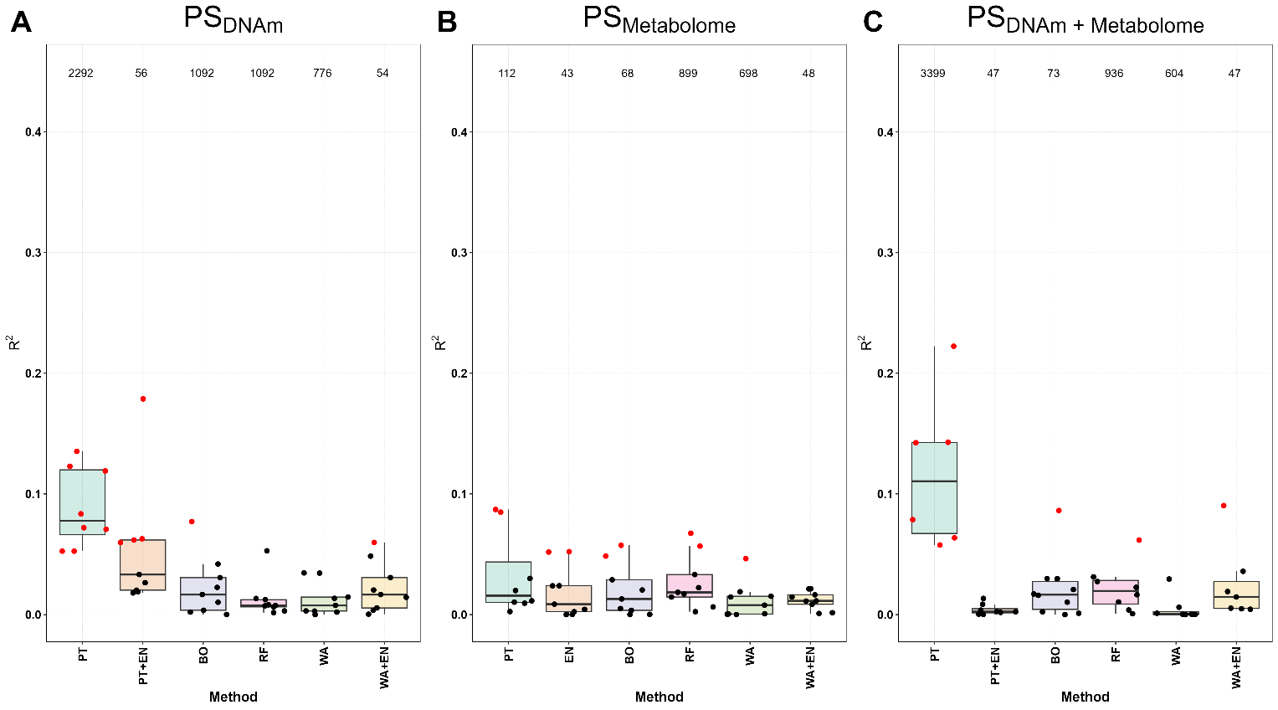
Figure S3. Overview of the results of PS calculation using the various methods and their accuracy of fitting from the individual and combined data sets (McFadden 𝑅² and p-value) on CERAD outcome. All three sub-graphs are structured in the same way and therefore the explanation can be made on one graph and apply to all three graphs: A) DNAm data set (single-omics PS), B) metabolome data set (single-omics PS) and C) combination of both individual data sets (multi-omics PS). The following 6 methods are shown on the x-axis: PT: Pruning & Thresholding, EN: Elastic Net or EN+PT, BO: Boosting, RF: Random Forest, WA: Windows Approach and WA+EN (due to the high dimension, EN can only be applied to the smaller data set and then PT is used before for dimension reduction). McFadden R² is shown on the y-axis, so that for each method a boxplot is shown for the 10 iterations, with the individual results shown as black (not significant) and red (significant) points. At the top are the recorded number of features or cpg-sites included in the PS (mean value across the 10 iterations).
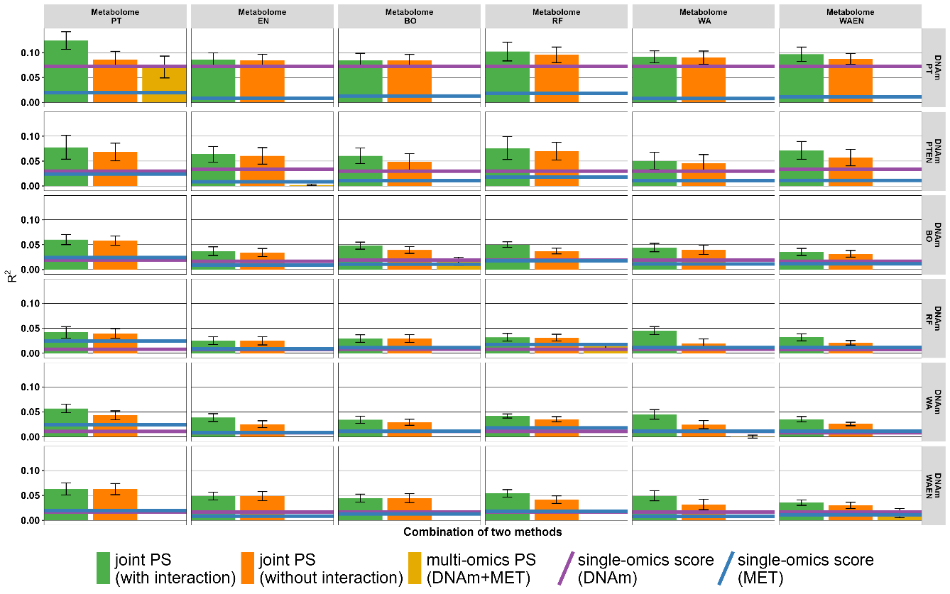
Figure S4. Results from single- and multi-omics PS each individual graph shows the R² for the PS of the individual and combined datasets, with the method from the DNAm dataset shown on the x-axis and the metabolome dataset on the y-axis (CERAD score). The methods are PT: Pruning & Thresholding, EN: Elastic Net, BO: Boosting, RF: Random Forest, WA: Windows Approach and WA+EN. McFadden R2 is shown on the y-axis, so that for each method the median with standard error (SE) is drawn as bar plot with SE bars. The values in a subgraph are from the following data sets or combinations: Joint PS models with interaction term (green), Joint PS models without interaction term (orange) and multi-omics PS from both combined data sets (golden). Since the single PS are at most as good (median) as the joint PS, we have omitted these for better consideration and drawn only the PS with the highest value as a line in the subgraph. If the single PS from DNAm data set is higher than the PS from the metabolome data set, we took the value of the DNAm PS and drew a blue line (vice versa for the single PS from metabolome data set purple). Due to the calculation, the golden boxplots are only present in the subgraphs that use the same methods in both data sets.
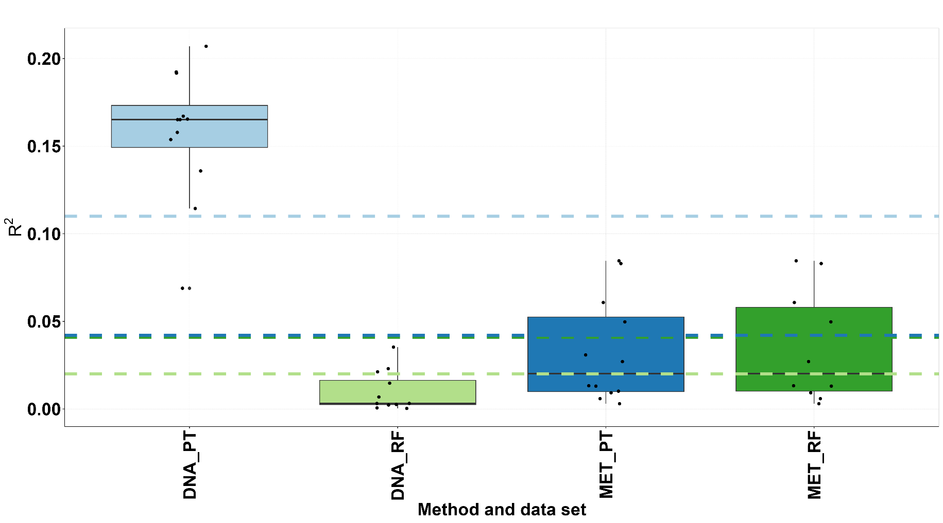

Figure S5. Comparison of the two best methods in the DNAm and metabolome datasets of the R² of different sample sizes. In the previous analysis of the single-omics PS, the maximum number of observations of the respective data sets were taken, i.e. DNAm (n=154) and metabolome (n=141) and R² determined. Now the joint observations were used as in the joint or multi-omics PS determination of n=138. We ran RF and PT as best methods for both data sets with 10 iterations. The methods and corresponding data sets are plotted on the x-axis and the R² on the y-axis. For comparison with the previous analyses, the medians were entered as dashed lines.
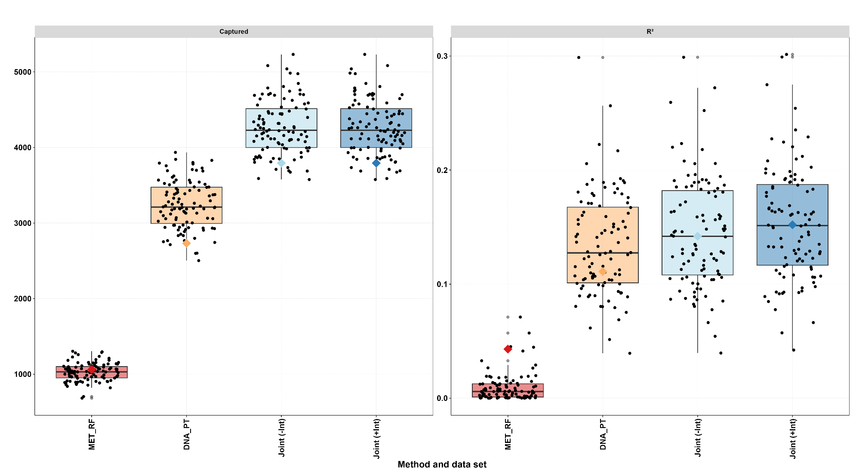
Figure S6. Comparison of the results of the PS for the best methods in the DNAm (PT) and metabolome (RF) datasets and the joint PS with and without the interaction term in 100 iterations. In the left figure we can see the numbers of captured features / CpG sites (y-axis) for the four different PS (x-axis) as a boxplot with 100 jittered points. In the right figure the R² for the four methods and datasets is showing for the 100 iterations. The colored star is the mean value of the 10 iterations from the main part of this work for both values (captured features/CpG sites and R²).

Figure S7. Pearson Correlation structure between the different methods and PS of each data set. On the x-axis are the PS of the different methods based on DNAm data set and on the y-axis the PS of the different methods based on the metabolome data set. The methods are PT: Pruning & Thresholding, EN: Elastic Net, BO: Boosting, RF: Random Forest, WA: Windows Approach and WA+EN. The color intensity and the size of the dots indicate the respective correlation coefficient according to Bravais-Pearson.

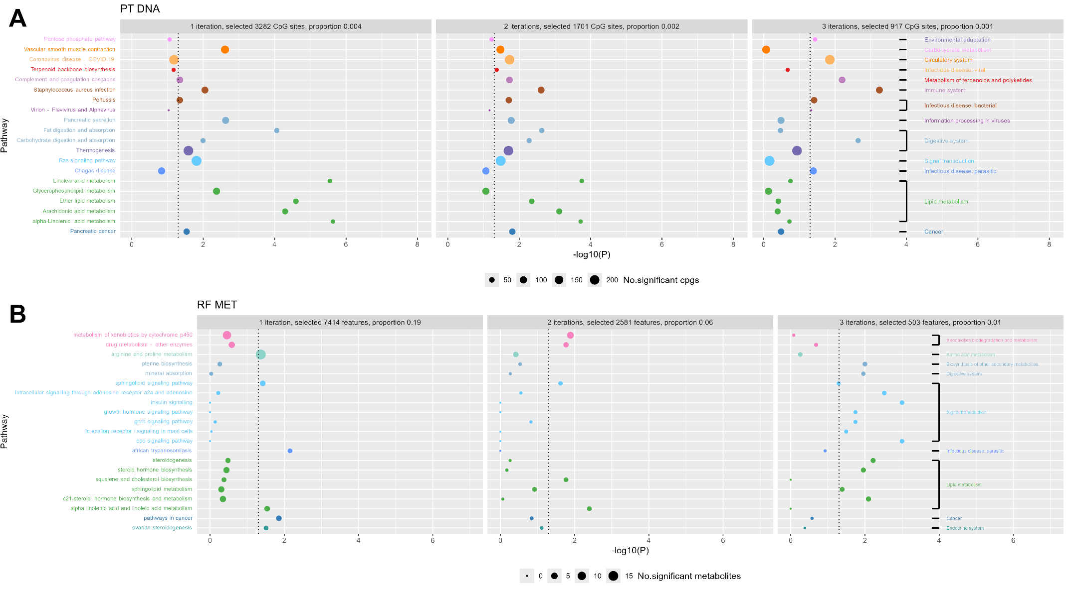
Figure S8. For the DNAm data set (A) with the PT method scatter plots of KEGG pathway enrichment analysis, where at least in (1), (2) or (3) the weighted CpG-sites were found. For the Metabolome data set (B) with the RF method scatter plots of KEGG pathway enrichment analysis, where at least in (1), (2) or (3) iterations the weighted features were found. Only pathways classes, which had at least one pathway with significant p-values in more than one iteration. The number of significant CpG-Sites/ features in the pathway is indicated by the circle area, and the circle color represents the predefined pathway classes. On the x-axis the p-value (as -log10(p)) is represented with the significance level of 0.05 (dotted line). The proportion refers to the number of selected variables divided by the total number of variables (789,286 for DNAm; 35,348 for metabolomics). We display on the y-axis the different pathway terms enriched by KEGG database; the single pathway stands on the y-axis and the classes of them in the last plot.

Figure S9. For the DNAm data set (A) with the PT method scatter plots of KEGG pathway enrichment analysis, where at least in (1), (2) or (3) the weighted CpG-sites were found. For the Metabolome data set (B) with the RF method scatter plots of KEGG pathway enrichment analysis, where at least in (1), (2) or (3) iterations the weighted features were found. Only pathways classes, which had at least one pathway with significant p-values in more than one iteration. The number of significant CpG-Sites/ features in the pathway is indicated by the circle area, and the circle color represents the predefined pathway classes. On the x-axis the p-value (as -log₁₀(p)) is represented with the significance level of 0.05 (dotted line). The proportion refers to the number of selected variables divided by the total number of variables (789,286 for DNAm; 35,978 for metabolomics). We display on the y-axis the different pathway terms enriched by KEGG database; the single pathway stands on the y-axis and the classes of them in the last plot. The following pathways classes are not presented in the figure because the corresponding pathway class was only significant in one iteration: A) For DNAm: Carbohydrate metabolism (pentose phosphate pathway), Metabolism of terpenoids and polyketides (terpenoid backbone biosynthesis), Information processing in viruses (virion – flavivirus and alphavirus) and Infection disease: parasitic (Chagas disease); B) For metabolome: Cancer (pathways in cancer), Endocrine system (ovarian steroidogenesis), Infection disease: parasitic (African trypanosomiasis), Biosynthesis of other secondary metabolites (pterine biosynthesis), Digestive system (mineral absorption), Amino acid metabolism (arginine and proline metabolism) and Xenobiotics biodegradation and metabolism (metabolism of xenobiotics by cytochrome p450; drug metabolism – other enzymes)

Figure S10. Percentage of variance explained by each latent factor across data modalities (DNAm, metabolome).
Factor1 explains a substantial proportion of variance in the DNAm (99.12%), while Factor2 contributes (80.18%) to the metabolome data.
B) Additional tables
Table ST1. Comparison of R² values using Median (Q1: 1st, Q3: 3rd quartile and IQR: interquartile range) for the combination of both data sets (DNAm and metabolome data set) in the joint model with and without interaction term (equation (4)) – ABC score.

 |  | additive with interaction (N:10) | additive without interaction (N:10)
DNA_BO vs. MET_BO | Median (Q1, Q3) | 0.055 (0.027, 0.068) | 0.040 (0.021, 0.052)
 | IQR | 0.041 | 0.031
DNA_BO vs. MET_EN | Median (Q1, Q3) | 0.057 (0.029, 0.067) | 0.035 (0.021, 0.054)
 | IQR | 0.038 | 0.032
DNA_BO vs. MET_PT | Median (Q1, Q3) | 0.057 (0.054, 0.063) | 0.053 (0.045, 0.061)
 | IQR | 0.010 | 0.017
DNA_BO vs. MET_RF | Median (Q1, Q3) | 0.068 (0.062, 0.086) | 0.055 (0.050, 0.075)
 | IQR | 0.024 | 0.024
DNA_BO vs. MET_WA | Median (Q1, Q3) | 0.039 (0.022, 0.066) | 0.033 (0.018, 0.062)
 | IQR | 0.044 | 0.044
DNA_BO vs. MET_WAEN | Median (Q1, Q3) | 0.043 (0.029, 0.049) | 0.030 (0.016, 0.036)
 | IQR | 0.020 | 0.020
DNA_PT vs. MET_BO | Median (Q1, Q3) | 0.130 (0.125, 0.158) | 0.118 (0.105, 0.152)
 | IQR | 0.032 | 0.047
DNA_PT vs. MET_EN | Median (Q1, Q3) | 0.130 (0.128, 0.159) | 0.117 (0.106, 0.153)
 | IQR | 0.031 | 0.047
DNA_PT vs. MET_PT | Median (Q1, Q3) | 0.151 (0.137, 0.172) | 0.128 (0.114, 0.169)
 | IQR | 0.035 | 0.054
DNA_PT vs. MET_RF | Median (Q1, Q3) | 0.154 (0.129, 0.177) | 0.134 (0.118, 0.174)
 | IQR | 0.048 | 0.056
DNA_PT vs. MET_WA | Median (Q1, Q3) | 0.134 (0.109, 0.160) | 0.125 (0.108, 0.155)
 | IQR | 0.051 | 0.047
DNA_PT vs. MET_WAEN | Median (Q1, Q3) | 0.132 (0.121, 0.176) | 0.123 (0.115, 0.167)
 | IQR | 0.055 | 0.051
DNA_PTEN vs. MET_BO | Median (Q1, Q3) | 0.081 (0.042, 0.137) | 0.077 (0.037, 0.126)
 | IQR | 0.095 | 0.089
DNA_PTEN vs. MET_EN | Median (Q1, Q3) | 0.082 (0.041, 0.139) | 0.073 (0.037, 0.128)
 | IQR | 0.098 | 0.091
DNA_PTEN vs. MET_PT | Median (Q1, Q3) | 0.113 (0.069, 0.162) | 0.091 (0.066, 0.139)
 | IQR | 0.093 | 0.073
DNA_PTEN vs. MET_RF | Median (Q1, Q3) | 0.093 (0.075, 0.142) | 0.088 (0.074, 0.136)
 | IQR | 0.067 | 0.061
DNA_PTEN vs. MET_WA | Median (Q1, Q3) | 0.073 (0.027, 0.127) | 0.065 (0.022, 0.112)
 | IQR | 0.101 | 0.090
DNA_PTEN vs. MET_WAEN | Median (Q1, Q3) | 0.052 (0.050, 0.119) | 0.049 (0.049, 0.112)
 | IQR | 0.069 | 0.063
DNA_RF vs. MET_BO | Median (Q1, Q3) | 0.046 (0.037, 0.058) | 0.034 (0.030, 0.049)
 | IQR | 0.022 | 0.019
DNA_RF vs. MET_EN | Median (Q1, Q3) | 0.046 (0.038, 0.057) | 0.035 (0.030, 0.047)
 | IQR | 0.019 | 0.017
DNA_RF vs. MET_PT | Median (Q1, Q3) | 0.081 (0.045, 0.085) | 0.057 (0.039, 0.075)
 | IQR | 0.040 | 0.036
DNA_RF vs. MET_RF | Median (Q1, Q3) | 0.068 (0.054, 0.093) | 0.057 (0.041, 0.078)
 | IQR | 0.038 | 0.037
DNA_RF vs. MET_WA | Median (Q1, Q3) | 0.036 (0.022, 0.048) | 0.035 (0.021, 0.043)
 | IQR | 0.025 | 0.022
DNA_RF vs. MET_WAEN | Median (Q1, Q3) | 0.036 (0.028, 0.049) | 0.034 (0.018, 0.044)
 | IQR | 0.021 | 0.025
DNA_WA vs. MET_BO | Median (Q1, Q3) | 0.036 (0.026, 0.045) | 0.023 (0.016, 0.037)
 | IQR | 0.019 | 0.021
DNA_WA vs. MET_EN | Median (Q1, Q3) | 0.036 (0.029, 0.039) | 0.024 (0.016, 0.033)
 | IQR | 0.010 | 0.017
DNA_WA vs. MET_PT | Median (Q1, Q3) | 0.051 (0.021, 0.082) | 0.048 (0.019, 0.056)
 | IQR | 0.061 | 0.036
DNA_WA vs. MET_RF | Median (Q1, Q3) | 0.064 (0.043, 0.073) | 0.047 (0.034, 0.065)
 | IQR | 0.030 | 0.031
DNA_WA vs. MET_WA | Median (Q1, Q3) | 0.024 (0.019, 0.040) | 0.015 (0.009, 0.031)
 | IQR | 0.021 | 0.021
DNA_WA vs. MET_WAEN | Median (Q1, Q3) | 0.017 (0.012, 0.032) | 0.011 (0.007, 0.015)
 | IQR | 0.020 | 0.007
DNA_WAEN vs. MET_BO | Median (Q1, Q3) | 0.030 (0.013, 0.038) | 0.021 (0.013, 0.029)
 | IQR | 0.025 | 0.016
DNA_WAEN vs. MET_EN | Median (Q1, Q3) | 0.031 (0.014, 0.037) | 0.022 (0.013, 0.030)
 | IQR | 0.023 | 0.017
DNA_WAEN vs. MET_PT | Median (Q1, Q3) | 0.050 (0.021, 0.067) | 0.048 (0.020, 0.054)
 | IQR | 0.046 | 0.034
DNA_WAEN vs. MET_RF | Median (Q1, Q3) | 0.051 (0.035, 0.064) | 0.046 (0.033, 0.063)
 | IQR | 0.029 | 0.029
DNA_WAEN vs. MET_WA | Median (Q1, Q3) | 0.024 (0.020, 0.042) | 0.012 (0.009, 0.032)
 | IQR | 0.022 | 0.023
DNA_WAEN vs. MET_WAEN | Median (Q1, Q3) | 0.019 (0.013, 0.028) | 0.004 (0.004, 0.018)
 | IQR | 0.014 | 0.014

Table ST2. Comparison of R² values using Median (Q1: 1st, Q3: 3rd quartile and IQR: interquartile range) for the combination of both data sets (DNAm and metabolome data set) in the joint model with and without interaction term (equation (4)) – Braak stage.

 |  | additive with interaction (N:10) | additive without interaction (N:10)
DNA_BO vs. MET_BO | Median (Q1, Q3) | 0.032 (0.024, 0.043) | 0.022 (0.016, 0.031)
 | IQR | 0.019 | 0.015
DNA_BO vs. MET_EN | Median (Q1, Q3) | 0.033 (0.023, 0.045) | 0.022 (0.016, 0.034)
 | IQR | 0.022 | 0.018
DNA_BO vs. MET_PT | Median (Q1, Q3) | 0.029 (0.021, 0.045) | 0.021 (0.017, 0.043)
 | IQR | 0.024 | 0.026
DNA_BO vs. MET_RF | Median (Q1, Q3) | 0.028 (0.016, 0.040) | 0.027 (0.015, 0.036)
 | IQR | 0.023 | 0.022
DNA_BO vs. MET_WA | Median (Q1, Q3) | 0.019 (0.013, 0.033) | 0.018 (0.008, 0.027)
 | IQR | 0.020 | 0.018
DNA_BO vs. MET_WAEN | Median (Q1, Q3) | 0.026 (0.013, 0.033) | 0.025 (0.012, 0.026)
 | IQR | 0.021 | 0.014
DNA_PT vs. MET_BO | Median (Q1, Q3) | 0.113 (0.099, 0.122) | 0.096 (0.092, 0.118)
 | IQR | 0.023 | 0.026
DNA_PT vs. MET_EN | Median (Q1, Q3) | 0.112 (0.098, 0.121) | 0.096 (0.091, 0.117)
 | IQR | 0.024 | 0.026
DNA_PT vs. MET_PT | Median (Q1, Q3) | 0.109 (0.096, 0.128) | 0.104 (0.092, 0.122)
 | IQR | 0.033 | 0.031
DNA_PT vs. MET_RF | Median (Q1, Q3) | 0.112 (0.096, 0.114) | 0.102 (0.090, 0.113)
 | IQR | 0.018 | 0.023
DNA_PT vs. MET_WA | Median (Q1, Q3) | 0.104 (0.091, 0.136) | 0.099 (0.089, 0.127)
 | IQR | 0.045 | 0.037
DNA_PT vs. MET_WAEN | Median (Q1, Q3) | 0.107 (0.100, 0.142) | 0.097 (0.091, 0.128)
 | IQR | 0.042 | 0.037
DNA_PTEN vs. MET_BO | Median (Q1, Q3) | 0.076 (0.061, 0.137) | 0.075 (0.059, 0.113)
 | IQR | 0.075 | 0.054
DNA_PTEN vs. MET_EN | Median (Q1, Q3) | 0.076 (0.060, 0.136) | 0.075 (0.057, 0.113)
 | IQR | 0.076 | 0.056
DNA_PTEN vs. MET_PT | Median (Q1, Q3) | 0.119 (0.080, 0.130) | 0.107 (0.078, 0.124)
 | IQR | 0.050 | 0.046
DNA_PTEN vs. MET_RF | Median (Q1, Q3) | 0.104 (0.067, 0.143) | 0.102 (0.063, 0.124)
 | IQR | 0.077 | 0.061
DNA_PTEN vs. MET_WA | Median (Q1, Q3) | 0.090 (0.067, 0.110) | 0.077 (0.065, 0.106)
 | IQR | 0.044 | 0.042
DNA_PTEN vs. MET_WAEN | Median (Q1, Q3) | 0.096 (0.065, 0.127) | 0.083 (0.059, 0.116)
 | IQR | 0.062 | 0.057
DNA_RF vs. MET_BO | Median (Q1, Q3) | 0.040 (0.030, 0.048) | 0.028 (0.023, 0.040)
 | IQR | 0.018 | 0.017
DNA_RF vs. MET_EN | Median (Q1, Q3) | 0.038 (0.027, 0.047) | 0.027 (0.022, 0.040)
 | IQR | 0.019 | 0.018
DNA_RF vs. MET_PT | Median (Q1, Q3) | 0.045 (0.022, 0.071) | 0.036 (0.017, 0.055)
 | IQR | 0.048 | 0.038
DNA_RF vs. MET_RF | Median (Q1, Q3) | 0.038 (0.032, 0.048) | 0.029 (0.024, 0.041)
 | IQR | 0.016 | 0.018
DNA_RF vs. MET_WA | Median (Q1, Q3) | 0.030 (0.023, 0.044) | 0.027 (0.018, 0.038)
 | IQR | 0.020 | 0.020
DNA_RF vs. MET_WAEN | Median (Q1, Q3) | 0.030 (0.020, 0.052) | 0.025 (0.020, 0.033)
 | IQR | 0.032 | 0.013
DNA_WA vs. MET_BO | Median (Q1, Q3) | 0.022 (0.016, 0.025) | 0.021 (0.009, 0.025)
 | IQR | 0.010 | 0.016
DNA_WA vs. MET_EN | Median (Q1, Q3) | 0.020 (0.013, 0.024) | 0.019 (0.007, 0.024)
 | IQR | 0.011 | 0.017
DNA_WA vs. MET_PT | Median (Q1, Q3) | 0.025 (0.012, 0.057) | 0.022 (0.006, 0.053)
 | IQR | 0.046 | 0.047
DNA_WA vs. MET_RF | Median (Q1, Q3) | 0.022 (0.018, 0.031) | 0.020 (0.014, 0.030)
 | IQR | 0.014 | 0.016
DNA_WA vs. MET_WA | Median (Q1, Q3) | 0.013 (0.007, 0.027) | 0.009 (0.003, 0.018)
 | IQR | 0.020 | 0.015
DNA_WA vs. MET_WAEN | Median (Q1, Q3) | 0.010 (0.005, 0.022) | 0.008 (0.004, 0.016)
 | IQR | 0.017 | 0.012
DNA_WAEN vs. MET_BO | Median (Q1, Q3) | 0.017 (0.014, 0.033) | 0.015 (0.009, 0.025)
 | IQR | 0.020 | 0.016
DNA_WAEN vs. MET_EN | Median (Q1, Q3) | 0.015 (0.013, 0.030) | 0.015 (0.009, 0.023)
 | IQR | 0.017 | 0.014
DNA_WAEN vs. MET_PT | Median (Q1, Q3) | 0.031 (0.013, 0.046) | 0.021 (0.008, 0.044)
 | IQR | 0.033 | 0.036
DNA_WAEN vs. MET_RF | Median (Q1, Q3) | 0.027 (0.012, 0.035) | 0.021 (0.010, 0.032)
 | IQR | 0.023 | 0.022
DNA_WAEN vs. MET_WA | Median (Q1, Q3) | 0.009 (0.006, 0.024) | 0.006 (0.002, 0.016)
 | IQR | 0.018 | 0.013
DNA_WAEN vs. MET_WAEN | Median (Q1, Q3) | 0.015 (0.011, 0.021) | 0.011 (0.005, 0.019)
 | IQR | 0.010 | 0.014

Table ST3. Comparison of R² values using Median (Q1: 1st, Q3: 3rd quartile and IQR: interquartile range) for the combination of both data sets (DNAm and metabolome data set) in the joint model with and without interaction term (equation (4)) – CERAD score.

 |  | additive with interaction (N:10) | additive without interaction (N:10)
DNA_BO vs. MET_BO | Median (Q1, Q3) | 0.048 (0.025, 0.060) | 0.039 (0.025, 0.054)
 | IQR | 0.034 | 0.030
DNA_BO vs. MET_EN | Median (Q1, Q3) | 0.037 (0.024, 0.060) | 0.034 (0.023, 0.053)
 | IQR | 0.035 | 0.030
DNA_BO vs. MET_PT | Median (Q1, Q3) | 0.060 (0.034, 0.078) | 0.058 (0.032, 0.073)
 | IQR | 0.044 | 0.040
DNA_BO vs. MET_RF | Median (Q1, Q3) | 0.050 (0.038, 0.067) | 0.037 (0.030, 0.054)
 | IQR | 0.029 | 0.023
DNA_BO vs. MET_WA | Median (Q1, Q3) | 0.044 (0.026, 0.062) | 0.040 (0.009, 0.062)
 | IQR | 0.037 | 0.054
DNA_BO vs. MET_WAEN | Median (Q1, Q3) | 0.035 (0.031, 0.051) | 0.032 (0.023, 0.039)
 | IQR | 0.021 | 0.016
DNA_PT vs. MET_BO | Median (Q1, Q3) | 0.084 (0.075, 0.141) | 0.084 (0.071, 0.123)
 | IQR | 0.066 | 0.052
DNA_PT vs. MET_EN | Median (Q1, Q3) | 0.086 (0.078, 0.142) | 0.084 (0.071, 0.123)
 | IQR | 0.064 | 0.052
DNA_PT vs. MET_PT | Median (Q1, Q3) | 0.124 (0.065, 0.145) | 0.086 (0.062, 0.136)
 | IQR | 0.080 | 0.073
DNA_PT vs. MET_RF | Median (Q1, Q3) | 0.102 (0.078, 0.158) | 0.096 (0.072, 0.126)
 | IQR | 0.080 | 0.055
DNA_PT vs. MET_WA | Median (Q1, Q3) | 0.091 (0.063, 0.130) | 0.090 (0.053, 0.125)
 | IQR | 0.067 | 0.073
DNA_PT vs. MET_WAEN | Median (Q1, Q3) | 0.097 (0.083, 0.135) | 0.087 (0.083, 0.119)
 | IQR | 0.051 | 0.036
DNA_PTEN vs. MET_BO | Median (Q1, Q3) | 0.061 (0.050, 0.099) | 0.049 (0.034, 0.091)
 | IQR | 0.049 | 0.057
DNA_PTEN vs. MET_EN | Median (Q1, Q3) | 0.064 (0.060, 0.103) | 0.061 (0.033, 0.097)
 | IQR | 0.043 | 0.064
DNA_PTEN vs. MET_PT | Median (Q1, Q3) | 0.078 (0.042, 0.149) | 0.068 (0.035, 0.111)
 | IQR | 0.107 | 0.076
DNA_PTEN vs. MET_RF | Median (Q1, Q3) | 0.076 (0.047, 0.145) | 0.070 (0.033, 0.101)
 | IQR | 0.098 | 0.067
DNA_PTEN vs. MET_WA | Median (Q1, Q3) | 0.050 (0.032, 0.068) | 0.046 (0.030, 0.063)
 | IQR | 0.035 | 0.032
DNA_PTEN vs. MET_WAEN | Median (Q1, Q3) | 0.072 (0.057, 0.113) | 0.057 (0.038, 0.076)
 | IQR | 0.056 | 0.039
DNA_RF vs. MET_BO | Median (Q1, Q3) | 0.029 (0.023, 0.056) | 0.029 (0.019, 0.053)
 | IQR | 0.033 | 0.034
DNA_RF vs. MET_EN | Median (Q1, Q3) | 0.025 (0.022, 0.063) | 0.025 (0.016, 0.052)
 | IQR | 0.041 | 0.036
DNA_RF vs. MET_PT | Median (Q1, Q3) | 0.042 (0.019, 0.084) | 0.040 (0.018, 0.070)
 | IQR | 0.065 | 0.052
DNA_RF vs. MET_RF | Median (Q1, Q3) | 0.032 (0.024, 0.050) | 0.031 (0.023, 0.050)
 | IQR | 0.027 | 0.027
DNA_RF vs. MET_WA | Median (Q1, Q3) | 0.045 (0.022, 0.060) | 0.020 (0.010, 0.045)
 | IQR | 0.037 | 0.036
DNA_RF vs. MET_WAEN | Median (Q1, Q3) | 0.032 (0.025, 0.044) | 0.021 (0.017, 0.026)
 | IQR | 0.019 | 0.009
DNA_WA vs. MET_BO | Median (Q1, Q3) | 0.034 (0.029, 0.061) | 0.029 (0.017, 0.050)
 | IQR | 0.032 | 0.033
DNA_WA vs. MET_EN | Median (Q1, Q3) | 0.038 (0.024, 0.060) | 0.025 (0.016, 0.053)
 | IQR | 0.036 | 0.037
DNA_WA vs. MET_PT | Median (Q1, Q3) | 0.057 (0.037, 0.062) | 0.043 (0.020, 0.053)
 | IQR | 0.024 | 0.034
DNA_WA vs. MET_RF | Median (Q1, Q3) | 0.042 (0.035, 0.052) | 0.035 (0.026, 0.041)
 | IQR | 0.017 | 0.015
DNA_WA vs. MET_WA | Median (Q1, Q3) | 0.045 (0.018, 0.066) | 0.024 (0.008, 0.046)
 | IQR | 0.048 | 0.038
DNA_WA vs. MET_WAEN | Median (Q1, Q3) | 0.035 (0.026, 0.047) | 0.026 (0.018, 0.035)
 | IQR | 0.021 | 0.017
DNA_WAEN vs. MET_BO | Median (Q1, Q3) | 0.045 (0.030, 0.066) | 0.044 (0.014, 0.060)
 | IQR | 0.036 | 0.045
DNA_WAEN vs. MET_EN | Median (Q1, Q3) | 0.049 (0.030, 0.067) | 0.049 (0.014, 0.060)
 | IQR | 0.038 | 0.045
DNA_WAEN vs. MET_PT | Median (Q1, Q3) | 0.063 (0.029, 0.072) | 0.063 (0.024, 0.068)
 | IQR | 0.043 | 0.044
DNA_WAEN vs. MET_RF | Median (Q1, Q3) | 0.054 (0.037, 0.071) | 0.042 (0.036, 0.069)
 | IQR | 0.034 | 0.033
DNA_WAEN vs. MET_WA | Median (Q1, Q3) | 0.049 (0.018, 0.061) | 0.032 (0.018, 0.048)
 | IQR | 0.043 | 0.030
DNA_WAEN vs. MET_WAEN | Median (Q1, Q3) | 0.035 (0.033, 0.040) | 0.030 (0.019, 0.034)
 | IQR | 0.006 | 0.016

C) Further statistical description
i) Stage 4
Stage 4a (Single-Omics PS): Here, each omics type (e.g., DNAm or metabolomic PS) is associated independently with the outcome variable. Models are adjusted for relevant covariates, such as sex, race, age at death, educational attainment, PMI and ADI, to accurately assess the association. For an ordinal outcome $Y$ with $L$ ordered categories $(Y∈\{1,2,…,L\})$, the cumulative probability is modeled as:
$P\left(Y_{i}≤k\right)=Φ\left(θ_{k}-η_{i}\right),k=1,…,L-1$,
where $P(Y_{i}​≤k)$ is the cumulative probability that $Y$ falls in category $k$ or below, $Φ$cumulative distribution function (e.g., logistic or normal),$θ_{k }$​are thresholds separating the categories and $η_{i}$​ are linear combination of predictors $η_{i}=β_{0}​+β_{1}​⋅{PS}_{i}​+\sum_{j=1}^{p}{γ_{j}*X_{ij}}$​ [1]. The most widely used model for ordinal outcomes is the ordinal logistic regression model, which assumes proportional odds:
$\log\left(\frac{P(y_{i}≤k \left|X_{i})\right.}{P(y_{i}>k \left|X_{i})\right.}\right)= θ_{k}-η_{i}$, | (1)
where $\frac{P(Yi​>k)}{P(Yi​≤k)}$​ are the cumulative odds of being in category $k$ or below, $θ_{k}$​category-specific threshold $η_{i}=β_{0}​+β_{1}​⋅{PS}_{i}​+\sum_{j=1}^{p}{γ_{j}*X_{ij}}$ [2].
McFadden’s R², also known as the pseudo-R², is a measure of goodness of fit for logistic regression models, including ordinal and multinomial logistic regression. For a given model, McFadden’s R² is calculated as:
$R^{2}=1-\frac{ln⁡L(full model)}{ln⁡L(null model)}$ ,
where $ln L(full model)$ is the log-likelihood of the fitted model, including all predictors and $ln L(null model)$ is the log-likelihood of the null model, which includes only the intercept. McFadden's R² is typically lower than traditional R² because it is based on the improvement in log-likelihood rather than the explained variance, reflecting the model's predictive power for ordinal outcomes rather than continuous variance. A value between 0.2 and 0.4 indicates a meaningful improvement over the null model and is considered a good fit in this context. Unlike traditional R², which explains the proportion of variance, McFadden’s R² should be interpreted as a relative measure of model fit rather than a direct percentage [3]. While the standard McFadden R² provides an overall measure of model fit, it does not indicate the unique contribution of specific predictors. This is where the partial McFadden R² becomes valuable.
The partial McFadden R² quantifies the contribution of a set of predictors by comparing two models: Restricted model that includes all covariates except for the predictors whose effect is being isolated and the full model that includes all covariates, including the predictors of interest. By evaluating the improvement in log‑likelihood when the predictors of interest are added, the partial McFadden R² provides insight into their explanatory power. The formula for the partial McFadden R² is given by: $R_{partial}^{2}=\frac{lnL_{restricted}-lnL_{full}}{lnL_{restricted}}=1-\frac{\ln{L_{full}}}{\ln{L_{restricted}}}$ , where $\ln{L_{restricted}}$ is the log‑likelihood of the model that excludes the predictors of interest and $\ln{L_{full}}$ is the log‑likelihood of the model that includes the predictors of interest.
The partial McFadden R² can be viewed as analogous to a partial R² in linear regression, quantifying the incremental improvement provided by the additional predictors. Since this value is derived from a ratio of log‑likelihoods, it reflects the relative explanatory power of the added predictors compared to the restricted model. In practice, researchers and practitioners often use this measure to decide whether the inclusion of extra predictors justifies the added model complexity.
Stage 4b (Joint-Omics PS): This step involves integrating multiple omics Risk Scores into a joint model to test if they collectively improve predictive power Assuming that we have two PS from different omics data the regression equation (see (1)) is extended to $η_{i}=β_{0}​+β_{1}​⋅{PS}_{1,i}+β_{2}​⋅{PS}_{2,i}​+\sum_{j=1}^{p}{γ_{j}*X_{ij}}$. This is the combined integrated model for both omics data sets. In ordinal outcome models, interaction terms are used to assess whether the effect of one predictor depends on the level of another predictor, resulting in the following equation: $η_{i}=β_{0}​+β_{1}​⋅{PS}_{1,i}+β_{2}​⋅{PS}_{2,i}​+β_{3}​⋅{(PS}_{1,i}*{PS}_{2,i})​+\sum_{j=1}^{p}{γ_{j}*X_{ij}}$.
Incorporating an interaction term between the two single-omics PS allows for a more nuanced understanding of relationships between predictors and ordinal outcomes. For the goodness of fit for logistic regression models we use like in the single-omics PS the partial McFadden’s R² [3].
Stage 4c (Multi-Omics PS):
As mentioned above here we combine both data sets (DNAm and metabolome) with some preprocessing steps like z-score transform. With this combined new data set the calculation stages are the same as in Stage 4a for the single-omics PS was described.

ii) Methods
Statistical and machine learning methods for variable selection & estimation of weights

- Pruning & Thresholding (PT)
Pruning involves systematically reducing the number of features, or CpG-sites in a model by removing those that are highly correlated or redundant. By eliminating these correlated markers, pruning simplifies the model, reduces multicollinearity, and decreases computational demands without significantly compromising prediction accuracy [4]. Pruning generally involves iteratively removing variants/variables based on their correlations without relying on association significance, focusing primarily on reducing multicollinearity across the entire set of variants. In the present analysis, pruning was integrated into hierarchical clustering. Hierarchical clustering with pruning is a technique that applies pruning principles to hierarchical clustering to reduce redundancy in high-dimensional data. By combining clustering with pruning, it is possible to create a streamlined clustering result that retains the most informative clusters and minimizes noise or redundancies, particularly useful in DNAm, metabolomic, and other “omics” datasets. Hierarchical clustering organizes data points into a tree-like structure (dendrogram) based on their pairwise distances. It begins with each data point as its own cluster and iteratively merges the two closest clusters until a single cluster encompassing all data points is formed. We use one of two main types of hierarchical clustering: the Agglomerative (bottom-up) clustering: Start with each data point as a separate cluster and merge them iteratively. Complete-linkage clustering is a corresponding method for agglomerative clustering where the distance between two clusters is defined as the maximum distance between any pair of points in the two clusters. For the distance metric in hierarchical clustering, we use the Pearson correlation to calculate the distance between the clusters. When applying pruning to hierarchical clustering, the goal is to simplify the dendrogram by removing clusters or data points that add little new information, thus focusing on clusters with distinct, meaningful information. In high-dimensional data, each data point (e.g., CpG sites, metabolites features) has an associated importance score (e.g., association strength, p-value). During hierarchical clustering, prune variables within each cluster that fall below a set importance threshold, reducing redundancy by keeping only the top variables within each cluster.
Thresholding is a technique commonly used in high-dimensional data analysis, particularly in the context of genetic, epigenetic, and metabolomic studies, to filter out weak associations and focus on the most relevant variables. By applying a statistical or p-value-based cutoff, thresholding helps to reduce noise, improve interpretability, and enhance the predictive power of models by including only those variables that meet a predefined level of importance or association [4].
Thresholding can be formally described as follows:
- Define a Threshold $t$: The first step is to define a threshold $t$, which could be a p-value, a correlation coefficient, or any other measure of association or importance.
- Apply the Threshold: For each feature ${x​}_{i}$ (e.g., CpG site, metabolite) with an associated score $s(x_{i}​)$, retain $x_{i}$ if and only if $s(x_{i}​)≥t$. This score $s(x_{i}​)$ could represent statistical significance (e.g., p-value), effect size, correlation coefficient, or another measure relevant to the context. Mathematically: $x_{i}$is retained if $s(x_{i}​)≥t$.
- Binary Masking: Thresholding can be represented by a binary indicator function, where each feature is assigned a value of 1 (included) or 0 (excluded) based on whether it meets the threshold:
- $I(x_{i})=\left\{\begin{aligned}1 if {s(x}_{i}) ≥t \\ 0 if {s(x}_{i})<t\end{aligned}\right.$
This binary masking function $I(x_{i}​)$ can then be used to filter variables in downstream analyses, retaining only those that meet the threshold.
Together, pruning and thresholding provide complementary techniques to manage the vast number of variables, leading to more streamlined and interpretable prediction models [5].

- Elastic Net (EN)
Elastic Net (regression) is a regularization technique that linearly combines the penalties of Lasso (L1) and Ridge (L2) regression to address some of the limitations of each approach individually. It is particularly useful when dealing with datasets with many predictors or when predictors are highly correlated. Elastic Net aims to retain the feature selection ability of Lasso and the stability provided by Ridge in a single model [6].

The Elastic Net objective function is defined as:
$\min_{β}\left(\frac{1}{2N}\sum_{i=1}^{N}{{(y_{i}-X_{i}β)}^{2}}+λ\left(α\sum_{j=1}^{p}{\left|β_{j}\right|+\frac{1-α}{2}\sum_{j=1}^{p}{β_{j}^{2}}}\right)\right)$,
where $N$is the number of observations, $p$ is the number of variables, $y_{i}$is the target outcome, $X_{i}$is the vector of variables for the $i$-th observation, $β$is the vector of coefficients to be estimated, $λ$is the regularization parameter controlling the overall strength of the penalty and $α$is the mixing parameter that balances the L1 (Lasso) and L2 (Ridge) penalties.
The Elastic Net penalty term consists of two components: 1. L1 Penalty (Lasso): $α\sum_{j=1}^{p}{\left|β_{j}\right|}$, which encourages sparsity by driving some coefficients to zero. 2. L2 Penalty (Ridge): $\frac{1-α}{2}\sum_{j=1}^{p}{β_{j}^{2}}$, which helps handle multicollinearity by shrinking coefficients without necessarily setting them to zero. Both key parameters can be explained in the following manner: The regularization parameter $λ$ controls the extent of regularization. Higher values of $λ$ increase the penalty on the coefficients, reducing model complexity. Mixing Parameter $α$determines the balance between Lasso and Ridge penalties: For $α=1$the model behaves like Lasso, focusing on feature selection. For $α=0$ the model behaves like Ridge, focusing on coefficient shrinkage without setting them to zero. And between $0<α<1$the model applies a combination of both L1 and L2 penalties, achieving a trade-off between sparsity and stability.
Elastic Net is advantageous for datasets where predictors are highly correlated because it can select groups of correlated variables together [6]. In contrast, Lasso tends to select only one feature from a group of correlated variables, while Elastic Net encourages joint selection.
When applying Elastic Net regression to an ordinal outcome (i.e., a dependent variable with ordered categories, such as rating scales from "low" to "high"), additional considerations are necessary to account for the ordered nature of the outcome. Standard Elastic Net regression is designed for continuous outcomes, but with ordinal outcomes, ordinal regression models (e.g., ordinal logistic regression) can be adapted with Elastic Net regularization. This approach ensures that the model respects the ordinal structure while applying regularization to manage multicollinearity and improve prediction accuracy.
The Elastic Net regularized ordinal regression objective function becomes:
$\min_{β}\left(-\sum_{i=1}^{N}{\log{P\left(y_{i} \left|X_{i}β\right.\right)}}+λ\left(α\sum_{j=1}^{p}{\left|β_{j}\right|+\frac{1-α}{2}\sum_{j=1}^{p}{β_{j}^{2}}}\right)\right)$,
where $P\left(y_{i} \left|X_{i}β\right.\right)$is the probability of observing the ordinal outcome $y_{i}$ for the $i$-th observation, given the predictors $X_{i}$​ and coefficients $β$. The probability $P\left(y_{i} \left|X_{i}β\right.\right)$is often modeled using an ordinal logistic (proportional odds) or probit function, respecting the ordinal structure by assuming that outcomes fall within specific ranges of a latent continuous variable.
Example: Proportional Odds Model with Elastic Net Regularization
For ordinal logistic regression, the proportional odds assumption assumes a common slope for each category of the ordinal outcome but different intercepts, defined as:
$\log\left(\frac{P(y_{i}≤k \left|X_{i})\right.}{P(y_{i}>k \left|X_{i})\right.}\right)= θ_{k}-η_{i}$,
where $k$indexes the thresholds between ordinal categories, $θ_{k}$​ are the threshold parameters that separate the ordinal categories and $X_{i}β$ is the linear predictor with the Elastic Net penalty applied to $β$ as in the Elastic Net objective function.
This formulation, incorporating Elastic Net regularization, encourages a sparse or grouped solution depending on the values of α and $λ$ and is advantageous when predictors are numerous or correlated [2].

- Boosting (BO)
Gradient boosting [7]is a state-of-the-art ensemble method for constructing predictive models in an iterative fashion. The idea behind gradient boosting is performing functional gradient descent in the linear span of simple models (such as simple linear regression models or shallow decision trees). More precisely, in each iteration,
- the gradient of the current loss (between the outcome and the current model predictions) is computed,
- a simple model is fit to the gradient, and
- the ensemble model is updated by adding the new model.
Thus, the resulting model $f\left(X\right)= ρ_{0}+\sum_{b=1}^{B}{f_{b}ρ_{b}(X)}$ is a sum of B simple models $f_{b}$ weighted by boosting coefficients $ρ_{b}$.
In high-dimensional applications in which only a fraction of predictors influence the outcome, gradient boosting can be particularly efficient for constructing multiple linear regression models, as the computational complexity is given by $Ο(Bpn)$ (see, e.g., [8]), where B is the (pre-specified) number of boosting iterations/maximum number of terms, compared to ordinary linear regression or regularized procedures such as elastic net that exhibit a complexity of $Ο(p^{2}n)$ [9].
Gradient boosting can be also employed for other outcome types that belong to the exponential family [10]. In this paper, an ordinal outcome $Yϵ \{1,…, K\}$ is studied. Hence, an ordinal boosting algorithm is used that models the outcome with the commonly used proportional odds assumption

$$P\left(Y≤k\right)= \frac{1}{1+\exp{(f\left(X\right)-θ_{k})}} , k=1,…,K,$$

for category thresholds $θ_{1},…, θ_{K}$ . Schmid et al. [11] derived the necessary negative log- likelihood loss function with corresponding gradient for applying gradient boosting to ordinal outcomes and proposed optimizing the thresholds in every boosting iteration with respect to the current model. More details can be found in [11]. We implemented the algorithm in R and did not use standard boosting libraries, as their application crashed when attempting to fit models to our high-dimensional data set (p = 789,286).

4. Random Forest (RF)
Random Forest is an ensemble learning method that combines multiple decision trees to improve predictive performance and robustness, making it effective for both classification and regression tasks [12]. The model builds a "forest" of trees, where each tree is grown on a random subset of the data, helping to reduce overfitting and improve generalizability.
The Random Forest algorithm follows these main steps:
- Bootstrap Sampling: From the original dataset of size $N$, multiple samples are drawn with replacement to create bootstrap samples. Each sample will serve as the training set for a single decision tree.
- Feature Subset Selection: At each node within each tree, a random subset of variables (of size $m$, where $m<p$, with $p$ as the total number of variables) is selected. The best split among these variables is chosen, a process that helps reduce the correlation between trees and thus improves ensemble diversity.
- Tree Growth: Each decision tree is grown without pruning, allowing it to reach its maximum depth until a stopping criterion (e.g., minimum node size) is met. This ensures high variance among individual trees.
- Aggregation (Voting or Averaging): For a classification problem, the Random Forest prediction is given by: $\hat{y}=mode\left({\left\{T_{b}\left(x\right)\right\}}_{b=1}^{B}\right),$ where: $\hat{y}$​ is the predicted class label, $T_{b}​(x)$ is the prediction from the $b$-th tree in the ensemble, given input $x$ and $B$ is the total number of trees.
For regression, the Random Forest prediction is the mean of the predictions from each tree:$\hat{y}=\frac{1}{B}\sum_{b=1}^{B}{T_{b}(x)}$,where: $\hat{y}$​ is the predicted class label, $T_{b}​(x)$ is the prediction from the $b$-th tree in the ensemble, given input $x$ and $B$ is the total number of trees.
Since each tree in RF is trained on a bootstrap sample, roughly one-third of the original samples are left out (not included in the training sample). These are known as Out-of-Bag (OOB) samples and can be used to estimate the model's error without requiring a separate test set [12]. Random Forest provides a measure of feature importance based on how much each feature improves the split criterion (e.g., Gini impurity or mean squared error) when used in nodes across all trees. By combining multiple trees and using random feature selection at each split, Random Forest reduces the risk of overfitting compared to individual decision trees [13].
To identify statistically significant variables in a Random Forest model, a variable importance test was developed. The work from Janitza et al. [14],introduces a computationally efficient approach designed for high-dimensional data, where traditional permutation-based tests are often too resource-intensive. The proposed method leverages a modified version of the permutation Variable Importance Measures (VIMs), inspired by cross-validation, to estimate an empirical null distribution based on non-positive importance scores. Compared to standard permutation-based tests, it maintains Type I error control while achieving similar or even higher power at a significantly lower computational cost. The function var.sel.vita() implements the Vita approach for variable selection, ensuring that feature importance is statistically validated rather than merely relying on raw importance scores. By constructing an empirical null distribution from non-positive VIMs, as described by Janitza et al. [14], and utilizing the importance_pvalues function from the ranger package [15], it assigns p-values to each variable. This process enables the identification of statistically significant predictors, retaining only truly relevant features and enhancing model interpretability while mitigating overfitting risks.

5. (Sliding) Windows approach (WA)
Another method, particularly suitable for large amounts of data, is the so-called cross leverage score (CLS) [16]. These were originally developed for variable selection in genome-wide studies but can also be applied to other types of data, such as omics data. We will use these scores for a pre-selection of variables with which we will later calculate the risk scores. The CLS indicate for each variable its leverage on the outcome variable. Theoretically, each CLS is equal to its corresponding parameter in a least squares solution up to a small bounded additive error. At the same time, the score also contains information on whether the corresponding variable is part of a significant interaction effect, even if there is no significant main effect of the variable. The great advantage of the CLS is that these scores can also be calculated streamwise. The data stream algorithm allows data to be read in sequentially, resulting in a very fast and effective calculation that uses only a fraction of the computer’s memory.
The approach is motivated by dimension reduction methods, whereby a $n ≪p$ problem has to be addressed here. Therefore, we consider the transposed matrix
$$\tilde{X}={\left[X,y\right]}^{T} ∈ R^{\tilde{p} x n}$$
with $\tilde{p}=p+1$and $p$ the number of variables and n the number of observations.
$X ∈ R^{n x p}$ is the data matrix and $y ∈ R^{n}$ denotes the response. The CLS are given by the off-diagonal entries of the hat matrix $H={QQ}^{T}$ of $\tilde{X}$. So, we need to calculate the QR-decomposition $\tilde{X}=QR$. Since we are only interested in the CLS between the variables $j∈\left\{1,…, p\right\}$ and the response $y$, we have to calculate the dot products of rows $Q_{j.}$ with row $Q_{\tilde{p}.}$ :
$$c_{j\tilde{p}}=〈Q_{j.}, Q_{\tilde{p}.}〉, j∈ \left\{1,…,p\right\} .$$
This score provides information on the mutual influence of $x_{j}$ and $y$ [16]. To avoid computing the QR decomposition with running time $Ο(n^{2}p)$ [17], which is prohibitively slow for p very large (e.g. millions of omics variables), we consider a streamwise computation, here the sliding window approach [16]. We calculate the QR-decomposition for many small matrices instead of one QR-decomposition for a very large matrix and merge the results a suitable way. We the select the $q=\left\lceil n\log{n}\right\rceil$ variables that have the most extreme CLS for subsequent analyses. Theoretically, this is motivated by the coupon collector’s problem [18] , which requires oversampling by a $\log{n}$ factor so that the selection contains at least as many variables to ensure that the submatrix preserves the full rank n of the original matrix [19].

References (Supplement only)
[1] McCullagh, P. (1980). Regression Models for Ordinal Data. Journal of the Royal Statistical Society. Series B (Methodological).
[2] Simon, N. et al. (2013). A Sparse-Group Lasso. Journal of Computational and Graphical Statistics.
[3] McFadden, D. (1974). Conditional logit analysis of qualitative choice behavior.
[4] Wu, J. et al. (2013). Strategies for Developing Prediction Models From Genome‐Wide Association Studies. Genetic Epidemiology. https://doi.org/10.1002/gepi.21762.
[5] Privé, F. et al. (2019). Making the Most of Clumping and Thresholding for Polygenic Scores. The American Journal of Human Genetics. https://doi.org/10.1016/j.ajhg.2019.11.001.
[6] Zou, H. and Hastie, T. (2005). Regularization and Variable Selection Via the Elastic Net. Journal of the Royal Statistical Society Series B: Statistical Methodology. https://doi.org/10.1111/j.1467-9868.2005.00503.x.
[7] Friedman, J.H. (2001). Greedy function approximation: A gradient boosting machine. The Annals of Statistics. https://doi.org/10.1214/aos/1013203451.
[8] Lau, M. et al. (2025). Boosting interaction tree stumps for modeling statistical interactions. .
[9] Efron, B. et al. (2004). Least angle regression. The Annals of Statistics. https://doi.org/10.1214/009053604000000067.
[10] Bühlmann, P. and Hothorn, T. (2007). Boosting algorithms: Regularization, prediction and model fitting. Statistical Science. https://doi.org/10.1214/07-STS242.
[11] Schmid, M. et al. (2011). Geoadditive regression modeling of stream biological condition. Environmental and Ecological Statistics. https://doi.org/10.1007/s10651-010-0158-4.
[12] Breiman, L. (2001). Random Forests. Machine Learning. https://doi.org/10.1023/A:1010933404324.
[13] Tin Kam HoRandom decision forests. Proceedings of 3rd International Conference on Document Analysis and Recognition. https://doi.org/10.1109/ICDAR.1995.598994.
[14] Janitza, S. et al. (2015). A computationally fast variable importance test for random forests for high-dimensional data.
[15] Wright, M.N. and Ziegler, A. (2017). ranger: A Fast Implementation of Random Forests for High Dimensional Data in C++ and R. Journal of Statistical Software. https://doi.org/10.18637/jss.v077.i01.
[16] Teschke, S. et al. (2024). Detecting Interactions in High‐Dimensional Data Using Cross Leverage Scores. Biometrical Journal. https://doi.org/10.1002/bimj.70014.
[17] Golub, G.H. and Van Loan, C.F. (1996). Matrix Computations , Johns Hopkins University Press.
[18] TROPP, J.A. (2011). IMPROVED ANALYSIS OF THE SUBSAMPLED RANDOMIZED HADAMARD TRANSFORM. Advances in Adaptive Data Analysis. https://doi.org/10.1142/S1793536911000787.
[19] Erdős, P. and Rényi, A.. (1961). On a Classical Problem of Probability Theory.A Magyar Tudományos Akadémia Matematikai. Kutató Intézetének Közleményei 6.

