Supplementary for “Inclination asymmetry enables plasticity-mediated grain boundary migration in metals”
Mohammed Kamran Bhat¹, Anxin Ma¹, Maik Punke², Peter Schweizer¹, Hui Ding¹, Waleed Mohammed¹, James P. Best¹, Dierk Raabe¹, Tobias Brink¹, *Marco Salvalaglio^{2,3} & *Gerhard Dehm¹
¹ Max Planck Institute for Sustainable Materials, 40237 Düsseldorf, Germany
² Institute of Scientific Computing, TU Dresden, 01062 Dresden, Germany.
³ Dresden Center for Computational Materials Science, TU Dresden, 01062 Dresden, Germany.
*Corresponding authors: : marco.salvalaglio@tu-dresden.de, dehm@mpi-susmat.de

Section S1: Experimental results
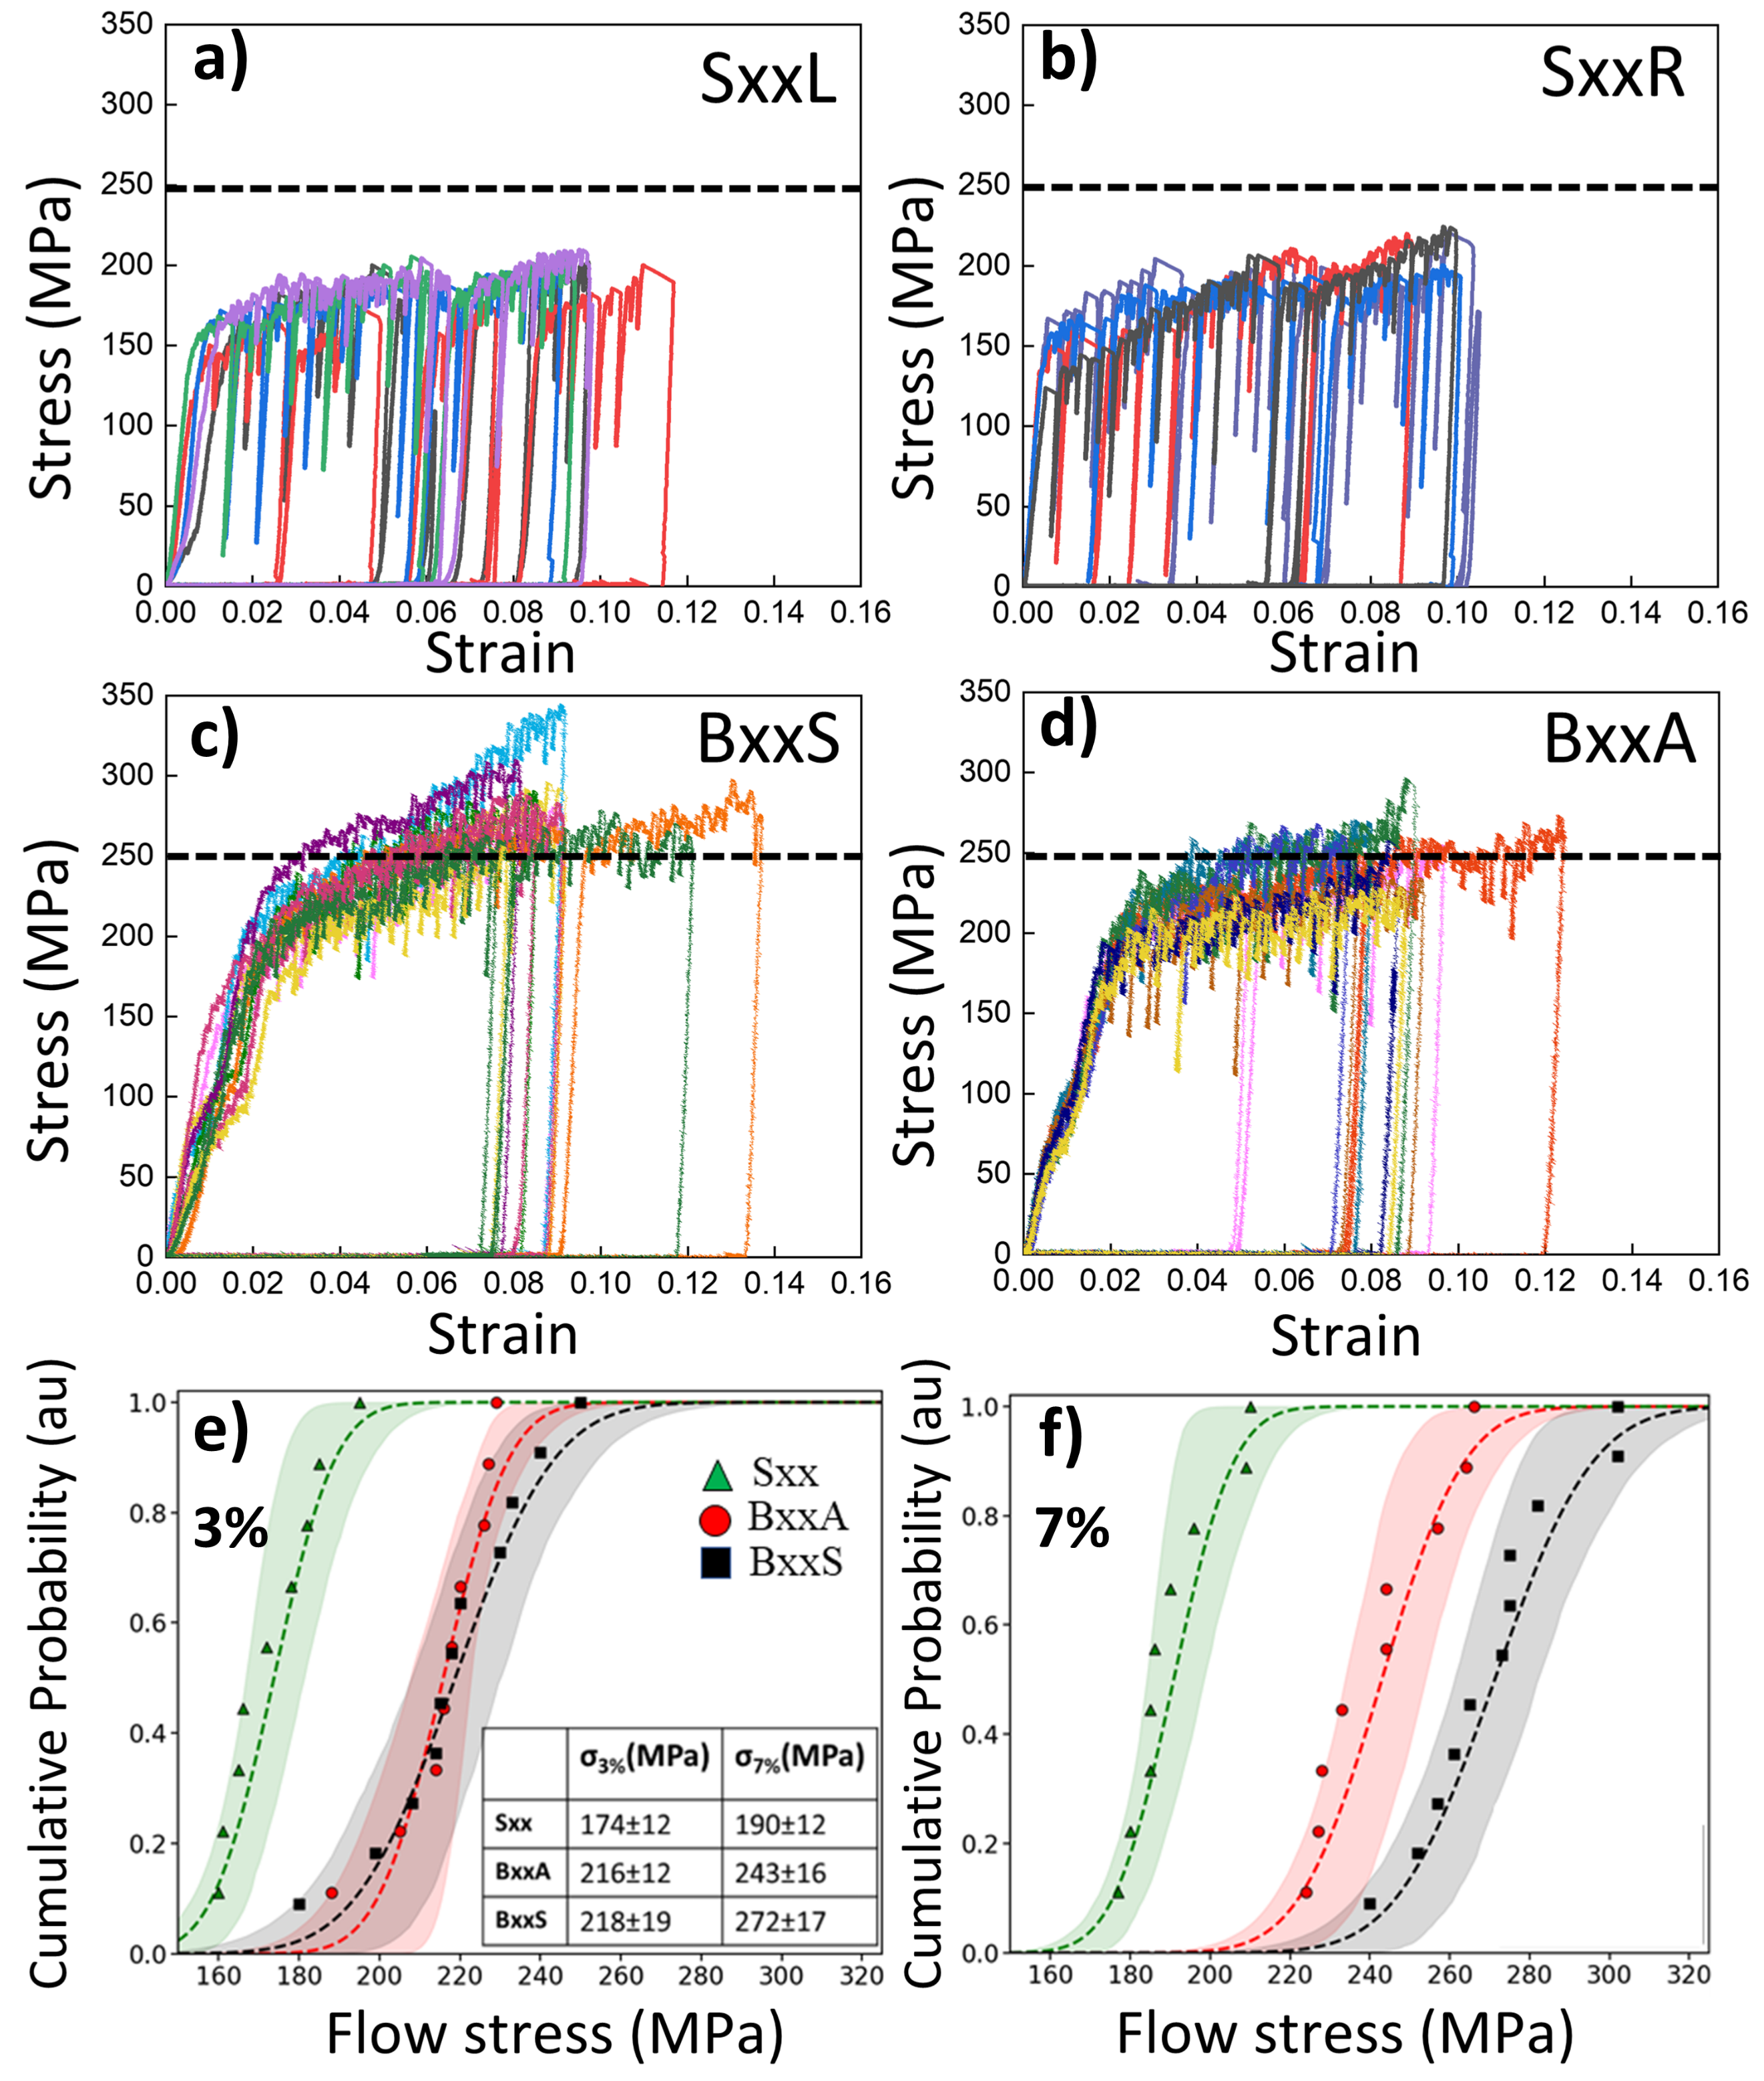
Figure S1: (a–d) Stress vs strain behaviour of several micropillars tested at strain rate of 10⁻³ s⁻¹. (a) Single crystalline micropillar corresponding to SxxL. (b) Single crystalline micropillar corresponding to SxxR (c) BxxS containing micropillar, and (d) BxxA conating micropillars. (e–f) Cumulative probability distribution of the flow stress for single-crystalline (Sxx), counter-bodies and two GB inclinations at (e) 3% strain and (f) 7% strain, including the best-fit curve and the 95% confidence intervals. A arbitary dashed black line at 250 MPa in (a–d) serves only as a guide for the eyes.

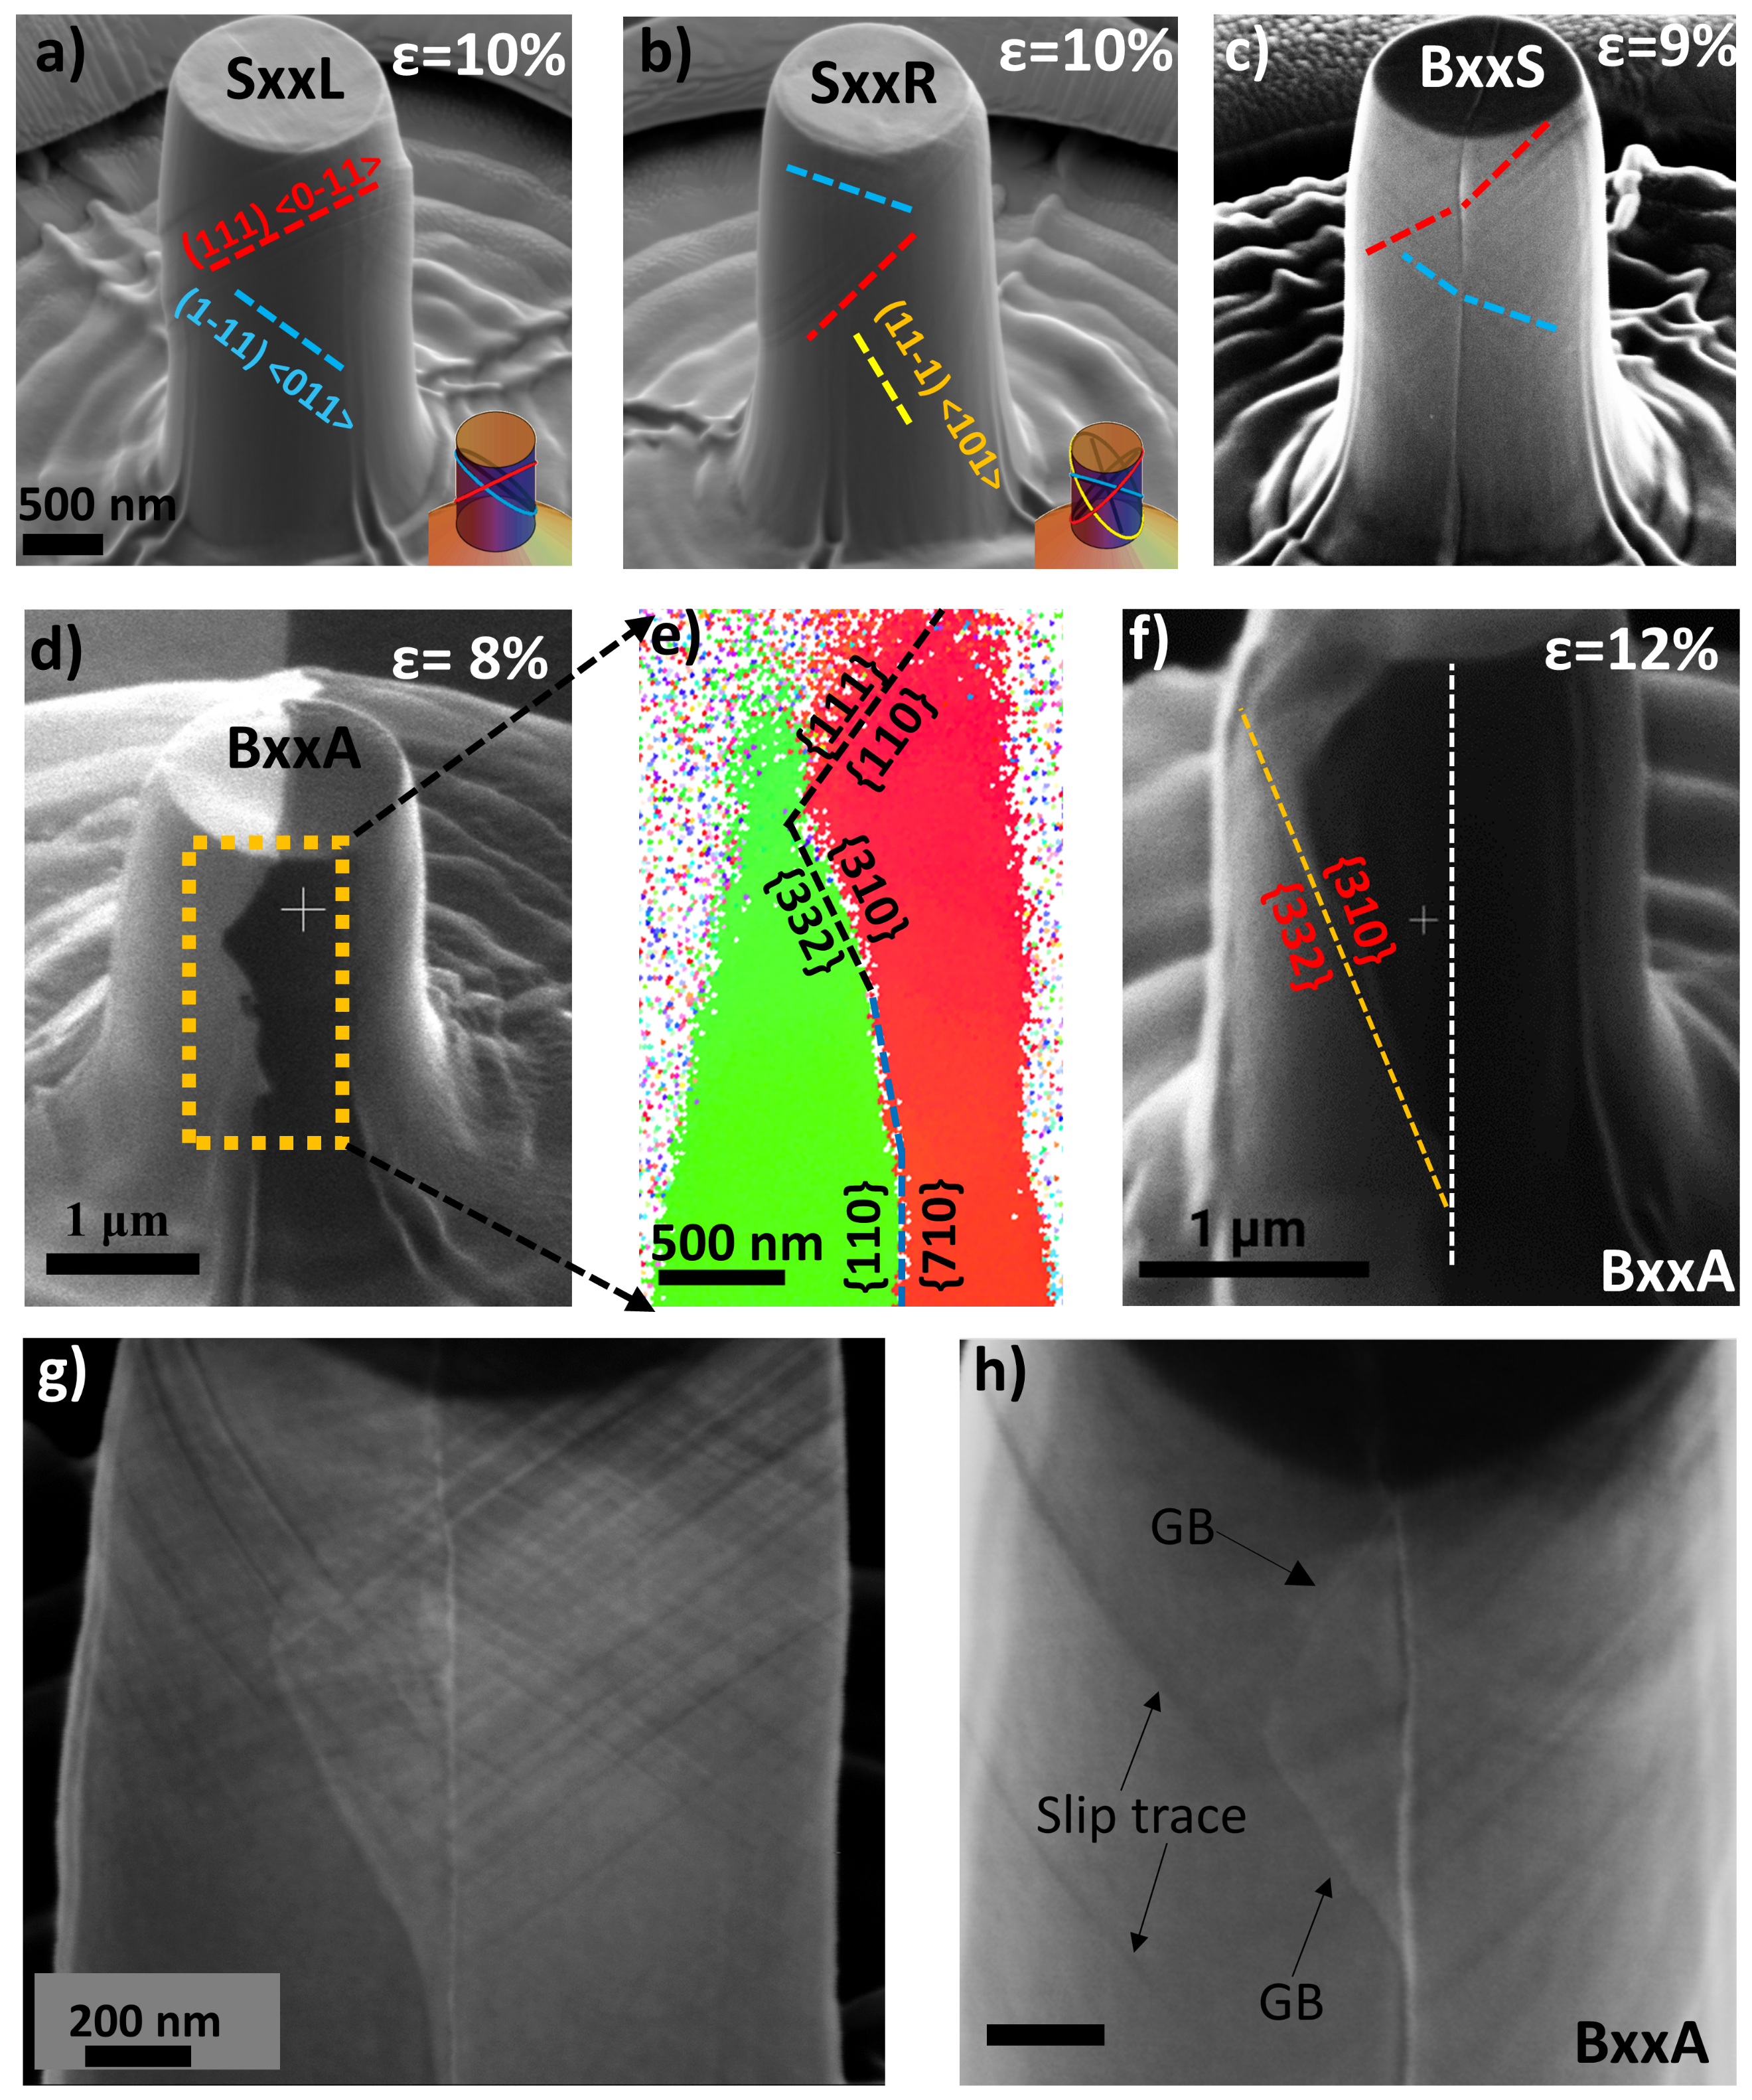
Figure S2: (a-b) Post-deformation images of GL and GR deformed to a strain of 10%. The slip traces are identified and the insets show simulated slip traces. (c) Post-deformation image of BxxS deformed to a strain of 9%. d) FIB images reveal sharp grain contrast in BxxA deformed to 8% strain. (e) Corresponding EBSD cross-section clearly show that the SxxR grain is growing relative to SxxL, with GB facets highlighted by dashed lines. Note that the top {111}/{110} facet could not be accurately determined in (e) due to poor indexing and is referenced from (d). (f) FIB grain-contrast image of BxxA deformed to 12% strain, which is the maximum strain tested in our experiments. The migrated GB is highlighted in yellow and corresponds to the {310}/{332} GB plane. The white dashed line marks the original GB position. (g) Corresponding to Fig. 2c, shown without annotations or markings. (h) BxxA micropillar with both migrated facets aligned close to {111}/{110}.

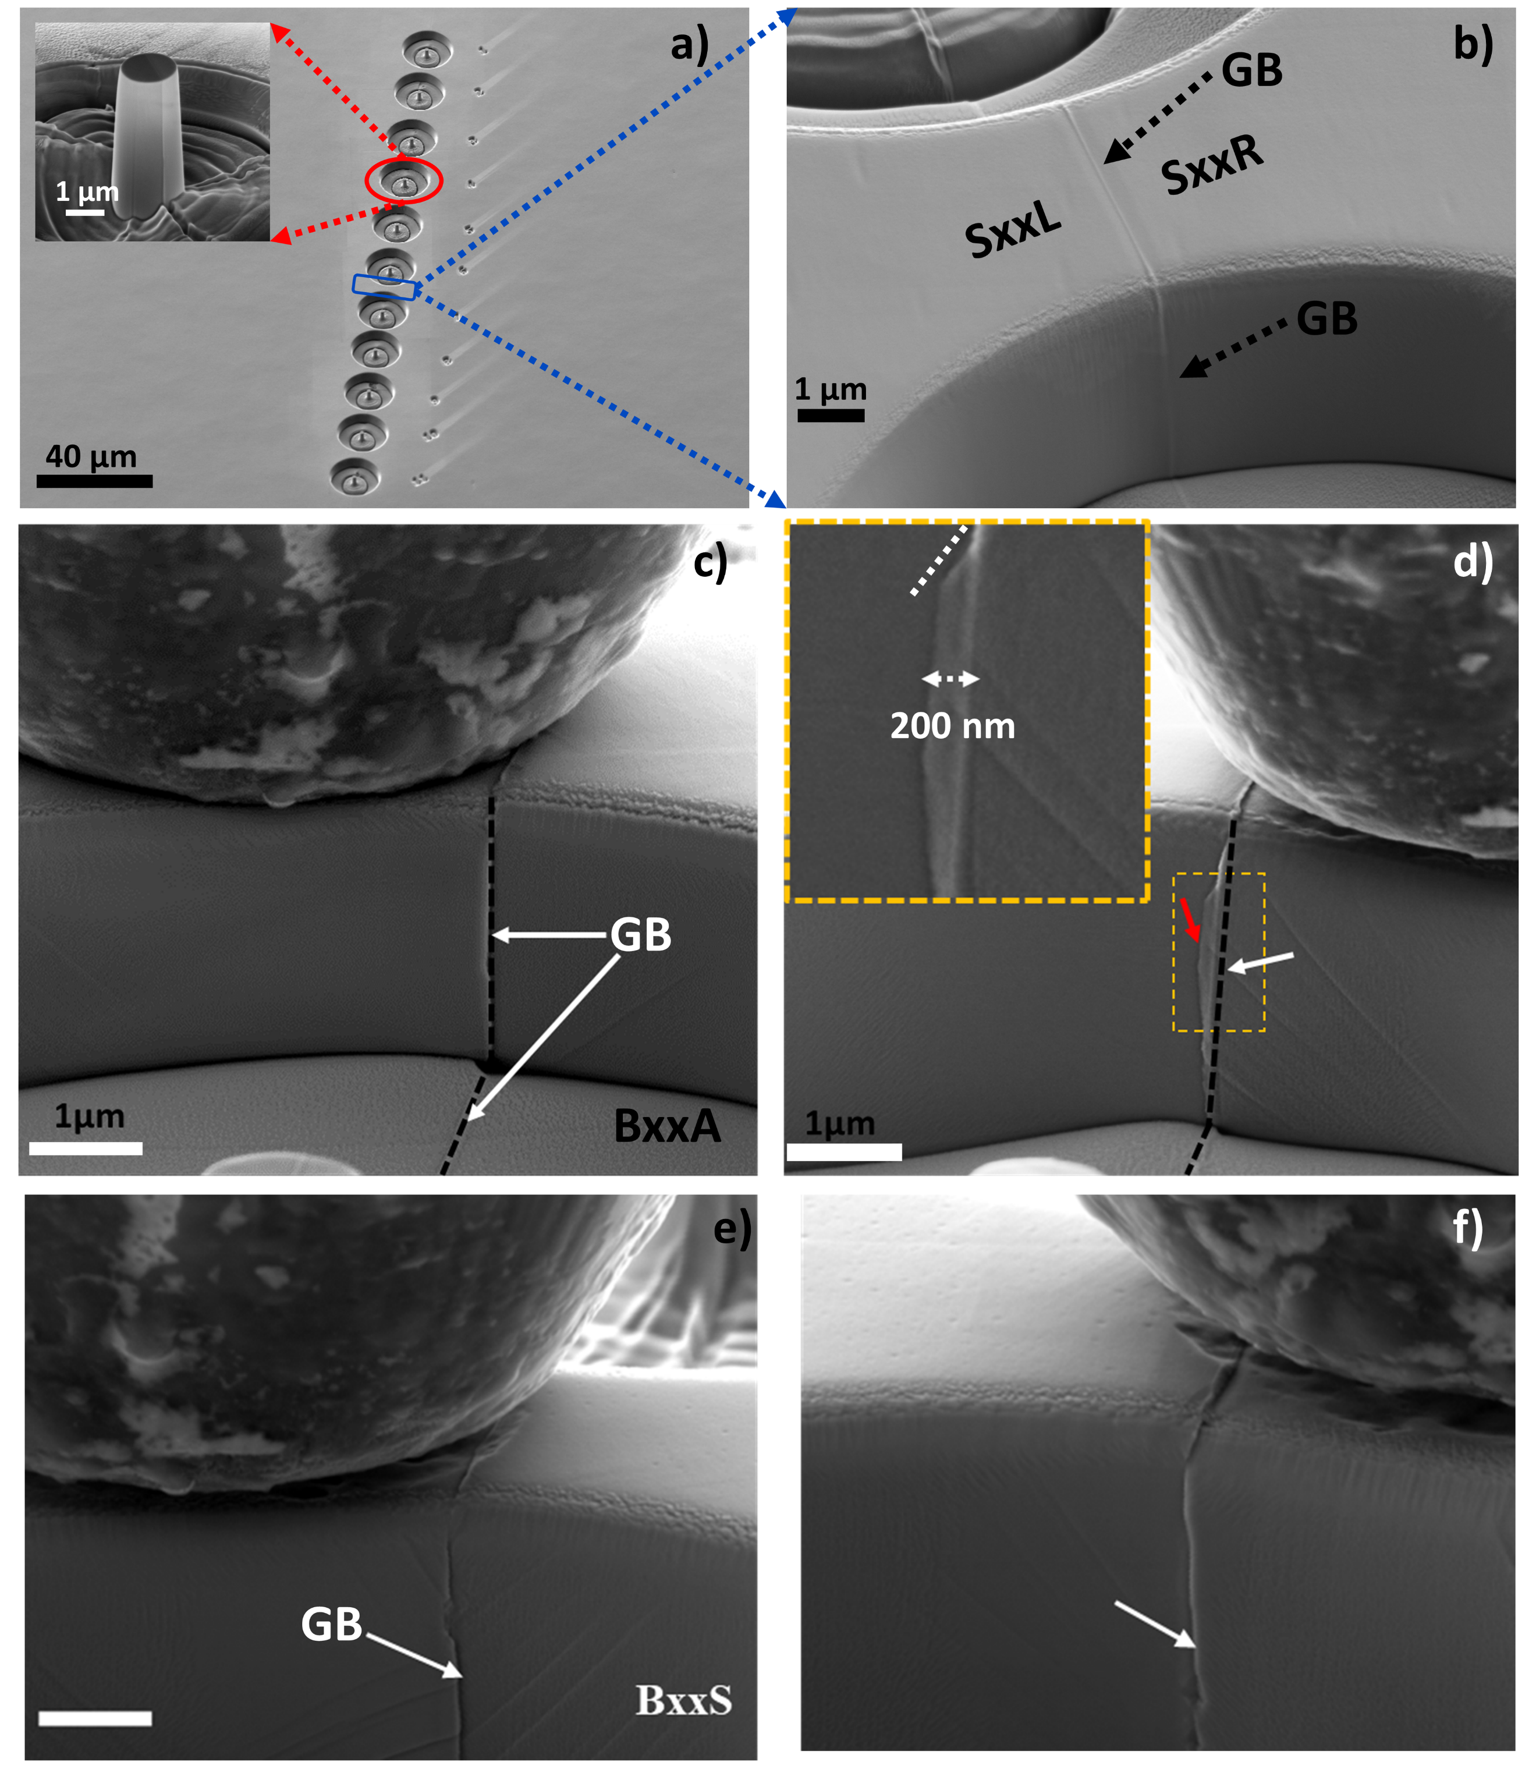
Figure S3: (a) An array of micropillars on BxxA, with the inset showing an undeformed micropillar. The magnified region in (b) corresponds to the area defined as the “microwall” used for flat-punch indentation. The GB is marked with dashed black arrows (c-f) Post-indentation SEM images of the microwall configuration (c–d) Indentation on BxxA, with (c) corresponding to an indent on SxxL and (d) on SxxR. (e–f) Indentation on BxxS on either side. Comparisons reveal GB migration/faceting is only observed in (d). The white arrow in d highlights the initial GB position, and the red arrow marks the post-indentation position. The white dashed line in the inset image in (d) indicates the GB facet corresponding to the {111}/{110} planes.

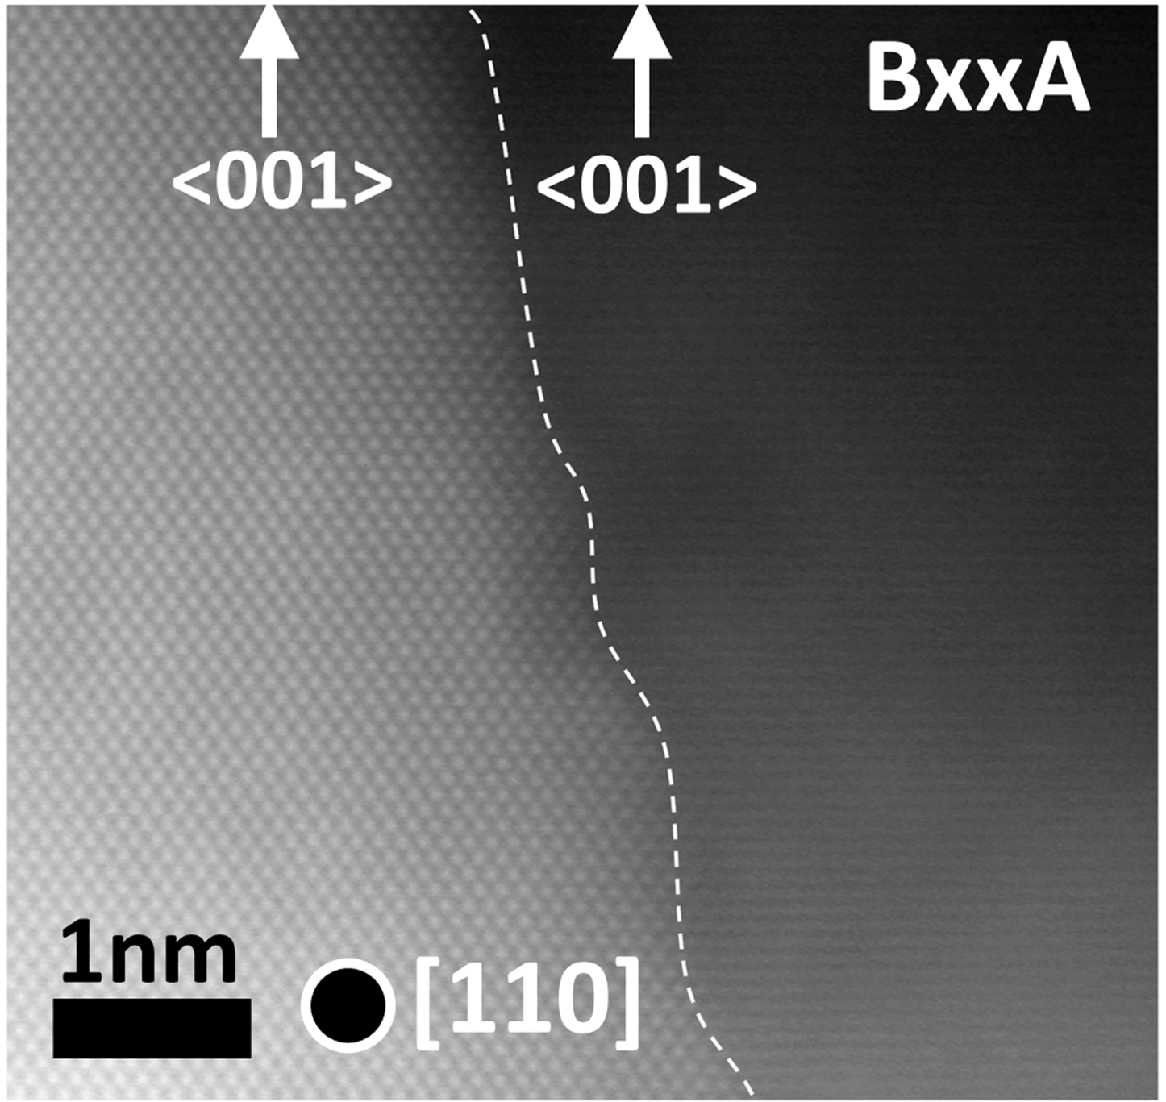
Figure S4: Cross-sectional TEM micrograph of the BxxA, where SxxR is viewed along the [110] zone axis. The GB, marked by a white dashed line exhibits nanoscale undulations.

Section S2: Crystal Plasticity Fast Fourier Transform Simulations
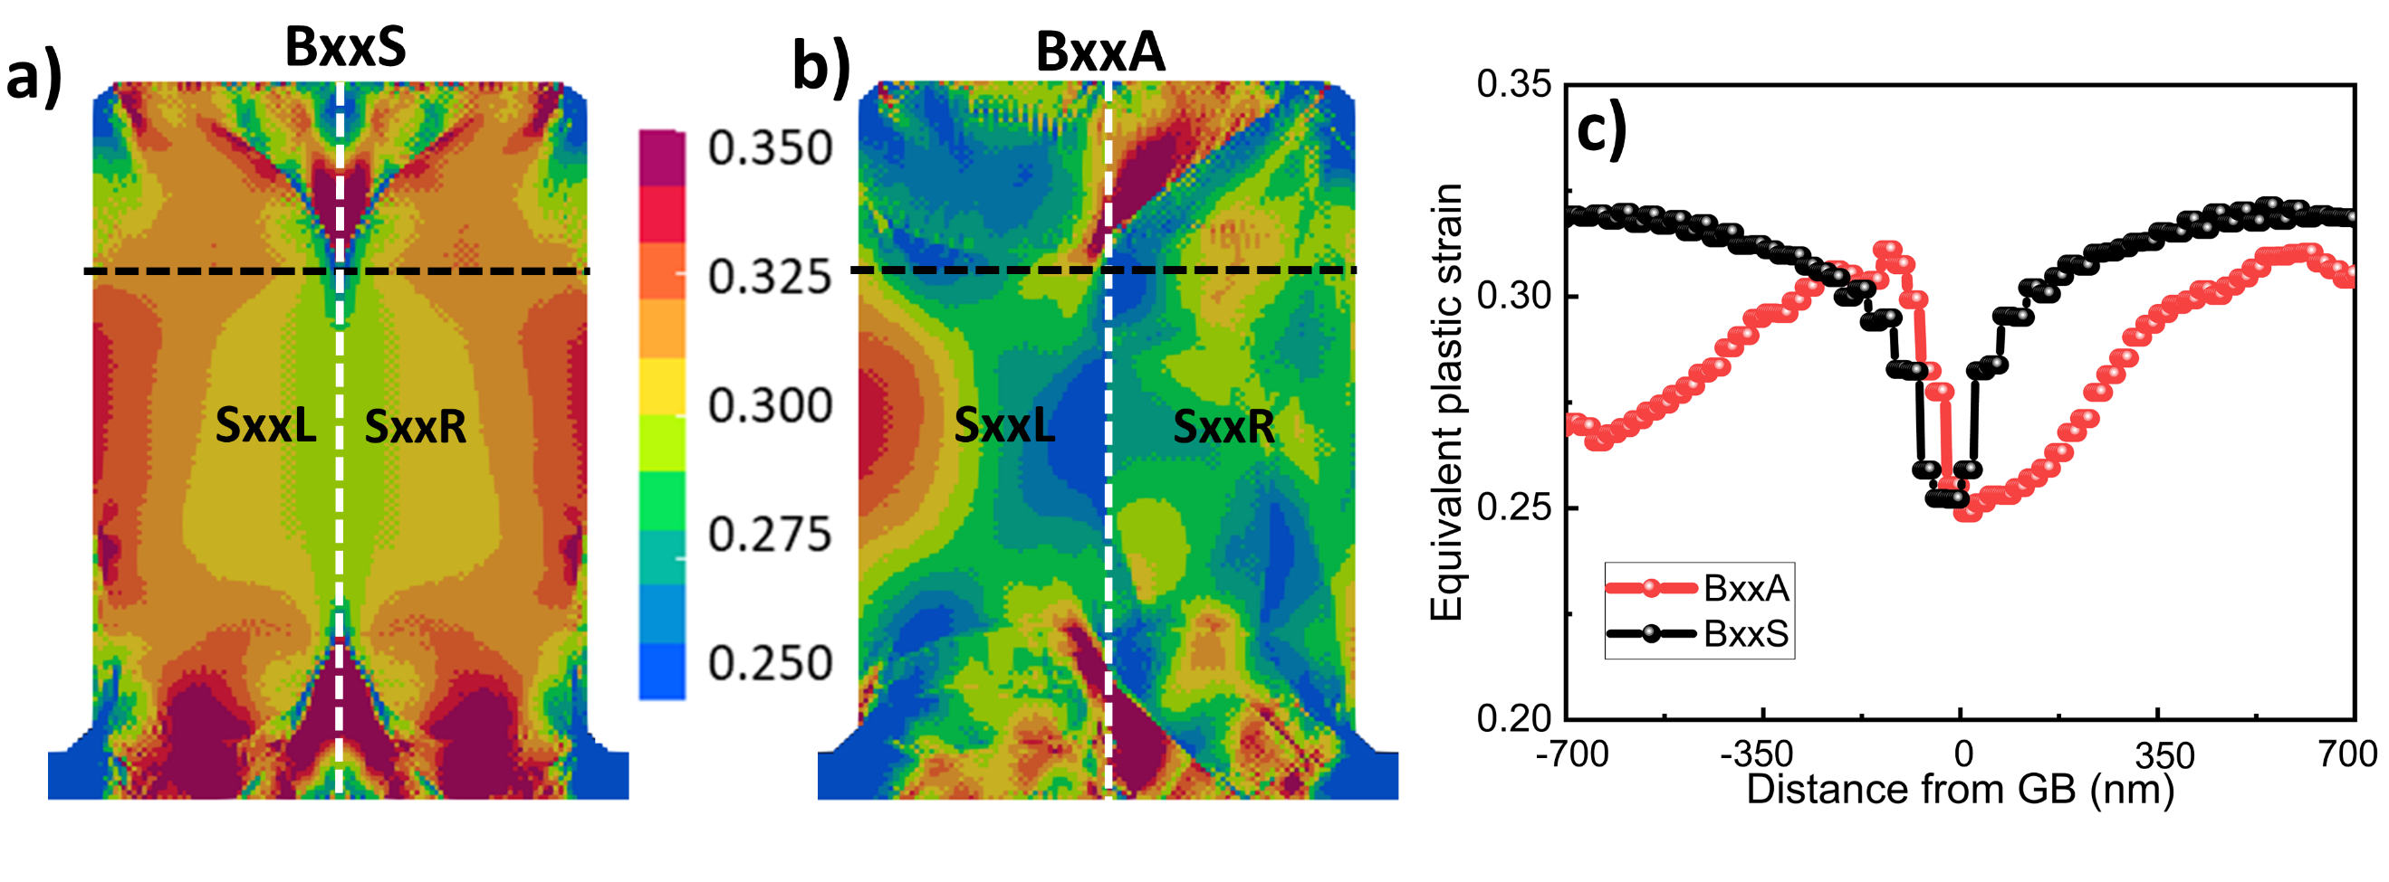
Figure S5: a-b) Equivalent plastic strain in BxxS and BxxA GB. The values extracted along the black dashed line are shown in (c).
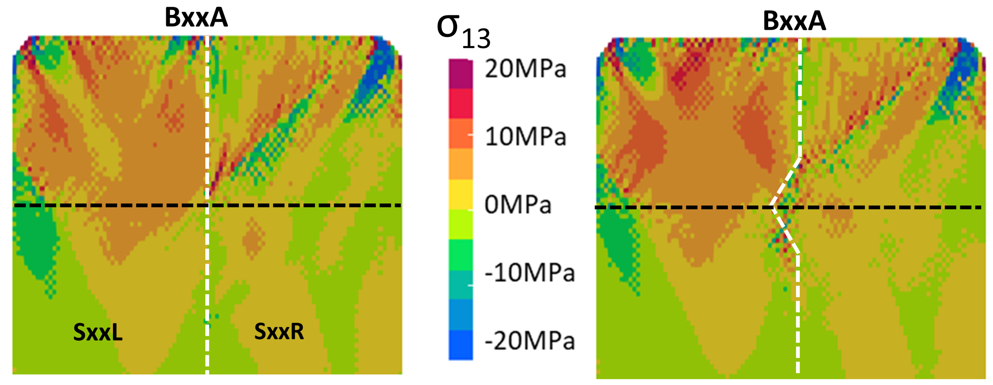

Figure S6: Shear stress distribution along the GB plane before (left) and after the onset of GB bulging (right). For a flat GB (left), the resolved shear stress σ₁₃ is negligible (σ₁₃/σvM≈0.005), a slight GB bulge (right) in the strong energy gradient region increases this ratio tenfold (σ₁₃/σvM≈0.05).
Section S3. Phase-field crystal simulations
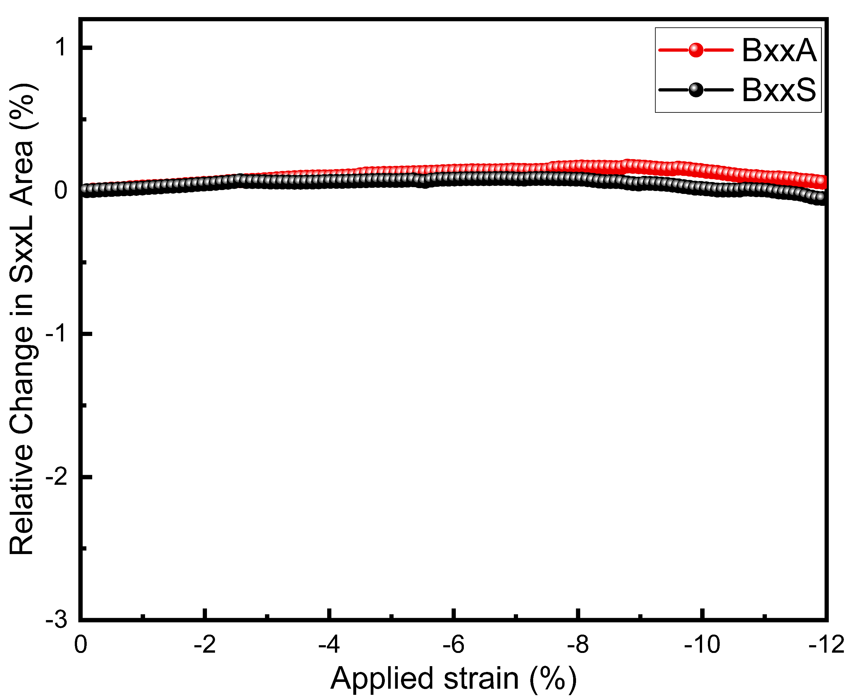
Figure S7: No migration under uniaxial compression along the tilt axis z in either of the GB.

Section S4: Molecular Dynamics Simulations
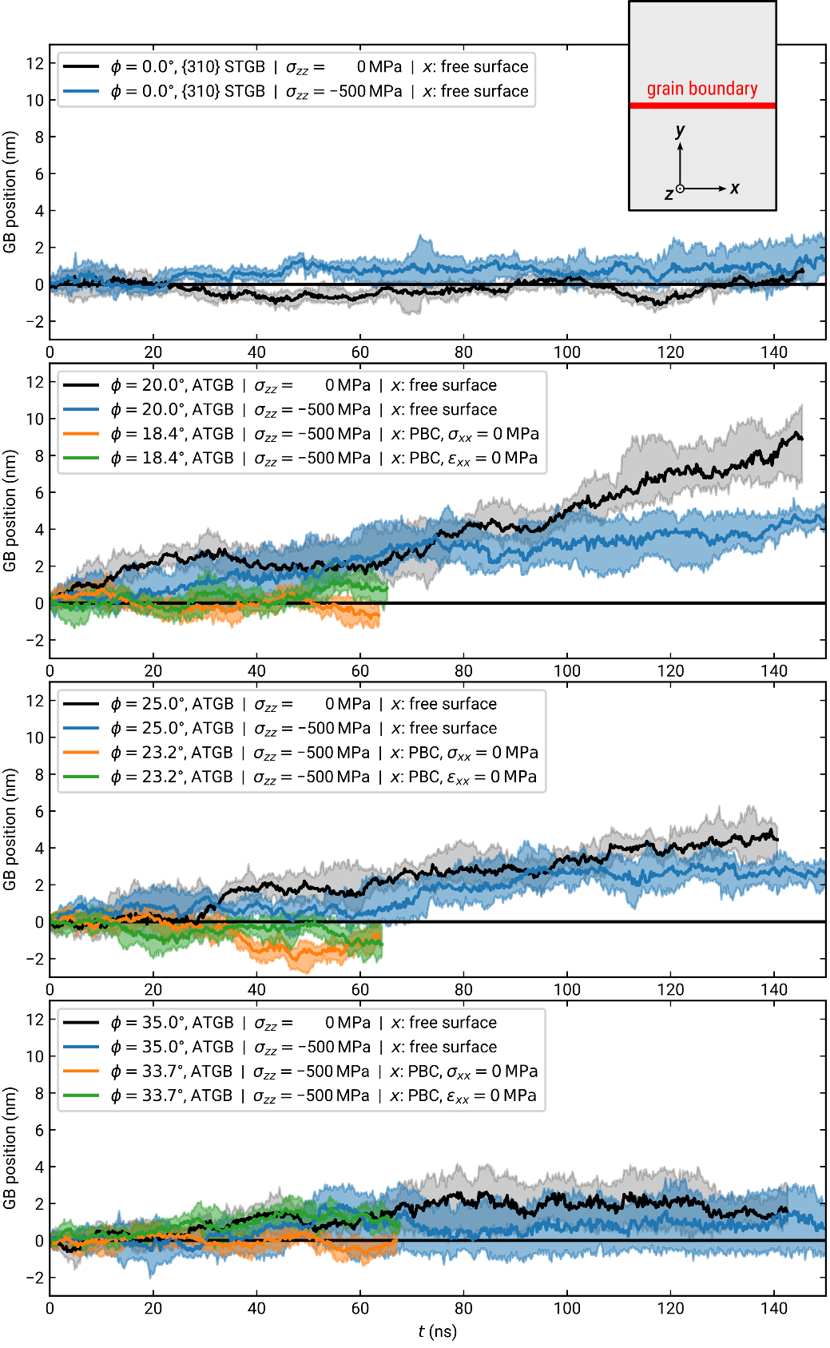
Figure S8: Molecular dynamics simulations of various Σ5 GBs with [001] tilt axis. Bicrystals of size 20×160×0.3615 nm³ were constructed with different inclinations ϕ from the symmetric {310} boundary. They contained no defects apart from grain boundary and surfaces. The z direction was always periodic and the y direction always open. We used a small size along z and temperature of 800 K in order to accelerate the grain boundary mobility as much as possible. For the x direction, we tested free surfaces, periodic boundaries (PBC) with a barostat at zero stress, or fixed boundaries (ε = 0). Low-index grain boundary planes were chosen for the PBC samples such that their periodic x length was reasonable. The inclination angles therefore slightly deviate from the open boundary samples. We applied either zero or 500 MPa compressive stress along the tilt axis (z). When keeping the x direction at fixed strain, we obtained a compressive stress of around 300 MPa along x. We can observe some GB movement in the asymmetric GBs, but there is no statistically significant difference between different stress states, including zero stress. The samples with free surfaces in x direction might be slightly more mobile. We conclude that dislocation-free samples exhibit no GB mobility—apart from thermal fluctuations—under these stress conditions.

Section S5: Molecular Statics simulations
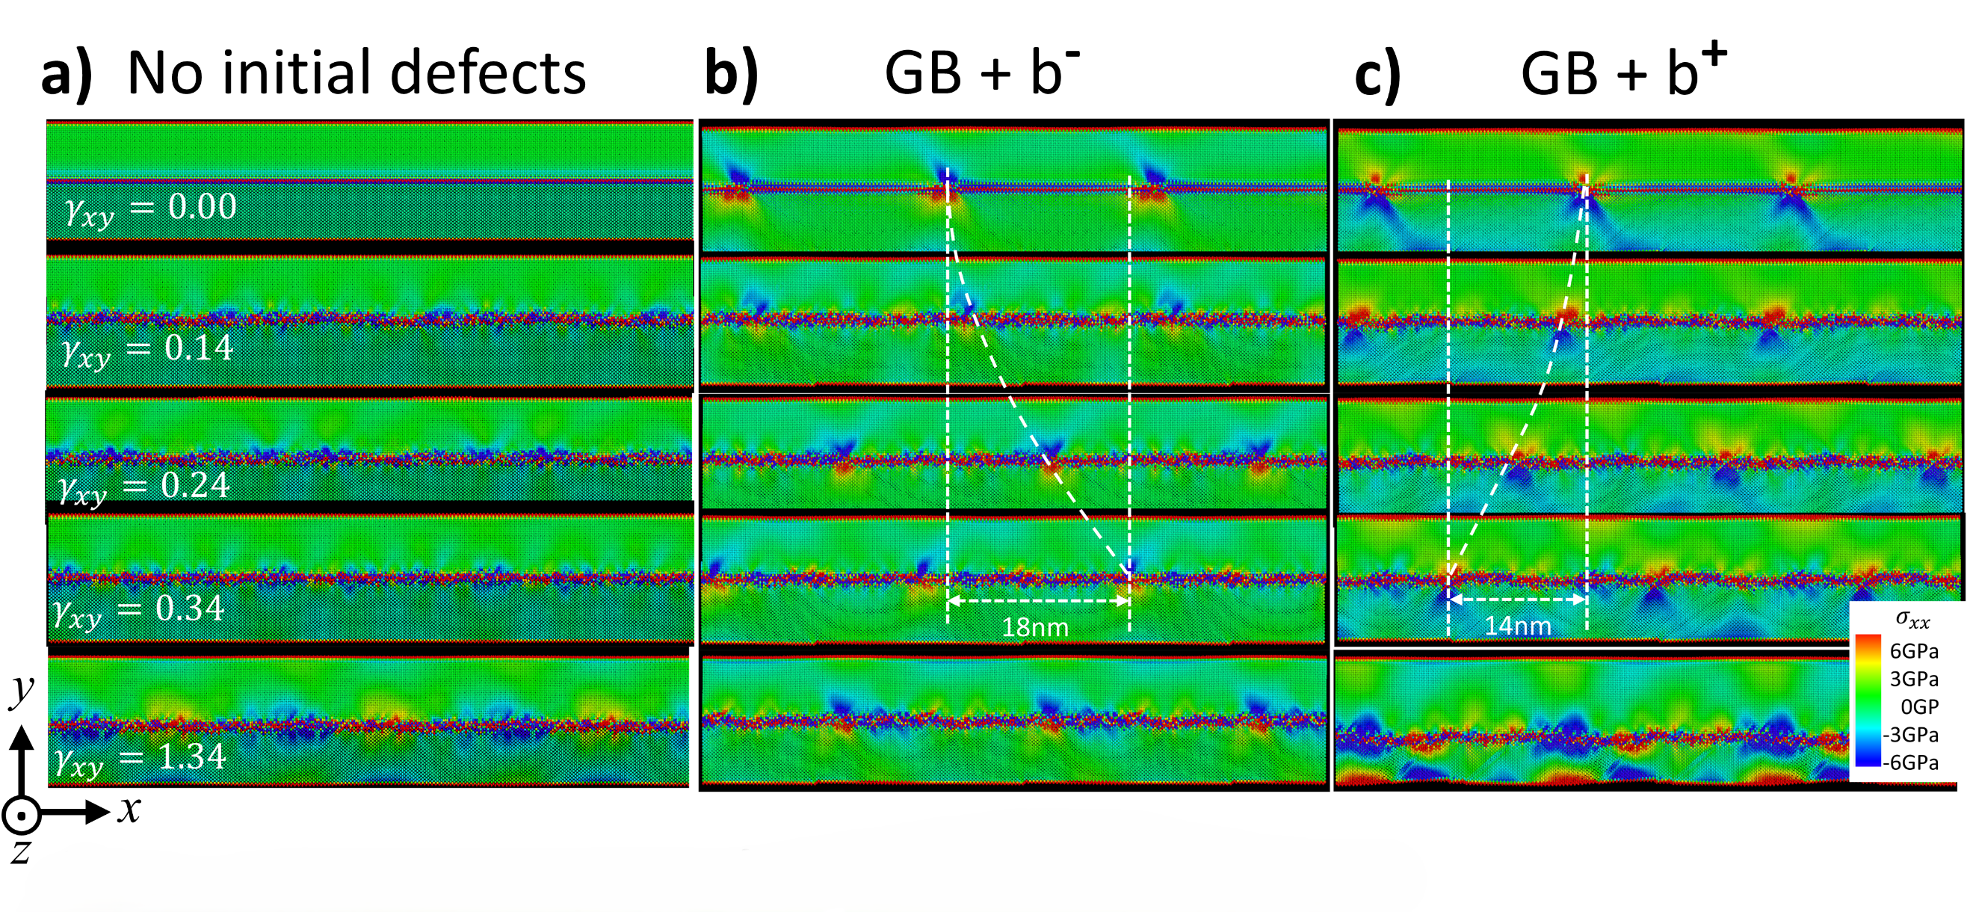
Figure S9: Shear coupling for BxxA with and without dislocations. (a) Migration of perfect BxxA. (b) BxxA absorbed a negative Burgers vector b⁻ and (c) a positive Burgers vector b⁺
Table 1: Shear coupling factor (β) corresponding to fig 6c
Case | β
b+, negative shear | -21
b-, positive shear | -26
b-, negative shear | -30
no initial defects, negative shear | -34
no initial defects, positive shear | -43
b+, positive shear | -46

