Supplementary Table S1. Canonical marker genes used for major-lineage and T/NK-state annotation in the discovery cohort
Category | Cell state / lineage | Representative marker genes | Annotation purpose
Major lineage | T-cell naive / memory | IL7R, TCF7, LEF1, CCR7, CD28 | Identification of naive / memory-like T-cell populations
Major lineage | Cytotoxic CD8 T cells | CD8A, CD8B, GZMK, GZMA, CCL5, EOMES | Identification of cytotoxic / effector CD8 T-cell populations
Major lineage | Exhausted cytotoxic lymphocytes | CXCL13, PDCD1, TIGIT, LAG3, TOX, ENTPD1 | Identification of exhausted-like / tumor-reactive lymphocyte states
Major lineage | NK cells | NKG7, FCGR3A, FGFBP2, TYROBP, TRAC-low profile | Identification of NK-cell populations
Major lineage | B cells | CD79A, MS4A1, CD74, HLA-DRA | Identification of B-cell lineage
Major lineage | Plasma cells | MZB1, JCHAIN, XBP1, IGKC, IGHG-related genes | Identification of plasma-cell lineage
Major lineage | Myeloid cells | LST1, FCER1G, TYROBP, CTSB, C1QC | Identification of macrophage / monocyte-dominant myeloid populations
Major lineage | Monocytes | FCN1, VCAN, S100A8, S100A9 | Identification of inflammatory monocyte-like states
Major lineage | Neutrophils | CXCL8, S100A12, FCGR3B, CSF3R | Identification of neutrophil populations
Major lineage | Mast cells | TPSAB1, KIT, CPA3 | Identification of mast-cell populations
Major lineage | Endothelial cells | PECAM1, EMCN, KDR, VWF | Identification of endothelial lineage
Major lineage | CAF / stromal cells | COL1A1, COL1A2, DCN, TAGLN, ACTA2 | Identification of fibroblast / stromal populations
Major lineage | Pericyte / smooth muscle cells | RGS5, ACTA2, TAGLN, MYH11 | Identification of pericyte / smooth-muscle-like stromal cells
Major lineage | Tumor epithelial cells | EPCAM, KRT8, KRT18, KRT19, MSLN / secretory or squamoid epithelial programs | Identification of malignant epithelial / tumor-associated populations
Major lineage | Cycling cells | MKI67, TOP2A, STMN1, CENPF | Identification of proliferating / cycling populations
T/NK subtype | T_progenitor_like | IL7R, TCF7, SELL, LTB, CCR7 | Identification of progenitor / early memory-like T-cell state
T/NK subtype | T_activated_CCR7_NR4A3 | CCR7, NR4A3, IL7R, TCF7, CD40LG | Identification of activated transitional T-cell state
T/NK subtype | T_activated_HLAII_like | HLA-DRA, HLA-DPA1, HLA-DPB1, CD74 | Identification of activated antigen-presentation-associated T-cell state
T/NK subtype | CD8_GZMK_effector_like | GZMK, EOMES, CCL5, CD8A, CD8B, CXCR6 | Identification of responder-associated effector-like CD8 program
T/NK subtype | CD8_GZMK_stress_like | GZMK, stress-response genes, cytotoxic markers | Identification of stress-associated GZMK-positive CD8 state
T/NK subtype | CD8_activated_exhausted | GZMB, TNFRSF9, LAG3, ENTPD1, RHOB | Identification of activated exhausted-like CD8 state
T/NK subtype | CD8_CXCL13_exhausted | CXCL13, TOX2, GNG4, ENTPD1, LAG3 | Identification of responder-associated exhausted-like but tumor-reactive CD8 program
T/NK subtype | CD8_tissue_resident_like | CXCR6, ITGAE, ZNF683, tissue-retention-associated genes | Identification of tissue-resident-like CD8 state
T/NK subtype | CD8_TNFSF9_activated | TNFSF9, GZMB, activation-associated effector genes | Identification of highly activated CD8 state
T/NK subtype | Cytotoxic_dysfunctional_LAYN | LAYN, inhibitory / dysfunctional markers, cytotoxic genes | Identification of dysfunctional cytotoxic lymphocyte state
T/NK subtype | gdT_exhausted_like | TRGC2, exhaustion-associated genes, cytotoxic markers | Identification of exhausted-like γδ T-cell state
T/NK subtype | gdT_NK_hybrid | TRGC2, NKG7, FCGR3A, NK-associated genes | Identification of hybrid γδ T / NK-like state
T/NK subtype | NK_FCGR3A_like | FCGR3A, TYROBP, NKG7, TRAC-low profile | Identification of FCGR3A-dominant NK state
T/NK subtype | NK_FGFBP2_high | FGFBP2, NKG7, FCGR3A, PRF1 | Identification of terminally cytotoxic NK state
T/NK subtype | NK_metal_response_like | metallothionein genes with NK-associated background | Identification of stress / metal-response NK-like state
T/NK subtype | Treg_classic | FOXP3, IL2RA, CTLA4, TIGIT | Identification of canonical regulatory T-cell state
T/NK subtype | Treg_activated | FOXP3, IL2RA, CTLA4, ICOS, activated Treg-associated markers | Identification of activated regulatory T-cell state
Supplementary Table S1. Representative marker genes used for lineage and state annotation in the discovery cohort. Major-lineage annotation was first performed at the whole-cohort level and then refined by focused reclustering of T/NK cells. Marker selection emphasized canonical lineage markers together with program-level interpretability rather than reliance on a single gene alone. The final T/NK labels were based on manual annotation integrating top differentially expressed genes, canonical immune markers, and biological context.
Supplementary Table S2. Gene composition of compact immune-program signatures used for downstream bulk and spatial validation
Signature | Gene symbol | Source state | Used in external bulk validation | Used in spatial validation
sig_CD8_GZMK_effector | GZMK | CD8_GZMK_effector_like | Yes | Yes
sig_CD8_GZMK_effector | KLRG1 | CD8_GZMK_effector_like | Yes | Yes
sig_CD8_GZMK_effector | EOMES | CD8_GZMK_effector_like | Yes | Yes
sig_CD8_GZMK_effector | SLAMF7 | CD8_GZMK_effector_like | Yes | Yes
sig_CD8_GZMK_effector | ITM2C | CD8_GZMK_effector_like | Yes | Yes
sig_CD8_GZMK_effector | CMC1 | CD8_GZMK_effector_like | Yes | Yes
sig_CD8_CXCL13_exhausted | GNG4 | CD8_CXCL13_exhausted | Yes | Yes
sig_CD8_CXCL13_exhausted | PTPN13 | CD8_CXCL13_exhausted | Yes | Yes
sig_CD8_CXCL13_exhausted | CXCL13 | CD8_CXCL13_exhausted | Yes | Yes
sig_CD8_CXCL13_exhausted | RDH10 | CD8_CXCL13_exhausted | Yes | Yes
sig_CD8_CXCL13_exhausted | TOX2 | CD8_CXCL13_exhausted | Yes | Yes
sig_CD8_CXCL13_exhausted | THADA | CD8_CXCL13_exhausted | Yes | Yes
sig_Treg_activated | FANK1 | Treg_activated | Yes | Yes*
sig_Treg_activated | FOXP3 | Treg_activated | Yes | Yes*
sig_Treg_activated | IL2RA | Treg_activated | Yes | Yes*
sig_Treg_activated | LAPTM4B | Treg_activated | Yes | Yes*
sig_Treg_activated | IL1R2 | Treg_activated | Yes | Yes*
Supplementary Table S2. Compact immune-program signatures derived from manually annotated responder-associated or comparison T/NK states in the discovery cohort and used for downstream cross-platform validation. sig_CD8_GZMK_effector and sig_CD8_CXCL13_exhausted were treated as the two primary responder-associated CD8 programs. sig_Treg_activated was retained as an auxiliary comparison program for evaluating local regulatory-exclusion patterns.
* The Treg-associated program contained five genes in the external bulk validation setting but four genes in the spatial validation setting because gene availability differed across platforms, as reflected by the platform-specific signature gene counts.
Supplementary Table S3. Top-ranked pseudobulk differential-expression results for responder-associated CD8 programs
logFC > 0 = higher in responders
logFC < 0 = lower in responders / relatively higher in non-responders**
Part A. CD8_GZMK_effector_like
Program | Gene | logFC | logCPM | F | P value | FDR | Direction in responders
CD8_GZMK_effector_like | NEAT1 | 1.1171 | 8.7785 | 19.1730 | 0.0001095 | 0.8268 | Higher
CD8_GZMK_effector_like | RASGRP2 | 1.3424 | 5.6425 | 16.8225 | 0.0002206 | 0.8329 | Higher
CD8_GZMK_effector_like | LCMT1 | -1.9617 | 4.3699 | 13.9948 | 0.0005961 | 0.9133 | Lower
CD8_GZMK_effector_like | ZNF862 | 1.1170 | 4.9718 | 12.8220 | 0.0009627 | 0.9133 | Higher
CD8_GZMK_effector_like | CCND3 | 0.8875 | 7.4761 | 12.8638 | 0.0009901 | 0.9133 | Higher
CD8_GZMK_effector_like | AC007969.1 | -0.7131 | 8.8656 | 12.3289 | 0.0012229 | 0.9133 | Lower
CD8_GZMK_effector_like | PSME1 | -0.6875 | 8.4156 | 12.3225 | 0.0012259 | 0.9133 | Lower
CD8_GZMK_effector_like | VPS37B | 1.1150 | 5.3720 | 12.2216 | 0.0012473 | 0.9133 | Higher
CD8_GZMK_effector_like | KANSL3 | -1.0966 | 5.6176 | 11.5339 | 0.0015661 | 0.9133 | Lower
CD8_GZMK_effector_like | PIGT | 0.9135 | 5.4426 | 11.5256 | 0.0016504 | 0.9133 | Higher
CD8_GZMK_effector_like | UBC | -0.8649 | 9.2318 | 11.3036 | 0.0018482 | 0.9133 | Lower
CD8_GZMK_effector_like | FAM162A | -0.9892 | 5.5350 | 10.6950 | 0.0022282 | 0.9133 | Lower
CD8_GZMK_effector_like | RNF166 | -0.8808 | 6.4543 | 10.5731 | 0.0024202 | 0.9133 | Lower
CD8_GZMK_effector_like | SERPINB1 | -0.7148 | 7.3514 | 10.6006 | 0.0024541 | 0.9133 | Lower
CD8_GZMK_effector_like | CUX1 | 1.1008 | 4.8090 | 10.4032 | 0.0025809 | 0.9133 | Higher
Part B. CD8_CXCL13_exhausted
Program | Gene | logFC | logCPM | F | P value | FDR | Direction in responders
CD8_CXCL13_exhausted | TMEM64 | 1.5107 | 5.7235 | 21.3603 | 0.0000780 | 0.2534 | Higher
CD8_CXCL13_exhausted | NUDT16 | 2.1596 | 6.3625 | 20.8474 | 0.0001543 | 0.2534 | Higher
CD8_CXCL13_exhausted | UGCG | 1.0108 | 6.7565 | 17.7745 | 0.0002590 | 0.2534 | Higher
CD8_CXCL13_exhausted | HIVEP3 | -1.7626 | 6.1547 | 16.4198 | 0.0003020 | 0.2534 | Lower
CD8_CXCL13_exhausted | BCL3 | -1.7718 | 7.1894 | 16.3930 | 0.0003372 | 0.2534 | Lower
CD8_CXCL13_exhausted | AGPS | -1.6246 | 5.8345 | 16.0828 | 0.0003410 | 0.2534 | Lower
CD8_CXCL13_exhausted | PFKP | -1.6198 | 6.6929 | 15.1319 | 0.0004959 | 0.2861 | Lower
CD8_CXCL13_exhausted | PPIE | -1.6609 | 5.7833 | 14.8700 | 0.0005282 | 0.2861 | Lower
CD8_CXCL13_exhausted | TMEM205 | -1.6695 | 5.9234 | 14.5536 | 0.0005877 | 0.2861 | Lower
CD8_CXCL13_exhausted | SPPL2A | -1.1004 | 6.9003 | 14.4452 | 0.0006892 | 0.2861 | Lower
CD8_CXCL13_exhausted | GZMK | -2.0799 | 6.1955 | 13.8941 | 0.0007556 | 0.2861 | Lower
CD8_CXCL13_exhausted | NIFK | -1.5079 | 5.9833 | 13.8057 | 0.0007698 | 0.2861 | Lower
CD8_CXCL13_exhausted | HAPLN3 | -1.8699 | 5.8409 | 13.3229 | 0.0009450 | 0.3241 | Lower
CD8_CXCL13_exhausted | SKIL | -1.1442 | 7.1009 | 12.9535 | 0.0012021 | 0.3342 | Lower
CD8_CXCL13_exhausted | P2RX5 | 1.2290 | 5.9294 | 12.8171 | 0.0012948 | 0.3342 | Higher
CD8_CXCL13_exhausted | ZNF831 | 1.0292 | 6.8510 | 12.9128 | 0.0013186 | 0.3342 | Higher
Supplementary Table S3. Top-ranked pseudobulk differential-expression results for the two responder-associated CD8 programs in the discovery cohort. Sample-level pseudobulk profiles were compared between responders and non-responders. Positive logFC values indicate relatively higher expression in responders, whereas negative logFC values indicate relatively lower expression in responders. Because of the limited cohort size and substantial biological heterogeneity, most single-gene results did not remain significant after multiple-testing correction. Accordingly, these results were interpreted primarily at the level of ranked trends and pathway/program consistency rather than as standalone FDR-significant single-gene findings.
Supplementary Table S4. AOI-level spatial coexpression results between immune-program signatures and local functional features in PanCK-positive tumor-associated compartments
Part A. Responder-associated CD8 programs in PanCK-positive compartments
Segment | Signature | Feature | Spearman rho | P value | FDR | n | Interpretation
PanCK pos | sig_CD8_GZMK_effector | axis_mhc_i | 0.2780 | 0.0911 | 0.1409 | 38 | Positive trend
PanCK pos | sig_CD8_GZMK_effector | axis_mhc_ii | 0.2323 | 0.1601 | 0.2148 | 38 | Positive trend
PanCK pos | sig_CD8_GZMK_effector | axis_ifn_axis | 0.4953 | 0.0017817 | 0.0069896 | 38 | Significant positive
PanCK pos | sig_CD8_GZMK_effector | axis_antigen_present | 0.2704 | 0.1007 | 0.1511 | 38 | Positive trend
PanCK pos | sig_CD8_GZMK_effector | HLA-DRA | 0.2586 | 0.1169 | 0.1680 | 38 | Positive trend
PanCK pos | sig_CD8_GZMK_effector | CD74 | 0.2518 | 0.1271 | 0.1801 | 38 | Positive trend
PanCK pos | sig_CD8_GZMK_effector | HLA-A | 0.2465 | 0.1355 | 0.1893 | 38 | Positive trend
PanCK pos | sig_CD8_GZMK_effector | HLA-B | 0.3004 | 0.0673 | 0.1089 | 38 | Positive trend
PanCK pos | sig_CD8_GZMK_effector | HLA-C | 0.2054 | 0.2153 | 0.2711 | 38 | Weak positive
PanCK pos | sig_CD8_GZMK_effector | B2M | 0.1984 | 0.2316 | 0.2881 | 38 | Weak positive
PanCK pos | sig_CD8_GZMK_effector | TAP1 | 0.4555 | 0.0044123 | 0.0136379 | 38 | Significant positive
PanCK pos | sig_CD8_GZMK_effector | PSMB8 | 0.1898 | 0.2526 | 0.3031 | 38 | Weak positive
PanCK pos | sig_CD8_GZMK_effector | PSMB9 | 0.3262 | 0.0462 | 0.0798 | 38 | Positive trend
PanCK pos | sig_CD8_GZMK_effector | CXCL9 | 0.3621 | 0.0261 | 0.0493 | 38 | Significant positive
PanCK pos | sig_CD8_GZMK_effector | CXCL10 | 0.4052 | 0.0122 | 0.0278 | 38 | Significant positive
PanCK pos | sig_CD8_GZMK_effector | STAT1 | 0.4395 | 0.0061792 | 0.0165863 | 38 | Significant positive
PanCK pos | sig_CD8_GZMK_effector | IRF1 | 0.3980 | 0.0139 | 0.0308 | 38 | Significant positive
Segment | Signature | Feature | Spearman rho | P value | FDR | n | Interpretation
PanCK pos | sig_CD8_CXCL13_exhausted | axis_mhc_i | 0.0881 | 0.5978 | 0.6222 | 38 | Weak positive
PanCK pos | sig_CD8_CXCL13_exhausted | axis_mhc_ii | 0.1912 | 0.2493 | 0.3027 | 38 | Weak positive
PanCK pos | sig_CD8_CXCL13_exhausted | axis_ifn_axis | 0.4522 | 0.0047341 | 0.0142024 | 38 | Significant positive
PanCK pos | sig_CD8_CXCL13_exhausted | axis_antigen_present | 0.1406 | 0.3984 | 0.4465 | 38 | Weak positive
PanCK pos | sig_CD8_CXCL13_exhausted | HLA-DRA | 0.2067 | 0.2123 | 0.2707 | 38 | Weak positive
PanCK pos | sig_CD8_CXCL13_exhausted | CD74 | 0.1419 | 0.3940 | 0.4465 | 38 | Weak positive
PanCK pos | sig_CD8_CXCL13_exhausted | HLA-A | 0.1426 | 0.3918 | 0.4465 | 38 | Weak positive
PanCK pos | sig_CD8_CXCL13_exhausted | HLA-B | 0.1181 | 0.4788 | 0.5195 | 38 | Weak positive
PanCK pos | sig_CD8_CXCL13_exhausted | HLA-C | -0.0629 | 0.7066 | 0.7066 | 38 | Null / weak negative
PanCK pos | sig_CD8_CXCL13_exhausted | B2M | -0.0763 | 0.6480 | 0.6609 | 38 | Null / weak negative
PanCK pos | sig_CD8_CXCL13_exhausted | TAP1 | 0.5336 | 0.0006738 | 0.0036174 | 38 | Significant positive
PanCK pos | sig_CD8_CXCL13_exhausted | PSMB8 | 0.1391 | 0.4036 | 0.4475 | 38 | Weak positive
PanCK pos | sig_CD8_CXCL13_exhausted | PSMB9 | 0.3800 | 0.0192 | 0.0384 | 38 | Significant positive
PanCK pos | sig_CD8_CXCL13_exhausted | CXCL9 | 0.7183 | 1.16E-06 | 4.45E-05 | 38 | Strong significant positive
PanCK pos | sig_CD8_CXCL13_exhausted | CXCL10 | 0.5724 | 0.0002245 | 0.0017618 | 38 | Strong significant positive
PanCK pos | sig_CD8_CXCL13_exhausted | STAT1 | 0.2918 | 0.0757 | 0.1207 | 38 | Positive trend
PanCK pos | sig_CD8_CXCL13_exhausted | IRF1 | 0.4244 | 0.0083842 | 0.0208582 | 38 | Significant positive
Part B. Treg-associated comparison program in PanCK-positive compartments
Segment | Signature | Feature | Spearman rho | P value | FDR | n | Interpretation
PanCK pos | sig_Treg_activated | axis_mhc_i | -0.4422 | 0.0058523 | 0.0161333 | 38 | Significant negative
PanCK pos | sig_Treg_activated | axis_mhc_ii | -0.4682 | 0.0033405 | 0.0112077 | 38 | Significant negative
PanCK pos | sig_Treg_activated | axis_ifn_axis | -0.2074 | 0.2108 | 0.2707 | 38 | Weak negative
PanCK pos | sig_Treg_activated | axis_antigen_present | -0.5041 | 0.0014398 | 0.0061190 | 38 | Significant negative
PanCK pos | sig_Treg_activated | HLA-DRA | -0.4673 | 0.0034063 | 0.0112077 | 38 | Significant negative
PanCK pos | sig_Treg_activated | CD74 | -0.4636 | 0.0036987 | 0.0117897 | 38 | Significant negative
PanCK pos | sig_Treg_activated | HLA-A | -0.4214 | 0.0089062 | 0.0216294 | 38 | Significant negative
PanCK pos | sig_Treg_activated | HLA-B | -0.4700 | 0.0032122 | 0.0112077 | 38 | Significant negative
PanCK pos | sig_Treg_activated | HLA-C | -0.3942 | 0.0148848 | 0.0317343 | 38 | Significant negative
PanCK pos | sig_Treg_activated | B2M | -0.3916 | 0.0156123 | 0.0324991 | 38 | Significant negative
PanCK pos | sig_Treg_activated | TAP1 | -0.1848 | 0.2656 | 0.3150 | 38 | Weak negative
PanCK pos | sig_Treg_activated | PSMB8 | -0.3299 | 0.0436377 | 0.0780885 | 38 | Negative trend
PanCK pos | sig_Treg_activated | PSMB9 | -0.2603 | 0.1144 | 0.1667260 | 38 | Weak negative
PanCK pos | sig_Treg_activated | CXCL9 | -0.0844 | 0.6134 | 0.6320 | 38 | Null / weak negative
PanCK pos | sig_Treg_activated | CXCL10 | -0.3067 | 0.0614890 | 0.1028177 | 38 | Negative trend
PanCK pos | sig_Treg_activated | STAT1 | -0.1951 | 0.2395 | 0.2944 | 38 | Weak negative
PanCK pos | sig_Treg_activated | IRF1 | 0.0955 | 0.5671 | 0.6025 | 38 | Weak positive / null
Supplementary Table S4. AOI-level spatial coexpression results in PanCK-positive tumor-associated compartments from the GeoMx DSP validation cohort. Spearman correlation was used to quantify the relationship between immune-program signature scores and local functional features related to MHC activity, antigen presentation, interferon signaling, and chemokine expression. sig_CD8_GZMK_effector and sig_CD8_CXCL13_exhausted were analyzed as the two primary responder-associated CD8 programs, whereas sig_Treg_activated was retained as a comparison program to assess regulatory-exclusion-associated patterns. Positive rho values indicate direct spatial coupling, whereas negative rho values indicate inverse spatial association. The complete raw results file also contained PanCK-negative compartment analyses.
Supplementary Table S5. High-versus-low PanCK-positive AOI comparison of IFN-, chemokine-, and antigen-presentation-related features
Part A. CXCL13-exhausted signature-high versus signature-low PanCK-positive AOIs
Signature | Feature | Mean_high | Mean_low | Higher_in | P value | FDR | Interpretation
sig_CD8_CXCL13_exhausted | axis_mhc_i | 0.6544 | 0.6128 | High | 1.0000 | 1.0000 | No difference
sig_CD8_CXCL13_exhausted | axis_mhc_ii | 0.5852 | 0.4482 | High | 0.6032 | 0.7072 | Weak positive trend
sig_CD8_CXCL13_exhausted | axis_ifn_axis | 0.9167 | 0.6227 | High | 0.02333 | 0.09547 | Positive trend
sig_CD8_CXCL13_exhausted | axis_antigen_present | 0.5660 | 0.5007 | High | 0.8175 | 0.8686 | No difference
sig_CD8_CXCL13_exhausted | HLA-DRA | 0.3084 | 0.0613 | High | 0.5441 | 0.6852 | Weak positive trend
sig_CD8_CXCL13_exhausted | CD74 | 0.2048 | 0.1558 | High | 0.7075 | 0.8019 | No difference
sig_CD8_CXCL13_exhausted | HLA-A | 0.6048 | 0.5312 | High | 0.8175 | 0.8686 | No difference
sig_CD8_CXCL13_exhausted | HLA-B | 0.4555 | 0.4589 | Low | 0.9310 | 0.9593 | No difference
sig_CD8_CXCL13_exhausted | HLA-C | 0.4535 | 0.6924 | Low | 0.3394 | 0.4616 | Weak negative trend
sig_CD8_CXCL13_exhausted | B2M | 0.2466 | 0.5725 | Low | 0.4879 | 0.6381 | Weak negative trend
sig_CD8_CXCL13_exhausted | TAP1 | 0.9889 | 0.5933 | High | 0.006204 | 0.03516 | Significant positive
sig_CD8_CXCL13_exhausted | PSMB8 | 0.8905 | 0.7656 | High | 0.6032 | 0.7072 | Weak positive trend
sig_CD8_CXCL13_exhausted | PSMB9 | 0.9412 | 0.6756 | High | 0.05711 | 0.14936 | Positive trend
sig_CD8_CXCL13_exhausted | CXCL9 | 0.8816 | 0.3541 | High | 0.0005433 | 0.01847 | Significant positive
sig_CD8_CXCL13_exhausted | CXCL10 | 0.9446 | 0.3692 | High | 0.003063 | 0.02839 | Significant positive
sig_CD8_CXCL13_exhausted | STAT1 | 0.9082 | 0.5716 | High | 0.09641 | 0.18211 | Positive trend
sig_CD8_CXCL13_exhausted | IRF1 | 0.9106 | 0.8016 | High | 0.003771 | 0.02839 | Significant positive
Part B. GZMK-effector signature-high versus signature-low PanCK-positive AOIs
Signature | Feature | Mean_high | Mean_low | Higher_in | P value | FDR | Interpretation
sig_CD8_GZMK_effector | axis_mhc_i | 0.8369 | 0.4303 | High | 0.04624 | 0.13101 | Positive trend
sig_CD8_GZMK_effector | axis_mhc_ii | 0.6554 | 0.3781 | High | 0.2707 | 0.4184 | Weak positive trend
sig_CD8_GZMK_effector | axis_ifn_axis | 0.8709 | 0.6685 | High | 0.004176 | 0.02839 | Significant positive
sig_CD8_GZMK_effector | axis_antigen_present | 0.7393 | 0.3274 | High | 0.07974 | 0.17004 | Positive trend
sig_CD8_GZMK_effector | HLA-DRA | 0.4242 | -0.0544 | High | 0.2230 | 0.36098 | Weak positive trend
sig_CD8_GZMK_effector | CD74 | 0.3715 | -0.0109 | High | 0.2836 | 0.41930 | Weak positive trend
sig_CD8_GZMK_effector | HLA-A | 0.8539 | 0.2821 | High | 0.03713 | 0.11477 | Positive trend
sig_CD8_GZMK_effector | HLA-B | 0.8216 | 0.0928 | High | 0.03193 | 0.10855 | Positive trend
sig_CD8_GZMK_effector | HLA-C | 0.8445 | 0.3014 | High | 0.1542 | 0.27589 | Weak positive trend
sig_CD8_GZMK_effector | B2M | 0.5841 | 0.2350 | High | 0.2120 | 0.36041 | Weak positive trend
sig_CD8_GZMK_effector | TAP1 | 0.9370 | 0.6451 | High | 0.008247 | 0.04006 | Significant positive
sig_CD8_GZMK_effector | PSMB8 | 0.8846 | 0.7715 | High | 0.3107 | 0.44019 | Weak positive trend
sig_CD8_GZMK_effector | PSMB9 | 0.9326 | 0.6842 | High | 0.02527 | 0.09547 | Positive trend
sig_CD8_GZMK_effector | CXCL9 | 0.7258 | 0.5099 | High | 0.08502 | 0.17004 | Positive trend
sig_CD8_GZMK_effector | CXCL10 | 0.7802 | 0.5336 | High | 0.08502 | 0.17004 | Positive trend
sig_CD8_GZMK_effector | STAT1 | 0.9399 | 0.5399 | High | 0.002756 | 0.02839 | Significant positive
sig_CD8_GZMK_effector | IRF1 | 0.8995 | 0.8128 | High | 0.06996 | 0.16989 | Positive trend
Supplementary Table S5. Comparison of local functional features between signature-high and signature-low PanCK-positive AOIs in the GeoMx DSP cohort. PanCK-positive AOIs were dichotomized by the median score of the corresponding immune-program signature. Mean values are shown for the high-score and low-score groups. Higher_in indicates which group showed the larger mean value. These analyses were used to assess whether tumor-associated compartments enriched for responder-associated CD8 programs also displayed stronger interferon signaling, chemokine activity, or antigen-presentation-associated states.
Supplementary Figure S1. Single-cell quality-control and preprocessing overview of the discovery cohort.
(A) Distribution of core quality-control metrics before filtering, including detected features (nFeature_RNA), total UMI counts (nCount_RNA), and mitochondrial transcript proportion (percent.mt).
(B) Scatter-plot overview of the relationships between feature counts, total counts, and mitochondrial content used to assess overall single-cell data quality.
(C) Elbow plot used to guide principal-component selection for downstream clustering and visualization. Together, these panels summarize the preprocessing framework applied before major-lineage annotation and focused T/NK-cell analyses.
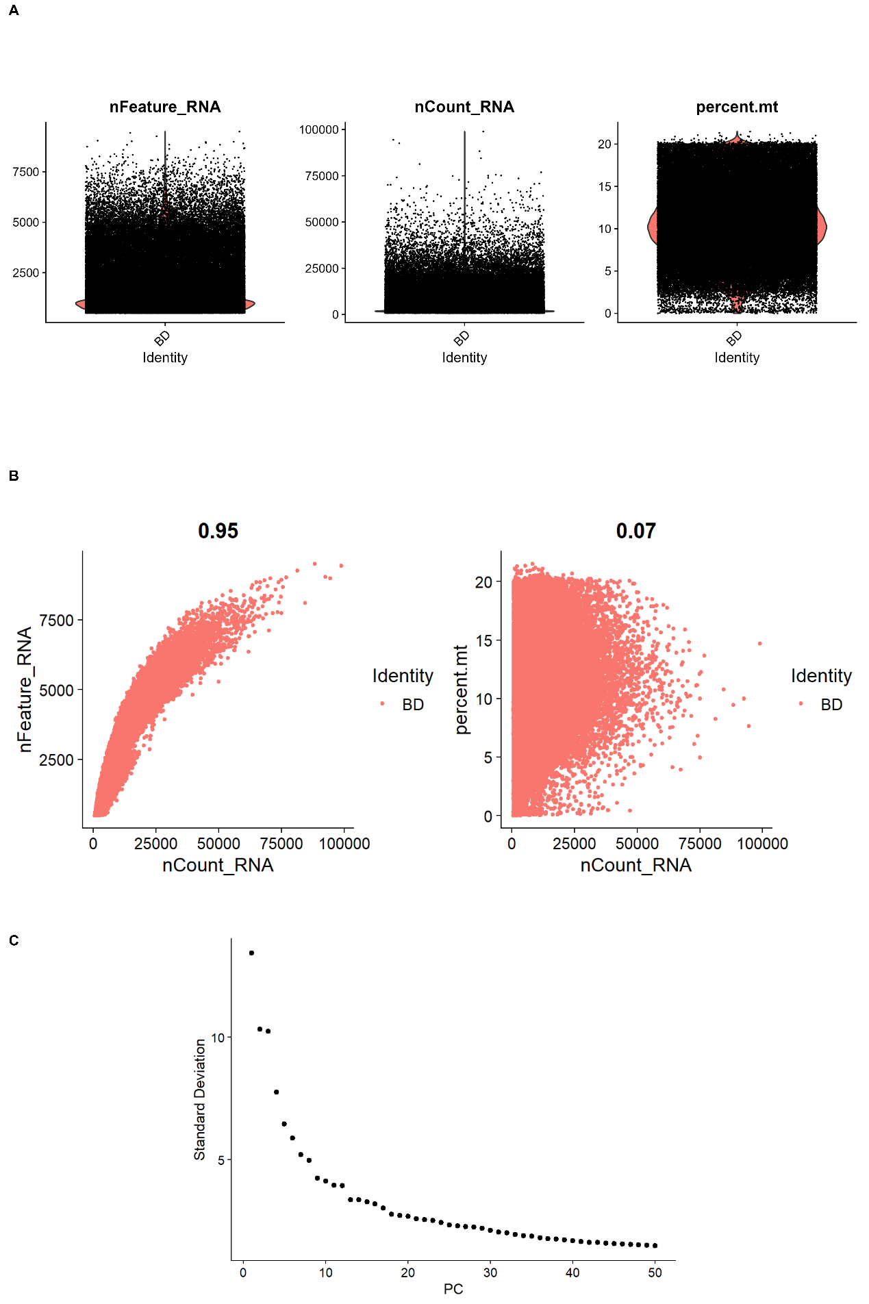
Supplementary Figure S2. Additional marker-expression support for T/NK-state annotation.
(A) Feature-plot visualization of representative marker genes supporting manual annotation of major T/NK states, including effector-like, exhausted-like, and Treg-associated populations.
(B) Dot-plot summary of canonical marker-gene expression across manually annotated T/NK subtypes.
(C) Summary of average program or module scores across manually annotated T/NK states, providing orthogonal support for subtype-level biological interpretation. Together, these supplementary panels provide additional support for the manual T/NK annotation framework used in Figure 2.
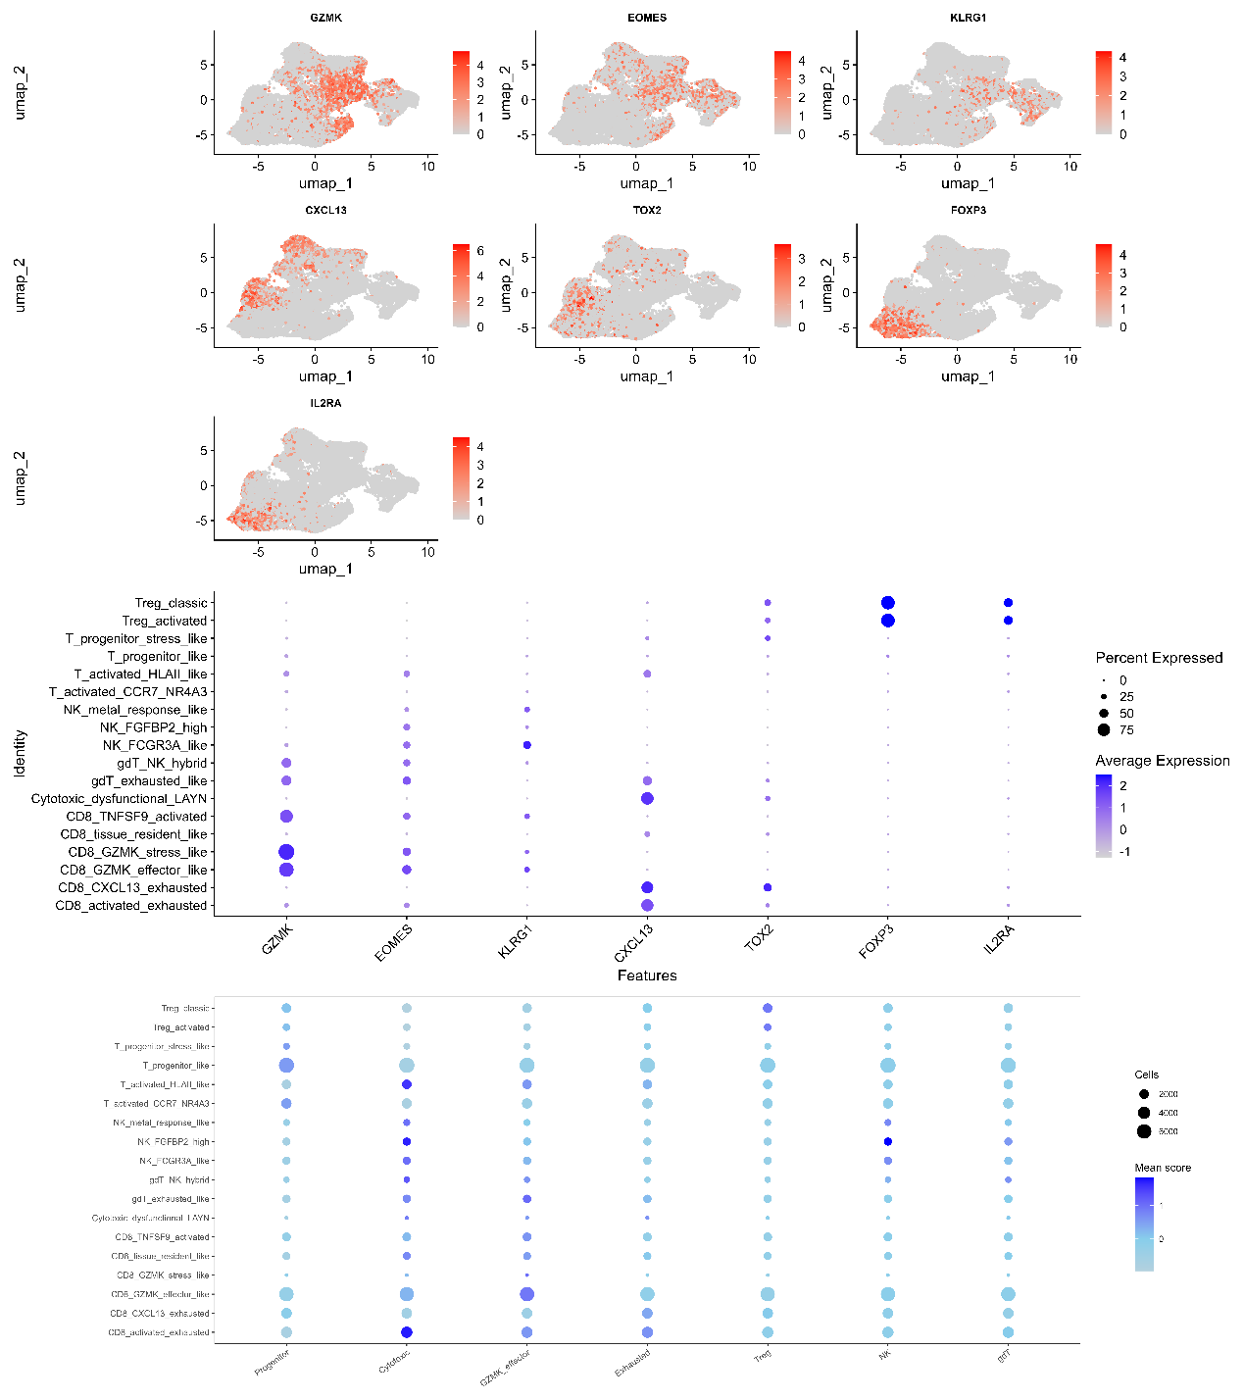
Supplementary Figure S3. Additional spatial quality metrics and AOI composition summaries in the GeoMx DSP cohort.
(A) Number of AOIs across response groups and spatial compartments.
(B) Distribution of AOI area in PanCK-negative and PanCK-positive compartments.
(C) Distribution of AOI nuclei counts in PanCK-negative and PanCK-positive compartments. These supplementary panels provide additional context for the compartment-level spatial analyses presented in Figure 5.
