Supporting information (Appendix)
Table S1 Parameter estimates of the multistate tuberculosis pharmacometrics (MTP) model as reported by Clewe et al. [11] and used as the structural foundation for recreating simulations in mrgsolve
Parameter | Units | Estimate | RSE (%)
k_FNᵃ | days⁻¹ | 0.897 × 10⁻⁶ | 1.2
k_SNᵃ | days⁻¹ | 0.186 | 4.3
k_SFᵃ | days⁻¹ | 0.0145 | 3.9
k_NSᵃ | days⁻¹ | 0.123 × 10⁻² | 2.7
k_FSLinᵃ,ᵇ | days⁻² | 0.166 × 10⁻² | 2.1
S₀ᵃ | mL⁻¹ | 9770 | 2.4
k_Gᵃ,ᶜ | days⁻¹ | 0.206 | 1.1
k_GLogᵃ | days⁻¹ | 0.192 | 12.5
F₀ᵃ | mL⁻¹ | 4.1 | 2.9
F₀Logᵃ | mL⁻¹ | 674 × 10³ | 39.2
B_maxᵃ | mL⁻¹ | 242 × 10⁶ | 4.5
B_maxStationaryᵃ | mL⁻¹ | 1410 × 10⁶ | 0.8
FG_k | L·mg⁻¹ | 0.017 | 11.1
FD_Emax | days⁻¹ | 2.15 | 4.5
FD_EC50 | mg·L⁻¹ | 0.52 | 9.8
SD_Emax | days⁻¹ | 12.2 | 5.6
SD_EC50 | mg·L⁻¹ | 13.4 | 10.4
ND_k | L·mg⁻¹·days⁻¹ | 0.236 | 12.2
ω²_Fᵃ | % | 473.3 | 5.9
Proportional residual error | % | 63.8 | 7.8
Estimates are shown with corresponding relative standard errors (RSE). Units are expressed using SI conventions.

Table S2 PBPK final inputs used for the compound model (physicochemical data, calculation methods, enzyme/transporter kinetics, and DDI parameters)
Section | Target | Parameter | Value
Compound parameters |  | Solubility at reference pH | 2800 mg/L
Compound parameters |  | Reference pH | 7.5
Compound parameters |  | Lipophilicity | 2.5 log units
Compound parameters |  | Fraction unbound (plasma, reference value) | 17 %
Compound parameters |  | Specific intestinal permeability (transcellular) | 1.24E-05 cm/min
Compound parameters |  | Is small molecule | Yes
Compound parameters |  | Molecular weight | 822.94 g/mol
Compound parameters |  | Plasma protein binding partner | Albumin
Calculation methods |  | Partition coefficients | Rodgers and Rowland
Calculation methods |  | Cellular permeabilities | PK-Sim Standard
Enzyme kinetics (AADAC) | AADAC | Enzyme concentration | 1 µmol/L
Enzyme kinetics (AADAC) | AADAC | Vmax | 6.5 µmol/min
Enzyme kinetics (AADAC) | AADAC | Km | 195.1 µmol/L
Enzyme kinetics (AADAC) | AADAC | kcat | 9.865 1/min
Transporter kinetics (P-gp) | P-gp | Transporter concentration | 60 nmol/L
Transporter kinetics (P-gp) | P-gp | Vmax | 2.87 µmol/min
Transporter kinetics (P-gp) | P-gp | Km | 55 µmol/L
Transporter kinetics (P-gp) | P-gp | kcat | 0.6088 1/min
Transporter kinetics (OATP1B1) | OATP1B1 | Transporter concentration | 109.6 µmol/L
Transporter kinetics (OATP1B1) | OATP1B1 | Vmax | 0.372 µmol/min
Transporter kinetics (OATP1B1) | OATP1B1 | Km | 1.5 µmol/L
Transporter kinetics (OATP1B1) | OATP1B1 | kcat | 5.21004653 1/min
Renal clearance (GFR) |  | GFR fraction | 1
DDI (Inhibition) | Inhibition CYP2C8 | Ki | 30.2 µmol/L
DDI (Inhibition) | Inhibition CYP2C9 | Ki | 150µmol/L
DDI (Inhibition) | Inhibition CYP3A4 | Ki | 18.5 µmol/L
DDI (Inhibition) | Inhibition BCRP | Ki | 14µmol/L
DDI (Inhibition) | Inhibition OATP1B1 | Ki | 0.29µmol/L
DDI (Inhibition) | Inhibition OATP1B3 | Ki | 0.5µmol/L
DDI (Inhibition) | Inhibition OATP2B1 | Ki | 78.2 µmol/L
DDI (Inhibition) | Inhibition P-gp | Ki | 9.1µmol/L
DDI (Induction) | Induction CYP1A2 | EC50 | 0.34µmol/L
DDI (Induction) | Induction CYP1A2 | Emax | 0.65
DDI (Induction) | Induction CYP2C8 | EC50 | 0.34µmol/L
DDI (Induction) | Induction CYP2C8 | Emax | 3.2
DDI (Induction) | Induction CYP2E1 | EC50 | 0.34µmol/L
DDI (Induction) | Induction CYP2E1 | Emax | 0.8
DDI (Induction) | Induction CYP3A4 | EC50 | 0.34µmol/L
DDI (Induction) | Induction CYP3A4 | Emax | 9
DDI (Induction) | Induction AADAC | EC50 | 0.34µmol/L
DDI (Induction) | Induction AADAC | Emax | 0.985
DDI (Induction) | Induction OATP1B1 | EC50 | 0.34µmol/L
DDI (Induction) | Induction OATP1B1 | Emax | 0.383
DDI (Induction) | Induction P-gp | EC50 | 0.34µmol/L
DDI (Induction) | Induction P-gp | Emax | 2.5

MTP Model Implementation and Verification
The MTP model was originally implemented in NONMEM [11]. For the present work, the same system of ordinary differential equations was re-implemented in mrgsolve [19] in R. All structural components, bacterial state transitions, growth kinetics, and rifampicin drug-effect relationships (Emax, EC50), were parameterized using the values reported by Clewe et al. [11] (Table S1) without modification, to ensure consistency with the published model.
The mrgsolve implementation was verified by reproducing three benchmark simulation scenarios from the original Clewe et al. study: (i) natural bacterial growth in the absence of drug over 200 days (Fig. S1); (ii) bacterial dynamics during the logarithmic growth phase under rifampicin exposures ranging from 0 to 16 mg/L over 30 days (Fig. S2); and (iii) bacterial dynamics during the stationary-phase infection under rifampicin exposures ranging from 0 to 64 mg/L (Fig. S3). In each scenario, the mrgsolve implementation reproduced the qualitative and quantitative behavior of the original NONMEM-based model, including the relative dynamics of fast-, slow-, and non-multiplying subpopulations, with no visually discernible differences from the published trajectories.
Following verification, the standalone mrgsolve MTP model was used for all subsequent rifampicin pharmacodynamic simulations within the PBPK–PD framework.

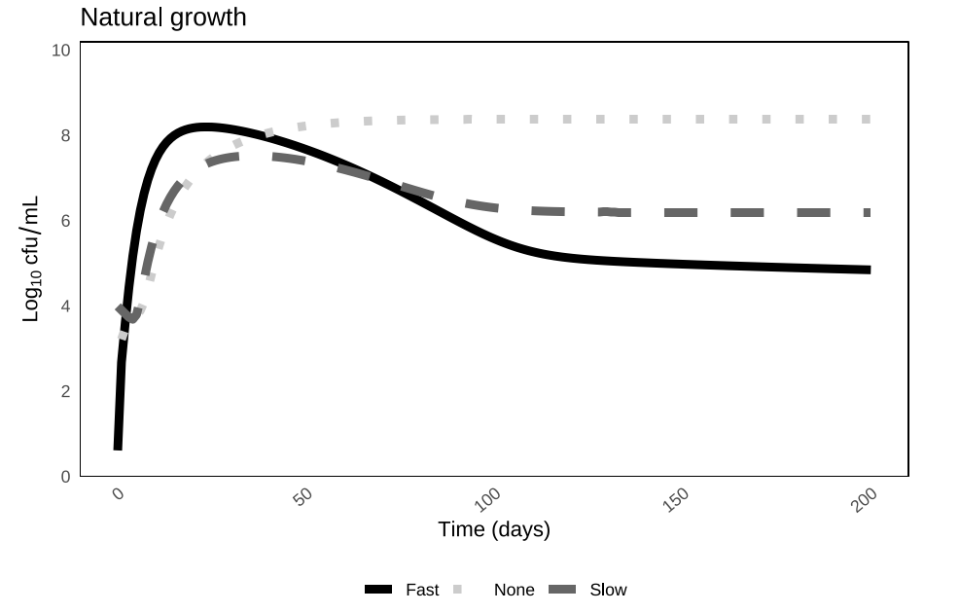
Fig. S1 Simulated natural growth of M. tuberculosis subpopulations in the absence of drug treatment over 200 days, based on the MTP model [11] re-implemented in mrgsolve [20]. Fast-multiplying (solid black), slow-multiplying (dark gray dashed), and non-multiplying (light gray dotted) bacterial subpopulations are shown

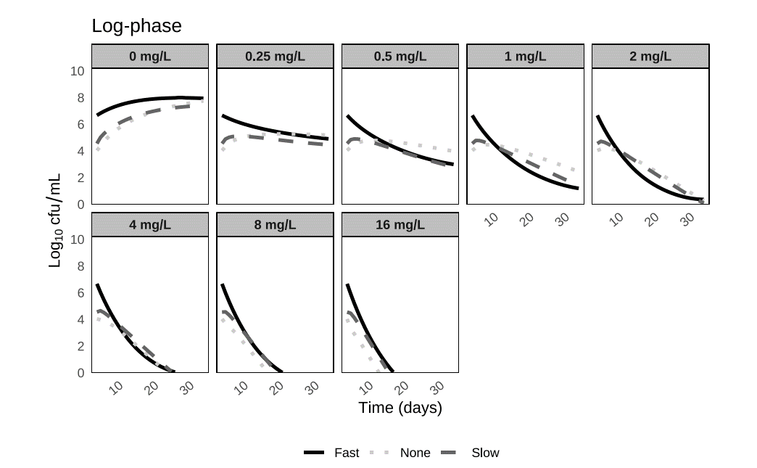
Fig. S2 Simulated bacterial dynamics during logarithmic-phase growth under increasing rifampicin exposure, based on the MTP model [11] re-implemented in mrgsolve [20]. Trajectories of fast-multiplying (solid black), slow-multiplying (dark gray dashed), and non-multiplying (light gray dotted) M. tuberculosis subpopulations are shown over 30 days. Each panel corresponds to a different constant rifampicin concentration

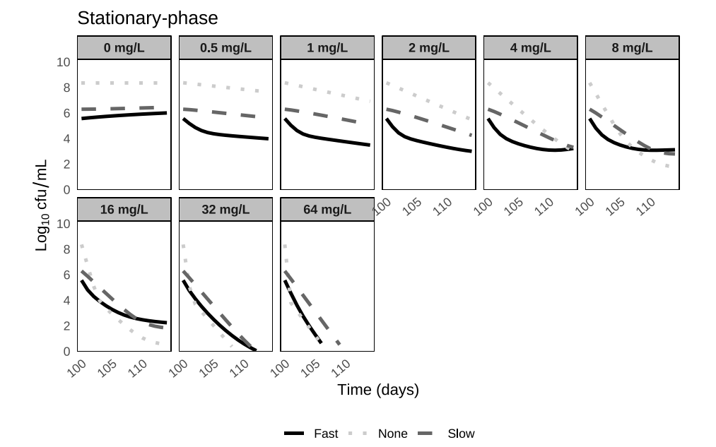
Fig. S3 Simulated bacterial dynamics during stationary-phase infection under increasing rifampicin exposure, based on the MTP model [11] re-implemented in mrgsolve [20]. Trajectories of fast-multiplying (solid black), slow-multiplying (dark gray dashed), and non-multiplying (light gray dotted) M. tuberculosis subpopulations are shown over [duration] days. Each panel corresponds to a different constant rifampicin concentration

In vitro release data extraction and digitization
In vitro dissolution data for controlled-release rifampicin formulations were obtained from two studies by Hiremath and Saha [15, 16], which systematically investigated the effect of formulation variables on rifampicin release from hydroxypropyl methylcellulose (HPMC) matrix tablets. Five distinct controlled-release formulations (R1–R5) were selected from each study.
The 2004 series [15] used low-viscosity HPMC (15 cPs) at polymer proportions of 20%, 30%, 40%, 50%, and 60% (R1–R5; Fig. S4), prepared by wet granulation. The 2008 series [16] used HPMC K100LV (100 cPs) at polymer proportions of 10%, 20%, 30%, 40%, and 60% (R1–R5; Fig. S5), prepared by direct compression. In both studies, increasing polymer proportion produced progressively extended release. The 2008 K100LV series exhibited a wider overall spread of release rates than the 2004 series, reflecting the slower drug release achievable with the higher-viscosity grade. Together, the two series provided ten controlled-release formulations spanning a broad range of release kinetics suitable for mechanistic absorption modeling.
Published dissolution profiles were extracted from the reported figures and digitized to generate time-resolved fraction-released data for each formulation. Because published in vitro release experiments are typically terminated before complete drug release is achieved, all digitized dissolution profiles were extrapolated to 100% cumulative release. This step was necessary to avoid introducing artificial differences in total absorbed dose between formulations. Without extrapolation, the unreleased fraction at the end of each in vitro experiment would be treated as permanently unavailable for absorption, which would unfairly penalize formulations with slower release kinetics. Extrapolation ensured that differences between formulations reflected release kinetics rather than incomplete extent of release, under the assumption that full drug release would occur given sufficient time and adequate sink conditions in vivo.

Formulation implementation in PK-Sim®
The digitized and extrapolated dissolution profiles were implemented in PK-Sim® using the user-defined Table formulation functionality. For each formulation (R1–R5), the in vitro release kinetics defined the time course of luminal drug release in the PK-Sim GI tract model, allowing mechanistic translation of formulation-specific release behavior into predicted systemic exposure. An immediate-release (IR) formulation was included as a reference, using the dissolution profile from the original OSP rifampicin model [21].
All formulations were simulated using the same rifampicin dose (10 mg/kg once daily) and identical physiological and clearance parameters to allow direct comparison of formulation effects on plasma pharmacokinetics. Using the qualified rifampicin PBPK model [21], repeated once-daily dosing was simulated over a 14-day treatment period for each formulation, and plasma rifampicin concentration–time profiles were generated for all virtual individuals. The resulting formulation-specific plasma exposure profiles were subsequently coupled to the MTP model within the PBPK–PD framework to evaluate how differences in release kinetics translate into early bactericidal activity and treatment success.
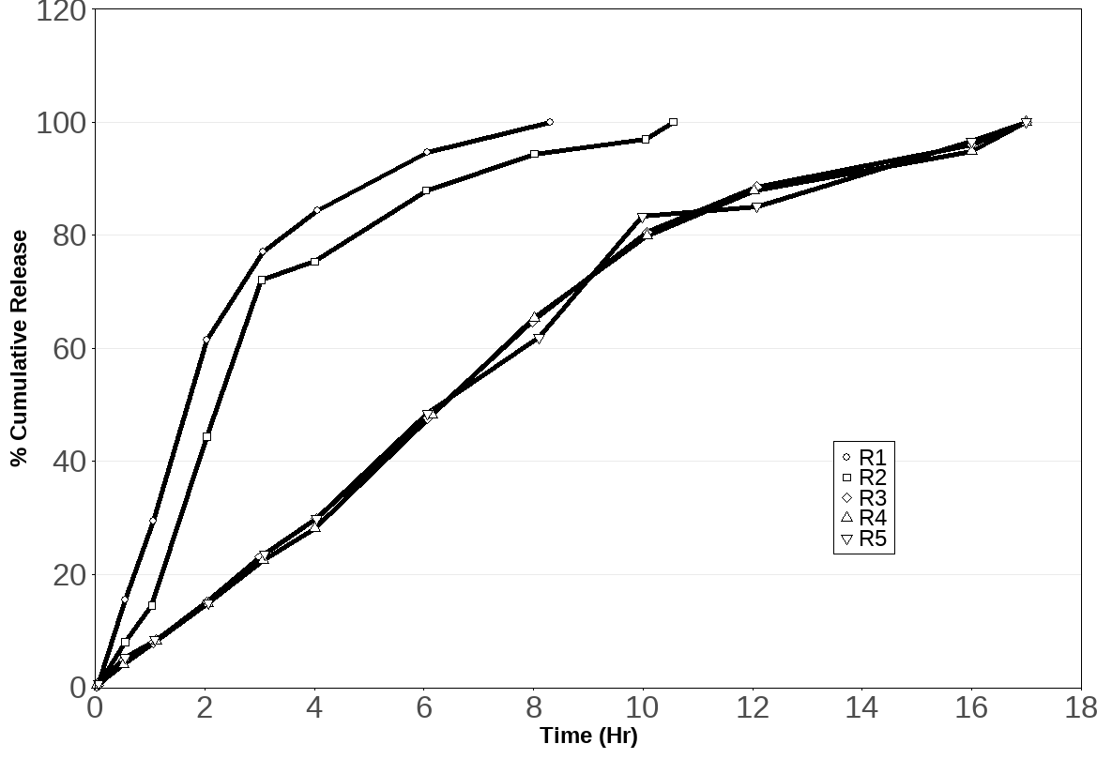Fig. S4 Digitized in vitro dissolution profiles of controlled-release rifampicin formulations reported by Hiremath and Saha [15]. Cumulative drug release (% of dose) is shown over time for HPMC matrix tablets prepared with low-viscosity HPMC (15 cPs) at increasing polymer proportions: R1 (20%), R2 (30%), R3 (40%), R4 (50%), R5 (60%). Profiles were extrapolated to 100% cumulative release as described in the text
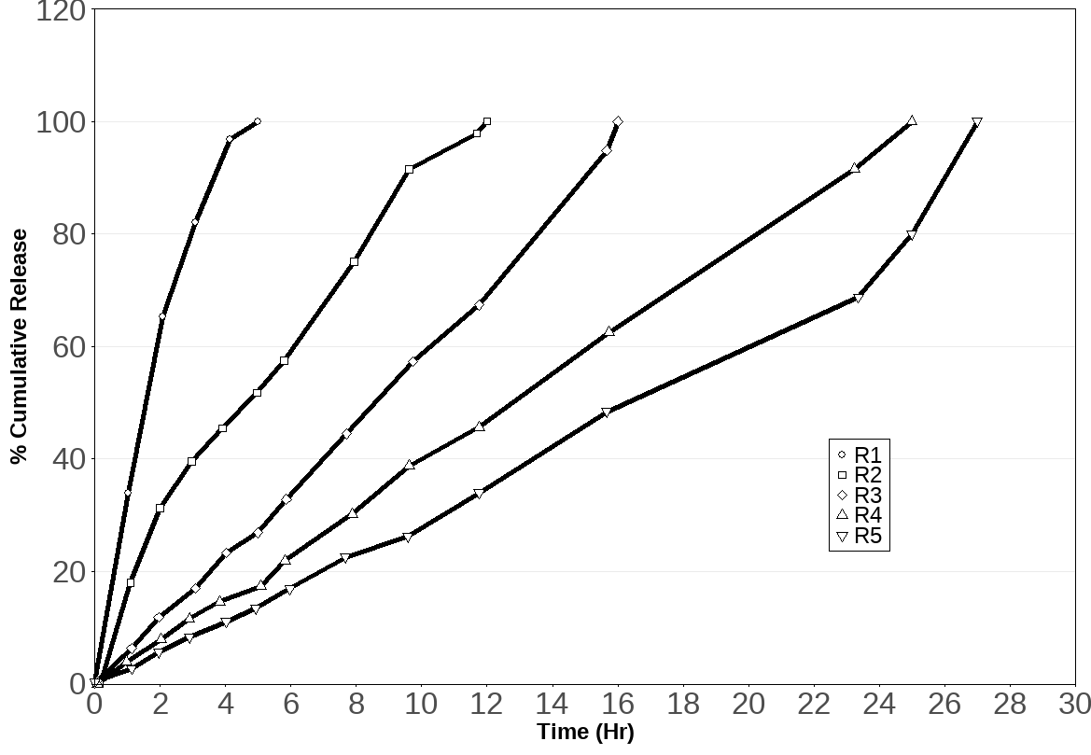Fig. S5 Digitized in vitro dissolution profiles of controlled-release rifampicin formulations reported by Hiremath and Saha [16]. Cumulative drug release (% of dose) is shown over time for HPMC K100LV (100 cPs) matrix tablets prepared at increasing polymer proportions: R1 (10%), R2 (20%), R3 (30%), R4 (40%), R5 (60%). Profiles were extrapolated to 100% cumulative release as described in the text

Geriatrics
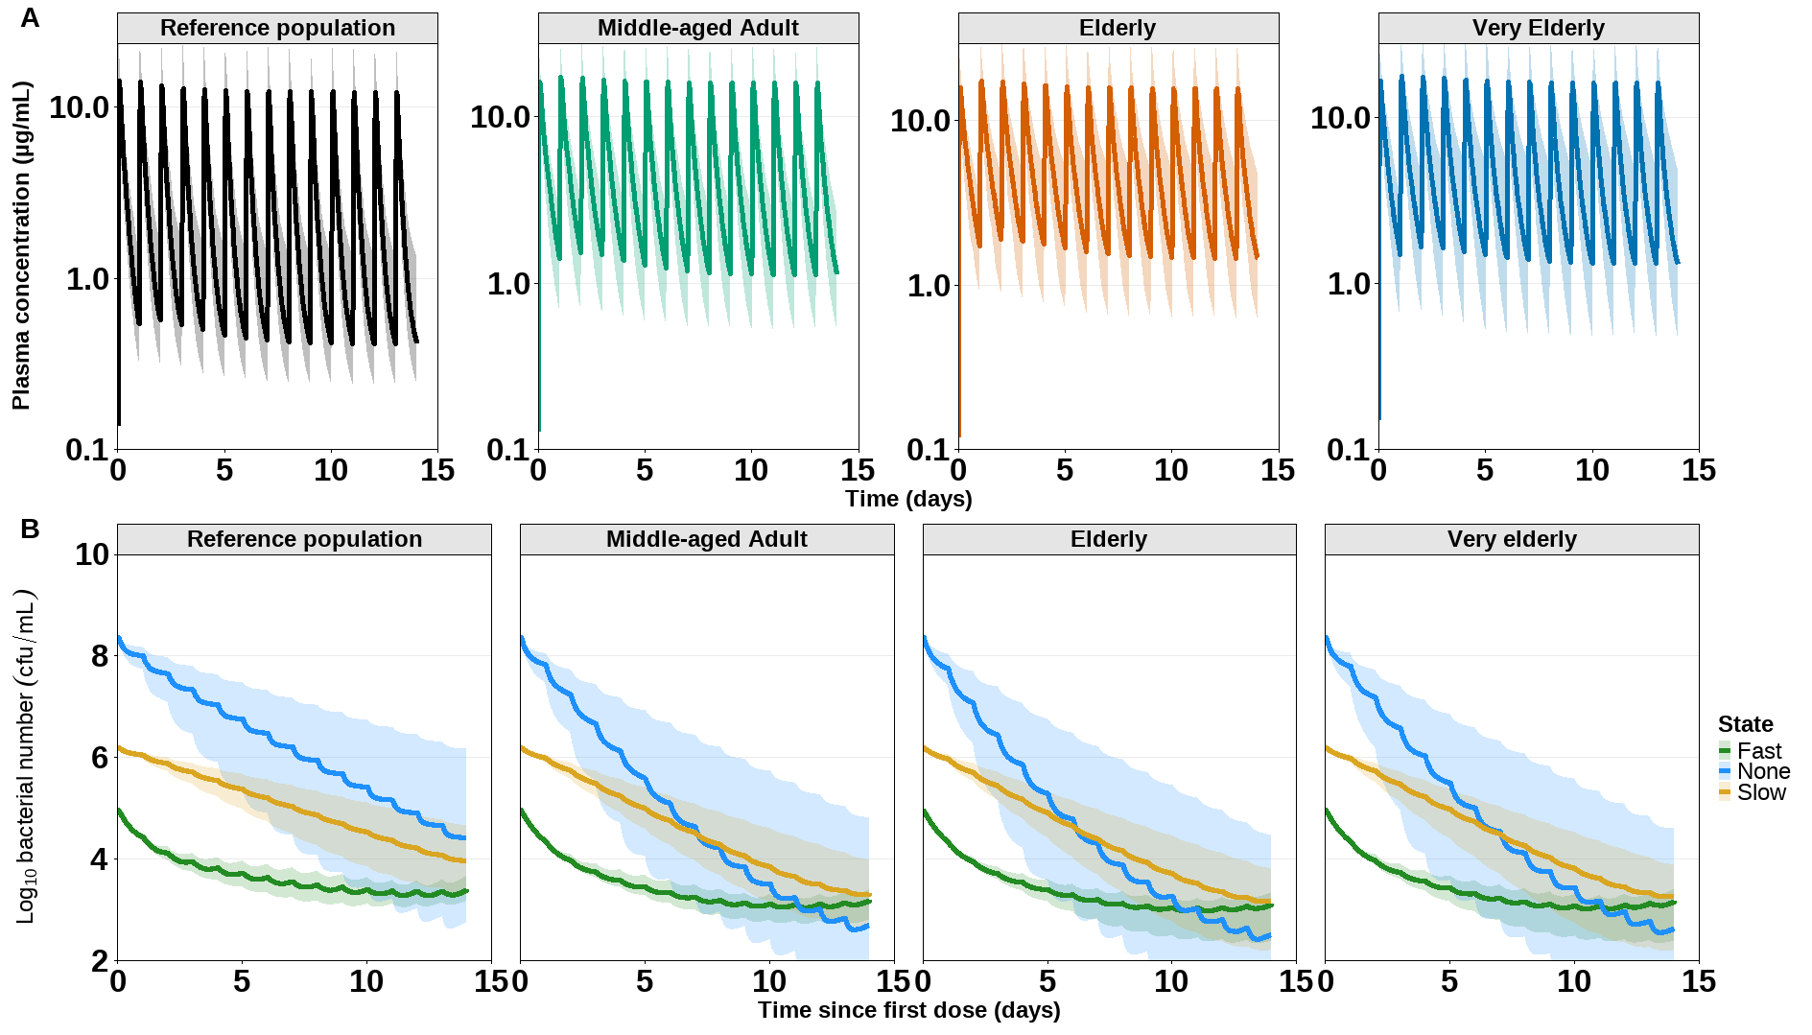
Fig. S6 PBPK and PBPK–PD simulations of rifampicin treatment in geriatric populations. Once-daily oral rifampicin (10 mg/kg) was simulated over 14 days for a reference adult population (18–55 years) and for middle-aged (40–65 years), elderly (65–80 years), and very elderly (80–100 years) cohorts. Median trajectories (solid lines) and 5th–95th percentile ranges (shaded regions) are shown across virtual individuals (n = 100 per cohort). (a) PBPK-simulated plasma rifampicin concentration–time profiles. (b) Predicted bacterial subpopulation dynamics, showing log₁₀ bacterial counts of fast-, slow-, and non-multiplying M. tuberculosis subpopulations as described by the multistate tuberculosis pharmacometrics (MTP) model

Table S3. Model-predicted relative treatment success after 14 days of rifampicin therapy (10 mg/kg once daily) in geriatric populations
Population | Relative success (vs reference)
Reference population (18–55 years) | 1.00
Middle-aged adult (40–65 years) | 1.26
Elderly (65–80 years) | 1.26
Very elderly (80–100 years) | 1.28
Values represent the ratio of treatment success probability relative to the reference population (reference = 1.00).

Pediatrics
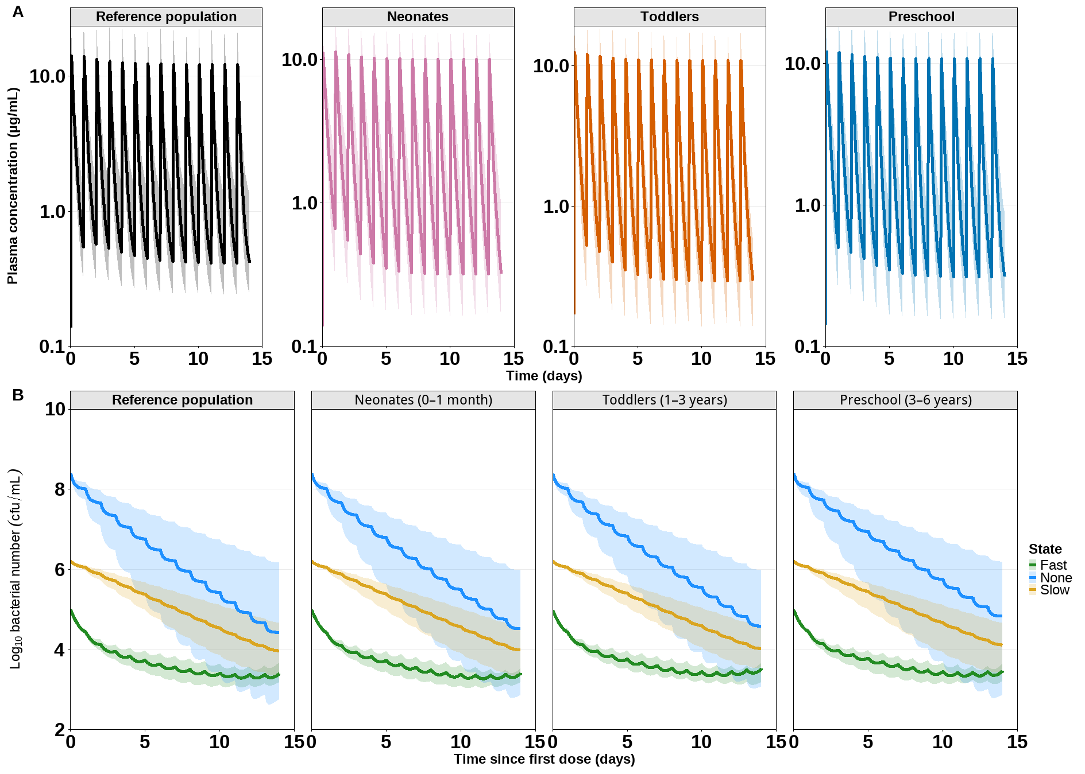
Fig. S7 PBPK and PBPK–PD simulations of rifampicin treatment in pediatric populations. Once-daily oral rifampicin (10 mg/kg) was simulated over 14 days for an adult reference population and three pediatric cohorts: neonates (0–1 month), toddlers (1–3 years), and preschool-aged children (3–6 years). Median trajectories (solid lines) and 5th–95th percentile ranges (shaded regions) are shown across virtual individuals (n = 100 per cohort). (a) PBPK-simulated plasma rifampicin concentration–time profiles. (b) Predicted bacterial subpopulation dynamics, showing log₁₀ bacterial counts of fast-, slow-, and non-multiplying M. tuberculosis subpopulations as described by the multistate tuberculosis pharmacometrics (MTP) model

Table S4 Model-predicted relative treatment success after 14 days of rifampicin therapy (10 mg/kg once daily) in pediatric populations
Population | Relative success (vs reference)
Reference population (adult, 18–55 years) | 1.00
Neonates (0–1 month) | 1.03
Toddlers (1–3 years) | 1.01
Preschool (3–6 years) | 0.90
Values represent the ratio of treatment success probability relative to the reference population (reference = 1.00). All cohorts received the same weight-based rifampicin dose (10 mg/kg once daily) to isolate the impact of physiology-driven exposure differences

Pregnancy
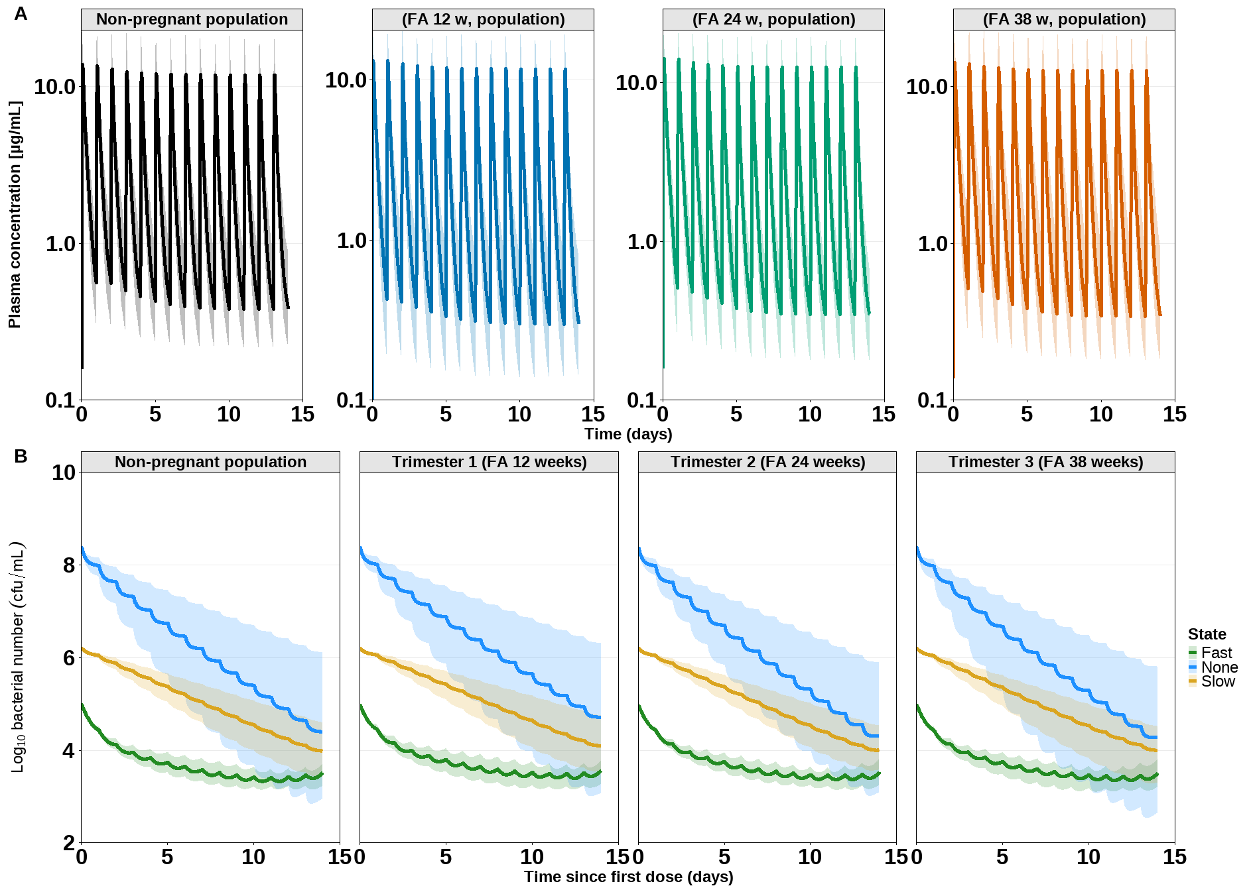
Fig. S8 PBPK and PBPK–PD simulations of rifampicin treatment in pregnant populations. Once-daily oral rifampicin (10 mg/kg) was simulated over 14 days for a non-pregnant adult reference population and trimester-specific pregnant cohorts at approximately 12 (T1), 24 (T2), and 38 (T3) weeks of gestation. Median trajectories (solid lines) and 5th–95th percentile ranges (shaded regions) are shown across virtual individuals (n = 100 per cohort). (a) PBPK-simulated plasma rifampicin concentration–time profiles. (b) Predicted bacterial subpopulation dynamics, showing log₁₀ bacterial counts of fast-, slow-, and non-multiplying M. tuberculosis subpopulations as described by the multistate tuberculosis pharmacometrics (MTP) model

Table S5 Model-predicted relative treatment success after 14 days of rifampicin therapy (10 mg/kg once daily) in pregnant populations
Population | Relative success (vs reference)
Non-pregnant | 1.00
T1 (FA 12 weeks) | 0.84
T2 (FA 24 weeks) | 1.01
T3 (FA 38 weeks) | 1.01
Values represent the ratio of treatment success probability relative to non-pregnant (non-pregnant = 1.00). FA = fertilization age.

Modified release 2004
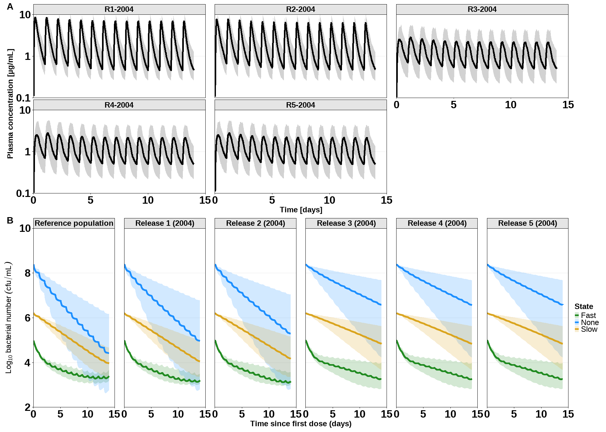
Fig. S9 PBPK and PBPK–PD simulations of rifampicin treatment across the 2004 controlled-release formulation series. Once-daily oral rifampicin (10 mg/kg) was simulated over 14 days for an immediate-release reference formulation and five controlled-release formulations derived from in vitro dissolution data of low-viscosity HPMC (15 cPs) matrix tablets at increasing polymer proportions (20–60%; R1–R5) reported by Hiremath and Saha [15]. Median trajectories (solid lines) and 5th–95th percentile ranges (shaded regions) are shown across virtual individuals (n = 100 per formulation). (a) PBPK-simulated plasma rifampicin concentration–time profiles. (b) Predicted bacterial subpopulation dynamics, showing log₁₀ bacterial counts of fast-, slow-, and non-multiplying M. tuberculosis subpopulations as described by the multistate tuberculosis pharmacometrics (MTP) model

Table S6. Model-predicted relative treatment success after 14 days of rifampicin therapy across the 2004 modified release series
Formulation | Relative success (vs reference)
Reference (immediate-release) | 1.00
Release 1 (20% HPMC) | 0.79
Release 2 (30% HPMC) | 0.69
Release 3 (40% HPMC) | 0.28
Release 4 (50% HPMC) | 0.29
Release 5 (60% HPMC) | 0.28
Values represent the ratio of treatment success probability relative to the reference population (reference = 1.00)

