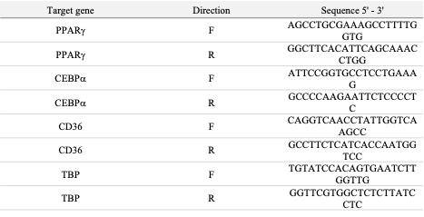
Supplementary Table 3. List of primers to quantify the adipogenic markers. Primers were designed to amplify PPARg, CEBPa, and CD36 transcripts. Expression levels of these adipogenic markers were normalized to the housekeeping gene TBP.

