Supporting Information
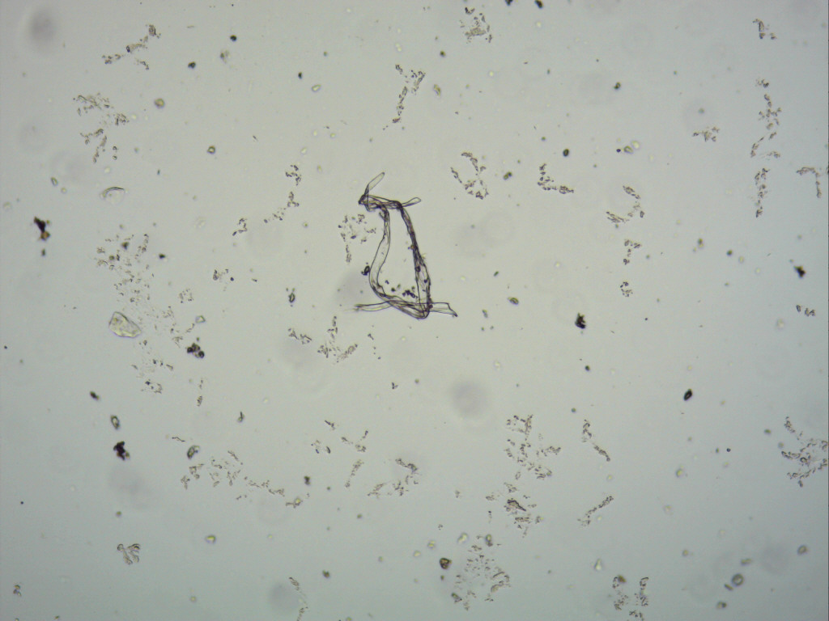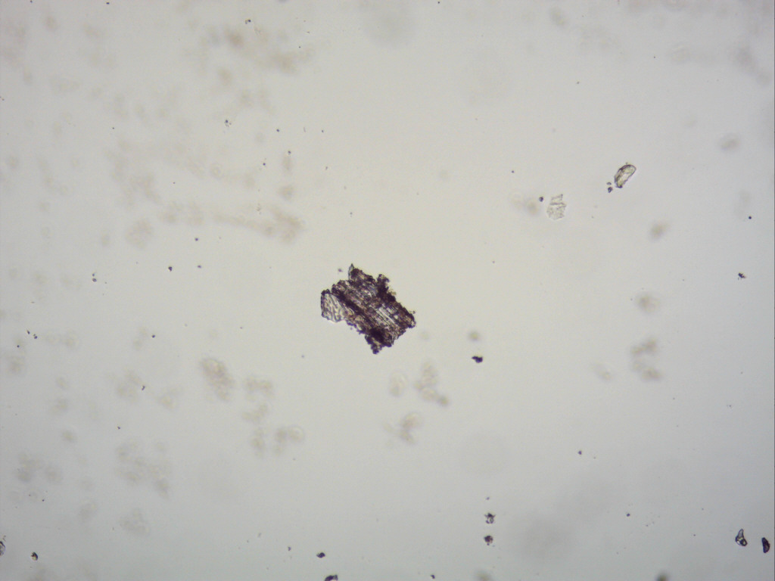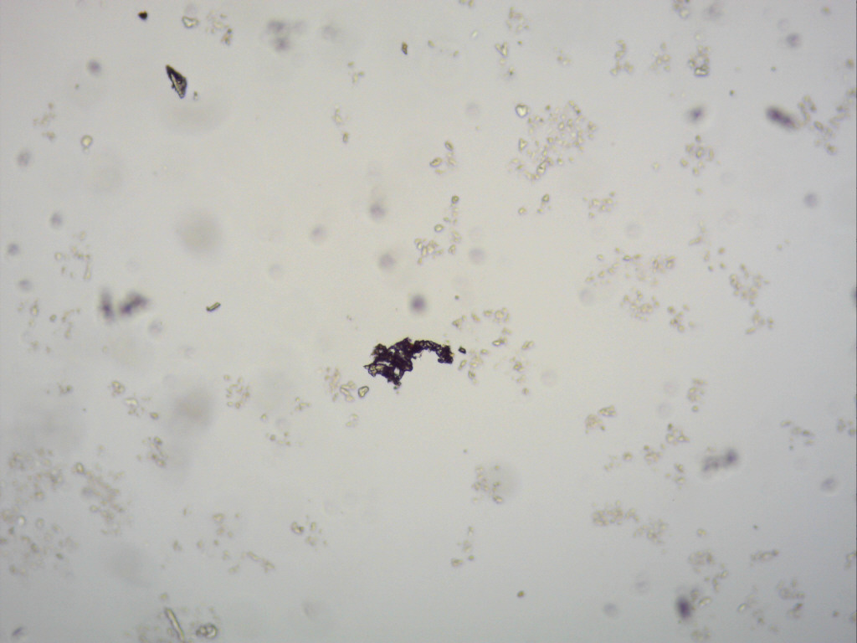
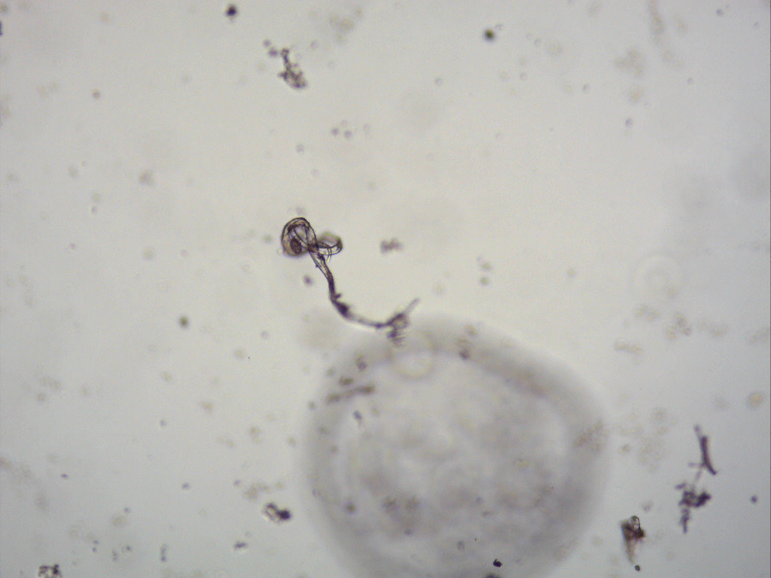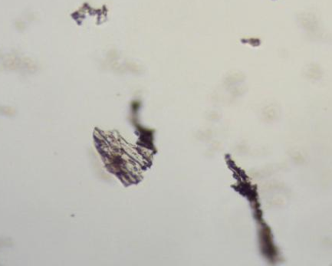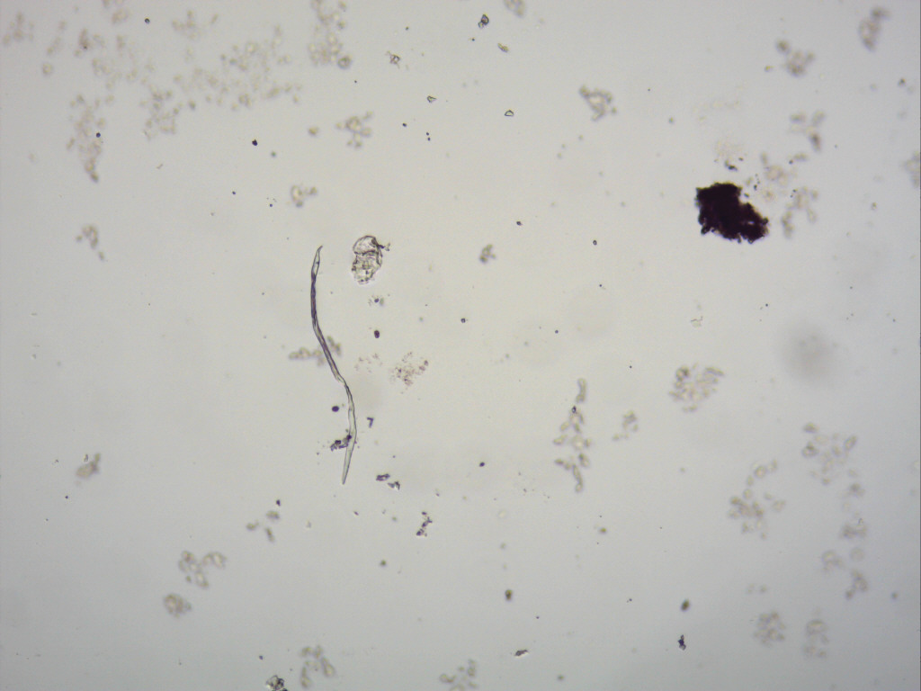
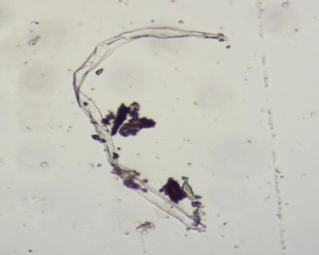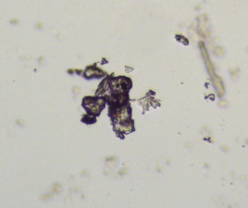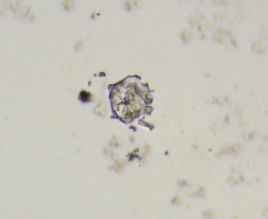
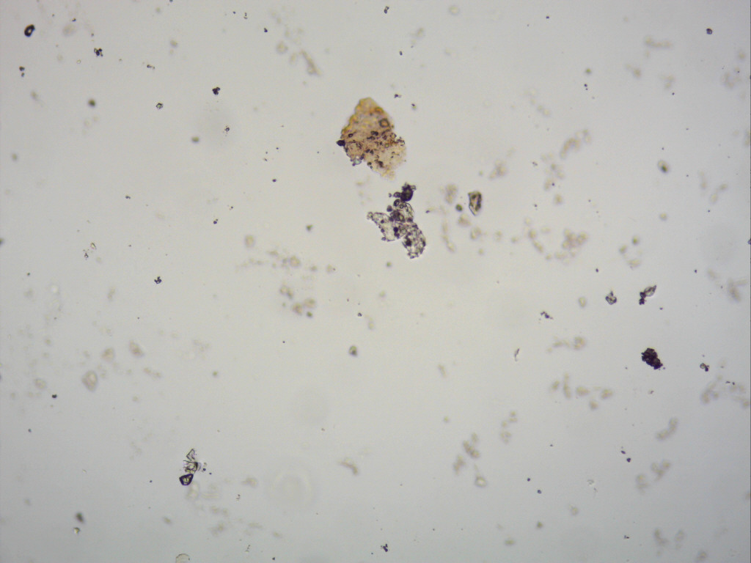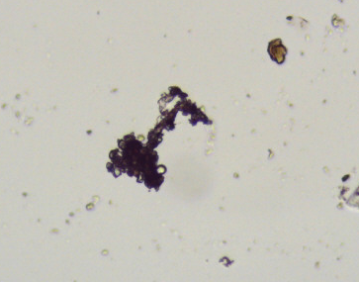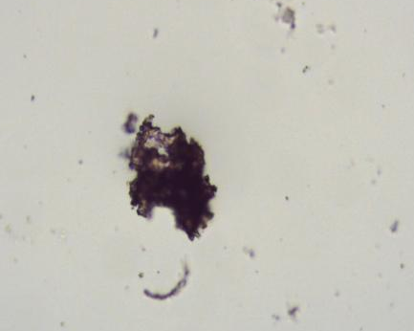
Figure S1: Microscope images of PU microplastic surface morphology
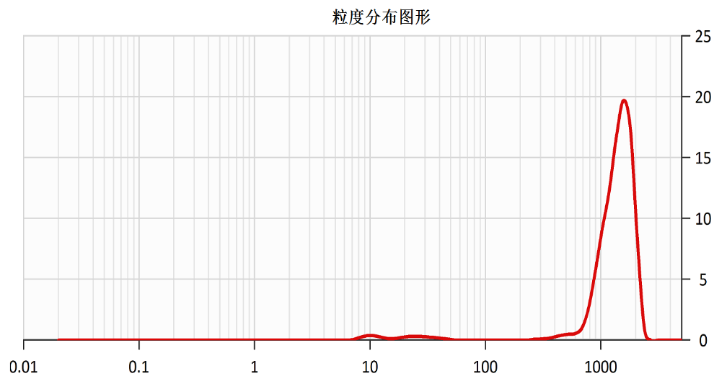
Figure S2: Particle size distribution distribution of plastic particles
Table S1 Particle size distribution of plastic particles
Size (μm) | 0.000 | 12.00 | 30.00 | 50.00 | 100.00 | 200.00 | 300.00 | 400.00 | 500.00 | 2600.00
Percent (%) | 0.00 | 1.10 | 2.66 | 3.32 | 3.33 | 3.33 | 3.44 | 3.80 | 4.43 | 100.00
Table S2 Heavy metal concentrations in different samples (mg/kg)
Content | MPs |  |  | EF |  |  | N-PV |  |  | P |  |  | F
Content | 1 | 2 | 3 | 1 | 2 | 3 | 1 | 2 | 3 | 1 | 2 | 3 | 1 | 2 | 3
As | 4.63 | 5.46 | 4.28 | 2.80 | 2.84 | 2.75 | 3.22 | 3.16 | 3.21 | 3.80 | 3.76 | 3.82 | 3.10 | 3.08 | 3.13
Zn | 665.47 | 632.95 | 623.70 | 52.13 | 51.11 | 54.49 | 53.79 | 53.61 | 56.66 | 41.70 | 29.82 | 33.89 | 47.93 | 55.67 | 44.17
Cu | 13.67 | 18.80 | 10.81 | 18.99 | 16.27 | 14.62 | 7.96 | 12.47 | 10.91 | 14.56 | 9.91 | 7.17 | 12.96 | 18.50 | 16.93
Ni | 39.32 | 40.67 | 42.01 | 25.54 | 21.13 | 29.95 | 17.44 | 17.75 | 17.13 | 28.83 | 23.35 | 29.88 | 21.75 | 16.37 | 19.32
Co | 6.92 | 7.30 | 7.23 | 10.12 | 8.69 | 9.63 | 9.13 | 9.12 | 8.12 | 7.85 | 7.87 | 7.42 | 9.09 | 9.09 | 8.86
Mn | 207.98 | 174.51 | 215.03 | 468.36 | 402.80 | 467.59 | 514.09 | 441.58 | 474.45 | 449.53 | 442.03 | 434.53 | 450.55 | 472.99 | 431.90
Cr | 91.54 | 95.72 | 97.07 | 79.54 | 75.57 | 76.57 | 92.87 | 94.67 | 91.08 | 70.42 | 57.70 | 80.82 | 74.77 | 68.88 | 60.29
Pb | 19.73 | 18.80 | 17.87 | 19.13 | 18.61 | 16.54 | 28.57 | 26.43 | 26.90 | 16.40 | 21.72 | 19.01 | 16.75 | 18.34 | 19.71
Cd | 0.12 | 0.11 | 0.13 | 0.12 | 0.09 | 0.11 | 0.13 | 0.11 | 0.10 | 0.10 | 0.10 | 0.11 | 0.11 | 0.10 | 0.10

Table S3 PCA feature vectors for every indicator
Loadings | PC1 | PC2 | PC3 | PC4 | PC5
As | 0.404 | 0.025 | -0.261 | -0.292 | 0.151
Zn | 0.405 | -0.076 | 0.209 | -0.330 | -0.202
Cu | -0.026 | -0.575 | 0.525 | -0.164 | -0.327
Ni | 0.396 | -0.202 | -0.050 | 0.362 | 0.462
Co | -0.364 | -0.084 | 0.486 | 0.197 | 0.353
Mn | -0.408 | 0.143 | -0.126 | 0.238 | -0.036
Cr | 0.262 | 0.389 | 0.539 | -0.036 | 0.422
Pb | -0.072 | 0.649 | 0.218 | -0.231 | -0.258
Cd | 0.377 | 0.153 | 0.143 | 0.705 | -0.495
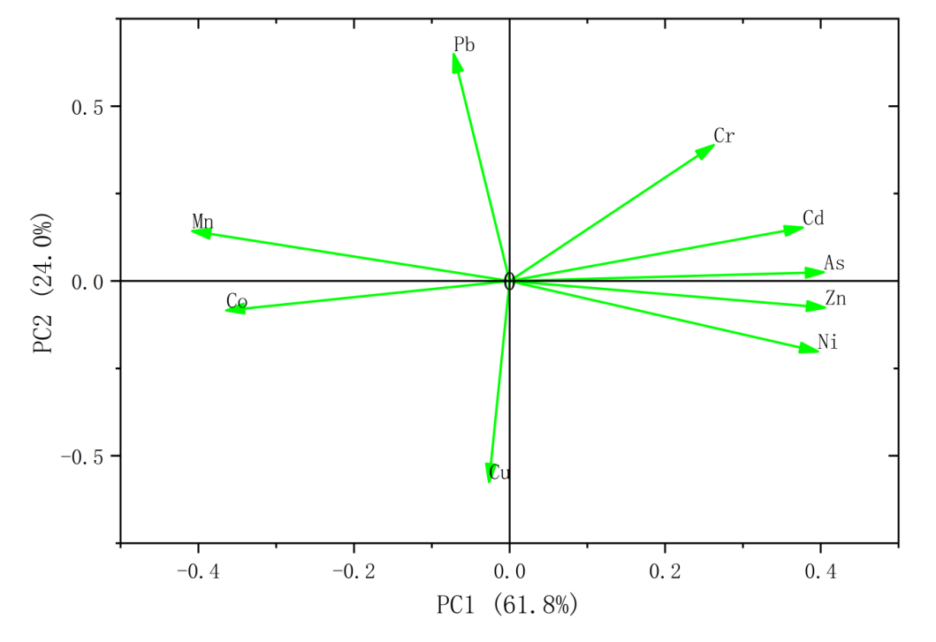
Figure S3: load diagram of PCA feature vectors
Table S4 Single factor pollution indices of various metals among five types of soil
 | MPs | EF | N-PV | P | F
As | 0.0799 | 0.0932 | 0.0533 | 0.0632 | 0.1034
Cu | 0.0008 | 0.1663 | 0.0006 | 0.0006 | 0.1613
Ni | 0.0452 | 0.2554 | 0.0194 | 0.0304 | 0.1915
Pb | 0.0235 | 0.1508 | 0.0341 | 0.0238 | 0.1522
Cd | 0.0018 | 0.3559 | 0.0018 | 0.0016 | 0.3441
Co | 0.1021 | 0 | 0.1256 | 0.1101 | 0
Zn | 0 | 0.2103 | 0 | 0 | 0.1970
Cr | 0 | 0.3861 | 0 | 0 | 0.3399
Table S5 Cumulative index of different heavy metalsof soil
 | MPs | EF | N-PV | P | F
As | 0.49 | 0.29 | 0.33 | 0.39 | 0.32
Zn | 10.25 | 0.84 | 0.87 | 0.56 | 0.79
Cu | 0.72 | 0.83 | 0.52 | 0.53 | 0.81
Ni | 1.48 | 0.93 | 0.64 | 1.00 | 0.70
Co | 0.62 | 0.82 | 0.76 | 0.67 | 0.78
Mn | 0.35 | 0.79 | 0.84 | 0.78 | 0.80
Cr | 1.50 | 1.22 | 1.47 | 1.10 | 1.08
Pb | 0.84 | 0.81 | 1.22 | 0.85 | 0.82
Cd | 1.83 | 1.64 | 1.76 | 1.64 | 1.59

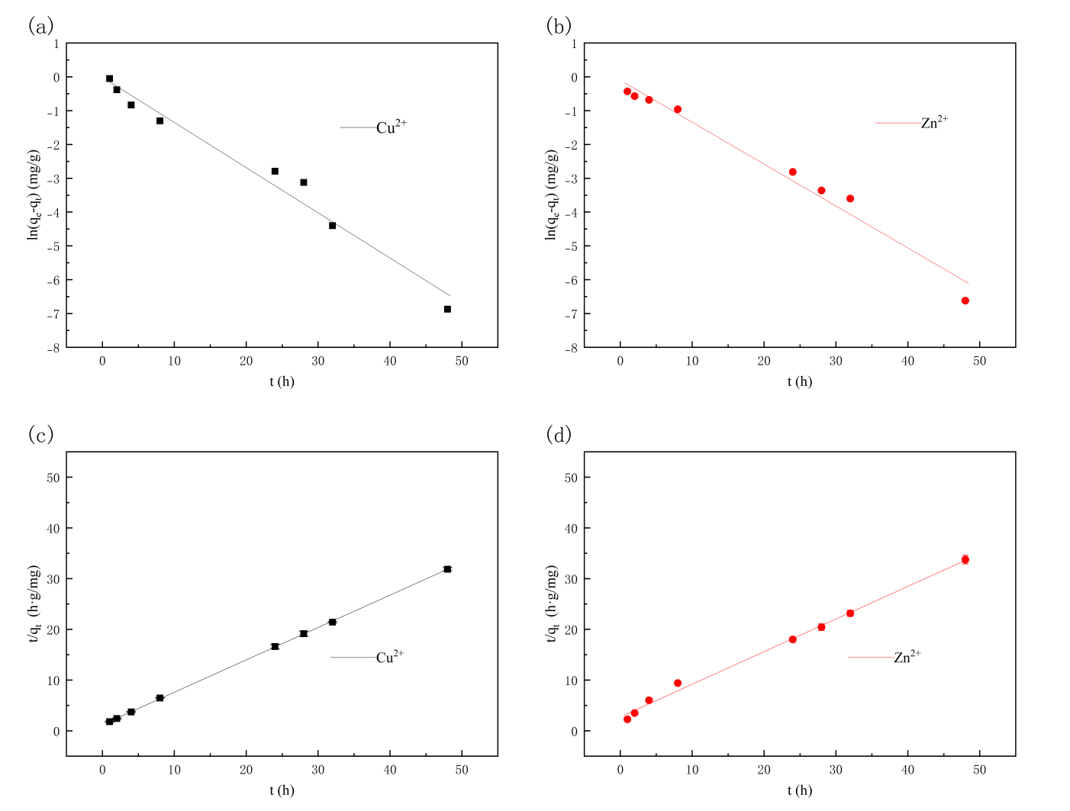
Figure S4 Dynamic equation fitting diagram of microplastics in single system (a: quasi-first-order adsorption kinetics fitting diagram of Cu²⁺; b: quasi-first-order adsorption kinetics fitting diagram of Zn²⁺; c: quasi-second-order adsorption kinetics fitting diagram of Cu²⁺; d: quasi-second-order adsorption kinetics fitting diagram of Zn²⁺)
Table S6 Adsorption capacities q_{t} (mg/g) of Cu²⁺ and Zn²⁺ of microplastics in single and binary system
Single system
Time | Cu²⁺ |  |  |  |  | Zn²⁺
(h) | qt 1 | qt 2 | qt 3 | Mean | SD | qt 1 |  | qt 2 |  | qt 3 |  | Mean | SD
1 | 0.599 | 0.550 | 0.514 | 0.554 | 0.043 | 0.292 |  | 0.286 |  | 0.308 |  | 0.295 | 0.011
2 | 0.817 | 0.858 | 0.788 | 0.821 | 0.035 | 0.403 |  | 0.380 |  | 0.361 |  | 0.381 | 0.021
4 | 1.063 | 1.063 | 1.087 | 1.071 | 0.014 | 0.435 |  | 0.481 |  | 0.418 |  | 0.445 | 0.033
8 | 1.240 | 1.233 | 1.229 | 1.234 | 0.006 | 0.556 |  | 0.575 |  | 0.568 |  | 0.566 | 0.010
24 | 1.446 | 1.482 | 1.404 | 1.444 | 0.039 | 0.867 |  | 0.914 |  | 0.885 |  | 0.889 | 0.024
28 | 1.475 | 1.491 | 1.419 | 1.462 | 0.038 | 0.881 |  | 0.927 |  | 0.934 |  | 0.914 | 0.029
32 | 1.504 | 1.494 | 1.483 | 1.494 | 0.011 | 0.915 |  | 0.901 |  | 0.948 |  | 0.921 | 0.024
48 | 1.522 | 1.502 | 1.494 | 1.506 | 0.014 | 0.930 |  | 0.941 |  | 0.975 |  | 0.949 | 0.023
Binary system
Time | Cu²⁺ |  |  |  |  | Zn²⁺
(h) | qt 1 | qt 2 | qt 3 | Mean | SD | qt 1 | qt 2 |  | qt 3 |  | Mean |  | SD
1 | 0.373 | 0.391 | 0.415 | 0.393 | 0.021 | 0.149 | 0.158 |  | 0.164 |  | 0.157 |  | 0.008
2 | 0.659 | 0.621 | 0.641 | 0.640 | 0.019 | 0.161 | 0.200 |  | 0.220 |  | 0.194 |  | 0.030
4 | 0.788 | 0.815 | 0.805 | 0.803 | 0.014 | 0.290 | 0.253 |  | 0.286 |  | 0.276 |  | 0.020
8 | 1.053 | 1.027 | 1.022 | 1.034 | 0.017 | 0.382 | 0.366 |  | 0.362 |  | 0.370 |  | 0.011
24 | 1.184 | 1.210 | 1.190 | 1.195 | 0.014 | 0.691 | 0.704 |  | 0.725 |  | 0.707 |  | 0.017
28 | 1.227 | 1.248 | 1.210 | 1.228 | 0.019 | 0.720 | 0.743 |  | 0.734 |  | 0.732 |  | 0.012
32 | 1.283 | 1.300 | 1.268 | 1.284 | 0.016 | 0.747 | 0.774 |  | 0.746 |  | 0.756 |  | 0.016
48 | 1.296 | 1.324 | 1.291 | 1.304 | 0.018 | 0.774 | 0.790 |  | 0.762 |  | 0.776 |  | 0.014

Figure S5 The fitting diagram of the dynamic model of microplastics in a binary system (a:quasi-first-order adsorption kinetics fitting diagram of Cu²⁺ ;b: quasi-first-order adsorption kinetics fitting diagram of Zn²⁺ ;C. quasi-second-order adsorption kinetics fitting diagram of Cu²⁺;d: quasi-second-order adsorption kinetics fitting diagram of Zn²⁺.)
Table S7 Isothermal adsorption capacities of microplastics during the adsorption process in binary system
Cu²⁺ |  |  |  |  |  | Zn²⁺
15℃ |  | 25℃ |  | 35℃ |  | 15℃ |  | 25℃ |  | 35℃
Ce (mg/L) | qe (mg/g) | Ce (mg/L) | qe (mg/g) | Ce (mg/L) | qe (mg/g) | Ce (mg/L) | qe (mg/g) | Ce (mg/L) | qe (mg/g) | Ce (mg/L) | qe (mg/g)
0.587 | 0.085 | 0.58 | 0.085 | 0.389 | 0.097 | 0.534 | 0.088 | 0.606 | 0.084 | 0.502 | 0.094
1.259 | 0.164 | 1.419 | 0.155 | 0.904 | 0.186 | 1.36 | 0.158 | 1.552 | 0.147 | 1.86 | 0.132
3.208 | 0.288 | 2.822 | 0.311 | 2.154 | 0.351 | 3.288 | 0.283 | 3.635 | 0.262 | 3.872 | 0.251
7.624 | 0.503 | 5.772 | 0.614 | 4.148 | 0.711 | 8.128 | 0.472 | 8.098 | 0.474 | 9.808 | 0.375
24.384 | 0.457 | 10.776 | 1.273 | 9.88 | 1.327 | 20.512 | 0.689 | 20.362 | 0.698 | 25.133 | 0.412
51.968 | 0.722 | 28.928 | 2.104 | 19.376 | 2.677 | 40.256 | 1.425 | 47.837 | 0.97 | 52.416 | 0.695
111.296 | 1.002 | 79.136 | 2.932 | 42.592 | 5.124 | 80.256 | 2.865 | 103.6 | 1.464 | 107.626 | 1.226

Figure S6 Adsorption isotherm fitting diagram of microplastics in the binary system (a:Cu²⁺ Fruendlich model fitting graph;b: Zn²⁺ Fruendlich model fitting graph;c: Cu²⁺ Langmuir model fitting graph;d: Zn²⁺ Langmuir model fitting diagram).
Figure S7 Fitting diagram of adsorption thermodynamic equation

Risk assessment models
In this study, three exposure pathways considered: oral ingestion, dermal contact, and inhalation. The total carcinogenic risk and hazard index of a single pollutant through the aforementioned three pathways is calculated using the following formula:
${CR}_{n}={CR}_{ois}+{CR}_{dcs}+{CR}_{pis}$ （S1）
$H_{n}={HQ}_{ois}+{HQ}_{dcs}+{HQ}_{pis}$ （S2）
- Oral intake:
${OISER}_{ca}=\frac{{OISER}_{a}×{ED}_{a}×{EF}_{a}×{ABS}_{o}}{{BW}_{a}×{AT}_{ca}}×{10}^{−6}$ （S3）
${OISER}_{nc}=\frac{{OISER}_{a}×{ED}_{a}×{EF}_{a}×{ABS}_{o}}{{BW}_{a}×{AT}_{nc}}×{10}^{−6}$ （S4）
Where ${OISER}_{ca}$And${OISER}_{nc}$ refer to the orally ingested soil exposure levels (carcinogenic effect and non carcinogenic effect) (kg_{soil}/(kg_{weight} d⁻¹). According to the appendix recommended value, ${OISER}_{a}$ (mg·d⁻¹)=100, ED_{a} (a)=25, EF_{a} (d·a⁻¹)=250, BW_{a} (kg)=61.8, ABS_{o}=1, AT_{ca} (d)=27740, AT_{nc} (d)=9125.
Substituting the aforementioned parameters, ${OISER}_{ca}$=3.6×10⁻⁷ (kg_{soil}/(kg_{weight} d⁻¹) and ${OISER}_{nc}$=1.1×10⁻⁶ (kg_{soil}/(kg_{weight} d⁻¹).
${CR}_{ois}={OISER}_{ca}×C_{sur}×{SF}_{o}$ （S5）
${HQ}_{ois}=\frac{{OISER}_{nc}×C_{sur}}{{RfD}_{o}×SAF}$ （S6）
Where SF_{o} is oral intake carcinogenicity slope factor. Due to the high levels of arsenic exposure and its easy accessibility, recommended value of 1.5 is assigned to the arsenic intake carcinogenicity slope factor. RfD_{o} is the reference dose for oral intake, with different recommended values for various metals.
- Dermal contact
${DCSER}_{ca}=\frac{{SAE}_{a}×{SSAR}_{a}×{EF}_{a}×{ED}_{a}×E_{v}×{ABS}_{d}}{{BW}_{a}×{AT}_{ca}}×{10}^{−6}$ （S7）
${DCSER}_{nc}=\frac{{SAE}_{a}×{SSAR}_{a}×{EF}_{a}×{ED}_{a}×E_{v}×{ABS}_{d}}{{BW}_{a}×{AT}_{nc}}×{10}^{−6}$ （S8）
${SAE}_{a}=239×H_{a}^{0.417}×{BW}_{a}^{0.517}×{SER}_{a}$ （S9）
Where DCSER_{ca} and DCSER_{nc} refer to the soil exposure dose via skin contact (carcinogenic effect and non carcinogenic effect) (kg_{soil}/(kg_{weight} d⁻¹). According to the appendix recommended value, SAEa is adult exposed skin surface area, SSARa (mg·cm⁻²) = 0.2; Ha (cm) =161.5, SERa = 0.18, and then the calculated SAEa (cm²) = 3022.87. ABSd is the akin contact absorption efficiency factor, equals 0.03 of arsenic and 0.001 of cadmium. Ev (event/d) =1.
Calculation based on the data yields the following skin contact carcinogenic effects: (kg_{soil}/(kg_{weight} d⁻¹): ${DCSER}_{ca}$ _{arsenic} = 6.6×10⁻⁸, ${DCSER}_{ca}$_{cadmium}=2.2×10⁻⁹; ${DCSER}_{nc}$ _{arsenic} =2.0×10⁻⁷; ${DCSER}_{nc}$ _{cadmium} =6.7×10⁻⁹.
${CR}_{dcs}={DCSER}_{ca}×C_{sur}×{SF}_{d}$ （S10）
${HQ}_{dcs}=\frac{{DCSER}_{nc}×C_{sur}}{{RfD}_{d}×SAF}$ （S11）
Where SF_{d} is the skin contact carcinogenicity slope factor and the recommended value is 1.5.
- Inhalation
${PISER}_{ca}=\frac{{PM}_{10}×{DAIR}_{a}×{ED}_{a}×PIAF×(fspo×{EFO}_{a}+fspi×{EFI}_{a})}{{BW}_{a}×{AT}_{ca}}×{10}^{−6}$ （S12）
${PISER}_{nc}=\frac{{PM}_{10}×{DAIR}_{a}×{ED}_{a}×PIAF×(fspo×{EFO}_{a}+fspi×{EFI}_{a})}{{BW}_{a}×{AT}_{nc}}×{10}^{−6}$ （S13）
Where PISERca and ${PISER}_{nc}$refer to the soil exposure dose via skin contact (carcinogenic effect and non carcinogenic effect) (kg_{soil}/(kg_{weight} d⁻¹). According to the appendix recommended value, PM10 (mg·m ⁻³) =0.119, DAIRa (m³ ·d⁻¹)= 14.5, PIAF =0.75, fspi =0.8, fspo =0.5, EFIa (d·a⁻¹) =187.5, EFOa (d·a⁻¹) =62.5. Then DCSER_{ca} =3.4E-09, and DCSER_{nc} =1.04E-08.
${CR}_{pis}={PISER}_{ca}×C_{sur}×{SF}_{i}$ （S14）
${HQ}_{pis}=\frac{{PISER}_{nc}×C_{sur}}{{RfD}_{i}×SAF}$ （S15）

