TITLE: Few-layer graphene induces both primary and secondary genotoxicity in in vitro alveolar barrier models

Michael J Burgum¹, Martin JD Clift¹, Stephen J Evans¹, Nicole Hondow², Andy Brown², Afshin Tarat³, Gareth J Jenkins¹ and Shareen H Doak*¹

1. Institute of Life Science, Swansea Univeristy Medical School, Swansea University, Singleton Park, Swansea SA2 8PP, Wales, UK.
2. School of Chemical and Process Engineering, University of Leeds, Leeds, LS2 9JT, UK.
3. Perpetuus Carbon Technologies, Unit B1, Olympus Court, Millstream Way, Swansea Vale, Llansamlet, SA70AQ.

*Corresponding Author:

Tel: +44 1792 295388
Fax: +44 1792 602147
E-mail address: s.h.doak@swansea.ac.uk

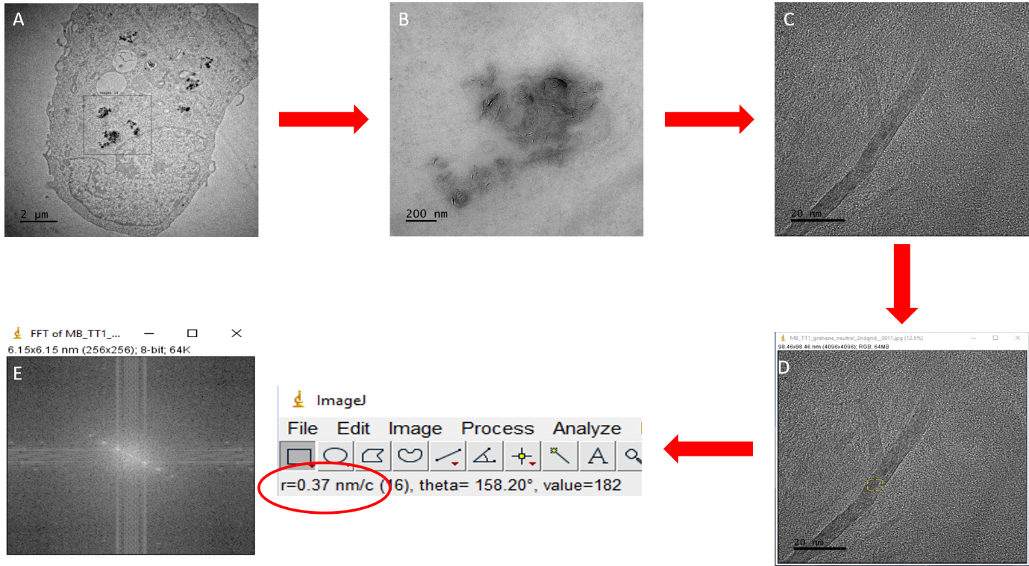
Supplementary Figure 1. Methodology for quantitatively investigating ENM uptake in TT1 cells. Firstly, a TT1 cell was located containing ENMs (A), then high resolution focusing is performed to visualise the FLG contained within an endocytic vesicle (B). A FLG crystal is then focused upon in (C & D) whereby the FLG stack is oriented on its Z-axis. Once the image has been captured (E), fast Fourier transform (FFT) can be performed using ImageJ to provide the final output.

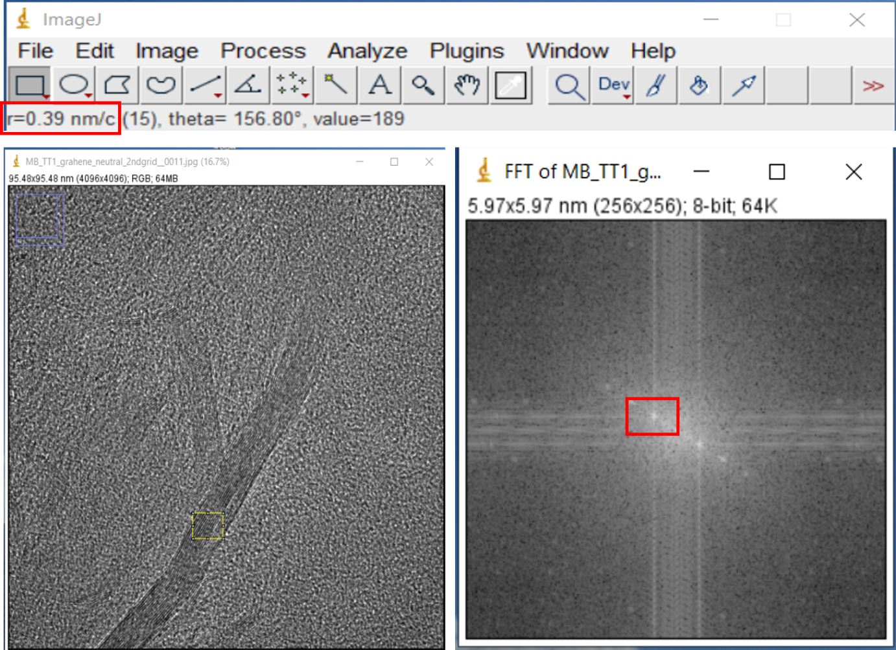
Supplementary Figure 2. FFT analysis provides structural information regarding the electronic arrangement of the crystal. Electron density will always be strongest at the atomic position which then allows the user to measure the spacing between the layers of graphene which in the case of this Neutral-FLG sample is 0.39nm, exactly what you would expect the atomic spacing of graphitic material to be. Analysis of this type typically allows a (+/-) 10% in standard deviation.

