Supplementary Information - Improving ALD-Al₂O₃ surface passivation of Si using native SiO_{x}
Michael N. Getz, Marco Povoli, Eduard Monakhov

Table S1: Thickness measured by SE before and after Al₂O₃ deposition on single-side polished Si substrates.
Pretreatment | T_{dep} (˚C) | Thickness before dep. (nm) | Thickness post dep. (nm)
HF-dip | 150 | 0.7 ± 0.06 | 20.7 ± 0.05
HF-dip | 200 | 0.6 ± 0.04 | 19.9 ± 0.4
HF-dip | 250 | 0.6 ± 0.06 | 18.4 ± 0.2
HF-dip | 300 | 0.6 ± 0.04 | 16.9 ± 0.2
… | 150 | 1.9 ± 0.2 | 21.3 ± 0.2
… | 200 | 1.54 ± 0.06 | 20.2 ± 0.2
… | 250 | 1.6 ± 0.1 | 18.8 ± 0.1
… | 300 | 1.6 ± 0.1 | 17.3 ± 0.2
Table S2: Thickness measured by SE before and after Al₂O₃ deposition of samples deposited on double-side polished Si substrates.
Pretreatment | T_{dep} (˚C) | Thickness before dep. (nm) | Thickness post dep. (nm)
HF-dip | 150 | 0.6 ± 0.04 | 19.5 ± 0.6
HF-dip | 200 | 0.6 ± 0.04 | 19.7 ± 0.1
HF-dip | 250 | 0.6 ± 0.06 | 18.4 ± 0.1
HF-dip | 300 | 0.6 ± 0.04 | 17.4 ± 0.2
… | 150 | 1.6 ± 0.1 | 20.0 ± 0.8
… | 200 | 1.6 ± 0.1 | 19.8 ± 0.3
… | 250 | 1.6 ± 0.1 | 18.2 ± 0.08
… | 300 | 1.6 ± 0.1 | 17.3 ± 0.2
Figure S1: Auger-corrected inverse lifetime 8 months after annealing of no-HF samples (a) and HF-dipped (b). Dashed lines show the linear fits used to extract J_{0s}.

Series resistance correction and effective charge extraction:
The measured capacitance, C_{m}, and conductance, G_{m} as a function of applied gate voltage, V. C_{m}, and G_{m,} obtained from parallel conductance mode were corrected for series resistance, R_{s}, before extracting any parameters. R_{s} was determined by^{[1]}:

 | $$R_{s}= \frac{G_{ma}}{G_{ma}^{2}+ ω^{2}C_{ma}^{2}},$$ | (1)

where C_{ma} and G_{ma} are the measured capacitance and conductance in accumulation, respectively, and ω is the angular frequency, 2πf. The series corrected capacitance and conductance, C and G, respectively, were determined by:^{[1]}

 | $$C= \frac{\left(G_{m}^{2}+ ω^{2}C_{m}^{2}\right)C_{m}}{a^{2}+ ω^{2}C_{m}^{2}},$$  $$G= \frac{\left(G_{m}^{2}+ ω^{2}C_{m}^{2}\right)a}{a^{2}+ ω^{2}C_{m}^{2}},$$ | (2)  (3)

where a is:

 | $$a= G_{m}-\left(G_{m}^{2}+ ω^{2}C_{m}^{2}\right)R_{s}.$$ | (4)

The presented CV and GV characteristics in the paper and in the supplementary materials section have been corrected for series resistance.
The effective interface charge, Q_{eff}, was determined by first calculating the flatband capacitance, C_{FB}, given by:

 | $$C_{FB}= \frac{C_{ox}ε_{Si}A/λ}{C_{ox}+ ε_{Si}A/λ},$$ | (5)

where C_{ox} is the Al₂O₃ capacitance and is equal to C_{ma}. ε_{Si} is the relative dielectric constant of silicon assumed to be 1.03 × 10⁻¹² F/cm,^{[2]} A is the area of the gate electrode, and λ is the Debye length given by:

 | $$λ= \frac{ε_{Si}k_{B}T}{q^{2}N_{A}},$$ | (6)

where k_{B} is the Boltzmann constant, T is the measurement temperature, q is the electron charge, and N_{A} is the doping of the substrate. The substrate doping was determined from the slope of the 1/C² data of the annealed samples and was determined to be 2 × 10¹⁶ cm⁻³. The flatband voltage, V_{FB}, was then extracted by reading out the voltage at C_{FB}. Q_{eff} was finally calculated from:^{[3]}

 | $$Q_{eff}= \frac{C_{ox}(φ_{ms}-V_{FB})}{q},$$ | (7)

where φ_{ms} is given by:

 | $$φ_{ms}=F_{m}-χ_{Si}-\frac{E_{g}}{2}-\frac{k_{B}T}{q}ln⁡(\frac{N_{A}}{n_{i}}),$$ | (8)

where F_{m} = 4.08 eV^{[4]} is the work function of Al, and χ_{Si}, E_{g}, and n_{i} are the electron affinity (4.05 eV),^{[5]} band gap (1.12 eV), and intrinsic doping (8.2 × 10⁹ cm⁻³ at 298 K) of silicon, respectively. φ_{ms} was determined to be -0.9 eV for the samples used in this study.

Figure S2: Calculated Q_{eff} for each frequency in Figure 5a in the main article and fitted to a double exponential.
Figure S3: CV of a no-HF sample deposited at 200 ˚C. The gate voltage was swept from inversion to accumulation (blue) and then back again (red).

9
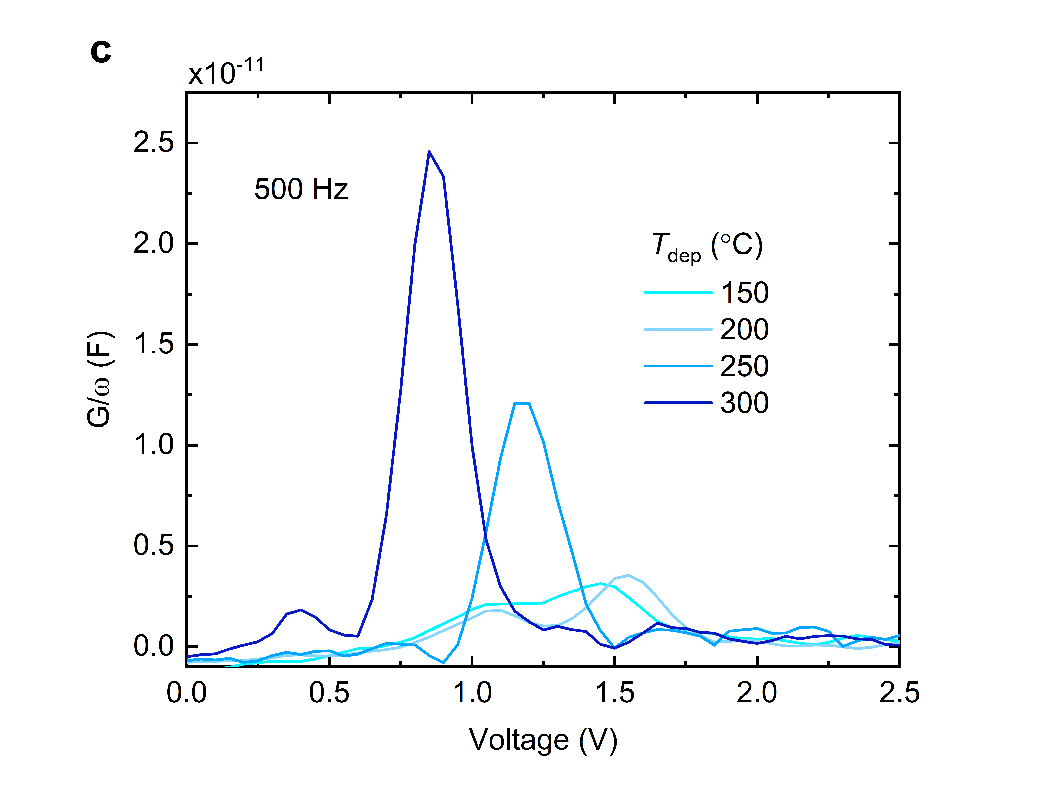
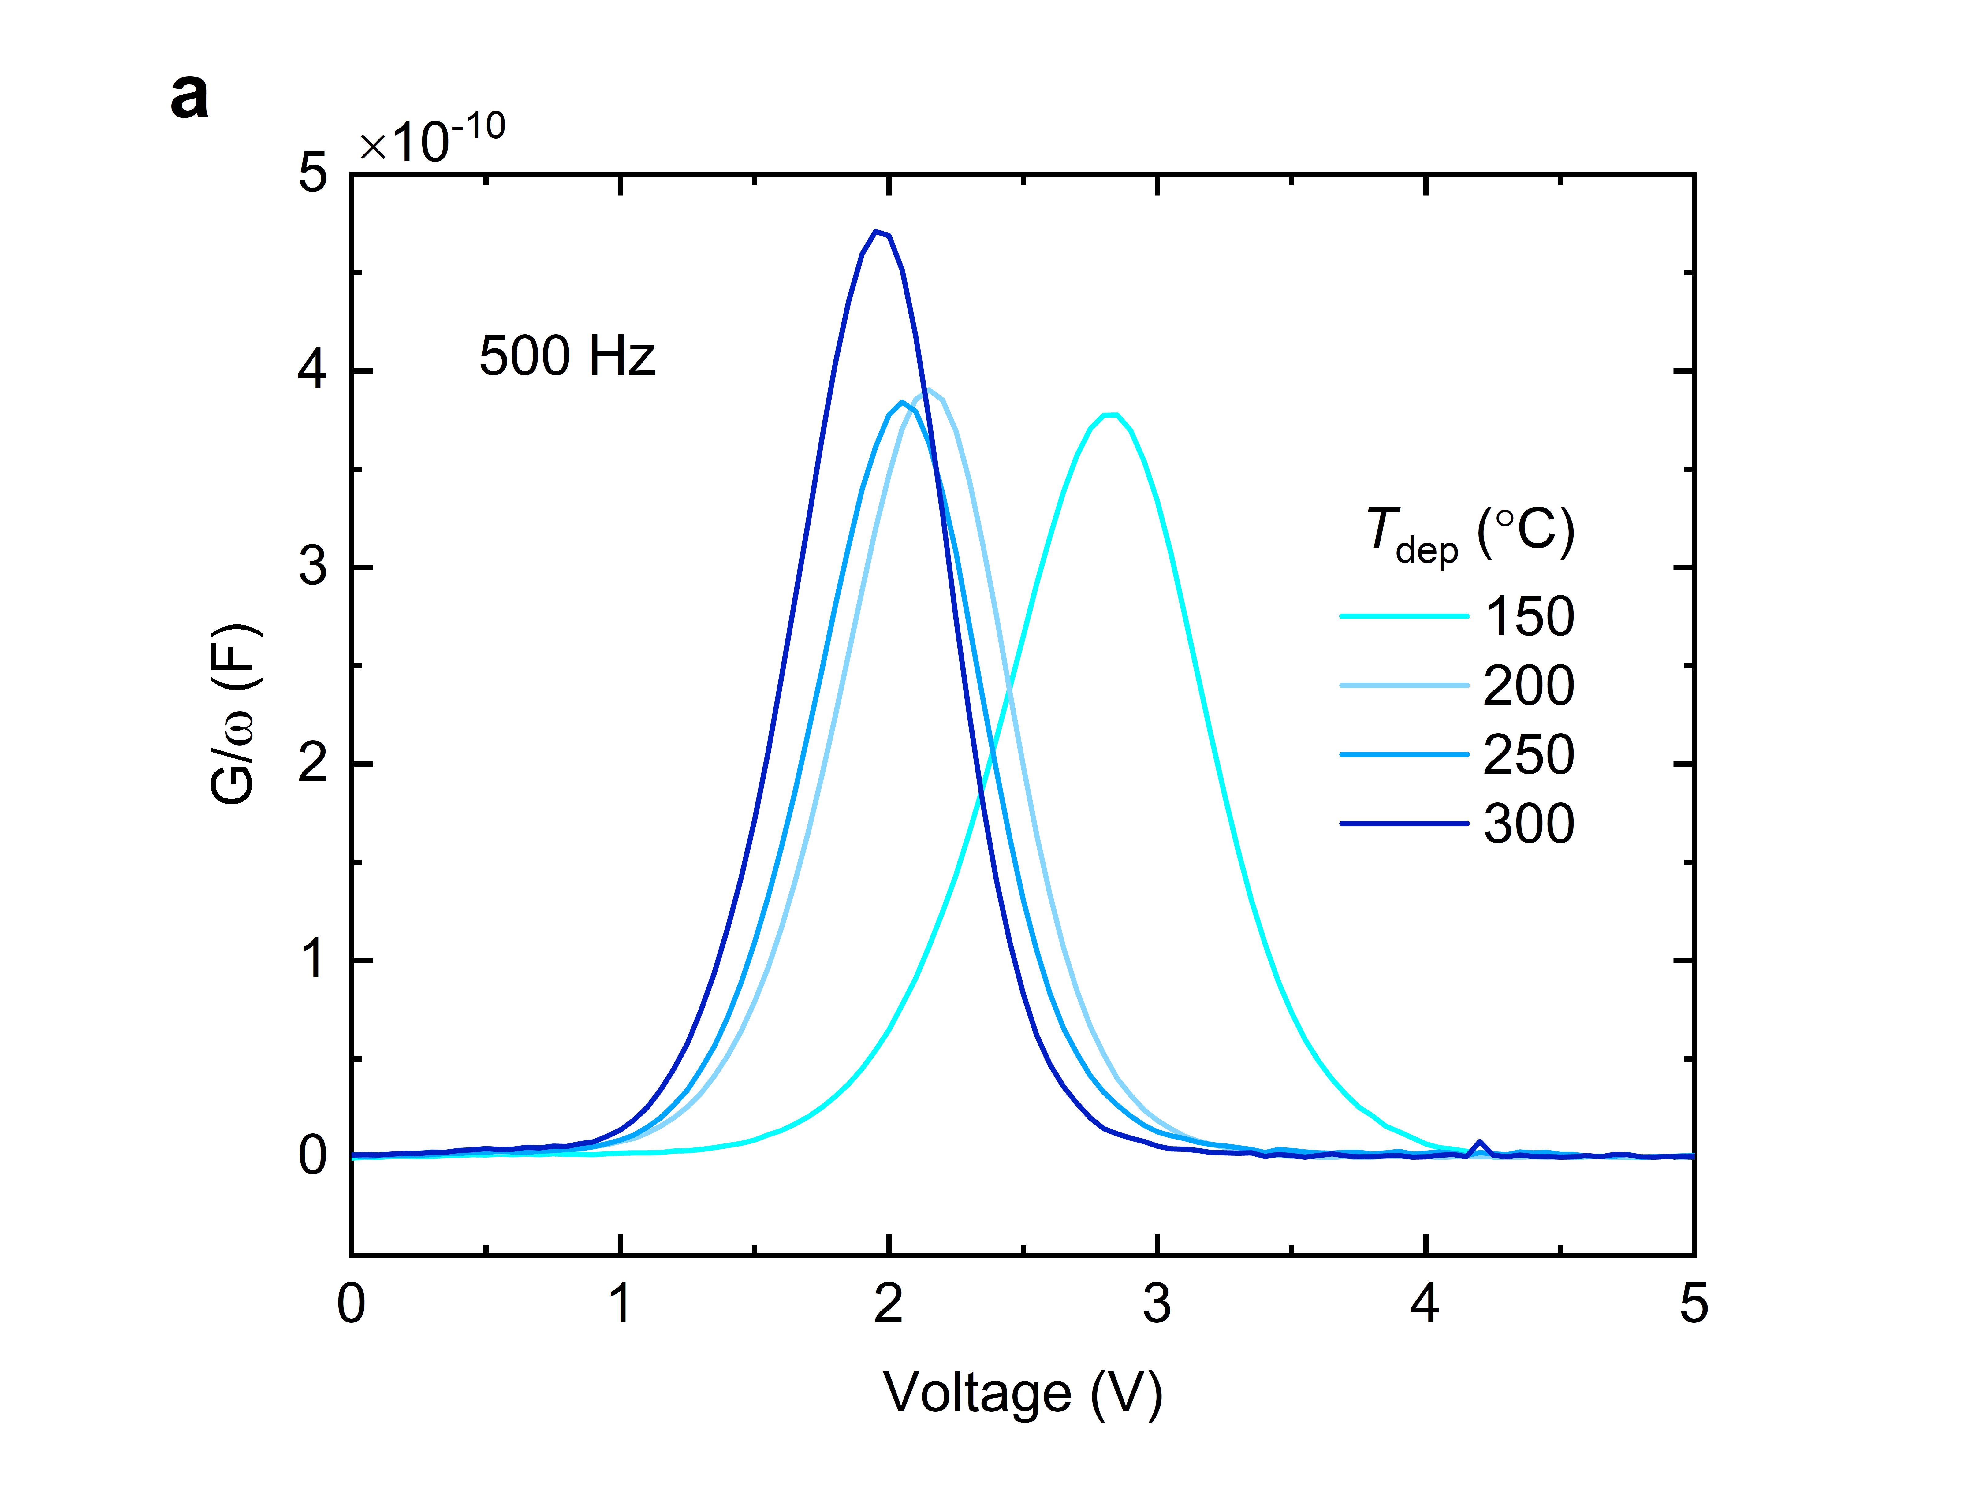
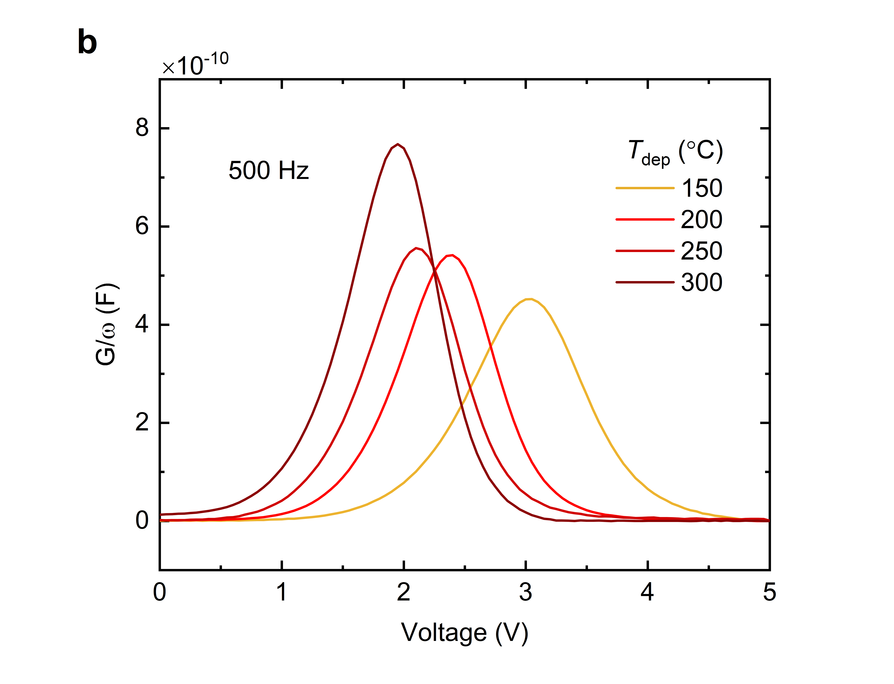
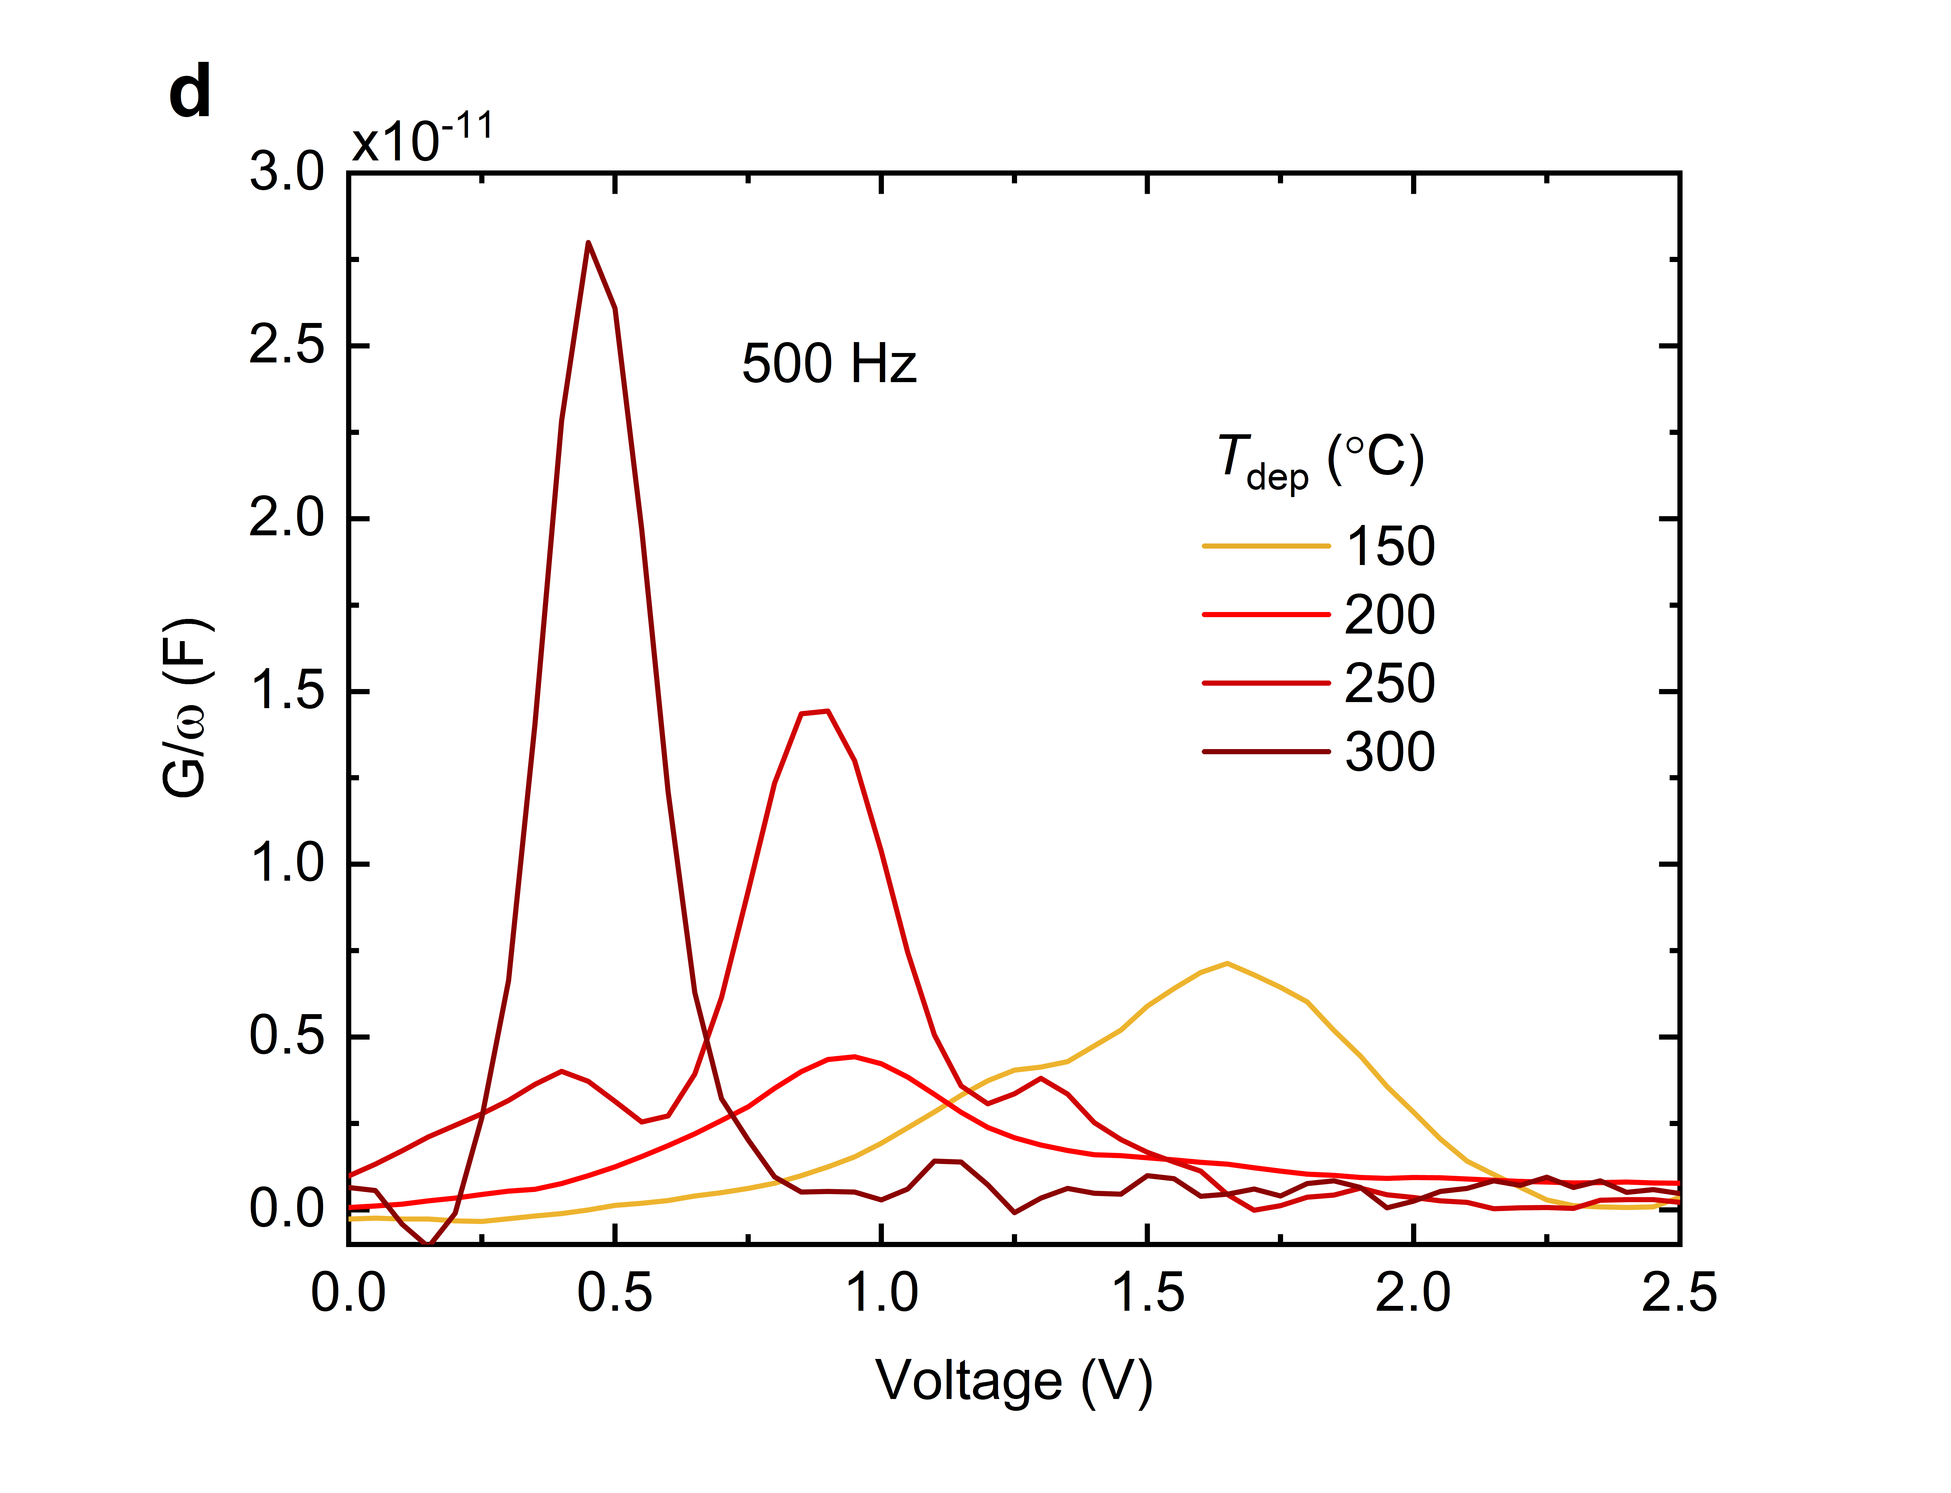
Figure S4: 500 Hz GV characteristics of samples deposited at 150 – 300 ˚C for a) no-HF as deposited, b) HF-dip as-deposited, c) no-HF annealed, and d) HF-dip annealed.

Figure S5: GV of a no-HF sample (a) and HF-dipped sample (b) deposited at 250 ˚C.
Table S3: Q_{fix} and D_{it} of as-deposited.
 | no-HF |  | HF-dipped
T_{dep} (˚C) | Q_{fix} (cm⁻²) | D_{it} (ev⁻¹ cm⁻²) | Q_{fix}(cm⁻²) | D_{it} (ev⁻¹ cm⁻²)
150 | -4.7 × 10¹² | 2.0 × 10¹² | -4.0 × 10¹² | 2.7 × 10¹²
200 | -4.6 × 10¹² | 2.1 × 10¹² | -4.5 × 10¹² | 2.4 × 10¹²
250 | -4.4 × 10¹² | 2.1 × 10¹² | -3.6 × 10¹² | 3.3 × 10¹²
300 | -4.8 × 10¹² | 2.6 × 10¹² | -4.4 × 10¹² | 4.4 × 10¹²

Table S4: Q_{fix} and D_{it} of no-HF and HF-dipped samples after FG anneal at 435 ˚C.
 | no-HF |  | HF-dipped
T_{dep} (˚C) | Q_{fix} (cm⁻²) | D_{it} (ev⁻¹ cm⁻²) | Q_{fix} (cm⁻²) | D_{it} (ev⁻¹ cm⁻²)
150 | -3.5 × 10¹² | 1.0 × 10¹⁰ | -3.6 × 10¹² | 2.6 × 10¹⁰
200 | -4.2 × 10¹² | 9.8 × 10⁹ | -4.0 × 10¹² | 2.8 × 10¹⁰
250 | -3.7 × 10¹² | 6.5 × 10¹⁰ | -2.9 × 10¹² | 3.8 × 10¹⁰
300 | -3.2 × 10¹² | 6.4 × 10¹⁰ | -2.4 × 10¹² | 7.0 × 10¹⁰

References
[1] E. H. Nicollian, J. R. Brews, MOS (Metal Oxide Semiconductor) Physics and Technology, Wiley, New York, 1982.
[2] M. Wolf, The Physics of Computing, Elsevier, Cambridge, United States, 2017.
[3] D. K. Schroder, Semiconductor Material and Device Characterization, 3rd ed., John Wiley & Sons, Inc., New Jersey, 2005.
[4] P. A. Tipler, R. A. Llewellyn, Modern Physics, 5th ed., W. H. Freeman, 2008.
[5] B. El-Kareh, Silicon Devices and Processes, Springer, 2009.

