Cell-Size-dependent of bacterial communities antibiotic resistome profiles and risk assessment in a river: A metagenomic analysis

Pengfei Yang¹, Jiaxian Yao¹, Yuehua Zhang², Yongzhen Zhao², Zening Wang², Shuhan Li³, Fangzhou Gao⁴, Guannan Mao⁵, Shuai Zhang^{6*}, Wei Hu^{1*}

¹College of Tobacco Science and Engineering, Zhengzhou University of Light Industry, Zhengzhou, China;
²Tobacco Henan Industrial Limited Company, Zhengzhou, Henan, China;
³College of Environmental Science and Engineering, Nankai University, Tianjin, China;
⁴SCNU Environmental Research Institute, Guangdong Provincial Key Laboratory of Chemical Pollution and Environmental Safety & MOE Key Laboratory of Theoretical Chemistry of Environment, South China Normal University, Guangzhou, China
⁵Center for the Pan-third Pole Environment, Lanzhou University, Lanzhou, China;
⁶Technology Center, China Tobacco Shandong Inductrial Co., Ltd, Shandong, China.

* Corresponding author, e-mail: hvvhuwei@126.com.

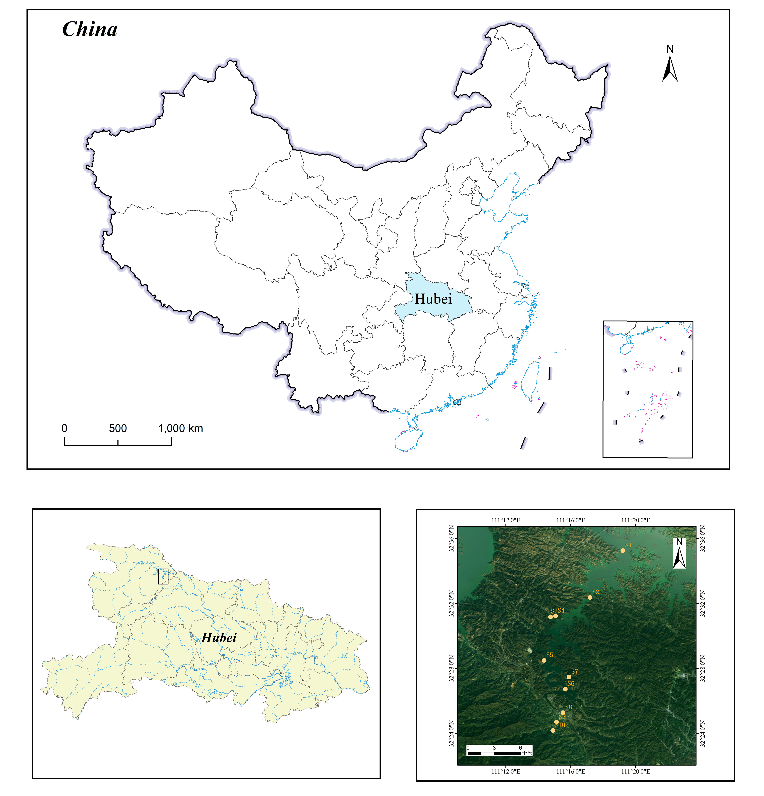
Figure S1 Sampling map in the river

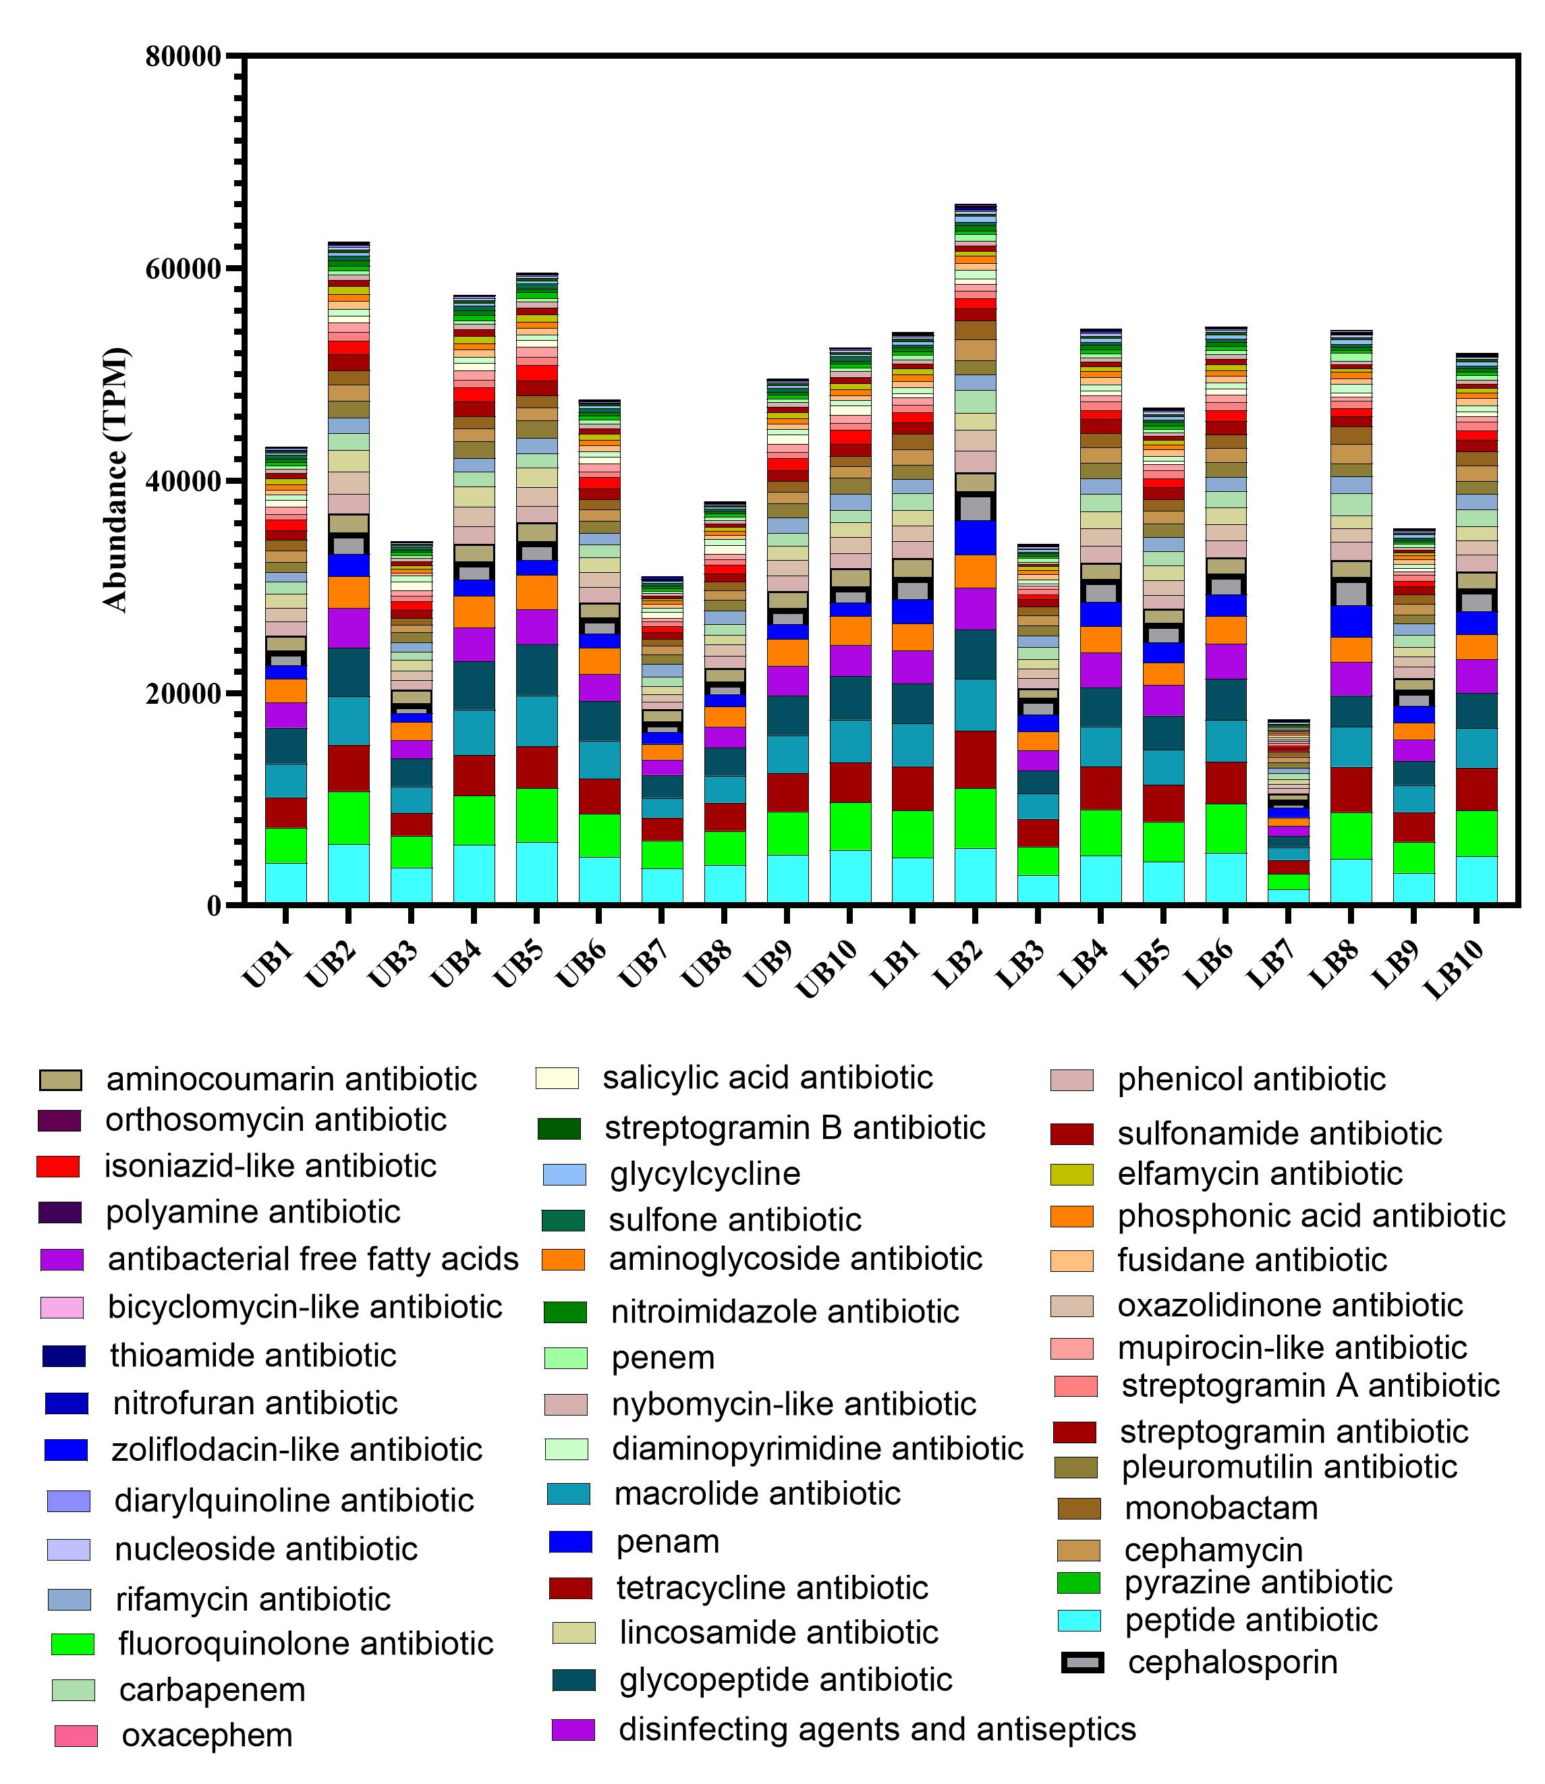
Figure S2 the abundance of ARGs types

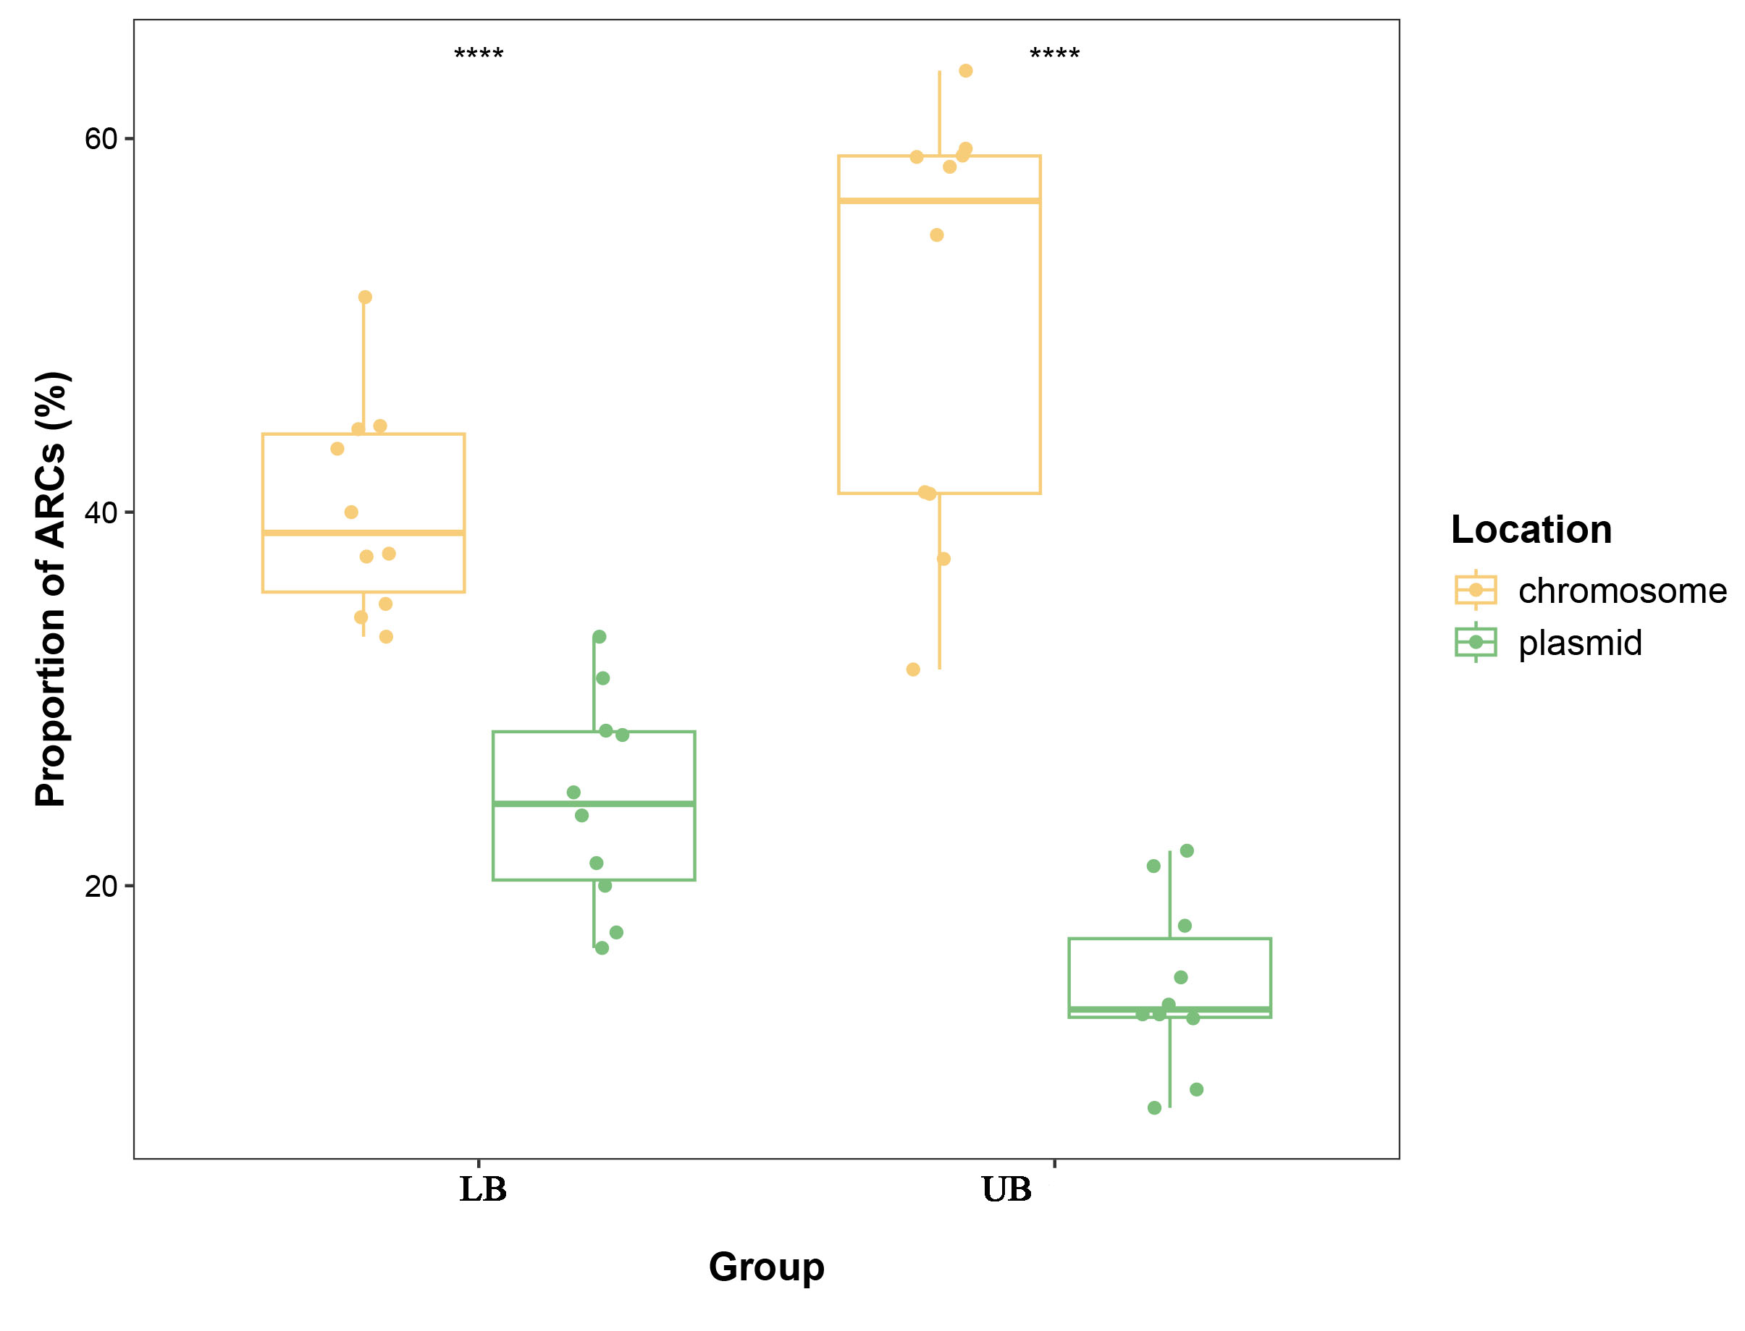
Figure S3 the proportion of ARCs in the LB and UB groups

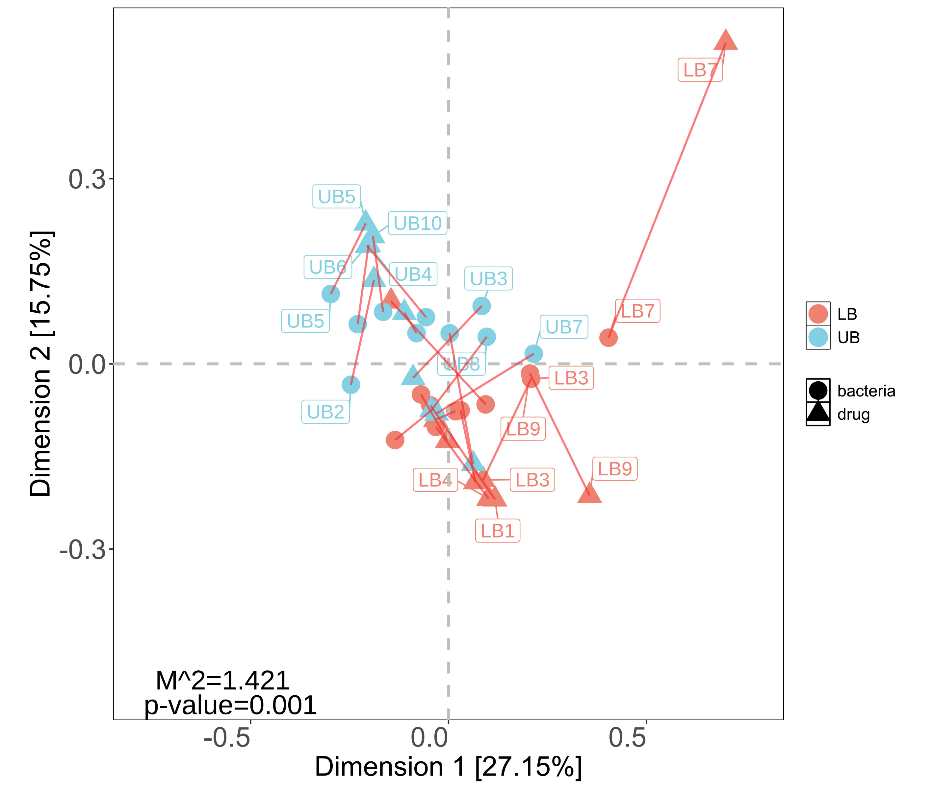
Figure S4 Procrustes analysis showing the significant correlations between bacteria and ARGs

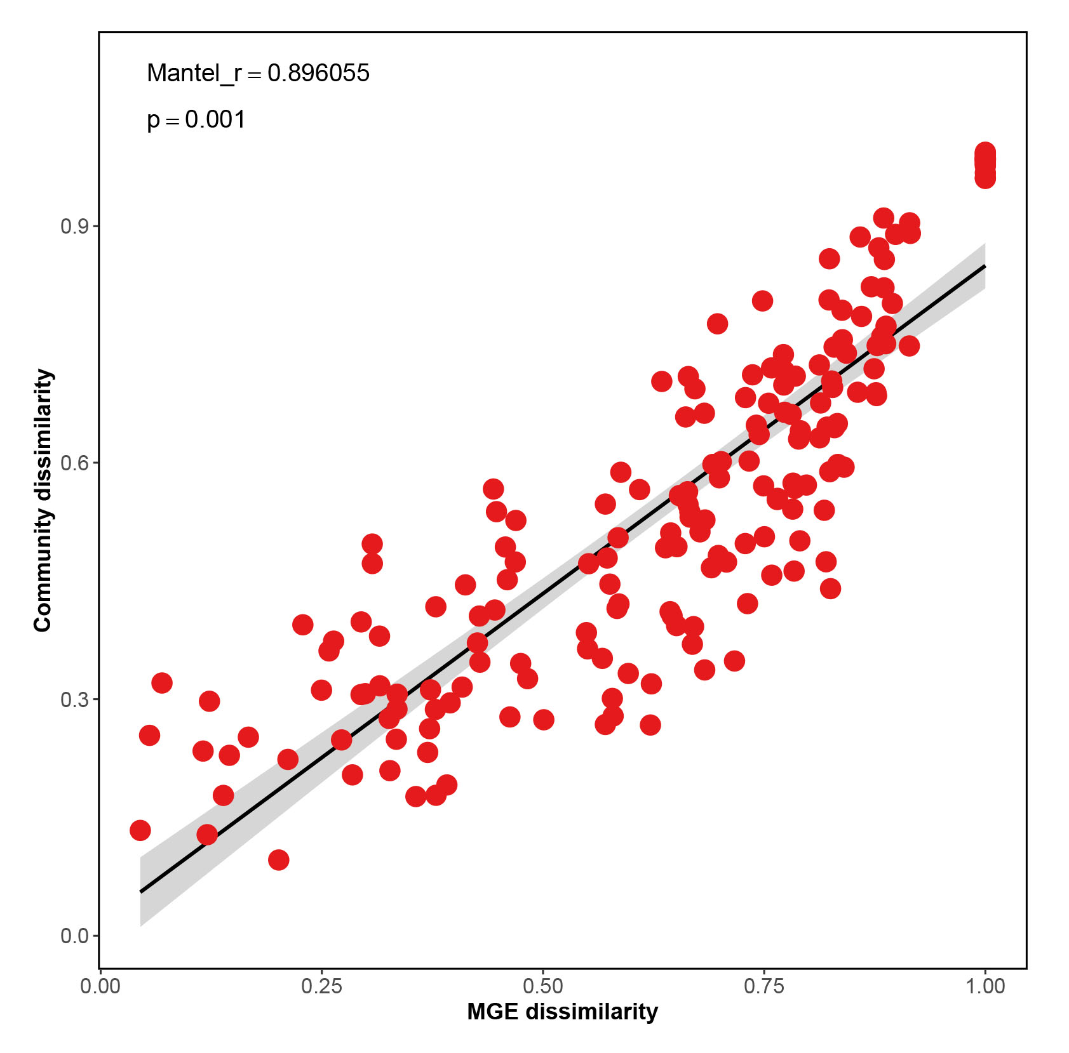
Figure S5 The relationship between MGE dissimilarity and community dissimilarity

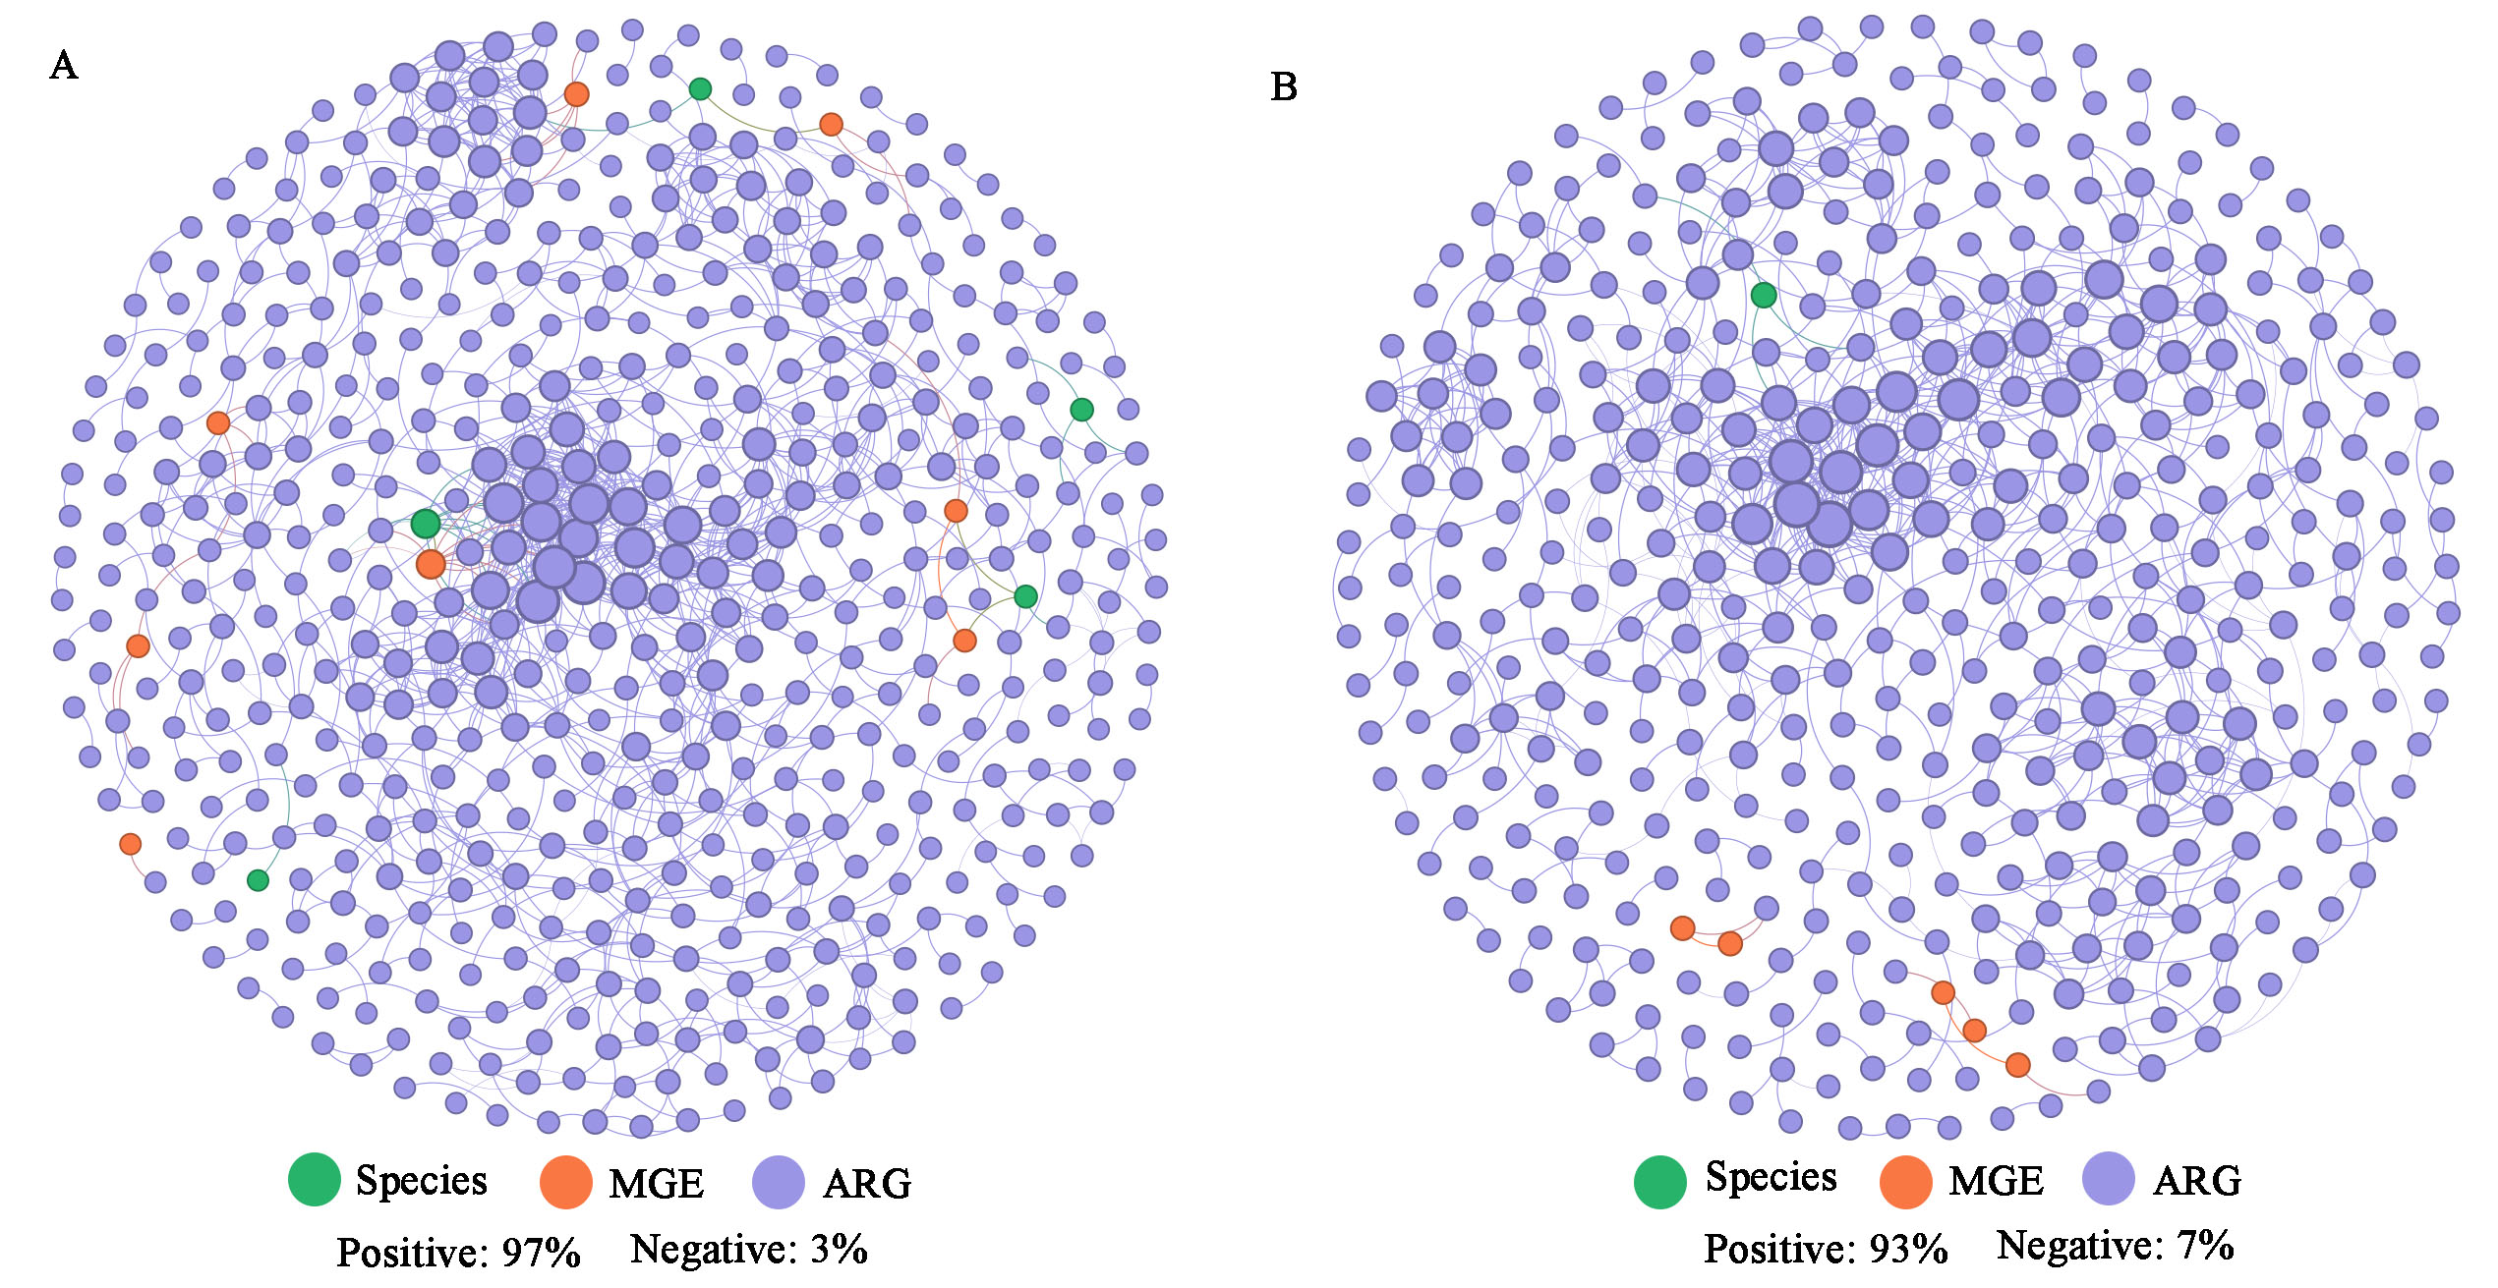
Figure S6 Co-occurrence networks of bacteria, MGEs and ARGs based on pairwise Spearman’s correlations

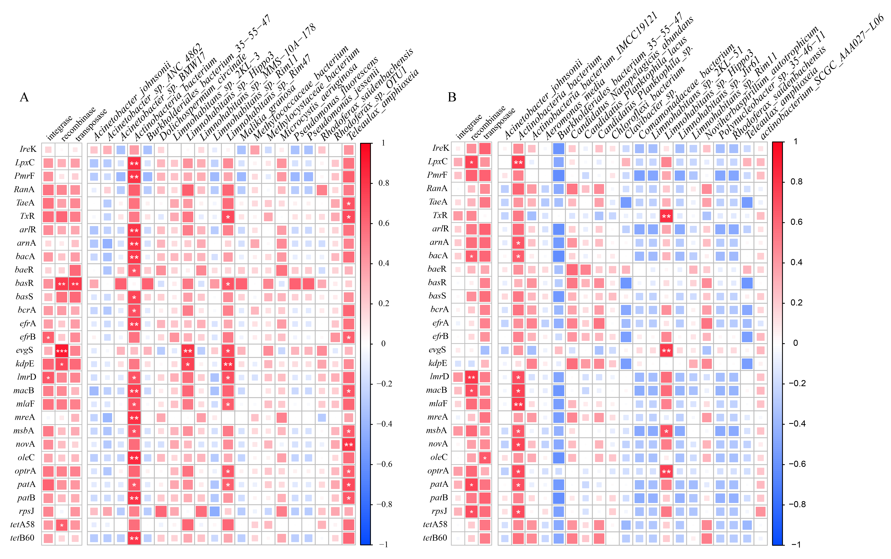
Figure S7 the correlations between ARGs and bacteria

Table S1 Summary of environmental factors of all samples
 | Longitude | Latitude | T | PH | DO | TOC(mg/L) | IC(mg/L) | TC(mg/L) | TN(mg/L) | TP(mg/L)
S1 | 111.320146 | 32.58745 | 15.4 | 7.855 | 7.9 | 2.95 | 23.76 | 26.73 | 0.7905 | 0.12
S2 | 111.286451 | 32.53947 | 15.7 | 7.794 | 9.7 | 1.29 | 22.7 | 23.99 | 0.703 | 0.14
S3 | 111.246043 | 32.51961 | 15.8 | 7.828 | 9.4 | 1.42 | 23.02 | 24.44 | 0.7589 | 0.14
S4 | 111.2509881 | 32.52049 | 15.7 | 7.833 | 8.68 | 3.22 | 20.48 | 23.7 | 0.9309 | 0.2
S5 | 111.239316 | 32.47499 | 15.6 | 7.905 | 8.2 | 2.43 | 20.92 | 23.35 | 0.8221 | 0.22
S6 | 111.261116 | 32.44551 | 15.6 | 7.73 | 9.06 | 1.73 | 20.59 | 22.31 | 0.9637 | 0.24
S7 | 111.264887 | 32.45797 | 15.7 | 7.948 | 9.8 | 1.3 | 21.25 | 22.55 | 1.14 | 0.45
S8 | 111.258725 | 32.42137 | 15.5 | 7.795 | 9.85 | 1.15 | 14.71 | 15.86 | 1.09 | 0.39
S9 | 111.252103 | 32.41176 | 15.6 | 7.88 | 9.16 | 1.6 | 13.88 | 15.48 | 1.23 | 0.44
S10 | 111.248257 | 32.40311 | 15.7 | 7.92 | 8.4 | 2.14 | 12.64 | 14.77 | 1.11 | 0.42

Table S2 Summary of count, percentage of the LB and UB groups in all samples
 | UB count (10⁶) | LB count (10⁶) | UB percentage | LB percentage | UB FSC | LB FSC
S1 | 45.13 | 67.45 | 40.76 | 59.24 | 2089.11 | 3613.33
S2 | 32.81 | 36.31 | 48.01 | 51.99 | 850.85 | 3782.99
S3 | 17.427 | 23.212 | 43.14 | 56.86 | 2621.28 | 4767.75
S4 | 24.771 | 28.333 | 47.09 | 52.91 | 1132.01 | 4355.52
S5 | 20.761 | 30.339 | 40.98 | 59.02 | 718.17 | 2823.47
S6 | 50.557 | 31.719 | 57.2 | 42.8 | 1405.93 | 2449.4
S7 | 15.705 | 17.365 | 47.95 | 52.05 | 1615.45 | 3583.94
S8 | 34.765 | 48.801 | 42.07 | 57.93 | 2067.96 | 3236.27
S9 | 18.547 | 23.976 | 43.94 | 56.06 | 2154.3 | 4679.34
S10 | 27.482 | 16.734 | 62.91 | 37.09 | 773.39 | 4566.81

Table S3 the correlations between ARGs and environmental factors
 | LB |  |  |  | UB
 | Mental |  | Partial Mental |  | Mental |  | Partial Mental
 | r | P | r | P | r | P | r | P
T | -0.066 | 0.533 | -0.047 | 0.502 | -0.043 | 0.488 | 0.153 | 0.246
PH | 0.106 | 0.279 | 0.138 | 0.221 | 0.027 | 0.387 | 0.080 | 0.287
DO | 0.039 | 0.354 | 0.010 | 0.419 | 0.216 | 0.043 | 0.196 | 0.048
TOC | -0.144 | 0.787 | -0.158 | 0.775 | -0.0005 | 0.393 | -0.016 | 0.456
TC | -0.060 | 0.577 | -0.147 | 0.761 | -0.014 | 0.492 | -0.128 | 0.752
TN | 0.179 | 0.09 | 0.131 | 0.236 | 0.075 | 0.248 | -0.013 | 0.509
TP | 0.249 | 0.041 | 0.216 | 0.044 | 0.223 | 0.041 | 0.1275 | 0.176

Table S4 Network graph topological structure parameters
 | LB | UB
Node | 524 | 428
edges | 1209 | 889
Average degree | 4.6415 | 4.145
graph diameter | 23 | 21

