Supporting Information
Manifold partitioning induced sequential optical reasoning & decision framework for photonic computing
Zhihao Li^{1†}, Jing Pan^{1†*}, Wei Yan^{1, 2}, Yu Xie², Lingmei Ma², Xiaoyu Sun¹, Min Qiu^{1, 2*}
1. Zhejiang Key Laboratory of 3D Micro/Nano Fabrication and Characterization, Department of Electronic and Information Engineering, School of Engineering, Westlake University, Hangzhou, Zhejiang 310030, China.
2. Westlake Institute for Optoelectronics, Fuyang, Hangzhou, Zhejiang 311400, China.
†These authors contribute equally to this work.
*Corresponds to: panjing75@westlake.edu.cn, qiumin@westlake.edu.cn
Table S1. Comparison with the state-of-the-art ONNs.
Work | Architecture | Density  (TOPS/mm²) | Efficiency  (TOPS/W) | Achievable task | Data source | Error | Scalability
Shen et al.¹ | MZI | 1.12 | N/A | Recognition | Vowel-4 | CC | Scale
Lin et al.² | DONN | 4×10⁻⁵ | N/A | Recognition | MNIST/Fashion-MNIST | CC | Scale
Feldmann et al.³ | MZI-PCM-OFM | 162 | 0.5 | Recognition | MNIST | CC | Scale /WDM
Zhou et al.⁴ | DONN | N/A | 1.578 | Recognition | MNIST/Fashion-MNIST/Weizmann/KTH | ~N/A | Scale/TDM
Ashtiani et al.⁵ | MZI-MRR | 3.5 | 2.9 | Recognition | Handwritten letters-2/4 | CC | Scale
Liu et al.⁶ | DONN | N/A | 1.0×10⁻⁶ | Recognition/CDMA/MBF | MNIST/Oil-painting | CC | Scale
Xu et al.⁷ | MZI-DONN | 1.76×10³ | 160 | Recognition/Generation | CIFAR-10/mini-ImageNet/Style | CC | Scale/ECOC
Yu et al.⁸ | DONN | 0.45 | N/A | Image reconstruction | Optical fiber speckle | CC | Scale
Wang et al.⁹ | MZI-DONN | 7×10⁴ | N/A | Recognition/Generation | MNIST/Fashion-MNIST/ CIFAR-100/NLG/CMR/ImageNet | CC | Scale/TDM
Chen et al.¹⁰ | DONN | N/A | 0.18-2.0 | Content generation | MNIST/Fashion-MNIST/  Butterflies-100/Celeb-A/Van Gogh-style | ~N/A | Scale/TDM
Kalinin et al.¹¹ | SLM-MicroLED array-Analog electronics | N/A | 500 | Recognition/Regression/  Compressed sensing | MNIST/Fashion-MNIST/Gaussian & Sinusoidal curve /MRI/Transaction settlement | CC | Scale/TDM
Chen et al.¹² | DONN-SMF array | 262 | 664 | Content generation | Semantic generation/Stytle transfer/  Denoising/3D vision (NeRF)/Video generation | CC | Scale/WDM
Tian et al.¹² | MZI | 0.055 | 7 | Recognition | MNIST/Fashion-MNIST/KTH/Weizmann | CC | Scale
Tesla V100 | EIC | 0.037 | 0.1 | Universe | Universe | ~N/A | Scale
Google TPU | EIC | 0.28 | 2.3 | Universe | Universe | ~N/A | Scale
NVIDIA-A100 | EIC | NA | 0.78 | Universe | Universe | ~N/A | Scale
Light Intelligence¹³ | MZI-EIC | NA | 2.38 | Ising problems | Combination optimization | CC | Scale
Light Matter¹⁴ | MZI- EIC | 0.047 | 1.01 | AI models | ResNet/BERT/Atari | CC | Scale
This work | DONN | NA | 23.3 | Recognition | Optical fiber speckle | ~N/A | Scale/SORD
Symbol * means the architecture in the promising situation. Abbrev. MZI: Mach–Zehnder interferometer; CC: Cascaded connection; DONN: Diffractive optical neural network; PCM: Phase change material; OFM: Optical frequency comb; WDM: Wavelength division multiplexing; TDM: Temporal division multiplexing; MRR: Micro-ring resonator; ECOC: Error-correcting output codes; CDMA: Code division multiple access; MBF: Multi-beam focusing; NLG: Natural language generation; CMR: Cross-modal recognition; SMF: Single-mode fiber; MRI: Magnetic resonance imaging; EIC: Electronic integrated circuit; SORD: Sequential optical reasoning & decision.
Table S2. Energy consumption of the components in the proposed system.
Component category | Device | Model | Power consumption
Optical computing core | 532 nm Laser source | Changchun New Industries,  MGL-FN-532-AOM | 25 W
Optical computing core | Spatial Light Modulator | UPOLabs, HDSLM80R | 18 W
Signal acquisition | CCD camera | Basler, acA1920-25gc | 2.5 W
Signal acquisition | Beam profiler | BeamOn U3 | 4.5 W
Peripheral unit | 3D force sensor | SRI, M3815A | 3 W
Peripheral unit | 3-axis translation stage | Daheng Optics, GCD040102 | 50W
Host control | workstation | Lenovo, Xiaoxin Pro 14 | 100 W
Total system power |  |  | 203 W

Note 1. ONN Scaling law—Theoretical derivation of information capacity
a) Theoretical framework and space-bandwidth product analysis
To rigorously quantify the information processing capacity, we model the system under ideal conditions: a monochromatic, coherent input field propagating through a linear, polarization-independent medium (air). By neglecting evanescent waves and higher-order back-reflections in the scalar diffraction regime (propagation distance z >> wavelength λ), the system's theoretical limit is governed by the available degrees of freedom (DoFs).
The computational capacity of DONN is dual-constrained by the hardware architecture and the physical nature of light. First, the structural DoF of the phase mask (or spatial light modulator) is physically bounded by its discrete pixilation. Following the Nyquist sampling theorem, the structural capacity is defined as¹⁵:
$$\begin{aligned}{DoF}_{structural}=\frac{A_{mask}}{ΔxΔy}=N_{x}×N_{y} \#\left(1\right)\end{aligned}$$
where A_{mask} is the modulation area, N_{x}, N_{y} denote the pixel counts along orthogonal axes, and ∆x, ∆y represent the pixel pitch.
However, the effective computational capacity is fundamentally upper-bounded by the space-bandwidth product (SBP) of the input propagating optical field. The SBP serves as the intrinsic metric for information capacity, defined as the product of the spatial field-of-view (FoV) area A_{FoV} (A_{FoV}=πD²/4 for a circular aperture of diameter D) and the spatial frequency bandwidth B_{spatial}. Given the scalar diffraction limit, the maximum spatial frequency is restricted because evanescent waves (spatial frequencies |v| > 1/λ) cannot propagate to the far-field, bounding the absolute maximum spatial frequency bandwidth B_{spatial} to approximately (2/λ)². This physically corresponds to a strict Nyquist sampling interval of λ/2 for the propagating optical field. Consequently, the SBP quantifies the theoretical maximum number of independent information channels (i.e., optical modes) the system can transmit, theoretically scaling as¹⁶:
$$\begin{aligned}{SBP}_{max}=A_{FoV}×B_{spatial}≈\frac{A_{FoV}}{{\left(λ/2\right)}^{2}}\#\left(2\right)\end{aligned}$$
Concurrently, the spatial resolution of these channels is governed by the Rayleigh criterion, where the minimum resolvable angle is physically constrained by θ_{min}≈1.22λ/D. Ultimately, the ability of the DONN to resolve complex tasks depends on effectively mapping the mathematical task complexity onto these tunable DoFs within the diffraction-limited constraints.
b) Effective degrees of freedom analysis
Based on the SBP constraints established above, we categorize the effective information processing capacity N_{eff} across the optical architectures in three distinct regimes:
1) Single-layer and sub-wavelength architectures.
For a standard single-layer system, the processing capacity is governed by a bottleneck principle: it is determined by the minimum between the system’s structural modulation capability N_{DoF} and the intrinsic information capacity of the optical field itself SBP_{max}. Thus, the effective DoF is:
$$\begin{aligned}N_{eff}^{(1)}=\min\left( N_{DoF},{SBP}_{max}\right)\#\left(3\right)\end{aligned}$$
Notably, this limitation extends to metasurfaces or deep sub-wavelength structures. Although such devices possess a structural DoF (M) significantly exceeding the diffraction limit (M >> N_{DoF}), information transfer in the far-field regime (diffraction distance z >> wavelength λ) is strictly confined to propagating modes. Since high-frequency information encoded in evanescent waves decays exponentially, the effective exploitable neurons remain bounded by the diffraction-limited SBP_{max}. Thus, merely reducing pixel size below the diffraction limit yields diminishing returns for far-field information processing.
2) Multi-layer diffractive networks.
To transcend the single-layer structural bottleneck N_{DoF}, cascading multiple diffractive layers provides a physically viable mechanism to cumulatively expand the solution space. For a network comprising K diffractive layers, the total structural dimensionality scales linearly. Considering the phase continuity conditions required for inter-layer optical coupling, each additional layer contributes N_{DoF}-1 independent variables. The aggregate structural dimensionality D^{(K)} is thus expressed as:
$$\begin{aligned}D^{(K)}=K∙N_{DoF}-\left(K-1\right)\#\left(4\right)\end{aligned}$$
However, while the structural dimensionality scales with K, the ultimate computational capacity of the system is not infinite; it is bounded by the theoretical maximum of the linear transformation matrix connecting the input and output fields. Let N_{in} and N_{out} denote the number of independent spatial modes (resolvable channels constrained by the SBP limit) within the input and output FoV, respectively. The maximum dimensionality of the full-connectivity matrix is N_{in}×N_{out}. Therefore, by unifying Eq. (3) and Eq. (4), the generalized effective information processing capacity for any K-layer DONN is formulated as:
$$\begin{aligned}N_{eff}^{\left(K\right)}=\min\left( D^{\left(K\right)},N_{in}×N_{out}\right) \#\left(5\right)\end{aligned}$$
This unified equation mathematically demonstrates that when K = 1, the system gracefully reduces to the single-layer bottleneck (since D⁽¹⁾ = N_{DoF}). As K increases, multi-layer architectures exponentially approximate complex transformations until reaching the physical full-connectivity bound. The information processing capacities across different DONN architectures are summarized in Table S3.
Table S3. Information processing capacity of DONN systems.
System architecture | Structural DoF | Effective DoF | Limiting factors
Single-layer network | N_{DoF} | $$min⁡({SBP}_{max}, N_{DoF})$$ | SBP (Aperture & wavelength)
Metasurface (deep sub-wavelength) | M >> N_{DoF} | $$min⁡({SBP}_{max}, N_{DoF})$$ | Propagating modes (Evanescent decay)
Multi-layer network | $$D^{(K)}=K∙N_{DoF}-\left(K-1\right)$$ | $$\min\left( D^{\left(K\right)},N_{in}×N_{out}\right)$$ | Number of layers (K) & phase continuity
Based on the preceding analysis, the system's information processing capacity—representing its computational solving capability—can be formally defined. We denote the total dimensionality of the solution space achievable by the optical architecture as D_{sol}. This solution space characterizes the maximum complexity of the linear transformations the physical system can express.
Driven by the effective degree of freedom analysis, D_{sol} is mathematically equivalent to the aggregate effective structural parameters $N_{eff}^{\left(K\right)}$ derived in Eq. (5):
$$\begin{aligned}D_{sol}=N_{eff}^{\left(K\right)}=min\left(N_{in}×N_{out},K∙N_{DoF}-\left(K-1\right)\right)\#\left(6\right)\end{aligned}$$
where, N_{in} and N_{out} denote the number of independent spatial modes (resolvable diffraction-limited channels defined by the SBP) within the input and output fields of view, respectively. Consequently, the product N_{in}×N_{out} defines the maximum dimensionality of the idea linear transformation matrix connecting the input and output fields, representing the theoretical upper bound of the system's capacity regardless of physical depth. Additionally, the term $K∙N_{DoF}-\left(K-1\right)$ corresponds to the aggregate number of effectively controllable neurons (pixels) distributed across all K diffractive layers accounting for inter-layer phase continuity.
c) Complexity of the target classification task C_{task}
For a classification task involving C distinct categories, the fundamental difficulty is quantified by the information required to correctly resolve the input-label mapping. From an information-theoretic perspective, assuming the categories are equiprobable, the baseline entropy of the target labels is H(Y)=log₂C.
We define the total task complexity C_{task} as the joint entropy H(X,Y), which represents the total information content required to fully describe the relationship between the input data X and the class labels Y. Using the chain rule of entropy, this can be decomposed as:
$$\begin{aligned}C_{task}=H\left(X,Y\right)=H\left(Y\right)+H\left(X | Y\right)=\log_{2}C+H\left(X | Y\right)\#\left(7\right)\end{aligned}$$
This formulation reveals that task difficulty stems from two distinct sources:
1) Label space uncertainty H(Y)=log₂C. This term quantifies the size of the selection space, representing the intrinsic uncertainty of the class labels prior to any observation.
2) Intra-class complexity H(X|Y). This conditional entropy term quantifies the variability or randomness of the input data X given a specific class Y. It serves as a metric for the distinctness of the data manifold; for instance, a class with high visual diversity (e.g., varying poses, backgrounds, or subtypes) yields a high H(X|Y)¹⁷. Physically, this represents the noise or interference that the classifier must overcome to establish a decision boundary.
A higher C_{task} implies a more complex joint distribution that the network must approximate, thereby necessitating a larger solution space D_{sol} and greater computational resources.
This definition is theoretically grounded in Fano’s inequality, which establishes a lower bound on the classification error probability P_{e} as a function of conditional uncertainty¹⁸. The inequality dictates that:
$$\begin{aligned}H\left(X | Y\right)≤H\left(P_{e}\right)+P_{e}\log_{2}\left(C-1\right)\#\left(8\right)\end{aligned}$$
This relationship mathematically confirms that minimizing the classification error rate P_{e} fundamentally requires resolving the conditional uncertainty H(X|Y). Therefore, datasets with lower intra-class variability (lower H(X|Y)) inherently allow for lower theoretical error bounds, consistent with our definition of task complexity.
d) Empirical performance scaling laws.
Directly establishing a closed-form analytical relationship between the available solution space D_{sol}, task complexity C_{task}, and classification accuracy (Acc) presents significant challenges due to the non-linear nature of the system. Instead, we adopted an inverse approach by modeling the classification error rate P_{e} to derive accuracy via the fundamental relation Acc=1-P_{e}. We decompose the total system error into approximation error ε_{approx}, optimization error ε_{optim}, and physical error ε_{physical}, these three components, modeled as a weighted linear combination:
$$\begin{aligned}P_{e}≈ε_{approx}+ε_{optim}+ε_{physical}=A∙ε_{approx}+B∙ε_{optim}+{C∙ε}_{physical}\#\left(9\right)\end{aligned}$$
where, the coefficients A, B, and C serve as system-specific weighting coefficients for architectural variations and task-dependent sensitivities.
1) Approximation error ε_{approx}: The capacity-complexity mismatch.
The approximation error ε_{approx} stems from the inherent limitation of the finite solution space D_{sol} to perfectly reconstruct the ideal mathematical transformation required by the task complexity C_{task}. Drawing from function approximation theory¹⁹, for a d-dimensional function with smoothness β, the approximation error by a neural network with N basis functions typically follows a power-law decay, often bounded by O(N^{-α}) (e.g., Barron’s bounds of $O(1/N)$ or $O(1/\sqrt{N})$).
Similarly, statistical learning theory posits that generalization error is governed by the ratio of the VC dimension (correlated with model complexity D_{sol}) to the sample size^{20,21}. Synthesizing these frameworks, we establish a core scaling relationship based on information density—defined as the ratio of the task's information demand to the system's solution capacity. ε_{approx} is modeled as:
$$\begin{aligned}ε_{approx}=A∙{\left(\frac{C_{task}}{D_{sol}}\right)}^{γ}=A∙{\left(\frac{\log_{2}\left(C\right)+H(X|Y)}{D_{sol}}\right)}^{γ}\#\left(10\right)\end{aligned}$$
Here, the ratio C_{task}/D_{sol} serves as a critical dimensionless metric quantifying the sufficiency of the linear model capacity against the task complexity. The exponent γ is a task-dependent scaling exponent that captures the efficiency of utilizing the available degrees of freedom D_{sol} to resolve the task entropy C_{task}. It is intrinsically linked to the smoothness β of the target manifold and the effective dimension d_{eff} of the problem²². This formulation unifies the asymptotic behavior of approximation theory and VC dimension analysis: error minimizes when model capacity far exceeds task complexity D_{sol} >> C_{task} and escalates rapidly when the task demands saturate the available capacity.
For highly entangled manifolds, the global task complexity C_{task} inherently exceeds the strictly bounded D_{sol} of a single linear diffractive layer, causing the approximation error ε_{approx} to asymptotically saturate. Instead of artificially inflating the denominator D_{sol} via physical nonlinear activation layers, the SORD framework manipulates the introduces an entirely distinct mathematical mechanism to manipulate this scaling law’s numerator. By conditionally partitioning the task, SORD drastically reduces the effective local complexity C_{task} (driven by the compression of conditional entropy H(X|Y)). By ensuring the inequality C_{sub-task} << D_{sol} holds at each temporal iteration, SORD suppresses ε_{approx} to negligible levels using pure linear operators. This provides rigorous mathematical validation for SORD’s capability to functionally replace physical non-linearities via dynamic temporal scaling.
2) Optimization error ε_{optim}: Computational resource constraints.
The optimization error ε_{optim} stems from the limitations of the training algorithm and finite training resources in finding the global optimum for the phase mask weights. Distinct from the theoretical capacity D_{sol}, this error represents the discrepancy between the existence of an ideal mapping and the optimizer’s actual convergence within a finite computational budget C_{train} (e.g., training iterations or total FLOPs)²³. Given the non-convex nature of the optical neural network landscape, algorithms like stochastic gradient descent (SGD) are prone to settling in local minima rather than the global optimum. Following empirical scaling laws in machine learning, this residual optimization error typically follows a power-law decay relative to the training resources:
$$\begin{aligned}ε_{optim}∝B∙\frac{1}{{\left(C_{train}\right)}^{δ}}\#\left(11\right)\end{aligned}$$
where δ represents the optimization scaling exponent, governed by the convergence rate of the specific algorithm and the complexity of the high-dimensional loss landscape.
3) Physical error ε_{physical}: The irreducible noise floor.
The physical error ε_{physical} originates from irreducible hardware imperfections and environmental noise, which create an inevitable discrepancy between the ideal mathematical model and the actual physical implementation²⁴. Distinct from algorithmic limits, this term represents a composite of strictly positive noise sources that establish an asymptotic performance floor. Specifically, it encompasses quantization errors dictated by the finite pixel pitch ∆x and discrete phase levels Q of the spatial light modulator, alongside systemic noise arising from fabrication tolerances σ_{fab}, optical alignment inaccuracies, partial coherence of the light source, and fundamental quantum shot noise. Consequently, this physical baseline ε_{physical} constitutes a hard limit that cannot be surpassed merely by increasing model capacity or extending training iterations.
By aggregating these components with empirical coefficients, we derive a unified, first-principles scaling law that quantitatively connects the system's physical parameters D_{sol}, computational resources C_{train}, and task difficulty C_{task} to the final classification accuracy (Acc):
$$\begin{aligned}P_{e}≈A{∙\left(\frac{\log_{2}C+H\left(X | Y\right)}{D_{sol}}\right)}^{γ}+B∙\frac{1}{{\left(C_{train}\right)}^{δ}}+ε_{physical }\left(∆x, Q, σ_{fab},…\right)\#\left(12\right)\end{aligned}$$
$$\begin{aligned}Acc≈1-\left[A{∙\left(\frac{\log_{2}C+H\left(X | Y\right)}{D_{sol}}\right)}^{γ}+B∙\frac{1}{{\left(C_{train}\right)}^{δ}}+ε_{physical }\left(∆x, Q, σ_{fab},…\right)\right]\#\left(13\right)\end{aligned}$$
e) Theoretical form and numerical validation
The structural form of the derived scaling law is validated by drawing parallels with established scaling laws in large language models (LLMs). A comparative analysis reveals a striking structural isomorphism between the two frameworks.

Table S4. Comparison of Scaling Law parameters between the proposed DONN architecture and LLMs.
Comparison metrics | Large Language Models²⁵ | DONN architecture [This work]
Governing equation | $$L\left(N,D\right)={\left(\frac{N_{c}}{N}\right)}^{α_{N}}+{\left(\frac{D_{c}}{D}\right)}^{α_{D}}+L_{∞}$$ | $P_{e}≈{\left(\frac{A^{'}}{D_{sol}}\right)}^{γ}+{\left(\frac{B^{'}}{C_{train}}\right)}^{δ}+ε_{physical }$
Model scale metric | Parameter count (N) | Solution space dimensionality (D_{sol})
Scaling characteristic | Power-law decay | Power-law decay
Compute cost metric | Compute budget (D) | Training compute (C_{train})
Model capacity term | $$L\left(N\right)≈{\left(\frac{N_{c}}{N}\right)}^{α_{N}}$$ | $$ε_{approx}≈{\left(\frac{A^{'}}{D_{sol}}\right)}^{γ}$$
Optimization-limited scaling | $$L\left(D\right)≈{\left(\frac{D_{c}}{D}\right)}^{α_{D}}$$ | $$ε_{optim}≈{\left(\frac{B^{'}}{C_{train}}\right)}^{δ}$$
Irreducible noise floor | Inherent loss ($L_{∞}$) | Physical error (ε_{physical})
1) Model capacity (N vs. D_{sol}): In LLM scaling laws, performance is governed by the parameter count $N$. In our optical framework, this is replaced by the solution space dimensionality D_{sol}. Crucially, unlike the simple discrete counting of parameters in digital models, D_{sol} is a physical quantity derived from wave optics and linear algebra, representing the effective degrees of freedom realizable by the DONN architecture (K, N_{DoF}, N_{in}, N_{out}). Both parameters, however, fundamentally dictate the model's capacity to minimize approximation error, adhering to the power-law decay predicted by function approximation theory.
2) Optimization dynamics (D vs. C_{train}): Although the physical implementation differs, the training of a DONN shares the same mathematical nature as LLM training: a high-dimensional non-convex optimization problem. Consequently, the decay of optimization error ε_{optim} with respect to computational resources C_{train} follows a power-law trajectory analogous to that observed in digital neural networks.
3) Irreducible error floor (L∞ vs. ε_{physical}): The constant term L∞ in LLM scaling laws, representing inherent data noise or structural limitations, finds its direct physical counterpart in our ε_{physical}. Both terms quantify the irreducible error floor that defines the system's asymptotic performance limit.
To empirically validate the core information density term C_{task}/D_{sol} within our scaling law, we conducted a controlled numerical experiment. While D_{sol} is physically deterministic²⁶, the task complexity C_{task}—defined theoretically via information entropy—is challenging to compute precisely for arbitrary datasets.
To experimentally validate this theoretical bound, we utilized the structural similarity index (SSIM) as a rigorous, quantifiable physical proxy for the task complexity C_{task} and the associated conditional entropy H(X|Y). Mathematically, SSIM quantifies the structural correlation between two optical fields (images), x and y, based on their intensity means μ, variances σ², and covariance σ_{xy}:
$$\begin{aligned}SSIM\left(x,y\right)=\frac{\left(2μ_{x}μ_{y}+c_{1}\right)\left(2σ_{xy}+c_{2}\right)}{\left(μ_{x}^{2}+μ_{y}^{2}+c_{1}\right)\left(σ_{x}^{2}+σ_{y}^{2}+c_{2}\right)} \#\left(14\right)\end{aligned}$$
where c₁ and c₂ are stabilization constants. In the physical context of optical speckles, a higher SSIM indicates a greater degree of spatial intensity overlap and severe manifold entanglement between different optical modes. Consequently, manipulating the SSIM of the input dataset directly modulates the physical entanglement, effectively acting as an empirical tuning knob for the conditional entropy H(X|Y).
To empirically isolate the impact of this task complexity, we constructed a binary classification task distinguishing between two classes of speckle patterns. By systematically varying the SSIM between the classes while rigorously fixing the available solution space dimensionality D_{sol} of the optical hardware, training algorithms, and experimental conditions, we could directly observe the onset of the approximation error ε_{approx}. The detailed dataset configurations for these controlled complexities are summarized in Table S5, and the corresponding training convergence and classification performance are presented in Supplementary Information Figs. S1-S3.
Table S5. Similarity and performance of the binary classification tasks
Comparison | SSIM | FSIM | Accuracy
0.1Nvs0.12N | 0.8297 | 0.9079 | 57.5%
0.1Nvs0.14N | 0.8297 | 0.9083 | 58.5%
0.1Nvs0.16N | 0.8286 | 0.9077 | 62.0%
0.1Nvs0.18N | 0.8271 | 0.907 | 64.0%
0.1Nvs0.20N | 0.8238 | 0.9062 | 63.0%
0.1Nvs0.22N | 0.8194 | 0.9068 | 67.0%
0.1Nvs0.24N | 0.8202 | 0.9066 | 71.5%
0.1Nvs0.25N | 0.8202 | 0.9066 | 71.2%
0.1Nvs0.3N | 0.98 | 0.929 | 75.5%
0.1Nvs0.4N | 0.979 | 0.927 | 85%
0.1Nvs0.5N | 0.946 | 0.899 | 91.0%
0.1Nvs0.6N | 0.912 | 0.888 | 99.0%
0.1Nvs0.7N | 0.900 | 0.878 | 100%
0.1Nvs0.8N | 0.898 | 0.879 | 100%
0.1Nvs0.9N | 0.908 | 0.884 | 100%
0.1Nvs1.0N | 0.889 | 0.858 | 99.5%
0.1Nvs1.1N | 0.885 | 0.855 | 100%
0.1Nvs1.2N | 0.880 | 0.854 | 100%
0.1Nvs1.3N | 0.877 | 0.852 | 100%
0.1Nvs1.4N | 0.877 | 0.852 | 100%
0.1Nvs1.5N | 0.880 | 0.854 | 100%
0.1Nvs1.6N | 0.880 | 0.854 | 100%
0.1Nvs1.7N | 0.880 | 0.854 | 100%
0.1Nvs1.8N | 0.879 | 0.853 | 100%
0.1Nvs1.9N | 0.877 | 0.852 | 100%
0.1Nvs2.0N | 0.877 | 0.852 | 100%
0.5Nvs1.0N | 0.8221 | 0.8963 | 98.5%
0.5Nvs1.5N | 0.6869 | 0.8998 | 100%
1.0N-1.5N | 0.7329 | 0.9033 | 97%

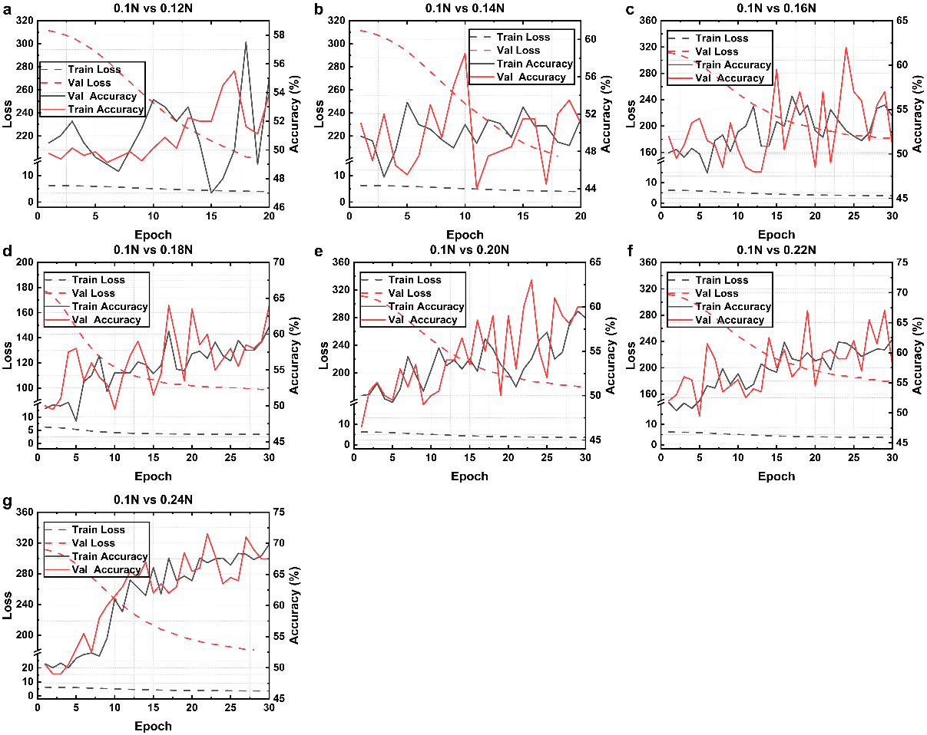
Figure S1. Convergence profiles and model performance for binary classification tasks differentiating pressure magnitudes at 0.02 N intervals. The model was trained and evaluated (detector size: 40, batch size: 64, 30 epochs) to discriminate a baseline pressure of 0.1 N from increasingly distinct pressure states: a, 0.12 N; b, 0.14 N; c, 0.16 N; d, 0.18 N; e, 0.20 N; f, 0.22 N; and g, 0.24 N.

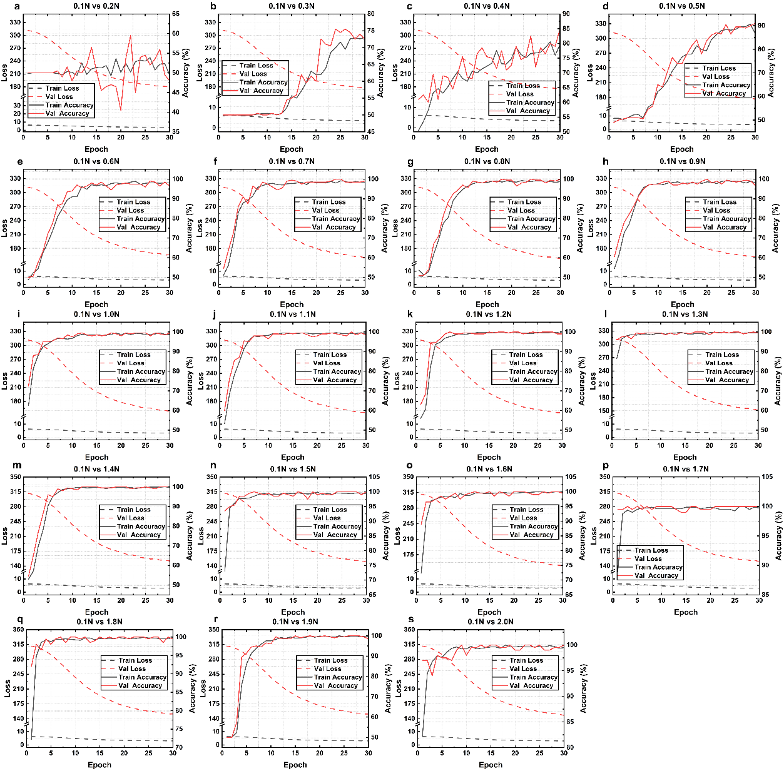
Figure S2. Convergence profiles and model performance for binary classification tasks differentiating pressure magnitudes at 0.1 N intervals. The model was trained and evaluated (detector size: 40, batch size: 64, 30 epochs) to discriminate a baseline pressure of 0.1 N from a sequence of distinct pressure states: a, 0.2 N; b, 0.3 N; c, 0.4 N; d, 0.5 N; e, 0.6 N; f, 0.7 N; g, 0.8 N; h, 0.9 N; i, 1.0 N; j, 1.1 N; k, 1.2 N; l, 1.3 N; m, 1.4 N; n, 1.5 N; o, 1.6 N; p, 1.7 N; q, 1.8 N; r, 1.9 N; and s, 2.0 N.

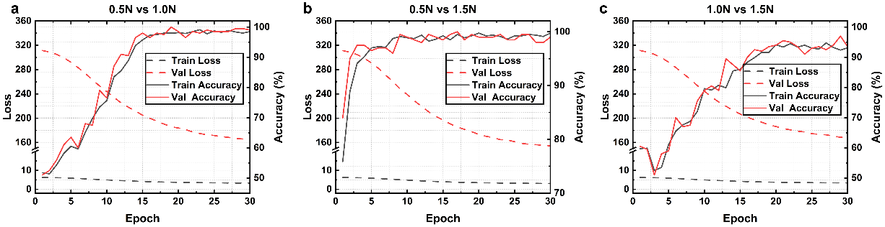
Figure S3. Convergence profiles and model performance for binary classification tasks distinguishing specific pressure pairs. The model was trained and evaluated (detector size: 40, batch size: 64, 30 epochs) to discriminate between the following pressure states: a, 0.5 N vs. 1.0 N; b, 0.5 N vs. 1.5 N; and c, 1.0 N vs. 1.5 N.
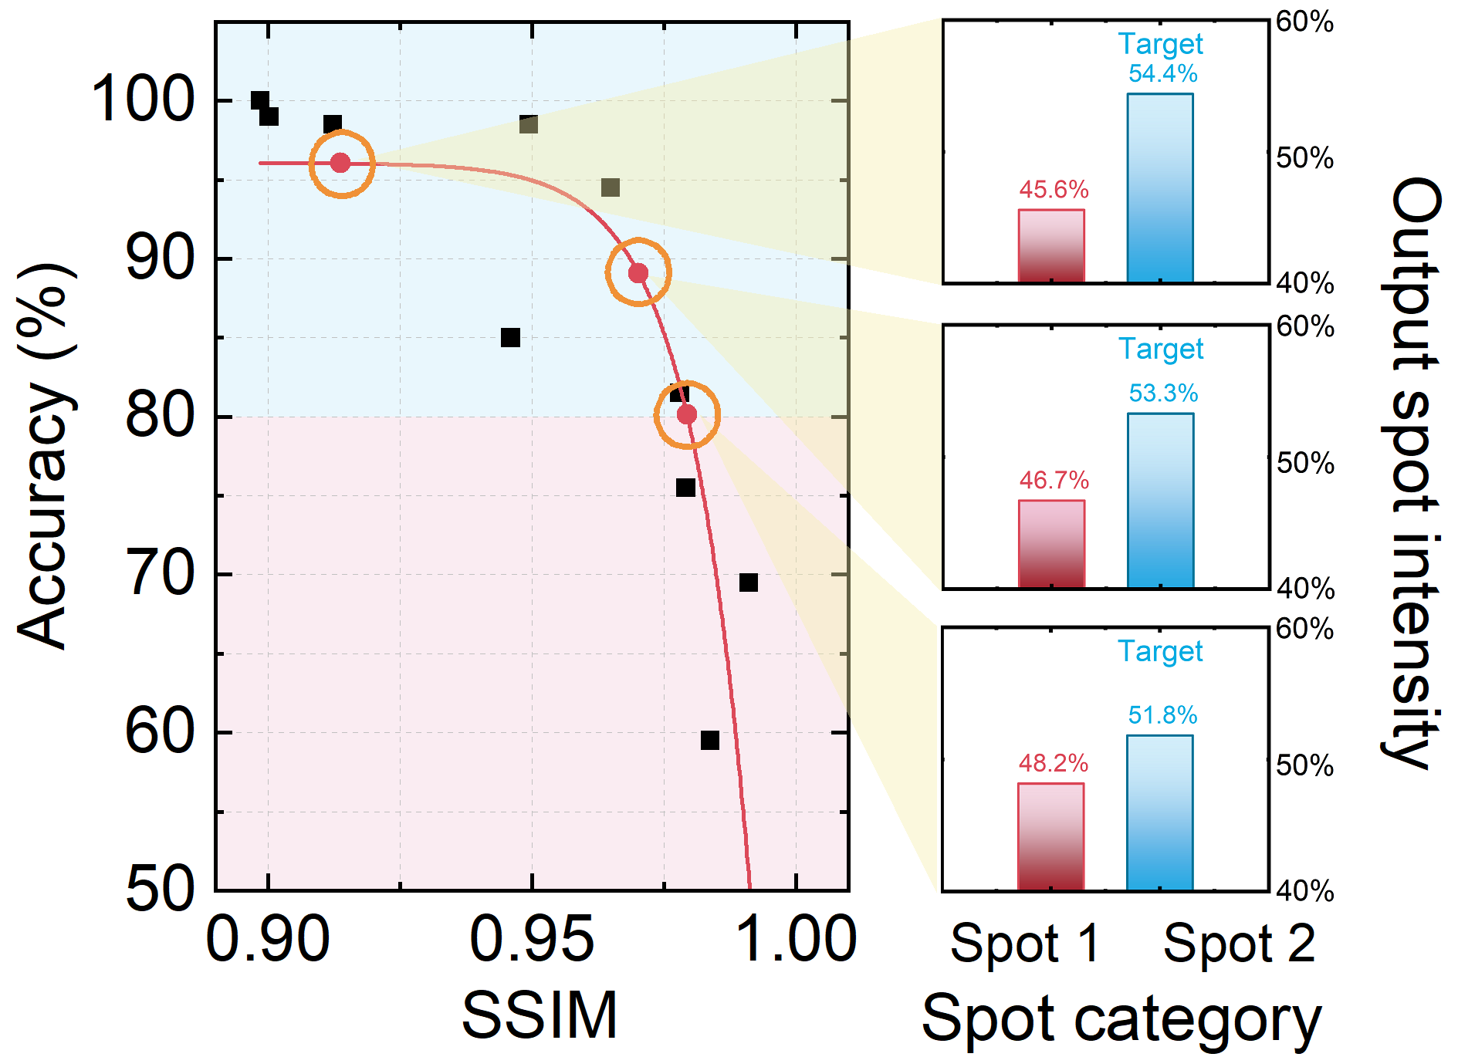
Figure S4. Characterization of the system’s performance limits and discrimination threshold within an extreme binary classification scenario.
As shown in Fig. S4, with the increase in dataset similarity (SSIM)—corresponding to an increase in H(X|Y) and thus C_{task}—the system's classification accuracy exhibits a precipitous decline from near 100%. This trend aligns consistently with the theoretical prediction that the approximation error ε_{approx} scales as a power law of the information density C_{task}/D_{sol}. This agreement confirms that the ratio of physical solution space to task information demand is indeed the governing metric for performance prediction.
Note 2. Mathematical equivalence between geometric discriminant ratio J and conditional entropy H(X|Y)
In the main text, we demonstrate that the SORD framework progressively increases the geometric discriminant ratio, which intrinsically dictates a reduction in the conditional entropy:
$$\begin{aligned}\frac{d_{inter}^{\left(K\right)}}{d_{intra}^{\left(K\right)}}≥\frac{d_{inter}^{\left(0\right)}}{d_{intra}^{\left(0\right)}}, H^{\left(K\right)}\left(X | Y\right)≤H^{\left(0\right)}\left(X | Y\right) \#\left(15\right)\end{aligned}$$
This inverse relationship is not an empirical heuristic assumption but a rigorous mathematical equivalence grounded in information-theoretic learning and multivariate statistics. The detailed analytical derivation, bridging physical geometric metrics to theoretical error bounds is provided below.
Step 1: The total variance constraint and geometric spread
In a high-dimensional optical feature space, the total variance (or total scatter) of the input data, denoted by the matrix S_{t}, is an intrinsic, fixed property of the physical datasets before any specific classification task is applied. According to the law of total variance, S_{t} can be deterministically decomposed into the between-class scatter matrix S_{b} and within-class scatter matrix S_{w}²⁷:
$$\begin{aligned}S_{t}=S_{b}+S_{w} \#\left(16\right)\end{aligned}$$
Taking the trace (which represents the sum of Euclidean squared distances in the feature space) on both sides yields a constant total spread:
$$\begin{aligned}Tr\left(S_{t}\right)=Tr\left(S_{b}\right)+Tr\left(S_{w}\right)=Constant \#\left(17\right)\end{aligned}$$
The classic Fisher discriminant ratio is formally using these variances as $J=Tr\left(S_{b}\right)/Tr\left(S_{w}\right)$²⁷, which corresponds to the squared metric ${(d_{inter}/d_{intra})}^{2}$. Since Euclidean distances are strictly non-negative, maximizing the linear ratio $d_{inter}/d_{intra}$ discussed in the main text is mathematically identical to maximizing the formal ratio J. As the sum $Tr\left(S_{b}\right)+Tr\left(S_{w}\right)$ is strictly constrained by the constant physical input $Tr\left(S_{t}\right)$, any geometric maximization of the ratio J analytically guarantees that the intra-class spread $Tr\left(S_{w}\right)$ (i.e., $d_{intra}^{2}$) must monotonically decrease, while the inter-class separation $Tr\left(S_{b}\right)$ (i.e., $d_{inter}^{2}$) increases.
Step 2: Bridging intra-class spread to manifold volume
For a specific class c, the intra-class geometric spread is defined by the trace of its covariance matrix, $d_{intra, c}^{2}=Tr\left(Σ_{c}\right)=\sum_{i=1}^{D}{λ_{i}}$, where λ_{i} are the D non-negative eigenvalues of ∑_{c}. The geometric volume of this intra-class manifold is proportional to the generalized variance, given by the determinant $\left|Σ_{c}\right|=\prod_{i=1}^{D}{λ_{i}}$²⁸. According to the Arithmetic-Geometric Mean (AM-GM) inequality, the product of these eigenvalues is strictly bounded by their sum. By substituting $d_{intra, c}^{2}$, we obtain a deterministic upper bound for the manifold volume strictly as a function of the scalar intra-class distance:
$$\begin{aligned}{\left(\prod_{i=1}^{D}{λ_{i}}\right)}^{\frac{1}{D}}≤\frac{1}{D}\sum_{i=1}^{D}{λ_{i}}⟹\left|Σ_{c}\right|=\prod_{i=1}^{D}{λ_{i}}≤{\left(\frac{1}{D}\sum_{i=1}^{D}{λ_{i}}\right)}^{D}={\left(\frac{d_{intra, c}^{2}}{D}\right)}^{D} \#\left(18\right)\end{aligned}$$
Therefore, physically compressing the Euclidean intra-class spread $d_{intra}$ strictly constraints and exponentially shrinks the upper bound of the geometric manifold volume |∑_{c}|.
Step 3: Bridging manifold volume to conditional entropy
In information theory, for a continuous D-dimensional random variable, the maximum entropy principle states that the Gaussian distribution yields the maximum differential entropy for a given covariance matrix²⁹. Thus, the class-conditional differential entropy $h(X|Y=c)$ is strictly upper-bounded by the log-determinant of its covariance matrix. Substituting the AM-GM bound derived in Step 1, we obtain:
$$\begin{aligned}h\left(X | Y=c\right)≤\frac{1}{2}\ln{(({2πe)}^{D}\left|Σ_{c}\right|)}≤\frac{1}{2}\ln\left({\left(2πe\right)}^{D}{\left(\frac{d_{intra, c}^{2}}{D}\right)}^{D}\right) \#\left(19\right)\end{aligned}$$
$$\begin{aligned}h\left(X | Y=c\right)≤\frac{D}{2}\ln\left(\frac{2πe}{D}d_{intra, c}^{2}\right) \#\left(20\right)\end{aligned}$$
Since the global conditional entropy H(X|Y) is the expectation of the class-conditional differential entropies over all discrete classes²⁹:
$$\begin{aligned}H\left(X | Y\right)=\sum_{c=1}^{C}{P\left(Y=c\right)h\left(X | Y=c\right)} \#\left(21\right)\end{aligned}$$
Substituting the upper bound of $h(X|Y=c)$ into this equation reveals that a structural compression of the intra-class Euclidean spread $d_{intra, c}^{2}$ (forced by maximizing J in step 1) deterministically forces a strict logarithmic reduction in the global conditional entropy H(X|Y).
Step 4: Bounding the Bayesian classification error
The ultimate impact of compressing H(X|Y) is mathematically mapped to the classification performance P_{e} through information-theoretic error bounds. As rigorously proven by Petridis et al.³⁰, under homoscedastic assumptions, maximizing this geometric Fisher ratio J is analytically identical to maximizing the mutual information I(X;Y) between the features X and the labels Y. According to Shannon’s definition, $I\left(X;Y\right)=H\left(X\right)-H(X|Y)$. Since the total source entropy H(X) of the input optical field is a fixed physical constant, maximizing I(X;Y) is exclusively achieved by minimizing the conditional entropy H(X|Y).
Subsequently, this geometric optimization directly bounds the posterior classification uncertainty. According to the symmetry of mutual information, we have:
$$\begin{aligned}I\left(X;Y\right)=H\left(Y\right)-H\left(Y | X\right) \#\left(22\right)\end{aligned}$$
Rearranging this yields a direct relation between the posterior classification uncertainty H(Y|X) and our physical conditional entropy H(X|Y):
$$\begin{aligned}H\left(Y | X\right)=H\left(X | Y\right)+H\left(Y\right)-H\left(X\right) \#\left(23\right)\end{aligned}$$
For a specific dataset and physical setup, both the prior label entropy H(Y) and the source optical field entropy H(X) are fixed constants. Thus, any geometric reduction in H(X|Y) deterministically dictates a strictly proportional reduction in H(Y|X). Substituting this into the Hellman-Raviv bound³¹ – which fundamentally constrains the Bayesian classification error probability P_{e} – yields an explicit upper bound governed entirely by the physical conditional entropy:
$$\begin{aligned}P_{e}≤\frac{1}{2}H\left(Y | X\right)=\frac{1}{2}\left[H\left(X | Y\right)+H\left(Y\right)-H\left(X\right)\right] \#\left(24\right)\end{aligned}$$
Furthermore, combining this with Fano’s inequality provides a definitive analytical envelope for the classification error³²:
$$\begin{aligned}\frac{H\left(Y | X\right)-H\left(P_{e}\right)}{\log\left(C-1\right)}≤P_{e}≤\frac{1}{2}H\left(Y | X\right) \#\left(25\right)\end{aligned}$$
where C is the number of classes, $H\left(P_{e}\right)≤1 bit$ is the binary entropy function of the error. Substituting our derived expression for H(Y|X) and taking the absolute maximum of $H\left(P_{e}\right)=1$ to linearize the lower bound, we obtain a rigorous theoretical envelope where P_{e} is strictly bounded by linear functions of H(X|Y):
$$\begin{aligned}\frac{H\left(X | Y\right)+H\left(Y\right)-H\left(X\right)-1}{\log\left(C-1\right)}≤P_{e}≤\frac{1}{2}H\left(X | Y\right)+\frac{H\left(Y\right)-H\left(X\right)}{2} \#\left(26\right)\end{aligned}$$
Letting $α_{upper}=1/2$ and $α_{lower}=1/\log{(C-1)}$, the bound simplifies to:
$$\begin{aligned}α_{lower}H\left(X | Y\right)+β_{lower}≤P_{e}≤α_{upper}H\left(X | Y\right)+β_{upper} \#\left(27\right)\end{aligned}$$
This linear envelope explicitly supports the core logic: the conditional entropy H(X|Y) represents the residual information unresolved by the physical optical operators, mathematically acting as the approximation error ε_{approx}. By utilizing dynamic operator selection, the SORD architecture redistributes the constant total covariance S_{t}: it structurally compresses the intra-class manifolds (Tr(S_{w})) to maximize the Fisher ratio J. As proven above, this geometric compression analytical tightens the upper bound of the conditional H(X|Y), which consequently suppresses the theoretical upper bound of the classification error P_{e}, ensuring enhanced task performance without scaling physical network depth.

Note 3. Data distribution complexity reduction via geometry optimization
To rigorously quantify the topological complexity of the 100-class speckle dataset and extend the SORD paradigm to standard computer vision benchmarks (MNSIT/Fashion-MNIST/CIFAR-10), we established a four-stage manifold analysis framework. This pipeline is designed to dissect the intrinsic geometric structure of high-dimensional data, providing the theoretical basis for the hierarchical task decomposition strategy employed in SORD.
1) Manifold preprocessing via spectral decomposition
Directly applying nonlinear manifold learning techniques, such as the common t-SNE approach, to raw high-dimensional data often leads to convergence failures due to the curse of dimensionality and pixel-level noise³³. Principal component analysis (PCA) is first employed as a spectral preprocessing step to extract the dominant signal variance while suppressing the high-frequency noise. By reducing the dimensionality to 50 principal components, we preserve the global topological skeleton of the manifold, ensuring the robustness of subsequent clustering and visualization. Let $X∈R^{n×d}$ denote the centered data matrix. We compute the covariance matrix ∑:
$$\begin{aligned}Σ=\frac{1}{n-1}X^{T}X \#\left(28\right)\end{aligned}$$
Performing eigen-decomposition on ∑ yields the eigenvectors $v_{i}$ and eigenvalues $λ_{i}$: $\sum{v_{i}}=λ_{i}v_{i}$. We select the projection matrix $W=\left[v_{1},…,v_{k}\right]$ corresponding to the top k=50 largest eigenvalues. The projection lower-dimensional representation is given by: X_{new}=XW.
2) Topological visualization via stochastic neighbor embedding
t-SNE is then used to unfold the highly curved and entangled manifolds onto a 2D plane within the reduced PCA space. This probabilistic approach preserves local neighborhood structures, enabling a visual diagnosis of the topological overlaps and entanglement severity that challenge linear classifiers. Specifically, t-SNE minimizes the Kullback-Leibler (KL) divergence between the joint probability distribution P in the high-dimensional and Q in the low-dimensional space. The high-dimensional similarity p_{j|i} is based on Gaussian distribution:
$$\begin{aligned}p_{j|i}=\frac{exp⁡(-{\left\|x_{i}-x_{j}\right\|}_{2}^{2}/2σ_{i}^{2})}{\sum_{k≠i}{\exp\left(-{\left\|x_{i}-x_{k}\right\|}_{2}^{2}/2σ_{i}^{2}\right)}} \#\left(29\right)\end{aligned}$$
Here, the variance $σ_{i}^{2}$ is not a fixed empirical constant; rather, it is uniquely determined for each data point x_{i} via a binary search to match a user-specified parameter called perplexity, which dictates the effective number of local neighbors. To compute the symmetric joint probability for the objective function, we define $p_{ij}=(p_{j|i}+p_{i|j})/2N$, where N is the total number of samples.
To mitigate the crowding problem in the reduced space, the low-dimensional similarity q_{ij} employs a heavy-tailed student’s t-distribution (with 1 degree of freedom):
$$\begin{aligned}q_{ij}=\frac{{\left(1+{\left\|y_{i}-y_{j}\right\|}_{2}^{2}\right)}^{-1}}{\sum_{k≠l}{{\left(1+\left.{\left\|y_{k}-y_{l}\right\|}_{2}^{2}\right.\right)}^{-1}}} \#\left(30\right)\end{aligned}$$
The overall objective function is to minimize the KL divergence C between these two distributions:
$$\begin{aligned}C=\sum_{i}{KL\left(P_{i}∥Q_{i}\right)=\sum_{i}{\sum_{j}{p_{ij}\log{\frac{p_{ij}}{q_{ij}}}}}} \#\left(31\right)\end{aligned}$$
The optimization process utilizes gradient descent to solve this objective function with respect to the low-dimensional coordinates y_{i}. By iteratively updating y_{i}, the algorithm finds the optimal 2D representations that best preserve the high-dimensional manifold topology.
3) Intrinsic geometric affinity and hierarchical structure discovery
To reveal the underlying topological relationships between classes and visualize them as the geometric similarity matrix shown in Figure S6, we first computed the geometric centroid c_{i} for each class i in the reduced PCA space:
$$\begin{aligned}c_{i}=\frac{1}{N_{i}}\sum_{x∈class i}{x} \#\left(32\right)\end{aligned}$$
where N_{i} is the number of samples in class i. Subsequently, we calculated the pairwise Euclidean distance matrix D between these centroids, where $D_{ij}={\left\|c_{i}-c_{j}\right\|}_{2}$ . To convert this distance metric into a bounded similarity measure for heatmap visualization, we applied an inverse transformation:
$$\begin{aligned}S_{ij}=\frac{1}{1+αD_{ij}} \#\left(33\right)\end{aligned}$$
where α is a scaling factor defined as α = 0.1 in our visualizations to optimally normalize the dynamic range of the heatmap. This geometric similarity matrix S (Fisher score as metric) quantitively represents the intrinsic manifold affinity: higher values (darker blue in the heatmap) indicate classes that are geometrically proximate and thus topologically related in the high-dimensional feature space.
Based on this geometric affinity, we employ agglomerative hierarchical clustering using Ward’s method to construct the dendrogram. Unlike other linkage strategies, Ward’s method minimizes the total within-cluster variance. This geometric criterion tends to generate compact, spherical clusters, perfectly aligning with the physical intuition of SORD (as discussed in Supplementary Information Note 2), which actively minimizes intra-class variance ($d_{intra}^{2}$) for optical linear separability. The Ward distance d(i, j) between two clusters i and j is defined as the incremental increase in the error sum of squares (ESS) resulting from the merging of them:
$$\begin{aligned}d\left(i,j\right)=ESS_{i+j}-\left(ESS_{i}+ESS_{j}\right)=\frac{\left|i\right|\left|j\right|}{\left|i\right|+\left|j\right|}{\left\|c_{i}-c_{j}\right\|}_{2}^{2}\#\left(34\right)\end{aligned}$$
where c_{i} and c_{j} are the centroids of clusters i and j, and |i| and |j| denote their respective cardinalities. The resulting dendrogram provides a visual map of the data’s natural grouping hierarchy, serving as a fundamental reference for the subsequent sequential manifold partitioning outcomes.
4) Statistically guided partitioning
Unlike physical datasets where state parameters (e.g., perturbation pressure and location in optical fibers) can serve as natural clustering priors, abstract semantic datasets often lack such explicit physical metadata. To systematically guide the sequential manifold partitioning in these cases, the SORD architecture employs the Fisher discriminant score (J) as a purely statistical optimization metric.
This metric quantifies the linear optical separability of a specific partition by measuring the ratio of inter-class dispersion to intra-class compactness. For a given partition dividing the data into C groups (or sub-tasks), the between-class scatter matrix S_{b} and the within-class scatter matrix S_{w} are rigorously defined using the outer products of the feature vectors:
$$\begin{aligned}S_{b}=\sum_{i=1}^{C}{N_{i}\left(μ_{i}-μ\right){\left(μ_{i}-μ\right)}^{T}} \#\left(35\right)\end{aligned}$$
$$\begin{aligned}S_{w}=\sum_{i=1}^{C}{\sum_{x∈C_{i}}{\left(x-μ_{i}\right){\left(x-μ_{i}\right)}^{T}}} \#\left(36\right)\end{aligned}$$
where μ_{i} is the centroid of group i, N_{i} is the number of samples in group i, μ is the global mean of the partitioned subset, and x represents the D-dimensional sample feature vectors belonging to class C_{i}. As mathematically established in Supplementary Information Note 2, taking the trace of these scatter matrices yields the sum of squared Euclidean distances, corresponding to our geometric metrics $d_{inter}^{2}$ and $d_{intra}^{2}$, respectively. Therefore, the Fisher score J is calculated as the ratio of these traces:
$$\begin{aligned}J=\frac{Tr\left(S_{b}\right)}{Tr\left(S_{w}\right)}=\frac{\sum_{i=1}^{C}{N_{i}{\left\|μ_{i}-μ\right\|}_{2}^{2}}}{\sum_{i=1}^{C}{\sum_{x∈C_{i}}{{\left\|x-μ_{i}\right\|}_{2}^{2}}}}\#\left(37\right)\end{aligned}$$
By explicitly maximizing this Fisher criterion J during hierarchical clustering, the SORD architecture identifies the optimal strategy to decompose a complex 100-class problem with highly entangled, nonlinear global manifold into a sequence of purely linearly separable sub-problems. A higher Fisher score unequivocally indicates a partition that is structurally optimized for linear optical projection. This statistical metric effectively serves as an algorithmic compass, guiding the dynamic routing of the optical field without relying on physical priors. It provides a rigorous methodology to trade temporal degrees of freedom (sequential diffractive layers) for enhanced spatial solvability, definitively proving that algorithmic sequential routing can functionally replace physical nonlinear activation layers across universal semantic tasks.
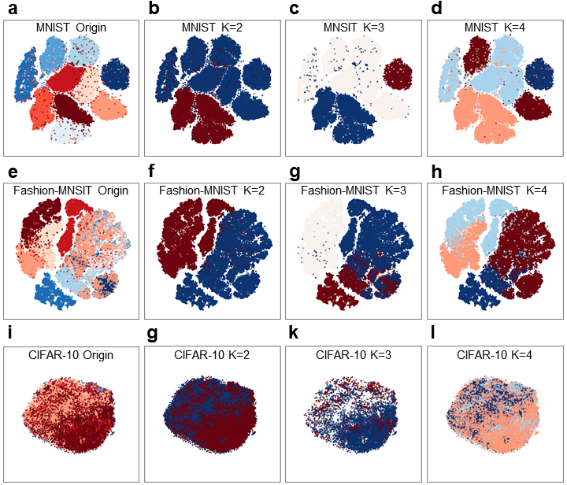
Figure S5. Visualization of manifold topology and Fisher-guided hierarchical partitioning across standard computer vision benchmarks. The t-SNE projections illustrate the intrinsic high-dimensional structure of three datasets and validate the class-grouping strategy employed by the SORD architecture. a-d, MNIST dataset analysis. (a) Global t-SNE distribution of the 10 digit classes, showing relatively distinct clusters. (b-d) Optimal partitioning of the 10 classes into K=2,3, and 4 coarse-grained sub-tasks namely super-classes, respectively. The color coding represents the assignment of specific digits to layer 1 decision regions computed by maximizing the Fisher score to ensure optimal linear separability. e-h, Fashion-MNSIT dataset analysis. (e) Global distribution exhibiting higher manifold complexity and class overlap compared to MNIST. (f-h) Corresponding Fisher-optimal partitions for K=2,3,4, effectively grouping structurally similar clothing items to simplify the primary classification boundary. i-l, CIFAR-10 dataset analysis. (i) Global distribution revealing severe topological entanglement and high-intra-class variance, indicative of the high task C_{task}. (j-l) Fisher-guided partitions K=2,3,4 that strategically group topologically related classes in the distribution space to facilitate robust hierarchical optical inference.

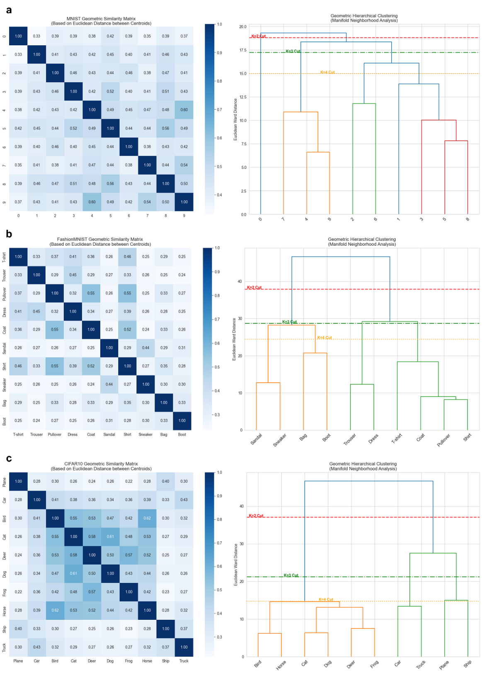
Figure S6. Geometric similarity matrices and hierarchical clustering dendrograms. This figure visualizes the intrinsic geometric relationships between classes, which serve as the basis for the SORD partitioning strategy. The left column shows the geometric similarity matrix derived from Euclidean distances between class centroids in the PCA feature space, where darker blue indicates higher affinity. The right column displays the corresponding hierarchical clustering dendrogram using Ward’s linkage, with dashed lines indicating the optimal cut levels for K=2 (red), K=3 (green) and K=4 (yellow) partitions. a, MNIST dataset. The dendrogram reveals a natural grouping of morphologically similar digits, guiding the system to process them in the same sub-branch. b, Fashion-MNIST dataset. Distinct clusters emerge, reflecting semantic categories. c, CIFAR-10 dataset. The analysis separates different groups, confirming that the geometric clustering successfully captures high-level semantic structures even in complex natural image datasets.

Note 4. Quantitative manifold rectification analysis via distance distribution overlap.
To objectively verify the manifold rectification capability of the SORD architecture, especially its ability to reduce the task complexity by decomposing the global manifold into sub-manifolds, we developed a quantitative metric based on the overlap of feature distance distributions.
- Monte carlo pairwise sampling strategy
Calculating the full pairwise distance matrix for the large datasets is computationally prohibitive O(N²) complexity. To efficiently approximate the true manifold geometry, a monte carlo sampling strategy is employed. Specifically, we randomly sampled N_{pairs}=500000 pairs of data points (x_{i}, x_{j}) from the PCA-reduced feature space (50 dimensions). For a specific partitioning strategy like random vs. geometric partitioning, we categorized these pairs into two sets based:
Intra-group set D_{intra}: Pairs belonging to the same partition group (y_{i}=y_{j}). These represent the local geometric compactness within a sub-manifold.
Inter-group set D_{inter}: Pairs belonging to different partition groups (y_{i}≠y_{j}). These represent the global separation between sub-manifolds.
The Euclidean distance d for each pair is calculated as:
$$\begin{aligned}d_{ij}={\left\|x_{i}-x_{j}\right\|}_{2}\#\left(38\right)\end{aligned}$$
2) Probability density function (PDF) estimation
To enable a fair comparison between the intra- and inter-group distributions regardless of their sample counts, we normalized the raw frequency histograms into PDFs. Let H(d) be the histogram of distances with bin width ∆w. The probability density function P(d) is defined such that the integral over the entire distance domain equals 1:
$$\begin{aligned}\int_{0}^{∞}{P\left(d\right)dd=1} \#\left(39\right)\end{aligned}$$
In our discrete implementation (with 100 bins), the density value for the k-th bin is calculated as:
$$\begin{aligned}P\left(d_{k}\right)=\frac{{Count}_{k}}{N_{total}∙∆w} \#\left(40\right)\end{aligned}$$
where N_{total} is the total number of sampled pairs in the respective set.
3) Overlap coefficient calculation
The distribution overlap area (OA), visualized as the purple intersection regions, serves as our quantitative proxy for linear inseparability. A high overlap indicates that the local geometry (intra) is indistinguishable from the global geometry (inter), implying severe entanglement. A low overlap indicates that the sub-manifolds are distinct and rectified. Mathematically, the overlap area is calculated as the intersection of the two probability densities, P_{intra}(d) and P_{inter}(d):
$$\begin{aligned}OA= \int_{0}^{∞}{\min\left(P_{intra}\left(x\right),P_{inter}\left(x\right)\right)dx} \#\left(41\right)\end{aligned}$$
In the discrete domain, this integral is computed as the sum of the minimum density values across all bins:
$$\begin{aligned}OA≈\sum_{k=1}^{100}{\min\left(P_{intra}\left(d_{k}\right),P_{inter}\left(d_{k}\right)\right)∙∆w} \#\left(42\right)\end{aligned}$$
4) Interpretation of results
As evidenced in Fig. 2, the random partitioning strategy yields near-total overlap (e.g. OA≈97% for MNIST), confirming that arbitrary cuts fail to disentangle the high-dimensional knot. In contrast, the SORD geometry-guided partitioning significantly shifts the P_{intra} distribution towards zero (smaller local distances) and pushes P_{inter} to higher values, minimizing the overlap (e.g., reducing OA to 73% for MNIST). This dramatic reduction in distribution overlap quantitively confirms that SORD effectively unfolds the entangled global manifold. From a topological perspective, this precise manifold unfolding is a geometric transformation traditionally achievable only through the application of physical non-linearities in wave optics. By algorithmically isolating categories into distinct, localized sub-manifolds, SORD inherently guarantees a high SNR and absolute linear separability for the subsequent linear optical decision layers, validating its capability to synthetically bridge the nonlinear gap.
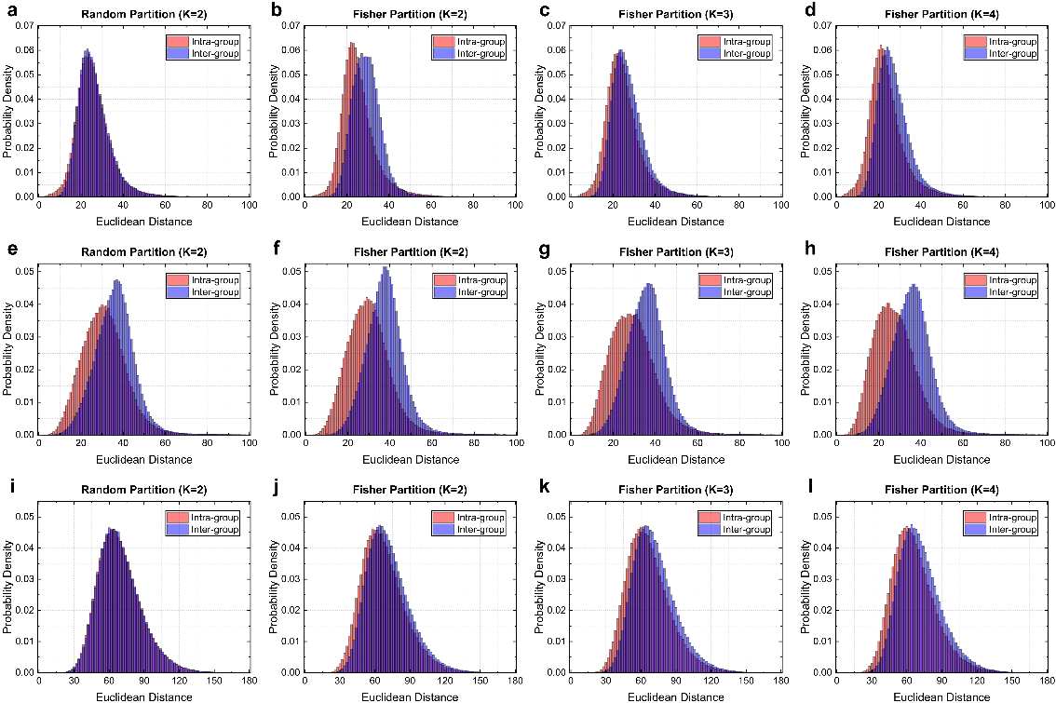
Figure S7. Probability density analysis of feature distance distributions across grouping strategies. A granular view of the manifold rectification effect by visualizing the PDFs of intra-group (red) and inter-group (blue) feature distances. The overlap area (purple intersection) serves as a quantitative proxy for linear inseparability. a-d, MNIST dataset. (a) Random partitioning (K=2) results in nearly identical distributions with extensive overlap, indicating high ambiguity. (b-d) Geometry-based partitioning for K=2, 3, 4 progressively shifts the intra-group distribution towards zero and separates it from the inter-group distribution, significantly reducing the overlap area and enhancing linear separability. e-h, Fashion-MNIST. Similar to MNIST, the random grouping (e) exhibits severe entanglement. The optimized geometric partitions (f-h) successfully disentangle the manifold, with the K=2 strategy (f) showing the most distinct separation between local compactness and global dispersion. i-l, CIFAR-10 dataset. Despite the higher complexity, the geometric partitioning strategies (j-l) consistently reduce the distributional overlap compared to the random partitioning (i), confirming the robustness of the SORD manifold unfolding mechanism even in complex semantic feature spaces.

Note 5. Training convergence and classification performance of single-layer ONN on standard computer vision datasets.
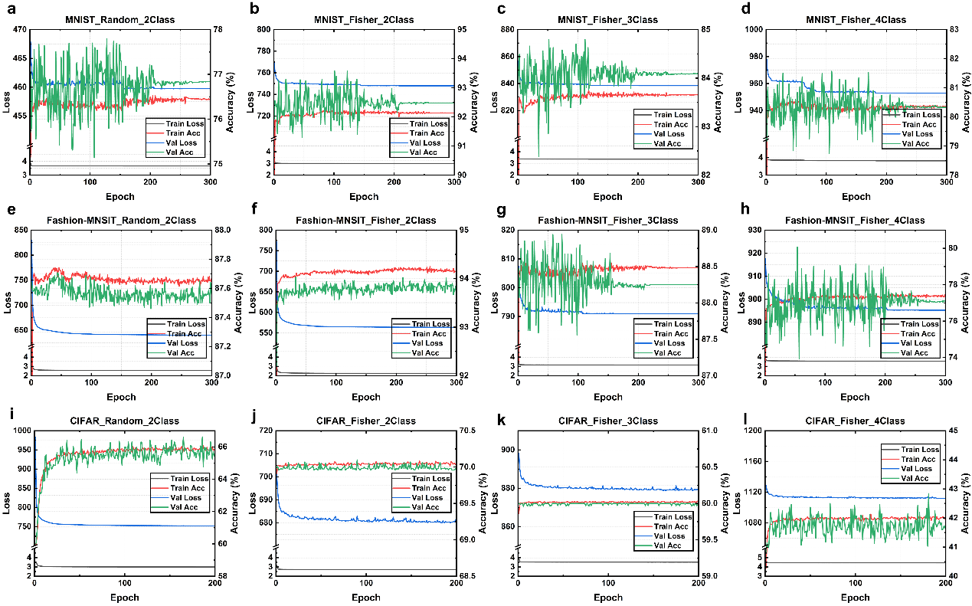
Figure S8. Training dynamics and convergence analysis of the SORD first-layer classification across standard vision benchmarks. The training loss and validation accuracy curves demonstrate the stability and performance of different manifold partitioning strategies on MNIST, Fashion-MNIST, and CIFAR-10 datasets. All models utilized a consistent first-layer configuration (detector size: 40, batch size: 256). a-d, Convergence profiles on the MNIST dataset over 300 epochs, comparing the random K=2 (a) against geometry-based (Fisher score-verified) partitioning with K=2 (b), K=3 (c), and K=4 (d). e-h, Corresponding analysis for the Fashion-MNIST dataset over 300 epochs, illustrating the performance gain of geometric partitioning (f-h) over random grouping (e). i-l, Training trajectories for the CIFAR-10 dataset over 200 epochs. Despite the higher complexity of CIFAR-10, the geometric partitioning strategies (j-l) consistently outperform the random grouping (i) in terms of validation accuracy and training stability.

Note 6. Fabrication of the sensing end of the experimental ONN system
There are two main parts of the sensing end: the optical fiber sensor and the pressing testing platform.
The optical fiber sensor consists of a twisted single-mode fiber (Corning, SMF-28e) embedded within a polydimethylsiloxane (PDMS) film. We constructed a fiber twisting platform to precisely control the fabrication process. As shown in Fig. S9, the fiber was clamped by two fiber rotators (Thorlabs, HFR007) and twisted until the desired twist period was achieved. A glass slide coated with a PDMS film was positioned on a mounting platform. Once the fiber was twisted to the target angle, the platform was raised until the fiber contacted the PDMS film. Hot-melt adhesive was applied to secure the twisted fiber, after which the structure was released from the stage. Finally, uncured PDMS was poured onto the setup to fully encapsulate the fiber.

Figure S9. The photograph of the custom-built fiber twisting platform.
The pressure testing platform comprises a motorized 3-axis translation stage, a commercial 3D force sensor, and a tungsten probe, all positioned above a manually adjustable sample stage. The probe is rigidly mounted to the commercial force sensor and driven by the motorized translation stage to exert localized pressure on the optical fiber sensor. Real-time force data is transmitted to a host computer, enabling precise control over the loading position simultaneous with force monitoring.
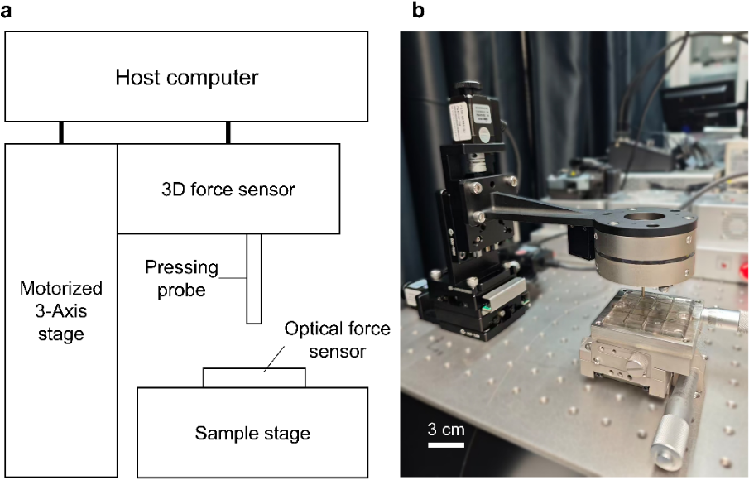
Figure S10. a, Schematic diagram of the pressure testing system. b, Photograph of the experimental setup.
Note 7. Analysis of the stability of the sensing end of the ONN system
In the pressure testing system, the pressing force is applied by driving the probe into the sensor using the 3-axis motorized stage, where the magnitude of the load is modulated directly by the pressing depth. Given the extreme sensitivity of fiber sensor to environmental stress, validating the capability of the system to exert stable stress is critical.
Fig. S11 illustrates the force fluctuations across six conditions, comprising an unloaded baseline and five distinct pressure levels. The system demonstrated excellent stability; specifically, the 3σ values deviation was maintained between 0.01 to 0.017 N throughout the 5 minutes testing period. Additionally, the Supplementary Information Video S1 shows the evolution of the fiber output over a 24-hour period.
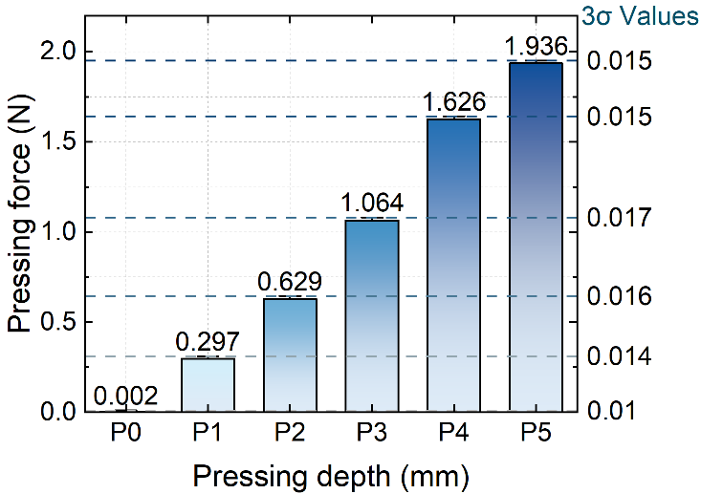
Figure S11. Force stability analysis (3σ)

Note 8. Finite element analysis of optical fields in twisted fibers
In an ideal, untwisted step-index multimode fiber, the linearly polarized (LP) modes propagate orthogonally within degenerate mode groups, maintaining negligible inter-modal coupling due to the waveguide’s cylindrical symmetry. Introducing mechanical torsion disrupts this equilibrium by generating a non-uniform azimuthal shear stress distribution across the fiber cross-section. Through the elasto-optic effect, this stress induces a rotation of the refractive index tensor (or permittivity tensor), creating a helical perturbation along the optical axis. This symmetry breaking acts as a highly efficient continuous mode mixer. This perturbation lifts the degeneracy of the LP modes and induces significant energy redistribution among mode groups, facilitating coupling between LP modes and orbital angular momentum (OAM) vortex modes. Consequently, the output speckle pattern formed by the complex interference of these excited modes, becomes hypersensitive to fiber deformations. By mapping subtle physical changes to distinct variations in intensity distribution, this mechanism constructs a high-dimensional, non-linear, and deterministic feature space for classification tasks.
Table S6. Parameters used in the finite element method (FEM) simulations.
Parameter Category | Parameter Name | Symbol | Value | Unit
Geometry | Core radius | r_{core} | 4.1 | μm
Geometry | Cladding radius | r_{clad} | 62.5 | μm
Geometry | Simulation length | L | 100 | μm
Optical properties | Wavelength | λ | 532 | nm
Optical properties | Core refractive index | n_{core} | 1.45 | N/A
Optical properties | Cladding refractive index | n_{clad} | 1.444 | N/A
Mechanical &  Elasto-optic | Photoelastic Constant | p₁₁ | 0.27 | N/A
Mechanical &  Elasto-optic | Photoelastic Constant | p₁₂ | 0.12 | N/A
The SMF-28e fiber with core radius r_{core}≈4.1 µm, core refractive index n_{core}=1.45, cladding refractive index n_{clad}=1.444, and the operating wavelength λ= 532 nm. The normalized frequency V and mode volume estimation M is defined as below:
$$\begin{aligned}V=\frac{2πr_{core}}{λ}∙NA=\frac{2πr_{core}}{λ}\sqrt{n_{core}^{2}-n_{cladding}^{2}}\#\left(43\right)\end{aligned}$$
$$\begin{aligned}M≈\frac{V^{2}}{2}\#\left(44\right)\end{aligned}$$
By substituting these parameters into Eqs. (28) and (29), the normalized frequency V of the fiber is calculated to be approximately 6.38 at 532 nm. This value indicates that the fiber supports approximately 20 guided modes. Due to the distinct propagation constants of these excited modes, significant multimode interference occurs, resulting in the characteristic speckle patterns observed at the fiber output.
To quantify the internal state of the twisted fiber, we performed finite element method (FEM) simulations using COMSOL Multiphysics (solid mechanics module and waveguide optics) with parameters shown as Table S6. When the fiber is subjected to a torsion rate of $α$ (rad/m), a complex stress field distribution $σ(x,y)$ is generated within the fiber core and cladding. According to the photoelastic effect, this mechanical stress induces a change in the refractive index tensor, described by:
$$\begin{aligned}∆n_{ij}=-\frac{n_{0}^{3}}{2}\sum_{k=1}^{3}{\sum_{l=1}^{3}{p_{ijkl}ϵ_{kl}}}\#\left(45\right)\end{aligned}$$
where $n_{0}$ is the refractive index of the unstressed silica, $p_{ijkl}$ represents the strain-optic tensor, and $ϵ_{kl}$ denotes the strain tensor.
The simulation results reveal that geometric twisting induces a non-circularly symmetric shear stress distribution, creating a quadrupole-like perturbation in the refractive index profile (Fig. S12a). Physically, this strong torsion stress breaks the degeneracy of standard LP modes and induces significant spin-orbit interaction, favoring the propagation of optical vortex modes compatible with the helical geometry (Fig. S10b). Mode analysis demonstrates that this perturbation exerts a discriminative effect on fiber modes: as the twist period decreases (i.e., twist rate increases), the confinement loss for higher-order modes (HOMs) increases significantly, forcing them to radiate into the cladding (i.e. leaky modes).
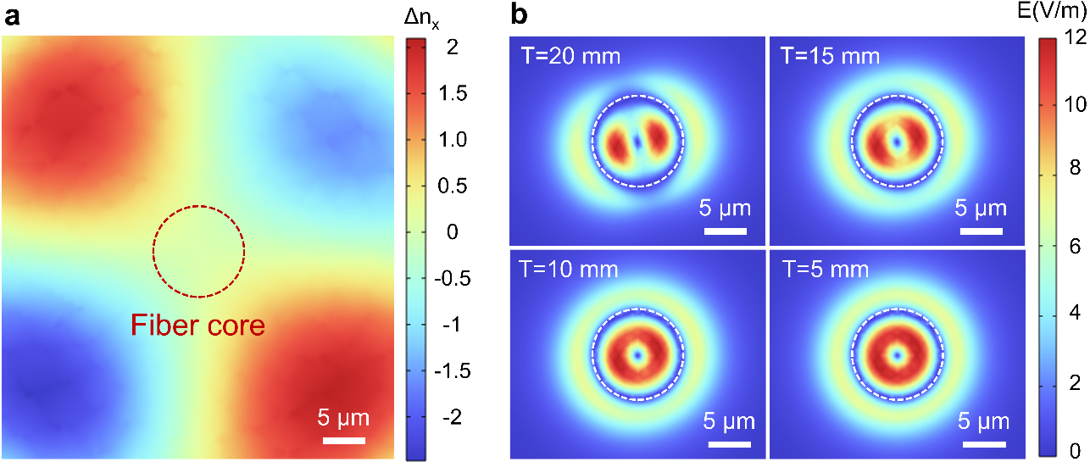
Figure S12. a, Cross-sectional refractive index perturbation (Δn_{x}) of a SMF-28E fiber with twist period of 5 mm. b, Simulation of mode evolution in the twisted fiber with an effective refractive index of 1.445.
Note 9. Forward propagation model based on the scalar wave theory of light
The forward propagation mechanism within the SORD framework is modeled using classical scalar diffraction theory, where each computational stage follows the principle of a DONN. In this architecture, the programmable SLM functions as a reconfigurable modulation plane, with its phase mask weight matrix dynamically updated to execute specific logical operations. Upon propagation through the collimation and beam-expansion optics, the coherent wavefront undergoes spatially variant phase modulation at the SLM plane. This process effectively implements a fully-connected linear transformation between the input nodes and the output intensity distribution at the detector plane, governed by free-space Fresnel diffraction. The receptive field and the effective degrees of freedom (DoF) of each optical neuron are determined by the pixel pitch of the SLM, the propagation distance, and the numerical aperture of the system.
In this diffractive framework, the complex-valued summation of the optical field is physically performed through interference. It is important to note that while square-law detection at the sensor plane, which converts incident complex amplitudes into measurable intensities, inherently provides a terminal nonlinear projection, a single final stage non-linearity is mathematically and practically insufficient to untangle highly complex, non-convex data manifolds. Traditional deep optical networks attempt to solve this by inserting physical all-optical nonlinear activation functions like nonlinear optical materials between consecutive propagation layers. This SORD architecture fundamentally bypasses this requirement. By temporally multiplexing these strictly linear diffractive layers on a single SLM, the system progressively rectifies and linearizes the localized sub-manifolds before they even reach the final detection plane. Consequently, SORD achieves a deep, high-order feature mapping and hierarchical inference using purely linear intermediate optical operations, maintaining a compact single-layer physical footprint while extremely eliminating the severe optical losses and probable massive energy consumption associated with inter-layer nonlinear materials.
The unit input at the (x, y) coordinate of the captured optical fiber speckle image input plane, denoted as $I_{in}(i,j)$, is encoded into the amplitude of the coherent input optical field $U_{in}$. After padding the image up to the computation grid size to avoid the edge aliasing within the calculation and assuming a plane wave illumination with a constant phase $θ_{0}=0$, the complex field can be formulated as $U_{in}\left(x,y\right)=\sqrt{I_{in}\left(x,y\right)}$. The optical field of each input nodes is modulated with the corresponding element on the phase of SLM and connected to the output through diffraction, thus the transmitted optical field $U_{\text{mod}}$ can be represented as $U_{\text{mod}}\left(x,y\right)=U_{\text{in}}\left(x,y\right)⋅t\left(x,y\right)=U_{\text{in}}\left(x,y\right)⋅e^{jϕ\left(x,y\right)}$. This field is modulated by the first phase mask layer. The transmission function of the k-th diffractive layer (k=1, 2, 3 corresponding to the hierarchical of SORD) can be described as $t_{\text{k}}\left(x,y\right)=exp(jϕ_{k}\left(x,y\right))$, where $ϕ_{k}\left(x,y\right)$ denotes the trainable phase parameter at position $\left(x,y\right)$. The propagation process of light from phase mask SLM to the detector plane follows the Rayleigh-Sommerfield diffraction integration, which provides a rigorous solution to the Helmholtz equation for scalar waves, the optical field $U_{\text{out }}\left(x,y\right)$ at a distance z can be expressed at the superposition of spherical waves emanating from every point on the input plane²:
$$\begin{aligned}U_{\text{out }}\left(x',y'\right)=\frac{1}{jλ}\iint_{-∞}^{+∞}{U_{mod}\left(x,y\right)\frac{\exp\left(jkr\right)}{r}\cos{θ}dxdy}\#\left(46\right)\end{aligned}$$
where $λ$ is the working wavelength of the perception system, $k=2π/λ$ is the wavenumber, $\left(x,y\right)$ are coordinates on the source plane, $r=\sqrt{{\left(x'-x\right)}^{2}+{\left(y'-y\right)}^{2}+z^{2}}$ is the Euclidean distance, and $cosθ=z/r$ the obliquity factor. Furthermore, directly calculating the above integral in theoretical training has a computational complexity of $O(N^{4})$, which is prohibitive for training. The angular spectrum method is used to convert the spatial operation to the frequency multiplication by convolution theorem whose complexity is only O(N²logN). The above Eq. (4) can be recognized as a linear spatial convolution:
$$\begin{aligned}U_{\text{out }}\left(x,y\right)=U_{\text{mod }}\left(x,y\right)*h\left(x,y\right)\#\left(47\right)\end{aligned}$$
where $h\left(x,y\right)=\frac{1}{2π}\frac{z}{r}\left(\frac{1}{r}-jk\right)\frac{\exp\left(jkr\right)}{r}$ is the impulse response of free space. According to the convolution theorem, the Fourier transform of the output field is the product of the Fourier transform of the input field and the transfer function of free space $H\left(f_{x},f_{y}\right)=F\{h\left(x,y\right)\}$ . The transfer function $H\left(f_{x},f_{y}\right)$is derived by substituting the plane wave expansion $A\left(f_{x},f_{y}\right)e^{j2π\left(f_{x}x+f_{y}y\right)}e^{jk_{z}z}$ into the Helmholtz equation $(∇^{2}+k^{2})U=0$, leading to the dispersion relation $k_{x}^{2}+k_{y}^{2}+k_{z}^{2}=k^{2}$. Thus, the propagation kernel in the frequency domain is:
$$\begin{aligned}H\left(f_{x},f_{y}\right)=e^{jk_{z}z}=\exp\left(j2πz\sqrt{\frac{1}{λ^{2}}-f_{x}^{2}-f_{y}^{2}}\right) \#\left(48\right)\end{aligned}$$
where A is the field amplitude, f_{x} and f_{y} are spatial frequencies. To ensure physical accuracy, evanescent waves (i.e., $f_{x}^{2}+f_{y}^{2}>1/λ^{2}$) are filtered out or treated as non-propagating decaying terms. Therefore, the diffractive propagation in our forward model is computed as:
$$\begin{aligned}U_{\text{out }}\left(x,y\right)=F^{-1}\left\{F\left\{U_{mod}\left(x,y\right)\right\}⋅H\left(f_{x},f_{y}\right)\right\} \#\left(49\right)\end{aligned}$$
where ℱ and ℱ⁻¹ denote the fast Fourier transform (FFT) and Inverse FFT, respectively. The final result $U_{out}(x,y)$ is the complex amplitude distribution of the target plane at a distance of z after diffractive modulation, the squared modulus of which represents the light intensity pattern received by the detector $I_{final}\left(x,y\right)={{|U}_{out}\left(x,y\right)|}^{2}$. Training the perception system with an error backpropagation algorithm requires a differentiable objective function. To simultaneously ensure the physical quality of the focused spot and the accuracy of the decision boundary, mean square error is used to construct the loss function L_{MSE}, imposing a strict pixel-level constraint that not only requires correct classification but also enforces the convergence of light energy into an ideal geometric shape in spatial distribution.
$$\begin{aligned}L_{\text{MSE}}=\frac{1}{N}\sum_{i=1}^{N}{{\left\|I_{\text{norm}}^{\left(i\right)}-M_{\text{target}}^{\left(y_{i}\right)}\right\|}_{F}^{2}} \#\left(50\right)\end{aligned}$$
where L_{MSE} enforces the spatial energy distribution to match the predefined target intensity pattern M_{target}, ensuring high signal-to-noise ratio and thus optimizes the categorization probability. This is crucial for enhancing the robustness of optical computing in noisy environments.

Note 10. The changes of dynamic light intensity ratio during the pressure process
To further investigate the dynamic response of the system, we monitored the optical signal variations under continuous loading. As shown in Fig. S13, the light intensity at Position 3 exhibits a distinct change corresponding to the applied pressure. This dynamic behavior validates the end-to-end functionality of the integrated system, confirming that the tactile signals are successfully mapped onto the SLM and processed optically on the result plane. And there is a Supplementary Information Video S2 to show the dynamic modulation process.
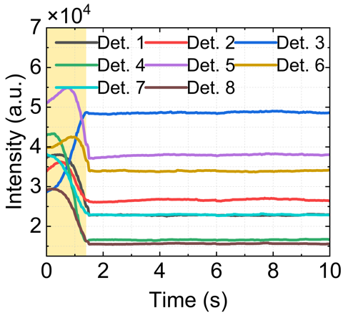
Figure S13. Dynamic light intensity change diagram during the pressure process at position 3.

Note 11. Data distribution of 100-class speckle task after geometry partitioning
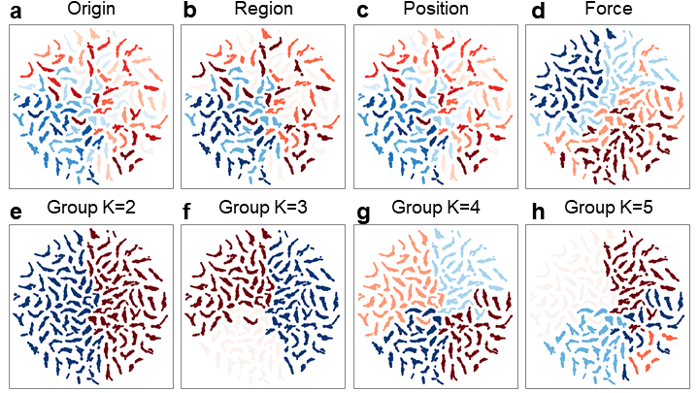
Figure S14. Comparative t-SNE manifold analysis: Physical intuition versus Fisher-guided algorithm partitioning. The visualization contrasts the manifold topology labeled by explicit physical priors against the data-driven grouping derived from the Fisher score, revealing distinct structural insights. a-d, Physical attribute mapping. (a) Global t-SNE distribution of the 100-class speckle dataset. (b) Distribution labeled by physical region (5 macroscopic zones), showing naturally clustered structures that guided our initial coarse-to-fine strategy. (c-d) Distributions labeled by subordinate attributes (position and force), appearing scattered and entangled within the global view. e-h, Fisher-guided algorithmic partitioning. These panels display the optimal super-class assignments computed by maximizing the Fisher score for (e) K=2, (f) K=3, (g) K=4, and (h) K=5 subsets. Notably, the algorithmic partition for K=5 (h) yields a grouping strategy distinct from the physical region map (b). Unlike the spatially contiguous physical regions, the Fisher-guided approach clusters classes based on statistical separability in the feature space. This divergence suggest that the SORD architecture is not limited to physics-driven heuristics; it functions as a robust, data-driven paradigm capable of discovering alternative high-dimensional manifold cuts to resolve entanglement, offering a pathway to potentially superior accuracy beyond human intuition.

Note 12. Data distribution analysis of the 100-class speckle dataset
To deeply probe the entanglement mechanism between spatial position and mechanical force within the speckle manifold, we performed a differential PSD analysis to quantify the spectral footprint of these two physical variables and explain the difficulty of separating them using a single linear transform.
1) Differential image construction
To isolate the dynamic spectral components from the static fiber mode background, we computed differential images representing pure position variation ∆I_{pos} and pure force variation ∆I_{force}:
Position difference (contextual background): $∆I_{pos}=I\left(x+∆x,F\right)-I(x,F)$
Force difference (signal perturbation): $∆I_{force}=I\left(x,F+∆F\right)-I(x,F)$
2) Radial PSD and spectral overlap analysis
We computed the azimuthally averaged radial PSD, P(r), for both differential sets:
$$\begin{aligned}P\left(r\right)=\frac{1}{2πr}\int_{0}^{2π}{{\left|F\{ΔI\}\left(r,θ\right)\right|}^{2}dθ} \#\left(51\right)\end{aligned}$$
3) Analysis of spectral entanglement
Unlike simple multi-scale systems where features occupy distinct frequency bands, our analysis in Fig. S15 reveals a critical spectral overlap. The PSD of ∆I_{pos} exhibits a broadband distribution resembling white noise. This indicates that a change in position effectively re-randomizes the global phase relationship, acting as a high-entropy contextual background. And the PSD of ∆I_{force} shows a spectral profile that is highly congruent with and superimposed upon the position spectrum. The spectral centroids of both variables are proximally located, implying that force information is not isolated in separate frequency band but is embedded within the spatial context. This severe spectral entanglement mathematically prohibits simple frequency-domain filtering like a high-pass filter from separating force from position, necessitating the context-aware hierarchical decomposition strategy employed by SORD.
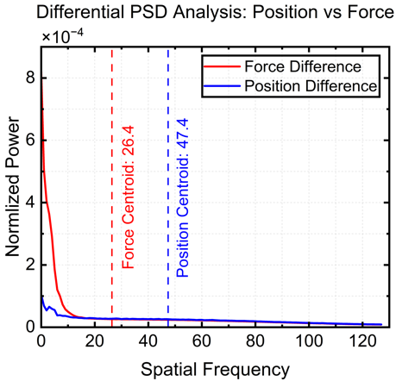
Figure S15. Spectral entanglement analysis between spatial context and force perturbation. The differential PSD profiles reveals a significant frequency-domain overlap between the two physical variables. The position difference in blue line exhibits a broadband, quasi-white noise distribution with a higher spectral centroid C_{spec}≈47.4, indicating that spatial displacement induces a global high-entropy reconfiguration of the speckle field acting as a contextual background. In contrast, the force difference in red line manifests as spectrally concentrated perturbation with a lower centroid C_{spec}≈26.4. This observation confirms that force information is deeply embedded within the broadband spatial context rather than occupying a distinct frequency band, thereby necessitating the hierarchical strategy employed by the SORD architecture.

Note 13. Training convergence and classification performance for speckle classification tasks
According to the priori ONN performance in classifying the few numbers of speckle types, the static single-layer ONN can easily meet these requirements. Fig. S16 and S17 show the convergence and classification performance for the 4-class and 8-class classification tasks with different hyperparameters in training, respectively. However, if the difficulty of task is increased to the level of a 100-class classification task, the SORD framework needs to be used to complete this task and improve the performance. The details of training and performance are shown in the below Fig. S18.
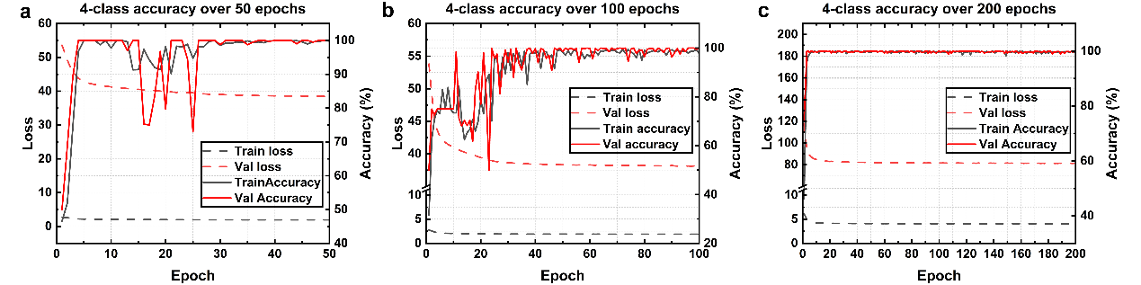
Figure S16. Convergence profiles and performance evaluation for the 4-class classification task across varying training epochs. The plots illustrate the training and evaluation trajectories of the model under distinct epoch configurations: a, 50 epochs; b, 100 epochs; and c, 200 epochs.
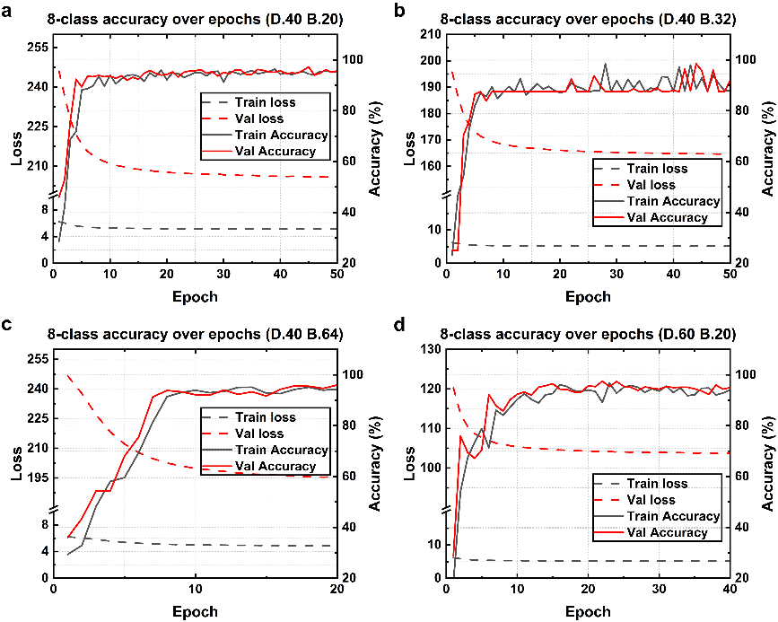
Figure S17. Convergence profiles and model performance for the 8-class classification task under distinct hyperparameter configurations. The panels illustrate training and evaluation outcomes based on varying combinations of detector size and batch size: a, detector size 40, batch size 20; b, detector size 40, batch size 32; c, detector size 40, batch size 64; and d, detector size 60, batch size 20.
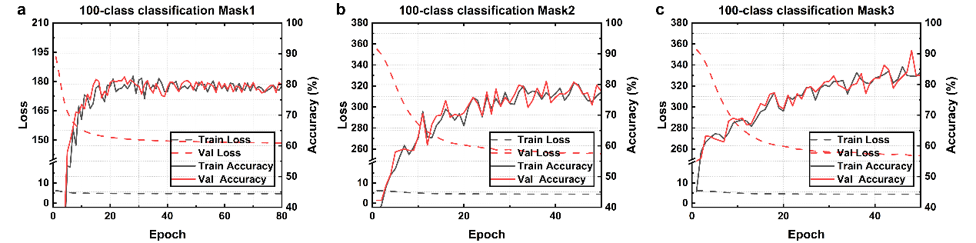
Figure S18. Convergence profiles and model performance for the hierarchical 100-class classification task. The model was trained and evaluated on the 100-class dataset (detector size: 40) across three sequential stages with distinct hyperparameter configurations: a, layer 1 (mask f₁) trained with a batch size of 256 over 80 epochs; b, the specific layer 2 branch for region A₃ (mask f_{1,3}) trained with a batch size of 128 over 50 epochs; and c, the specific layer 3 branch for point P_{3,4} (mask f_{1,3,4}) trained with a batch size of 64 over 50 epochs.

Note 14. Training convergence and classification performance of single-layer ONN based on SORD for the HCI task

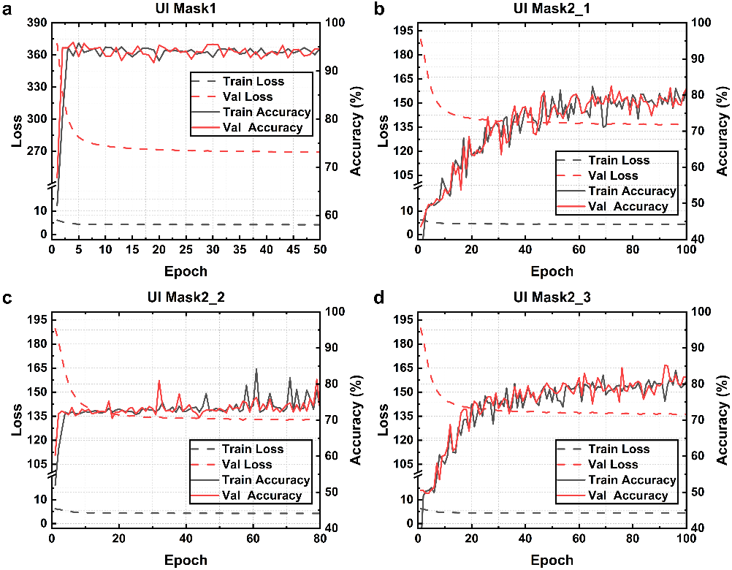
Figure S19. Convergence profiles and model performance for the real-time HCI task. The model was trained and evaluated on the HCI dataset (detector size: 40) under specific hyperparameter configurations for each hierarchical branch: a, user interface (UI) 1, trained with a batch size of 128 over 50 epochs; b, UI 2_1 corresponding to pose 1, trained with a batch size of 64 over 100 epochs; c, UI 2_2 corresponding to pose 2, trained with a batch size of 64 over 80 epochs; and d, UI 2_3 corresponding to pose 3, trained with a batch size of 64 over 100 epochs.

Note 15. Performance of the perception system with SORD framework
• Equivalent operations per second and total end-to-end classification time
The computing speed and energy efficiency of the all-optical brain-inspired perception system based on DONN architectures are calculated based on the time cost and energy consumption, respectively. The evaluation of the system’s computing performance is based on the total operations (OPs) required to complete a single full inference, covering both optical operations and electronic operations and the equivalent real-number operations of floating point operations (FLOPs) is adopted as the standard unit of measurement.
• Optical operations R_{o}
Optical operations primarily consist of three physical processes: phase modulation of optical field, diffractive weighted connection in free-space propagation and the equivalent nonlinear activation of intensity detection at each node in the SORD architecture. In the real domain, a complex multiplication converts to 4 real multiplications and 2 real additions (6 Ops), while a complex addition requires 2 real additions (2 Ops)⁴. Assuming the physical resolution of the system is N×N pixels (in our demonstrated experiments of the perception system, N=1200), the total number of nodes in a single diffractive layer is K=N²=1.44×10⁶ In the phase modulation process, the input optical field is multiplied element-wise with the phase mask, thereby involving K complex multiplications, OPs_{mod}=6K. Within the diffractive weighted connections, every node on the input plane is connected to the corresponding every node on the output plane via diffraction based on the fully connected nature of physical optics. Mathematically, this is equivalent to a dense complex matrix multiplication of size K×K, where specifically includes K² complex multiplications and K(K-1) complex additions. Thus, the real operations can be derived as: OPs_{diff}=6×K²+2×K(K-1)=6K²+2K²-2K=8K²-2K. As the detector measures light intensity I=|U|², the nonlinear activation process involves squaring the optical field, namely 1 multiplication, OPs_{act}=6K. The total optical operations per layer R_{layer}:
$$\begin{aligned}R_{layer}=OPs_{diff}+OPs_{mod}+OPs_{act}=\left(8K^{2}-2K\right)+6K+6K=8K^{2}+10K \#\left(52\right)\end{aligned}$$
Substituting the system parameter K=1.44×10⁶:
$$\begin{aligned}R_{layer}≈8×{\left(1.44×{10}^{6}\right)}^{2}≈1.66×{10}^{13} OPs≈16.6 Tera-OPs \#\left(53\right)\end{aligned}$$
Total optical operations for the SORD system R_{o}: Since the SORD architecture in the demonstrated 100-class classification task consists of three cascaded diffractive layers after selective (mask 1, mask 2, mask 3), a single complete inference path involves 3 optical propagations:
$$\begin{aligned}R_{o}=3×R_{layer}=3×\left(8K^{2}+10K\right)≈49.8 Tera-OPs \#\left(54\right)\end{aligned}$$
• Electronic operations R_{e}
Electronic operations are mainly responsible for the control flow and data readout of system, including comparing the detector outputs from the previous layer to determine which mask to load for the subsequent layer and sending control signals to SLM. Since R_{o}~10¹³ while R_{e} is typically on the order of 10³~10⁶, the condition R_{e} << R_{o} makes the total operations R_{t}≈ R_{o}.
• Computing speed and operational throughput
The computing speed v, quantified in operations per second (OPs/s), is intrinsically limited by the hardware refresh rate and the inference latency. The SORD architecture executes in a strictly sequential conditional feedback loop: mask update → optical propagation → detection → conditional decision (mask 1 → decision → mask 2 → decision → mask 3). Let the latency of a single conditional optical stage be τ_{c}. Because the SLM must be entirely refreshed with a new pattern strictly based on the readout of the previous stage, the temporal operations cannot overlap. Thus, τ_{c} is definitively the sum of the SLM refresh time τ_{SLM} and the detector exposure/readout time τ_{Det}:
$$\begin{aligned}τ_{c}=τ_{SLM}+τ_{Det}\#\left(55\right)\end{aligned}$$
For a K-stage SORD inference sequency (e.g., K=3 in our experimental demonstration), the total inference latency τ_{total} accumulates sequentially:
$$\begin{aligned}τ_{total}=K⋅τ_{c} \#\left(56\right)\end{aligned}$$
The equivalent computing power of the system is defined by the total number of optical operations R_{t} divided by the total inference time. Assuming each diffractive layer contributes an equal structural computing load (denoted as R_{layer} operations per layer), the system throughput is:
$$\begin{aligned}v=\frac{R_{t}}{τ_{\text{total }}}=\frac{K⋅R_{\text{layer }}}{K⋅τ_{c}}=\frac{R_{\text{layer }}}{τ_{c}} \#\left(57\right)\end{aligned}$$
As we use the commercial high-speed SLM with 60 Hz and the beam quality analyzer with bench-top computer as sensor to detect the optical intensity, the system frame rate was set f_{sys}=1/τ_{c}=60 Hz.
$$\begin{aligned}v=1.66×{10}^{13}×60≈1.0×{10}^{15}\text{ OPs}/\text{s}=1 \text{PO}\text{P}\text{S}\#\left(58\right)\end{aligned}$$
This substantial computing power is primarily attributed to the massive parallelism of optical diffraction (K² connections). At a resolution of 1200×1200, a single layer achieves over 16 trillion equivalent connection operations.
• Energy efficiency
Energy efficiency measures the number of operations completed within per second per unit of power consumption (OPs/s/W) and is divided into direct energy efficiency and system energy efficiency.
Direct performance η_{dir}: This metric considers only the power consumption of the active optical components directly enabling the computation, primarily the laser source power P_{opt}, representing the theoretical upper limit of the optical core's efficiency. The formula is derived as the ratio of peak computing speed v to optical power P_{opt}:
$$\begin{aligned}η_{dir}=\frac{v}{P_{opt}} \#\left(59\right)\end{aligned}$$
Based on the above calculation Eq. (44) with a system frame rate of 60 Hz, the derived computing speed is v≈1.0×10¹⁵ Ops/s (1 POPS). As the used all-solid-state laser source power P_{opt} ≈ 43 W:
$$\begin{aligned}η_{\text{dir }}=\frac{1.0×{10}^{15}\text{OPs}/\text{s}}{43\text{W}}=23.3×{10}^{12}\text{ OPs}/\text{s}/\text{W}=23.3 \text{TOPS}/\text{W}\#\left(60\right)\end{aligned}$$
This indicates that the passive diffractive optical core achieves an extremely high performance-to-power ratio. More profoundly, by algorithmically synthesizing nonlinear decision boundaries through sequential time-domain switching, the SORD architecture strictly confines the energy consumption to the initial laser emission and the low-power dynamic updates of the SLM. It circumvents the massive optical attenuation and prohibitive electrical pumping energies inherently required by physical nonlinear optical materials in the designs of traditional deep optical network. Consequently, the system achieves a highly competitive practical energy efficiency of 23.3 TOPs/W, firmly establishing that scalable, hyper-complex nonlinear perception tasks can be resolved with ultra-low hardware complexity and power budgets.
System performance η_{sys}: This metric accounts for the total power consumption of the prototype system, including the laser, SLM, beam quality analyzer as sensor, and the control computer, which represents the practical energy efficiency of the full setup. Thus, the total system power consumption P_{sys} is estimated as:
$$\begin{aligned}P_{sys}=P_{Laser}+P_{SLM}+P_{Det}+P_{PC} \#\left(61\right)\end{aligned}$$
As listed in Supplementary Table S2, the measured total power consumption of the perception system was P_{sys} =145.5 W, comprising values of P_{PC}=100 W for the bench-top computer controlling SLM selective switching and readout of optical intensity form the beam quality analyzer, P_{Det}=4.5 W for the beam quality analyzer, P_{Laser}=25 W for the all-solid-state laser, P_{SLM}=18 W for the SLM. According to the above Eqs. (58), (59), (60) and (61), the calculated results of the computing speed and total system energy efficiency of the perception system with SORD architecture are 1 POPS and 5 TOPS/W.

Reference：Uncategorized References
1 Shen, Y. et al. Deep learning with coherent nanophotonic circuits. Nature Photonics 11, 441-446 (2017). https://doi.org/10.1038/nphoton.2017.93
2 Lin, X. et al. All-optical machine learning using diffractive deep neural networks. Science 361, 1004-1008 (2018). https://doi.org/10.1126/science.aat8084
3 Feldmann, J. et al. Parallel convolutional processing using an integrated photonic tensor core. Nature 589, 52-58 (2021). https://doi.org/10.1038/s41586-020-03070-1
4 Zhou, T. et al. Large-scale neuromorphic optoelectronic computing with a reconfigurable diffractive processing unit. Nature Photonics 15, 367-373 (2021). https://doi.org/10.1038/s41566-021-00796-w
5 Ashtiani, F., Geers, A. J. & Aflatouni, F. An on-chip photonic deep neural network for image classification. Nature 606, 501-506 (2022). https://doi.org/10.1038/s41586-022-04714-0
6 Liu, C. et al. A programmable diffractive deep neural network based on a digital-coding metasurface array. Nature Electronics 5, 113-122 (2022). https://doi.org/10.1038/s41928-022-00719-9
7 Xu, Z. et al. Large-scale photonic chiplet Taichi empowers 160-TOPS/W artificial general intelligence. Science 384, 202-209 (2024). https://doi.org/10.1126/science.adl1203
8 Yu, H. et al. All-optical image transportation through a multimode fibre using a miniaturized diffractive neural network on the distal facet. Nature Photonics 19, 486-493 (2025). https://doi.org/10.1038/s41566-025-01621-4
9 Wang, C., Cheng, Y., Xu, Z., Dai, Q. & Fang, L. Diffractive tensorized unit for million-TOPS general-purpose computing. Nature Photonics 19, 1078-1087 (2025). https://doi.org/10.1038/s41566-025-01749-3
10 Chen, S., Li, Y., Wang, Y., Chen, H. & Ozcan, A. Optical generative models. Nature 644, 903-911 (2025). https://doi.org/10.1038/s41586-025-09446-5
11 Kalinin, K. P. et al. Analog optical computer for AI inference and combinatorial optimization. Nature 645, 354-361 (2025). https://doi.org/10.1038/s41586-025-09430-z
12 Chen, Y. et al. All-optical synthesis chip for large-scale intelligent semantic vision generation. Science 390, 1259-1265 (2025). https://doi.org/10.1126/science.adv7434
13 Hua, S. et al. An integrated large-scale photonic accelerator with ultralow latency. Nature 640, 361-367 (2025). https://doi.org/10.1038/s41586-025-08786-6
14 Ahmed, S. R. et al. Universal photonic artificial intelligence acceleration. Nature 640, 368-374 (2025). https://doi.org/10.1038/s41586-025-08854-x
15 Shannon, C. E. Communication in the Presence of Noise. Proceedings of the IRE 37, 10-21 (1949). https://doi.org/10.1109/JRPROC.1949.232969
16 Dennis, G. Theory of communication. Journal of the Institution of Electrical Engineers - Part I: General 94, 58-58 (1946).
17 Tishby, N., Pereira, F. C. & Bialek, W. (2000).
18 Fano, R. M. & Hawkins, D. Transmission of Information: A Statistical Theory of Communications. American Journal of Physics 29, 793-794 (1961). https://doi.org/10.1119/1.1937609
19 DeVore, R. A. & Lorentz, G. G. Constructive approximation / Ronald A. DeVore, George G. Lorentz. (Springer-Verlag, 1993).
20 Vapnik, V. N. & Chervonenkis, A. Y. On the Uniform Convergence of Relative Frequencies of Events to Their Probabilities. Theory of Probability \& Its Applications 16, 264-280 (1971). https://doi.org/10.1137/1116025
21 Vapnik, V. N. An overview of statistical learning theory. IEEE Trans Neural Netw 10, 988-999 (1999). https://doi.org/10.1109/72.788640
22 DeVore, R. A. Nonlinear approximation. Acta Numerica 7, 51-150 (1998). https://doi.org/10.1017/S0962492900002816
23 Bottou, L. in Proceedings of COMPSTAT'2010. (eds Yves Lechevallier & Gilbert Saporta) 177-186 (Physica-Verlag HD).
24 Miller, D. A. B. Perfect optics with imperfect components. Optica 2 (2015). https://doi.org/10.1364/optica.2.000747
25 Vaswani, A. et al. in 31st Annual Conference on Neural Information Processing Systems (NIPS). (2017).
26 Kulce, O., Mengu, D., Rivenson, Y. & Ozcan, A. All-optical information-processing capacity of diffractive surfaces. Light Sci Appl 10, 25 (2021). https://doi.org/10.1038/s41377-020-00439-9
27 Duda, R. O. Pattern Classification, Second Edition. (2001).
28 Anderson, T. W. An Introduction to Multivariate Statistical Analysis. (Wiley, 2003).
29 Cover, T. M., & Thomas, J. A. Elements of Information Theory (2nd ed.). Wiley-Interscience. (Chapter 8) (2006).
30 Petridis, S. & Perantonis, S. J. On the relation between discriminant analysis and mutual information for supervised linear feature extraction. Pattern Recognition 37, 857-874 (2004). https://doi.org/10.1016/j.patcog.2003.12.002
31 Martin E. Hellman, J. R. Probability of error equivocation and the Chernoff bound. IEEE Transactions on Information Theory 16, 368-372 (1970).
32 Chen, M., Carson, W., Rodrigues, M., Calderbank, R. & Carin, L. in Proceedings of the 29th International Coference on International Conference on Machine Learning 1507–1514 (Omnipress, Edinburgh, Scotland, 2012).
33 Maaten, L. & Hinton, G. Visualizing Data using t-SNE. Journal of Machine Learning Research 9, 2579-2605 (2008).

