Supporting Information for
A Polyrotaxane-Based Solid Electrolyte with Cableway-Type Li-ion Transport
Zhangqin Shi^{1,2†}, Yuhang Liu^{1†}, Xinyang Yue^{1,2}*, Qinghui Zeng^{1,2}, Ruixue Bai¹, Luoyi Ding^{1,2}, Wei Yu¹, Shuang Wei^{1,3}, Zhaoming Zhang¹*, Xuzhou Yan¹*, and Zheng Liang^{1,2}*
¹Frontiers Science Center for Transformative Molecules, School of Chemistry and Chemical Engineering, Shanghai Jiao Tong University, Shanghai, 200240 China
²Zhangjiang Institute for Advanced Study, Shanghai Jiao Tong University, Shanghai, 200240 China
³Shanghai TANSUO Testing Co., Ltd., Shanghai, 200240 China
†These authors contributed equally to this work
*Corresponding authors. E-mails: liangzheng06@sjtu.edu.cn; xzyan@sjtu.edu.cn; xinyangyue@sjtu.edu.cn; zhangzhaoming@sjtu.edu.cn

S1 Experimental Details
S1.1 Materials and general methods
All reagents were commercially available and used as supplied without further purification. All the solvents were used as received from Adamas®beta as Reagent Grade (99%). Deuterated solvents for nuclear magnetic resonance (NMR) spectroscopy were purchased from Cambridge Isotope Laboratories (Andover, MA). All reactions were performed under ambient laboratory conditions, and no precautions were taken to exclude atmospheric moisture unless otherwise specified.

S1.2 The preparation of CCN-SPE, CCB-SPE, PR-SPE, and NPR-SPE
The CCN, CCB, PR, and NPR films were immersed in a LiTFSI/THF solution for 12 hours, respectively. After retrieval, they were dried for various measurements.

S1.3 Characterization
NMR spectra were acquired on a Bruker Avance DMX 400 spectrometer. Deuterated solvents were used for locking, and chemical shifts were calibrated against the residual solvent signals or tetramethylsilane (TMS) as an internal standard. The melting points of solid compounds were tested on a WRX-4 micro melting point apparatus (Shanghai Yice Instrument Co., LTD, China). High-resolution mass spectra were obtained on a Bruker SolariX 7.0T FT-ICR MS spectrometer. Fourier-transform infrared (FTIR) spectra were collected on a Nicolet 6700 FT-IR spectrometer equipped with a DTGS detector. The thermal stability of the samples was evaluated by thermogravimetric analysis (TGA) on a TA Instruments Q500 analyzer. Measurements were performed under a nitrogen atmosphere using approximately 5 mg of sample, heated from 50 to 800 °C at a rate of 20 °C min⁻¹. Thermal transitions were investigated by differential scanning calorimetry (DSC) on a TA Instruments Q2000 under nitrogen. The mechanical properties of the polymers were assessed via standard stress/strain tests using an Instron 3343 universal testing machine. The viscoelastic properties were characterized using a TA Instruments ARES G2 stress-controlled rheometer. All experiments utilized an 8 mm parallel plate geometry. The morphological features of lithium metal and the solid polymer electrolytes (SPEs) were examined by scanning electron microscopy (SEM) at an accelerating voltage of 5 kV. The chemical distribution and composition of the electrode-electrolyte interphase were probed by time-of-flight secondary ion mass spectrometry (TOF-SIMS). The growth and evolution of lithium dendrites within the SPE matrix were visualized non-destructively using X-ray computed tomography (Xradia 520 Versa), with a pixel size of 0.7088 μm, an operating voltage of 100 kV, and a current of 140 μA. The localized nanoscale mid-IR spectra and absorption maps were carried out using a Contact-AFM-IR probe in contact mode. These measurements are based on the photo-thermal induced resonance of the AFM cantilever. IR spectra were acquired over the 1000 to 1500 cm⁻¹. The AFM-IR spectra and 3D intensity maps were generated using Analysis Studio soft.

S1.4 Swelling tests
The swelling experiments were performed with a piece of the sample (~10 mg). The samples were immersed in tetrahydrofuran (THF) at room temperature. The swelling ratio was calculated by Equation S1:
$Swelling ratio \left(\%\right)=\left[\frac{W_{s}-W_{d}}{w_{d}}\right]×100$ (Eq. S1)
where W_{s} is the weight of the swollen sample, and W_{d} is the weight of the dry sample.

S1.5 Electrochemical measurements
All electrochemical cells were assembled in an argon-filled glove box (H₂O and O₂ < 0.1 ppm). For full-cell, LiFePO₄ (LFP) cathode, Super-P conductive additives (SP), polytetrafluoroethylene (PTFE) were used, all sourced from Guangdong Canrd New Energy Technology Co., Ltd. The cathode was prepared by mixing the active material/SP/PTFE/SPE at a mass ratio of 90/5/2/3 wt. %, using a high-speed blade mixer to ensure uniform mixing of all components. Subsequently, it was pressed and rolled in a twin-roll press to form a self-supporting electrode membrane, which was then adhered to the aluminum current collector through a thermal compounding process. Ionic conductivity of the SPEs was measured by electrochemical impedance spectroscopy (EIS) using a symmetric stainless steel (SS) | SPE | SS blocking cell. Impedance spectra were collected from 10⁶ to 10⁻¹ Hz with an AC amplitude of 10 mV over a temperature range of 30 to 80 °C. The ionic conductivity was calculated according to Equation 2:
$σ=\frac{L}{R_{b}×S}$ (Eq. S2)
where L denotes the thickness of the SPE, S represents the contact area between the electrode and the electrolyte, and R_{b} corresponds to the bulk resistance obtained from the impedance plot. To elucidate the ion transport mechanism, the temperature-dependent conductivity data were further analyzed using the Vogel–Tammann–Fulcher (VTF) equation, as depicted in Equation 3:
$σ=\frac{A}{\sqrt{T}}exp⁡(\frac{-E_{a}}{R(T-T_{0})})$ (Eq. S3)
where σ is the ionic conductivity, E_{a} is the apparent activation energy for ionic conduction, A is a pre-exponential factor corresponding to the concentration of mobile ions. R is the gas constant, and T₀ is the ideal glass transition temperature (Vogel temperature), typically taken as 50 ℃ below the glass transition temperature (T_{g}) in polyelectrolytes.
The lithium-ion transference number (t_{Li⁺}) was determined by combining chronoamperometry and electrochemical impedance spectroscopy on symmetric Li|SPE|Li cells under a DC polarization of 10 mV, and was calculated using Equation 4.
$t_{{Li}^{+}}=\frac{I_{s}}{I_{0}}×\frac{V-I_{0}R_{0}}{V-I_{s}R_{s}}$ (Eq. S4)
where I₀ and I_{s} denote the initial and steady-state currents, respectively, and R₀ and R_{s} are the represent the interfacial resistances before and after DC polarization, respectively. The impedance spectra were acquired before and after each polarization step at room temperature (RT), scanning from 10⁶ to 10⁻¹ Hz with an AC amplitude of 10 mV.
Galvanostatic charge–discharge cycling of the LFP cells was performed within a voltage window of 2.5–4.0 V (vs. Li⁺/Li). The specific capacities used for C-rate calculations was defined as 170 mAh g⁻¹ for LFP. Prior to formal cycling, all cells underwent a preconditioning procedure consisting of three formation cycles at 0.1 C and 45 °C. EIS measurements were conducted on Li symmetric cells at various cycling stages using an AC amplitude of 10 mV across a frequency range of 10⁶ to 10⁻¹ Hz. All galvanostatic tests were carried out at room temperature using NEWARE (CT-4008) and LAND (CT3001A) battery test systems, while EIS and other potentiostatic measurements were performed on Bio-Logic SP200 and Metrohm Autolab AUT812 instruments.

S1.6 DFT calculation
Molecular quantum calculations were performed to calculate the interactions of the linkers with Li ion. The B3LYP functional with the D3 corrections¹ was applied to these calculations along with the 6-311++G** basis set². All structures were optimized without any symmetry constraints and the optimized minimum-energy structures were verified as stationary points on the potential energy surface by performing numerical harmonic vibrational frequency calculations. All of the theoretical calculations were performed with the Gaussian 16 package³. All interactions were corrected for the Basis Set Superposition Error (BSSE) with the CounterPoise (CP) method⁴. The equation for the calculation of binding energy is defined as Supplementary Equation 4:
BE=E(AB)–[E(A)+E(B)]+△EBSSE (Supplementary Eq. 4)
where E(A) is the total energy of the adsorbate, E(B) is the total energy of the substrate, E(AB) is the total energy of the adsorbate/substrate system in the equilibrium state, and △EBSSE is the basis set superposition error (BSSE) energy of the complex.

S1.7 MD simulation
Atomistic molecular dynamics simulations have been performed in the GROMACS⁵ (version 2020.6) simulation package, using the General Amber force field (GAFF2). 5 four-armed molecules with two 24-crown 8-ether molecules on each PEG part with 9 repeat unit were randomly inserted into a cubic box around 13 nm. The other system contains no 24-crown 8-ether molecule. The systems were then solvated with pre-built tetrahydrofuran molecules. After thousands of steps of energy minimization, the systems were equilibrated under the NPT ensemble and followed the production runs of 50 ns under the canonic ensemble. The temperature was coupled to 298 K using the Nose-Hoover method and the pressure was coupled to 1 atm using the Parrinello-Rahman method. The cutoff scheme of 1.2 nm was implemented for the non-bonded interactions, and the Particle Mesh Ewald method⁶ with a Fourier spacing of 0.1 nm was applied for the long-range electrostatic interactions. All covalent bonds with hydrogen atoms were constraint using the LINCS algorithm⁷.

S2 Synthetic routes of pseudorotaxane used in this study
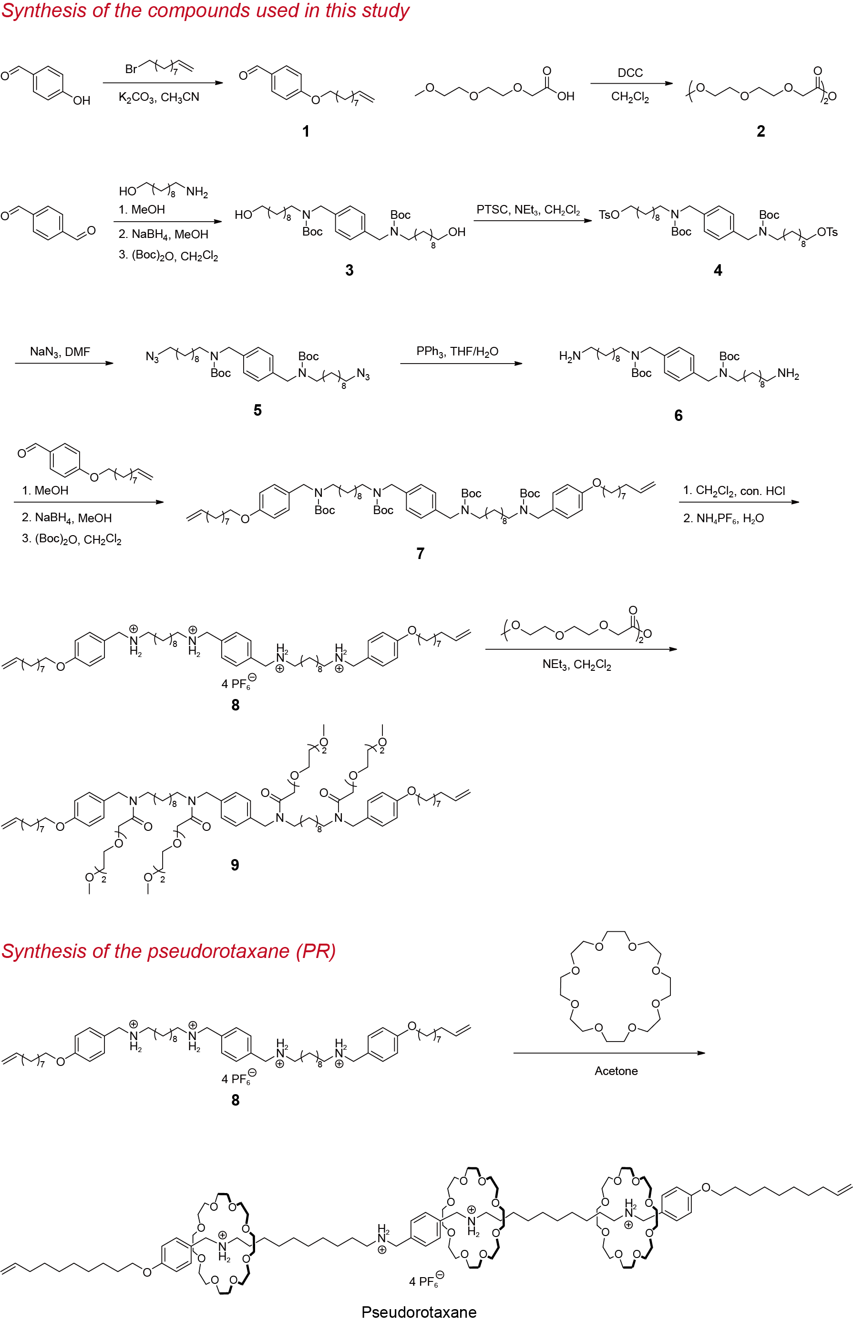
Figure S1. Synthetic route of the pseudorotaxane.
Synthesis of compound 1
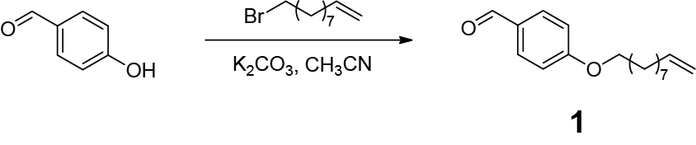
4-Hydroxybenzaldehyde (5.00 g, 40.94 mmol), 10-bromo-1-decene (8.97 g, 40.94 mmol), K₂CO₃ (11.3 g, 81.88 mmol) were dissolved in CH₃CN (200 mL) under a nitrogen atmosphere and heated to 90 ○C via an oil bath. The reaction was kept for 12 h and then cooled to room temperature. The mixture was filtered, and the filtrate was evaporated. The crude product was further purified by the column chromatography on silica gel (petroleum ether/ethyl acetate, 20:1 v/v) to give compound 1 as a light-yellow oil (10.1 g, 95%). The ¹H NMR spectrum of the compound 1 is shown in Figure S2. ¹H NMR (CDCl₃, 400 MHz, 298 K) δ (ppm): δ 9.87 (s, 1H), 7.82 (d, J = 8.4 Hz, 2H), 6.99 (d, J = 8.5 Hz, 2H), 5.89−5.74 (m, 1H), 5.05−4.89 (m, 2H), 4.03 (t, J = 6.5 Hz, 2H), 2.09−2.00 (m, 2H), 1.85−1.77 (m, 2H), 1.52−1.41 (m, 2H), 1.41−1.29 (m, 8H). The ¹³C NMR spectrum of the compound 1 is shown in Figure S3. ¹³C NMR (CDCl₃, 101 MHz, 298 K) δ (ppm): 156.14, 155.60, 137.57, 137.34, 127.74, 127.22, 79.52, 62.85, 53.44, 50.12, 49.47, 46.61, 46.39, 32.75, 29.46, 29.38, 29.28, 28.45, 28.02, 27.85, 26.80, 25.73. The HRESIMS of the compound 1 is shown in Figure S4: m/z calcd for C₁₇H₂₄O₂Na, 283.1674 [M+Na]⁺; found 283.1671 [M+Na]⁺.

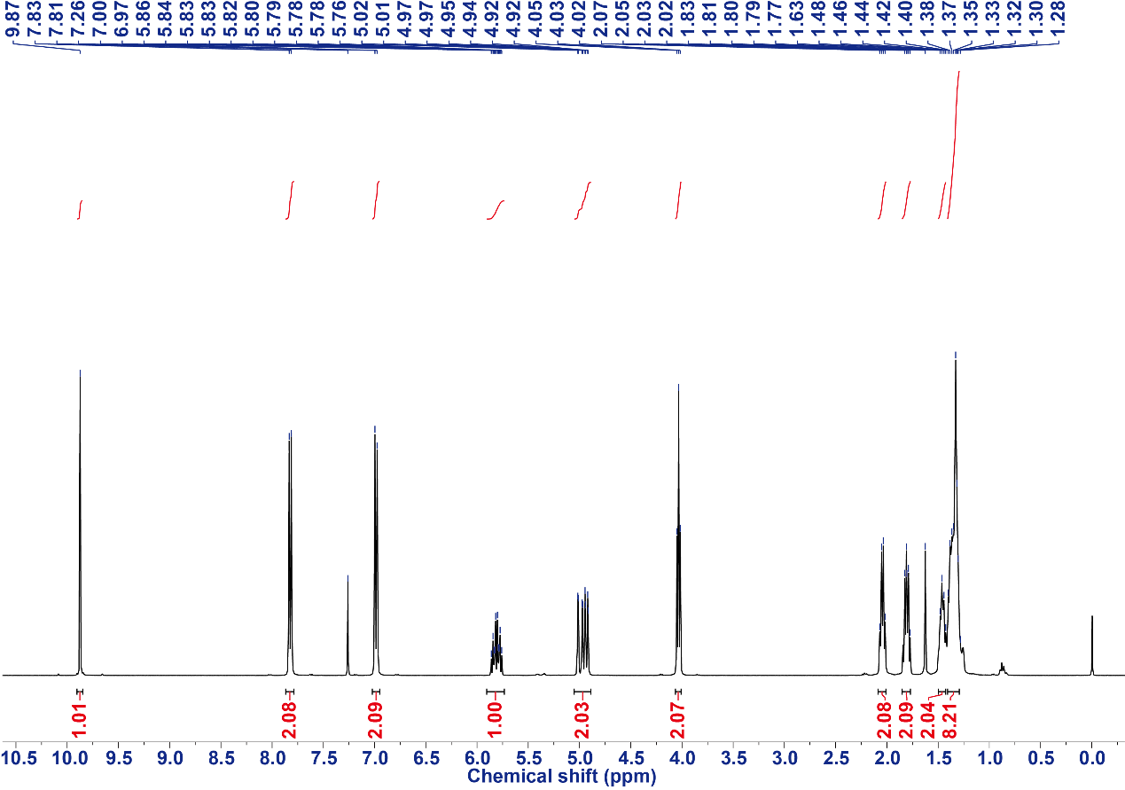
Figure S2. The ¹H NMR spectrum (CDCl₃, 400 MHz, 298 K) of the compound 1.
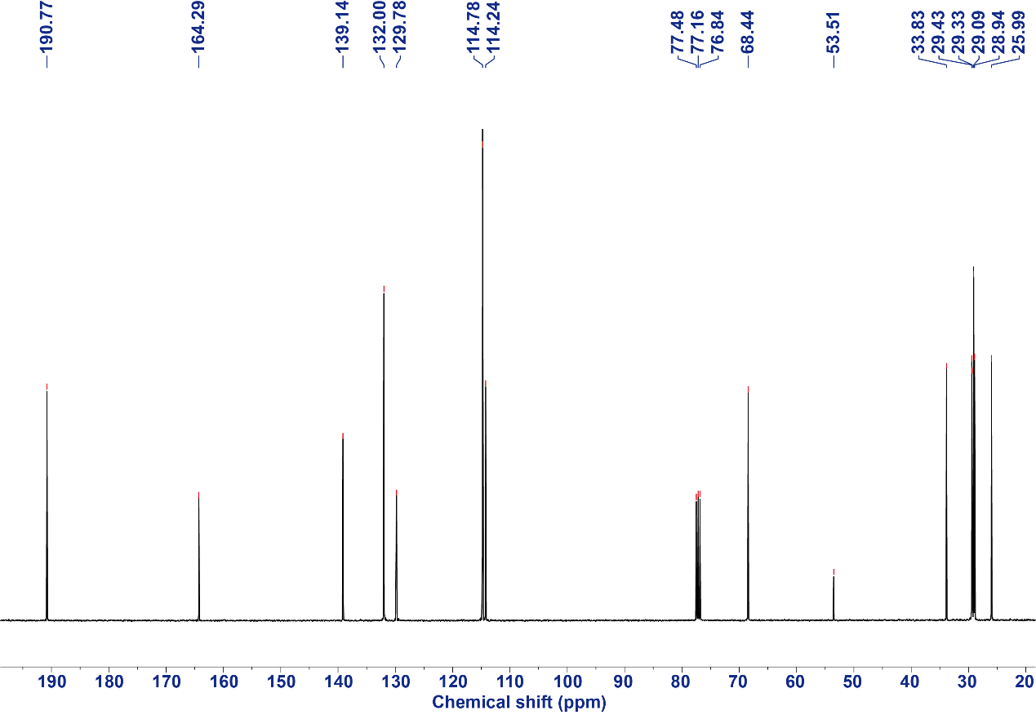
Figure S3. The ¹³C NMR spectrum (CDCl₃, 101 MHz, 298 K) of the compound 1.

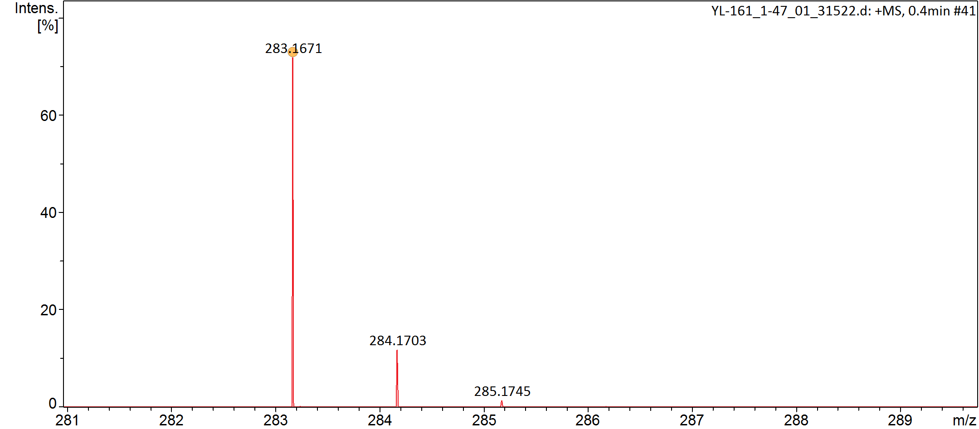
Figure S4. The electrospray ionization mass spectrum of the compound 1.

Synthesis of compound 2
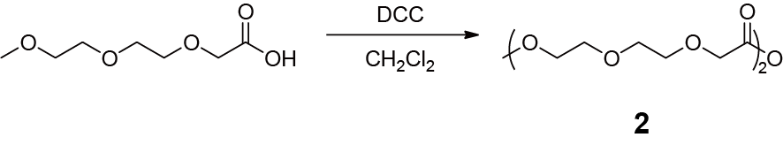
To a solution of [(methoxy)ethoxy]ethoxyacetic acid (4.28 g, 24.0 mmol) in CH₂Cl₂ (20 mL) was added N,N’-dicyclohexylcarbodiimide (DCC) (2.48 g, 12.0 mmol). The mixture rapidly turned cloudy and was stirred at room temperature for 4 h. The reaction mixture was then filtered through a coarse frit, and the filtrate was concentrated under reduced pressure to afford the crude compound 2 as a slightly cloudy liquid, which was used directly without further purification. The ¹H NMR spectrum of the compound 2 is shown in Figure S5. ¹H NMR (CDCl₃, 400 MHz, 298 K) δ (ppm): 4.30 (s, 4H), 3.78−3.73 (m, 4H), 3.71−3.66 (m, 5H), 3.65−3.61 (m, 4H), 3.56−3.51 (m, 4H), 3.36 (s, 4H). The ¹³C NMR spectrum of the compound 2 is shown in Figure S6. ¹³C NMR (CDCl₃, 101 MHz, 298 K) δ (ppm): 166.35, 71.96, 71.24, 70.81, 70.65, 69.01, 59.13. The HRESIMS of the compound 2 is shown in Figure S7: m/z calcd for C₁₄H₂₆O₉Na, 361.1475 [M+Na]⁺; found 361.1470 [M+Na]⁺.

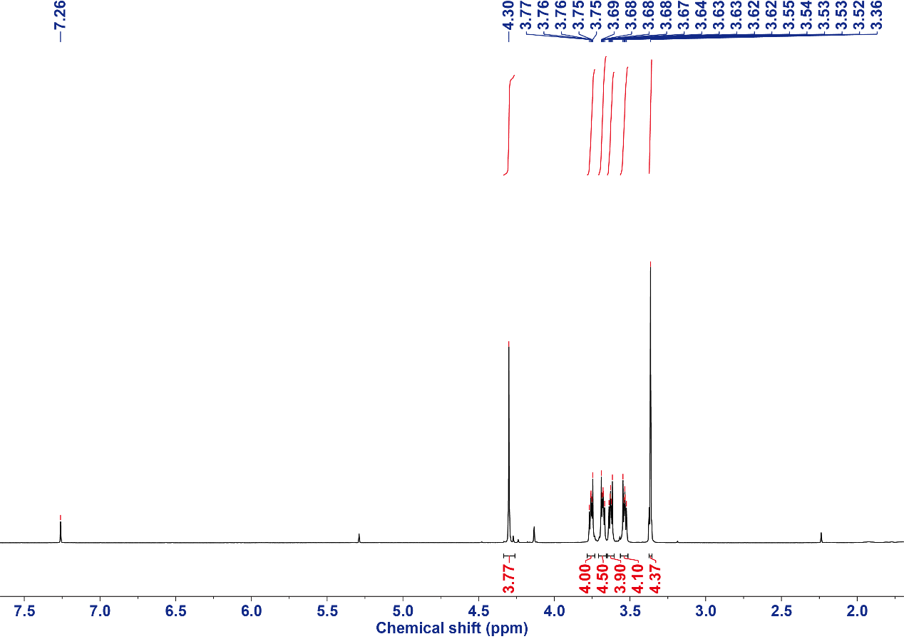
Figure S5. The ¹H NMR spectrum (CDCl₃, 400 MHz, 298 K) of the compound 2.

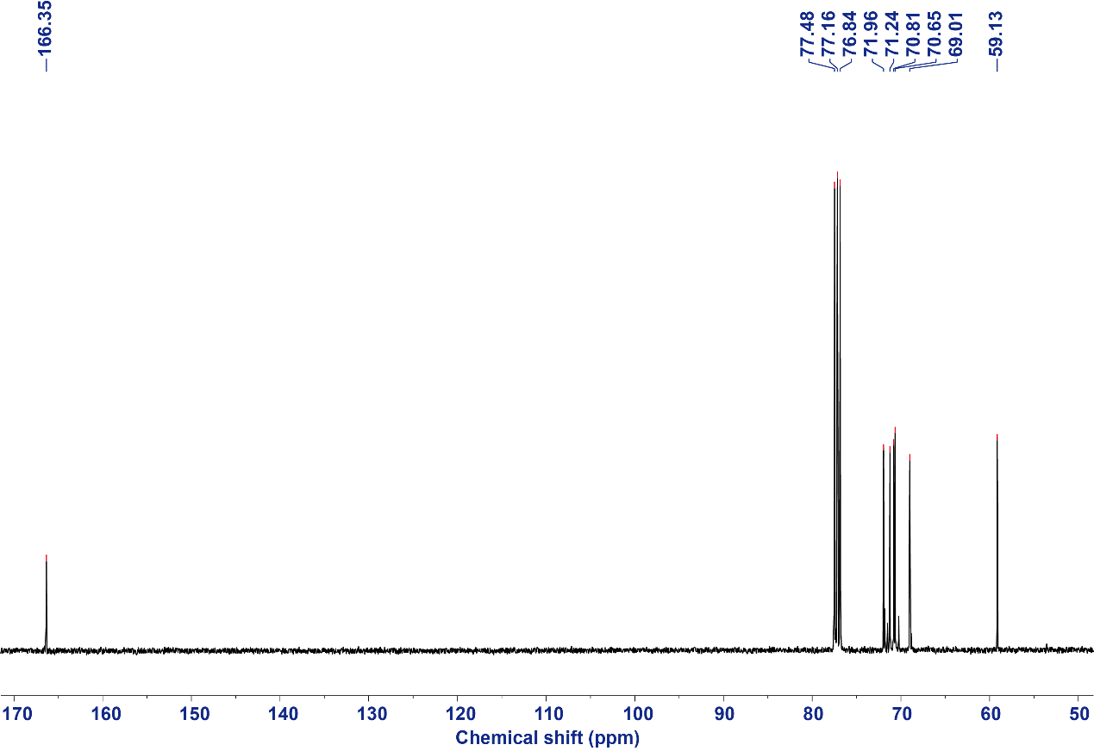
Figure S6. The ¹³C NMR spectrum (CDCl₃, 101 MHz, 298 K) of the compound 2.

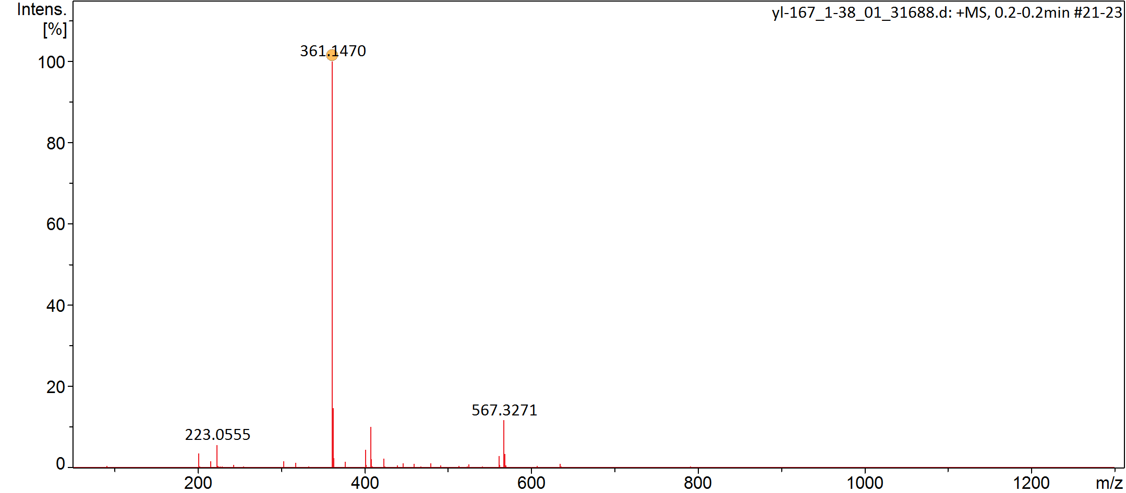
Figure S7. The electrospray ionization mass spectrum of the compound 2.

Synthesis of compound 3
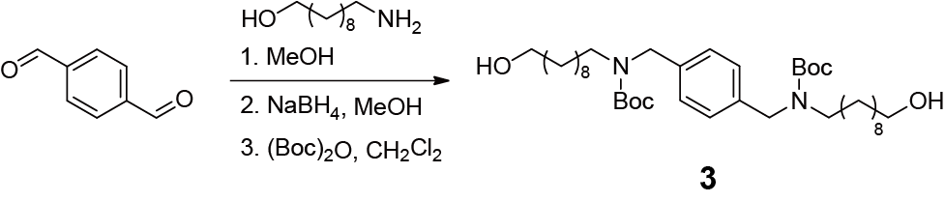
A solution of the terephthalaldehyde (5.35 g, 40.1 mmol) and the 10-amino-1-decanol (13. g, 80.0 mmol) in 400 mL methanol was heated under reflux for 24 h using a Dean-Stark apparatus. The solvent was then evaporated to give a yellow oil. The mixture was diluted with 400 mL MeOH, and then NaBH₄ (4.54 g, 120 mmol) was added portionwise at 0 °C. Stirring was maintained at room temperature for a further 4 h; then, an aqueous solution of HCl was added to the reaction mixture. Methanol was evaporated, and the residue was diluted with dichloromethane and washed with an aqueous solution of NaOH. The two layers were separated, the aqueous layer was extracted with dichloromethane and the organic layers were combined, dried over Na₂SO₄ and concentrated. The obtained crude product was stirred together with (Boc)₂O (18.3 g, 120 mmol) in dry CH₂Cl₂ (400 mL) for 8 h at room temperature. Finally, the solvent was removed under vacuum, and the crude product was further purified by column chromatography on silica gel (CH₂Cl₂/methanol, 100:1 v/v) to give compound 3 as a colorless oil (19.5 g, 75%). The ¹H NMR spectrum of the compound 3 is shown in Figure S8. ¹H NMR (CDCl₃, 400 MHz, 298 K) δ (ppm): 7.16 (s, 4H), 4.39 (d, J = 15.6 Hz, 4H), 3.62 (t, J = 6.6 Hz, 4H), 3.13 (d, J = 34.4 Hz, 4H), 1.59−1.51 (m, 8H), 1.50−1.38 (m, 20H), 1.38−1.17 (m, 28H). The ¹³C NMR spectrum of the compound 3 is shown in Figure S9. ¹³C NMR (CDCl₃, 101 MHz, 298 K) δ (ppm): 156.14, 155.60, 137.57, 137.34, 127.74, 127.22, 79.52, 62.85, 53.44, 50.12, 49.47, 46.61, 46.39, 32.75, 29.46, 29.38, 29.28, 28.45, 28.02, 27.85, 26.80, 25.73. The HRESIMS of the compound 3 is shown in Figure S10: m/z calcd for C₃₈H₆₈O₆N₂Na, 671.4975 [M+Na]⁺; found 671.4972 [M+Na]⁺.

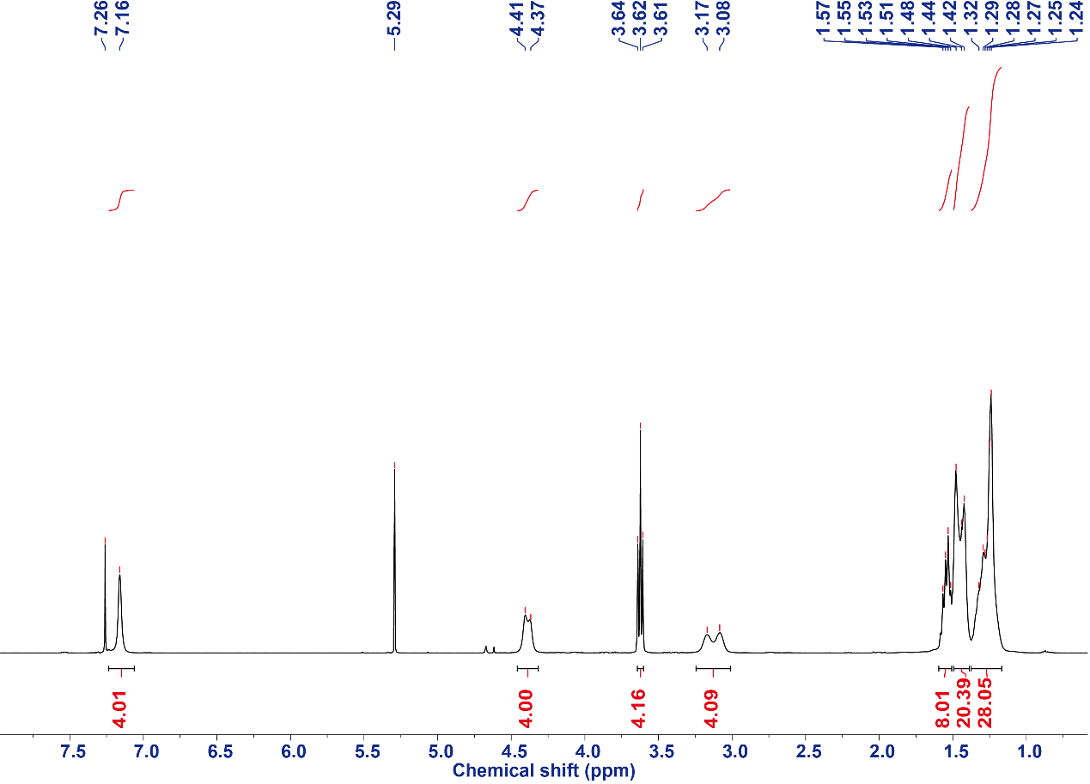
Figure S8. The ¹H NMR spectrum (CDCl₃, 400 MHz, 298 K) of the compound 3.

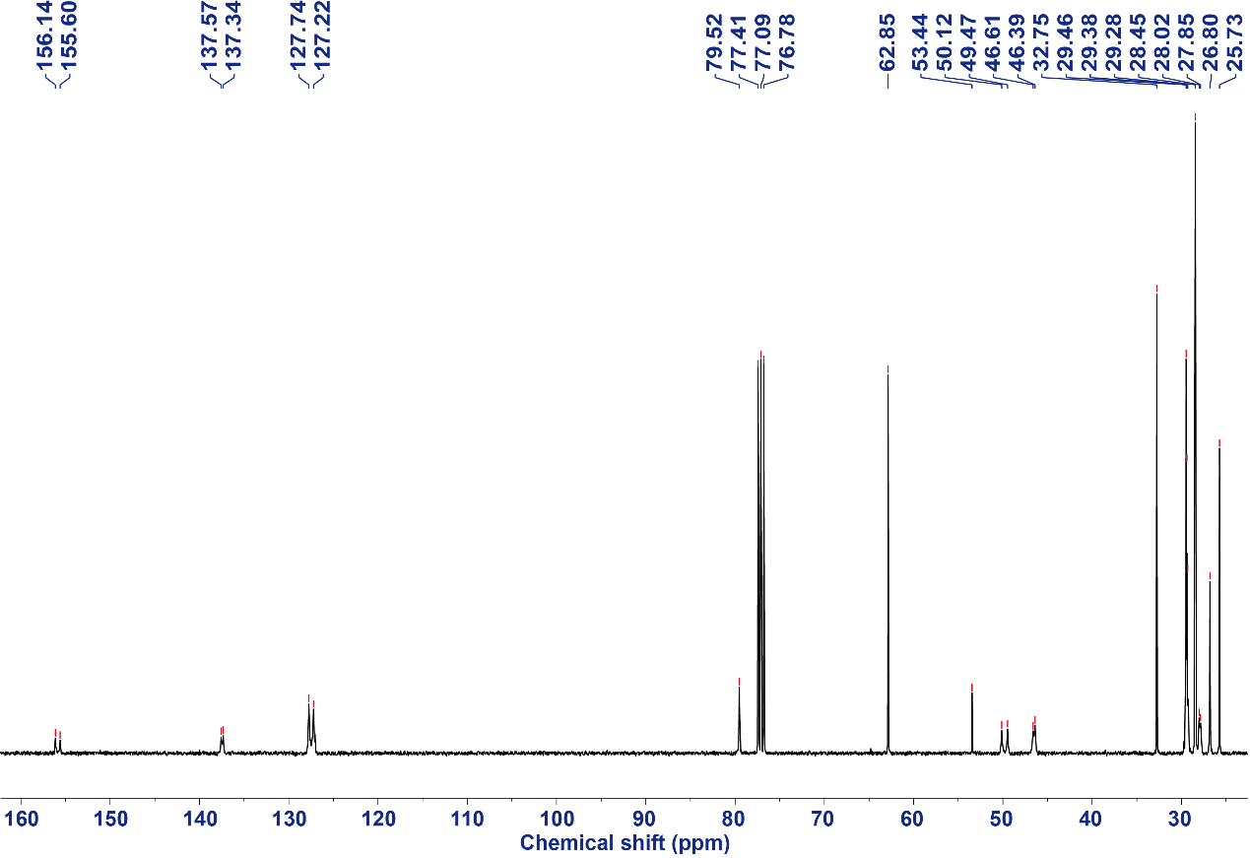
Figure S9. The ¹³C NMR spectrum (CDCl₃, 101 MHz, 298 K) of the compound 3.

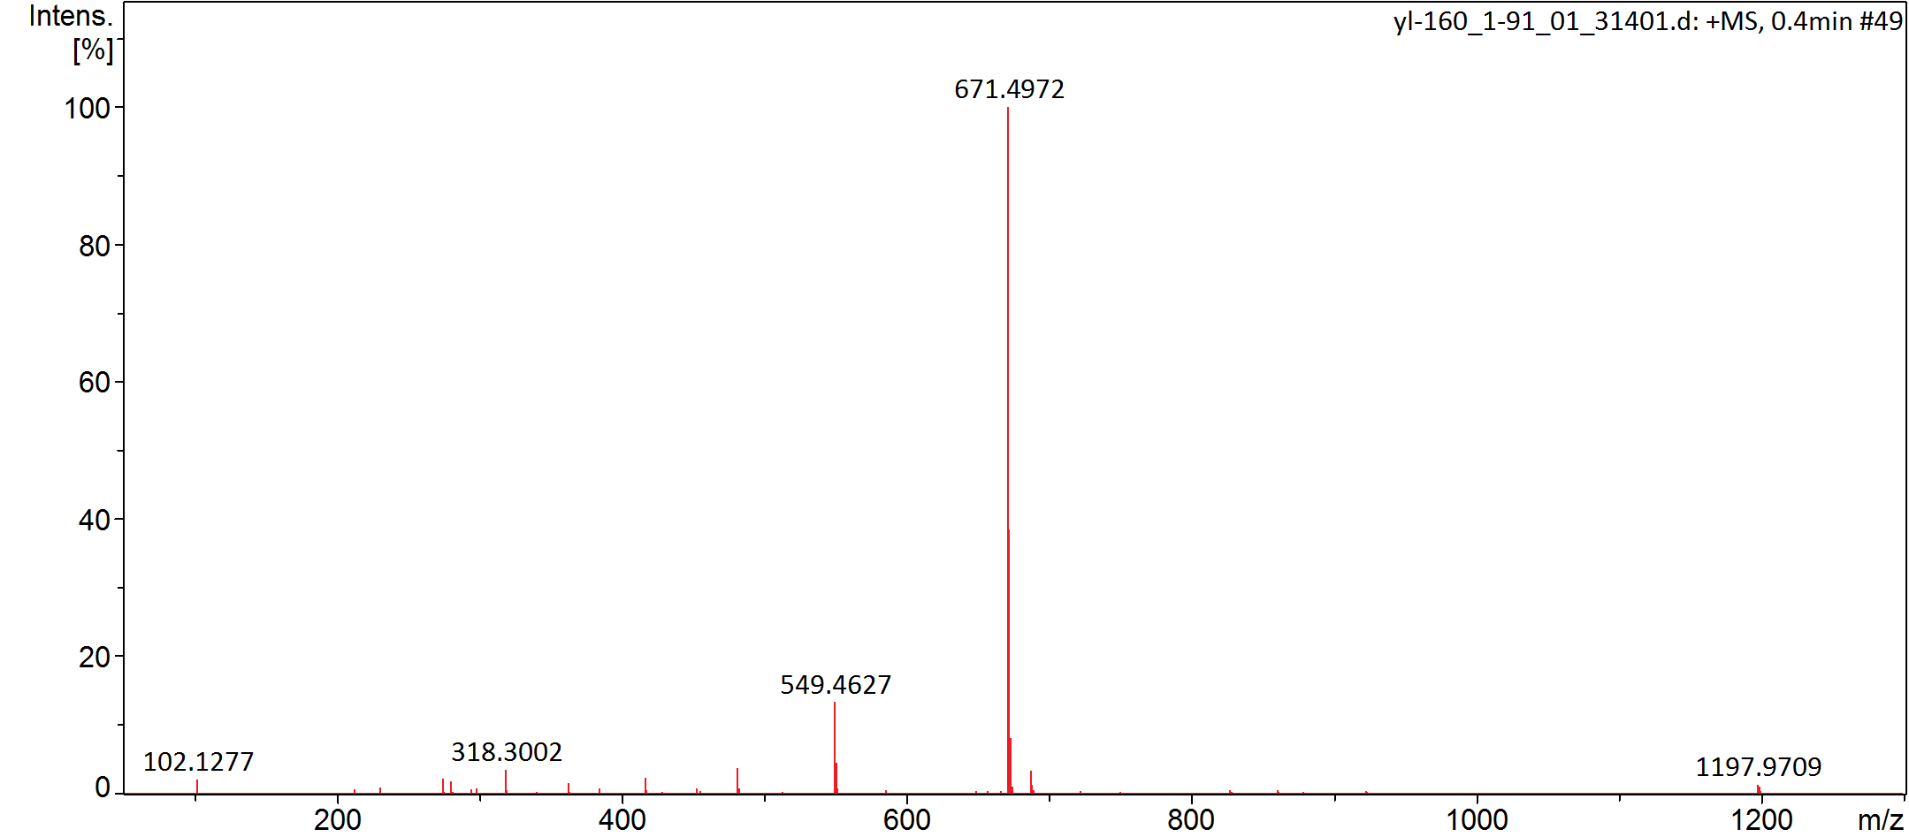
Figure S10. The electrospray ionization mass spectrum of the compound 3.

Synthesis of compound 4
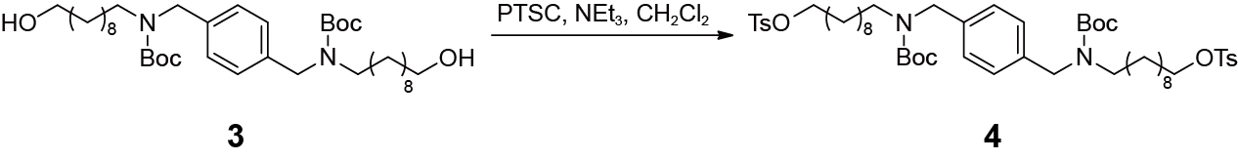
The crude compound 3 and Et₃N (30.0 mL) were dissolved in CH₂Cl₂ (100 mL) and cooled to 0 °C. Tosyl chloride (19.0 g, 100 mmol) dissolved in CH₂Cl₂ (300 mL) was added dropwise to the cooled reaction mixture over a period of 3 h. The reaction mixture was allowed to reach room temperature and stirred for 15 h. The organic phase was washed with 1 M HCl, aqueous NaCl, and water. The organic phase was dried using Na₂SO₄ and the solution was evaporated, and the crude product was further purified by column chromatography on silica gel (petroleum ether/ethyl acetate, 3:1 v/v) to give compound 4 as a yellow oil (29.3 g, 86%). The ¹H NMR spectrum of the compound 4 is shown in Figure S11. ¹H NMR (CDCl₃, 400 MHz, 298 K) δ (ppm): δ 7.74 (d, J = 8.3 Hz, 4H), 7.30 (d, J = 8.1 Hz, 4H), 7.14 (s, 4H), 4.36 (s, 4H), 3.97 (t, J = 6.5 Hz, 4H), 3.10 (d, J = 27.1 Hz, 4H), 2.40 (s, 6H), 1.62−1.54 (m, 4H), 1.51−1.34 (m, 22H), 1.27−1.12 (m, 24H). The ¹³C NMR spectrum of the compound 4 is shown in Figure S12. ¹³C NMR (CDCl₃, 101 MHz, 298 K) δ (ppm): 156.04, 155.54, 144.63, 137.56, 137.39, 133.14, 129.80, 127.81, 127.68, 127.22, 79.38, 70.68, 53.51, 50.08, 49.43, 29.39, 29.26, 29.24, 28.85, 28.76, 28.42, 26.79, 25.28, 21.59. The HRESIMS of the compound 4 is shown in Figure S13: m/z calcd for C₅₂H₈₀O₁₀N₂S₂Na, 979.5152 [M+Na]⁺; found 979.5198 [M+Na]⁺.

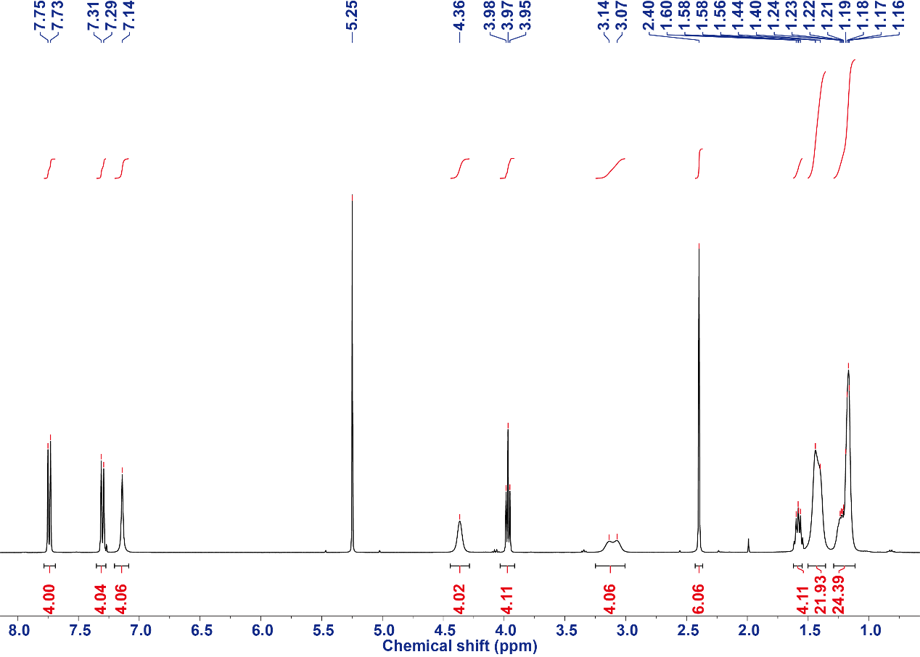
Figure S11. The ¹H NMR spectrum (CDCl₃, 400 MHz, 298 K) of the compound 4.

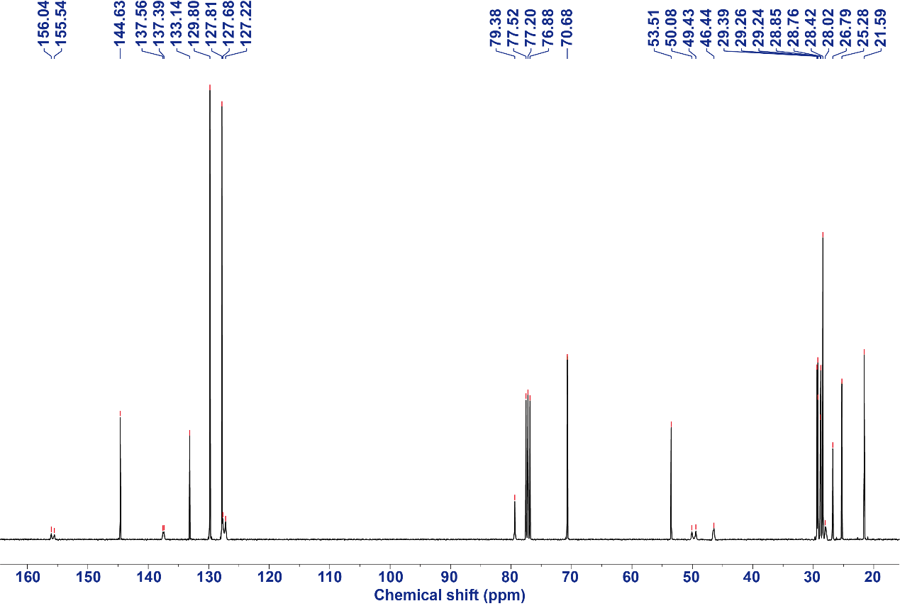
Figure S12. The ¹³C NMR spectrum (CDCl₃, 101 MHz, 298 K) of the compound 4.

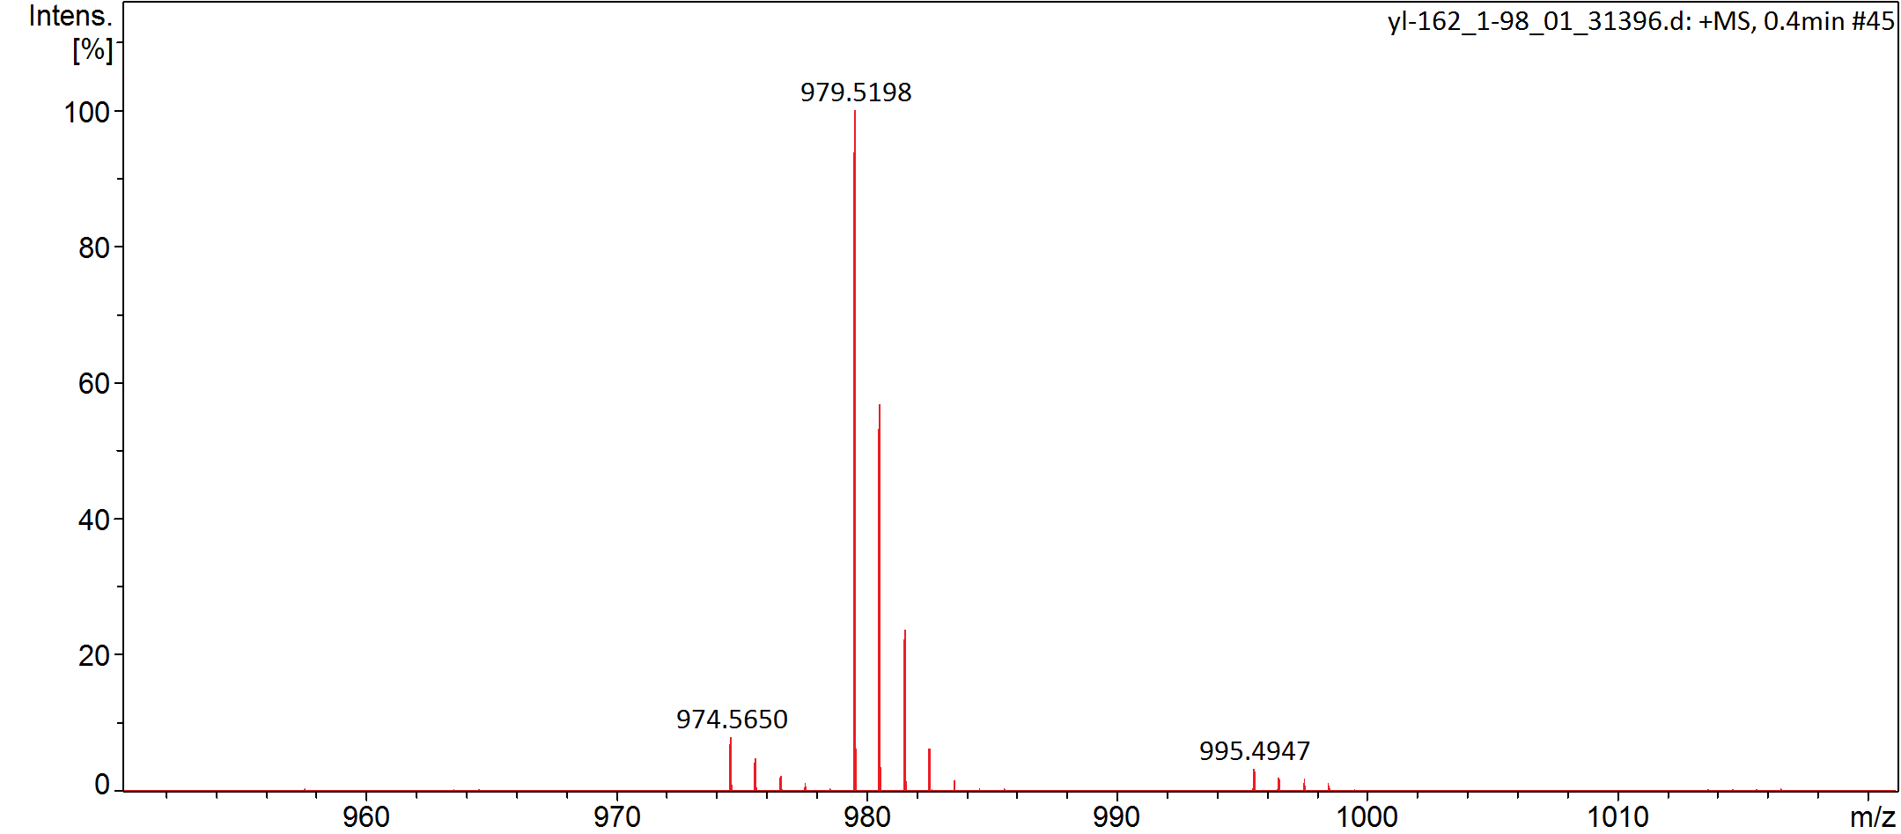
Figure S13. The electrospray ionization mass spectrum of the compound 4.

Synthesis of compound 6
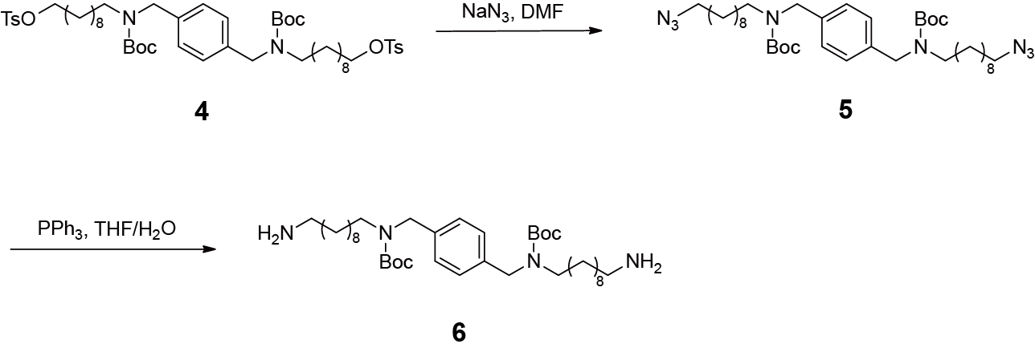
A solution of compound 4 and sodium azide (5.50 g, 84.0 mmol) in DMF (300 mL) was stirred at 80 °C for 5 h. After cooling, ethyl acetate was added to the reaction mixture, and the mixture was washed with water. The organic layer was dried over anhydrous sodium sulfate, filtered, and concentrated in vacuo to afford crude compound 5. The crude compound 5 was dissolved in THF (300 mL), and the solution was cooled to 0 °C. Triphenylphosphine (26.2 g, 100 mmol) was then added, and the mixture was allowed to warm to room temperature and stirred for 22 hours. A few drops of water were added, and stirring was continued for an additional 1 h. The reaction mixture was concentrated in vacuo to yield crude compound 6 as a yellow liquid, which was used in the next step without further purification.

Synthesis of compound 7
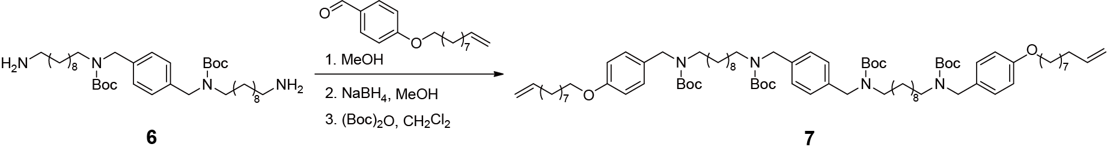
A solution of compound 6 and 4-dec-9-enyloxy-benzaldehyde (20.8 g, 80.0 mmol) in 400 mL methanol was heated under reflux for 24 h using a Dean-Stark apparatus. The solvent was then evaporated to give a yellow oil. The mixture was diluted with 400 mL MeOH, and then NaBH₄ (3.34 g, 4.54 g, 120 mmol) was added portionwise at 0 °C. Stirring was maintained at room temperature for a further 4 h; then, an aqueous solution of HCl was added to the reaction mixture. Methanol was evaporated, and the residue was diluted with dichloromethane and washed with an aqueous solution of NaOH. The two layers were separated, the aqueous layer was extracted with dichloromethane and the organic layers were combined, dried over Na₂SO₄ and concentrated. The obtained crude product was stirred together with (Boc)₂O (18.3 g, 120 mmol) in dry DCM (400 mL) for 8 h at room temperature. The solution was evaporated and the crude was further purified by gel chromatography with PE/EA = (3/1 v/v) as an eluent to afford compound 7. Finally, the solvent was removed under vacuum, and the crude product was further purified by column chromatography on silica gel (CH₂Cl₂/methanol, 200:1 v/v) to give compound 7 as a colorless oil (12.8 g, 85%). The ¹H NMR spectrum of the compound 7 is shown in Figure S14. ¹H NMR (CDCl₃, 400 MHz, 298 K) δ (ppm): 7.19−7.09 (m, 8H), 6.86−6.80 (m, 4H), 5.89−5.74 (m, 2H), 5.03−4.88 (m, 4H), 4.43−4.29 (m, 8H), 3.92 (t, J = 6.6 Hz, 4H), 3.12 (d, J = 30.4 Hz, 8H), 2.07−1.99 (m, 4H), 1.79−1.72 (m, 4H), 1.53−1.40 (m, 48H), 1.37−1.28 (m, 16H), 1.22 (s, 24H). The ¹³C NMR spectrum of the compound 7 is shown in Figure S15. ¹³C NMR (CDCl₃, 101 MHz, 298 K) δ (ppm): 158.28, 156.09, 155.57, 139.15, 137.38, 130.50, 128.99, 128.39, 127.71, 127.21, 114.38, 114.17, 79.42, 67.98, 53.44, 49.42, 49.08, 33.80, 29.56, 29.41, 29.38, 29.35, 29.30, 29.06, 28.91, 28.49, 28.46, 26.88, 26.05. The HRESIMS of the compound 7 is shown in Figure S16: m/z calcd for C₈₂H₁₃₄O₁₀N₄Na, 1357.9998 [M+Na]⁺; found 1357.9998 [M+Na]⁺.

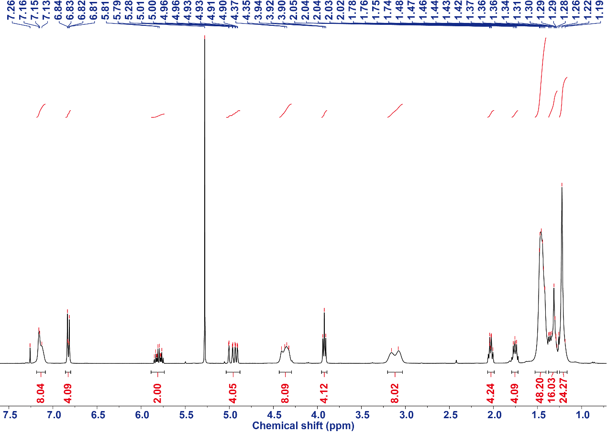
Figure S14. The ¹H NMR spectrum (CDCl₃, 400 MHz, 298 K) of the compound 7.

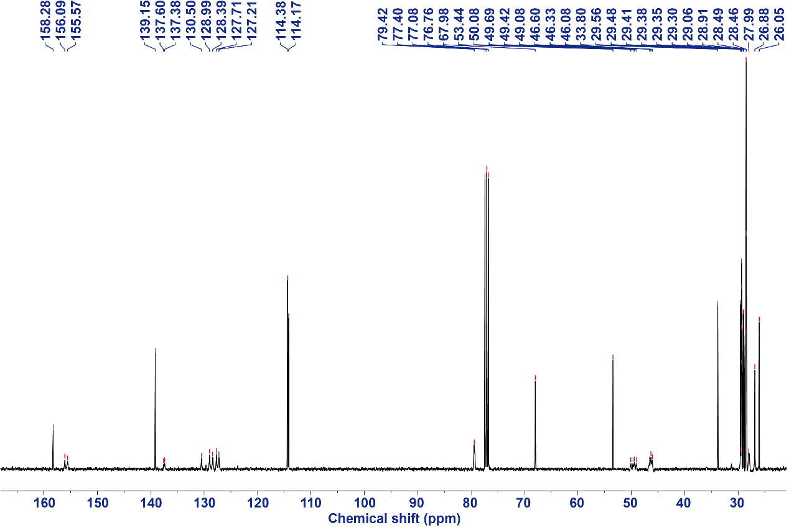
Figure S15. The ¹³C NMR spectrum (CDCl₃, 101 MHz, 298 K) of the compound 7.

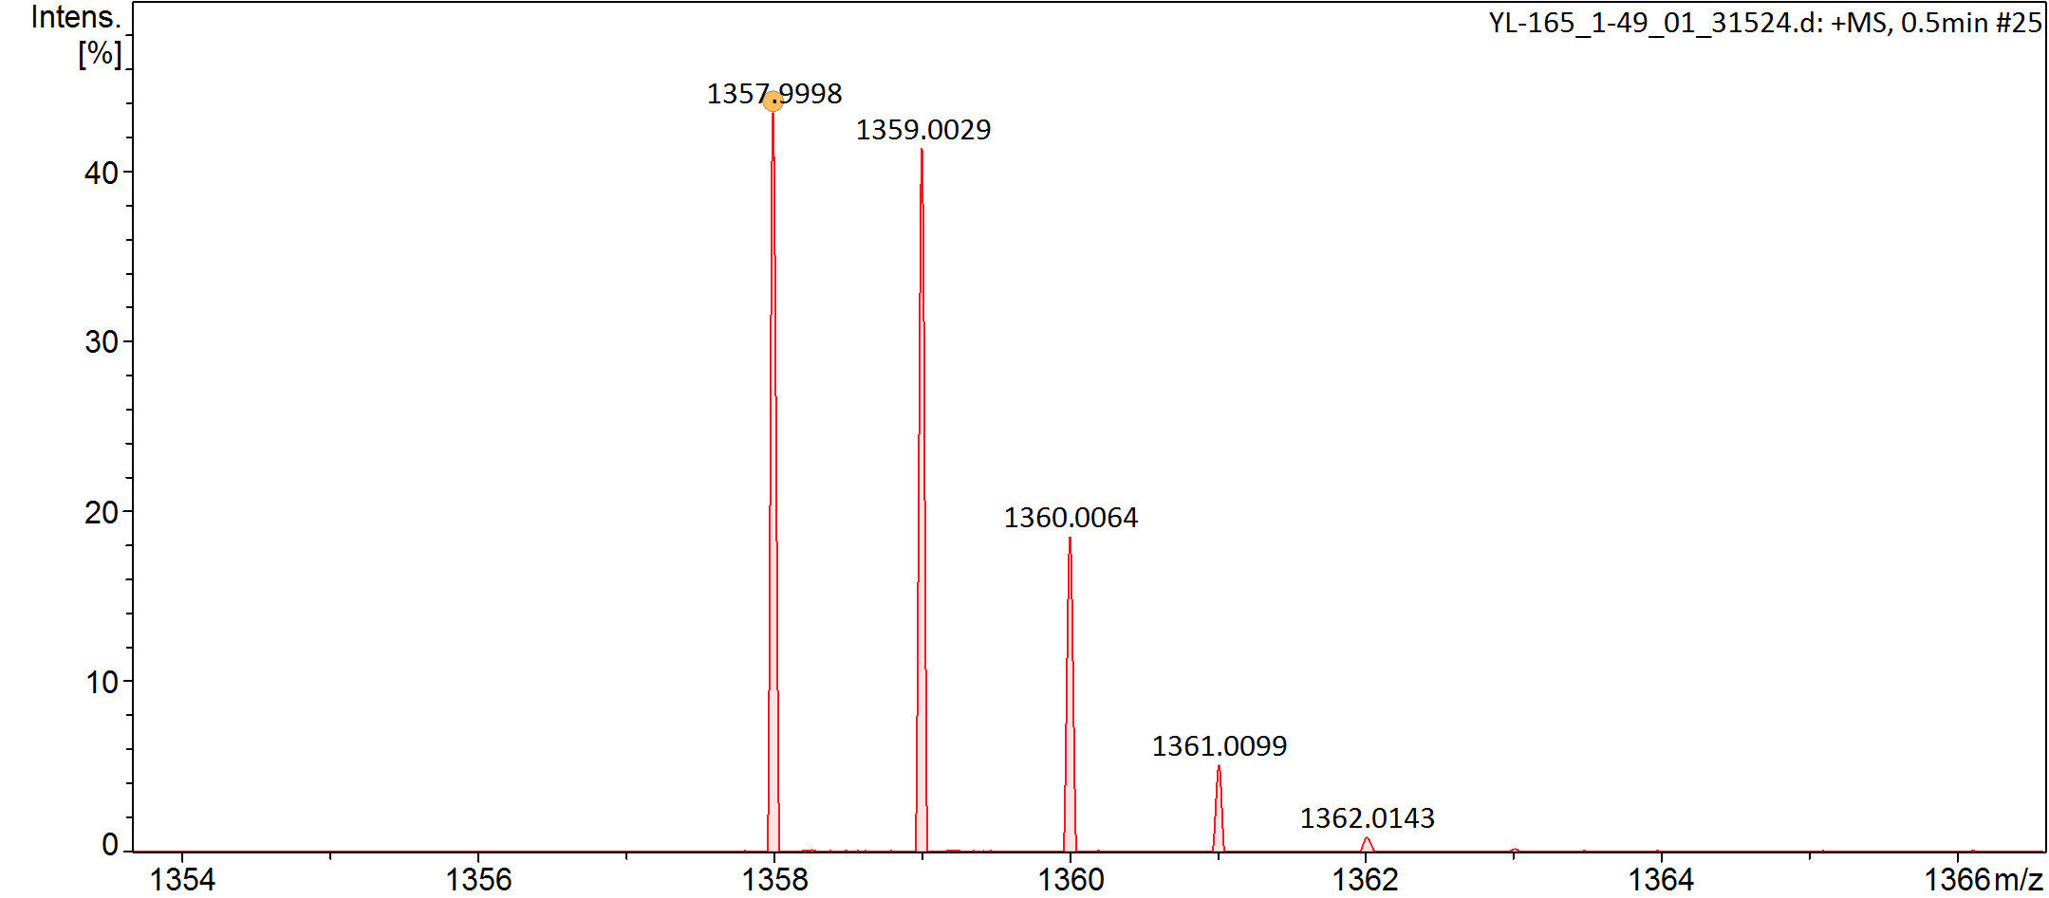
Figure S16. The electrospray ionization mass spectrum of the compound 7.

Synthesis of compound 8
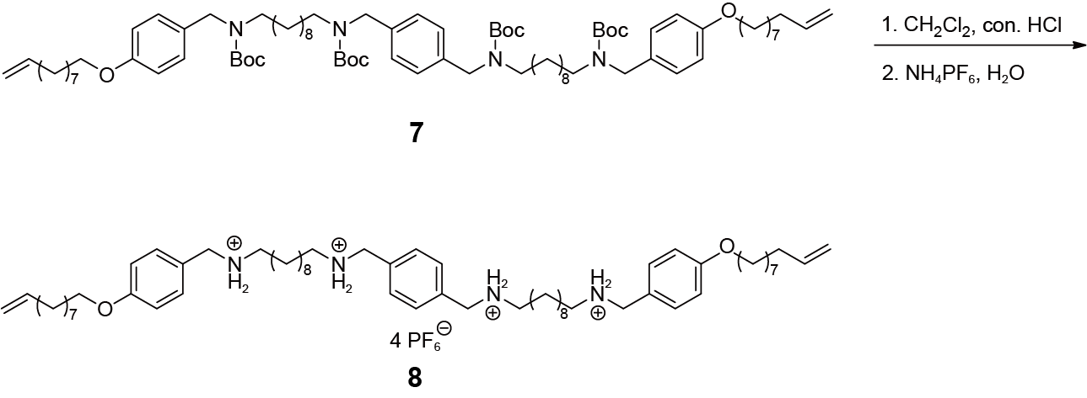
Con. HCl (2.50 mL, 2.88 mmol) was added to a solution of the crude compound 7 in 400 mL dichloromethane. The mixture was stirred for 2 h. The solution was washed by water, and then organic phase was collected. Saturated NH₄PF₆ aqueous solution (200 mL) was added. The biphasic solution was stirred vigorously for 1 h. The two phases were separated and the aqueous layer was extracted with dichloromethane. The organic layers were then combined, dried over Na₂SO₄ and concentrated to give the compound 8 as a white solid (2.55 g, 97%). M.p. = 251 °C. The ¹H NMR spectrum of compound 8 is shown in Figure S17. ¹H NMR (DMSO-d₆, 400 MHz, 298 K): 8.60 (s, 8H), 7.53 (s, 4H), 7.38 (d, J = 8.4 Hz, 4H), 6.99 (d, J = 8.4 Hz, 4H), 5.86−5.72 (m, 2H), 5.06−4.86 (m, 2H), 4.16 (s, 4H), 4.06 (s, 4H), 3.97 (t, J = 6.5 Hz, 4H), 2.88 (dt, J = 16.2, 7.8 Hz, 8H), 2.01 (q, J = 6.8 Hz, 4H), 1.70 (p, J = 6.8 Hz, 4H), 1.58 (t, J = 8.0 Hz, 8H), 1.39−1.16 (m, 44H). The ¹³C NMR spectrum of compound 8 is shown in Figure S18. ¹³C NMR (DMSO-d₆, 101 MHz, 298 K) δ (ppm): 159.67, 139.30, 133.21, 131.93, 130.60, 124.04, 115.13, 115.03, 70.46, 68.00, 50.04, 47.20, 46.79, 33.65, 29.41, 29.31, 29.29, 29.24, 29.19, 29.08, 29.06, 29.00, 28.93, 28.71, 26.50, 25.94, 25.91, 25.87. HRESIMS is shown in Figure S19: m/z calcd for C₆₂H₁₀₄N₄O₂, 245.1950 [M−4PF₆−2H+2Na]⁴⁺; found 245.1902 [M−4PF₆−2H +2Na]⁴⁺.
Figure S17. ¹H NMR spectrum (DMSO-d₆, 400 MHz, 298 K) of compound 8.

Figure S18. ¹³C NMR spectrum (DMSO-d₆, 100 MHz, 298 K) of compound 8.
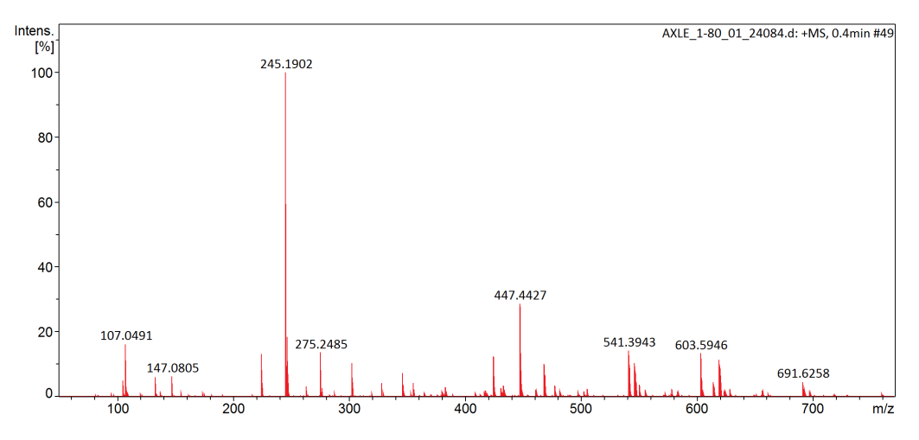
Figure S19. Electrospray ionization mass spectrum of compound 8.

Preparations of PR network
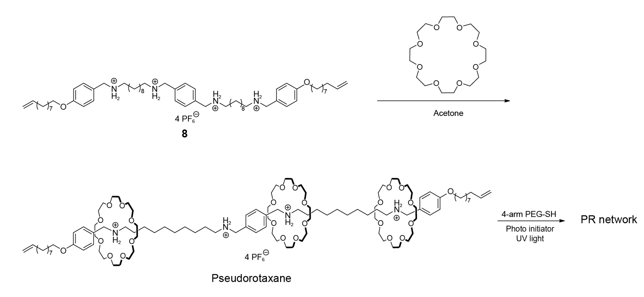
Figure S20. The preparation of PR network.

Preparations of covalent crosslinking network (CCN) network
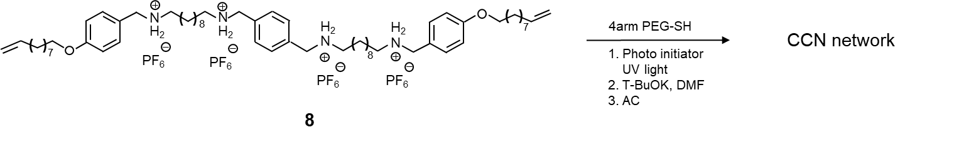
Figure S21. The preparation of CCN network.

Synthesis of compound 9
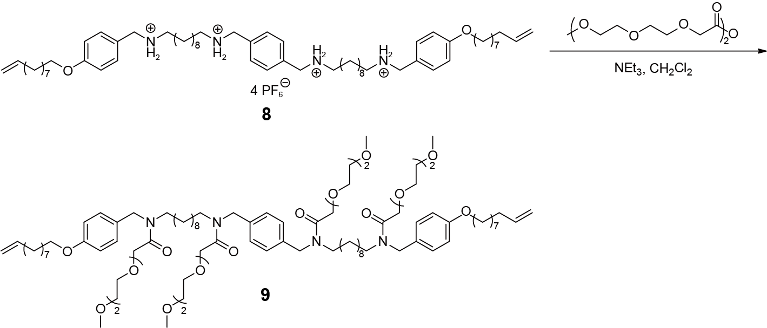
To a solution of compound 8 (0.46 g, 0.30 mmol) and triethylamine (0.61 g, 6.00 mmol) in dry CH₂Cl₂ (30 mL) was added acetic anhydride (4.06 g, 12.0 mmol) and then stirred for 24 h at room temperature. The mixture was diluted with CH₂Cl₂ and washed with a saturated aqueous solution of NaHCO₃, brine, and water successively. The organic phase was collected and dried over Na₂SO₄. Then, the crude was further purified by column chromatography on silica gel (CH₂Cl₂/methanol, 15:1 v/v) to give compound 9 as a colorless liquid (0.32 g, 67%). The ¹H NMR spectrum of compound 9 is shown in Figure S20. ¹H NMR (CDCl₃, 400 MHz, 298 K): 7.21−7.04 (m, 8H), 6.86−6.78 (m, 4H), 5.85−5.72 (m, 2H), 5.02−4.88 (m, 4H), 4.58−4.41 (m, 8H), 4.29−4.24 (m, 4H), 4.23−4.15 (d, m, 4H), 3.94−3.87 (m, 4H), 3.78−3.47 (m, 37H), 3.34 (d, J = 8.1 Hz, 12H), 3.31−3.24 (m, 4H), 3.17−3.10 (m, 4H), 2.23 (d, J = 18.5 Hz, 4H), 2.04−1.99 (m, 4H), 1.78−1.70 (m, 4H), 1.27−1.15 (m, 44H). The ¹³C NMR spectrum of compound 9 is shown in Figure S21. ¹³C NMR (CDCl₃, 101 MHz, 298 K) δ (ppm): 139.32, 114.91, 114.63, 114.30, 72.04, 70.78, 70.64, 68.15, 59.20, 33.93, 32.07, 31.58, 30.33, 29.84, 29.49, 29.20, 29.04, 27.04, 26.18, 22.84, 14.27, 1.17. HRESIMS is shown in Figure S22: m/z calcd for C₉₀H₁₅₀N₄O₁₈Na, 1598.0843 [M+Na]⁺; found 1598.0850 [M+Na]⁺; and m/z calcd for C₉₀H₁₅₀N₄O₁₈Na, 810.5370 [M+2Na]²⁺; found 810.5361 [M+2Na]²⁺.

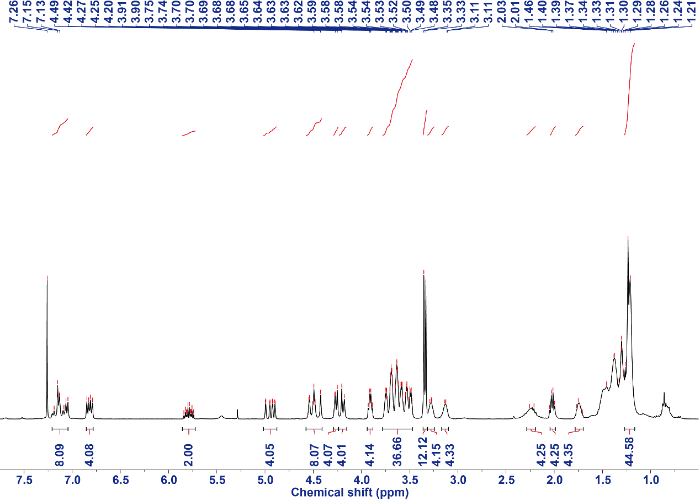
Figure S22. The ¹H NMR spectrum (CDCl₃, 400 MHz, 298 K) of the compound 9.

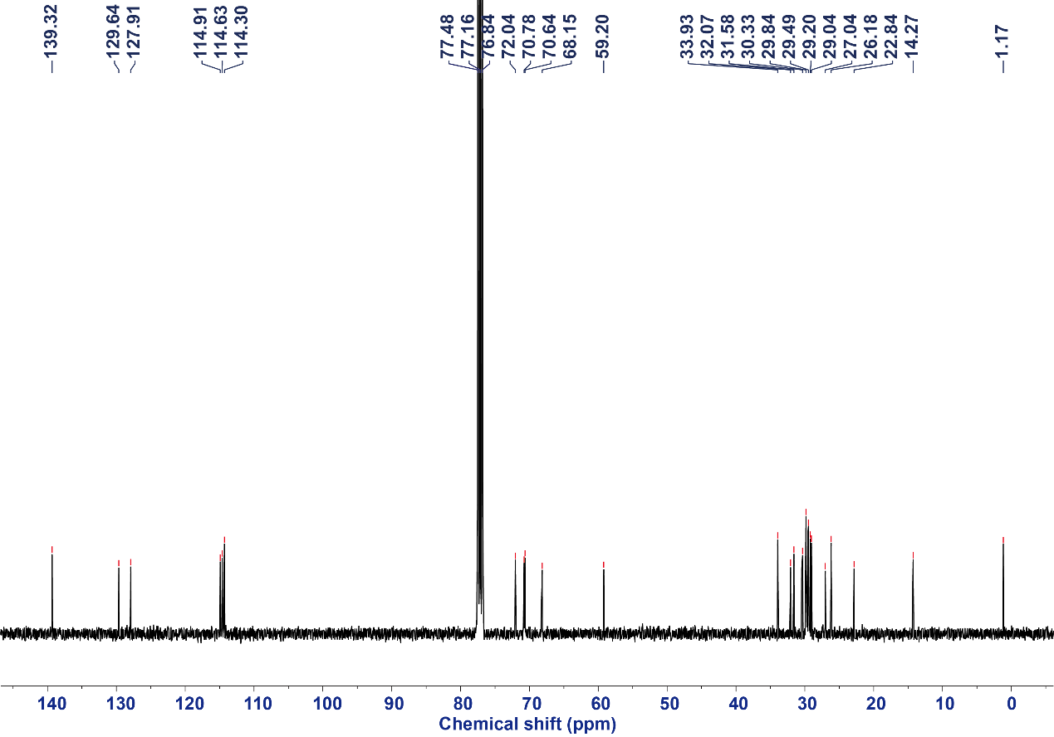
Figure S23. The ¹³C NMR spectrum (CDCl₃, 101 MHz, 298 K) of the compound 9.
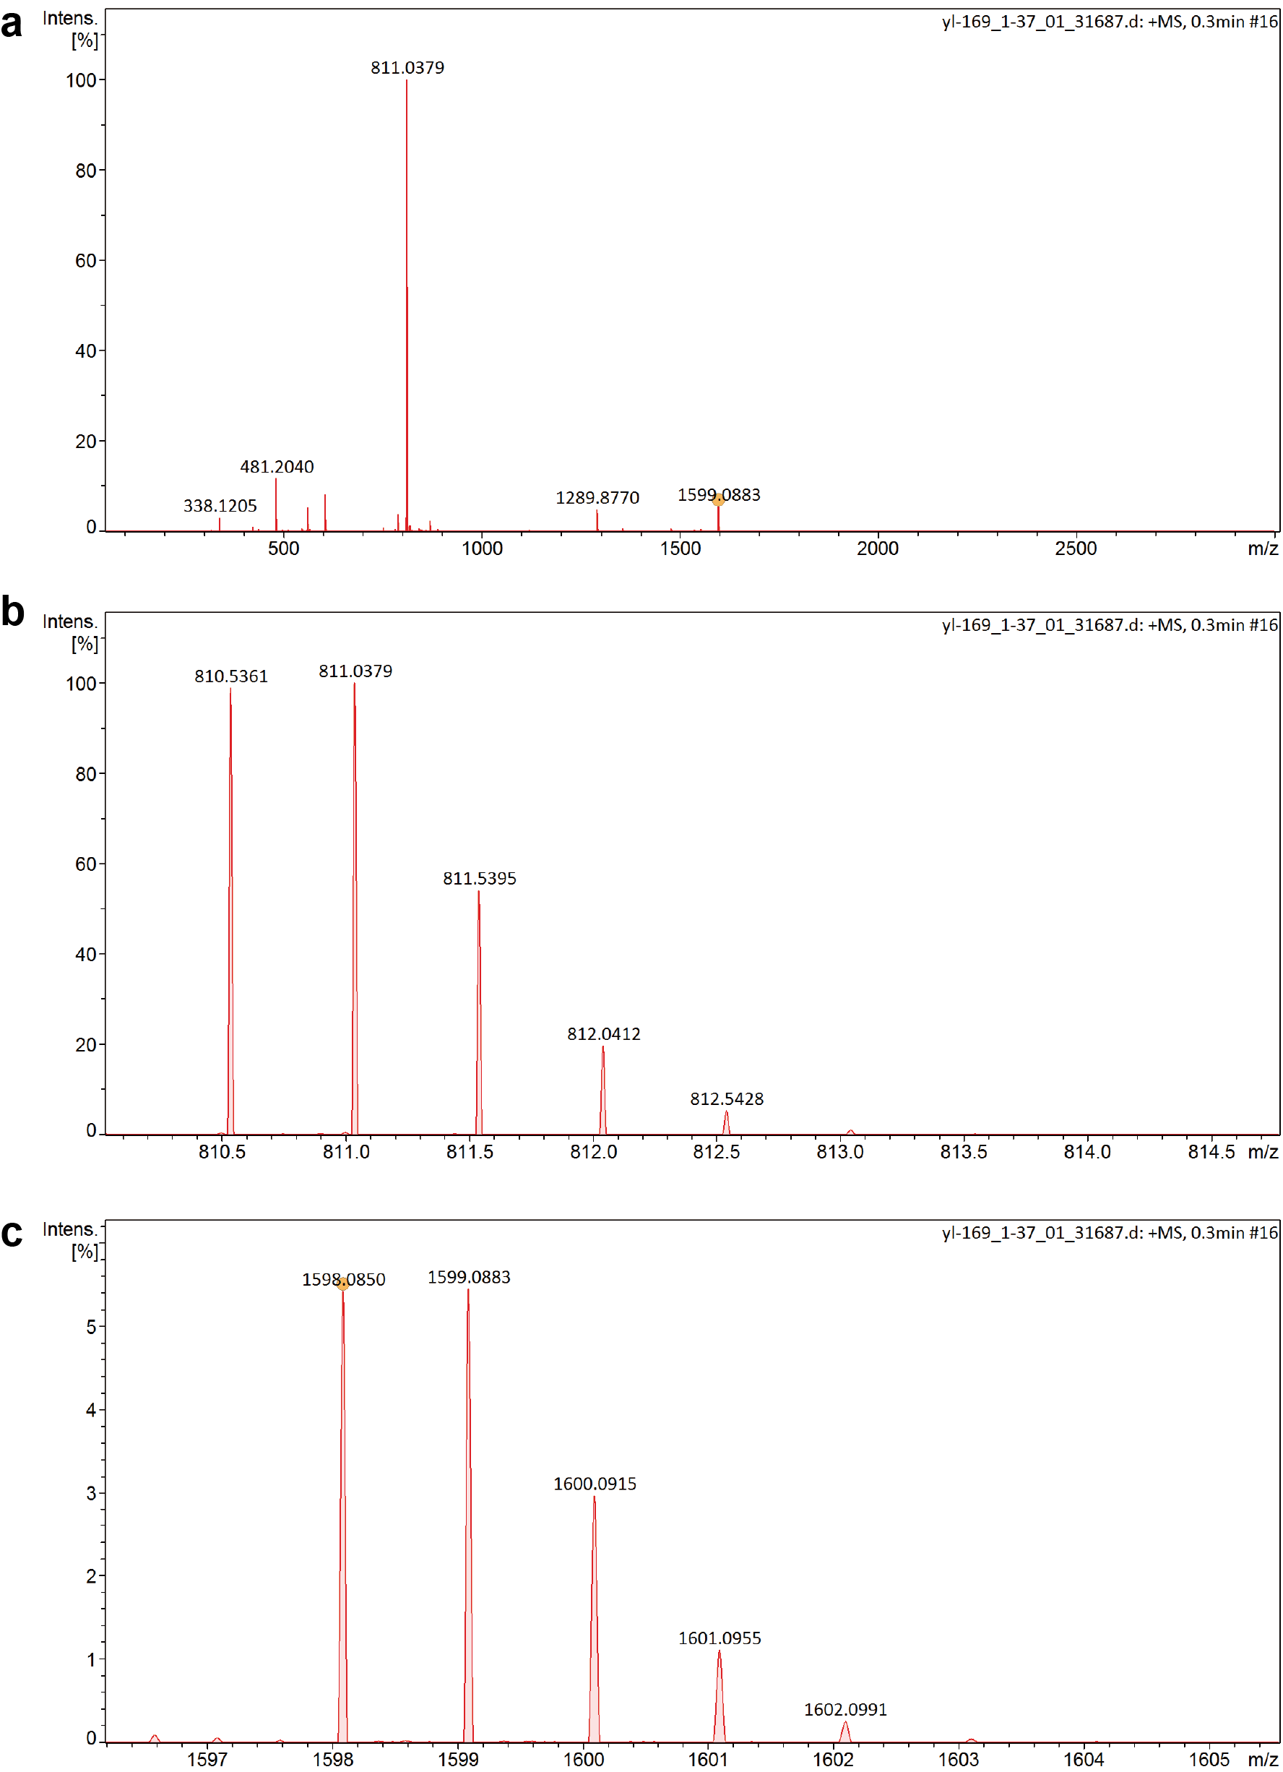
Figure S24. (a) The electrospray ionization mass spectrum of the compound 9, and (b and c) the corresponding zoom-in image.

Preparations of CCB (the CCN with PEG side chains) network
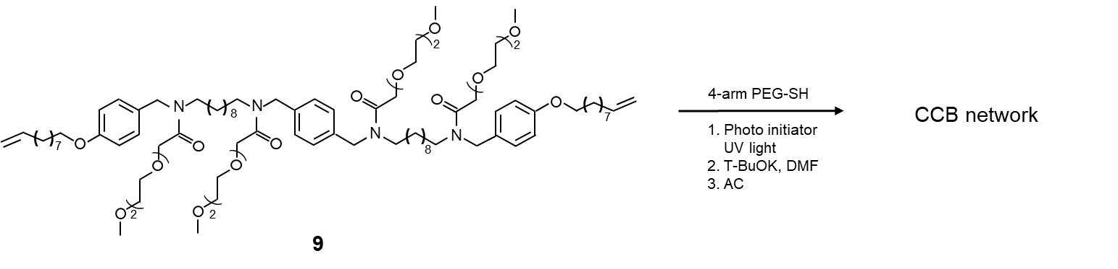
Figure S25. The preparation of CCB network.
S3 Supplementary Figures

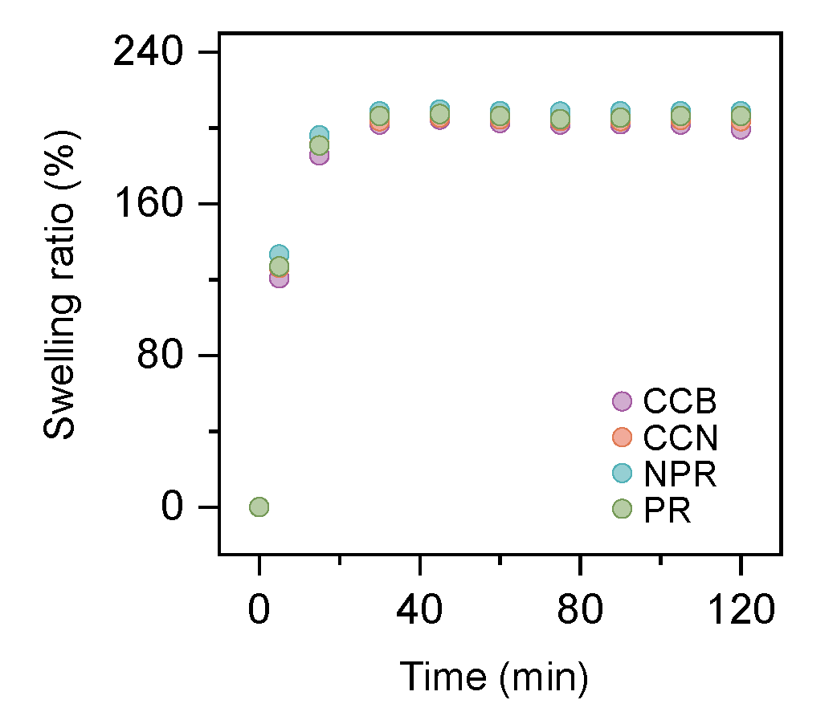
Figure26. Swelling ratios of NPR, PR, CCN, and, CCB in THF as a function of swelling time.

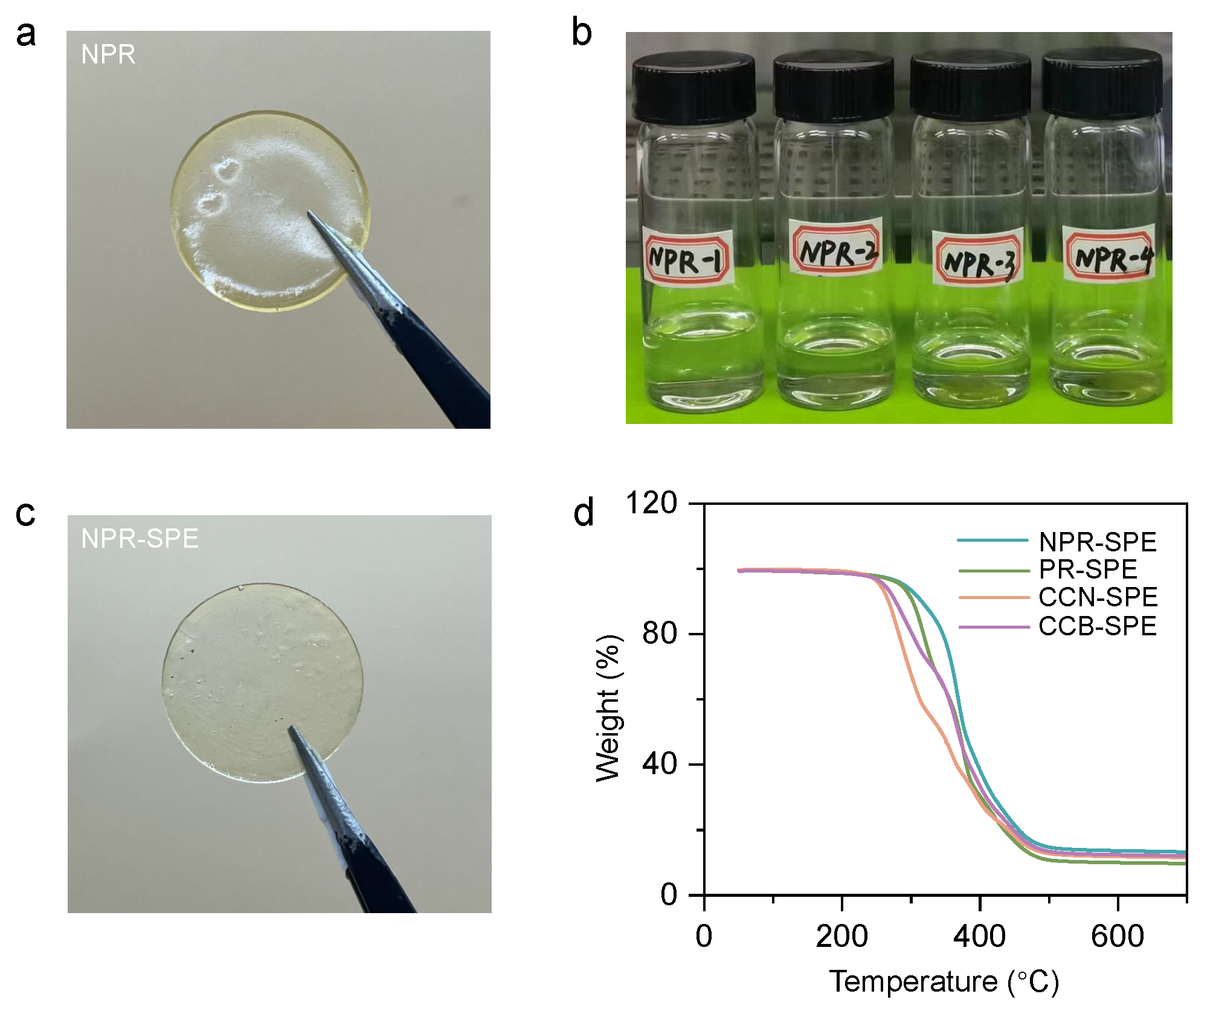
Figure S27. The optical photographs of the (a) NPR film, (b) NPR immersed in LiTFSI solutions with different concentrations, and (c) NPR-SPE film. (d) TGA curves of NPR-SPE, PR-SPE, CCN-SPE, and CCB-SPE recorded under N₂ flow (50 mL min⁻¹) with a heating rate of 20 ℃ min⁻¹.

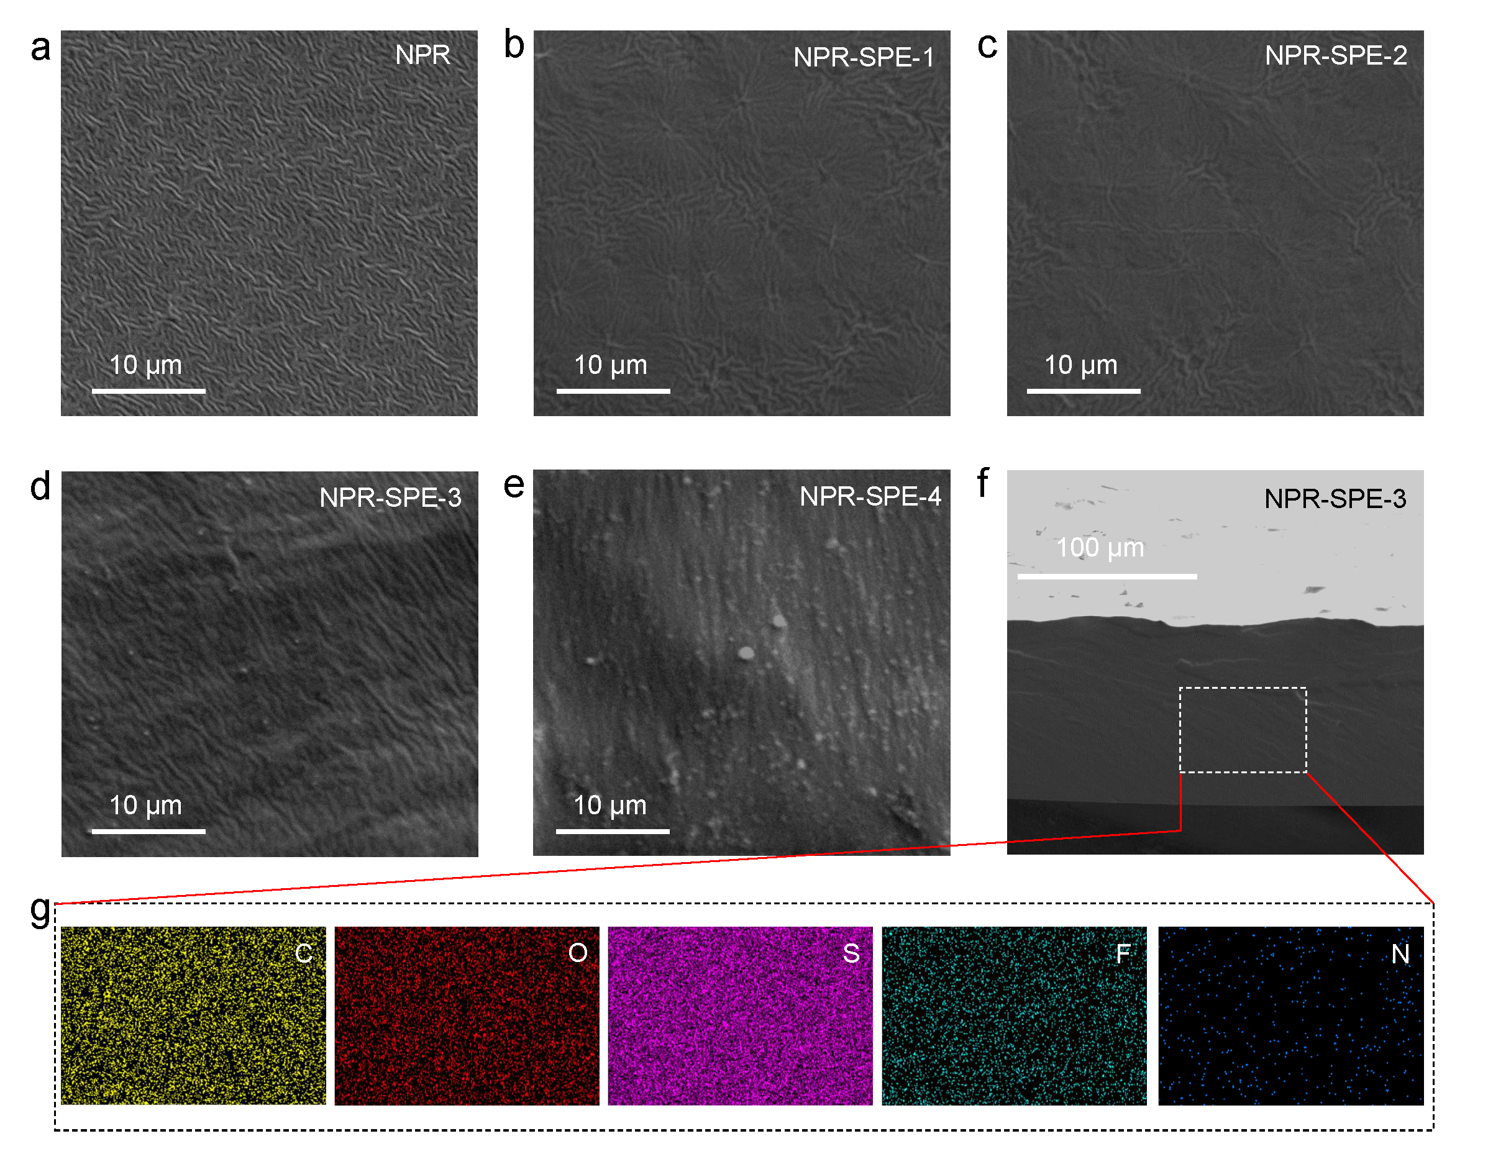
Figure S28. SEM images of NPR and NPR-SPE. (a) NPR without lithium salt. NPR-SPE with (b) 20%, (c) 25%, (d) 28%, and (e) 30% Li salt addition. (f) The cross-sectional SEM image of the NPR-SPE, and the (g) corresponding EDS mapping.

Notes: The SEM images revealed that immersion in the lithium salt solution transformed the initially undulating surface morphology of NPR into a smoother topography. Furthermore, increasing the LiTFSI concentration led to the formation of crystalline salt deposits on the surface at higher concentrations. The optimal LiTFSI concentration of 28% was identified, yielding an SPE film with a thickness of approximately 100 µm. EDS mapping confirmed the homogeneous distribution of LiTFSI throughout the NPR matrix at this concentration.

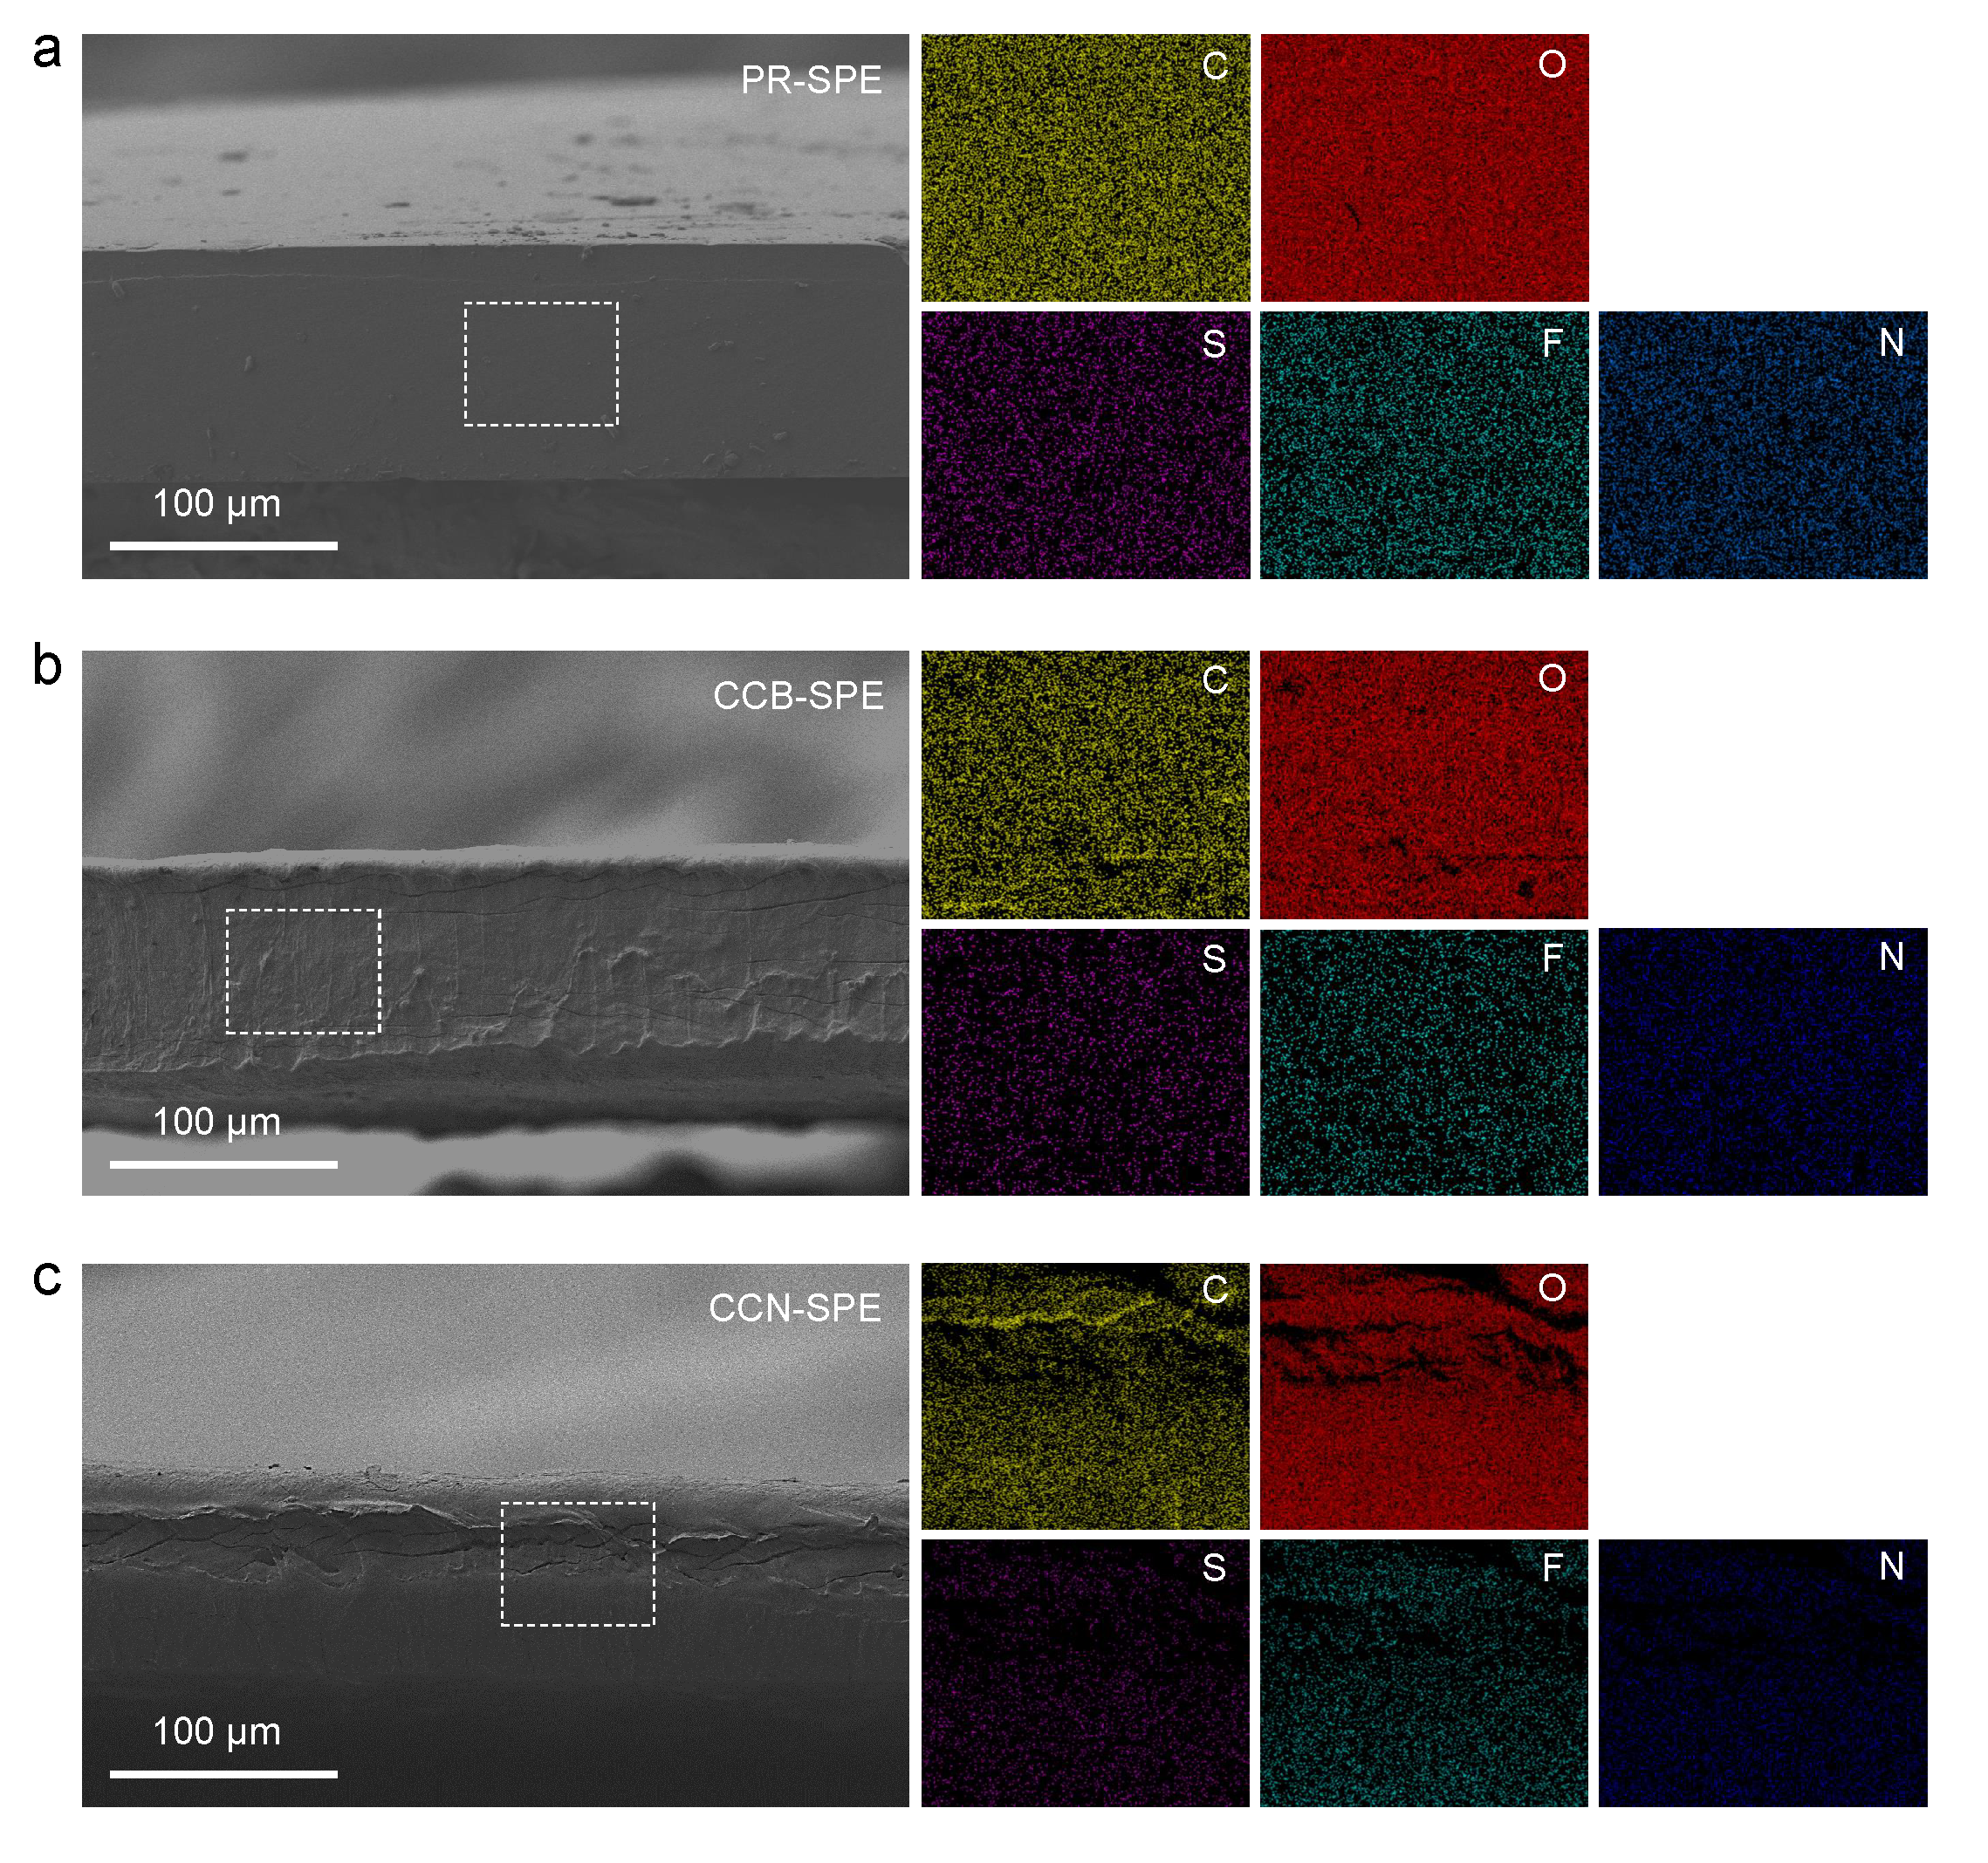
Figure 29. Cross-sectional SEM and EDS mapping images of (a) PR-SPE, (b) CCB-SPE, and (c) CCN-SPE.

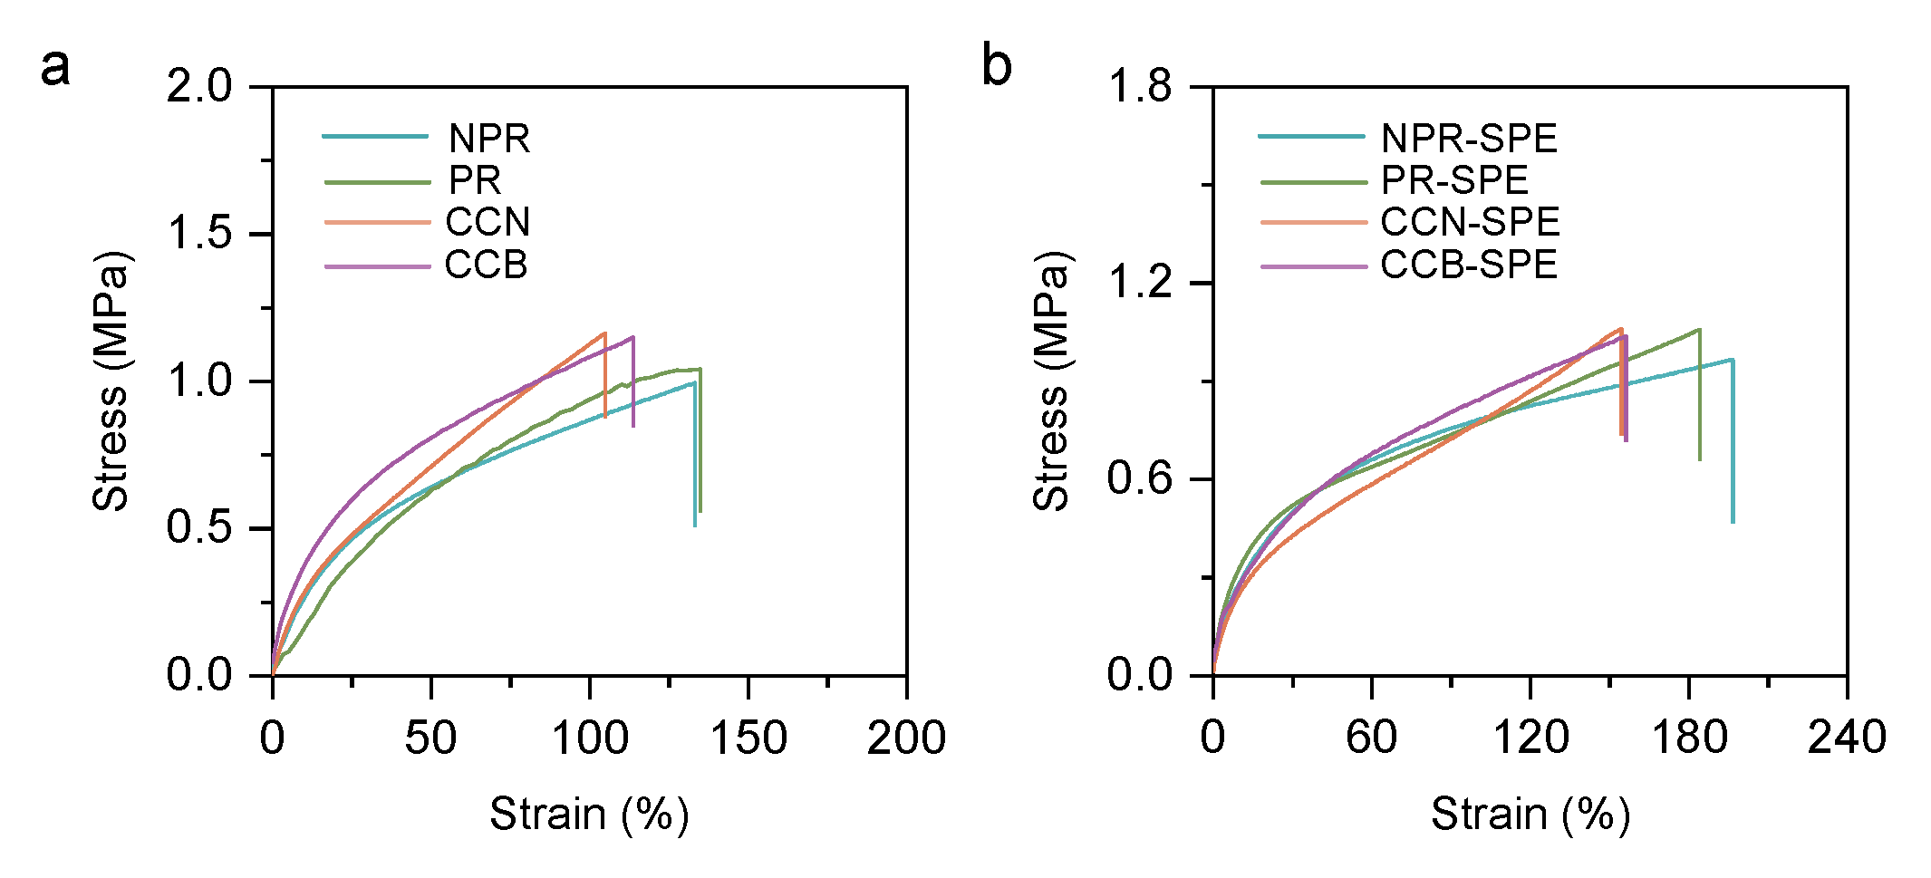
Figure S30. (a) Stress–strain curves of NPR, PR, CCN, and CCB. (b) Stress–strain curves of NPR-SPE, PR-SPE, CCN-SPE, and CCB-SPE.

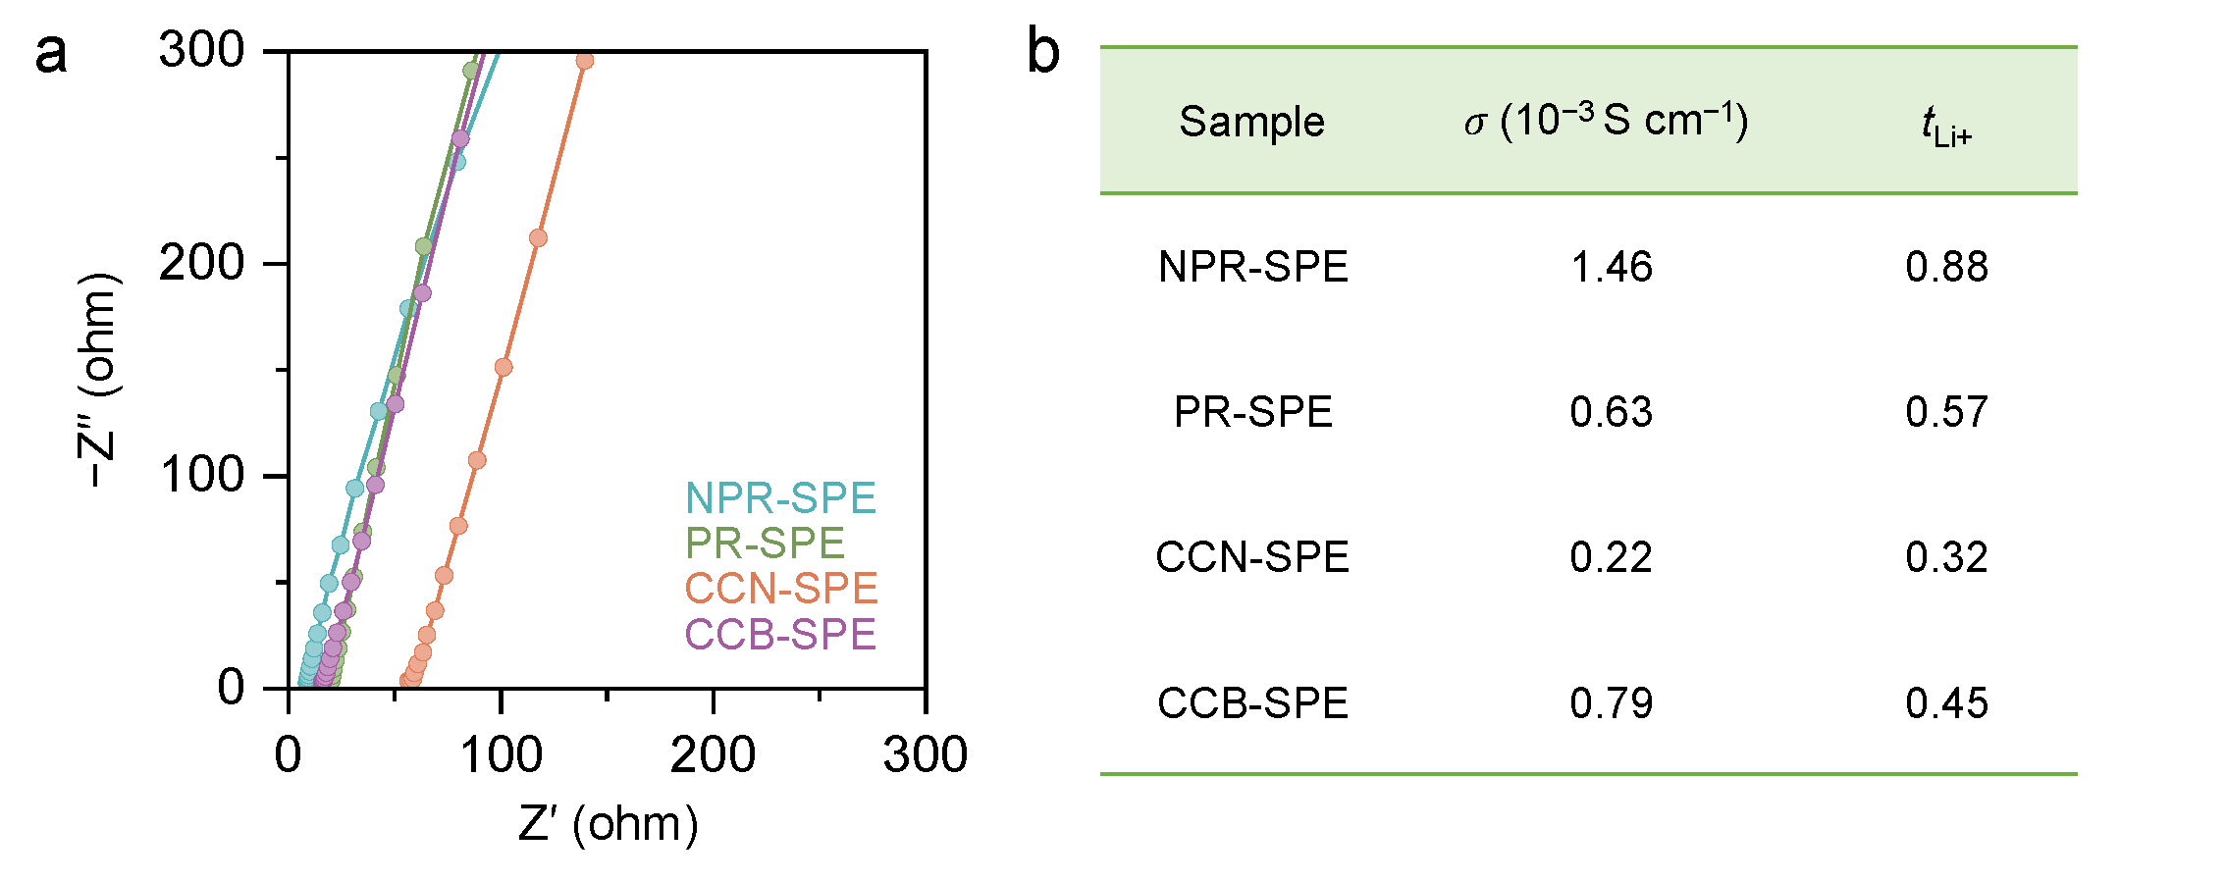
Figure S31 (a) EIS spectra of SS||SS symmetric cells with NPR-SPE, PR-SPE, CCN-SPE, and CCB-SPE at RT. (b) Ionic conductivity and Li-ion transference number of NPR-SPE, PR-SPE, CCN-SPE, and CCB-SPE at RT.

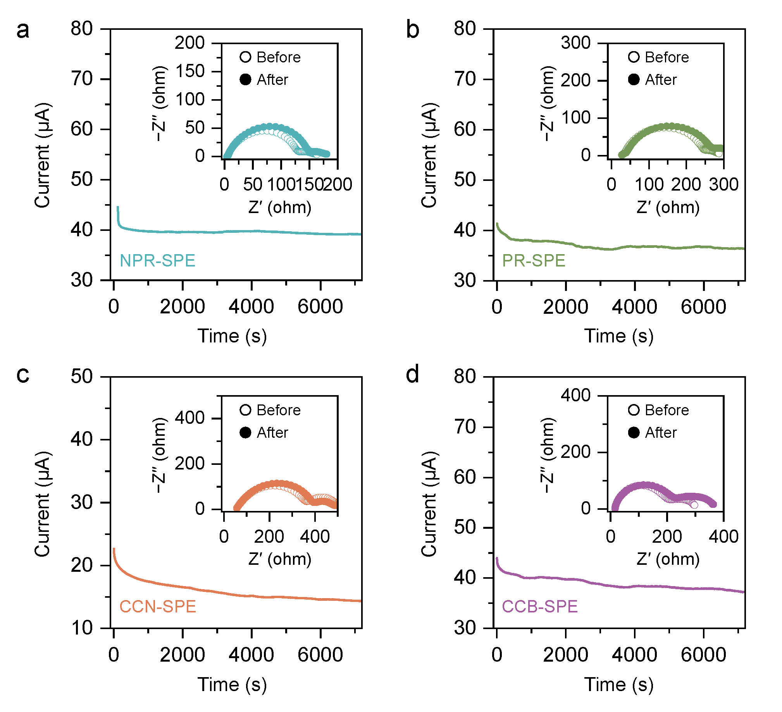
Figure S32. Chronoamperometry curves at 10 mV applied voltage and corresponding impedance spectra (inset: before and after polarization) for Li symmetric cells employing (a) NPR-SPE, (b) PR-SPE, (c) CCN-SPE, and (d) CCB-SPE.

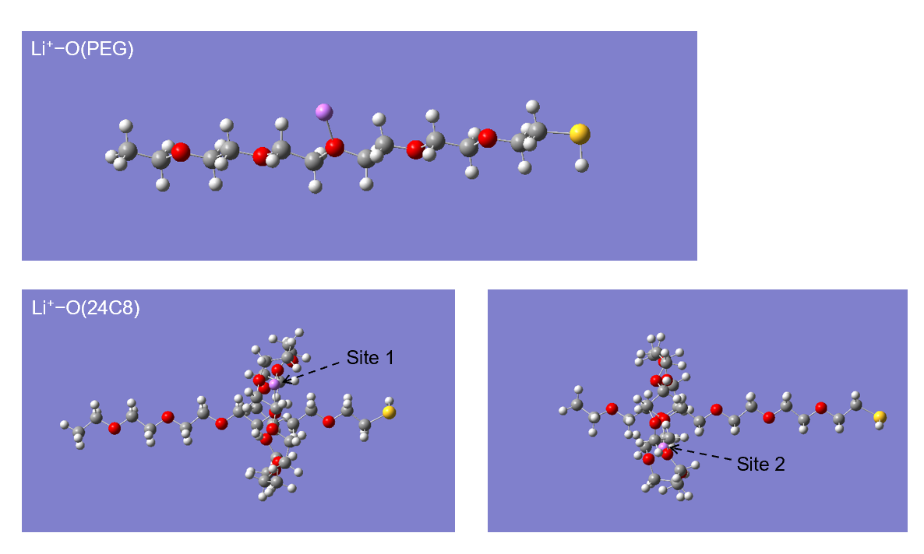
Figure S33. The binding site of Li⁺∙∙∙24C8 (R−O−R) and Li⁺∙∙∙PEG (R−O−R).

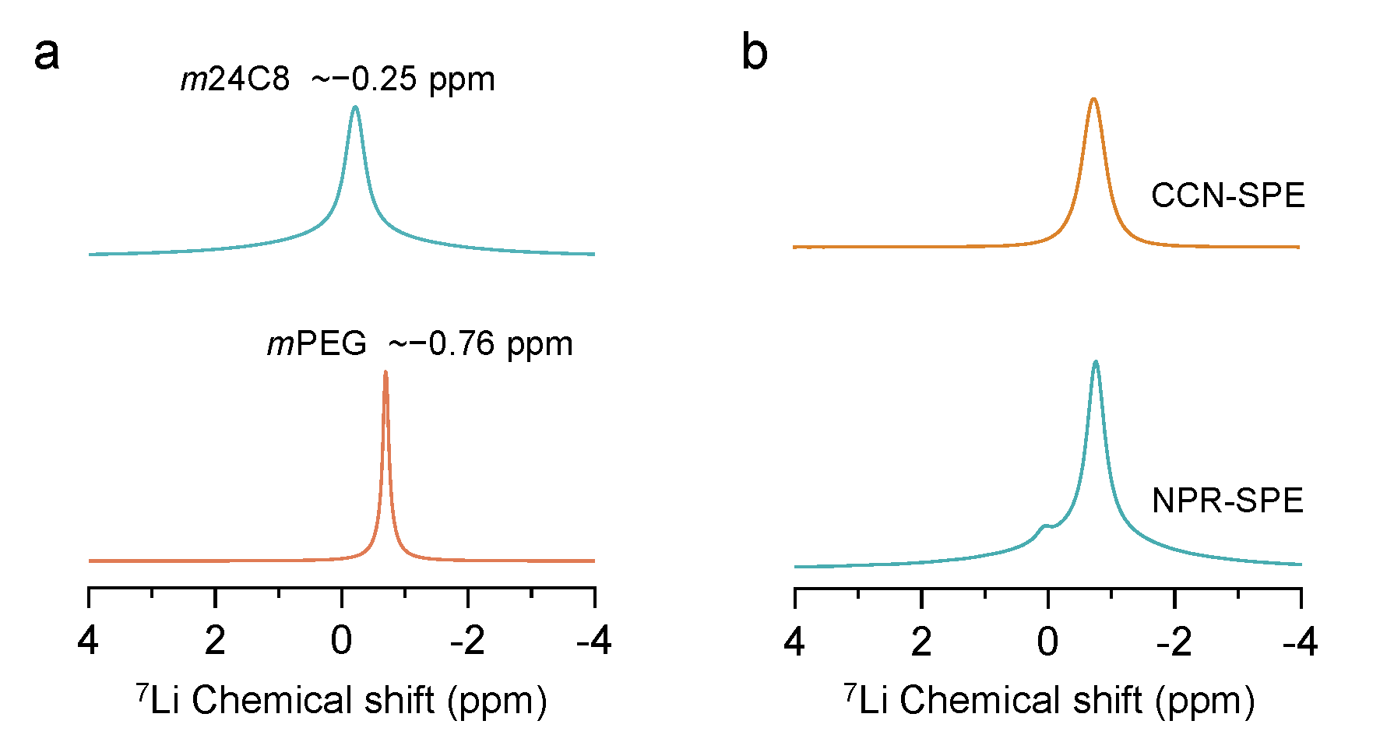
Figure S34. Solid-state ⁷Li NMR spectra of (a) 24C8/PEG with LiTFSI and (b) CCN-SPE and NPR-SPE.

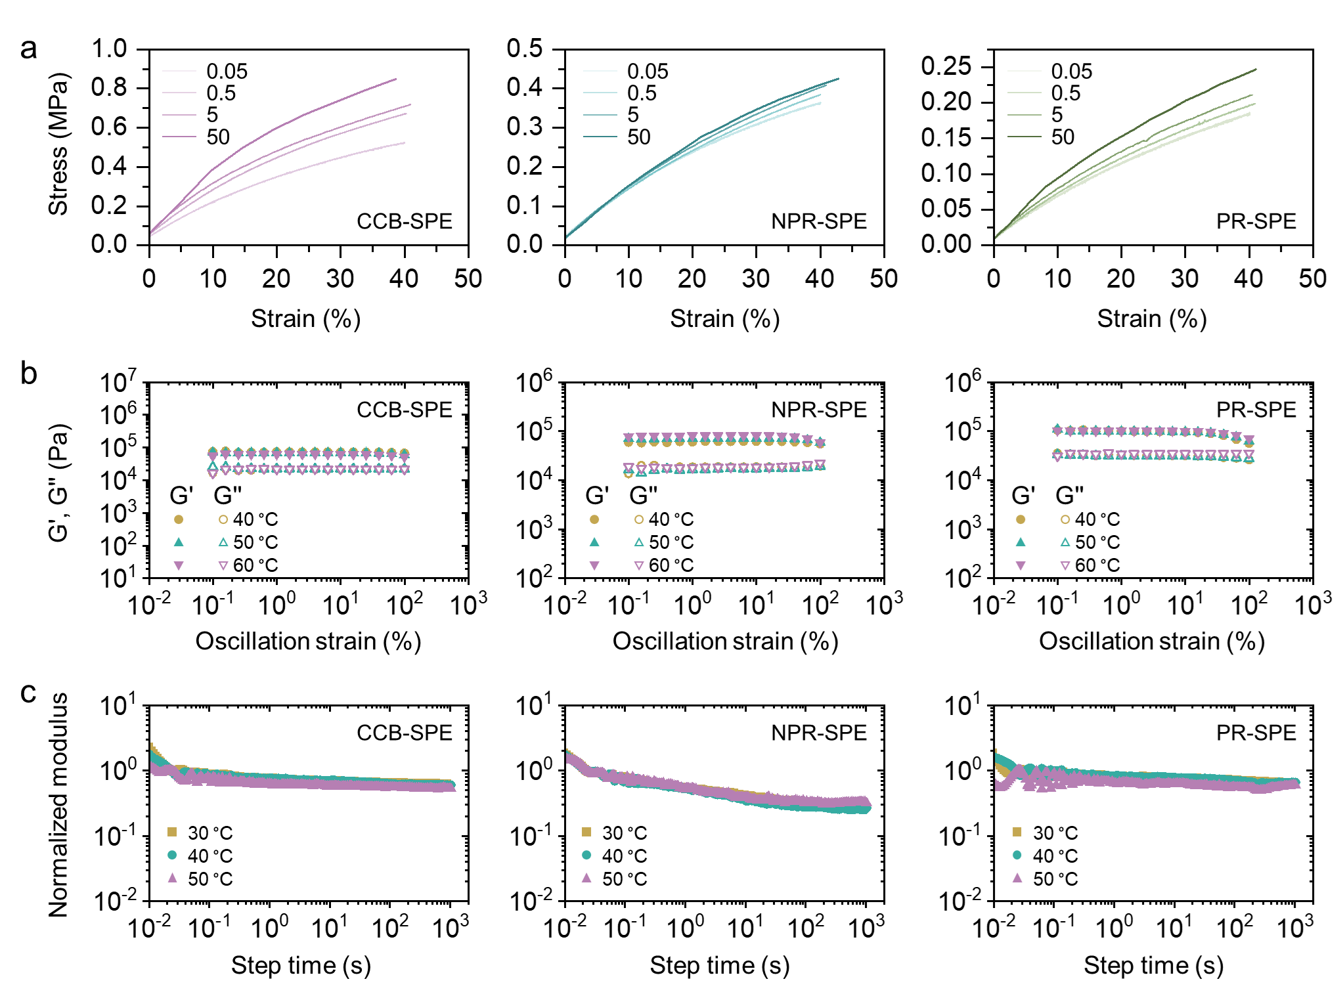
Figure S35. (a) Stress–strain curves of NPR-SPE, PR-SPE, and CCB-SPE under different loading. (b) Strain sweep at different temperatures (40, 50, and 60 °C) of NPR-SPE, PR-SPE, and CCB-SPE. (c) Normalized modulus as a function of step time for NPR-SPE, PR-SPE, and CCB-SPE.

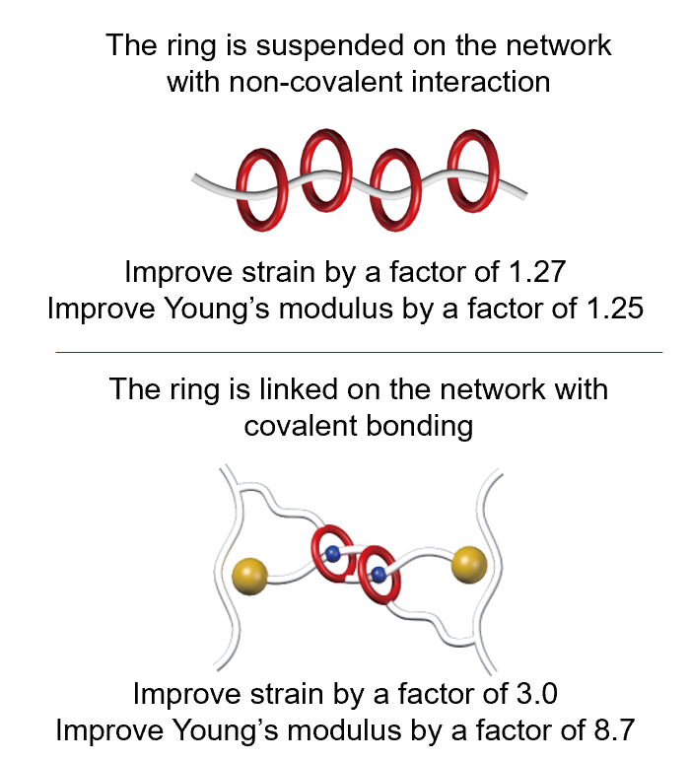
Figure S36. Comparison of mechanical properties and the key structure of the studied NPR and the previously reported MIP.

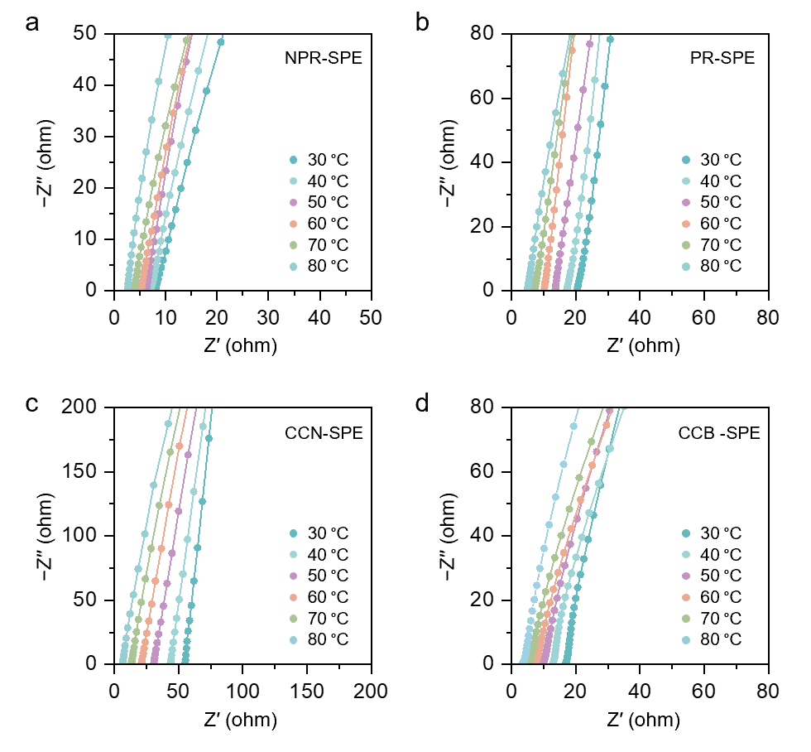
Figure S37 EIS spectra of SS||SS symmetric cells using (a) NPR-SPE, (b) PR-SPE, (c) CCN-SPE, and (d) CCB-SPE at various temperatures (from 30 ℃ to 80 ℃).

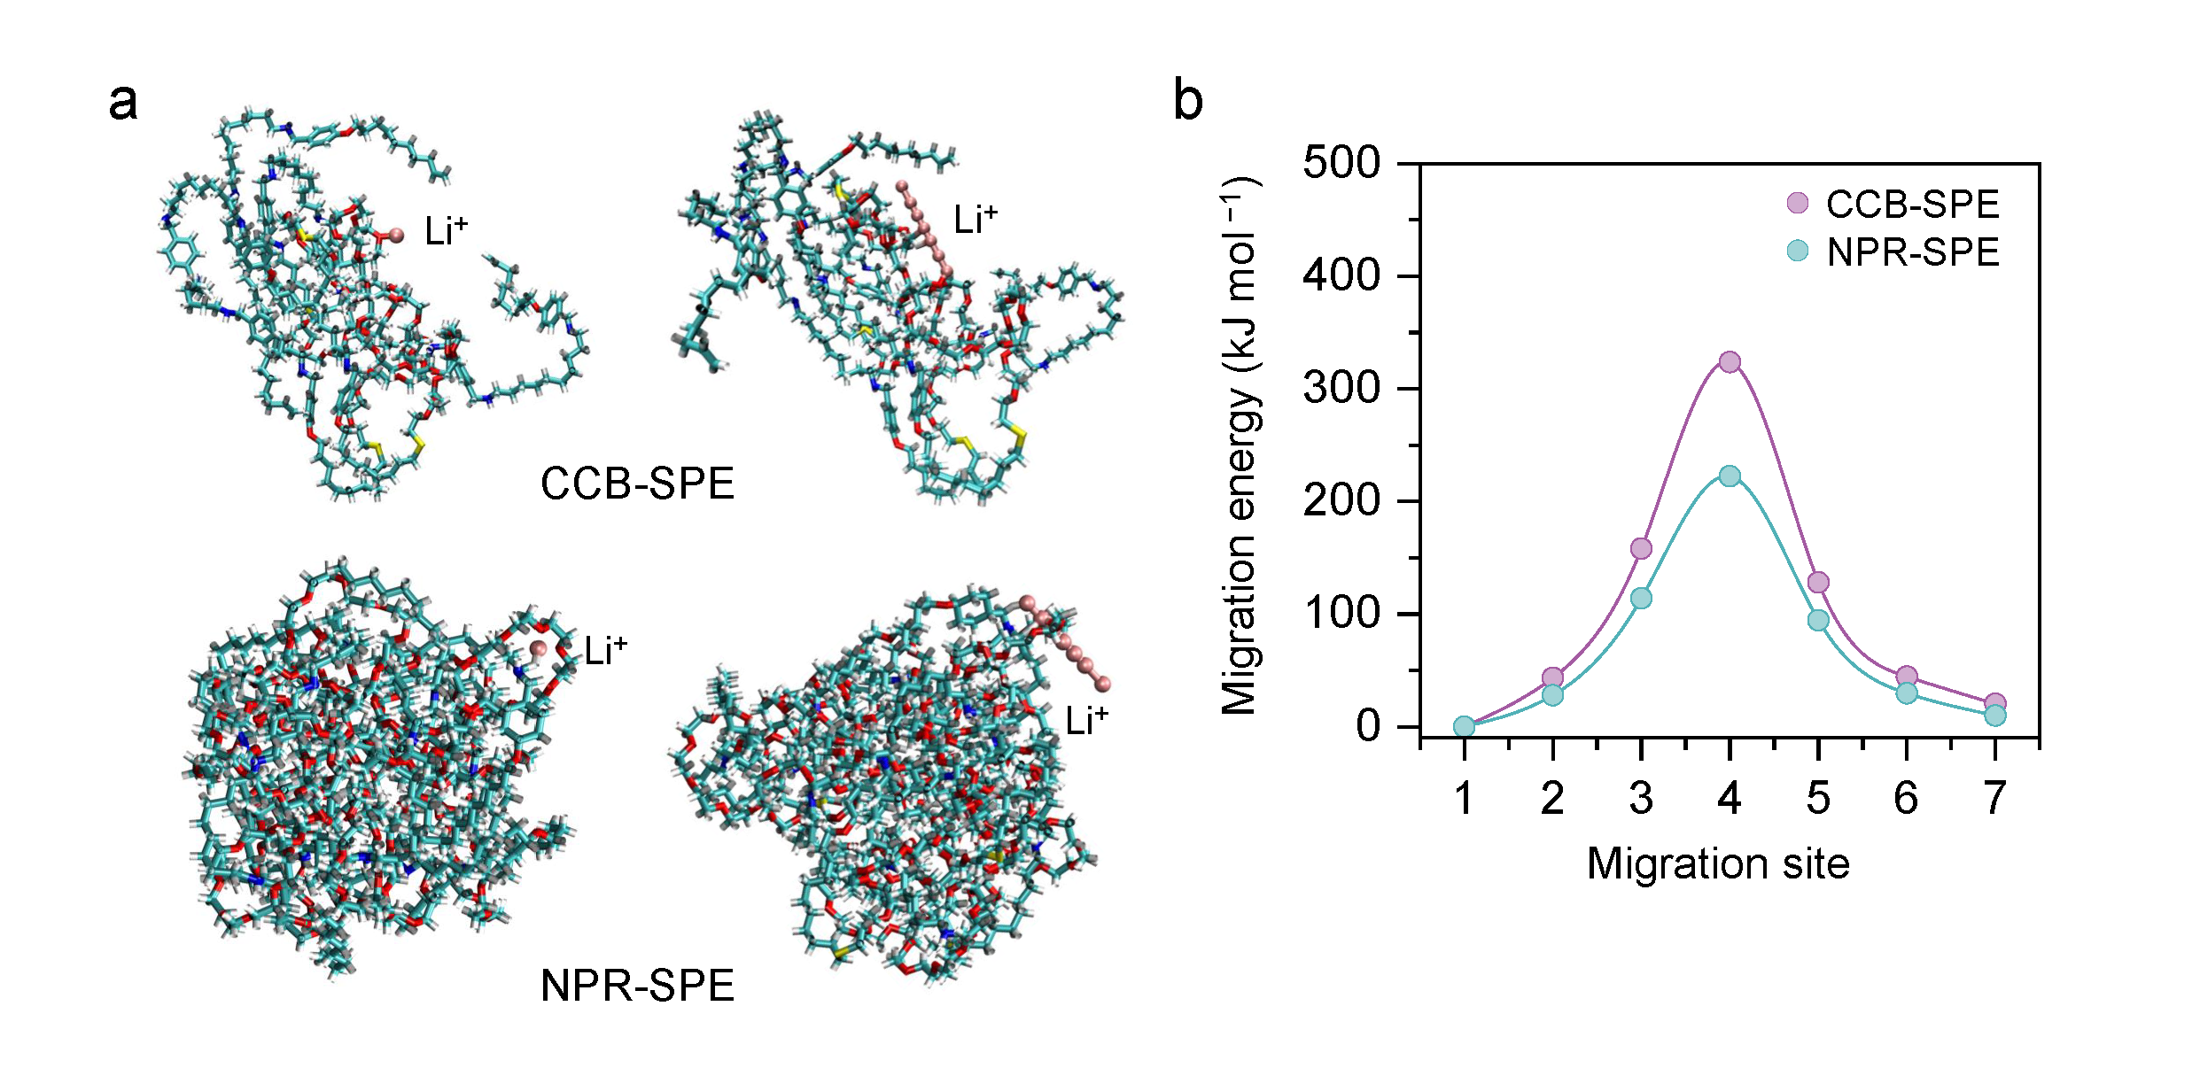
Figure S38. (a) Possible conduction pathways of NPR-SPE and CCB-SPE. (b) Migration energy of Li-ions in NPR-SPE and CCB-SPE.

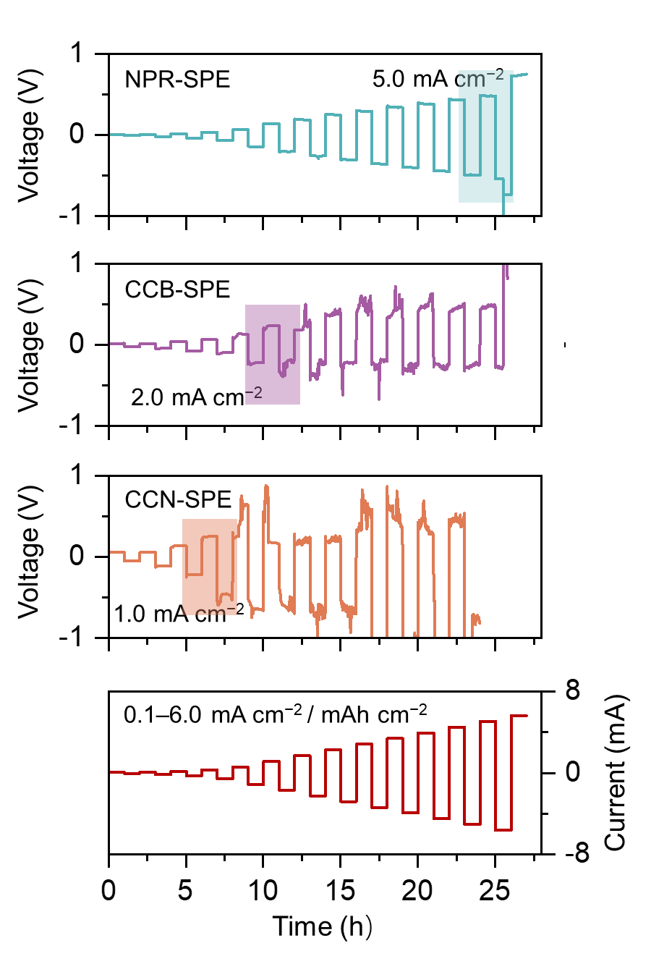
Figure S39. CCD of Li symmetric cells using NPR-SPE, CCB-SPE, and, CCB-SPE.

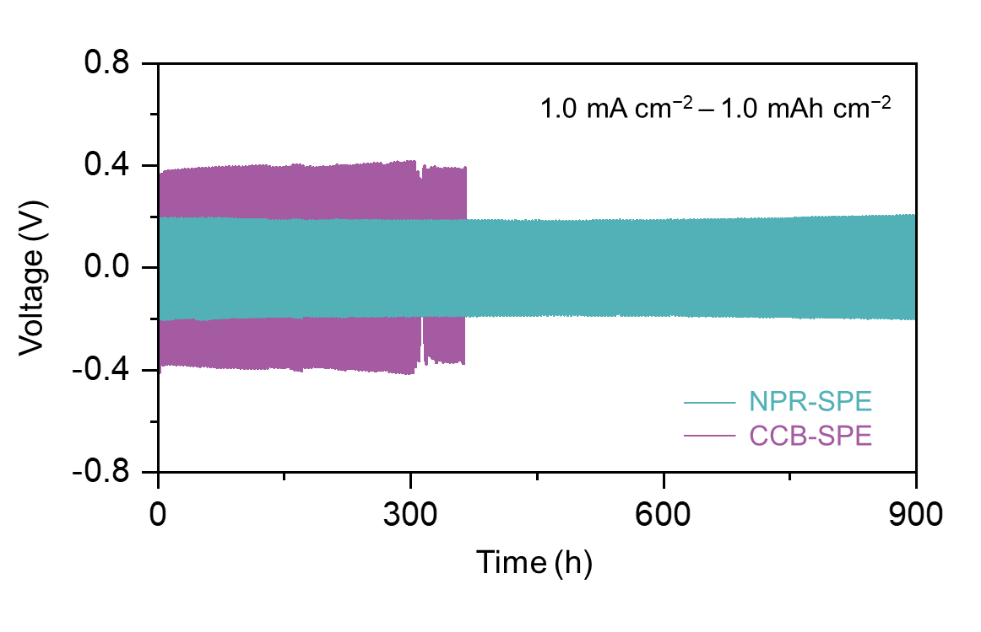
Figure S40. Long-term cycling of Li symmetric cells using NPR-SPE, CCB-SPE, and, CCB-SPE at 1.0 mA cm⁻² with a 1.0 mAh cm⁻² Li capacity.

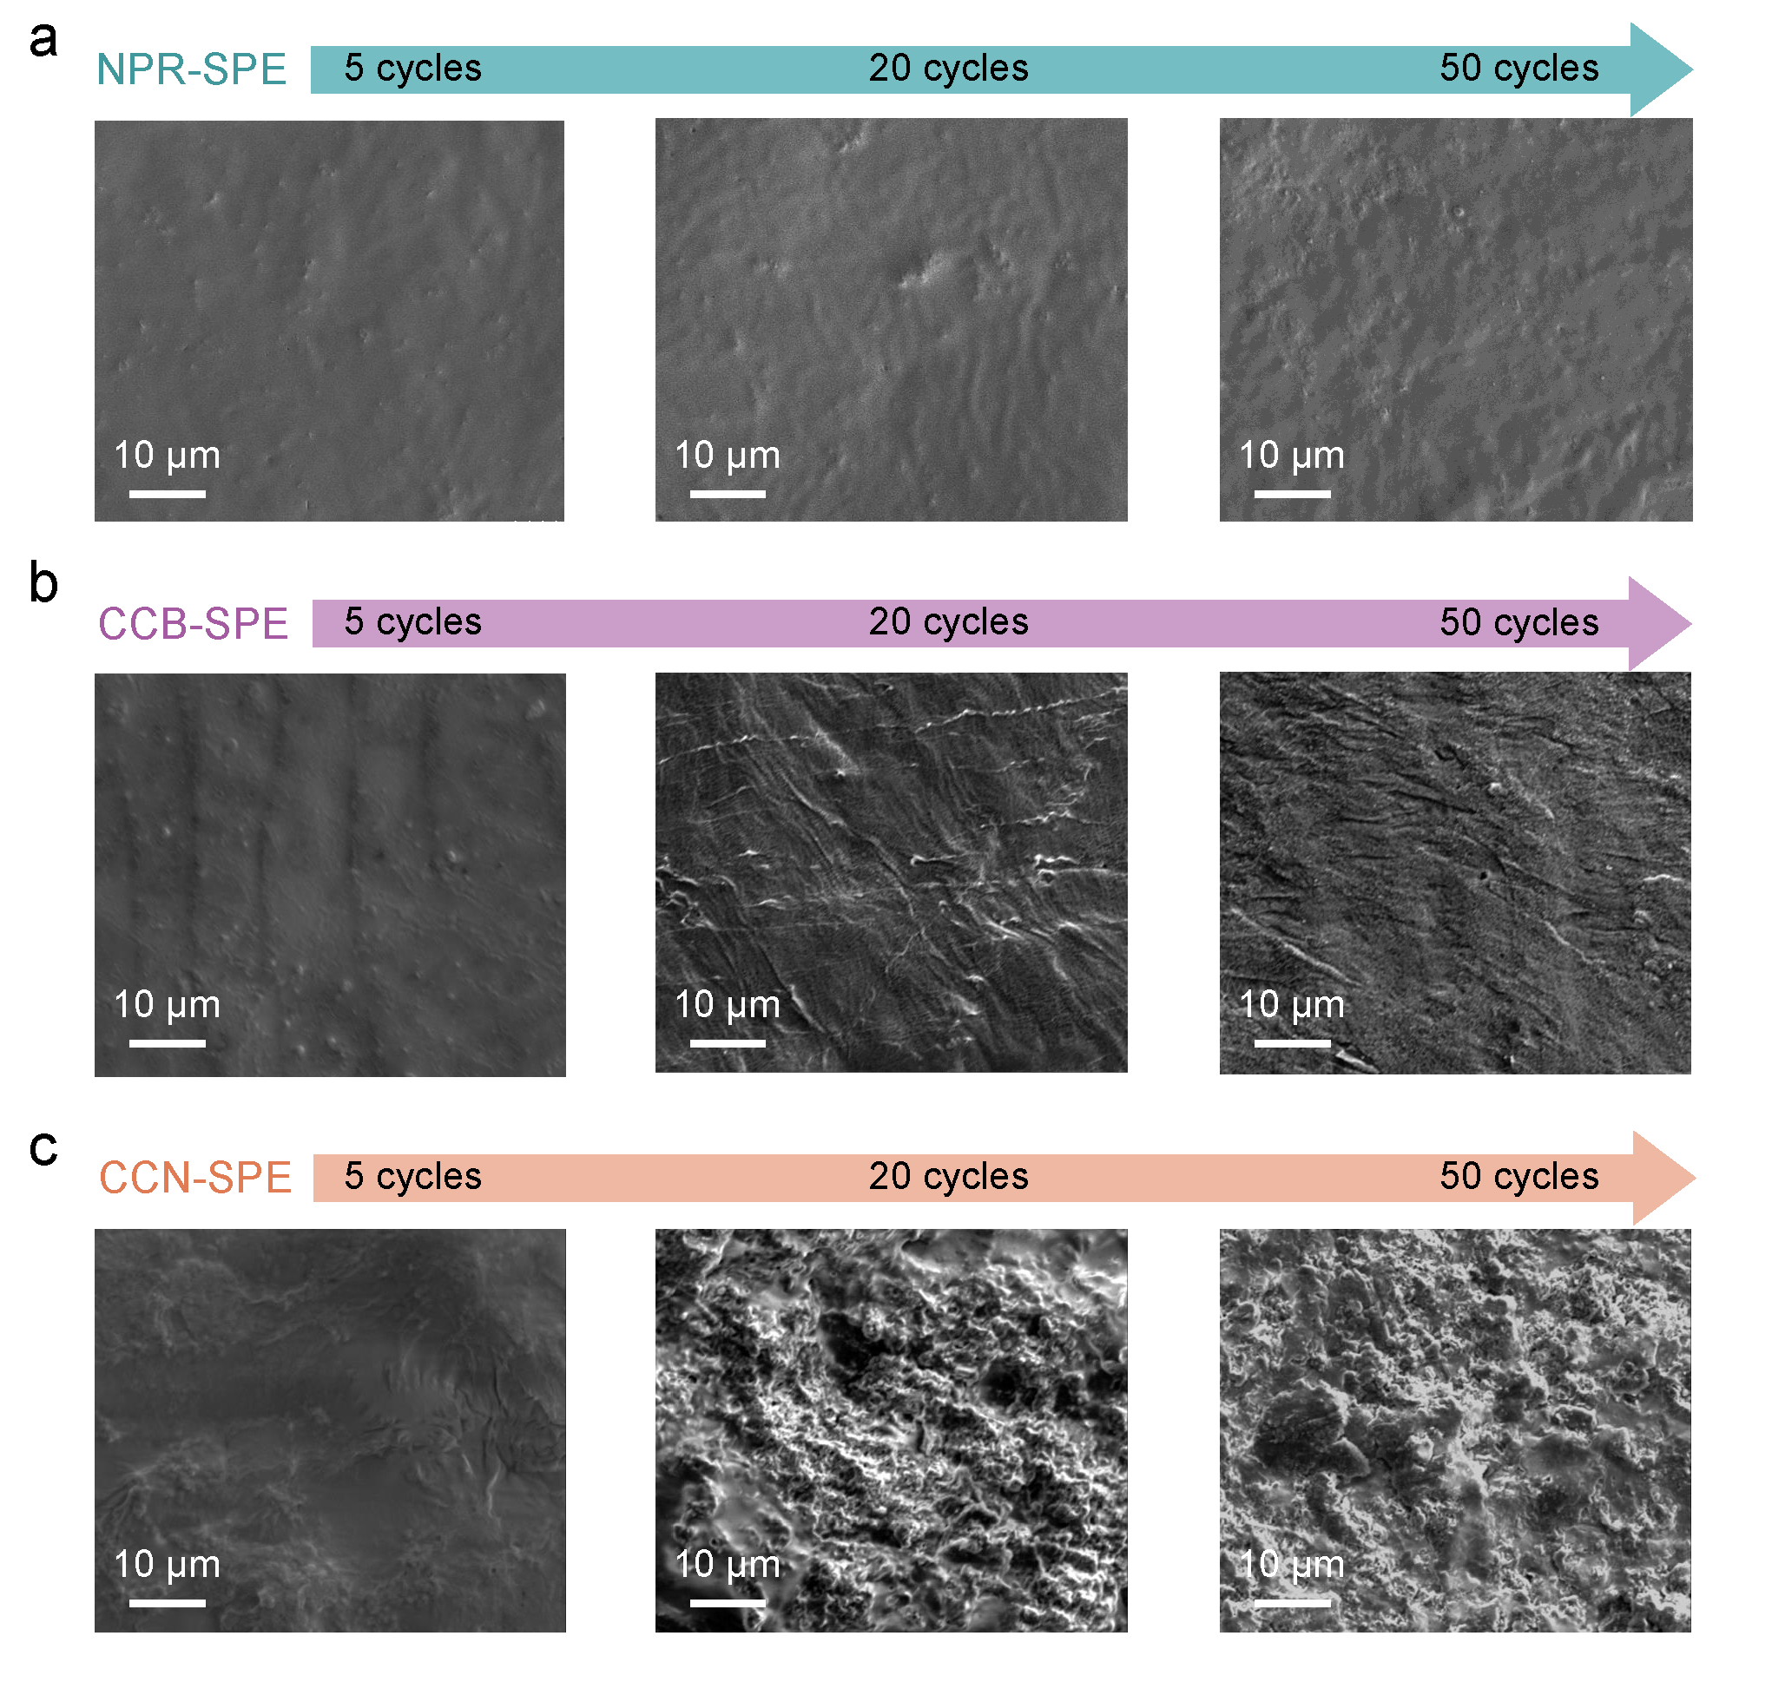
Figure S41. Morphological evolution of (a) NPR-SPE, (b) CCB-SPE, and (c) CCN-SPE after 5, 20, and 50 cycles in Li symmetric cells at 0.5 mA cm⁻² with a 0.5 mAh cm⁻² Li capacity.

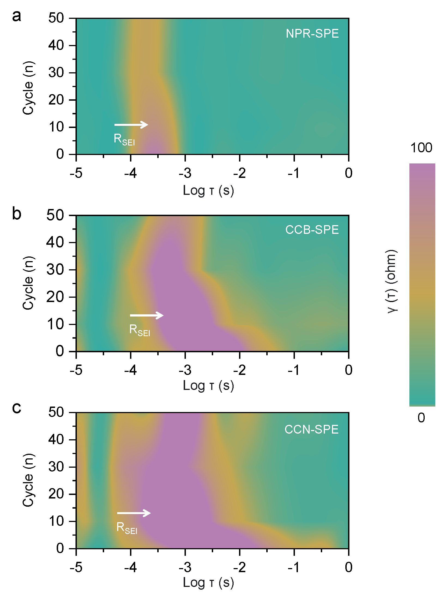
Figure S42. In-situ DRT analysis of Li symmetric cells using (a) NPR-SPE, (b) CCB-SPE, and (c) CCN-SPE.

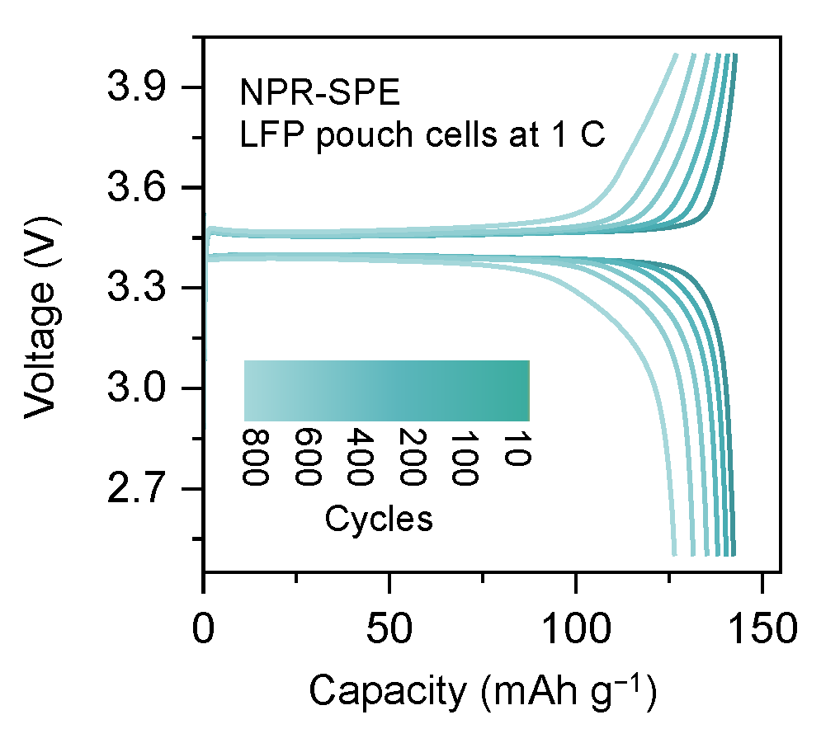
Figure S43. Voltage profiles of the LFP pouch cell using NPR-SPE at different cycles.

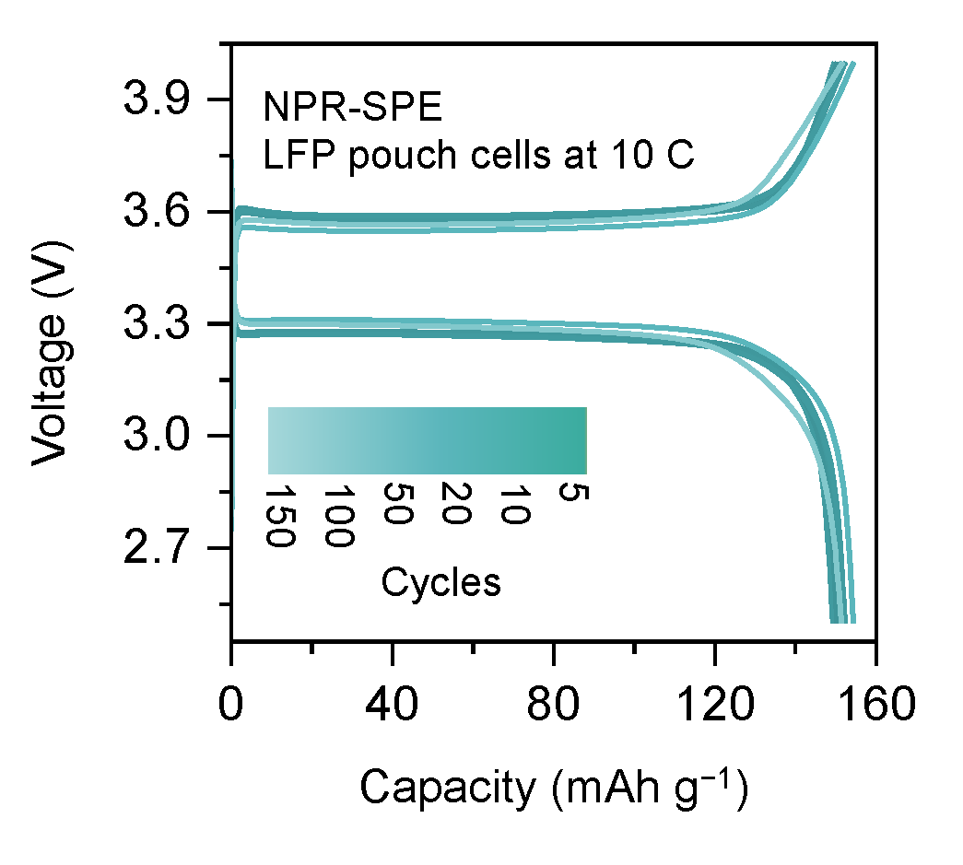
Figure S44 Voltage profiles of the LFP pouch cell using NPR-SPE at different cycles.

Table S1 Comparison of ion-conductivity capability with reported polymer electrolyte.
Structural type | Sample | Test  temperature (°C) | Ionic conductivity  (×10⁻⁴ S cm⁻¹) | Li-ion transference number | Li-ion conductivity  (×10⁻⁴ S cm⁻¹) | Ref.
CCN | LiPHB | 30 | 5.9 | 0.7 | 4.13 | S8
CCN | ASPE | 20 | 3.42 | 0.66 | 2.2572 | S9
CCN | dcnSPEs | RT | 0.119 | 0.54 | 0.06426 | S10
CCN | PTADOL | RT | 1.48 | 0.76 | 1.1248 | S11
CCN | P1000PEG-SPE | RT | 4.2 | 0.51 | 2.142 | S12
CCN | PEGDE-PEGDA-1000 | RT | 0.53 | 0.44 | 0.2332 | S13
CCN | PEG-HMDI-ZrMOF | 30 | 5.7 | 0.84 | 4.788 | S14
CCN | M-S-PEGDA | RT | 2.26 | 0.44 | 0.9944 | S15
CCN | ePU@H | 35 | 1.48 | 0.48 | 0.7104 | S16
CCN | DPE1 | 25 | 1.17 | 0.71 | 0.8307 | S17
CCN | PCL-MDI-DBPG | 40 | 2.2 | 0.57 | 1.254 | S18
CCN | PZEA-IL6 | 30 | 1.0 | --- | -- | S19
CCN | ILBM-70 | RT | 5.3 | --- | -- | S20
NCCN | PCPE-550 | 50 | 2.7 | 0.63 | 1.701 | S21
NCCN | TPU/P-DOL | 25 | 2.61 | 0.62 | 1.6182 | S22
NCCN | In situ-SL2 | RT | 4.4 | 0.87 | 3.828 | S23
NCCN | DLM30 | 30 | 2.2 | 0.46 | 1.012 | S24
NCCN | S-LHCE | 20 | 2.7 | 0.72 | 1.944 | S25
NCCN | PVLN | RT | 7.3 | 0.4 | 2.92 | S26
NCCN | LPIFD | RT | 3.0 | 0.64 | 1.92 | S27
NCCN | PPF40 | 25 | 6.0 | --- | -- | S28
NCCN | eEPE-50 | 25 | 3.5 | 0.43 | 1.505 | S29
NCCN | DNSE@IN | RT | 3.9 | 0.67 | 2.613 | S30
NCCN | CPE-3 | 30 | 6.0 | --- | -- | S31
MIN | G@MOF(Ti)-15 | 25 | 13.6 | 0.71 | 9.656 | S32
MIN | mPR-SPE | 25 | 28 | 0.61 | 17.08 | S33
MIN | SCGPE-3 | 30 | 17.3 | 0.71 | 12.283 | S34
MIN | B-2.5 | 20 | 22 | 0.45 | 9.9 | S35
MIN | MSPE | RT | 10.4 | 0.72 | 7.488 | S36
MIN | APR-PPCE | 25 | 20 | 0.66 | 13.2 | S37
MIN | LiNO₃-PRX-SPE | 25 | 59.3 | 0.71 | 42.103 | S38

Table S2 Cycling performance of the Li symmetric cell with reported all-solid-state polymer electrolyte.
Sample | Test  temperature  (°C) | Li symmetric cell |  |  | Ref.
Sample | Test  temperature  (°C) | Current density  (mA cm⁻²) /  Li capacity (mAh cm⁻²) | Operation time  (h) | Critical current density  (mA cm⁻²) | Ref.
SPC | 40 | 0.1 / 0.1 | 780 | 0.1 | S39
poly (DOL-TTE)-LP | RT | 0.5 / 0.5 | 2000 | 1.0 | S40
in situ-SL2 | RT | 0.3 / 0.3 | 1000 | 0.5 | S23
PVBE SPE | RT | 0.1 / 0.1 | 1600 | 0.1 | S41
PTMG-HDI-BHDS | RT | 0.2 / 0.2 | 6000 | 1.0 | S42
PDMA-Li | RT | 0.5 / 0.5 | 600 | 0.5 | S43
PBO/PEO | 60 | 0.1 / 0.1 | 1000 | 0.4 | S44
PDOL-5%PS | RT | 1.0 / 1.0 | 1000 | 1.0 | S45
PAN fiber-PEGDA | RT | 0.2 / 0.2 | 600 | 1.04 | S46
CPE | 25 | 0.1 / 0.1 | 400 | 0.15 | S47
PRX-SPE | RT | 0.2 / 0.2 | 100 | 0.2 | S38
PEO-6TiF4 | 30 | 0.1 / 0.1 | 1300 | 1.6 | S48
SSE@PH-BN/LN | RT | 0.5 / 0.5 | 1500 | 0.5 | S49
ASPE | RT | 0.2 / 0.2 | 2250 | 2 | S9
P2-salt₅₅ | RT | 0.05 / 0.05 | 1700 | 0.1 | S50
HPEM/PVCA | 30 | 0.1 / 0.1 | 800 | 0.4 | S51
PDOL@ZnO | RT | 0.5 / 0.5 | 1500 | 1.5 | S52
PCPE-550 | RT | 0.5 / 0.1 | 1200 | 1.0 | S21
LiBTFSI/PEO | 70 | 0.1 / 0.3 | 550 | 0.1 | S53
NPR-SPE | RT | 0.5 /0.5 | 8000 | 5.0 | This work

Table S3 Cycling performance of the Li||LFP cell with reported all-solid-state polymer electrolyte.
Sample | Test  temperature (°C) |  |  |  | Full cell |  |  |  | Ref.
Sample | Test  temperature (°C) | Cathode | Cycling  (Capacity retention > 70%) |  |  | Current density (C) | Rate capability (C) |  | Ref.
P2-salt55 | RT | LFP | 60 |  |  | 0.1 | 0.5 |  | S50
SSE@PH | RT | LFP | 95 |  |  | 0.1 | 1.0 |  | S49
PRX-SPE | RT | LFP | 100 |  |  | 0.1 | 1.0 |  | S38
PVBE SPE | RT | LFP | 105 |  |  | 0.1 | 1.0 |  | S41
PAN-PEGDA | RT | LFP | 150 |  |  | 0.3 | 0.5 |  | S46
PDMA-Li | RT | LFP | 150 |  |  | 0.2 | 1.0 |  | S43
LDR | 25 | LFP | 150 |  |  | 0.2 | 2.0 |  | S54
poly-LP | RT | LFP | 200 |  |  | 0.2 | 1.0 |  | S40
PCPE-550 | 50 | LFP | 200 |  |  | 0.2 | 2.0 |  | S21
LiBTFSI/PEO | RT | LFP | 200 |  |  | 0.2 | 1.0 |  | S53
CPE | RT | LFP | 250 |  |  | 0.5 | 2.0 |  | S47
PBO/PEO | 60 | LFP | 300 |  |  | 0.5 | 2.0 |  | S44
SPC | 30 | LFP | 425 |  |  | 1.0 | 2.0 |  | S39
PDOL-5%PS | 25 | LFP | 600 |  |  | 2.0 | 2.0 |  | S45
P-HDI-BHDS | RT | LFP | 700 |  |  | 0.3 | 1.0 |  | S42
HPEM/PVCA | 30 | LFP | 900 |  |  | 0.5 | 3.0 |  | S51
PEO-6TiF4 | 30 | LFP | 1000 |  |  | 1.0 | 2.0 |  | S48
ASPE | RT | LFP | 1000 |  |  | 0.5 | 2.0 |  | S9
NPR-SPE | RT | LFP | 2400 |  |  | 10.0 | 10.0 |  | This work

References
1. Grimme, S., Ehrlich, S. & Goerigk, L. Effect of the damping function in dispersion corrected density functional theory. J. Comput. Chem. 32, 1456-1465 (2011).
2. Petersson, G. A. et al. A complete basis set model chemistry. I. The total energies of closed‐shell atoms and hydrides of the first‐row elements. J. Chem. Phys. 89, 2193-2218 (1988).
3. Gaussian 16, Revision B.01, M. J. Frisch, G. W. Trucks, H. B. Schlegel, G. E. Scuseria, M. A. Robb, J. R. Cheeseman, G. Scalmani, V. Barone, G. A. Petersson, H. Nakatsuji, X. Li, M. Caricato, A. V. Marenich, J. Bloino, B. G. Janesko, R. Gomperts, B. Mennucci, H. P. Hratchian, J. V. Ortiz, A. F. Izmaylov, J. L. Sonnenberg, D. Williams-Young, F. Ding, F. Lipparini, F. Egidi, J. Goings, B. Peng, A. Petrone, T. Henderson, D. Ranasinghe, V. G. Zakrzewski, J. Gao, N. Rega, G. Zheng, W. Liang, M. Hada, M. Ehara, K. Toyota, R. Fukuda, J. Hasegawa, M. Ishida, T. Nakajima, Y. Honda, O. Kitao, H. Nakai, T. Vreven, K. Throssell, J. A. Montgomery, Jr., J. E. Peralta, F. Ogliaro, M. J. Bearpark, J. J. Heyd, E. N. Brothers, K. N. Kudin, V. N. Staroverov, T. A. Keith, R. Kobayashi, J. Normand, K. Raghavachari, A. P. Rendell, J. C. Burant, S. S. Iyengar, J. Tomasi, M. Cossi, J. M. Millam, M. Klene, C. Adamo, R. Cammi, J. W. Ochterski, R. L. Martin, K. Morokuma, O. Farkas, J. B. Foresman, and D. J. Fox, Gaussian, Inc., Wallingford CT, 2016.
4. Boys, S. F. & Bernardi, F. The calculation of small molecular interactions by the differences of separate total energies. Some procedures with reduced errors. Mol. Phys. 19, 553-566 (1970).
5. Hess, B., Kutzner, C., van der Spoel, D. & Lindahl, E. GROMACS 4: Algorithms for Highly Efficient, Load-Balanced, and Scalable Molecular Simulation. J. Chem. Theory Comput. 4, 435-447 (2008).
6. Essmann, U., et al., A smooth particle mesh Ewald method. J. Chem. Phys. 19, p. 8577-8593 (1995).
7. Hess, B., Bekker, H., Berendsen, H. J. C. & Fraaije, J. G. E. M. LINCS: A linear constraint solver for molecular simulations. J. Comput. Chem. 18, 1463-1472 (1997).
8. Yang, Z., Ye, Y., Meng, N. & Lian, F. Adaptive 3D cross-linked single-ion conducting polymer electrolytes enable powerful interface for solid state batteries. Angew. Chem. Int. Ed. 64, e202505232 (2025).
9. Wang, H. et al. A strongly complexed solid polymer electrolyte enables a stable solid state high-voltage lithium metal battery. Energy Environ. Sci. 15, 5149-5158 (2022).
10. Shi, L. et al. In situ formed cross-linked polymer networks as dual-functional layers for high-stable lithium metal batteries. J. Energy Chem. 79, 253-262 (2023).
11. Du, Y. et al. Ameliorating structural and electrochemical properties of traditional poly-dioxolane electrolytes via integrated design of ultra-stable network for solid-state batteries. Energy Stor. Mater. 56, 310-318 (2023).
12. Choi, Y. G. et al. Pyrrolidinium-PEG ionic copolyester: Li-ion accelerator in polymer network solid-state electrolytes. Adv. Energy Mater. 11, 2102660 (2021).
13. Duan, H. et al. In-situ plasticized polymer electrolyte with double-network for flexible solid-state lithium-metal batteries. Energy Stor. Mater. 10, 85-91 (2018).
14. Pei, F. et al. Multisite crosslinked poly(ether-urethane)-based polymer electrolytes for high-voltage solid-state lithium metal batteries. Adv. Mater. 36, 24092699 (2024).
15. Wang, H. et al. Thiol-branched solid polymer electrolyte featuring high strength, toughness, and lithium ionic conductivity for lithium-metal batteries. Adv. Mater. 32, 2001259 (2020).
16. Li, S. et al. Metal-organic framework-derived elastic solid polymer electrolytes enabled by covalent crosslinking for high-performance lithium metal batteries. Adv. Funct. Mater. 35, 2415495 (2025).
17. Wang, R. et al. Designing PEO-based electrolytes via entropy-enthalpy engineering for high-voltage solid-state lithium metal batteries. Adv. Funct. Mater. 36, e16074 (2026).
18. Wu, L. et al. Flame-retardant polyurethane-based solid-state polymer electrolytes enabled by covalent bonding for lithium metal batteries. Adv. Funct. Mater. 34, 2310084 (2024).
19. Wang, S. et al. A polyzwitterion-mediated polymer electrolyte with high oxidative stability for lithium-metal batteries. Small 19, 2304677 (2023).
20. Gerbaldi, C. et al. UV-cured polymer electrolytes encompassing hydrophobic room temperature ionic liquid for lithium batteries. J. Power Sources 195, 1706-1713 (2010).
21. Ren, Y. et al. Mixing functionality in polymer electrolytes: a new horizon for achieving high-performance all-solid-state lithium metal batteries. Angew. Chem. Int. Ed. 64, e202422169 (2025).
22. Wang, K. et al. Dynamic interface regulation in solid-state lithium-metal batteries by in situ polymerized highly elastic ultrathin layers. Energy Stor. Mater. 81, 104469 (2025).
23. Lv, Q. et al. Developing dynamic ion transport channels in polymer solid electrolytes for high-performance lithium metal batteries. J. Am. Chem. Soc. 147, 27611-27623 (2025).
24. Yang, F. W. et al. Ultra-long life solid-state lithium metal batteries enabled by 3D-printing of integrated porous cathode/composite polymer electrolyte with dynamic covalent bonds. Adv. Mater. 37, e09057 (2025).
25. Xu, S. et al. Decoupling of ion pairing and ion conduction in ultrahigh-concentration electrolytes enables wide-temperature solid-state batteries. Energy Environ. Sci. 15, 3379-3387 (2022).
26. Zhu, Q. et al. Activating interfacial ion exchange in composite electrolytes to realize high-rate and long-cycling solid-state lithium batteries. Angew. Chem. Int. Ed. 64, e202425221 (2025).
27. Zhang, W. et al. Single-phase local-high-concentration solid polymer electrolytes for lithium-metal batteries. Nat. Energy 9, 386-400 (2024).
28. Zheng, C. et al. High-performance garnet-type solid-state lithium metal batteries enabled by scalable elastic and Li⁺-conducting interlayer. Adv. Funct. Mater. 33, 2302729 (2023).
29. Zeng, Z. et al. Nanophase-separated, elastic epoxy composite thin film as an electrolyte for stable lithium metal batteries. Nano Letters 21, 3611-3618 (2021).
30. Yao, M. et al. A robust dual-polymer@Inorganic networks composite polymer electrolyte toward ultra-long-life and high-voltage Li/Li-rich metal battery. Adv. Funct. Mater. 33, 2213702 (2023).
31. Chen, Y. T., Chuang, Y. C., Su, J. H., Yu, H. C. & Chen-Yang, Y. W. High discharge capacity solid composite polymer electrolyte lithium battery. J. Power Sources 196, 2802-2809 (2011).
32. Liu, Q. et al. Constructing host–guest recognition electrolytes promotes the Li⁺ kinetics in solid-state batteries. Energy Environ. Sci. 17, 780-790 (2024).
33. Kim, B. et al. Aligned ion conduction pathway of polyrotaxane-based electrolyte with dispersed hydrophobic chains for solid-state lithium–oxygen batteries. Nano-Micro Lett. 17, 31 (2024).
34. Deng, X. et al. Highly tough slide-crosslinked gel polymer electrolyte for stable lithium metal batteries. Angew. Chem. Int. Ed. 63, e202410818 (2024).
35. Yan, S. et al. High-performance ionogels from dynamic polyrotaxane-based networks. Angew. Chem. Int. Ed. 64, e202503307 (2025).
36. Liu, Y. et al. A transformative molecular muscle solid electrolyte. J. Am. Chem. Soc. 148, 1570-1580 (2026).
37. Kim, B., Kim, M., Kang, Y. C. & Seo, J.-H. Enhancing lithium-ion transport in polymer plastic crystal electrolytes via formation of physically dynamic networks. Adv. Funct. Mater. e24564 (2025).
38. Seo, J. et al. Mechanically interlocked polymer electrolyte with built-in fast molecular shuttles for all-solid-state lthium batteries. Adv. Energy Mater. 11, 2102583 (2021).
39. Zhou, H.-Y. et al. Supramolecular polymer ion conductor with weakened Li ion solvation enables room temperature all-solid-state lithium metal batteries. Angew. Chem. Int. Ed. 62, e202306948 (2023).
40. Wen, S. et al. Integrated design of ultrathin crosslinked network polymer electrolytes for flexible and stable all-solid-state lithium batteries. Energy Stor. Mater. 47, 453-461 (2022).
41. Armand, M. et al. Poly(vinyl butyrate) esters as stable polymer matrix for solid-state Li-metal batteries. ACS Energy Lett. 10, 579-587 (2025).
42. Pei, F. et al. Interfacial self-healing polymer electrolytes for long-cycle solid-state lithium-sulfur batteries. Nat. Commun. 15, 351 (2024).
43. Liu, Y. et al. Regulating the solvation structure in polymer electrolytes for high-voltage lithium metal batteries. Angew. Chem. Int. Ed. 63, e202405802 (2024).
44. Du, A. et al. Breaking the trade-off between ionic conductivity and mechanical strength in solid polymer electrolytes for high-performance solid lithium batteries. Adv. Energy Mater. 14, 2400808 (2024).
45. Mu, K. et al. Hybrid crosslinked solid polymer electrolyte via in-situ solidification enables high-performance solid-state lithium metal batteries. Adv. Mater. 35, 2304686 (2023).
46. Zhang, Y. et al. Fiber-reinforced ultrathin solid polymer electrolyte for solid-state lithium-metal batteries. Adv. Funct. Mater. 35, 2421054 (2025).
47. Ding, P. et al. Molecular self-assembled ether-based polyrotaxane solid electrolyte for lithium metal batteries. J. Am. Chem. Soc. 145, 1548-1556 (2023).
48. Wang, C. et al. High-performance all-solid-state lithium metal batteries: special cationic polymerization interface chemistry. Adv. Funct. Mater. 35, 2500761 (2025).
49. Liu, K. et al. High-strength ultrathin solid-state electrolyte with ion-rectifying honeycomb-like skeleton for lithium metal batteries free from external pressure. Adv. Funct. Mater. 36, e11558 (2026).
50. Wang, H. et al. Single-ion polymer-in-salt electrolytes enabling percolating ionic nanoaggregates for ambient-temperature solid-state batteries. J. Am. Chem. Soc. 147, 14554-14563 (2025).
51. Liang, X. et al. In situ polymerized hybrid nanofiber membranes boost high-voltage stability of solid-state lithium metal batteries. ACS Nano 19, 27620-27633 (2025).
52. Gao, H. et al. An in situ polymerized solid-state electrolyte for uniform lithium deposition via the piezoelectric effects. Adv. Energy Mater. 15, 2501379 (2025).
53. Qiao, L. et al. Anion π–π stacking for improved lithium transport in polymer electrolytes. J. Am. Chem. Soc. 144, 9806-9816 (2022).
54. Wang, R.-H. et al. Photoexcitation-enhanced high-ionic conductivity in polymer electrolytes for flexible, all-solid-state lithium-metal batteries operating at room temperature. Angew. Chem. Int. Ed. 64, e202417605 (2025).

