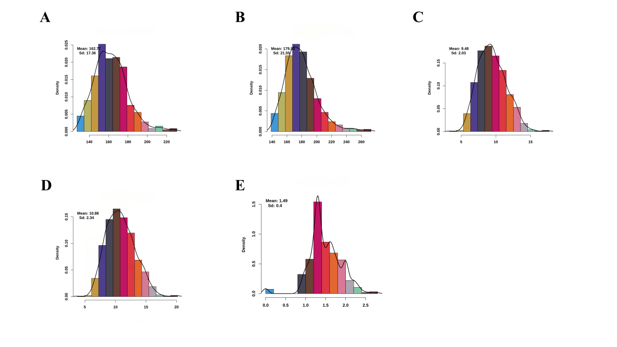
Figure S1. Distribution of phenotypic values for AGE100, AGE115, BF100, BF115, and BW in the study population. (A) AGE100, (B) AGE115, (C) BF100, (D) BF115, (E) BW.

