SUPPLEMENTARY FIGURES
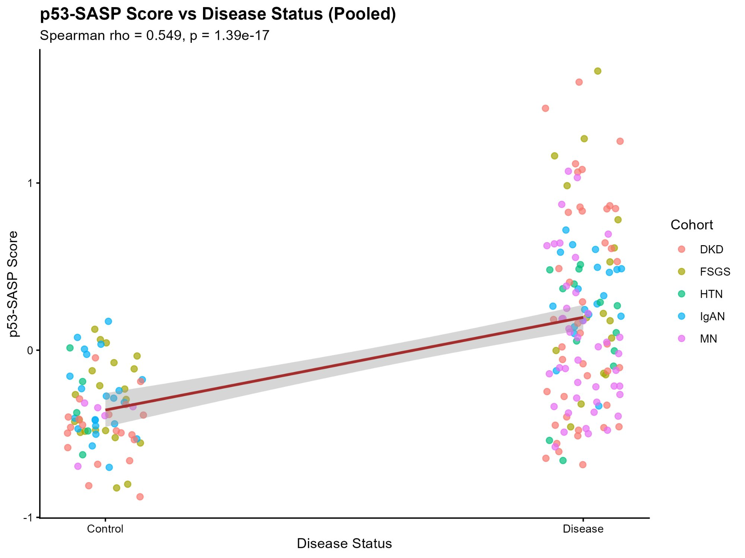
Supplementary Figure 1. Composite p53-SASP score versus disease status (pooled across all five cohorts, n=206 samples). Spearman rho = 0.549, p = 1.39x10-17. Each point represents one sample color-coded by cohort. The regression line with 95% confidence interval demonstrates significant association of the p53-SASP composite score with CKD disease status.
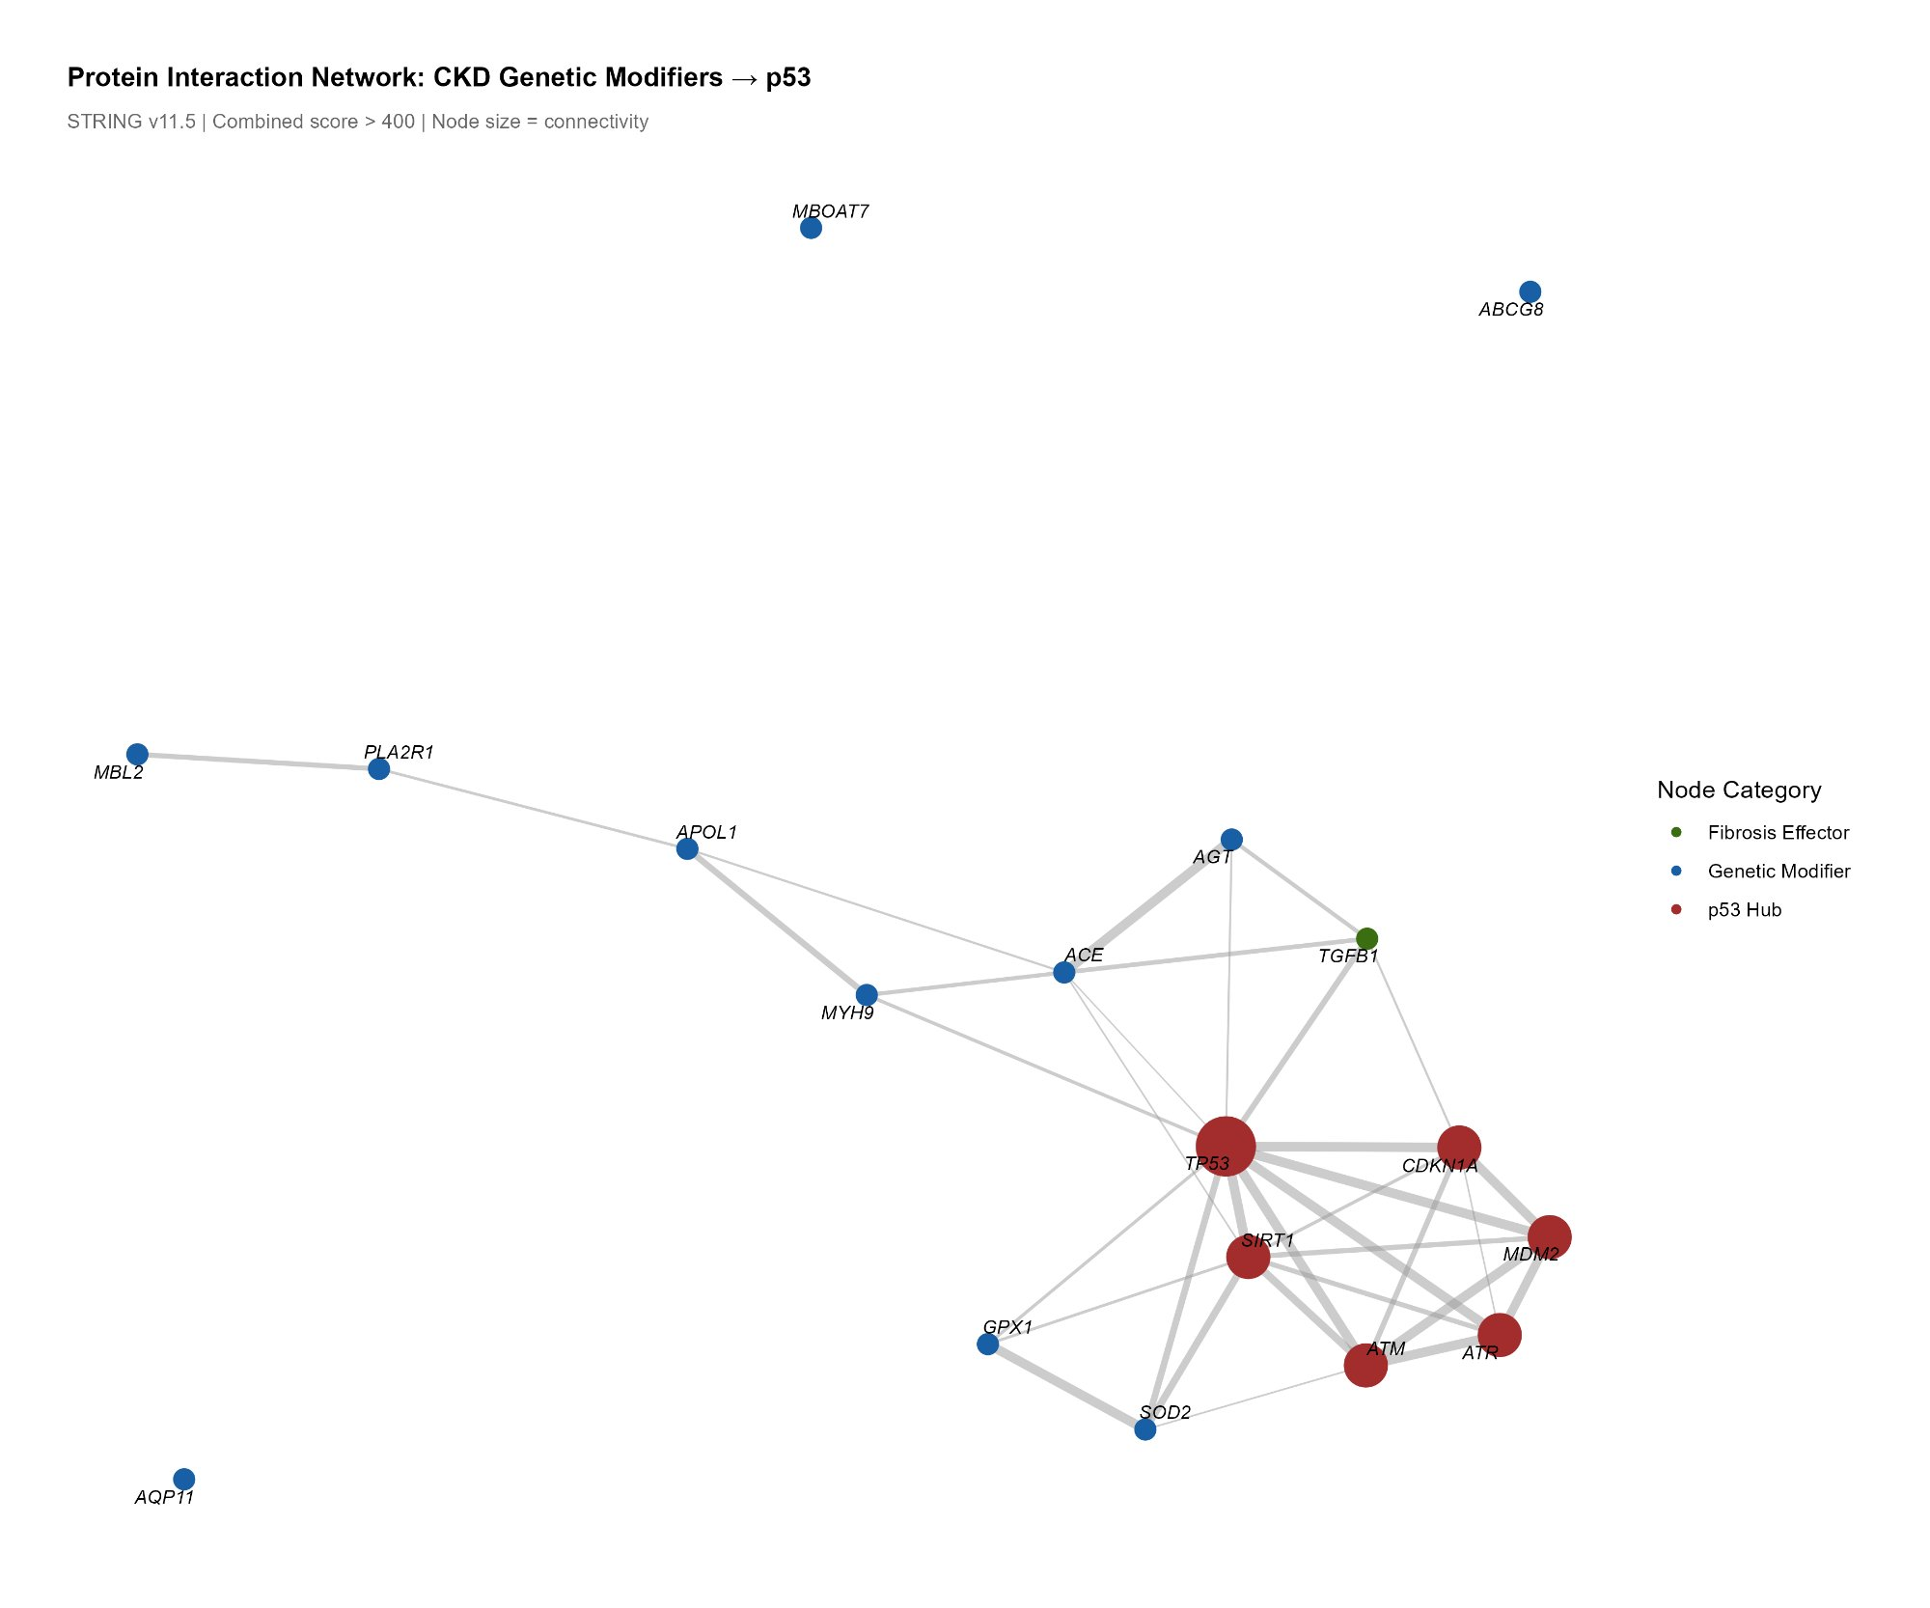
Supplementary Figure 2. STRING v11.5 protein-protein interaction network. Seed proteins include all seven genetic modifier class representatives and key p53 pathway nodes (n=18 proteins, combined score threshold > 400, 70 interactions). TP53 is the most highly connected hub. MBOAT7, ABCG8, and AQP11 show limited STRING-verified connections, consistent with their indirect lipotoxic and ER stress mechanisms of p53 activation.
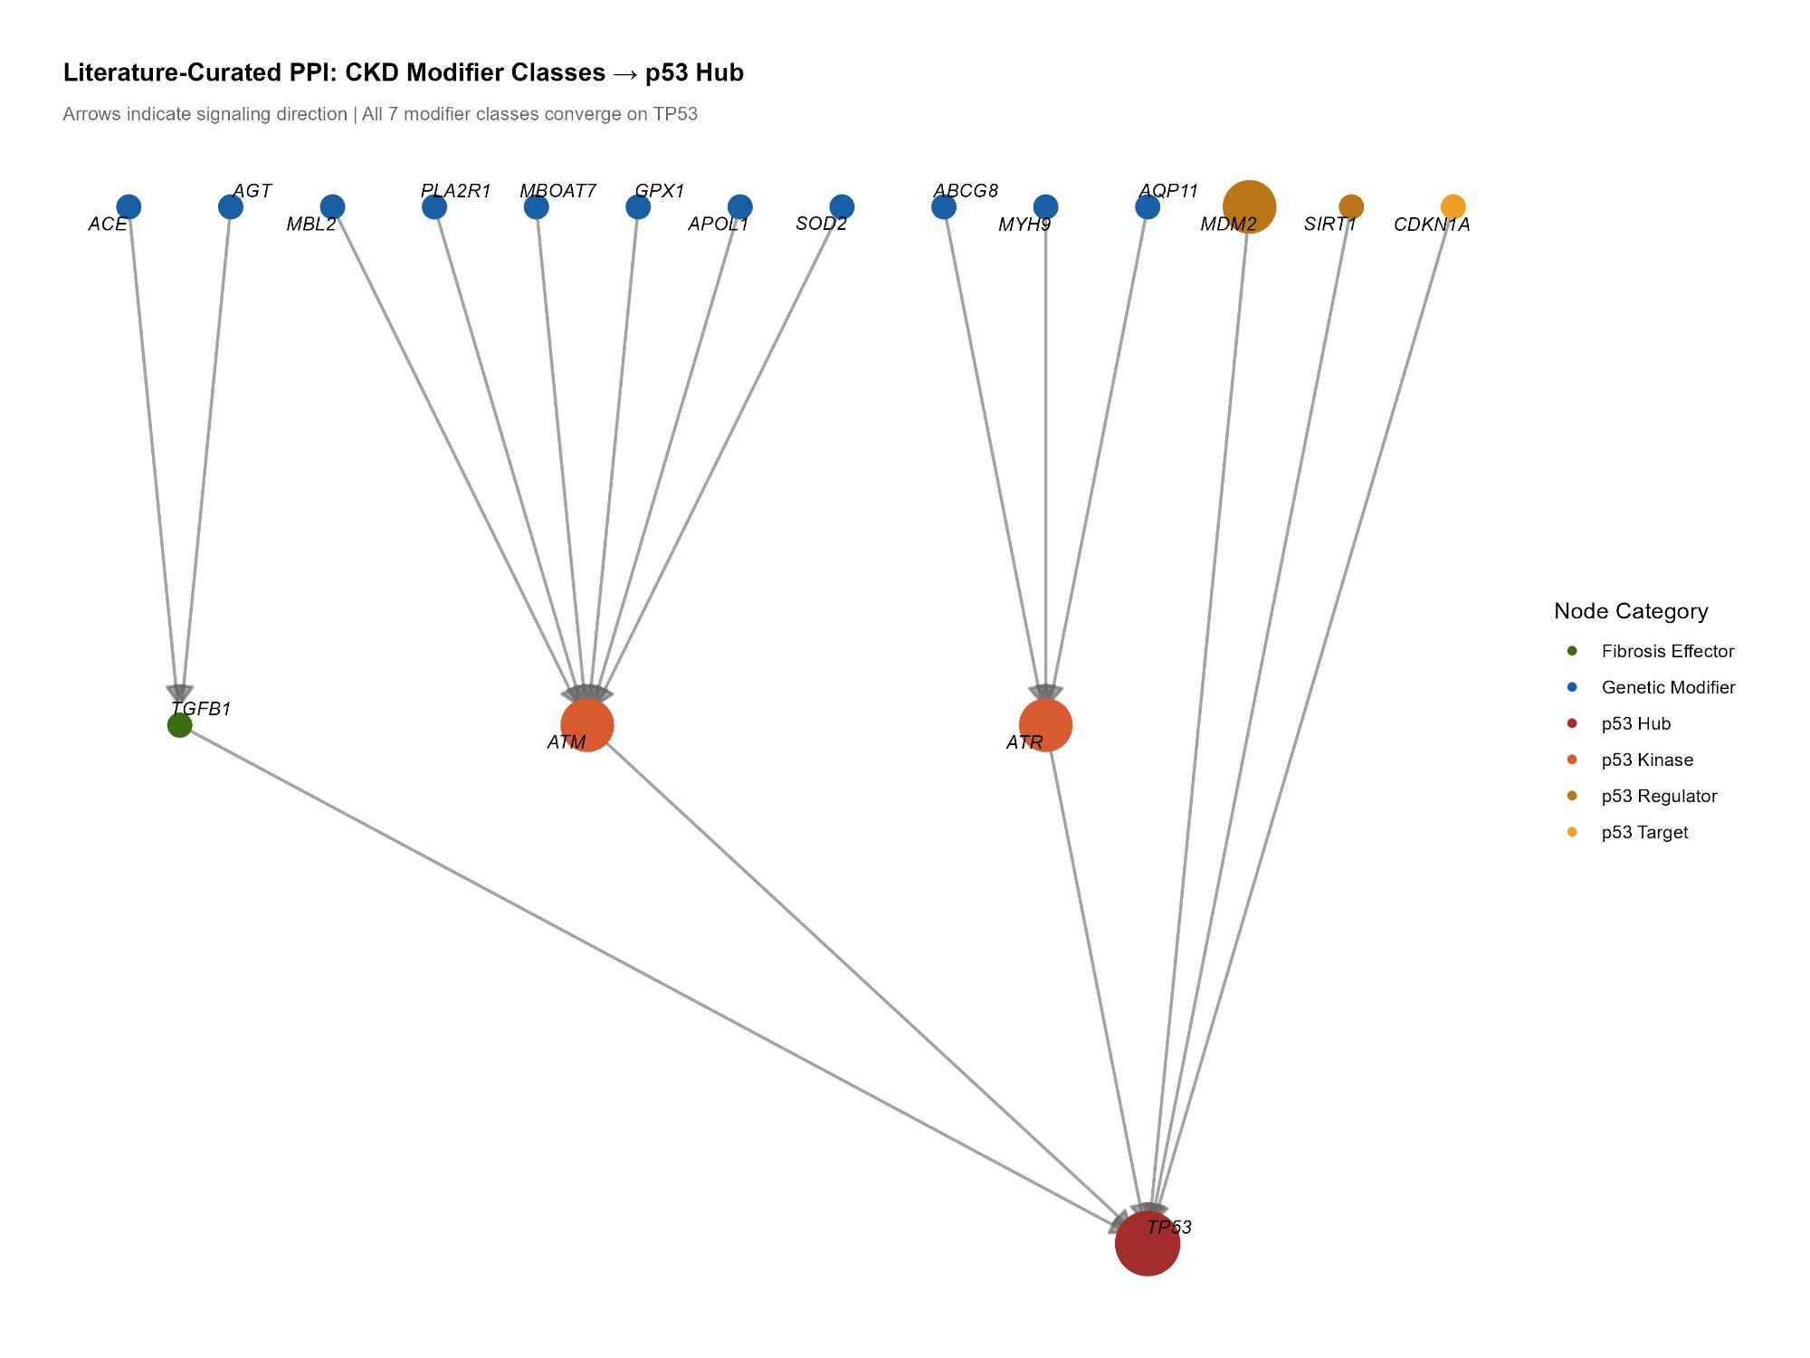
Supplementary Figure 3. Literature-curated directed PPI network: CKD modifier classes to p53 hub. Arrows indicate signaling direction. All seven modifier class proteins connect to TP53 through ATM, ATR, or TGFB1 intermediaries. Node size reflects degree centrality. Sources: Olabisi 2016 (APOL1), Kao 2008 (MYH9), Fujita 2009 (SOD2/GPX1), Samarakoon 2013 (ACE/AGT/TGFB1), Morishita 2005 (AQP11), Roos 2006 (MBL2), Kang 2015 (ABCG8/MBOAT7).
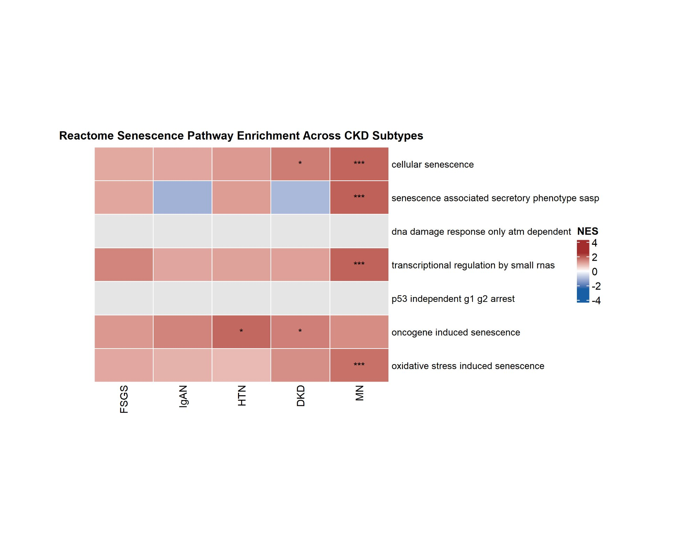
Supplementary Figure 4. Reactome senescence pathway enrichment across five CKD subtypes. NES heatmap for seven pre-specified Reactome senescence pathways. CELLULAR_SENESCENCE is enriched in DKD (NES = 1.57, padj = 0.019) and MN (NES = 1.86, padj = 8.33x10-6). REACTOME_SASP is significantly enriched in MN (NES = 1.92, padj = 3.14x10-5). ONCOGENE_INDUCED_SENESCENCE is enriched in HTN (NES = 1.83, padj = 0.013) and DKD (NES = 1.54, padj = 0.043). Stars: *, padj<0.05; ***, padj<0.001.
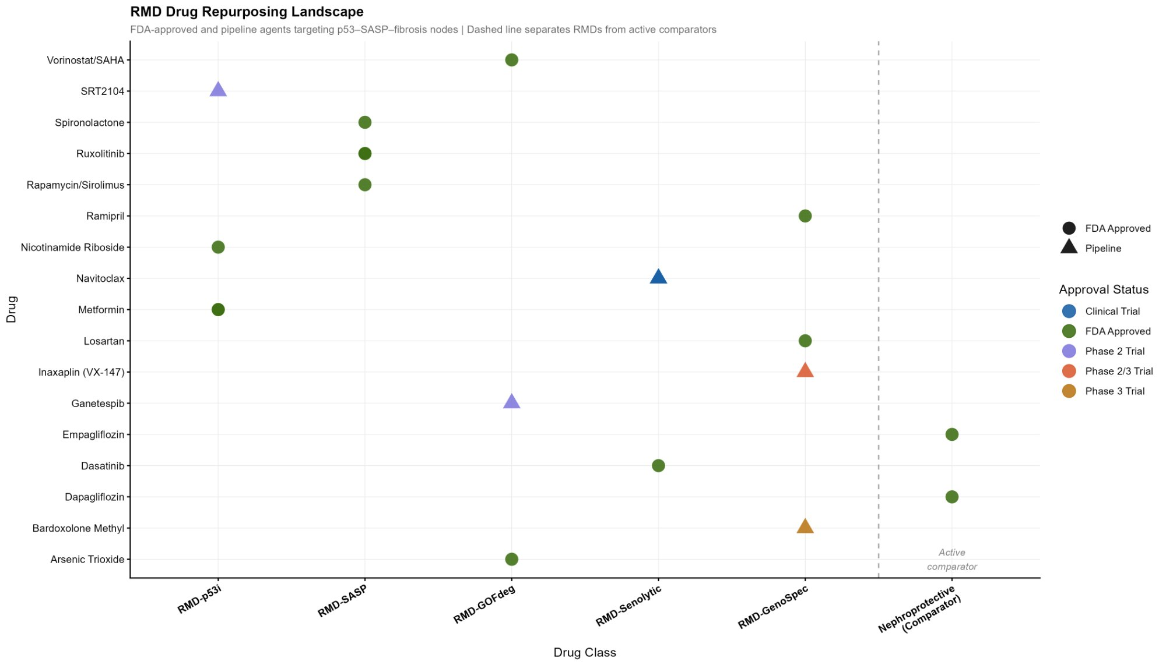
Supplementary Figure 5. RMD drug repurposing landscape. Dot plot of 18 existing FDA-approved and pipeline agents classified across five RMD subclasses. Circles indicate FDA-approved agents; triangles indicate pipeline/trial-stage agents. Dashed vertical line separates RMD agents from nephroprotective active comparators (empagliflozin, dapagliflozin). Inaxaplin is classified as RMD-GenoSpec Class I.
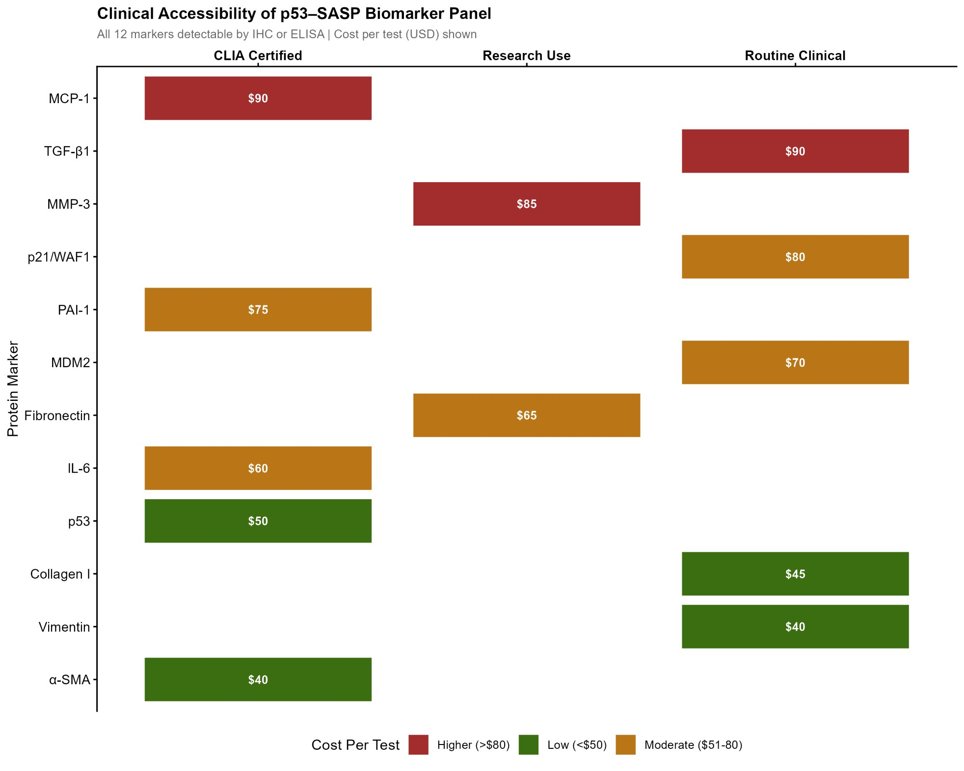
Supplementary Figure 6. Clinical accessibility of the p53-SASP biomarker panel. Twelve protein markers are detectable by IHC or CLIA-certified ELISA. Color indicates approximate per-test cost: green = low (<$50), amber = moderate ($51-80), red = higher (>$80). Seven markers are accessible by routine clinical or CLIA-certified platforms. Alpha-SMA ($40) and Collagen I ($45) are currently used in routine renal pathology, providing an immediately implementable basis for RMD patient stratification.

