Supplementary Section 1.Flowchart of the study sample.

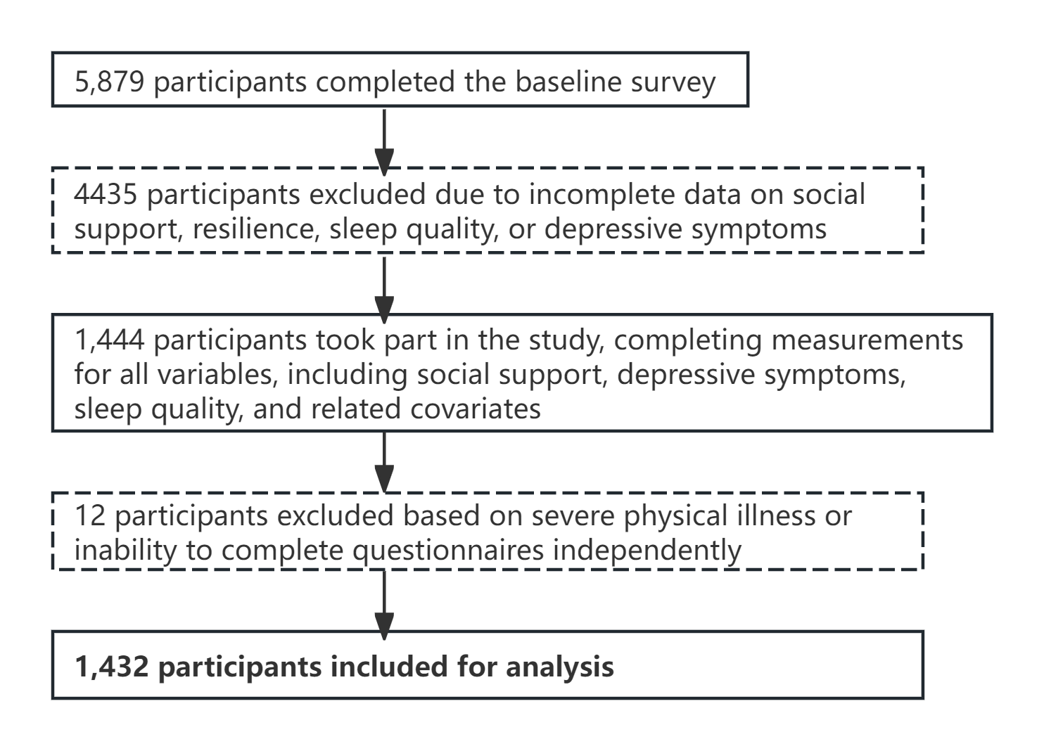
Supplementary Figure 1: Flowchart of the study sample

Supplementary Section 2. PHQ-9, SSRS, CD-RISC-10 and PSQI

PHQ-9: Alpha coefficients for the PHQ-9 were indicative of good internal reliability: 0.89.

Supplementary Table 1: Anchor points for the 9-item Patient Health Questionnaire Depression Scale (PHQ-9) scale
Item | Percent responses
Item | 0 | 1 | 2 | 3
Little interest or pleasure in doing things | 91.4 | 7.3 | 1 | 0.3
Feeling down, depressed, or hopeless | 91.3 | 7.5 | 1 | 0.3
Trouble falling or staying asleep, or sleeping too much | 83.4 | 7.7 | 4.3 | 4.7
Feeling tired or having little energy | 91.1 | 7.4 | 1 | 0.6
Poor appetite or overeating | 93.6 | 5.4 | 0.7 | 0.3
Feeling bad about yourself, or that you are a failure or have let yourself or your family down | 96.1 | 3.1 | 0.5 | 0.3
Trouble concentrating on things, such as reading the newspaper or watching television | 95.9 | 3.1 | 0.6 | 0.3
Moving or speaking so slowly that other people could have noticed, or the opposite—being so fidgety or restless that you have been moving around a lot more than usual | 96 | 3.2 | 0.5 | 0.3
Thoughts that you would be better off dead or of hurting yourself in some way | 99 | 0.8 | 0 | 0.2

SSRS:

Supplementary Table 2: Anchor points for the Social Support Rating Scale(SSRS)
Item | Mean(SD)
Subjective social support |  | 5.45（2.8）
Objective social support |  | 32.35（3.9）
Utilization of social support |  | 7.89（2.9）

CD-RISC-10: Alpha coefficients for the CD-RISC-10 were indicative of good internal reliability: 0.98.

Supplementary Table 3: Anchor points for the 10-item Connor-Davidson Resilience Scale(CD-RISC-10)

Item | Percent responses
Item | 0 | 1 | 2 | 3 | 4
Able to adapt to change | 2.9 | 2.2 | 5.9 | 19.6 | 69.5
Can deal with whatever comes | 2.4 | 1.4 | 4.9 | 19.2 | 72.1
Tries to see humorous side of problems | 2.7 | 1.5 | 4.5 | 19 | 72.2
Coping with stress strengthens | 2.7 | 1 | 4.3 | 19.5 | 72.6
Tends to bounce back after illness or hardship | 2.5 | 1.5 | 4 | 19.7 | 72.3
Can achieve goals despite obstacles | 2.4 | 1.3 | 4.5 | 19.1 | 72.8
Can stay focused under pressure | 2.7 | 1.5 | 5.2 | 19.4 | 71.3
Not easily discouraged by failure | 2.9 | 1.1 | 4.3 | 18.9 | 72.8
Thinks of self as strong person. | 2.7 | 1 | 4.1 | 18.6 | 73.5
Can handle unpleasant feelings | 2.9 | 0.8 | 4.7 | 18.8 | 72.7

PSQI: Alpha coefficients for the PSQI were indicative of good internal reliability: 0.72.

Supplementary Table 4: Anchor points for the Pittsburgh Sleep Quality Index(PSQI)
Item | Percent responses
Item | 0 | 1 | 2 | 3
Subjective Sleep Quality | 12.4 | 67.2 | 17.9 | 2.5
Sleep Latency | 38 | 35.4 | 15.8 | 10.8
Sleep Duration | 50.9 | 28.6 | 12.4 | 8.2
Habitual Sleep Efficiency | 50.4 | 22.8 | 10.5 | 16.3
Sleep Disturbances | 17.3 | 75.1 | 7.1 | 0.5
Use of Sleeping Medication | 93.7 | 2.2 | 1.2 | 2.9
Daytime Dysfunction | 76 | 12.3 | 8 | 3.8

Supplementary Section 3.Correlation Coefficients of Variables

Supplementary Table 5. Correlation Coefficients of the Variables
 | PSQI | PHQ-9 | CD_RISC-10 | SRSS
PSQI | 1 | 0.339*** | 0.056 | -0.036
PHQ | — | 1 | -0.069** | -0.033
CD_RISC | — | — | 1 | 0.049
SRSS | — | — | — | 1
Note.: * p < .05, ** p < .01, *** p < .001

