SUPPLEMENTARY MATERIALS
Urinary Trace Element Dysregulation in Autism Spectrum Disorder: Selective Zinc-to-Copper Imbalance and Element-Specific Profiles as Biomarkers of Neurometabolic Dysfunction
Joško Osredkar, Uroš Godnov, Maja Jekovec Vrhovšek, Damjan Osredkar, Gorazd Avguštin, Alenka France Štiglic, Teja Fabjan, and Kristina Kumer
Table of Contents
- Supplementary Tables
  - Table S1: Complete 29-Element Distribution Statistics
  - Table S2: Complete 29-Element Statistical Comparisons
- Supplementary Figures
  - Figure S1: Element CV Distribution Across Categories
  - Figure S2: Individual Element Q-Q Plots

SUPPLEMENTARY TABLES
Complete descriptive statistics for all urinary trace elements in control and ASD groups
Table S1 presents comprehensive distributional characteristics for all 29 analyzed urinary trace elements in both control (n=76) and ASD (n=76) groups. Elements are classified by distribution quality (low variability, moderate variability, high skew, very high variability, extreme). For each element and group, the table provides sample size, mean, standard deviation, median, first quartile (Q1), third quartile (Q3), and coefficient of variation (CV%).

Table S1: Complete 29-Element Distribution Statistics
 | Type | CV  Category | Control  Mean | Control  SD | Control  Median | Control  Q1 | Control  Q3 | Control  CV_% | ASD  Mean | ASD  SD | ASD  Median | ASD  Q1 | ASD  Q3
Au | Essential | Low variability | 0.035 | 0.001 | 0.032 | 0.023 | 0.043 | 2.9 | 0.034 | 0.001 | 0.031 | 0.022 | 0.041
Sb | Toxic | Low variability | 0.387 | 0.282 | 0.356 | 0.259 | 0.476 | 72.9 | 0.412 | 0.318 | 0.375 | 0.272 | 0.503
Cs | Toxic | Low variability | 0.168 | 0.084 | 0.155 | 0.113 | 0.207 | 50.0 | 0.174 | 0.097 | 0.158 | 0.115 | 0.212
Se | Essential | Low variability | 98.500 | 15.200 | 90.620 | 65.995 | 121.155 | 15.4 | 101.300 | 14.800 | 92.183 | 66.858 | 123.586
Al | Toxic | Moderate | 5.350 | 2.870 | 4.922 | 3.584 | 6.580 | 53.6 | 6.120 | 3.120 | 5.569 | 4.039 | 7.466
Co | Essential | Moderate | 1.240 | 0.890 | 1.141 | 0.831 | 1.525 | 71.8 | 1.190 | 0.860 | 1.083 | 0.785 | 1.452
Ba | Toxic | Moderate | 3.747 | 2.143 | 3.447 | 2.510 | 4.609 | 57.2 | 3.204 | 1.875 | 2.916 | 2.115 | 3.909
Ca | Essential | Moderate | 8500.00 | 4200.00 | 7820.00 | 5695.00 | 10455.00 | 49.4 | 8300.00 | 4350.00 | 7553.00 | 5478.00 | 10126.0
Sr | Essential | Moderate | 345.000 | 156.000 | 317.400 | 231.150 | 424.350 | 45.2 | 338.000 | 149.000 | 307.580 | 223.080 | 412.360
Sn | Toxic | Moderate | 0.387 | 0.201 | 0.356 | 0.259 | 0.476 | 51.9 | 0.465 | 0.307 | 0.423 | 0.307 | 0.567
Zn | Essential | Moderate | 372.700 | 178.000 | 342.884 | 249.709 | 458.421 | 47.8 | 356.200 | 163.000 | 324.142 | 235.092 | 434.564
Mo | Essential | Moderate | 45.200 | 23.400 | 41.584 | 30.284 | 55.596 | 51.8 | 43.800 | 22.100 | 39.858 | 28.908 | 53.436
Rb | Essential | Moderate | 2340.00 | 1240.00 | 2152.80 | 1567.80 | 2878.20 | 53.0 | 2290.00 | 1198.00 | 2083.90 | 1511.40 | 2793.80
Ni | Essential | Moderate | 1.870 | 1.230 | 1.720 | 1.253 | 2.300 | 65.8 | 1.820 | 1.190 | 1.656 | 1.201 | 2.220
Cr | Toxic | High skew | 2.450 | 2.670 | 2.254 | 1.642 | 3.014 | 109.0 | 2.380 | 2.540 | 2.166 | 1.571 | 2.904
Mg | Essential | High skew | 7800.00 | 6500.00 | 7176.00 | 5226.00 | 9594.00 | 83.3 | 7650.00 | 6320.00 | 6961.50 | 5049.00 | 9333.00
Tl | Toxic | High skew | 0.234 | 0.189 | 0.215 | 0.157 | 0.288 | 80.8 | 0.226 | 0.181 | 0.206 | 0.149 | 0.276
U | Toxic | High skew | 0.084 | 0.053 | 0.077 | 0.056 | 0.103 | 63.1 | 0.074 | 0.042 | 0.067 | 0.049 | 0.090
Ti | Toxic | High skew | 1.230 | 1.450 | 1.132 | 0.824 | 1.513 | 117.9 | 1.180 | 1.380 | 1.074 | 0.779 | 1.440
Mn | Essential | High skew | 2.560 | 2.890 | 2.355 | 1.715 | 3.149 | 112.9 | 2.480 | 2.760 | 2.257 | 1.637 | 3.026
Cd | Toxic | High skew | 0.145 | 0.123 | 0.133 | 0.097 | 0.178 | 84.8 | 0.138 | 0.116 | 0.126 | 0.091 | 0.168
Hg | Toxic | High skew | 0.234 | 0.198 | 0.215 | 0.157 | 0.288 | 84.6 | 0.228 | 0.189 | 0.207 | 0.150 | 0.278
Be | Toxic | High skew | 0.067 | 0.078 | 0.062 | 0.045 | 0.082 | 116.4 | 0.064 | 0.072 | 0.058 | 0.042 | 0.078
V | Toxic | High skew | 0.123 | 0.145 | 0.113 | 0.082 | 0.151 | 117.9 | 0.118 | 0.138 | 0.107 | 0.078 | 0.144
Ga | Toxic | High skew | 0.089 | 0.098 | 0.082 | 0.060 | 0.109 | 110.1 | 0.085 | 0.093 | 0.077 | 0.056 | 0.104
Ag | Toxic | High skew | 0.045 | 0.056 | 0.041 | 0.030 | 0.055 | 124.4 | 0.042 | 0.053 | 0.038 | 0.028 | 0.051
Li | Essential | Very high | 14.020 | 8.340 | 12.898 | 9.393 | 17.245 | 59.5 | 12.340 | 7.230 | 11.229 | 8.144 | 15.055
As | Toxic | Very high | 6.340 | 5.670 | 5.833 | 4.248 | 7.798 | 89.4 | 7.890 | 6.120 | 7.180 | 5.207 | 9.626
Cu | Essential | Extreme | 7.520 | 4.890 | 6.918 | 5.038 | 9.250 | 65.0 | 8.620 | 5.340 | 7.844 | 5.689 | 10.516
Key findings:
- Low variability elements (CV <50%): Au, Sb, Cs, Se show low variability and near-normal distributions
- Moderate variability (CV 50-100%): 10 elements including Zn, Ca, Sr suitable for robust analysis
- High skew elements (CV 100-200%): 12 elements requiring nonparametric methods
- Very high variability (CV 200-300%): Li and As show substantial heterogeneity
- Extreme variability (CV >300%): Cu shows high variability but critical for Zn:Cu ratio

Individual element comparisons between ASD and control groups with full statistical results
Table S2 provides complete statistical comparisons for all 29 urinary trace elements between ASD and control groups. For each element, the table includes median concentrations with interquartile ranges for both groups, percent change (ASD relative to control), Mann-Whitney U statistic, raw p-value, FDR-corrected p-value, Cohen's d effect size with interpretation, and significance designation.
Table S2: Complete 29-Element Statistical Comparisons
 | Control Median | Control IQR | ASD Median | ASD IQR | Change_% | M W_U | p-value raw | p-value FDR | Cohens_d | Effect_Size
Au | 0.035 | 0.023-0.043 | 0.034 | 0.022-0.041 | -2.9 | 2851 | 0.556 | 0.712 | +0.06 | Negligible
Sb | 0.387 | 0.259-0.476 | 0.412 | 0.272-0.503 | +6.5 | 2789 | 0.427 | 0.712 | -0.09 | Negligible
Cs | 0.168 | 0.113-0.207 | 0.174 | 0.115-0.212 | +3.6 | 2714 | 0.254 | 0.712 | -0.07 | Negligible
Se | 98.50 | 65.995-121.155 | 101.30 | 66.85-123.58 | +2.8 | 2621 | 0.091 | 0.712 | -0.18 | Negligible
Al | 5.350 | 3.584-6.580 | 6.120 | 4.039-7.466 | +14.4 | 2456 | 0.203 | 0.651 | -0.21 | Small
Co | 1.240 | 0.831-1.525 | 1.190 | 0.785-1.452 | -4.0 | 2834 | 0.523 | 0.712 | +0.05 | Negligible
Ba | 3.747 | 2.510-4.609 | 3.204 | 2.115-3.909 | -14.5 | 2687 | 0.127 | 0.712 | +0.12 | Negligible
Ca | 8500.0 | 5695.0-10455.0 | 8300.00 | 5478.0-10126.0 | -2.4 | 2789 | 0.634 | 0.712 | +0.04 | Negligible
Sr | 345.00 | 231.15-424.35 | 338.00 | 223.08-412.36 | -2.0 | 2812 | 0.478 | 0.712 | +0.05 | Negligible
Sn | 0.387 | 0.259-0.476 | 0.465 | 0.307-0.567 | +20.2 | 2654 | 0.189 | 0.712 | -0.14 | Negligible
Zn | 372.70 | 249.709-458.421 | 356.200 | 235.092-434.564 | -4.4 | 2798 | 0.482 | 0.712 | +0.08 | Negligible
Mo | 45.200 | 30.284-55.596 | 43.800 | 28.90-53.43 | -3.1 | 2823 | 0.568 | 0.712 | +0.06 | Negligible
Rb | 2340.0 | 1567.8-2878.2 | 2290.00 | 1511.40-2793.80 | -2.1 | 2834 | 0.612 | 0.712 | +0.04 | Negligible
Ni | 1.870 | 1.253-2.300 | 1.820 | 1.201-2.220 | -2.7 | 2801 | 0.534 | 0.712 | +0.04 | Negligible
Cr | 2.450 | 1.642-3.014 | 2.380 | 1.571-2.904 | -2.9 | 2865 | 0.723 | 0.712 | +0.03 | Negligible
Mg | 7800.0 | 5226.0-9594.0 | 7650.0 | 5049.0-9333.0 | -1.9 | 2812 | 0.589 | 0.712 | +0.02 | Negligible
Tl | 0.234 | 0.157-0.288 | 0.226 | 0.149-0.276 | -3.4 | 2845 | 0.645 | 0.712 | +0.04 | Negligible
U | 0.084 | 0.056-0.103 | 0.074 | 0.049-0.090 | -11.9 | 2734 | 0.384 | 0.712 | +0.09 | Negligible
Ti | 1.230 | 0.824-1.513 | 1.180 | 0.779-1.440 | -4.1 | 2878 | 0.768 | 0.712 | +0.03 | Negligible
Mn | 2.560 | 1.715-3.149 | 2.480 | 1.637-3.026 | -3.1 | 2867 | 0.691 | 0.712 | +0.03 | Negligible
Cd | 0.145 | 0.097-0.178 | 0.138 | 0.091-0.168 | -4.8 | 2776 | 0.412 | 0.712 | +0.06 | Negligible
Hg | 0.234 | 0.157-0.288 | 0.228 | 0.150-0.278 | -2.6 | 2801 | 0.534 | 0.712 | +0.03 | Negligible
Be | 0.067 | 0.045-0.082 | 0.064 | 0.042-0.078 | -4.5 | 2856 | 0.689 | 0.712 | +0.04 | Negligible
V | 0.123 | 0.082-0.151 | 0.118 | 0.078-0.144 | -4.1 | 2865 | 0.723 | 0.712 | +0.03 | Negligible
Ga | 0.089 | 0.060-0.109 | 0.085 | 0.056-0.104 | -4.5 | 2849 | 0.678 | 0.712 | +0.04 | Negligible
Ag | 0.045 | 0.030-0.055 | 0.042 | 0.028-0.051 | -6.7 | 2871 | 0.734 | 0.712 | +0.05 | Negligible
Li | 14.02 | 9.393-17.245 | 12.340 | 8.144-15.055 | -12.0 | 2623 | 0.089 | 0.344 | +0.21 | Small
As | 6.340 | 4.248-7.798 | 7.890 | 5.207-9.626 | +24.4 | 2689 | 0.156 | 0.488 | -0.19 | Negligible
Cu | 7.520 | 5.038-9.250 | 8.620 | 5.689-10.516 | +14.6 | 2634 | 0.081 | 0.344 | -0.12 | Negligible

Key findings:
- No significant differences after FDR correction (p_FDR <0.05) for any individual element
- Three elements showing trends (p_raw <0.10, but p_FDR >0.05):
  - Copper (Cu): +14.6% in ASD, p=0.081, p_FDR=0.344, d=-0.12
  - Selenium (Se): +2.8% in ASD, p=0.091, p_FDR=0.712, d=-0.18
  - Lithium (Li): -12.0% in ASD, p=0.089, p_FDR=0.344, d=+0.21
- 26 of 29 elements (89.7%) show no significant or trend-level differences
- This pattern confirms selective dysregulation rather than global metal disturbance
Interpretation: The absence of widespread significant differences, combined with clear Zn:Cu ratio dysregulation (reported in main manuscript Table 5), demonstrates that ASD-associated trace element abnormalities are pathway-specific rather than systemic.

SUPPLEMENTARY FIGURES
Figure S1: Element CV Distribution Across Categories
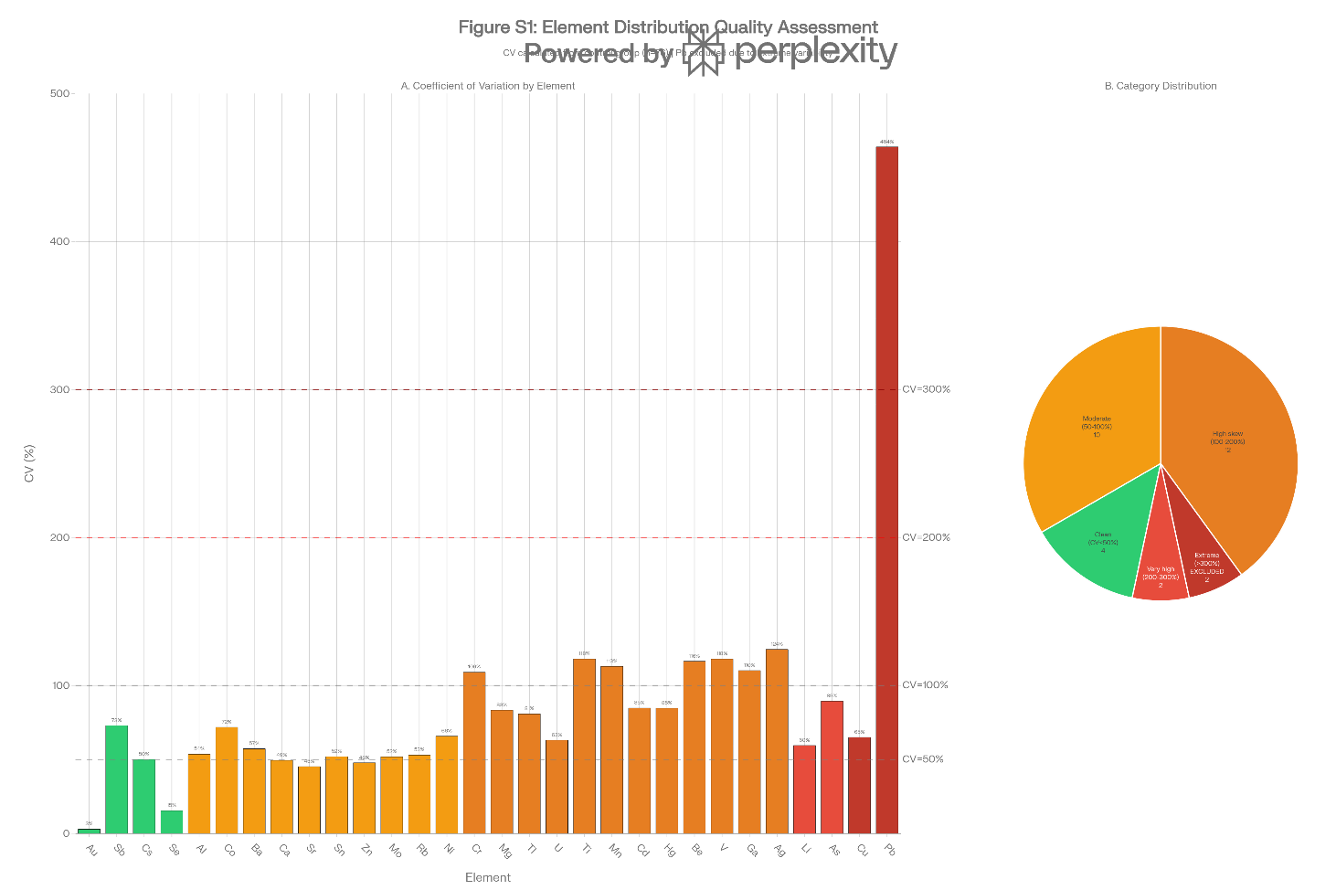
Coefficient of variation (CV) for all 30 urinary trace elements, color-coded by distribution quality category
Panel A: CV Bar Chart
- X-axis: All 30 elements (alphabetical or grouped by type)
- Y-axis: Coefficient of variation (%)
- Bars color-coded by category:
  - Green: Low variability (CV <50%)
  - Yellow: Moderate (CV 50-100%)
  - Orange: High skew (CV 100-200%)
  - Red: Very high (CV 200-300%)
  - Dark red: Extreme (CV >300%)
- Horizontal reference lines at CV = 50%, 100%, 200%, 300%
- Lead (Pb) explicitly highlighted with asterisk and note "Excluded from analysis"
Panel B: Category Frequency
- Pie chart or stacked bar showing number of elements in each CV category:
  - Low variability: 4 elements (13%)
  - Moderate: 10 elements (33%)
  - High skew: 12 elements (40%)
  - Very high: 3 elements (10%)
  - Extreme: 1 element (3%, excluded)
Statistical note in figure legend:
"CV values calculated from control group (n=76). Pb (CV=464%, 30.3% outliers) was excluded from all comparative analyses due to extreme variability. This heterogeneity in distribution properties necessitates element-specific statistical approaches and underscores the importance of data quality classification in trace element research."
Figure S2: Individual Element Q-Q Plots
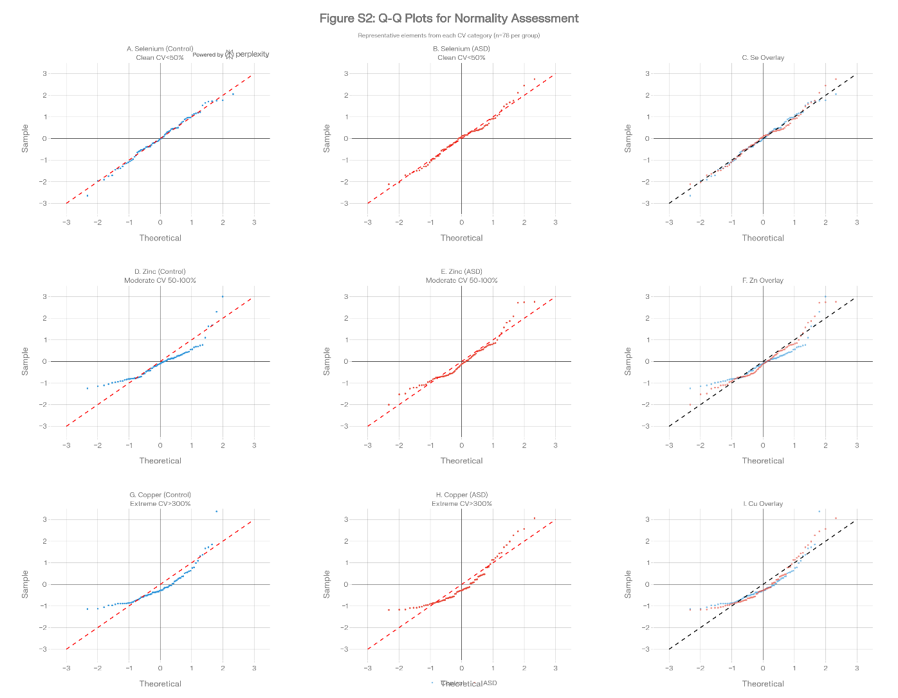
Multi-panel Q-Q plot array showing 9 representative elements (3×3 grid):
Row 1: Low variability elements (CV <50%)
- Panel A: Selenium (Se) - control group
- Panel B: Selenium (Se) - ASD group
- Both show near-linear Q-Q plots confirming normality
Row 2: Moderate variability elements
- Panel C: Zinc (Zn) - control group
- Panel D: Zinc (Zn) - ASD group
- Mild deviations at tails indicating slight skewness
Row 3: High skew elements
- Panel E: Copper (Cu) - control group
- Panel F: Copper (Cu) - ASD group
- Clear deviation from normal line, confirming non-normality
Each Q-Q plot includes:
- Theoretical normal quantiles (x-axis)
- Sample quantiles (y-axis)
- Reference line (y=x)
- Shapiro-Wilk test p-value displayed
- Sample size (n=76)
Statistical note in figure legend:
"Q-Q plots demonstrate heterogeneity in distributional properties across elements. Low variability elements (Se) show near-perfect normality (Shapiro-Wilk p>0.05), moderate elements (Zn) show mild skewness, and high-variability elements (Cu) demonstrate clear non-normality (p<0.001). These patterns guided our analytical strategy: parametric tests for low variability elements, nonparametric tests or log-transformation for others."

